Host immune response to infectious bronchitis virus Q1 in two commercial broiler chicken lines

Basim Manswr^{1,2*}, Christopher Ball^{1*}, Anne Forrester¹, Julian Chantrey³ and Kannan Ganapathy^{1#}

¹Institute of Infection and Global Health, University of Liverpool, Leahurst, UK
²Faculty of Veterinary Medicine, Diyala University, Iraq
³School of Veterinary Science, University of Liverpool, Leahurst, UK

#Corresponding author: Kannan Ganapathy (gana@liverpool.ac.uk)
*Co-first authors

ABSTRACT
This study investigated the pathogenesis of infectious bronchitis virus (Gammacoronavirus) strain Q1 in two commercial broiler chicken lines, and the host immune response to infection. Chicks from each line were grouped into either infected or control. Following Q1 infection at day-old, fast (Line-A) and slow (Line-B) growing chicks were monitored for clinical signs and body weights. At 3, 7, 9, 14, 21 and 28 days post infection (dpi), five birds were humanely euthanised, and trachea, kidney and proventriculus tissues were collected for quantitative RT-PCR and histopathology. Blood was collected weekly to determine IBV-specific ELISA antibody titres. Q1 infection significantly reduced the body weights of Line-A chicks at 14 and 21 dpi, but there were no significant differences in Line-B. Through qRT-PCR, significantly higher viral loads were found in the trachea, proventriculus and kidney tissues of Line-A chicks at 7-9 dpi. At day-old and at 28 dpi, the mean antibody titre in Line-B was notably higher than Line-A. Significant IFN-α mRNA expression was noted in the trachea and kidneys of Line-A, whereas no change occurred in Line-B. Chicks in Line-B, compared to those in Line-A, demonstrated a tissue-dependent increase of IFN-β, TLR3, IL-1β and IL-6 and LITAF gene transcription responses to IBV Q1. It appears that the level of maternal antibodies, growth rates, and other inherent host genetic factors could have influenced the differences in viral loads and immune responses.

KEYWORDS: Infectious bronchitis virus, Q1, gammacoronavirus, chicken, immunopathogenesis.

INTRODUCTION
Avian infectious bronchitis virus (IBV) is a Gammacoronavirus that replicates in the epithelium of lower and upper respiratory, digestive, reproductive and kidney tissues of chickens (Cavanagh, 2007; Ganapathy et al., 2012b; Yu et al., 2001). The virus belongs to the family of Coronaviridae, in the order of Nidovirales (Cavanagh, 2007). Both layer and broiler chickens are susceptible to IBVs but the clinical impact can vary depending on the infecting strain (Cavanagh, 2007). IBV strains have been reported in different parts of the world (Jackwood, 2012; Jones, 2010), with some localised to certain regions/countries and others globally present. One IBV strain that emerged in China in 1996, known as Q1, successfully disseminated to countries across four different continents (Jackwood, 2012; Yu et al., 2001). In 2016, the Q1 genotype was recognized to be part of the GI-16 lineage (Valastro et al., 2016), and based on clinical observations, the virus has been reported to cause respiratory, digestive and reproductive diseases in chickens (Toffan et al., 2013). The impact of infection and pathology differs between chicken breeds, and along with the degree of IBV strain virulence, this variation could also be associated with host immune responses (Cavanagh, 2007). It would be advantageous to understand the underlying immunobiological response to IBV Q1 in different chicken lines, as excessive host responses are likely to be associated with illness and subsequent production losses (Hesse et al., 2017; Kapczynski et al., 2013; Koutsakos et al., 2019).
Globally, certain broiler chicken breeds/Lines are desirable to commercial producers for their increased productivity (Tallentire et al., 2016). However, poultry production faces a number of infectious and non-infectious challenges to remain sustainable. Infection by IBV is a major challenge that causes increased mortality, reduced body weight gain, poor feed conversation ratio in broilers, and a decline in layer egg production and quality (Boroomand et al., 2012; Jackwood and de Wit, 2013). In addition, a variety of non-infectious causes are driving the industry to change from conventional fast-growing, to slower-growing commercial broiler chicks. This includes pressures from the wider public, changing consumer preferences, large retailers and European regulations (Council, 2007). For IBV, while publications are available on the general immune responses (Awad et al., 2016b; van Ginkel et al., 2015), to date, limited information is available on the differences in host innate and adaptive immune responses in different lines of commercial broiler chickens when challenged by virulent IBVs (Raj and Jones, 1996; Smith et al., 2015), particularly for recently emerged variant IBV strains. Adaptive immunity is derived from the initial exposure, followed by a specific memory cell response. In comparison, the innate response is non-specific, acts for a broad range of pathogens, and is the first line of defence from infection by utilising protein activation pathways, such as pattern recognition receptors (PPRs), interferons (IFNs) and pro-inflammatory cytokines (Chhabra et al., 2015a). By comparing the pathogenesis and immune responses between different chicken breeds, several studies have demonstrated differences in gene expression due to heat stress (Rimoldi et al., 2015), Salmonella or Campylobacter infection (van Hemert et al., 2006), feed removal (Benyi et al., 2010) or daily feed skip restriction (Netshipale et al., 2012). It has been suggested that genes linked to the B haplotype have a role in the bird’s resistance to IBV (Bacon et al., 2004; Banat et al., 2013; Silva et al., 2019). Using a microarray analysis of egg-laying chickens, Smith et al., investigated host gene expression in the trachea following IBV M41 infection in line 15I (inbred White Leghorn strain) and line N (non-inbred Cornell strain) birds (Smith et al., 2015).
It is important to understand the pathogenicity and host immune response to Q1 infection, particularly in two broiler chicken lines with differing growth rates. This is due to an increasing number of European producers switching to slow growers, while fast-growing chicks continue to be the preferred broiler lines in developing countries. This study reports on the pathogenicity of IBV Q1, and the humoral and innate immune responses in two lines of commercial broiler chickens following experimental infection.
MATERIALS AND METHODS
Ethical statement
All experimental procedures were performed according to UK legislation governing experimental animals under the project licence P8E4FC2C9. Experimental procedures were approved by the University of Liverpool’s ethical review process.
Virus strain
An IBV Q1 virus strain (GI-16 lineage; reference number 37089/2013) was used to infect both chicken lines in this study [12]. The virus was propagated in embryonated SPF eggs and titrated in tracheal organ cultures (TOCs). The virus was checked for viral avian contamination of other avian viruses, such as Newcastle Disease virus, avian metapneumovirus, and avian influenza virus, by RT-PCR. It was also checked for bacterial contamination, such as Escherichia coli and Mycoplasma spp, by culture prior to use in this study (Chhabra et al., 2018).
Chick welfare and management
Two breeds of day-old broiler chicks (Line-A and Line-B) used in this study were supplied by two different commercial hatcheries. The Line-A (fast growing) chicks reach a live slaughter weight of 2.2 Kg at 35 days old, whereas Line-B (slow growing) chicks can take 56 days to reach the same weight. In this experiment, chicks were reared up to 28 days of age in separate, negative pressure isolation rooms (University of Liverpool, UK), and kept on wood shaving litter with antibiotic-free food and water supplied ad libitum. The parent breeding stock for both lines received vaccination against IBV, including live Massachusetts, 793B and inactivated Massachusetts vaccines.
Experimental design
Chicks from Line-A and Line-B were each allocated into two groups; IBV Q1 infected (Line A, n=20; Line B, n=20) and sham-inoculated control (Line A, n=20; Line B, n=20). Before challenge, blood was collected from ten birds to assay for IBV maternal antibody levels. At day-old, chicks in both infected groups were inoculated via the oculonasal route with 100 µl of IBV Q1 (10^{4.5} CD₅₀/bird) (Chhabra et al., 2015b) and chicks in the control groups were sham-inoculated with 100 µl virus-free allantoic fluid. At weekly intervals, the body weights of 10 chicks from each group were recorded, and clinical signs were observed daily. At 3, 7, 9, 14, 21 and 28 dpi, five birds were humanely euthanised and their trachea, kidneys and proventriculus scored for gross lesions. Sections of these tissues were collected in RNAlater (Qiagen, Crawley, UK) and stored at -20 ºC to assay for quantification of virus load (all tissues), and expression of host gene mRNA (trachea and kidney). Separate sections of trachea and kidney were also collected in 10% buffered formalin for histological examination. Proventriculus tissue was also collected for virus isolation. At 1, 7, 14, 21, 28 dpi, blood was collected via the brachial vein from eight birds from each group. Sera was then separated and stored at -20 ºC for detection of IBV antibodies by ELISA.
Clinical signs
Clinical signs were recorded daily for each group (Jackwood and de Wit, 2013). Briefly, the clinical signs were scored as mild (coughing, head shaking and nasal scratching), moderate (mild signs plus ocular and nasal discharge), and severe (moderate signs plus depression with gasping or ruffled feathers). As per the project licence, birds exceeding the moderate clinical sign threshold were humanely euthanised and removed from the experiment.
Gross lesions and histopathology
Gross lesions were recorded as previously described (Mahgoub et al., 2010). Histopathology changes in the trachea, kidneys and proventriculus were scored as follows: 0 = no change, 1 = mild, 2 = moderate, 3 = severe (Chen and Itakura, 1996; Chhabra, 2016; Yu et al., 2001). Blind histological scoring was conducted by a European-specialist pathologist at the University of Liverpool.
Detection of IBV
Quantitative RT-PCR: For individual tissues of trachea, kidney and proventriculus, total RNA was extracted from 30 mg per tissue using the RNeasy Plus Mini kit (Qiagen) according to the manufacturer’s instructions (Awad et al., 2014). Quantification of viral RNA from tissue extracts was carried out using qRT-PCR as previously described (Jones et al., 2011). All reactions were performed in duplicate using the One-Step RT-PCR Qiagen kit and 40 ng of total RNA per reaction. Amplification plots were analysed, and the threshold cycle (Ct) value determined. Mean Ct values for each tissue sample were converted to log relative equivalent units (REU) of viral RNA using a standard curve generated using five 10-fold dilutions of extracted RNA from infective allantoic fluid of 10⁶ EID₅₀ of M41 as previously described (Löndt et al., 2013).
IBV isolation: Only for proventriculus tissues was virus isolation attempted in embryonated specific pathogen free (SPF) eggs as previously described (Guy, 2008). Following the third passage, allantoic fluid was tested for IBV by RT-PCR and sequenced as previously described (Ball et al., 2016) .
Host gene expression analysis
From RNA extracted from trachea and kidney tissues collected at 1, 3, 7, 9, and 14 dpi, host gene expression analysis was carried out using qRT-PCR. The following genes were included for analysis; type I interferon (IFN-α and IFN-β), toll like receptor 3 (TLR3), melanoma differentiation associated protein 5 (MDA5), pro-inflammatory cytokines (IL-6 and IL-1β) and lipopolysaccharide-induced tumor necrosis factor (TNF)-α factor (LITAF) (Chhabra et al., 2018). Each sample was tested in triplicate on the LightCycler® 480 (Roche, UK) platform, using LightCycler® 480 SYBR Green I Master mix and primers as previously described (Kuchipudi et al., 2012). Data was normalised against 18S rRNA expression and presented as the mean fold difference in mRNA transcripts of infected against the control samples.
Detection of anti-IBV antibodies
Sera were analysed using a commercial IBV ELISA kit (IDEXX, UK) according to manufacturer’s instructions, and samples with a sample/positive ratio greater than 0.2 were considered positive. Antibody titres were determined by converting the sample/positive ratio according to the formula provided by the manufacturer.
Statistical analysis
Statistical analysis was carried out using GraphPad Prism version 6. Differences between the two groups were analysed using univariate ANOVA, along with the homogeneity of variance test, to confirm statistical differences within the data set. This was followed by post hoc Bonferroni testing. When groups had p<0.05 for the homogeneity of variance test, Tamhane’s T2 was applied post hoc instead of Bonferroni. Fisher’s exact test was applied to determine significant differences in seroconversion between the infected groups at 28 dpi. Differences were considered significant at p<0.05 unless stated.
RESULTS
Body weight reduction in Line-A, rather than Line-B Q1-infected chicks
Significant reduction was noted in the mean body weights at 14 and 21 dpi for Line-A chicks that received Q1 compared to the control group (Figure 1A). In contrast, no significant changes were noted in the Q1-infected Line-B chicks (Figure 1B). Both Line-A groups had significantly higher body weights compared to the respective Line-B groups at 21 and 28 dpi (Figure 1C and Figure 1D).
Clinical signs and pathological lesions
In both infected groups, mild clinical signs started at 5 dpi and lasted until 14 and 13 dpi for Line-A and Line-B respectively. Signs in both groups were represented by sneezing, tracheal rales, head shaking, nasal exudate, eye scratching and diarrhoea. No birds showed clinical signs close to or exceeding the threshold of the project licence. A single sudden mortality was found in the Q1-infected Line-A group at 5 dpi. Both control groups were absent of clinical signs throughout the experiment.
Tracheal gross lesions in both infected groups consisted of congestion, hyperaemia, and excessive exudate. In both infected groups, kidney lesions consisted of paleness, swelling and urate deposition. There were no noticeable gross lesions at day 21 and 28 dpi for any groups.
Histopathology tracheal lesions in both infected Line-A and Line-B groups consisted of deciliation, epithelial degeneration, decreased mucous cells and heterophil infiltration. Kidney lesions appeared at 3 dpi in both infected groups and peaked at 21 and 14 dpi in Line-A and Line-B respectively. Histological changes consisted of epithelial degeneration, lymphoid infiltration and lymphoid nodules. There were no histopathological changes seen in the proventriculus for Line-B, while in Line-A, lesions comprising of glandular sinus dilation, lymphoid infiltration and scattered lymphoid follicles were seen at 7 and 9 dpi. There were no significant differences in the microscopic lesion scores between infected groups.
Q1 identification and viral loads in trachea and kidney tissue
At 7 dpi, Line-A had a significantly higher tracheal viral load compared to all other timepoints (Figure 2A), whereas Line-B saw a significant increase in viral load from 1 to 3 dpi, which then significantly declined by 14 dpi (Figure 2B). Kidney tissues were positive at 7, 9 and 14 dpi for both Line-A and Line-B, but there were no significant differences at these sampling points. Similarly, no proventriculus samples from Line-A had significant changes. However, in Line-B, samples at 9 dpi were significantly lower than at 3 or 7 dpi. Detection in the kidney occurred at a later time point (7 dpi) compared to the trachea (1 dpi) or proventriculus (3 dpi). No IBV was detected beyond 14 dpi in the trachea and kidney, nor beyond 9 dpi in the proventriculus.
Q1 virus isolation from proventriculus tissues in spite of low viral load
Re-isolation of IBV Q1 was successful from proventriculus tissue of both chicken lines at 7 and 9 dpi. In the 393 bp portion of the S1 gene sequenced, the re-isolated Q1 strains from both groups had 99 % nucleotide identity to the initial inoculum.
Humoral immune response to IBV Q1
A significantly higher mean titre of maternally derived antibodies (MDA) was detected in Line-B compared to Line-A (3709±456 and 1666±389 respectively) at day-old. After 7 dpi, at all sampling intervals, both the mean and individual bird titres of both control groups were below the positive titre threshold of 396. Flock seroconversion was noted in both infected groups at 21 (Line-A = 12.5%; Line B = 37.5%) and 28-days old (Line A = 25%; Line-B = 62.5%). For Line-A, average group antibody titres remained below the positive threshold throughout the experiment, whereas the Line-B infected group had an average positive antibody titre of 510 at 28 dpi (Figure 3).
Differential mRNA gene expression: IFN-α and IFN-β
Trachea: There was significant up-regulation of IFN-α expression in the Line-A infected group at all sampling days compared to the control group, with expression peaking at 3 dpi and declining until 14 dpi (Figure 4). No significant increase in IFN-α gene expression was noted for Line-B. For IFN-β, both infected groups had significant up-regulated expression for all sampling days, with the exception of Line-A at 14 dpi (Figure 4).
Kidney: Expression of IFN-α was only significantly up-regulated at 1 dpi in Line-A compared to the control group (Figure 4). Similarly, IFN-β was only significantly up-regulated at 1-3 dpi for Line-A, with no significant change witnessed for Line-B.
Differential mRNA gene expression: TLR3 and MDA5
Trachea: Significant up-regulation of TLR3 was present at 1-7 dpi in Line-A compared to the control group (Figure 4). In contrast, the gene was significantly up-regulated at all sampling points for Line-B (Figure 4). Levels of MDA5 were significantly up-regulated at 1 dpi in Line-A, whereas they were significantly down-regulated for Line-B at the same time point. No other changes were seen in subsequent sampling days.
Kidney: There was significant up-regulation noted for TLR3 in Line-B at all sampling times compared to the control, with no changes in Line-A present at any point (Figure 4). Both Line-A and Line-B demonstrated up-regulation of MDA5 at 7 and 9 dpi compared to their respective controls (Figure 4).
Differential mRNA gene expression: IL-1β, IL-6 and LITAF
Trachea: Expression of IL-1β was up-regulated at all sampling points for Line-A compared to the control group, whereas Line-B was only up-regulated at 1 dpi (Figure 4). Significant up-regulation of IL-6 was seen in Line-A from 3-9 dpi compared to the control (Figure 4). In contrast, Line-B was significantly down-regulated during early infection (1 dpi), followed by up-regulation from 3-7 dpi. No significant changes were noted for LITAF mRNA expression throughout the experiment.
Kidney: Line-A only demonstrated significant up-regulation of IL-1β at 9-14 dpi, whereas Line-B was significantly up-regulated to a much greater extent throughout all sampling points compared to their respective control groups. Similarly, while IL-6 and LITAF were significantly up-regulated at 7-9 dpi in Line-A, there was a prolonged response in Line-B, with significant up-regulation seen from 3-14 dpi and 1-14 dpi respectively. The mRNA response peaked at 9 dpi for IL-1β and IL-6 in both bird lines, with peak LITAF expression seen at 14 and 9 dpi in Line-A and in Line-B respectively.
DISCUSSION
The IBV Q1 strain is capable of infecting a number of different chicken breeds, including both layers and broilers (Ababneh et al., 2012; Ganapathy et al., 2015; Sesti et al., 2014). Though field investigations involving Q1 have been reported, there has been no in-depth investigation on the pathogenesis of this virus, especially for commercial broilers. This study demonstrated that the IBV Q1 strain was able to induce clinical signs, mainly involving the respiratory system, which were similar to those caused by other classical and variant strains of virulent IBV (Awad et al., 2016a; Ball et al., 2019; Ren et al., 2019). Cavanagh (2007) reported that different chicken breeds may respond differently depending on the IBV strain [1], and Smith et al. (2015) identified potential host gene differences between IBV-resistant and susceptible egg-laying chicken breeds (Smith et al., 2015). In recent years, there has been an increased use in farming of slow growing broilers, mainly due to public welfare concerns (Kubota et al., 2019; Yang and Jiang, 2005). For this reason, both fast (Line-A) and slow (Line-B) growing broilers were included in this study. Results showed similar levels of clinical signs, and gross and histopathological lesions of both broiler lines following Q1 infection. Despite this, variations were found in average body weights, viral load, and innate and humoral immune responses. The potential reasons and implications for such differences between the lines are discussed.
Following Q1 infection, there was a significant drop in body weight in Line-A at 14 and 21 dpi compared with the Line-A control, which was not present in Line-B. Both a reduction in body weight and an increased feed conversion ratio (FCR) have been associated with IBV infections in the field (Ganapathy et al., 2012b; Irvine et al., 2010), and experimentally found in Q1-infected SPF chicken (Ganapathy et al., 2012a; Mahgoub et al., 2010). Here, the impact on body weight was seen only in the fast-growing Line-A birds, which also had greater levels of viral load and early induction of IFN-α (trachea and kidney) and MDA5 (trachea). In addition, proventriculus microscopic lesions in Line-A included glandular sinus dilation, lymphoid infiltration and scattered lymphoid follicles (Toffan et al., 2013), which were completely absent from Line-B. RT-PCR of pooled oropharyngeal swabs of Line-A birds were positive for up to 4 weeks, but in Line-B, were only positive up to 2 weeks (data not shown). It is likely that the poor body weight increases in Line-A were due to an increased severity of infection and inflammation, which may have persisted for longer in Line-A rather than Line-B. Debilitating effects have been demonstrated in groups of fast rather than slow growing chicks following Campylobacter jejuni infection (Williams et al., 2013).
Significantly lower viral loads in multiple tissue types for Line-B (e.g. trachea and kidney at 7 dpi and the proventriculus at 7-9 dpi) rather than in Line-A, demonstrates more efficient clearance of the virus by Line-B chicks. As this study was designed to assess the pathogenicity of Q1 in two different lines of broiler chicks, it was not known if the above differences were due to variations in the inherent breed factors or the differences in day-old MDA levels. It has been previously reported that MDA can influence both IBV infection and vaccination efficiency (de Wit and Cook, 2014).
Following infection, innate immune responses in both lines of chicks were examined. Based on previous studies (Chhabra et al., 2018; Okino et al., 2017), the gene signatures (TLR3 and MDA5), type-1 interferons (IFN-α and IFN- β) and cytokines (IL-6, IL-1β, and LITAF) were chosen for analysis. The pattern and magnitude of mRNA expression in the trachea and kidneys was differentiable between the two lines. For the trachea, the Line-B chicks had significant up-regulation of IFN-β, and a significant down-regulation of MDA5 and IL-6. In the same Line of chicks, there were no significant changes in type-1 IFN, MDA5 and LITAF mRNA expression in the kidneys throughout the experimental duration. This further demonstrated the faster and effective induction of early immune responses in Line-B birds to clear the virus. These changes are closely associated with day-old MDA levels, lower IBV RNA load in trachea and kidney tissues, and higher humoral antibody titres by 28 dpi. This shows that host immunity of the Line-B birds had played a role in inhibiting the infection and rate of clearance of the IBV Q1.
It was of interest to note that IFN-α mRNA expression was significantly expressed in the trachea of fast growers, whereas it was IFN-β which was up-regulated in Line-B, compared to the relative control birds. Interferons have been reported to inhibit virus replication of several avian viruses such as IBV, Newcastle disease virus and Marek’s disease virus (Jarosinski et al., 2001; Marcus et al., 1999; Pei et al., 2001). It has been previously suggested that IFNs also impair virus dissemination before the antigen-specific immune response is activated (Goodbourn et al., 2000; Guidotti and Chisari, 2000). There was significant up-regulation of both IFNs in kidney tissues of Line-A, which wasn’t present for Line-B, reflecting potentially greater inhibition of Q1 in the latter. As stated above, it was highly possible that the spread of Q1 to visceral organs of chicks in Line-B was either slow due to higher levels of MDA.
Expression of proinflammatory cytokine (IL-6 and IL-1β) mRNA was up-regulated and prolonged in Line-A trachea tissue, whereas in Line-B, it was either down-regulated (IL-6) or significantly expressed for a much shorter period (only at 1 dpi). This was consistent with gross lesions, and conversely associated with higher viral load. These findings further demonstrate a mild tissue reaction to Q1 infection in the Line-B chicks, in contrast to a more prominent reaction in Line-A. Tracheal mRNA expression of these cytokines is associated with a degree of inflammation and tissue damage following IBV infection (Asif et al., 2007; Chhabra, 2016; Jang et al., 2013; Okino et al., 2014). IBV has previously been reported to impair the production of IL-6 and stimulate the production of IL-1β (Amarasinghe et al., 2018). LITAF, a protein that binds to specific cell surface receptors and initiates intracellular signalling cascades (Kotani et al., 2000), showed minimal change in the trachea and kidney of Line-B, compared to the control, whereas Line-A demonstrated significant up-regulation at later time points (9 and 14 dpi). This is associated with higher Q1 viral load in this line compared to Line-B, and inversely, this might be linked to the MDA levels and/or host genetic factors.
In conclusion, this study has confirmed the pathogenic effects of Q1 in two broiler chicken breeds with different inherent growth rates and maternal antibody titres. Findings showed that Line-B, which had higher day-old MDA levels, showed lower viral loads, earlier virus clearance and a greater magnitude of innate immune response to Q1 infection. It is highly possible that MDA levels had a role in neutralizing the infecting Q1 virus. To date, there have been no comparative studies on the effect of chicken growth rates on IBV pathogenesis. Current findings provide the basis for further investigation on potential influence of chicken growth rate on infection, immunity and clearance of IBV. Understanding the immunopathology of different commercial broiler breeds/Lines to different IBV strains can provide comprehensive information that could further strengthen IBV control strategies.
DECLARATIONS
Competing interests
The authors declare that they have no competing interests.
Funding
BM is in receipt of a studentship from the Iraq government. The funders had no role in study design, data collection and interpretation, or the decision to submit the work for publication.
Author contribution
Conceptualization, KG; Methodology, CB, KG and BM; Investigation, CB, BM and AF; Data Curation, BM, CB; Writing – Original Draft Preparation, BM and CB; Writing – Review & Editing, CB and KG; Visualization, CB; Supervision, KG, JC and CB; Funding Acquisition, KG.
Acknowledgements
Not applicable
REFERENCES
Ababneh, M., Dalab, A.E., Alsaad, S., Al-Zghoul, M., 2012. Presence of Infectious Bronchitis Virus Strain CK/CH/LDL/97I in the Middle East. ISRN Vet Sci 2012, 201721.
Amarasinghe, A., Abdul-Cader, M.S., Almatrouk, Z., van der Meer, F., Cork, S.C., Gomis, S., Abdul-Careem, M.F., 2018. Induction of innate host responses characterized by production of interleukin (IL)-1beta and recruitment of macrophages to the respiratory tract of chickens following infection with infectious bronchitis virus (IBV). Vet Microbiol 215, 1-10.
Asif, M., Lowenthal, J.W., Ford, M.E., Schat, K.A., Kimpton, W.G., Bean, A.G., 2007. Interleukin-6 expression after infectious bronchitis virus infection in chickens. Viral immunology 20, 479-486.
Awad, F., Baylis, M., Ganapathy, K., Awad, F., 2014. Detection of variant infectious bronchitis viruses in broiler flocks in Libya. Int. J. Vet. Sci. Med. International Journal of Veterinary Science and Medicine 2, 78-82.
Awad, F., Chhabra, R., Forrester, A., Chantrey, J., Baylis, M., Lemiere, S., Hussein, H.A., Ganapathy, K., 2016a. Experimental infection of IS/885/00-like infectious bronchitis virus in specific pathogen free and commercial broiler chicks. Res Vet Sci 105, 15-22.
Awad, F., Hutton, S., Forrester, A., Baylis, M., Ganapathy, K., 2016b. Heterologous live infectious bronchitis virus vaccination in day-old commercial broiler chicks: clinical signs, ciliary health, immune responses and protection against variant infectious bronchitis viruses. Avian Pathology 45, 169-177.
Bacon, L., Hunter, D., Zhang, H., Brand, K., Etches, R., 2004. Retrospective evidence that the MHC (B haplotype) of chickens influences genetic resistance to attenuated infectious bronchitis vaccine strains in chickens. Avian Pathology 33, 605-609.
Ball, C., Bennett, S., Forrester, A., Ganapathy, K., 2016. Genetic mutations in live infectious bronchitis vaccine viruses following single or dual in vitro infection of tracheal organ cultures. Journal of General Virology 97, 3232-3237.
Ball, C., Forrester, A., Herrmann, A., Lemiere, S., Ganapathy, K., 2019. Comparative protective immunity provided by live vaccines of Newcastle disease virus or avian metapneumovirus when co-administered alongside classical and variant strains of infectious bronchitis virus in day-old broiler chicks. Vaccine 37, 7566-7575.
Banat, G.R., Tkalcic, S., Dzielawa, J.A., Jackwood, M.W., Saggese, M.D., Yates, L., Kopulos, R., Briles, W.E., Collisson, E.W., 2013. Association of the chicken MHC B haplotypes with resistance to avian coronavirus. Dev Comp Immunol 39, 430-437.
Benyi, K., Acheampong-Boateng, O., Norris, D., Ligaraba, T., 2010. Response of Ross 308 and Hubbard broiler chickens to feed removal for different durations during the day. Tropical animal health and production 42, 1421-1426.
Boroomand, Z., Asasi, K., Mohammadi, A., 2012. Pathogenesis and tissue distribution of avian infectious bronchitis virus isolate IRFIBV32 (793/B serotype) in experimentally infected broiler chickens. ScientificWorldJournal 2012, 402537.
Cavanagh, D., 2007. Coronavirus avian infectious bronchitis virus. Veterinary research 38, 281-297.
Chen, B.Y., Itakura, C., 1996. Cytopathology of chick renal epithelial cells experimentally infected with avian infectious bronchitis virus. Avian Pathol 25, 675-690.
Chhabra, R., 2016. Studies on variant infectious bronchitis viruses: In vitro and in vivo comparison of virulence, immunopathogenesis and protection. University of Liverpool. PhD Dissertation.
Chhabra, R., Ball, C., Chantrey, J., Ganapathy, K., 2018. Differential innate immune responses induced by classical and variant infectious bronchitis viruses in specific pathogen free chicks. Developmental & Comparative Immunology 87, 16-23.
Chhabra, R., Chantrey, J., Ganapathy, K., 2015a. Immune Responses to Virulent and Vaccine Strains of Infectious Bronchitis Viruses in Chickens. Viral Immunol 28, 478-488.
Chhabra, R., Forrester, A., Lemiere, S., Awad, F., Chantrey, J., Ganapathy, K., 2015b. Mucosal, cellular, and humoral immune responses induced by different live infectious bronchitis virus vaccination regimes and protection conferred against infectious bronchitis virus Q1 strain. Clinical and Vaccine Immunology 22, 1050-1059.
Council, E., 2007. Council Directive 2007/43/EC of 28 June 2007: laying down minimum rules for the protection of chickens kept for meat production, Official Journal of the European Union.
de Wit, J.J., Cook, J.K., 2014. Factors influencing the outcome of infectious bronchitis vaccination and challenge experiments. Avian Pathol 43, 485-497.
Ganapathy, K., Ball, C., Forrester, A., 2015. Genotypes of infectious bronchitis viruses circulating in the Middle East between 2009 and 2014. Virus Research 210, 198-204.
Ganapathy, K., Wilkins, M., Forrester, A., Lemiere, S., Cserep, T., McMullin, P., Jones, R.C., 2012a. QX-like infectious bronchitis virus isolated from cases of proventriculitis in commercial broilers in England. The Veterinary record 171, 597.
Ganapathy, K., Wilkins, M., Forrester, A., Lemiere, S., Cserep, T., McMullin, P., Jones, R.C., 2012b. QX-like infectious bronchitis virus isolated from cases of proventriculitis in commercial broilers in England. Veterinary Record 171, 597.
Goodbourn, S., Didcock, L., Randall, R.E., 2000. Interferons: cell signalling, immune modulation, antiviral response and virus countermeasures. J Gen Virol 81, 2341-2364.
Guidotti, L.G., Chisari, F.V., 2000. Cytokine-mediated control of viral infections. Virology 273, 221-227.
Guy, J.S., 2008. Isolation and propagation of coronaviruses in embryonated eggs. Methods Mol Biol 454, 109-117.
Hesse, M., Stamm, A., Berndt, A., Glunder, G., Weber, R., 2017. Immune response to Salmonella infections in vaccinated and non-vaccinated turkeys. Res Vet Sci 115, 165-173.
Irvine, R., Cox, W., Ceeraz, V., Reid, S., Ellis, R., Jones, R., Errington, J., Wood, A., McVicar, C., Clark, M., 2010. Detection of IBV QX in commercial broiler flocks in the UK. Veterinary Record 167, 877-879.
Jackwood, M.W., 2012. Review of infectious bronchitis virus around the world. Avian Dis 56, 634-641.
Jackwood, M.W., de Wit, J.J., 2013. Infectious Bronchitis, 13th ed. Whiley-Blackwell, New Jersey.
Jang, H., Koo, B.S., Jeon, E.O., Lee, H.R., Lee, S.M., Mo, I.P., 2013. Altered pro-inflammatory cytokine mRNA levels in chickens infected with infectious bronchitis virus. Poultry science 92, 2290-2298.
Jarosinski, K.W., Jia, W., Sekellick, M.J., Marcus, P.I., Schat, K.A., 2001. Cellular responses in chickens treated with IFN-alpha orally or inoculated with recombinant Marek's disease virus expressing IFN-alpha. J Interferon Cytokine Res 21, 287-296.
Jones, R.C., 2010. Viral respiratory diseases (ILT, aMPV infections, IB): are they ever under control? British Poultry Science 51, 1-11.
Jones, R.M., Ellis, R.J., Cox, W.J., Errington, J., Fuller, C., Irvine, R.M., Wakeley, P.R., 2011. Development and validation of RT-PCR tests for the detection and S1 genotyping of infectious bronchitis virus and other closely related gammacoronaviruses within clinical samples. Transbound Emerg Dis 58, 411-420.
Kapczynski, D.R., Afonso, C.L., Miller, P.J., 2013. Immune responses of poultry to Newcastle disease virus. Dev Comp Immunol 41, 447-453.
Kotani, T., Wada, S., Tsukamoto, Y., KUWAMURA, M., SAKUMA, S., 2000. Kinetics of lymphocytic subsets in chicken tracheal lesions infected with infectious bronchitis virus. Journal of Veterinary Medical Science 62, 397-401.
Koutsakos, M., Kedzierska, K., Subbarao, K., 2019. Immune Responses to Avian Influenza Viruses. J Immunol 202, 382-391.
Kubota, S., Vandee, A., Keawnakient, P., Molee, W., Yongsawatdikul, J., Molee, A., 2019. Effects of the MC4R, CAPN1, and ADSL genes on body weight and purine content in slow-growing chickens. Poult Sci 98, 4327-4337.
Kuchipudi, S.V., Tellabati, M., Nelli, R.K., White, G.A., Perez, B.B., Sebastian, S., Slomka, M.J., Brookes, S.M., Brown, I.H., Dunham, S.P., Chang, K.C., 2012. 18S rRNA is a reliable normalisation gene for real time PCR based on influenza virus infected cells. Virol J 9, 230.
Löndt, B.Z., Brookes, S.M., Kelly, M.D., Nash, B.J., Brown, I.H., 2013. Failure to infect pigs co-housed with ducks or chickens infected experimentally with A/turkey/Turkey/1/2005 (H5N1) highly pathogenic avian influenza virus. Veterinary Microbiology 162, 944-948.
Mahgoub, K., Bassiouni, A., Afify, M.A., Rabie, S.N., 2010. The prevalence of infectious bronchitis (IB) outbreaks in some chicken farms III: cross protection of vaccinated chickens versus field IB virus. J Am Sci 6, 94-108.
Marcus, P.I., van der Heide, L., Sekellick, M.J., 1999. Interferon action on avian viruses. I. Oral administration of chicken interferon-alpha ameliorates Newcastle disease. J Interferon Cytokine Res 19, 881-885.
Netshipale, A., Benyi, K., Baloyi, J., Mahlako, K., Mutavhatsindi, T., 2012. Responses of two broiler chicken strains to early-age skip-a-day feed restriction in a semi-arid subtropical environment. African Journal of Agricultural Research 7, 6523-6529.
Okino, C.H., dos Santos, I.L., Fernando, F.S., Alessi, A.C., Wang, X., Montassier, H.J., 2014. Inflammatory and cell-mediated immune responses in the respiratory tract of chickens to infection with avian infectious bronchitis virus. Viral Immunol 27, 383-391.
Okino, C.H., Mores, M.A., Trevisol, I.M., Coldebella, A., Montassier, H.J., Brentano, L., 2017. Early immune responses and development of pathogenesis of avian infectious bronchitis viruses with different virulence profiles. PLoS One 12, e0172275.
Pei, J., Sekellick, M.J., Marcus, P.I., Choi, I.S., Collisson, E.W., 2001. Chicken interferon type I inhibits infectious bronchitis virus replication and associated respiratory illness. J Interferon Cytokine Res 21, 1071-1077.
Raj, G.D., Jones, R., 1996. Immunopathogenesis of infection in SPF chicks and commercial broiler chickens of a variant infectious bronchitis virus of economic importance. Avian Pathology 25, 481-501.
Ren, G., Liu, F., Huang, M., Li, L., Shang, H., Liang, M., Luo, Q., Chen, R., 2019. Pathogenicity of a QX-like avian infectious bronchitis virus isolated in China. Poult Sci.
Rimoldi, S., Lasagna, E., Sarti, F.M., Marelli, S.P., Cozzi, M.C., Bernardini, G., Terova, G., 2015. Expression profile of six stress-related genes and productive performances of fast and slow growing broiler strains reared under heat stress conditions. Meta gene 6, 17-25.
Sesti, L., Sanguinetti, H.R., Zenobi, C.R., Terrera, M.V., Jauregui, M., Chacón. J., Sara, L., Paulet, P., 2014. Diagnostic, Epidemiology and Control of the Q1 Infectious Bronchitis Virus (IBV) Variant Strain In Peru, Colombia,Argentina and Chile, 8th symposium on ACOV & AMPV / 2nd meeting cost action 1207,, , Rauischholzhausen, Germany, pp. 56-64.
Silva, A.P.D., Hauck, R., Kern, C., Wang, Y., Zhou, H., Gallardo, R.A., 2019. Effects of Chicken MHC Haplotype on Resistance to Distantly Related Infectious Bronchitis Viruses. Avian Dis 63, 310-317.
Smith, J., Sadeyen, J.R., Cavanagh, D., Kaiser, P., Burt, D.W., 2015. The early immune response to infection of chickens with Infectious Bronchitis Virus (IBV) in susceptible and resistant birds. BMC Vet Res 11, 256.
Tallentire, C.W., Leinonen, I., Kyriazakis, I., 2016. Breeding for efficiency in the broiler chicken: A review. Agronomy for Sustainable Development 36, 66.
Toffan, A., Bonci, M., Bano, L., Bano, L., Valastro, V., Vascellari, M., Capua, I., Terregino, C., 2013. Diagnostic and clinical observation on the infectious bronchitis virus strain Q1 in Italy. Vet Ital 49, 347-355.
Valastro, V., Holmes, E.C., Britton, P., Fusaro, A., Jackwood, M.W., Cattoli, G., Monne, I., 2016. S1 gene-based phylogeny of infectious bronchitis virus: An attempt to harmonize virus classification. Infect Genet Evol 39, 349-364.
van Ginkel, F.W., Padgett, J., Martinez-Romero, G., Miller, M.S., Joiner, K.S., Gulley, S.L., 2015. Age-dependent immune responses and immune protection after avian coronavirus vaccination. Vaccine 33, 2655-2661.
van Hemert, S., Hoekman, A.J., Smits, M.A., Rebel, J.M., 2006. Gene expression responses to a Salmonella infection in the chicken intestine differ between lines. Vet Immunol Immunopathol 114, 247-258.
Williams, L., Sait, L., Trantham, E., Cogan, T., Humphrey, T., 2013. Campylobacter infection has different outcomes in fast-and slow-growing broiler chickens. Avian diseases 57, 238-241.
Yang, N., Jiang, R.-S., 2005. Recent advances in breeding for quality chickens. World's Poultry Science Journal 61, 373-381.
Yu, L., Jiang, Y., Sharon, L., Wang, Z., Nam, S.J., Liu, W., Kwang, J., 2001. Characterization of Three Infectious Bronchitis Virus Isolates from China Associated with Proventriculus in Vaccinated Chickens. Avian Diseases 45, 416-424.

LIST OF FIGURES
Figure 1. Mean body weight comparisons at 1, 7, 14, 21 and 28 dpi. (A) Line-A control and Q1-infected groups, (B) Line-B control and Q1-infected groups, (C) Line-A and Line-B controls and (D) Line-A and Line-B Q1-infected groups. Data represents the mean with standard error with significant differences indicated with an asterisk.

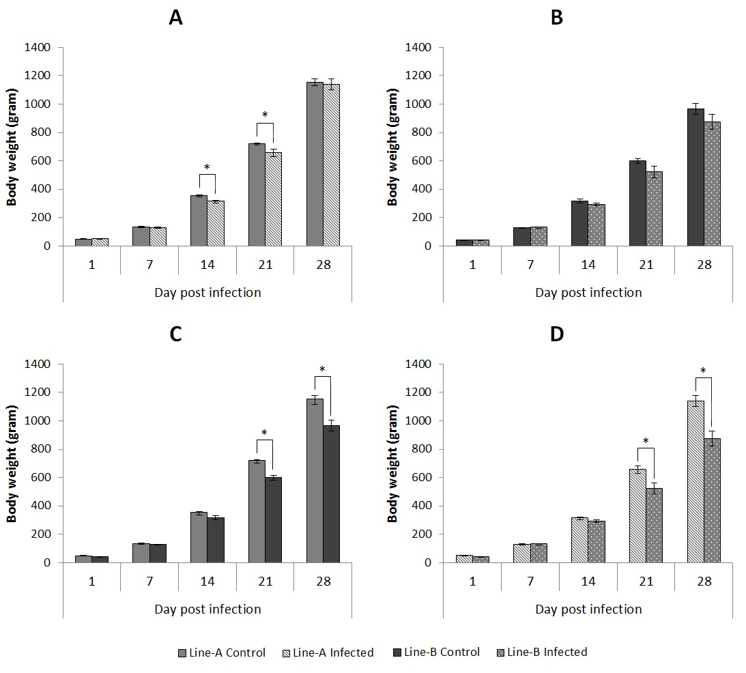

Figure 2. Viral RNA load in the trachea, kidney and proventriculus from infected groups of Line-A and Line-B. Data is expressed as the mean log relative equivalent units (REU) of RNA, with standard error margins. Significant differences between sampling days with positive samples are indicated with different letters.

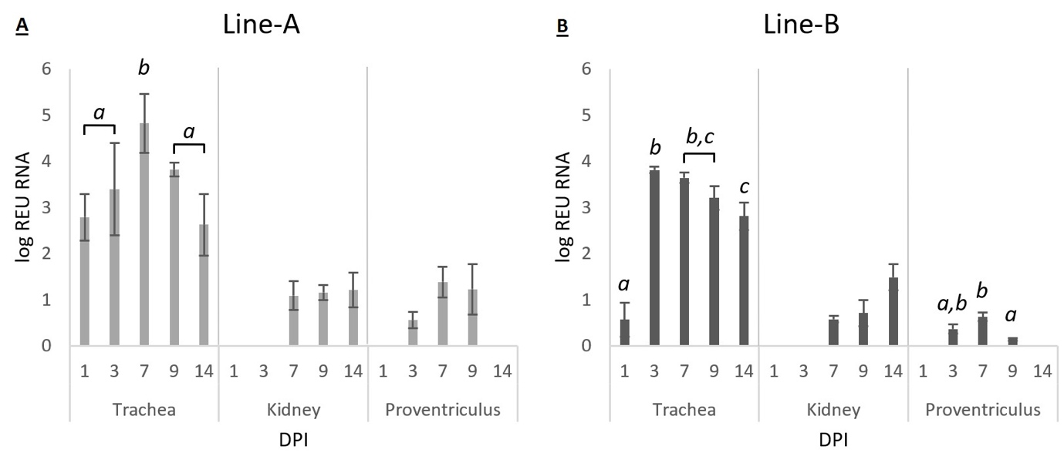

Figure 3. Mean infectious bronchitis virus (IBV)-specific ELISA antibody titres of the control and Q1-infected chicks (n=8/group) at 0, 7, 14, 21 and 28 days-old. The mean (n=10/group) titre of maternal derived antibodies of IBV at day-old (prior to infection) is indicated. Data are expressed as mean values ± SEM. The ELISA cut-off (396) is indicated with a dashed line.

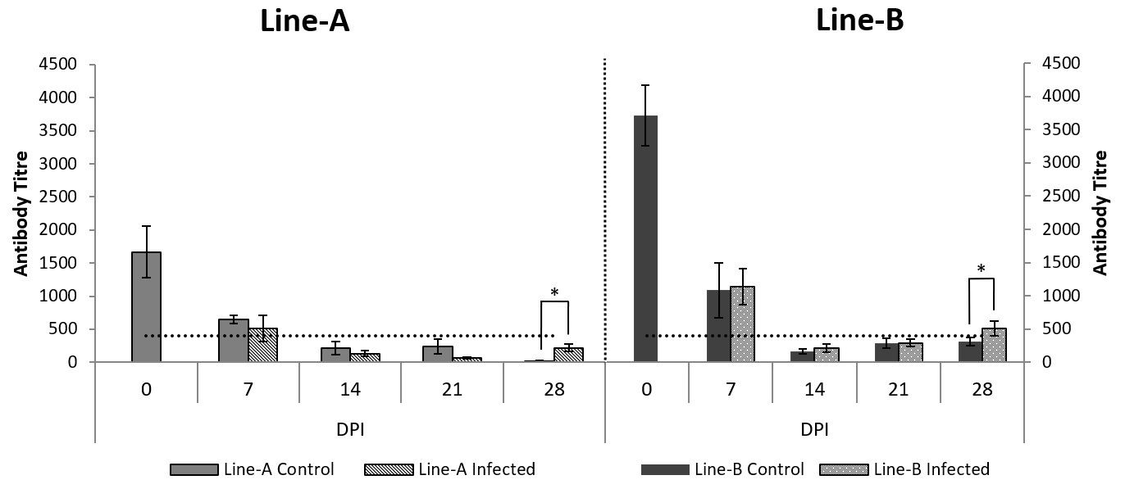

Figure 4. Relative mRNA expression in tracheal and kidney tissue for Line-A and Line-B following infection with IBV Q1. Data is normalised against 18S values, and represented as the significant (p<0.05) average fold change in mRNA expression compared to the corresponding control groups. Colour change is based on a linear scale between -5 and 70. Non-significant data is not shown.

