Aerosol formation due to a dental procedure: insights leading to the transmission of diseases

Parisa Mirbod¹∗, Eileen A. Haffner¹, Maryam Bagheri¹, Jonathan E. Higham³
¹Department of Mechanical and Industrial Engineering, University of Illinois at Chicago,
842 W. Taylor Street, Chicago, IL, 60607, USA
²College of Dentistry Department of Oral Biology, University of Illinois at Chicago,
842 W. Taylor Street, Chicago, IL, 60607, USA
³School of Environmental Sciences, University of Liverpool, Liverpool, UK
* Paste corresponding author name(s) here.
Email: pmirbod@uic.edu
Keywords
Aerosol formation, droplet velocity, dental procedures, transmission of diseases

Author Contributions
P.M. designed the research; E.H., M.B., and J.H. performed the research; P.M. and J.H. analyzed the data; and P.M., E.H., and J.H. wrote the paper.
This PDF file includes:
Main Text
Figures 1 to 7
Tables 1
Abstract
As a result of the outbreak and diffusion of SARS-CoV-2, there has been a directive to improve medical working conditions. In dentistry, airborne particles are produced through aerosolization facilitated by ultrasonic dental instruments. To develop methods for reducing risks of infection in confined environments, understanding the nature and dynamics of these droplets is imperative and timely. This study provides the first evidence of aerosol formation from an ultrasonic scalar under simulated oral conditions. State-of-the-art optical flow tracking velocimetry and shadowgraphy measurements are employed to study the velocity and trajectories of droplets produced during a dental scaling process and to provide information on the generated droplet size. We observe that as the scalar is turned on, a large droplet is first formed near the scalar tip that then bursts into numerous smaller droplets with distributions of sizes and velocities. While the droplet sizes are found to vary from 5 μm to 300 μm, approximately 90% of the droplets appear to vary between average diameters of 12.5 μm and 68.5 μm; these correspond to droplet nuclei that could carry viruses. The droplet velocities also vary between 0.7 m/s and 1.3 m/s, with most of them moving at approximately 1 m/s. These observations confirm the critical role of aerosols in the transmission of disease during dental procedures, which is invaluable knowledge for developing protocols and procedures to ensure the safety of both dentists and patients.
Significance Statement
To characterize the velocities and trajectories of droplets produced during dental scaling and to provide deeper insights into the generated droplet sizes, we employed state-of-the-art optical flow tracking velocimetry and shadowgraphy measurements. While the droplet sizes were found to vary from 5 μm to 300 μm, approximately 90% of the droplets appeared to vary between average diameters of 12.5 μm and 68.5 μm; these correspond to droplet nuclei that could carry viruses. These observations confirm the critical role of aerosols in the transmission of disease during dental procedures, which is invaluable knowledge for developing protocols and procedures to ensure the safety of both dentists and patients.

Main Text

Introduction

A global pandemic emerging from a novel strain of severe acute respiratory syndrome coronavirus 2 (SARS-CoV-2), namely, COVID-19, has ravaged the world throughout 2020. This human-to-human disease is spread by either blood or saliva droplets entrained into aerosols by coughing, sneezing or other means. While the use of face coverings and face shields might reduce transmission in public and general day-to-day life, in professions such as dentistry, the transmission of bodily fluids is almost unavoidable (1-3). Such transmissions have been well documented; accordingly, the Dental Research Journal and the United States Department of Labor have assessed dentistry as one of the most hazardous occupations with a high risk of exposure to infections such as COVID-19 (4, 5).
The arsenal of a typical dentist comprises a variety of high-speed drilling, cleaning and scaling instruments. These instruments utilize water and compressed air that combine with saliva and even blood, creating aerosols that potentially carry viral particles (6). Ideally, during a global pandemic, all dentistry employing aerosol-producing tools would cease, but in reality, this is simply not feasible, as a lack of treatment can also pose risks; for example, a dental abscess caused by a small infection can lead to sepsis and even death (7). In a recent report, the WHO acknowledged the need for dental work to continue and highlighted that this necessitates the use of aerosol-producing tools (8, 9). Most worryingly, in the context of an airborne virus, previous dental studies (10, 11) have shown that aerosols created by dental devices contain droplets so small that they can stay airborne for extended periods and that these aerosols contain large distributions of droplet sizes. On average, these particles have been found to feature diameters of 50 µm and <10 µm, which can penetrate deep into the respiratory system (12, 13). These droplet distributions also contain diameters >50 µm; unfortunately, these droplets “splatter” and pose significant transmission risks (14-16). Moreover, particles that splatter and land on surfaces are prone to further evaporation and delayed entrainment of the virus into the air (13). However, these aerosol transmission mechanisms are not exclusive to COVID-19; they also apply to viruses such as influenza, human immunodeficiency virus (HIV), and even future novel viruses (16,17). To understand the transmission of the virus, we first need to understand the dynamics of the aerosol surrogate, based upon which it will be possible for dental procedures to be modified and developed to mitigate or minimize transmission.
In this study, we use state-of-the-art experimental fluid mechanics tools, namely, optical flow tracking velocimetry (OFV) and shadowgraphy, to investigate the original formation of droplets created by a Cavitron Ultrasonic Scaler (CUS) during the scaling process. Several researchers have previously examined the sizes of droplets using various methods during sneezing, coughing, talking, and breathing (18-27). However, little information is available in terms of both the size and the velocity of the droplet nuclei that are produced using the implementation of dental instruments. While two previous studies have used visualization techniques to make such estimations (28), to the best of our knowledge, our study is the first of its kind to investigate droplet nuclei in such detail using quantitative methods. The data obtained in this work have the potential to be used as guidance to further model how airborne particles are transported into the environment and the human respiratory system and to advance our understanding of how aerosols are transmitted in dental clinics/offices, health care centers, and hospitals.

Results
In this study, we investigate the aerosols produced by a CUS manufactured by DENTSPLY International, PA, USA. We simulate a patient’s mouth by using a life-size mannequin with a full set of teeth. The CUS comes with different scalar tips designed for use on different areas of the patient’s teeth. A Slimline SLI 10L 30K ultrasonic insert was fitted onto the CUS to study the effect of the spray on the front teeth of the patient. As in routine dental practice, the tip of the Slimline was placed perpendicular to the front lower teeth pointing towards the gum line (see Fig. 1) and remained in the same position for all of the experiments. The CUS was connected to a standard water tap (20 psi to 40 psi) within the laboratory. In the experiments, we set the flow rate to 29.5 ml/min, a typical flow rate used in practice.
3.1. Global droplet velocity contours
Fig. 2 shows the global velocity components (U, V, and magnitude) for the planes both parallel and perpendicular to the teeth, i.e., planes P₁ and P₂, respectively, obtained from OFV. Figs. 2(a, d) demonstrate that the maximum U velocity of 1.5 m/s occurs near the tip of the CUS close to the front teeth, while it is reduced far from the tip. The mean V velocity is the lowest at 0.2 m/s compared with the mean maximum velocity (2.5 m/s) of the magnitude velocity profile as can be seen in Fig. 2(b,c,e,f). The spray breaks up at a distance of approximately 10 mm from the teeth, where the magnitude of the velocity almost disappears. The splatter attains a cone shape before breaking up farther from the tip; at the breakup location, the cone disintegrates into droplets and aerosols with reduced velocities. The continuous breakup of droplets into smaller sizes and aerosols is apparent farther from the teeth. Furthermore, a myriad of other droplets is detected due to the ejection of the water from the CUS device.
The temporal evolution of close-up snapshots of the splatter velocity magnitude at various times for the (a,b,c) P₁ plane and (d,e,f) P₂ plane are presented in Fig. 3. Here, the duration of the CUS operation is approximately 100 ms. Our experiments reveal that first, a large droplet is produced at the tip of the CUS with a diameter of approximately 330 µm, as observed in Fig. 4(a); however, this large droplet bursts, on average, after 57 ms, generating a huge number of droplets of various sizes. A sequence of splatter formation at (a) 0.04 s, (b) 0.08 s, and (c) 0.12 s during the CUS operation can be observed in Figs. 4(a,b,c). It should be noted that the size of this large droplet depends on the flow rate (i.e., the setting at which the CUS is operated). The droplet trajectories representing 20% of the detected droplets for both the P₁ and the P₂ planes acquired using OFV are also shown in Fig. 5. The color bars represent the individual droplets’ velocity magnitude, which varies in the field of view. The maximum speed of the droplets is approximately 1.3 m/s, and most of the droplets are large enough to settle down quickly. We even observed droplets approximately 9 mm from the CUS tip; these droplets are either very small in size or evaporate rapidly, producing droplet nuclei. These droplets could be responsible for the transmission of viruses to the respiratory system.
To further characterize the droplet size distribution produced after the breakup of the largest droplet, we employed the shadowgraphy technique. As shown in Fig. 6(a,b), we measured droplet sizes ranging from 5 μm to 300 μm with a maximum observed speed of 1.4 m/s. It should be noted that the size and velocity distributions of the individual droplets depend strongly on the flow rate at which CUS device operates. In addition, the person’s mouth and the particular tooth targeted by the CUS might affect this distribution. While the size distribution of respiratory droplets has been the subject of a number of studies (e.g., (18)), with increasing focus on improving the measurement precision in the small submicron range (e.g., (22), (24), (25)), to the best of the author’s knowledge, the size and velocity distributions of the droplets produced using the CUS have not been considered heretofore. Generally, it is assumed that smaller droplets and particles penetrate the respiratory tract and reach deeper target tissues within the lungs. Experiments on animals using respiratory pathogens and solid particles suggest that inhalation of an atomized solution increases the infection and death rates compared with direct intranasal inoculation (e.g., (29), (30)). Our results confirm that small droplet sizes are indeed produced during dental procedures, including those involving a CUS; thus, new protocols must be considered in dental clinics/offices, health care centers, and hospitals.
Moreover, we compared our experimentally obtained data with the Rosin-Rammler equation (34). The Rosin-Rammler size distribution is a well-known distribution function and a convenient representation of the droplet size distribution for liquid sprays. This distribution is used in a broad array of applications ranging from bioproduct development (31) to the breakup of liquid droplets (e.g., in spray technology (32)) and aerosol science (33). The Rosin-Rammler distribution function assumes that an exponential relationship exists between the droplet diameter d_{p}, and the mass fraction of droplets with a diameter greater than d_{p} can be defined as $Y_{d}=e^{-{(d/\overline{d})}^{n}}$, where $\overline{d}$ is the size constant (mean diameter) and n is the size distribution parameter (spread parameter). Our results show very good agreement with the mathematical model proposed by the Rosin-Rammler size distribution. In particular, this technique of fitting the Rosin-Rammler curve to spray data can be employed to report the droplets diameter and spread parameter and further to computationally model how droplets are transmitted to the environment, including dental clinics/offices.
To generalize the problem and to characterize the breakup of the fluid in more detail, we also examined some dimensionless parameters, for which we measured the characteristic length to be the CUS tip diameter, $d=635$ µm. We defined the Reynolds number as $Re={u_{o}ρ_{f}d}/{μ_{f}}$, where $u_{o}$ is the initial velocity as it leaves the tip of the device, which was determined from the flow rate, and $ρ_{f}$ and $μ_{f}$ are the density and the viscosity of the fluid, respectively. Water is considered in this study to be at room temperature (20°C), where $ρ_{f}=0.998 \frac{g}{cm^{3}}$ and $μ_{f}=0.001 Pa.s$. The Weber number can then be defined as $We={ρ_{f}u_{o}^{2}d}/σ$, where $σ$ is the surface tension of water (35) and the resulting Ohnesorge number is $Oh={μ_{f}}/{\sqrt{ρ_{f}dσ}}={\sqrt{We}}/{Re}$ (26). To calculate the Stokes number, which is responsible for the settling of droplets, the relaxation time (which depends on the average droplet diameter) needs to be determined first. The relaxation time is reported as ${\overline{τ}}_{o}={ρ_{f}{\overline{d}}_{p}^{2}}/{18μ_{g}}$, where $μ_{g}=1.82x{10}^{-5} Pa.s$ is the viscosity of the surrounding gas (air in this study) and the average droplet diameter ${\overline{d}}_{p}^{2}$ can be determined using shadowgraphy. The Stokes number can then be defined as $St={{\overline{τ}}_{o}u_{o}}/d$ (36). Table 1 reports the resulting dimensionless parameters of the current study. For comparison, the values computed for coughing and sneezing are also shown in Table 1. Comparing the dimensionless parameters from our experiments to those produced by coughing and sneezing confirms that our reported values are much lower than the values associated with coughing/sneezing (26, 35-38). This is because the flow rate in which the CUS operates is much lower resulting in a laminar flow regime compared to the coughing/sneezing where the flow is turbulent; therefore, the related values would be higher.

Discussion

With the increasing emphasis on the airborne transmission of viruses, there is an urgent need to understand the mechanisms responsible for aerosol generation as well as the sites of origin within the respiratory tract and the proximity of those sites to regions of active infection, particularly dental clinics. While it is believed that respiratory infections can be spread via “contact” with droplets from expiratory activities such as talking, coughing and sneezing and from aerosol-generating clinical procedures, little studies performed to quantitatively analyze the droplets produced by dental devices using state-of-the-art fluid mechanics techniques. Dental devices, in general, use water in combination with compressed air for coolant and spraying, which generates aerosols. It is critical to characterize the sizes of these droplets, as the size predominately determines the times aerosols can remain airborne; thus, the possibility of infectious diseases to spread leading to strategies for controlling infections. In this study, we performed the very first analysis of the size and velocity distributions of the droplet nuclei produced by a CUS in a setting common to dental clinics. We measured the flow rate of the CUS using a plastic bag and an electronic balance with a high precision; we characterized our analysis based on a flow rate of 29.5 ml/min, which is typical in dentistry operations. We carried out a series of experiments using state-of-the-art techniques, namely, OFV and shadowgraphy. We applied OFV to measure the global velocity of the droplets and utilized shadowgraphy to measure the number, size, shape, and speed of individual droplets produced by the CUS. Specifically, the experiments in this study were carried out on the front teeth, where we found the maximum number of droplets and occurrences of splatter moving out of the mouth. Depending on the flow rate, the droplet sizes ranged from 5 μm to 500 μm. As the flow rate increased, smaller droplets were produced, and their velocity decreased.

We also computed some dimensionless numbers, including the Reynolds and Stokes numbers, to further examine the transmission of droplets. In general, at low Reynolds numbers, similar to the findings of this study, the Stokes settling speed of a droplet in an ambient gas phase is proportional to its surface area, which decreases with time due to evaporation. The role of airborne transmission in respiratory disease was first examined by Wells (30, 39), who compared the complete evaporation time to the settling time of different droplets with diameters ranging from 1 to 1000 μm. He found that droplets with diameters of d>100 μm settle to the ground in less than 1 s without significant evaporation, whereas droplets with d < 100 μm will typically become droplet nuclei before settling (30). Droplets with d < 5–10 μm rapidly evolve into droplet nuclei with settling speeds of less than 3 mm/s; these droplets may become suspended and advected by a cloud of air emitted by the environment or resuspended by any ambient flow that may arise, for example, through air conditioning. Our experiments were performed at a relative humidity of 25% and a temperature of 20°C; therefore, one expects that the droplets would evaporate in a few seconds. We estimated that for a 2 µm droplet size, the evaporation time is approximately 1 ms (40). These suspended droplet nuclei are expected to be critical elements in long-range airborne transmission; e.g., these nuclei could be inhaled by others, thereby stimulating new SARS-CoV-2 infections.

The splatters and droplets formed by the CUS are generally composed of suspended droplets of varying sizes and of the surrounding atmosphere, which is hot/cold and moist. These splatters and droplets also contain saliva and blood, which may change our results. Nonetheless, the data obtained in this work are timely and can serve as guidance to further model the transmission of airborne particle to humans and to advance our understanding of how aerosols are transmitted in dental clinics/offices, health care centers, and hospitals. These experiments can be used not only for COVID-19, which has the potential to spread through droplets and aerosols from infected individuals, but also for other viruses, including HIV, hepatitis B, and influenza, all of which are possible hazards that a dental worker or patient can encounter in a dental clinic.

Materials and Methods (Experimental Procedure)

For our quantitative measurements, we used two tools commonly utilized in fluid mechanics: a) to determine the velocity fields and Lagrangian paths of droplets, we used optical flow tracking velocimetry (OFV), and b) to determine the size of individual droplets, shadowgraphy was employed.
2.1. Optical flow tracking velocimetry
OFV is a commonly used method in fluid mechanics (41-45). This method is used to determine the motion of features from a set of high-speed videos. In our case, we used OFV to track individual droplets created by the Cavitron Select SPS Ultrasonic Scaler (CUS); however, the aerosol plume created by the CUS is fully three-dimensional (3D). Using a 1 mm laser sheet created by a 527 nm Nd-YLF (Photonics Industries, DM20-527) laser, we were able to illuminate a single plane inside of the aerosol, providing us with a two-dimensional (2D) slice. Using a high-speed camera (Phantom) equipped with a Nikon lens with a focal length of 60 mm, we were further able to capture the reflections from the water droplets. We considered two different planes, P₁ and P₂, as shown in Fig. 1(a,b). One plane, P₁, is parallel to the tip of the CUS, and the other plane, P₂, is perpendicular to the tip. In each case, to ensure that the mean velocities were fully resolved, 3000 images were collected resolving more than 100 integral time scales.
The OFV method is based on solving sets of linear equations (i.e., the optical flow equations), reducing the computational complexity. There are two primary steps involved in OFV: the first step is determining the features to track, and the second step is tracking them across frames. In this work, we employed the commercial code known as FlowOnTheGo. FlowOnTheGo uses eigenfeatures to determine “features” from the image gradients. These eigenfeatures are determined by first constructing a correlation matrix defined as
$M = \left[\begin{matrix}Ψ_{x}^{2} & Ψ_{x}Ψ_{y} \\ Ψ_{y}Ψ_{x} & Ψ_{y}^{2}\end{matrix}\right],$ (1)
where $Ψ(x,y;t)$ is the pixel intensity and $Ψ_{x}$ and $Ψ_{y}$ are the intensity gradients in the x- and y-directions, respectively. Gradients are computed from a smoothed field using a Gaussian kernel with a width of five pixels. A response value, R, is taken as the minimum of the two eigenvalues of the correlation matrix given by
$R = min\left[λ_{1},λ_{2}\right],$ (2)
where
$det\left[M-λI\right]=0.$ (3)
In FlowOnTheGo, $λ_{i}$ features are defined as regions with R > 0.01. The displacements of features are calculated based on the assumption that the spatial displacements between frames are sufficiently small such that $Ψ\left(x,y;t\right)$ can be expressed as
$Ψ\left(x,y;t\right)= Ψ\left(x+δx, y+δy;t+δt\right).$ (4)
Following a Taylor expansion, the above equation can then be rearranged to give the optical flow equation as
$Ψ_{t} + uΨ_{x} + vΨ_{x} ≅0$, (5)
where $Ψ_{t}$ is the partial derivative of the pixel intensity with respect to time between image pairs and $u$ and $v$ are the velocities in the x- and y-directions, respectively. The optical flow equation is an underdetermined equation with two unknowns, $u$ and $v$. A variety of methods can be used to resolve this challenge. The Lucas-Kanade solution method (43, 44) is applied to solve the optical flow equations in FlowOnTheGo. The Lucas-Kanade approach assumes that the velocity gradients are relatively small; i.e., the velocity at one location is the same as that at its neighbors. Then, a system of optical flow equations can be constructed for each feature as
$uΨ_{x}\left(x+i,y+j\right)+ vΨ_{y}\left(x+i,y+j\right)= -Ψ_{t}\left(x+i,y+j\right),$(6)
where i and j define the neighborhood around the feature at pixel x, y. In our application, we used a neighborhood of 11; i.e., i and j ranged from -5 to +5. This setting allowed us to solve the equation using a least square method and determine $u$ and $v$ as follows:
$\left[\begin{matrix}u \\ v\end{matrix}\right] ={\left[\begin{matrix}\sum_{i,j}{Ψ_{x}^{2}} & \sum_{i,j}{Ψ_{x}Ψ_{y}} \\ \sum_{i,j}{Ψ_{y}Ψ_{x}} & \sum_{i,j}{Ψ_{y}^{2}}\end{matrix}\right]}^{-1}\left[\begin{matrix}\sum_{i,j}{Ψ_{x}Ψ_{t}} \\ \sum_{i,j}{Ψ_{y}Ψ_{t}}\end{matrix}\right]$(7)
Once $u$ and $v$ have been located, we can use these to construct Lagrangian streamlines; alternatively, we can use a gridded interpolator to create a velocity field and scale the fields using a calibration plate (46).
2.2 Shadowgraphy and particle identification
Shadowgraphy is a well-used technique in fluid mechanics that allows us to quantitively visualize small droplets using simple optics (45). To create these visualizations, we used a high magnification and backlight illumination (Fig. 7). The measurement plane is defined by the camera depth of focus in the focal plane. In our setup, we used a Navitar zoom lens (Thorlabs, Inc.) attached to the high-speed Phantom camera set to an exposure rate of 20 µs. This allowed us to zoom into a small region (~100 µm thick) to accurately measure the size of small droplets on the order of 5 µm (see Fig. 7). From the raw images, we used an in-house detection code to determine the size and location of each droplet. The code works by first binarizing the raw image based on an adaptive threshold. Using an adaptive Hough transform (47), we then determined circular regions, i.e., droplets, and defined the velocity of the droplets using OFV. However, instead of using the eigenfeatures for droplet detection, we employed the centroids determined by the Hough transform.

Acknowledgments

This work was funded by the University of Illinois at Chicago – College of Dentistry.

References

1. Peng X, et al. (2020) Transmission routes of 2019-nCoV and controls in dental practice. International Journal of Oral Science 12(1):1-6.
2. Wei J & Li Y (2016) Airborne spread of infectious agents in the indoor environment. American journal of infection control 44(9):S102-S108.
3. Volgenant CM, Persoon IF, de Ruijter RA, & de Soet J (2020) Infection control in dental health care during and after the SARS‐CoV‐2 outbreak. Oral Diseases.
4. Ayatollahi J, et al. (2012) Occupational hazards to dental staff. Dental research journal 9(1):2.
5. Administration OSaH (2020) U.S. Department of Labor issues alert to help keep dental industry practitioners safe during the coronavirus pandemic.
6. Cleveland JL, et al. (2016) Transmission of blood-borne pathogens in US dental health care settings: 2016 update. The Journal of the American Dental Association 147(9):729-738.
7. Shweta S (2013) Dental abscess: A microbiological review. Dental Research Journal 10(5):585.
8. CDC (Best Practices for Environmental Cleaning in Healthcare Facilities in Resource-Limited Settings.
9. Organization WH (Decontamination and Reprocessing of Medical Devices for Health-care Facilities.
10. Bennett A, et al. (2000) Microbial aerosols in general dental practice. British dental journal 189(12):664-667.
11. Nikitin N, Petrova E, Trifonova E, & Karpova O (2014) Influenza virus aerosols in the air and their infectiousness. Advances in virology 2014.
12. Micik RE, Miller RL, Mazzarella MA, & Ryge G (1969) Studies on dental aerobiology: I. Bacterial aerosols generated during dental procedures. Journal of dental research 48(1):49-56.
13. Harrel SK & Molinari J (2004) Aerosols and splatter in dentistry: a brief review of the literature and infection control implications. The Journal of the American Dental Association 135(4):429-437.
14. Hinds WC (1999) Aerosol technology: properties, behavior, and measurement of airborne particles (John Wiley & Sons).
15. Cottone JA, Terezhalmy GT, & Molinari JA (1991) Practical infection control in dentistry (Lea & Febiger).
16. Monaghan N (2016) Emerging infections–implications for dental care. British dental journal 221(1):13-15.
17. Smales F & Samaranyake L (2003) Maintaining dental education and specialist dental care during an outbreak of a new coronavirus infection. Part 1: A deadly viral epidemic begins. British dental journal 195(10):557-561.
18. Duguid J (1946) The size and the duration of air-carriage of respiratory droplets and droplet-nuclei. Epidemiology & Infection 44(6):471-479.
19. Loudon RG & Roberts RM (1967) Droplet expulsion from the respiratory tract. American Review of Respiratory Disease 95(3):435-442.
20. Papineni RS & Rosenthal FS (1997) The size distribution of droplets in the exhaled breath of healthy human subjects. Journal of Aerosol Medicine 10(2):105-116.
21. Nicas M, Nazaroff WW, & Hubbard A (2005) Toward understanding the risk of secondary airborne infection: emission of respirable pathogens. Journal of occupational and environmental hygiene 2(3):143-154.
22. Johnson G, et al. (2011) Modality of human expired aerosol size distributions. Journal of Aerosol Science 42(12):839-851.
23. Yang S, Lee GW, Chen C-M, Wu C-C, & Yu K-P (2007) The size and concentration of droplets generated by coughing in human subjects. Journal of Aerosol Medicine 20(4):484-494.
24. Morawska L, et al. (2009) Size distribution and sites of origin of droplets expelled from the human respiratory tract during expiratory activities. Journal of Aerosol Science 40(3):256-269.
25. Zayas G, et al. (2012) Cough aerosol in healthy participants: fundamental knowledge to optimize droplet-spread infectious respiratory disease management. BMC pulmonary medicine 12(1):1-12.
26. Scharfman B, Techet A, Bush J, & Bourouiba L (2016) Visualization of sneeze ejecta: steps of fluid fragmentation leading to respiratory droplets. Experiments in Fluids 57(2):24.
27. Bahl P, et al. (2020) Airborne or droplet precautions for health workers treating COVID-19? The Journal of infectious diseases.
28. Bentley CD, Burkhart NW, & Crawford JJ (1994) Evaluating spatter and aerosol contamination during dental procedures. Journal of the American Dental Association (1939) 125(5):579.
29. Sonkin LS (1951) The role of particle size in experimental air-borne infection. American journal of hygiene 53(3):337-354.
30. Wells WF (1955) Airborne Contagion and Air Hygiene. An Ecological Study of Droplet Infections. Airborne Contagion and Air Hygiene. An Ecological Study of Droplet Infections.
31. Varga E, Titchener‐Hooker N, & Dunnill P (2001) Prediction of the pilot‐scale recovery of a recombinant yeast enzyme using integrated models. Biotechnology and bioengineering 74(2):96-107.
32. Lefebvre AH & McDonell VG (2017) Atomization and sprays (CRC press).
33. Dunbar CA & Hickey AJ (2000) Evaluation of probability density functions to approximate particle size distributions of representative pharmaceutical aerosols. Journal of aerosol science 31(7):813-831.
34. Rosin P (1933) Laws governing the fineness of powdered coal. Journal of Institute of Fuel 7:29-36.
35. Zigan L, Schmitz I, Wensing M, & Leipertz A (2012) Reynolds number effects on atomization and cyclic spray fluctuations under gasoline direct injection conditions. Fuel Systems for IC Engines, (Elsevier), pp 253-263.
36. van der Voort DD, Dam NJ, Clercx HJ, & Van De Water W (2018) Characterization of spray-induced turbulence using fluorescence PIV. Experiments in Fluids 59(7):110.
37. Gupta J, Lin CH, & Chen Q (2009) Flow dynamics and characterization of a cough. Indoor air 19(6):517-525.
38. Bourouiba L, Dehandschoewercker E, & Bush JW (2014) Violent expiratory events: on coughing and sneezing. Journal of Fluid Mechanics 745:537-563.
39. Wells WF (1934) ON AIR-BORNE INFECTION: STUDY II. DROPLETS AND DROPLET NUCLEI. American journal of Epidemiology 20(3):611-618.
40. Sirignano WA (2010) Fluid dynamics and transport of droplets and sprays (Cambridge university press).
41. Fullmer WD, et al. (2020) Comparison of velocimetry methods for horizontal air jets in a semicircular fluidized bed of Geldart Group D particles. Powder Technology 359:323-330.
42. Mella D, Brevis W, Higham J, Racic V, & Susmel L (2019) Image-based tracking technique assessment and application to a fluid–structure interaction experiment. Proceedings of the Institution of Mechanical Engineers, Part C: Journal of Mechanical Engineering Science 233(16):5724-5734.
43. Lucas BD & Kanade T (1981) An iterative image registration technique with an application to stereo vision.
44. Lucas BD & Kanade T (1985) Optical Navigation by the Method of Differences. IJCAI, (Citeseer), pp 981-984.
45. Settles GS (2012) Schlieren and shadowgraph techniques: visualizing phenomena in transparent media (Springer Science & Business Media).
46. Higham J & Brevis W (2019) When, what and how image transformation techniques should be used to reduce error in Particle Image Velocimetry data? Flow Measurement and Instrumentation 66:79-85.
47. Illingworth J & Kittler J (1987) The adaptive Hough transform. IEEE Transactions on Pattern Analysis and Machine Intelligence (5):690-698.

Figures and Tables

Fig. 1. Experimental procedures to detect aerosol formation by a Cavitron Ultrasonic Scaler (CUS). (a) Setup schematic for the optical flow tracking velocimetry (OFV) technique to detect the droplet velocity and lagrangian path. Examples of the raw OFV images in the (b) P₁ plane and (c) P₂ plane recorded with a high-speed camera at 7.6 kHz.

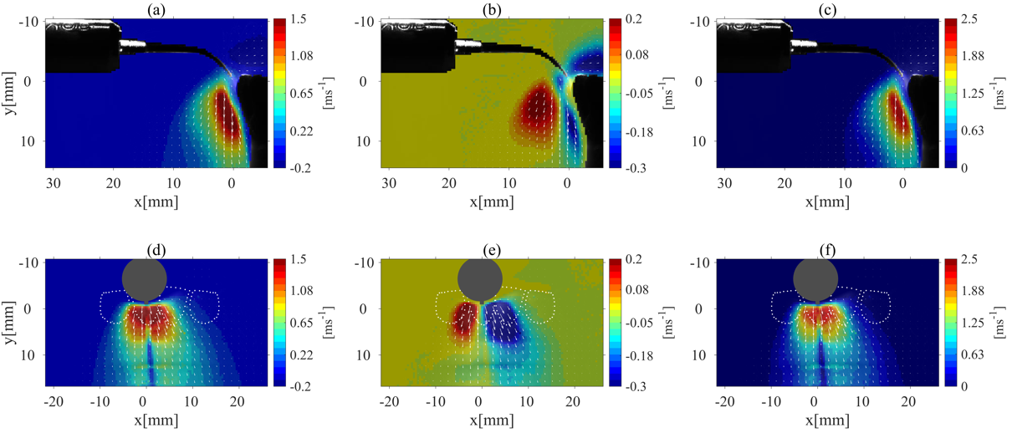
Fig. 2. The mean field of the (a) $U$ velocity component, (b) $V$ velocity component, and (c) velocity magnitude for the plane parallel to the CUS tip, P₁, and the (d) $U$ velocity component, (e) $V$ velocity component, and (f) velocity magnitude for the plane perpendicular to the CUS tip, P₂. The white arrows in the figures specify the velocity vectors.

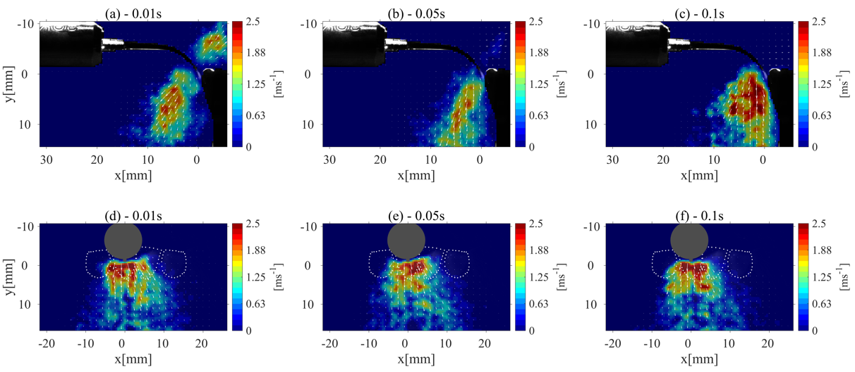
Fig. 3. Temporal evolution of the velocity magnitude of the splatter for the P₁ plane at (a) 0.01 s, (b) 0.05 s, and (c) 0.1 s and for the P₂ plane at (d) 0.01 s, (e) 0.05 s, and (f) 0.1 s. The white arrows in the figures specify the velocity vectors

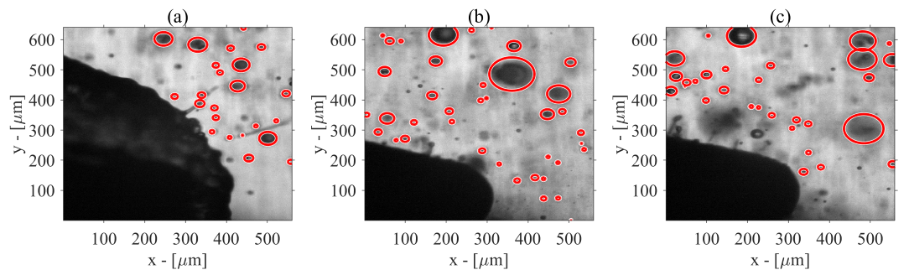
Fig. 4. Sequences of splatter formation at (a) 0.04 s, (b) 0.08 s, and (c) 0.12 s. Image samples were recorded using a high-speed camera at 7.6 kHz and two halogen backlights.
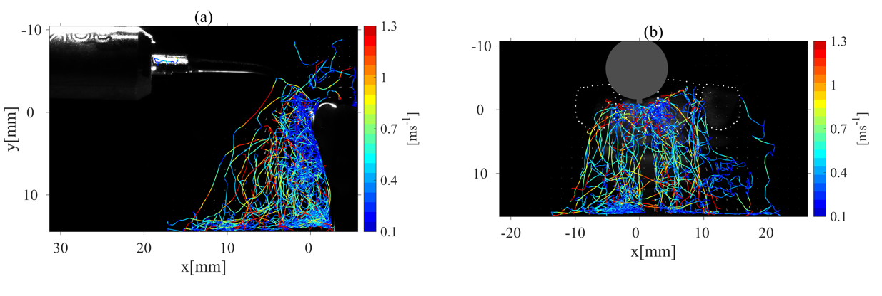
Fig. 5. Droplet trajectories representing 20% of the detected droplets for the (a) P₁ plane and the (b) P₂ plane.

(c)
Fig. 6. (a) Histogram of the droplet size distribution, (b) the velocity distribution of the droplets, and (c) the Rosin-Rammler curve fitted for our obtained experimental droplet size data with a 29.5 ml/min flow rate.
Fig. 7. (a) Schematic of the experimental setup of backlight illumination for the shadowgraphy technique. (b) An example of backlight illumination at 0.08 s recorded using a high-speed camera at 7.6 kHz and two halogen backlights.
Table 1. The experimental parameters for the different tests conducted at 20°C. The dimensionless parameters remained constant throughout all experiments. The second row represents the values reported for coughing and sneezing.
 | Flow rate (ml/min) | $$u_{o}$$  (cm/s) | $$Re$$ |  | $$We$$ | $$Oh$$ |  | $${\overline{τ}}_{o}$$ | St
Aerosol formation by the CUS | 29.5 | 4.92 | 31.19 |  | 0.02 | 4.7x10⁻³ |  | 7.55x10⁻³ | 0.57
Coughing/ Sneezing | 9.6x10⁴- 5.1x10⁵ (37) | Coughing: 112 (37)  Sneezing: 220 | Coughing: 10⁴ (38)  Sneezing: 4x10⁴ (38) | Sneezing: 2.2 (26) |  |  | Sneezing<1 (26) | - | -

