The impact of female mating strategies on the success of insect control technologies
Andreas Sutter¹, Tom A. R. Price² & Nina Wedell^{3†}

¹ School of Biological Sciences, University of East Anglia, Norwich Research Park, NR4 7TJ Norwich, UK; a.sutter@uea.ac.uk
² Institute of Infection, Veterinary and Ecological Sciences, University of Liverpool, Liverpool, L69 7ZB, UK; t.price@liverpool.ac.uk
³Biosciences, University of Exeter, Penryn Campus, Penryn TR10 9FE, UK; n.wedell@exeter.ac.uk
† corresponding author: n.wedell@exeter.ac.uk

Highlights
- Insect control techniques are rapidly expanding, including novel genomic tools
- Many techniques target reproduction by releasing males with manipulated fertility
- Control is hampered if males have low mating and fertilisation success
- Females can respond behaviourally and evolutionarily to maintain reproductive fitness
- Considering mating ecology is important to improve a technique’s effectiveness

Abstract
Attempts to control insect pests and disease vectors have a long history. Recently, new technology has opened a whole new range of possible methods to suppress or transform natural populations. But it has also become clear that a better understanding of the ecology of targeted populations is needed. One key parameter is mating behaviour. Often modified males are released which need to successfully reproduce with females while competing with wild males. Insect control techniques can be affected by target species’ mating ecology, and conversely mating ecology is likely to evolve in response to manipulation attempts. A better understanding of (female) mating behaviour will help anticipate and overcome potential challenges, and thus make desirable outcomes more likely.

Targeting reproduction to control pest and vector populations
Insect pests and disease vectors cause huge economic costs [1], mortality in livestock and more human deaths than any other animals [2]. Not surprisingly then, the wish to control or eradicate insect pest populations has a long and diverse history. Many technologies for insect control involve direct attempts to kill targets with insecticides and natural enemies (e.g. on dengue [3]). An alternative (and often complimentary) strategy is to disrupt the reproduction of target populations. Early ideas included pheromone traps, the release of irradiation-sterilised males, disrupting reproduction by releasing closely related species leading to hybrid offspring mortality or sterility, and the introduction of desirable alleles into populations through the repeated release of individuals carrying these variants [4]. These techniques have largely involved releases of males, as adding males to a population rarely increases population size and stability [5]. The recent revolution in genome modification techniques has allowed the design of novel technologies to more effectively disrupt reproduction in a greater range of targets (e.g. [6,7]). Many of these techniques also focus on negative effects of males on female fitness, either disrupting male fertilisation of wild females to eliminate populations [8,9] or directly transforming the target population by using reproductive incompatibility to drive a tailored cargo of genes into wild populations [10,11] — for example making mosquitos unable to transmit dengue virus [12].
Many different technical and ecological aspects determine the success of pest and disease vector control attempts. In this review, we focus on one aspect, interactions between control strategies and mating ecology, particularly in the context of male release and female behaviour. Previous reviews have highlighted the value of considering mating ecology and incorporating research on reproductive behaviour into pest control [4,13,14], but these reviews largely predated recent technological advances. Here we focus on Dipterans, because the order has a long history of successful SIT (see [15] for a recent review), and practical advances in novel control technologies have disproportionately been developed in Drosophila for application in mosquitos. Applying novel technologies to non-dipteran targets may be more challenging. For example, key lepidopteran targets such as army worms, cactus moths, or winter moths may be hindered by less developed genomic tools and knowledge [16]. It will be exciting to see whether novel techniques can be developed for colonial organisms with long generation times like fire ants or hornets, or facultatively parthenogenetic species such as aphids.
Among the newer genetic technologies, initial attention focussed predominantly on mechanistic feasibility [17], and on whether genetic resistance at target loci would halt the spread and thwart effectiveness [18,19]. Recently, ideas and concepts from evolutionary ecology have increasingly been incorporated to improve insect release technologies (e.g. [5,20–24]) and combat pesticide resistance [25], which is key to developing a more long-term sustainable management strategy. Importantly, the mating ecology of a population can have dramatic impacts, not only on the initial responsiveness to release strategies [26], but also on long-term evolutionary responses. Manipulating the reproduction of a target population in many cases means getting individuals (i.e. females) to behave against their fitness interests, which will promote the evolution of resistance through changes in behaviour, physiology or anatomy. The greater the impact on reproduction, the stronger the selective pressure to evolve mitigation strategies. Thus, whether target populations can be eliminated or transformed is ultimately a question of whether and how quickly they evolve resistance in response to manipulation attempts. We therefore need a holistic approach that includes evolutionary strategies and is able to predict and mitigate likely resistance scenarios, to ensure effective, sustainable and safe deployment [5].

Male-release strategies that disrupt reproduction
Here, we briefly summarise the techniques used for population transformation and/or suppression in three broad categories: SIT and RIDL, IIT, and insects carrying novel genetic constructs, explained below (Fig 1).

- Sterile insect technique (SIT) and release of insects carrying dominant lethals (RIDL)
The traditional SIT typically works through the mass-release of radiation-sterilised insects, with males seeking out and mating with wild females, thus reducing their offspring production (Fig 1A). The SIT has been successfully deployed in numerous countries around the globe to suppress populations of screwworm flies, tephritid fruit flies, tsetse flies, onion flies, beetles, moths and mosquitos [4,15]. This technique has been shown to work best against low density target populations with large release numbers and a correspondingly high sterile male to wild male ratio. Given the labour intensity and the large infrastructural investments needed to create and irradiate millions or billions of insects (and sex-sort mosquitos for male-only releases), the traditional SIT is not accessible for economically less important pests. The sterility of males means that releases have to be repeated to suppress wild populations. RIDL updates SIT by releasing fertile males bearing dominant lethal alleles that in nature kill offspring during development [27]. If lethality occurs only in female offspring (fsRIDL), the dominant lethals can continue to spread through sons, reducing the need for repeated releases [20,28].

- Incompatible insect technology (IIT)
Endosymbionts are microorganisms living within the cells of their host. They are present in most insects and are predominantly vertically inherited from mother to offspring. Some endosymbionts manipulate host reproduction in a variety of ways to enhance their spread. Frequently, this involves inducing cytoplasmic incompatibility (CI) in which sperm from infected males kills zygotes when mating with uninfected females, thereby reducing the fitness of uninfected females (Fig 1B). The best-characterised endosymbiont is the bacterium Wolbachia, which has been enlisted as an agent to suppress vector and pest insect populations since the 1950s, predominantly in mosquito vectors [10,23]. Release of Wolbachia-infected males can suppress populations through severe reproductive incompatibilities. Bi-sex releases can spread Wolbachia through CI and effectively reduce virus transmission (e.g. dengue, zika) in mosquitoes [23]. However, Wolbachia can also have major impacts on insect mating biology (Fig 1; [29]).

- Sperm killing and sex ratio distorting gene drives
Segregation distorting gene drives are selfish genetic elements that manipulate gametogenesis, often killing a male’s non-carrying sperm, to enhance their own transmission (i.e. they “drive”; Fig 1C). While Wolbachia can generate drive by cytoplasmically-induced male sterility, most natural gene drives are segregation distorters that operate during gametogenesis. Sperm-killer drives frequently impair the fertility of carrier males [30], and some gene drives cause sex ratio distortion by targeting Y- or X-bearing sperm [31]. There is growing excitement about the recent development of a variety of different types of synthetic gene drivers (e.g. CRISPR-Cas9, homing endonucleases) to manage pest and vector populations, in particular malaria-transmitting mosquitoes (e.g. [32]). Some of these novel technologies specifically seek to disrupt female reproduction by inducing male sterility [8,9]. However, there are several obstacles to their successful implementation. Target organisms rapidly evolve resistance [18], and synthetic gene drives may invade non-target populations [33]. In addition, gene drives that compromise male fertility will impose strong selection on females to evolve mating strategies, such as increased mating frequency, that can undermine the success of drive-carrying males (e.g. [34]). One potential solution could be to modify existing natural gene drives, as these have proven themselves able to remain successful in natural populations over evolutionary timescales [35].

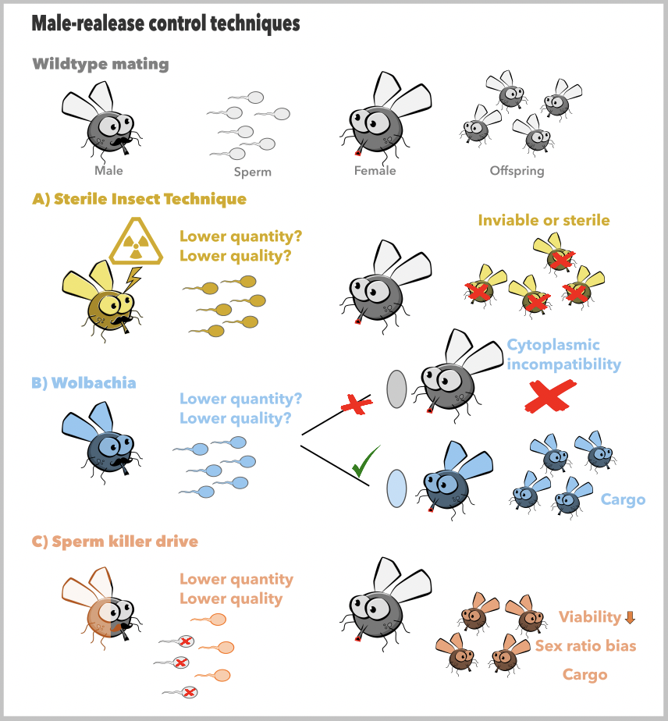
Figure 1: Three ways of manipulating reproduction of target insect populations through male release. A) Mass release of sterilised males or males with dominant lethal alleles that disrupt reproduction in females by rendering offspring inviable or sterile. Sterilisation of released males is typically achieved by irradiation-induced mutations and is often accompanied by a reduction in sperm quantity and/or quality [36]. Though not an intrinsic feature of the technique, insertion of genetically engineered dominant lethal mutations might also negatively affect sperm phenotypes [20]. B) Mass release of Wolbachia-carrying males which cause reproductive failure through cytoplasmic incompatibility (CI) with wildtype females, or bi-sex releases of insects carrying Wolbachia as a cargo (e.g. blocking virus transmission) that spreads due to CI. Wolbachia-encoded genes of viral origin modify sperm of infected males inducing CI and ensure rescue of infected females’ eggs, resulting in production of Wolbachia-infected offspring [37]. Sperm modification by Wolbachia can decrease male fertility [38,39] and reduce sperm competitive ability [40], the severity of which depends on male mating history and age [41]. C) Release of males with a sperm killer gene drive that spreads reduced viability, a biased sex ratio, or a genetic cargo through a population by distorting inheritance in heterozygous males. Sperm killing by default renders a large portion of a male’s spermatids or ejaculated sperm unfit for fertilisation, thus reducing ejaculate quantity and sometimes also quality [30].

Consequences for insect reproduction
- Impact on male reproductive success
No matter the intervention mechanism, what this diverse range of insect control attempts have in common is that, for a desirable outcome, the (male) carriers need to survive and mate in the target population, and the manipulation mechanism needs to work under field conditions (Fig 2). One commonality across the different intervention techniques discussed here is that they have the potential to reduce male fertility (Fig 1), which can have a large impact on female mating behaviour and the success of the technique. Mating with a sterilised male may not render females unresponsive to further mating attempts. The success of the SIT thus depends on the effects of sterilisation on sperm and seminal fluids, and on which of these ejaculate components female sexual receptivity responds to [36]. If females mate with multiple males, sperm competitiveness of sterilised males depends on whether sterilisation is achieved through elimination of sperm or through dominant lethal mutations in sperm. In polyandrous species, females that mate with a sterile male may remate rapidly [42]. Depending on the relative number of fertile males available, female remating can potentially maintain female fertility, and thus reduce or undermine the effectiveness of the SIT. Similarly, there is strong evidence that Wolbachia can reduce male fertility (e.g. flies [40], moths [39]) which may reduce the efficacy of Wolbachia for population control. Sperm killing and sex ratio distortion by gene drives can also have dramatic impacts on male fertility and female mating decisions, which has been shown in several taxa [29,30]. At times, severe sperm killing can reduce female fertility after mating with drive-carrying males, promoting increased mating frequency, which can be exacerbated under a female-biased sex ratio [43].
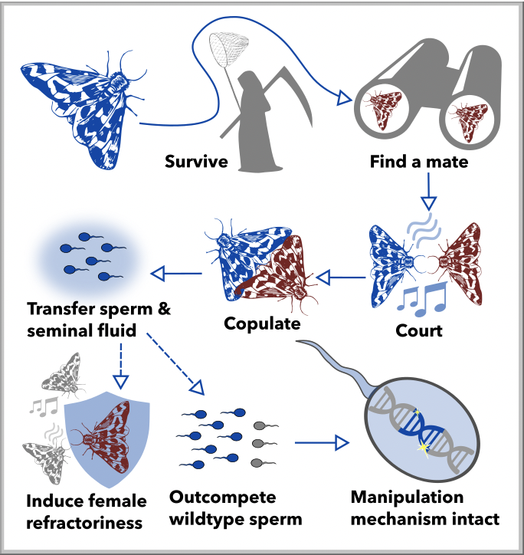
Figure 2: Released males need to survive in nature, find or attract a mate, successfully court, copulate and transfer an ejaculate. Mating success of released males can be reduced by the impact of mass-rearing [20], by using a genetic background that is not locally adapted [44], or by inadvertently linking the construct to an existing mate choice target that is unfavourable. For example, mass-rearing may relax selection on effective mate-searching, long-distance attraction and male attractiveness, or lead to excessive male aggression. It is also likely to alter the microbiota of the males [45], which can affect survival and attractiveness [46]. On the other hand, lab-rearing conditions could be optimised to create very attractive and successful males, such as by feeding supplements or managed breeding [15,20,47]. After mating, males need to elicit the appropriate refractory period in females [42], and sperm of manipulated males need to be competitive against wildtype sperm in species where females remate, typically requiring high sperm numbers and appropriate seminal fluid proteins. The (genetic) manipulation mechanism needs to ensure that ejaculate production is robust under field conditions, which are likely to be more challenging than lab conditions. Finally, the sterility-, lethality-, incompatibility- or drive-inducing mechanism needs to work properly in field conditions. Similarly, if transformation is the aim of the intervention, the cargo must remain intact (e.g. endosymbiont susceptibility to heat [48]).

- Counteradaptations by females: Behavioural plasticity and evolutionary responses
Competitiveness and fertility of released males are often compromised, particularly under challenging natural conditions (but see e.g. [49,50]). Evolution has shaped female reproductive strategies to respond to variation in male fertility and genetic quality, and to mitigate fitness costs imposed by males [51]. Thus, females are likely to respond to interventions that suppress male fertility through facultative behaviours and/or evolved changes. Natural rates of mating failure can be substantial, and females may increase remating after ineffective matings (e.g. [42,52]), even in monandrous species [53]. Similarly, females of many species by default mate with multiple — sometimes very many — males, which will dampen the success of released males if their sperm have reduced competitiveness. For example, experimentally allowing multiple mating in a polyandrous species conferred protection from a driving sex ratio distorter that caused extinction in populations with enforced monandry [34]. Finally, females may have pre-existing reproductive strategies that allow them to circumvent the need to mate altogether, such as facultative asexual reproduction through parthenogenesis, though this is probably not very widespread among insect species.
Mitigating fitness costs associated with modified males may also promote evolved responses. If the modification is detectable (directly or through linkage with an expressed trait), then females could evolve to discriminate against modified males before mating [54–56]. Indeed, in some instances, females have been found to evolve behavioural discrimination against sterile males after releases into natural populations [54,57]. However, this appears to be quite rare. Similarly, if Wolbachia affects female mate discrimination, with infected females preferentially mating with infected males, then this may undermine the efficacy of the IIT as it will reduce the incidence of CI [58]. Evidence for this comes from the Drosophila paulistorum species complex where flies preferentially mate with flies carrying the same Wolbachia strain [59]. However, several other studies have found no evidence for female mate choice by uninfected females against Wolbachia-infected males [29]. Perhaps more simply, increased inbreeding behaviour or assortative mating could be another evolutionary response in females that can hamper the success of population control technologies [60].
If males bearing the manipulation technology are poor sperm competitors, females may increase their fitness by mating with multiple males. This could cause females to rapidly evolve higher remating rates. Polyandry is heritable in many insects (e.g. [61]), populations can carry high loads of standing variation for polyandry [62], and mating systems can evolve rapidly (e.g. within ten generations [43]). However, empirical evidence for effects of polyandry on the success of insect control techniques is scarce. A rare test of the hypothesis that sterilised males select for increased polyandry did not find elevated polyandry (or discrimination against sterile males) after experimental evolution, but the starting populations may not have included genetic variation in polyandry [63]. On the other hand, a naturally occurring sex ratio distorter caused rapid evolution of increased polyandry in fruit flies [43]. Whether females will counter population control attempts through evolved responses will depend on the competitiveness of released males, on the amount of standing genetic variation for female mating behaviour, and on the speed of population elimination/transformation.

- Consequences for the success of control technologies
It is clear that any intervention technology aimed at targeting male fertility will impose strong selection on females to mitigate the fitness costs associated with mating with manipulated males, often involving increased female mating frequency. Therefore, it is important to take the consequences of increased polyandry into consideration when designing insect control measures. Mating ecology has started to receive more attention recently, as have ecological factors that can influence the success of released males [5,21] (Fig 3). Ecological factors themselves can also affect female mating activity. For example, several gene drives skew the population sex ratio, which can promote increased female mating to ensure high fertility when males are rare [64], hence undermining the effectiveness of the technique. Nonetheless, a biased sex-ratio combined with additional intervention techniques could potentially suppress a population before resistance can evolve [32,65]. Moreover, combining Wolbachia IIT with SIT has recently been shown to result in an almost complete elimination of Aedes albopictus mosquito populations in the field [66]. Wolbachia has also been shown to confer protection to the insect host against RNA viruses and bacteria [12], that may aid the transmission success of Wolbachia through target populations [23,58], thus accelerating its spread and effectiveness of the intervention technology [10].
Figure 3: Manipulation technologies can negatively affect mating and fertilisation success of released (A) sterile, (B) Wolbachia- or (C) gene drive-carrying males, and field conditions may exacerbate these effects. Mass-rearing of lab populations and the choice of genetic background is likely to have an impact on male success [20,67]. Harsh climatic conditions, pesticides and pathogens as well as environmental complexity might also impact released adults disproportionately [44]. For example, releases of a susceptible strain of Aedes aegypti mosquitoes in Brazil failed whereas a pesticide-resistant strain successfully transformed the native mosquito population [68]. Similarly, field conditions could hamper the effectiveness of the (genetic) manipulation mechanism. For example, low temperatures can alter sperm competition dynamics between drive-carrying and wildtype males [69], and elevated temperatures in the field can substantially reduce Wolbachia-induced CI in Ae. aegypti [48]. Mass-release of males also alters the operational sex ratio in a population, which likely increases selection on (sperm) competitiveness of wild males, and may increase female mate acceptance thresholds beyond pre-release levels [70]. Conversely, Y-shredder gene drives that reduce male availability are likely to increase female multiple mating in response to sperm limitation [64]. Given the fitness costs of disrupted reproduction, females may also directly decrease the mating and/or fertilisation success of manipulated males, both through behavioural plasticity and evolved responses [43,52,71,72].

Key lessons
Understanding mating ecology of the target organism is important when choosing the technique most robust to resistance evolution. Even closely related species can differ vastly in mating ecology and in how females respond after mating with infertile males [73], making generalisations difficult. However, we think that two key aspects need to be considered.
(i) Accurately assessing male mating and fertilisation competitiveness. Lowered male competitiveness increases deployment costs, and delays eradication/suppression of the target population, leaving more time for resistance evolution. Using released insects genetically close to target population might help, as should regularly “refreshing” lab populations with wild individuals carrying alleles that have proven competitive under field conditions, though this may trade-off with lab rearing efficiency. Drive technologies might outperform SIT in this respect, as they can potentially quickly introgress into wild populations rather than relying on repeated releases of individuals mass-bred in the lab.
(ii) Evaluating likely evolved female responses. Understanding the mating ecology of the target populations and how it potentially interacts with the manipulation technique is pivotal. For example, releasing a technology that severely impairs sperm quality into a population with substantial genetic variation for polyandry could fail due to immediate and/or evolved responses in female mating behaviour. Explicitly testing the fertility of manipulated males in sperm competition with wild males is a crucial step towards predicting their efficacy as population control agents, particularly in species where females are known to remate. When experimentally testing female responses, it is important to not only measure the average response, but also the (genetic) variation in the response, which ultimately determines the evolutionary potential for behavioural resistance evolution.
We have illustrated here that female mating behaviour and mating strategies are likely to be key components determining how target populations will respond to many of the novel control technologies. Decades of research has given us a strong understanding of female mating strategies, how plastic female behaviour can alter male success, and how it evolves in response to selective forces. Incorporating this wealth of knowledge into the development and deployment of novel control technologies promises to increase their long-term effectiveness.

References:
1. Bradshaw CJA, Leroy B, Bellard C, Roiz D, Albert C, Fournier A, Barbet-Massin M, Salles J-M, Simard F, Courchamp F: Massive yet grossly underestimated global costs of invasive insects. Nat Commun 2016, 7:12986.
2. World Health Organization: World malaria report 2019. 2019,
3. Achee NL, Gould F, Perkins TA, Reiner RC, Morrison AC, Ritchie SA, Gubler DJ, Teyssou R, Scott TW: A critical assessment of vector control for dengue prevention. PLoS Negl Trop Dis 2015, 9:e0003655.
4. Dyck VA, Hendrichs J, Robinson AS: Sterile Insect Technique: Principles and Practice in Area-Wide Integrated Pest Management. Springer; 2005.
5. Dhole S, Lloyd AL, Gould F: Gene drive dynamics in natural populations: The importance of density-dependence, space and sex. Annu Rev Ecol Syst 2020, doi:10.1146/annurev-ecolsys-031120-101013.
Dhole et al. 2020: ** Excellent review highlighting the importance of ecological and evolutionary factors in determining the success of gene drive interventions in natural populations.
6. Burt A: Heritable strategies for controlling insect vectors of disease. Philos Trans R Soc B Biol Sci 2014, 369:20130432.
7. Harvey-Samuel T, Ant T, Alphey L: Towards the genetic control of invasive species. Biol Invasions 2017, 19:1683–1703.
8. Kandul NP, Liu J, Sanchez C. HM, Wu SL, Marshall JM, Akbari OS: Transforming insect population control with precision guided sterile males with demonstration in flies. Nat Commun 2019, 10:84.
Kandul et al. 2019: * Exciting first proof of principle in Drosophila of a novel CRISPR-based technology termed precision guided SIT (pgSIT). Female lethality and male sterility means eggs could be released if successfully developed in mosquitos. The construct only slightly reduces male precopulatory competitveness under lab conditions, and even increases longevity.
9. Lester PJ, Bulgarella M, Baty JW, Dearden PK, Guhlin J, Kean JM: The potential for a CRISPR gene drive to eradicate or suppress globally invasive social wasps. Sci Rep 2020, 10:1–13.
Lester et al. 2020: * Examines the potential for a CRISPR-Cas9 gene drive to control the invasive haplodiploid common wasp (Vespula vulgaris), which is a pest in New Zealand by targeting specific spermatogenesis genes. Models incorporating the genetic and life history traits of wasps identified the level of male sterility drive needed to achieve population control.
10. Ritchie SA, Staunton KM: Reflections from an old Queenslander: can rear and release strategies be the next great era of vector control? Proc R Soc B Biol Sci 2019, 286:20190973.
Ritchie & Staunton 2019: ** Very interesting historical view of various interventions against Ae. aegypti, discussing the reasons why they fail.
11. Gantz VM, Jasinskiene N, Tatarenkova O, Fazekas A, Macias VM, Bier E, James AA: Highly efficient Cas9-mediated gene drive for population modification of the malaria vector mosquito Anopheles stephensi. Proc Natl Acad Sci 2015, 112:E6736–E6743.
12. Hoffmann A, Montgomery B, Popovici J, Iturbe-Ormaetxe I, Johnson P, Muzzi F, Greenfield M, Durkan M, Leong Y, Dong Y, et al.: Successful establishment of Wolbachia in Aedes populations to suppress dengue transmission. Nature 2011, 476:454–457.
13. Boake CR, Shelly TE, Kaneshiro KY: Sexual selection in relation to pest-management strategies. Annu Rev Entomol 1996, 41:211–229.
14. Harari AR, Sharon R, Weintraub PG: Manipulation of Insect Reproductive Systems as a Tool in Pest Control. In Advances in Insect Control and Resistance Management. . Springer International Publishing; 2016:93–119.
15. Pérez-Staples D, Díaz-Fleischer F, Montoya P: The sterile insect technique: Success and perspectives in the neotropics. Neotrop Entomol 2020, doi:10.1007/s13744-020-00817-3.
16. Triant DA, Cinel SD, Kawahara AY: Lepidoptera genomes: current knowledge, gaps and future directions. Curr Opin Insect Sci 2018, 25:99–105.
17. Sinkins SP, Gould F: Gene drive systems for insect disease vectors. Nat Rev Genet 2006, 7:427–435.
18. Champer J, Liu J, Oh SY, Reeves R, Luthra A, Oakes N, Clark AG, Messer PW: Reducing resistance allele formation in CRISPR gene drive. Proc Natl Acad Sci U S A 2018, 115:5522–5527.
19. Deredec A, Burt A, Godfray HCJ: The population genetics of using homing endonuclease genes in vector and pest management. Genetics 2008, 179:2013–2026.
20. Leftwich PT, Bolton M, Chapman T: Evolutionary biology and genetic techniques for insect control. Evol Appl 2016, 9:212–230.
21. Khamis D, Mouden C El, Kura K, Bonsall MB: The effect of dispersal , mating success and seasonality on the genetic control of mosquitoes. bioRxiv 2020, doi:10.1101/2020.05.25.114413.
Khamis et al. 2020: ** Comprehensive modelling of different gene drive and Wolbachia scenarios, illustrating the importance of mosquito behavioural ecology such as mating preferences, assortative mating and dispersal beahviour for the effectiveness of these intervention technologies.
22. Khamis D, El Mouden C, Kura K, Bonsall MB: Ecological effects on underdominance threshold drives for vector control. J Theor Biol 2018, 456:1–15.
23. Ross PA, Turelli M, Hoffmann AA: Evolutionary ecology of Wolbachia releases for disease control. Annu Rev Genet 2019, 53:93–116.
24. Wilkins KE, Prowse TAA, Cassey P, Thomas PQ, Ross J V.: Pest demography critically determines the viability of synthetic gene drives for population control. Math Biosci 2018, 305:160–169.
25. Karlsson Green K, Stenberg JA, Lankinen Å: Making sense of Integrated Pest Management (IPM) in the light of evolution. Evol Appl 2020, 13:1791–1805.
26. Calkins C, Parker A: Sterile Insect Quality. In Sterile Insect Technique: Principles and Practice in Area-Wide Integrated Pest Management. Edited by Dyck VA, Hendrichs J, Robinson A. Springer; 2005:269–296.
27. Carvalho DO, McKemey AR, Garziera L, Lacroix R, Donnelly CA, Alphey L, Malavasi A, Capurro ML: Suppression of a field population of Aedes aegypti in Brazil by sustained release of transgenic male mosquitoes. PLoS Negl Trop Dis 2015, 9:e0003864.
28. Alphey L: Genetic control of mosquitoes. Annu Rev Entomol 2014, 59:205–224.
29. Wedell N: Selfish genes and sexual selection: the impact of genomic parasites on host reproduction. J Zool 2020, 311:1–12.
30. Verspoor RL, Price TAR, Wedell N: Selfish genetic elements and male fertility. Philos Trans R Soc B 2020, 375:20200067.
Verspoor et al. 2020: * Recent review illustrating the widespread impacts of naturally occuring selfish agents on male fertility, including gene drives, endosymbionts and viruses.
31. Jaenike J: Sex chromosome meiotic drive. Annu Rev Ecol Syst 2001, 32:25–49.
32. Simoni A, Hammond AM, Beaghton AK, Galizi R, Taxiarchi C, Kyrou K, Meacci D, Gribble M, Morselli G, Burt A, et al.: A male-biased sex-distorter gene drive for the human malaria vector Anopheles gambiae. Nat Biotechnol 2020, 38:1054–1060.
33. Esvelt KM, Gemmell NJ: Conservation demands safe gene drive. PLOS Biol 2017, 15:e2003850.
34. Price TAR, Hurst GDD, Wedell N: Polyandry prevents extinction. Curr Biol 2010, 20:471–475.
35. Price TAR, Windbichler N, Unckless RL, Sutter A, Runge J-N, Ross PA, Pomiankowski A, Nuckolls NL, Montchamp‐Moreau C, Mideo N, et al.: Resistance to natural and synthetic gene drive systems. J Evol Biol 2020, 33:1345–1360.
36. Lance DR, McInnis DO: Biological Basis of the Sterile Insect Technique. In Sterile Insect Technique: Principles and Practice in Area-Wide Integrated Pest Management. Edited by Dyck VA, Hendrichs J, Robinson A. Springer; 2005:69–94.
37. Shropshire JD, Bordenstein SR: Two-By-One model of cytoplasmic incompatibility: Synthetic recapitulation by transgenic expression of cifA and cifB in Drosophila. PLOS Genet 2019, 15:e1008221.
38. Snook RR, Cleland SY, Wolfner MF, Karr TL: Offsetting effects of Wolbachia infection and heat shock on sperm production in Drosophila simulans: Analyses of fecundity, fertility and accessory gland proteins. Genetics 2000, 155:167–178.
39. Lewis Z, Champion de Crespigny FE, Sait SM, Tregenza T, Wedell N: Wolbachia infection lowers fertile sperm transfer in a moth. Biol Lett 2011, 7:187–189.
40. Champion de Crespigny FE, Wedell N: Wolbachia infection reduces sperm competitive ability in an insect. Proc R Soc B Biol Sci 2006, 273:1455–1458.
41. Awrahman ZA, Champion de Crespigny F, Wedell N: The impact of Wolbachia, male age and mating history on cytoplasmic incompatibility and sperm transfer in Drosophila simulans. J Evol Biol 2014, 27:1–10.
42. Kraaijeveld K, Chapman T: Effects of male sterility on female remating in the Mediterranean fruitfly, Ceratitis capitata. Proc R Soc B Biol Sci 2004, 271:S209–S211.
43. Price TAR, Hodgson DJ, Lewis Z, Hurst GDD, Wedell N: Selfish genetic elements promote polyandry in a fly. Science 2008, 322:1241–1243.
44. Aldersley A, Pongsiri A, Bunmee K, Kijchalao U, Chittham W, Fansiri T, Pathawong N, Qureshi A, Harrington LC, Ponlawat A, et al.: Too “sexy” for the field? Paired measures of laboratory and semi-field performance highlight variability in the apparent mating fitness of Aedes aegypti transgenic strains. Parasit Vectors 2019, 12:357.
Aldersley et al. 2019: * Nice illustration that mating success of transgenic males measured in benign laboratory conditions can overestimate their their mating success under challenging semi-field conditions.
45. Dickson LB, Ghozlane A, Volant S, Bouchier C, Ma L, Vega-Rúa A, Dusfour I, Jiolle D, Paupy C, Mayanja MN, et al.: Diverse laboratory colonies of Aedes aegypti harbor the same adult midgut bacterial microbiome. Parasit Vectors 2018, 11:207.
46. Heys C, Lizé A, Lewis Z, Price TAR: Drosophila sexual attractiveness in older males is mediated by their microbiota. Microorganisms 2020, 8:168.
47. Kang DS, Cunningham JM, Lovin DD, Chadee DD, Severson DW: Mating competitiveness of transgenic Aedes aegypti (Diptera: Culicidae) males against wild-type males reared under simulated field conditions. J Med Entomol 2020, doi:10.1093/jme/tjaa111.
48. Ross PA, Ritchie SA, Axford JK, Hoffmann AA: Loss of cytoplasmic incompatibility in Wolbachia-infected Aedes aegypti under field conditions. PLoS Negl Trop Dis 2019, 13:1–20.
Ross et al. 2019. PLoS Negl Trop Dis: ** Great illustration of the importance of ecology, showing that heatwaves could potentially eradicate a previously successful driver.
49. Lee HL, Vasan S, Ahmad NW, Idris I, Hanum N, Selvi S, Alphey L, Murad S: Mating compatibility and competitiveness of transgenic and wild type Aedes aegypti (L.) under contained semi-field conditions. Transgenic Res 2013, 22:47–57.
50. Bouyer J, Culbert NJ, Dicko AH, Pacheco MG, Virginio J, Pedrosa MC, Garziera L, Pinto ATM, Klaptocz A, Germann J, et al.: Field performance of sterile male mosquitoes released from an uncrewed aerial vehicle. Sci Robot 2020, 5:eaba6251.
51. Chapman T: Sexual Conflict: Mechanisms and emerging themes in resistance biology. Am Nat 2018, 192:217–229.
52. Sutter A, Travers LM, Oku K, L. Delaney K, J. Store S, Price TAR, Wedell N: Flexible polyandry in female flies is an adaptive response to infertile males. Behav Ecol 2019, 30:1715–1724.
53. Fisher DN, Doff RJ, Price TAR: True polyandry and pseudopolyandry: why does a monandrous fly remate? BMC Evol Biol 2013, 13:157.
54. McInnis DO, Lance DR, Jackson CG: Behavioral resistence to the sterile insect technique by Mediterranean fruit fly (Diptera: Tephritidae) in Hawaii. Ann Entomol Soc Am 1996, 89:739–744.
55. Manser A, Lindholm AK, Weissing FJ: The evolution of costly mate choice against segregation distorters. Evolution 2017, 71:2817–2828.
56. Lande R, Wilkinson G: Models of sex-ratio meiotic drive and sexual selection in stalk-eyed flies. Genet Res 1999, 74:245–253.
57. Hibino Y, Iwahashi O: Appearance of wild females unreceptive to sterilized males on Okinawa Is. in the eradication program of the Melon fly, Dacus cucurbitae Coquillett (Diptera: Tephritidae). Appl Entomol Zool 1991, 26:265–270.
58. Mateos M, Martinez Montoya H, Lanzavecchia SB, Conte C, Guillén K, Morán-Aceves BM, Toledo J, Liedo P, Asimakis ED, Doudoumis V, et al.: Wolbachia pipientis associated with tephritid fruit fly pests: From basic research to applications. Front Microbiol 2020, 11:1–23.
59. Schneider DI, Ehrman L, Engl T, Kaltenpoth M, Hua-Van A, Le Rouzic A, Miller WJ: Symbiont-driven male mating success in the neotropical Drosophila paulistorum superspecies. Behav Genet 2019, 49:83–98.
Schneider et al. 2019: ** One of very few papers that convincingly shows that males and females prefer mating with partners carrying compatible endosymbiont strains. This illustrates that mate choice against drive-bearing individuals can evolve.
60. Bull JJ, Remien CH, Krone SM: Gene-drive-mediated extinction is thwarted by population structure and evolution of sib mating. Evol Med Public Heal 2019, 2019:66–81.
61. Travers LM, Simmons LW, Garcia-Gonzalez F: Additive genetic variance in polyandry enables its evolution, but polyandry is unlikely to evolve through sexy or good sperm processes. J Evol Biol 2016, 29:916–928.
62. Sutter A, Travers LM, Weedon M, Oku K, Price TAR, Wedell N: No selection for change in polyandry under experimental evolution. J Evol Biol 2019, 32:717–730.
63. Kuriwada T, Kumano N, Shiromoto K, Haraguchi D, Matsuyama T, Kohama T: Female preference did not evolve under laboratory conditions in the solanaceous fruit fly Bactrocera latifrons. Int J Pest Manag 2014, 60:160–165.
64. Charlat S, Reuter M, Dyson EA, Hornett EA, Duplouy A, Davies N, Roderick GK, Wedell N, Hurst GDD: Male-killing bacteria trigger a cycle of increasing male fatigue and female promiscuity. Curr Biol 2007, 17:273–277.
65. Maselko M, Heinsch S, Das S, Smanski M: Genetic incompatibility combined with female-lethality is effective and robust in simulations of Aedes aegypti population control. bioRxiv 2018, doi:10.1101/316406.
66. Zheng X, Zhang D, Li Y, Yang C, Wu Y, Liang X, Liang Y, Pan X, Hu L, Sun Q, et al.: Incompatible and sterile insect techniques combined eliminate mosquitoes. Nature 2019, 572:56–61.
Zheng et al. 2019: * Impressive field demonstration that combining two well established techniques, SIT and IIT, can successfully eliminate local mosquito populations.
67. Pérez-Staples D, Shelly TE, Yuval B: Female mating failure and the failure of ‘mating’ in sterile insect programs. Entomol Exp Appl 2013, 146:66–78.
68. Garcia GA, Hoffmann AA, Maciel-de-Freitas R, Villela DAM: Aedes aegypti insecticide resistance underlies the success (and failure) of Wolbachia population replacement. Sci Rep 2020, 10:63.
Garcia et al. 2020: * Compelling demonstration of how attempts to use Wolbachia to drive an inability to transmit dengue failed due to the accidental choice of a strain of mosquito that was susceptible to pesticides, fatally reducing the fitness of the released mosquitos.
69. Giraldo-Perez P, Herrera P, Campbell A, Taylor ML, Skeats A, Aggio R, Wedell N, Price TAR: Winter is coming: hibernation reverses the outcome of sperm competition in a fly. J Evol Biol 2016, 29:371–379.
70. Michalczyk Ł, Millard AL, Martin OY, Lumley AJ, Emerson BC, Gage MJG: Experimental evolution exposes female and male responses to sexual selection and conflict in Tribolium castaneum. Evolution 2011, 65:713–724.
71. Champion de Crespigny FE, Hurst LD, Wedell N: Do Wolbachia-associated incompatibilities promote polyandry? Evolution 2008, 62:107–122.
72. Angelard C, Montchamp-Moreau C, Joly D: Female-driven mechanisms, ejaculate size and quality contribute to the lower fertility of sex-ratio distorter males in Drosophila simulans. BMC Evol Biol 2008, 8:326.
73. Abraham S, Herrera-Cruz M, Perez-Staples D: Female remating behaviour in pest tephritid fruit flies and it implications for the SIT. In Proceedings of the 9th International Symposium of Fruit Flies of Economic Importance 2016, 323-338.

Declaration of Interest: none

Acknowledgements: We thank Phil Leftwich, Michael Sheehan, Clare Rittschof and two reviewers for insightful comments on earlier versions of this manuscript. This work was supported by a Swiss National Science Foundation Fellowship to AS [grant number P300PA_177906], who is currently employed through NERC [grant number NE/S011188/1], by a UKRI grant to TARP [grant number NE/S001050/1 to TARP], and by a Royal Society Wolfson Merit Award to NW.

