FROM FLATS TO POLICIES: BREAKING THE BOUNDARIES BETWEEN DISCIPLINES - A JOINT ‘STUDIO’ FOR ARCHITECTURE AND PLANNING STUDENTS

Authors:

MANUELA MADEDDU & JOHANNA MUSZBEK

Institution:

UNIVERSITY OF LIVERPOOL

INTRODUCTION
Urban problems have become more complex over the past century and now encompass challenges including global climate change and pan-national housing crises. These are ‘wicked problems’ that have neither an agreed definition nor a single solution. Whilst it is generally agreed that no single profession can tackle these problems alone, which will instead require cross-disciplinary and collaborative responses, the built environment professions remain stubbornly separate, guided by ‘silo mentalities’. The format of higher education has helped perpetuate the divide between disciplines, and built environment education providers now have a responsibility to raise awareness of the vital contributions made by other disciplines to tackling complex problems and global challenges.
This paper details the results of a joint design studio for architecture and planning students that ran for two years at the University of Liverpool in London and which attempted to build an ‘interdisciplinary bridge’ between these disciplines. The aim of the studio was to develop a collaborative pedagogy that, whilst maintaining disciplinary boundaries, sought greater understanding of the processes, methods and ultimately the limits of these respective fields as a way of adequately framing and communicating their design solutions in response to current built environment challenges.

The role of Higher Education
In the Anglo-American university tradition, planning and architectural education have long been separated. There are twenty-seven planning schools in the UK and the Republic of Ireland which provide courses professionally accredited by the Royal Town Planning Institute (RTPI). Eleven of those twenty-seven sit in the same faculty as a school of architecture; four offer a shared programme (e.g. BA Architecture and Planning), and only one of those programmes has joint RTPI and RIBA (Royal Institute of British Architects) accreditation.
This separation between architecture and planning (within higher education first, and then within the profession) has incubated very different design cultures. Whilst in planning schools, design is more context / place and policy dependent, aimed at remedying socio-economic challenges, and it is often identified with problem-solving and used to visualize planning requirements; in architecture schools, design is usually seen as an individually-oriented experimental activity that privileges creative expression and artistic originality over evidence-based inquiry. Both approaches have long been criticized: the former, for its tendency to generate ‘space-less’ responses (due to its architectural illiteracy) and for its reliance on pre-conceived solutions, with little vision; and the latter for the advancement of ‘place-less’ visions, a self-referential reliance on its formal vocabulary and a detachment of the design object from its social and historical contexts. The disconnection between ‘space’ and ‘place’ priorities, arising from this ‘design schism’, has been blamed for poor quality urban transformations rooted in urban design as “large-scale architecture” that ignore crucial issues such as social justice and well-being.

Historical precedents
The growing disciplinary separation of planning from architecture has been questioned throughout the twentieth century given the importance attached to multi-scalar readings of the city. Without the need for mapping out a comprehensive history of this debate, we looked at events, projects, methodologies where the discourse intensified.
The Congres lnternationaux d'Architecture Moderne (CIAM, 1928-59), in discussing the ‘Functional City’, enlarged its focus from the consideration of architecture to that of urban and regional planning. However, CIAM’s ‘tabula rasa’ approach was a negation of the (non-modern) city itself; planning was viewed mainly as ‘physical transformation’ and the group’s prescriptions were “narrowly based on design solutions”. There was also insufficient attention to the public realm: areas between buildings were condemned to be ‘left over’ spaces between architectural objects, which people just passed through. The group also considered nature, rather than the city, to be their primary reference and the natural partner to domestic space, thus ignoring the relationship of individual dwellings with a wider public realm.
In the 1950s, Team Ten (CIAM’s youth members) began critiquing CIAM’s approach to the built environment and questioned the split between architecture and urban planning, which had been reinforced by the recognition of urban planning as a separate discipline some decades earlier – the first School of Planning in the UK was established in Liverpool in 1909. The group asked for the “architect-urbanist” to consider the built environment in its entirety, as an “indivisible whole”. Amsterdam’s Municipal Orphanage, by Aldo van Eyck, comprised more than 300 interconnected units, grouped around several patios and a courtyard: a ‘small city’ designed as “a decentralized urban node”; a ‘city within the house’. Despite seeking to create a new piece of the urban fabric, however, the orphanage reinforced the idea of building as artefact. Pedagogic endeavours were also hugely influential in this discourse: as an example, the ‘Green Archipelago’ (1977) introduced a reading of the city through its morphological fragments; the city became a source for its own renewal. In this project-manifesto, Ungers and colleagues reconceived Berlin as an archipelago, where ‘urban islands’ (design artefacts) would float within a ‘sea’ of natural areas. By suggesting a city of many islands, they created “in effect, a polycentric urban landscape” of interconnected parts.

THE ‘DESIGN LAB’ AT THE UNIVERSITY OF LIVERPOOL IN LONDON
The ‘Design Lab’ was established in 2018. It brought together the Departments of Architecture, Geography and Planning, and Industrial Design in a shared space in central London, where the potential of project-based interdisciplinary learning could be tested. The joint studio for architecture and planning students was one of several collaborative projects. Design studios presented the most obvious pedagogical environment to foster interdisciplinary collaboration, employing design-led and project-based investigations informed by continual critical reflection and feedback. Only through hands-on collaborative practices can students understand the multi-scalar nature of every urban challenge, different disciplinary rationales, languages and practices, and how professions relate to one another.

Urban Design as a meeting point
For the purposes of the Design Lab, ‘the city’ was considered a crucial meeting point for architecture and planning students. Both disciplines approach urban design differently, in light of their contrasting design cultures and tools: whilst the ‘top down’ architectural approach is, in its extreme form, considered “dogmatic, deterministic and elitist” – with urban design regarded as an “heroic act” led by the individual architect - urban design within planning schools relies on “collective and participatory effort” and is typically delivered in a “pluralistic, deliberative and participatory” way. However, in many planning schools urban design is mistakenly considered a specialism rather than “a common grounding that all built environment students should cover”. This can mean that planning students lack basic design skills and possess only “a rudimentary design appreciation”. They generally know what “bad things” look like, but do not know how they “can be done better”. A key problem in architecture schools is that the “importance of the urban realm” is often “undermined by a myopic focus on the object”.
The Lab sought to tackle these issues by developing a methodology that combined problem-analysis with design-solution, drawing together core knowledge and skills of architecture and planning. The design process set shared priorities such as the appreciation of the complex notion of context, a common language for dealing with the ‘wicked problems’ of cities, and an understanding of ‘good places’ and place-making. Our ‘research by design’ approach guided students to think about design from first principles, to explore the environment through design at different scales, instead of considering analysis and design as two consequential steps in the process, so that “desirable” and “unexpected” outcomes could be generated, rather than “probable, but less desirable” ones.

THE DESIGN STUDIOS
Two design studios were run: the first focused on an inner city area (in 2018/19), and the second on a suburban location (in 2019/20). Both addressed the ‘wicked problem’ of London’s housing crisis, but whilst the first was concerned with urban transformation and retrofit, the second sought proposals for new development on the edge of the city. The architecture students were all undergraduates whilst the planning students were a mix of undergraduates and postgraduates.

The Studios’ approach
A first task for the studios was to establish a ‘common ground’ for students on two fronts:
- through a ‘thematic organisation’ of the problems, whereby students acquired a more nuanced understanding of the context, that incorporated a multiplicity of design ‘dimensions’, and a knowledge of the different languages, roles and ‘modus operandi’ of the two built environment ‘professions’; and
- through a ‘multi scalar approach’ to design, promoting an understanding of the reciprocal relationship between all scales of the built environment and between urban problems and stakeholders.
The outcome of this guided approach was a shared ‘toolkit’: a set of resources that the students utilized for their thematic inquiries into the context (focusing, for example, on the urban form, the real estate market, or the movement of people), survey drawings at a variety of spatial scales, and also a series of possible planning and design tools that could be used for guiding and communicating design outcomes; from policies and master plans to design codes, from figure grounds to building and urban sections (Figure1).

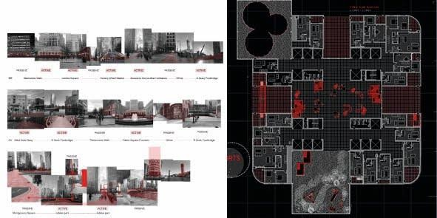
Figure 1. Toolkit: Dynamic- Static elements in different scales
(Zhang H.,Ma T., Ye Y.-left; Dolan O.,-right)

Studio 1: Transforming Canary Wharf
The inner city studio focused on Canary Wharf in the London Borough of Tower Hamlets. Students were asked to imagine its transformation from a global financial district to a new local neighbourhood.
The studio’s hypothesis was that in the near future automation, and the corporate restructuring of work, would fundamentally shift the economic function of Canary Wharf, with redundant offices turned into homes and live-work spaces. Students were asked to explore new scenarios of live-work arrangements and investigate how these might impact on the public realm; how, for example, a new shared space infrastructure would redefine private and public boundaries. The aim was to steer students to two key questions:
- From the public realm to the flat: How would Canary Wharf change if it were populated by residents who also worked there?
- From the flat to the public realm: Would the area’s daily / weekly life alter and what impact might this have on the wider neighbourhood?
Students were given a ‘poster’ template that guided them to address the challenges of the area at different spatial scales and across different timelines: from the global and national (drawing comparisons with other global cities), to the urban scale (with a view to understanding the function of the area within its city-wide context), to the Canary Wharf site itself, down to the building scale and the consideration of individual urban and architectural elements (such as external and internal corridors, for instance); they were also asked to consider various ‘dimensions’ of urban design, leading them to take account of socio-economic attributes and drivers, as well as demonstrate an appreciation of urban form (Figure 2 and Figure 3).
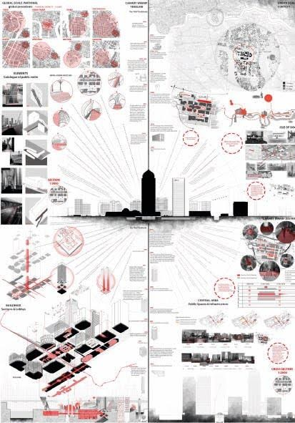
Figure 2. Poster1: Reactivating the City
(Dolan O., Zhang H.,Ma T., Ye Y.)

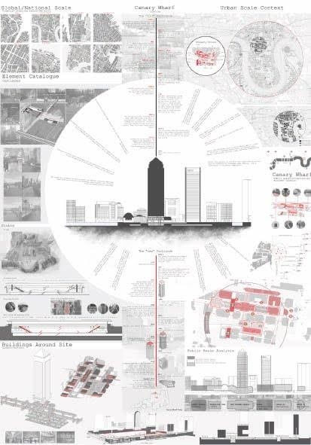
Figure 3 Poster2: Urban Zones and Fragments
(Gordon J., Li Y.,Yao C., and Huang K.)
Each group, a mix of architecture and planning students, explored a different sub-theme within the same poster template – ultimately visualizing Canary Wharf’s challenges and potentials, linked to the given scenario. On each poster a series of ‘topics’ emerged, providing a thematic lens for analysis (starting with ‘what is the problem?’), leading to design operations through which solutions were proposed (‘how do we respond?’). These ‘topics’ became part of the ‘shared toolkit’ that guided their design process at every scale and allowed the systematic re-assessment of the area:
- Diversity-Diversifying: in this case, the analysis looked at aspects - or lack thereof – of functional, socio-demographic, formal-typological, structural-material, ecological diversity, which then became the design drivers of the transformation (Figure 4).
- Zones-Re-zoning: the sectional and planar analysis allowed for horizontal and vertical re-zoning of the area. In addition to reconfiguring the programmatic-functional zones at all scales, different dimensions – e.g. acoustic, ecological, economic (real-estate) - were also considered (Figure 5).

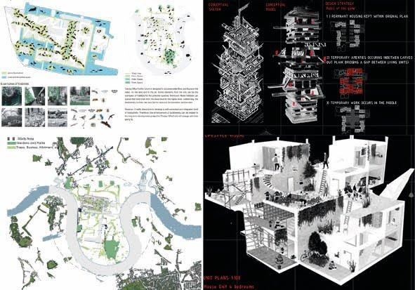
Figure 4. Bio and Programmatic Diversity
(Sun C., Zhang J., Xu J.,Ye Y.-left; Dolan O.-right)

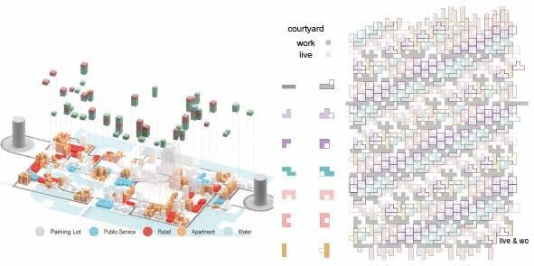
Figure 5. Functional -Economical-Typological Zones in all scales
(Yao C., Huang K., Zhao Y. -left; Li Y.-right)

Studio 2: Developing New Suburbia
New Barnet, at the north-east tip of the London Borough of Barnet, provided the focus for the second studio. This typical suburban area is characterized by low-density car-dependent housing interspersed with green spaces and land recycling opportunities.
The premise of the studio was a future in which far fewer people commute to work and there is greater diversity of home ownership models. Students were asked to reflect on the impact that a shift to shared modes of transport would have on the architectural and planning infrastructure of peripheral developments and also what lifestyles this future suburbia would offer if residents worked primarily from home or in the local area.
Students were again steered to address two key questions:
- From the public realm to the flat: will streets, parks and public spaces become dominant spatial figures?
- From the flat to the public realm: how might the face of suburbia change if all new housing areas were developed according to a cooperative model? And how might suburbia cater for a mix of lifestyles, including the transience associated with short-term tenancies?
This time, students were asked to present their findings and ideas through a brochure and billboard, of the types used to advertise new development projects. They needed to imagine where the billboard might be located, if it were to appeal to and attract the inhabitants of this new suburbia. Again, students were asked to consider the area’s context, characteristics, challenges and potentials across various ‘dimensions’: some remained constant while others, including ecology, were paid greater attention in the second studio, given the potential for connections beyond London’s edge.
Students were confronted, in this suburban location, with a relative ‘carte blanche’ and were challenged to create an ‘urban vision’ where there was none. This meant that they had to define the ‘rules of the game’: a multi scalar, systematic approach that focused on designing new development types, ‘formulas’, standards, regulations and design codes (Figure 6).

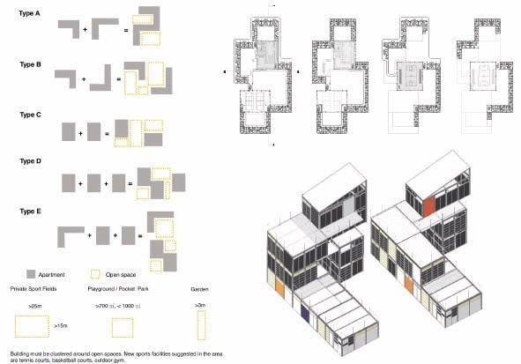
Figure 6. Design Codes for Low Rise, High Density - Low Cost Self Built Cooperative
(Tseng H-C.-left; Clarence A., Zhang, Baganz D.-right)

With titles ranging from ‘Active Suburbia’ to ‘Botanical Suburbia’, the billboards presented alternate visions for New Barnet while the brochures relayed the research and a critical position supporting those visions (Figure 7).

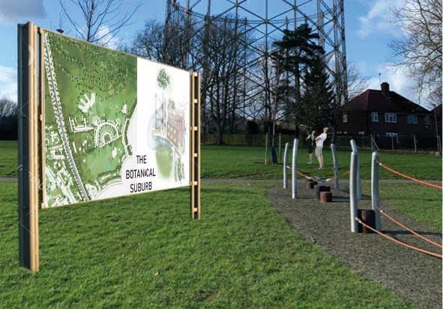
Figure 7. Billboard: Botanical Suburbia
(Kleczek K., Lashhab M., Raja A., Li L., Wang Q., Wang Y.)

These included large scale design interpretations of the cooperative development model, typological explorations of the housing, and the development of ‘design codes’ that codified the design formula:
- Self-Built Cooperatives would be developed on a checkered grid urban pattern, where the footprint of the building equals the courtyard area. The metrics for this development was based on the measurement of the cheapest existing construction products (panels and frame members) aimed to produce a low cost, low rise, high density estate (Figure 6).
- Live-Work Cooperatives were envisioned through a series of connected courtyards framed by crescents. The elongated units of the crescent introduced patios (courtyards in the scale of the unit) so as to separate live-work areas. Party-wall development of the crescent aimed to maximise green space (Figures 8 and 9).
- Farming Cooperatives explored the ‘mat’ urban type in a continuous allotment-greenhouse-living development by the greenbelt. The varied, cascading section maximizes sun exposure. To form stable communities and initiate productive land use, the allotment sizes were optimised in relation to the size of collectives, length of tenancy and crop production (Figure 10).

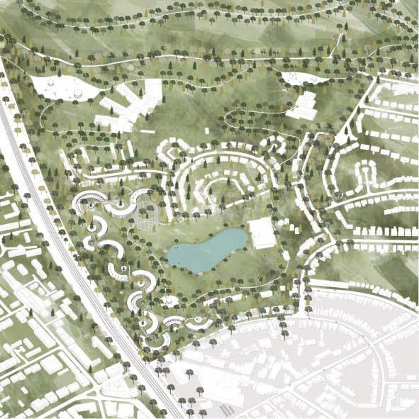
Figure 8. Live-Work Crescents in Botanical Suburbia
(Li L.)

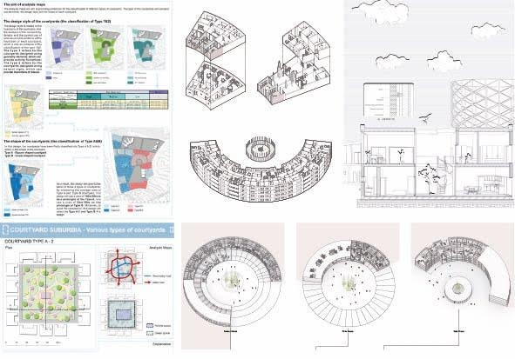
Figure 9. Design Codes for Courtyards - Live-work Cooperatives
(Zheng Z.-left; Li L.-right)

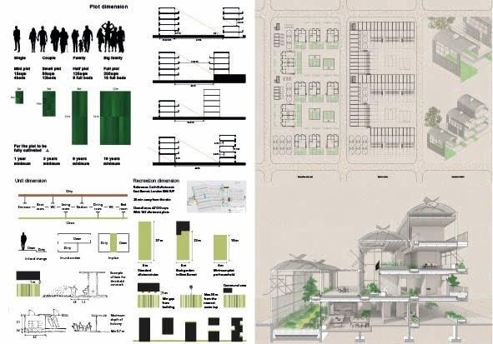
Figure 10. Design Codes for Living on Productive Landscape - Farming Cooperatives
(Magsarjav T.)

CONCLUSIONS
The studios evidenced how the different disciplinary groups were able to broaden their appreciation of the use of space and the connectivity of place to wider socio-economic contexts. Students were also exposed to the political and economic frameworks that impact on design decisions at all scales, and to the power of design to lead systemic change by setting new standards and proposing new solutions. It was sometimes the planning students who arrived at architectural responses to the challenges of place (including through typological operations, such as codifying courtyards) and architecture students who used ‘planning tools’ (including design codes) to provide regulatory responses to urban challenges – evidencing beneficial cross-overs in thinking.
The studios were realized through the University of Liverpool’s investment in an interdisciplinary Design Lab. Unfortunately, the London Campus – along with its Design Lab – closed in 2020, resurrecting many of the obstacles that such collaborations face. The physical separation of disciplines is a source of other problems. These relate to administrative and organizational challenges (centred on budgeting), timetabling (planning modules in Liverpool need to complete in twelve weeks, but architecture ones are longer) and the credit weightings attributed to modules. None of these should be insurmountable, but then tend to harden into departmental boundaries that front-line staff struggle to overcome.
Other challenges are discipline-specific. Planning schools frequently sit outside built environment faculties and too few people understand the role and relevance of design, viewing it as a desirable but not essential feature of planning education. This consigns students to design illiteracy and a poor understanding of place and place-making: masters’ students, in particular, struggled with basic design tasks, lacking the broader grounding of their undergraduate peers. But there are problems also in RIBA accredited architecture school, where the focus is often skewed towards technology and exploration of the wider urban context remains superficial. Confronting ‘reality’ is narrowed down to addressing issues around construction and environmental sustainability, rather than understanding the politics of urban development and regulatory processes.
There is clear benefit in working across disciplinary boundaries and exposing students to new perspectives, new knowledge sets and new tools. The project-based studio pedagogy could be extended to other disciplines – including business, real estate, communication studies and other design fields. This would involve further development of the methodology: a designed and phased iterative process with continuous feedback loops and a shared evaluation of projects. The diversity of student background and experience is both a challenge and an opportunity; cohorts of students are increasingly international, and students from different countries and contrasting planning and design cultures bring their own, often very particular and diverse ideas about place quality. As cities are increasingly diverse, it is important that we reflect this diversity in our teaching methods, so long as we can progress towards cultural understanding, and develop a common design language that brings professions together.

REFERENCES

Horst W. J. Rittel and Melvin M. Webber, “Dilemmas in a General Theory of Planning,” Policy Science 4, no. 2 (1973): 155.
Klaus R. Kunzmann, “Planning education in a globalized world,” European Planning Studies 7, no. 5 (1999): 550.
“Study at University,” Royal Town Planning Institute (RTPI), accessed December 07, 2020, https://www.rtpi.org.uk/accredited-qualifications.
Mahyar Arefi and Menelaos Triantafillou, “Reflections on the Pedagogy of Place in Planning and Urban Design,” Journal of Planning Education and Research 25 (2005): 75.
Michael K. Jenson, “Educating the 21st century architect: complexity, innovation, interdisciplinary methods, and research in design”, in Design Studio Pedagogy: Horizons for the future, ed. Ashraf M. Salama and Nicholas Wilkinson (Gateshead, UK: The Urban International Press, 2007), 48.
Anthony W. Shuman, “Introduction: the Pedagogy of Engagement”, in From the Studio to the Streets, ed. Mary C. Hardin et al. (Sterling, VA: Stylus Publishing, 2006), 8.
Tridib Banerjee, “The brave new urban design pedagogy: some observations”, Journal of Urban Design 21 no. 5 (2016): 540-41.
James Holston, The Modernist City: An Anthropological Critique of Brasilia (Chicago: University of Chicago Press, 1989), 83.
Simin Davoudi and Ali Madanipour, “Two Charters of Athens and Two Visions of Utopia: Functional and Connected,” Built Environment 38 no. 4 (2012): 462.
Karin Jaschke, “City is house and house is city: Aldo van Eyck, Piet Blom and the architecture of homecoming”, in Intimate Metropolis, ed. Vittoria Di Palma et al. (London and New York: Routledge, 2009), 175.
Jaschke, “City is house and house is city”, 176.
Igor Fracalossi, “AD Classics: Amsterdam Orphanage / Aldo van Eyck,” ArchDaily, accessed December 09, 2020, https://www.archdaily.com/151566/ad-classics-amsterdam-orphanage-aldo-van-eyck
Aldo van Eyck, “ls Architecture Going to Reconcile Basic Values?.” In CIAM '59 in Otterlo, edited by Oscar Newman (Stuttgart: Krämer Verlag, 1961), 28.
Florian Hertweck and Sébastien Marot, The City in the City - Berlin: The Green Archipelago (Zürich: LarsMüller Publishers, 2013), 12.
Stefania Staniscia, “Sceptred isles,” The Architectural Review 1460 (April 2019): 51.
Banerjee, “The brave new urban design pedagogy”, 540.
Building Better Building Beautiful Commission (BBBBC), Living with beauty (London: Ministry of Housing Communities & Local Government, 2020), 112.
Kunzmann, “Planning education in a globalized world”, 552.
Jenson, “Educating the 21st century architect”, 48.
Rob Roggema, “Research by Design: Proposition for a Methodological Approach,” Urban Science 1 no. 2 (2016): 3.
Nick Gallent, Whose Housing Crisis? Assets and Homes in a Changing Economy (Bristol: Policy Press, 2019), 23.
Matthew Carmona et al., Public Places - Urban Spaces. The Dimensions of Urban Design (London: Routledge, 2010, Second Edition), 74.
Carmona et al, Public Places - Urban Spaces, 77-266.
Nick Gallent et al. Planning on the Edge. The context for planning at the rural-urban fringe (Routledge: London, 2005), 138. BIBLIOGRAPHY Arefi, Mahyar, and Triantafillou, Menelaos. “Reflections on the Pedagogy of Place in Planning and Urban Design.” Journal of Planning Education and Research 25 (2005): 75-88. Banerjee, Tridib. “The brave new urban design pedagogy: some observations.” Journal of Urban Design, 21 no. 5 (2016): 540-44. Building Better Building Beautiful Commission (BBBBC). Living with beauty. London: Ministry of Housing Communities & Local Government, 2020. Carmona, Matthew, Tiesdell, Stepve, Heath,Tim, and Oc, Taner. Public Places - Urban Spaces. The Dimensions of Urban Design. London: Routledge, 2010, Second Edition. Davoudi, Simin and Madanipour, Ali. “Two Charters of Athens and Two Visions of Utopia: Functional and Connected.” Built Environment, 38 no. 4 (2012): 459-68. Fracalossi, Igor. “AD Classics: Amsterdam Orphanage / Aldo van Eyck.” ArchDaily. Accessed December 09, 2020, https://www.archdaily.com/151566/ad-classics-amsterdam-orphanage-aldo-van-eyck Gallent, Nick. Whose Housing Crisis? Assets and Homes in a Changing Economy. Bristol: Policy Press, 2019. Gallent, Nick, Andersson, Johan, and Bianconi, Marco. Planning on the Edge. The context for planning at the rural-urban fringe. Routledge: London, 2005. Hertweck, Florian and Marot, Sébastien. The City in the City - Berlin: The Green Archipelago. Zürich: LarsMüller Publishers: 2013. Holston, James. The Modernist City: An Anthropological Critique of Brasilia. Chicago: University of Chicago Press, 1989. Jaschke, Karin. “City is house and house is city: Aldo van Eyck, Piet Blom and the architecture of homecoming”, in Intimate Metropolis, edited by Vittoria Di Palma, Diana Periton, and Marian Lathouri, 175-194. London and New York: Routledge, 2009. Jenson, Michael K. “Educating the 21st century architect: complexity, innovation, interdisciplinary methods, and research in design”, in Design Studio Pedagogy: Horizons for the future, edited by Ashraf M. Salama and Nicholas Wilkinson, 47-62. Gateshead, UK: The Urban International Press, 2007: Kunzmann, Klaus R. “Planning education in a globalized world.” European Planning Studies 7, no. 5 (1999): 549-55. Rittel, Horst W., and Webber, Melvin M. “Dilemmas in a General Theory of Planning.” Policy Science 4, no. 2 (1973): 155–69. Roggema, Rob. “Research by Design: Proposition for a Methodological Approach.” Urban Science 1 no. 2 (2016): 1-19. Royal Town Planning Institute (RTPI). “Study at University.” Accessed December 07, 2020. https://www.rtpi.org.uk/accredited-qualifications Shuman, Anthony W. “Introduction: the Pedagogy of Engagement”, in From the Studio to the Streets, edited by Mary C. Hardin, Richard Eribes, and Charles (Corky) Poster, 1-16. Sterling, VA: Stylus Publishing, 2006 Staniscia, Stefania. “Sceptred isles.” The Architectural Review 1460 (April 2019): 48-51. van Eyck, Aldo. “ls Architecture Going to Reconcile Basic Values?.” In CIAM '59 in Otterlo, edited by Oscar Newman, 26-35. Stuttgart: Krämer Verlag, 1961.

