Porous metal properties analysis: A machine learning approach

Avalos-Gauna E.¹, Zhao, Y ²., Palafox-Novack L.¹, Ortiz-Monasterio-Martínez P. ¹
- eavalos@up.edu.mx ¹, y.y.zhao@liv.edu.mx ², lpalafox@up.edu.mx ¹, portizmo@up.edu.mx ¹
- Facultad de Ingeniería, Universidad Panamericana, Campus México, Augusto Rodin 498, 03920, CDMX, México
- Department of Engineering, The University of Liverpool, Brownlow Hill, Liverpool, L69 3GH, UK

  - Abstract
During many years, the search for new and improved materials has been an arduous task, full of experimentation. In more recent years, computer aided techniques (i.e. numerical simulation) have complemented the research and development process (R&D). These two approaches mainly defined the way material science works. Yet, both techniques have shown cost-efficiency disadvantages. Optimization algorithms like the ones used in machine learning, have proven to be an alternative tool when dealing with lots of data and finding a solution. While the use of machine learning is a well stablished technique, its application in material science is relatively new. Material Informatics provide a new approach to analyse materials such as porous metals by employing previous data sets. This paper aims to study reliability to predict permeability and Forchheimer´s coefficient coefficients of open-cell porous metal. The key features selected as predictors are pore parameters such as porosity, pore size, and coordination number. A comparison between polynomial regression, random forest regressor and artificial neural network is utilised.
Keywords: Porous metals, Permeability, Forchheimer´s coefficient, Machine learning, Artificial neural network, Material informatics
  - Introduction
Study of materials science and materials design have been linked to previous experiences and trial-error analysis since the beginning [1]. From that, empirical correlations had been obtained between processing conditions and desired performances [2]. By doing so, the main purpose is to obtain and enhancement of the material by modifying its known properties. This typical material selection approach is widely accepted to address product-level performance requirements. Many industries are enriched by new or improved multifunctional materials. Although they might have good properties, that do not necessarily mean that the materials have the right balance of properties needed for specific engineering applications [1]. For instance, in high performance alloys and composite materials, maximum performance is often achieved within a specific range of properties with a small variance [3].
More recently, computational techniques are included in evaluating performance metrics necessary to support materials design [4]. This approach is known as numerical simulation (e.g. finite element models) and it has been used during the past few decades to analyse different material properties. Yet, the principal issue in obtaining relevant properties from a numerical model, is the correct selection of the main microstructure measures that have a higher influence on them. To solve this predicament, the selection is made generally based on experience [5]. Moreover, the time and expense required in any of these two approaches, often limits the development of new materials [6]. Additionally, modern advances in experimental and computational sciences have generated vast amounts of data [7]. Consequently, new fast and reliable approaches are needed for data analysis on materials. One of the most promising and novel fields to deal with large amounts of data is materials informatics.
Materials informatics can be used for material analysis and developments [8]. This is due to the “big data” generated by experimentation and simulations. Materials informatics offers unprecedented opportunities for new materials discovery with improved properties with the implementation of machine learning techniques [9]. Machine learning algorithms use statistical models and optimization algorithms to reveal patterns within data. Insights can be obtained through predictions or classifications depending on the chosen algorithm. The machine learning process can be observed in Fig. 1. The advantage over traditional experimentation and simulations, is that computers can often handle much larger and higher dimensional data in a more efficient manner [10].
Some applications of different algorithms implemented on material informatics can be found in the literature. For instance, Çeçen et al. [11] analysed polymeric fuelled cells microstructure properties. Principal component analysis and a multiple linear regression model were used to stablish structure-property correlations. Correlations for diffusivity, tortuosity and porosity exhibited higher accuracy than traditional models found in the literature. Tapia et al. [12] used a Gaussian model for porosity prediction on metal-based additive manufacturing process. Porosity is a common defect that has been reported to occur in selective laser melting. In their study, the Gaussian model developed made use of laser power and scanning speed as input parameters to predict porosity. It was reported that low porosity can be predicted with use of the Gaussian model. Moreover, Khanzadeh et al. [13] implemented a different machine learning approach for porosity prediction on additive manufacturing pieces. In their study, direct laser deposition was considered as manufacturing technique. Their study focused on the classification of the melting pools thermal image streams for porosity obtention. Different classification techniques were tested such as support vector machines, principal component analysis and K-nearest neighbours. It is reported that K – Nearest Neighgours (KNN) exhibited the best performance in classification of ill-structured melt pools for achieving low porosity on the final manufactured parts. Pardakhti et al. [14] studied the structural and chemical features of Metalic Organic Frameworks (MOFs) and their correlation with methane absorption. The machine learning techniques revised were decision tree, Poisson regression, support vector machine (SVM) and random forest. Given the large dataset they had available, their training set only consisted of 8% of the total data. This was equal to 130,398 records. The random forest exhibited great accuracy for prediction (98%) and a lesser computational time than current techniques for absorption measurement.
Artificial neural networks (ANN) are also another viable machine learning technique. They have been widely used for supervised learning predictions. Moreover, Skinner & Broughton [15] stated its wide applications for material sciences since early this century. Dudsik & Strek [16] for instance, implemented ANN’S when studying the strength properties of open-cell aluminium porous metal during compression. In their study, different ANN architectures were analysed to approximated stress-strain relations. To assess ANN’s performance, different statistical metrics were used. The results showed that their approach provides an approximation of mean absolute relative error (MARE) between 7% to 10%. Similarly, Altarazi et al. [17] tested an ANN to evaluate polyvinylchloride (PVC) composites properties. In their analysis, different combinations of activations functions, network layers, and number of perceptron’s per layer were used. The Levenberg-Marquardt backpropagation and radial basis training algorithms/activation function were found to be the most appropriate for tensile strength, ductility, and density of extruded PVC composite predictions. In their study, the model accounts for weights percentages of virgin PVC, recycled PVC, CaCO3 filler, CaCO3 particle ductility, and density of extruded PVC.

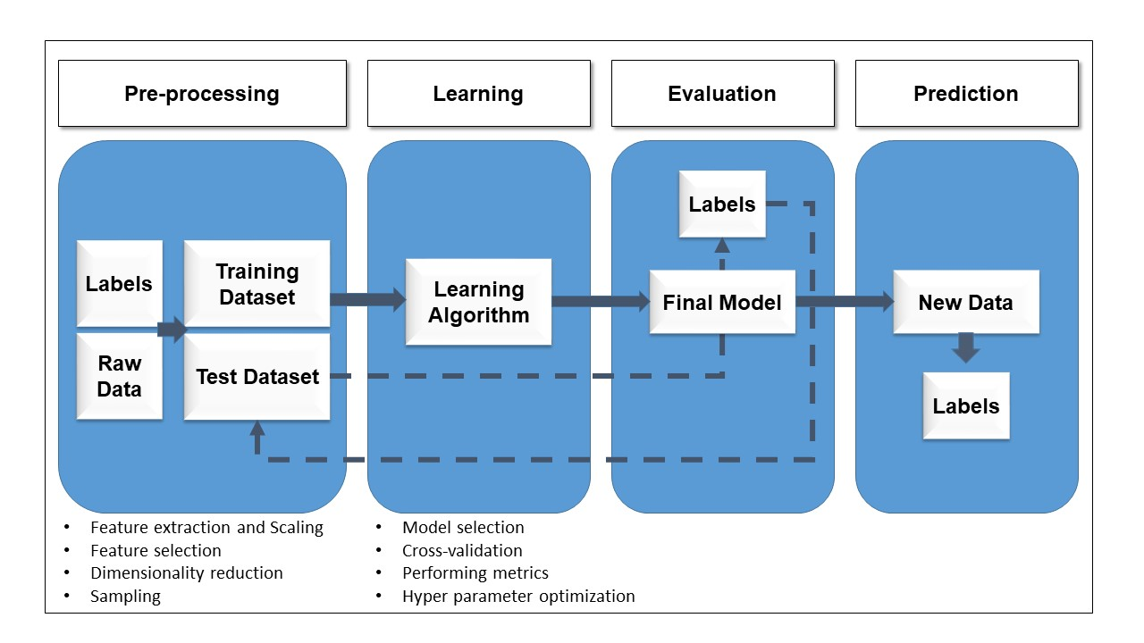
Fig. 1 Machine learning process
Methodology
One of the key aspects of materials informatics is that it lowers the costs of R&D as it does not have to use many experimental tests and reduces the computational usage. Plus the implementation time is faster than the traditional way of doing research [4]. Therefore, the main purpose of this paper is to demonstrate that data science tools are ideally suited to tackle the fluid flow problem of a porous copper geometry. The experimental analysis can be found in [18] and [19]. The numerical analysis can be found in [20]. For the current work, the experimental and numerical results were coupled for machine learning purposes. To start with the machine-learning model, the following elements were implemented:
- Data preparation
The first step is to generate a dataset that comprises of the features (independent variables) and the targets or descriptors (dependant variables) [21]. This could come from experimental data results, numerical simulation, or in this case, both entries. The input variables and the target outcomes must be cleaned, before any machine learning algorithm is implemented. The cleaning process includes looking and dealing for missing data, eliminating not relevant features, and an exploratory data analysis in most of the cases when threating with secondary data. This process was performed in both data sets. For the experimental data, average values were used where range values were available.
- Descriptor selector
The next step is to define which material properties have to be selected as the key features that describe the performance of the material on a given aspect[22]. Descriptor or target selection consist on finding the most influential features by implementing different data extraction techniques and dimensionality reduction methods such as Principal Component Analysis [6]. Depending on the number of elements in the material, the dimensionality of the input may differ. Hence, it is not possible to apply the same model to materials with different number of elements. Thus, an exploratory data analysis was performed to find correlations amongst all parameters available on de dataset. These correlations were ploted on a correlation matrix (Fig. 2). Positive relationships are marked in red whereas negative relationships are marked in blue. Stronger relatioships are marked with darker colors whereas weak relationships are marked with faded colors. In the current analysis, the predictor variables to be employed are: Potassium carbonate diameter (K₂CO₃) [micrometres], porosity $(f)$, Copper particle diameter [micrometres]', and Coordination number. For the target variables, two sets of analysis were performed: one for Permeability and another for the Forchheimer’s coefficient.
- Model selection and evaluation
Extracting and validating the model, must bear in mind that it must fit the data set and the type of data each feature has, without over-fitting or under fitting. Various regression methods are implemented. A thorough knowledge beforehand of the physics representing the problem is critical in selecting the most accurate machine learning technique [23]. Therefore, it is vital to understand the key features on a porous metal. Porous metals are a novel type of material with hollow spaces deliberated included into the material during its manufacturing process. [24] This hollow spaces or pores provide with a unique set of properties to the material. [25]
For active cooling applications, the porous metal is expected to have an open-cell structure. The cooling system is composed of the porous metal medium and the fluid is used as a coolant flowing through the material. According to literature [26], the pressure drop across the sample is strongly affected by the pore structure [27]. For the porous structure, there are many studies that analyse the flow problem within a porous media [28]. Fluid flow through porous metals can be considered as turbulent if the Reynolds number increases to a critical value [29]. Thus, a nonlinear relationship is used to calculate the pressure drop due to the porous media. This relationship is known as the Forchheimer’s equation [30]:
$$\frac{∆P}{∆L}=\frac{μv}{K}+ρCv^{2}$$
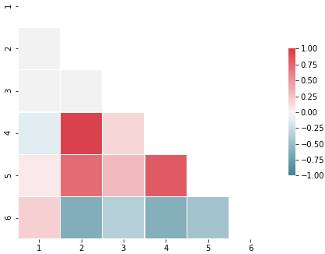
Fig. 2 Correlation matrix amongst the structural parameters: (1)K₂CO₃ diameter, (2)Porosity, (3)Cu diameter, (4)Coordination number, (5)Permeability and (6)Forchheimer´s coefficient
where $∆P$ is the pressure drop between the inlet and outlet of the porous media, $∆L$ is the length of the porous media, $μ$ is the viscosity of the fluid, $v$ is the Darcian velocity of the fluid (i.e., flow rate divided by the cross-sectional area), $ρ$ is the density of the fluid (water in this case), $K$ is the permeability of the porous media and $C$ is the Forchheimer’s coefficient, or form drag coefficient. $K$ and $C$ are often the focus of many investigations on porous media.
For the machine learning model selection, polynomial regression, random forest, and an ANN were employed to establish relationships between the input variables and the target outcomes. Finally, by using 5-fold cross validation, the most optimal will be selected [5]. The final dataset used comprises of 856 records for permeability prediction and 826 for Forchheimer’s coefficient.
- Model implementation
As stated before, the most relevant features are obtained which then are used to make predictions of the target properties. This process is developed in two stages, the first one is known as training phase and the second one is the testing phase. After the model has been implemented, insights can be drawn from the predictions. This will derive in the development of specific type of materials or even tailored materials. For materials informatics, the literature designates five descriptor categories: constitutional, topological, physicochemical, structural, and quantum-chemical [22]. For this paper, only topological properties were used. Lastly, after the model has been implemented, it is crucial to evaluate its performance. This can be done by using statistical metrics such as Pearson’s coefficient (R²) or root mean square error (RMSE).
Machine Learning models
For the current study, three different supervised machine learning techniques were employed. Polynomial regression, random forest regressor and ANN were tested to predict permeability and Forchheimer’s coefficient.
- Polynomial regression
This method has the advantage of being simple to understand, fast and straightforward to implement, given its simplicity, it is not adequate for complex problems [23]. The dependent variable (i.e. y) is assumed to be obtainable by evaluating a linear function of the explanatory variables (i.e. x). The linear regression is represented as [31]:
$$y=x^{T}β+ε$$
where $x^{T}$ is the transpose vector of all explanatory variables, $β$ is a vector of weights, which we must estimate, and $ε$ is a with zero mean normal variable that represents random effects. Equation 3 is useful when the relationship between predictors and target values is somehow linear. Yet, depending on the number $(m)$ of elements on $x^{T}$, there are $2^{m}-1$ models to test. Therefore, only those variables that contribute the most to predict the target variable are considered.
Nonetheless, when the observed trend does not adjust well with this approach, it is possible to add another term to the equation to account for the non-linear behaviour:
$$y={x_{0}}^{n}β_{0}+{x^{T}}_{i}β_{i}+ε$$
where ${x^{T}}_{i}$ and $β_{i}$ are still vectors, and ${x_{0}}^{n}β_{0}$ is the selected feature to display the nonlinear behaviour. In all cases of polynomial regression, the main objective is to find the parameters that minimises the loss function using eq. (4):
$$\frac{∂}{∂x}\left(\frac{1}{n}\sum_{i}^{n}{{\left(y\left(x_{i}\right)-y_{i}\right)}^{2}}\right)=0$$
- Random forest (RF)
A widely used and effective technique in machine learning involves the use of learning models known as ensembles. An ensemble takes multiple individual learning models and combines them to produce an aggregate model that is more powerful than any of its individual learning models alone [32]. Random forest is a supervised machine learning ensemble that encompasses several decision trees for prediction or classification problems [9]. A decision tree represents a procedure where analysing data based on their attributes [13]. It is a supervised learning algorithm that is mostly used for classification problems. It works for both discrete and continuous dependent variables. It involves a selection process that can be described as a sequence of binary selections [33]. By fitting a number of decision trees, a random forest uses various sub-samples of the dataset and use averaging to improve the predictive accuracy and control overfitting of the final prediction. The number of trees on any random forest model usually is around tens or hundreds of trees depending on data complexity. For the current analysis one hundred trees were used.
- Artificial neural network (ANN)
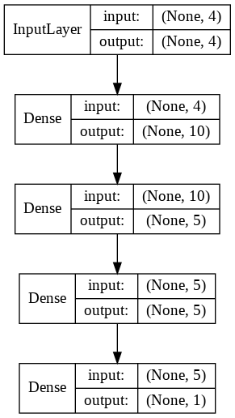
Fig. 3 Artificial Neural Network architecture used for the current study
ANN are a novelty approach widely employed in recent years in applications such as pattern recognition and material science [23]. ANN are inspired on how the nervous system, neural networks and neurons are composed. In reality, biological neurons are interconnected in a network structure, whit each neuron having an electrical signal as input and later transmitting a response to a neighbouring neuron when a certain activation threshold is surpassed [34]. In ANNs, neurons are called perceptron, and the back propagation method is often used to train the network’s weights and biases for each perceptron with the sigmoid function as the most common activation function used [35]:
$$θ\left(u\right)=\frac{1}{1+e^{-u}}$$
Where $u$ represents a linear function within a perceptron. An ANN is formed by layers of several number of perceptrons. Each perceptron on one layer is interconnected with the perceptrons from the next layer. These processing units are made up of one layer of inputs, a group of hidden layers, and one output layer. The final goal of the ANN is to learn about the information presented to produce one output report [36]. The ANN’s architecture used for the current study comprised of five layers as shown in Fig. 3. The first layer is the input layer for all predictor variables. Then, the following three layers are hidden layers for data processing. The last layer corresponds to the output layer for the target prediction.
  - Results and discussion
A numerical data set was employed to train different machine learning models to predict permeability and Forchheimer’s coefficient. The dataset was transformed in a way that can be processed by all machine learning techniques proposed in the current study. The dataset was divided into 80% for training, and 20% for testing. Later, ten k fold cross-validation was used on each technique to avoid overfitting. Finally, the trained algorithms were compared against the testing set to measure accuracy.
The target features for the current analysis are permeability and Forchheimer’s coefficient. Therefore, they were computed on two separate analysis. The predictor variables in both cases were pore diameter (given by que potassium carbonate particle size), porosity, metal particle size (given by the copper particles) and coordination number. The sample size for the permeability analysis is 856 and 826 for the Forchheimer´s coefficient.
$$\begin{matrix}X=\left\{\begin{matrix}\begin{matrix}x_{0} : Pore size \\ x_{1} : Porosity \end{matrix} \\ \begin{matrix}x_{2} : Copper size \\ x_{3} : Coordination number\end{matrix}\end{matrix}\right. \\ Y=\left\{\begin{matrix}y_{0} :Permeability \\ y_{1} :Forchheimer´s coeff\end{matrix}\right.\end{matrix}$$

The polynomial regression analysis was performed using combinations of all four predictor variables. For that, an algorithm was created to generate a linear model which after was tested to measure Pearson´s correlation coefficient. The algorithm tested for all possible combinations with the predictor variables. From all possible combinations, only the top three combinations are shown in Table 1. The results showed that the multiple linear regression considering all four predictors obtained the highest Pearson´s coefficients. For the permeability regression, the highest correlation was of 0.761 and for the Forchheimer´s coefficient was of 0.625. These results agree well with the nonlinear behaviour of both variables as shown in Fig. 4 and equation (1).
Table 1 Pearson coefficients for multiple linear regression combinations
$$Y$$ | Combinations of $X$ | $$R^{2}$$
$$y_{0}$$ | $$x_{0}, x_{1}, x_{2}, x_{3}$$ | 0.761
$$y_{0}$$ | $$x_{0}, x_{1}, x_{3}$$ | 0.756
$$y_{0}$$ | $$x_{0}, x_{2}, x_{3}$$ | 0.723
$$y_{1}$$ | $$x_{0} x_{1}, x_{2}, x_{3}$$ | 0.625
$$y_{1}$$ | $$x_{0}, x_{1}, x_{2}$$ | 0.572
$$y_{1}$$ | $$x_{1}, x_{2}, x_{3}$$ | 0.547

The next step was to implement a better model that accounts for the nonlinearities. Only the best combination in each analysis was used for polynomial, random forest, and ANN algorithms. For the polynomial algorithm, different degrees were employed in order to improve accuracy. One important aspect to keep in mind is to check for overfitting [33]. For instance, it was observed that overfitting started to occur at a polynomial of degree 4 in both analyses. Thus, it was decided to use only a degree 3 polynomial for the current study. All models were tested using 20% of the full dataset employed. To assess accuracy of all methods, Q-Q plots were designed for both outputs (Fig. 5 for permeability and Fig. 6 for Forchheimer´s coefficient).
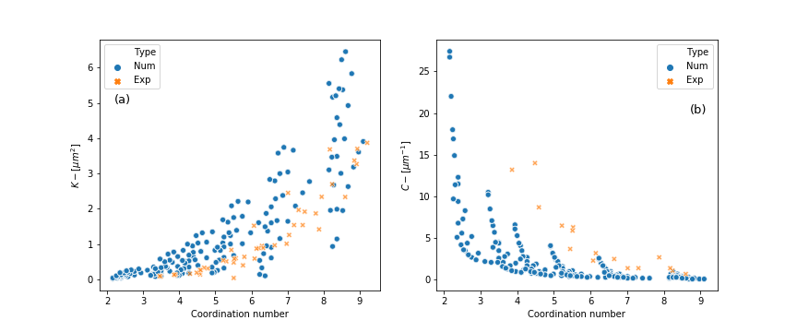
Fig. 4 Relationship between (a) Permeability with Coordination number and (b) Forchheimer´s coefficient and coordination number
Each plot shows how well each model performed when trying to predict K and C. Fig. 5 (a) shows a multiple linear regression of degree 1 between the structural parameters and permeability. The Q-Q plot shows some correlation between predictors and target outcome. Yet, the linear model only predicted successfully 76% of the expected values for permeability. Additionally, the observed mean squared error (MSE) is of 0.471. By increasing the polynomial degree with was possible to achieve averaged better accuracy (94.5%) but still with similar MSE. Moreover, the 5-fold test for the polynomial regression exhibited a wide range between the less optimum and the top result of the analysis going from 86.4% to 98.3% respectively. The next step that followed is the analysis of the data with a random forest regressor, i.e. Fig. 5 (c). For the random forest algorithm, it was set to use 100 decision trees with a minimum split of 2. The averaged accuracy obtained for this model was of 98.3% with a MSE of 0.014. The standard deviation for the 5-fold test for the random forest regressor was of 0.57% meaning that all test obtained a similar accuracy. Finally, the predictor variables were used on an ANN. Different activation functions were tested but, in the end, regular linear was used on each hidden layer. The algorithm processed all data for 500 epochs. The results for that analysis can be observed in Fig. 5 (d). This technique averaged the best accuracy to predict permeability amongst all other four techniques (98.7%). However, the MSE was slightly higher to the random forest regressor. Nonetheless, random forest tends to overfit the data while neural networks keeps learning when new data becomes available. Additionally, the top test of the 5-fold exhibited an accuracy close to 99% and overall, the standard deviation was of 0.6%.
For the Forchheimer’s coefficient prediction, similar results were observed. The multiple linear regression model only predicted 60.5% correctly. Fig. 6 (a) shows how disperse the results are. The MSE also is quite large, i.e. 13.462, meaning that the difference in prediction for some points is huge. After implementing the other machine learning techniques, it is possible to observe an improvement on both metrics (accuracy and MSE). All three cases showed accuracy of 99%, yet random forest regressor had the best prediction accuracy (99.5%). For the MSE, the ANN, Fig. 6 (d), had less difference in errors with the predicted values. However, the 5-fold test showed differences amongst machine learning techniques. For instance, ANN minimum accuracy rate was of 41.4%. This led to a standard deviation for the 5-fold test for ANN of 22%. This could imply that the ANN is not learning properly from the dataset and some parameter tuning might need to be used. For the multiple linear regression, it was possible to observe similar accuracy results around 60% with a standard deviation of 6%. Only random forest and polynomial regression model had similar results throughout their corresponding 5-fold tests. 99.3% and 0.23% averaged accuracy and standard deviation for the polynomial regression and 99.52% and 0.11% averaged accuracy and standard deviation for the random forest regressor. Overall, the results showed a big improvement from the multiple linear regression with all three algorithms for both target variables ($K$ and $C$). Moreover, it was possible to correlate structural parameters of the porous metal to target values that often in the literature are obtain mainly through experimental means.
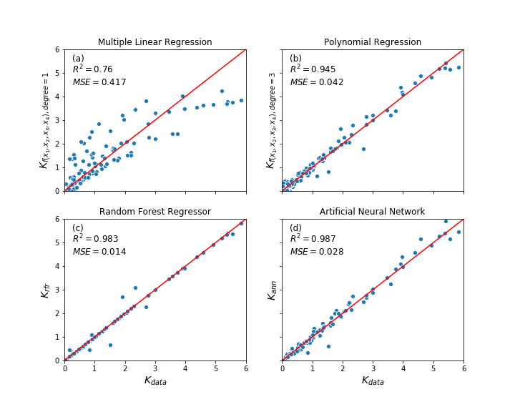
Fig. 5 Q-Q plot for Permeability and predicted values using different machine learning techniques: (a) Multiple Linear Regression, (b) Polynomial Regression, (c) Random Forest Regressor, (d) Artificial Neural Network
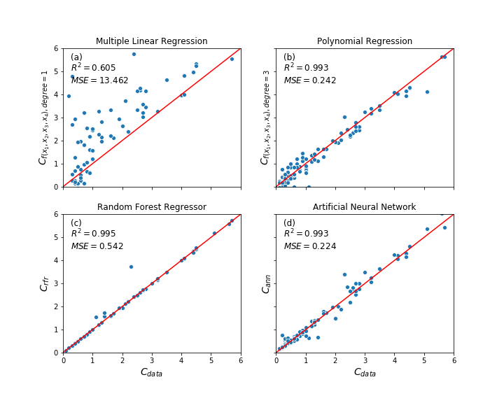
Fig. 6 Q-Q plot for Forchheimer’s coefficient and predicted values using different machine learning techniques: (a) Multiple Linear Regression, (b) Polynomial Regression, (c) Random Forest Regressor, (d) Artificial Neural Network
  - Conclusions
This paper presented a way to calculate permeability and Forchheimer´s coefficient from data generated experimentally and numerically. The model used a correlation matrix to establish the main features to use for analysis which were pore size, porosity, metal particle size and coordination number. With the implementation of a multiple linear regression, it was possible to obtain the best correlation factor for the target properties by using a combination of four predictor features. The multiple linear regression was later used to assess the effectiveness of the machine learning approaches. With this combination of features, three different machine learning techniques were tested to improve accuracy prediction. The results showed that polynomial regression showed a big improvement from the multiple linear regression. Moreover, it accounted for most of the nonlinearities on the data. Additionally, the results suggest that the addition of a third-degree term improves the calculation of permeability and Forchheimer´s coefficient. For the other two machine learning techniques, random forest regressor performed best for both analyses. Although, ANN had better results in some areas, it was observed a lack of consistency on the 5-fold test. Some parameter tuning is suggested to compensate for the differences. To sum up, this paper successfully presented a novel approach for porous metals material properties calculation. Random forest regressor and polynomial regression shown to be the most adequate algorithms for this analysis.
  - References.
[1] B. D. Conduit, N. G. Jones, H. J. Stone, and G. J. Conduit, “Probabilistic design of a molybdenum-base alloy using a neural network,” Scr. Mater., vol. 146, pp. 82–86, 2018, doi: 10.1016/j.scriptamat.2017.11.008.
[2] K. Matouš, M. G. D. Geers, V. G. Kouznetsova, and A. Gillman, “A review of predictive nonlinear theories for multiscale modeling of heterogeneous materials,” J. Comput. Phys., vol. 330, pp. 192–220, 2017, doi: 10.1016/j.jcp.2016.10.070.
[3] T. Lookman, P. V. Balachandran, D. Xue, J. Hogden, and J. Theiler, “Statistical inference and adaptive design for materials discovery,” Curr. Opin. Solid State Mater. Sci., vol. 21, no. 3, pp. 121–128, 2017, doi: 10.1016/j.cossms.2016.10.002.
[4] J. H. Panchal, S. R. Kalidindi, and D. L. McDowell, “Key computational modeling issues in Integrated Computational Materials Engineering,” CAD Comput. Aided Des., vol. 45, no. 1, pp. 4–25, 2013, doi: 10.1016/j.cad.2012.06.006.
[5] A. Gupta, A. Cecen, S. Goyal, A. K. Singh, and S. R. Kalidindi, “Structure-property linkages using a data science approach: Application to a non-metallic inclusion/steel composite system,” Acta Mater., vol. 91, pp. 239–254, 2015, doi: 10.1016/j.actamat.2015.02.045.
[6] K. Rajan, “Materials informatics,” Mater. today, pp. 38–45, 2005, doi: 10.1007/s10845-018-1392-0.
[7] J. M. Rondinelli et al., “Accelerating Functional Materials Discovery,” American Ceramic Society Bulletin, 2013.
[8] B. Meredig, “Industrial materials informatics: Analyzing large-scale data to solve applied problems in R&D, manufacturing, and supply chain,” Curr. Opin. Solid State Mater. Sci., vol. 21, no. 3, pp. 159–166, 2017, doi: 10.1016/j.cossms.2017.01.003.
[9] A. Agrawal and A. Choudhary, “Perspective: Materials informatics and big data: Realization of the ‘fourth paradigm’ of science in materials science,” APL Mater., vol. 4, no. 5, 2016, doi: 10.1063/1.4946894.
[10] L. Himanen, A. Geurts, A. S. Foster, and P. Rinke, “Data-Driven Materials Science: Status, Challenges, and Perspectives,” Advanced Science, vol. 6, no. 21. John Wiley and Sons Inc., Nov. 01, 2019, doi: 10.1002/advs.201900808.
[11] A. Çeçen, T. Fast, E. C. Kumbur, and S. R. Kalidindi, “A data-driven approach to establishing microstructure-property relationships in porous transport layers of polymer electrolyte fuel cells,” J. Power Sources, vol. 245, pp. 144–153, 2014, doi: 10.1016/j.jpowsour.2013.06.100.
[12] G. Tapia, A. H. Elwany, and H. Sang, “Prediction of porosity in metal-based additive manufacturing using spatial Gaussian process models,” Addit. Manuf., vol. 12, pp. 282–290, 2016, doi: 10.1016/j.addma.2016.05.009.
[13] M. Khanzadeh, S. Chowdhury, M. Marufuzzaman, M. A. Tschopp, and L. Bian, “Porosity prediction: Supervised-learning of thermal history for direct laser deposition,” J. Manuf. Syst., vol. 47, no. April, pp. 69–82, 2018, doi: 10.1016/j.jmsy.2018.04.001.
[14] M. Pardakhti, E. Moharreri, D. Wanik, S. L. Suib, and R. Srivastava, “Machine Learning Using Combined Structural and Chemical Descriptors for Prediction of Methane Adsorption Performance of Metal Organic Frameworks (MOFs),” ACS Comb. Sci., vol. 19, no. 10, pp. 640–645, 2017, doi: 10.1021/acscombsci.7b00056.
[15] A. J. Skinner and J. Q. Broughton, “Neural networks in computational materials science: Training algorithms,” Model. Simul. Mater. Sci. Eng., vol. 3, no. 3, pp. 371–390, 1995, doi: 10.1088/0965-0393/3/3/006.
[16] M. Dudzik and A. M. Strȩk, “ANN Architecture Specifications for Modelling of Open-Cell Aluminum under Compression,” Math. Probl. Eng., vol. 2020, 2020, doi: 10.1155/2020/2834317.
[17] S. Altarazi, M. Ammouri, and A. Hijazi, “Artificial neural network modeling to evaluate polyvinylchloride composite’s properties,” Comput. Mater. Sci., vol. 153, no. June, pp. 1–9, 2018, doi: 10.1016/j.commatsci.2018.06.003.
[18] Z. Xiao and Y. Zhao, “Heat Transfer Coefficient of Porous Copper with Homogeneous and Hybrid Structures in Active Cooling,” J. Mater. Res., vol. 28, no. 17, pp. 2545–2553, Jul. 2013, doi: 10.1557/jmr.2013.190.
[19] J. M. Baloyo and Y. Zhao, “Heat Transfer Performance of Micro-Porous Copper Foams with Homogeneous and Hybrid Structures Manufactured by Lost Carbonate Sintering,” MRS Proc., vol. 1779, 2015.
[20] Edgar Avalos-Gauna, “Numerical Simulation of Active Cooling Using Porous Metals,” University of Liverpool, 2017.
[21] W. Lu, R. Xiao, J. Yang, H. Li, and W. Zhang, “Data mining-aided materials discovery and optimization,” J. Mater., vol. 3, no. 3, pp. 191–201, 2017, doi: 10.1016/j.jmat.2017.08.003.
[22] H. Ohno, “Uniforming the dimensionality of data with neural networks for materials informatics,” Appl. Soft Comput. J., vol. 46, pp. 17–25, 2016, doi: 10.1016/j.asoc.2016.04.017.
[23] E. Bélisle, Z. Huang, S. Le Digabel, and A. E. Gheribi, “Evaluation of machine learning interpolation techniques for prediction of physical properties,” Comput. Mater. Sci., vol. 98, pp. 170–177, 2015, doi: 10.1016/j.commatsci.2014.10.032.
[24] Y. Zhao, “Porous Metallic Materials Produced by P/M Methods,” J. Powder Metall. Min., vol. 02, no. 03, pp. 2–3, 2013, doi: 10.4172/2168-9806.1000e113.
[25] J. Banhart, “Manufacture , Characterisation and Application of Cellular Metals and Metal Foams,” Prog. Mater. Sci., vol. 46, pp. 559–632, 2001.
[26] Ö. Baǧci, M. Özdemir, and N. Dukhan, “Flow Regimes in Packed Beds of Spheres From pre-Darcy to Turbulent,” Transp. Porous Media, vol. 104, no. 3, pp. 501–520, Jun. 2014, doi: 10.1007/s11242-014-0345-0.
[27] J. M. Baloyo, “Porous Metals with Novel Structures for Optimum Heat Exchange Performance, PhD Thesis,” University of Liverpool, 2016.
[28] M. Faiz, “Comparison of porous media permeability: experimental, analytical and numerical methods, PhD thesis,” Loughborough University, 2014.
[29] J. Despois and A. Mortensen, “Permeability of Open-Pore Microcellular Materials,” Acta Mater., vol. 53, no. 5, pp. 1381–1388, Mar. 2005, doi: 10.1016/j.actamat.2004.11.031.
[30] C. Xin, Z. Rao, X. You, Z. Song, and D. Han, “Numerical Investigation of Vapor–Liquid Heat and Mass Transfer in Porous Media,” Energy Convers. Manag., vol. 78, pp. 1–7, Feb. 2014, doi: 10.1016/j.enconman.2013.10.047.
[31] D. Forsyth, Probability and Statistics for Computer Science, 1st Ed. Springer International Publishing, 2018.
[32] M. Bowles, Machine Learning in Python, essential techniques for predictive analysis, 10th Ed. Indianapolis, IN: John Wiley & Sons, Inc., 2015.
[33] C. M. Bishop, Pattern Recognition and Machine Learning, 9th Ed. Cambridge, UK: Springer New York, 2006.
[34] N. Artrith and A. Urban, “An implementation of artificial neural-network potentials for atomistic materials simulations: Performance for TiO2,” Comput. Mater. Sci., vol. 114, pp. 135–150, 2016, doi: 10.1016/j.commatsci.2015.11.047.
[35] T. M. Ahmed, P. L. Green, and H. A. Khalid, “Predicting Fatigue Performance of Hot Mix Asphalt using Artificial Neural Networks,” Road Mater. Pavement Des., vol. 18, 2017, doi: 10.1080/14680629.2017.1306928.
[36] H. Chiroma, S. Abdulkareem, and A. Gital, “An Intelligent Model Framework for Handling Effects of Uncertainty Events for Crude Oil Price Projection: Conceptual Paper,” Proc. Int. …, vol. I, pp. 10–14, 2014, [Online]. Available: http://www.iaeng.org/publication/IMECS2014/IMECS2014_pp58-62.pdf.

