Climate disinformation adverts: real-world indicators of an online problem
Mark Pogson
Department of Communication and Media, University of Liverpool, UK
mark.pogson@liverpool.ac.uk

Abstract
Anti-climate organisations increasingly use adverts on social media to spread disinformation. Efforts to counter this typically focus on the messaging itself, rather than real-world factors which correlate with its prevalence. Analysis of social, economic and political data in America reveals multiple important factors which may offer potential solutions to the problem.

Introduction
In the first 6 months of 2020, 51 climate disinformation adverts ran on Facebook in America, gaining a total of around 25 views per 1000 citizens [1]. Countering disinformation is vital to avoid adverse effects on opinions and behaviour [2], but Facebook removed only 1 of the adverts, despite its fact-checking commitments, which it also circumvents by labelling content as opinion [3]. Online educational strategies can help to counter disinformation [4,5], but real-world factors, including political, media, social and natural environments are also important [6,7,8].
The number of times the climate disinformation adverts were viewed on Facebook has previously been found to follow a similar rural-urban divide to political orientation, with the highest rates among conservative men over the age of 55 in rural areas [1]. The aim of the present study is to perform a more detailed investigation of real-world factors which correlate with the prevalence of climate disinformation, by using multiple sources of state-level data in America.

Methods
A list of data sources is available as supplementary information, along with the collated data and code used for analysis, written in a Python 3.8 Jupyter Notebook. To obtain data for several hundred attributes, files were downloaded from a data aggregation site [9], but the primary sources for the data used in the final results are also detailed in the supplementary information. Where data were not available for all states, the attribute was dropped. Washington DC, which does not belong to any state, was excluded from analysis due to the lack of data for many attributes.
Attributes were ranked by magnitude of correlation with disinformation impressions. Correlation between attributes was also calculated, and highly correlated attributes (|r|>0.9) were all dropped except for the one most correlated with disinformation impressions; this was performed to reduce duplication of information in the analysis. To select attributes for a multilinear model, attributes were added to the model in order of correlation magnitude with disinformation impressions; they were retained if they gave significant model parameters at 95% confidence, and the process continued until the model r² reached 0.9, which was obtained with 9 attributes. To check this did not cherry-pick arbitrary parameters which happened to fit the data well but without any generalisable meaning, a simple train-test split was performed, using the first 30 states alphabetically to fit the model using the 9 identified attributes, and the last 20 states for testing; the test gave r²=0.49 for just the top attribute and r²=0.61 with all 9, indicating a reasonable selection.

Results
Before fitting any models, the data attributes were ranked by correlation with disinformation views, termed impressions. The top 10 are shown in Figure 1(a). Of the several hundred attributes investigated, voting data for the 2016 and 2000 presidential elections were ranked 1st and 3rd (2020 data were unavailable at the time of analysis). Both elections had marked similarities, including the polarising ideological appeal of the winning candidates [10,11]. Polarising ideology is also relevant to the abortion rate (ranked 2nd) and gun laws (ranked 8th), where higher rates of abortion and stricter gun laws are both linked to lower disinformation impressions. Broadband coverage (ranked 4th) tends to lower disinformation impressions, which may reflect a combination of factors, including infrastructure, urban population and internet engagement. It is worth noting that levels of broadband coverage and the demographics of Facebook users may have opposing effects on disinformation impressions: lower internet use reduces opportunities to view disinformation, but is also likely to be associated with proportionally higher use of Facebook and conservative views [12]. Suicide rate (ranked 5th) is positively correlated with disinformation impressions; this partly reflects the proportion of males in each state (explaining almost half the variance in suicides), but several economic, religious, social and cultural factors are also likely to contribute [13]. Greater economic development is associated with lower disinformation impressions (6th and 10th ranked attributes). Conservativism, both in terms of marriage (ranked 7th) and identity (ranked 9th), is associated with higher disinformation impressions.
Beyond the top 10 attributes, alcohol taxation, alcohol consumption, murder rate, healthcare expenditure per capita, infant mortality, median age of citizens, workplace satisfaction, and IQ show almost no correlation with disinformation impressions (r² < 0.01). Higher levels of vaccination rates, cigarette taxes, economic and cultural diversity, education expenditure, college graduation rate, and overall happiness scores, are all associated with lower disinformation impressions (r² > 0.1). Higher levels of gun violence, energy consumption, political diversity, executions, teenage pregnancies, obesity, divorce, rape, opioid prescription, infant mortality, road fatalities, fossil fuel production, and the self-reported height of both males and females, are all associated with higher disinformation impressions (r² > 0.1).
Figure 1(b) shows multilinear regression model fits which use a combination of diverse attributes that together explain 90% of variance in disinformation impressions, as described in the Methods. These attributes include minimum permitted driving age, where younger ages correspond to more disinformation impressions. Coal production is also positively correlated with disinformation impressions. These suggest a possible cultural importance of fossil fuels to climate disinformation, which cuts across political lines.
Figure 2(a) compares the multilinear model with data. Predictions using only the 2016 voting data show generally good agreement, but with a few large outliers, all of which are greatly reduced by the inclusion of further attributes. The disinformation impressions inevitably reflect both the interest of audiences and the targeting of adverts, which are difficult to disentangle without access the raw advertising data, but the main outliers tend to be at extremes of the data range, possibly indicating feedback between disinformation impressions and the targeting of adverts; it may also reflect under-parameterisation of the model or nonlinearities in the data. Figure 2(b) shows data attributes for selected states. In Virginia, the particularly low level of coal production and high minimum driving permit age both help to improve the prediction compared to using just the 2016 voting data. In Montana, the low broadband coverage appears particularly important to the model prediction.

Discussion
The above results support previous observations that political orientation is a key factor in the level of impressions of climate disinformation adverts [1]. While this is unsurprising, it underlines an important point, which is that the problem is largely political, and political action is required not only to return climate science to being a bipartisan issue [14], but also to hold advertisers and social media companies to account. It further appears that ideology is an important related factor, while economic and cultural factors are also important, and education and health also play a role. Interestingly, college graduation rate is strongly associated with lower disinformation impressions, but IQ shows almost no correlation, and SAT scores show a small positive correlation with disinformation impressions, suggesting that non-academic factors which affect progression to higher education may be more important than academic ability.
The study has focussed on correlation as a starting point to explore the potential significance of real-world factors on the spread of climate disinformation. However, correlation must of course be distinguished from causation, and further work is required to understand causality. There is also a level of arbitrariness to the data attributes considered, both in terms of their availability and selection for the model. However, the fact that disinformation impressions can be predicted so well by a small number of attributes may help to shape both real-world and online interventions. It should be noted that the study has assumed a uniform intent behind disinformation impressions; there will of course be some interactions that are accidental or motivated by objective curiosity, but the fraction of these has been assumed equal in all states, and is very possibly negligible in any case.
Many of the real-world factors associated with disinformation impressions predate both the internet and mainstream discussion of climate issues, as illustrated by the year of statehood being a good predictor (r²=0.3), though of course there are many confounding factors. Due to cultural differences between countries, findings should be generalised with caution, but similar economic and social factors are almost certainly of widespread relevance.
The positive correlation of fossil fuel production and energy consumption on disinformation impressions suggests that individuals whose income and lifestyle are highly dependent on fossil fuels are more likely to seek or receive disinformation that vindicates their way of life. Therefore, investment in low-carbon energy, jobs and infrastructure might not only have the direct effect of reducing greenhouse gas emissions, but also reducing the cultural importance of fossil fuels, thus helping to shift attitudes so that further action is possible [15]. Other measures to provide economic security to citizens, such as universal basic income, may also be beneficial to break the dependence on fossil fuels and the associated susceptibility to climate disinformation [16].
Fact-checking and educational approaches are often referred to as vaccines for disinformation, which can be applied not only on the recipients but also the originators of disinformation [14]. However, just as in real life, individuals who believe in disinformation may be the most resistant to vaccination, so countermeasures must recognise this and tailor their approach to the target audience. Exploring the medical analogy further, disinformation itself might be considered only a symptom of multiple comorbidities, rather than a disease itself. Indeed, it is entirely predictable that both advertisers and social media companies will spread disinformation so long as it is profitable and within the law; it therefore is important to address these underlying issues if the problem is to be solved. It is also unsurprising that audiences will be inclined to believe disinformation that tells them what they want to hear, which is often further encouraged by respected news sources that both sow doubt over climate science and profit from advertising carbon-intensive lifestyles [17,18]. The results of the present study suggest that real-world factors deserve greater attention to counter climate disinformation adverts on social media.

References
- Influence Map. Climate Change and Digital Advertising: https://influencemap.org/report/Climate-Change-and-Digital-Advertising-86222daed29c6f49ab2da76b0df15f76 (2020).
- Bastick, Z. Would you notice if fake news changed your behavior? An experiment on the unconscious effects of disinformation. Computers in Human Behavior, 116, 106633 (2021).
- New York Times. How Facebook Handles Climate Disinformation, https://www.nytimes.com/2020/07/14/climate/climate-facebook-fact-checking.html (2020).
- Pennycook, G., & Rand, D. G. Fighting misinformation on social media using crowdsourced judgments of news source quality. Proceedings of the National Academy of Sciences, 116(7), 2521-2526.Vaidyanathan (2020). PNAS, 117(32): 18902–18905 (2019).
- Iyengar, S., & Massey, D. S. Scientific communication in a post-truth society. PNAS, 116(16), 7656-7661 (2019).
- Scheufele, D. A., & Krause, N. M. Science audiences, misinformation, and fake news. PNAS, 116(16), 7662-7669 (2019).
- Czarnek, G., Kossowska, M., & Szwed, P. Right-wing ideology reduces the effects of education on climate change beliefs in more developed countries. Nature Climate Change, https://doi.org/10.1038/s41558-020-00930-6 (2020).
- Boudet, H., Giordono, L., Zanocco, C., Satein, H., & Whitley, H. Event attribution and partisanship shape local discussion of climate change after extreme weather. Nature Climate Change, 10(1), 69-76 (2020).
- World Population Review. https://worldpopulationreview.com/state-rankings (accessed November 2020).
- The Guardian. How the Bush dynasty's tactics birthed the President Trump nightmare, https://www.theguardian.com/us-news/2016/feb/19/bush-dynasty-donald-trump-south-carolina-adam-haslett (2018).
- Noel, H. Political ideologies and political parties in America. (Cambridge University Press, Cambridge, 2014).
- The Guardian. Is Facebook for old people? Over-55s flock in as the young leave, https://www.theguardian.com/technology/2018/feb/12/is-facebook-for-old-people-over-55s-flock-in-as-the-young-leave (2018).
- Goldsmith, S. K., Pellmar, T. C., Kleinman, A. M., & Bunney, W. E. Reducing suicide: A national imperative. (National Academies Press, Washington, DC, 2002).
- Cook, J. Understanding and Countering Misinformation About Climate Change. In Chiluwa, I. E., & Samoilenko, S. A. (Eds.), Handbook of Research on Deception, Fake News, and Misinformation Online, pp. 281-306 (2019).
- Jylhä, K. M., & Hellmer, K. Right‐Wing Populism and Climate Change Denial: The Roles of Exclusionary and Anti‐Egalitarian Preferences, Conservative Ideology, and Antiestablishment Attitudes. Analyses of Social Issues and Public Policy, https://doi.org/10.1111/asap.12203 (2020).
- Hoynes, H., & Rothstein, J. Universal basic income in the United States and advanced countries. Annual Review of Economics, 11, 929-958 (2019).
- McCright, A. M. Political orientation moderates Americans’ beliefs and concern about climate change. Climatic Change, 104(2), 243-253 (2011).
- Nichols, J., & McChesney, R. W. Tragedy and farce: How the American media sell wars, spin elections, and destroy democracy. (New Press, New York, 2006).

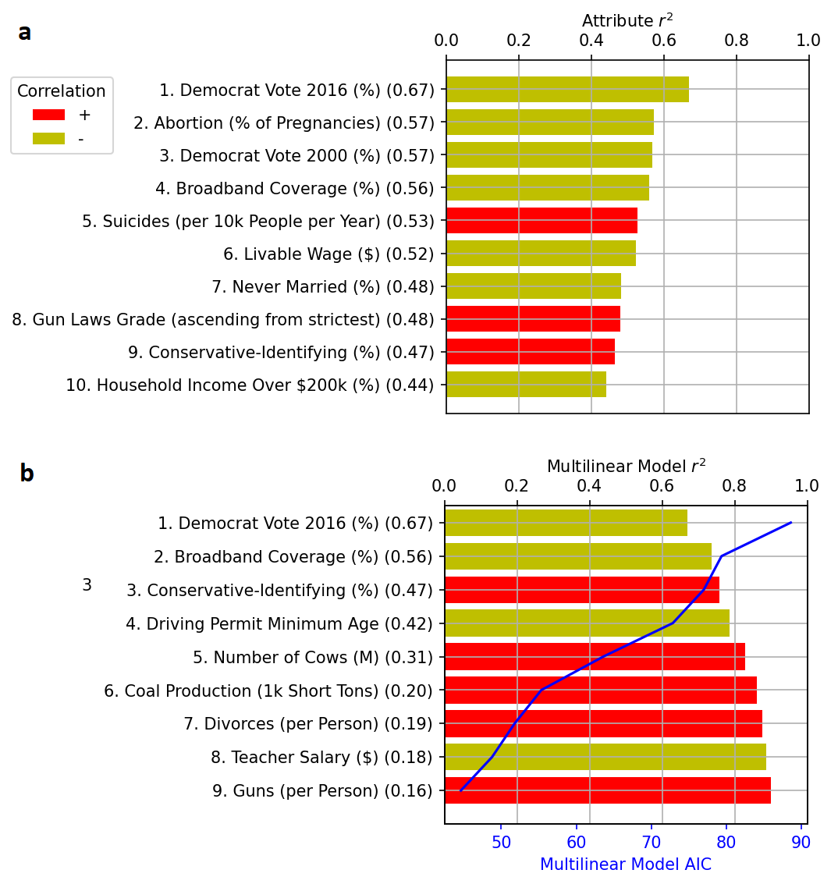
Figure 1. Data attributes ordered by correlation with climate disinformation impressions. (a) Individual attributes. (b) Multilinear model fits for attributes which add significant model parameters at 95% confidence. The r² of individual attributes is shown in brackets, and the sign of correlation with disinformation impressions is shown by the bar colour. Model AIC (Akaike Information Criterion) is also shown, where lower values show an improved fit, accounting for the number of fitted parameters.

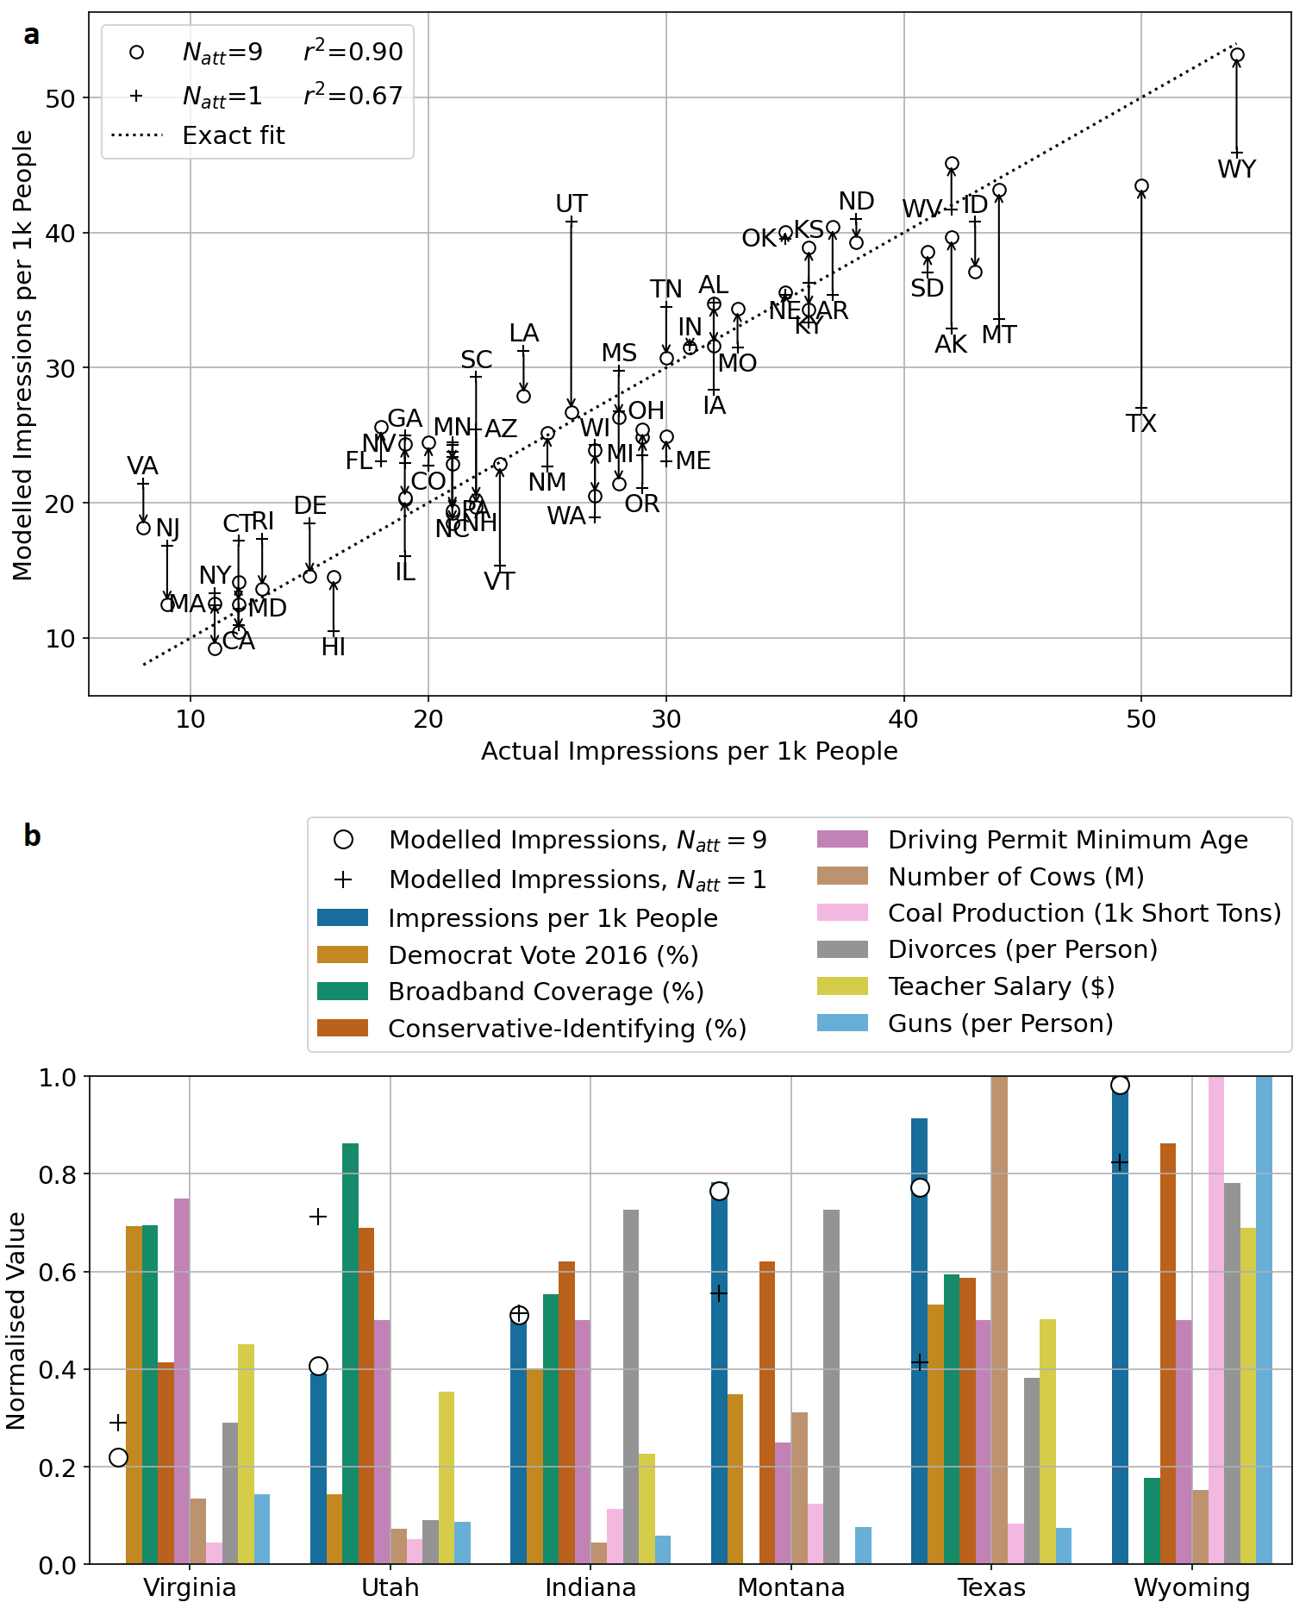
Figure 2. Comparison of model and data. (a) Model versus data for disinformation impressions using the 1st and all 9 data attributes, with arrows indicating the shift; two-letter state abbreviations are also shown. (b) Normalised data for selected states, with modelled disinformation impressions also shown.

