CONSORT 2010 Flow Diagram
Allocated to LDAC-T Ara-C 20mg twice a day for 10 days with Tosedostat120mg once a day for up to 6 months (n= 123)
♦ Received allocated intervention (n= 114)
♦ Did not receive allocated intervention (n=9)
Patient died before starting treatment (n=6)
Did not start treatment (n=2)
Randomised in error (n=1)
Figure 1. CONSORT flow diagram

Allocation

Follow-Up

Analysis (ITT)

Enrollment
Randomized (n= 247)
Allocated to LDAC Ara-C 20mg twice a day for 10 days (n=124)
♦ Received allocated intervention (n=116 )
♦ Did not receive allocated intervention (n=8)
Patient died before starting treatment (n=4)
Did not start treatment (n=1)
Randomised in error (n=3)

No survival data (n=0)
Withdrew from trial treatment (n=11)
No survival data (n=0)
Withdrew from trial treatment (n=8)
Analysed (n= 122)
♦ Excluded from analysis (n= 0)

Analysed (n=121)
♦ Excluded from analysis (n= 0)
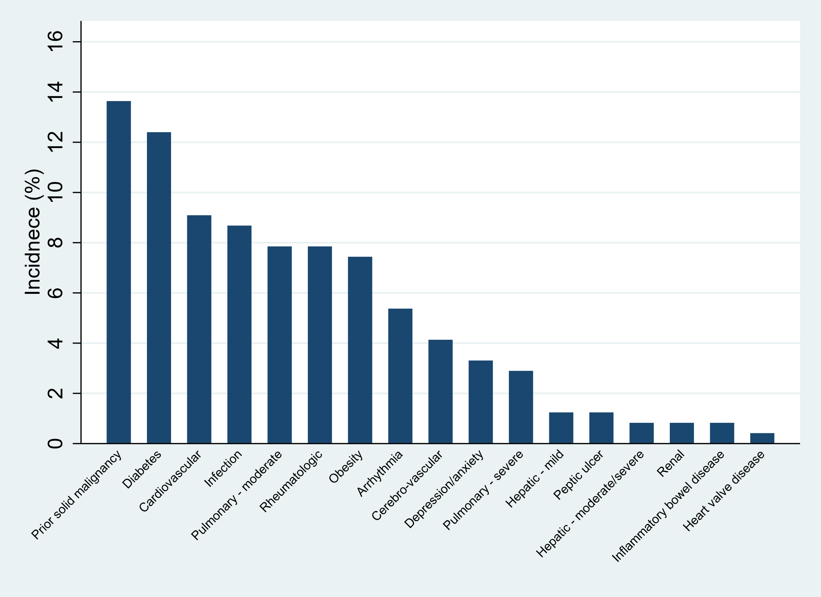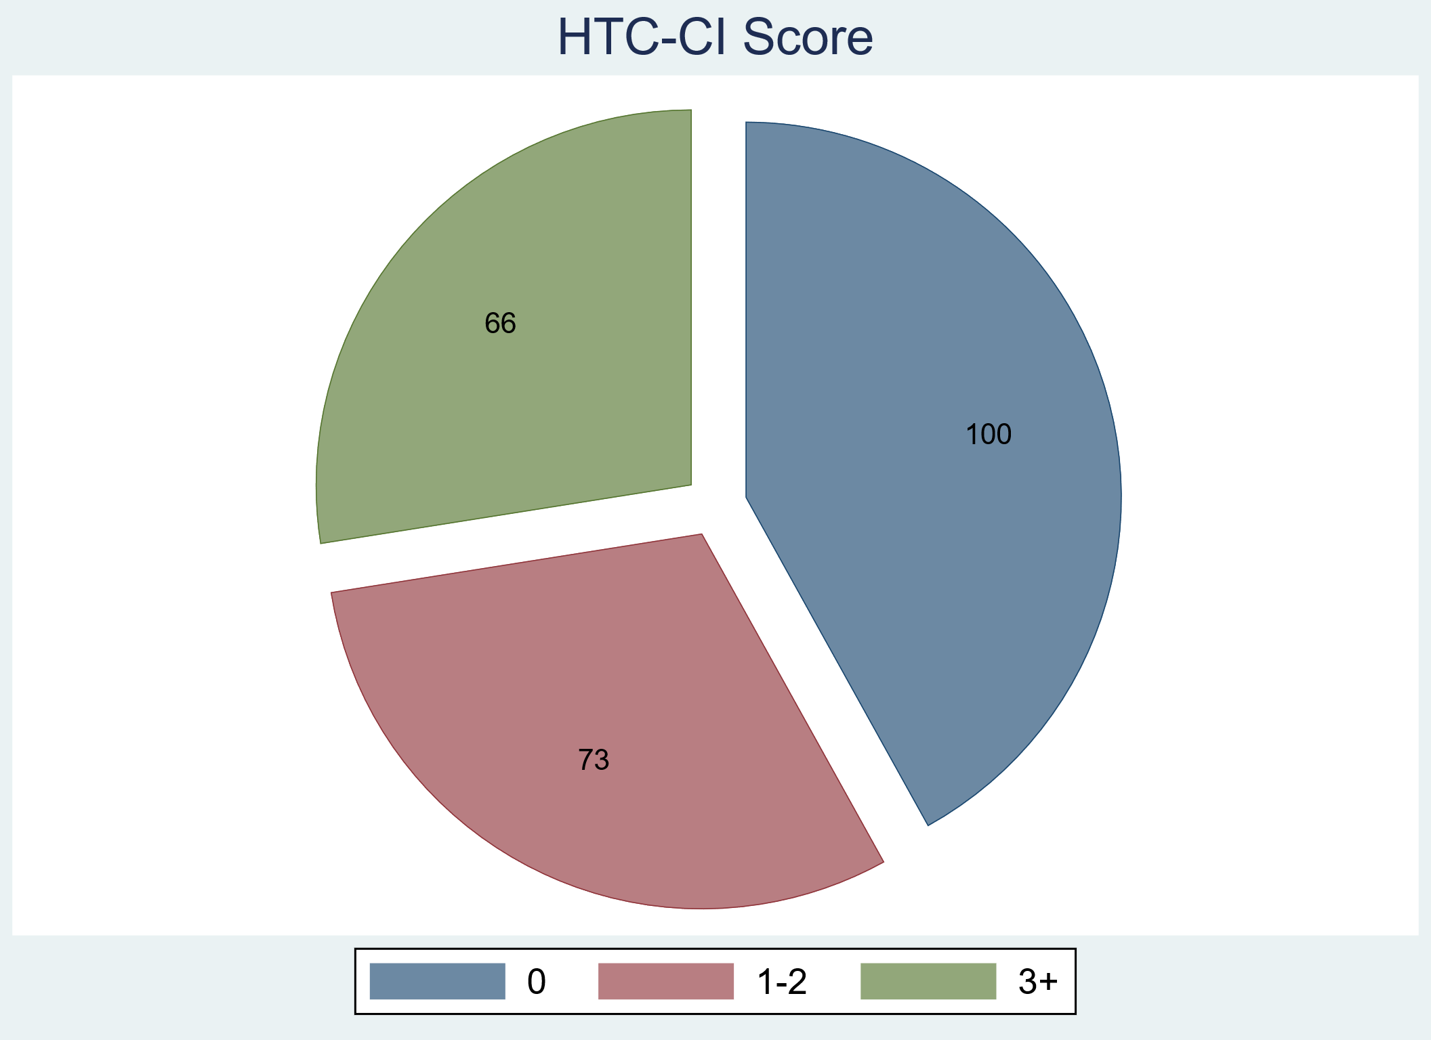
Figure 2. Co-morbidities

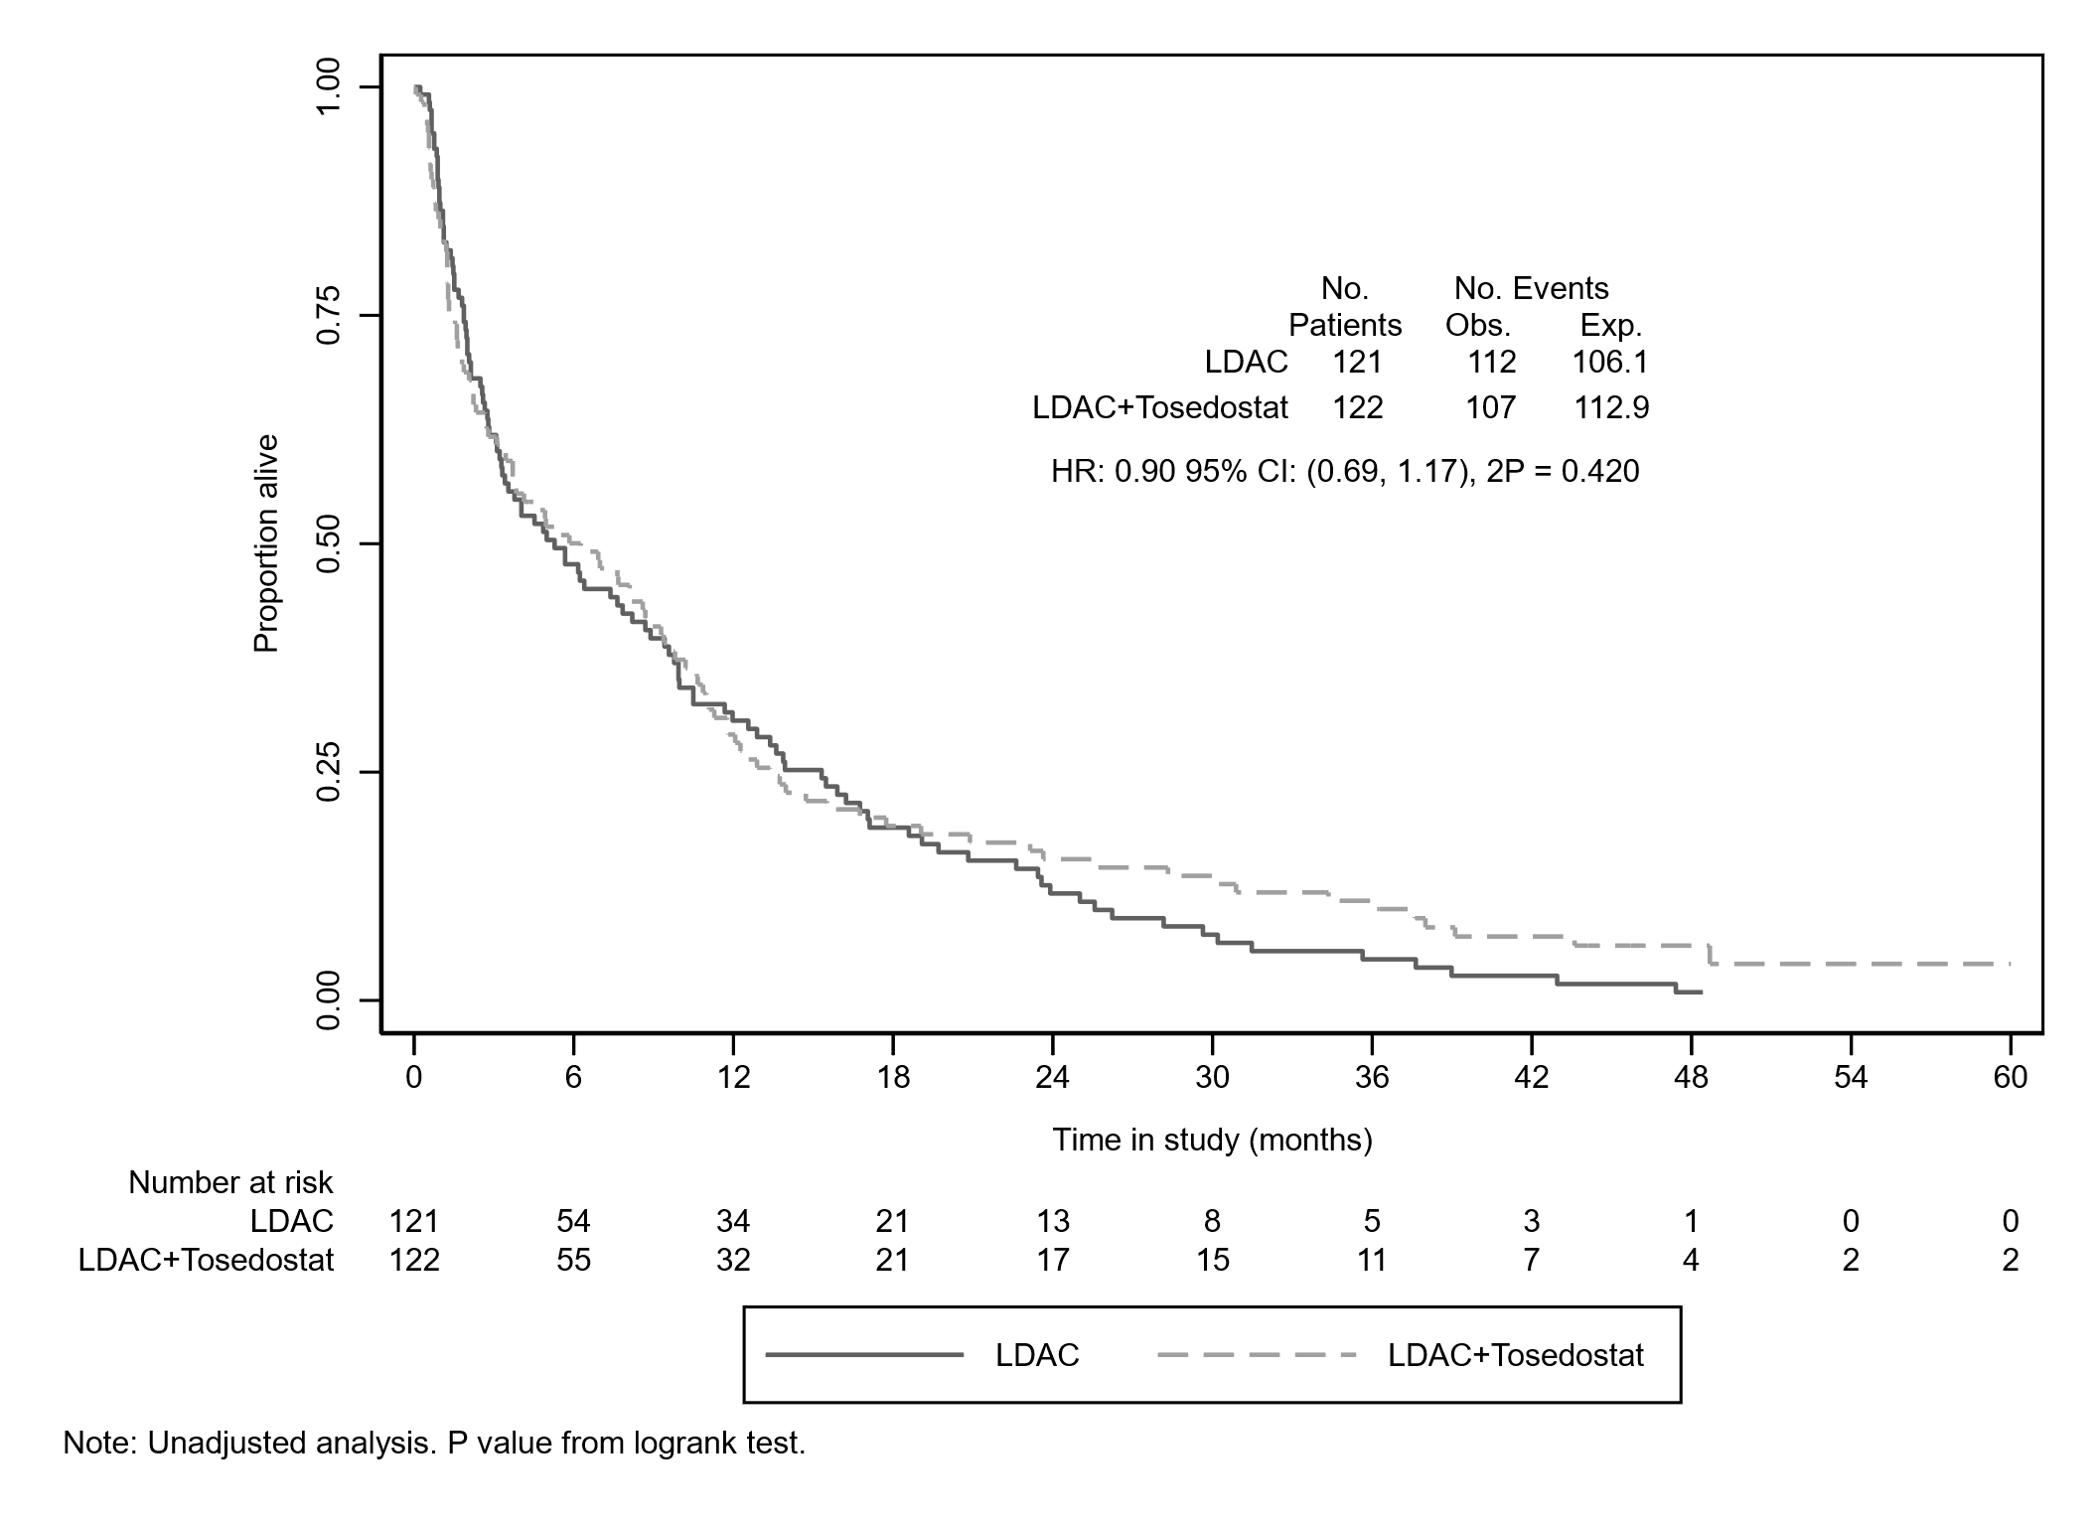
Figure 3a. Overall survival (OS)

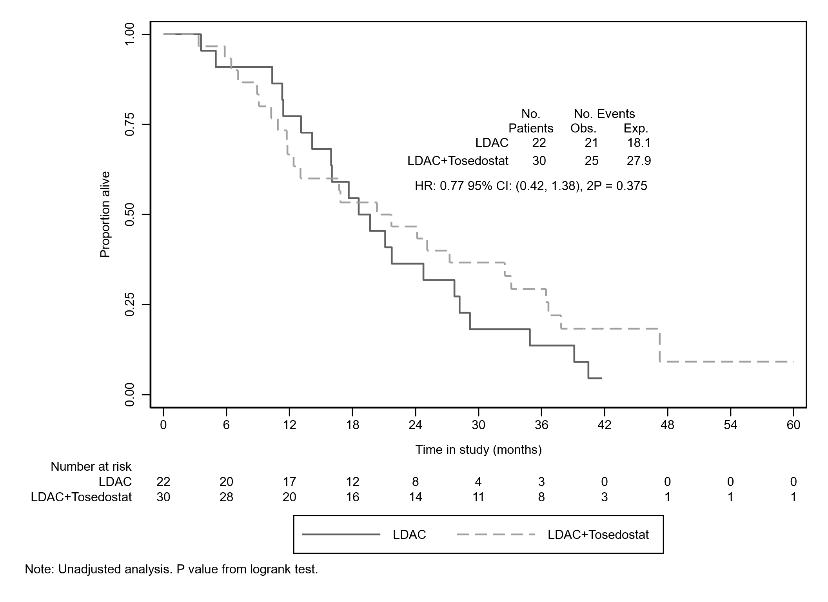

Figure 3b. Overall survival from complete response (OS from CR)

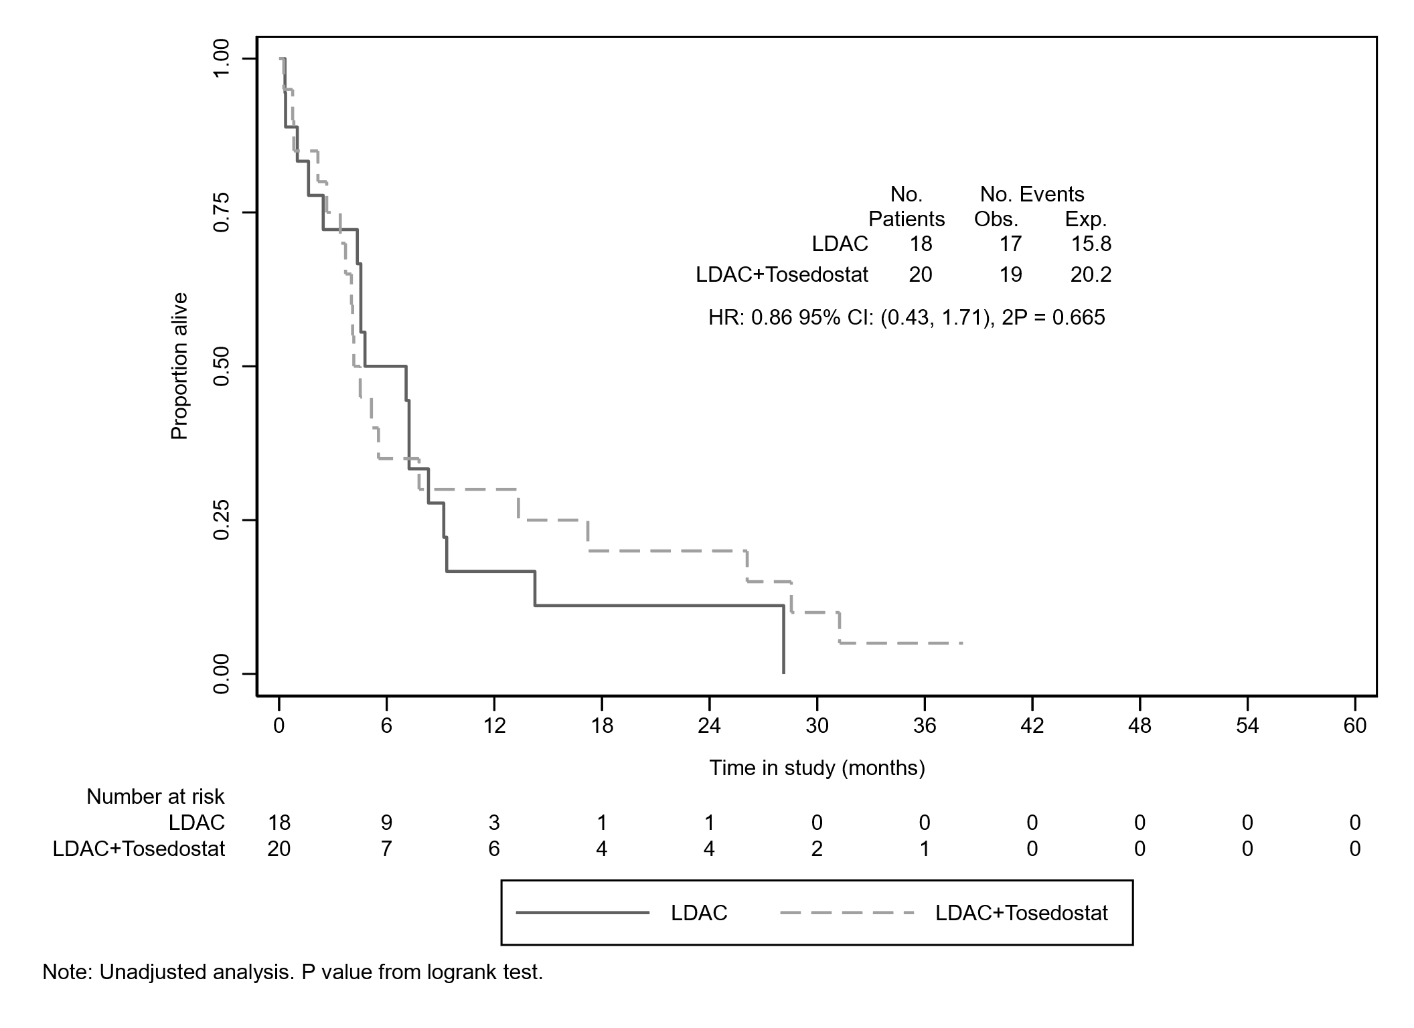
Figure 3c. Survival from relapse

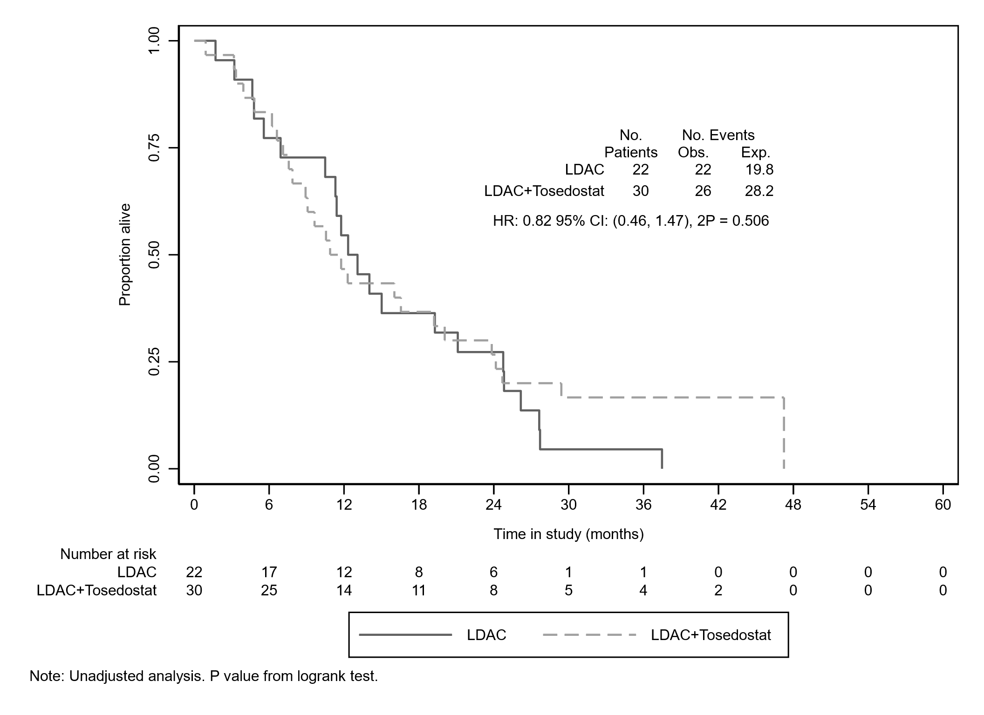

Figure 3d. Relapse free survival (RFS)

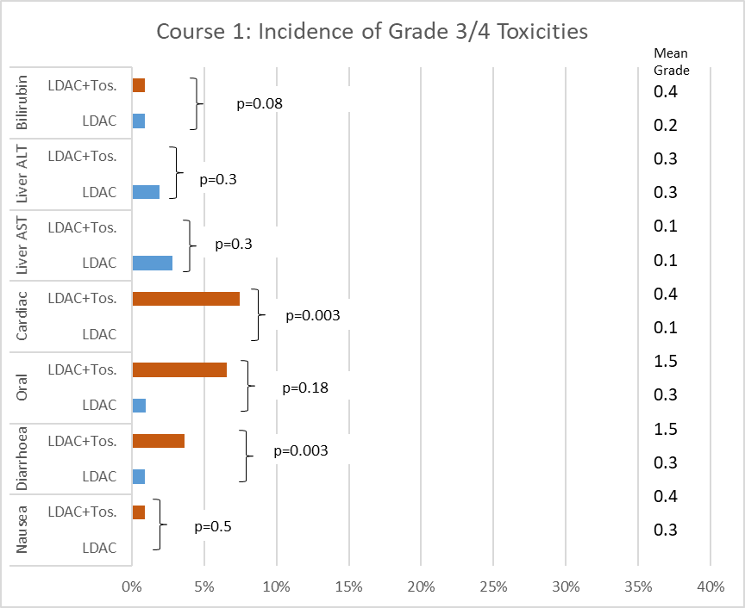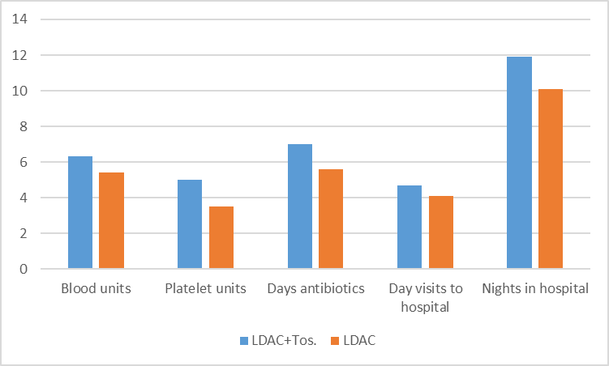

Figure 4a: Course 1 toxicity (expressed as percentage of patients) and resources used (the only significant difference between arms was an increased use of platelets in course 1 (mean 5.0 vs 3.5 pools p=0.006).

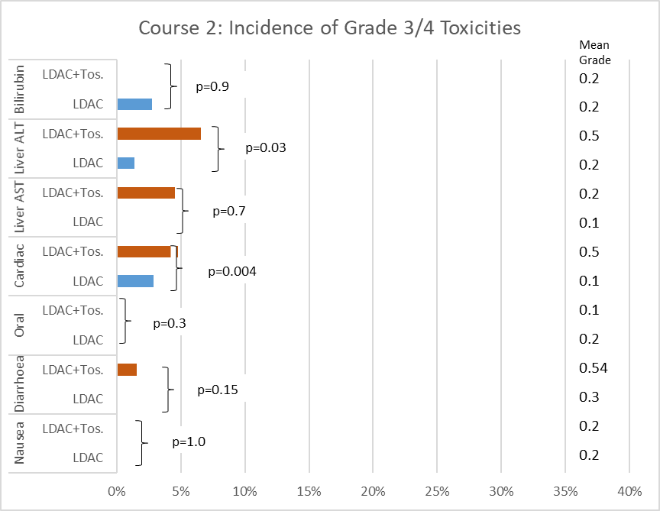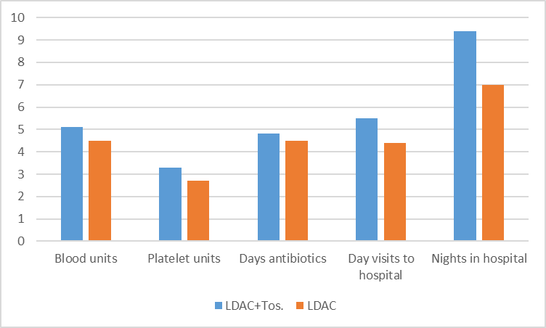

Figure 4b: Course 2 toxicity (expressed as percentage of patients) and resources used (no significant differences).

 | Treatment comparison
 | LDAC |  | LDAC+Tosedostat |  | Total
 | N=121 |  | N=122 |  | N=243
Age at entry (years)
Mean (SD) | 76.6 | (5.2) | 76.9 | (5.7) | 76.8 | (5.4)
Median (IQR) | 76.8 | (73.8, 79.9) | 76.9 | (73.0, 81.4) | 76.8 | (73.2, 80.7)
Min, max |  | (60.9, 88.9) |  | (61.6, 88.8) |  | (60.9, 88.9)
Missing (%) | 0 | (0.0) | 0 | (0.0) | 0 | (0.0)
Age group (years)
60-64 | 2 | (1.7) | 4 | (3.3) | 6 | (2.5)
65-69 | 12 | (9.9) | 9 | (7.4) | 21 | (8.6)
70-74 | 29 | (24.0) | 30 | (24.6) | 59 | (24.3)
75-79 | 49 | (40.5) | 41 | (33.6) | 90 | (37.0)
80+ | 29 | (24.0) | 38 | (31.1) | 67 | (27.6)
Missing (%) | 0 | (0.0) | 0 | (0.0) | 0 | (0.0)
Sex
Female | 47 | (38.8) | 51 | (41.8) | 98 | (40.3)
Male | 74 | (61.2) | 71 | (58.2) | 145 | (59.7)
Missing (%) | 0 | (0.0) | 0 | (0.0) | 0 | (0.0)
WHO performance status
0 | 27 | (22.3) | 27 | (22.1) | 54 | (22.2)
1 | 68 | (56.2) | 66 | (54.1) | 134 | (55.1)
2 | 21 | (17.4) | 23 | (18.9) | 44 | (18.1)
3 | 5 | (4.1) | 6 | (4.9) | 11 | (4.5)
Missing (%) | 0 | (0.0) | 0 | (0.0) | 0 | (0.0)
AML type
De novo | 81 | (66.9) | 80 | (65.6) | 161 | (66.3)
Secondary | 34 | (28.1) | 35 | (28.7) | 69 | (28.4)
High risk MDS | 6 | (5.0) | 7 | (5.7) | 13 | (5.3)
Missing (%) | 0 | (0.0) | 0 | (0.0) | 0 | (0.0)
WBC categories (10^9/L)
0.0 - 9.9 | 78 | (64.5) | 75 | (61.5) | 153 | (63.0)
10.0 - 49.9 | 28 | (23.1) | 29 | (23.8) | 57 | (23.5)
50 - 99.9 | 8 | (6.6) | 12 | (9.8) | 20 | (8.2)
100+ | 7 | (5.8) | 6 | (4.9) | 13 | (5.3)
Missing (%) | 0 | (0.0) | 0 | (0.0) | 0 | (0.0)
Cytogenetic status
Favourable | 1 | (0.8) | 1 | (0.8) | 2 | (0.8)
Normal/Intermediate | 79 | (65.3) | 78 | (63.9) | 157 | (64.6)
Adverse | 25 | (20.7) | 29 | (23.8) | 54 | (22.2)
Unknown | 16 | (13.2) | 14 | (11.5) | 30 | (12.3)
Missing (%) | 0 | (0.0) | 0 | (0.0) | 0 | (0.0)
Wheatley Index
Good | 8 | (6.6) | 5 | (4.1) | 13 | (5.3)
Standard | 45 | (37.2) | 43 | (35.2) | 88 | (36.2)
Poor | 68 | (56.2) | 74 | (60.7) | 142 | (58.4)
Missing (%) | 0 | (0.0) | 0 | (0.0) | 0 | (0.0)
Numbers are Mean (SD), Median (IQR), Minimum and Maximum or Frequency (%).

Table 1: Patient Characteristics.
 | Randomisation
 | LDAC+Tosedostat | LDAC | OR/HR (95% CI) | P value
 | N=121 | N=122
Patient status, n(%)
Resistant disease | 73 (60.3) | 83 (68.0)
Induction death | 19 (15.7) | 16 (13.1)
Achieved CR/CRi | 30 (24.8) | 22 (18.0)
Response outcomes, n(%)
CR | 23 (19.0) | 15 (12.3) | 0.61 (0.30-1.23) | 0.17
CRi | 7 (5.8) | 7 (5.7)
ORR (CR+CRi) | 30 (24.8) | 22 (18.0) | 0.68 (0.37, 1.27) | 0.22
Survival endpoints
30 day mortality | 16.2 | 13.5 | 1.26 (0.65, 2.46) | 0.5
60 day mortality | 31.2 | 27.5 | 1.20 (0.74, 1.93) | 0.5
1 year survival | 29.1 | 30.6 | 1.03 (0.76, 1.41) | 0.8
2 year survival | 15.5 | 11.7 | 0.97 (0.73, 1.28) | 0.8
1 year RFS | 46.7 | 54.5 | 1.63 (0.74, 3.59) | 0.22
2 year RFS | 26.7 | 27.3 | 1.41 (0.74, 2.68) | 0.3
2 year survival after remission | 46.7 | 36.4 | 0.88 (0.43, 1.80) | 0.7
1 year survival after relapse | 30.0 | 16.7 | 0.93 (0.45, 1.92) | 0.8
1 year survival no CR/CRi | 7.7 | 15.9 | 1.24 (0.90, 1.71) | 0.18
Notes:
Response endpoints are reported as n (%) and odds ratios comparing LDAC to LDAC+Tosedostat.
Survival endpoints are reported as Kaplan-Meier estimates (%) and hazard ratios comparing LDAC+Tosedostat to LDAC.
Table 2: Overall Outcomes: CR = complete remission, CRi = remission with incomplete counts, RFS = relapse free survival.
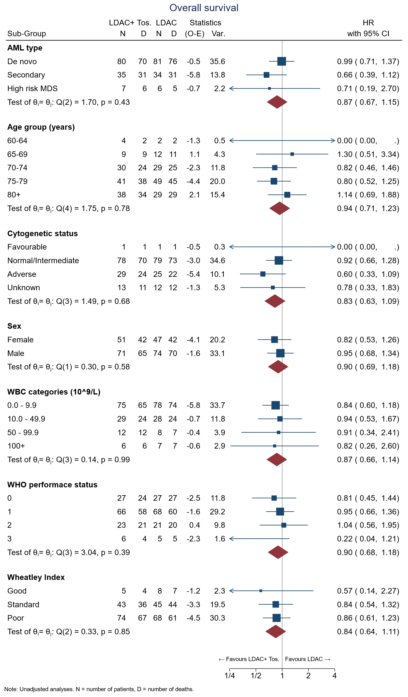
Supplementary Figure 2: Tests for Subgroup Interactions.

