Water-in-Oil Lecithin Microcapsule Production using an In-line Mixer

Daniel H. S. Harvey*¹, Alexandra Whittaker¹, Keith Arnold², John F. Mills³ and Dmitry G. Shchukin¹
This article highlights the feasibility of creating water-in-oil lecithin microcapsules, at predetermined sizes, at large-scale quantities (~80 kg/h) using the Controlled Deformation Dynamic Mixer (CDDM) mixer. The aim of this work was to create capsules with the exterior properties of oil and the fat content of water, with the impact being the replacement of oil in food formulations with water-in-oil capsules. Benchmark trials were performed using ultrasonic mixers and bench-top high-shear mixers, and the capsules created compared to those produced using CDDM technology. This work highlights that the CDDM is capable of both matching the ultrasonic mixer for capsule formulation, and can create capsules of varying size; dependent on the processing parameters used. Oil content of the capsules was reduced by over 85% resulting in water capsules with ~13% oil covering the shell, enabling the capsules to maintain the exterior properties of oil but with minimal fat.
Keywords: encapsulation; high-shear mixing; rotor-stator; microcapsule; nanocapsule; obesity

¹ Department of Chemistry, University of Liverpool, Crown Street, Liverpool, L69 7ZD UK DHarvey@liverpool.ac.uk

² Materials Innovation Factory, University of Liverpool, Oxford Street, Liverpool, L7 3NY UK

³ C-Tech Innovation Limited, Capenhurst Technology Park, Capenhurst, Cheshire, CH1 6EH
Introduction
Obesity is currently directly responsible for over 10,000 hospital admissions per year and is a factor in the admission of over 700,000 hospital admissions per year; worryingly 29% of adults in the UK are obese, as are 20% of 11 year olds (NHS Digital, 2019). Obesity and a high-fat diet are responsible, directly and/or indirectly, for multiple health conditions including male infertility, hepatic steatosis, type 2 diabetes, atherosclerotic cardiovascular disease and depression (Ferramosca and Zara, 2014; Ferramosca et al., 2018; Grundy, 2004; Reynolds et al., 2018). Cardiovascular disease and obesity can be reduced through reducing total fat intake (Chen et al., 2020), particularly through the reduction of saturated fats (Hammad, 2016). Furthermore, through reduction in fat intake, obesity can be reduced, and health can begin to be restored to patients (Hooper et al., 2012). Dr Kermit Jones highlighted that obesity is also a major factor for dying of Covid-19 (Jones, 2020) and this was confirmed following further studies by Public Health England (Gov.UK, 2020). To aid in the reduction of obesity through consumption of oil containing products, this work looks to replace fatty oil in foods with water through replacement of pure oil with oil covered lecithin capsules and liposomes.
Liposomes were first reported by Bangham, et al. in 1965 and the publication led to extensive research in the field with many applications being discovered, such as in food, nanomedicines and cosmetics (Bozzuto and Molinari, 2015). A liposome is one or more phospholipid bilayers that are arranged spherically and are able to trap functional compounds, the properties of which can vary considerably with surface charge, method of preparation and particle size (Nguyen et al., 2017). Liposomes are particularly desirable materials due to their initial functionality, and the ability to further tune that functionality by chemical or enzymatic resolution further along in the processing (Shivakumar et al., 2012).
Lecithin is the phospholipid of choice due to it being a naturally occurring material that can be obtained from multiple sources (extraction can from egg yolk, yeast or soybeans), it provides high permeability of the liposome membrane and has a low cost, minimising production expenses (Nguyen et al., 2017; Tattrie et al., 1968). Work performed by Machado et al. (2014) highlighted lecithin as being a suitable encapsulation reagent for not only food, but for various materials, including both medical and pharmaceutical. Although no consumer studies have yet been performed on lecithin capsules containing water with oil bonded to the capsule exterior, lecithin derived from soy is currently used in chocolate manufacture where it is used as a flow enhancer (Böhme et al., 2016) implying that not only is lecithin safe to eat, there is a place for it in a sweet foods. The chemical structure of phosphatidylcholine (lecithin) is provided in Fig. 1.
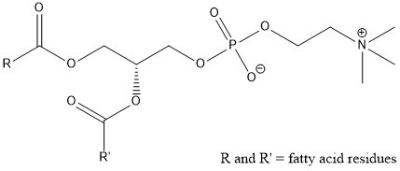
Figure 1. Chemical structure of lecithin (phosphatidylcholine).
There are many publications on lecithin however of particular interest is that Chen et al. reported the production of liposomes using lecithin (from different sources) forming with oil and water due to the polar area of the phosphatidylcholine packing together to leave the nonpolar part of the molecule in the bulk of the continuous phase (Chen et al., 2012). As the aim of this work is to mass produce water capsules with a lecithin and oil shell previous work highlighting it is feasible at small scale is of relevance.
Ultrasonic mixers provide a different way of mixing to standard impeller devices and high-pressure homogenizers. They produce acoustic cavitation which results in the growth, oscillation, and collapse of microbubbles in the fluid medium (Skorb et al., 2010). The subsequent impact of these microbubbles causes chemical and physical changes to both the reagents involved and their surroundings (Skorb et al., 2010). Over the past decade sonochemistry has transformed from being an exotic art to a technique used by chemists in a multitude of research areas (Belova et al., 2010). Food chemistry has significantly advanced from producing a simple emulsion using ultrasonic mixing, to utilising ultrasonic to specifically enhance the stabilising properties of an emulsion system (Abismaïl et al., 1999; Lad and Murthy, 2012; Sui, et al., 2017).
The Controlled Deformation Dynamic Mixer (CDDM) is a unique mixing technology designed and developed to allow for both distributive and dispersive mixing (Brown et al., 2012). By moving the stator up and down the rotor, through the addition of shims of specific sizes, the stator can be displaced relative to the rotor and allow the operator to move through the different mixing modes (Fig. 2).
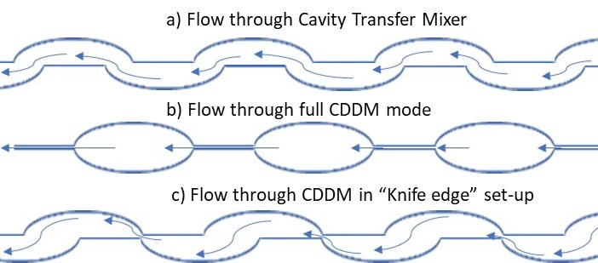
Figure 2. Illustration showing flow of fluid through a) cavity transfer mixer, b) full CDDM mode and c) CDDM knife (Harvey et al., 2019).
The CDDM has shown previously it is capable of processing plant fibres and creating products of equal viscosity to industrially used high-pressure homogenizers (Harvey et al., 2019). The ability to configure the mixer depending on the reagents and required product makes the potential of this mixer vast and allows investigation into the impact of pressure and mixing speed upon capsule formation. This work involves utilising both the dispersive elements of the mixer to obtain as small capsules and liposomes as possible in order to mimic oil droplets, whilst utilising the distributive aspect to ensure that they are evenly distributed throughout the fluid medium. Unlike ultrasonic mixers, the CDDM is capable of large-scale production through in-line mixing and high-flow rates.

Materials and Methods

2.1 Materials
Lecithin, 90% purity from soybean, was purchased from Alfa Aesar, composed of 90% phosphatidylcholine, along with 10% impurities such as phosphatidylethanolamine, lysophosphatidylcholine and triglycerides (Choi et al., 1999). Both Sunflower oil and vegetable oil (rapeseed oil) were purchased from food retailers, the brands of oil remaining the same throughout the study.

2.2 Mixers
Four different mixers were evaluated for their efficiency in lecithin capsule formation: an ultrasonic probe (QSonica Q700 Sonicator, QSonica, Newtown, Connecticut, USA), an Ultra-Turrax T25 basic homogenizer (IKA-Werke, Staufen, Germany), an Ultra-Turrax T50 homogenizer (IKA-Werke, Staufen, Germany) and a Controlled Deformation Dynamic Mixer (TecExec Ltd, Glossop, UK).
Prior to formulation using the Controlled Deformation Dynamic Mixer (CDDM) the premix formulation was gentle stirred with a EUROSTAR Power Control-Visc Stirrer (EURO-ST P CV S2, IKA-Werke, Staufen, Germany).

2.3 Analytical Apparatus
A Malvern Mastersizer 3000 (MS3000) capable of analysing particles of sizes between 10nm and 3.5mm was used to determine the size of the capsules; the Hydro MV sample dispersion unit filled with water and operated at a pump speed of 2400 rpm to analyse the oil-in-water capsules, and the Hydro SV sample dispersion unit filled with vegetable oil was operated at 1800 rpm using a micro magnetic stirrer bar to analyse the water-in-oil capsules. The D[3,2] value known as the Sauter Mean Diameter or Surface Area Moment Mean is calculated to be the ratio of the total volume of the particles to the total surface area; the smaller the number, the smaller the capsules are in size (Phadke and Eichorst, 1991). To obtain D[3,2] values for the capsules the samples were left to separate out via gravimetric separation as due to the stable lecithin capsule coating there was no agglomeration. Following the formation of two clear layers, an aliquot of the capsule layer was added dropwise into the sample dispersion unit until the obscuration was at the appropriate level (between 3-5% for sub-micron capsules, 5-10% for 1µm-100µm capsules). The MS3000 then performed laser diffraction on the samples using the following parameters; refractive index of 1.475 for the capsules as although 1.465 is the RI for both rapeseed oil and sunflower oil (Aparicio et al., 2018), the lecithin shell will increase it slightly, and an absorption of 0.001. Five measurements were taken for each sample using both red laser and blue light analysis to ensure nothing was missed. The span of each sample was taken and recorded for further analysis and scrutiny of the particle size data produced. The span is a measurement produced automatically by Malvern Mastersizers and is “the difference between the 10th and 90th percentiles, divided by the median particle size” (Kippax, 2013). The span is used to determine how broad or tight the particle size distribution is.
An Olympus BX53 Microscope was used to perform optical microscopy on the capsules. Each sample analysed was left to separate out via gravimetric separation, before a small aliquot (~20µL) of the capsule layer was placed on a glass slide, a cover slip placed over the top, and analysis performed using transmission microscopy.
A Tescan S8000G Focused Ion Beam/Scanning Electron Microscope (FIB/SEM) fitted with Quorum Technologies PP3010 cryogenic system was used to study the water-in-oil microcapsules following liquid nitrogen slushing. Energy Dispersive Spectroscopy (EDS) was used to analyse the microcapsules in the FIB/SEM (Oxford Instruments Aztec).

2.4 Oil-in-Water (O/W) Capsules
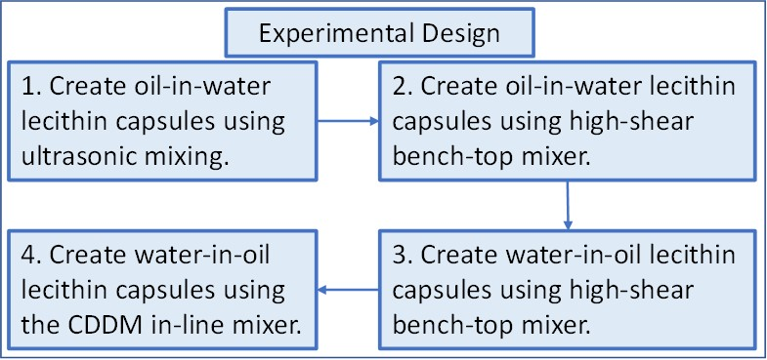
Figure 3. Flow diagram detailing the complete experimental design.
To create a benchmark for this work, as per the experimental design in Fig. 3, a series of ultrasonic trials were performed using a QSONICA Q700 Sonicator with a power rating of 700 Watts, and a frequency of 20 kHz. The materials were added to the sample vessel (vessel size 300mL) with a total working volume of 100mL before the sonicator was switched on and the reagents were mixed for 120 seconds.
The second step of the experimental design required creation of oil-in-water lecithin capsules using high-shear mixing. Trials were performed using bench-top homogenizers Ultra-Turrax T25 basic and Ultra-Turrax T50. The reason two high-shear mixers were used is because this allowed an investigation of the impact of impeller speed from 250 rpm through to 24000 rpm. The method of capsule preparation is identical to the ultrasonic with the exception being the temperature of the high-shear mixer trials was kept constant at 40°C to prevent the mixer being blocked, and to enable calorimetric analysis to be performed on the ultrasonic trials.

2.5 Water-in-Oil (W/O) Capsules
A premix was prepared involving powdered lecithin (2 wt%) distributed within vegetable oil (78 vol%); the reagents were gently stirred and water (20 vol%) was slowly added while the formulation was mixed using a EUROSTAR Power Control-Visc Stirrer (fitted with a Jiffy Mixer HS-1 stirrer) at 750 rpm for 120 seconds. This premix slurry was then processed initially using the Ultra-Turrax T25 basic to ascertain whether water-in-oil capsules could be created. Upon successful creation of them, a 2kg batch of premix slurry was formulated and processed using the CDDM where it resided in the mixing chamber for less than a second.

Results and Discussion

3.1 Ultrasonic Oil-in-Water Mixing Trials
Work performed by Sui et al., in 2017, highlighted that ultrasonic mixing of lecithin and soybean protein isolate can result in stabilized emulsions, dependent on the processing parameters (Sui et al., 2017). The data in Fig. 4a confirms their findings and highlights the fact that the size of the lecithin capsules is dependent on the amplitude of the ultrasonic mixer; increasing amplitude reduces the size of the capsules and liposomes produced.
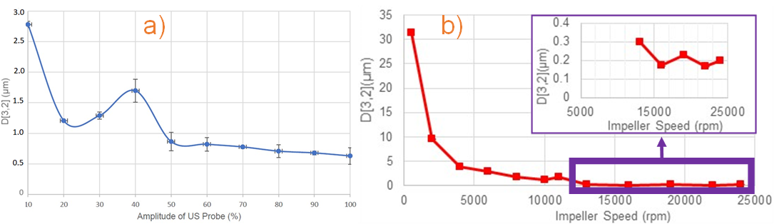
Figure 4. Capsule size as affected by a) Amplitude of ultrasonic probe. b) Impeller speed of high-shear mixer.
The data in Fig. 4a for trials performed with an amplitude of 30% and 40% show an increase in size with increasing amplitude from the ultrasonic probe, rather than a decrease in size with increasing amplitude, leading to larger capsules being formed at these input values. One hypothesis is this occurs because particles are coalescing at these specific energy input, an occurrence referred to as ‘over-processing’ at specific energies (Desrumaux and Marcand, 2002; Sui et al., 2017). Tornberg describes "overprocessing" as an instance which can occur when most flocculated emulsions are stabilised by soy protein (Tornberg, 1980). It should be noted that the larger error on the measurement at 40% amplitude highlights that the “overprocessing” phenomena can vary quite substantially with respect to resulting particle size.
Work performed in 2006 by Shchukin et al., demonstrated that polyelectrolyte capsules, specifically those without inorganic nanoparticles in, can become deformed after sonification (Shchukin et al., 2006). Instead of continuing to decrease in size as the ultrasonic amplitude is increased; this proposes another hypothesis that the “over-processing” could simply be the capsules undergoing a process of deformation, and as such they are larger when analysed using particle sizing techniques.
A third hypothesis for the overprocessing phenomena is that when ultrasonic mixing using at an amplitude value between 30-40%, annealing could be occurring between smaller capsules forming larger ones. Wang et al., reported in 2013 that annealing takes place when nanoparticles have contact with hot spots, which are short lived and micrometer sized (Wang et al., 2013). If the lecithin undergoes annealing then the ~1µm sized capsules will merge with smaller ones forming capsules ~1.5µm sized capsules.
Confirming the findings of previous work on the formation of lecithin capsules using ultrasonic created a benchmark with which comparison to the impact of high-shear mixing on the formulation of lecithin liposomes and capsules could be compared to.

3.2 Ultra-Turrax Oil-in-Water Mixing Trials
The results from these trials are very similar to those from the ultrasonic mixing trials; the data in Fig. 4b shows that as impeller speed increases, the size of the capsules formed decreases. It can be seen in Fig. 4b that there is an instance of “overprocessing” when the high-shear mixers are operating around 11,000 rpm. This may simply be that 11,000 rpm is the lowest speed at which the Ultra-Turrax T25 basic homogenizer operates at, as the Ultra-Turrax T50 homogenizer has a maximum speed of 10,000 rpm, and at its lowest speed the T25 is not able to match the T50 when operating at full power. As a similar “bump” in the curve has been observed in Fig. 4a it is proposed that 11,000 rpm is the speed at which overprocessing occurs and that the impeller speed of the homogenizer is not the reason for the increase, particularly as the drop back down to the curve is so rapid following this.
The data in both Fig. 4a and Fig. 4b indicate that the greater the energy input into the system, the smaller the lecithin capsules produced. It is noteworthy to highlight that the change in mixer had limited impact on the capsules produced, there is almost no variation in the trendline whatsoever and repeats of the trials yield results so identical that the error bars which are present on the graph, appear invisible.
To confirm the size of the capsules, and ensure they were not merely artefacts of the particle size analyser, microscopy was utilised to obtain visual images of the capsules formulated. The images displayed in Fig. 5a provide a visual representation of the formulated capsules that supports the particle size data presented in Fig. 4a and Fig. 4b. It can be observed that at slower speeds there are a lot of larger capsules, and that as the impeller speed is increased, significantly smaller capsules are formed, and the larger capsules are fewer, if at all present.
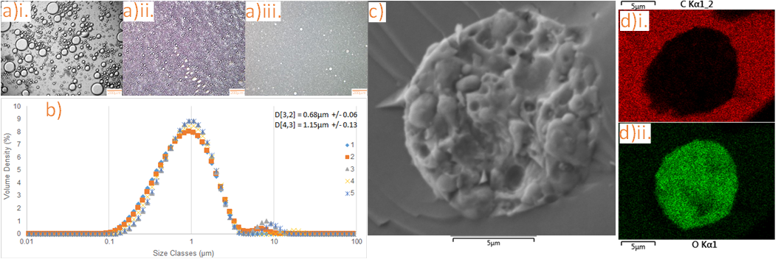
Figure 5. a) Microscopy images of lecithin capsules produced using the Ultra-Turrax mixer at i. 500 rpm. ii. 11,000 rpm. iii. 24,000 rpm. The scale bar in each image is representative of 200µm (length). b) Particle Size Distribution of Water-in-Oil capsules. c) Cryo-Scanning Electron Microscopy image of the capsules produced using the CDDM. d)i) Energy Dispersive Spectroscopy (EDS) of the capsules shown in c) with focus on carbon. d)ii) Energy Dispersive Spectroscopy (EDS) of the capsules shown in c) with focus on oxygen.

3.3 Controlled Deformation Dynamic Mixer Water-in-Oil Mixing Trials
Several bench-top homogenizer trials were performed to determine the maximum water content that could be used to make water-in-oil capsules following the premix formulations steps; ~20% water phase was found to be the optimum water quantity to use. Percentages of water 25% and above resulted in the formation of large oil-in-water capsules with few water-in-oil capsules produced.
Based on the findings from the bench-top trials it was determined that a high amount of energy would be required to be input into the system in order to get as small capsules as possible. A high impeller speed (15,000 rpm), with a constant flow (80 kg/h) and the CDDM set in the “knife-edge” position were the predetermined parameters. The data displayed in Fig. 5b shows the results of a single trial at these process parameters with each separate analysis numbered. It can be observed [from the data in Fig. 5b] that the CDDM is capable of not only producing capsules of equal size in large quantities, the resultant size of these water-in-oil capsules is comparable with the oil-in-water capsules produced using the ultrasonic mixer at 100% amplitude. To confirm the size of these smaller capsules, cryogenic temperature scanning electron microscopy (Cryo-SEM) was used.
The cryo-SEM image (Fig. 5c) shows the presence of multiple sub-micron capsules, supporting the particle size data in Fig. 5b. This corroborates with the data obtained during the bench-top ultrasonic and bench-top ultra-turrax trials, that the particle size data is accurate and that the capsules have been formulated and are present. It appears that during the cryogenic freezing process, smaller capsules have agglomerated, giving the appearance of a larger capsule, however upon closer observation the sub-micron capsules can be seen and appear to be almost spherocylindrical in shape.
Energy Dispersive Spectroscopy (EDS) performed on the sample confirms that the capsules are water-in-oil as there is little detection of carbon within the capsules due them being filled with water, however they are surrounded by a large presence of carbon in the form of oil. This is displayed in the EDS image in Fig. 5d)i where carbon is highlighted in red. To confirm this hypothesis, EDS images were taken with a focus on the presence of oxygen. Fig. 5d)ii shows the same sample with an incredibly high presence of oxygen throughout the capsule [coloured green]. The oxygen in the oil surrounding the capsule can be seen as there are green dots scattered around the capsule, however they are very small in comparison to the intense green of the capsule where oxygen is concentrated as a result of the water. Although the capsule shell itself is rich in carbon, as is the oil within which it resides, the significantly larger quantity of water that fills the interior of the capsule makes the detection of the carbon incredibly difficult using EDS; the presence of the oxygen in the water is clear due the dense presence of it.
The percentages of oil, water and lecithin within the final capsules was determined theoretically by mass. The capsules were removed using gravimetric separation, due them having a greater density than the oil. Following processing it was calculated that ~13% of the oil remained bonded to the lecithin of the capsules (Table 1).
Table 1. Percentages of reagents from a production run of lecithin microcapsules using in-line mixer.
 | Water Phase (including lecithin) (%) | Oil Phase (%)
Prior to formulation | 23.3 | 76.7
Recovered following processing | 36.1 | 63.9
Difference | 12.8 | 12.8

From the data in Table 1 it can be hypothesised that replacing 100% of oil within a formulation with these water-in-oil capsules will result in a fat reduction (of that contributed by the oil) of ~87%, with the majority of the fat replaced with water and lecithin. The removal of the final amounts of oil bonded to the capsules is currently unrequired because they provide the capsules with the exterior properties of oil, allowing them to bond as they would if they were entirely oil.

3.4 Specific Energy Required to make Lecithin Capsules
The specific energy required to make the lecithin capsules using the QSonica Q700 Sonicator, the Ultra-Turrax T25 basic homogenizer and the Controlled Deformation Dynamic Mixer (CDDM) is reported in Table 2.
Table 2. Specific energy required by each mixer to make the smallest lecithin capsule reported using each mixer.
Mixer | Capsule Formed | Smallest D[3,2](µm) | Span | Specific Energy Required
Ultra-Turrax T25 | Oil-in-Water | 0.168 | 3.65 | 2.2 kJ/kg
CDDM | Water-in-Oil | 0.677 | 1.94 | 14.5 kJ/kg
Q700 Sonicator | Oil-in-Water | 0.620 | 2.04 | 120 kJ/ kg
Q700 Sonicator at 50% Amplitude | Oil-in-Water | 0.720 | 2.06 | 60 kJ/ kg

To calculate the specific energy for the CDDM to create the lecithin capsules, both the rotational power and the power resulting from the pressure driven component of it must be calculated. The rotational power is calculated using the expression for turbulent power draw developed by Kowalski et al., (2011):
$Power\left(W\right)=P_{oz}ρN^{3}D^{5}+k_{1}ṁN^{2}D^{2}$ (1)
where P_{oz} = 0.1, ρ is the density, N denotes the rotations per second, D is the diameter in metres, k₁ = 10, and ṁ is the mass flow rate (kg s^{–1}).
The power resulting from the pressure driven component is then calculated (Harvey et al., 2019):
$Power= ∆P\frac{ṁ}{ρ}$ (2)
The specific energy is subsequently obtained through dividing the sum of the power calculated using equation 1 and equation 2, then dividing them by the mass flow rate (Harvey et al., 2019):
$Specific Energy= \frac{Total Power}{ṁ}$ (3)
The power used by the Ultra-Turrax T25 has been calculated using the first half of equation 1 (as there is no flow rate) and using the same P_{oz} value as the CDDM.
$Power\left(W\right)=P_{oz}ρN^{3}D^{5}$ (4)
The power used by for the QSonica Q700 sonicator is displayed during processing and was recorded.
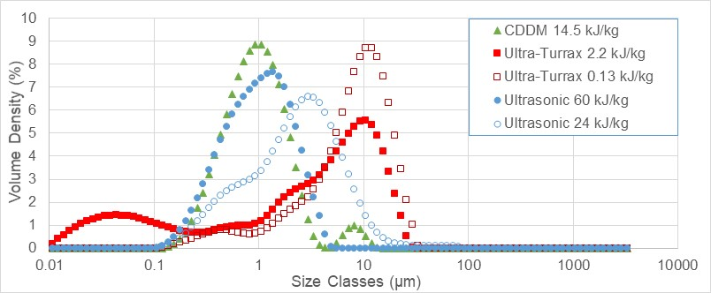
Figure 6. Particle size distribution of capsules produced by the three mixers using the respective specific energy values listed.
The data in Fig. 6 shows that a bimodal distribution is obtained for both the high-shear mixers when analysed using a particle sizer. Large capsules are formed as soon as the reagents begin mixing and are broken down and reformed into smaller capsules, however a point is reached when the capsules size becomes so small that it requires more power than is being inputted to break them down further. In the case of the CDDM it can be argued that there is simply not enough time within the mixing chamber for all the larger capsules to be further broken down, as the time spent within the mixer is a fraction of a second when operating at high flow rates.
Ultrasonic mixing follows the same pattern as high-shear mixing with regards to the particle size distribution initially being bimodal, however after enough energy has been transferred into the system, monomodal distribution appears to be obtained. It is of great interest, and worth highlighting, that when operating at 50% amplitude, and thus using 50% less energy, the ultrasonic mixer is still capable of creating capsules with a monomodal distribution (Fig. 6).
Based on the evidence in Fig. 6 we can conclude that the greater the energy input into the system, the smaller the size of capsules generated. This statement is contrary to the values presented in Table 2 when looking solely at the D[3,2] value, however when taking into account the span, a significantly different view of the capsules created is observed. The Ultra-Turrax T25 capsules, although having a D[3,2] value of 168nm, have a span of 3.65, a value 77% higher than that of the Q700 capsules, and 88% greater that that of those produced by the CDDM. Combining the span results with the particle size distribution curves in Fig. 6 confirms that although the Ultra-Turrax is able to make the smallest capsules, the majority of the capsules are significantly larger that the D[3,2] value and both the CDDM and the Q700 sonicator are capable of making a significantly larger quantity of smaller capsules.

Conclusion
This work has shown that it is possible to make stable water-in-oil lecithin microcapsules at flow rates of 80 kg/h using a high-shear in-line mixer. The microcapsules created using the CDDM are parity in size to the oil-in-water capsules formulated using an ultrasonic mixer (~680 nm in size) and require less specific energy to formulate. The capsule size is controllable due to it being a result of energy input into the system, and as such the water-in-oil capsules can be made to a predetermined size, depending on the requirement. It is proposed that these microcapsules can replace oil in food formulations, significantly reducing the fat content of the final formulation. Replacement of pure oil would aid in the reduction of the fat content of food products and positively reduce obesity that is detrimental to the health of millions globally. Theoretically the water-in-oil capsules should behave as oil droplets as the entire shell is surrounded with oil, however it is recommended further work be performed to confirm this. Further work should also look to ascertain the impact of higher flow rates than those observed. Based on the findings of this work, capsules of the same size should be able to be produced at higher flow rates but with lower shear, as the energy input is the determining factor with regards to capsule size.

Conflicts of interest
There are no conflicts to declare.

Acknowledgements
Funding: This work was supported by Innovate UK (Project 102695), ERC Consolidator grant (Project 647969) and and RSC International Exchanges grant IEC/R2/202163

References
Abismaïl, B., Canselier, J.P., Wilhelm, A.M., Delmas, H. & Gourdon, C. (1999). Emulsification by ultrasound: drop size distribution and stability. Ultrasonics Sonochemistry, 6, 75-83.
Aparicio, R., García González, D. L. and Aparicio-Ruiz, R. (2018). Vegetable Oils. In: Morin, J-F and Lees, M. FoodIntegrity Handbook A guide to food authenticity issues and analytical solutions. Nantes, France: Eurofins Analytics France, pp.359-382.
Belova, V., Gorin, D. A., Shchukin, D. G. and Mӧhwald, H. (2010). Selective Ultrasonic Cavitation on Patterned Hydrophobic Surfaces. Angewandte Chemie-International Edition, 49, 7129-7133.
Böhme, B., Symmank, C. and Rohm, H. (2016), Physical and sensory properties of chocolate made with lecithin of different origin. Eur. J. Lipid Sci. Technol., 118: 1839-1845.
Bozzuto, G. & Molinari, A. (2015). Liposomes as nanomedical devices. International Journal of Nanomedicine, 10, 975–999.
Brown, C. J., Irving, G. N. & Kowalski, A. J. (2012). US Patent 20120127826, 2012.
Choi, S-Y., Oh, S-G., Bae, S-Y. & Moon, S-K. (1999). Effect of Short-Chain Alcohols as Co-surfactants on Pseudo-ternary Phase Diagrams Containing Lecithin. Korean Journal of Chemical Engineering, 16, 377-381.
Chen, Y., Wu, Q., Zhang, Z., Yuan, L., Liu, X. & Zhou, L. (2012). Preparation of Curcumin-Loaded Liposomes and Evaluation of Their Skin Permeation and Pharmacodynamics. Molecules, 17, 5972-5987.
Chen, Y., She, Y., Zhang, R., Wang, J., Zhang, X. and Gou, X. (2020). Use of starch‐based fat replacers in foods as a strategy to reduce dietary intake of fat and risk of metabolic diseases. Food Science & Nutrition, 8,16-22. doi:10.1002/fsn3.1303
Desrumaux, A. & Marcand, J. (2002). Formation of sunflower oil emulsions stabilized by whey proteins with high‐pressure homogenization (up to 350 MPa): effect of pressure on emulsion characteristics. International Journal of Food Science & Technology, 37, 263-269.
Ferramosca, A. & Zara, V. (2014). Modulation of hepatic steatosis by dietary fatty acids. World Journal of Gastroenterology, 20, 1746-1755.
Ferramosca, A., Di Giacomo, M., Moscatelli, N. & Zara, V. (2018). Obesity and Male Infertility: Role of Fatty Acids in the Modulation of Sperm Energetic Metabolism. European Journal of Lipid Science and Technology, 120, DOI: 10.1002/ejlt.201700451.
Gov.UK. (2020). Excess weight can increase risk of serious illness and death from COVID-19. https://www.gov.uk/government/news/excess-weight-can-increase-risk-of-serious-illness-and-death-from-covid-19 (Accessed 5th October 2020).
Grundy, S.M. (2004). Obesity, Metabolic Syndrome, and Cardiovascular Disease. Journal of Clinical Endocrinology & Metabolism, 89, 2595-2600.
Hammad, S., Pu, S. & Jones, P.J. (2016). Current Evidence Supporting the Link Between Dietary Fatty Acids and Cardiovascular Disease. Lipids, 51, 507-517 DOI 10.1007/s11745-015-4113-x
Harvey, D.H.S., Mothersdale, T., Shchukin, D. & Kowalski, A.J. (2019), Plant Fiber Processing Using the Controlled Deformation Dynamic Mixer. Chemical Engineering & Technology, 42, 1566-1573.
Hatschek, E. (1923). Kolloidchemie, 1914–1922. By Dr. R. En. Liesengang. Pp. viii + 100. Dresden and Leipzig: Theodor Steinkopff, 1922. Journal of the Society of Chemical Industry, 42, 157-157.
Hooper, L., Abdelhamid, A., Moore, H. J., Douthwaite, W., Murray Skeaff, C., & Summerbell, C. D. (2013). Effect of reducing total fat intake on body weight: systematic review and meta-analysis of randomised controlled trials and cohort studies. British Medical Journal, 345, doi: https://doi.org/10.1136/bmj.e7666.
Jones, K. (2020). Obesity is a major risk factor for dying of Covid-19. We need to take it more seriously, https://www.theguardian.com/commentisfree/2020/jun/15/obesity-is-a-major-risk-factor-for-dying-of-covid-19-we-need-to-take-it-more-seriously, (accessed 18th June 2020).
Kippax, P. (2013). Mastersizer 3000e Recorded Webinar – Answers to Outstanding Questions. Available online: https://www.materials-talks.com/blog/2013/10/10/mastersizer-3000e-recorded-webinar-answers-to-outstanding-questions/ (Accessed 03/03/2021)
Kowalski, A. J., Cooke, M. & Hall, S. (2011). Expression for Turbulent Power Draw of an In-line Silverson High Shear Mixer. Chemical Engineering Science, 66, 241-249. DOI: 10.1016/j.ces.2010.10.010.
Lad, V. N., & Murthy, Z. V. P. (2012). Enhancing the stability of oil-in-water emulsions emulsified by coconut milk protein with the application of acoustic cavitation. Industrial & Engineering Chemistry Research, 51, 4222-4229.
Machado, A. R., de Assis, L. M., Machado, M. I. R., and de Souza-Soares, L. A. (2014). Importance of lecithin for encapsulation processes. African Journal of Food Science, 8, 176-183.
Nguyen, T. L., Nguyen, T. H. & Nguyen, D. H. (2017). Development and In Vitro Evaluation of Liposomes Using Soy Lecithin to Encapsulate Paclitaxel. International Journal of Biomaterials, 1-7, doi: 10.1155/2017/8234712.
NHS Digital, Lifestyles Team. (2019). Statistics on Obesity, Physical Activity and Diet, England, 2019. Available from: https://digital.nhs.uk/data-and-information/publications/statistical/statistics-on-obesity-physical-activity-and-diet/statistics-on-obesity-physical-activity-and-diet-england-2019 [Accessed 20th April 2020].
Phadke, D. S. and Eichorst, J. L. (1991). Evaluation of Particle Size Distribution and Specific Surface Area of Magnesium Stearate. Drug Development and Industrial Pharmacy, 17, 901-906.
Reynolds, M., Driver, S., Bennett, M., Patel, S., Rainey, E. & Warren, A. M. (2018). Examining the relationship between obesity and mental health outcomes among individuals admitted to a level I trauma centre. Clinical Obesity, 8, 337–344.
Shchukin, D. G., Gorin, D. A. and Mӧhwald, H. (2006). Ultrasonically Induced Opening of Polyelectrolyte Microcontainers. Langmuir, 22, 7400-7404.
Shivakumar, K. M., Chetana, R. & Yella Reddy, S. (2012). Preparation and Properties of Encapsulated Fat Powders Containing Speciality Fat and ω/Pufa-Rich Oils. International Journal of Food Properties, 15, 412-425.
Skorb, E. V., Shchukin, D. G., Mӧhwald, H. and Andreeva, D. V. (2010). Ultrasound-driven design of metal surface nanofoams. Nanoscale, 2, 722–727.
Sui, X., Bi, S., Qi, B., Wang, Z., Zhang, M., Li, Y. & Jiang, L. (2017). Impact of ultrasonic treatment on an emulsion system stabilized with soybean protein isolate and lecithin: Its emulsifying property and emulsion stability. Food Hydrocolloids, 63, 727-734.
Tattrie, N. H., Bennett, J. R. & Cyr, R. (1968). Maximum and minimum values for lecithin classes from various biological sources. Canadian Journal of Biochemistry, 46, 819-824.
Tornberg, E. (1980). Functional Characteristics of Protein Stabilized Emulsions: Emulsifying Behavior Of Proteins In A Sonifier. Journal of Food Science, 45, 1662-1668. https://doi.org/10.1111/j.1365-2621.1980.tb07585.x
Wang, H., Jia, L., Bogdanoff, P., Fiechter, S., Mӧhwald, H. and Shchukin, D. (2013). Size-related native defect engineering in high intensity ultrasonication of nanoparticles for photoelectrochemical water splitting. Energy & Environmental Science, 6, 799-804.

