Foot anatomy, walking energetics, and the evolution of human bipedalism

James P Charles,*, Barbara Grant, Kristiaan D’Août, Karl T Bates

Department of Musculoskeletal & Ageing Science, Institute of Life Course & Medical Sciences, University of Liverpool, UK

*Corresponding author.
E-mail address: j.charles@liverpool.ac.uk (J.P. Charles).

Abstract
Inter-species differences in locomotor efficiency have been extensively researched, but within-species variation in the metabolic cost of walking and its underlying causes have received much less attention. This is somewhat surprising given the importance of walking energetics to natural selection, and the fact that the mechanical efficiency of striding bipedalism in modern humans is thought to be related in some part to the unique morphology of the human foot. Previous studies of human running have linked specific anatomical traits in the foot to variations in locomotor energetics to provide insight into form-function relationships in human evolution. However, such studies are relatively rare, particularly for walking. In this study, relationships between a range of functional musculoskeletal traits in the human lower limb and the energetics of walking over compliant and non-compliant substrates are examined, with particular focus on the lower limb and foot. Twenty-nine young, healthy individuals walked across three surfaces - a non-compliant lab floor, and compliant 6cm and 13 cm thick foams - at self-selected speeds whilst oxygen consumption was measured, from which the metabolic cost of transport was calculated. Lower limb lengths, calcaneus lengths, foot shape indices and maximum isometric plantarflexion torques were also measured and subsequently tested for relationships with metabolic cost over these surfaces using linear regression. It was found that metabolic cost varied considerably between individuals within and across substrate types, but this variation was not statistically related to or explained by variations in musculoskeletal parameters considered to be adaptively important to efficient bipedal locomotion. This therefore provides no supportive evidence that variations in these gross anatomical parameters confer significant advantages to the efficiency of walking, and therefore suggest caution in the use of similar metrics to infer differences in walking energetics in closely related fossil species.

Keywords: cost of transport; compliant substrates; foot shape, isokinetic dynamometer, magnetic resonance imaging

- Introduction
With a combination of pronounced longitudinal and transverse tarsal arches, a robust calcaneus and a compliant Achilles tendon, the morphology of the modern human foot and ankle complex is unique among Hominoids. Along with relatively long lower limbs, these key anatomical features are assumed to contribute to the high efficiency of striding bipedal walking in modern humans, particularly relative to other extant great apes and extinct hominins (Steudel-Numbers and Tilkens, 2004; Crompton et al., 2008; Pontzer et al., 2009; Holowka and Lieberman, 2018; Hu et al., 2021). However, there is a substantial amount of variation in locomotor efficiency both within and between modern human populations (Scholz et al., 2008; Pontzer et al., 2009; Raichlen et al., 2011), with little strong empirical evidence to elucidate the mechanisms behind it. It has been hypothesized that this within-species variation in locomotor energetics may be linked to differential expression of anatomical characters that represent key innovations in the evolution of locomotion in that species (Steudel-Numbers and Tilkens, 2004; Steudel-Numbers et al., 2007; Raichlen et al., 2011; Stearne et al., 2016). However, such studies are relatively rare and have proved inconclusive, particularly for walking. For instance, it has been previously suggested that lower limb length, which is directly related to overall body stature, could have a significant effect on walking efficiency in certain modern human populations (Steudel-Numbers and Tilkens, 2004), although the reported relationships were somewhat weak (R² = 0.30 at 2.6 mph). Additionally, previous studies of human running have causatively linked shorter calcaneus lengths to variation in running energetics, although these relationships during walking are less strong (Raichlen et al., 2011).
A number of more recent studies have focused on the role that the morphology of the midfoot bones and plantar aponeurosis (components of the medial longitudinal arch) have in optimizing the efficiency of bipedal locomotion. For example, it is hypothesized that the functional dynamics of the medial longitudinal arch is linked to locomotor efficiency due to its function in either modulating the stiffness of the human midfoot during the toe-off phase of gait through the windlass mechanism (Hicks, 1954) or providing an elastic energy-saving role (Stearne et al., 2016), although the precise mechanisms behind these functions are somewhat unclear (Griffin et al., 2015; Welte et al., 2018; Farris et al., 2020; Welte et al., 2021). Farris et al. (2020) instead suggested that the strength of the ankle plantarflexors could play a significant role in stiffening the plantar aponeurosis and are therefore related to locomotor efficiency by optimizing the strength of push-off, particularly through changes of speed and over different terrains. However, this analysis only considered the soleus muscle, so how the strength of the entire group of ankle plantarflexors affects the efficiency of locomotion has yet to be explicitly tested. Ultimately, the functional effects of several aspects of lower limb and foot musculoskeletal anatomy, particularly lower limb length, arch height, foot shape and ankle plantarflexor strength, have yet to be reliably empirically tested in a large, anatomically variable cohort and therefore require further study.
It is worth noting that the vast majority of studies that have inferred the relationships between locomotor efficiency and certain aspects of our anatomy are derived from measurements obtained during gait over flat surfaces or treadmills in laboratory settings, which may not be representative of all daily activities and particularly those encountered by human ancestors. It is therefore also unclear how substrates interact with lower limb and foot anatomy to modulate the efficiency of locomotion. Certain terrains are known to significantly impact locomotor performance, with uneven and complaint surfaces such as sand found to increase the cost of walking (Lejeune et al., 1998; Davies and Mackinnon, 2006; Voloshina et al., 2013). Lejeune et al. (1998) attributed these increases in walking cost with decreases in the efficiency of mechanical work generated by muscles and tendons, which some studies have linked to changes in foot-substrate interactions as substrate compliance changes (Bates et al., 2013a, Hatala et al., 2018), or disruptions to the inverted pendulum mechanics of walking (Zamparo et al., 1992; Kuo, 2002; Donelan et al., 2002; Kuo et al., 2005). However, it is also likely that certain morphologies are suited to optimize locomotor performance during walking over particular terrains (Jagnandan and Higham, 2018), which could have shaped how our unique lower limb and foot anatomy evolved. Recent studies utilizing large plantar pressure data sets have highlighted high levels of functional variation in midfoot pressure and arch dynamics across individuals, but also within some individuals step-to-step (Bates et al., 2013b; McClymont et al., 2016). These studies have hypothesized that this functional variation may represent active and passive modulation of mid-foot compliance during locomotion as a mechanism for aiding stability and efficiency during foot–substrate interactions (Bates et al., 2013b), but this remains largely untested.
The aim of this study is to investigate the interactions between lower limb and foot musculoskeletal anatomy and metabolic energy expenditure in modern humans during walking over different types of terrain. Variations in musculoskeletal anatomy between a range of individuals were quantified using foot pressure analysis, measurements from magnetic resonance imaging (MRI) and muscle strength testing from an isokinetic dynamometer. The relationships between these anatomical factors and mass-specific cost of transport (CoT) will not only shed more light on the functional consequences of intra-specific anatomical variation but will also influence how particular anatomical features in the hominin fossil record, while often indirectly inferred, are interpreted from a functional perspective. Here we test the null hypothesis that anatomical parameters within the lower limb and foot which are often considered central to the evolution of bipedal locomotion, such as lower limb length, calcaneus length, foot shape and ankle plantarflexor force, are not significantly related to the energetic cost of walking over hard, level surfaces. Previous work has shown increases in the cost of walking over compliant surfaces and significant relationships between anatomical variables and the cost of high demand activities (e.g., running). However, the role anatomical variation plays in mediating the cost of transport on compliant substrates has not been tested. We therefore also test a second null hypothesis that these same anatomical parameters are not significantly related to the cost of navigating more compliant and energetically expensive substrates, as well as relative across-substrate increases in metabolic cost.

- Methods
29 young, healthy individuals (15 males, 14 females; age = 27.2 ± 3.68 years; body mass = 71.4 ± 8.92 kg; body mass index = 22.9 ± 2.09 kgm⁻²) signed informed consent before participating in the study in accordance with ethical approval from the University of Liverpool’s Central University Research Ethics Committee for Physical Interventions (Reference number: 3757). To measure and quantify the energy efficiency of walking of each subject on different types of terrain, oxygen uptake (VO₂) and carbon dioxide produced (CO₂) were measured continuously during 4 minutes of barefoot walking in a breath-by-breath analysis on three surfaces: 1) hard, level floor; 2) a compliant polyether polyurethane foam with a thickness of 6 cm (hereby referred to as “Thin foam”) and 3) the same foam of 13 cm thickness (hereby referred to as “Thick foam”; eFoam.co.uk. Medium Foam. Density Range: 31–34 kgm⁻³, Hardness strength: 100–130Nm, Tensile strength: minimum 85 kPa). Data from only the final 4 minutes of a total of 7 minutes of walking were analyzed to account for the delay in the stabilization of physiological parameters. These measurements were recorded using a K5 wearable metabolic unit (COSMED, Rome), with 5-minute resting periods before and after each recording. Resting metabolic rates were recorded for each participant during 15 minutes of lying in a supine position before the walking trials, from which data from the final 10 minutes were analyzed to allow for the stabilization of values. CoT (mlO₂m⁻¹) was then calculated for each subject during walking on the floor (CoT_{floor}) as well as the thin (CoT_{thin}) and thick foams (CoT_{thick}) as VO₂^{net}m⁻¹, where VO₂^{net} is the total VO₂ measured during walking from each subject minus the total VO₂ measured during resting. The differences between CoT on the floor and thin foams (CoT_{floor-thin}) and floor and thick foams (CoT_{floor-thick}) were also calculated to quantify the relative change in cost introduced by walking on compliant substrates and address our second hypothesis. Distances travelled throughout the 4 minutes of walking over each substrate for each subject were calculated from average walking speeds derived from the speed of a spherical infra-red marker placed on the xyphoid process, which was tracked by a 12 camera Oqus 7 Qualisys motion capture system (Qualisys Inc., Göteborg).
Several musculoskeletal variables were measured from each subject to quantify their lower limb and foot anatomy (Fig. 1). These included:
Lower limb length (L_{L}): measured from a 10-second static pose recorded by the motion capture system. Defined as the distance between the right greater trochanter and right lateral ankle (on the lateral malleolus) motion capture markers (Fig. 1a).
Calcaneus tuber length (L_{CT}): used as a proxy for Achilles tendon moment arm, and defined as the maximum distance between the posterior edge of the calcaneal tuberosity and the anterior edge of the posterior talocalcaneal surface, similar to Raichlen et al. (2011). This was measured from MRI data of the ankle of each subject (Fig. 1b), which were acquired using the following sequence: Double Echo Steady State (DESS), sagittal orientation, isometric voxel size of 0.6 mm, repetition time (TR) of 12.9ms, echo time (TE) of 5ms, 224 slices, number of signal averages (NSA) of 1.
Foot shape indices: The Chippaux-Smirak (CS) index (ratio of arch width to forefoot width) and Staheli-Arch (SA) index (ratio of arch width to hindfoot width) were measured to quantify foot shape. These were measured from averaged dynamic foot pressure prints recorded from 2.5 minutes of walking at 1.3 ms⁻¹ on an FDM-T foot pressure treadmill (Zebris, Isny im Allgäu; Fig. 1c), collected and processed following the protocols in previous studies (Bates et al., 2013b; McClymont et al., 2016). Both these indices were used to classify each individual into three separate categories based on foot shape—for CS index: high arch (<0.199), normal arch (0.200–0.399), and low arch (>0.400); for SA index: high arch (<0.299), normal arch (0.300–0.549), and low arch (>0.550).
Maximum isometric ankle plantarflexion torque (T_{MaxPF}): The participants laid in a supine position on a Humac NORM isokinetic dynamometer (CSMi, Stoughton, MA), with their hip flexed and knees locked at 90° of flexion, and their ankle held at full dorsiflexion (average 16 ± 7° across all subjects; Fig. 1d). They were then asked to exert their maximal plantarflexion force for 5 repetitions of 5 seconds each, with 5 seconds rest in between each repetition. T_{MaxPF} was taken as the maximum value throughout each of these five repetitions.
For the calculated CoT values and each measured anatomical variable the coefficient of variation (CV), the ratio between the standard deviation and the mean value (expressed as a percentage), was calculated to quantify the variation across all subjects.
Linear regression analyses were used to quantify the strength of the relationships between the anatomical parameters and CoT over each surface. However, L_{L}, L_{CT}, T_{maxPF}, and CoT were significantly correlated with body mass (Fig. 2). To remove the effect of body mass, L_{L}, L_{CT}, T_{maxPF}, CoT_{floor}, CoT_{thin}, CoT_{thick}, CoT_{floor-thin} and CoT_{floor-thick} were all regressed against body mass, with the standardized residuals of these regressions used in subsequent regression analyses. This is similar to previous studies (Steudel-Numbers and Tilkens, 2004; Raichlen et al., 2011), who also found L_{L}, L_{CT} and CoT to be significantly correlated with body mass. As there was no relationship between either the CS index or SA index and body mass, the raw data of these variables were regressed against the residuals of CoT on all surfaces. All statistical analyses were performed in MATLAB v. 2019b (Mathworks, Natick, MA), with statistical significance set at p < 0.05.
To compare the variation in CoT and musculoskeletal anatomy within this study population to that in other extant and extinct species, reference data was collated from a variety of sources.
Cost of transport: Homo neanderthalensis, KNM-ER 1472, KNM-ER 1481, KNM-WT 15000, OH 34, OH 28, early Homo sapiens (inferences from skeletal morphology reported by Steudel-Numbers and Tilkens, 2004); Pan troglodytes (calculations from experimentally obtained bipedal data reported by Sockol et al., 2007); Australopithecus afarensis (calculations from computational biomechanical models and simulations reported by Sellers et al., 2005 and Nagano et al., 2005).
Lower limb lengths: H. neanderthalensis, KNM-ER 1472, KNM-ER 1481, OH 34, OH 28, early H. sapiens (Steudel-Numbers and Tilkens, 2004); KNM-WT 15000, AL 288-1, Pan troglodytes, Pan paniscus, Gorilla, Hylobates (measurements from 3D digital material. For model sources, see Supplementary Online Material [SOM] Table S1).
Calcaneus tuber lengths: early H. sapiens, Neanderthals (Raichlen et al., 2011); KNM-WT 15000, AL 288-1, Pan troglodytes, Pan paniscus, Gorilla, Hylobates (measurements from 3D digital material. For model sources, see SOM Table S1).

- Results
3.1. Cost of transport
Walking CoT significantly increased with foam thickness (p ≤ 0.05; Fig. 3a), with walking on the floor on average resulting in the lowest CoT (mean = 8.02 ± 1.84 mlO₂m⁻¹), and the thick foam resulting in the highest across all subjects (mean = 14.25 ± 3.17 mlO₂m⁻¹). There was also high variability in these values across the study participants, with CoT_{floor} ranging from 4.85 mlO₂m⁻¹ to 10.74 mlO₂m⁻¹ (CV = 22.9%), CoT_{thin} from 5.82 mlO₂m⁻¹ to 14.93 mlO₂m⁻¹ (CV = 22.9%) and CoT_{thick} from 6.09 mlO₂m⁻¹to 22.53 mlO₂m⁻¹ (CV: 22.2%; Table 1; Fig. 3b). There was also substantial variation in CoT_{floor-thin} (from 0.42 mlO₂m⁻¹ to 4.32 mlO₂m⁻¹; CV = 47.1%) and CoT_{floor-thick} values (1.23 mlO₂m⁻¹to 12.14 mlO₂m⁻¹; CV = 33.7%). The CoT on all surfaces were also significantly related to each other (Figs. 3c-e; CoT_{floor} vs CoT_{thin}: R² = 0.79, p ≤ 0.01; CoT_{floor} vs. CoT_{thick}: R² = 0.58, p ≤ 0.01; CoT_{thin} vs CoT_{thick}: R² = 0.78, p ≤ 0.01; CoT_{floor-thin} vs CoT_{floor-thick}: R² = 0.51, p ≤ 0.01). Average walking speeds were similar on all three substrates (Floor: 1.30 ± 0.17 ms⁻¹; Thin: 1.28 ± 0.16 ms⁻¹; Thick: 1.12 ± 0.14 ms⁻¹).
3.2. Anatomical variation
There was much less variation in many of the anatomical variables throughout this subject population, with CVs of 12.7% for M_{B} (min = 53.3 kg, max = 90 kg), 5.38% for L_{L} (min = 0.81 m, max = 1.00 m) and 6.36% for L_{CT} (min = 49.8 mm, max = 66.3 mm; Table 1; Fig. 4a).
There was however higher variation in T_{maxPF} and the arch indices between the subjects. T_{maxPF} ranged from 19.2 Nm to 129.3 Nm (CV = 36.3%), and when normalized to body mass the CV was reduced slight to 32.7% (values ranged from 0.33 to 1.47 Nmkg⁻¹). The CVs of the CS and SA indices were similar (34.3% and 36.4% respectively; Fig. 4a), and these were also significantly correlated with each other (R² = 0.91, p ≤ 0.01; Fig. 4b). This suggests that as methods of quantifying foot shape these indices are similarly effective at classifying individuals as having “normal”, low or high arches, which is also supported by the fact that all subjects were classed in the same categories by both indices. For the subjects where foot pressure data were available, 17 subjects were classified as having “normal” arch heights, 8 as having low arches and 5 as having high arches. SA index was not significantly correlated with calcaneus tuber length when accounting for body mass (R² = 0.07; Fig. 4c), implying that overall foot shape could be difficult to infer from limited skeletal material. Calcaneus tuber length was found to be significantly related to maximum plantarflexor strength when accounting for body mass (R² = 0.78; Fig. 4d).

3.3. Relationships with the cost of transport
Despite the high variation in walking CoT on all surfaces, and within some of the morphological and functional anatomical variables, there were no statistically significant relationships between any anatomical variable and walking energetics on any surface, even when accounting for body mass (Figs. 5-9). Table 2 lists the results of each regression analysis.

- Discussion
The primary aim of this study was to test for hypothesized relationships between variations in modern human lower limb anatomy and CoT, with a focus on anatomical parameters within the foot that are considered central to the evolution of efficient bipedalism (Steudel-Numbers and Tilkens, 2004; Crompton et al., 2008; Pontzer et al., 2009; Holowka and Lieberman, 2018). This study builds upon previous investigations into form-function relationships in the human musculoskeletal system by investigating several different anatomical metrics in a relatively large cohort of individuals, and by studying the effect of terrain type on the metabolic cost of walking. This subsequently increases the applicability of the results to the study of human evolution and the evolution of bipedalism, as hominins are thought to have walked over variable and often compliant substrates that may incur high CoTs relative to non-compliant substrates during used in laboratory gait studies. It was hypothesized that various anatomical factors would not significantly impact the energetic cost of walking over either hard, level surfaces or more compliant terrains, and these null hypotheses were supported by the results.
Firstly, CoT across all subjects increased significantly when walking over the thicker foam surfaces relative to the harder, flatter floor, which is similar to previous studies of walking energetics over compliant surfaces (e.g., Lejeune et al., 1998; Davies and Mackinnon, 2006). CoT_{floor}, CoT_{thin}, CoT_{thick} as well as CoT_{floor-thin} and CoT_{floor-thick}, were highly variable amongst the subjects, with coefficients of variation of 23.5%, 21.7%, 20.8%, 43.6% and 37.2% respectively (Fig. 3b; Table 1). These CoT values were also significantly correlated with each other (Fig. 3c-f), suggesting that locomotor efficiency on one surface is intrinsically linked to efficiency on another surface. This hints that specific anatomical or physiological traits could predispose individuals to have relatively high metabolic costs during walking, irrespective of terrain. Previous literature has suggested that in terms of anatomy, the length of the lower limb could be related to the efficiency of walking, and that ankle plantarflexor strength could play a role in stiffening the foot during push-off and by extension increasing walking efficiency (Steudel-Numbers and Tilkens, 2004; Griffin et al., 2015; Farris et al., 2020). However, despite the substantial inter-subject variation in the metabolic cost of walking across all surfaces, the lack of any statistically significant relationships is not consistent with these previous studies and suggests that in this population at least, the ability to efficiently walk across compliant surfaces does not appear to be affected by any of the studied morphological variables in the lower limb and foot (Figs. 5-9). This suggests that an individual’s lower limb length, body stature and ankle plantarflexor strength may not be as critical in influencing locomotor efficiency as previously hypothesized at the intra-species level (Steudel-Numbers and Tilkens, 2004; McCarthy et al., 2006). Furthermore, the lack of correlation between calcaneus tuber length or the foot shape indices and CoT hints that neither the morphology of the longitudinal arch, the forefoot, or the hindfoot substantially impacts the ability to efficiently walk over compliant surfaces, as previously posited (Otman et al., 1988; Karimi et al., 2013; Stearne, et al., 2016). This also suggests that reported variations in midfoot pressure and arch dynamics across individuals may not be as functionally relevant as previously assumed (Bates et al., 2013b; McClymont et al., 2016).
In general, more work is needed to fully investigate the complex relationships between form and function in the human musculoskeletal system, particularly as it is recognized that not all potentially impactful anatomical variations of the foot were included in these analyses. For instance, it is likely that the transverse tarsal arch and the intrinsic muscles and ligaments of the foot have significant roles in enhancing midfoot stiffness (Welte et al., 2018; Farris et al., 2020; Venkadesan et al., 2020; Welte et al., 2021), as could variations in the shape, orientation and joint surface morphology of individual tarsal bones (DeSilva et al., 2019). Exactly how these complex features of the modern human foot dynamically interact with each other to optimize the efficiency of walking have yet to be explicitly tested, but to do so was out of the scope of the current study. However, constant improvements in imaging techniques such as dynamic biplane radiography of the foot and ankle (e.g., Welte et al., 2021) mean that investigating these relationships in a dynamic context is possible in future work.
Another caveat that potentially limits the applicability of some of these results is that the variation in subject lower limb length and calcaneus tuber length were relatively small (CVs: 5.3% and 6.3% respectively), suggesting that the individuals within this study population were fairly homogenous in terms of their musculoskeletal anatomy. Therefore, it is possible that if the impacts of anatomy on locomotor efficiency are subtle, they would not have been visible within this study population due to the lack of inter-subject variation in certain anatomical metrics. It’s unclear how much variation in lower limb and calcaneus length exists within other modern human populations or indeed between populations, although the variation in calcaneus length seems somewhat smaller than what is seen in early H. sapiens or H. neanderthalensis specimens (Raichlen et al., 2011), suggesting that this study population is particularly homogeneous in terms of those metrics.
In contrast, maximum ankle plantarflexor strength and the foot shape indices (Chippaux-Smirak and Staheli-Arch index, which quantified foot shape and were reflective of longitudinal arch height, forefoot width and heel width) were more variable (CVs- 32.7%, 34.3% and 36.4% respectively) than lower limb length and calcaneus length. However, these metrics also showed no significant correlations with the cost of walking locomotion. Therefore, it is likely that given the lack of any significant relationship across all the tested musculoskeletal anatomical factors and walking CoT in this study population, locomotor efficiency is determined to at least in part by factors other than the gross anatomical variables measured here, such as total limb muscle mass (SOM Fig. S1), muscle physiology or various morpho-functional aspects of cardiorespiratory and gait dynamics.
For instance, inter-subject variations in muscle fiber types could translate into differences in the utilization of oxygen, and therefore could be the reason behind the differences in the metabolic cost of walking. A moderate-to-strong correlation between the proportion of type I muscle fibers and distance running performance has been reported previously (Saltin et al., 1995), and could also affect walking efficiency over different surfaces. Stiff tendons have been also been suggested to be related to higher metabolic costs of walking and running (Fukunaga et al., 2001; Maganaris and Paul, 2002; Lichtwark and Wilson, 2007) as well as jumping (Bobbert, 2001), with tendon strains of between 5% and 7% at maximum isometric force in the Achilles tendon reported to result in the lowest costs (Denton and Umberger, 2020). This relationship between the mechanical properties of tendons and locomotor efficiency could therefore explain the variations in CoT seen in these individuals. However, obtaining estimates of tendon strain and/ or stiffness was not possible in this study. Predicting musculotendon parameters such as these on an individual muscle level is difficult to achieve in vivo and are often predicted using musculoskeletal modelling. Such models allow for the prediction of musculotendon parameters such as force and mechanical work which are difficult or impossible to measure in vivo, and recent research has proven the validity and accuracy of subject-specific models generated from magnetic resonance imaging sequences (Charles et al., 2020).
It is also likely that gait kinematics and kinetics (joint angles, moments and spatiotemporal variables) also affect energetic efficiency, particularly in walking as these factors directly impact inverted pendular mechanics. Walking is most efficient when the whole-body center of mass moves in an inverted pendulum motion which ensures an optimal exchange of kinetic and potential energy between gait cycles (Cavagna et al., 1976).Some previous work has suggested that the external mechanical work needed to move the center of mass in this inverted pendulum motion, particularly at the step-to-step transitions, is directly related to the cost of walking (Donelan et al., 2002; Kuo, 2002; Kuo et al., 2005), and that deviations from this pattern are related to higher costs of walking on compliant surfaces (Zamparo et al., 1992). This raises the possibility that individuals who are better at maintaining their regular kinematics and inverted pendulum motion of their centre of mass over compliant terrains will incur less of an increase in metabolic cost. However, others have reported opposing results, with Lejeune et al. (1998) showing little change to pendular mechanics during walking on sand relative to the floor despite an increase in cost, and Sasaki et al. (2009) suggesting that there is little correlation between external work and musculotendon work (and by extension metabolic cost). These studies instead propose that musculotendon work and efficiency are more directly related to the cost of walking instead of inverted pendular mechanics and energy exchange. To fully investigate the mechanisms behind the variation in the cost of walking seen here, the specific relationships between walking kinematics, pendular exchange, musculoskeletal anatomy and the efficiency of locomotion on these compliant foam surfaces relative to flatter terrains will be studied further.
Despite the lack of any significant relationships between lower limb anatomy and the efficiency of walking, these findings nevertheless have some implications for the evolution of bipedal locomotion. Predictions regarding the functional capabilities of our ancestors have often been inferred from the available fossil material, and are based on the current theoretical understanding of how anatomical form relates to musculoskeletal function in extant great apes, and particularly modern humans. For example, the earliest anatomical based evidence for efficient orthograde striding bipedalism in the hominin fossil record appears with early Homo, specifically the tall and long-limbed Homo ergaster, where it is inferred that this species would have been an efficient walking biped with substantial endurance running capabilities (Steudel-Numbers et al., 2007). Earlier hominin species such as A. afarensis however display both human- (probable medial longitudinal arch, heel strike plantigrady) and great ape- like (abducted hallux, long toes) features in their lower limbs and feet and uncertainties regarding how these features impact function have led to several contradictory interpretations of their locomotor repertoires (Leakey and Hay, 1979; Latimer et al., 1982; Ward et al., 2011). For instance, it is argued that A. afarensis either possessed retained climbing abilities in its feet which affected its bipedal kinematics (Susman et al., 1984; Harcourt-Smith and Aiello, 2004) or alternatively was more than capable of human-like bipedalism (Latimer and Lovejoy, 1982; Ward et al., 2011; Holowka and Lieberman, 2018), albeit possibly with a higher energetic cost (Nagano et al., 2005; Sellers et al., 2005).
Ultimately, the uncertainty surrounding the functional capabilities of A. afarensis, and indeed other hominin species, stems largely from the lack of understanding of how these various human- and great ape- like characteristics impact whole body function in extant animals. However, the lack of significant relationships between inter-subject variations in many of these morphological metrics (e.g., lower limb length, foot morphology) and walking efficiency over compliant surfaces suggests that a degree of caution should be taken when predicting the functional performance of any extinct species through the observation of small variations in simple skeletal metrics in the fossil record. This is particularly highlighted by the similarity between the cost of walking measured in this study population and the predicted costs in various hominin species (Steudel-Numbers and Tilkens, 2004; Nagano et al., 2005; Sellers et al., 2005; Sockol et al., 2007), where most hominins fall within the modern human range (Fig. 10a). This is despite the differences in anatomical variables such as lower limb length and calcaneus length between these same populations (Steudel-Numbers and Tilkens, 2004; Raichlen et al., 2011), where most hominins and hominoids have shorter limb lengths and longer calcanei that fall outside the range of modern human anatomical variation (Figs. 10b-d). Similarly, the lack of a significant relationship between muscle strength and the cost of walking presented here suggests that inferring inter-specific variations in muscle strength in extinct species, as has been done previously (Ruff et al., 2016), also may not be hugely informative when predicting their efficiency of everyday tasks such as walking over compliant substrates. Interestingly however, a significant relationship between calcaneus tuber length and maximum isometric plantarflexor torque (when accounting for body mass) was found in this population (Fig. 4d). While neither metric was significantly related to the cost of walking on any surface here, shorter calcanei have previously been shown to be directly related to lower costs of running (Raichlen et al., 2011), suggesting that inferring muscle strength in extinct species may instead be more functionally relevant when studying their capabilities during higher demand movements.

- Future perspectives
Walking is a somewhat sub-maximal dynamic activity, even on the thicker, more compliant surfaces used here, meaning the range in CoT between individuals could be substantially lower than other dynamic activities such as running, the efficiency of which is also known to vary considerably amongst modern human populations (Scholz et al., 2008). In fact, despite little empirical knowledge about how anatomy relates to musculoskeletal function during walking, slightly more is known about these form-function relationships during running, where it has been shown that smaller calcaneus lengths (Scholz et al., 2008; Raichlen et al., 2011) and longer lower limbs (Steudel-Numbers et al., 2007) are both associated with lower energetic costs of running. Additionally, given that many studies hypothesize that early Homo species developed endurance running abilities to practice persistence hunting (Liebenberg, 2006, 2008), studying the relationships between musculoskeletal anatomy and locomotor efficiency during running across different terrains could provide results that are more relevant to the evolution of bipedal locomotion, and give more insight into the mechanisms behind the evolution of our unique lower limb and foot anatomy.
As briefly noted above, the absence of any significant relationships between lower limb and foot musculoskeletal anatomy in walking could also be explained by the anatomical features studied as well as the relative morphological homogeneity of the participants in this study. Future work will seek to investigate the interactions between different anatomical variables, particularly intrinsic muscle functional capacity, and the metabolic cost of walking over multiple terrains. Furthermore, as all the subjects here were young, healthy habitually shod individuals of similar demographics and lifestyles, the coefficients of variation in some of the measured anatomical variables amongst these individuals were fairly low. Therefore, any anatomical adaptations for efficient walking may not be apparent in these individuals, particularly as wearing shoes on a daily basis (despite being barefoot during this study) is likely to affect their foot function relative to individuals wearing minimal footwear or who are habitually barefoot (Lieberman et al., 2010). Therefore, measuring CoT during walking in different populations in future studies, such as indigenous populations living in non-urbanized environments, could give a more accurate picture of the true relationships between anatomy and walking energetics and allow for more valid informed predictions of the potential locomotor efficiency of hominin species.

Acknowledgments
This study was funded by a project grant from the Leverhulme Trust (RPG-2017-296).

References
Bates, K.T., Savage, R., Pataky, T.C., Morse, S.A., Webster, E., Falkingham, P.L., Ren, L., Qian, Z., Collins, D., Bennett, M.R., McClymont, J., Crompton, R.H., 2013a. Does footprint depth correlate with foot motion and pressure? Journal of The Royal Society Interface 10, 20130009.
Bates, K.T., Collins, D., Savage, R., McClymont, J., Webster, E., Pataky, T.C., D'Août, K., Sellers, W.I., Bennett, M.R., Crompton, R.H., 2013b. The evolution of compliance in the human lateral mid-foot. Proceedings of the Royal Society B. 280, 20131818.
Bobbert, M.F., 2001. Dependence of human squat jump performance on the series elastic compliance of the triceps surae: a simulation study. Journal of Experimental Biology. 204, 533–542.
Bramble, D.M., Lieberman, D.E., 2004. Endurance running and the evolution of Homo. Nature 432, 345–352.
Cavagna, G.A., Thys, H., Zamboni, A., 1976. The sources of external work in level walking and running. The Journal of Physiology 262, 639–657.
Charles, J.P., Grant, B., D'Août, K., Bates, K.T., 2020. Subject-specific muscle properties from diffusion tensor imaging significantly improve the accuracy of musculoskeletal models. Journal of Anatomy 237, 941–959.
Crompton, R.H., Vereecke, E.E., Thorpe, S.K., 2008. Locomotion and posture from the common hominoid ancestor to fully modern hominins, with special reference to the last common panin/hominin ancestor. Journal of Anatomy 212, 501– Proceedings of the American Society of Biomechanics 543.
Davies, S.E., Mackinnon, S.N., 2006. The energetics of walking on sand and grass at various speeds. Ergonomics 49, 651–660.
Denton, A.N., Umberger, B.R., 2020. Effects of varying tendon stiffness on the metabolic cost of walking. In: Proceedings of the American Society of Biomechanics. August 4th -7th 2020. Atlanta, GA. p 51.
DeSilva, J, McNutt, E, Benoit, J, Zipfel, B. 2019. One small step: A review of Plio‐Pleistocene hominin foot evolution. American Journal of Physical Anthropology. 168:S67: 63– 140.
Donelan, J.M., Kram, R., Kuo, A.D., 2002. Mechanical work for step-to-step transitions is a major determinant of the metabolic cost of human walking. Journal of Experimental Biology 205: 3717-3727.
Farris, D.J., Birch, J., Kelly, L., 2020. Foot stiffening during the push-off phase of human walking is linked to active muscle contraction, and not the windlass mechanism. Journal of The Royal Society Interface 17, 20200208.
Fukunaga, T., Kubo, K., Kawakami, Y., Fukashiro, S., Kanehisa, H., Maganaris, C.N., 2001. In vivo behaviour of human muscle tendon during walking. Proceedings of the Royal Society B 268, 229–233.
Griffin, N.L., Miller, C.E., Schmitt, D., D'Août, K., 2015. Understanding the evolution of the windlass mechanism of the human foot from comparative anatomy: Insights, obstacles, and future directions. American Journal of Physical Anthropology 156, 1–10.
Harcourt-Smith, W.E.H., Aiello, L.C. 2004. Fossils, feet and the evolution of human bipedal locomotion. Journal of Anatomy 204. 403–16
Hatala K.G., Perry, D.A., Gatesy, S.M., 2018. A biplanar X-ray approach for studying the 3D dynamics of human track formation, Journal of Human Evolution 121, 104-118.
Hicks, J.H., 1954. The Mechanics of the Foot .2. The Plantar aponeurosis and the arch. Journal of Anatomy 88, 25–30.
Holowka, N.B., Lieberman, D.E., 2018. Rethinking the evolution of the human foot: insights from experimental research. Journal of Experimental Biology 221, jeb174425.
Hu, D., Xiong, C.H., Sun, R. 2021. Working out the bipedal walking expenditure of energy based on foot morphology of different hominid genera: Implications for foot evolution. Journal of Theoretical Biology 519, 110646.
Jagnandan, K., Higham, T.E. 2018. How rapid changes in body mass affect the locomotion of terrestrial vertebrates: ecology, evolution and biomechanics of a natural perturbation, Biological Journal of the Linnean Society 124, 279–293
Karimi, M.T., Fereshtehnejad, N., Pool, F., 2013. The impact of foot insole on the energy consumption of flat-footed individuals during walking. Foot & Ankle Specialist 6, 21–26.
Kuo, A. D. 2002. Energetics of Actively Powered Locomotion Using the Simplest Walking Model. ASME. Journal of Biomechanical Engineering. 124(1): 113–120.
Kuo, A.D., Donelan, J.M., Ruina, A. 2005. Energetic Consequences of Walking Like an Inverted Pendulum: Step-to-Step Transitions. Exercise and Sport Sciences Reviews 33, 88-97.
Latimer, B.M., Lovejoy, C.O., Johanson, D.C., Coppens, Y., 1982. Hominid tarsal, metatarsal, and phalangeal bones recovered from the Hadar Formation - 1974-1977 collections. American Journal of Physical Anthropology 57, 701–719.
Leakey, M.D., Hay, R.L., 1979. Pliocene footprints in the Laetolil Beds at Laetoli, Northern Tanzania. Nature 278, 317–323.
Lejeune, T.M., Willems, P.A., Heglund, N.C., 1998. Mechanics and energetics of human locomotion on sand. Journal of Experimental Biology 201, 2071–2080.
Lichtwark, G.A., Wilson, A.M., 2007. Is Achilles tendon compliance optimised for maximum muscle efficiency during locomotion? Journal of Biomechanics 40, 1768–1775.
Liebenberg, L., 2006. Persistence hunting by modern hunter-gatherers. Current Anthropology 47, 1017–1025.
Liebenberg, L., 2008. The relevance of persistence hunting to human evolution. Journal of Human Evolution 55, 1156–1159.
Lieberman, D.E., Venkadesan, M., Werbel, W.A., Daoud, A.I., D'Andrea, S., Davis, I.S., Mang'Eni, R.O., Pitsiladis, Y., 2010. Foot strike patterns and collision forces in habitually barefoot versus shod runners. Nature 463, 531–535.
Maganaris, C.N., Paul, J.P., 2002. Tensile properties of the in vivo human gastrocnemius tendon. Journal of Biomechanics 35, 1639–1646.
McCarthy, J.P., Hunter, G.R., Larson-Meyer, D.E., Bamman, M.M., Landers, K.A., Newcomer, B.R., 2006. Ethnic differences in triceps surae muscle-tendon complex and walking economy. The Journal of Strength and Conditioning Research 20, 511–518.
McClymont, J., Pataky, T.C., Crompton, R.H., Savage, R., Bates, K.T., 2016. The nature of functional variability in plantar pressure during a range of controlled walking speeds. Royal Society Open Science 3, 160369.
Nagano, A. Umberger, B. R. Marzke, M. W. Gerritsen, K. G., 2005. Neuromusculoskeletal computer modeling and simulation of upright, straight-legged, bipedal locomotion of Australopithecus afarensis (A.L. 288-1). American Journal of Physical Anthropology 126, 2-13.
Otman, S., Basgoze, O., Gokce-Kutsal, Y., 1988. Energy cost of walking with flat feet. Prosthetics and Orthotics International 12, 73–76.
Pontzer, H., Raichlen, D.A., Sockol, M.D., 2009. The metabolic cost of walking in humans, chimpanzees, and early hominins. Journal of Human Evolution 56, 43–54.
Raichlen, D.A., Armstrong, H., Lieberman, D.E., 2011. Calcaneus length determines running economy: implications for endurance running performance in modern humans and Neandertals. Journal of Human Evolution 60, 299–308.
Ruff, C.B., Burgess, M.L., Ketcham, R.A., Kappelman, J., 2016. Limb bone structural proportions and locomotor behavior in A.L. 288-1 ("Lucy"). PLoS One 11, e0166095.
Saltin, B., Kim, C.K., Terrados, N., Larsen, H., Svedenhag, J., Rolf, C.J., 1995. Morphology, enzyme activities and buffer capacity in leg muscles of Kenyan and Scandinavian runners. Scandinavian Journal of Medicine & Science in Sports 5, 222–230.
Sasaki, K., Neptune, R. R. & Kautz, S. A. 2009. The relationships between muscle, external, internal and joint mechanical work during normal walking. Journal of Experimental Biology. 212, 738 –744.
Scholz, M.N., Bobbert, M.F., van Soest, A.J., Clark, J.R., van Heerden, J., 2008. Running biomechanics: shorter heels, better economy. Journal of Experimental Biology 211, 3266–3271.
Sellers, W.I., Cain, G.M., Wang, W., Crompton, R.H., 2005. Stride lengths, speed and energy costs in walking of Australopithecus afarensis: using evolutionary robotics to predict locomotion of early human ancestors. Journal of The Royal Society Interface 2, 431–441.
Sockol, M.D., Raichlen, D.A., Pontzer, H., 2007. Chimpanzee locomotor energetics and the origin of human bipedalism. Proceedings of the National Academy of Sciences USA 104, 12265–12269.
Stearne, S.M., McDonald, K.A., Alderson, J.A., North, I., Oxnard, C.E., Rubenson, J., 2016. The foot's arch and the energetics of human locomotion. Scientific Reports 6, 19403.
Steudel-Numbers, K.L., Tilkens, M.J., 2004. The effect of lower limb length on the energetic cost of locomotion: implications for fossil hominins. Journal of Human Evolution 47, 95–109.
Steudel-Numbers, K.L., Wall-Scheffler, C.M., 2009. Optimal running speed and the evolution of hominin hunting strategies. Journal of Human Evolution 56, 355–360.
Steudel-Numbers, K.L., Weaver, T.D., Wall-Scheffler, C.M., 2007. The evolution of human running: effects of changes in lower-limb length on locomotor economy. Journal of Human Evolution 53, 191–196.
Susman, R.L., Stern, J.T., Jungers, W.L. 1984. Arboreality and bipedality in the Hadar hominids. Folia Primatol (Basel) 43:113–156.
Venkadesan, M., Yawar, A., Eng, C.M., Dias, M.A., Singh, D.K., Tommasini, S.M., Haims, A.H., Bandi, M.M., Mandre, S., 2020. Stiffness of the human foot and evolution of the transverse arch. Nature 579, 97–100.
Voloshina, A.S., Kuo, A.D., Daley, M.A., Ferris, D.P., 2013. Biomechanics and energetics of walking on uneven terrain. Journal of Experimental Biology 216, 3963–3970.
Ward, C.V., Kimbel, W.H., Johanson, D.C., 2011. Complete fourth metatarsal and arches in the foot of Australopithecus afarensis. Science 331, 750–753.
Welte, L., Kelly, L.A., Lichtwark, G.A., Rainbow, M.J., 2018. Influence of the windlass mechanism on arch-spring mechanics during dynamic foot arch deformation. Journal of The Royal Society Interface 15, 20180270.
Welte, L., Kelly, L.A., Kessler, S.E., Lieberman, D.E., D'Andrea S.E., Lichtwark G.A., Rainbow M.J. 2021. The extensibility of the plantar fascia influences the windlass mechanism during human running. Proceedings of the Royal Society B 288, 20202095.
Zamparo, P., Perini, R., Orizio, C., Sacher, M., Ferretti, G. 1992. The energy cost of walking or running on sand. European Journal of Applied Physiology 65, 183–187.
Figure captions
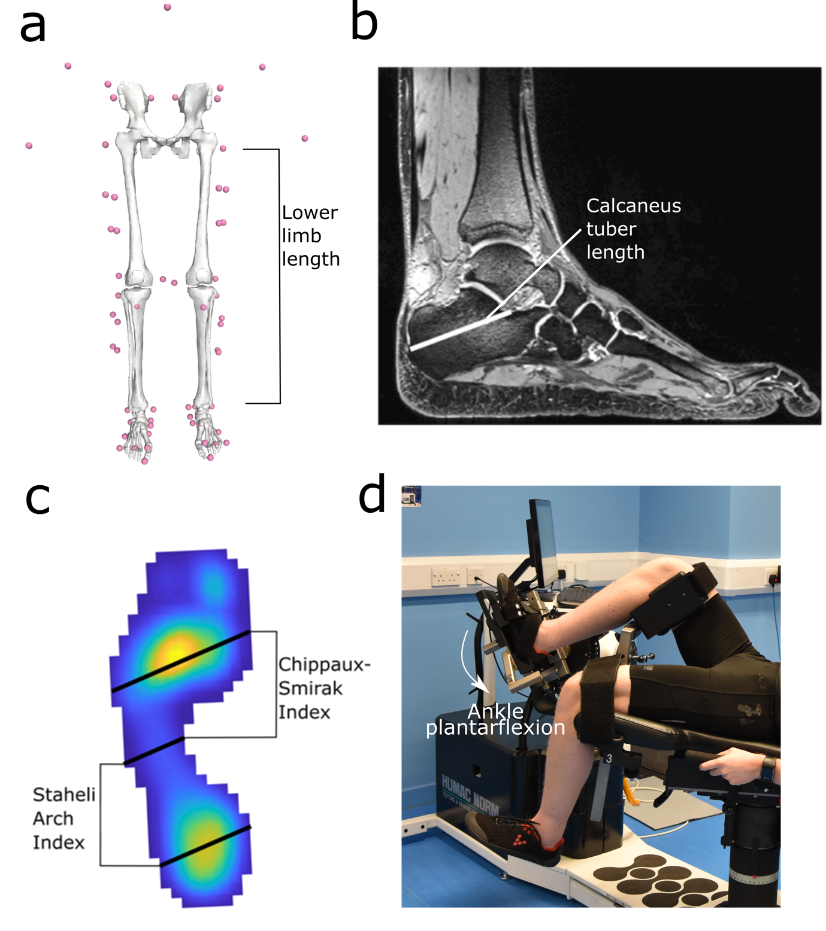
Figure 1. The anatomical variables collected in this study and tested for their relationships with metabolic cost of walking. These include: a) lower limb length, measured from motion capture markers; b) calcaneus tuber length, used as an approximation of Achilles tendon moment arm; c) Chippaux-Smirak and Staheli Arch index, used to quantify foot shape; d) maximum isometric ankle plantarflexor muscle torque, measured from an isokinetic dynamometer.

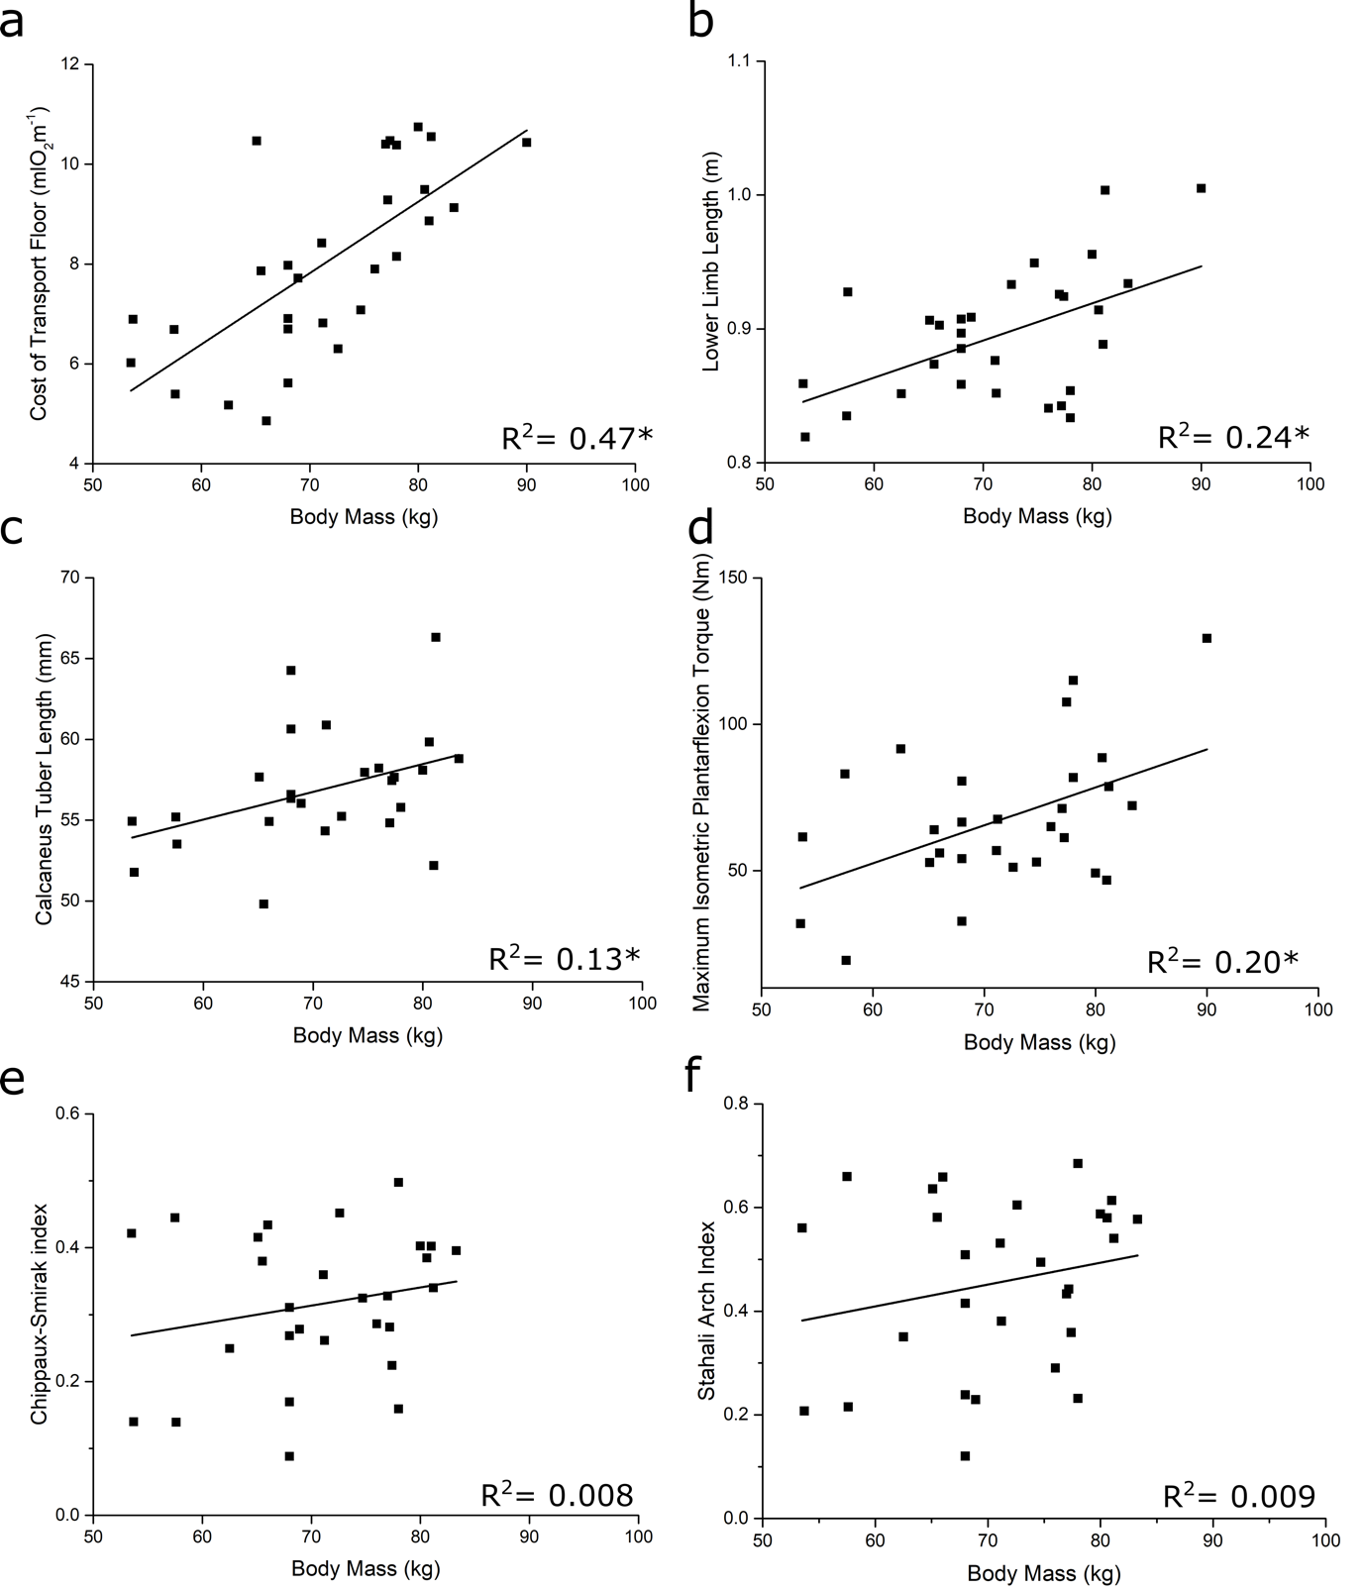
Figure 2. Bivariate plots of the relationships between body mass and physiological and anatomical variables. Significant relationships (p < 0.05) were found between body mass and the cost of transport on the floor (a), lower limb length (b), calcaneus tuber length (c), maximum isometric plantarflexion torque (d), Chippaux-Smirak index (e) and Stehali Arch index (f). Due to these significant relationships, the standardized residuals of these correlations were used in subsequent linear regression analyses to investigate the relationships between the cost of transport and anatomy. The relationships between body mass and the Chippaux-Smirak and Staheli Arch indices were not statistically significant.

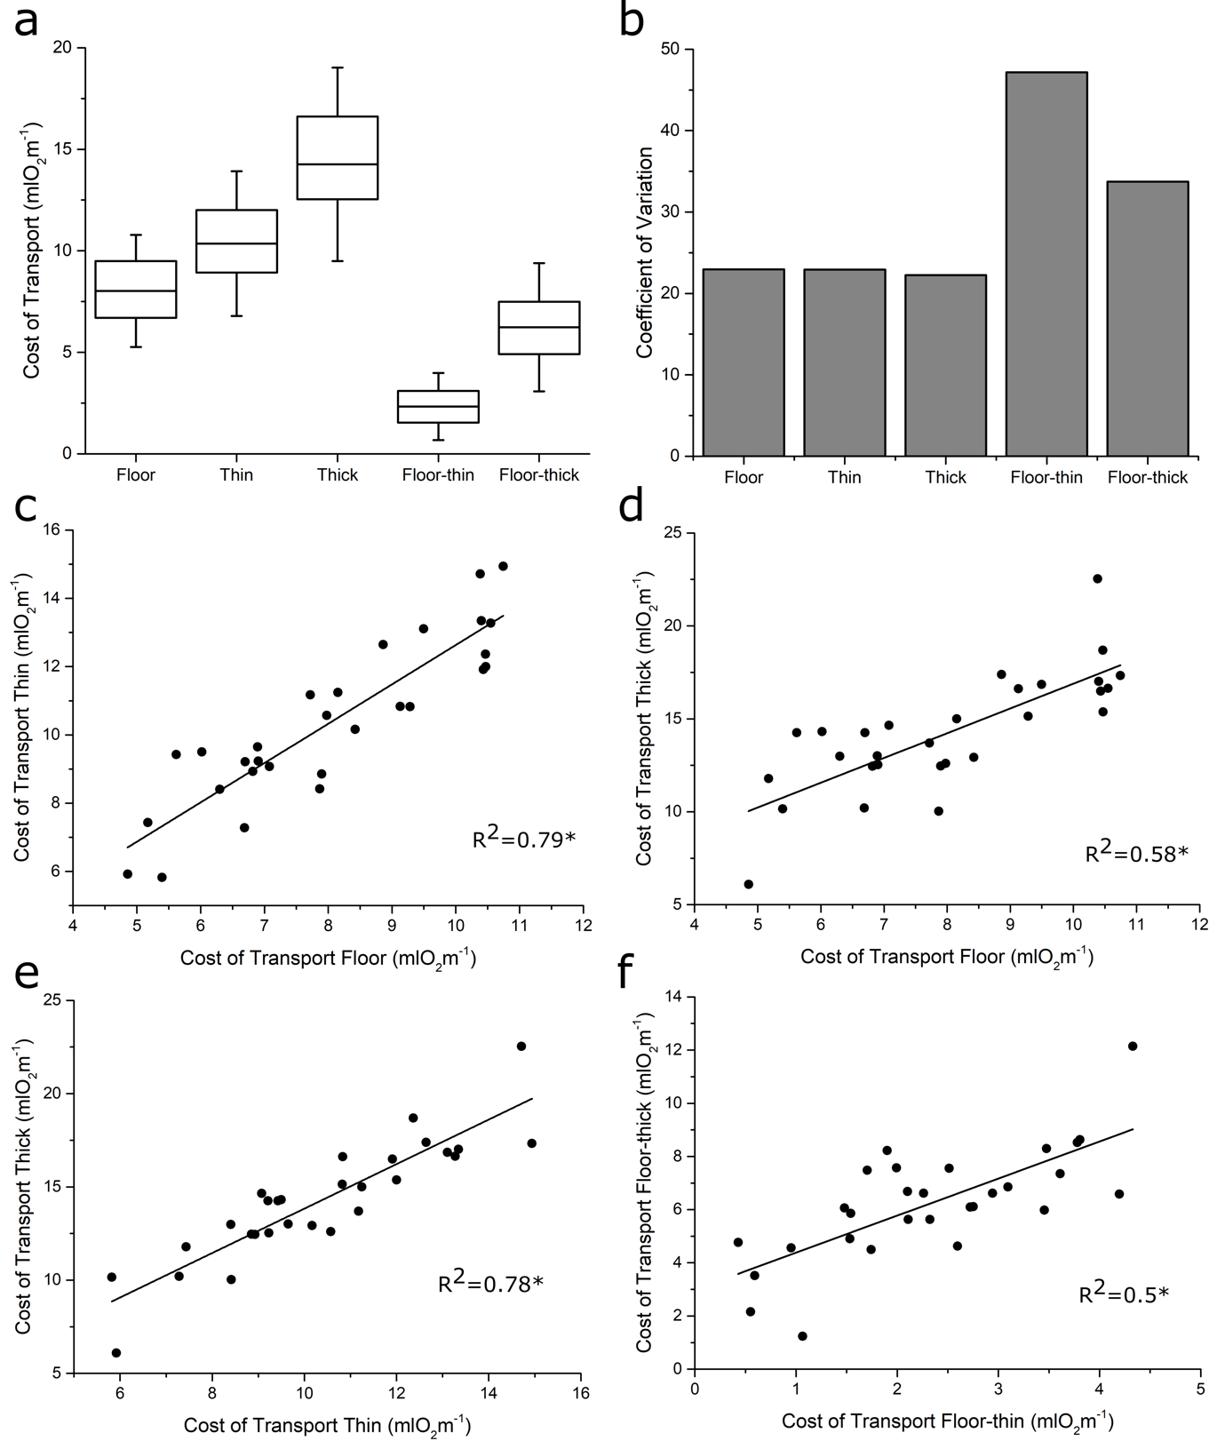
Figure 3. The metabolic cost of transport (CoT) increased during walking on all surfaces in this study. CoT on average increased when walking on more compliant surfaces (a), and there was substantial variation in these CoT values on all surfaces between the subjects (b). The cost of walking on the floor was also significantly correlated (p < 0.05) with the cost of walking on both the thin and thick foams (c, d), as was the cost of walking on the thin and thick foams (e). Regressing the difference between the cost of walking on the floor and thin foam with the difference between the floor and the thick foam also found a significant relationship (f). * indicates a statistically significant correlation.

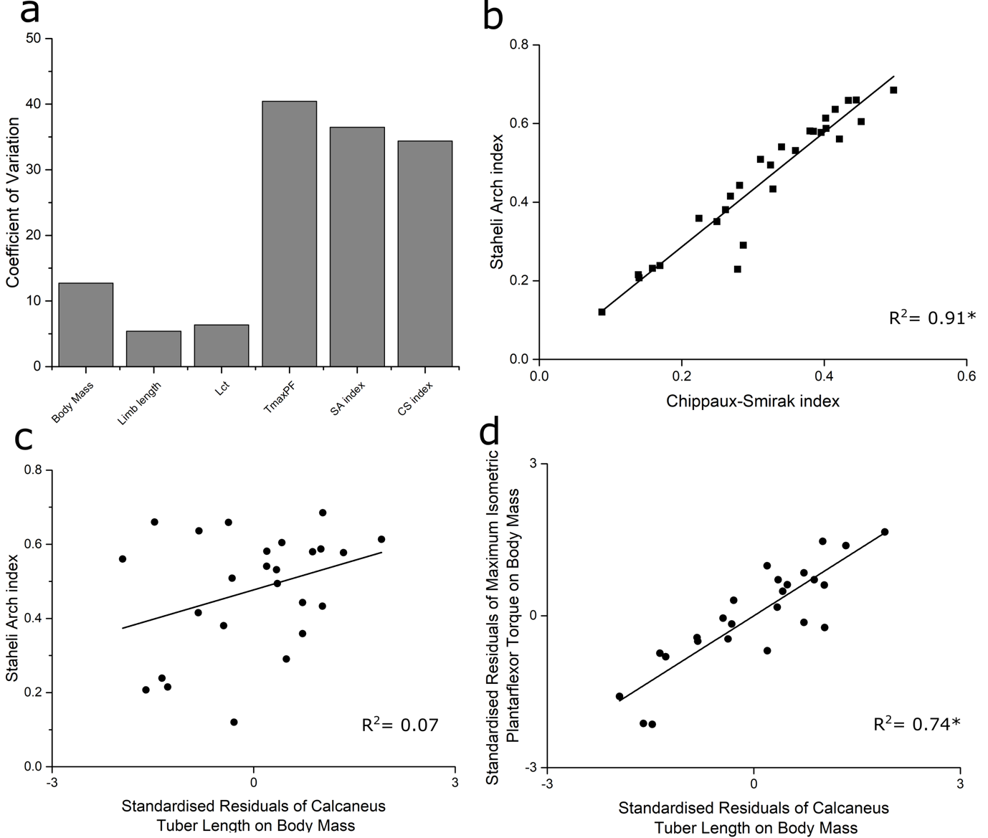
Figure 4. Coefficients of variation in each anatomical variable measured in this study (a). Body mass, lower limb length and calcaneus tuber length (L_{ct}) were very homogenous between these subjects, however variation was substantially higher in maximum isometric ankle plantarflexor torque (T_{maxPF}), Staheli arch (SA) index and Chippaux-Smirak (CS) index. Relationship between CS and SA index (b), showing an equal power in these indices to quantify foot shape and arch height. Also shown are the relationships between calcaneus tuber length (accounting for the effect of body mass) and SA index (c) as well as maximum isometric plantarflexor torque (accounting for the effect of body mass; d). * indicates statistical significance (p < 0.05). The significant relationship in (d) suggests that calcaneus length could be a metric from which to infer ankle plantarflexor muscle strength in the fossil record.

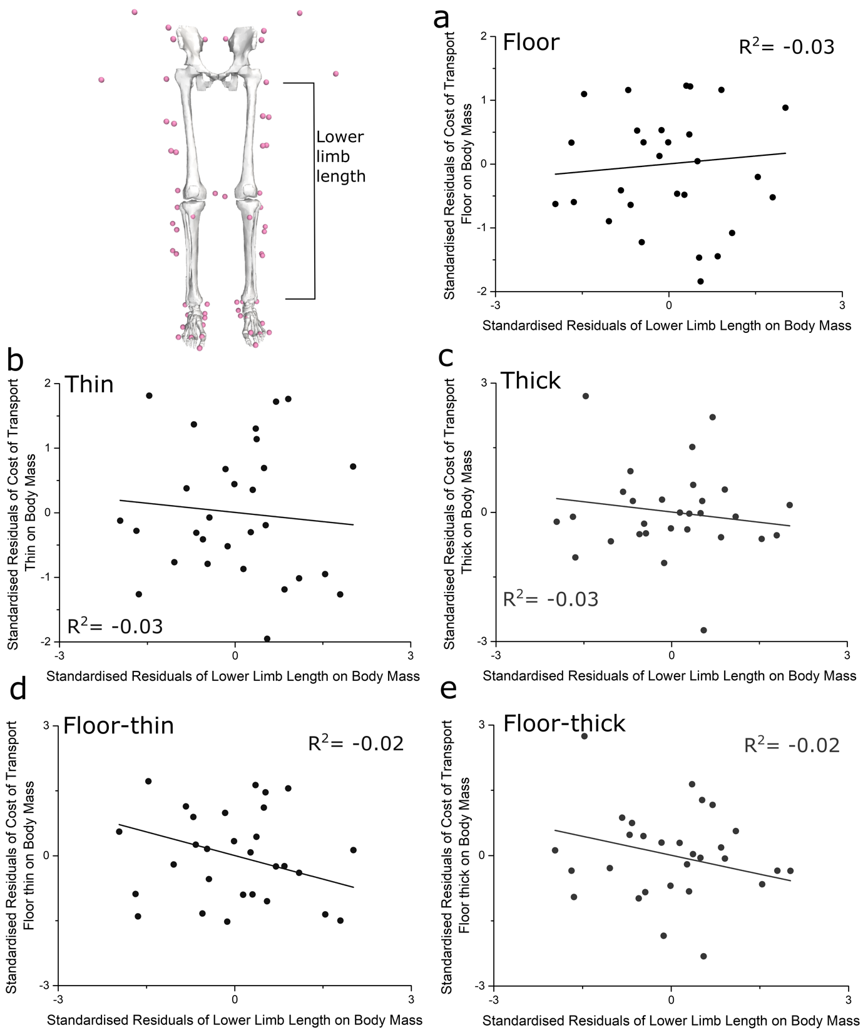
Figure 5. Bivariate plots of the relationships between the cost of walking locomotion on all surfaces (a-c), as well as the difference between the surfaces (d, e), and lower limb length, accounting for the effect of body mass. No significant correlations were found on any surface.
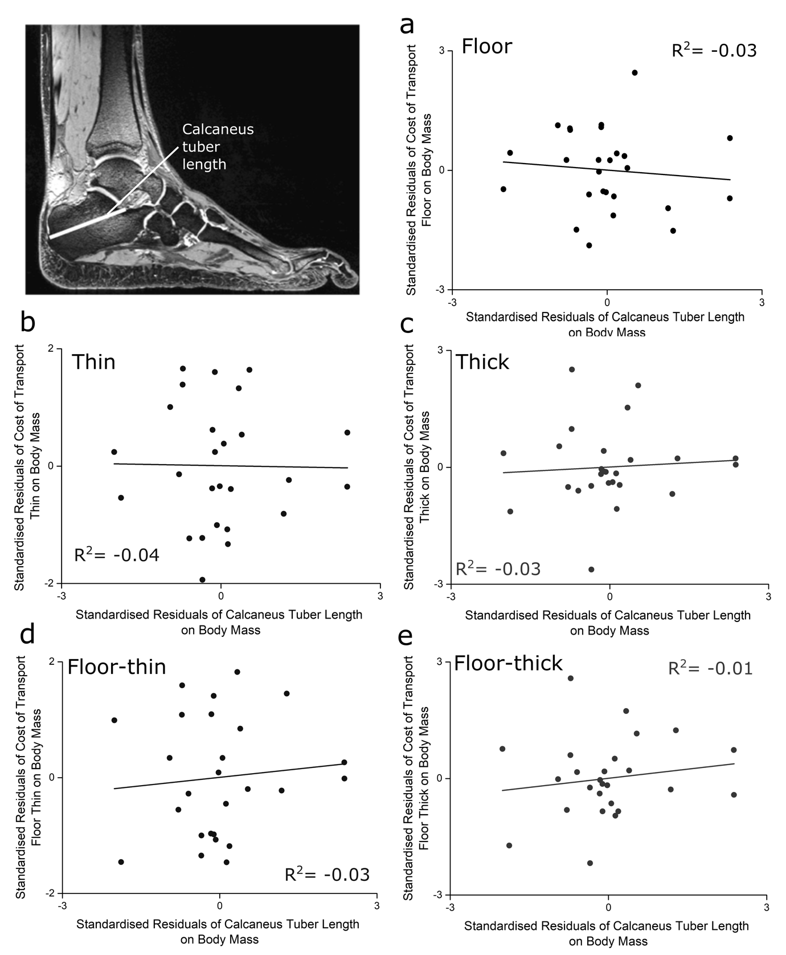
Figure 6. Bivariate plots of the relationships between the cost of walking locomotion on all surfaces (a-c), as well as the difference between the surfaces (d, e), and calcaneus tuber length, accounting for the effect of body mass. No significant correlations were found on any surface.
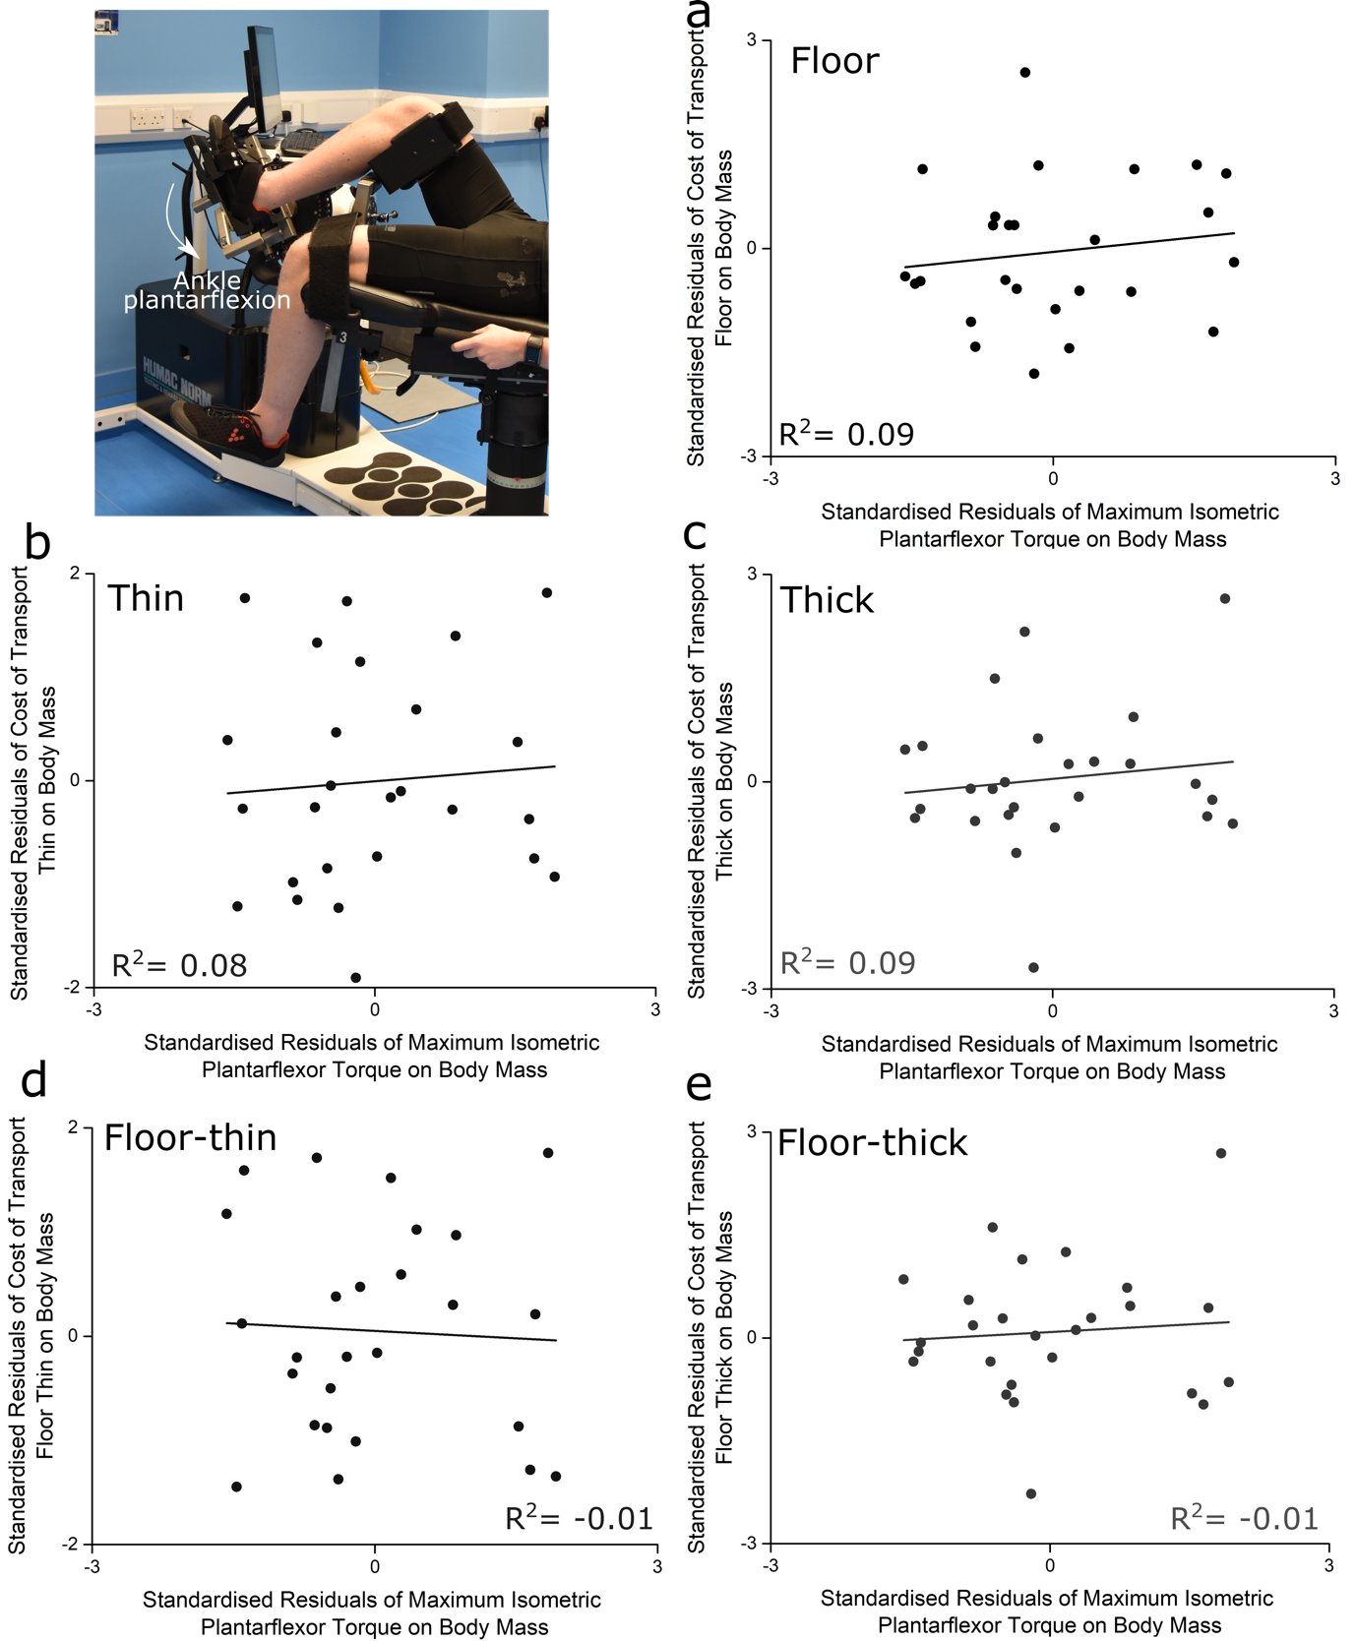
Figure 7. Bivariate plots of the relationships between the cost of walking locomotion on all surfaces (a-c), as well as the difference between the surfaces (d, e), and maximum isometric plantarflexor torque accounting for the effect of body mass. No significant correlations were found on any surface.
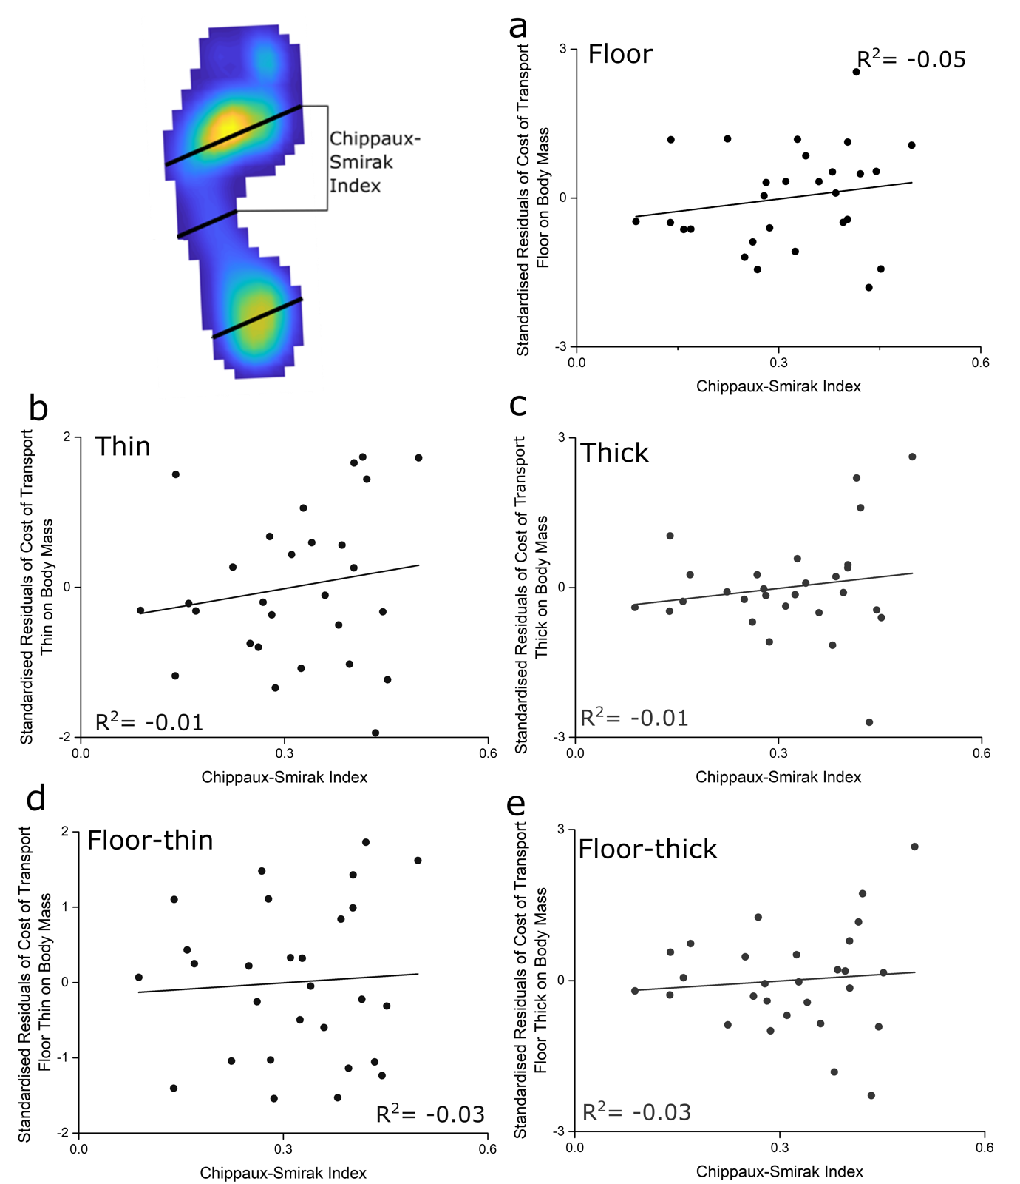
Figure 8. Bivariate plots of the relationships between the cost of walking locomotion on all surfaces (a-c), as well as the difference between the surfaces (d, e), and Chippaux-Smirak index, accounting for the effect of body mass. No significant correlations were found on any surface.
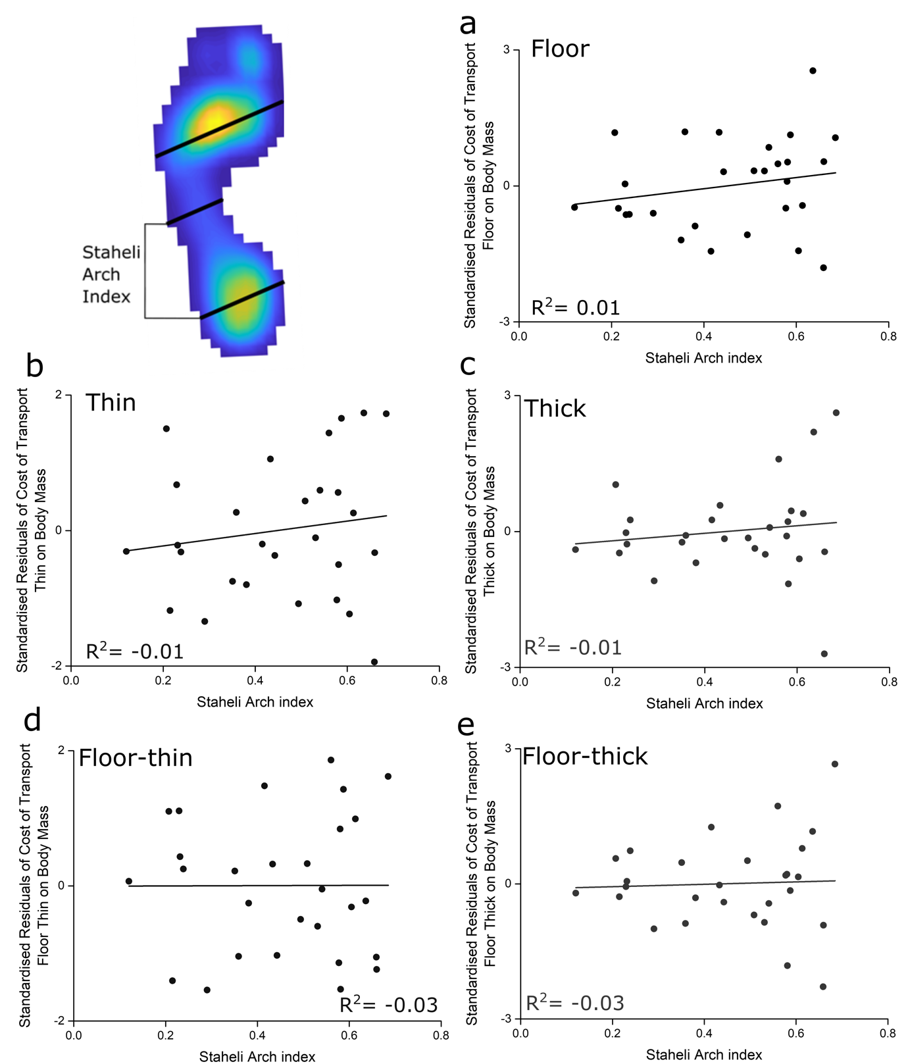
Figure 9. Bivariate plots of the relationships between the cost of walking locomotion on all surfaces (a-c), as well as the difference between the surfaces (d, e), and Staheli Arch index, accounting for the effect of body mass. No significant correlations were found on any surface.
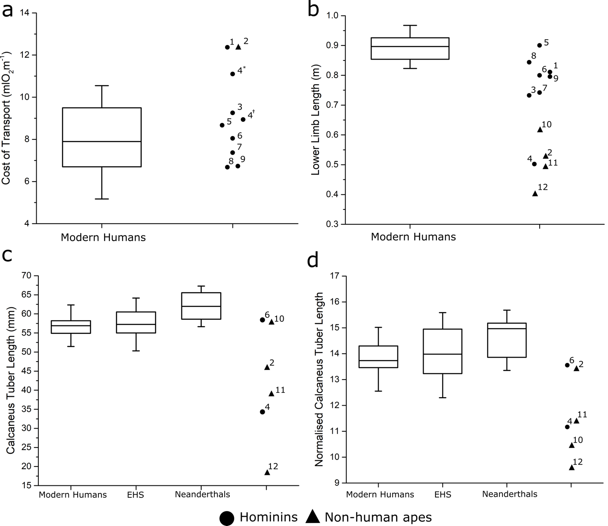
Figure 10. Cost of transport (CoT) and anatomical variables in modern humans (this study population) relative to data from other hominins and non-human apes. CoT on the non-compliant floor (a) within the modern human population was fairly variable and was similar to predicted in most hominin species, except for Homo neanderthalensis, as well as Pan troglodytes. Despite this similarity in walking cost, there is a large disparity in lower limb lengths and calcaneus lengths between modern humans and hominins/hominoids. In terms of lower limb lengths (b), only early H. sapiens and OH 28 (H. ergaster) fall within the range of modern humans, with earlier hominins and hominoids having shorter lower limbs. The raw calcaneus tuber lengths (c) of modern humans were on average shorter than early H. sapiens and Neanderthals, with only those of KNM-WT 15000 (H. ergaster) and Gorilla within the range of modern humans. When normalized to body mass (/body mass^{1/3}) the difference between modern human, early H. sapiens and Neanderthal calcaneus lengths were smaller, with only KNM-WT 15000 (H. ergaster) and Pan troglodytes falling within the modern human range (d). 1. H. neanderthalensis; 2. Pan troglodytes; 3. KNM-ER 1481 (H. erectus); 4. AL 288-1 (A. afarensis). * indicates cost of transport estimates from Nagano et al. (2005). † indicates cost of transport estimates from Sellers et al. (2005). 5. Early H. sapiens; 6. KNM-WT 15000 (H. ergaster); 7. KNM-ER 1472 (Homo rudolfensis); 8. OH 28 (H. ergaster); 9. OH 34 (Homo habilis) 10. Gorilla; 11. Pan paniscus; 12. Hylobates.

Table 1
Anthropometric and metabolic cost data from each subject. Means, standard deviations (SD) and coefficients of variation (CV) for each variable are also shown.
Subject | Age | Height (m) | Body mass (kg) | BMI (kgm⁻²) | L_{L} (m) | L_{ct} (mm) | T_{maxPF} (Nm) | CS index | SA index | CoT_{Floor} | CoT_{Thin} | CoT_{Thick} | CoT_{Floor-thin} | CoT_{Floor-thick}
1 | 35 | 1.76 | 68.00 | 21.95 | 0.86 | 64.27 | 80.66 | 0.17 | 0.24 | 6.70 | 9.21 | 14.25 | 2.51 | 7.56
2 | 25 | 1.75 | 71.10 | 23.22 | 0.88 | 54.33 | 56.86 | 0.36 | 0.53 | 8.42 | 10.16 | 12.92 | 1.74 | 4.50
3 | 32 | 1.82 | 74.70 | 22.55 | 0.95 | 57.96 | 52.93 | 0.32 | 0.49 | 7.08 | 9.07 | 14.65 | 1.99 | 7.57
4 | 26 | 1.76 | 72.60 | 23.44 | 0.93 | 55.23 | 51.16 | 0.45 | 0.60 | 6.30 | 8.40 | 12.98 | 2.10 | 6.68
5 | 21 | 1.77 | 76.00 | 24.26 | 0.84 | 58.22 | 65.02 | 0.29 | 0.29 | 7.90 | 8.85 | 12.46 | 0.95 | 4.56
6 | 21 | 1.70 | 57.50 | 19.90 | 0.84 | 55.19 | 83.08 | 0.45 | 0.66 | 6.69 | 7.28 | 10.20 | 0.59 | 3.51
7 | 24 | 1.75 | 68.00 | 22.20 | 0.89 | 56.59 | 54.08 | 0.31 | 0.51 | 7.98 | 10.57 | 12.60 | 2.60 | 4.62
8 | 27 | 1.93 | 90.00 | 24.16 | 1.00 | - | 129.35 | - | - | 10.43 | 11.91 | 16.50 | 1.48 | 6.06
9 | 23 | 1.80 | 77.40 | 23.89 | 0.92 | 57.66 | 107.59 | 0.22 | 0.36 | 10.47 | 12.00 | 15.38 | 1.53 | 4.91
10 | 29 | 1.80 | 80.60 | 24.88 | 0.91 | 59.84 | 88.60 | 0.38 | 0.58 | 9.50 | 13.11 | 16.85 | 3.61 | 7.35
11 | 26 | 1.81 | 68.00 | 20.76 | 0.90 | 56.34 | 32.77 | 0.09 | 0.12 | 6.91 | 9.23 | 12.53 | 2.32 | 5.63
12 | 29 | 1.77 | 68.90 | 21.99 | 0.91 | 56.04 | - | 0.28 | 0.23 | 7.72 | 11.18 | 13.70 | 3.46 | 5.98
13 | 29 | 1.67 | 62.50 | 22.41 | 0.85 | - | 91.62 | 0.25 | 0.35 | 5.17 | 7.43 | 11.79 | 2.26 | 6.62
14 | 32 | 1.68 | 53.70 | 19.03 | 0.82 | 51.77 | 61.49 | 0.14 | 0.21 | 6.89 | 9.65 | 13.01 | 2.75 | 6.12
15 | 28 | 1.86 | 83.30 | 24.08 | 0.93 | 58.80 | 72.24 | 0.40 | 0.58 | 9.13 | 10.84 | 16.62 | 1.70 | 7.49
16 | 39 | 1.78 | 80.00 | 25.25 | 0.96 | 58.10 | 49.21 | 0.40 | 0.59 | 10.74 | 14.94 | 17.33 | 4.20 | 6.58
17 | 25 | 1.72 | 71.20 | 24.07 | 0.85 | 60.88 | 67.58 | 0.26 | 0.38 | 6.82 | 8.93 | 12.45 | 2.11 | 5.63
18 | 27 | 1.70 | 68.00 | 23.53 | 0.91 | 60.64 | 66.60 | 0.27 | 0.42 | 5.62 | 9.43 | 14.25 | 3.81 | 8.63
19 | 26 | 1.64 | 53.50 | 20.01 | 0.86 | 54.93 | 31.91 | 0.42 | 0.56 | 6.02 | 9.50 | 14.32 | 3.48 | 8.30
20 | 29 | 1.80 | 66.00 | 20.37 | 0.90 | 54.92 | 56.02 | 0.43 | 0.66 | 4.86 | 5.92 | 6.09 | 1.06 | 1.23
21 | 26 | 1.71 | 57.60 | 19.70 | 0.93 | 53.52 | 19.38 | 0.14 | 0.22 | 5.40 | 5.82 | 10.16 | 0.43 | 4.76
22 | 27 | 1.72 | 81.00 | 27.38 | 0.89 | 52.19 | 46.77 | 0.40 | 0.61 | 8.86 | 12.64 | 17.39 | 3.78 | 8.52
23 | 27 | 1.75 | 65.10 | 21.26 | 0.91 | 57.67 | 52.83 | 0.42 | 0.64 | 10.47 | 12.37 | 18.69 | 1.90 | 8.22
24 | 25 | 1.78 | 78.00 | 24.62 | 0.83 | - | 81.84 | 0.16 | 0.23 | 8.15 | 11.25 | 15.01 | 3.09 | 6.85
25 | 26 | 1.69 | 77.00 | 26.96 | 0.93 | 54.83 | 71.28 | 0.33 | 0.43 | 10.40 | 13.34 | 17.02 | 2.94 | 6.62
26 | 27 | 1.74 | 78.00 | 25.76 | 0.85 | 55.79 | 114.99 | 0.50 | 0.68 | 10.39 | 14.71 | 22.53 | 4.33 | 12.15
27 | 26 | 1.78 | 77.20 | 24.37 | 0.84 | 57.45 | 61.25 | 0.28 | 0.44 | 9.28 | 10.83 | 15.14 | 1.54 | 5.86
28 | 27 | 1.72 | 65.50 | 22.14 | 0.87 | 49.80 | 63.99 | 0.38 | 0.58 | 7.87 | 8.42 | 10.03 | 0.55 | 2.16
29 | 25 | 1.91 | 81.20 | 22.26 | 1.00 | 66.32 | 78.79 | 0.34 | 0.54 | 10.55 | 13.27 | 16.65 | 2.72 | 6.10
Mean | 27.29 | 1.75 | 71.38 | 23.40 | 0.90 | 56.70 | 61.60 | 0.34 | 0.50 | 8.02 | 10.35 | 14.26 | 2.33 | 6.23
SD | 3.41 | 0.06 | 8.62 | 2.42 | 0.05 | 4.09 | 22.14 | 0.10 | 0.14 | 1.81 | 2.33 | 3.12 | 1.08 | 2.07
CV | 12.50 | 3.57 | 12.08 | 10.35 | 5.14 | 7.22 | 35.94 | 29.95 | 28.99 | 22.55 | 22.53 | 21.88 | 46.35 | 33.15
Abbreviations: L_{L} = lower limb length; L_{CT} = Calcaneus tuber length; T_{maxPF} = Maximum isometric plantarflexor torque; CS index = Chippaux-Smirak index; SA index = Staheli Arch index; CoT = Cost of transport (mlO₂m⁻¹).
Table 2
R-squared (R²) values from linear regression analyses to test for relationships between anatomical variables and walking energetics. ª
 | Body mass (kg) | L_{L} (m) | L_{ct} (mm) | T_{maxPF} (Nm) | CS index | SA index | CoT_{Floor} | CoT_{Thin} | CoT_{Thick} | CoT_{Floor-thin} | CoT_{Floor-thick}
Body mass (kg) | - | 0.24* | 0.13* | 0.2* | <0.01 | <0.01 | 0.47* | 0.39* | 0.30* | 0.01 | 0.02
L_{L} (m) | 0.24* | - | - | - | - | - | -0.03 | -0.02 | -0.01 | 0.09 | 0.05
L_{ct} (mm) | 0.13* | - | - | - | - | - | -0.03 | -0.04 | -0.03 | -0.03 | -0.01
T_{maxPF} (Nm) | 0.2* | - | - | - | - | - | -0.01 | -0.03 | -0.02 | -0.04 | -0.03
CS index | <0.01 | - | - | - | - | 0.90* | <0.01 | <0.01 | -0.01 | -0.03 | -0.02
SA index | <0.01 | - | - | - | 0.90* | - | <0.01 | -0.01 | -0.02 | -0.04 | -0.04
CoT_{Floor} | 0.47* | -0.03 | -0.03 | -0.01 | <0.01 | <0.01 | - | 0.79* | 0.58* | -0.02 | -0.03
CoT_{Thin} | 0.39* | -0.02 | -0.04 | -0.03 | <0.01 | -0.01 | 0.79* | - | 0.72* | 0.41* | 0.29*
CoT_{Thick} | 0.30* | -0.01 | -0.03 | -0.02 | -0.01 | -0.02 | 0.58* | 0.72* | - | 0.33* | 0.51*
CoT_{Floor-thin} | 0.01 | 0.09 | -0.03 | -0.04 | -0.03 | -0.04 | -0.02 | 0.41* | 0.33* | - | 0.50*
CoT_{Floor-thick} | 0.02 | 0.05 | -0.01 | -0.03 | -0.02 | -0.04 | -0.03 | 0.29* | 0.51* | 0.50* | -
Abbreviations: L_{L} = lower limb length; L_{CT} = Calcaneus tuber length; T_{maxPF} = Maximum isometric plantarflexor torque; CS index = Chippaux-Smirak index; SA index = Staheli Arch index; CoT = Cost of transport (mlO₂m⁻¹).
ª Asterisks indicate statistically significant relationships (p < 0.05).

