**Applicability of Sc2O3 versus Al2O3 in MIM rectifiers for IR rectenna**

S. Almalki*, S.B. Tekin, N. Sedghi, S. Hall, I.Z. Mitrovic*

Department of Electrical Engineering and Electronics, University of Liverpool, Liverpool L69 3GJ, UK

*E-mail address of corresponding authors: [s.almalki2@liverpool.ac.uk](mailto:s.almalki2@liverpool.ac.uk), [ivona@liverpool.ac.uk](mailto:ivona@liverpool.ac.uk)

**Abstract**

Impedance matching between the terahertz antenna and ultra-fast Metal-Insulator-Metal (MIM) diode is a crucial issue in realizing rectenna technology for harvesting infrared (IR) energy spectrum. In this paper, scandium oxide (Sc2O3) based MIM diodes were fabricated using magnetron sputtering and their rectification performance compared to state-of-the-art Au/Al2O3/Au diodes. The fabricated Al/Sc2O3/Al diode has exhibited around two orders of magnitude lower zero-bias dynamic resistance(*RD0* = 956 kΩ) and high zero-bias responsivity (*β0* = 1 A/W) in advance to Au/Al2O3/Au diode. The results point to applicability of scandium oxide in MIM rectifiers for IR rectenna.

**Keywords:** dielectric, Sc2O3, Al2O3, rectifier, rectenna

1. **Introduction**

The jury is still out on the optimal rectifier oxide materials (NiO, Al2O3, TiO2, CuO) and antenna design (dipole, microstrip, bow-tie, slot, Vivaldi, log-spiral) in achieving an efficient infrared (IR) rectenna system [1,2]. It is the untapped IR region, offering maximum emissivity at around 30 THz, that has been driving research with the smallest thin film Ni/NiO/Ni Metal Insulator Metal (MIM) diode embedded in the gap of bow-tie nanoantenna reported more than twenty years ago [3,4]. For IR energy harvesting applications, it is paramount that MIM diodes have high responsivity (*β*) and low zero-bias resistance (*RD*) without the need for an external bias voltage [5]. The choice of metal is crucial too, as it impacts the diode resistance and hence its coupling efficiency [4]. The asymmetric M1IM2 design, i.e. use of metals with different work functions, can enhance zero-bias rectification but comes with the trade-off of decreased coupling efficiency due to increased diode resistance. The most recent work indicates a possibility of 28.3 THz rectification through MIM-based rectenna with Al2O3 as insulator and metal contacts such as Au/Ti [6], Al/Al [7], Au/Au [1,8] and Au/Ag[1]. In this paper, Al/Sc2O3/Al and Au/Al2O3/Au diodes were fabricated and characterized. The rectification parameters such as responsivity, dynamic resistance, non-linearity and asymmetry were derived from measured current-voltage (*I-V*) characteristics. The results indicate enhanced rectification properties of zero-bias responsivity, *β0* = 1 A/W and zero-bias dynamic resistance, *RD0*= 956 kΩ for Al/Sc2O3/Al MIM diode when compared to Au/Al2O3/Au diode. The simulated *I-V* characteristics underpin the trends observed experimentally.

1. **Experimental**

The MIM Sc2O3 and Al2O3-based devices were fabricated on cleaned ultra-smooth Corning glass plates. The Corning glass plates were cleaned by immersion in a solution of deionized (DI) water and Decon 90 followed by rinsing in flowing DI water for 10-15 minutes. Furthermore, isopropanol and acetone were used for deep clean followed by 2 min exposure in an ultra-violet (UV) ozone cleaner to remove remaining residues from the treatment with solvents. Al2O3 oxide films were deposited by conventional thermal atomic layer deposition (ALD) using a Cambridge Nanotech Savannah reactor using the trimethyl-aluminium (TMA) precursor combined with water at the growth rate of 0.125 nm/cycle. Dose (0.2 s) and purge (4 – 10 s) times were chosen to ensure a self-limiting ALD reactions occurred, and the substrate temperature was 200 °C throughout. The H2O source was pulsed for 0.04 seconds followed by a purge time of 4-10 seconds. This ALD cycle process was continued until the desired thickness was obtained. Sc2O3 films were deposited using a Moorefields NanoPVD-RF magnetron sputter at 60 W with a growth rate of 0.004 nm/s. The top and bottom metals of Al and Au were thermally evaporated using the Moorefields Minilab 060 evaporator with the thickness of ~60 nm. Finally, the diodes were patterned using a shadow mask having 100 µm ×100 µm device area. The cross-section and the top view of fabricated devices are shown in Figs. 1(a)-(b) and 1(c) respectively.

In addition to thin films on corning glass, the reference oxide films of Al2O3 and Sc2O3 were deposited on Si, to study their optical properties using variable angle spectroscopic ellipsometry (VASE). Variable angle J.A. Woollam M2000 spectroscopic ellipsometer with the spectral range of 240 – 1700 nm (0.7 to 5.1 eV) was used to determine the thickness, surface roughness and optical constants (refractive index and extinction coefficient) of the dielectric films. The *I-V* measurements were performed using a Agilent B1500 semiconductor parameter analyser with an integrated probe station at room temperature and under a dark, screened environment.



**Figure 1**. Schematic cross-sections of (a) Al/Sc2O3/Al and (b) Au/Sc2O3/Au MIM diodes fabricated by sputtering and ALD respectively with nominal thickness of oxides (3 nm) and metals (60 nm); (c) top view of a device structure showing diode area of 100 μm x100 μm.

1. **Results and Discussion**

Figure 2(a) shows refractive index (*n*) vs. photon energy for Al2O3 and Sc2O3 films extracted from modelling of VASE (* * vs. photon energy data using a Cauchy model. A higher *n* can be observed for Sc2O3 compared to the Al2O3 which is in agreement with reported in the literature [9-12]. The refractive index for ALD amorphous a-Al2O3 3.8 nm film has been found to vary from 1.67 to 1.75 [9] in the energy range of 1.2-5 eV; while in Ref. [10] sputtered a-Al2O3 film exhibits *n* of 1.50-1.67 at 550 nm (2.25 eV). In case of Sc2O3, 350 nm amorphous CVD (chemical vapour deposited) film has been found to have *n* varying from 1.87 – 1.94 [11] in the range 1.2 - 3.1 eV, with *n* = 1.89 at 550 nm, while the latter for crystalline c-Sc2O3 has been found to be 2.00 [12]. For films in this work, *n* at 550 nm is 1.91 for Sc2O3 and 1.76 for Al2O3. It is evident from the literature [9-12] that *n* is strongly affected by thickness and processing of the films. The thickness (± 0.1 nm) of the insulator in MIM diodes was found to be 3.5 nm for Sc2O3 and 3.0 nm for Al2O3 by VASE using a Cauchy model with mean squared error fit of < 5.

The electrical properties of Sc2O3- and Al2O3-based MIM diodes were investigated by *I-V* measurements. The following rectification parameters were studied: (i) responsivity (*β = dI"(V)/2I'(V*)), (ii) dynamic resistance (*RD = (dI/dV)*-1), (iii) non-linearity (*fNL = (V/I*) × *RD*) and (iv) asymmetry (*η = |I+/I-*| where *I*+ refers to forward bias current and *I*- to reverse bias current). These parameters, derived from the experimental current density *(J)* vs. voltage *(V)* characteristics (Figs. 2(b)), are shown in Figs. 2(c)-(f). It can be seen that Al/Sc2O3/Al diode

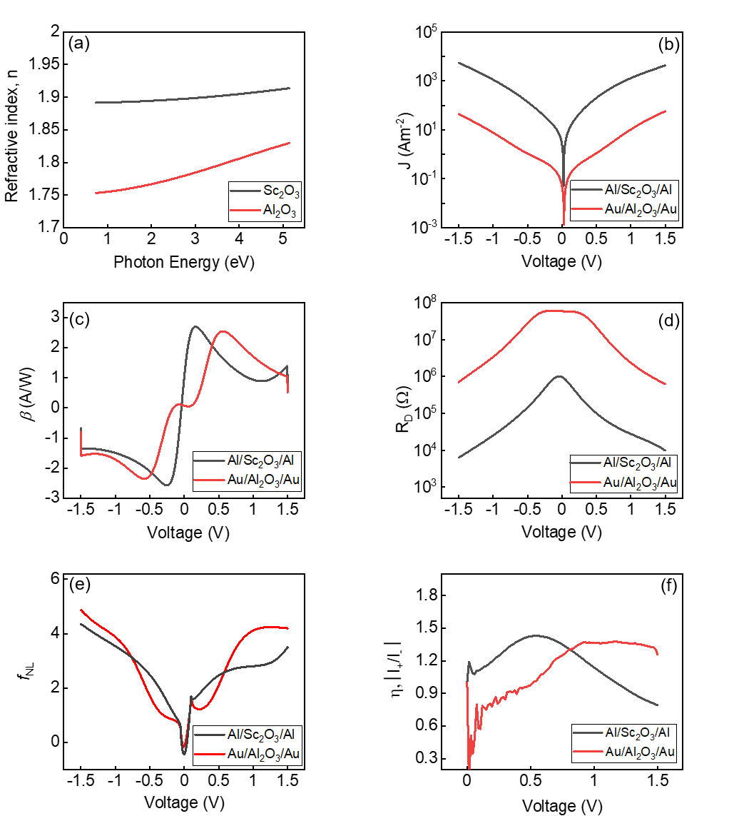

**Figure 2.** (a) Refractive index (n) vs photon energy of deposited Sc2O3 and Al2O3 films extracted by VASE. (b) J-V, (c) responsivity, (d) dynamic resistance, (e) non-linearity, (f) asymmetry for Al/Sc2O3/Al and Au/Al2O3/Au diodes.

exhibits two orders of magnitude higher current than Au/Al2O3/Au diode (Fig. 2(b)) resulting in lower *RD0* of 956 kΩ (Fig. 2(d)). The former diode also shows improved *β0* asshown in Fig. 2(c). No substantial improvement in asymmetry and non-linearity can be observed for both diodes in Figs. 2(e)-(f). The latter is likely to be due to direct tunnelling being dominant conduction mechanism for both diodes within the voltage range of 0 to ± 1.5 V (Fig. 2 (b)), in line with the low asymmetry values reported for similar thin film MIM diodes at lower voltage levels [13].

The higher current observed experimentally for the Sc2O3 diode in Fig. 2(b) can be explained by the band alignment in Fig. 3(a). The optical band gap (6.43 eV) and electron affinity (1.57 eV) of Al2O3 have been measured previously by vacuum ultra-violet (VUV)-VASE [14] and secondary electron cut-off X-ray photoelectron spectroscopy (XPS) spectra [15]. The optical band gap for a-Sc2O3 has been reported to be 5.6-5.7 eV [16], while for c-Sc2O3 the value is found to be higher 6.0-6.1 eV [16,17]. The electron affinity () stated in Fig. 3(a) is deduced from internal photoemission measurements of valence band offset between Sc2O3 and Si of 2.5 eV [16] and measured band gap of 5.7 eV [16], and found to be 2.06 eV. The latter is in agreement with theoretical prediction of  of Sc2O3 calculated to be in the range of 1.98 to 2.5 eV [18]. The work function of Al and Au are as stated in Ref. [19]. The simulation of *I-V* curves is done using the in-house MATLAB simulation tool [20] taking into account the band alignment in Fig. 3(a), permittivity of Al2O3 of 10 and Sc2O3 of 14, and the electron effective mass (meff) of 0.25´m0 for Al2O3 and 0.2´m0 for Sc2O3, where m0 is the electron mass. Taking electron effective mass as a parameter in fitting of the tunneling current to experimental *I-V* data is in agreement with previous studies [21,22], e.g. in [21] the effective mass for Al2O3 of 0.22´m0 was used. A clear trend of enhanced current in the Sc2O3 diode when compared to the Al2O3 diode from simulated *J-V* curves can be seen in Fig. 3(b). Due to a smaller Al/Sc2O3 barrier, the tunneling current is increased, which causes a reduction in the resistance of the Al/Sc2O3/Al diode and improves the antenna/diode coupling efficiency. It is worth mentioning that the model only accounts for quantum-mechanical tunnelling; other mechanisms such as defect-assisted conductance and the local film inhomogeneity need to be considered to accurately model experimental *I-V* plots and are left for further study.

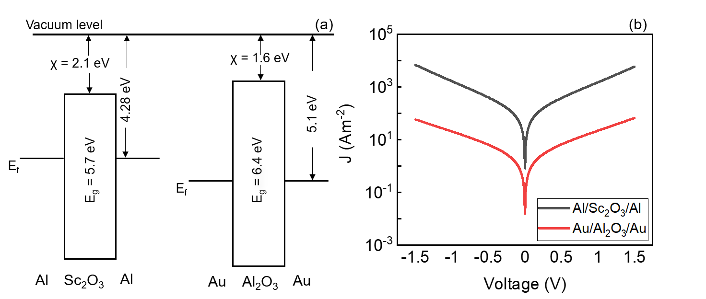

**Figure 3**. (a) Schematic of band diagrams of Al/Sc2O3/Al and Au/Al2O3/Au diodes based on values of band gaps and work function/electron affinities from Refs. [14-19]; (b) their simulated J-V characteristics.

In summary, the rectification parameters obtained from diodes in this work and the referring in literature are shown in Table 1. It is worth mentioning that the diodes fabricated in this work are not optimized in terms of low resistance-area (RA) product, closely related to the resistance ´ capacitance (RC) time constant of the diode. High efficiency detection requires good impedance matching to antennas, whose impedances are typically in the range of 30–300 W [23]. The early work on Ni/NiO/Ni diodes that demonstrated very small RA of 1 W(mm)2 [3,4] has underpinned improved, more repeatable fabrication process with yield of ~80%, however these devices exhibited low responsivity at room temperature of ~0.2 A/W [23]. Moreover, the use of bottom Al metal in MIM diode may form an undesirable native AlOx film [24], while evaporation of top Al may lead to oxygen scavenging [25] from the underlying Sc2O3 film, making it less thermodynamically stable. To address the above, further research will comprise (i) fabrication of smaller area diodes processed by e-beam lithography and (ii) use of different metal electrodes such as Ag, Cr, Mo, Au, Cu, Ta, Ni, Zn and Nb to alleviate issues with thermodynamic stability. The significance of results presented in this paper is in demonstrating that Sc2O3 could provide an extra degree of freedom in MIM device design for rectenna due to higher electron affinity than Al2O3.

**Table 1**. Comparison of rectification parameters of MIM diodes fabricated in this work and in the literature [1,6,7].

|  |  |  |  |  |  |
| --- | --- | --- | --- | --- | --- |
| Reference | Diode | *β0* (A/W) | *βmax* (A/W) | Zero-Bias *RD* (Ω) | |
| This work | Al-Sc2O3-Al | 1.0 | 2.7 @ 0.2 V | | 0.96 M |
| This work | Au/Al2O3/Au | 0.08 | 2.5 at 0.6 V | | 58.2 M |
| [1]* | Au/Al2O3/Au | 0.5 | 1.85 at 2 V | | 1.4 x 1012 |
| [1]* | Au/Al2O3/Ag | 0.5 | 2.2 at 2V | | 0.85 x 1012 |
| [6] | Au/Al2O3/Ti | 0.44 | 1.25 | | 98 k |
| [7] | Al/Al2O3/Al | 0.1 | -1.4 | | 10 M |

*Ref. [1] values are from simulations.

1. **Conclusion**

The Al/Sc2O3/Al and Au/Al2O3/Au diodes have been fabricated using sputtering and atomic layer deposition for oxide films, respectively. The thickness of the films and their optical properties have been assessed using spectroscopic ellipsometry. The experimental results indicate enhanced zero-bias responsivity and reduced zero-bias dynamic resistance for Sc2O3-based MIM diode and its potential for application in IR rectenna.

**Acknowledgments**

The authors acknowledge the EPSRC, UK, project no. EP/K018930/1 and British Council UKIERI F.No.184-1/2018(IC) projects for funding.

**References**

[1] Yahyaoui A, Elsharabasy A, Yousaf J, Rmili H. Numerical analysis of MIM-based log-spiral rectennas for efficient infrared energy harvesting. Sensors. 2020;20:1–16.

[2] Shriwastava S, Tripathi CC. Metal–Insulator–Metal diodes: a potential high frequency rectifier for rectenna application. J Electron Mater. 2019;48:2635–52.

[3] Fumeaux C, Herrmann W, Kneubühl FK, Rothuizen H. Nanometer thin-film Ni-NiO-Ni diodes for detection and mixing of 30 THz radiation. Infrared Phys Technol. 1998;39:123–83.

[4] Wilke I, Oppliger Y, Herrmann W, Kneubühl FK. Nanometer thin-film Ni-NiO-Ni diodes for 30 THz radiation. Appl Phys A. 1994;58:329–41.

[5] Zhu Z, Joshi S, Grover S, Moddel G. Graphene geometric diodes for terahertz rectennas. J Phys D Appl Phys. 2013;46:185101.

[6] Jayaswal G, Belkadi A, Meredov A, Pelz B, Moddel G, Shamim A. Optical rectification through an Al2O3 based MIM passive rectenna at 28.3 THz. Mater Today Energy. 2018;7:1–9.

[7] Esfandiari P, Bernstein G, Fay P, Porod W, Rakos B, Zarandy A, et al. Tunable antenna-coupled metal-oxide-metal (MOM) uncooled IR detector (Invited Paper). Infrared Technol Appl XXXI. 2005;5783:470.

[8] Tekin SB, Das P, Weerakkody AD, Sedghi N, Hall S, Mitrovic IZ, et al. Single and triple insulator tunnel rectifiers for infrared energy harvesting. 2020 Jt Int EUROSOI Work Int Conf Ultim Integr Silicon. IEEE; 2020. p. 1–4.

[9] Wang Z-Y, Zhang R-J, Lu H-L, Chen X, Sun Y, Zhang Y, et al. The impact of thickness and thermal annealing on refractive index for aluminum oxide thin films deposited by atomic layer deposition. Nanoscale Res Lett. 2015;10:1–6.

[10] Houska J, Blazek J, Rezek J, Proksova S. Overview of optical properties of Al2O3 films prepared by various techniques. Thin Solid Films. 2012;520: 5405-5408.

[11] Dixon SC, Jiamprasertboon A, Carmalt CJ, Parkin IP. Luminescence behaviour and deposition of Sc2O3 thin films from scandium (III) acetylacetonate at ambient pressure. Appl Phys Lett. 2018;112:221902.

[12] Medenbach O, Dettmar D, Shannon RD, Fischer RX, Yen WM. Refractive index and optical dispersion of rare earth oxides using a small-prism technique. J Opt A: Pure Appl Opt. 2001;3:174-177.

[13] Alimardani N, Conley Jr JF. Enhancing metal-insulator-insulator-metal tunnel diodes via defect enhanced direct tunneling. Appl Phys Lett. 2014;105:082902.

[14] Mitrovic IZ, Althobaiti M, Weerakkody AD, Dhanak VR, Sedghi N, Hall S, Chalker PR, Tsoutsou D, Dimoulas A. Ge interface engineering using ultra-thin La2O3 and Y2O3 films: study of the effect of deposition temperature. Journal of Applied Physics. 2014;115;114102.

[15] Mitrovic IZ, Weerakkody AD, Sedghi N, Ralph JF, Hall S, Dhanak VR et al. Controlled modification of resonant tunneling in metal-insulator-insulator-metal structures. Appl Phys Lett. 2018;112:012902.

[16] Afanas’ev VV, Shamuilia S, Badylevich M, Stesmans A, Edge LF, Tian W et al. Electronic structure of silicon interfaces with amorphous and epitaxial insulating oxides: Sc2O3, Lu2O3, LaLuO3. Microelectron Eng. 2007;84:2278–81.

[17] Tippins HH. Absorption edge spectrum of scandium oxide. J Phys Chem Solids. 1966;27: 1069-1071.

[18] Hosseini S, Vahedpour M, Shaterian M, Rezvani MA. Investigation of structural and optoelectronic properties of Sc2O3 nanoclusters: a DFT study. Phys Chem Res. 2018;6:493–504.

[19] Michaelson HB. The work function of the elements and its periodicity. Journal of Applied Physics. 1977;48(11):4730.

[20] Sedghi N, Ralph JF, Mitrovic IZ, Chalker PR, Hall S. Electron trapping at the high-κ/GeO2 interface: the role of bound states. Appl Phys Lett. 2013;102: 092103.

[21] Kerber A, Cartier E, Degraeve R, Roussel PJ, Pantisano L, Kauerauf T, Groeseneken G, Maes HE, Schwalke U. Charge trapping and dielectric reliability of SiO2–Al2O3 gate stacks with TiN electrodes. IEEE Transactions on Electron Devices. 2003;50(5):1261.

[22] Elsharabasy AY, Negm AS, Bakr MH, Deen MJ. Global optimization of rectennas for IR energy harvesting at 10.6 μm. IEEE Journal of Photovoltaics. 2019;9(5):1232.

[23] Hobbs PCD, Laibowitz RB, Libsch FR. Ni-NiO-Ni tunnel junctions for terahertz and infrared detection. Applied Optics. 2005;44(32):6813.

[24] Weerakkody AD, Sedghi N, Mitrovic IZ, Zalinge van H, Nemr Noureddine I, Hall S, Wrench JS, Chalker PR, Phillips LJ, Treharne R, Durose K. Enhanced low voltage nonlinearity in resonant tunnelling metal-insulator-insulator-metal nanostructures. Microelectronic Engineering. 2015;147:298.

[25] Gomez A, Castan H, Garcia H, Duenas S, Bailon L, Pampillon MA, Feijoo PC, San Andres E. Interface quality of Sc2O3 and Gd2O3 films based metal–insulator–silicon structures using Al, Pt, and Ti gates: effect of buffer layers and scavenging electrodes. J Vac Sci Technol B. 2013;31(1):01A106.