Spatiotemporal model to quantify stocks of building structural products for a prospective circular economy

Atta Ajayebiª*, Peter Hopkinsonª, Kan Zhou^{b}, Dennis Lam^{b} Han-Mei Chen^{c}, and Yong Wang^{c}

ªExeter Business School, University of Exeter, Northcote House, The Queen’s Drive, Exeter, EX4 4QJ, UK
^{b}Department of Civil and Structural Engineering, University of Bradford, Bradford, West Yorkshire, BD7 1DP, UK
^{c}School of Mechanical, Aerospace and Civil Engineering, University of Manchester, Oxford Rd, Manchester, M13 9PL, UK
* Corresponding author

s.a.ajayebi@exeter.ac.uk
p.hopkinson@exeter.ac.uk
k.zhou1@bradford.ac.uk
d.lam1@bradford.ac.uk
han-mei.chen@manchester.ac.uk
yong.wang@manchester.ac.uk

Abstract:
The building construction sector consumes significant quantities of resources, generates high levels of waste and creates many negative environmental impacts including carbon emissions. These problems are characteristic of linear value chains. In contrast, a circular economy approach to building construction has the potential to moderate these three problems. One way this can be achieved is to enable in-use building stocks as a repository of products for future reuse, sometimes referred to as urban mining. A key stage in such a shift is to be able to quantify stocks of construction materials and assess their direct reuse potential as products against criteria such as their location, age, type, and embodied carbon. The majority of studies of building stocks have focused on producing aggregated quantities of materials, regardless of the required information for assessing the potential value streams of future reuse. In this paper, an integrated framework for spatiotemporal mapping of building structural products integrating external geometries and construction history is presented. To demonstrate its capacity, the stocks of clay bricks within the external walls of buildings are assessed where six types of buildings four types of bricks are specified. Dimensions, weights, ages and embodied carbon of materials are estimated for case studies of three urban regions in Northern England: Manchester, Leeds and Bradford, and the results are spatially mapped for the city of Bradford. The paper provides the first systematic and comprehensive area-wide model to evaluate stocks of building structural products for future urban mining and circular economy building construction systems.

Highlights:
- Area wide spatiotemporal modelling to improve of building structural product stock estimations
- Bottom up modelling and granular quantification of specific product categories by building types.
- Spatially-explicit LCA of urban stocks shows where embodied carbon is accumulated
- First step integration of spatially mapping material stocks and environmental footprints to support the business modelling for future circular economy building construction systems

Keywords: Stock Assessment; Circular Economy; Embodied Carbon; Spatiotemporal; Brickwork; Life Cycle Assessment
- Introduction, context, and scope:
The construction industry is a materially intensive sector while making significant contributions to economic growth, for example 5–13% of the total annual gross added value within the European Union (Eurostat, 2018). Globally, around 65% of total aggregates and approximately 20% of total metals are used by the construction sector to create the built environment (Krausmann et al., 2017). Over the past century the overall use of construction materials (by weight) has increased by a factor of 42 and the same period has seen a 23 fold increase in the accumulation of in-use materials to 792 Gt (Krausmann et al., 2017). At the same time construction and demolition waste (CDW) is the most voluminous waste stream accounting for over a quarter of all waste generated in the EU (European Commission, 2018). In addition, the construction industry is a major contributor to climate change (IPCC, 2014). While emissions during the service life of buildings have been considered to be a driver of global warming (IPCC, 2014), with the increasing efficiency of buildings operation, embodied impacts of the construction materials gain more importance in the overall building life cycle (Göswein, Silvestre, Habert, & Freire, 2019).

Most buildings are demolished at the end of their economic or technical life using destructive techniques. Structural products such as steel are recycled back to steel – often as rebar, whilst brick and concrete is usually downcycled to form aggregate which degrades their intrinsic characteristics, or landfilled (Horvath, 2004). The low cost of virgin materials, methods of construction, industry norms and lack of capabilities and skills contribute to this down-cycling and reduction of potential value at the end of service life. Such destruction-oriented practices lose much of the embodied energy and carbon footprint savings associated with mining of raw materials, processing, manufacturing, stockpiling, and transportation. It also removes the opportunity to reclaim and reuse products directly and to avoid CDW generation while providing the economy with sources of building products from secondary sources.

As an alternative to downcycling and recycling, construction and buildings have been stated as having the highest potential for circular economy value creation (Hopkinson, Chen, Zhou, Wang, & Lam, 2018)(Pomponi & Moncaster, 2017). The potential to mine stocks of urban building materials is one form of circular economy value creation and there is growing interest in various ‘banks’ of materials that can be recovered from multiple sources (Wiedenhofer, Steinberger, Eisenmenger, & Haas, 2015). In Europe, the circular Economy action plan had proposed lunching a ‘Strategy for a Sustainable Built Environment’ that will promote circularity principles. Actions such as requirements for recycled content for certain construction products have been proposed (European Commission, 2020). The recently published European Green Deal specifies that the design of new buildings at all stages should be in line with the needs of the circular economy (European Commission, 2019).

The reclamation and reuse of certain building and construction materials such as heritage stone, roof materials, soft furnishings and architectural features is already commonplace and a niche market. For example, only 10% of bricks in the UK are reclaimed at the time of demolition, mainly heritage bricks from lime based mortar construction (Anderson, J. Adams, K. and Shiers, 2012). The deconstruction and reclaim of structural products used in post- 1945 building construction such as bricks, steel and concrete is however much more challenging.

Despite these challenges, the potential to urban mine structural products – as product, for direct reuse or remanufacture is gaining increasing attention (Ajayebi et al., 2019). In the case of brick, one of the largest class of materials used in construction in Europe, bindings by concrete mortar have led some to conclude that they are almost impossible to reclaim without damage (Gregory, Hughes, & Kwan, 2004), (Iacovidou & Purnell, 2016). New techniques however are being developed or proposed that challenge the status quo and create the potential to deconstruct buildings to reclaim structural products such as brick directly for reuse at >90% potential (Zhou et al., 2020). As technologies to reclaim and reuse structural building products improve, comprehensive evaluations are needed to assess feasibilities and to determine the potential size of structural product ‘material banks’ and their circular economy value creation potential. The focus of this paper is one structural building product- brick. In the UK, alone over 2 billion bricks were delivered to construction businesses in 2019, however, little data is available on where these bricks have ended up in the construction sector (National Statisitcs, 2019). A study by (Krausmann et al., 2017) estimates that in 2010 demolition of bricks, stones and tiles alone created 1.3 billion tonnes of construction and demolition waste (CDW) globally while 3.2 billion tonnes were added to the built environment. The same study estimates the total volume of in-use stocks of bricks around 77.6 billion tonnes globally.

The majority of previous building stock assessment studies are concerned with estimating quantities of materials, rather than product, in aggregated figures. However, the reclaim and direct reuse of products, such as bricks, concrete panels or steel elements, is rarely discussed. In order to assess reuse potential in construction materials stock assessment, a more detailed analysis of building construction and quantification of individual products is needed at a specific time and a specific location. This requires a spatiotemporal framework. Furthermore, the recovery and reclaim of building products needs to be both economically and environmentally beneficial to support industry take-up. This requires analysis and characterisation of materials sizes, ages and previous functions.

The aim of this paper therefore is to quantify and map the in-use structural bricks within the external walls of urban building stocks in order to support value-analysis and decision-making for a more circular built environment and construction sector. Production of new bricks have significant carbon footprint as well as other life cycle environmental impacts. Environmental Product Declarations of average UK bricks have shown significant climate change, ecotoxicity, human toxicity and freshwater eutrophication life cycle impacts associated with their production (BRE, 2019).
The scope of this paper is residential and commercial buildings. These have been categorised into following six types of buildings: terraced, semi-detached, high-rise, and low-rise for residential buildings, and urban commercial core and offices for commercial buildings accounting for around 43% of the urban building stock’s footprint area. An assembly of materials such as brick is considered a ‘product’ and the external walls are studied as a structure of the named types.
The intermediate goals of the study are creating a three-dimensional representation of urban buildings for the spatiotemporal model, classifying bricks into types, assigning product-specific material contents and accounting for the embodied carbon of the stock. This extends previous studies in 3 ways: 1) a novel spatiotemporal model of buildings based on their exterior geometric features while integrating a classification for types of buildings based on their architecture and function. Types of bricks and their quantities in external walls are also implemented in the model along with the year of construction. 2) an LCA-based embodied carbon accounting is implemented in the model, based on the assumption of new equivalent materials on the market replacing the current in-use stock of bricks. All the above features are at the resolution of individual buildings. The areas of the focus for the assessment are selected within the three city regions in the North of England of Leeds, Bradford and Manchester which has a large legacy of brick buildings from the 19th century onwards.
Section 2 describes previous studies and approaches to modelling building stocks and their materials. Section 3 presents the methods and the model and also presents the results of the analysis, and conclusions are provided in section 4.

- Background:
Research interest in building stock assessment is relatively new (Kleemann, Lederer, Rechberger, & Fellner, 2017) with recent studies reporting the quantitative, qualitative, and structural characterisation of building material stocks within single cities (Meinel, Hecht, & Herold, 2009)(Oezdemir, Krause, & Hafner, 2017), (Mastrucci, Marvuglia, Popovici, Leopold, & Benetto, 2017) or larger geographical areas (Fishman, Schandl, Tanikawa, Walker, & Krausmann, 2014) (Tanikawa, Fishman, Okuoka, & Sugimoto, 2015)(Sandberg et al., 2016). Methods for analysing material stocks of buildings can generally be classified into bottom-up or top-down approaches. The top-down approach accounts for quantities of stocks by analysing inflows and outflows of certain materials into the economy and assuming the difference would be net additions to the in-use stocks. The required data are typically assembled from annual macro-economic statistics such as input-output tables, sectoral production statistics and trade records (Augiseau & Barles, 2017). The top-down approach allows for the practical calculation of larger areas such as countries and does not require data collection on individual buildings. On the other hand, the results are often highly aggregated, at industry sectoral, material types and geographical levels. Thus, it is often impossible to study specific building products, buildings types or targeted areas.
Alternatively, bottom-up approaches attempt to account for buildings within urban areas or regions by incorporating multiple datasets, models, direct data collection, or tools. In the absence of digitised construction and material plans of buildings, the quantification building stocks at scale is not normally feasible. Instead bottom-up studies tend to focus on smaller areas and often rely on estimations using typologies to represent groups of buildings (Augiseau & Barles, 2017). By considering representative archetypes, it is possible to assess stocks over relatively larger areas. While some of the attempts to develop archetypes differentiate between materials within building structures (e.g. (Nemry et al., 2008) where internal and external walls are distinguished, most studies only focus on aggregated masses of the materials for the entire buildings (Gontia, Nägeli, Rosado, Kalmykova, & Österbring, 2018).
The availability of georeferenced information makes it possible to analyse the accumulation or reduction of products in a spatially-explicit way. Geographical Information Systems (GIS) are used to improve the quality and functionality of bottom-up building stocks models. This has been advocated by previous studies, for instance (Tanikawa & Hashimoto, 2009) proposed a 3D representation of accumulation of stocks over decades. So far only a handful of studies have presented granularly spatialised stock distribution results (Augiseau & Barles, 2017) and there is still a need to improve and standardise accounting for the spatial patterns of stocks (Stephan & Athanassiadis, 2017b)(Krausmann et al., 2017). In addition, studies of the bottom-up approach may include integration of the temporal dimension of material accumulation in the analysis (Tanikawa & Hashimoto, 2009) or studies associating land cover, LCA and material stocks (Stephan & Athanassiadis, 2017a)(Stephan & Athanassiadis, 2017b). In conclusion, the previous studies of in-use stocks found that quantities of construction materials can be accounted for and mapped through bottom-up assessment if practical simplification are applied. The findings show it is possible to model a variety of in-use construction materials ranging from steel to carpet. GIS has been proven as a critical tool as it enables incorporating maps and spatial analysis while producing spatially-explicit results. Enabling additional elements of building morphologies, material types, composition of structural products of buildings, and regional flows of materials are some of the characteristics that can improve a spatially-explicit bottom-up assessment. A comprehensive framework that integrates the above aspects, into a single decision-making tool would be a significant step towards quantifying the stocks of building products which combined with new techniques for selective deconstruction form the basis for reducing the volumes of CDW and reuse of products at a higher value into new buildings and construction projects. In order to produce an evaluative assessment of materials at high resolutions, bottom-up assessment is the primary choice of methodology but requires further expansion to adapt to the requirements of certain applications. The adaptations of the bottom-up approach as a tool for evaluation of in-use stocks’ potential for a circular economy is described in the methodology section.
- Methodology

The general equation for calculating the total material stock (MS) for type a of structure b can be expressed as:

${MS}_{a,b}\left(t\right) = \sum_{ }{\left(S_{a,b(t)}{×MI}_{a,b(t)} \right)}$ (1)

Where S is the spatial element and MI is a corresponding material intensity that connects material contents to S. This formula is general and both MI and S have broad variabilities considering the types of materials and the dimensions that can represent the spatial element. The spatial element of S can indicate a certain geometrical aspect of structures that can be related to the morphology of individual buildings. S can denote volumes, shapes, areas or lengths. Most bottom-up studies consider S to be the floor area of the building, the footprint on the ground, or the volume of individual buildings (Ortlepp, Gruhler, & Schiller, 2016). MIs represent typical numbers, weights or volumes of construction materials per length, area or volume of a building in the study area. The relationship is based on assuming homogeneity between constructions of the same type and typically a linear extrapolation relationship between spatial dimensions and materials (Gontia et al., 2018). MI is often described as a constant coefficient (static), and obtained from the literature, primary data collection or calculated based on modelling representative buildings and is a critical site-specific coefficient of bottom-up assessments that affects all final results. While previous studies have shown that MIs for the same material can vary by a factor of 10 (Gontia et al., 2018), recent studies have suggested a move towards type and product specific MIs (Ortlepp, Gruhler, & Schiller, 2018). As t in the above formula denotes time of MS accumulation, the results can be temporally explicit and account for the accumulation of stocks over time, providing the S and MI elements are also temporally explicit.

The above formula shows that two outstanding datasets are required to describe the stock accumulation of products over time and space: 1) A spatial representation of the geometrical aspects of the built environment and the period of construction, to estimate S, 2) A set of corresponding coefficients for product-specific (MI) as an indicator for material composition.

Static MIs prevent distinguishing between different types of materials, for instance, in previous studies, bricks made in the 17th century or 2010 are not distinguished and both are accounted for by weights, rather than numbers. Moreover, static MIs cannot describe materials that constitute structural products. This study presents the first attempt to describe MI as product-specific and classified in types rather than mass or volume of materials. The methods of this study apply a product-specific material intensity of number of bricks per area of external walls Thus, the S factor in equation (1) is the areas of the external walls of each structure.

3.1. Structure of a spatiotemporal model for bricks
A spatiotemporal mapping of brick stocks that can be categorised based on types of buildings, construction time and location of stocks has several key requirements. Initially, it has to be spatially-explicit i.e. it should be suitable to be projected on a map where every building has an assigned location with coordinates. This enables the integration of GIS into the analysis. Secondly, land use has to be specified so the built-up areas can be distinguished from roads, green spaces etc. but also to demonstrate the building types for the built-up areas.

Figure 1 demonstrates how the spatial model integrates multiple sources of raw data to facilitate quantifications of equations (1) and (2). Step 1 demonstrates integration of two datasets by spatial analysis and creation of the spatiotemporal map. Step 2 provides relevant MIs for each type of brick. Step 3 involves integration of the MIs into the spatiotemporal map and mapping brick stocks Step 4 calculates GWP of 1 kg of typical brick on the UK market and applies it to the 4 brick types. and step 5 provides a comprehensive urban map of buildings that indicates local embodied GWP acumulation over time .

Step 1: The spatio-temporal model was constructed by associating dataset layers of building dimensions from the Ordnance Survey (OS) (OS, 2019) and the land cover data of Historical Landscape Characterisation (HLC) (HLC, 2019). The OS topography layer provides data on terrains and features including buildings. For buildings, the data include footprint perimeters on the ground and heights. The HLC data provide historical records for land parcels that are polygonised based on similar features such as those of a council estate or a park. The data include construction years and building types.
The OS and HLC data are connected through spatial intersection. Spatial analysis is carried out with ArcGIS Pro V2.4.2 and both 2D and 3D maps are created based on the above descriptions. The spatiotemporal analysis integrates four readymade features of: Building Types (a), Construction Year (t), footprint perimeters (FP), and Relevant Height (RelH) for each individual building from the data sources. RelH and FP are derived from OS and t and a are derived from HLC and they are associated by spatial intersection in GIS. Construction year indicates the time the stock is added to the urban environment, but it also provides an estimation for the time of manufacturing and thus typology for the bricks. RelH denotes the distance between the top of the external wall and the ground, and thus it is used for calculating the required wall dimensions. For each building, S in equation 1, can be calculated by multiplying FO and RelH.
More details about integration of the spatial layers into the desired dataset are described in the supplementary data (S2).

Results
Embodied Carbon of bricks
Life Cycle Assessment
Map of urban embodied GWP accumulation
Spatial Analysis
Structures’ polygon
Building heights
Land cover history
Building types
HLC
OS

Material Intensities:
Product-specific typological Component
Map of in-use brick stock
Spatiotemporal model
1
2
3
5
Spatial Intersection
4
✔3D representation
✔Age
✔Type of buildings

(1) Footprint Perimeters (FP)
(2) Relevant Heights (RelH)
(3) Construction Year (t)
(4) Type (a)
  - Figure 1: Structure of the spatial analysis leading to development of the spatiotemporal map of buildings. Steps 1, 2 and 4 are performed independently leading to mapping in-use stocks and urban GWPs. In step 1, the features that are derived from the datasets demonstrated.
Step 2: Product-specific material intensities: typological assessment of clay bricks

Types, size, age, usage and quality of bricks and mortar layers are some of the key factors contributing to the reuse potential of bricks. The brick industry is mature and relatively homogenous, but the qualities of bricks have changed significantly over time and it is important to account for these changes when assessing stocks for the purpose of evaluating reuse potentials. Bricks are categorised into different ‘types’ based on various characterisations including, shapes, sizes, age, and material.

The dimensions and ages of bricks are key features when calculating MIs and there are patterns associable with the technical and economic aspects of brick production that can provide the basis to create relevant MIs. The size of bricks can vary considerably depending on type and year of manufacture. Typically, and in order to facilitate bricklaying and calculations of the required materials for certain surface areas, there have been attempts to standardise brick dimensions. Although the actual dimensions vary in sizes, composition and shapes, it is possible to specify typical categorisation to represent the majority of the stock. Here, a general classification of brick types based on production is presented to distinguish between four types ranging from the early 18th century till now. The classification can be described as:

- Type B1: Traditional early hand-made bricks that are generally thicker than later bricks but can vary significantly in dimensions. The bonding was mainly lime and sand mortar.
- Type B2: Mechanised bricks that tend to be larger in length compared to later bricks and more standardised in dimensions.
- Type B3: The imperial sized British Standard for bricks that dominated the post-war era, might be perforated and thus lighter providing better insulation. Generally can be handmade into moulds, or machine-made by wire-cutting
- Type B4: The contemporary modern bricks, measured in metric sizing – can be perforated or hollow, mainly bonded with cement mortar – matching the specifications of British Standards: BS EN 772-3:1998 - BS EN 771-1:2003.

The most typical dimensions and production era for the above types can be used to characterise the entire stocks and provide the information that is required for calculating the MIs. While historically brick sizes in the UK varied quite a lot, by considering the above classification, typical and average dimensions can be assigned to each type. For modern metric bricks (type B4), this can be done with more certainty as the dimensions are defined by the British Standards. As there are variation in dimensions of the three other types (B1, B2 and B3), average sizes based on direct measurements from (Historic Scotland, 2014) are considered for this study. It should be noted that there are many variations in the above brick types, in shape, texture and other features but these four types are used as archetypes to represent the wide range of bricks and facilitate city-wide calculations. In addition, as the types are defined based on the year of production, it is possible to relate them to the temporal aspect of the spatiotemporal model of buildings and estimate the locations of the types of bricks. The common dimensions for bricks are presented in Figure 2. To form a wall, bricks are laid in mortar and typically 15–20% of a brick wall’s weight is mortar. Similar to bricks, mortar quantities and qualities are diverse, but it can be assumed to be generally classified into lime-based and cement-based mortar. A 10mm mortar joint is often used as a common practice in contemporary brickwork and it is assumed to be the case in this study.
The dimensions of these bricks can then be applied to estimate the number of bricks required per m² area of wall, assuming walls are at least one skin wall of one brick thick. This study only focuses on external walls of buildings due to their potential for reuse. Since 1920s in the UK, most external masonry walls have been built as cavity walls which is composed of two masonry walls separated by an air space. The outer wall is made of brick and faces the outside of the building structure. The inner wall may be constructed of masonry units such as concrete block, structural clay, brick or reinforced concrete (ref). Thus, the assumption of walls being one brick thick is closer to lower estimations. For a typical building, the window/door frame to façade ratio of the outer area is considered to be 25% and the remaining surface is assumed to be covered entirely by bricks and mortar. When the brick dimensions, mortar content, and hollow areas are considered, As it can be seen in Figure 2. Initially and for each type, the number of bricks per m² of an entirely bricked wall is calculated based on the A and B dimensions as well the thickness of mortar layer. Furthermore, the brick intensity of the walls can be calculated for each type of bricks by considering that 75% of the surface of walls is bricked. The calculated MIs are rounded up.

Brick
Mortar layer
B
A
C
10 mm
 | Dimensions  A × B × C (mm) | Brick numbers within the external surface  (bricks/m²) | Brick MI within the walled area (bricks/m²)
Type B1: ‘Handmade’  Pre 1850 | 203.2 × 76.2 × 63.5 | 55 | 42
Type B2: ‘Mechanised’  1851-1945 | 228.6 × 114.3 × 95.2 | 34 | 26
Type B3: ‘Imperial BS’  1946-1970 | 219.7 × 104.8 × 66.7 | 38 | 29
Type B4: ‘Modern’  1971-Present | 215 × 102.5 × 65 | 40 | 30
  - Figure 2: Material intensity of external walls characterised by type of bricks based on their era of construction.
The buildings are sorted and categorised based on the year of construction in order to determine which MI would be applicable. Subsequently, following equation1, for each individual building, the number of bricks is calculated by applying the MI and S. Following the calculations, the results are imported into the spatiotemporal map for visualisation.

Step 3 (a) Map of in use stocks Figure 3 shows the locations of the three urban areas within Britain and the designated spatial boundaries of the study. For Bradford, a 5 km × 5 km area is designated that covers most of the urban built up areas within the city boundaries. Similarly, for Leeds and Manchester, 10 km × 5 km and 15 km × 5 km areas are selected respectively.

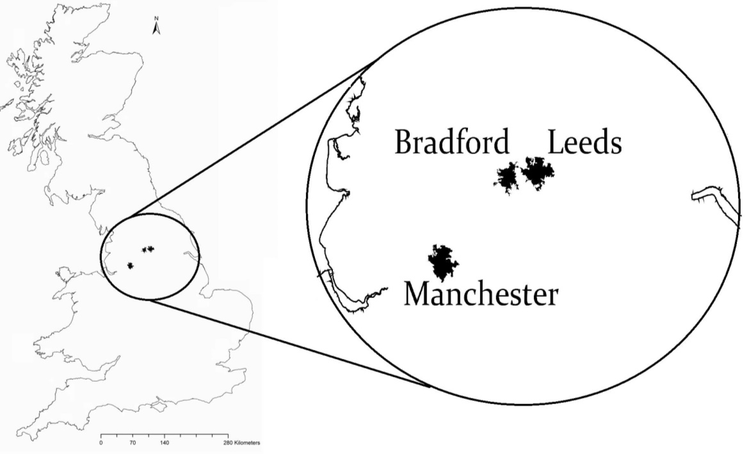
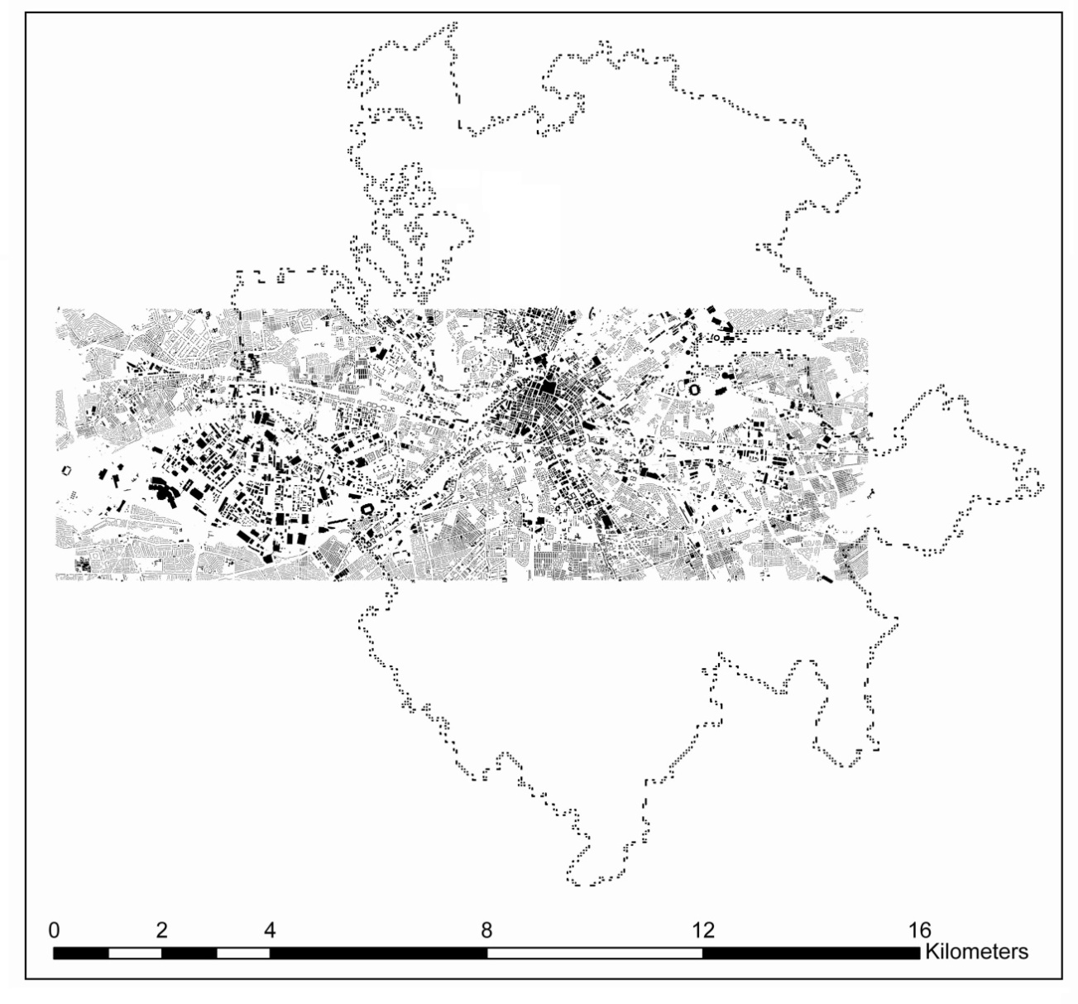
Manchester
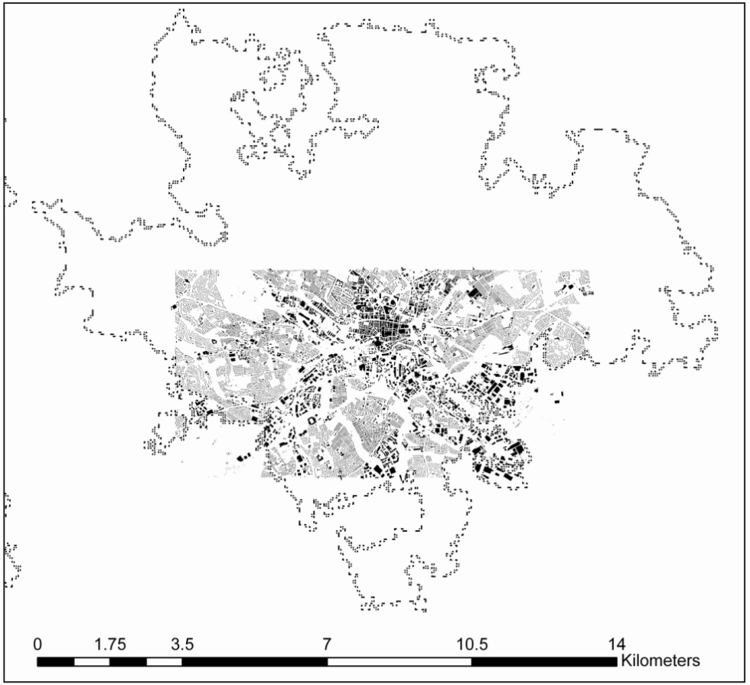
Leeds
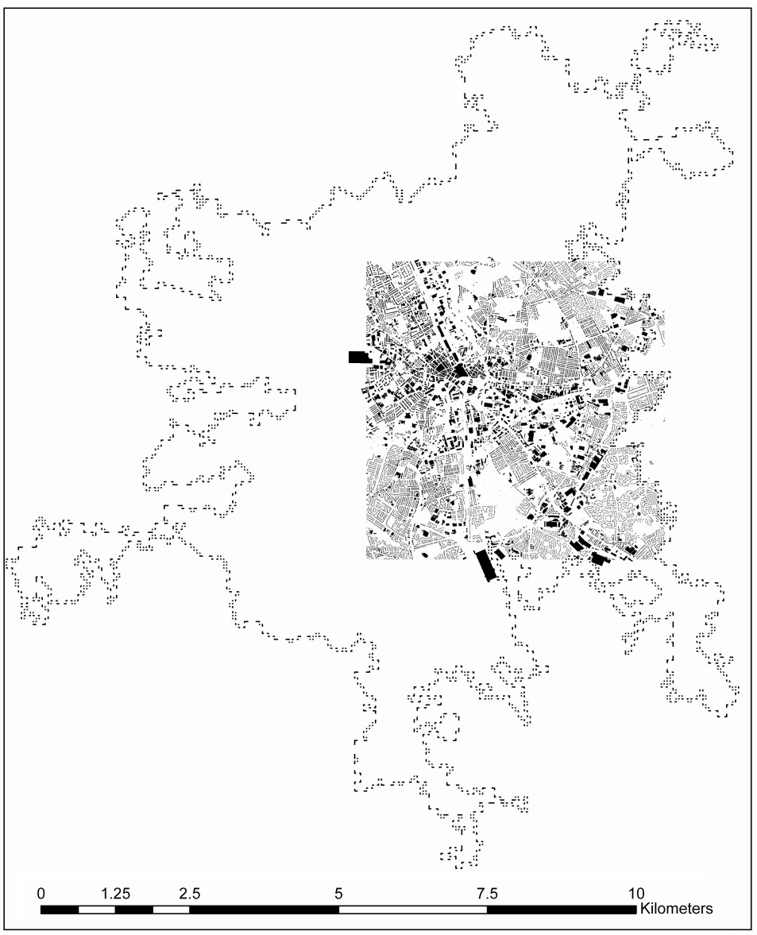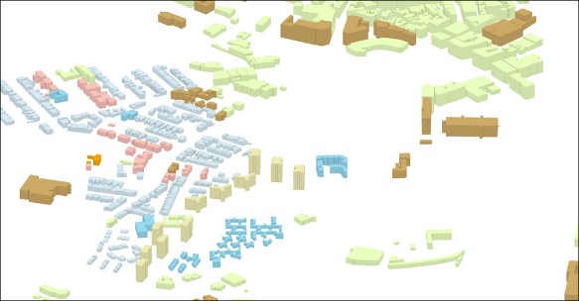
Bradford
  - Figure 3: Geographical extent of Manchester (1), Leeds (2) and Bradford (3) case study areas. The dotted lines are city borders and the red rectangles mark the boundaries of the study. 5km×5km tiles are selected that cover the urban densely built-up areas of the town centres. For Manchester three, for Leeds two and for Bradford one tile are selected. The granular black polygons are building footprints. A snapshot of the developed 3D GIS model of buildings is depicted in a window over Bradford.

Step 3 (b) Mapping of in-use brick stocks
As the results are in the form of hundreds of thousands of data entries, only aggregated and visualisations of results are provided. In addition, a further spatial representation of results is provided for one of the case study areas (Bradford) in order to demonstrate the capabilities and the level of details of the spatiotemporal model. Initially, the aggregated quantities of brick stocks are presented based on the numbers of total bricks and characterised by the type of buildings. This is primarily calculated for each individual building by utilising equation 1. Figure 4 demonstrates how any individual building is marked by a polygon on the 2D map (2) and a spatial object on the 3D model (3). The geometrical aspects of Relh and FP are considered (4) and the window/door frame to façade along with brick sizes and mortars provide product-specific MIs.

1 | 2 | 3 | 4 | 5
Aerial Image | 2D Map | 3D Model | Buildings | External Walls
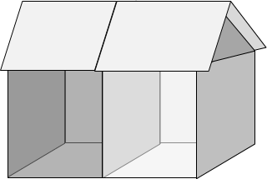
FP
RelH
  - Figure 4: Demonstration of two semi-detached buildings and product representation on the map, 3D model and the geometrical aspects of the external walls.

The buildings are classified into the 4 material-temporal cohorts based on the construction year as was described in step 2. As for each cohort the specific MIs are applied, the results of the material stocks (i.e. numbers of bricks for each brick type) can be further categorised based on the types of buildings. This will calculate the number of bricks for each individual building in the three case study areas. For the geographical extents of case studies, the results are aggregated and presented here, categorised by types of buildings, as well as types of bricks (Figure 5).

  - Figure 5: numbers of bricks (millions) within Bradford, Leeds and Manchester case study areas characterised by types of buildings and types of bricks.

The results of the analysis of brick stocks are spatially explicit with high-resolution location information as each building is located on the GIS map. Moreover, the results have the temporal resolution of one year, representing the year of added materials to the in-use stock. Therefore, by integrating the number of bricks into the spatiotemporal map, it is possible to produce a granular spatial representation of bricks over the case study area. For this purpose, the stock calculations are exported into the spatial model by matching them to the corresponding buildings. Subsequently, a city-wide map of brick stocks is generated that demonstrates the exact locations of the brick stock over the urban area and differentiates types and intensities of bricks on a map. This mapping of stocks is implemented for the first case study (the city of Bradford) and four maps are generated each for a brick type. In addition, the maps are converted into 3D representation by assigning the volumes of bricks for each building to the corresponding object on the map. The volumes are then exaggerated five-fold for better noticeability and a bird’s eye view of the maps is provided in Figure 6.

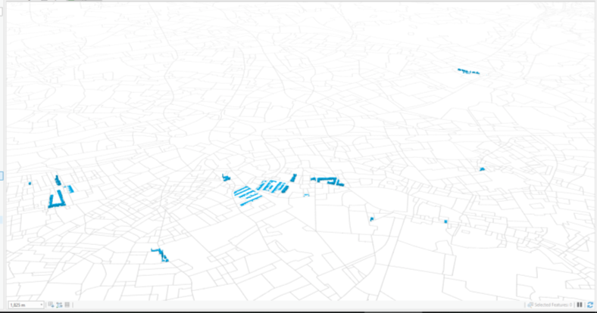  B1 | 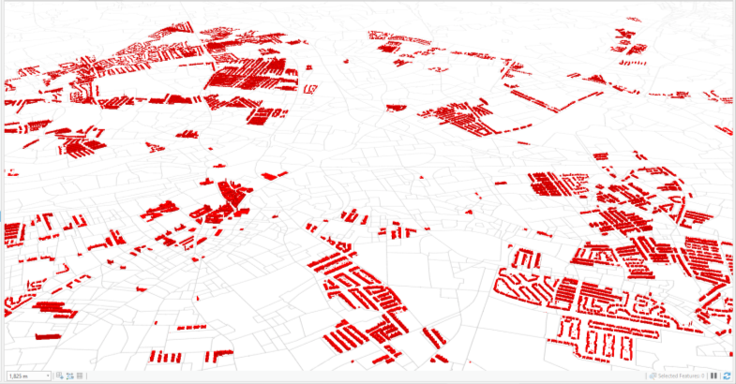  B2
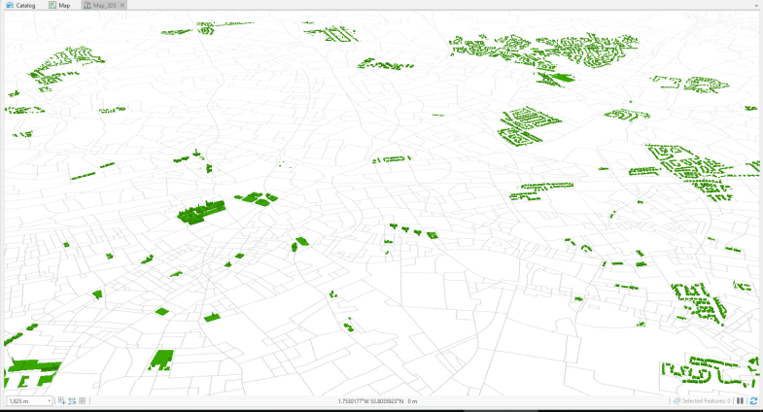  B3 | 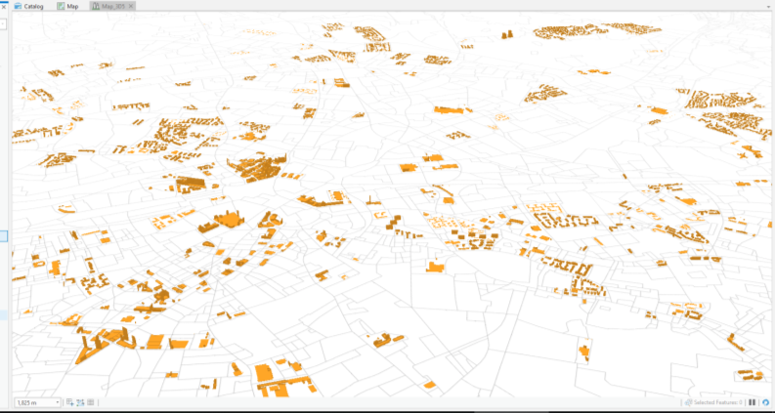  B4
  - Figure 6: Bird’s-eye view of the granular spatial distribution of volumes of bricks stocks of Bradford urban area. The volumes represent quantities of bricks, characterised by type. The volumes are exaggerated fivefold for better demonstration.

The granular resolution of the results at the level of individual buildings enables further analysis by integrating the GIS model into alternative representations. On the other hand, the high resolution of results with multiple embedded characteristics would add to the complexity of observation and interpretation. Moreover, local and regional assessments can benefit from maps of stocks that represent areas with higher intensities of certain type of materials. For this purpose, granular results can be rasterised by projection of the values onto a grid cell. In our case a 500m$×$500m mesh of rasters is overlaid on the results map. The total numbers of brick stocks for the buildings within the boundary of each cell are calculated for each type of brick. The raster mesh is categorised by colour-coding the cells according to the number of bricks that they encompass. As a result, four rasterised maps are generated for Bradford (Figure 6) that demonstrate efficiently which areas have a higher concentration of brick stocks of certain types.

B1 | B2
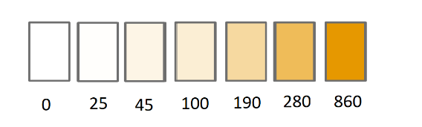 | 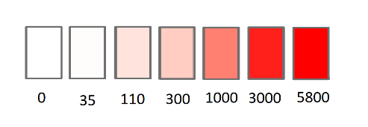
B3 | B4
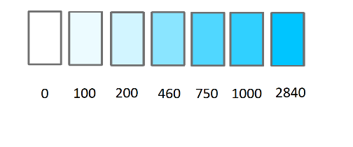 | 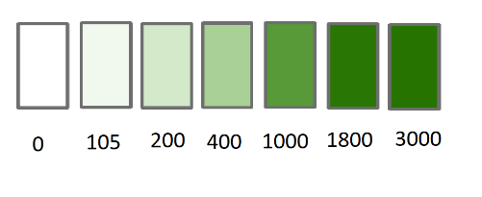

  - Figure 7: Map of rasterised local intensity of brick stocks of residential, commercial and office buildings characterised by types of brick. 500m grid cell is applied and aggregated number of bricks of each type are represented by a colour intensity. The legends demonstrate the associated colours with total numbers (in thousands) of bricks in each cell.
Step 4 Embodied Carbon of in-use stock.

Once the material stock is calculated and mapped, it can be utilised to associate the stock mapping to the life-cycle environmental assessment of building materials. To demonstrate this potential, this study connects the material stocks to an LCA of production and provision of bricks. LCA is a method to evaluate the impacts of systems by accounting for life-cycle exchanges, particularly material and energy (ISO, 2006). The goal of this LCA is to assess the Global Warming Potential (GWP) of the in-use stocks at urban scale. This impact is expressed as embodied Green House Gas emissions or simply embodied carbon. The LCA uses the spatialised mapping of brick stocks as an input in order to produce regional results. Regionalised LCA is relatively new and facing practicality challenges when attempting to produce spatially-explicit results (Heijungs, 2012). Spatio-temporally dynamic LCAs benefit from regionalised models of flows and stocks (Finnveden et al., 2009). Mapping the stocks of the construction industry provides an opportunity to produce regionalised LCA results more efficiently as the sector is relatively mature, with more homogenous types and consistent techniques that makes spatiotemporal modelling more feasible. For the Bradford case study area, the spatialised stocks are incorporated into LCA calculations. The system boundary includes the upstream processes of raw material supply and manufacturing of bricks and in addition, an average distance of transportation is included in the analysis. In addition, construction of brick walls is included in the system boundary, while the end of life activities of demolition, waste processing, disposal and credits of recycling are excluded from the analysis.

For the sake of practicality, accounting for the environmental burden of the in-use stock is based on the assumption that their life-cycle GWP is equal to a comparable new product on the market, resulting in a mass allocation of 1:1. The functional unit is considered as one kg of brick. Subsequently, the GWP for material type a of structure b can be described by:

${GWP}_{a,b}\left(t\right) = \sum{\left({MS}_{a,b(t)}{×{LCE}_{a} ×CF}_{a(t)} \right)}$ (2)

where GWP for type a of structure b is measured in kg of emissions equivalent to the effect of CO₂ towards the impact of climate change (kg CO₂eq.), LCE is the total life cycle emissions contributing to the GWP impact for production of 1kg of brick, and CF is the characterisation factor describing the quantities of life cycle emissions into GWP values. LCE derives from a Life Cycle Inventory analysis (LCI) of new bricks on the market. In equation 2, MS are derived from the analysis of stocks as described in Section 3 methodology, LCE is calculated by running a Life Cycle Inventory analysis of a typical brick based on a readily available dataset, and CF are adopted from a Life Cycle Impact Assessment model. Details of the LCA calculations, including sources of data and models for this case study are provided in Supplementary Material S1. A GWP score for each type of brick can be calculated by equation2, which can be implemented into the spatiotemporal model. The results can be temporally mapped at urban scale to demonstrate the trend of accumulation of embodied carbon over time.

Step 5: Map of embodied GWP accumulation
Integrating LCA into a spatially-explicit map of in-use stocks creates a spatially-explicit map of embodied LCA results. As the dataset have multiple features for each data point, it is possible to characterise the results in different ways. Here, the GWP results are characterised based on the construction year, thus, creating a map of GWP accumulation over time (Figure 8). The intensity maps indicate the trend of accumulation of embodied carbon at urban scale and which areas accumulated higher values of GWP over time can be observed. Note that each map has a separate legend and the colours of the spectrum are associated with a different GWP numbers in each map.

Embodied Carbon Accumulation Over Time
Pre 1900 | 1900-1920 | 1920-1945
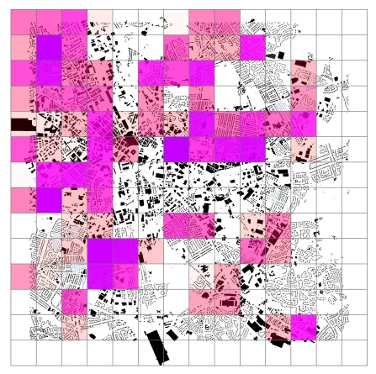 | 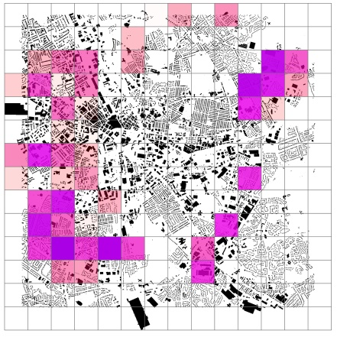 | 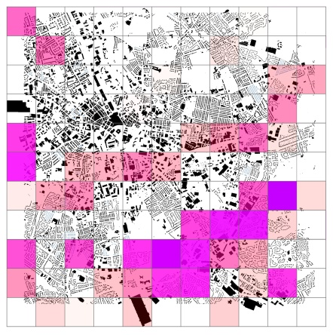
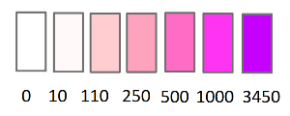 | 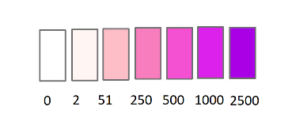 | 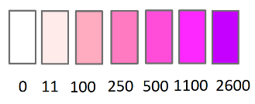
1945-1960 | 1960-1975 | 1975-1990
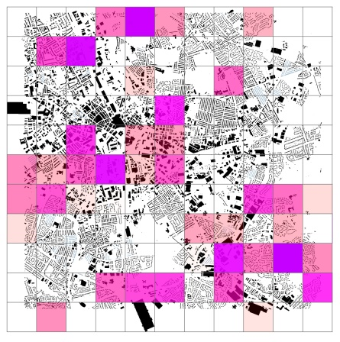 | 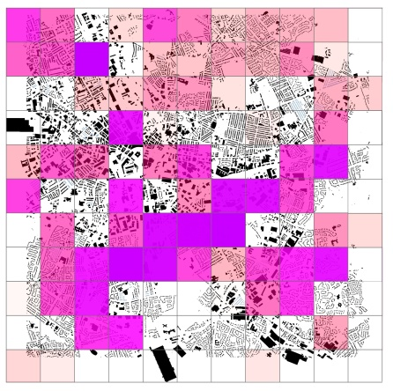 | 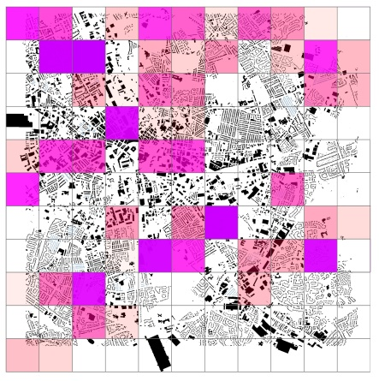
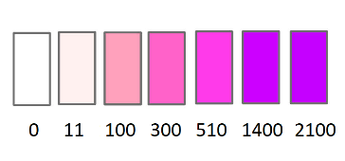 | 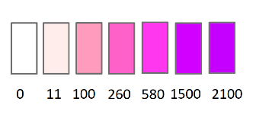 | 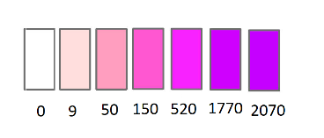
Post 1990
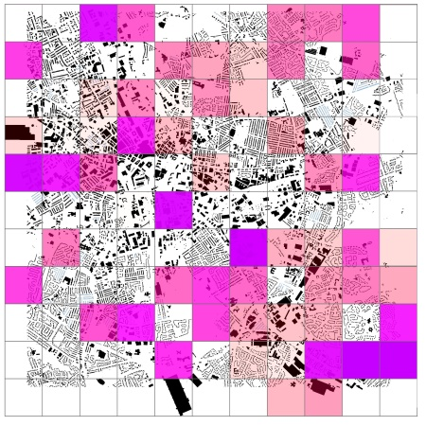
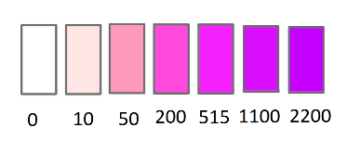
  - Figure 8: Spatially and temporally explicit rasterised mapping of accumulation of embodied life cycle GWP. Each map demonstrates the embodied GWP of the added stock of bricks over the specified period while colour intensities demonstrate the quantities of the accumulated GWP of each cell. The legends for each cell demonstrate the corresponding colours to the total GWPs
- Discussions:
It was highlighted in the literature review that a potential benefit of the spatiotemporal mapping of stocks would be integrating multiple characteristics such as land use, building morphologies, and regional flows. The results provide a granular map of brick stocks as well as embodied GWPs at a resolution of individual buildings. This level of detail provides valuable insights for further assessment as the supply stream of future reusable materials is mapped with embedded qualitative and quantitative data. The results of this study demonstrated the stocks of bricks in the case study urban areas. While the substantial size of the brick ‘material banks’ demonstrates the availability of the in-use stock, the technical feasibility of reclaiming in-use bricks can reveal reclamation potential. Previously, a key technical challenge was the assumption that it would be impossible to separate bricks from cement-based mortar without damage to the brick (Addis, 2012). Recent studies have shown that this is can be done effectively and at scalable capacities (Zhou et al., 2020). Currently there is a demand for more than 2 billion bricks annually in the UK, and at the same time around 2.5 billion bricks are demolished. The results of this paper and the above numbers suggest there is a potential to meet the demand of the market by reclaiming bricks and reusing. However, further research is needed to assess the quality of reclaimed bricks, as well as the willingness of the market stakeholders to purchase reclaimed bricks.
While this paper does not attempt to estimate the service life of the material repositories, there is a potential to utilise the brick quantities, age of materials and types of buildings to formulate future demolition out-flows. The methods, modelling and analysis presented in this study has potential for applicability and scalability, providing certain criteria are taken into consideration. Five aspects of 1) building types, 2) construction date, 3) footprint areas, 4) building heights, and 5) material intensities are required to apply the assessment methods to an urban area in any country. For the UK, the HLC land use dataset can be used as a basis, while building morphologies of the external surfaces are added to the model from the OS dataset. Currently the scopes of both HLC and OS in the UK are limited. Large rural and some smaller urban built areas are not covered which inhibits a comprehensive nationwide study with the current method. However, there is widespread coverage of urban areas which has the highest number and density of buildings. Other countries have comparable datasets and currently there is even an ambitious attempt to create a global library of urban footprint areas ane heights (CADMAPPER, 2020). The archetypical brick MIs of this study are adaptable to the whole UK, but for other countries, a new set of archetypes and MIs must be specified. Thus, the presented model is generally adaptable and applicable to other areas.
Considering building types, terraced housing in particular encompasses large quantities of bricks, accounting for over 80% of total stocks in all three areas. The results reveal the significance of terraced housing as a potential source of reclamation, compared to other types. More detailed results are presented in Supplementary Material S3. For the types of bricks, type B2 (of the pre-war mechanised bricks) also dominates the share of available bricks, especially in residential buildings. It is also noticeable that Manchester has significantly higher brick intensity over the urban areas compared to Leeds and Bradford. Further validations of the quantities of stocks could improve the accuracy of assessment studies. Direct measurements of buildings, reviewing construction plans or observing demolition can all be used as methods of validating stock calculations. The results and the model can additionally provide estimates of alternative pathways of reuse versus virgin materials and potentially other pathways such as downcycling and upcycling. The applications for the developed model of stocks are not limited to assessing reuse. 3D building models provide a realistic spatial representation of urban areas and thus could be used for urban planning. For instance, simulation of views from different locations and elevations and reuse plan could be created prior to construction of buildings. The temporal aspect of the presented model provides new ways of visualising the materialistic growth of the urban areas over time which could be used as a foundation for establishment of the stocks-flows model.
The uncertainties in the results are directly attributable the geographical and historical scopes of the case studies. The UK stock of bricks is considered one of the most diverse in the world (Lloyd, 1925). For instance, a survey of UK bricks by Harrison (2010), studied the variations in the lengths, widths and thicknesses of UK bricks by hundreds of direct measurements (Harrison, 2019). The results showed that there is a geographical pattern to the dimensions of bricks as there is tendency for bigger bricks to be found in the north. An early 20th century study of English brickwork (Lloyd, 1925) found that the contemporary bricks (20th century) tend to have more uniform dimensions compared to earlier types. Both studies found that pre-1850 bricks (Type B1) had noticeable variations in dimensions due to arbitrary moulding techniques but generally were bigger in size. This can be attributed to a brick tax imposed by the government in 1784 that was paid per brick, so brick makers responded by making larger bricks, which meant fewer were needed for a given size wall. The pre-1850 era is also marked by variations in mortar joint but there is a general trend of decreasing in sizes over time (Campbell & Saint, 2002).
Considering these studies, it can be asserted the uncertainties of the results of this study are higher with the type B1 and generally the results’ quality would improve towards contemporary types.
5. Conclusions:
Determining buildings’ material composition prior to demolition is a valuable source of information for prospective urban mining and its value increases when finer levels of details of certain qualities are implemented into the analysis. This study is the first to implement the four essential aspects of granular spatial resolution, temporal dimension, embodied carbon and material/building typologies into the analysis of stocks of an urban area. These aspects pave the way for evaluating the in-use stock for a circular economy which considers in-use building materials as repositories for future construction at the End of Service Life (EoSL) of buildings.
The evaluative aspects that were embedded in the developed model can help assess the reuse potential of bricks in the following ways. For GWP, when defining alternative EoSL scenarios, the embodied carbon of the in-use stocks is an essential part of comparing life cycle of reuse compared to business as usual scenarios. Moreover, the exact locations of the embodied GWPs can enable implementing evaluation of the distances required for transportation into the study. For the temporal aspect, material qualities change over time and under load bearing conditions. Accounting for the age of materials in stock assessment facilitates assessing their qualitative value for reuse. In addition, age can be used as an indicator for end-of-life estimations, which is valuable for implementing circular economy. Previous studies such as (Miatto et al., 2019) and (Stephan & Athanassiadis, 2017b) have shown that the demolition release rate of CDW can be estimated by considering building types and ages and typical lifespan. In addition, the age of the materials can be an indication of manufacturing features such as brick types, as was demonstrated in this study. A general typology that was presented here provides an opportunity to inform the market about qualities of reclaimable stocks. While prospective methods of accounting for materials such as Building Information Modelling (BIM), material passports, and CAD models are in their infancy, methods such as the stock assessment approach described in this paper can improve reusability at EoSL of materials. This is particularly essential as estimations show the vast majority of the building stock of the next few decades have already been built, thus signifying a retrospective view of current stocks and their reuse. Almost all previous bottom-up studies of brick stocks considered static MIs per volume or floor areas of buildings. However, one study (Ortlepp et al., 2018) proposed moving towards MIs that are specifically calculated for building elements such as roofs or foundation. This study has implemented this idea for bricks within the external walls of buildings and indicates the potential of evaluation of the in-use stock for implementing a circular economy.
Acknowledgements
This work was supported by the Engineering and Physical Sciences Research Council (EPSRC) research grant ‘REBUILD - REgenerative BUILDings and products for a circular economy’ [Grant reference: EP/P008917/1].

Number of worlds:
Number of Figures/tables: 8
Bibliography:

Addis, B. (2012). Building with Reclaimed Components and Materials. https://doi.org/10.4324/9781849770637
Ajayebi, A., Chen, H.-M., Zhou, K., Hopkinson, P., Wang, Y., & Lam, D. (2019). REBUILD: Regenerative Buildings and Construction systems for a Circular Economy. IOP Conference Series: Earth and Environmental Science, 225(1), 012015. https://doi.org/10.1088/1755-1315/225/1/012015
Anderson, J. Adams, K. and Shiers, D. (2012). Minimising the Environmental Impact of Construction Waste. BRE: Watford.
Augiseau, V., & Barles, S. (2017). Studying construction materials flows and stock: A review. Resources, Conservation and Recycling, 123, 153–164. https://doi.org/10.1016/J.RESCONREC.2016.09.002
BRE. (2019). Statement of Verification BRE Global Scheme Document SD207 Environmental Product Declaration-provided by The Brick Development Association.
CADMAPPER. (2020). CADMAPPER. Retrieved May 14, 2020, from https://cadmapper.com/
Campbell, J. W. P., & Saint, A. (2002). The Manufacture and Dating of English Brickwork 1600–1720. Archaeological Journal, 159(1), 170–193. https://doi.org/10.1080/00665983.2002.11020519
European Commission. (2018). Development and implementation of initiatives fostering investment and innovation in construction and demolition waste recycling infrastructure. Retrieved from http://ec.europa.eu/environment/waste/studies/pdf/CDW infrastructure study.pdf
European Commission. (2019). The European Green Deal. In European Commission (Vol. 53). https://doi.org/10.1017/CBO9781107415324.004
European Commission. (2020). Circular Economy Action Plan For a cleaner and more competitive Europe.
Eurostat. (2018). Economy-wide material flow accounts. In Eurpoean Commission. Retrieved from http://epp.eurostat.ec.europa.eu/portal/page/portal/product_details/publication?p_product_code=KS-34-00-536
Finnveden, G., Hauschild, M. Z., Ekvall, T., Guinée, J., Heijungs, R., Hellweg, S., … Suh, S. (2009). Recent developments in Life Cycle Assessment. Journal of Environmental Management, 91(1), 1–21. https://doi.org/10.1016/j.jenvman.2009.06.018
Fishman, T., Schandl, H., Tanikawa, H., Walker, P., & Krausmann, F. (2014). Accounting for the Material Stock of Nations. Journal of Industrial Ecology, 18(3), 407–420. https://doi.org/10.1111/jiec.12114
Gontia, P., Nägeli, C., Rosado, L., Kalmykova, Y., & Österbring, M. (2018). Material-intensity database of residential buildings: A case-study of Sweden in the international context. Resources, Conservation and Recycling, 130, 228–239. https://doi.org/10.1016/J.RESCONREC.2017.11.022
Göswein, V., Silvestre, J. D., Habert, G., & Freire, F. (2019). Dynamic Assessment of Construction Materials in Urban Building Stocks: A Critical Review. Environmental Science & Technology, 53(17), 9992–10006. https://doi.org/10.1021/acs.est.9b01952
Gregory, R. J., Hughes, T. G., & Kwan, A. S. K. (2004). Brick recycling and reuse. Proceedings of the Institution of Civil Engineers - Engineering Sustainability, 157(3), 155–161. https://doi.org/10.1680/ensu.2004.157.3.155
Harrison, J. (2019). Brick sizes. Retrieved from http://jaharrison.me.uk/Brickwork/Sizes.html
Heijungs, R. (2012). Spatial differentiation, GIS-based regionalization, hyperregionalization, and the boundaries of LCA. Environment and Energy (Editorial Series of Italian Commodity Science Academy and Engineering Association of Messina) Franco Angeli, Milano, Italy, 165–187.
Historic Scotland. (2014). Scottish Traditional Brickwork. Retrieved from https://www.brick.org.uk/admin/resources/g-scottish-traditional-brickwork.pdf
HLC. (2019). Historic Landscape Characterisation | Historic England. Retrieved July 20, 2019, from https://historicengland.org.uk/research/methods/characterisation-2/historic-landscape-characterisation/
Hopkinson, P., Chen, H.-M., Zhou, K., Wang, Y., & Lam, D. (2018). Recovery and reuse of structural products from end-of-life buildings. Proceedings of the Institution of Civil Engineers - Engineering Sustainability, 1–10. https://doi.org/10.1680/jensu.18.00007
Horvath, A. (2004). CONSTRUCTION MATERIALS AND THE ENVIRONMENT. Annual Review of Environment and Resources, 29(1), 181–204. https://doi.org/10.1146/annurev.energy.29.062403.102215
Iacovidou, E., & Purnell, P. (2016). Mining the physical infrastructure: Opportunities, barriers and interventions in promoting structural components reuse. Science of The Total Environment, 557–558, 791–807. https://doi.org/10.1016/J.SCITOTENV.2016.03.098
IPCC. (2014). Climate Change 2014: Mitigation of Climate Change: Working Group III Contribution to the Fifth Assessment Report of the Intergovernmental Panel on. In Ipcc. https://doi.org/using statistical
ISO. (2006). International Organization for Standardization (ISO)14040:2006 - Environmental management - Life cycle assessment - Requirements and guidelines 2006 (Vol. 2006).
Kleemann, F., Lederer, J., Rechberger, H., & Fellner, J. (2017). GIS-based Analysis of Vienna’s Material Stock in Buildings. Journal of Industrial Ecology, 21(2), 368–380. https://doi.org/10.1111/jiec.12446
Krausmann, F., Wiedenhofer, D., Lauk, C., Haas, W., Tanikawa, H., Fishman, T., … Haberl, H. (2017). Global socioeconomic material stocks rise 23-fold over the 20th century and require half of annual resource use. Proceedings of the National Academy of Sciences, 114(8), 1880–1885. https://doi.org/10.1073/PNAS.1613773114
Lloyd, N. (1925). A history of English brickwork : with examples and notes of the architectural use and manipulation of brick from mediaeval times to the end of the Georgian period. Antique Collectors’ Club.
Mastrucci, A., Marvuglia, A., Popovici, E., Leopold, U., & Benetto, E. (2017). Geospatial characterization of building material stocks for the life cycle assessment of end-of-life scenarios at the urban scale. Resources, Conservation and Recycling, 123, 54–66. https://doi.org/10.1016/J.RESCONREC.2016.07.003
Meinel, G., Hecht, R., & Herold, H. (2009). Analyzing building stock using topographic maps and GIS. Building Research & Information, 37(5–6), 468–482. https://doi.org/10.1080/09613210903159833
Miatto, A., Schandl, H., Forlin, L., Ronzani, F., Borin, P., Giordano, A., & Tanikawa, H. (2019). A spatial analysis of material stock accumulation and demolition waste potential of buildings: A case study of Padua. Resources, Conservation and Recycling, 142, 245–256. https://doi.org/10.1016/J.RESCONREC.2018.12.011
National Statisitcs. (2019). Monthly Statistics of Building Materials & Components- April 2019. Retrieved from https://www.gov.uk/government/statistics/building-materials-and-components-statistics-april-2019
Nemry, F., Uihlein, A., Jrc, I., Colodel, C. M., Wittstock, B., Braune, A., … Gmbh, C. H. (2008). Environmental Improvement Potential of Residential Buildings. https://doi.org/10.2791/38942
Oezdemir, O., Krause, K., & Hafner, A. (2017). Creating a Resource Cadaster—A Case Study of a District in the Rhine-Ruhr Metropolitan Area. Buildings, 7(4), 45. https://doi.org/10.3390/buildings7020045
Ortlepp, R., Gruhler, K., & Schiller, G. (2016). Material stocks in Germany’s non-domestic buildings: a new quantification method. Building Research & Information, 44(8), 840–862. https://doi.org/10.1080/09613218.2016.1112096
Ortlepp, R., Gruhler, K., & Schiller, G. (2018). Materials in Germany’s domestic building stock: calculation model and uncertainties. Building Research & Information, 46(2), 164–178. https://doi.org/10.1080/09613218.2016.1264121
OS. (2019). Ordnance Survey: Britain’s Mapping agency. Retrieved July 20, 2018, from https://www.ordnancesurvey.co.uk/
Pomponi, F., & Moncaster, A. (2017). Circular economy for the built environment: A research framework. Journal of Cleaner Production, 143, 710–718. https://doi.org/10.1016/J.JCLEPRO.2016.12.055
Sandberg, N. H., Heidrich, O., Dawson, R., Dimitriou, S., Vimm-r, T., Filippidou, F., … Brattebø, H. (2016). Dynamic building stock modelling: Application to 11 European countries to support the energy efficiency and retrofit ambitions of the EU. Energy and Buildings, 132, 26–38. https://doi.org/10.1016/J.ENBUILD.2016.05.100
Stephan, A., & Athanassiadis, A. (2017a). Quantifying and mapping embodied environmental requirements of urban building stocks. Building and Environment, 114, 187–202. https://doi.org/10.1016/J.BUILDENV.2016.11.043
Stephan, A., & Athanassiadis, A. (2017b). Towards a more circular construction sector: Estimating and spatialising current and future non-structural material replacement flows to maintain urban building stocks. https://doi.org/10.1016/j.resconrec.2017.09.022
Tanikawa, H., Fishman, T., Okuoka, K., & Sugimoto, K. (2015). The Weight of Society Over Time and Space: A Comprehensive Account of the Construction Material Stock of Japan, 1945-2010. Journal of Industrial Ecology, 19(5), 778–791. https://doi.org/10.1111/jiec.12284
Tanikawa, H., & Hashimoto, S. (2009). Urban stock over time: spatial material stock analysis using 4d-GIS. Building Research & Information, 37(5–6), 483–502. https://doi.org/10.1080/09613210903169394
Wiedenhofer, D., Steinberger, J. K., Eisenmenger, N., & Haas, W. (2015). Maintenance and Expansion: Modeling Material Stocks and Flows for Residential Buildings and Transportation Networks in the EU25. Journal of Industrial Ecology, 19(4), 538–551. https://doi.org/10.1111/jiec.12216
Zhou, K., Chen, H.-M., Wang, Y., Lam, D., Ajayebi, A., & Hopkinson, P. (2020). Developing advanced techniques to reclaim existing end of service life (EoSL) bricks – an assessment of reuse technical viability. Developments in the Built Environment, 100006. https://doi.org/10.1016/J.DIBE.2020.100006

