Received 00th January 20xx,
- Department of Chemistry and Materials Innovation Factory, University of Liverpool, Crown Street, Liverpool, L69 7ZD, UK. E-mail Anna.Slater@liverpool.ac.uk.
- Department of Chemistry, Durham University, South Road, Durham, DH1 3LE, UK.
Electronic Supplementary Information (ESI) available, including experimental procedures and computational and analytical data. See DOI: 10.1039/x0xx00000x
Accepted 00th January 20xx
DOI: 10.1039/x0xx00000x

High-yielding flow synthesis of a macrocyclic molecular hinge
Christopher D. Jones,ª Laurence J. Kershaw Cook,ª David Marquez-Gamez,ª Konstantin V. Luzyanin,ª Jonathan W. Steed^{b} and Anna G. Slater*ª
Many molecular machines incorporate modular structures with well-defined motile capabilities, such as axles and wheels. Hinges are particularly useful, as they provide the minimum flexibility needed for a simple and pronounced conformational change. Compounds displaying multiple stable conformers are common, but molecular hinges almost exclusively operate via dihedral rotations rather than truly hinge-like clamping mechanisms. An ideal molecular hinge would better reproduce the behaviour of hinged mechanical devices, such as cantilevers and tweezers, while remaining soluble, scalable and synthetically versatile. Herein, we describe two isomeric macrocycles with clamp-like open and closed geometries, which crystallise as separate polymorphs but interconvert freely in solution. These readily soluble structures were produced concomitantly from inexpensive reagents, without supramolecular templating or high-dilution conditions, via a one-pot addition-cyclisation reaction. After investigating the reaction mechanism via NMR kinetic measurements, we developed a semi-continuous flow synthesis to deliver macrocycle yields of over 90% with high selectivity for a single isomer. Crucially, the macrocycles feature voids that are sterically protected from guests, including highly reactive species such as fluoride ions. The structures could thus act as chemically inert hinges for synthetic recceptors and flexible porous materials, allowing them to explore a range of conformations and adaptively bind to target guests.
Introduction
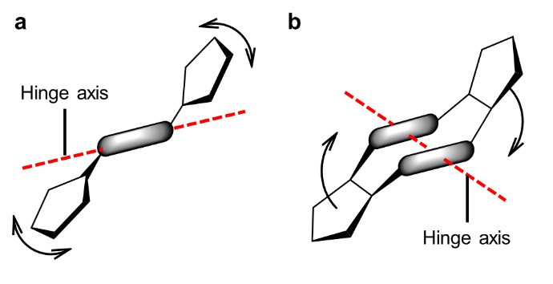
Biological processes depend strongly on the ability of molecules to undergo reliable and reversible changes in shape. Finely controlled conformational transitions play important roles, for example, in muscle contraction, transmembrane ion transport and ATP synthesis.¹⁻³ A key ambition of supramolecular chemists is to engineer molecular machines capable of performing useful work, such as catalysis, transport and host-guest binding, with comparable precision.^{4, 5} To date, synthetic molecular machines have featured complex arrangements of moving parts, including rings that shuttle between stations on a linear or circular track^{6, 7} and crane-like arms that can transfer labile moieties between reactive docking sites.^{8, 9}
Molecular machines typically consist of modular components linked by covalent or mechanical bonds. For example, a nanocar may be constructed by connecting pseudo-spherical adamantane or fullerene wheels to a central dipolar chassis via an alkyne axle.¹⁰ Rotors¹¹ and shuttles⁷ commonly incorporate a catenane or rotaxane, while hinges are built from moieties with interconvertible geometric isomers. Suitable structures include photoisomerisable double bonds, such as stilbenes, imines and azobenzenes,¹² and fused aliphatic rings with distinct chair, boat and skew conformations.^{13, 14} Hinging provides a mechanism for controlling resonance energy transfer¹⁵ and other physical phenomena dependent on the separation of interacting groups. Alternatively, hinged architectures may function as molecular clips or tweezers, varying the distance between their closing “jaws” to maximise binding with an encapsulated guest.^{16, 17}
Fig. 1 (a) Schematic mechanism of a typical molecular hinge based on torsional rotations around a rigid spacer, such as a double bond or disubstituted ring; (b) clamp-like mechanism of a macrocyclic molecular hinge (this work).
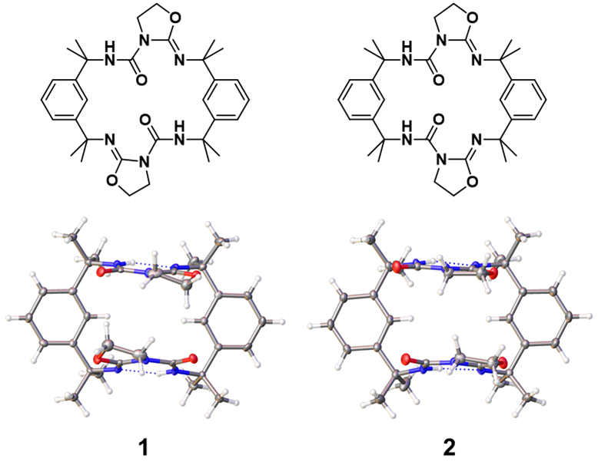
Despite their simple mechanical function, synthesising molecular hinges with widespread utility remains a challenge. Hinges based on a flexible single¹⁸⁻²⁰ or double^{15, 21-23} bond or disubstituted ring system²⁴⁻²⁷ operate through a dihedral rotation rather than a clamping motion, making them sub-optimal scaffolds for pincer-like receptors (Fig. 1a). In addition, these isomerisation processes are often triggered by an external stimulus,²⁸ so are of limited use if switching must occur freely and frequently at room temperature as in conformationally adaptive host-guest binding.²⁹ Larger structures displaying conformational isomerism³⁰⁻³² are typically difficult to synthesise or derivatise, or incompatible with certain solvents and reactive guests. Furthermore, a truly versatile molecular hinge must exhibit well-defined open and closed forms, with little additional flexibility, and be unable to form significant host-guest interactions itself. These features ensure that the hinging process is predictable, entropically viable and easy to implement in a modular supramolecular receptor,³³ while preserving the affinity and selectivity of the intended binding sites.
Macrocycles represent a promising starting point for the construction of more reliable clamp-like molecular hinges (Fig. 1b). Even complex macrocycles may be highly rigid, exhibiting a precise arrangement of functional groups around a well-defined central cavity.³⁴ Thus, conformational isomerism in macrocycles typically involves a small number of structures with shapes that are easy to distinguish and usefully diverse.³⁵⁻³⁷ Conformers are described as atropisomers if they can be manipulated as separate compounds, interconverting only at elevated temperatures or through the breaking of a bond.³⁸ By contrast, non-atropisomeric conformers may equilibrate readily in solution under ambient conditions. Atropisomerism is widely exploited in medicinal macrocycles, such as vancomycin,³⁹ to fix the compounds in their most biologically active conformations.⁴⁰ Conformationally flexible macrocycles, meanwhile, may favour different forms in response to physical or chemical stimuli.²⁹ Since conformers typically display pronounced differences in their spectroscopic, host-guest binding and solid-state properties, flexible macrocycles may be integrated into remotely switchable molecular containers and other stimuli-responsive supramolecular materials.⁴¹
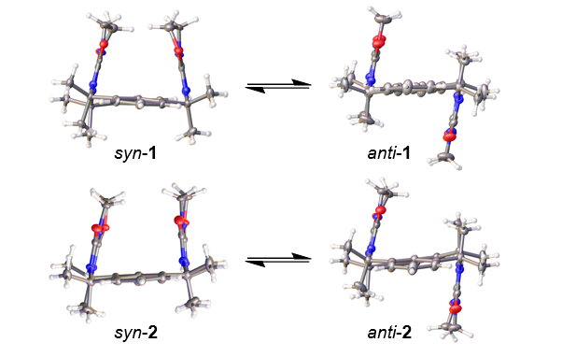
Another important advantage of macrocycles is that binding sites are confined to fixed locations within an easily modified intrinsic void.⁴² The shape of this void may be tuned to ensure tight complementarity with a target guest, for applications such as catalysis, drug delivery and molecular recognition.⁴³ Likewise, undesirable guest uptake by a macrocyclic hinge may be avoided by the inclusion of competitive intramolecular motifs or bulky peripheral substituents, which present a steric barrier to incoming species.³⁰ Introducing more flexibility into a macrocycle can lead to a stronger induced fit with guests,⁴⁴⁻⁴⁶ provided the increase in complementarity compensates for the greater loss of entropy on binding.⁴⁷ However, it may also provide a gating mechanism by which to limit the possibility of host-guest interactions. For example, a labile coordination site⁴⁸ or isomerisable double bond⁴⁹ may allow the structure to switch to a more closed conformation, reducing the accessibility of internal binding sites.
Designing and synthesising a flexible macrocycle can be a difficult task. In the absence of preorganised intermediates, protecting groups, supramolecular templates and high-dilution conditions are often necessary to favour macrocycle formation over oligomerisation pathways.⁵⁰ Syntheses may therefore be slow and low-yielding or involve multiple protection and deprotection steps. An increasingly popular approach is to make use of flow reaction platforms,^{51, 52} in combination with in- or on-line reaction monitoring and automated optimisation techniques,⁵³ to identify the most efficient and selective reaction conditions. Reactants in flow may be mixed, heated, and cooled more uniformly, and the synthetic protocol may be adjusted continuously in response to real-time yield and kinetic measurements. By enabling more controlled addition of reagents and higher reaction temperatures, flow technology has allowed macrocycles to be generated more rapidly, in higher yields, and with fewer side products than conventional batch methods.⁵⁴
Fig. 2 Formulae and crystal structures of isomeric macrocycles 1 and 2 in their syn conformations. Oxazolidine rings are angled out of the macrocycle plane, producing clamp-like geometries.
In this investigation, two isomeric macrocycles, 1 and 2, (Fig. 2) were prepared from readily available reagents via a one-pot addition-cyclisation reaction. Remarkably, each macrocycle transitions between a pair of distinct conformers in solution, which can be isolated as separate concomitant single crystals for analysis by single-crystal X-ray diffraction (SCXRD) (Fig. 3). Furthermore, the ratio of macrocycles in the product may be tuned by varying the sequence in which the starting materials are mixed. A semi-continuous synthetic method was used to maximise the rate of macrocycle formation and attain high selectivity for product 2. Synthesising the macrocycles in flow allows the intermediates and products to be monitored over a range of temperatures, aiding optimisation of the reaction conditions and kinetic analysis of key mechanistic steps.
Fig. 3 Crystal structures of 1 and 2 in their syn and anti geometries. The conforrmers interconvert readily in solution but crystallise separately as concomitant single crystals.
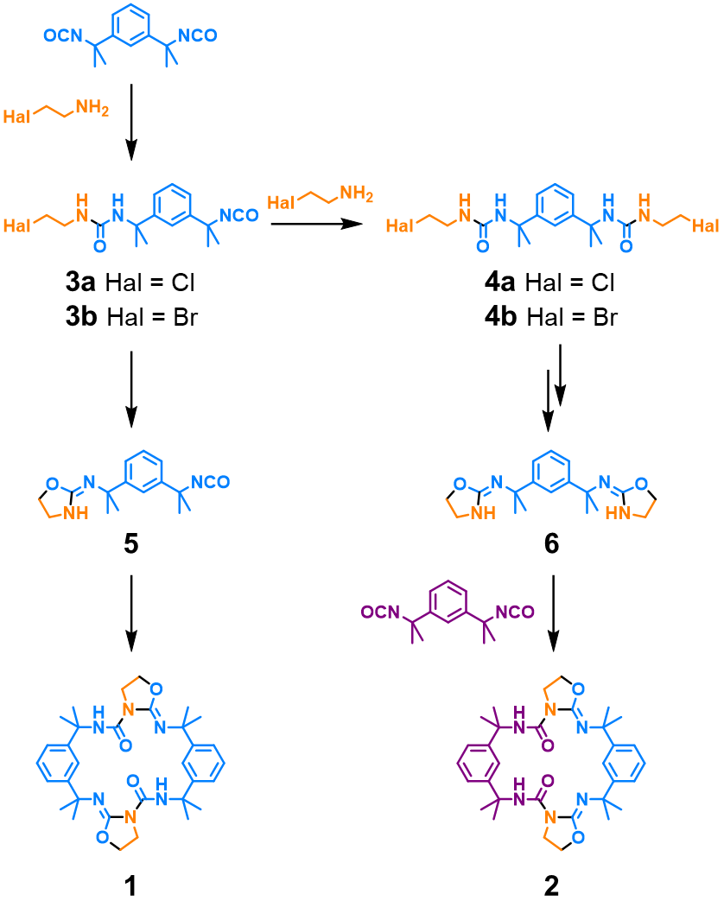
As molecular hinges, macrocycles 1 and 2 display several useful properties. Firstly, syn-anti transitions offer access to well-defined open and closed geometries, which are readily characterised in both solution and the solid state. Based on variable-temperature NMR (VT-NMR), crystallographic and computational studies, we propose that the hinging mechanism differs from that of similarly flexible macrocycles, such as calixpyrroles,⁵⁵ in that it involves a simple rapid clamping motion with no alternative conformers. In addition, NMR and computational studies suggest that the macrocycles interact only weakly with guests, including protic solvents and highly basic species such as fluoride ions, due to shielding of their internal voids by bulky methyl groups and oxazolidine rings. Finally, both compounds are readily soluble and may be synthesised easily and inexpensively on a large scale. Given the simplicity and derivatisability of the amine⁵⁶ and isocyanate⁵⁷ starting materials, these structures would serve as useful scaffolds for clamp-like receptors, hinged molecular machines and flexible porous framework materials, enabling reliable changes in shape and adaptive recognition of target guests.
Results and discussion
Synthesis and characterisation
A mixture of 1 and 2 is generated by reacting tetramethylxylylene diisocyanate with 2-chloroethylamine or 2-bromoethylamine in the presence of triethylamine base. In our proposed mechanism (Fig. 4), the reaction generates a mono-urea 3 or bis-urea 4, which slowly cyclise to form the nucleophilic 2-iminooxazolidines 5 and 6. These intermediates likely exist as a mixture of tautomers and stereoisomers⁵⁸ but react further to form macrocycles only in the Z configurations, which allow for a stabilising intramolecular hydrogen bond in the final product.⁵⁹ Macrocycle 1 is produced by the homocoupling of 5, while its isomer 2 results from the addition of 6 to a second equivalent of diisocyanate. The structures of the oxazolidine intermediates and their mechanism of formation is highly unusual. Although cyanate ions can undergo cyclisation reactions with substituted alkylamines,⁶⁰ comparable O-alkylation of an isocyanate is rarely reported⁶¹ and has never been used to generate macrocyclic structures.
Macrocycles 1 and 2 can be separated by column chromatography and purified by recrystallisation from methanol. The structures of the compounds were confirmed by SCXRD and are consistent with elemental analysis, mass spectrometry and NMR spectroscopy data. Intriguingly, each compound adopts two stable conformations that crystallise separately as concomitant polymorphs. The conformers differ in the orientations of the oxazolidine rings, displaying either U-shaped syn or Z-shaped anti configurations (Fig. 3). Isomers anti-1 and syn-2 are achiral, while the chiral compounds syn-1 and anti-2 give rise to intrinsically racemic crystal forms. The conformers are rigidified by intramolecular hydrogen bonds between the urea and imine groups⁶² but otherwise exhibit no significant supramolecular motifs in the solid state. Consequently, the compounds can be dissolved readily in dichloromethane and chloroform for assessment of their stereodynamic and host-guest binding properties. The solution processability of the compounds is also an advantage for their large-scale synthesis and functionalisation, leading to more optimal clamp-like receptors for practical applications.
Fig. 4 Proposed mechanism for the one-pot synthesis of macrocycles 1 and 2, via the unusual oxazolidine intermediates 5 and 6. Formulae are coloured to highlight the origins of atoms and bonds in the final products, while newly formed bonds are indicated in black. Reactions are performed in chloroform at 20-60°C with 300 mM of triethylamine, 145 mM of the amine hydrohalide, and 1 eq. of the diisocyanate added in one or two stages.
Molecular hinge behaviour
The conformational isomerism of compounds 1 and 2 is unusually well-defined. Each macrocycle exhibits distinct syn and anti forms, which can be readily distinguished by powder X-ray diffraction (PXRD). When 10 mM chloroform solutions of the compounds are slowly evaporated, the resulting precipitates consist mainly of the syn-1 (Fig. 5a) and anti-2 (Fig. 5b) polymorphs. However, recrystallisation the materials from methanol causes the anti-1 and syn-2 polymorphs to preferentially form. The ¹H NMR spectrum of each macrocycle at room temperature contains one set of resonances and can be assigned to the thermal average of its syn and anti conformations, with no indication of separate atropisomeric species (I would suggest giving this ¹H NMR spectrum at the SI or add the corresponding entry to the Figure 6). It can be concluded that interconversion of the conformers is not fully restricted by the bulky methyl groups of 1 and 2 and occurs rapidly in solution on the NMR timescale, as in the case of the similarly methylated calixpyrroles.⁵⁵ This switching behaviour allows the ratio of conformers to vary during crystallisation, favouring different polymorphs depending on the crystal growth conditions.

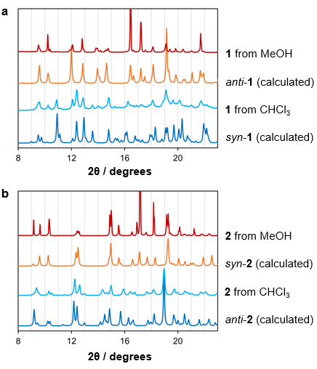
Fig. 5 Calculated PXRD patterns of (a) 1 and (b) 2 from the crystal structures of their syn and anti conformers, and the experimental patterns obtained after recrystallisation of the compounds from chloroform and methanol.
Variable-temperature ¹H NMR (VT-NMR) offers further insight into the mechanism of conformational switching.⁶³ Each macrocycle displays two triplet signals in the range 3.5-4.3 ppm which were attributed to the four methylene protons of the oxazolidine ring, matching the NMR assignments of literature analogues (Fig. 6a).⁵⁹ At room temperature, both protons of each CH₂ site are chemically and magnetically equivalent due to the rapid interconversion of the syn and anti conformers. However, when dichloromethane-d₂ solutions of 1 (Fig. 6b) and 2 (Fig. 6c) are cooled below -20 and -40°C, respectively, the inequivalent protons α₁ and α₂ and β₁ and β₂ are clearly resolved as separate with matching integrals. We propose that protons α₁ and β₁ give rise to downfield signals due to interactions with the opposing oxazolidine rings and, in macrocycle 1, the attached urea carbonyl groups. Indeed, the crystal structure of syn-1 displays interatomic CH···OC distances of 2.6-2.9 Å (with a mean value of 2.73 Å), while CH···HC contacts in both syn-1 and syn-2 lie in the range 2.3-2.8 Å (with means of 2.49 Å and 2.57 Å for 1 and 2, respectively).
The coalescence temperature, T_{C}, for each methylene group was estimated by extrapolating the chemical shifts of the split signals to the point of convergence. These values may be used to estimate the activation energy for the transition, ΔG‡, via the Eyring equation:⁶³
$$∆G^{‡}=-RT\ln\left(\frac{{hk}_{r}}{kT_{C}}\right) (1)$$
where k is the Boltzmann constant, h the Planck constant, R the molar gas constant and k_{r} the rate constant for the conformational change. The value of k_{r} is determined from Δδ, the maximum separation of the syn and anti signals in Hz:

$$k_{r}=\frac{π}{\sqrt{2}}∆δ (2)$$

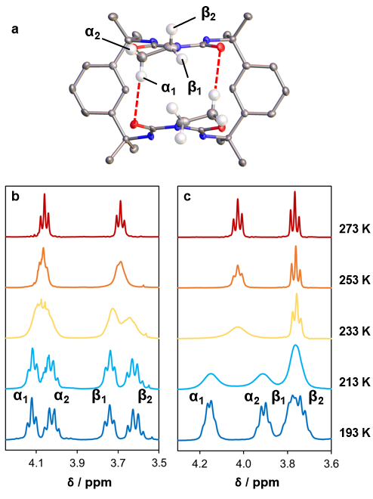
For 1 and 2, this analysis yields $∆G^{‡}$ values of 54 ± 1 and 47 ± 1 kJ mol⁻¹, respectively. Macrocycle 1 displays a slightly larger barrier for the syn-anti transition, suggesting that opening of the syn form is resisted by stronger interactions between the oxazolidine rings.
Fig. 6 (a) Assignment of the four methylene proton environments in 1, with close CH···OC contacts illustrated in red. The methylene protons are enlarged and other protons omitted for clarity; (b) VT-NMR spectra of 1, showing splitting of the ¹H methylene signals below 253 K; (c) VT-NMR spectra of 2, showing splitting of the ¹H methylene signals below 233 K.
To rationalise their relative stabilities, the syn and anti conformers of 1 and 2 were modelled using the density functional theory (DFT) method B3LYP⁶⁴ in the basis sets 6-31++G**,⁶⁵ def2-TZVP⁶⁶ and aug-cc-pVDZ.⁶⁷ After geometry optimisation, syn-1 is approximately 13 kJ mol⁻¹ lower in energy than anti-1, while anti-2 is 6 kJ mol⁻¹ more stable than syn-2. The oxazolidine rings of syn-1 interact more strongly due to the antiparallel alignment of dipoles and close contacts between the methylene and carbonyl groups. In syn-2, where the oxazolidine rings exhibit a parallel configuration, no such CH···OC interactions are possible. Thus, syn-1 and anti-2 are expected to be the dominant conformations of the macrocycles in solution. This hypothesis is supported by our PXRD studies, which indicate a greater abundance of the predicted low-energy conformers when 1 and 2 are precipitated from chloroform (Fig. 5). Preferential crystallisation of the higher-energy anti-1 and syn-2 conformers from methanol could result from solvent-macrocycle hydrogen bonding or other stabilising solvation effects, which are not accounted for in our DFT calculations.
Additional DFT calculations were performed to explore the mechanism of conformational switching. For each conformer, one torsion angle was altered in increments of 0.2-5.0° until the alternative macrocycle structure was reached. The geometry was optimised for each fixed torsion angle in the 6-31+G* basis set and its energy compared with that of the starting conformation (Fig. 7a). The calculations suggest that the two conformational changes are mechanistically similar, involving rotations of the phenyl groups out of the plane of the macrocycle (Fig. 7b). The intramolecular hydrogen bonds are strongly preserved, forcing each urea-oxazolidine motif to move as a single rigid structure like the jaw of a clamp. Following refinement of the highest-energy geometries in a range of larger basis sets, we estimated an activation barrier of 37-41 kJ mol⁻¹ for conversion of anti-2 to the less stable syn form. Conversion of anti-1 to syn-1 is opposed by a similar energy barrier, but the reverse transition displays a much larger activation energy of 51-54 kJ mol⁻¹ due to the relatively high stability of the syn geometry.
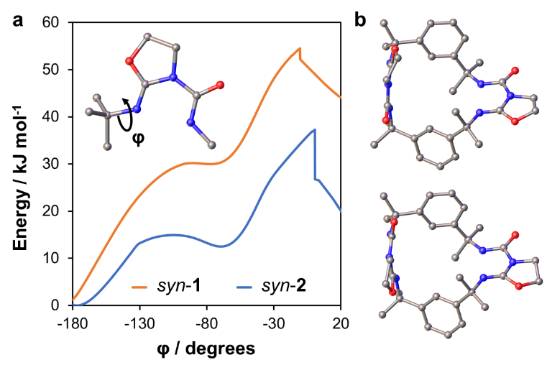
Strong agreement between these results and those of our VT-NMR experiments suggests that the behaviour of the macrocycles in solution has been accurately described. Interestingly, further refining the model with a D3BJ dispersion correction⁶⁸ has little effect on the energy landscape of 2 but increases the stability of syn-1, and thus the barrier for the syn-anti transition, by 16-19 kJ mol⁻¹. This discrepancy could be due to an overestimation of dispersion forces between the oxazolidine rings or the omission of solvation effects from the modelled system.
Fig. 7 (a) DFT energies (B3LYP/6-31+G*) of 1 and 2 for varying values of the methyl-imine torsion angle (inset); (b) the highest-energy conformations of 1 (top) and 2 (bottom), in which the oxazolidine rings adopt a perpendicular arrangement and the phenyl groups twist out of the macrocycle plane.
Given the simplicity and rapidity of their conformational switching behaviour, compounds 1 and 2 represent appealing scaffolds for the construction of larger clamp-like macrocycles. There is much scope for derivatising the xylylene spacers or decorating the oxazolidine rings with functional substituents, like the rim substituents of calixarenes³¹ and calixpyrroles,³² to deliver stronger host-guest binding or stimuli-responsive properties. The ability to incorporate a reliable hinge into more complex materials, such as polymers and network solids, could offer increased control over useful physical properties such as porosity and gelation capacity. Exploring this modular synthetic approach will be a key objective of our future research.
Batch synthesis
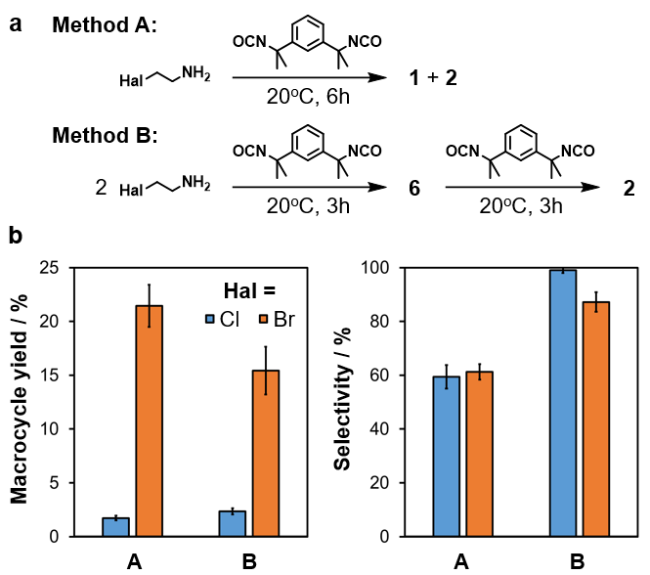
Macrocycles 1 and 2 can be produced in different ratios by varying the sequence in which reagents are mixed (Fig. 8a). If the amine and isocyanate react in an equimolar ratio over six hours (Method A), neither isomer is strongly favoured. By contrast, adding two equivalents of the amine to the neat isocyanate followed by a second equivalent of neat isocyanate after three hours (Method B) results in a high selectivity for compound 2. It is proposed that the ureas 3 and 4 form rapidly but only slowly cyclise to yield the oxazolidines 5 and 6. Thus, Method B allows for near-quantitative conversion of mono-urea 3 to bis-urea 4, preventing the formation of macrocycle 1 via intermediate 5.
Fig. 8 (a) One-pot macrocyclisation reactions involving one (Method A) or two (Method B) reagent addition steps; (b) total yields and selectivities of macrocycle syntheses using different methodologies and amine starting materials. Selectivity is equal to the yield of 2 as a percentage of the total macrocycle yield. Error bars represent the standard deviations for replicate experiments (n = 4).
The selectivity of the reaction can be reliably measured without purification due to the presence of highly deshielded urea protons in the macrocycle structures. The NMR signals for the urea groups of 1 and 2 occur as singlets at 10.9 and 10.7 ppm, respectively, making them easily distinguishable from other species. Yields may be measured by NMR analysis of the crude product, after quenching and evaporation of the reaction mixture, using acetonitrile as a reference standard. In both reaction methods, the outcome strongly depends on the halide leaving group of the amine reactant (Fig. 8b). Use of 2-chloroethylamine produces low yields of 1.7 ± 0.2% in Method

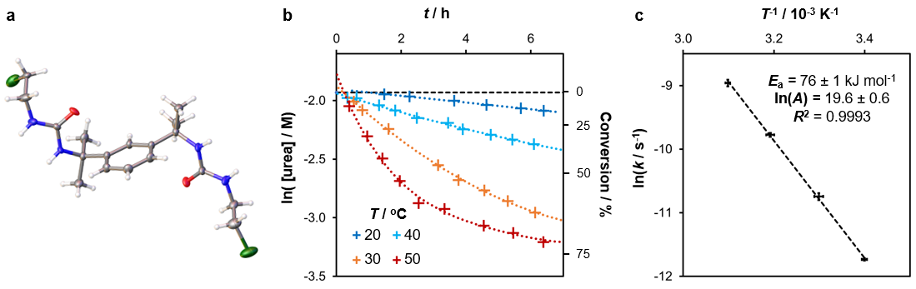
Fig. 9 (a) Crystal structure of 4a in its orthorhombic polymorph, obtained by slow evaporation of an acetonitrile solution; (b) first-order kinetic plot comparing urea conversions over time (t) at different reaction temperatures (T), with a dashed line marking the maximum possible value of ln([urea]); (c) Arrhenius plot for the urea cyclisation reaction, from which the activation energy (E_{a}) and pre-exponential factor (A) may be calculated. Error bars represent the standard error in ln(k) and the standard deviation in T⁻¹ for replicate experiments (n = 4).
A and 2.3 ± 0.3% in Method B but enables a selectivity of nearly 100% in the latter process. Reactions with 2-bromoethylamine occur more readily, delivering yields of 21 ± 2% and 15 ± 2% for Methods A and B, respectively. However, the selectivity of Method B for 2 is compromised when this starting material is used, reaching a value of just 87 ± 4%. The poorer leaving group of 2-chloroethylamine results in a higher selectivity and lower yield because the oxazolidine rings are produced more slowly, ensuring that urea formation is complete before the macrocycles can form.
In both Methods A and B, higher temperatures and longer reaction times enable total isolated macrocycle yields of 30-50%. Furthermore, the selectivity of Method B for isomer 2 exceeds 90% even if both steps occur at 50ºC with a total reaction time of 24 hours. Higher yields and shorter reaction times are possible if the synthesis is performed as a semi-continuous process (vide infra). Nonetheless, as one-pot processes involving inexpensive and readily available starting materials, the batch reactions offer a viable route for the large-scale manufacture of macrocyclic hinges. We anticipate reactions of this type finding widespread use in the synthesis of more complex molecular architectures, delivering flexible scaffolds with unusual three-dimensional morphologies in a single facile reaction step.
Mechanistic studies
The high selectivity of reactions involving 2-chloroethylamine suggests that conversion of the bis-urea 4a to oxazolidine 6a is a rate-determining step at room temperature. Indeed, by performing the first step of Method B at 0ºC and evaporating the reaction mixture after one hour, the intermediate 4a was obtained in a 45% yield. Like other bis-ureas derived from tetramethylxylylene diisocyanate and an alkylamine,⁶⁹ 4a can be recrystallised from polar solvents to yield single crystals suitable for analysis by SCXRD (Fig. 9a). Molecules of the bis-urea adopt an extended conformation and interact via urea-urea tape motifs, crystallising from acetonitrile as a three-dimensional hydrogen bonding network of hydrogen bonded tapes and from methanol as a lamellar structure. Intriguingly, NMR analysis of the compound with triethylamine in DMSO-d₆ indicates that cyclisation may be induced by heating, without risk of oligomerisation. Thus, it may be possible to generate oxazolidine 6 in a more controlled fashion, for incorporation into a wider variety of macrocyclic species.
To gain further insight into the rate-determining step of the reaction, emergence of the urea and oxazolidine intermediates was monitored at room temperature by in situ NMR spectroscopy. Due to strong overlap of their NMR signals, urea intermediates such as 3 and 4 cannot be quantified separately. Nonetheless, monitoring the disappearance of urea signals in the range 5.5-6.5 ppm allows the average rate constant of cyclisation to be reliably measured (Fig. 9b). The two amine starting materials react with the isocyanate at similarly high rates, delivering maximum urea concentrations after 15 minutes. However, the intermediates produced from 2-chloroethylamine, 3a and 4a, cyclise 87 ± 3 times more slowly. The cyclisation displays pseudo-first order kinetics, with a rate constant k of (7.0 ± 0.1) x 10⁻⁴ s⁻¹ for 2-bromoethylamine and just (8.0 ± 0.2) x 10⁻⁶ s⁻¹ for 2-chloroethylamine at 21ºC. The time needed for half of the chloro species 3a and 4a to cyclise is 24.0 ± 0.5 hours, while the bromo derivatives 3b and 4b reach the same conversion after only 16.5 ± 0.3 minutes.
Selective formation of macrocycle 2 is possible only if the initial amine-isocyanate addition reaction is considerably faster than the cyclisation step. Once the unwanted intermediate 3a has been consumed, cyclisation may be safely accelerated to optimise the rate of macrocycle formation. We assessed the thermal dependency of cyclisation in Method B by performing NMR kinetic studies at several temperatures and estimating the activation energy E_{a} from an Arrhenius plot (Fig. 9c). The results reveal an E_{a} value of 76.5 ± 1.4 kJ mol⁻¹ and frequency factor⁷⁰ lnA of (4 ± 2) x 10⁸ s⁻¹, meaning that a reaction temperature of 70 ± 1°C is needed to match the room-temperature k value of 2-bromoethylamine. Since the standard boiling point of chloroform is only 61°C, heating a batch reaction mixture is unlikely to result in the optimum cyclisation rate.
In the final stage of the reaction, macrocyclisation is favoured over oligomerisation due to preorganisation of the reaction intermediates. It is likely that 6 adopts a C-shaped conformation similar to the rigid geometries of the bis-oxazoline (BOX) and related “boxman” compounds, which are used as chelating ligands for asymmetric catalysis.⁷¹⁻⁷⁴ The methyl groups of the xylylene spacer are highly important, as reactions using the non-methylated isocyanate as a starting material produce insoluble ureas and no significant macrocycle formation. To rationalise this observation, DFT energies were calculated for varying conformations of 6 and its non-methylated analogue 7, spanning all possible xylylene-oxazolidine torsion angles φ₁ and φ₂ (Fig. 10). Due to the symmetry of the molecules, the energies are recorded on triangular contour plots, and convergence may be assessed by comparing symmetry-equivalent combinations of φ₁ and φ₂. Optimisations were performed with a D3BJ correction for dispersion forces, but omitting this adjustment was found to have little effect on the final appearance of the contour plot.
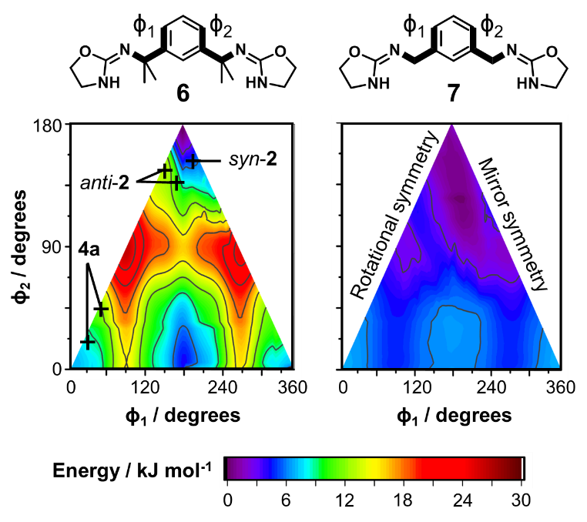
The energy landscapes of the intermediates reveal pronounced differences in molecular flexibility. Compound 7 can adopt a wide range of conformations with a maximum difference in energy of just 9.5 kJ mol⁻¹. By contrast, conformations of 6 differ by up to 25 kJ mol⁻¹ and are most stable when the phenyl ring and C-N bonds are approximately co-planar, as in the macrocycles 1 and 2. We conclude that methylation of the xylylene group lowers the entropic cost of macrocycle formation and increases the abundance of suitable precursor geometries.⁷⁵ This conformational bias, which is comparable to the Thorpe-Ingold effect,⁷⁶ usefully eliminates the need for templating or high-dilution conditions typically encountered in macrocycle syntheses.⁵⁰
Fig. 10 DFT energies (B3LYP/6-31+G*) of bis-oxazolidine 6 and its theoretical analogue 7 for 5° increments of the torsion angles φ₁ and φ₂. The contour plots are calculated by averaging the results of replicate geometry optimisations (n = 8) with different initial molecular conformations. Crystal-structure geometries of bis-urea 4a and macrocycle 2 are plotted for comparison.
Flow synthesis
Selective production of 2 allows the macrocycle to be isolated without wasteful separation steps. However, the reliability of the synthesis is limited by the need for stepwise addition of the isocyanate. Furthermore, the reaction is inconveniently slow and challenging to scale up, as effective mixing is needed to maintain a constant stoichiometric ratio of the starting materials. While increasing the temperature can improve the efficiency of the process, excess heating may lower selectivity by enabling early accumulation of intermediate 5. This problem could be minimised by completing each step of the synthesis at a different temperature. However, it is difficult to make rapid changes to the conditions of a batch reaction while ensuring uniformity of the reaction mixture, particularly if the process is conducted on a larger scale.
The yield, consistency and scalability of the reaction can be enhanced by transferring the batch process to a continuous flow platform (Fig. 11). By performing the synthesis in a flow reactor with two heated coils, we were able to ensure a high mixing rate and automate reagent additions at fixed time points. Use of a dynamic backpressure regulator (BPR) set to 3.0 bar allowed the reaction temperature to be safely increased up to 100°C. Furthermore, a switching valve allowed the reaction mixture to be automatically sampled for analysis by at-line UPLC-MS, providing useful insight into the reaction mechanism through rapid detection of intermediates and side products.
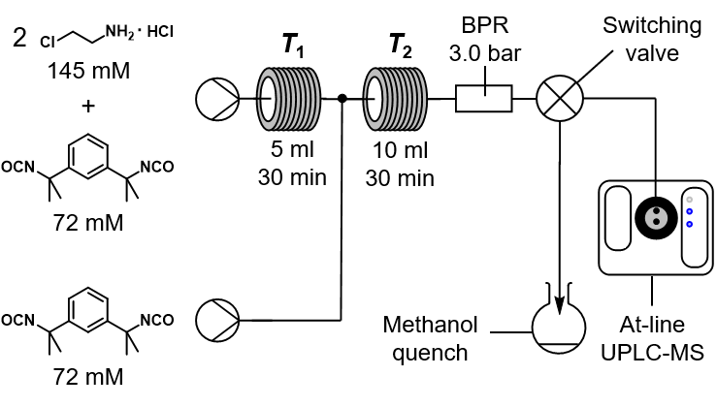
For each flow reaction, stock solutions of the starting materials were prepared using a 0.3 M solution of triethylamine in chloroform. NMR studies confirm that the compounds are stable in solution for over 24 hours at room temperature. In the first, non-continuous step, neat isocyanate was mixed with two equivalents of the amine as in Method B. The resulting mixture was heated to a temperature T₁ in the first coil to drive formation of the oxazolidine species. Finally, the reaction was completed by mixing the solution with another equivalent of isocyanate in a second coil at temperature T₂. The selectivity of the synthesis for product 2 depends on minimising macrocycle formation before in the first reaction step. Thus, in less selective reactions, UPLC-MS measurements after the first coil (Fig. 12) reveal positive ion signals for the macrocycle at m/z 575 (M + H⁺) and 597 (M + Na⁺). A signal at m/z 288 is also observed after both coils, corresponding to the unwanted intermediate 5 in the first step and a fragment ion of 1 in the final product mixture.
Fig. 11 Flow reactor schematic for the semi-continuous synthesis of macrocycle 2 The solutions are prepared with 300 mM in chloroform and mixed after the first coil in a 1:1 volumetric ratio. A switching valve may be used to sample the reaction mixture before or after the second coil for at-line analysis by UPLC-MS. A methanol quench is included to ensure reliable quantification of reaction yields.
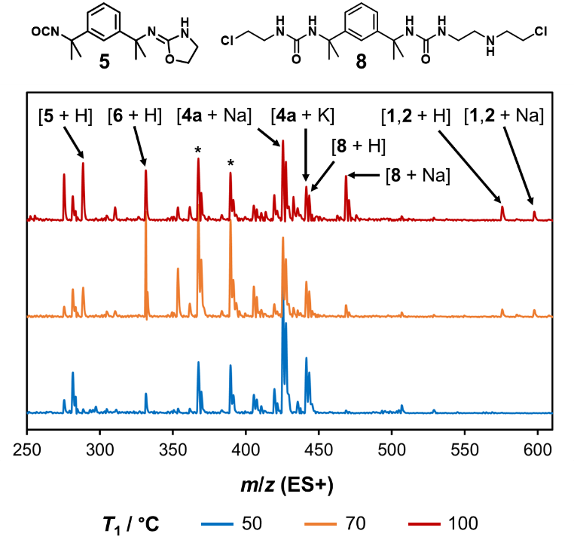
Fig. 12 At-line mass spectra for reaction mixtures sampled after the first reaction step at different temperatures (T₁). Molecular ions of the macrocycles, key intermediates and a proposed adduct of 4a and 2-chloroethylamine are assigned. Peaks marked with asterisks correspond to the molecular ion and sodium adduct of the mono-cyclisation product of 4a, which subsequently converts to 6.
Products of the flow reactions were quenched immediately in methanol and quantified against an acetonitrile standard as in the batch reaction studies. Repeat experiments confirm the reliability of the protocol, demonstrating that replicate yields and selectivities typically vary by less than one percentage point. The impact of the first heated coil was assessed by varying T₁ and fixing T₂ at a low value of 50°C, to minimise oxazolidine formation in the second coil. Flow syntheses at T₁ > 60°C are higher-yielding than the batch reactions of both 2-chloro and 2-bromoethylamine at room temperature, despite being restricted to shorter reaction times. This result suggests that oxazolidine formation is no longer rate-limiting when T₁ is high, allowing yields to be increased by raising T₂ and accelerating the final reaction step.
As T₁ is increased from 50 to 75°C, the total macrocycle yield increases due to greater formation of intermediate 6 (Fig. 13a). However, a decrease in yield above 90°C is evidence of competing reaction pathways, which inhibit the cyclisation process. Likewise, the selectivity for product 2 remains above 90% when T₁ < 75°C but falls sharply at higher temperatures (Fig. 13b). UPLC-MS analysis after the first coil at T₁ = 100°C reveals a strong peak that likely corresponds to bis-urea 8, an adduct of 4a with 2-chloroethylamine (Fig. 12). It is therefore likely that the inferior outcomes at high T₁ are due, at least in part, to off-target amine alkylation reactions.
The final reaction step was optimised by varying T₂ at a fixed value of T₁ = 70°C. Although increasing T₂ also lowers the selectivity for 2, more complete formation of intermediate 6 in the first coil limits the potential for alkyl adducts and other side products. Thus, selectivity varies more gradually with temperature than in the first coil, decreasing by just 3 percentage points per 10°C of heating. Yields, conversely, increase dramatically with T₂, reaching 97% at T₂ = 100°C and plateauing at a maximum 79% yield of 2 above T₁ = 90ºC. All major NMR signals of the optimal crude products can be assigned to 1, 2 and triethylamine, confirming that high T₂ values drive macrocycle formation to completion while avoiding oligomerisation, alkylation and other off-target reaction pathways.
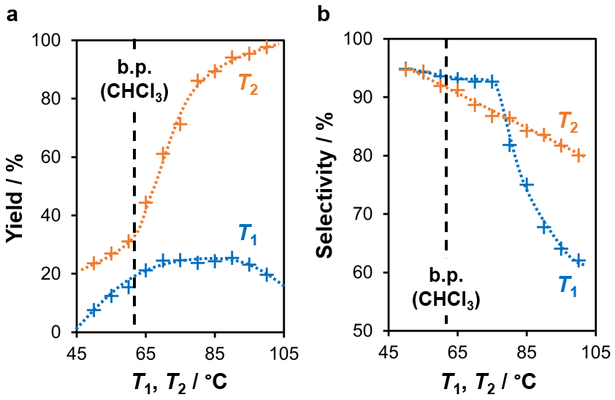
The optimised values of T₁ and T₂ exceed the boiling point of the chloroform solvent (61°C). Thus, the high-yielding synthesis of 2 is only possible due to pressurisation of the system in flow. Indeed, batch and flow syntheses conducted at 60°C with equal reaction times produce similar total macrocycle yields of just 28 ± 1 and 27 ± 2%, respectively, with selectivities of 97.8 ± 0.5 and 95.5 ± 0.5%. We conclude that the use of a flow reactor allows yields to be almost tripled by providing safe and reliable access to higher reaction temperatures.
Fig. 13 (a) Total macrocycle yields and (b) selectivities for reactions performed at different reaction temperatures T₁ and T₂. Reaction outcomes are quantified by comparing the NMR integrals of the macrocycle NH signals with the CH₃ signal of an acetonitrile standard. Values of T₁ are compared at T₂ = 50°C, while values of T₂ are compared at T₁ = 70°C. Where replicate experiments were performed, mean values are reported, but trend lines are drawn as guides for the eye only. The boiling point of chloroform is marked, indicating the maximum temperature of batch reactions at ambient pressure.
Host-guest binding
In their syn conformations, macrocycles 1 and 2 are geometrically similar to molecular clips.^{16, 17} These C-shaped molecules are designed to provide a rigid concave binding surface to encapsulate guests in a shape-selective fashion. Host-guest interactions could limit the usefulness of a molecular hinge, however, by impeding changes in conformation and competing with the binding sites of attached receptor moieties. To investigate this possibility, solutions of the macrocycles in CDCl₃ were titrated with 0-120 equivalents of various guests (Fig. 14a).⁷⁷ Changes in the NMR chemical shift of the NH proton, Δδ, were measured relative to a reference tetramethylsilane (TMS) signal and fitted to a suitable isotherm if significant binding (Δδ > 0.02 ppm) was observed (Fig. 14b).
Remarkably, neither macrocycle interacts strongly with most of the neutral guests tested. Indeed, only methanol was found to produce measurable values of Δδ for 1 as well as 2, interacting in a 1:1 stoichiometry with an association constant (K₁₁) of approximately 0.8 M⁻¹ in both cases (Fig. 14c). Similarly low K₁₁ values have been recorded for hydrogen bonded complexes of esters,⁷⁸ suggesting that methanol forms OH···OC hydrogen bonds but does not bind directly to the NH groups. Macrocycle 2 also displays small but significant Δδ values with hydrogen bond acceptors such as acetonitrile, acetone, nitrobenzene and dimethylformamide. Titration studies with acetonitrile reveal a K₁₁ value smaller than that of methanol, consistent with the formation of weaker CH···nitrile and CH···carbonyl contacts. We hypothesise that acetonitrile and other small polar guests can bind weakly to 2 by entering the narrow void of the macrocycle with only slight disruption of its stable conformation.

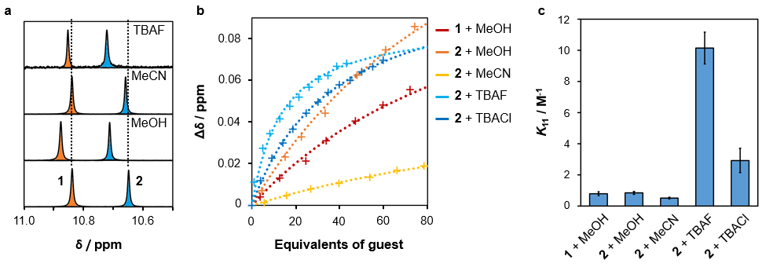
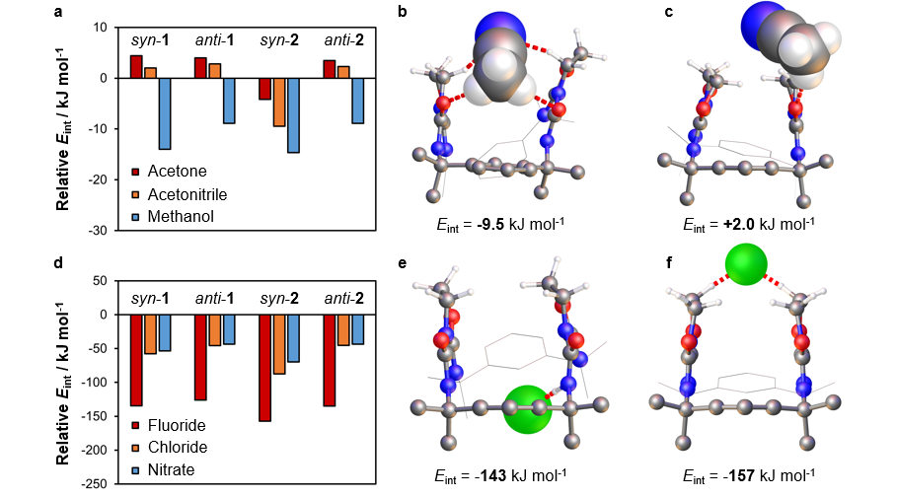
Fig. 14 (a) 1H NMR signals of the NH groups of 1 (marked in orange) and 2 (blue), before and after the addition of different guests (50 eq.). Spectra were recorded using separate 9 mM solutions of 1 and 2 in CDCl3 and concatenated to aid comparison; (b) 1H NMR chemical shifts of the NH groups in 1 and 2 with fixed macrocycle concentrations (9 mM) and varying quantities of an added guest. Trend lines correspond to the best-fit binding isotherms for the Δδ values, fitted to the full range of collected data (10-14 points spanning 0-120 eq. for neutral guests and 0-60 eq. for TBA salts); (c) mean 1:1 association constants for the macrocycle-guest combinations, with error bars representing the standard error in K11 for replicate experiments (n = 3).
Fig. 15 (a) Calculated (B3LYP/6-31++G**) interaction energies (E_{int}) for complexes of 1 and 2 with neutral guests, and the most stable binding configurations of acetonitrile with (b) 2 and (c) 1; (d) E_{int} values for complexes of 1 and 2 with anionic guests, and the most stable (e) NH···F⁻ and (f) CH···F⁻ contacts in fluoride complexes of 2. All E_{int} values are expressed relative to the corresponding chloroform complexes. Hydrogen bonds and major dipole-dipole interactions are marked in red, and parts of the macrocycles omitted for clarity.

The mechanisms of binding were explored further by modelling the interactions of methanol, acetonitrile, acetone and chloroform with the syn and anti conformers of both macrocycles. DFT optimisations were performed from a variety of starting configurations in the 6-31+G* basis set, then refined in the larger basis set 6-31+G**. Counterpoise corrections for basis set superposition error⁷⁹ were omitted due to their negligible impact on energy values. The energy of each host-guest interaction (E_{int}) was calculated by subtracting the total energy of the free host and guest from the energy of the geometry-optimised complex.⁷⁹ Finally, the favourability of the structures was estimated by comparing their E_{int} values with those of the corresponding chloroform complexes. Although E_{int} does not account for guest-guest interactions or changes in solvation, it nonetheless offers insight into the relative binding strengths of 1 and 2 and the structural differences between their host-guest assemblies.
As predicted, the DFT results suggest that all macrocycle conformers engage in methanol-carbonyl hydrogen bonding without undergoing significant deformation. However, only syn-2 can interact effectively with acetone and acetonitrile, establishing multiple interactions with the guests via the oxazolidine methylene and urea carbonyl groups (Fig. 15a). Chloroform associates less strongly as it is unable to establish the same bifurcated dipole-dipole motifs. Likewise, 1 displays smaller E_{int} values because guests cannot interact simultaneously with both carbonyl groups (Fig. 15b). In the syn-1 conformer, binding is further weakened by the presence of CH···OC contacts, which compete with the formation of intermolecular hydrogen bonds and prevent separation of the oxazolidine rings to accommodate guests.
Titration of the macrocycles with anionic species, in the form of tetrabutylammonium (TBA) salts, also produces measurable Δδ values. For 1, these changes are too small for the association constants to be reliably quantified. Conversely, 2 interacts with fluoride and chloride to give Δδ values in the range 0.06-0.07 ppm. The smaller Δδ values of other salts suggest that the TBA cation binds the macrocycles only weakly, while comparisons of hydrated and anhydrous TBACl indicate that interactions with water of crystallisation are also relatively minor. In addition, the absence of a triplet peak in the region 15-17 ppm confirms that macrocycles are not deprotonated by fluoride to form bifluoride (HF₂⁻) ions.⁸⁰ Both halides conform to a 1:1 binding model and interact more strongly than the neutral guests. However, the K₁₁ values of the anions are smaller than those of typical NH-halide complexes by 3-4 orders of magnitude.⁸¹ For 90% of the molecules of 2 to participate in 1:1 binding, at least 0.90 ± 0.09 M (100 ± 10 eq.) TBAF or 3.3 ± 0.9 M (370 ± 100 eq.) TBACl would be required. It is likely that halide-macrocycle hydrogen bonds are destabilised by competing intramolecular interactions or heavily disfavoured by the compact macrocycle geometry.
DFT modelling suggests that the binding of anions by 2 is controlled by steric crowding around the NH sites. In both the syn and anti conformers, chloride and nitrate ions are too large to fit within the macrocycle void so interact primarily with external CH groups. The fluoride ion exhibits a larger E_{int} value and can penetrate further between the methyl groups and oxazolidine rings, even engaging in NH···F⁻ hydrogen bonding (Fig. 15c). However, these interactions are weakened by the resulting conformational strain, making them less stable than the alternative CH···F⁻ contacts (Fig. 15d). As expected from the NMR data, compound 1 binds anions consistently less strongly in both of its conformers. Though NH···F⁻ hydrogen bonds are still possible, particularly in the anti geometry, these offer only a small enthalpic advantage over alternative binding modes so are unlikely to be strongly favoured in solution.
Overall, our results illustrate that the macrocycles are resistant to interactions with a variety of species, including highly basic fluoride ions. Though the carbonyl groups act as weak hydrogen bond acceptors, the urea protons are shielded by intramolecular hydrogen bonds and bulky peripheral groups. Thus, the shape and flexibility of the macrocycles can be considered independent of their chemical environment. This predictability is crucial if the structures are to function as modular molecular hinges, providing synthetic scaffolds for a novel family of clamp-like receptors and conformationally adaptive materials.
Conclusions
A pair of simple flexible macrocycles has been produced from commercially available starting materials via a one-pot addition-cyclisation reaction. The mechanism of this process has been explored in detail, allowing key intermediates to be isolated and characterised and the ratio of isomeric products to be reliably controlled. Furthermore, by performing part of the synthesis as a continuous flow process, we have achieved over 90% selectivity for a single macrocycle with a total macrocycle yield of nearly 80%. Both macrocycles function as molecular hinges, undergoing an unusual clamp-like transition between isolable syn and anti conformers. Thus, this work represents a valuable addition to the synthetic toolbox of supramolecular chemists, delivering versatile, scalable and chemically inert building blocks for the modular assembly of molecular machines.
Conflicts of interest
There are no conflicts to declare.
Acknowledgements
AGS thanks the Royal Society and the Engineering and Physical Sciences Research Council (EPSRC) for a Royal Society-EPSRC Dorothy Hodgkin Fellowship, a Research Grant (RSG\R1\180357) and an Enhancement Award (RGF\EA\201048) that supported this work. JWS and CDJ thank the EPSRC for supporting preliminary research via a Doctoral Training Studentship (1374655) awarded to CDJ. CDJ thanks the University of Liverpool for support through the Early Career Researcher Fund, and AGS and CDJ also thank the EPSRC for funding (EP/R005931/1). This work made use of equipment from the Analytical Services/Department of Chemistry as well as shared equipment at the Materials Innovation Factory (MIF) created as part of the UK Research Partnership Innovation Fund (Research England) and co-funded by the Sir Henry Royce Institute.
Notes and references
1. Gouaux, E.; MacKinnon, R., Principles of Selective Ion Transport in Channels and Pumps. Science 2005, 310 (5753), 1461.
2. Piccolino, M., Biological machines: from mills to molecules. Nature Rev. Mol. Cell Biol. 2000, 1 (2), 149-152.
3. Boyer, P. D., The ATP Synthase — A Splendid Molecular Machine. Annu. Rev. Biochem. 1997, 66 (1), 717-749.
4. van Dijk, L.; Tilby, M. J.; Szpera, R.; Smith, O. A.; Bunce, H. A. P.; Fletcher, S. P., Molecular machines for catalysis. Nature Rev. Chem. 2018, 2 (3), 0117.
5. Erbas-Cakmak, S.; Leigh, D. A.; McTernan, C. T.; Nussbaumer, A. L., Artificial Molecular Machines. Chem. Rev. 2015, 115 (18), 10081-10206.
6. Cui, J.-S.; Ba, Q.-K.; Ke, H.; Valkonen, A.; Rissanen, K.; Jiang, W., Directional Shuttling of a Stimuli-Responsive Cone-Like Macrocycle on a Single-State Symmetric Dumbbell Axle. Angew. Chem. Int. Ed. 2018, 57 (26), 7809-7814.
7. Liu, Y.; Flood, A. H.; Bonvallet, P. A.; Vignon, S. A.; Northrop, B. H.; Tseng, H.-R.; Jeppesen, J. O.; Huang, T. J.; Brough, B.; Baller, M.; Magonov, S.; Solares, S. D.; Goddard, W. A.; Ho, C.-M.; Stoddart, J. F., Linear Artificial Molecular Muscles. J. Am. Chem. Soc. 2005, 127 (27), 9745-9759.
8. Kassem, S.; Lee, A. T. L.; Leigh, D. A.; Markevicius, A.; Solà, J., Pick-up, transport and release of a molecular cargo using a small-molecule robotic arm. Nature Chem. 2016, 8 (2), 138-143.
9. Lewandowski, B.; De Bo, G.; Ward, J. W.; Papmeyer, M.; Kuschel, S.; Aldegunde, M. J.; Gramlich, P. M. E.; Heckmann, D.; Goldup, S. M.; D’Souza, D. M.; Fernandes, A. E.; Leigh, D. A., Sequence-Specific Peptide Synthesis by an Artificial Small-Molecule Machine. Science 2013, 339 (6116), 189.
10. Rapenne, G.; Joachim, C., The first nanocar race. Nature Rev. Mater. 2017, 2 (6), 17040.
11. Kottas, G. S.; Clarke, L. I.; Horinek, D.; Michl, J., Artificial molecular rotors. Chem. Rev. 2005, 105 (4), 1281-1376.
12. Natali, M.; Giordani, S., Molecular switches as photocontrollable “smart” receptors. Chem. Soc. Rev. 2012, 41 (10), 4010-4029.
13. Skibiński, M.; Gómez, R.; Lork, E.; Azov, V. A., Redox responsive molecular tweezers with tetrathiafulvalene units: synthesis, electrochemistry, and binding properties. Tetrahedron 2009, 65 (50), 10348-10354.
14. Iwamoto, H.; Hidaka, Y.; Fukazawa, Y., Conformational control of molecular tweezers containing a disulfide bond by redox reactions. Tetrahedron Lett. 2008, 49 (2), 277-280.
15. Tsuchiya, S., Intramolecular Electron Transfer of Diporphyrins Comprised of Electron-Deficient Porphyrin and Electron-Rich Porphyrin with Photocontrolled Isomerization. J. Am. Chem. Soc. 1999, 121 (1), 48-53.
16. Hardouin–Lerouge, M.; Hudhomme, P.; Sallé, M., Molecular clips and tweezers hosting neutral guests. Chem. Soc. Rev. 2011, 40 (1), 30-43.
17. Leblond, J.; Petitjean, A., Molecular Tweezers: Concepts and Applications. ChemPhysChem 2011, 12 (6), 1043-1051.
18. Lv, X.; Han, Y.; Yang, Z.; Li, Z.; Gao, Z.; Wang, F., Pre-organized molecular tweezer stabilized by intramolecular hydrogen bonds: solvent-responsive host–guest complexation. Tetrahedron Lett. 2016, 57 (18), 1971-1975.
19. Ghosh, K.; Sarkar, A. R.; Patra, A., Pyridinium amide-based simple synthetic receptor for selective recognition of dihydrogenphosphate. Tetrahedron Lett. 2009, 50 (47), 6557-6561.
20. Greenland, B. W.; Burattini, S.; Hayes, W.; Colquhoun, H. M., Design, synthesis and computational modelling of aromatic tweezer-molecules as models for chain-folding polymer blends. Tetrahedron 2008, 64 (36), 8346-8354.
21. Wezenberg, S. J.; Vlatković, M.; Kistemaker, J. C. M.; Feringa, B. L., Multi-State Regulation of the Dihydrogen Phosphate Binding Affinity to a Light- and Heat-Responsive Bis-Urea Receptor. J. Am. Chem. Soc. 2014, 136 (48), 16784-16787.
22. Marchi, E.; Baroncini, M.; Bergamini, G.; Van Heyst, J.; Vögtle, F.; Ceroni, P., Photoswitchable Metal Coordinating Tweezers Operated by Light-Harvesting Dendrimers. J. Am. Chem. Soc. 2012, 134 (37), 15277-15280.
23. Wang, J.; Feringa, B. L., Dynamic Control of Chiral Space in a Catalytic Asymmetric Reaction Using a Molecular Motor. Science 2011, 331 (6023), 1429.
24. Doistau, B.; Benda, L.; Cantin, J.-L.; Cador, O.; Pointillart, F.; Wernsdorfer, W.; Chamoreau, L.-M.; Marvaud, V.; Hasenknopf, B.; Vives, G., Dual switchable molecular tweezers incorporating anisotropic MnIII–salphen complexes. Dalton Trans. 2020, 49 (26), 8872-8882.
25. Zhang, X.; Ao, L.; Han, Y.; Gao, Z.; Wang, F., Modulating Pt⋯Pt metal–metal interactions through conformationally switchable molecular tweezer/guest complexation. Chem. Commun. 2018, 54 (14), 1754-1757.
26. Tsuchido, Y.; Suzaki, Y.; Ide , T.; Osakada, K., Dynamic Properties of Molecular Tweezers with a Bis(2-hydroxyphenyl)pyrimidine Backbone. Chem. Eur. J. 2014, 20 (16), 4762-4771.
27. Petitjean, A.; Khoury, R. G.; Kyritsakas, N.; Lehn, J.-M., Dynamic Devices. Shape Switching and Substrate Binding in Ion-Controlled Nanomechanical Molecular Tweezers. J. Am. Chem. Soc. 2004, 126 (21), 6637-6647.
28. Baroncini, M.; Silvi, S.; Credi, A., Photo- and Redox-Driven Artificial Molecular Motors. Chem. Rev. 2020, 120 (1), 200-268.
29. Wang, X.; Jia, F.; Yang, L.-P.; Zhou, H.; Jiang, W., Conformationally adaptive macrocycles with flipping aromatic sidewalls. Chem. Soc. Rev. 2020, 49 (13), 4176-4188.
30. Appavoo, S. D.; Huh, S.; Diaz, D. B.; Yudin, A. K., Conformational Control of Macrocycles by Remote Structural Modification. Chem. Rev. 2019, 119 (17), 9724-9752.
31. Ikeda, A.; Shinkai, S., Novel Cavity Design Using Calix[n]arene Skeletons: Toward Molecular Recognition and Metal Binding. Chem. Rev. 1997, 97 (5), 1713-1734.
32. Kim, D. S.; Sessler, J. L., Calix[4]pyrroles: versatile molecular containers with ion transport, recognition, and molecular switching functions. Chem. Soc. Rev. 2015, 44 (2), 532-546.
33. Steed, J. W., A modular approach to anion binding podands: adaptability in design and synthesis leads to adaptability in properties. Chem. Commun. 2006, (25), 2637-2649.
34. Liu, Z.; Nalluri, S. K. M.; Stoddart, J. F., Surveying macrocyclic chemistry: from flexible crown ethers to rigid cyclophanes. Chem. Soc. Rev. 2017, 46 (9), 2459-2478.
35. Katoono, R.; Sakamoto, K.; Suzuki, T., Dual dynamic chirality generated in the assembly of three achiral rods through the three-fold twisting of a macrocycle. Chem. Commun. 2019, 55 (38), 5503-5506.
36. Chai, H.; Yang, L.-P.; Ke, H.; Pang, X.-Y.; Jiang, W., Allosteric cooperativity in ternary complexes with low symmetry. Chem. Commun. 2018, 54 (55), 7677-7680.
37. He, Z.; Ye, G.; Jiang, W., Imine Macrocycle with a Deep Cavity: Guest-Selected Formation of syn/anti Configuration and Guest-Controlled Reconfiguration. Chem. Eur. J. 2015, 21 (7), 3005-3012.
38. Bringmann, G.; Gulder, T.; Gulder, T. A. M.; Breuning, M., Atroposelective Total Synthesis of Axially Chiral Biaryl Natural Products. Chem. Rev. 2011, 111 (2), 563-639.
39. Nicolaou, K. C.; Boddy, C. N. C., Atropselective Macrocyclization of Diaryl Ether Ring Systems: Application to the Synthesis of Vancomycin Model Systems. J. Am. Chem. Soc. 2002, 124 (35), 10451-10455.
40. Clayden, J.; Moran, W. J.; Edwards, P. J.; LaPlante, S. R., The Challenge of Atropisomerism in Drug Discovery. Angew. Chem. Int. Ed. 2009, 48 (35), 6398-6401.
41. Blanco-Gomez, A.; Corton, P.; Barravecchia, L.; Neira, I.; Pazos, E.; Peinador, C.; Garcia, M. D., Controlled binding of organic guests by stimuli-responsive macrocycles. Chem. Soc. Rev. 2020, 49 (12), 3834-3862.
42. Schneider, H.-J., Binding Mechanisms in Supramolecular Complexes. Angew. Chem. Int. Ed. 2009, 48 (22), 3924-3977.
43. Yu, G. C.; Jie, K. C.; Huang, F. H., Supramolecular Amphiphiles Based on Host-Guest Molecular Recognition Motifs. Chem. Rev. 2015, 115 (15), 7240-7303.
44. Berry, S. N.; Qin, L.; Lewis, W.; Jolliffe, K. A., Conformationally adaptable macrocyclic receptors for ditopic anions: analysis of chelate cooperativity in aqueous containing media. Chem. Sci. 2020, 27, 7015-7022.
45. Yang, L.-P.; Zhang, L.; Quan, M.; Ward, J. S.; Ma, Y.-L.; Zhou, H.; Rissanen, K.; Jiang, W., A supramolecular system that strictly follows the binding mechanism of conformational selection. Nature Commun. 2020, 11 (1), 2740.
46. Jokic, D.; Boudon, C.; Pognon, G.; Bonin, M.; Schenk, K. J.; Gross, M.; Weiss, J., Structural and Binding Features of Cofacial Bis-Porphyrins with Calixarene Spacers: Pac-Man Porphyrins That Can Chew. Chem. Eur. J. 2005, 11 (14), 4199-4209.
47. Zhou, H.-X.; Gilson, M. K., Theory of Free Energy and Entropy in Noncovalent Binding. Chem. Rev. 2009, 109 (9), 4092-4107.
48. Takata, H.; Ono, K.; Iwasawa, N., Controlled release of the guest molecule via borate formation of a fluorinated boronic ester cage. Chem. Commun. 2020, 56 (42), 5613-5616.
49. Han, M.; Michel, R.; He, B.; Chen, Y.-S.; Stalke, D.; John, M.; Clever, G. H., Light-Triggered Guest Uptake and Release by a Photochromic Coordination Cage. Angew. Chem. Int. Ed. 2013, 52 (4), 1319-1323.
50. Martí-Centelles, V.; Pandey, M. D.; Burguete, M. I.; Luis, S. V., Macrocyclization Reactions: The Importance of Conformational, Configurational, and Template-Induced Preorganization. Chem. Rev. 2015, 115 (16), 8736-8834.
51. Plutschack, M. B.; Pieber, B.; Gilmore, K.; Seeberger, P. H., The Hitchhiker’s Guide to Flow Chemistry. Chem. Rev. 2017, 117 (18), 11796-11893.
52. Hartman, R. L.; McMullen, J. P.; Jensen, K. F., Deciding Whether To Go with the Flow: Evaluating the Merits of Flow Reactors for Synthesis. Angew. Chem. Int. Ed. 2011, 50 (33), 7502-7519.
53. Baumann, M., Integrating continuous flow synthesis with in-line analysis and data generation. Org. Biomol. Chem. 2018, 16 (33), 5946-5954.
54. Godin, E.; Morin, E.; Collins, S. K., Continuous-Flow Macrocyclization. Aldrichimica Acta 2018, 51 (2), 35-46.
55. Blas, J. R.; López-Bes, J. M.; Márquez, M.; Sessler, J. L.; Luque, F. J.; Orozco, M., Exploring the Dynamics of Calix[4]pyrrole: Effect of Solvent and Fluorine Substitution. Chem. Eur. J. 2007, 13 (4), 1108-1116.
56. Chen, Y.; Sun, X.; Wu, N.; Li, J.; Jin, S.; Zhong, Y.; Liu, Z.; Rogachev, A.; Chong, H.-S., Synthetic and theoretical investigation on the one-pot halogenation of β-amino alcohols and nucleophilic ring opening of aziridinium ions. Org. Biomol. Chem. 2016, 14 (3), 920-939.
57. Knölker, H.-J.; Braxmeier, T.; Schlechtingen, G., A Novel Method for the Synthesis of Isocyanates Under Mild Conditions. Angew. Chem. Int. Ed. 1995, 34 (22), 2497-2500.
58. Remko, M.; Walsh, O. A.; Richards, W. G., Ab initio and DFT study of molecular structure and tautomerism of 2-amino-2-imidazoline, 2-amino-2-oxazoline and 2-amino-2-thiazoline. Chem. Phys. Lett. 2001, 336 (1), 156-162.
59. Bosc, J.-J.; Jarry, C.; Ouhabi, J.; Laguerre, M.; Carpy, A., New investigation of the reaction of 2-amino-2-oxazolines with isocyanates and isothiocyanates. Evidence of a transposition during the second step. Can. J. Chem. 1996, 74 (7), 1341-1347.
60. Moore, W. M.; Webber, R. K.; Fok, K. F.; Jerome, G. M.; Connor, J. R.; Manning, P. T.; Wyatt, P. S.; Misko, T. P.; Tjoeng, F. S.; Currie, M. G., 2-Iminopiperidine and Other 2-Iminoazaheterocycles as Potent Inhibitors of Human Nitric Oxide Synthase Isoforms. J. Med. Chem. 1996, 39 (3), 669-672.
61. Park, Y. J.; Sickerman, N. S.; Ziller, J. W.; Borovik, A. S., Utilizing tautomerization of 2-amino-oxazoline in hydrogen bonding tripodal ligands. Chem. Commun. 2010, 46 (15), 2584-2586.
62. Yamato, K.; Kline, M.; Gong, B., Cavity-containing, backbone-rigidified foldamers and macrocycles. Chem. Commun. 2012, 48 (100), 12142-12158.
63. Casarini, D.; Lunazzi, L.; Mazzanti, A., Recent Advances in Stereodynamics and Conformational Analysis by Dynamic NMR and Theoretical Calculations. Eur. J. Org. Chem. 2010, 2010 (11), 2035-2056.
64. Becke, A. D., A new mixing of Hartree–Fock and local density‐functional theories. J. Chem. Phys. 1993, 98 (2), 1372-1377.
65. Frisch, M. J.; Pople, J. A.; Binkley, J. S., Self‐consistent molecular orbital methods 25. Supplementary functions for Gaussian basis sets. J. Chem. Phys. 1984, 80 (7), 3265-3269.
66. Weigend, F.; Ahlrichs, R., Balanced basis sets of split valence, triple zeta valence and quadruple zeta valence quality for H to Rn: Design and assessment of accuracy. Phys. Chem. Chem. Phys. 2005, 7 (18), 3297-3305.
67. Woon, D. E.; Dunning, T. H., Gaussian basis sets for use in correlated molecular calculations. III. The atoms aluminum through argon. J. Chem. Phys. 1993, 98 (2), 1358-1371.
68. Grimme, S.; Ehrlich, S.; Goerigk, L., Effect of the damping function in dispersion corrected density functional theory. J. Comput. Chem. 2011, 32 (7), 1456-1465.
69. Jones, C. D.; Kennedy, S. R.; Walker, M.; Yufit, D. S.; Steed, J. W., Scrolling of Supramolecular Lamellae in the Hierarchical Self-Assembly of Fibrous Gels. Chem 2017, 3 (4), 603-628.
70. Gowenlock, B. G., Arrhenius factors (frequency factors) in unimolecular reactions. Q. Rev. Chem. Soc. 1960, 14 (2), 133-145.
71. Blasius, C. K.; Ren, B.-T.; Bürgy, D.; Liu, Y.-K.; Li, B.; Michalsky, I.; Wadepohl, H.; Deng, Q.-H.; Gade, L. H., Expanding the Boxmi Ligand Family: Synthesis and Application of NON and NSN Ligands. J. Org. Chem. 2020, 85 (10), 6719-6731.
72. Johnson, J. S.; Evans, D. A., Chiral bis(oxazoline) copper(II) complexes: Versatile catalysts for enantioselective cycloaddition, aldol, Michael, and carbonyl ene reactions. Acc. Chem. Res. 2000, 33 (6), 325-335.
73. Evans, D. A.; Barnes, D. M.; Johnson, J. S.; Lectka, R.; von Matt, P.; Miller, S. J.; Murry, J. A.; Norcross, R. D.; Shaughnessy, E. A.; Campos, K. R., Bis(oxazoline) and bis(oxazolinyl)pyridine copper complexes as enantioselective Diels-Alder catalysts: Reaction scope and synthetic applications. J. Am. Chem. Soc. 1999, 121 (33), 7582-7594.
74. Ghosh, A. K.; Packiarajan, M.; Cappiello, J., C-2-symmetric chiral bis(oxazoline)-metal complexes in catalytic asymmetric synthesis. Tetrahedron: Asymmetry 1998, 9 (1), 1-45.
75. Blankenstein, J.; Zhu, J. P., Conformation-directed macrocyclization reactions. Eur. J. Org. Chem. 2005, 2005 (10), 1949-1964.
76. Zheng, Y. P.; Xu, J. X., Thorpe-Ingold Effect and Its Application in Cyclizations in Organic Chemistry. Prog. Chem. 2014, 26 (9), 1471-1491.
77. Thordarson, P., Determining association constants from titration experiments in supramolecular chemistry. Chem. Soc. Rev. 2011, 40 (3), 1305-1323.
78. Dharmalingam, K.; Ramachandran, K.; Sivagurunathan, P., Hydrogen bonding interaction between acrylic esters and monohydric alcohols in non-polar solvents: An FTIR study. Spectrochim. Acta A 2007, 66 (1), 48-51.
79. van Duijneveldt, F. B.; van Duijneveldt-van de Rijdt, J. G. C. M.; van Lenthe, J. H., State of the Art in Counterpoise Theory. Chem. Rev. 1994, 94 (7), 1873-1885.
80. Montis, R.; Bencini, A.; Coles, S. J.; Conti, L.; Fusaro, L.; Gale, P. A.; Giorgi, C.; Horton, P. N.; Lippolis, V.; Mapp, L. K.; Caltagirone, C., Fluoride binding by an anionic receptor: tuning the acidity of amide NH groups for basic anion hydrogen bonding and recognition. Chem. Commun. 2019, 55 (19), 2745-2748.
81. Molina, P.; Zapata, F.; Caballero, A., Anion Recognition Strategies Based on Combined Noncovalent Interactions. Chem. Rev. 2017, 117 (15), 9907-9972.

