Article
Metrics for Measuring Sustainable Product Design Concepts
Ji Han ^{1,}*, Pingfei Jiang ² and Peter R.N. Childs ³
Citation: Lastname, F.; Lastname, F.; Lastname, F. Title. Energies 2021, 14, x. https://doi.org/10.3390/xxxxx
Academic Editor: Firstname Lastname
Received: date
Accepted: date
Published: date
Publisher’s Note: MDPI stays neutral with regard to jurisdictional claims in published maps and institutional affiliations.
Copyright: © 2021 by the authors. Submitted for possible open access publication under the terms and conditions of the Creative Commons Attribution (CC BY) license (https://creativecommons.org/licenses/by/4.0/).
¹ School of Engineering, University of Liverpool, Liverpool, UK; ji.han@liverpool.ac.uk
² Department of Mechanical Engineering, Kingston University, London, UK; p.jiang@kingston.ac.uk
³ Dyson School of Design Engineering, Imperial College London, London, UK; p.childs@imperial.ac.uk
* Correspondence: ji.han@liverpool.ac.uk
Abstract: Although products can contribute to the eco-systems positively, they can cause negative environmental impacts throughout their life cycles, from obtaining raw material, production, use, to end-of-life. It is reported that most negative environmental impacts are decided at early design phases, which suggests that the determination of product sustainability should be considered as early as possible, such as the conceptual design stage, when it is still possible to modify the design concept. However, most of the existing concept evaluation methods or tools are focused on assessing the feasibility or creativity of the concepts generated, lacking the measurements of sustainability of concepts. The paper explores the key factors related to sustainable design with regards to environmental impacts, and describes a set of objective measures of sustainable product design concept evaluation, namely Material, Production, Use and End-of-life. The rationales of the four metrics are discussed, with corresponding measurements. A case study is conducted to demonstrate the use and effectiveness of the metrics for evaluating product design concepts. The paper is the first study exploring the measurement of product design sustainability focusing on the conceptual design stage. It can be used as a guideline to measure the level of sustainability of product design concepts to support designers in developing sustainable products. Most significantly, it urges the considerations of sustainability design aspects at early design phases, and also provides a new research direction in concept evaluation regarding sustainability.
Keywords: sustainability, design sustainability; conceptual design, concept evaluation, product design, sustainable product design

1. Introduction
The world population has increased from 1 billion in 1800 to 7.8 billion in 2020 [1]. Although the world population growth rate is decreasing, it is predicted that the world population will reach 9.7 billion by 2064 subsequently declining to 8.8 billion in 2100 [2]. The population growth has led to global issues, such as overconsumption of resource and energy, and pollution. Sustainability is a fundamental attribute playing an increasingly significant role in design nowadays, especially in product design, where it is considered a mandatory requirement for solving those global challenges [3].
In recent years, there has been an increasing focus on sustainable product developments, due to environmental regulations and expectations of consumers [4]. It is imperative for modern firms and enterprises to consider sustainability in product design and development [5]. Sustainable development is often defined as the ‘development that meets the needs of the present without compromising the ability of future generations to meet their own needs’ [6]. Sustainability commonly involves three interconnected pillars: social, economic and environment [7]. However, sustainability in design is primarily focused on environmental aspects [4]. Therefore, sustainable design is described as a design approach for reducing the environmental impacts throughout a product’s entire life cycle [8-10]. Material extraction, manufacturing, use and end-of-life of a product produced all have impacts on the environment [11]. It is thereby critical for designers, while designing new sustainable products, to select the raw materials with the least environmental impact, influence manufacturers to minimise environmental damage, and consider an environmental-friendly manner to use and dispose of the product [12].
Conceptual design, which involves activities such as concept generation and assessment, is arguably the most significant stage in the design process. As an early stage in design, concept assessment has a powerful impact on the downstream activities, such as product production, use, and end-of-life [13-16]. It is a complex task involving decision making based on multiple criteria [13,14], which significantly saves product development cost and time, as well as raises the awareness of design concept improvement opportunities. The decisions made have a critical influence on the environmental impact of a product, as well as performance, cost, reliability and safety [17]. The decisions often have high impacts at the conceptual design stage, but decrease significantly as the design process progresses [16].
Environmental impacts occur throughout a product’s entire life cycle, from raw materials, production, use, to end-of-life, while the environmental impacts at different stages vary significantly among different products. For example, although both kettles and cameras are consumer electronics, kettles embody most of the environmental impacts at the use stage while cameras, ignoring digital storage, embody most of the impacts at the production and raw material stages [18,19]. However, most of the environmental impacts are ‘locked’ into the product during early design stages, where the product concept is formed, functions and performance are determined, materials and manufacturing processes are selected [20]. The ‘lock-in’ of environmental impacts are determined and cumulated throughout the product’s life cycle [20]. Nevertheless, it is reported that 80% of sustainability impacts are decided at the design stage, involving both conceptual design and detailed design [11].
According to these studies, Figure 1 indicates that the impact of decisions decreases while the cumulative ‘lock-in’ environmental impact increases, as the product life cycle matures [16,20,21]. The figure shows the significance and advantages of addressing sustainability issues of a product as early as possible in the design process, as it is challenging and costly to address sustainability issues at later stages [21,22]. For instance, it is easier to design an energy-efficient product rather than educating consumers to use the product in an energy-saving manner for the aim of reducing environmental impacts. Therefore, the opportunity to minimise a product’s environmental impacts mainly exist in the preliminary design stage, especially in conceptual design where decisions have high impacts [23,24].
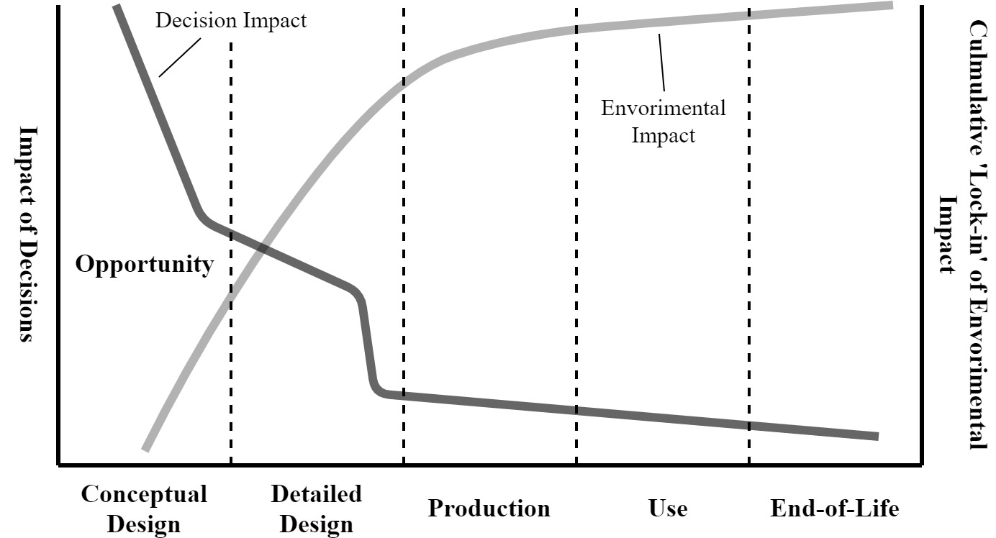
Figure 1. Opportunity in conceptual design for minimising cumulative ‘lock-in’ of environmental impact (Adapted from [16] and [20] )
However, product design engineers generally focus on producing products that meet the required technical performance, aesthetics, durability and costs demands [25], but lack awareness of the wider environmental impact of the design [12] (Knowledge Gap 1). For instance, Brundage, et al. [26] indicated there is a lack of communications between designers and manufacturers, which limits designers in reducing environmental impacts from a manufacturing perspective. It is also challenging to improve a product’s sustainability once the product is designed [21,22] (Knowledge Gap 2). Thereby, there is a need to project later sustainability-related activities, such as manufacturing, use and end-of-life, to early design stages to inform better decision making [27-29]. For example, a product designed for easy manufacturing and assembly could increase the chances for it to be reused or recycled, leading to a reduction in environmental impacts [30]. Nevertheless, the majority of existing concept assessment methods or tools are used to evaluate the feasibility and creativity of the concepts generated at early design stages [31-37] (Knowledge Gap 3). Therefore, current concept assessment methods could not guarantee the generation of sustainable product design concepts which embody minimum environmental impacts. These three knowledge gaps implied that there is a need to come up with an approach to measure the sustainability of design concepts, considering aspects of later activities in the product life cycle, and therefore promoting a more sustainable design manner.
The paper aims to offer support to designers in generating sustainable design concepts by considering a wide range of aspects to minimise negative environmental impacts, and ultimately leading to sustainable products. The primary objective of the paper is to answer the following research questions: 1). What are the critical factors related to sustainable design, particularly environmental impacts? 2). Is there a set of metrics that can measure sustainable product design concepts?
The remainder of the paper is organised as follows: the next section reviews the related work on sustainability and concept assessment. In Section 3, four metrics (Material, Production, Use and End-of-life), for measuring sustainable product design concepts are proposed with rationales and measurements. A case study demonstrating the application of the metrics is provided in Section 4, followed by discussion in Section 5 and conclusion in Section 6.

2. Related Work

2.1. Sustainable Product Design
Many methods and tools have been developed to support sustainable product design. Life Cycle Assessment (LCA) is the most often used [38-41], which is a framework for calculating the environmental impacts of a product or service along its life cycle [42]. However, LCA methods are more suitable to be implemented at later design phases, as it often requires a large amount of data while the design of a product is more defined, of which materials, components and processes are specified [43,44].
Quality Function Deployment (QFD) is another popular approach for supporting sustainable product design. For instance, Bereketli and Erol Genevois [45] and Younesi and Roghanian [46] employed Quality Function Deployment for Environment (QFDE) to consider both environmental and economic aspects. Wu and Ho [47] and Ocampo, et al. [48] came up with integrated QFD approaches to address uncertainties, ambiguities, and interdependencies of decision parameters. Although QFD based approaches provide benefits, such as considering voice of customers and logical organisations of information, it could be complex and time-consuming to process a large matrix and challenging to offer valid quantitative information [49,50].
In addition to LCA and QFD based tools, several other types of methods have been developed to support sustainable product design, such as CAD integrated tools, diagram tools, checklists and guidelines, as well as Design for X approaches [42]. However, most of these tools require training and experience to implement, and some require specific knowledge to interpret results in order to gain insights. More importantly, very few existing sustainability tools or methods are found to be capable of supporting designers in sustainable product design at the conceptual design stage, concept assessment in particular, from the review conducted in this study.

2.2. Concept Assessment Methods
Concept assessment is often used to assess the feasibility and creativity, while sometimes sustainability, aspects of design concepts in new product development. In this study, feasibility refers to whether a product produced could meet the design requirements, such as functional performance, business constraints and customer needs. Creativity indicates the novelty, usefulness and surprise of a design [51]. Sustainability refers to designing a product with minimum negative environmental impacts. Feasibility, creativity and sustainability are not mutually exclusive, they can be interrelated when evaluating product design concepts. For example, the usefulness of a product is generally equivalent to the product’s functional performance [51].
General multi-criteria decision-making techniques are often used to assess design concepts, such as Harris Profile [31], Pugh’s Matrix [34], Tabular Evaluation Matrix [37]. These methods often employ matrices consisting of a series of weighted criteria against which the design concept need to be assessed. A ranking of the concepts with a quasi-quantitative measure of the advantages and disadvantages are provided to support the selection of the most suitable concept [37]. Although these methods could be used to assess creativity or sustainability depending on the criteria selected, they are mainly used to assess the feasibility of the concepts generated.
There also exist several other methods aimed at assessing the feasibility of design concepts generated. For instance, Davoodi, et al. [35] applied the Technique for Order of Preference by Similarity to Ideal Solution (TOPSIS) method to select the best concept, based on the distance from ideal and non-ideal solutions. A shorter distance indicates a better design concept alternative, and vice versa. Goswami and Tiwari [52] suggested a framework to select the best design concept with the least risk by employing Bayesian network methodology. Zhu, et al. [15] and Tiwari, et al. [13] proposed integrative methods, by employing VlseKriterijumska Optimizacija I Kompromisno Resenje (VIKOR), to perform multi-criteria decision analysis for selecting the best design concept. Shidpour, et al. [14] indicated a multi-criteria design concept evaluation method based on rough set theory for assessing the quantitative criteria of a product (such as costs) and fuzzy set theory for assessing the qualitative criteria (such as aesthetics). Rondini, et al. [53] proposed a two-step Importance Performance Analysis (IPA) based method, but focusing on product-service system. It is used for demonstrating the trade-off between customer value and provide value to direct design teams in progressing solution principles.
Creativity assessment methods aim at selecting the most creative concept, as well as identifying creative designers and inventors [36]. The Consensual Assessment Technique (CAT), proposed by Amabile [32], is known as the ‘gold standard’ in creativity assessment, which is grounded in the definition of creativity that ‘the process by which something so judged (to be creative) is produced’. The CAT method often employs a group of experts in the domain in question to evaluate the creativity of a product.
However, human judgement criteria-based methods are the most often used in product concept creativity assessment. For example, Creative Product Semantic Scale (CPSS) [33,54,55] is a popular method for assessing design creativity. It involves three dimensions: novelty, resolution, and elaboration and synthesis, with associated sub-dimensions. Horn and Salvendy [56] indicated the use of novelty, affect and importance, which are connected with consumer satisfaction, for assessing product design creativity. Sarkar and Chakrabarti [36] came up with a method assessing creativity through evaluating the novelty and usefulness of a design concept. Novelty is assessed by using the SAPPhIRE model [57] and the Function-Behaviour-Structure (FBS) model, while usefulness is assessed based on level of importance, rate of popularity of use, frequency of usage, and duration of use. Chiu and Shu [58] used novelty, usefulness, and cohesiveness to measure design concepts’ creativity. Demirkan and Afacan [59] proposed three assessment factors related to the shape, characteristics, and design principles of a product, respectively. Lee, et al. [60] measured design creativity by using novelty, usefulness, aesthetics and complexity. Srinivasan, et al. [61] employed novelty and quality, while Starkey, et al. [62] used usefulness and uniqueness for assessing creativity of product design concepts.
In comparison with the methods for assessing the feasibility and creativity of product design concepts, a limited number of methods have been developed to evaluate the sustainability of product design concepts. For instance, Lindow, et al. [63] presented an interdisciplinary method based on the combination of the House of Quality and Life Cycle Sustainability Assessment, considering both product properties and sustainability indicators. However, this method requires a large amount of information to perform a complete assessment, which is time-consuming and expensive. Hassan, et al. [64] came up with a systematic approach to assess the sustainability of alternative part configurations. It employs a weighted decision matrix to determine the sustainability scores of design configurations, and an artificial neural network to measure the sustainability performance. However, this approach can only assess the sustainability of a single part of a product rather than the whole product. Turan, et al. [65] developed a sustainability assessment model in product development to support designers in making better decisions before completing the final concept. The model integrates a green project management concept for guiding the sustainability assessment, a new scale of weighting criteria for easing the rating process, and Rough-Grey Analysis for supporting decision-making. The assessment model is designed specifically for the automotive industry, limiting its application.
A summary of the concept assessment methods for product design illustrated in this section is presented in Table 1, with highlights of whether the method is aimed at assessing feasibility, creativity or sustainability. As shown in the table, the majority of the concept assessment methods are aimed at evaluating the feasibility or creativity aspects of the concept generated. Sustainability aspects in concept assessment have been overlooked by most researchers, and therefore it is potentially worthwhile to explore a set of metrics for measuring sustainable product design concepts.

Table 1. Summary of concept assessment methods for product design
Concept Assessment Methods | Year of Publication | Feasibility | Creativity | Sustainability
Harris [31] | 1976 | X
Amabile [32] | 1982 |  | X
O'Quin and Besemer [33] | 1989 |  | X
Pugh and Clausing [34] | 1996 | X
Horn and Salvendy [56] | 2009 |  | X
Davoodi, et al. [35] | 2011 | X
Sarkar and Chakrabarti [36] | 2011 |  | X
Chiu and Shu [58] | 2012 |  | X
Chulvi, et al. [54] | 2012 |  | X
Demirkan and Afacan [59] | 2012 |  | X
Lindow, et al. [63] | 2013 |  |  | X
Goswami and Tiwari [52] | 2014 | X
Lee, et al. [60] | 2015 |  | X
Zhu, et al. [15] | 2015 | X
Hassan, et al. [64] | 2016 |  |  | X
Shidpour, et al. [14] | 2016 | X
Tiwari, et al. [13] | 2016 | X
García-García, et al. [55] | 2017 |  | X
Rondini, et al. [53] | 2017 | X
Turan, et al. [65] | 2017 |  |  | X
Childs [37] | 2018 | X
Srinivasan, et al. [61] | 2018 |  | X
Starkey, et al. [62] | 2019 |  | X

3. Metrics for Measuring Sustainable Product Design Concepts
Four metrics, Material, Production, Use and End-of-life, for measuring sustainable product design concepts are proposed based on existing studies on sustainable design and conceptual design. The four metrics are described in the following sub-sections with the underpinning rationales and measurements, respectively. However, it is challenging to determine the actual value of the negative environmental impacts caused at the conceptual design stage. As a result, to reflect the level of sustainability in a simple but effective manner, measurement scales of Low (0), Medium (1) and High (2) are employed to indicate sustainability attributes.

3.1. Material
The assessment of materials in sustainable product design concepts is of fundamental importance. Materials have direct impacts on products with regards to the origin, property and use of materials. Origin of materials refers to where the materials, used by the components and parts of a product, are originally sourced, involving non-renewable and renewable resources. Non-renewable resources are limited in supply, which cannot be replenished or replaced, such as fossil fuels, minerals and metal ores. Popular materials produced from non-renewable resources involves fossil-based plastics, metals and glass, which are often used in product design. Renewable resources refer to those that can be easily regenerated. Materials that are renewable, such as bamboo, mushroom, natural rubber, wood, and cotton, are increasingly used in product design. An increasing number of sustainable materials have been developed by applying renewable resources. For example, bioplastics, which are less or minimally reliant on fossil fuel, are produced by using renewable plants, such as sugarcanes, corns and potatoes. In addition, there is currently an emerging trend in utilising waste materials for design. For instance, by-product waste materials (such as chicken feathers and bran), which are secondary products generated from production, are often used as raw materials.
Toxicity, recyclability and biodegradability are the main indicators of material sustainability properties. A material that is recyclable or biodegradable and non-toxic is often preferred, while materials that are toxic as well as neither recyclable nor biodegradable should be avoided in product conceptual design.
The use of material in a product refers to the volume/weight of materials and the number of types of materials involved. Using less volume/weight of materials contributes to a positive environmental impact, as it consumes less amount of resources and energies from material sourcing, production to product end-of-life. The more types of materials used increases a product’s complexity, which will lead to more negative environmental impacts throughout the product’s life cycle, as it increases the difficulties in product production and end-of-life. Therefore, determining which material(s) to use and identifying how the material(s) are used in a product design concept are strongly associated with its sustainability performance.

3.1.1. Measurement of Material
In the conceptual design stage, information such as material origins, material properties and the use of materials need to be determined to assist designers with evaluation. As suggested in the preceding, Low (0), Medium (1) and High (2) are used to indicate sustainability attributes. For example, if the origin of one type of material used comes from a promising renewable source then a rating of High, a score of 2 will be given. Similar principles apply to material properties. For example, if the material is toxic, cannot be recycled nor is biodegradable then a rating of Low, a score of 0 will be given. The use of material includes the weight/volume of materials and the number of types of materials used. Regardless of material origins, the fewer volume/weight and types of materials used will lead to less negative environmental impacts. However, it is difficult to judge the absolute quantity (weight/volume) of materials needed for a concept, therefore, this attribute refers to the potential for material quantity reduction at the time when the concept is evaluated. For instance, if the volume/weight of materials of a product concept could be easily reduced without affecting the structure and performance of the product, a High (2) score will be rated.
Table 2 summarises the attributes to consider for material sustainability and provides a brief explanation of each level to inform rational decision making. An equation is then developed to quantify the Material sustainability, shown in Equation (1).
Table 2. Attributes for measuring concept Material sustainability
Attributes | Symbol | Low = 0 | Medium = 1 | High = 2
Material Origin | M₁ | Non-renewable, e.g. fossil-based plastics, metal, glass | Hybrid,  e.g. bioplastics, by-product waste materials | Renewable, e.g. bamboo, wood, natural rubber
Material Property | M₂ | Toxic, neither recyclable nor biodegradable | Either Toxic or non-toxic, either recyclable or biodegradable | Non-toxic, can be easily reused or recycled
The Use of Material - Quantity | M₃ | Poor potential for material quantity reduction | Fair potential for material quantity reduction | Good potential for material quantity reduction
The Use of Material - Type | N | Not Applicable

$$Metric_{Material}=\frac{9×(\frac{\sum_{i=1}^{N}{\left(M_{1}+M_{2}\right)×M_{3}}}{N})}{8}+1$$ | (1)

In Equation (1), i refers to the ith type of material used in a concept. Multiplier is used to correlate attributes that have aggregated effect, for example, Material Original (M₁) and the Use of Material - Quantity (M₃) have clear aggregated effect hence they are multiplied together. These aggregated effects are added together and then divided by the number of material types N to indicate the overall Material sustainability that will vary between 0 and 8. In order to yield an accessible result, a scaling process is performed to ensure that the final score is within the range of 1 to 10, in which 1 refers to Poor and 10 refers to the Excellent with regards to sustainability.

3.2. Production (Manufacturing and Assembly)
Producing products in a sustainable manner, such as conserving resources, consuming less energy, and generating less pollution and waste, leads to minimum negative environmental impacts. However, production is a complex process where many design details are determined at the detailed design stage rather than the conceptual design stage. Therefore, only aspects related to manufacturing and assembly are discussed in this paper. Design for Manufacturing and Assembly (DFMA) is an effective approach to achieve sustainable production. This study has extracted core DFMA considerations, for ease of assembly and manufacturing, to measure sustainable production aspects of design concepts, as shown in Table 3. Minimising the number of parts in a practical manner, as well as using more standardised parts/components and fewer unique parts/components, could reduce inventory cost, process time and so on. Designing parts for ease of assembly involves better presentation (such as, avoiding too large or too small items and employing symmetric features), easy handling (such as avoiding over-size, sharp, slippery, heavy, and fragile items), mistake-proofing (such as using symmetric or asymmetric features to prevent parts being assembled in wrong orientations), and efficient insertion (such as employing self-aligning/locating features). Suitable fabrication methods refer to the identification of the most appropriate technology/process based on the material selected to minimise excessive operations, such as polishing and fine machining.

Table 3. DFMA considerations for sustainable product design concepts
DFMA Considerations | Explanations
The minimum number of parts | The practical minimum number of parts for both manufacturing and assembly.
Parts/components standardisation | The number of standardised parts/components and unique parts/components.
Parts assembly | Parts presentation, handling, mistake-proof and insertion for ease of assembly.
Suitable fabrication methods | Cost and energy effective technology/process for ease of manufacturing.

3.2.1. Measurement of Production
Production details, such as manufacturing methods, manufacturing parameters and assembly procedures can be difficult to determine at the conceptual design stage. However, designers are encouraged to consider these attributes with respect to sustainability to steer towards a more sustainable outcome. A similar approach explained in 3.1.1 is adopted here, for example, a Low rating, a score of 0 will be given if a concept requires a considerable number of customised parts/components implying that more negative impacts are created during production. An explanation of levels for each production attributes is provided in Table 4. It is worth noticing that these production attributes are concept dependent and this therefore requires subjective judgement, for instance, whether adequate standardisation has been achieved. In addition, unlike the types of materials, it is also challenging to evaluate each individual part/component with respect to standardisation, fabrication and assembly, therefore, here they are considered holistically at the concept level. An equation is then developed to quantify the sustainability with respect to production, as shown in Equation (2).
Table 4. Attributes for measuring concept Production sustainability
Attributes | Symbol | Low = 0 | Medium = 1 | High = 2
Balance between Number of Parts and Their Complexity | P₁ | Poor balance, e.g. contains too many parts or too complicated parts | Fair balance  e.g. contains few parts but are complicated | Good balance  e.g. contains few simple parts
Parts Standardisation | P₂ | The concept requires a considerable degree of customisation | The concept has a reasonable degree of potential to be standardised | The concept can benefit significantly by using standardised components
Parts Design for Assembly | P₃ | Poor potential for assembly optimisation | Fair potential for assembly optimisation | Good potential for assembly optimisation
Suitable Fabrication Method | P₄ | Excessive operations needed, e.g. polishing, fine machining | Partial excessive operations needed | No excessive operations needed

$$Metric_{Production}=\frac{{9×(P}_{1}×P_{2}+P_{3})×P_{4}}{12}+1$$ | (2)
Similar to Material, the aggregated effect for Production attributes is considered here. This is again reflected on the multiplier. For example, Balance between Number of Parts and Their Complexity (P₁) is closely related to Part Standardisation (P₂) while Suitable Fabrication Method (P₄) will amplify their effect, hence P₁×P₂×P₄. The equation leads to an overall score for Production sustainability that will vary between 0 and 12. A similar scaling process is performed to ensure that the final rating will yield a value between 1 (Poor) and 10 (Excellent).

3.3. Use
The use of a product pertains mainly to the amount of time the product is owned and operated by its user. A product’s lifetime starts from when it is acquired to when the product is discarded, which is primarily determined at the conceptual design stage. Functional obsolescence, maintenance prevention and aesthetic obsolescence are the main reasons that lead to the end-of-life of a product. In early studies, product lifetime extension was employed to reduce resource consumptions and waste productions by means such as easy to repair and upgrade. However, a longer life span of a product does not necessarily indicate the product is more resource and waste efficient. For instance, longer lifetime products usually consume more resources in material and production. These extra resources are wasted if a product’s lifetime is longer than the time of the product being needed by the users. Therefore, product lifetime optimisation, where a balance between extending and shortening the lifetime and use time is achieved, should be used as an effective strategy to minimise the negative environmental impacts of products. For example, less durable materials should be used for short-life or temporary products and parts. Another strategy to decrease environmental impacts at the use stage is to reduce the products’ resource or energy consumption. For example, LED lights consume much less electrical energy in comparison with incandescent lights, but produces the same illumination. Therefore, LED lights should be used rather than incandescent lights while designing products with illumination features.

3.3.1 Measurement of Use
As described in the preceding, the balance between product use time and lifetime needs to be considered during the conceptual design stage. An ideal scenario would be when the product use time is identical to its lifetime, implying that the product enters its end-of-life stage immediately after the use stage. Therefore, the ratio between product lifetime and use time is an attribute to consider, as shown in Table 5. Despite various product categories being evaluated, the product use time and lifetime balance can be determined in a unified way, meaning that the difference between them should always be minimised. For example, the perfect balance for a disposable coffee cup is that it can be recycled right after people finish their drinks. For a mobile phone, the ideal case would be that it can be recycled right after it breaks or when people getting a new one rather than sitting in a drawer. It is possible to use objective values to determine the thresholds (Low, Medium and High) of Product Use Time/Lifetime (U₁), but they would be largely dependent on the products themselves. Therefore, subjective descriptors, such as significantly shorter/longer, are employed.
Energy consumption during use directly indicates the energy efficiency, hence it is used as the second attribute. Different products can vary significantly hence it would be difficult to judge without considering the product category. As a result, it would be beneficial to develop a look-up table by collecting data of day-to-day products and come up with a range of specific values for energy consumption for different product categories. By this, the designer could make judgements by referring to the table more easily. However, it is time-consuming to construct such a look-up table, and thereby subjective descriptors are used for Energy Consumption during Use (U₂) in this study. Robustness, reliability and maintenance are treated as the third attribute to indicate sustainability. For example, if a design is more robust, reliable and easy to maintain, it is then unlikely to cause significant negative environmental impact due to malfunctioning and servicing. Equation (3) is then developed to quantify the Use sustainability. Again, the aggregated effect of attributes is considered here and denoted by multipliers. For example, the effect of Energy Consumption during Use (U₂) will be amplified by the Product Use Time/Lifetime (U₁), hence U₁ × U₂ in the equation. The same scaling process is applied to ensure the final sustainability score falls between 1 and 10.
Table 5. Attributes for measuring concept Use sustainability
Attributes | Symbol | Low =0 | Medium = 1 | High = 2
Product Use Time/Lifetime | U₁ | Product lifetime is significantly shorter/longer than product use time | Product lifetime is fairly shorter/longer than product use time | Product lifetime is almost identical to product use time.
Energy Consumption during Use | U₂ | The concept consumes a significant amount of energy | The concept consumes a fair amount of energy | The concept consumes a slight amount of energy
Robustness, Reliability and Maintenance | U₃ | The concept requires a significant amount of resource to maintain/service | The concept consumes a fair amount of resource to maintain/service | The concept consumes a slight amount of resource to maintain/service

$$Metric_{Use}=\frac{9×U_{1}×\left(U_{2}+U_{3}\right)}{8}+1$$ | (3)

3.4. End-of-life
End-of-life refers to a product that is at the end of its life cycle, where the product needs to be discarded. End-of-life approaches, such as recycling, reuse, repair and remanufacturing, are considered more sustainable than conventional disposal methods involving incineration and landfill. Employing biodegradable materials and using waste-to-energy technologies are often used to decrease the negative impacts caused by product disposals, such as landfill and incineration. However, product disposal still leads to issues, such as pollutions and contaminations, and thereby are considered unsustainable. Recycling is a process to convert a disposed product into new materials or objects; reuse involves the action of using the product or parts of the product, without changing the structures, for original and new purposes; repair refers to the replacement of non-functional or damaged parts of the product; and remanufacturing returns the product to a ‘like-new’ condition. Product disassembly is often needed and considered a significant process in product end-of-life, even for landfill and incineration. Easy for disassembly tactics, such as employing detachable joints, using standardised fasteners, minimising the number of fasteners, and avoiding glues, should be considered at the conceptual design stage to contribute to sustainable product end-of-life. In addition to easy for disassembly, strategies such as using compatible materials, employing modular parts, easy for identification and inspection, and easy for sorting, could also support product end-of-life processing for better environmental performance.

3.4.1. Measurement of End-of-life
Comparing with recycling, remanufacturing and repair, reuse requires the least resource and therefore is listed as an individual attribute. Recycling, remanufacturing and repair all require further handling and processing, which consumes more energy and materials, hence they are categorised together. Some parts of a product are inevitably not reusable, recyclable, remanufacturable or repairable, and need to be disposed of. As a result, the environmental impact caused by disposal needs to be considered. A product at its end-of-life often requires disassembling to obtain the parts to be reused, recycled, remanufactured, repaired or even disposed of. Therefore, the degree to whether the concept is easy to disassemble at its end-of-life is another important attribute. Table 6 presents a summary of the explanations for the attributes discussed. Similar to other metrics, the potential aggregated effect is represented by multipliers of attributes, for example, in order to Reuse (E₁), Recycle, Remanufacture, and Repair (E₂) and Dispose (E₃) the components of a product, the Ease of Disassembly (E₄) of the product is critical. Equation (4) with a scaling operation was developed for the End-of-life sustainability.
Table 6. Attributes for measuring concept End-of-life sustainability
Attributes | Symbol | Low = 0 | Medium = 1 | High = 2
Reuse | E₁ | Poor potential for re-use | Fair potential for re-use | Good potential for re-use
Recycling, Remanufacturing and Repair | E₂ | Poor potential for recycling and remanufacturing | Fair potential for recycling and remanufacturing | Good potential for recycling and remanufacturing
Disposal | E₃ | Significant impact due to disposal | Moderate impact due to disposal | Little impact due to disposal
Ease of Disassembly | E₄ | Poor potential for disassembly optimisation | Fair potential for disassembly optimisation | Good potential for disassembly optimisation

$$Metric_{EOL}=\frac{9×(E_{1}+E_{2}+E_{3})×E_{4}}{12}+1$$ | (4)

3.5. The Four Metrics
Material, Production, Use and End-of-life are the four metrics, involving fifteen attributes, proposed for measuring sustainable product design concepts. A summary of the metrics is depicted in Figure 2. The four metrics proposed could be used individually to measure specific aspects of a product design concept’s sustainability, as well as integrated to provide insights into the concept’s overall sustainability. Equation (1) – (4) are developed to indicate the degree of sustainability, from Poor (1) to Excellent (10). A demonstration of utilising the four metrics in a systematic manner for measuring sustainable product design concepts is presented in Section 4.
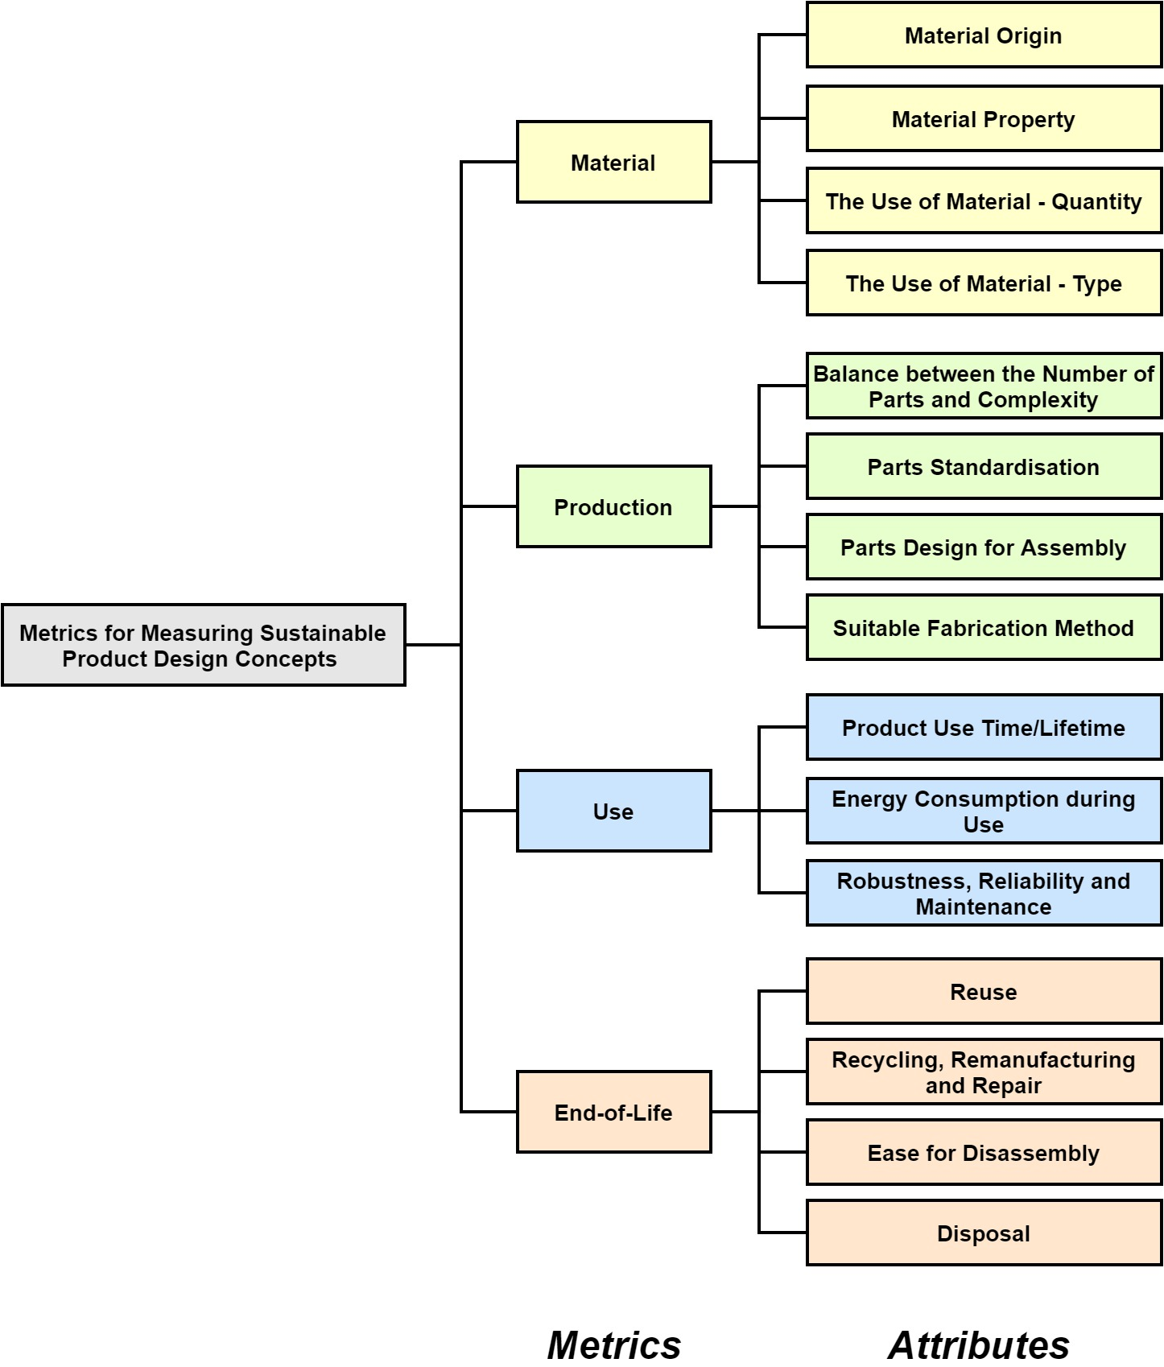
Figure 2. Metrics and attributes for measuring sustainable product design concepts

4. Case Study
A case study has been conducted to demonstrate the application of the metrics explored. Two design concepts of portable blenders, as shown in Figure 3, have been used in the case study for sustainability measurement by a design expert through employing the four metrics, Material, Production, Use and End-of-life, and associated measurements illustrated in the preceding. The two blender concepts were generated respectively by two novice design engineers who participated in the case study voluntarily with high levels of interests. To be more specific, the two design novices were asked to come up with a conceptual design of a portable blender, and present the concept using sketches or CAD drawings with annotations. The key product design specifications of the portable blender design were provided to the two design novices to guide them in the conceptual design stage, as shown in Table 7. The design novices have signed up with standard case study protocols to provide the permission to use their design concepts in this publication and related analysis
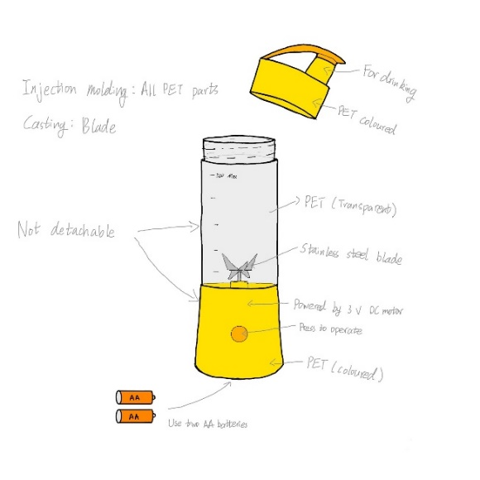
Concept (a) | Concept (b)
Figure 3. Portable blender Concept (a) and (b)

Table 7. Key product design specifications
Function | - To process nuts, fruits and vegetables into liquid.  - The blender should be able to operate without plugging into a power socket.
Performance | - The needed operating time should be within 30 seconds.  - The residual particles should not exceed 3mm in diameter.  - The blender needs to easy to clean.
Safety | - The blender should not possess risks for causing injuries at any time.
Purpose Market | - For outdoor use, e.g. travel, hiking and picnic.
Quantity | - For product trial, 300 units are expected.
Quality & Reliability | - Food hygiene standard has to be met.  - The blender should withstand high/low pressure, shock, dust and water.
Cost | - Should not cost more than a conventional juice blender.
Size and Weight | - The blender should be easy to carry with one hand.  - The weight should not exceed 2kg.
Life span | - The blender should last at least six months with daily use.
Recycle | - The blender should be easy to recycle at its end of life.
Environment | - The blender should cause minimum environment impact across its entire life cycle, e.g. service life and end of life.

As shown in Figure 3, concept (a) is a portable blender powered by a 3 V DC motor using two AA batteries. The body part of the blender consists of a jug section and a base section, but are not detachable. The base section is used to house the blade, motor, AA batteries and other associated electronic components, while the jug section is for containing ingredients such as fruits and vegetables. A cap is designed with a spout lid, which is screwed on the jug during blending and drinking. PET (polyethene terephthalate) has been selected to produce the cap, jug and base, while injection moulding has been selected as the manufacturing process. Stainless steel is selected for manufacturing the blade via casting. Concept (b) is a manually powered, hand-held design, without the need for batteries or AC/DC power supply. It consists of a lid and a body section. There are two lids, one for sealing the container body properly whilst providing interface for the attaching the handle bar. Another lid can be used when the blending is finished and it has an aperture for easy dispensing. The body section contains a transparent PET container with stainless steel shaft and two sets of blades. The steel shaft and blades can be removed completely for easy cleaning and replacement.

4.1. Evaluation and Results
The design expert, with over 8 years of experience in design engineering, participated voluntarily in the case study to assess the sustainability of the two portable blender concepts. Prior to starting the assessment, explanations of the metrics and instructions for using the equations were provided to the design expert. The results of the evaluation are shown in Table 8. For instance, for the Material metric of Concept (a), four types of materials: PET, stainless steel, battery and motor, are included in the evaluation. PET is the material used for the cap, base and jug, while stainless steel is used for the blade of the blender. The motor and battery are not strictly materials, as they have multiple components and features involving many types of materials. However, it is challenging, as well as time-consuming, to consider all materials used for fabricating motor and battery. Therefore, components such as a motor and battery, which contain multiple materials, are considered individual types of materials to ease the evaluation process. For the Material Origin (M₁) attribute, PET, stainless steel, battery and motor are all produced using non-renewable resources, such as fossil fuels and minerals, and thereby Low scores of 0 are rated. For the Material Property (M₂) attribute, PET is a recyclable material but is toxic to the environment, thus, a Medium (1) score is rated. Stainless steel is a non-toxic and recyclable material, and thereby achieving a High (2) score. Both battery and motor contain materials that are non-recyclable and toxic, and thereby receiving Low (0) scores. For the Use of Material – Quantity (M₃) attribute, both PET and stainless steel have fair potentials for material quantity reduction, such as reducing the thickness of the wall or the size of the blade, and thereby assigning Medium (1) scores. There are poor potentials to reduce material quantities for both battery and motor, thus, Low (0) scores are rated. As a result, Concept (a) has achieved a Material metric score of 1.84 according to Equation (1). The measurements of the other metrics of Concept (a), as well as the sustainability measurement of Concept (b), are depicted in Table 8.

Table 8. Evaluation of the two blender concepts
Metrics | Attributes | Concept (a) | Concept (b)
Material | Material Origin (M₁) | - PET – 0  - Stainless steel – 0  - Battery – 0  - Motor - 0 | - Bamboo – 2  - Rubber – 2  - Stainless steel – 0  - PET - 0
 | Material Property (M₂) | - PET – 1  - Stainless steel – 2  - Battery – 0  - Motor - 0 | - Bamboo – 1  - Rubber – 1  - Stainless steel – 2  - PET - 1
 | The Use of Material – Quantity (M₃) | - PET – 1  - Stainless steel – 1  - Battery – 0  - Motor - 0 | - Bamboo – 1  - Rubber – 0  - Stainless steel – 1  - PET - 1
 | The Use of Material – Type (N) | 4 | 4
Material Metric |  | $Metric_{Material}=\frac{9×\left(\frac{\sum_{i=1}^{N}{\left(M_{1}+M_{2}\right)×M_{3}}}{N}\right)}{8}+1=\frac{9×\left(\frac{\left(0+1\right)×1+\left(0+2\right)×1+\left(0+0\right)×0+(0+0)×0}{4}\right)}{8}+1=1.84$ | $Metric_{Material}=\frac{9×\left(\frac{\sum_{i=1}^{N}{\left(M_{1}+M_{2}\right)×M_{3}}}{N}\right)}{8}+1=\frac{9×\left(\frac{\left(2+1\right)×1+\left(2+1\right)×0+\left(0+2\right)×1+(0+1)×1}{4}\right)}{8}+1=2.69$
Production | Balance between the Number of Parts and Complexity (P₁) | Simple design, only a few simple parts - 2 | Simple design, only a few simple parts - 2
 | Parts  Standardisation (P₂) | Motor, battery and gear box can benefit from standard components – 2 | All components require customisation – 0
 | Parts Design for  Assembly (P₃) | Good potential for assembly optimisation – 2 | Good potential for assembly optimisation – 2
 | Suitable Fabrication Method (P₄) | No excessive operations needed - 2 | Partial excessive operations needed - 1
Production Metric |  | $Metric_{Production}=\frac{{9×(P}_{1}×P_{2}+P_{3})×P_{4}}{12}+1=\frac{9×(2×2+2)×2}{12}+1=10$ | $Metric_{Production}=\frac{{9×(P}_{1}×P_{2}+P_{3})×P_{4}}{12}+1=\frac{9×(2×0+2)×1}{12}+1=2.5$
Use | Product Use Time/Lifetime (U₁) | The design life time should be close to its use time - 2 | The design life time should be close to its use time - 2
 | Energy Consumption during Use (U₂) | Needs AA batteries to power - 1 | Manually operated, no other energy required - 2
 | Robustness, Reliability and Maintenance (U₃) | Internal components for the base, e.g. motor and gearbox will require a fair amount of resource to maintain/service - 1 | All components are easy to maintain – 2
Use Metric |  | $Metric_{Use}=\frac{9×U_{1}×\left(U_{2}+U_{3}\right)}{8}+1=\frac{9×2×\left(1+1\right)}{8}+1=5.5$ | $Metric_{Use}=\frac{9×U_{1}×\left(U_{2}+U_{3}\right)}{8}+1=\frac{9×2×\left(2+2\right)}{8}+1=10$
End-of-Life | Reuse (E₁) | Battery, motor and gearbox have fair potential to be reused - 1 | Poor potential for re-use as all components are custom-made - 0
 | Recycling, Remanufacturing and Repair (E₂) | PET plastic, steel blades and batteries can be recycled, i.e. fair potential for recycling and remanufacturing - 1 | PET plastic, steel shaft and blades can be recycled, bamboo can be remanufactured - 2
 | Disposal (E₃) | Batteries, motors will cause moderate impact due to disposal - 1 | All components will have little impact due to disposal - 2
 | Ease for Disassembly (E₄) | Blender base that contains battery, motor and gearbox will be difficult to disassemble - 1 | All components are easy to remove - 2
End-of-Life Metric |  | $Metric_{EOL}=\frac{9×(E_{1}+E_{2}+E_{3})×E_{4}}{12}+1=\frac{9×(1+1+1)×1}{12}+1=3.25$ | $Metric_{EOL}=\frac{9×(E_{1}+E_{2}+E_{3})×E_{4}}{12}+1=\frac{9×(0+2+2)×2}{12}+1=7$

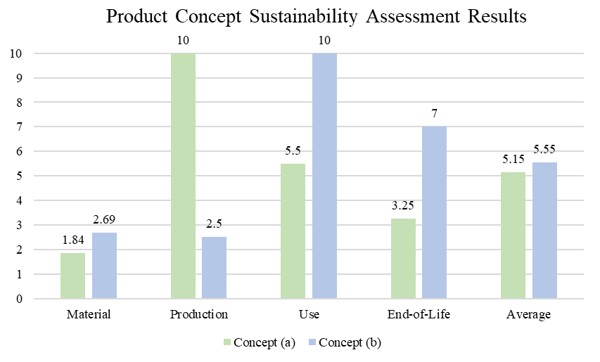
Figure 4. Product concept sustainability assessment results – Concept (a) and (b)

An overview of the product concept sustainability assessment results of Concept (a) and (b) are shown in Figure 4, including the results of the four metrics and the average sustainability score. As shown in the figure, Concept (a) has achieved 1.84 in Material metric, 10 in Production metric, 5.5 in Use metric and 3.25 in End-of-Life metric, with an average sustainability score of 5.15. Concept (b) has achieved Material, Production, Use, and End-of-Life metric scores of 2.69, 2.5, 10, and 7, respectively, with an average sustainability score of 5.55. As a result, although the average sustainability scores of Concept (a) and (b) are at a similar level, their metric scores are different. For example, Concept (a) outperforms Concept (b) in terms of Production, as it employs standard components and requires no excessive fabrication operations, as presented in Table 8. However, Concept (b) has higher scores considering Material, Use, and End-of-Life metrics in comparison with Concept (a), due to features such as using renewable and less toxic materials, employing manual operation, being easy to maintain, recycle, remanufacture, and disassemble.
In addition to the comparison, the sustainability assessment results also indicate sustainability improvement directions for each concept. For example, Concept (a) has achieved poor performance in terms of the Material metric, especially the Material Origin (M₁) attribute, as shown in Table 8. Thereby, using renewable materials, such as recycled glass, to replace the use of PET for producing the jug of the blender, could potentially increase the sustainability score of the concept regarding the Material metric. Concept (b) has poor performance in Production, of which the Parts Standardisation (P₂) attribute has been rated a Low (0) score and the Suitable Fabrication Method (P₄) attribute has been rated a Medium (1) score. Thereby, using a standardised rotating handle with shaft that is available on the market will reduce the number of customisation parts and the excessive fabrication operations needed, which could potentially improve the Production score. Other improvement strategies could be inferred to increase the scores of the remaining sustainability metrics of the two concepts.

5. Discussion
Four metrics, Material, Production, Use and End-of-life, are proposed in this study for measuring sustainable product design concepts. The corresponding attributes with associated measurement equations could be used to identify the sustainability level of a concept, with regards to the four metrics, in a quantitative manner. The attribute scores, Low (0) to High (2) applied are in the simplest form possible to provide the most straightforward indication of attribute sustainability. The equations developed aim to indicate the sustainability of each metric by using multipliers to link attributes that have aggregated effects, for instance, Material Origin and Use of Material - Quantity, and using summation to indicate the cumulative effects of attributes. The equations developed and used are not necessarily the final form and modifications can be envisaged. For example, different weights can be assigned to attributes within a metric, referring to different product design applications, to better indicate concept-specific sustainability. The major advantage of using equations is to make quantitative comparisons between different concepts. The designer is able to obtain instant results of concept sustainability based on the scores. More significantly, scores for different metrics allow an indication of sustainability improvement directions. For instance, if a product design concept has received a poor sustainability evaluation rating for a metric, the designer could explore which attribute(s) of the metric has low ratings and then modify the design concept accordingly for sustainability improvements.
This study has three implications. First, the four metrics identified for measuring product design concepts could effectively improve a product’s sustainability level at a lower cost in comparison to addressing sustainability issues at later stages. Solving sustainability issues once a product is designed or at late design stages is challenging and expensive [21,22], whereas decisions made at the conceptual design stage have high impacts on minimising the negative environmental impacts on downstream activities, such as material, production, use, and end-of-life [13-16]. The second implication is that the study has raised the significance of addressing sustainability issues at the conceptual design stage. Many design features related to product sustainability or environmental impacts are not often considered by design engineers, as they generally focus on cost, performance and durability [12,25,26]. This could result in products lack of sustainability considerations, while the introduction of the four metrics for assessing the sustainability of product concepts has the potential to foster designers in considering sustainability design features during conceptual design. The third implication is the need for more and better sustainability concept assessment tools. The review conducted in this study has revealed that the majority of existing concept assessment methods or tools are aimed at assessing the feasibility or creativity aspects of product design concepts. Although a few methods exist for evaluating the sustainability of product design concepts, these methods are limited in use [63-65]. The metrics for measuring sustainable product design concepts proposed in this study have an extensive application scope in practice, which could also be utilised as a theoretical foundation for developing advanced sustainability concept evaluation tools.
However, the metrics proposed are aimed at recommending design changes at the conceptual design stage, and it might be challenging to suggest final determinations. It thereby requires the designer or evaluator who uses the metrics for evaluation to possess sufficient knowledge and experience in sustainable design, as well as decision-making skills, to yield final design decisions. Further explorations, such as to conduct more practical case studies, are needed to examine how well the four metrics represent sustainability, to increase the metrics’ suitability for conceptual design, and to improve the measurement equations.

6. Conclusion
Sustainability plays an increasingly significant role in modern product design and development, while it is indicated that most of the negative environmental impacts are determined at early design stages, such as conceptual design. However, the review of prior literature has shown that most of the existing concept evaluation methods are geared to measure the feasibility or creativity of concepts generated rather than sustainability. The lack of measurements of sustainability at the conceptual design stage often leads to non-sustainable products, which result in negative environmental impacts. Therefore, this paper has explored the key sustainable design elements and proposed a set of metrics for measuring sustainable product design concepts. The four metrics identified, Material, Production, Use and End-of-life, associated with corresponding attributes and measurement equations, can support designers in producing sustainable design concepts and ultimately leading to sustainable products with minimal negative environmental impacts. Although this paper aims at assessing the environmental aspects of sustainable product design concepts, products produced also impact both the social and economic dimensions of sustainability through manufacturing, use and end-of-life which contribute to both employability and value creation [66].
The paper is the first study exploring metrics for evaluating product design sustainability at the conceptual design stage. It has delivered three significant contributions to the engineering design, sustainability and energy research communities. First, it serves as a guideline to measure the level of sustainability of design concepts for supporting sustainable product design in a quantitative manner. Secondly, it urges design practitioners and researchers the importance of considering sustainable design aspects at early design stages. Finally, the study offers new research insights into exploring sustainable concept evaluation, and can be used as an infrastructure to develop future concept evaluation tools.

Author Contributions: Conceptualization, J.H., P.J. and P.R.N.C.; methodology, J.H. and P.J.; investigation, J.H. and P.J.; writing—original draft preparation, J.H. and P.J.; writing—review and editing, J.H., P.J. and P.R.N.C; supervision, P.R.N.C; All authors have read and agreed to the published version of the manuscript.
Funding: This research received no external funding
Conflicts of Interest: The authors declare no conflict of interest.

References
- Parker, J.; Simpson, G.D. A Theoretical Framework for Bolstering Human-Nature Connections and Urban Resilience via Green Infrastructure. Land 2020, 9, 252.
- Vollset, S.E.; Goren, E.; Yuan, C.-W.; Cao, J.; Smith, A.E.; Hsiao, T.; Bisignano, C.; Azhar, G.S.; Castro, E.; Chalek, J.; et al. Fertility, mortality, migration, and population scenarios for 195 countries and territories from 2017 to 2100: a forecasting analysis for the Global Burden of Disease Study. The Lancet 2020, 396, 1285-1306, DOI: 10.1016/S0140-6736(20)30677-2.
- Mesa, J.; Maury, H.; Arrieta, R.; Corredor, L.; Bris, J. A novel approach to include sustainability concepts in classical DFMA methodology for sheet metal enclosure devices. Research in Engineering Design 2018, 29, 227-244, DOI: 10.1007/s00163-017-0265-4.
- Fargnoli, M.; De Minicis, M.; Tronci, M. Design Management for Sustainability: An integrated approach for the development of sustainable products. Journal of Engineering and Technology Management 2014, 34, 29-45, DOI: 10.1016/j.jengtecman.2013.09.005.
- Chiu, M.-C.; Chu, C.-H. Review of sustainable product design from life cycle perspectives. International Journal of Precision Engineering and Manufacturing 2012, 13, 1259-1272.
- WCED. Our common future; Oxford University Press: Oxford, New York, 1987.
- Purvis, B.; Mao, Y.; Robinson, D. Three pillars of sustainability: in search of conceptual origins. Sustainability Science 2019, 14, 681-695, DOI: 10.1007/s11625-018-0627-5.
- He, B.; Gu, Z. Sustainable design synthesis for product environmental footprints. Design Studies 2016, 45, 159-186, DOI: 10.1016/j.destud.2016.04.001.
- Vallet, F.; Eynard, B.; Millet, D.; Mahut, S.G.; Tyl, B.; Bertoluci, G. Using eco-design tools: An overview of experts' practices. Design Studies 2013, 34, 345-377, DOI: 10.1016/j.destud.2012.10.001.
- Chen, C.; Zhu, J.; Yu, J.-Y.; Noori, H. A new methodology for evaluating sustainable product design performance with two-stage network data envelopment analysis. European Journal of Operational Research 2012, 221, 348-359, DOI: 10.1016/j.ejor.2012.03.043.
- Ahmad, S.; Wong, K.Y.; Tseng, M.L.; Wong, W.P. Sustainable product design and development: A review of tools, applications and research prospects. Resources, Conservation and Recycling 2018, 132, 49-61, DOI: 10.1016/j.resconrec.2018.01.020.
- Howarth, G.; Hadfield, M. A sustainable product design model. Materials & Design 2006, 27, 1128-1133, DOI: 10.1016/j.matdes.2005.03.016.
- Tiwari, V.; Jain, P.K.; Tandon, P. Product design concept evaluation using rough sets and VIKOR method. Advanced Engineering Informatics 2016, 30, 16-25, DOI: 10.1016/j.aei.2015.11.005.
- Shidpour, H.; Da Cunha, C.; Bernard, A. Group multi-criteria design concept evaluation using combined rough set theory and fuzzy set theory. Expert Systems with Applications 2016, 64, 633-644, DOI: 10.1016/j.eswa.2016.08.022.
- Zhu, G.-N.; Hu, J.; Qi, J.; Gu, C.-C.; Peng, Y.-H. An integrated AHP and VIKOR for design concept evaluation based on rough number. Advanced Engineering Informatics 2015, 29, 408-418, DOI: 10.1016/j.aei.2015.01.010.
- Wang, L.; Shen, W.; Xie, H.; Neelamkavil, J.; Pardasani, A. Collaborative conceptual design—state of the art and future trends. Computer-Aided Design 2002, 34, 981-996, DOI: 10.1016/S0010-4485(01)00157-9.
- Hsu, W.; Liu, B. Conceptual design: issues and challenges. Computer-Aided Design 2000, 32, 849-850, DOI: 10.1016/S0010-4485(00)00074-9.
- Marcinkowski, A.; Zych, K. Environmental Performance of Kettle Production: Product Life Cycle Assessment. Management Systems in Production Engineering 2017, 25, 255-261, DOI: 10.1515/mspe-2017-0037.
- WRAP. Environmental assessment of consumer electronic products. Available online: http://archive.wrap.org.uk/sites/files/wrap/Environmental%20assessment%20of%20consumer%20electronic%20products.pdf (accessed on 25.05.2021).
- Lewis, H.; Gertsakis, J.; Grant, T.; Morelli, N.; Sweatman, A. Design+ environment: a global guide to designing greener goods; Routledge: 2017.
- Ramani, K.; Ramanujan, D.; Bernstein, W.Z.; Zhao, F.; Sutherland, J.; Handwerker, C.; Choi, J.-K.; Kim, H.; Thurston, D. Integrated Sustainable Life Cycle Design: A Review. Journal of Mechanical Design 2010, 132, DOI: 10.1115/1.4002308.
- Birch, A.; Hon, K.K.B.; Short, T. Structure and output mechanisms in Design for Environment (DfE) tools. Journal of Cleaner Production 2012, 35, 50-58, DOI: 10.1016/j.jclepro.2012.05.029.
- Ruy, M.; Alliprandini, D.; Scur, G. Environmental assessment in the conceptual design phase of new product development. International Journal of Sustainable Design 2019, 3, 182-204.
- Hallstedt, S.I. Sustainability criteria and sustainability compliance index for decision support in product development. Journal of Cleaner Production 2017, 140, 251-266, DOI: 10.1016/j.jclepro.2015.06.068.
- Yang, C.J.; Chen, J.L. Accelerating preliminary eco-innovation design for products that integrates case-based reasoning and TRIZ method. Journal of Cleaner Production 2011, 19, 998-1006, DOI: 10.1016/j.jclepro.2011.01.014.
- Brundage, M.P.; Bernstein, W.Z.; Hoffenson, S.; Chang, Q.; Nishi, H.; Kliks, T.; Morris, K.C. Analyzing environmental sustainability methods for use earlier in the product lifecycle. Journal of Cleaner Production 2018, 187, 877-892, DOI: 10.1016/j.jclepro.2018.03.187.
- Kravchenko, M.; Pigosso, D.C.A.; McAloone, T.C. Developing A Tool to Support Decisions in Sustainability-Related Trade-Off Situations: Understanding Needs and Criteria. Proceedings of the Design Society: DESIGN Conference 2020, 1, 265-274, DOI: 10.1017/dsd.2020.137.
- Gagnon, B.; Leduc, R.; Savard, L. From a conventional to a sustainable engineering design process: different shades of sustainability. Journal of Engineering Design 2012, 23, 49-74, DOI: 10.1080/09544828.2010.516246.
- McAloone, T.C.; Pigosso, D.C.A. Ecodesign Implementation and LCA. In Life Cycle Assessment: Theory and Practice, Hauschild, M.Z., Rosenbaum, R.K., Olsen, S.I., Eds.; Springer International Publishing: Cham, 2018; pp. 545-576.
- Suhariyanto, T.T.; Wahab, D.A.; Rahman, M.N.A. Product Design Evaluation Using Life Cycle Assessment and Design for Assembly: A Case Study of a Water Leakage Alarm. Sustainability 2018, 10, 2821.
- Harris, J.S. New product profile chart. Chemtech 1976, 6, 554-564.
- Amabile, T.M. Social psychology of creativity: A consensual assessment technique. Journal of Personality and Social Psychology 1982, 43, 997-1013, DOI: 10.1037/0022-3514.43.5.997.
- O'Quin, K.; Besemer, S.P. The development, reliability, and validity of the revised creative product semantic scale. Creativity Research Journal 1989, 2, 267-278, DOI: 10.1080/10400418909534323.
- Pugh, S.; Clausing, D. Creating innovtive products using total design: the living legacy of Stuart Pugh; Addison-Wesley Longman Publishing Co., Inc.: 1996.
- Davoodi, M.M.; Sapuan, S.M.; Ahmad, D.; Aidy, A.; Khalina, A.; Jonoobi, M. Concept selection of car bumper beam with developed hybrid bio-composite material. Materials & Design 2011, 32, 4857-4865, d DOI: 10.1016/j.matdes.2011.06.011.
- Sarkar, P.; Chakrabarti, A. Assessing design creativity. Design Studies 2011, 32, 348-383, DOI: 10.1016/j.destud.2011.01.002.
- Childs, P.R.N. Mechanical design engineering handbook, 2nd ed.; Butterworth-Heinemann: Oxford, UK, 2018.
- Yung, W.K.C.; Chan, H.K.; So, J.H.T.; Wong, D.W.C.; Choi, A.C.K.; Yue, T.M. A life-cycle assessment for eco-redesign of a consumer electronic product. Journal of Engineering Design 2011, 22, 69-85, DOI: 10.1080/09544820902916597.
- Mestre, A.; Vogtlander, J. Eco-efficient value creation of cork products: an LCA-based method for design intervention. Journal of Cleaner Production 2013, 57, 101-114, DOI: 10.1016/j.jclepro.2013.04.023.
- Deng, C.; Wu, J.; Shao, X. Research on eco-balance with LCA and LCC for mechanical product design. The International Journal of Advanced Manufacturing Technology 2016, 87, 1217-1228, DOI: 10.1007/s00170-013-4887-z.
- Civancik-Uslu, D.; Puig, R.; Voigt, S.; Walter, D.; Fullana-i-Palmer, P. Improving the production chain with LCA and eco-design: application to cosmetic packaging. Resources, Conservation and Recycling 2019, 151, 104475, DOI: 10.1016/j.resconrec.2019.104475.
- Rossi, M.; Germani, M.; Zamagni, A. Review of ecodesign methods and tools. Barriers and strategies for an effective implementation in industrial companies. Journal of Cleaner Production 2016, 129, 361-373, DOI: 10.1016/j.jclepro.2016.04.051.
- Wisthoff, A.; Ferrero, V.; Huynh, T.; DuPont, B. Quantifying the Impact of Sustainable Product Design Decisions in the Early Design Phase Through Machine Learning. In Proceedings of the ASME 2016 International Design Engineering Technical Conferences and Computers and Information in Engineering Conference, 2016.
- Millet, D.; Bistagnino, L.; Lanzavecchia, C.; Camous, R.; Poldma, T. Does the potential of the use of LCA match the design team needs? Journal of Cleaner Production 2007, 15, 335-346, DOI: 10.1016/j.jclepro.2005.07.016.
- Bereketli, I.; Erol Genevois, M. An integrated QFDE approach for identifying improvement strategies in sustainable product development. Journal of Cleaner Production 2013, 54, 188-198, DOI: 10.1016/j.jclepro.2013.03.053.
- Younesi, M.; Roghanian, E. A framework for sustainable product design: a hybrid fuzzy approach based on Quality Function Deployment for Environment. Journal of Cleaner Production 2015, 108, 385-394, DOI: 10.1016/j.jclepro.2015.09.028.
- Wu, Y.-H.; Ho, C.C. Integration of green quality function deployment and fuzzy theory: a case study on green mobile phone design. Journal of Cleaner Production 2015, 108, 271-280, DOI: 10.1016/j.jclepro.2015.09.013.
- Ocampo, L.A.; Labrador, J.J.T.; Jumao-as, A.M.B.; Rama, A.M.O. Integrated multiphase sustainable product design with a hybrid quality function deployment – multi-attribute decision-making (QFD-MADM) framework. Sustainable Production and Consumption 2020, 24, 62-78, DOI: 10.1016/j.spc.2020.06.013.
- Olewnik, A.; Lewis, K. Limitations of the House of Quality to provide quantitative design information. International Journal of Quality & Reliability Management 2008, 25, 125-146, DOI: 10.1108/02656710810846916.
- Abu-Assab, S. Quality Function Deployment in New Product Development. In Integration of Preference Analysis Methods into Quality Function Deployment: A Focus on Elderly People, Abu-Assab, S., Ed.; Gabler Verlag: Wiesbaden, 2012; pp. 47-68.
- Han, J.; Forbes, H.; Schaefer, D. An exploration of how creativity, functionality, and aesthetics are related in design. Research in Engineering Design 2021, DOI: 10.1007/s00163-021-00366-9.
- Goswami, M.; Tiwari, M.K. A predictive risk evaluation framework for modular product concept selection in new product design environment. Journal of Engineering Design 2014, 25, 150-171, DOI: 10.1080/09544828.2014.921806.
- Rondini, A.; Bertoni, M.; Pezzotta, G. An IPA Based Method for PSS Design Concept Assessment. Procedia CIRP 2017, 64, 277-282, DOI: 10.1016/j.procir.2017.03.061.
- Chulvi, V.; Sonseca, Á.; Mulet, E.; Chakrabarti, A. Assessment of the Relationships Among Design Methods, Design Activities, and Creativity. Journal of Mechanical Design 2012, 134, 111004-111004-111011, DOI: 10.1115/1.4007362.
- García-García, C.; Chulvi, V.; Royo, M. Knowledge generation for enhancing design creativity through co-creative Virtual Learning Communities. Thinking Skills and Creativity 2017, 24, 12-19, DOI: 10.1016/j.tsc.2017.02.009.
- Horn, D.; Salvendy, G. Measuring consumer perception of product creativity: Impact on satisfaction and purchasability. Human Factors and Ergonomics in Manufacturing & Service Industries 2009, 19, 223-240, DOI: 10.1002/hfm.20150.
- Chakrabarti, A.; Sarkar, P.; Leelavathamma, B.; Nataraju, B.S. A functional representation for aiding biomimetic and artificial inspiration of new ideas. Artificial Intelligence for Engineering Design, Analysis and Manufacturing 2005, 19, 113-132, DOI: 10.1017/S0890060405050109.
- Chiu, I.; Shu, L.H. Investigating effects of oppositely related semantic stimuli on design concept creativity. Journal of Engineering Design 2012, 23, 271-296, DOI: 10.1080/09544828.2011.603298.
- Demirkan, H.; Afacan, Y. Assessing creativity in design education: Analysis of creativity factors in the first-year design studio. Design Studies 2012, 33, 262-278, DOI: 10.1016/j.destud.2011.11.005.
- Lee, J.H.; Gu, N.; Ostwald, M.J. Creativity and parametric design? Comparing designer's cognitive approaches with assessed levels of creativity. International Journal of Design Creativity and Innovation 2015, 3, 78-94, DOI: 10.1080/21650349.2014.931826.
- Srinivasan, V.; Song, B.; Luo, J.; Subburaj, K.; Elara, M.R.; Blessing, L.; Wood, K. Does Analogical Distance Affect Performance of Ideation? Journal of Mechanical Design 2018, 140, DOI: 10.1115/1.4040165.
- Starkey, E.M.; Menold, J.; Miller, S.R. When Are Designers Willing to Take Risks? How Concept Creativity and Prototype Fidelity Influence Perceived Risk. Journal of Mechanical Design 2019, 141, DOI: 10.1115/1.4042339.
- Lindow, K.; Woll, R.; Stark, R. Developing Sustainable Products: An Interdisciplinary Challenge. In Proceedings of the ICoRD'13, 2013; 517-527.
- Hassan, M.F.; Saman, M.Z.M.; Sharif, S.; Omar, B. Sustainability evaluation of alternative part configurations in product design: weighted decision matrix and artificial neural network approach. Clean Technologies and Environmental Policy 2016, 18, 63-79.
- Turan, F.M.; Johan, K.; Nor, N.H.M.; Omar, B. Sustainability Assessment Model in Product Development. IOP Conference Series: Materials Science and Engineering 2017, 226, 012021, DOI: 10.1088/1757-899x/226/1/012021.
- Tarne, P.; Traverso, M.; Finkbeiner, M. Review of Life Cycle Sustainability Assessment and Potential for Its Adoption at an Automotive Company. Sustainability 2017, 9, 670.

