**A novel method for transient heat conduction in a quasi-periodic structure with nonlinear defects**

Haichao Cui a, Qiang Gao a,*, Xiaolan Li a, Huajiang Ouyang b

a *State Key Laboratory of Structural Analysis for Industrial Equipment,*

*International Center for Computational Mechanics, Department of Engineering Mechanics, Faculty of Vehicle Engineering and Mechanics, Dalian University of Technology, Dalian 116023, P.R. China*

*b School of Engineering, University of Liverpool, The Quadrangle,*

*Liverpool L69 3GH, UK*

Email: cuihaichao@mail.dlut.edu.cn, qgao@dlut.edu.cn,

Lixln@mail.dlut.edu.cn, h.ouyang@liverpool.ac.uk

*Corresponding author: Tel: 86 411 84707608; e-mail address: qgao@dlut.edu.cn

January 2020

**Abstract** This paper proposes an efficient numerical method for transient heat conduction in a quasi-periodic structure with nonlinear defects. According to the physical features of transient heat conduction, a quasi-superposition principle for transient heat conduction in a quasi-periodic structure with nonlinear defects is presented, and then a new method is developed to separate the above nonlinear problem to be solved into a linear problem of a perfect periodic structure and nonlinear problems of some small-scale structures with defects. As the scale of nonlinear problem to be solved is significantly reduced and low computational resource is required, outstanding efficiency is achieved. Finally, a numerical example shows that the proposed method is effective and accurate.

***Keywords***: Quasi-periodic structure; Nonlinear transient heat conduction; Finite element method; Quasi-superposition principle

**1. Introduction**

It is well known that the periodic structure composed of many identical unit cells plays an important role in modern engineering fields. However, in some cases, the material properties or geometries of some unit cells may not be perfect because of small changes for special purposes in design or normal wear. For the sake of discrimination, those unit cells whose physical properties or geometries are different from perfect ones are called as defective unit cells, and the corresponding structure is called as a quasi-periodic structure. When thermal properties of a defective unit cell are dependent on temperature, the defective unit cell is thought to have a nonlinear defect; otherwise, the unit cell is regarded to have a linear defect. As the linear defect is a special case of the nonlinear one, we will focus on the quasi-periodic structure with nonlinear defects in this research.

Generally, when some strong concentrated heat sources are presented in some tiny regions, such as welding [1, 2], temperature gradients of the areas near these concentrated heat sources are much larger than that of the other area, thus these areas usually exhibit strong nonlinearity, and it is no longer appropriate to assume that the whole solution domain is linear. Besides, for realizing some special functions, some perfect unit cells are usually replaced by nonlinear defective ones, which also result in strong local nonlinearity, such as in a functionally gradient material [3]. In addition, due to the influence of manufacturing technology and fatigue damage, thermal properties of the entire structure may also be quasi-periodic. All such cases belong to transient heat conduction in quasi-periodic structures [4-6]. In engineering applications, quasi-periodic structures usually serve under complex thermal environments, thus it is significant to predict thermal behaviours of quasi-periodic structures.

In this paper, the main characteristic of nonlinear transient heat conduction in a quasi-periodic structure is that nonlinear behaviours only induced by nonlinear defects are local while the other large area behaves linearly. The general analysis method for this kind of problem assumes that the whole solution domain is nonlinear. And then a combination of transient and nonlinear equation algorithms is adopted for solving the above problem, resulting in reforming the global thermal matrices and solving the system of linear equations in each iteration for every time step. Thus, a significant amount of computational resources are usually required [7].

In order to improve the computational efficiency, some methods have been developed to separate the above nonlinear problem into a linear domain and some local nonlinear domains, such as sub-structuring techniques [2, 8]. In this paper, a similar but different idea will be presented. Based on the physical features of transient heat conduction, a quasi-superposition principle is developed, and the transient heat conduction problem of a quasi-periodic structure with nonlinear defects is transformed into nonlinear problems of some small-scale structures with defective unit cells and a linear problem of a perfect periodic structure. Finally, the above nonlinear and linear problems are individually solved by appropriate numerical methods efficiently.

**2. FEM for transient heat conduction in a quasi-periodic structure with nonlinear defects**

This present work is intended to develop an efficient and accurate method to solve transient heat conduction in a quasi-periodic structure with a few nonlinear defects, as shown in Fig. 1(a). The perfect and defective unit cells are shown in Fig. 1(b) and (c), respectively. The governing equation and boundary conditions are expressed as follows









The initial temperature is



where  is temperature; ,  and  are the temperature-dependent density, specific heat and thermal conductivity, respectively;  is the internal heat generation;  is the total computational time;  is the solution domain enclosed by the boundary  ;  and  denote the given temperature and heat flux, respectively;  and  represent the heat convection coefficient and the environmental temperature, respectively;  is the unit outward normal vector; and  is the initial temperature.

Using the FEM, the following equation can be obtained



where  denotes the temperature vector;  is the derivation of  with respect to time ;  is the thermal force vector;  represents the initial temperature vector;  and  are the thermal conductivity matrix and the lumped mass heat capacity matrix, respectively.

If traditional numerical schemes are utilized to solve the nonlinear ordinary differential equation, thermal conductivity and capacity matrices of the whole model need to be reformed and the system of linear equations must be solved in each iteration. Therefore, it is very time-consuming for a large-scale quasi-periodic structure. In order to improve the computational efficiency, a quasi-superposition principle and a novel method will be proposed in Sections 3 and 4, respectively.

**3. The quasi-superposition principle**

The physical feature of transient heat conduction proposed in [9] indicates that, the initial excitations in a unit cell can only affect *m* adjacent unit cells in any direction within a time step. Based on the above physical feature, a quasi-superposition principle will be proposed for transient heat conduction in a quasi-periodic structure with nonlinear defects.

For convenience, a periodic structure composed of  unit cells is chosen as an example for demonstrating the quasi-superposition principle, and suppose that it only contains one nonlinear defective unit cell (1, 1), as shown in Fig. 2(a). After proper spatial discretization [9], the finite element model is depicted in Fig. 2(b). According to the physical feature of transient heat conduction, we can assume that the excitations in a unit cell can only affect one unit cell in any direction within a time step. The nodes of the mesh are grouped as follows: let the nodes belonging to defective unit cell (1, 1) be set as *a*, such as those located on the blue mesh in Fig. 3(b); let the nodes which do not belong to but connect with the defect be set as *b*,such as those enclosed by the dotted lines; let the nodes which locate on unit cells (1, 2), (2, 2) and (2, 1) and do not connect with defective unit cell (i.e., except the set *b*) be set as *c*, such as those located on the red mesh; let the nodes located on unit cells (1, 3), (2, 3), (3, 3), (3, 2) and (3, 1) be set as *d*, such as those located on the green mesh; finally, let the remaining nodes be set as *e*. The excitations of the finite element model include the initial temperature vector  and the thermal force vector , as the hatched domains pictured in Fig. 3 where the mesh is omitted.

According to the above five nodal sets (i.e., *a*, *b*, *c*, *d* and *e*), the nodal thermal force and temperature vector can be rewritten as



Accordingly, the thermal capacity and conductivity matrices can be expressed as





Note that only sub-matrices  and  are related to temperature according to the grouping rules of nodes. Eq. can be transformed as



in which



and





Then Eq. can be rewritten as



where  denotes the value of  at initial time, i.e.,





where



in which  respects temperature responses of nodes belonging to nodal set *a* at initial time.

The solution of Eq. can be obtained by Duhamel integration



For any time interval , the above equation can be expressed as



where  is the time step, and  is the exponential of matrix , i.e.,



The block form of Eq. is



where



and  denotes temperature responses of nodes belonging to nodal set  at the *k*-th integration step.

Next, the excitations of the finite element model are subdivided into two groups according to whether they can affect the defect within a time step  or not. As we have assumed that the excitations can only affect one unit cell in any direction within a time step, the excitations which are applied on nodal sets *a*, *b* and *c* have an effect on the defective unit cell (1, 1), thus the corresponding excitations , , , ,  and  can be regarded as the first group of excitations, as the hatched domains shown in Fig. 3(b), while the remaining excitations , ,  and  have no effect on the defect within a time step, so those excitations can be regarded as the second group of excitations, as the hatched domains displayed in Fig. 3(c). The original excitations can be obtained by adding the two groups of excitations together, i.e.,



Substituting Eq. into Eq. , the following equation can be obtained



Since Eq. is nonlinear, itneeds to be computed iteratively. Assume the -th iterative result is , then the -th iterative result can be expressed as



From Eq. , the -th iterative result is equal to the sum of the first and second parts. The first part is the response induced by the first group of external excitations (i.e., , , , ,  and ). Since we have assumed that the excitations just affect one unit cell in any direction, only the responses of nodal sets , ,  and  can be affected by the first group of excitations, and the responses of nodal set  are only affected by external excitations  and , while the responses of nodal set *e* remain zero (see Fig. 3(b)). Thus,



in which  denotes the responses of nodes belonging to nodal set  caused by the first group of excitations in the -th iteration. The second part is the response caused by the second group of excitations (i.e., , ,  and ). Based on the physical feature of transient heat conduction, only the responses of nodal sets ,  and  can be affected by the second group of excitations within a time step and they may be non-zero, and the responses of nodal set  are only affected by external excitations  and , while the responses of nodal sets  and  remain zero (see Fig. 3(c)). Thus,



in which  denotes the responses of nodes belonging to nodal set  caused by the second group of excitations in the -th iteration.

Based on Eqs. -, the following equation can be obtained



The first term at the right hand of Eq. needs to be updated for each iteration because it is related to the former iteration results  and , while the second term at the right hand of Eq. remains unchanged during iterative process based on Eq. . Note that the first term is independent of the former iteration result .  and  can be obtained only by using the first term and are independent of the second term. Therefore, the first and second terms at the right hand of Eq. , which correspond to Eqs. and respectively, can be computed individually. In other words, they can be decoupled during the iterative process, and the second term just needs to be computed once.

Based on the above analysis, Eqs. and can be computed separately, and the sum of their convergence results is the temperature response of the entire structure at the -th integration step. Compared to the superposition principle of linear system, the above superposition for nonlinear transient heat conduction in a quasi-periodic structure can be called as the quasi-superposition principle.

**4. The main idea for solving transient heat conduction in quasi-periodic structure with a nonlinear defect**

Based on the quasi-superposition principle presented in Section 3, the main idea of the novel method will be illustrated in this section.

Since the second group of excitations has no effect on the defect within a time step, the defective unit cell can be replaced by a perfect one, and the original quasi-periodic structure is changed into a perfect periodic structure. Therefore, the computation of transient heat conduction due to the second group of excitations in the original quasi-periodic model is transformed into the computation of linear transient heat conduction in a perfect periodic model, see Fig. 3(c).

The efficient and accurate method proposed in [9] can be adopted for linear transient heat conduction in a perfect periodic structure. This method is developed based on the superposition principle, the physical feature of transient heat conduction and the periodic property of structure: computation of results of the entire periodic structure is transformed into computation of that of small-scale models, which can greatly reduce computation time and disk space. According to the proposed method in [9], each small-scale structure is composed of  unit cells, and the precise integration method [10] is used for solving temperature responses of each small-scale model. In addition, the parameter *m* and a corresponding time step  can also be determined during the process.

On the other hand, from Eq. , non-zero temperature responses induced by the first group of excitations which can have an effect on the nonlinear defect only exist in domain  composed of unit cell , see Fig. 3(b). Thus, for obtaining those non-zero temperature responses, we just need to solve the nonlinear transient heat conduction problem in domain . Since there is no heat exchange between domains  and  during a time step, the adiabatic condition can be applied on the top and right boundaries of domain , while boundary conditions of bottom and left boundaries of domain  remain the same as those of the original structure. As temperature responses of domain  remain zero within a time step, once temperature responses of domain  are computed, then the temperature responses of the entire structure can be obtained by the correspondence relationship between nodes.

The governing equation of nonlinear heat conduction in the sub-structure with domain  can be expressed as Eq. , and since the scale of the sub-structure is far smaller than that of the original structure for a small *m*, the Crank-Nicholson (C-N) method can be used to compute the above nonlinear transient heat conduction directly and efficiently. And a smaller time step (such as ) is chosen for ensuring the accuracy and reliability. In this present work, the modified Newton-Raphson (mN-R) method is used to solve the nonlinear equations obtained by the C-N method.

If the position of defective unit cell is fixed, the size of sub-structure with domain  is determined by the maximum number of unit cells *m* affected by the external excitation within a time step *η*. When a desired parameter *m* is given, the time step can be computed by the method proposed in Ref. [9]. On the one hand, when *m* chosen is a large value, the time step should also be large. If the nonlinear heat conduction is solved using the large time step, the oscillation of solution is easy to occur and the computational accuracy is very poor. At the same time, the computational effort of the nonlinear problem is also huge, so the computational efficiency is very low. On the other hand, if *m* chosen is a small value, the corresponding time step should also be small. It can not only ensure high accuracy, but also greatly reduce the computational effort of the nonlinear problem and improve the computational efficiency. According to our experience and numerical examples, it is better to set the parameter *m* as a small value.

Although the proposed method is illustrated by an example, the idea can be extended to the general quasi-periodic structure with multiple defective unit cells easily and directly without any difficultly. Generally, the fewer the defective unit cells there are and the more concentrated the defects distribution is, the lower the computational effort of the nonlinear heat conduction in the sub-structure is needed.

**5. Numerical example**

A periodic structure composed of  unit cells is considered. The unit cell is a square with a circular area and consists of two different materials denoted as #1 and #2, as shown in Fig. 4(a). The heat conduction coefficients are  and , respectively, and the volumetric heat capacities are  and , respectively. The unit cell is discretized using three-node triangle linear elements, and the mesh is shown in Fig. 4(b). The initial condition is



The heat exchanges are modelled by a Robin condition at the boundary surfaces *y*=0.1*N* m and *x*=0 with a heat transfer coefficient  and an external temperature , i.e.,



An adiabatic condition is assumed at the boundary surface *y*=0, i.e.,



The temperature at the boundary surface *x*=0.1*N* m is prescribed as



The following heat source  is imposed on the periodic structure



To illustrate the effect of defect on results, the following two cases are considered. Case 1: the periodic structure is perfect without defects; Case 2: some perfect unit cells in the above periodic structure are replaced by defective ones, and the unit cell numbers are ,  and , i.e.,



where . Each defective unit cell is the same as the perfect one except for its thermal properties. The heat conduction coefficients of each defective unit cell with two different materials are  and , and their volumetric heat capacities are  and .

When *N*=31, the transient heat conduction problems of both cases are solved by the proposed method. The small-scale model is composed of  unit cells, and the time step selected automatically by the proposed method is 2 s. The interval of integration is from 0 to 8000 s. To investigate the evolution of temperature with respect to time, the point located at *x*=1 m and *y*=1.6 m is detected. Fig. 5 shows the comparison of temperature evolution between both cases. The temperature contours corresponding to both cases at *t*=8000 s are depicted in Fig. 6. It can be observed that there are significant differences between temperature responses for both cases, which illustrates that defects can exert large influence on results.

To illustrate the accuracy of the proposed method, temperature responses of Case 2 are computed using the proposed method, the Runge-Kutta (R-K) method (ODE45 in MATLAB) and the C-N method. The interval of integration is [0, 400 s], and three time steps of 2, 1 and 0.5 s are adopted for the C-N method. The numerical results computed by the R-K method with absolute and relative tolerances  are considered as the reference solution. Relative error  is defined as



where  represents reference solutions of all nodes at a given time computed by the R-K method, and  denotes temperature responses of all nodes at the same time computed by the C-N method and the proposed method. When *N*=31, the relative errors are exhibited in Fig. 7, where lines with triangles, squares, pentagrams and diamonds correspond to the C-N method with three time steps and the proposed method, respectively. Fig. 7 indicates that the relative errors of results obtained from the C-N method with time steps of 2, 1 and 0.5 s are approximately 88%, 18% and 4%, while the one corresponding to the proposed method with time step of 2 s is only approximately . This verifies that the precision of the C-N method with a larger time step is very low, while the proposed method can give very accurate solutions even using a larger time step.

To validate the efficiency of the proposed method, the temperature responses of Case 2 are computed using the proposed method and the C-N method. The interval of integration is [0, 80 s], and relative time  is defined as



where  and  denote CPU times for the C-N method and the proposed method, respectively. The curves of relative time  corresponding to the C-N method with three time steps are pictured in Fig. 8, where lines with triangles, squares and pentagrams are the relative times corresponding to the C-N method with time steps of 2, 1 and 0.5 s, respectively. Fig. 8 shows that the relative time increases along with the increase of *N*, which demonstrates that the proposed method is more efficient than the C-N method for a larger scale quasi-periodic structure. For *N*=211, the quasi-periodic structure with defects has 4989729 nodes and 9972704 elements, and the efficiency of the proposed method is approximately 14, 30 and 40 times better than that of the C-N method.

**6. Conclusions**

A novel method is developed to analyse transient heat conduction in a quasi-periodic structure with a few nonlinear defects. According to the physical feature of transient heat conduction, a quasi-superposition principle is proposed. Based on the above principle, nonlinear transient heat conduction in a quasi-periodic structure is decoupled into several nonlinear problems of small-scale structures with nonlinear defects and a linear problem of a perfect periodic structure. The proposed method can not only avoid solving the large-scale nonlinear equations repeatedly, but also eliminate computation of reforming thermal matrices of the whole structure in each iteration for every time step. Therefore, the novel method is more efficient and requires less memory than the general analysis method. The following conclusions can be drawn based on the numerical example. Even if the Crank-Nicholson (C-N) method uses a time step which is 4 times smaller than that of the proposed method, its precision still cannot reach that of the proposed method, which verifies the high precision of the proposed method. For the problem with about 5 million nodes, with the same time step, the efficiency of the proposed method is approximately 14 times higher than that of the C-N method.

**Acknowledgements**

This project is sponsored by the Natural Science Foundation of China (No.11972107, No.91748203), the Fundamental Research Funds for the Central Universities (No.DUT2019TD37) and the China Scholarship Council (CSC)

**References**

[1] Lindgren, L. E., 2006, "Numerical modelling of welding," Comput. Methods Appl. Mech. Engrg., 195(48), pp. 6710-6736.

[2] Murakawa, H., Ma, N., and Huang, H., 2015, "Iterative substructure method employing concept of inherent strain for large-scale welding problems," Weld. World, 59(1), pp. 53-63.

[3] Ma, Q., and Cui, J. Z., 2013, "Second-Order Two-Scale Analysis Method for the Quasi-Periodic Structure of Composite Materials under Condition of Coupled Thermo-Elasticity," Adv. Mater. Res., 629, pp. 160-164.

[4] Su, F., Cui, J. Z., Xu, Z., and Dong, Q. L., 2010, "A second-order and two-scale computation method for the quasi-periodic structures of composite materials," Finite Elem. Anal. Des., 46(4), pp. 320-327.

[5] Su, F., Xu, Z., Cui, J. Z., and Dong, Q. L., 2011, "Multi-scale method for the quasi-periodic structures of composite materials," Appl. Math. Comput., 217(12), pp. 5847-5852.

[6] Yang, Z. Q., Sun, Y., Cui, J. Z., and Li, X., 2018, "A multiscale algorithm for heat conduction-radiation problems in porous materials with quasi-periodic structures," Commun. Comput. Phys., 24, pp. 204-233.

[7] Ditri, J., 2018, "Ambient Temperature and Self-Heating Scaling Laws for Materials With Temperature-Dependent Thermal Conductivity," J. Heat Transfer, 140(10), p. 102006.

[8] Brown, S., and Song, H., 1993, "Rezoning and dynamic substructuring techniques in FEM simulations of welding processes," J. Eng. for Industry, 115, pp. 415-422.

[9] Gao, Q., and Cui, H. C., 2018, "Efficient and accurate method for 2D periodic structures based on the physical features of the transient heat conduction," Int. J. Therm. Sci., 127, pp. 213-231.

[10] Zhong, W. X., and Williams, F. W., 1994, "A precise time step integration method," J. Mech. Eng. Sci., 208(63), pp. 427-430.

**Figure and Table Captions**

**Fig. 1.** (a) The quasi-periodic structure; (b) the perfect unit cell; (c) the defective unit cell.

**Fig. 2.** (a) A quasi-periodic structure composed of  unit cells with the nonlinear defective unit cell (1, 1); (b) the corresponding finite element model and the grouping rules of nodes.

**Fig. 3.** The quasi-superposition principle for transient heat conduction in a quasi-periodic structure with the nonlinear defect (1, 1). Hatched domains represent the external excitations including nodal temperatures and nodal thermal forces, and gradient-shaded domains represent non-zero temperature response distribution areas.

**Fig. 4.** The unit cell (a) and its FEM mesh (b).

**Fig. 5.** Distribution of temperature versus time at point (*x*=1 m, *y*=1.6 m).

**Fig. 6.** Comparisons of the temperature contours corresponding to the perfect structure (a) and the quasi-periodic structure with defects (b) when *N*=31 and *t*=8000 s.

**Fig. 7.** Relative errors of results obtained from the C-N method with time steps of 2 s (triangle),1 s (square), 0.5 s (pentagram) and the proposed method (diamond) when *N*=31.

**Fig. 8.** The relative times corresponding to the C-N method with time steps of 2 s (triangle), 1 s (square), 0.5 s (pentagram).

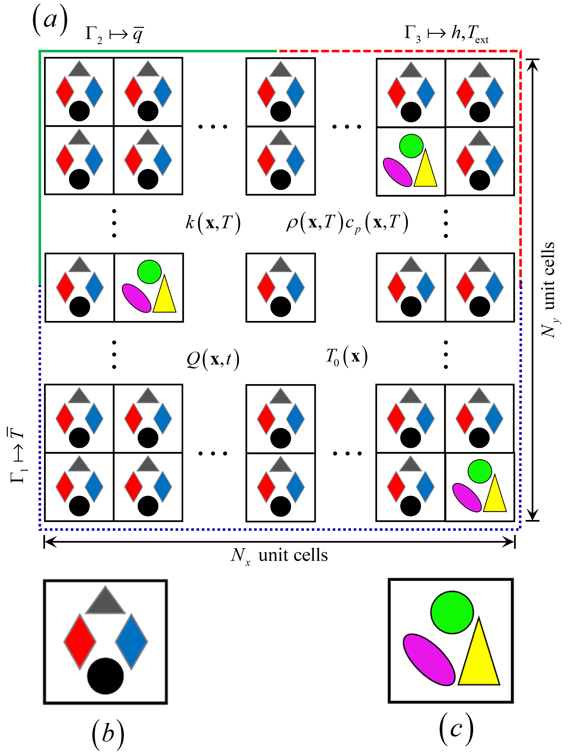

**Fig. 1.** (a) The quasi-periodic structure; (b) the perfect unit cell; (c) the defective unit cell.

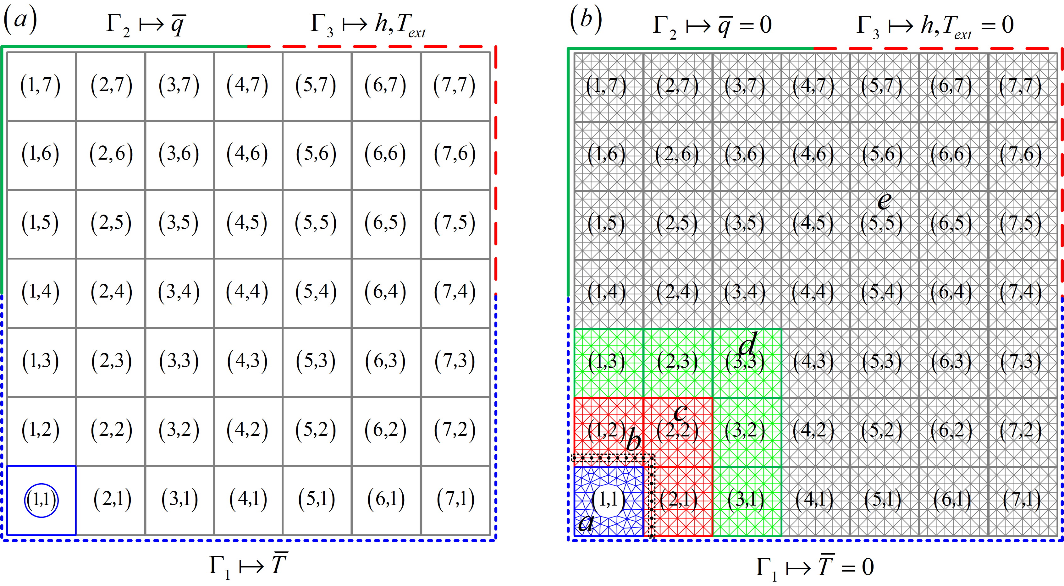

**Fig. 2.** (a) A quasi-periodic structure composed of  unit cells with the nonlinear defective unit cell (1, 1); (b) the corresponding finite element model and the grouping rules of nodes.

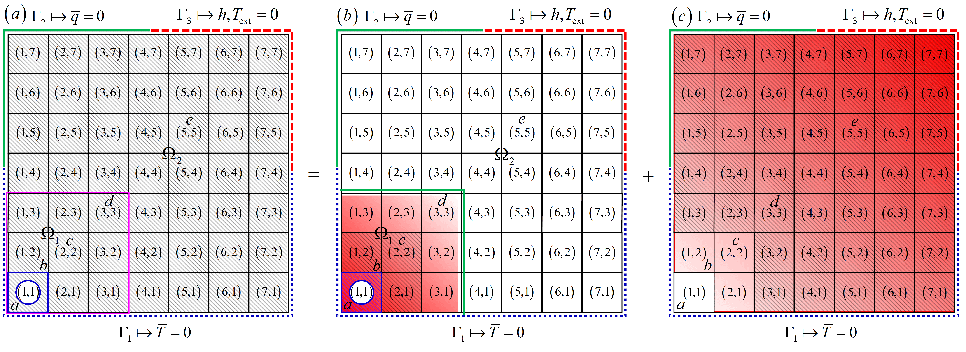

**Fig. 3.** The quasi-superposition principle for transient heat conduction in a quasi-periodic structure with the nonlinear defect (1, 1). Hatched domains represent the external excitations including nodal temperatures and nodal thermal forces, and gradient-shaded domains represent non-zero temperature response distribution areas.

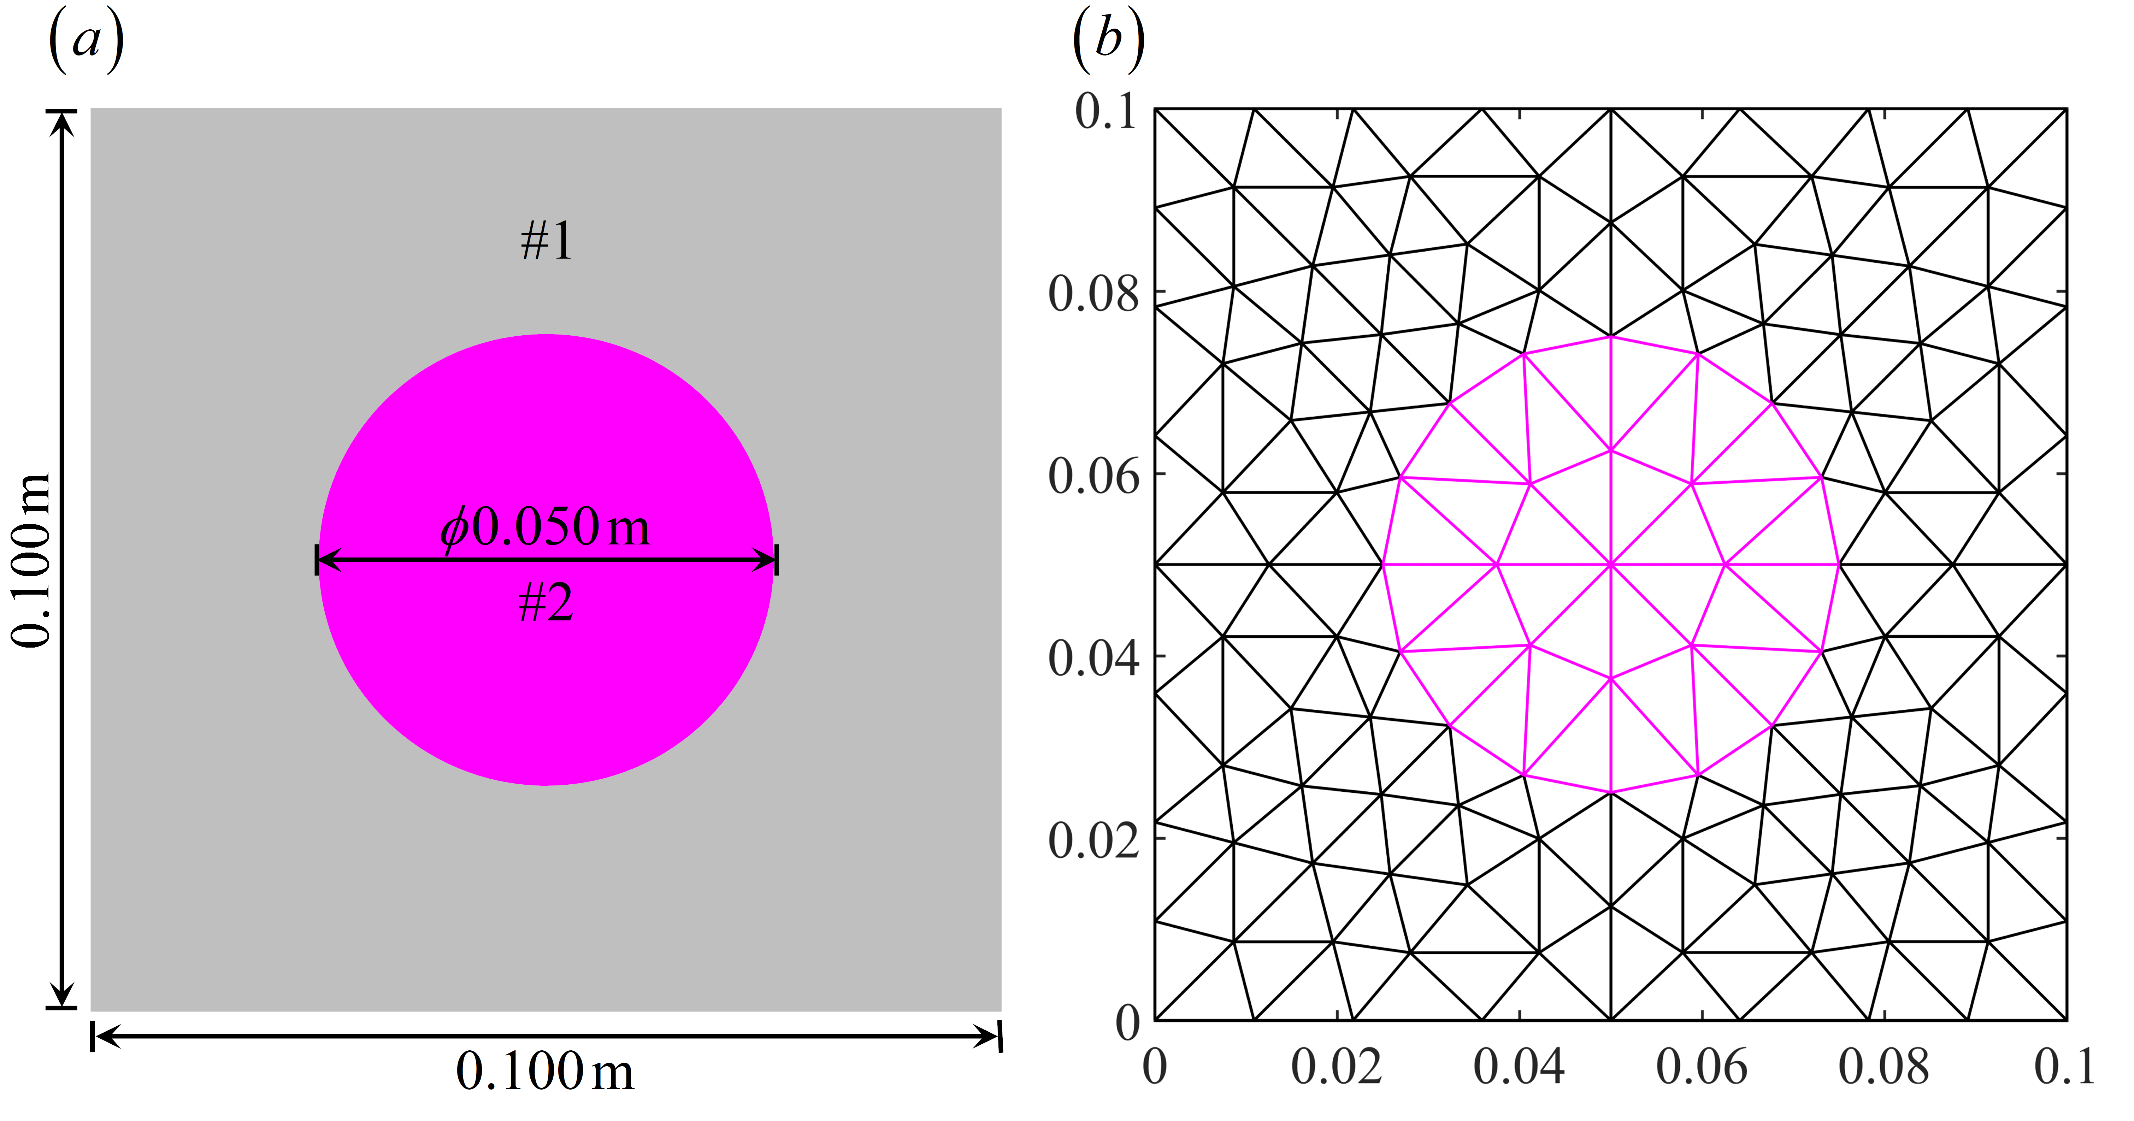

**Fig. 4.** The unit cell (a) and its FEM mesh (b).

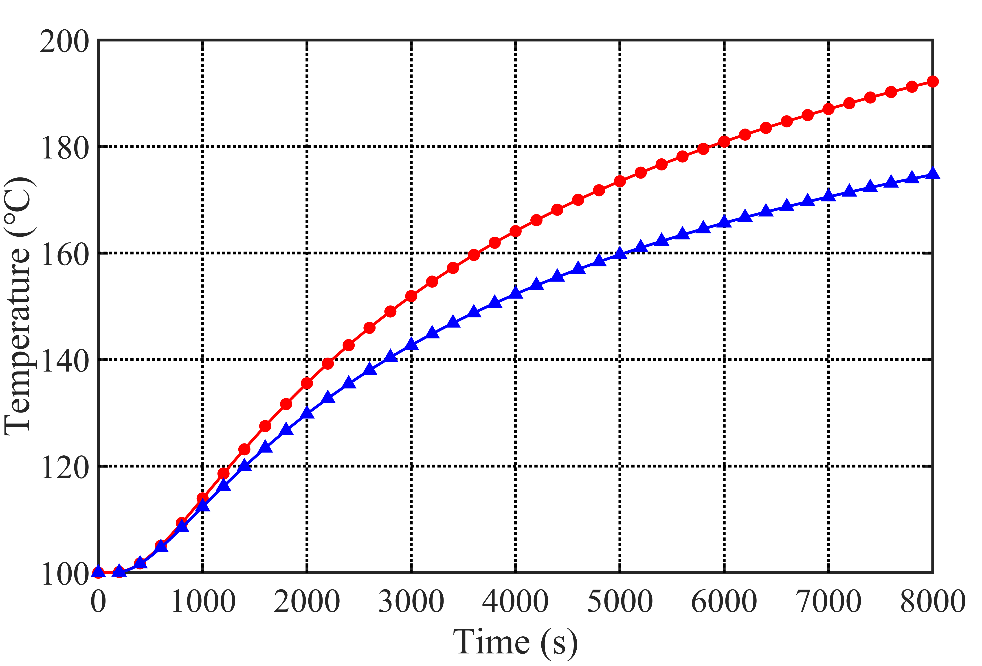

**Fig. 5.** Distribution of temperature versus time at point (*x*=1 m, *y*=1.6 m).

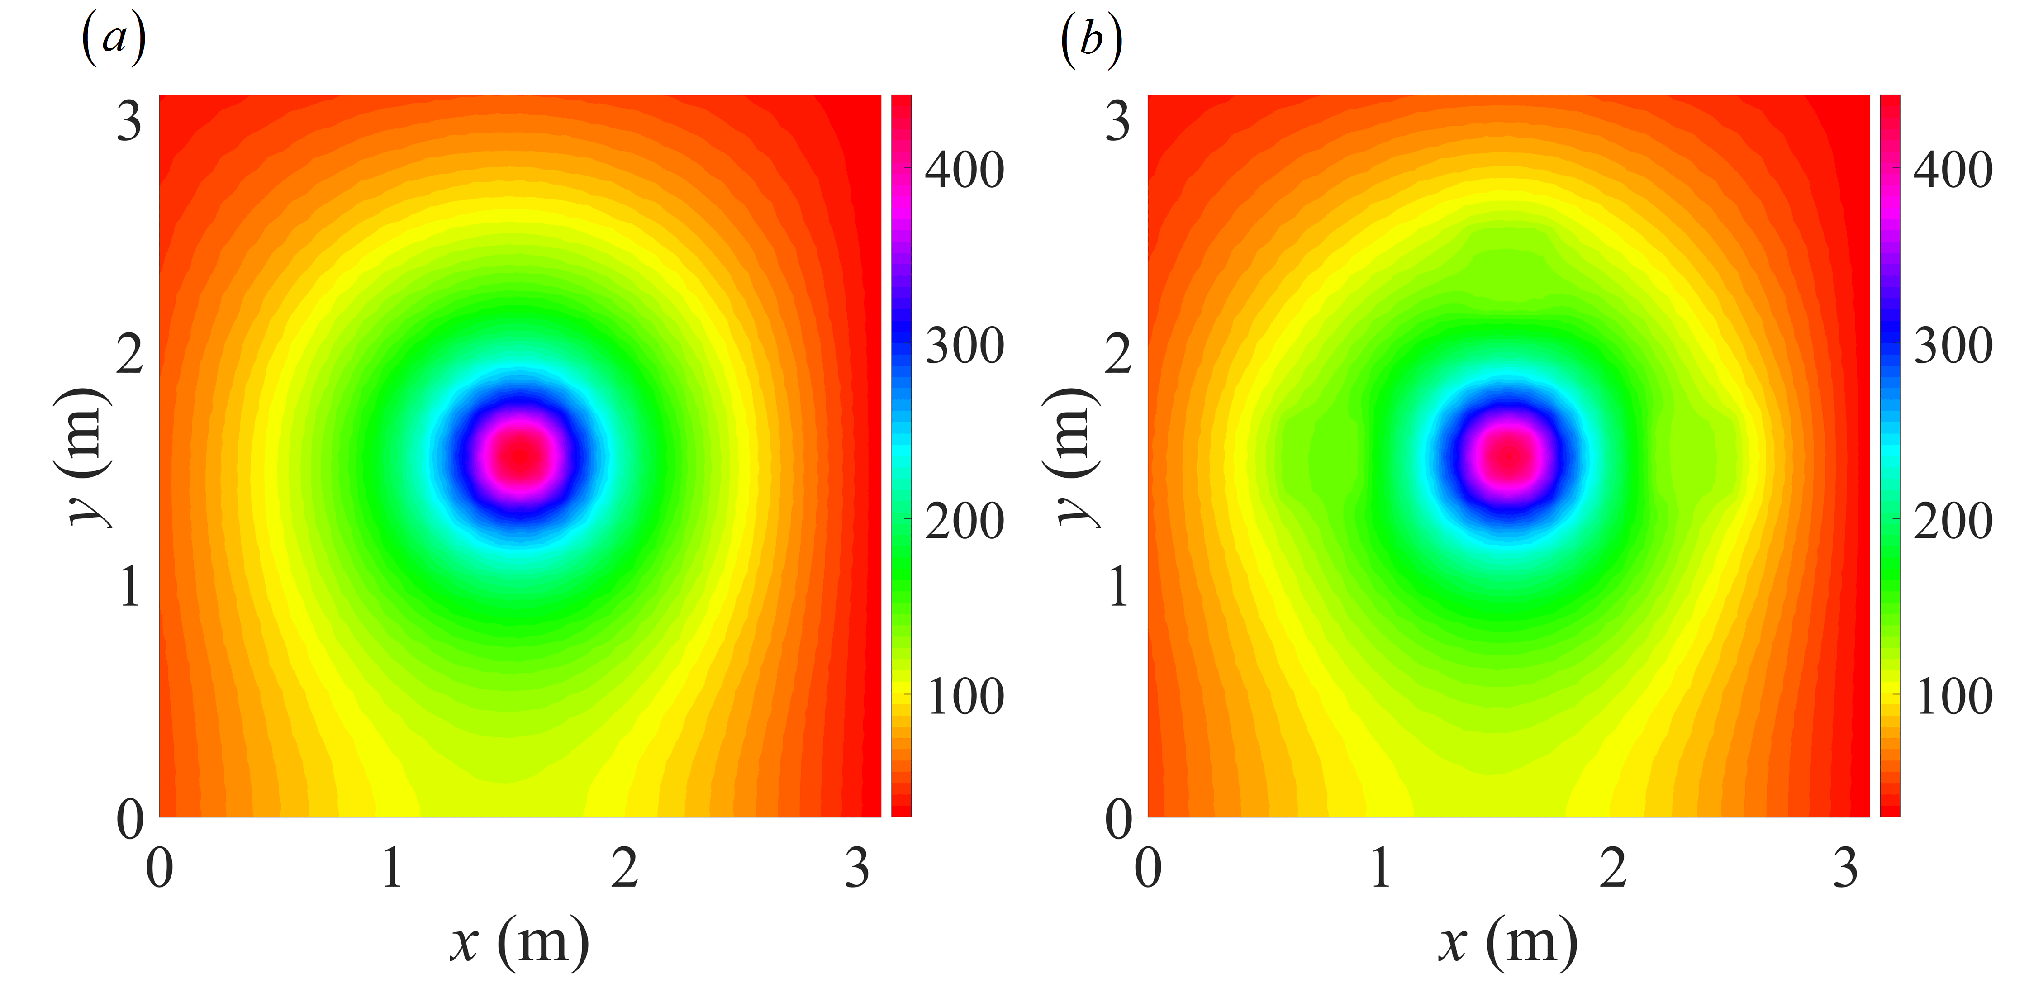

**Fig. 6.** Comparisons of the temperature contours corresponding to the perfect structure (a) and the quasi-periodic structure with defects (b) when *N*=31 and *t*=8000 s.

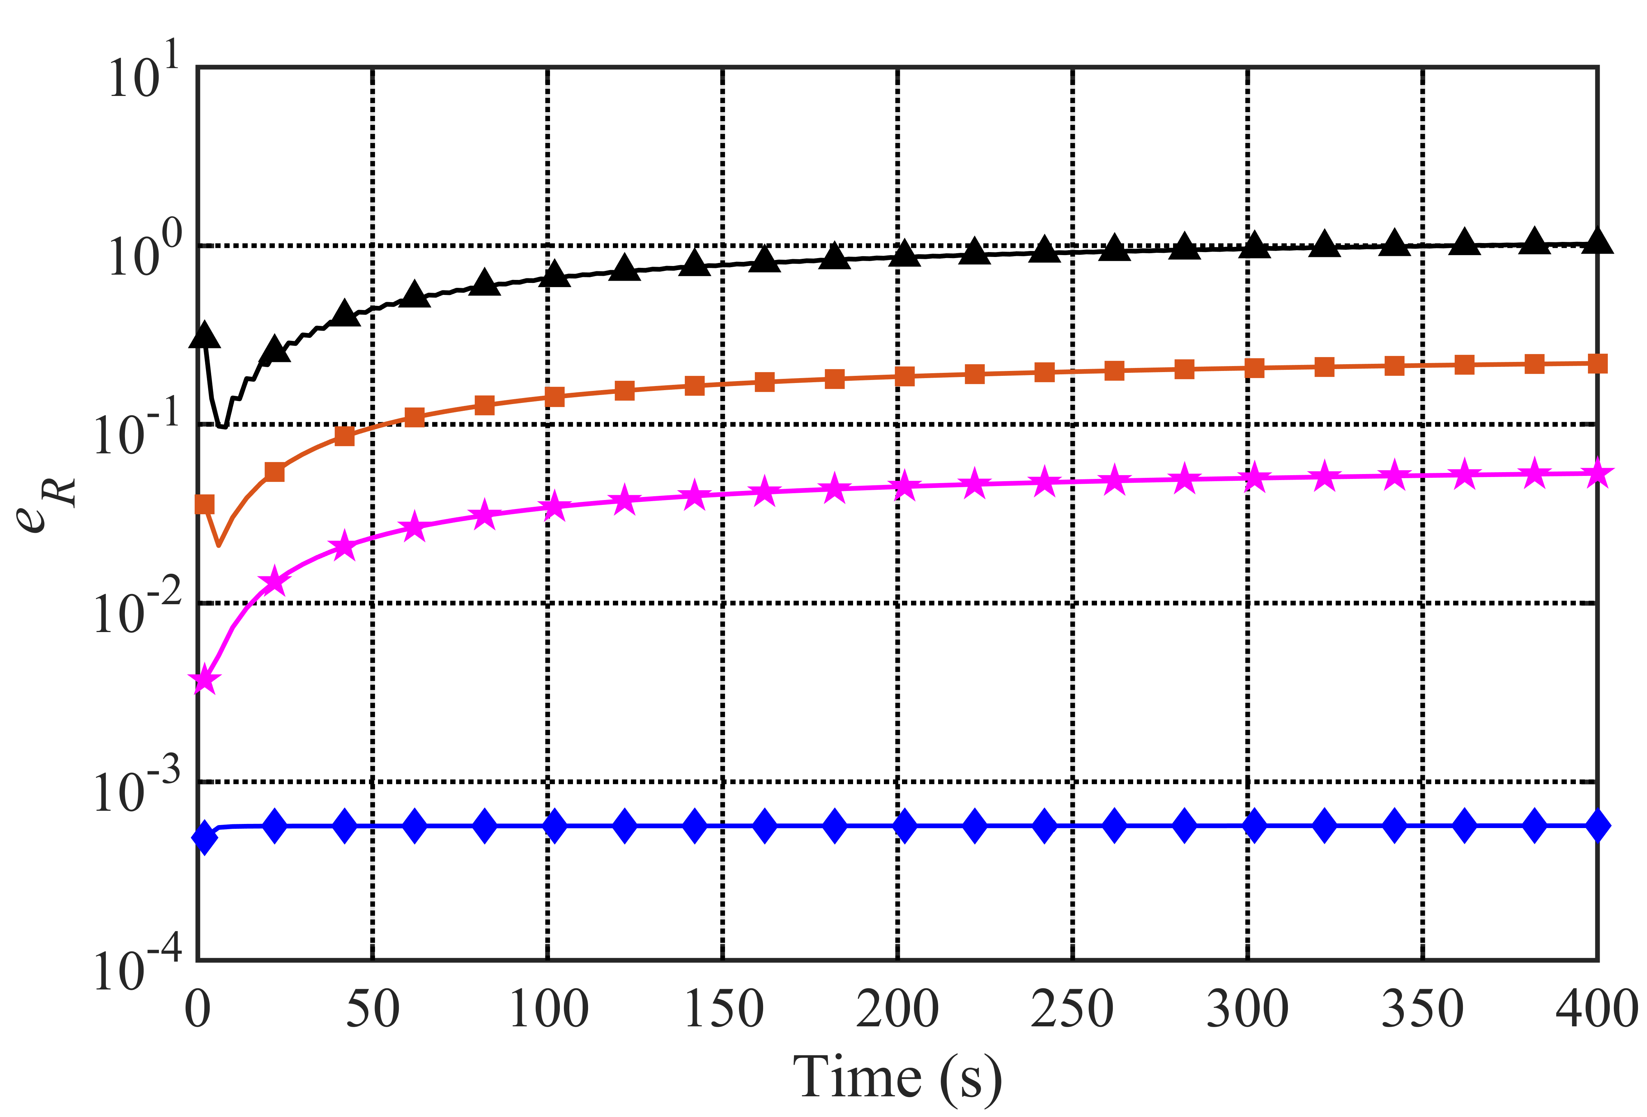

**Fig. 7.** Relative errors of results obtained from the C-N method with time steps of 2 s (triangle),1 s (square), 0.5 s (pentagram) and the proposed method (diamond) when *N*=31.

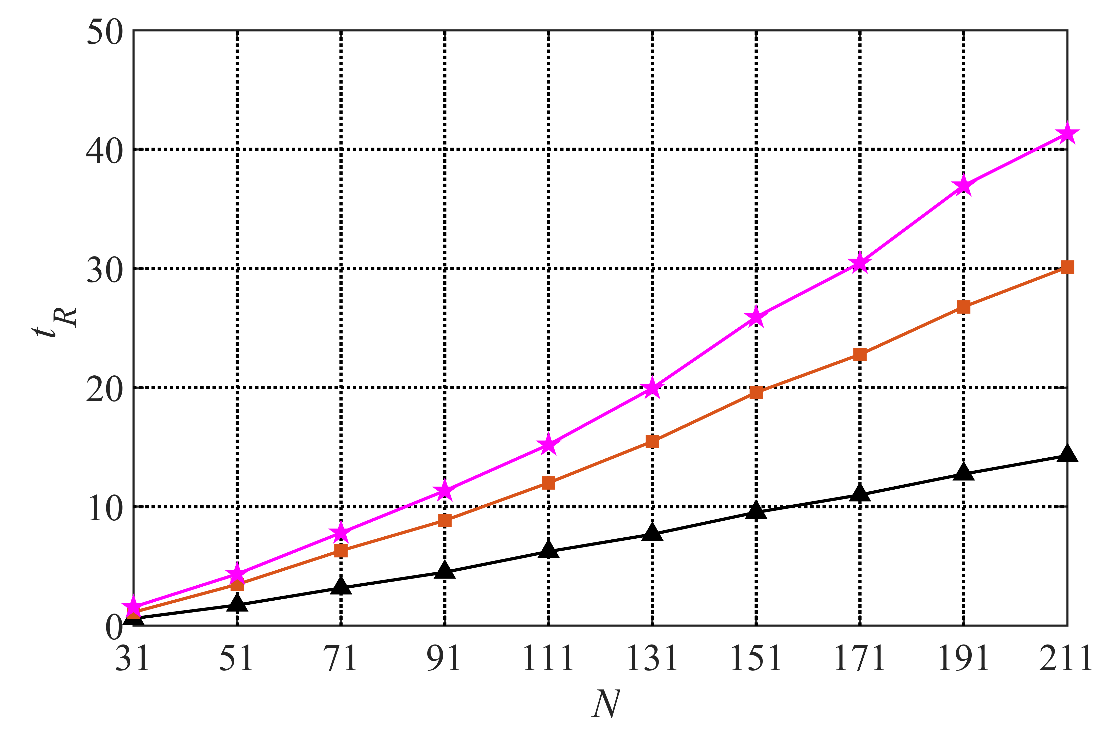

**Fig. 8.** The relative times corresponding to the C-N method with time steps of 2 s (triangle), 1 s (square), 0.5 s (pentagram).