Small animal disease surveillance 2020-21: SARS-CoV-2, syndromic surveillance and an outbreak of acute vomiting in UK dogs
Marisol Collinsª, Charlotte Appleton^{b}, David A. Singletonª, Sarah Caddy^{c}, Peter J.M. Nobleª, Gina L. Pinchbeckª, Shirley Smithª, Christopher Jewell^{b}, Barry Rowlingson^{b}, Bethany Brantª, Steven Smythª, Philip H. Jones^{d}, Alan D. Radfordª
a Institute of Infection, Veterinary and Ecological Sciences, University of Liverpool, Leahurst Campus, Chester High Road, Neston, CH64 7TE, United Kingdom
b Lancaster Medical School, Lancaster University, Furness Building, Lancaster, LA1 4YG, United Kingdom
c MRC Laboratory of Molecular Biology, Cambridge, United Kingdom
d Surveillance Intelligence Unit, Animal and Plant Health Agency, Woodham Lane, Addlestone, Surrey KT15 3NB, United Kingdom

About this report
This report is the ninth in a series provided to Vet Record by the Small Animal Veterinary Surveillance Network (SAVSET). The other reports in the series are available from https://bvajournals.onlinelibrary.wiley.com/journal/20427670
Anonymised data can be accessed for research by contacting the authors. SAVSNET also welcomes feedback on this report.
More information about SAVSNET is available at www.liverpool.ac.uk/savsnet

Introduction
This report by the Small Animal Veterinary Surveillance Network (SAVSNET) is the first to collate key companion animal health surveillance findings since the SARS-CoV-2 pandemic. The report outlines the impact of SARS-CoV-2 on UK companion animal consultation volume, summarises syndromic surveillance events, comments on our current understanding of SARS-CoV-2 in companion animal species and looks globally to other notable companion animal disease events during these times. More detail on the impact of SARS-CoV-2 on UK companion animal practice is available on the SAVSNET website (Singleton, 2020).

Impact of SARS-CoV-2 on companion animal consultations
Over the course of the pandemic to date, the country has undergone a series of national and regional lockdown periods, bringing varying yet sustained challenges to companion animal practice. In the first section of this report, we summarise the effect of these lockdowns on consultation volume, illustrating overarching effects and hopefully providing useful support to practice decision-making as governmental and profession-specific policy and guidance evolve further.
The report considers electronic health records (EHRs) captured by the SAVSNET project from booked consultations between a client and a veterinary surgeon or nurse, taking place in 219 voluntary collaborating veterinary practices (466 sites) during the period from 2nd March 2020 to 10th January 2021 inclusive. Data were captured from 514,354 canine, 195,349 feline and 56,873 other or unclassified species consultations. A detailed description of the methodology used by SAVSNET to capture EHRs has been previously provided (Sánchez-Vizcaíno and others 2015; Sanchez-Vizcaíno and others 2017).
To assess the impact of SARS-CoV-2 on companion animal consultations, the percentage change in booked consultation numbers submitted to SAVSNET was compared with median 2019 data per weekday. Country-level plotting (Fig. 1) encompasses all consultation data for all species and was selected to capture the divergent policy responses occurring across the devolved UK nations over time. Practice representation by country is 181 practices (408 sites) in England, 12 (15) in Northern Ireland (NI), 11 (25) in Scotland, and 13 (18) in Wales. Two practices had sites in both England and Scotland.
The dramatic effect of the first national lockdown in March 2020 is seen across each devolved nation, as is the gradual recovery following phased relaxation of lockdown measures over Summer 2020, though still with an overall significant and protracted decrease in consultation volume. Moving into Autumn 2020, there is evidence of local variation in line with changing governmental and veterinary profession policy and guidance e.g., moving into devolved ‘firebreak’ lockdowns such as 23rd October to 9th November 2020 in Wales. More recently, the early impact of a return to more strict devolved national lockdowns is evident, both by country and species group. The expected reduction in consultation volume over the Christmas period is visible through all the plots, as is the ‘sawtooth’ pattern reflecting the fluctuations in consultation schedules on different days of the week.
At the species level, effects over time on consultation volume when compared to median 2019 data are broadly similar, with most notably the large and protracted decrease in consultation volume following the first nationwide lockdown in March 2020.
As with the country-level data, there is a gradual recovery and levelling, and most recently a decrease as we move into 2021, which may have stricter lockdowns implemented in response to the third wave of the evolving pandemic.
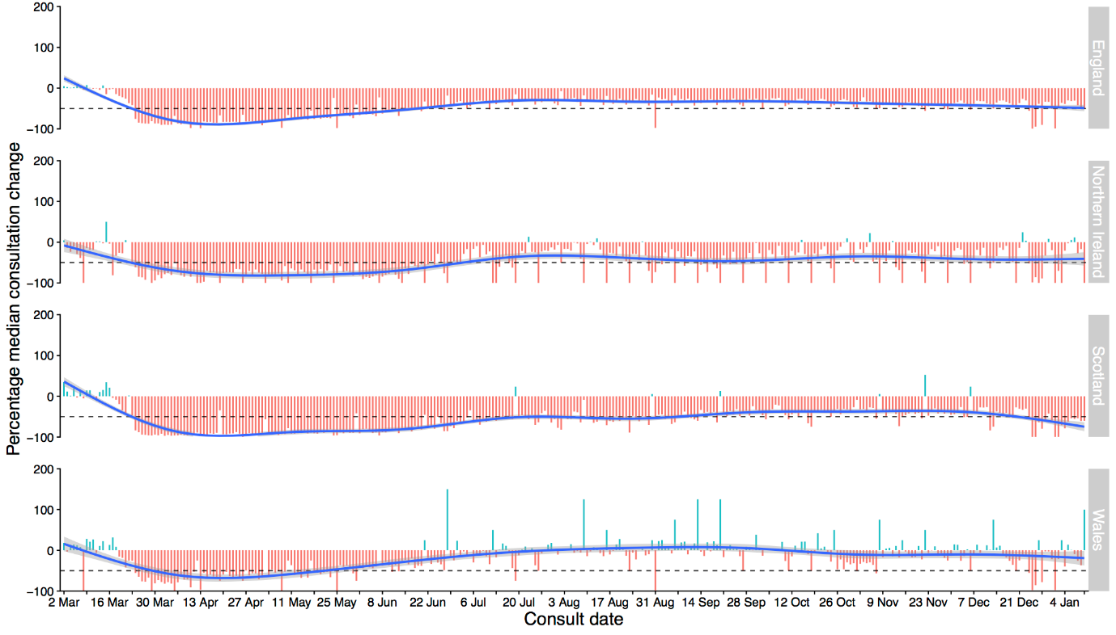
Fig 1. Percentage change in consultation data volume submitted to SAVSNET between 2nd March 2020 and 10th January 2021, compared against median 2019 data, by country in which the submitting veterinary practice is located and with the plot trend line, calculated by a generalised additive model, shown in blue. The horizontal dotted line represents a 50% reduction in consultation volume.

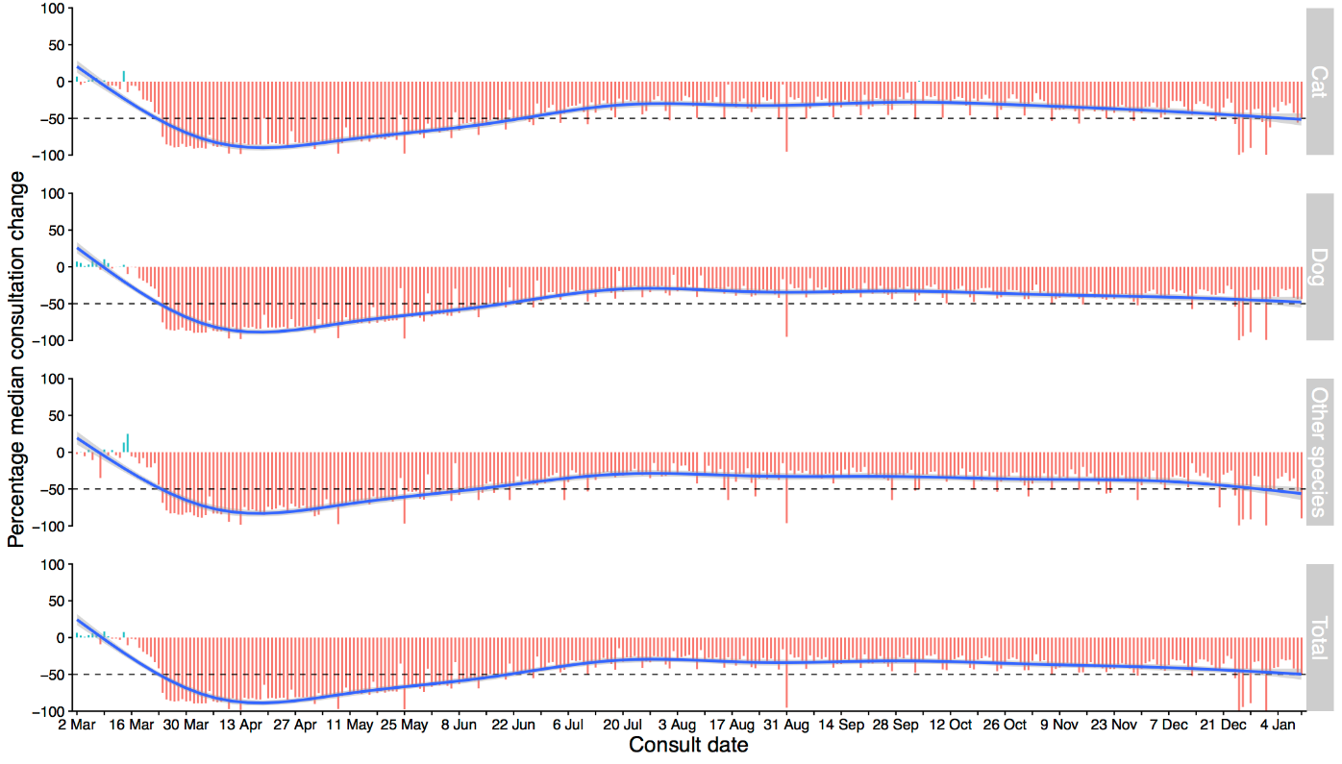
Fig 2. Percentage change in consultation data volume submitted to SAVSNET between 2nd March and 10th January 2021, compared against median 2019 data, in total and by species group, with the plot trend line shown in blue. The horizontal dotted line represents a 50% reduction in consultation volume.
It is important to note several points; firstly, SAVSNET only collects data from booked consultations, so these data do not reflect all practice activities taking place, nor will they capture the full complexity of the fluid and divergent lockdown policies enacted over time. However, we believe that the extended period of data capture means consultation volume can serve as a valid proxy for the impact of the SARS-CoV-2 pandemic on overall practice activity. Secondly, the lower level of data received from devolved regions with comparatively fewer practices participating in SAVSNET can result in apparent ‘jumps’ in the percentage data e.g. as seen at points on the Wales plotline in Fig. 1.; these should not be interpreted as discrete increases in median consultation volume. Based on the data received by SAVSNET, there is some evidence that consultation volumes in Wales returned closer to pre-Covid levels, more so than in other devolved administrations. Whether this is representative of wider differences between regions is unknown. Thirdly, the work of SAVSNET, while dedicated and ongoing, is not immune to the challenges of these times; points where changes to the flow of data coming into SAVSNET affect the analyses presented here and/or systematic data errors occur are clearly explained in the online reports.

Impact of COVID on leptospirosis and parvovirus laboratory diagnoses
The clear reduction in consultations during the SARS-CoV-2 pandemic raised concerns that reduced vaccination may see an unwelcome resurgence in vaccine preventable diseases. Indeed, we have noted a reduction in vaccine consultations overall (Singleton, 2020). Alongside veterinary practice data, SAVSNET collects veterinary diagnostic laboratory (VDL) test data on several vaccine preventable diseases. Here, we summarise VDL-confirmed reports of leptospirosis and parvovirus in dogs based on PCR testing. As in-practice tests and suspected cases prior to, or without diagnostics, are not included in these data, the figures should be viewed as a guide to changes in national burden, and not as an indicator to overall prevalence. Additional data on vaccine preventable diseases in dogs and cats and vaccine consultations, including broad geographical location of test data are available in the regular SAVSNET SARS-CoV-2 reports (Singleton, 2020). SAVSNET have previously explored vaccine uptake (Sánchez-Viscaíno and others, 2018) and are aiming to coalesce vaccine uptake and vaccine preventable disease surveillance in the future.

Leptospirosis
Between 1st January 2019 and 10th January 2021 inclusive, 2248 PCR submissions for leptospirosis from dogs were received by five VDLs, originating from 808 veterinary practice sites in the UK. Overall, 8.1% of test submissions were positive (n= 183, 95% CI 7.0-9.3) (Fig. 3).
Percentage testing positive varied between 0 and 20% per month over this time, with some evidence for a seasonal pattern; percentage testing positive was increased between October and December 2019, and in August and September 2020. Since then, the percentage testing positive appears to have normalised to pre-pandemic rates. These data match those of others, from albeit different climates, which also suggest a role for seasonal factors in disease epidemiology (Smith and others, 2019).
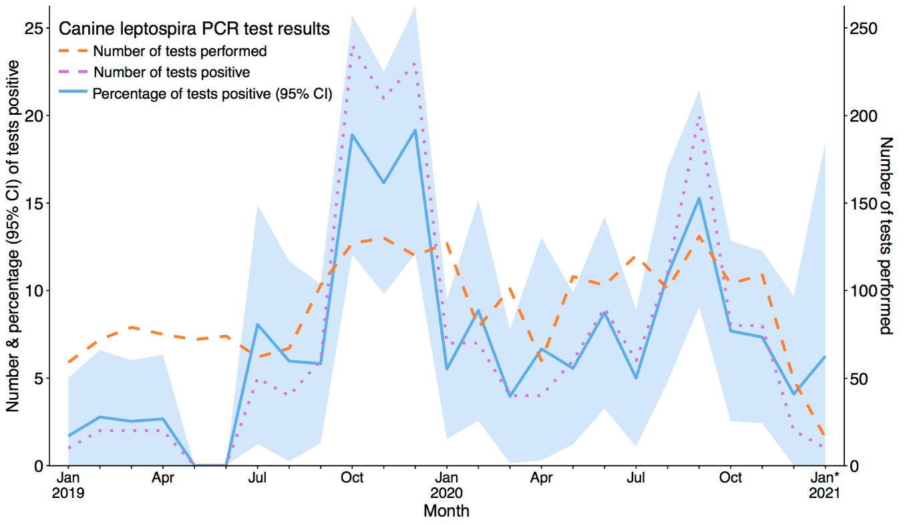
Fig. 3. Number and percentage of PCR leptospira positive tests (left axis) and number of tests by month (right axis) received from five VDL during the period 1st January 2019 to 10th January 2021 inclusive. Asterix denotes the incomplete month of January 2021 and 95% CI = 95% Confidence Interval [blue shaded area].
Parvovirus
Between 1st January 2019 and 10th January 2021 inclusive, 4286 PCR submissions for parvovirus from dogs were received by seven VDLs, originating from 778 veterinary practice sites in the UK. Overall, 7.4% of test submissions tested positive (n= 317, 95% CI 6.6-8.2) (Fig. 4.). The percentage of canine samples testing positive for parvovirus was broadly consistent over this time, generally between 5 and 10% per month. Whilst April and May 2020 did exceed this typical range, figures now appear to have returned to within normal range. There also appears to be a gradual increase in both the number of parvovirus tests performed and the number of animals testing positive, reaching a peak in December 2020. Whether this represents a change in testing policy or an increase in parvovirus cases in the wider population will need to be monitored.

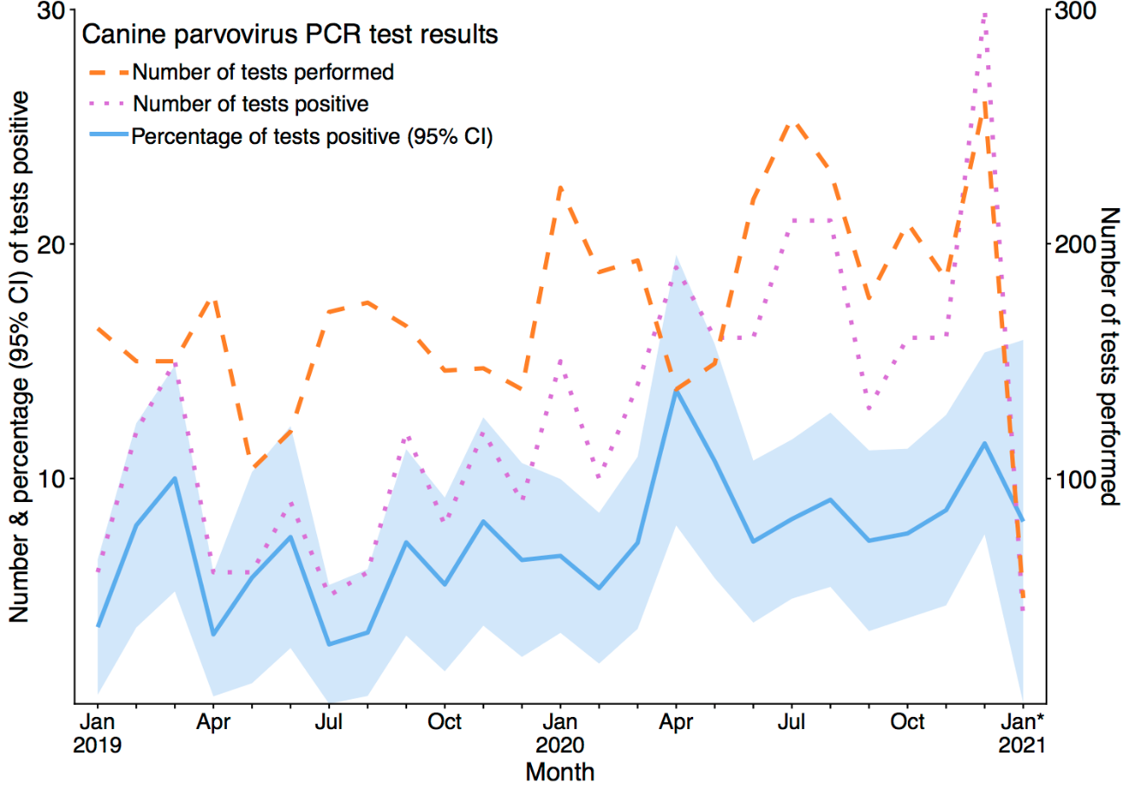
Fig. 4. Number and percentage of PCR parvovirus positive tests (left axis) and number of total tests by month (right axis) received from seven VDLs during the period 1st January 2019 to 10th January 2021 inclusive. Asterix denotes the incomplete month of January 2021 and 95% CI = 95% Confidence Interval.

Update on main presenting complaint temporal trends
In this section of the report, an observed prevalence time series of three key main presenting complaints (MPCs; gastroenteric, respiratory and pruritus) for both dogs and cats, from January 2019 to January 2020, highlights an acute vomiting outbreak in dogs and illustrates seasonal changes in the other MPCs (Fig. 5).
In January 2020, SAVNET responded to sporadic reports of acute onset, prolific vomiting in dogs in various parts of the UK. Syndromic surveillance, text mining and parallel laboratory and questionnaire investigations enabled an early and rapid response to the outbreak and revealed an association with canine enteric coronavirus (CeCoV) (Radford and others, 2021). In brief, over a period of eight weeks, the multidisciplinary investigation evidenced a number of key findings, including a statistical increase in gastroenteric disease in dogs, matched by a concomitant increase in maropitant therapy for rising cases of emesis; increased likelihood of male dogs, and dogs living with other vomiting dogs, being affected (supporting evidence of transmission); a significant genomic association of CeCoV with illness, and a lack of evidence of effect or transmission to humans or other species. This efficient response allowed SAVSNET to direct targeted and timely advice to veterinary practitioners about the outbreak, which SAVSNET considered statistically resolved in May 2020.
The plot labelled as Gastroenteric MPC in dogs in Figure 5a clearly shows the acute vomiting outbreak in dogs. For the summary plot, using a Gaussian process time series allows us to capture seasonal temporal correlation and determine any outliers. The model was trained on observed weekly proportional morbidity data from January 1st 2017 to 8th November 2019. Consultation records classified by the attending veterinary professional as ‘unwell’, according to MPC were used as a denominator to mitigate a drop in overall consultations as a result of the COVID-19 pandemic. The figures show predicted prevalence with shaded 95% (dark grey) and 99% (light grey) credible intervals, with extreme prevalence observations highlighted in orange or red. Since April 2020 to date, the observed estimates have appeared less stable than prior to the SARS-CoV-2 outbreak, likely reflecting changing patterns of consulting throughout COVID-19, such that periods of unusually high or low prevalence have become more common.
As well as the outbreak of gastroenteric disease (Fig. 5A) in dogs, these analyses clearly highlight the apparent seasonality of the respiratory (5B) and pruritus (5C) MPCs, which peak around November and September respectively. In cats, the pruritus (5F) MPC appears to peak in August, with less distinct seasonality in the gastroenteric (5D) or respiratory (5E) MPCs. Understanding such temporal variation will likely shed new light on the aetiologies of the syndromes in both species.
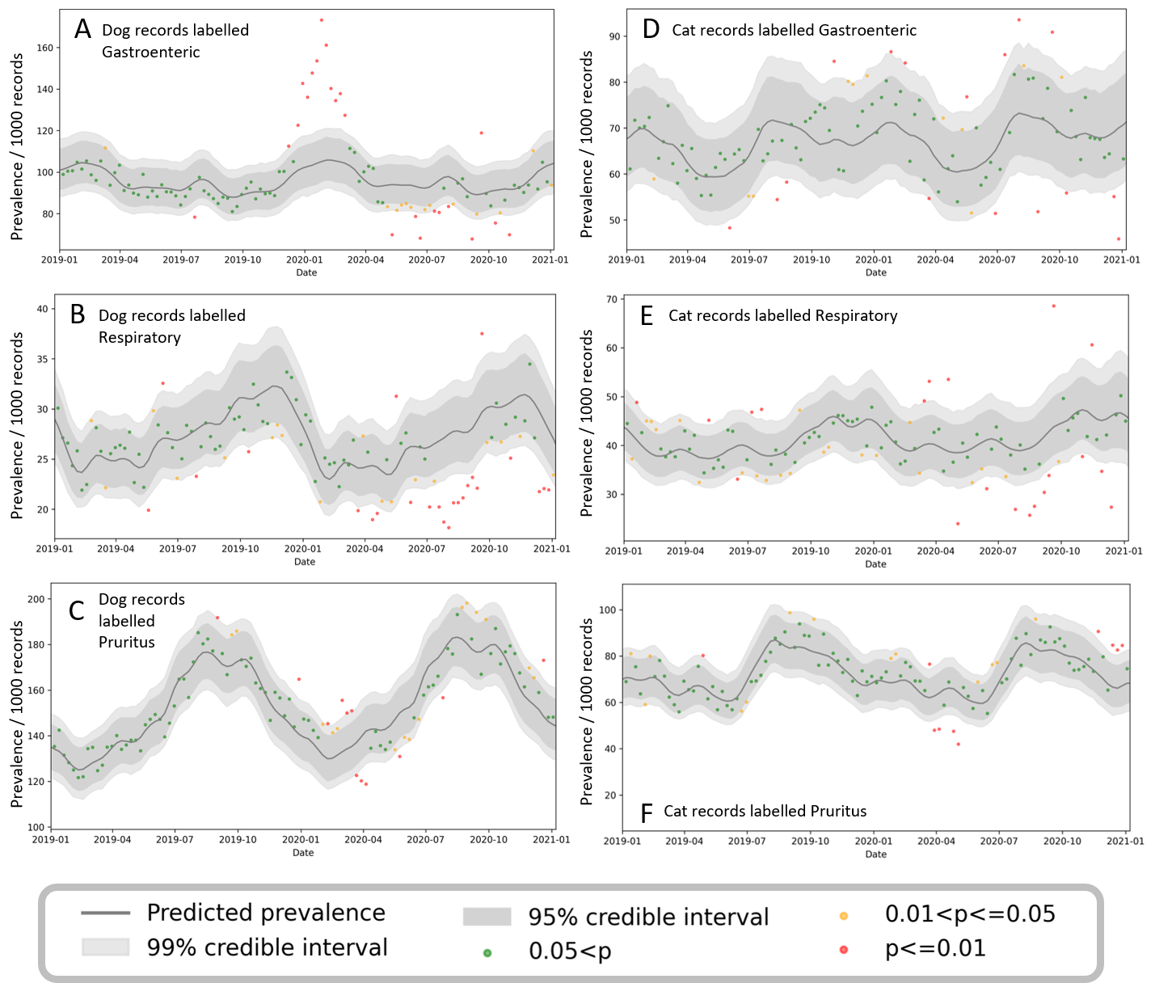

Fig. 5. Observed prevalence for gastroenteric (A,D), respiratory (B,E) and pruritus (C,F) in dogs (A,B,C) and cats (D,E,F) attending SAVSNET-participating practices from November 2018 to November 2020. Red points represent the extreme outliers (outside the 99 per cent credible interval [CI]), orange points represent the moderate outliers (outside the 95 percent CI but within the 99 percent CI), and green points represent the average trend (within the 95 per cent CI)

SARS-Cov-2 in pet animals: An overview

Background; -At the time of writing, SARS-CoV-2 has infected at least 104 million people and caused over 2.2 million deaths worldwide since its first reported emergence in Wuhan, China on 31st December 2019. SARS-CoV-2 has also been reported in a range of different animal species including companion animals (dogs, cats, ferrets), zoo animals and farmed mink. Identification of the virus in a small number of pets has raised concern about whether SARS-CoV-2 can cause disease in animals. In addition, the potential role of animals in SARS-CoV-2 epidemiology has been questioned; could pets transmit the virus to humans? Our understanding of SARS-CoV-2 in animals is now improving due to experimental and surveillance studies. The clinical implications of these results are summarised in this section of the report.

Infection and Clinical signs; -Experimental infections with SARS-CoV-2 performed in the US and China have shown that cats are susceptible to high doses of virus, with virus shedding detected for approximately five days after exposure. However, no experimentally infected cats over four months of age showed any clinical signs of disease. Variable respiratory pathology was identified by histopathology (lymphoplasmocytic rhinitis and mild interstitial pneumonia), but no gross lesions were reported (Bosco-lauth and others, 2020; Halfmann and others, 2020; Shi and others, 2020). It is unclear whether SARS-CoV-2 can cause disease in cats less than four months old, with only limited results published.
To the authors’ knowledge, no severe disease has been reported in any naturally infected domestic cats across the globe. In the UK, only one cat in the UK has tested positive (via RT-PCT and serology) for SARS-CoV-2 so far, and this case merely showed signs of mild respiratory infection. It is important to note that this cat also tested positive for feline herpesvirus (FHV), so it is likely that FHV played some role in the clinical signs in this instance.
Dogs are less susceptible to SARS-CoV-2 than cats according to experimental infections. No virus replication was detected after exposure to virus, and no clinical signs of disease were identified. However, two naturally infected asymptomatic dogs in Hong Kong tested positive for the virus on multiple occasions, suggesting infection is possible (Sit and others, 2020). Furthermore, SARS-CoV-2 specific antibodies have been detected in dogs after experimental infections, and in pet dogs and cats from Italy (Patterson and others, 2020).
SARS-CoV-2 has been shown to infect ferrets in experimental infections, and natural infections have occurred in mink (Oreshkova and others, 2020). Mild, non-specific symptoms (fever and inappetence) were reported in a small proportion of the experimentally infected ferrets, but no significant disease occurred. In contrast, severe respiratory disease and death has been reported on numerous Mink farms in Europe and the US.

Diagnosis; -SARS-CoV-2 testing for animals uses the same methodology as in humans; quantitative PCR (qPCR). In May 2020 (and subsequently updated on 1st March 2021), the Animal and Plant Health Agency (APHA) issued a series of guidelines advising which animals should be tested. With significant limitations on human tests available at the start of the UK outbreak, it was recommended that only Felids, Canids or Mustelids that had been in contact with a confirmed or suspect human COVID-19 case in the past three weeks should be screened for virus. Detecting SARS-CoV-2 infection in animals in the UK meets the criteria for reporting to the World Animal Health organisation (OIE) as an emerging infection in accordance with the OIE Terrestrial Animal Health Code (OIE, 2019; APHA, 2020a). As such, UK veterinarians have a regulatory duty to report positive case results to the competent authority i.e. APHA and Chief Veterinary Officers. Testing should only be conducted where it is the interest of the health and welfare of the animal; it is also advised that the animal should be showing clinical signs of disease that could be consistent with COVID-19, and that common causes of these symptoms should have been ruled out (APHA, 2020a).

At present there are no commercial tests for SARS-CoV-2 available for pets in the UK. There are a number of clinical research projects that are investigating the incidence of the virus in pets. Our surveillance based on MPCs suggests no rise in clinical disease in dogs and cats that could be associated with COVID-19.

Control and Treatment; -Study of a subset of cats and dogs that tested positive for SARS-CoV-2 infection has confirmed that virus was transmitted from owner to pet. This has been demonstrated using full genome sequencing (Barrs and others, 2020; Sit and others, 2020). To reduce the risk of human-to-animal transmission of the virus, owners with COVID-19 symptoms should maintain good hygiene around their pet. As no confirmed cases of cats or dogs naturally infected with SARS-CoV-2 have been reported to have significant clinical signs, no virus-specific treatment for suspected cases is indicated.

The overwhelming majority of people that get SARS-CoV-2 get it from another person. However, from a public health perspective, animal-to-human transmission of SARS-CoV-2 remains a concern.
There is as yet no evidence this has occurred from cats or dogs. To mitigate this further, it is advised that if possible, cats from households self-isolating with COVID-19 symptoms should be kept indoors, and that dogs, if necessary, should be exercised by someone else (BVA, 2021). This reduces the chance that cats and dogs, either infected or as fomites, could transmit the virus to other households. Outbreaks of SARS-CoV-2 in mink farms in several countries including Netherlands, Denmark, United States and Canada and evidence of zoonotic and anthroponotic transmission in such cases (Burkholz and others, 2020) have raised concern regarding the animal and human infection risks associated, including with ferrets kept as pets, working animals, or in research, particularly in high-density settings (PHE, 2020). APHA have issued guidance for ferret owners and veterinarians on enhanced precautionary biosecurity measures, including a 21-day isolation period for ferrets in COVID-19 self-isolating households or ferrets testing positive for SARS-CoV-2 or brought to UK from countries outside current travel corridor lists (APHA, 2020b).

Summary; -Despite the severity of SARS-CoV-2 infection in humans, there are no reports that show SARS-CoV-2 causes serious disease in dogs and cats. Furthermore, the risk of virus transmission from pets to humans is considered extremely low. Following the standard advice for reducing risk of SARS-CoV-2 transmission between humans e.g. good hand hygiene, and species-specific guidelines where indicated e.g. regarding ferrets, should be sufficient to ensure the risk of virus transmission to and from animals is minimised.

Global perspective
Seasonal canine illness
New cases fitting the description of Seasonal Canine Illness (SCI) were again being reported in late September 2020 (Promed Archive Number: 20200924.7803900). SCI seems to lack a clear case definition. Clinical signs, which are often described as appearing within 24-72 hours of dogs walking in autumnal woodland include vomiting, diarrhoea and lethargy. Whilst most animals recover with rigorous symptomatic therapy, some have died. Any cause remains unknown although some have suggested links with bacteria, blue-green algae, fungal spores or Harvest mites, but tests have not proved conclusive. This syndrome was first reported in dogs visiting the Sandringham Estate "and other woodland areas" in 2009. The SCI syndrome is not to be confused with another seasonal disease of dogs, reported every year from woodlands in England; Canine renal glomerular vasculopathy (CRGV also known as Alabama rot) also lacks a known aetiology but can be characterised and diagnosed by a thrombotic renal microangiopathy. The prognosis of CRGV is poor, although recent cases show recovery is possible. Understanding such sporadic syndromes remains a challenge for those involved in caring for dogs, especially in the absence of a national health authority. With Dogs Trust funding, SAVSNET agile (https://www.liverpool.ac.uk/savsnet/savsnet-agile/) is looking to understand what such a surveillance system could look like, and how it might be funded.

Rabbit Haemorrhagic Disease Virus (RHDV)
Outbreaks of rabbit haemorrhagic disease have been reported in Wales as well as the first cases in Northern Ireland (Anon, 2020). Whereas the original RHD virus caused obvious external signs like haemorrhage, the new RHDV2 strain, although also frequently lethal, has been associated with less overt outward disease, with wild rabbits often dying underground. As such it is possible that many cases in wild rabbits are being missed. The authors conclude by suggesting “Wild rabbits can be a source of virus for domestic animals and vice versa. We would encourage rabbit owners and their veterinarians to be aware of local outbreaks and take measures, including appropriate vaccination and biosecurity, to prevent the disease in domesticated rabbits”.
Canine distemper virus (CDV)
Some infections pose a threat not just to the original or main host, but can spill over to other species with sometimes drastic effects; CDV is one such disease. The disease can be extremely well controlled in domestic dogs, considered to be the primary host, through vaccination. However, this virus now has a long track record of affecting other species. A recent study on the Amur tiger (Panthera tigris altaica), which has less than 550 individuals in Russia and neighbouring areas of China, highlights the threat (Gilbert and others, 2020). Scientists showed that CDV is now established in other local wildlife species, such that vaccination of dogs alone is unlikely to be sufficient to protect the tigers. Instead, control was more likely to be achieved by vaccinating the tigers themselves, a process that whilst not without its challenges, could lead to “substantive reductions in extinction risks”. CDV has pedigree in this area, with earlier reports of fatal infections in a growing range of species including giant pandas (Feng and others, 2016); CDV is a virus that needs watching as it spreads its wings. Although not reportable, the OIE has included morbillivirus infections on a list of wildlife diseases that require surveillance “because of their importance for wild animals and also for early warning purposes, in order to protect human and livestock health” (OIE, 2020).

Acknowledgements
SAVSNET is based at the University of Liverpool and has major funding from the Biotechnology and Biological Sciences Research Council, British Veterinary Association and Dogs Trust. The SAVSNET team is also grateful to data providers both in veterinary practice (VetSolutions, Teleos, CVS Group and independent practitioners) and participating veterinary diagnostic laboratories (Axiom Veterinary Laboratories, Batt Laboratories, BioBest, BioTe Veterinary Laboratories, Idexx, NationWide Laboratories, Microbiology Diagnostics Laboratory at the University of Liverpool, the Department of Pathology and Infectious Diseases at the University of Surrey and the Veterinary Pathology Group) without whose support and participation these reports would not be possible. The team would also like to thank Susan Bolan, SAVSNET project administrator, for her support.

References

ANON (2020) Rabbit haemorrhagic disease: a re-emerging threat to lagomorphs, Veterinary Record, 187, 106-107.

APHA (2020)a APHA Briefing Note 18/20 SARS-CoV-2 in Animals – Case Definition, Testing and International Reporting Obligations. Available at: http://apha.defra.gov.uk/documents/ov/Briefing-Note-1820.pdf [Accessed: 5.3.21]

APHA (2020)b Preventative Measures regarding SARS-CoV-2 and Ferrets in the UK. Available at: http://apha.defra.gov.uk/documents/guidance-sars-cov-2-ferrets.pdf [Accessed: 5.3.21]

BARRS, V. R., PEIRIS, M., TAM, K., LAW, P., BRACKMAN, C. J., TO, E., YU, V., CHU, D., PERERA, R & SIT, T. (2020) ‘SARS-CoV-2 in Quarantined Domestic Cats from COVID-19 Households or Close Contacts, Hong Kong, China’, Emerging Infectious Diseases, 26(12).

BOSCO-LAUTH, A., HARTWIG, A. E., PORTER, S. M., GORDY, P.W., NEHRING, M., BYAS, A.D., VANDEWOUDE, S., RAGAN, I., MAISON, R.M. & BOWEN, R. M. (2020) ‘Experimental infection of domestic dogs and cats with SARS-CoV-2: Pathogenesis, transmission and response to re-exposure in cats’, PNAS, 117 (42), 26382-26388.

BRITISH VETERINARY ASSOCIATION (BVA). (2021) Coronavirus advice for animal owners (online) [Available at: https://www.bva.co.uk/coronavirus/coronavirus-advice-for-animal-owners/]

BURKHOLZ, S., POKHREL, S., KRAEMER, B.R., MOCHLY-ROSEN, D., CARBACK III, R.T., HODGE, T., HARRIS, P., CIOTLOS, S., WANG, L., HERTS, C.V. & RUBSAMER, R. (2020). Paired SARS CoV-2 Spike Protein Mutations Observed During Ongoing SARS-CoV-2 Viral Transfer from Humans to Minks and Back to Humans, bioRxiv doi: 0.1101/2020.12.22.424003, (online) Available at: https://www.biorxiv.org/content/10.1101/2020.12.22.424003v1.full [Accessed: 5.3.21]

FENG, N., YU, Y., WANG, T., WILKER, P., WANG, J., LI, Y., SUN, Z., GAO, Y. & XIA, X. (2016) Fatal canine distemper virus infection of giant pandas in China. Sci Rep. Jun 16 (6):27518.
GILBERT. G., SULIKHAN, N., UPHYRKINA, O., GONCHARUK, M., KERLEY, L., HERNANDEZ CASTRO, E., RICHARD REEVE, SEIMON, T., MCALOOSE,T., SERYODKIN, I.V., NAIDENKO, S. V., DAVIS, C.A., WILKIE, G. S., VATTIPALLY, S. B., ADAMSON, W. E., HINDS, C., THOMSON, E. C., WILLETT, B. J., HOSIE, M. J., LOGAN, N., MCDONALD, M., OSSIBOFF, R. J., SHEVTSOVA, E. I., BELYAKIN, S., YURLOVA, A. A., OSOFSKY, S. A., MIQUELLE, D. G., MATTHEWS, L. & CLEAVELAND, S. (2020) Distemper, extinction, and vaccination of the Amur tiger, Proceedings of the National Academy of Sciences, 117 (50) 31954-31962.

HALFMANN, P. J., HATTA, M., CHIBA, S., MAEMURA. T., FAN, S., TAKEDA, M., KINOSHITA, N., HATTORI, S., SAKAI-TAGAWA, Y., IWATSUKI-HORIMOTO, K., IMAI, M. & KAWAOKA, Y. (2020) ‘Transmission of SARS-CoV-2 in Domestic Cats’, The New England journal of medicine, 383(6), pp. 592–594.

JIANZHONG SHI, ZHIYUAN WEN, GONGXUN ZHONG, HUANLIANG YANG, CHONG WANG, BAOYING HUANG, RENQIANG LIU, XIJUN HE, LEI SHUAI, ZIRUO SUN, YUBO ZHAO, PEIPEI LIU, LIBIN LIANG, PENGFEI CUI, JINLIANG WANG, XIANFENG ZHANG, YUNTAO GUAN, WENJIE TAN, GUIZHEN WU, HUALAN CHEN, ZHIGAO BU. (2020) ‘Susceptibility of ferrets, cats, dogs, and different domestic animals to SARS-coronavirus-2’, Science, 368. pp1016-1020

OIE (2020) WORLD ANIMAL HEALTH INFORMATION SYSTEM (WAHIS) - WILD INTERFACE. Available at: https://www.oie.int/wahis_2/public/wahidwild.php/Index/indexcontent/newlang/en#
ORESHKOVA, N., MOLENAAR, R., VREMAN S., HARDERS, F., OUDE M., HAKZE-VAN DER HONING R.W., GERHARDS, N, TOLSMAN, P., BOUWSTRA, R., SIKKEMA, R. S., TACKEN, M., DE ROOIJ, M., WEESENDORP, E., ENGELSMA, M. Y., BRUSCHKE, C., SMIT, L., KOOPMANS, M., VAN DER POEL, W. & STEGEMAN, A. (2020) ‘SARS-CoV-2 infection in farmed minks , the’, Euro Surveillance, 25 (23) (May), pp. 1–7. Available at: https://doi.org/10.2807/1560-7917.ES.2020.25.23.2001005.

PATTERSON, E.U., ELIA, G., GRASSI, A., GIORDANO, A., DESARIO, C., MEDARDO, M., SMITH, S. L., ANDERSON, E. R., PRINCE, T., PATTERSON, G. T., LORUSSO, E., LUCENTE, M. S., LANAVE, G., LAUZI, S., BONFANTI, U., STRANIERI, A., MARTELLA, V., SOLARI BASANO, F., BARRS, V. R., RADFORD, A. D., AGRIMI, U., HUGHES, G. L., PALTRINIERI, S. & DECARO, N. (2020) Evidence of exposure to SARS-CoV-2 in cats and dogs from households in Italy. Nat Commun. 11, 6231.

PUBLIC HEALTH ENGLAND, HUMAN ANIMAL INFECTIONS AND RISK SURVEILLANCE (HAIRS) GROUP (2020) Qualitative assessment of the risk that SARS-COV-2 infection in UK captive Mustelinae populations presents to the UK human population. PHE report GW-1715. Available at: https://www.gov.uk/government/publications/hairs-risk-assessment-on-sars-cov-2-in-mustelinae-population

RADFORD, A.D., SINGLETON, D.A., JEWELL, C., APPLETON, C., ROWLINGSON, B., HALE, A.C., TAMAYO CUARTERO, C., NEWTON, R., SÁNCHEZ-VIZCAÍNO, F., GREENBERG, D., BRANT, B., BENTLEY, E.G., STEWART, J.P., SMITH, S., HALDENBY, S., NOBLE, P.J.M. & PINCHBECK, G. (2021) Outbreak of Severe Vomiting in Dogs Associated with a Canine Enteric Coronavirus, United Kingdom. Emerg Infect Dis.27(2):517-528.

SÁNCHEZ-VIZCAÍNO, F., JONES, P. H., MENACERE, T., HEAYNS, B., WARDEH, M., NEWMAN, J., RADFORD, A. D., DAWSON, S., GASKELL, R., NOBLE, P. J. M., EVERITT, S., DAY, M. J. & MCCONNELL, K. (2015) Small animal disease surveillance. Veterinary Record 177, 591-594

SÁNCHEZ-VIZCAÍNO, F., NOBLE, P. M., JONES, P. H., MENACERE, T., BUCHAN, I., REYNOLDS, S., DAWSON, S., GASKELL, R. M., EVERITT, S. & RADFORD, A. D. (2017) Demographics of dogs, cats, and rabbits attending veterinary practices in Great Britain as recorded in their electronic health records. BMC Vet Res 13, 218.

SÁNCHEZ-VIZCAÍNO, F., MUNIESA, A., SINGLETON, D. A., JONES, P. H., NOBLE, P. J. M., GASKELL, R., DAWSON, S., RADFORD, A. D. (2018) Use of vaccines and factors associated with their uptake variability in dogs, cats and rabbits attending a large sentinel network of veterinary practices across Great Britain, Epidemiol Infect. 146 (7), 895-903

SINGLETON, D. (2020) Impact of COVID-19 on companion animal veterinary practice (online) (Available at: www.liverpool.ac.uk/savsnet/covid-19-veterinary-practice-uk/) [Accessed: 5.3.21]

SIT, T. H. C., BRACKMAN, C. J., IP, S. M., TAM, K. W. S., LAW., P. Y. T., TO, E. M. W., YU, V. Y. T., SIMS, L. D., TSANG, D. N. C., CHU, D. K. W., PERERA, R. A. P. M., POON, L. L. M. & PEREIS, M. (2020) ‘Infection of dogs with SARS-CoV-2’, Nature, 586, 776-778.

SMITH, A., GONÇALVES ARRUDA, A., EVASON, M.D., WEESE, J., S., WITTUM, T. E., SZLOSEK, D. AND STULL, J. W. (2019) A cross-sectional study of environmental, dog, and human-related risk factors for positive canine leptospirosis PCR test results in the United States, 2009 to 2016. BMC Vet Res 15, 1

World Organisation for Animal Health (OIE) (2019) Terrestrial Animal Health Code, Notification of diseases, infections and infestations, and provision of epidemiological information, Chapter 1.1, Article 1.1.4 (online) Available at: https://www.oie.int/index.php?id=169&L=0&htmfile=chapitre_notification.htm [Accessed; 12.3.21]

