DOCUMENT NOW DOWNLOADED

Spectrum, risk factors, and outcomes of neurological and psychiatric complications of COVID-19: a UK-wide cross-sectional surveillance study
Amy L Ross Russell^{1,2,#}, Marc Hardwick^{2,3,#}, Athavan Jeyanantham³, Laura M White⁴, Saumitro Deb⁵, Girvan Burnside⁶, Harriet M Joy⁷, Craig J Smith^{8,9}, Thomas A Pollak¹⁰, Timothy R Nicholson¹⁰, Nicholas WS Davies¹¹, Hadi Manji^{12,13}, Ava Easton^{14,15}, Stephen Ray^{14,16}, Michael S Zandi¹³, Jonathan P Coles¹⁷, David K Menon¹⁷, Aravinthan Varatharaj^{2,3}, Beth McCausland^{2,3,18}, Mark A Ellul^{14,16,19}, Naomi Thomas^{20,21}, Gerome Breen²², Stephen Keddie^{23,24}, Michael P Lunn^{12,13}, Rustam Al-Shahi Salman²⁵, Alan Carson²⁵, Eileen Joyce¹³, Martin R Turner²⁶, Laura A Benjamin^{13,14}, Tom Solomon^{14,16,19}, Rachel Kneen^{14,16,27}, Sarah Pett^{28,29}, Rhys H Thomas^{20,21,30,}*, Benedict D Michael^{14,16,19,}*, Ian Galea^{2,3,}*, on behalf of the CoroNerve Studies Group∞
# Joint primary authors
* Joint senior authors
∞ Members are listed in appendix 3

Affiliations
¹NIHR Clinical Research Facility and Biomedical Research Centre, University Hospital Southampton NHS Foundation Trust, UK
²Department of Neurology, Wessex Neurological Centre, University Hospital Southampton NHS Foundation Trust, UK
³Clinical Neurosciences, Clinical and Experimental Sciences, Faculty of Medicine, University of Southampton, UK
⁴Aintree University Hospital’s NHS Foundation Trust, UK
⁵Liverpool Clinical Trials Centre, University of Liverpool, UK
⁶Department of Health Data Science, University of Liverpool, UK
⁷Neuroradiology Department, Wessex Neurological Centre, University Hospital Southampton NHS Foundation Trust, UK
⁸Manchester Centre for Clinical Neurosciences, Geoffrey Jefferson Brain Research Centre, Manchester Academic Health Science Centre, Salford Royal Foundation Trust, UK
⁹Division of Cardiovascular Sciences, Lydia Becker Institute for Immunology and Inflammation, University of Manchester, UK
¹⁰Institute of Psychiatry, Psychology, and Neuroscience, King’s College London, UK
¹¹Chelsea and Westminster NHS Foundation Trust, London, UK
¹²MRC Centre for Neuromuscular Diseases, National Hospital for Neurology, UK
¹³UCL Queen Square Institute of Neurology, University College London, UK
¹⁴Department of Clinical Infection Microbiology and Immunology, Institute of Infection, Veterinary, and Ecological Sciences, University of Liverpool, UK
¹⁵Encephalitis Society, Malton, UK
¹⁶The National Institute for Health Research Health Protection Research Unit for Emerging and Zoonotic Infections, University of Liverpool, UK
¹⁷Division of Anaesthesia, Department of Medicine University of Cambridge, UK
¹⁸Memory Assessment and Research Centre, Moorgreen Hospital, Southern Health Foundation Trust, UK
¹⁹Department of Neurology, The Walton Centre NHS Foundation Trust, UK
²⁰Translational and Clinical Research Institute, University of Newcastle, UK
²¹Wellcome Centre for Mitochondrial Research, University of Newcastle, UK
²²Department of Social Genetic and Developmental Psychiatry, King’s College London, UK
²³Department of Neuromuscular Diseases, University College London, UK
²⁴National Hospital for Neurology and Neurosurgery, University College London Hospitals NHS Foundation Trust, UK
²⁵Centre for Clinical Brain Sciences, University of Edinburgh, UK
²⁶Nuffield Department of Clinical Neurosciences, University of Oxford, UK
²⁷Department of Neurology, Alder Hey Children’s NHS Foundation Trust, Brain Infections Group, Institute of Infection and Global Health, University of Liverpool, UK
²⁸Medical Research Council Clinical Trials Unit, Institute of Clinical Trials and Methodology, University College London, UK
²⁹Institute for Global Health, University College London, UK
³⁰Department of Neurology, Royal Victoria Infirmary, UK

Corresponding address:
Professor Ian Galea, Professor of Clinical & Experimental Neurology, Clinical Neurosciences, Clinical & Experimental Sciences, Faculty of Medicine, University of Southampton, Mailpoint 806, Level D, Southampton General Hospital, Southampton SO16 6YD, UK. Email: I.Galea@soton.ac.uk

SUMMARY 445
Background
SARS-CoV2 is associated with neurological and psychiatric complications including cerebrovascular events, encephalopathy and peripheral nerve disease. Detailed clinical data, including factors associated with recovery, is lacking, hampering prediction modelling and targeted therapeutic interventions. We studied COVID-associated neurological and psychiatric complications, to investigate the key clinical features, including those associated with outcome.
Methods
This UK-wide cross-sectional surveillance study of neurological and psychiatric complications of COVID-19 in adult hospitalised patients captured detailed data on demographics/risk factors, pre-COVID-19 Rockwood frailty score, comorbidities, neurological presentation and outcome. A priori clinical case definitions, based on criteria adopted by the World Health Organisation, were used, with cross-specialty independent adjudication for discrepant cases. Patients meeting multiple clinical case definitions were identified. Cases of stroke were compared to normative data during the equivalent time-period prior to the pandemic. Multivariable logistic regression was performed using demographic and clinical variables, to determine the factors associated with outcome.
Findings
267 cases were included. Cerebrovascular events were most frequently reported (131, 49%), followed by central disorders (95, 36%) including delirium (28, 10%), central inflammatory (25, 9%), psychiatric (25, 9%), and other encephalopathies (17, 7%), including a severe encephalopathy not meeting delirium criteria; and peripheral nerve-disorders (41, 15%). 27% of cerebrovascular events occurred in patients <60 years. Relative to those >60 years old, the younger patients presented with delayed onset from respiratory symptoms, higher rates of multivessel occlusion (31%) and more frequently had systemic thrombotic events. Nevertheless, in both younger and older stroke cases there was an association with conventional, modifiable, cerebrovascular risk factors. The timing of neurological presentation varied between disease groups. In 34 cases (13%), clinical case definitions overlapped, and these cases were more likely to require intensive care and ventilation. Regardless of clinical case definition, older age, a higher pre-COVID-19 frailty score, and a high admission white cell count independently associated with a poor outcome. Limited recovery was most common for those with cerebrovascular events.
Interpretation
COVID-19 is associated with a broad spectrum of presentations throughout the nervous system, at varied time points relative to respiratory disease. Outcomes vary between disease groups, with cerebrovascular disease conferring the worst prognosis, but this effect was less marked than the pre-morbid factors of age and frailty. A severe encephalopathy occurs after COVID-19 and is associated with requiring intensive care and ventilation. COVID-19 is associated with large and multi-vessel stroke in young people, often with non-CNS thrombotic disease and requires further study. Nevertheless, conventional, modifiable risk factors were associated with stroke, even in younger people, suggesting the potential for public health intervention for this and future pandemics. These clinical data should be combined with blood and neuroimaging biomarkers so that patients can be stratified to targeted existing or novel therapeutics.
Funding: UK Research and Innovation, Medical Research Council, and National Institute of Health Research

INTRODUCTION
COVID-19 causes a multi-system disorder associated with a broad spectrum of neurological and neuropsychiatric complications, at a higher frequency than is seen in other coronaviruses (Mao, Ellul). Mild disease has been associated with neurological symptoms such as headache, anosmia and ageusia (Lechien, Mao) without major neurological complications (Cagnazzo). Approximately 10-25% of patients hospitalised with COVID-19 present with or develop a significant neurological disorder (Romero-Sanchez, Fronterra, Meppiel, Rifino, Cagnazzo), the risk of which may increase with disease severity (Mao, Liotta). Complications may reflect, para- or post-infectious central and peripheral immune-mediated syndromes, or rarely direct CNS infection (Paterson, Varatharaj). The potential for life-long neurological morbidity in survivors is likely to constitute a significant personal and public health burden long after the pandemic has passed (Ellul).
As neurological complications are varied and occur throughout the disease course, multiple mechanisms have been proposed. These may include direct viral infection via angiotensin converting enzyme-2 receptors expressed on cerebrovascular endothelium and neurones, systemic inflammation resulting in coagulopathy, cytokine toxicity, blood brain barrier disruption, antibody and cell-mediated autoimmunity and consequences of prolonged severe illness (Ellul, Wang, Violi, Beyrouti, Bastard). These suggested pathological processes may co-exist, act synergistically and occur simultaneously in different parts of the nervous system, causing overlapping clinical presentations.
Studies reporting neurological complications of COVID-19 have successfully met the pressing need to disseminate data rapidly to inform pandemic management and research efforts. However, this speed has limited geographical reach, so there is a paucity of nationwide studies and limited detailed clinical diagnostic and prognostic information. This is further hampered by a lack of unified diagnostic criteria and underappreciation of overlapping presentations. Consequently, the factors predicting recovery remain poorly understood.
To address these gaps, we conducted a UK-wide surveillance study of neurological and psychiatric complications of COVID-19 (March-October 2020). National and cross-specialty recruitment was conducted to identify common and more rare presentations and incorporated rigorous clinical case definitions to evaluate overlapping neurological presentations and determine the factors associated with recovery, enabling the future development of prognostic tools.
METHODS
Study design
Physicians were invited to complete standardised electronic Case Record Forms (CRFs) by the six major professional neuroscience associations in the UK (Association of British Neurologists, British Association of Stroke Physicians, Royal College of Psychiatrists, the Neuro Anaesthesia and Critical Care Society, and the Intensive Care Society). This study was approved by the University of Liverpool (UoL #7725/2020) and the University of Southampton (ERGO #56504). The British Peripheral Nerve Society’s surveillance study for Guillain-Barré syndrome (GBS) was performed independently (Keddie), but the case definitions and data fields were aligned to enable inclusion. Three cases were published as single case studies (Supplementary Table 1). The UK Health Research Authority advised that the study did not require review by an NHS Research Ethics Committee as this was a surveillance study with non-identifiable information.
The full CRF included demographics, evidence of SARS-CoV-2 infection, neurological and non-neurological clinical features, pre-morbid Rockwood frailty score (Rockwood), comorbidities and medications on admission, risk factors for stroke, respiratory disease course, requirement for intensive care, laboratory/imaging results, and modified Rankin score (mRS) (Quinn) at nadir and discharge (Appendix 2). The CRF is hosted on ALEA (aleaclinical.eu) through the Clinical Information Research Unit (www.the-ciru.com). Data lock was 14th October 2020.

Inclusion criteria
Physicians were invited to complete a CRF for any adult patient (>18 years) hospitalised with a neurological or psychiatric presentation and COVID-19. Using World Health Organisation criteria, cases were defined as 'confirmed COVID-19' if polymerase chain reaction (PCR) of respiratory samples or cerebrospinal fluid (CSF) was positive, or serology was positive for anti-SARS-CoV-2 antibodies. Cases were defined as 'probable COVID-19' if a chest radiograph or computed tomography (CT) was consistent with COVID-19 but PCR and serology were negative or not done. Finally, cases were defined as ‘possible COVID-19' if suspected on clinical grounds by the notifying clinician but PCR, serology, and chest imaging were negative or not done (Ellul), or if these data were unavailable. Cases of nosocomial infection following admission with a primary neurological presentation were excluded.

Clinical Case Definitions
Patients were classified using standardised clinical case definitions based on criteria adopted by the WHO (Ellul, Sacco). Cerebrovascular events were defined as symptoms, signs, and/or neuroimaging consistent with transient ischaemic attack, ischaemic or haemorrhagic stroke, or intracranial venous thrombosis. Central inflammatory conditions were defined as those involving the central nervous system (CNS), with evidence of meningeal, parenchymal or vascular inflammation (CSF white cell count > 4/mm³, and/or protein > 0·45g/dL, and/or neuroimaging consistent inflammation/demyelination) (Ellul). Delirium was defined in accordance with the DSM-5 and the Ten Societies position statement (Slooter): (1) new-onset disturbance in attention, awareness and cognition, developing over hours or days, with some fluctuation, not in the context of a severely reduced level of arousal, such as coma, and not secondary to medication or substance misuse; (2) encephalopathy attributable to fever/sepsis, and/or hypoxia-ischaemia. Therefore, severe encephalopathy was defined as those with a severely reduced level of arousal (a Glasgow coma score <13/15 and/or seizures). Psychiatric presentations were considered a primary diagnosis if there was no evidence of an explanatory neurological disorder (e.g., psychosis without encephalitis/delirium). When multiple psychiatric diagnoses were reported, the primary diagnosis was ascertained in accordance with a hierarchical model, whereby diagnostic primacy was allocated in the following order: organic disorders (including neurocognitive disorder) > psychotic disorders > mood disorders > anxiety disorders > personality/behavioural disorders (Beford). Peripheral neuropathies were cases involving the peripheral nervous system and categorised as inflammatory and non-inflammatory clinical presentations.
When cases met multiple clinical case definitions, the primary definition was determined by blinded adjudication of the CRF data by three groups of senior authors representing neurology, psychiatry, and stroke. Discrete clinical case definitions reported in the same patient were considered ‘overlapping syndromes’, for example GBS and an ischaemic cerebrovascular event. When complications were consistent with the primary clinical case definition, such as haemorrhage in acute haemorrhagic leukoencephalopathy, the primary diagnosis sufficed.
Patients with stroke were compared with those from the national stroke audit (Sentinel Stroke National Audit Programme, SSNAP, www.strokeaudit.org) over a comparable period in the preceding year (April - June 2019). Patients presenting with cerebrovascular events below the age of 60 were compared with those presenting above the age of 60.

Statistics
Statistical analysis was performed using SAS software (version 9.4; SAS Institute, Cary, NC, USA), SPSS v26 (IBM) and GraphPad Prism v8·4·3 (GraphPad Software, LLC). Normality of distribution was assessed using Kolmogorov-Smirnov tests. Data were analysed using descriptive statistics, group comparison tests, chi-squared tests, z tests for independent proportions, and univariable logistic regression. A good outcome was defined as mRS <2 (reflecting no symptoms, slight disability, but independent) and a poor outcome as mRS >2 (moderate disability requiring assistance-death). Multivariable logistic regression models for were developed using baseline pre-COVID-19 variables with >80% data availability. Two sensitivity analyses were carried out for each model, one adjusting for diagnostic categories, and one using multiple imputation to account for the potential effect of missing data. The imputation model used a fully conditional specification and included auxiliary variables weight and mRS at nadir. All hypothesis testing was two-tailed with alpha <0·05.

Role of the funding source
The funders of the study had no role in study design, data collection, data analyses, data interpretation, or writing of the article. The corresponding authors had full access to all the data, and had final responsibility for the decision to submit for publication.

RESULTS
Of 314 electronic CRF invitations accepted, 277 (89%) were submitted. The British Peripheral Nerve Society platform independently contributed an additional 24 cases. Cases not meeting the inclusion criteria or with incomplete core data were excluded (Figure 1). Included cases were from a broad range of subspecialities and geographical distribution (Supplementary Figures 1 and 2).
Of 267 included cases, 95 (36%) were female, and 44 (18%) were from Black, Asian and Minority ethnic groups (Table 1). 113 (42%), were below the age of 60 years. COVID-19 was confirmed or probable in 239 (90%) patients, with 28 (10%) defined as possible COVID-19 disease. The median (IQR) Rockwood frailty score before COVID-19 was 3 (2-5) (medical problems well controlled, but not regularly active beyond routine walking). Median (IQR) of Glasgow coma score on admission was 15 (14-15). Comorbidities were common, with 196 (81%) cases having at least one (Table 1 and Supplementary Table 2). In addition, 66 (28%) had comorbid neurological disease, and 22 (10%) had a history of psychiatric illness. The most common non-neurological symptoms were fever (172, 73%), cough (139, 67%) and lethargy (124, 68%). Anosmia and/or ageusia was reported in 21 (18%) cases (Supplementary Table 3).
Most cases primarily involved the CNS (226, 85%) (Figure 2). The largest group were cerebrovascular events, comprising 131 (49%) patients. The second most common CNS groups were delirium (28, 10%), and central inflammatory conditions (25, 9%); mostly demyelination and leukoencephalopathy, but also vasculitis, encephalitis, and opsoclonus-myoclonus syndrome (Figure 3). Psychiatric presentations (25, 9%) were most commonly new diagnoses (19, 76%) but included six patients with an exacerbation of an underlying conditions (24%). Those remaining were all other encephalopathies (17, 6%) including 13 with severe encephalopathy and four with posterior reversible encephalopathy syndrome (PRES). The peripheral nervous system was primarily involved in 41 (15%) cases, of which 35 (85%) were inflammatory and six (15%), were non-inflammatory.
A proportion of patients (34, 13%) met multiple primary clinical case definitions, with each diagnostic group overlapping at least two others, and 11 (32%) involving both the CNS and PNS (Figure 4). The greatest overlap was in the cerebrovascular (19 cases, 14%), delirium (15, 40%) and central inflammatory (11, 4%) groups. Patients with overlapping presentations more frequently required intensive care (20, 65% versus 56, 26%, p <0·001) and ventilation (71% versus 28%, p <0·001) compared to those meeting a single clinical case definition.
Most primary cerebrovascular events were ischaemic (105, 80%), including large vessel occlusions, small vessel infarcts and multi-territory infarcts affecting both large and small vessel distributions. Most cases of intracerebral haemorrhage were isolated (17, 81%), but a four (19%) were multifocal, and there was considerable overlap with other clinical case definitions, especially multi-vessel strokes. Patients with cerebrovascular events had a higher frequency of non-CNS thrombotic complications (e.g., pulmonary embolism, cardiac thrombus, renal artery thrombosis) than the rest of the cohort (11% versus 5%). As compared to historical non-COVID-19 stroke patients, those in association with COVID-19 were younger, had a greater number of comorbidities, and cerebrovascular risk factors (especially, diabetes mellitus, congestive heart failure, and atrial fibrillation), and had a worse outcome (Figure 5).
Within our cohort, cerebrovascular events occurred in 35 (27%) patients aged <60 years and, relative to those aged >60years old (96, 73%), they presented later, with a median (IQR) onset after respiratory symptoms of 10 days (0-18) compared to 0 days (-7 to 7) (p<0·001). The younger group also had lower rates of co-morbidities increasing stroke risk (16, 67% vs 77, 88%), a higher proportion of multi-vessel occlusion (9, 31% vs 11, 15%) and more non-neurological thrombotic events (6, 18% vs 8, 8%) (Supplementary Table 4).
The most common complication in the central inflammatory group was leukoencephalopathy, affecting 13 (52%) cases. Encephalitis was reported in three; in one PCR of CSF was positive for SARS-CoV2. Nine cases (43%) needed ventilation and had acute kidney injury, of which seven (78%) required renal replacement therapy.
Delirium had a bimodal age distribution, the first peak at 30-39 years (4, 14%) (Supplementary Table 5). Relative to the rest of the cohort delirium was not significantly associated with established risk factors such as age, markers of systemic inflammation, and intensive care (Supplementary Table 6). There were six cases that met both delirium and psychiatric diagnostic criteria, of which three were <60yrs old. One presented with new onset paranoid beliefs 48 hours prior to delirium; one had profound anxiety progressing to Capgras syndrome (a delusion of misidentification); and one developed prominent hallucination requiring multiple antipsychotic medications with ongoing symptoms several months after systemic recovery.
New psychiatric diagnoses included nine cases of psychosis, four cases of depression, two cases of anxiety and a single case each of catatonia, mania, neurocognitive / dementia-like syndrome and functional neurological disorder.
There were 13 additional cases of severe encephalopathy, that did not meet a clinical case definition of delirium as they had a severely reduced level of arousal (DSM5, Slooter). These severe encephalopathies were characterised by significant complications, frequently affecting consciousness, namely: provoked seizures and status epilepticus in younger patients with no premorbid conditions, cardiac and renal complications including cardiac arrest in working-age adults, and seizures in older adults with significant pre-existing neurological comorbidities (Supplementary Table 7). Those with this severe encephalopathy (n=13), in comparison to delirium (n=28), were younger (median decade 50-59 versus 60-69 years), had higher rates of admission to intensive care (8, 62% vs 8, 29%) and ventilation (8, 67% vs 9, 33%) and a longer median (IQR) duration of ventilation of 11 (0-36) vs 0 (0-13) days.
The peripheral neuropathies reported were predominantly GBS. Non-inflammatory peripheral neuropathy cases were mostly critical illness neuromyopathies, albeit without neurophysiological confirmation. There were no deaths in any patients with peripheral neuropathy.
In 66 (47%) patients, the onset of neurological disturbance occurred after their respiratory condition improved, and in 69 (29%), the neurological symptoms predated the onset of COVID-19 symptoms. Neurological symptoms started after a median (IQR) of 12 (2-22) days following onset of respiratory symptoms and lasted for a median (IQR) of 20 days (6-44) (Figure 6; Supplementary Table 8). Cerebrovascular events were associated with the earliest onset, with median (IQR) time from respiratory symptom onset to cerebrovascular event of 7·5 (2-16) days. Interestingly, longer time to onset was observed in the central inflammatory and psychiatric diagnoses as well as also for peripheral neuropathy diagnostic categories.
Outcome mRS was assessed at a median (IQR) follow-up time of 30 days (7-60). This was at hospital discharge (48%), as an inpatient (22%) or an outpatient (29%) (Supplementary Table 9). Patients in this study were substantially disabled, since 131 (56%) had an outcome mRS of 2-5; moreover 57 (24%) patients died. Outcome was assessed in three ways: whether mRS improved (mRS at outcome versus mRS nadir), mRS at outcome, and death.
Improvement in outcome mRS relative to the mRS score at nadir of illness was seen in all primary diagnostic categories other than cerebrovascular events (Figure 7). There was a significant difference in mRS improvement across diagnostic groups (Supplementary Table 10, p<0·001). Cerebrovascular events improved the least (39%, p<0·001), while central inflammatory conditions improved most (77%, p<0·03).
Multivariable analysis using baseline variables easily available at admission, demonstrated a higher probability of a poor outcome (mRS ≤2) with older age, a higher Rockwood frailty score and higher white cell count on admission. In comparison, the association of outcome with individual neurological diagnostic categories was negligible. A similar pattern was observed with mortality (Table 2).

DISCUSSION
Through a nationwide surveillance study of adults hospitalised with COVID-19, conducted through a cross-specialty collaboration spanning six national physician associations, we present the broad spectrum of potential neurological and psychiatric complications of COVID-19 on the central and peripheral nervous system. Our results build on existing knowledge (Mao, Riffino, Meppiel, Fronterra, Romero-Sanchez, Patterson, Wang, Cagnazzo, Fraiman), by applying both standardised, internationally agreed, a priori clinical case definitions and independent, blinded case adjudication to determination of specific diagnostic groups, and by presenting detail on the overlap between clinical presentations. We provide further evidence of a coagulopathy precipitating stroke in young patients, occurring in the para-infectious phase of illness, and suggest this group is distinct to older patients with multiple conventional risk factors. Nevertheless, despite a younger cohort of patients with COVID-19 associated stroke than non-COVID-19 stroke patients, conventional, often modifiable, risk factors were more frequent even in younger patients.
Onset of neurological disease, in days relative to respiratory symptoms, varied across different diagnostic categories. In 29% of cases, neurological symptoms preceded respiratory symptoms, suggesting occurrence during the virological, or para-infectious phase, the early part of which is usually asymptomatic (Wolfel, Nature). This supports early mechanisms such as activation of the innate immune system and direct viral effects on endothelial cells. Within the context of a pandemic, neurological syndromes described in this study could be a sentinel sign of COVID-19, and we encourage SARS-CoV-2 testing of patients with neurological presentations, including acute encephalopathy, in settings where asymptomatic testing is not routine. The later presentation of central inflammatory and peripheral nerve presentations, after respiratory recovery, and the high rates of improvement seen in these groups, supports a post-infectious process, driven by an adaptive immune response.
Our comparison with pre-COVID-19 SSNAP data identified higher rates of young stroke in our COVID-19 cohort, despite reports of a reduction in overall stroke admissions during the pandemic (Kansangra). The underlying mechanisms leading to stroke may differ between younger and older cases, as younger strokes had a significantly more delayed presentation, were associated with fewer comorbidities, and higher rates of both multi-vessel occlusion and of thrombotic complications outside of the CNS. These findings are supportive of a para-infectious thrombo-inflammation, potentially driven by endothelitis and subsequent cytokine release, and in line with previous reports of elevated serum markers of coagulopathy in stroke patients (Li). Early administration of anti-inflammatory therapy has potential benefit, and our data add further support to trials such as REMAP-CAP, RECOVERY, and ACTIV-4 to consider stroke outcomes so that this effect can be evaluated. In older cases, where the highest risk is in the initial days of symptoms, it is likely that COVID-19 is precipitating stroke similarly to other acute respiratory infections, through interaction with existing cerebrovascular risk factors (Smeeth NEJM 2004).
Encephalopathy is widely reported in COVID-19 (Helms, Argawal, Meppiel) and, in an undifferentiated form, has been demonstrated to be an independent predictor of death and poorer functional recovery in survivors (Liotta, Khan). However, there is a lack of consensus as to the distinct underlying pathophysiology (REF the Lancet psych letters?). The presentation of delirium in younger patients, seen frequently in our cohort, is unusual for a respiratory illness in the absence of severe hypoxia, and suggests COVID-19 confers additional risk compared to other infections. In addition to delirium, we identified distinct aetiological groups, including posterior reversible encephalopathy syndrome and a severe encephalopathy outside the accepted definition of delirium (Slooter). This latter syndrome may represent excitotoxic injury, such as is seen following seizures, metabolic disturbance, or an underlying inflammatory or microvascular process. The greater need for intensive care in this group may represent both the cause (exposure to potentially ictogenic medications) and the consequence of seizures. Indeed, multiple overlapping disease mechanisms may be apparent, even within an individual patient, and further studies are underway to evaluate this (COVID-CNS: https://covidcns.org/).
Age and a higher Rockwood frailty score were much more indicative of outcome than the neurological or psychiatric disorder. It is interesting that the adjusted hazard ratio of age for outcome (death or hospitalisation) is ten-fold that of neurological disorders (Clift). Individual disease groups were heterogeneous and did not demonstrate significantly different outcomes, but this requires further study in larger cohorts. Ongoing assessment of the predictive power of premorbid frailty will be important as we see increasing numbers of young people affected. Poor outcome also associated with a high admission white cell count, which might be a useful predictor given that this is usually normal in the early stages of COVID-19 (Han).
This study has several limitations. Participation by physicians occurred during an unprecedented healthcare and social emergency, during which clinical service and research teams were stretched. This has the potential for reporting bias, in particular under-reporting of mild disease, and potential over-representation of unusual presentations. These circumstances are also likely to have contributed to missing clinical data fields. We included cases from the very beginning of the pandemic and PCR confirmation of COVID-19 was not always present, though COVID-19-associated neurology was an inclusion criterion.
Conclusion and future directions
In this nationwide, cross-specialty study of neurological and psychiatric manifestations of COVID-19, older age and a higher pre-COVID-19 frailty score were associated with poor outcome, and the effect of these baseline characteristics overshadowed the effects of specific neurological diagnoses. Presentations spanned pre-symptomatic, early and later phases of COVID-19, implying different pathophysiological processes may occur, and these may act synergistically in driving neurological complications. Cerebrovascular events were the most common complication and, in young as opposed to older patients, COVID-19-associated events occurred later after respiratory symptom onset, supportive of thrombo-inflammation and systemic coagulopathy, and this requires further study. A severe encephalopathy beyond the clinical definition of delirium occurs during COVID-19. Future work must focus on longer term follow up of specific disease groups, and mechanistic studies using neuroimaging and biosamples to better characterise pathophysiology.

CONTRIBUTORS
ARR, MH, AJ and IG drafted the first version of the manuscript. The manuscript was revised by all the authors. ARR, MH, IG, BDM, LMW, SD and GB analysed data; CJS, RASS, TAP, TRN, LAB, NWSD, RHT, and BDM adjudicated diagnostic case assignment; HMJ gave neuroradiological opinion and prepared the images; LAB, TS, CJS, TRN, NWSD, HM, AE, MSZ, JPC and DKM formed the CoroNerve Studies Group Steering Committee; AV, BDM, MAE and NT provided support; SK and MPL donated data; RASS, CJS, AC, EJ and MRT facilitated reporting of cases through professional societies; IG, RHT, SP, RK, and BDM lead the CoroNerve Studies Management Group (www.coronerve.com).

DATA SHARING STATEMENT
Study data are available from the authors, upon reasonable request, subject to institutional agreements and ethical approvals.

ACKNOWLEDGMENTS
All authors are indebted to the following professional bodies and their membership who helped with inviting their membership to complete case report forms: the Association of British Neurologists (Rare Diseases Ascertainment and Recruitment team: Fardousa Musa and Joanne Lawrence), the British Association of Stroke Physicians, the Royal College of Psychiatrists (especially Wendy Burn, Adrian James, Mike Dilley and Tony David), the British Neuropsychiatry Association (especially Valerie Voon), the British Paediatric Neurology Association, the Neuro Anaesthesia and Critical Care Society, the Intensive Care Society, and the Faculty of Intensive Care Medicine. Authors would especially like to thank the staff at the Clinical Information Research Unit (www.the-ciru.com), most especially Richard Munday, Kevin Wheeler and Nicole Vaughan-Spickers. Thanks also to Elizabeth Tenorio (website management), Charlotte Stuart, Elizabeth Jarman, Monica Fenn, Carmen Jacob and Remi Guillochon (for help with case report forms) and Victoria Grimbly (for administrative support).

FUNDING
IG and AV are supported by NIHR and MRC. BDM and GB are supported to conduct COVID-19 neuroscience research by the UKRI/MRC (MR/V03605X/1); for additional neurological inflammation research due to viral infection BDM is also supported by grants from the MRC/UKRI (MR/V007181//1), MRC (MR/T028750/1) and Wellcome (ISSF201902/3). LAB is supported by Wellcome (222102/Z/20/Z). TS is supported by the National Institute for Health Research Health Protection Research Unit (NIHR HPRU) in Emerging and Zoonotic Infections at University of Liverpool (Grant Nos. IS-HPU-1112-10117 and NIHR200907), and NIHR Global Health Research Group on Brain Infections (No. 17/63/110), and the European Union's Horizon 2020 research and innovation program ZikaPLAN (Preparedness Latin America Network), grant agreement No. 734584. SP receives salary support from MRC core funding (MC_UU_12023/23, MC_UU_12023/26).

DECLARATION OF INTERESTS
None

RESEARCH IN CONTEXT
Evidence before this study
We reviewed relevant literature from May 1st 2020 from a repository hosted on the Journal of Neurology, Neurosurgery and Psychiatry website. This was populated by a PubMed search using the following criteria: (COVID-19 OR SARS CoV2 OR SARS-CoV-2) AND (neurol* OR neuropath* OR nervous system OR brain OR encephal* or meningit* OR guillain-barre syndrome OR cerebr* OR psych* OR mania OR psych* OR functional OR catatonia OR cognit* OR depress* OR anxi* OR obsessive OR post-traum* OR postraum* OR PTSD OR behaviour OR epilep* OR seizure OR headache OR migraine OR crani* OR cloza* OR deliri*), in addition to a MedRxiv search for COVID-19 OR SARS-COV2 OR SARS-CoV-2 in ‘neurology’ and/or ‘psychiatry’ categories. Included references were screened, and additional papers added at the discretion of the contributing author. Case series and cohort studies have described a wide range of COVID-19 complications affecting the nervous system, with the main phenotypes including stroke, altered mental state and peripheral nerve disease. Stroke has been observed in a minority of young adults with COVID-19 infection, but the underlying mechanisms and relevance of conventional cerebrovascular risk factors are under debate. Encephalopathy and delirium are widely reported, and associated with poor outcomes, yet single specialty attempts at defining different phenotypes and classifying the heterogenous presentations have been inconsistent. To date there have been no national cohort studies designed to capture and classify the full range and diagnostic detail of COVID-19-associated neurological complications, and only few have analysed the associations with outcome.
Added value of this study
While previous studies have provided information about the neurological spectrum of presentations of COVID-19 with much needed expediency, here we provide insights into a deeper level of understanding. Particular strengths were multiple speciality reporting of cases and multiple subspecialty review of COVID-19-associated neurological and psychiatric complications (including stroke, psychiatry, infectious disease, neuroinflammation and epilepsy). This approach differentiates our study from previous ones and enabled robust diagnostic formulation as well as a thorough examination of cases where overlapping diagnoses coexisted. We identify distinct subgroups presenting with encephalopathy, and the consensus recognition of a severe encephalopathy atypical for delirium. We find that COVID-19 lowered the threshold for stroke in younger adults, with a tendency for multiple infarcts and systemic thromboses. Younger and older COVID-19 stroke patients were distinct enough to suggest different mechanisms. Nevertheless, whilst our stroke cohort was younger than non-COVID-19 cases, conventional (often modifiable) cardiovascular risk factors were more prevalent in our COVID-19 cohort.
Implications of all the available evidence
These data on syndromic diagnoses, overlapping clinical presentations, and both temporal and risk factor associations identified in this study are essential to generate hypotheses for both mechanistic studies and predictive modelling; and also have implications for health service managers and policy makers. Pre-COVID-19 poor health, including modifiable risk factors, play a major role and have significant public health implications as we aim to minimise death and disability at the present time and in the future. Now studies should build on these demographic, clinical, temporal, and routine peripheral marker data, to evaluate the potential for serum and neuroimaging markers of brain injury, and peripheral and central markers of innate and adaptive immune responses and coagulation pathways if we are to mechanistically stratify patients suffering neurological complications of COVID-19 to existing and novel therapies; with the ultimate aim of improving patient outcomes in both this and future viral pandemics.

REFERENCES

1. Agarwal P, Ray S, Madan A, Tyson B. Neurological manifestations in 404 COVID-19 patients in Washington State. Journal of Neurology. 2020.
2. Bishara D, Harwood D, Sauer J, Taylor DM. Anticholinergic effect on cognition (AEC) of drugs commonly used in older people. Int J Geriatr Psychiatry. 2017;
3. Cagnazzo F, Arquizan C, Derraz I, Dargazanli C, Lefevre P-H, Riquelme C, et al. Neurological manifestations of patients infected with the SARS-CoV-2: a systematic review of the literature. J Neurol. 2020;
4. Clift AK, Coupland CAC, Keogh RH, Diaz-Ordaz K, Williamson E, Harrison EM, et al. Living risk prediction algorithm (QCOVID) for risk of hospital admission and mortality from coronavirus 19 in adults: national derivation and validation cohort study. BMJ 2020;
5. Ellul MA, Benjamin L, Singh B, Lant S, Michael BD, Easton A, et al. Neurological associations of COVID-19. The Lancet Neurology. 2020.
6. Fraiman P, Godeiro Junior C, Moro E, Cavallieri F, Zedde M. COVID-19 and Cerebrovascular Diseases: A Systematic Review and Perspectives for Stroke Management. Frontiers in Neurology. 2020.
7. Frontera JA, Sabadia S, Lalchan R, Fang T, Flusty B, Millar-Vernetti P, et al. A Prospective Study of Neurologic Disorders in Hospitalized COVID-19 Patients in New York City. Neurology. 2020;
8. Helms J, Kremer S, Merdji H, Schenck M, Severac F, Clere-Jehl R, et al. Delirium and encephalopathy in severe COVID-19: A cohort analysis of ICU patients. Crit Care. 2020;
9. Kansagra AP, Goyal MS, Hamilton S, Albers GW. Collateral Effect of Covid-19 on Stroke Evaluation in the United States. N Engl J Med. 2020;
10. Khan SH, Lindroth H, Perkins AJ, Jamil Y, Wang S, Roberts S, et al. Delirium Incidence, Duration, and Severity in Critically Ill Patients With Coronavirus Disease 2019. Crit Care Explor. 2020;
11. Lechien JR, Chiesa-Estomba CM, Place S, Van Laethem Y, Cabaraux P, Mat Q, et al. Clinical and epidemiological characteristics of 1420 European patients with mild-to-moderate coronavirus disease 2019. J Intern Med. 2020;
12. Li Y, Li M, Wang M, Zhou Y, Chang J, Xian Y, et al. Acute cerebrovascular disease following COVID-19: a single center, retrospective, observational study. Stroke Vasc Neurol. 2020;
13. Liotta EM, Batra A, Clark JR, Shlobin NA, Hoffman SC, Orban ZS, et al. Frequent neurologic manifestations and encephalopathy-associated morbidity in Covid-19 patients. Ann Clin Transl Neurol. 2020;
14. Mao L, Jin H, Wang M, Hu Y, Chen S, He Q, et al. Neurologic Manifestations of Hospitalized Patients with Coronavirus Disease 2019 in Wuhan, China. JAMA Neurol. 2020;
15. Meppiel E, Peiffer-Smadja N, Maury A, Bekri I, Delorme C, Desestret V, et al. Neurologic manifestations associated with COVID-19: a multicentre registry. Clin Microbiol Infect. 2020;
16. Paterson RW, Brown RL, Benjamin L, Nortley R, Wiethoff S, Bharucha T, et al. The emerging spectrum of COVID-19 neurology: Clinical, radiological and laboratory findings. Brain. 2020;
17. Pinto AA, Carroll LS, Nar V, Varatharaj A, Galea I. CNS inflammatory vasculopathy with antimyelin oligodendrocyte glycoprotein antibodies in COVID-19. Neurol Neuroimmunol neuroinflammation. 2020;
18. Quinn TJ, Dawson J, Walters MR, Lees KR. Reliability of the modified rankin scale: A systematic review. Stroke. 2009;
19. Rifino N, Censori B, Agazzi E, Alimonti D, Bonito V, Camera G, et al. Neurologic manifestations in 1760 COVID-19 patients admitted to Papa Giovanni XXIII Hospital, Bergamo, Italy. J Neurol. 2020;
20. Romero-Sánchez CM, Díaz-Maroto I, Fernández-Díaz E, Sánchez-Larsen Á, Layos-Romero A, García-García J, et al. Neurologic manifestations in hospitalized patients with COVID-19: The ALBACOVID registry. Neurology. 2020;
21. Sacco RL, Kasner SE, Broderick JP, Caplan LR, Connors JJ (Buddy), Culebras A, et al. An Updated Definition of Stroke for the 21st Century. Stroke. 2013;
22. Sawlani V, Scotton S, Jacob S, Nader K, Jen JP, Patel M, et al. COVID-19-related intracranial imaging findings: a large single-centre experience. Clin Radiol. 2020;
23. Slooter AJC, Otte WM, Devlin JW, Arora RC, Bleck TP, Claassen J, et al. Updated nomenclature of delirium and acute encephalopathy: statement of ten Societies. Intensive Care Med. 2020;
24. Varatharaj A, Thomas N, Ellul M, Davies NW, Pollak T, Tenorio EL, et al. UK-Wide Surveillance of Neurological and Neuropsychiatric Complications of COVID-19: The First 153 Patients. SSRN Electron J. 2020;
25. Wölfel R, Corman VM, Guggemos W, Seilmaier M, Zange S, Müller MA, et al. Virological assessment of hospitalized patients with COVID-2019. Nature. 2020;

TABLES

DEMOGRAPHICS

 |  | All patients
Age in years, n (%) | 20-29 | 6 (2)
 | 30-39 | 15 (6)
 | 40-49 | 35 (13)
 | 50-59 | 57 (21)
 | 60-69 | 51 (19)
 | 70-79 | 50 (19)
 | 80-89 | 36 (14)
 | >90 | 17 (6)
Sex, n (%) | Male | 172 (64)
 | Female | 95 (36)
Ethnicity, n (%) | Asian | 23 (9)
 | Black | 21 (8)
 | White | 196 (73)
 | Mixed | 3 (1)
 | Unknown | 24 (9)
COVID diagnosis, n (%) | Confirmed or probable | 239 (90)
 | Possible | 28 (10)
CLINICAL CHARACTERISTICS

 |  | All patients
ICU admission, n (%) | Yes | 76 (28)
 | No | 171 (64)
 | Unknown | 20 (8)
Ventilation required, n (%) | None | 165 (62)
 | NIV | 15 (6)
 | Invasive | 67 (25)
 | Unknown | 20 (7)
Pre-COVID-19 frailty score, median (IQR) |  | 3 (2-5)
At least one co-morbidity, n (%) |  | 196 (81)
Type of co-morbidity, n (%) | Any neurological | 66 (28)
 | Any psychiatric | 22 (10)
 | Hypertension | 125 (48)
 | Diabetes mellitus | 63 (24)
 | Atrial fibrillation | 43 (18)
 | Congestive heart failure | 19 (10)
 | Previous TIA/stroke | 25 (13)
Number of co-morbidities, median (IQR) |  | 2 (1-4)
Admission GCS, median (IQR) |  | 15 (14-15)
Fever, n (%) |  | 172 (73)
Admission WCC, median (IQR) |  | 8 (6-12)
Admission CRP, median (IQR) |  | 41 (9-140)
Any non-neurological, non-respiratory systemic complication, n (%) |  | 101 (42)
mRS at nadir, median (IQR) |  | 4 (3-5)
mRS at outcome, median (IQR) |  | 3 (2-5)
Improvement in mRS score, n (%) |  | 125 (53)
Admission length in days, median (IQR) |  | 23 (7-48)
Death n (%) |  | 57 (24)
Table 1. Patient demographics and clinical characteristics. mRS refers to modified Rankin Scale. Pre-COVID-19 frailty score refers to Rockwood frailty score. For definition of medically significant co-morbidities, see Supplementary Methods. Improvement in mRS score was defined as mRS at outcome < mRS at nadir, or mRS score of 0 at both nadir and outcome.

 | Complete case model: variables available at admission |  | Complete case model: adjusting for diagnostic variables |  | Multiple imputation model
OUTCOME VARIABLE: MRS SCORE AT OUTCOME >2

 | OR (95% CI) | p-value | OR (95% CI) | p-value | OR (95% CI) | p-value
Age (10-year age groups) | 1·67 (1·26, 2·22) | <0·001 | 1·66 (1·23, 2·25) | 0·001 | 1·64 (1·28, 2·11) | <0·001
Sex at birth (Male) | 1·61 (0·73, 3·55) | 0·236 | 1·40 (0·61, 3·24) | 0·431 | 1·74 (0·86, 3·52) | 0·124
Non-white ethnic group | 1·54 (0·62, 3·86) | 0·355 | 1·73 (0·66, 4·55) | 0·267 | 1·50 (0·64, 3·48) | 0·347
Clinical frailty scale (Rockwood) | 1·51 (1·13, 2·02) | 0·005 | 1·48 (1·08, 2·03) | 0·014 | 1·49 (1·16, 1·92) | 0·002
Pre-existing neurological disease | 1·05 (0·39, 2·87) | 0·920 | 1·38 (0·47, 4·10) | 0·560 | 1·45 (0·58, 3·58) | 0·425
Hypertension | 0·70 (0·30, 1·65) | 0·418 | 0·75 (0·31, 1·81) | 0·517 | 0.68 (0·32, 1·48) | 0·333
Diabetes | 1·16 (0·46, 2·98) | 0·751 | 0·96 (0·36, 2·55) | 0·928 | 1·73 (0·74, 4·00) | 0·203
Log₁₀ white cell count at admission | 7·51 (1·20,46·92) | 0·031 | 6·56 (1·01,42·53) | 0·049 | 6·62 (1·31,33·58) | 0·023
Cerebrovascular event diagnosis |  |  | 2·84 (0·72,11·22) | 0·136
Central inflammatory diagnosis |  |  | 1·68 (0·39, 7·33) | 0·490
Delirium diagnosis |  |  | 0·94 (0·24, 3·67) | 0·932
Psychiatric diagnosis |  |  | 0·65 (0·13, 3·26) | 0·600
Other CNS diagnosis |  |  | 0·94 (0·16, 5·70) | 0·950
Peripheral neuropathy diagnosis |  |  | 2·45 (0·47,12·87) | 0·289
OUTCOME VARIABLE: PATIENT DEATH

 | OR (95% CI) | p-value | OR (95% CI) | p-value | OR (95% CI) | p-value
Age (10-year age groups) | 1·50 (1·12, 2·00) | 0·007 | 1·42 (1·06, 1·91) | 0·020 | 1·48 (1·14, 1·92) | 0·003
Sex at birth (Male) | 1·13 (0·50, 2·58) | 0·762 | 1·17 (0·50, 2·75) | 0·714 | 1·31 (0·63, 2·70) | 0·473
Non-white ethnic group | 1·84 (0·53, 6·34) | 0·334 | 1·82 (0·52, 6·40) | 0·353 | 1·39 (0·45, 4·25) | 0·566
Clinical frailty scale (Rockwood) | 1·65 (1·28, 2·13) | <0·001 | 1·56 (1·20, 2·04) | 0·001 | 1·54 (1·23, 1·93) | <0·001
Pre-existing neurological disease | 0·62 (0·24, 1·59) | 0·318 | 0·79 (0·30, 2·08) | 0·630 | 0·89 (0·39, 2·06) | 0·789
Hypertension | 0·56 (0·24, 1·30) | 0·179 | 0·58 (0·25, 1·38) | 0·219 | 0·47 (0·21, 1·03) | 0·059
Diabetes | 1·06 (0·43, 2·62) | 0·905 | 0·98 (0·39, 2·48) | 0·964 | 1·77 (0·78, 3·97) | 0·170
Log₁₀ white cell count at admission | 1·76 (0·33, 9·35) | 0·507 | 1·46 (0·24, 8·74) | 0·677 | 2·35 (0·55,10·02) | 0·249
Cerebrovascular event diagnosis |  |  | 2·09 (058, 7·52) | 0·262
Delirium diagnosis |  |  | 0·84 (0·22, 3·26) | 0·798
Psychiatric diagnosis |  |  | 0·48 (0·05, 5·05) | 0·544
Other CNS diagnosis |  |  | 0·74 (0·07, 8·08) | 0·803
Table 2. Multivariable logistic regression analysis of mRS score at outcome >2 and patient death. Patients could have multiple diagnoses. Inflammatory and peripheral neuropathy diagnoses were excluded from the patient death analysis, as no deaths occurred in these groups.

FIGURES
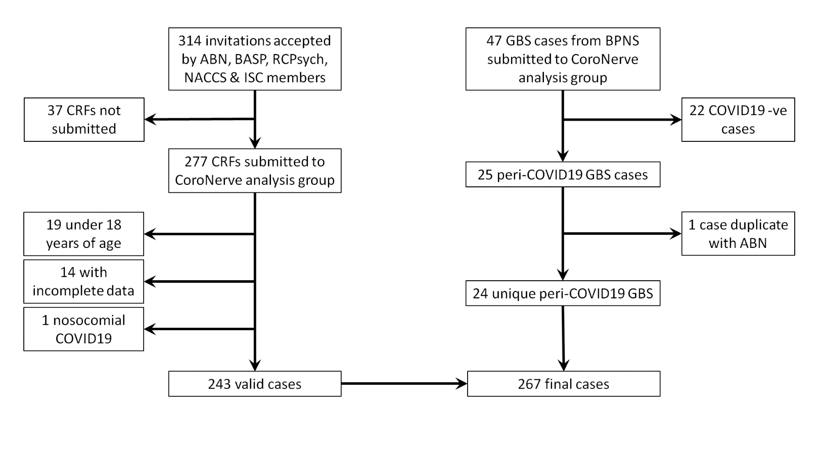
Figure 1. Recruitment flow diagram
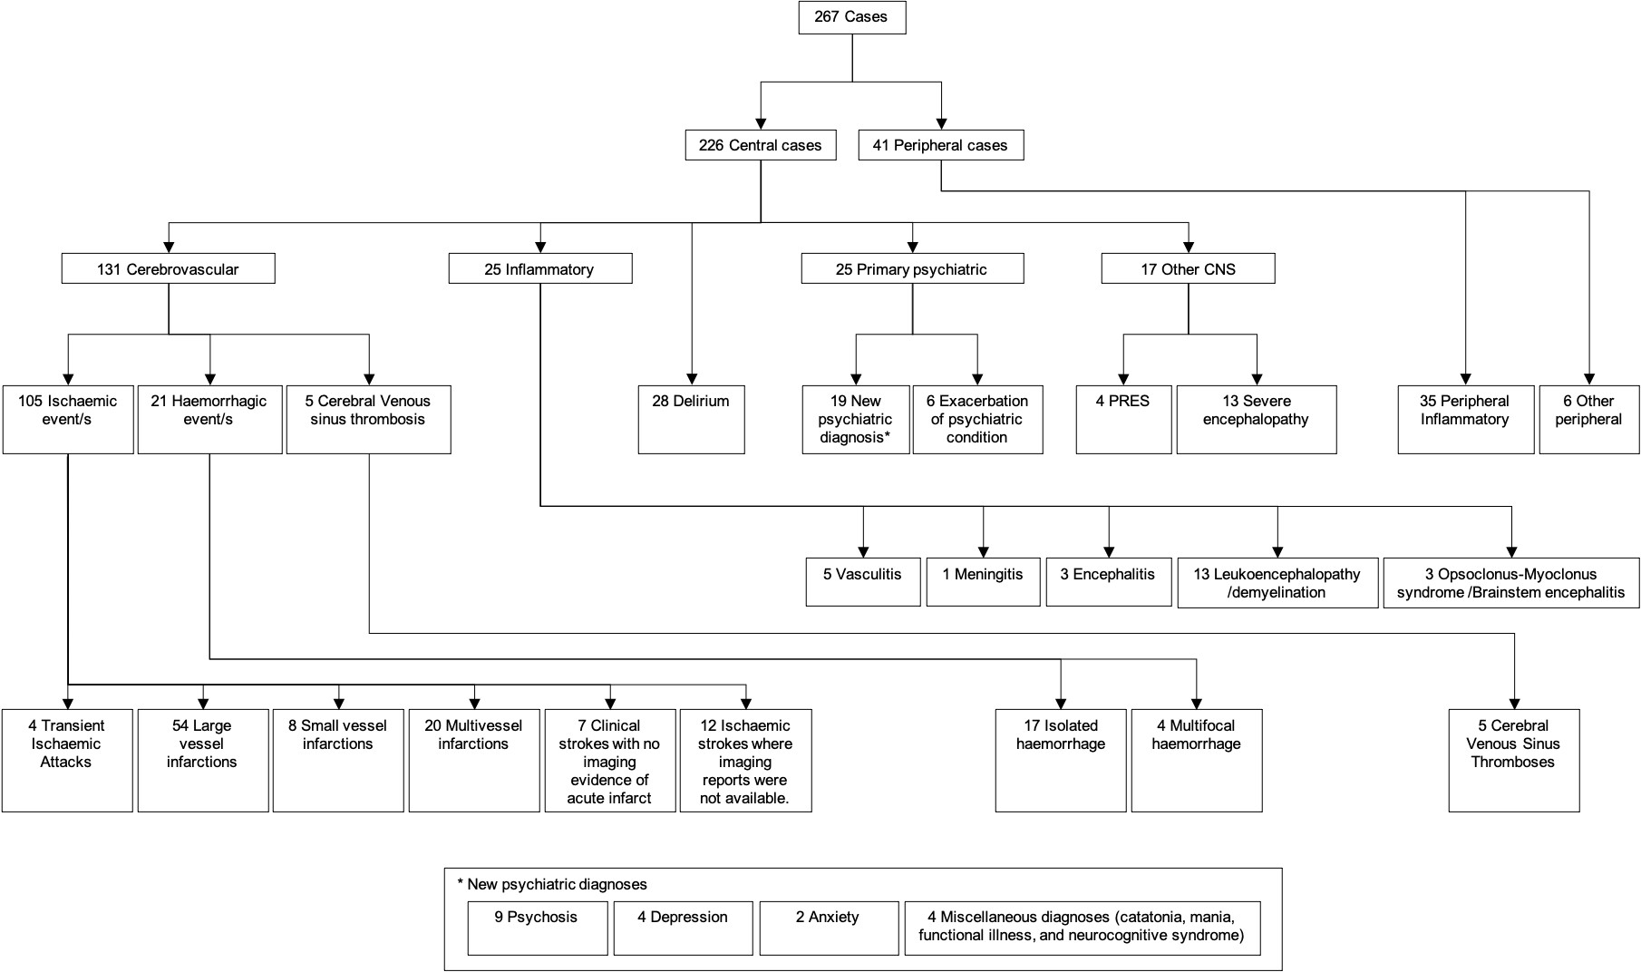
Figure 2. Classification of main neurological diagnoses
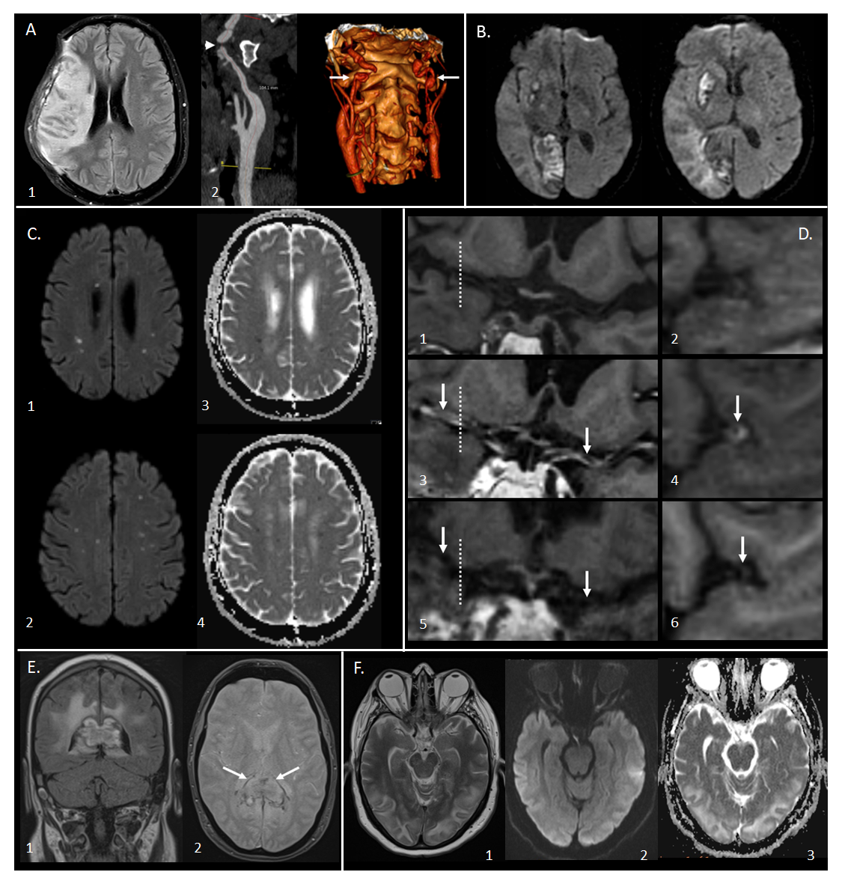
Figure 3. Magnetic resonance imaging demonstrating the range of neurological complications seen in this study.
- Territorial infarct, secondary to internal carotid artery (ICA) dissection in a middle-aged previously fit male: Axial fluid-attenuated inversion recovery image (1) showing a right middle cerebral artery (MCA) territory infarct following decompressive craniectomy for malignant MCA syndrome despite treatment with thrombolysis. Reformatted images from a CT angiogram (2) showing irregularity of the extracranial segment of both internal carotid arteries, consistent with dissection (arrows), with tight stenosis of the true lumen on the right (arrowhead).
- Multiple territorial infarcts in a female > 60 years old with a background of hypertension and dyslipidaemia: Diffusion-weighted images (DWI) demonstrate recent infarcts in the right medial occipital lobe and lentiform nucleus, involving the territories of the right posterior cerebral artery and lenticulo-striate perforators of the right MCA respectively.
- Acute lacunar infarcts due to small vessel vasculopathy in a male > 60 years old, with a background of hypertension and type 2 diabetes: B1000 images (1,2) and corresponding apparent diffusion coefficient (ADC) maps (3,4) from DWI showing multiple tiny foci of restricted diffusion
- Vasculitis in a male > 60 years old, with a background of type 2 diabetes, hypertension and hypercholesterolaemia: T1-weighted SPACE vessel wall imaging of both distal ICAs and proximal MCAs, with curved multiplanar coronal reconstructions along the course of both proximal MCAs (first column) and perpendicular to the right MCA (second column, at the position of the dotted line). Pre-treatment pre-contrast (1,2) and post-contrast images (3,4) demonstrate abnormal concentric, long segment vessel wall enhancement (arrows) of both proximal MCAs. Post-contrast images after treatment with prednisolone and tocilizumab (5,6) demonstrate treatment response with resolution of the previous abnormal mural MCA enhancement (arrows).
- Acute encephalomyelitis with haemorrhage in a middle-aged male, with a history of chronic obstructive pulmonary disease, who required intensive care and haemofiltration: Coronal FLAIR (1) and axial gradient echo (2) images showing focal heterogeneous signal abnormality and swelling of the splenium of the corpus callosum, with peripheral low signal indicative of haemosiderin staining (arrows). Confluent high signal is present in periventricular and deep white matter of the parieto-occipital region.
- Typical imaging appearances of posterior reversible encephalopathy syndrome in a normotensive middle-aged female: Axial T2 image (1) demonstrating hyperintense signal in subcortical white matter of both occipital lobes, with B1000 image (2) and ADC map (3) from DWI showing no corresponding restricted diffusion.

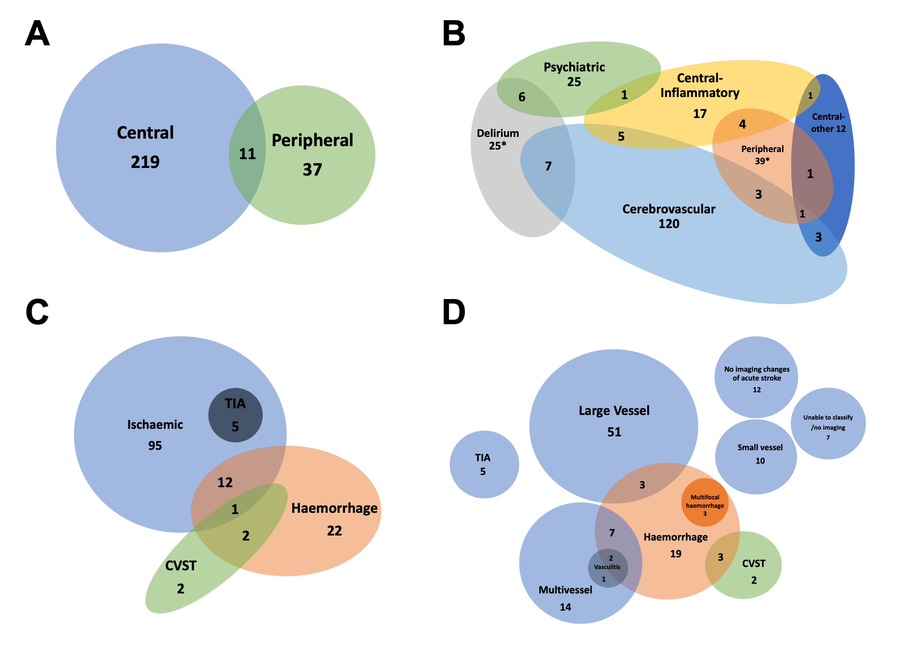
Figure 4. Venn diagrams showing overlap of diagnostic groups, when all diagnoses were considered, in addition to the primary neurological diagnosis. The total numbers for several groups are larger in Figure 2 than the primary diagnosis flowchart (Figure 1) due to coexisting diagnoses. (n) is number of cases. The numbers shown in overlapping circles demonstrate the number of cases with overlapping diagnoses.
A. Central and peripheral nervous system disease
B. Primary diagnostic categories (*two cases of Guillain-Barré syndrome with delirium were not possible to accommodate on this diagram)
C. Stroke group subtypes
D. Specific stroke group subtypes. CVST: cerebral venous sinus thrombosis, TIA: transient ischaemic attack.
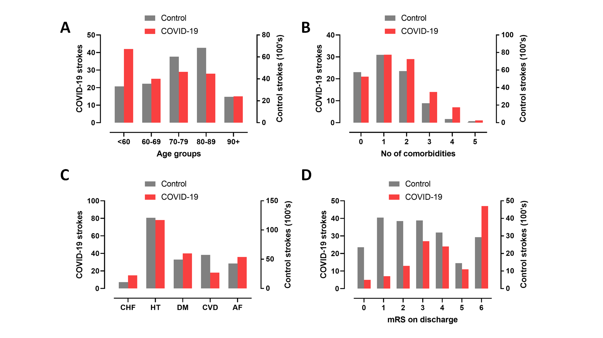
Figure 5. Comparison between strokes associated with COVID-19 in this study and strokes from a national UK audit in 2019. A, B: total number of co-morbidities which are risk factors for stroke (atrial fibrillation, hypertension, diabetes mellitus, congestive heart failure and previous TIA or stroke). C: Age distributions. D: mRS (modified Rankin scale) scores on discharge from hospital (or death).

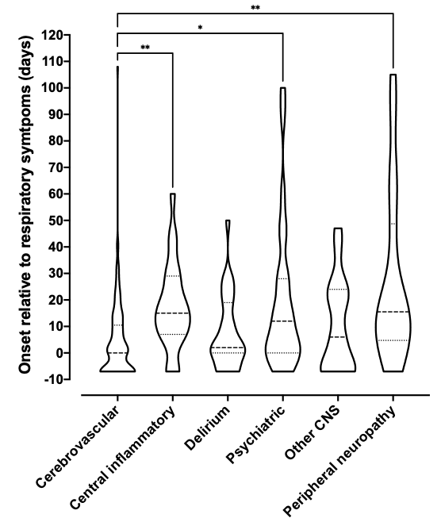
Figure 6. Violin plot demonstrating distributions of time intervals in days between onset of respiratory symptoms and onset of neurological symptoms for each primary diagnostic category. Patients whose neurological symptoms preceded COVID-19 symptoms were arbitrarily assigned a value of minus seven days. The Kruskal-Wallis test was used to determine any significant difference in time intervals between groups (p<0.0001). Dunn’s multiple group comparison test showed a significant difference between stroke and central inflammatory primary diagnostic groups (p=0.001), stroke and psychiatric groups (p=0.037), and stroke and peripheral groups (p=0.003).
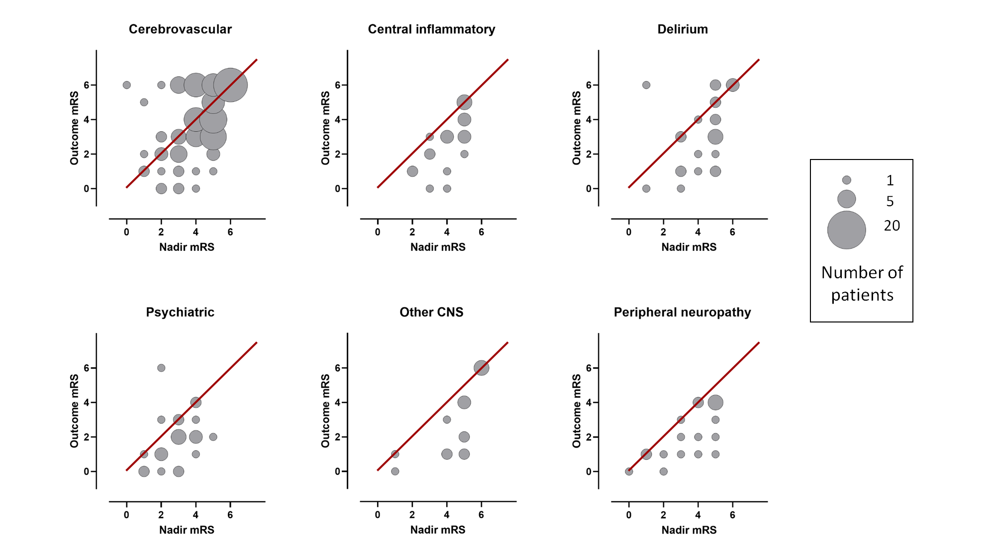
Figure 7. Bubble plots displaying the relationship between mRS (modified Rankin scale) at nadir of illness whilst in hospital and mRS at outcome assessment, within individual diagnostic categories. Bubble area corresponds to patient number. Line of equivalence is shown in red: cases below the line improved, cases above the line got worse, while cases on the line stayed the same.

Supplementary appendix 1

LIST OF COMORBIDITIES
Ischaemic heart disease
Heart failure or dilated cardiomyopathy
Atrial fibrillation
Hypertension
Valvular heart disease: any type
Takayasu's disease
Congenital heart disease: tetralogy of Fallot
Peripheral vascular disease
Neurodegenerative disease: any type
Previous subdural haematoma
Epilepsy
Cerebrovascular disease including previous transient ischaemic attacks
CNS vasculitis
Brain tumour
Multiple sclerosis
Previous deep vein thrombosis
Previous pulmonary embolism
Osteoporosis
Chronic obstructive pulmonary disease
Obesity related hypoventilation syndrome
Obstructive sleep apnoea
Bronchiectasis
Asthma
Pulmonary hypertension
Previous pulmonary tuberculosis
Hypothyroidism
Chronic kidney disease: diabetic nephropathy, hypertensive, unspecified, anti-glomerular basement membrane disease, glomerulonephritis
Hydronephrosis
Renal transplant
Polycystic kidney disease
CADASIL (Cerebral Autosomal Dominant Arteriopathy with Subcortical Infarcts and Leukoencephalopathy)
Human immunodeficiency virus
Latent syphilis
Chronic hepatitis C
Mannan-binding lectin deficiency
Previous gastric ulcer or upper GI bleed
Oesophagitis, gastritis and duodenitis
Inflammatory bowel disease: Crohn's, ulcerative colitis, coeliac
Oesophageal stricture with dysplasia: likely active cancer
Alcoholism
Type 1 and type 2 diabetes mellitus
Pernicious anaemia
Sickle cell disease
Any haematological malignancy
Obesity
Gout
Rheumatoid arthritis

LIST OF NON-NEUROLOGICAL THROMBOTIC EVENTS
Pulmonary embolism
Deep vein thrombosis
Left ventricular thrombus
Myocardial infarction
Renal artery thrombus
Right axillary vein thrombus
Jugular vein thrombosis
Disseminated intravascular coagulation

SUPPLEMENTARY TABLES
Diagnostic group | Specific diagnosis | Number of cases | Reference
Central inflammatory -  Demyelination/leukoencephalopathy | CNS inflammatory vasculopathy with antimyelin oligodendrocyte glycoprotein antibodies | 1 | https://doi.org/10.1212/NXI.0000000000000813
Central inflammatory -  Demyelination/leukoencephalopathy | Acute disseminated encephalomyelitis with corpus callosal haemorrhage | 1 | 10.1212/WNL.0000000000011001
Central inflammatory -  Vasculitis | Intracranial vasculitis | 1 | http://dx.doi.org/10.1136/jnnp-2020-324291
Peripheral nerve -  Inflammatory | Guillain-Barre syndrome | 25 | https://doi.org/10.1101/2020.07.24.20161471
Supplementary Table 1. Cases included in this study which have been published elsewhere.

Number of total comorbidities | n (%)
0 | 47 (19·3)
1 | 38 (15·6)
2 | 47 (19·3)
3 | 36 (14·8)
4 | 32 (13·2)
5 | 16 (6·6)
6 | 12 (4·9)
7 | 9 (3·7)
8 | 1 (0·4)
9 | 5 (2·1)
Supplementary Table 2. Distribution of total number of co-morbidities across all patients. See Supplementary methods for co-morbidity enumeration.
Symptom | n (%)
Cough | 139 (67)
Fever | 172 (73)
Rhinorrhoea | 24 (13)
Sore throat | 18 (11)
Headache | 37 (22)
Anosmia | 15 (13)
Loss of taste | 12 (10)
Chest pain | 20 (11)
Wheeze | 26 (14)
Shortness of breath | 134 (61)
Lethargy | 124 (68)
Arthralgia | 13 (10)
Myalgia | 42 (27)
Diarrhoea | 34 (18)
Abdominal pain | 24 (13)
Vomiting | 23 (12)
Other | 37 (21)
Supplementary Table 3. Reported non-neurological symptoms in all patients.

Cerebrovascular cases (n=131) |  | <60year (n=35) | ≥ 60 years  (n=96) | P value
Female sex, N (%) |  | 12 (34) | 39 (41) | ns^{b}
Onset relative to respiratory symptoms, median (IQR)  (n=130) |  | 10 (0-18) | 0 (-7 – 7) | <0·001ª
At least one co-morbidity increasing stroke risk, N (%) |  | 16 (67) | 77 (88) | 0·016^{b}
ICU admission, N (%) |  | 14 (41) | 15 (16) | 0·002^{b}
Non-CNS thrombotic event, N (%) |  | 6 (18) | 8 (8) | ns^{b}
Admission bloods, median (IQR) | CRP (n=124) | 73 (11-198) | 41 (6-114) | nsª
 | Platelets (n=129) | 245 (175-322) | 231 (174-304) | nsª
 | Lymphocytes (n=129) | 1 (0·8-1·7) | 1 (0·6-1·5) | nsª
Subtype, N (%) | Ischaemic | 29 (83) | 76 (79) | ns^{b}
 | Ischaemic: LVO | 15 (52) | 39 (51) | ns^{b}
 | Ischaemic: MVO | 9 (31) | 11 (14) | 0·053^{b}
 | Haemorrhagic | 2 (6) | 19 (20) | 0·052^{b}
 | CVST | 4 (11) | 1 (1) | 0·006^{b}
mRS score, median (IQR) | Nadir (n=129) | 4 (3-5) | 5 (4-5) | nsª
 | Outcome (n=128) | 3 (1-5) | 4 (3-6) | nsª
Supplementary Table 4. Differences in clinical characteristics between young (age <60 years) and old (>60 years) strokes. Co-morbidities increasing stroke risk were defined as hypertension, atrial fibrillation, diabetes mellitus, congestive heart failure and previous cerebrovascular disease. ‘LVO’ refers to large vessel occlusion, ‘MVO’ refers to multi-vessel occlusion. P-values derived from Mann-Whitneyª and Chi-squared^{b} tests

 |  | Cerebrovascular event | Central inflammatory | Delirium | Psychiatric | Other CNS | Peripheral  neuropathy
Age in years, n (%) | 20-29 | 1 (0·8) | 0 (0) | 1 (4) | 2 (8) | 0 (0) | 2 (5)
 | 30-39 | 2 (1·5) | 4 (16) | 4 (14) | 1 (4) | 3 (17·6) | 1 (2)
 | 40-49 | 17 (13·0) | 4 (16) | 0 (0) | 3 (12) | 3 (17·6) | 8 (20)
 | 50-59 | 15 (11·5) | 8 (32) | 6 (22) | 8 (32) | 5 (29·4) | 15 (37)
 | 60-69 | 24 (18·3) | 7 (28) | 4 (14) | 2 (8) | 3 (17·6) | 11 (27)
 | 70-79 | 29 (22·1) | 1 (4) | 9 (32) | 7 (28) | 1 (5·9) | 3 (7)
 | 80-89 | 28 (21·4) | 1 (4) | 2 (7) | 2 (8) | 2 (11·8) | 1 (2)
 | >90 | 15 (11·5) | 0 (0) | 2 (7) | 0 (0) | 0 (0) | 0 (0)
Sex, n (%) | Male | 80 (61) | 22 (88) | 19 (68) | 11 (44) | 9 (53) | 31 (76)
 | Female | 51 (39) | 3 (12) | 9 (32) | 14 (56) | 8 (47) | 10 (24)
Ethnicity, n (%) | Asian | 10 (8) | 3 (12) | 2 (7) | 3 (12) | 1 (6) | 4 (10)
 | Black | 6 (4) | 3 (12) | 4 (14) | 3 (12) | 2 (12) | 3 (7)
 | White | 107 (82) | 17 (68) | 17 (61) | 15 (60) | 12 (70) | 28 (68)
 | Mixed | 1 (1) | 1 (4) | 0 (0) | 1 (4) | 0 (0) | 0 (0)
 | Unknown | 7 (5) | 1 (4) | 5 (18) | 3 (12) | 2 (12) | 6 (15)
COVID diagnosis, n (%) | Confirmed or probable | 130 (99) | 22 (88) | 27 (93) | 20 (80) | 16 (94) | 25 (61)
 | Possible | 1 (1) | 3 (12) | 2 (7) | 5 (20) | 1 (6) | 16 (39)
ICU admission, n (%) | Yes | 29 (22) | 13 (52) | 8 (29) | 4 (16) | 10 (59) | 12 (29)
 | No | 100 (76) | 11 (44) | 19 (68) | 21 (84) | 7 (41) | 13 (32)
 | Unknown | 2 (2) | 1 (4) | 1 (3) | 0 (0) | 0 (0) | 16 (39)
Ventilation required, n (%) | None | 100 (76) | 10 (40) | 18 (64) | 18 (72) | 6 (35) | 13 (32)
 | NIV | 6 (5) | 1 (4) | 2 (7) | 5 (20) | 0 (0) | 1 (2)
 | Invasive | 24 (18) | 13 (52) | 7 (25) | 2 (8) | 10 (59) | 11 (27)
 | Unknown | 1 (1) | 1 (4) | 1 (4) | 0 (0) | 1 (6) | 16 (39)
Pre-COVID-19 frailty score, median (IQR) |  | 3 (2-6) | 2 (1-2) | 3 (2-5) | 3 (2-4) | 2 (2-4) | 2 (1-2)
At least one co-morbidity, n (%) |  | 115 (88) | 18 (78) | 21 (75) | 16 (64) | 14 (82) | 12 (63)
Number of co-morbidities, median (IQR) |  | 3 (1-4) | 2 (1-4) | 3 (0-5) | 1 (0-3) | 2 (1-4) | 1 (0-2)
Admission GCS, median IQR) |  | 15 (14-15) | 15 (14-15) | 15 (14-15) | 15 (14-15) | 14 (14-15) | 15 (15-15)
Fever, n (%) |  | 71 (63) | 22 (92) | 23 (85) | 16 (80) | 10 (77) | 30 (77)
Admission WCC, median (IQR) |  | 8·0 (6·0-12·0) | 8·0 (6·0-12·0) | 9·0 (6·0-10·0) | 7·0 (6·0-11·0) | 9·5 (5-13) | 8·0 (6·0-11·0)
Admission CRP, median (IQR) |  | 42 (7-145) | 61 (7-199) | 46 (15-158) | 42 (11-86) | 64 (12-140) | 13 (10-28)
Any non-neurological, non-respiratory complication, n (%) |  | 46 (36) | 15 (68) | 13 (46) | 9 (36) | 9 (53) | 9 (41)
mRS at nadir, median (IQR) |  | 5 (3-5) | 5 (3-5) | 5 (3-5) | 3 (2-4) | 5 (4-5) | 3 (2-4)
mRS at outcome, median (IQR) |  | 4 (3-6) | 3 (2-4) | 3 (1-5) | 2 (1-3) | 3 (1-6) | 2 (1-4)
Improvement in mRS score, n (%) |  | 50 (39) | 17 (77) | 15 (58) | 18 (72) | 11 (69) | 14 (74)
Admission length in days, median (IQR) |  | 21 (8-43) | 45 (22-73) | 26 (14-54) | 6 (3-26) | 32 (16-53) | 23 (2-59)
Death n (%) |  | 46 (36) | 0 (0) | 6 (23) | 1 (4) | 4 (25) | 0 (0)
Supplementary Table 5. Patient demographics and clinical parameters between primary diagnostic categories. mRS refers to modified Rankin Scale. Pre-COVID-19 frailty score refers to Rockwood frailty score.

 | With delirium | Without delirium | P
N | 38 | 229
Age by decade, median (IQR) | 60-69 (50-79) | 60-69 (50-79) | 0·916ª
Frailty score, median (IQR) | 3 (2-5) | 3 (2-5) | 0·347ª
Number of comorbidities, median (IQR) | 3 (1-5) | 2 (1-4) | 0·412ª
Preceding psychiatric illness, n (%) | 6 (16) | 16 (8) | 0·153#
Anticholinergic drugs, n (%) | 5 (17) | 14 (10) | 0·249#
Fever, n (%) | 28 (85) | 144 (71) | 0·095#
Admission WCC, median (IQR) | 9·0 (6·5-12·0) | 8·0 (6·0-12·0) | 0·495ª
Admission CRP, median (IQR) | 51 (15-137) | 40 (7-140) | 0·364ª
Need for intensive care, n (%) | 13 (35) | 63 (30) | 0·533#
Supplementary Table 6. Risk factors for delirium. Analysis was performed in all patients with delirium (not just cases where delirium was a primary diagnosis), versus the rest of the patients. Drugs were assessed for their capacity to cause delirium using the anticholinergic effect on cognition scale (Bishara 2016 - https://doi.org/10.1002/gps.4507); in cases where the total number of points on the anticholinergic effect on cognition scale for all listed drugs exceeded 2, a clinically significant anticholinergic effect was assumed. ªMann-Whitney U test #χ² test

Age (years) | Sex | Ethnicity | Diagnoses | Clinical frailty scale | Neurological comorbidity | Medical comorbidities | Cardiac complications | Renal complications | ICU | Medication | EEG results | mRS at nadir
31 to 40 | F | Unknown | Provoked seizure | Well |  | Hypothyroid, migraine, depression |  |  | N | Levothyroxine | Normal | 1
31 to 40 | M | White | Status epilepticus, multiple seizures | Well |  | T2DM |  |  | Y | Levetiracetam, metformin | Normal | 4
31 to 40 | M | White | Unexplained coma with tetraparesis, pupillary and eye movement abnormalities | Very Fit |  | Hypertension |  |  | Y | Aspirin, candesartan, esomeprazole | Not performed | 5
41 to 50 | M | Black or African or Caribbean or Black British | Encephalopathy with multiple seizures | Very Fit | Cerebrovascular disease | Hypertension |  |  | N |  | No results provided | 4
41 to 50 | M | Asian or Asian British | Encephalopathy with myoclonus | Well |  |  | Recurrent atrial flutter requiring DC cardioversion | Acute kidney injury requiring haemodialysis | Y | Rivaroxaban | Slow background suggesting mild encephalopathy | 5
51 to 60 | M | White | Encephalopathy with choreoathetosis and myoclonus | Very Fit |  |  | Right heart failure |  | Y | Olanzapine | Not performed | 5
51 to 60 | F | Black or African or Caribbean or Black British | Encephalopathy with myoclonus | Vulnerable |  | Polycystic kidney disease, recent renal transplant, Toxoplasmosis, CMV viraemia, T2DM | Cardiac arrest - asystole |  | Y | Multiple courses of antibiotics, heparin, warfarin, oxycodone, paracetamol, tacrolimus, prednisolone, mycophenolate, omeprazole, amlodipine, bisoprolol, lamivudine, pyridoxine, valganciclovir, aspirin | Mild slowing. No cortical correlates to twitches | 5
51 to 60 | F | Unknown | Severe encephalopathy | Very Fit |  | Mild asthma | Prolonged QTC | Acute kidney injury | Y | Multiple courses of IV antibiotics and antifungals, gabapentin, dexamethasone | Not performed | 6
51 to 60 | M | White | Encephalopathy with coma and seizure | Vulnerable | LD, ASD, schizophrenia |  |  |  | Y | Clozapine, valproic acid, cholecalciferol, procyclidine, enoxaparin | Slow anterior emphasis, with bi-hemispheric dysfunction | 5
61 to 70 | M | White | Encephalopathy with multiple seizures | Managing Well |  | Hypertension, pulmonary embolism, pancreatitis, T2DM |  |  | Y | Insulin, atorvastatin, carbocisteine, creon, lansoprazole, thyroxine, metformin, ramipril, Rivoroxaban | Mild encephalopathy | 5
61 to 70 | F | White | Encephalopathy with multiple seizures | Severely Frail | Frontotemporal dementia; previous subdural haematoma | NIDDM |  |  | N | Metformin, atorvastatin, citalopram | Not performed | 5
61 to 70 | M | White | Encephalopathy with seizure and left sided weakness | Mildly Frail | Dementia | COPD, alcohol abuse |  |  | N | Omeprazole, propranolol, steroid inhaler | Not performed | 6
81 to 90 | F | White | Encephalopathy with non-convulsive status epilepticus | Severely Frail | Stroke, epilepsy, dementia | Hypercholesterolaemia |  |  | N | Levetiracetam, atorvastatin, sertraline, clopidogrel | Moderate encephalopathy with PLEDs. Status demonstrated without electrographic recovery. | 6
Supplementary Table 7. Demographic and clinical characteristics of 13 cases with severe encephalopathy, outside clinical definition of delirium
Abbreviations: DC = direct current, QTc = corrected QT interval, LD = learning disability, ASD = autism spectrum disorder T2DM = type 2 diabetes mellitus, COPD = chronic obstructive pulmonary disorder, CMV = cytomegalovirus, NIDDM = non-insulin-dependent diabetes mellitus, IV = intravenous.

Duration of neurological symptoms (weeks) | n (%)
< 1 | 73 (28·2)
1 to 2 | 26 (10·0)
2 to 3 | 35 (13·5)
3 to 4 | 17 (6·6)
4 to 5 | 28 (10·8)
5 to 6 | 12 (4·6)
6 to 7 | 12 (4·6)
7 to 8 | 7 (2·7)
8 to 9 | 13 (5·0)
9 to 10 | 3 (1·2)
10 to 11 | 7 (2·7)
11 to 12 | 1 (0·4)
12 to 13 | 6 (2·3)
13 to 14 | 2 (0·8)
14 to 15 | 2 (0·8)
15 to 16 | 1 (0·4)
16 to 17 | 1 (0·4)
17 to 18 | 5 (1·9)
18 to 19 | 4 (1·5)
19 to 20 | 1 (0·4)
20 to 21 | 0 (0)
21 to 22 | 1 (0·4)
22 to 23 | 2 (0·8)
Supplementary Table 8. Distribution of reported duration in days of neurological symptoms in all patients.

mRS score at outcome | n (%)
0 | 17 (7)
1 | 31 (13)
2 | 30 (13)
3 | 45 (19)
4 | 40 (17)
5 | 16 (7)
6 | 57 (24)
Supplementary Table 9. Distribution of mRS (modified Rankin scale) scores at outcome for all patients.

Primary diagnostic category | Improvement in mRS n (%) | z test
Cerebrovascular event | 50 (39) | P<0.001
Central inflammatory | 17 (77) | p<0.02
Delirium | 15 (58) | NS
Psychiatric | 18 (72) | p<0.05
Other CNS | 11 (69) | NS
Peripheral neuropathy | 14 (74) | NS
Supplementary Table 10. Improvement in neurological function from nadir (within patient improvement between nadir and follow-up mRS – yes / no), as measured with the dichotomised mRS, differed across primary diagnostic groups (χ² (5, N = 236) = 23.9 p < 0.001). z tests for independent proportions were two-tailed.

SUPPLEMENTARY FIGURES
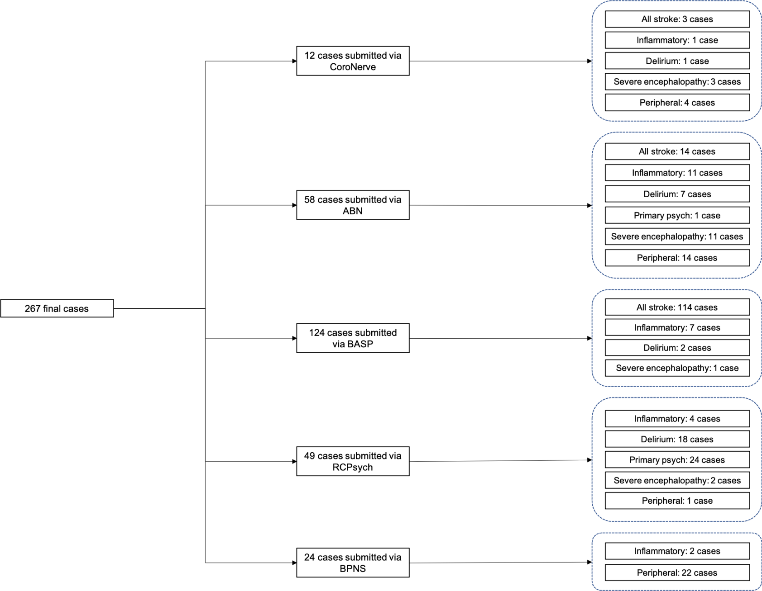
Supplementary Figure 1. Provenance of final cases by professional association platform
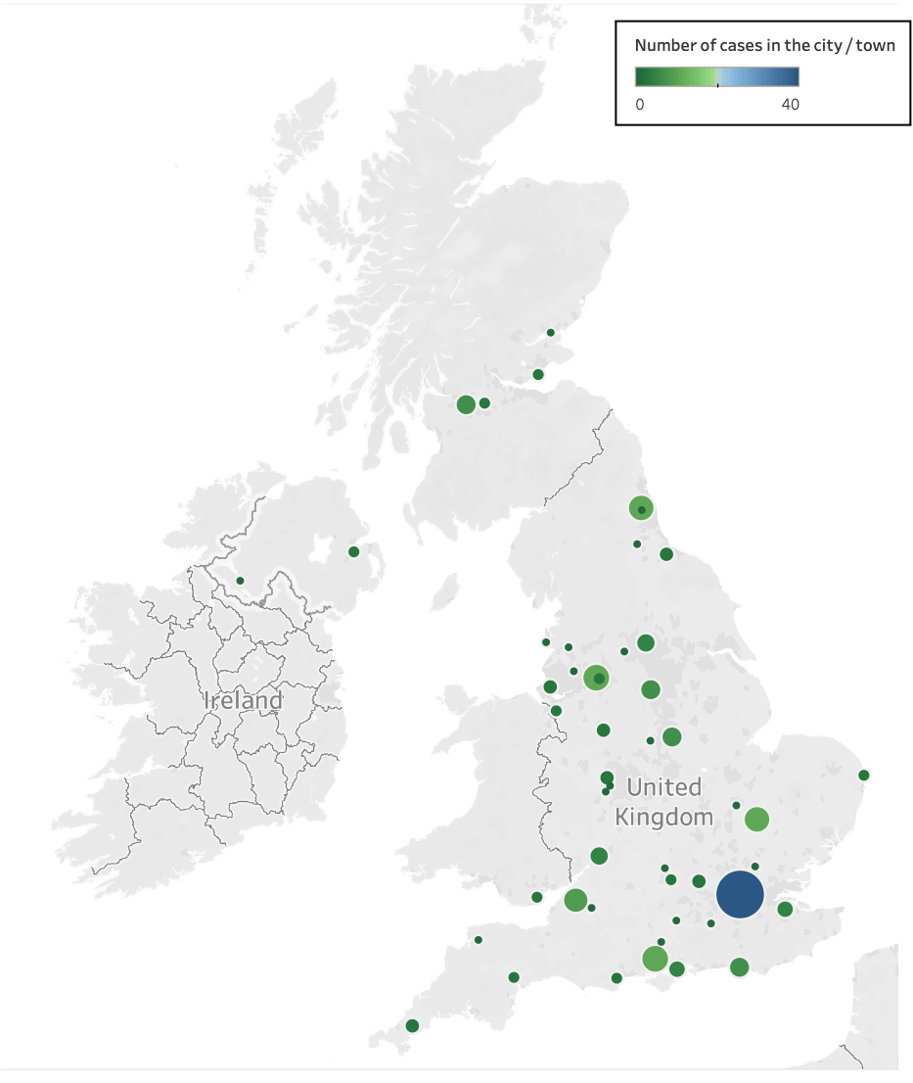
Supplementary Figure 2. Geographical spread of cases in the study, for those whose hospital details were available (n=219).

Supplementary appendix 2

Case Report Form

See separate file in subfolder Supplementary

Supplementary appendix 3
CoroNerve study group
Before data lock
Abraham-Thomas, Nisha
Adie, Katja
Al-Shahi Salman, Rustam
Allen, Claire
Amiruddin, Nabeel
Anwar, Fahim
Archibald, Neil
Arkell, James
Armitage, James
Arthur-Farraj, Peter
Atkin, Marc
Baker, Mark
Bakerly, Nawar
Bathula, Rajaram
Belcher, Alexandra
Bharambe, Viraj
Blair, Gordon
Blank, Catrin
Bolton, Jim
Bonello, Michael
Boubriak, Iryna
Boynton, Claire
Breen, David
Brenner, Robert
Briley, Dennis
Brodie, Fiona
Brown, Helga
Bruno, Stefania
Burn, John
Butchart, Angus
Chan, Kah Lok
Cheripelli, Bharath
Choulerton, James
Clatworthy, Philip
Clements, Joanne
Coates, Jonathon
Coles, Alasdair
Collin, Gwen
Cottrell, Peter
Coughlan, Charles
Daher, Mazen
Dale, Jane
Davies, Nicholas
Davies, Ruth
Defres, Sylviane
Dima, Sofia
Dodd, Katherine
Dodge, Liam
Doubal, Fergus
Dushianthan, Ahilanadan
Dutta, Dipankar
Ellis, Richard
Elmamoun, Salwa
Emerson, Hannah
Fearon, Patricia
Fernandes, Peter
Fiddes, Barnaby
Firth, James
Fisher, Emma
Fitzgerald, Alasdair
Fornolles, Caroline
Gallagley, Andrew
Gallen, Brian
Garcia del Carrizo, Fernando
Gemski, Alan
Gilbert, Jackie
Gkrania-Klotsas, Effrossyni
Golestani, Farhad
Gratrix, Andrew
Green, Susan
Grote, Helen
Grue, Rebecca
Grundler, Sabine
Grundmann, Alexander
Gunatilake, Savini
Hamad, Mahir
Hamandi, Khalid
Hamdalla, Hisham
Harkness, Kirsty
Harrower, Timothy
Hartman, Jennifer
Hassan, Ahamad
Hatfield, Alison
Hatfield, Catherine
Hillier, Charles
Hotton, Gary
Hubbett, Jack
Huda, Saif
Huneke, Nathan
Huys, Anne-Catherine
Ian, Thomas
Iftikhar, Hajira
Ihmoda, Ihmoda
Ilyas, Muhammad
Ispoglou, Sissi
Jones, Nicola
Kane, Ingrid
Keh, Ryan
Khalifeh, Hind
Kimber, Jeff
Kishore, Amit
Knolle, Martin
Kobylecki, Christopher
Kooij, Sander
Krishnan, Anita
Lambert, Matthew
Laws, Phil
Li, Lucia
Luxton, Rebecca
Madigan, Barbara
Maguire, Melissa
Majid, Arshad
Malik, Gauhar
Manford, Mark
Marigold, Richard
Marrinan, Sarah
Matthews, Paul
McCormick, Michael
McDougall, Marcia
Mcinnes, Caroline
McKee, David
McMullen, Isabel
Menezes, Brian
Miers, Stephanie
Misra, Amulya
Mistry, Dipak
Mitchell, James
Moragas, Mireia
Morrison, Hamish
Mowafi, Walied
Mudd, Paul
Murphy, Louis
Nagy, Anna
Newman, Edward
Ng, Choo
Nightingale, Sam
Nyo, Khin
O'Brien, Richard
Ong, Ivy
Oram, Matt
Ozalp, Belgin
Pankhurst, Kevin
Parmar, Nehal
Parr, Carmen
Pasco, Kath
Pearce, Sarah
Plant, Gordon
Price, David
Price, Gary
Pritchard, Nicholas
Proeschel, Harald
Protheroe, David
Quattrocchi, Graziella
Quinn, Terence
Rajan, Akansha
Redgrave, Jessica
Redwood, Rebecca
Rice, Claire
Roffe, Christina
Rogers, Jonathan
Roof, Alia
Ross Russell, Amy
Sachar, Amrit
Samarasekera, Neshika
Samaraweera, Amal
Sawcer, Stephen
Scott, Shona
Sekaran, Lakshmanan
Serra-Mestres, Jordi
Sharma, Kanchan
Siddiqui, Mohammed
Simon Thomas, Emily
Sin Fai Lam, Chun Chiang
Sissons, Andrew
Sittampalam, Mara
Sivananthan, Anushta
Smith, Craig
Soe, Thandar
Soliman, Mohamed
Sotiriou, Andreas
Stone, Jon
Sun, James
Swann, Peter
Syed, Hafiz
Szewczyk-Krolikowski, Konrad
Talaei, Maryam
Tanveer, Riffat
Templeton, Lisa
Thomas, Philip
Thomas, Rhys
Trezise, Catherine
Turner, David
van der Boom, Jaap
Varghese, Elizabeth
Waddell, Briony
Webb, Stephen
Weir, Nic
Wharton, Chris
Wiblin, Lou
Wiggam, Malcolm
Williams, Tim

After data lock
Armour, Cherie
Bullmore , Ed
Chinnery, Patrick
Dixon, Luke
Gabriel, Carolyn
Harrison , Neil
Leek , Charles
Paddick , Stella-Marie
Pengas, George
Pritchard, Jane
Shaw, Pamela
Taams , Leonie
Vincent , Angela
Wood, Nicholas

