A Novel Device for In-situ Force Measurements during Laser Powder Bed Fusion (L-PBF)

R. Magana-Carranza, J. Robinson, I. Ashton, P. Fox, C. Sutcliffe, E.A. Patterson
School of Engineering, University of Liverpool, Liverpool, UK
Email: sgrmagan@liverpool.ac.uk

Abstract
All Laser Powder Bed Fusion (L-PBF) parts contain residual stresses because of the high energy input, and the significant temperature gradients of the part during the manufacturing process. This residual stress can cause deformation leading to critical distortion and structural failure of the parts during manufacturing or in service. This paper details the design and first use of a force transducer device (FTD) to study the development of strains from which residual stresses can be inferred. The device consists of an array of load cells for in-situ measurement of forces over time during the L-PBF additive manufacturing process. Preliminary experimental results from in-situ measurements in a Renishaw AM 250 machine using a 67-degree rotating scan strategy using Inconel 625 build material showed that the forces induced in the first five layers represented approximately 80% of the maximum on completion of the build and were distributed such as to induce concave deformation of the part, i.e. tension in the centre and compression at the edges of the part.

Keywords
Laser Powder Bed Fusion (L-PBF), Residual Stress, Force measurement, Force Transducer Device.

- Introduction
Laser Powder Bed Fusion (L-PBF) is an additive manufacturing technology that enables the production of individual functional parts directly from a CAD model of nearly unlimited complex geometry without the need for additional tooling or pre-production costs [1, 2]. L-PBF has been widely used as a manufacturing process by industries such as aerospace, automotive and medical devices [3]. In the L-PBF process, a predefined thin layer of metal powder is deposited on a substrate and selectively scanned by a laser beam in an inert atmosphere to fully melt a thin layer of the metal powder, then the substrate is lowered by one-layer thickness. Subsequently, these process steps are repeated until a functional part is produced. The effects of the heat input and rapid cooling of the L-PBF process leads to the development of residual stresses that remain in the component after manufacture [4], and which influence the properties of the finished part and generate deformation of the part potentially leading to critical distortion. It has been identified that residual stresses develop during the L-PFB process due to a combination of a thermal gradient mechanism and the constrained shrinkage of material during cooling [5]. Stresses are developed by the rapid heating of the newly deposited layer and the slow heat conduction to underlying solid layers. When the laser beam melts the powder, the surrounding material heats up to a much greater temperature than the previously solidified layers. The heated material expands but it is restricted by the cooler solidified material inducing compressive strains in the new layer. After the laser beam moves away, rapid cooling of the surface of the new layer occurs, causing it to shrink more than the underlying material that cools more slowly, which creates tensile stresses in the new layer and compressive stresses in the previously solidified layers (figure 1). The progressive melting and solidification of the layers in the L-PBF process makes the prediction of residual stresses much more complex than in many other cases. Previous studies have shown that the parameters used for the building process, such as, scan strategy, laser power, scan speed, vector length and direction, and layer thickness, have a significant effect on the development of residual stresses within the part and affect the distortion of the finished part [5-9]. Merciles and Kruth [5], using the crack compliance method and X-ray diffraction, showed that the exposure strategy has a significant influence on the magnitude of residual stresses developed and found that the stresses were larger perpendicular to rather than along the scan direction. Kruth et al. [9], using the bridge curvature method, showed that shorter scan vectors reduced the measured distortion by 13% due to the lower thermal gradients induced. By using neutron diffraction, Anderson et al. [10] suggested that the stress magnitude and gradients could be significantly reduced by increasing the layer thickness.
Several studies have suggested that alternating scan vectors can reduce residual stresses [9, 11-14]. Yasa et al. [11] showed that sectoral scanning oriented at 45° with respect to the x- and y-axes reduced significantly the residual stresses compared to long scan vectors. More recently, Robinson et al. [12] for commercially pure titanium and Ali et al. [13] in Ti6Al4V reported that a 90° alternating scan strategy resulted in the lowest residual stresses. Cheng et al. [14], using a finite element analysis (FEA) of eight different scan strategies showed, that 45° line scanning produced the lowest residual stresses and part deformation. And, Robinson et al. [15] observed that a 90° alternating scan strategy resulted in lower stress in the scan direction but it raised the stress at 45° to the scan; hence they recommended a hatch rotation of 74° which gave a more uniform level of stress in all directions. Casavola et al. [16] using the hole drilling method determined that a thicker substrate reduced the development of residual stresses and part deformation; in addition, they found that the position of the part on the base plate had an effect on the magnitude of the residual stresses in the part, with the central position being the one with the lowest value of stress. Several experimental studies have found that increasing the base plate temperature reduced the residual stresses induced by the L-PFB process [9, 17, 18]. Shiomi et al. [17] found that heating the base plate to 160 °C reduced the residual stresses by 40%. In addition, Shiomi et al. [17] found that re-scanning every layer decreased the tensile stress by 55%. Subsequently, Kruth et al. [9] found that heating the base plate to 180 °C resulted in a reduction of the curvature of the test samples by 10% and, more recently, Ali et al. [13] showed that re-scanning with a 150% energy density resulted in 33.6% reduction in residual stress but affected the mechanical properties of the part. Hence, it can be concluded that there is an extensive literature on the origin and orientation of residual stresses in parts built using L-PBF; however, many of the results are difficult to reconcile and might be contradictory, probably due to the challenges involved in making direct measurements of the stresses either during or after the build process.
There is a substantial literature on the use of non-destructive testing (NDT) methods to inspect parts made by additive manufacturing, including a recent review by Toma et al. [19]; however, in general NDT provides information about defects rather than the stress state in a part. Little published work exists on the experimental measurement of stresses as they develop during the manufacturing process. Strains developed during the manufacturing process have been recorded by Shiomi et al. [17] and Van Belle et al. [20]; both of these studies used strain gauges attached to the lower face of a substrate as parts were built on its upper surface. Shiomi et al. [17], by attaching strain gauges to the centre of the bottom surface of the base plate, measured the strains developed parallel and perpendicular to the laser track; the measured strains showed that large tensile strains remained in the surface of the part after manufacturing. When using chrome molybdenum steel, heat treatment at 600 °C and 700 °C for one hour were found to reduce the residual stress by about 70%. The effect of re-scanning every layer decreased the residual stresses by 55% while heating of the base plate to 160 °C decreased the residual stresses by 40%. Van Belle et al. [20] fixed a strain gauge rosette and a K-type thermocouple to the centre of the bottom of the base plate; and then, the stress profile through the centre of the part was calculated using an adaptation of the layer removal technique described by Shiomi et al. [17]. In their study, Van Belle et al. [20] showed, for a part made with Maraging steel, with a height of 10 mm and a build layer of 40 µm, that the residual stresses were less important than for a part of height 5 mm with a build layer of 20 µm. In a similar study, Dunbar et al. [21] proposed a method for measuring the in-situ distortion and temperature using a micro-miniature displacement sensor in an enclosed chamber and found that a constant scan pattern produced more part deformation than a 67° rotating scan pattern for Inconel 718. The in-situ measurements showed that the thermal cycles caused by the processing of a layer affected the amount of distortion accumulated in the previous layers. These studies provide valuable information; however, the use of a single sensor provides only limited data. A much higher density of measurements is required to fully understand the stresses developed during the L-PFB process and the effect of scan strategies, process parameters and material properties on the residual stresses. Therefore, this paper describes the design of a novel in-situ device with multiple measurement points across the substrate that can be used in various L-PFB machines made by different manufacturers across a range of materials. The design of the device is described in the following section and its first use on Inconel 625 in the L-PFB process is reported in subsequent sections.
- Design of Force Transducer Device (FTD)
First, a single array Force Transducer Device (FTD) was designed and manufactured in order to measure the development of forces at different points in the build. It was composed of a single array of 14 load cells [Micro Load Cells 0-50 kg, Robot Shop, UK] arranged on a rectangular grid 32 mm x 112 mm, as shown in figure 2. The single array force transducer device (FTD) was a prototype that allowed the forces developed by unidirectional scan vectors to be evaluated during the L-PFB process prior to designing a more sophisticated device. In order to determine the effect of alternate scan strategies, a second force transducer device (FTD) was designed using a 4x4 load cell arrangement attached to two separate substrates. These two substrates were bolted on top of each other making an easily-installed standalone device, which can be installed in a machine in the same way as a regular substrate as shown in figure 3. The bottom level substrate holds an array of eight load cells which measure the forces developed at the top of the central columns supporting the part, and the top-level substrate has an array of eight load cells for measuring the forces on the outer columns supporting the part. In order to avoid any modification to the machine or the standard L-PBF process and to enable easy setup and removal, the force transducer device was designed using a 250 mm x 250 mm aluminium monocoque chassis with the size of a standard substrate [22], which allowed it to be fitted into different L-PBF machines as a standard substrate, as shown in figure4. The load cells were firmly attached using M5 bolts to the substrate at one end; and channels were machined in the FTD substrates to ensure the accurate position of the load cells. A section of the substrate was cut-off below the load cells to ensure that the movement of the load cells produced by the developed forces was not restricted during the build as shown in the cross-section in figure 5. To create a building platform, 10 mm diameter machined stainless steel pegs were bolted onto the free end of the load cells, which measured the force applied to their free ends via the shear induced by bending. To allow the part to be built on top and the powder to be spread evenly across the entire surface, the pegs needed to be aligned at the same position above the top surface; therefore, the pegs that were attached to the bottom load cells were 32 mm longer than those attached to the top load cells (figure 5). A slot was machined in the centre of each substrate, to allow access to remove the pegs once each build was completed without the need to remove the load cells after each build. To prevent the ingress of powder into the FTD, it was completely covered by adding two 5 mm thick plates separated by a 0.5 mm thick laser-cut silicone membrane, as shown in figure 5, which provided a planar top surface. The holes in the silicone membrane were 8 mm in diameter resulting in a tight fit around the 10 mm diameter machined pegs effectively sealing the load cell volume whilst allowing unobstructed transmission of loads through to the load cells. To ensure that there was no movement between the substrates, the system was held firmly together by 11 M5 screws that were countersunk to avoid interaction with the wiper during the build process.
The load cells used in the force transducer device shown in figures 3, 4 and 5 were strain gauge load cells (3135 Micro Load Cells 0-50 kg, Robot Shop, UK), with a rated output of 2.0c2±0.15 (mV/V), and a temperature sensitivity of 0.0016 percent/°C over an operating temperature range of -20 °C to 55 °C. The operating temperature of the force transducer device was monitored using K-type thermocouples, which were attached to two of the load cells (load cells 5 and 6) to ensure that they did not overheat. The load cells are of the binocular type and connected in full bridge format providing double sensitivity. The design of the load cells and their strain gauge arrangement is such that they are insensitive to the position of the load on the transducer, because of this the effects of the position of the part on the load cell has no effect. The load cells were connected to three 16-channel data acquisition systems (InstruNet i100, Omega, USA) with a sampling rate of 1000 Hz and a read-back accuracy of ±3 mV. The load cells were calibrated by adding known weights to each load cell in increments of 5 kg up to a maximum of 40 kg. The applied and measured loads were plotted to allow the equation of the corresponding regression line to be found for each of the sixteen load cells (figure 6a), and the gradient was taken as the scaling factor. The accuracy of this process was checked by inputting the scaling factor for each load cell into the software of the data acquisition system before repeating the calibration process and the results are shown in figure 6b and show a standard deviation of 0.222 kg for the distribution of the differences between the applied load and the registered load from each of the 16 load cells after the calibration.
- Materials and Processing Parameters
Test samples were built using Inconel 625 alloy (In625-0402 alloy, Renishaw, UK) which is used widely in additive manufacturing using L-PBF. Experimental work was carried out using a Renishaw AM250 machine (Renishaw, UK) with a maximum laser power of 200 W. The processing parameters used were recommended by the manufacturer to achieve parts with density greater than 99.95% and are listed in Table 1.
- Experimental Procedure
The force transducer device (FTD) was set up in the L-PFB machine as a regular substrate, as shown in figure 4, with the wires fed through the overflow compartment and out of the machine through a cable gland to maintain the inert atmosphere inside the build chamber. To prevent the wiper recoater interacting with the wiring, its maximum forward position was set to 230 mm; hence, no powder came through the overflow compartment. Forces are only induced in the load cells when the part being built is connected to more than one load cell allowing the forces to be reacted. To facilitate this process, pillars were built on top of the machined stainless steel pegs, starting from an 8 mm diameter circular base aligned to the top circular surface of the pegs and transitioning to a 15.5 mm square as shown in figure 7. These dimensions ensured that the top of the pillars came very close to each other but did not connect, so that no force was registered by the load cells. To ensure that the initial condition for every experiment was the same, these pillars were built with the same scanning strategy; i.e. a 67° rotating scan strategy, shown in figure 8, with the build parameters described in Table 1. A rotation of 67 degrees was used between each layer because a previous study showed that the use of a rotating scanning strategy decreased the level of residual stresses in Inconel [12, 13]. Once the pillars were complete, a 64 mm x 64 mm square part was built on top of them which connected them together. When the first layer of the square is complete, the pillars are connected, and therefore forces can be transmitted through them to the load cells, which allows the forces induced by the creation of each layer of the rest of the build to be measured. Each build was stopped before any of the load cells reaching their maximum load of 50 kg. No significant change in measured load was observed when the part cooled down after being completed, suggesting that load cell temperature had been successfully removed as an experimental error by the adoption of the cooling strategy and the correct selection of fully temperature compensated bridge arrangements.
- Results and Discussion
Figure 9 shows the forces registered by the load cells over time during the building of a 52-layer sample. The force measurements for the central load cells follow a linear trend after the first 500 seconds which is equivalent to approximately the first 8 layers. The force registered by the load cells for the corners of the part start to follow a linear trend earlier in the build and all the force-time traces show a higher amplitude layer-by-layer oscillation. The registered force after the part is finished is constant, as shown beyond 3,420 seconds in figure 9, which means there is no significant additional deformation of the part after it cools down. In more detail, the load cells numbered 1, 4, 13 and 16 at the corners show a rapid increase in tensile force from the start of the build and then increase at a slower nearly linear rate; whereas the central load cells numbered 6, 7, 10 and 11 exhibit the similar trends but in compression. However, the loads registered at the central locations on the edges (labelled as ‘external’ in figure 9) are always substantially lower than those registered at the corners or in the centre of the part. The load cells numbered 2, 3, 14, and 15 in the centre of edges, that are parallel to the x-axis and perpendicular to the scan direction in layer 1, appear to mirror the trends seen for the cells numbered 5, 9, 8 and 12 in the centre of the edges perpendicular to y-axis and parallel to the scan direction in layer 1. All of them show an initial increase in magnitude to a maximum at around 750 seconds, before decreasing in magnitude to almost zero at the end of the build for load cells 5, 8, 9, 14 & 15 and to zero at approximately 2500 seconds for load cells 2,3 and 12 which then increase in magnitude with the opposite sign until the end of the build. The tensile loads from the corner load cells 1 and 13 are higher in magnitude than those registered by the corner load cells located at the opposite side i.e. load cells 4 and 16. Also, the pairs of load cells 5 and 9, and 6 and 10, show lower magnitudes than their opposite pairs, load cells 8 and 12, and 7 and 11 respectively. In all the cases, the load cells with higher magnitudes are located at the left side of the FTD; this could be a consequence of the scan starting point on the first layer, which was at the bottom left side (figure 8), and this suggests that the order in which the scan vectors are exposed has an influence on the distribution of the forces developed in the part.
The built part is in static equilibrium with the force transducer device at the end of build and quasi-static equilibrium during the build such that there should be no net moment and the sum of the forces in the vertical direction should be equal to weight of the part. The mass of a part of height 5 mm with a 64 mm x 64 mm cross-section is about 92 grams so that the weight is negligible compared to the forces induced by the residual stresses. Thus, the tensile forces must balance the compressive forces and the distribution must be symmetrical to maintain the balance of moments, as shown by the red line in figure 9. Hence, the high tensile forces registered at the corners are balanced by the high compressive forces registered by the central load cells, and, at the end of the build, the small tensile forces at the centre of the edges parallel to the y-axis are balanced by the small compressive forces at the centre of the edges parallel to the x-axis. It can also be deduced, from the mean deviation of the sum of the forces (red line) from the x-axis in figure 9, that the measurement error for the force transduced device is around 5%.
Figure 10 show contour plots of the forces on the cells in 0.5 mm increments of build height up to the finished part (figure 10f). As shown in previous studies [23-28], the forces developed at the centre of the part are compressive while those at the corners of the part are tensile implying that they are pulling upwards, towards the laser. It would appear that the thermal gradient mechanism has caused differential contraction of the more recently built layers due their more rapid cooling than the layers beneath them; and the contraction is greater along the diagonals than shorter edges of the part, which causes a greater out-of-plane curvature and resultant forces along the diagonals, as registered by the central and corner load cells.
Figure 11 shows the sum of the magnitudes of the forces registered by the sixteen load cells during the building of a part with periods when the laser is switched on and off shown as vertical blue and white bands respectively, with the angle of the laser scanning relative to the x-axis shown for the first twenty-two layers. The initial layer scanned in the y-direction induces forces equal to just over 770 N with a small decrease of about 110 N while the laser is off. The second layer, which is scanned at 157 degrees to the x-direction, induces an increase in the forces of about 1000 N followed by small decrease of about 160 N during cooling when the laser is off. The pattern is repeated for the third layer, which is scanned at 224 degrees to the x-direction and induces an increase of about 660 N when the laser is on; followed by a decrease of about 330 N during cooling when the laser is switched off that is almost entirely recovered when the next layer is scanned at 291 degrees. The following and fifth layer is scanned at 358 degrees, i.e. parallel to the x-axis, and produces a further increase of about 860 N. Hence, the combined effect of these first five layers is to induce forces equal to about 3000 N compared to a maximum of about 3800 N during the complete build, i.e. about 80% of the maximum. As subsequent layers are scanned a repeated cycle of force is observed with layers scanned in directions within 20 degrees of the x-axis showing sharp maxima when the laser is on followed by a rapid decrease, and layers scanned in directions within 20 degrees of the y-axis exhibiting sharp decreases in force. These variations are superimposed on general trend of increasing magnitude of force when the laser is on and decreasing following switching off the laser and the associated part cooling. After the first ten to twenty layers the net increase in the sum of the forces is small as expected from the trends seen in figure 9. This might imply that there is a critical number of built layers beyond which the orientation of the initial scans has little or no impact on the development of the residual forces, perhaps because the built layers form a sufficiently thick substrate to reduce the effect of scanning direction as found by Casavola et al. [16].
The oscillatory nature of the traces in figures 9 and 11 were also observed in the strain gauge outputs obtained by Shiomi et al. [17] and hence are unlikely to be a feature of the current measurement apparatus. The initial difference in magnitude of the oscillations is probably a consequence of the direction of scan for the first layer which was in the y-direction and this would concur with the results of Shiomi et al. [17]. The likely cause of the oscillations is the local heating of the part causing relaxation of the residual strains already induced in the built layers prior to the melting and solidification processes for the new layer introducing additional residual strains. This explanation is consistent with the absence of the oscillations during the initial scans.
The in-situ measurements showed that the residual forces are in compression in the centre of the part and in tension at the corners, which agrees with previous experimental work [10, 29-31]. The results from the in-situ measurements have the potential to enhance understanding of intralayer effects and process parameters on the residual forces arising from the L-PFB process. Further work is needed with a range of metal powders to gain a complete understanding of the interaction of these parameters. The forces from the in-situ measurements reported here could be converted to residual stresses through the use of a finite element model to further explore the development of residual stresses in the L-PFB process and to optimize the process.
- Conclusions
The design and manufacture of a novel device for in-situ measurements during the L-PFB process has been described. The device allows the measurement of the spatial distribution and time-varying nature of the forces induced during the build process as well as an evaluation of the residual forces following the completion of the build. In preliminary tests using a 67-degree rotating scan strategy using Inconel 625 as the build material, the magnitude of the forces induced during the first five layers of the build represented 80% of the maximum during the build with relative low levels of relaxation when the laser was switched off between layers. However, in later stages of the build the level of forces induced and relaxed as the layers were scanned was approximately equal. The measurements showed that the forces developed in the central regions of the part were compressive and those on the outside edges were mainly tensile which agrees with previous research on the distribution of residual stresses by Rangaswamy [23]. The novel device provides an opportunity to explore the impact on residual strains of different processing parameters and metal powders using in-situ measurements.
Acknowledgements
The authors would like to acknowledge the help and resources provided by Stryker Advanced Technologies, Renishaw plc, Meta Consultancy LDA and the University of Liverpool.

References
1. Gibson I, Rosen D, Stucker B, Khorasani M. Additive manufacturing technologies. New York: Springer; 2014.
2. Wohlers T, Gornet T. History of additive manufacturing. Wohlers report. 2014; 24(2014): 118.
3. Bremen S, Meiners W, Diatlov A. Selective laser melting: A manufacturing technology for the future?. Laser Technik Journal. 2012 Apr; 9(2): 33-8.
4. Fu CH, Guo YB. Three-dimensional temperature gradient mechanism in selective laser melting of Ti-6Al-4V. Journal of Manufacturing Science and Engineering. 2014 Dec 1; 136(6): 061004.
5. Mercelis P, Kruth JP. Residual stresses in selective laser sintering and selective laser melting. Rapid Prototyping Journal, 2006. 12(5): 254-265.
6. Nickel AH, Barnett DM, Prinz FB. Thermal stresses and deposition patterns in layered manufacturing. Materials Science and Engineering: A. 2001 Oct 31; 317(1-2): 59-64.
7. Ali H, Ghadbeigi H, Mumtaz K. Residual stress development in selective laser-melted Ti6Al4V: a parametric thermal modelling approach. The International Journal of Advanced Manufacturing Technology. 2018 Jul; 97(5): 2621-33.
8. Bo Q, Yu-sheng S, Qing-song W, Hai-bo W. The helix scan strategy applied to the selective laser melting. The International Journal of Advanced Manufacturing Technology. 2012 Nov; 63(5): 631-40.
9. Kruth JP, Deckers J, Yasa E, Wauthlé R. Assessing and comparing influencing factors of residual stresses in selective laser melting using a novel analysis method. Proceedings of the Institution of Mechanical Engineers, Part B: Journal of Engineering Manufacture. 2012 Jun; 226(6): 980-91.
10. Anderson LS, Venter AM, Vrancken B, Marais D, Van Humbeeck J, Becker TH. Investigating the residual stress distribution in selective laser melting produced Ti-6Al-4V using neutron diffraction. In Mater. Res. Proc 2018 Apr 20 (Vol. 4, pp. 73-78).
11. Yasa E, Deckers J, Kruth JP, Rombouts M, Luyten J. Investigation of sectoral scanning in selective laser melting. In Engineering Systems Design and Analysis 2010 Jan 1 (Vol. 49187, pp. 695-703).
12. Robinson J, Ashton I, Jones E, Fox P, Sutcliffe C. Determination of the effect of scan strategy on residual stress in laser powder bed fusion additive manufacturing. Additive Manufacturing, 2018 Oct 1; 23: 13-24.
13. Ali H, Ghadbeigi H, Mumtaz K. Effect of scanning strategies on residual stress and mechanical properties of Selective Laser Melted Ti6Al4V. Materials Science and Engineering: A. 2018 Jan 17; 712:175-87.
14. Cheng B, Shrestha S, Chou K. Stress and deformation evaluations of scanning strategy effect in selective laser melting. Additive Manufacturing. 2016 Oct 1; 12:240-51.
15. Robinson JH, Ashton IR, Jones E, Fox P, Sutcliffe C. The effect of hatch angle rotation on parts manufactured using selective laser melting. Rapid Prototyping Journal. 2019 Mar 4; 25(2):289-298.
16. Casavola C, Campanelli SL, Pappalettere C. Experimental analysis of residual stresses in the selective laser melting process. In Proceedings of the XIth International Congress and Exposition, Orlando, Florida, USA 2008 Jun 2.
17. Shiomi M, Osakada K, Nakamura K, Yamashita T, Abe F. Residual stress within metallic model made by selective laser melting process. CIRP Annals. 2004 Jan 1; 53(1):195-8.
18. Mertens R, Vrancken B, Holmstock N, Kinds Y, Kruth JP, Van Humbeeck J. Influence of powder bed preheating on microstructure and mechanical properties of H13 tool steel SLM parts. Physics Procedia. 2016 Jan 1; 83: 882-90.
19. Toma A, Condruz R, Carlanescu R, Daniel I. A mini-review on non-destructive techniques for additive manufactured metal parts. In AIP Conference Proceedings 2020 Dec 3 (Vol. 2302, No. 1, p. 060017). AIP Publishing LLC.
20. Van Belle L, Vansteenkiste G, Boyer JC. Investigation of residual stresses induced during the selective laser melting process. In Key Engineering Materials 2013 (Vol. 554, pp. 1828-1834). Trans Tech Publications Ltd.
21. Dunbar AJ, Denlinger ER, Heigel J, Michaleris P, Guerrier P, Martukanitz R, Simpson TW. Development of experimental method for in situ distortion and temperature measurements during the laser powder bed fusion additive manufacturing process. Additive Manufacturing. 2016 Oct 1; 12: 25-30.
22. Robinson JH, PhD Thesis: Optimisation of Selective Laser Melting Process for the Production of Hypbrid Orthopaedic Devices. 2014, University of Liverpool: Liverpool UK.
23. Rangaswamy P, Griffith ML, Prime MB, Holden TM, Rogge RB, Edwards JM, Sebring RJ. Residual stresses in LENS® components using neutron diffraction and contour method. Materials Science and Engineering: A. 2005 Jun 15; 399(1-2): 72-83.
24. Ali H, Ma L, Ghadbeigi H, Mumtaz K. In-situ residual stress reduction, martensitic decomposition and mechanical properties enhancement through high temperature powder bed pre-heating of Selective Laser Melted Ti6Al4V. Materials Science and Engineering: A. 2017 May 17; 695: 211-20.
25. Li C, Fu CH, Guo YB, Fang FZ. Fast prediction and validation of part distortion in selective laser melting. Procedia Manufacturing. 2015 Jan 1; 1: 355-65.
26. Kruth JP, Froyen L, Van Vaerenbergh J, Mercelis P, Rombouts M, Lauwers B. Selective laser melting of iron-based powder. Journal of Materials Processing Technology. 2004; 149(1-3): 616-622.
27. Pohl H, Simchi A, Issa M, Dias HC. Thermal stresses in direct metal laser sintering. In 2001 International Solid Freeform Fabrication Symposium 2001.
28. Simson T, Emmel A, Dwars A, Böhm J. Residual stress measurements on AISI 316L samples manufactured by selective laser melting. Additive Manufacturing. 2017 Oct 1; 17: 183-9.
29. Denlinger ER, Gouge M, Irwin J, Michaleris P. Thermomechanical model development and in situ experimental validation of the Laser Powder-Bed Fusion process. Additive Manufacturing. 2017 Aug 1; 16: 73-80.
30. Vrancken B, Cain V, Knutsen R, Van Humbeeck J. Residual stress via the contour method in compact tension specimens produced via selective laser melting. Scripta Materialia. 2014 Sep 15; 87: 29-32.
31. Bartlett JL, Li X. An overview of residual stresses in metal powder bed fusion. Additive Manufacturing. 2019 May 1; 27: 131-49.

Table 1: Processing parameters used in the 200 W Renishaw AM250 machine for Inconel 625-0402 powder for additive manufacturing.

Processing Parameters
Power [W] | 200
Exposure Time [μs] | 100
Point Distance [μm] | 60
Hatch Distance [mm] | 0.14
Layer Thickness [μm] | 60

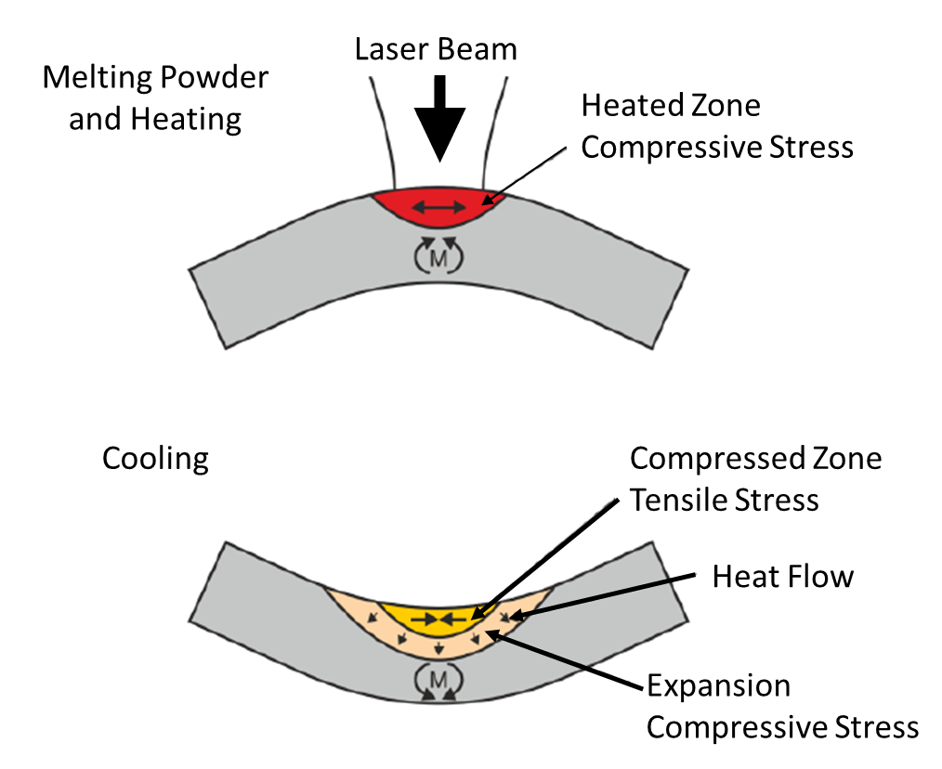
Figure 1: Effect of the thermal gradient mechanism on the development of residual stresses during the L-PFB process [from 11].

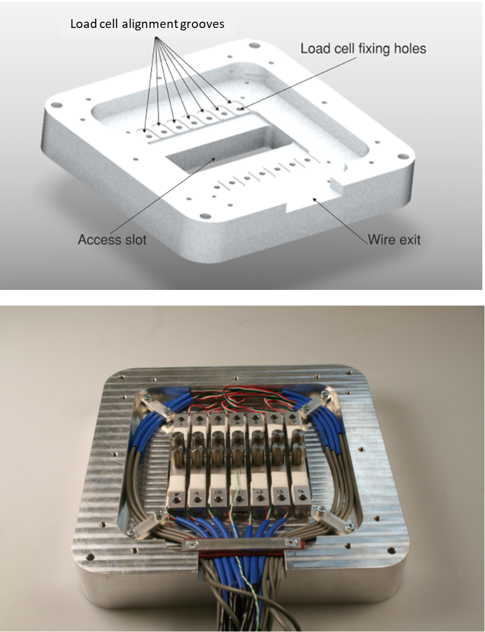

Figure 2: CAD model for an initial design (top) of the substrate for Force Transducer Device (FTD) with a single array of load cells; and the machined substrate (bottom) with stainless steel pegs attached to the load cells which were used as the building platform.

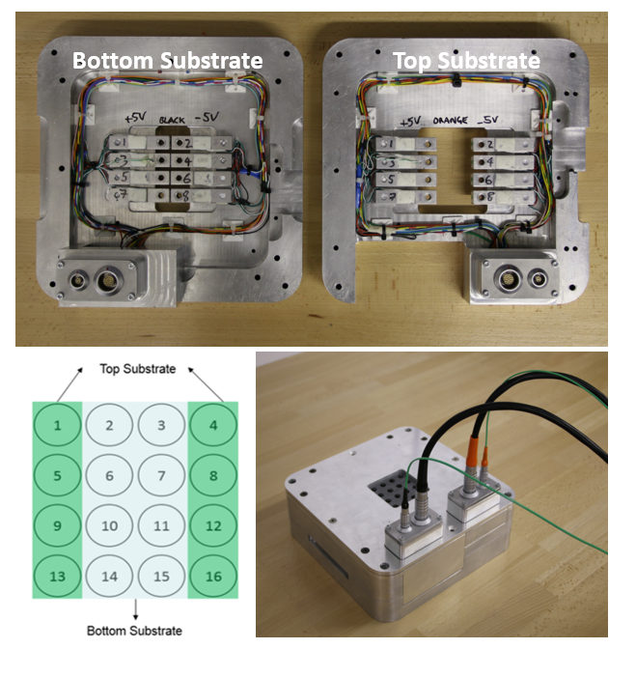
Figure 3: Force Transducer Device (FTD) with a two substrates (top) bolted on top of each (bottom right) to allow 4x4 load cells (bottom left) to be used to evaluate residual forces induced during the L-PFB process.

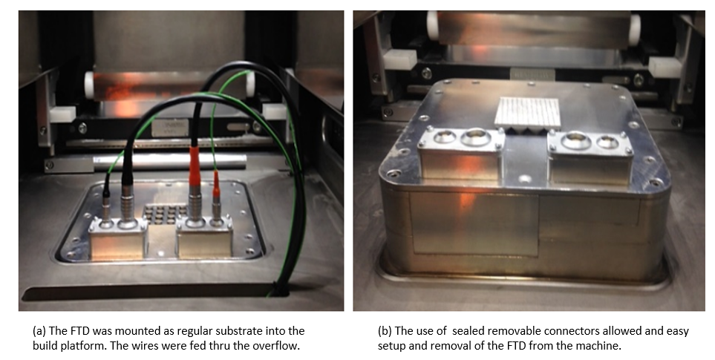

Figure 4: Force Transducer Device (FTD) shown in figure 3 installed in a Renishaw AM 250 machine as a regular substrate with the load cell wires fed through the overflow compartment to avoid disturbing the L-PFB building process.

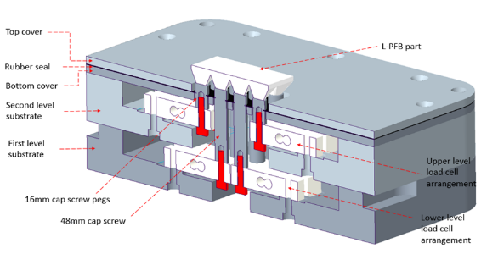

Figure 5: Cross-sectional diagram of the Force Transducer Device shown in figures 3 and 4, showing the arrangement of the 4X4 load cells and the assembly of the two substrates on top of one another.

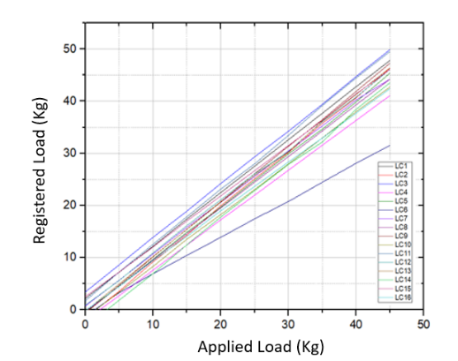
(a)
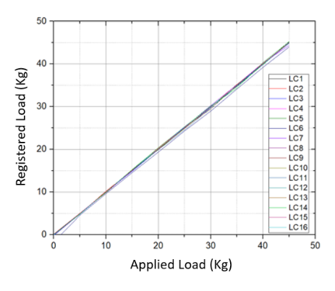
(b)
Figure 6: Loads registered by each load cell based on 5 kg increments of load: (a) before calibration; and (b) after calibration
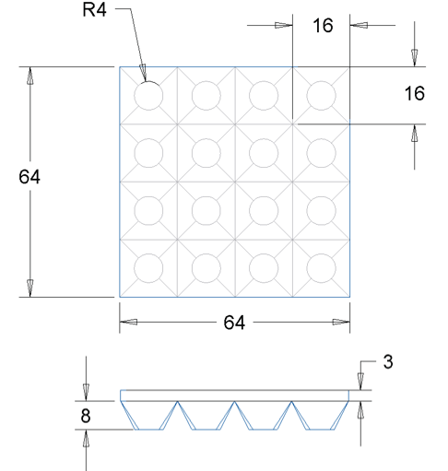
Figure 7: Schematic diagram of the part geometry build for in-situ measurements with the Force Transducer Device with all dimensions shown in millimetres.

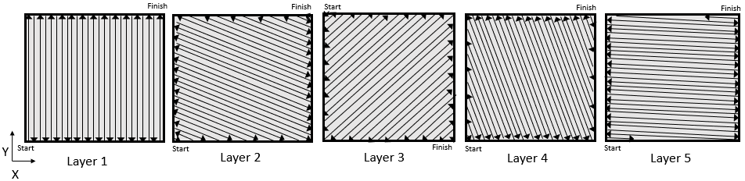
Figure 8: Schematic of the Meander scan strategy, based on a pattern of 67° rotating scans, used to build the samples specified in Table 1.

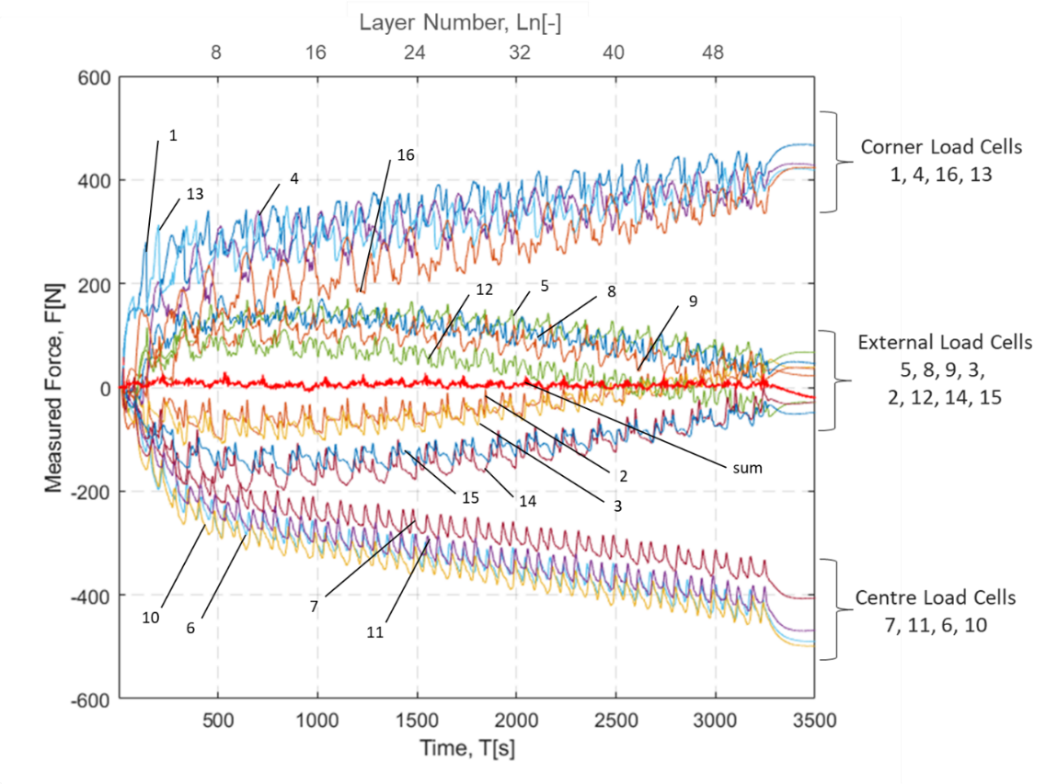
Figure 9: Forces registered by each of the load cells as a function of time and build layer for a part built using the scan strategy shown in figure 8. The load cell arrangement is shown in figure 3 and the cell numbers are marked on the plot as well as listed on the right for each cluster in descending order of magnitude of measured load at 3500 seconds. The red line shows the algebraic sum of the loads on all cells.

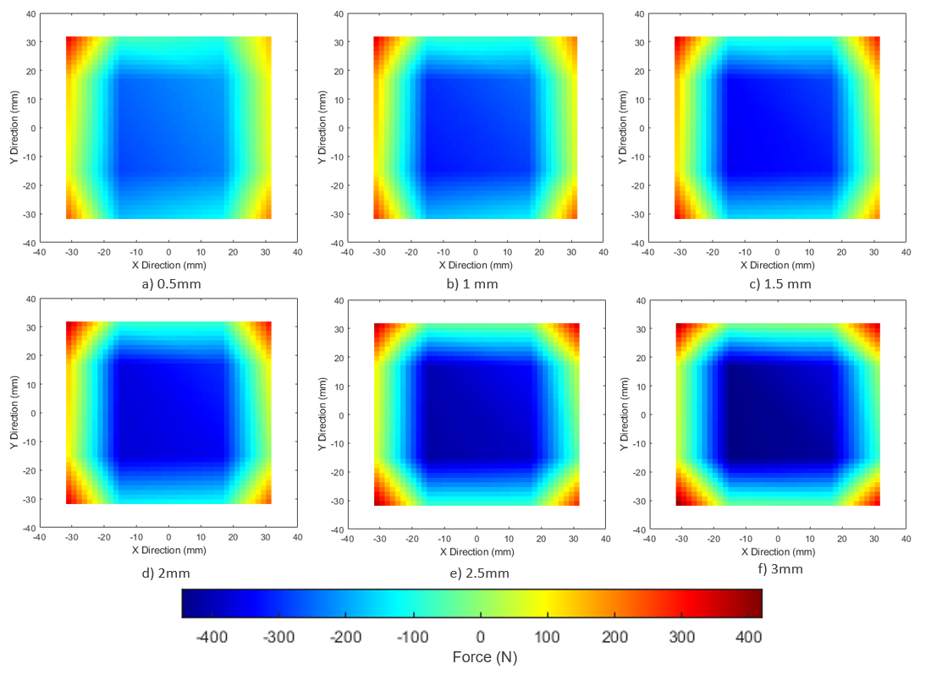

Figure 10: Contoured maps of measured forces shown in figure 9 for 0.5 mm increments of build height.

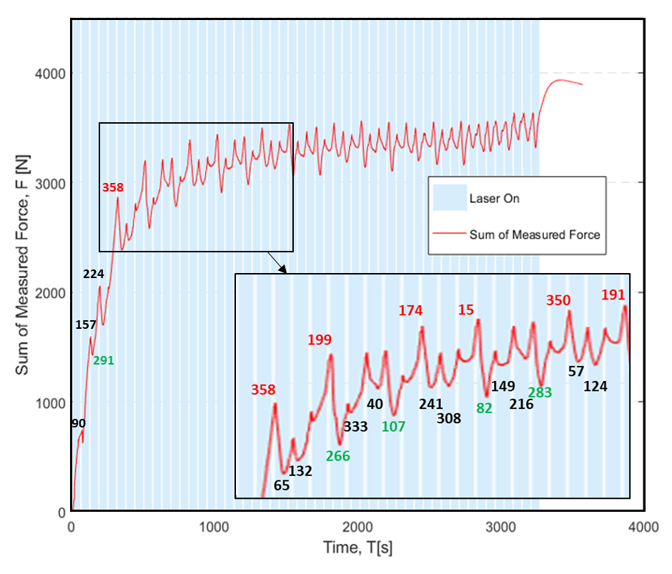

Figure 11: Sum of the absolute magnitude of forces measured by all load cells as a function of time during building of a sample using the 67° rotating scan strategy shown in figure 8 with the periods when the laser is on (blue) and off (white) shown together with the angle of the scan relative to the x-axis for the first 25 layers (angles within 20 degrees of the x- and y- directions shown in red and green respectively).

