The effect of processing parameters and material properties on residual forces induced in Laser Powder Bed Fusion (L-PBF)

R. Magana-Carranza, C.J. Sutcliffe*, E.A. Patterson
School of Engineering, University of Liverpool, Liverpool, UK
* Meta Consulting LDA, Portugal
Email: sgrmagan@liverpool.ac.uk

Abstract
During the L-PBF process stresses are developed due to the large temperature gradients induced by the laser beam and the fast cooling rates which occur while the part is being built. In this study, the development of forces induced layer by layer from the cycles of thermal gradient during L-PBF are measured in-situ using a Force Transducer Device (FTD) for several processing parameters, including laser power and scanning strategy in various metal powders. Three scan strategies were studied: Stripe, Meander and Chessboard, and the results showed that Meander developed the lowest residual forces. All of the processing parameters had a strong influence on the development of residual strains in L-PBF; and, it was found that the laser power had relatively little effect on the residual forces above a minimum threshold and that above a critical value the point distance had little effect on the residual forces. Four materials were investigated: Ti-6Al-4V, Inconel 625, Inconel 718 and maraging steel. Maraging steel exhibited much lower residual forces than the other materials, which could be due to the low temperature phase transformation in this material. Evidence for this mechanism in the maraging steel was provided by changing the inert atmosphere in the L-PBF chamber. In addition, changing the inert gas atmosphere from argon to nitrogen for the maraging steel samples had an effect on the development of forces which changed the direction of the part deformation when it was released at the end of the build process.
Keywords
Laser Powder Bed Fusion (L-PBF), Residual Stress, in situ measurements

Introduction
The Laser Powder Bed Fusion (L-PBF) process involves the selective melting of particular sections of a thin layer of metal powder spread over a flat bed using a laser beam as an energy source in an inert atmosphere. The process is repeated layer by layer until the desired 3-dimensional component, defined by a CAD model, has been manufactured [1-3]. The thermal cycle used in L-PBF, which involves high-temperature gradients and rapid cooling rates, develops residual stress in the manufactured part that leads to critical part distortion affecting the mechanical properties of the final components. Residual stresses are defined as stresses that remain inside a material when it has reached equilibrium with its environment, in this context, after manufacturing; however, they arise whenever a material undergoes non-uniform plastic deformation [4-6].
Residual stresses arise in the L-PBF process as a result of the thermal gradient mechanism (TGM) [7] that occurs around the laser spot; due to the localised heating of the upper layer by the laser energy and the subsequent rapid cooling during which a steep temperature gradient develops. When a new layer is created, it is heated in excess of the temperature of the underlying part, which causes the newly deposited layer to expand. The expansion of the new top layer is restricted by the cooler underlying layers, resulting in the development of compressive stresses in the new layer, giving rise to complimentary tensile stresses in the rest of the part. Initially, the compressive strains will be elastic; however, with a sufficiently large temperature difference between the new top layer and the underlying layers, the material's yield strength will be reached, and the top layer will be plastically compressed in the heated zone. In the absence of mechanical constraints, the part will tend to bend into a concave shape relative to the laser beam. When the heat source is removed, the new layer will cool quickly, of the order of ${10}^{3}-{10}^{8}$ K/s [8], contracting at a greater rate than the previously solidified part beneath, thus resulting in tensile stresses in the new layer and compressive stresses in the underlying layers. The shrinkage of the new layer is partially constrained by the plastic strain in the heating stage [7] and this contributes to tensile residual stresses in the surface of the part, which are generally undesirable since they can contribute to, and are often the primary cause of, fatigue failure, quench cracking and stress corrosion cracking [9]. In any free body, stress equilibrium must be maintained, which means that the presence of tensile residual stress in the surface of the component will be balanced by compressive stress elsewhere in the body. In samples produced using L-PBF, Vranken et al. [10], showed from two-dimensional residual stress plots obtained using the contour method, that the stress field in the build direction (Z-direction), was compressive in the centre and tensile near the top and bottom edges. Similar results were found by Denlinger et al. [11], who developed a three-dimensional finite element analysis (FEA), which included thermomechanical interactions, to provide insight on the accumulation of residual stress in multi-layer builds. The results from the FEA showed that the newly deposited layers experienced high levels of tension, above the yield strength, while the layers beneath were forced into compression.
Residual stresses can be classified by the three length scales (Types I, II and III) over which they operate [6]. Type I residual stresses are macro-stresses that act on the scale of the component's geometry and may cause global distortion. They arise from non-uniform plastic deformation and are the main cause of distortion during or after production of L-PBF parts. Type II residual stresses are micro-stresses acting at the scale of individual grains which tend to arise due to local microstructural effects, or when a phase transformation takes place. Type III residual stresses are at the atomic scale that arise from heterogeneous behaviour [6, 12, 13]. Type I residual stresses have been the main focus of study in the literature on additive manufactured parts because they can be mitigated through changes in the process conditions used in L-PBF [13].
Process variables, such as laser power, scan strategy, scan speed, layer thickness, material properties and part geometry, have an important impact on the resulting residual stresses and part deformation in the manufactured component. The magnitude and distribution of the residual stresses induced in the plane of manufacturing (XY-plane) vary according to these variables [7, 12-16] and the mechanical properties of the final part depend strongly upon the track taken by the laser in each layer, as well as the bond formed between each layer [17].
Bartlett and Li [13] categorised the dominant process parameters discussed in the literature into three groups: scanning strategy, beam variables and process conditions. Previous studies have reported that residual stresses in a component are affected by the scan strategy used to expose the metal powder in each layer to the laser beam [7, 18-24]. The scan strategy consists of two main parts: the scan pattern and the scan parameters, including the laser power, scan speed, scan spacing and layer thickness. The scanning strategy determines the distribution of energy in each layer. The variation of the length of the scan vector, the sequence and direction of the vectors and their rotation in the consecutive layers alters the way heat is supplied to the metal powder bed, and thus affects the residual stresses [7]. Mercelis and Kruth [7] suggested that the exposure strategy has a significant influence on the residual stress levels developed during the process. Results from their experimental work showed that subdividing each layer into smaller sections, e.g. squares for the chessboard scanning, resulted in a lower maximum stress value and equally large stresses in the X and Y directions. Yasa et al. [25] concluded that sectoral scanning reduced residual stresses, especially when the orientation of the scan tracks was diagonal as opposed to parallel or perpendicular to edges of the part, i.e. 45° to the X-direction; however, this finding needs further investigation of the effect of rotating the part by 45° and using an XY scanning strategy to demonstrate whether it is due to the position of the part rather than the scanning strategy. Similar results were obtained by Zaeh and Branner [26] who used the cantilever method and neutron diffraction to conclude that the use of island scanning was preferable to long scanning vectors. However, Ali et al. [15] determined that using full-length vectors (from side to side of the part) with a 90⁰ alternating scan strategy resulted in the lowest levels of residual stress. In a different study, Robinson et. al [27] found that using single scan vectors only in the Y direction reduced the developed residual stresses and deflection compared to using a Chessboard scan strategy. Additionally, they found that increasing the square size in the Chessboard scan strategy in the range from 2.5 mm to 20 mm reduced the level of residual stress. Similarly, Cheng et al. [28] based on a finite element analysis concluded that full-length line vectors with 45⁰ inclined scanning generated the lowest residual stresses and part deformation compared to the other scan strategies they tested. While, Robinson et al. [24] and Dunbar et al. [29] in different studies suggested employing rotating scan strategies between layers to mitigate residual stresses and part deformation rather than using unidirectional scan vectors.
Several studies have suggested that increasing energy input will increase residual stresses [30, 31]. Simson et al. [30] using neutron diffraction determined that the values of residual stress increased with a higher energy density in 316L steel samples. They proposed that components made with a lower energy density had high levels of porosity; and, by having un-melted zones between the scan tracks there were no fixed connections to the surrounding tracks, thus resulting in reduced levels of residual stress. Mukherjee et al. [31] suggested that a low heat input, which is sufficient for maintaining adequate interlayer bonding, is beneficial for the control of thermal strains. Process conditions, such as preheating the base plate, have also been shown to reduce residual stress significantly [32-34]. Kruth et al. [32] using the curvature method, showed that preheating the base plate to 180 ⁰C reduced the residual stresses by 10%, and, Shiomi et al. [33] showed that the residual stress in the top layer of the part was reduced by 40% when the base plate was preheated to 160 ⁰C. While, Vastola et al. [34] used a finite element analysis to show that increasing the temperature to which the bed was preheated reduced the residual stresses and each increment of 50⁰C in preheating produced a stress reduction of nearly 20%.
The material properties of the metal powders used in L-PBF influence the residual stresses developed in the process [35, 36]. The thermal diffusivity of materials is especially important in L-PBF, because it influences the temperature gradients during cooling; such that materials with a low value of thermal diffusivity develop larger residual stresses [37]. Processing parameters can have various effects on the residual stresses developed with different metal powders. Denlinger et al. [35], using in-situ measurements of the out-of-plane distortion and the hole drilling method, showed that increasing the interlayer dwell times from 0 to 40 seconds reduced the residual stress and part deformation by up to 55% in Inconel 625 samples, while the stresses and out-of-plane deformation increased for Ti-6Al-4V samples. Link et al. [38] by manipulating process parameters in the shape deposition manufacturing (SDM) process showed, for carbon steel parts, that phase transformations could cause volumetric changes which have the potential to reduce part deformation and stress.
Since material properties have an effect on the development of residual stress and can alter the effect of process parameters [13]; it is important to gain a better understanding of these complex interactions. It is clear that residual stress is a key issue for the future application of L-PBF in serial manufacturing and that many solutions to the mitigation of residual stresses have been proposed. It is also clear from the literature that, whilst many mitigation strategies have been suggested and applied to the L-PBF process, there is still some disagreement in the results that have been obtained by previous researchers. A major problem with the measurement of residual stresses is that in the majority of cases stress measurements can only be undertaken post-manufacture and insights into the stresses apparent during the building process cannot be investigated, similarly post manufacture tests relying on deformation measurement and neutron diffraction are dependent on the part geometry manufactured and the interaction between the part geometry and the scanning strategy.
To optimise and ameliorate the development of residual stresses in L-PBF enhanced, methods for the measurement of the stresses are required and it is preferable that these measurements can be taken during fabrication to obtain geometry independent ground-truth data which reveals the effect that laser and scan parameters/strategies have on the process. To achieve this, a novel force transducer has been deployed during the L-PBF process to record the restraint or reaction forces induced by the residual strains developed during the process.
Thus, this work investigates the effect of the three commonly used scanning strategies in L-PBF, namely Stripe, Meander and Chessboard, and of the process parameters on the development of the residual forces through in-situ measurements during the L-PBF process. In addition, the effect of material properties on the development of the forces are investigated using four metal powders: Ti-6Al-4V, Inconel 625, Inconel 718 and maraging steel.

Experimental Details

Materials and Processing Parameters
Experimental work was carried out using a Renishaw AM250 machine (Renishaw, UK) with a maximum laser power of 200 W. All test samples were built using a standard gas atomised powder material supplied by Renishaw for additive manufacturing with a particle size of 15-45 µm. To measure the effect of the metal properties on the development of residual stresses during the manufacturing process, samples were built with different metal powders widely used in L-PBF: Ti-6Al-4V ELI-0406 alloy (Renishaw, UK), In625-0402 alloy (Renishaw, UK), In718-04045 alloy (Renishaw, UK), and maraging steel M300 (Renishaw, UK).

Measurement device
A specially-designed force transducer device (FTD) was used to measure the development of forces during the building process [39]. The force transducer device (FTD) consists of an array of 16 load cells in a 4x4 arrangement to monitor the development of residual forces in a part as it is manufactured by measuring the spatial and temporal variation of the reactions through the base layer of the part. The load cells are attached to two 250x250 mm aluminium monocoque chassis bolted on top of each other. The size of the chassis allows the device to be fitted into any L-PBF machine as a standard substrate. The load cells were firmly attached using M5 bolts to the chassis at one end, and, at the other end, to Ø 10 mm machined pegs which formed a build platform (Figure 1). To prevent the ingress of powder into the force transducer device, the load cell area was completely covered by two 5 mm thick plates separated by a 0.5 mm thick laser-cut silicone membrane, as shown in the cross-section in Figure 1, such that the top plate provided a planar top surface. The holes in the silicone membrane were Ø 8 mm resulting in a tight fit around the Ø 10 mm machined pegs and effective sealing the load cell chamber whilst allowing unobstructed transmission of loads through to the load cells. To ensure that there was no movement between the chassis, the system was held firmly together by eleven M5 screws that were countersunk to avoid any interaction with the wiper during the build process.
The force transducer device (FTD) was set up in a Renishaw AM250 machine as a regular substrate, as shown in Figure 2. The wires were fed through the overflow compartment using a flange and a cable gland to seal the wire exit and maintain the inert atmosphere inside the build chamber. The wiper's maximum forward position was set to 230 mm to prevent the wiper recoater interacting with the wiring connectors; hence, no powder came through into the overflow compartment.
Forces are only induced in the load cells when the part being built is connected to more than one load cell since this allows the forces to be reacted through the cells. To facilitate this process, pillars were built on top of the machined pegs, starting from an Ø 8 mm circular base aligned to the circular top surface of the pegs and transitioning to a 15.5 mm square as shown in Figure 2. These dimensions ensured that the top of the pillars came very close to each other but did not connect, so that no force was registered by the load cells. To ensure that the initial condition for every experiment was the same, these pillars were built with the same scanning strategy, i.e., Stripe with a 67° alternating scan strategy using the build parameters described in Table 1 for each metal powder. Once the pillars were complete, a 64x64 mm part was built on top, as shown in Figure 2. The first layer of this square part connected the pillars, which allowed the forces induced by the addition of each layer of the rest of the build to be measured. Each build was stopped before any of the load cells reached their maximum permissible load of 500 N.
The load cells used in the force transducer device shown in Figure 2 were strain gauge load cells with a capacity of ±500 N (RobotShop, UK), with an electrical rated output of 1.0 ± 0.15 mV/V, and a temperature sensitivity of 0.0016 percentage rated output per degree Centigrade (%RO/°C) over an operating temperature range of -20 °C to 55 °C. The operating temperature of the force transducer device was monitored using K-type thermocouples, which were attached to two of the load cells (load cells 5 and 6). The strain-gauge configuration was based on a Wheatstone bridge for measuring bending strains and was insensitive to moments, such that if the built part was not perfectly aligned on the force transducer device, then the effect on the recorded loads was insignificant. The load cells were connected to three 16-channel data acquisition systems (InstruNet i100, Omega, USA) each with a sampling rate of 1000 Hz and a read-back accuracy of ±3 mV. The load cells were calibrated by adding known weights to each load cell in increments of 5 kg up to a maximum of 45 kg. The applied and measured loads were plotted to allow the equation of the corresponding regression line to be found for each of the sixteen load cells, and the gradient was taken as the scaling factor for the load cell. The accuracy of this process was checked by inputting the scaling factor for each load cell into the software of the data acquisition system before repeating the calibration process.

Effect of Process Parameters
The effect on residual stress formation of three scan strategies widely used in L-PBF, i.e., Stripe, Meander and Chessboard, was investigated by building a part using each strategy. The geometry of the parts was as described in Figure 2 and had a density greater than 99.9% of the cast metal. The scan strategies are shown in Figure 3, and the corresponding process parameters to achieve the target density are given in Table 1 for parts #1, #2 and #3. A 67° rotation per layer was applied for each scan strategy.
The effect of the laser power was investigated using one scanning strategy in the interests of conserving resources, with the Stripe strategy being chosen as it is most commonly used in industrial settings. Parts with three levels of laser power: 200 W, 180 W and 160 W were built and corresponded to parts #3, #4 and #5 in Table 1 for which all other parameters were constant. The build process was stopped when any load cell reached its maximum capacity of 500 N or when the part height reached 4 mm.
To investigate the effect of point distance on the residual forces, three parts (#6, #7 and #8) were built in Inconel 625, using the Stripe scan strategy with point distances of 60 µm, 70 µm and 80 µm, and all other parameters were constant as listed in Table 1. It was expected that changes in the point distance would affect the density of the part; hence, additional measurements of the part density were obtained from sample cubes (10x10x10 mm) built using the same parameters from which cross-sections perpendicular to the build direction were cut and mounted for optical microscopy. These samples were auto-polished using a Buehler Automet250 grinder-polisher (Buehler, USA) with non-crystallising colloidal silica to produce a surface roughness of 20 nm. Optical measurements of density were carried out using an optical Coordinate Measuring Machine (CMM), (SmartScope ZIP 300, OGP, UK). The cube was divided optically into twenty sectors and images were taken of each sector, these images were stitched together, a threshold was applied to generate binary images, and the black and white pixels counted separately to evaluate the metallurgical porosity of the specimens.
In addition, tensile test specimens were manufactured with their longitudinal axis parallel to the laser (Z-direction), and tensile tests were performed on a testing machine (Instron 5984, Instron, USA) equipped with a UKAS calibrated 100 kN load cell and an extensometer (Instron, USA). The tests were conducted using strain rates of 0.005 min⁻¹ from the start of the test to the yield point and 0.05 min⁻¹ from the yield point to failure, following Renishaw’s standardised procedure.

Effect of the Material Properties
The effect of the material properties was investigated by building parts using different metal powders, namely, Ti-6Al-4V, Inconel 625, Inconel 718 and maraging steel, using the parameters described in Table 1 for parts #8, #9, #10 and #11, to achieve a part density greater than 99.9 % of the corresponding cast metal. All of the samples were built using the same scan strategy, i.e. the Stripe scan strategy with a 67° rotation per layer, and all builds were stopped when any of the load cells reached their maximum load of 500 N or the part height reached 4 mm.

Effect of the inert gas
In order to measure the effect of the gas used to produce the inert atmosphere during the building process, maraging steel samples were built separately with argon and nitrogen as the inert gas (parts #11 & #12). The samples were built using the parameters described in Table 1. After manufacturing, the out-of-plane deformation of these parts was measured using a stereoscopic Digital Image Correlation (DIC) system (Q-400 DIC – Dantec Dynamics GmbH, Ulm, Germany) which consisted of a pair of CCD cameras with 1292×964 pixels which were fitted with matching 50 mm lenses that gave a spatial resolution of 20 pixels/mm. The experimental set-up is shown in Figure 4. Following completion of the building of each part, its top surface was completely painted white and then sprayed with black paint to form a speckle pattern (see insert in Figure 4). Digital images of the speckle pattern were captured at the end of the build process prior to and post removal from the force transducer device. These stereoscopic pairs of images were used to calculate the out-of-plane deformation of the samples caused by the release of the forces on removal from the force transducer device (FTD). The image correlation was performed with the Istra software (Dantec Dynamics GmbH) supplied with the system using a facet or sub-image size of 30 pixels with a pitch of 25 pixels.

Results
The Force Transducer Device (FTD) measures the forces induced at the base layer of the part being built and provides both the spatial distribution of these forces, as shown in figure 5, 7, 9 and 13, and the time-varying nature of the forces during the build process, as shown in figures 6, 8, 10 and 14. These forces are reacted through the chassis until the part is released when the lack of constraint causes the relaxation of the forces resulting in deformation of the part and induces residual strains in the part which are likely proportional to the measured forces, assuming linear elastic deformation of the part following release of the constraint.

Effect of the Scan Strategy
Figure 5 shows contour plots of the force distribution measured by the load cells for the finished parts #1, #2 and #3 produced using the three scan strategies. For all three parts, it can be seen that the forces developed in the corners are in tension while the centre of each part is in compression. The level of compression in the part built using the Chessboard strategy (#1) is greater than for the other two, which exhibit negligible differences. These observations are supported by the data for the corresponding absolute sum of the forces from in-situ measurements registered by the force transducer device as shown in Figure 6. At the end of the build process, the sum of the forces in the part built using the Chessboard strategy is about 1000 N higher than for the other two parts. The in-situ measurements registered by the load cells exhibit cyclic variations which probably arise from the thermal gradient mechanism (TGM) which causes the residual stresses to be relaxed as the laser heats each layer and then the residual stresses to be re-established as the part cools before the next layer is built [39]. When the initial layers are built, the strategies exhibited different levels of residual forces with the Chessboard strategy achieving a value of about 1000 N for the sum of the forces within 3 or 4 layers, compared to about 1500 N and 750 N for the parts built with the Stripe and Meander strategies. However, the sum of the forces for the part built with the Chessboard scan strategy increased rapidly from approximately layer 40, giving the highest value of 4500 N when the build was stopped because a load cell had reached its maximum capacity. The part built with the Meander strategy had the lowest value of 3500 N when the build was stopped which also allowed a greater maximum build height of 3.88 mm, that was 27% more than for the Chessboard strategy and 32% more than for the Stripe strategy.
The results in figure 5 would imply that local scanning of 5mm² fields in the Chessboard scan strategy (see figure 3) tends to induce more intense forces, both negative in the centre of the part and tensile at the corners, than the other two strategies, perhaps as a consequence of the input of energy into a relatively small area over short period of time. The Stripe scan strategy involves scanning 5mm wide stripes or bands that extend over the dimensions of the part which probably results in a less intense energy input to a small area and hence a smaller amplitude of forces in figure 5 and smaller sum of forces in figure 6 than the Chessboard strategy. However, in the Meander scan strategy (see figure 3), the long scans result in the laser revisiting most areas of the part only after a much longer interval than in the other two strategies which will allow more cooling to occur and probably is responsible for the lower sum of forces in figure 6 and the slightly lower amplitude of forces in figure 5.

Effect of Laser Power
The contour maps for the forces measured at the completion of 55 layers for parts #3, #4 and #5 with different levels of laser power are shown in Figure 7 and the corresponding absolute sum of the forces measured during the building in Figure 8. There is a significant difference (about 16%) between the measurements obtained with a lower level of laser power of 160 W and the two higher levels of laser power but no difference between the two higher levels of power. This could be due to a lack of fusion between the pillars and the first layers of the square part when the laser power was 160 W; since the part failed at layer 55 due to the wiper interacting with the part resulting from a lack of bonding between the deposited layers. It is likely that a lack of fusion would lead to low stiffness in the part so that lower residual stresses were established by the mechanisms associated with the thermal cycles induced by L-PBF which in turn would lead to lower levels of forces being reacted, as seen in figures 7 and 8.

Effect of Point Distance
The distribution of forces measured at the completion of the build for parts #6, #7 and #8 with different point distances can be seen in Figure 9. The parts were built until a load cell reached its maximum capacity of 500 N and the history of the absolute sum of the forces for each part are shown in Figure 10. It can be seen that with increasing point distance, the forces developed during the build were reduced, both during the build (figure 10) and at the end of the build (figure 9); although, the difference between the two higher values of point distance is negligible. The changes in the point distance caused corresponding changes in the scan speed, with a 10 mm increment in point distance producing a 100 mm/s increment in scan speed, which resulted in changes in the energy density values, porosity and density of the part, as shown in Figure 11. In other words, as the point distance increased, the energy density decreased resulting in a decrease in the part density and increase in porosity (figure 11). These changes in the material properties also caused changes in the mechanical performance of the material, as shown in Figure 12 where it can be seen that the elongation to failure and the ultimate tensile stress (UTS) of the material decreases with decreasing part density caused by the increasing point distance and lower energy density. It should be noted that there is small step in the trace for a point distance of 70 µm at about 450 MPa as a result of the specimen slipping in the grips; however, this was only identified when the study was finished and hence it was not possible to repeat the test. It implies that the final elongation to failure for this point distance should be reduced by about 0.4%.

Material Dependency
Figure 13 shows the contour maps of the forces measured in parts #8 to #11 when the build process was stopped because one of the load cells had reached its maximum capacity, except for the maraging steel sample for which the low levels of force allowed the build to continue until it finished at the design height of 4 mm; with the corresponding traces for the sum of the absolute forces shown in Figure 14. It is clear that the forces developed in the maraging steel are significantly smaller than those induced in the other three materials. From the start of the build to a height of about 0.3 mm, the sum of the absolute forces increased to only about 1250 N which was 50% less than that developed in the Inconel 718 part at the same height. The maximum value of the sum of the absolute forces in the maraging steel was reached at a build height of approximately 1.2 mm and reduced slightly to 1318 N when the build finished at a height of 4 mm. This was probably due to an allotropic transformation of martensite to austenite that occurs at relatively low temperatures and could have counteracted the influence of the thermal cycles that induce the residual stresses [40]. The other materials exhibited similar behaviour to one another with the maximum permissible force in a load cell being reached at a build height of about 2.5 mm. The maximum total force of 3770 N was measured in the Inconel 625 sample which would be expected to have a modulus of elasticity (E ≈ 207 GPa) very slightly higher than that of Inconel 718 (E ≈ 200 GPa) but significantly higher than Ti-6Al-4V (E ≈ 114 GPa). Hence, the trends in the magnitude of the forces measured by the FTD for these three materials are consistent with earlier observations that similar thermal strains induce larger forces in stiffer materials.

Effect of the inert gas
From the DIC measurements of the out-of-plane deformation shown in Figure 15, it can be observed the part deformation for the maraging steel built in argon gas created a convex shape relative to the laser and was both the opposite to and only about 20% of the deformation in the other materials that formed a concave shape. Similarly the range of forces measured on completion of the build was only about 20% of those measured in the Inconel and Ti-6Al-4V. However, when the maraging steel part was built using nitrogen gas as the inert atmosphere, the shape on release was reversed, i.e. it was approximately concave, as shown from the DIC measurements of the out-of-plane deformation in Figure 16; but only half the range of deformation and with significant deviation from concavity. This difference in shape could be due to the argon tending to reduce the retained austenite in the steel where as, nitrogen acts as an austenite stabiliser and promotes austenite reversion [41]. The maximum force measured when the part was built in a nitrogen atmosphere was 1608 N compared to 1420 N in the argon atmosphere as can be seen from the history of the sum of the absolute forces in Figure 17.

Discussion
The results in Figure 5 and 6 imply that the scan strategy has a significant impact on the development of residual stress in the L-PBF process concurring with recent work by Ali et al. [15], Bagg et al. [18], and Enneti et al. [42]. However, this is the first time that in situ measurements have been made of forces induced during the build process with different scan strategies. The results show that the shorter scan vectors of the Stripe and Chessboard strategies are associated with higher levels of force and that these are established from the start of the build. This data agrees with previous studies which have suggested that single line vectors produce lower residual stresses than sectional scanning [15, 28], but disagrees with others that imply the reverse [7, 25, 26], i.e. that full-length vectors resulted in the lowest levels of residual stress, especially when using rotating scan strategies.
A reduction in the energy input into the part, either by reducing the laser power (Figures 7 and 8) or by increasing the point distance (Figures 9 and 10), resulted in a reduction in the forces induced in the part and in both cases the changes observed were not proportional to the changes in the process parameter. In other words, there was no significant difference between the forces measured using values of 180 W and 200 W for laser power or values of 70 μm and 80 μm for point distance; however, a laser power of 160 W produced a step decrease in measured forces, and a point distance of 60 μm gave a step increase in the forces. In both cases, this behaviour probably results from a lack of fusion of the metal powder at the low energy density associated with the low value of laser power and high value of point distance. The results in Figure 11 show that the decrease in energy density is associated with an increase in porosity, which Mukherjee et al. [31] have predicted will lead to a reduction in residual strains; hence, the data in Figures 7 to 10 provide experimental confirmation of earlier computational modelling. The lack of fusion of the metal powder also has an impact on the ultimate tensile strength and elongation to failure of the part, as shown in Figure 12. This is consistent with the work reported by Zhirnov et al. [17] who found that the magnitude and distribution of residual stresses were dependent on the bond formed between each layer. Thus, the processing parameters and energy input should be carefully selected to ensure complete fusion of the metal powder particles, in order to reduce porosity and achieve complete bonding between layers; while avoiding excess energy input that will increase residual stresses by increasing the size of the melt pool and the heated affected zone [43].
Figures 13 and 14 show that the forces induced in the part are influenced by the choice of the material, which implies that the material properties have an effect on the development of residual strains during the L-PBF process. It is well-known that materials with lower thermal diffusivity tend to develop higher levels of thermal strains [37]. The coefficient of thermal expansion of the material is also important, because a large value will cause a high level of shrinkage of the material during cooling and, consequently, higher levels of stress [36]. The mean value of the coefficient of thermal expansion over the temperature range 20 °C to 982 °C is approximately $17.3×{10}^{-6}$ C⁻¹ for Inconel 625, which showed the highest level of force developed; compared to $16.0×{10}^{-6}$ C⁻¹ for Inconel 718 over the range 25 °C to 760 °C and $9.7×{10}^{-6}$ C⁻¹ for Ti-6Al-4V over the range 20 °C to 650 °C that both exhibited lower levels of forces during build process but values at the end of the build process within 4% of the value for Inconel 625. However, the mean coefficient of thermal expansion for maraging steel over the temperature range 0 °C to 100 °C is $10.3×{10}^{-6}$C⁻¹, which is greater than for Ti-6Al-4V, but maraging steel exhibited significantly lower values of force measured during and at the end of the build process. This is likely associated with the allotropic phase transformations between martensite and austenite that occurs in maraging steel which cause complex changes in the microstructure during L-PBF and during subsequent thermal cycles caused by scanning adjacent to the recently formed material [40]. This transformation is possibly also responsible for the reversal in orientation of the shape of the parts manufactured using argon and nitrogen as an inert gas (Figure 16) because nitrogen promotes the formation of austenite that has a lower specific volume than martensite [45], thus reducing the material expansion which has a less ameliorating impact on the thermal strains induced by the thermal gradients. In other words, in argon, the higher specific volume martensite counters the impact of the thermal gradient mechanism causing reversal of the curvature of the released part relative to Inconel; whereas in nitrogen, the higher levels of lower specific volume austenite reduce this effect so that the deformation tends towards that observed in Inconel.

Conclusions
A method to measure the forces induced during the layer by layer building of a metal part using the Laser-Powder Bed Fusion (L-PBF) process has been used to study the effect of the strategies, process parameters and material properties. The key findings from the experimental work were as follows:
- A comparison of three scan strategies: Chessboard, Meander and Stripe with process parameters designed to achieve a part density of greater than 99.9% of the cast metal, demonstrated that strategies with short line vectors, i.e. Chessboard and Stripe, tended to induce higher levels of forces both during and at the end of the build process for a square part with tensile forces at the corners and compressive forces in the centre.
- The forces induced in a square part both during the build and on completion of the build were relatively insensitive to the laser power and point distance unless the energy density was reduced below a critical level. A laser power of 160 W was observed to produce a significant reduction in measured forces compared to values of 200 W and 180 W; while point distances of 70 µm and 80 µm generated significantly lower forces and reductions in ultimate tensile strength and elongation to failure compared to using 60 µm, probably as a result of higher porosity in the part and lower levels of bonding between layers.
- The three high-temperature alloys, Ti-6Al-4V, Inconel 718 and Inconel 625 could be ranked in that order in terms of the total forces measured during the build process; however, on completion of the build process the total forces were within 4% of one another for the three metals. Maraging steel showed the lowest level of forces both during and on completion of the build as well as deformation on release that was the opposite in direction and of much lower magnitudes than for the other materials. This was probably due to phase transformations which countered the formation residual strains by the thermal gradient mechanism. Support for this mechanism was provided by replacing the standard argon atmosphere, used during the build process, with nitrogen which promotes austenite formation, and observing a reduction in the value and orientation of the forces measured at the end of the build and of the part deformation on release from the substrate.

Acknowledgements
The authors would like to acknowledge the help and resources provided by Renishaw Technologies and the University of Liverpool and special thanks to Dr Joseph Robinson, Dr Ian Ashton and Dr Peter Fox for their support during this project.

References
1. Murr L.E., Gaytan S.M., Ramirez D.A., Martinez E., Hernandez J., Amato K.N., Shindo P.W., Medina F.R. and Wicker R.B., Metal fabrication by additive manufacturing using laser and electron beam melting technologies. Journal of Materials Science & Technology. 2012 Jan 1; 28(1):1-4.
2. Gibson, I., Rosen, D.W., Stucker, B. and Khorasani, M., Additive Manufacturing Technologies. 2014, Springer: New York, USA.
3. Campbell I., Bourell D. and Gibson I., Additive manufacturing: rapid prototyping comes of age. Rapid Prototyping Journal, 2012. 18(4): 255-258.
4. Noyan I.C. and Cohen J.B., Residual stress: measurement by diffraction and interpretation. 2013, Springer: New York, USA.
5. Withers, P.J. and Bhadeshia, H.K.D.H., Residual stress. Part 2 – Nature and origins. Materials Science and Technology, 2001. 17(4): 366-375.
6. Withers, P., Residual stress and its role in failure. Reports on progress in physics, 2007. 70(12): 2211.
7. Mercelis, P. and Kruth, J.P., Residual stresses in selective laser sintering and selective laser melting. Rapid Prototyping Journal, 2006. 12(5): 254-265.
8. Thijs, L., Sistiaga, M.L.M., Wauthle, R., Xie, Q., Kruth, J.P. and Van Humbeeck, J., Strong morphological and crystallographic texture and resulting yield strength anisotropy in selective laser melted tantalum. Acta Materialia, 2013. 61(12): 4657-4668.
9. Kandil, F.A., Lord, J.D., Fry, A.T. and Grant, P.V., A review of residual stress measurement methods - a guide to technique selection, N.M. Centre, Editor. 2001, National Physical Laboratory: NPL Report MATC(A)04.
10. Vrancken, B., Cain, V., Knutsen, R. and Van Humbeeck, J., Residual stress via the contour method in compact tension specimens produced via selective laser melting. Scripta Materialia, 2014. 87: 29-32.
11. Denlinger, E.R., Gouge, M., Irwin, J. and Michaleris P., Thermomechanical model development and in situ experimental validation of the Laser Powder-Bed Fusion process. Additive Manufacturing, 2017. 16: 73-80.
12. Li, C., Liu, Z. Y., Fang, X. Y., Guo, Y. B., Residual Stress in Metal Additive Manufacturing. Procedia CIRP, 2018. 71: 348-353.
13. Bartlett, J.L. and Li, X., An overview of residual stresses in metal powder bed fusion. Additive Manufacturing, 2019, 27:131-149.
14. Mugwagwa, L., Dimitrov, D., Matope, S. and Yadroitsev, I., Influence of process parameters on residual stress related distortions in selective laser melting. Procedia Manufacturing, 2018. 21: 92-99.
15. Ali, H., Ghadbeigi, H. and Mumtaz, K., Effect of scanning strategies on residual stress and mechanical properties of Selective Laser Melted Ti6Al4V. Materials Science and Engineering: A, 2018. 712: 175-187.
16. Khorasani, A., Gibson, I., Awan, U.S. and Ghaderi, A., The effect of SLM process parameters on density, hardness, tensile strength and surface quality of Ti-6Al-4V. Additive Manufacturing, 2019. 25: 176-186.
17. Zhirnov, I.V., Podrabinnik, P., Tokbergenov, M., Okunkova, A.A., Smurov, I.Y., Optical Monitoring and Diagnostics of SLM Processing for Single Track Formation from Co-Cr Alloy. In Materials Science Forum, 2015. 834: 51-60.
18. Bagg, S.D., Sochalski-Kolbus, L.M. and Bunn, J.R., The effect of laser scan strategy on distortion and residual stresses of arches made with selective laser melting. 2016, available at https://core.ac.uk/reader/42693560 (last accessed 28 January 2021).
19. Bo, Q., Yu-sheng, S., Qing-song, W. and Hai-bo, W., The helix scan strategy applied to the selective laser melting. The International Journal of Advanced Manufacturing Technology, 2012. 63(5): 631-640.
20. Carter, L.N., Martin, C., Withers, P.J. and Attallah, M.M., The influence of the laser scan strategy on grain structure and cracking behaviour in SLM powder-bed fabricated nickel superalloy. Journal of Alloys and Compounds, 2014. 615: 338-347.
21. Dai, K. and Shaw, L., Distortion minimization of laser-processed components through control of laser scanning patterns. Rapid Prototyping Journal, 2002. 8(5): 270-276.
22. Jhabvala, J., Boillat, E., Antignac, T. and Glardon, R., On the effects of scanning strategies in the selective laser melting process. Virtual and Physical Prototyping, 2010. 5(2): 99-109.
23. Parry, L., Ashcroft, I.A. and Wildman, R.D., Understanding the effect of laser scan strategy on residual stress in selective laser melting through thermo-mechanical simulation. Additive Manufacturing, 2016. 12, Part A: 1-15.
24. Robinson, J.H., Ashton, I.R.T, Jones, E., Fox, P. and Sutcliffe, C., The effect of hatch angle rotation on parts manufactured using selective laser melting. Rapid Prototyping Journal, 2019. 25(2): 289-298.
25. Yasa, E., Deckers, J., Kruth, J.P., Rombouts, M. and Luyten, J., Investigation of Sectoral Scanning in Selective Laser Melting. In Engineering Systems Design and Analysis, 2010 49187: 695-703.
26. Zaeh, M.F. and Branner, G., Investigations on residual stresses and deformations in selective laser melting. Production Engineering, 2009. 4(1): 35-45.
27. Robinson, J., Ashton, I., Fox, P., Jones, E. and Sutcliffe, C., Determination of the effect of scan strategy on residual stress in laser powder bed fusion additive manufacturing. Additive Manufacturing, 2018. 23: 13-24.
28. Cheng, B., Shrestha, S. and Chou, K., Stress and deformation evaluations of scanning strategy effect in selective laser melting. Additive Manufacturing, 2016. 12, Part B: 240-251.
29. Dunbar, A.J., Denlinger, E.R., Heigel, J., Michaleris, P., Guerrier, P., Martukanitz, R. and Simpson, T.W., Development of experimental method for in situ distortion and temperature measurements during the laser powder bed fusion additive manufacturing process. Additive Manufacturing, 2016. 12: 25-30.
30. Simson, T., Emmel, A., Dwars, A., and Böhm, J., Residual stress measurements on AISI 316L samples manufactured by selective laser melting. Additive Manufacturing, 2017. 17: 183-189.
31. Mukherjee, T., Manvatkar, V., De, A., DebRoy, T., Mitigation of thermal distortion during additive manufacturing. Scripta materialia, 2017. 127: 79-83.
32. Kruth, J.P., Deckers, J., Yasa, E. and Wauthlé, R., Assessing and comparing influencing factors of residual stresses in selective laser melting using a novel analysis method. Proceedings of the Institution of Mechanical Engineers, Part B: Journal of Engineering Manufacture, 2012. 226(6): 980-991.
33. Shiomi, M., Osakada, K., Nakamura, K., Yamashita, T. and Abe, F., Residual Stress within Metallic Model Made by Selective Laser Melting Process. CIRP Annals, 2004. 53(1): 195-198.
34. Vastola, G., Zhang, G., Pei, Q.X. and Zhang, Y.W., Controlling of residual stress in additive manufacturing of Ti6Al4V by finite element modeling. Additive Manufacturing, 2016. 12: 231-239.
35. Denlinger, E.R., Heigel, J.C., Michaleris, P. and Palmer, T. A., Effect of inter-layer dwell time on distortion and residual stress in additive manufacturing of titanium and nickel alloys. Journal of Materials Processing Technology, 2015. 215: 123-131.
36. Vrancken, B., Wauthlé, R., Kruth, J.P. and Van Humbeeck, J., Study of the influence of material properties on residual stress in selective laser melting. In Proceedings of the solid freeform fabrication symposium. 2013, pp. 393-407.
37. Dieter, G.E. and Bacon, D.J., Mechanical metallurgy. Vol. 3. 1986: McGraw-Hill New York, USA.
38. Link, G., Huntley T., Nickel A., Leitgeb, R., Nguyen, T. and Prinz, F., Reducing part deformation by inducing phase transformation. In Proc. 10th Symp. on ‘Solid freeform fabrication’, Austin, TX, USA. 1999, pages 727-734.
39. Magana-Carranza, R., Ashton, I., Fox, P., Sutcliffe C. and Patterson, E.A., A Novel Device for In-situ Force Measurements during Laser Powder Bed Fusion (L-PBF). Additive Manufacturing, in review, 2021.
40. Bajaj, P., Hariharan, A., Kini, A., Kürnsteiner, P., Raabe, D. and Jägle, E.A., Steels in additive manufacturing: A review of their microstructure and properties. Materials Science and Engineering: A, 2020, 772: 138633.
41. LeBrun, T., Nakamoto, T., Horikawa, K. and Kobayashi, H., Effect of retained austenite on subsequent thermal processing and resultant mechanical properties of selective laser melted 17–4 PH stainless steel. Materials & Design, 2015. 81: 44-53.
42. Enneti, R.K., Morgan, R. and Atre, S.V., Effect of process parameters on the Selective Laser Melting (SLM) of tungsten. International Journal of Refractory Metals and Hard Materials, 2018. 71: 315-319.
43. Yadroitsev, I., Yadroitsava, I., Bertrand, P. and Smurov, I., Factor analysis of selective laser melting process parameters and geometrical characteristics of synthesized single tracks. Rapid Prototyping Journal, 2012, 18 (3): 201-208.
44. Takata N, Nishida R, Suzuki A, Kobashi M, Kato M. Crystallographic features of microstructure in maraging steel fabricated by selective laser melting. Metals. 2018, 8(6):440.
45. Lyassami M, Shahriari D, Ben Fredj E, Morin JB, Jahazi M. Numerical simulation of water quenching of large size steel forgings: Effects of macrosegregation and grain size on phase distribution. Journal of Manufacturing and Materials Processing. 2018 Jun;2(2):34.

Table 1: Processing parameters for all parts.
Part No. | 1 | 2 | 3 | 4 | 5 | 6 | 7 | 8 | 9 | 10 | 11 | 12
Scan Strategy | Chessboard | Meander | Stripe | Stripe | Stripe | Stripe | Stripe | Stripe | Stripe | Stripe | Stripe | Stripe
Laser Power, P (W) | 200 | 200 | 200 | 180 | 160 | 200 | 200 | 200 | 200 | 200 | 200 | 200
Exposure time, ET (μs) | 50 | 50 | 50 | 50 | 50 | 100 | 100 | 100 | 70 | 70 | 80 | 80
Point distance, PT (μm) | 55 | 75 | 55 | 55 | 55 | 80 | 70 | 60 | 60 | 60 | 65 | 65
Hatch distance, HD (mm) | 0.105 | 0.065 | 0.105 | 0.105 | 0.105 | 0.140 | 0.140 | 0.140 | 0.095 | 0.090 | 0.080 | 0.080
Layer thickness, LT (μm) | 30 | 30 | 30 | 30 | 30 | 60 | 60 | 60 | 60 | 60 | 40 | 40
Material | Ti-6Al-V | Ti-6Al-V | Ti-6Al-V | Ti-6Al-V | Ti-6Al-V | In 625 | In 625 | In 625 | Ti-6Al-V | In 718 | Steel | Steel
Inert gas | Argon | Argon | Argon | Argon | Argon | Argon | Argon | Argon | Argon | Argon | Argon | Nitrogen

Figures

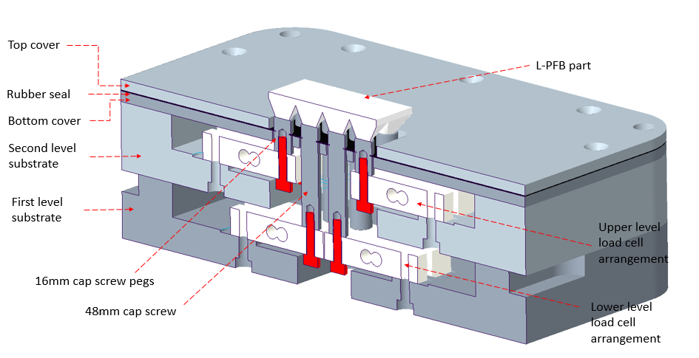
Figure 1: Cross-section of the Force Transducer Device (FTD) used for the in-situ measurements of forces induced during the L-PBF process; the FTD consists of sixteen load cells located in two chassis placed on top of one another and connected to the built-part via screw pegs (from [39]).

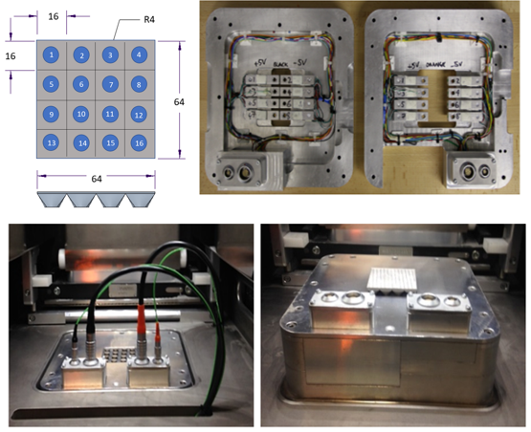
Figure 2: Force transducer device (FTD) showing the geometry of the manufactured part and the numbering of the load cells (top left), the load cells located in the two chassis (top right), the assembled FTD (bottom right) and set-up in a Renishaw AM250 machine with wiring for the load cells and thermocouples connected (bottom left).

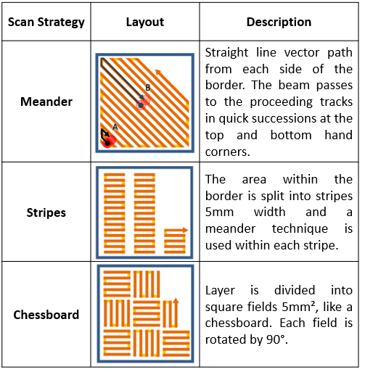
Figure 3: Description of scan strategies used in L-PBF processes.

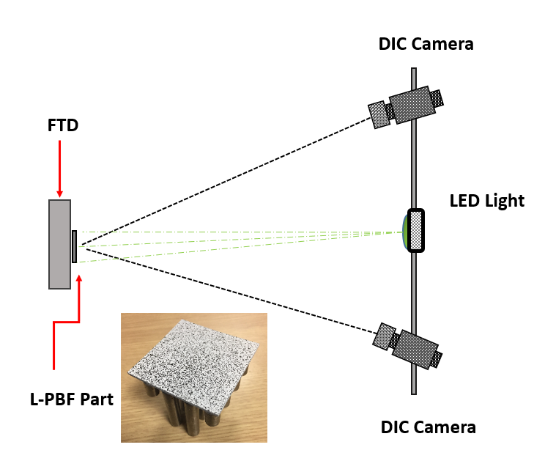
Figure 4: Experimental set-up for the digital image correlation (DIC) measurements of out-of-plane displacements of the parts during removal from the Force Transducer Device (FTD) and inset a photograph of the speckle pattern applied to the part after the build and before removal from the FTD.
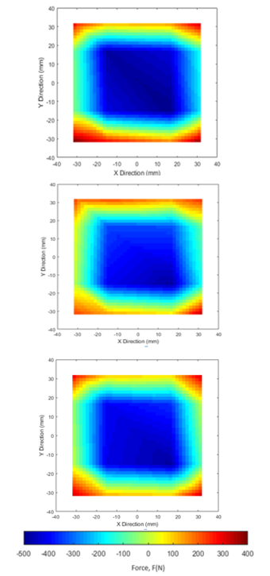
Figure 5: Contour maps of the measured forces on the completion of parts #1, #2 and #3 built with the Chessboard (top), Meander (middle) and Stripe (bottom) scan strategies respectively, see Table 1 for the process parameters. The building of each part was stopped when a load cell registered a force close to its maximum permissible value of 500 N.

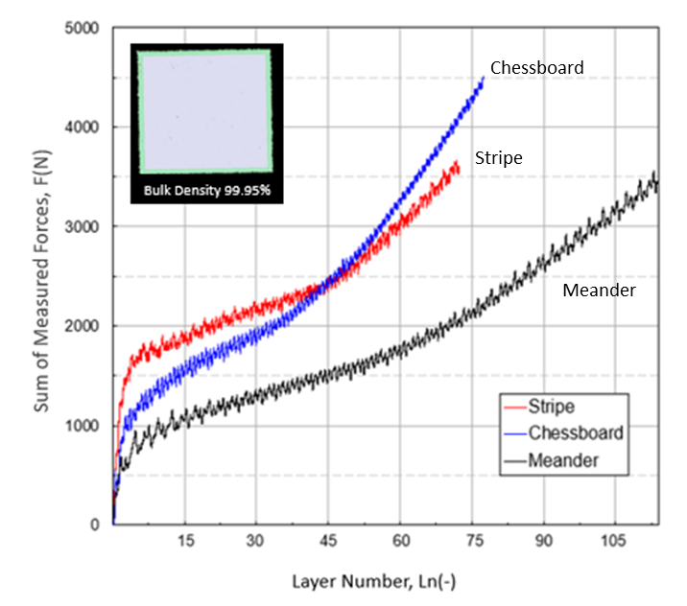
Figure 6: Comparison of the sum of the absolute forces measured using the FTD during the building of Ti-6Al-4V parts using Chessboard (part #1), Meander (part #2) and Stripe (part #3) scan strategies with the process parameters shown in Table 1 that were chosen to achieve part densities greater than 99.9% of the cast metal. The inset shows a typical level of porosity and in each case the build was stopped when the force on any load cell reached the maximum permissible value of 500 N.

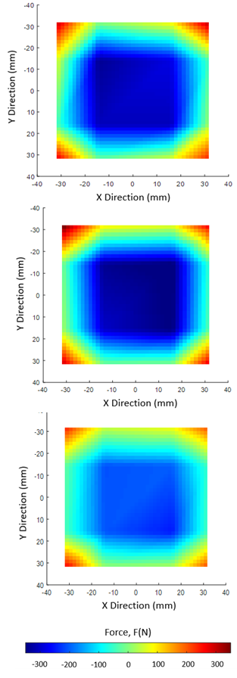
Figure 7: Contour maps of the measured forces at the completion of parts #3, #4 and #5 built with the Stripe scan strategy using values of laser power of 200 W (top), 180 W (middle) and 160 W (bottom) respectively, see Table 1 for the process parameters.

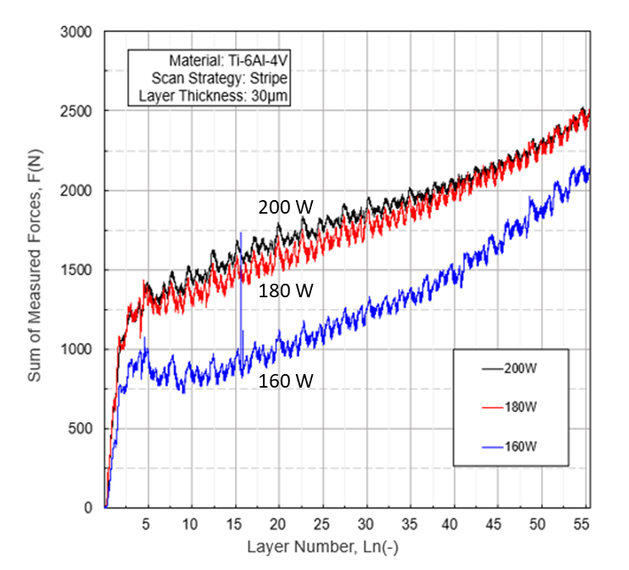
Figure 8: Sum of the absolute forces measured during the building of Ti-6Al-4V parts using the Stripe scan strategy and values for laser power of 200 W (part #3), 180 W (part #4) and 160 W (part #5) with the process parameters shown in Table 1.

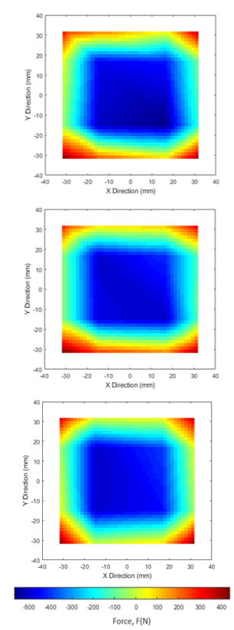
Figure 9: Contour maps of the measured forces at the completion of parts #6, #7 and #8 built with the Stripe scan strategy using values of point distance of 80 µm (top), 70 µm (middle) and 60 µm (bottom) respectively, see Table 1 for the process parameters.

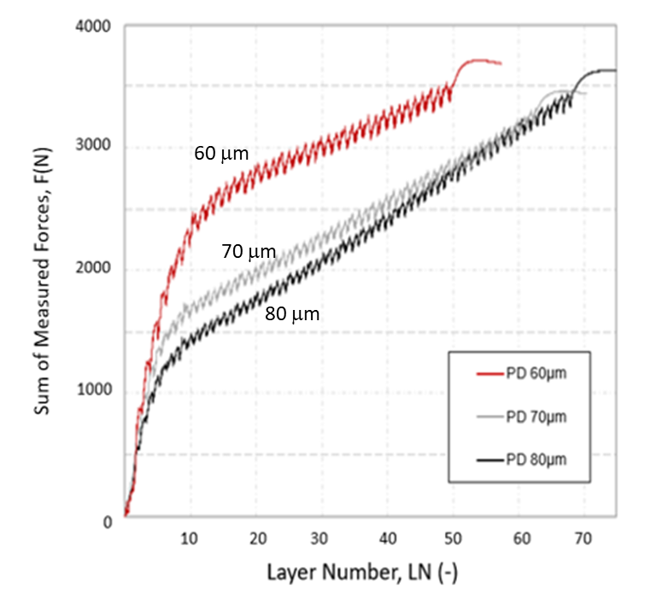
Figure 10: Sum of the absolute forces measured during the building of Inconel 625 parts using the Stripe scan strategy and values for point distance of 80 µm (part #6), 70 µm (part #7) and 60 µm (part #7) with the process parameters shown in Table 1; in each case, the build was stopped when the force on any load cell reached the maximum permissible value of 500 N.

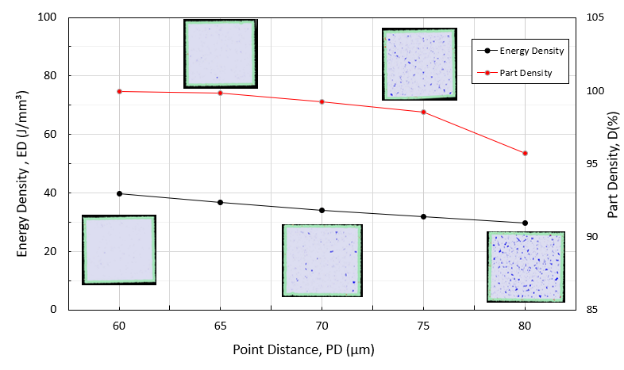
Figure 11: Effect of the variation of the Point Distance (PD) on the energy density and part density with the inset micrographs showing the porosity of the samples which were taken from 10 mm cubes.

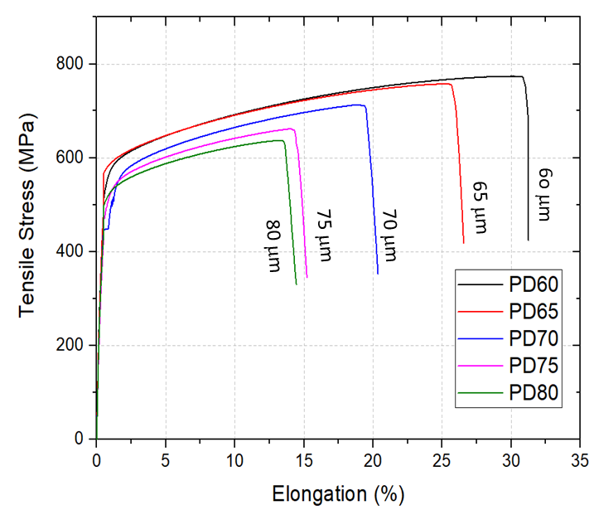
Figure 12: Stress-elongation plots from tensile tests on Inconel 625 samples with different values of point distance (PD).

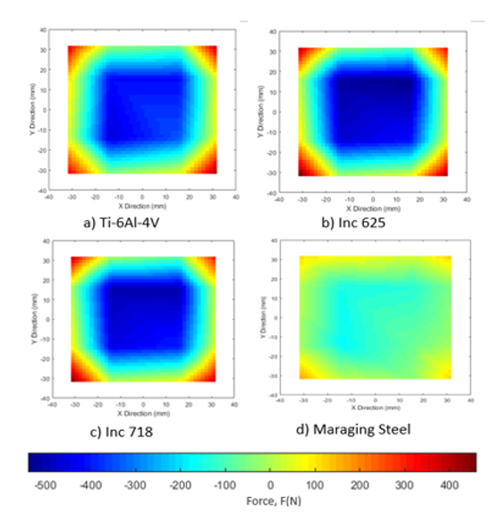

Figure 13: Contour maps of the measured forces at the completion of parts #8 to #11 with the Stripe scan strategy using high-temperature alloys Ti-6Al-4V (top left), Inconel 625 (top right) and Inconel 718 (bottom left) plus maraging steel (bottom right), see Table 1 for the process parameters. The parts were built until the maximum permissible load was reached by any of the load cells or until the maximum height of 4 mm was reached in the case of the maraging steel.

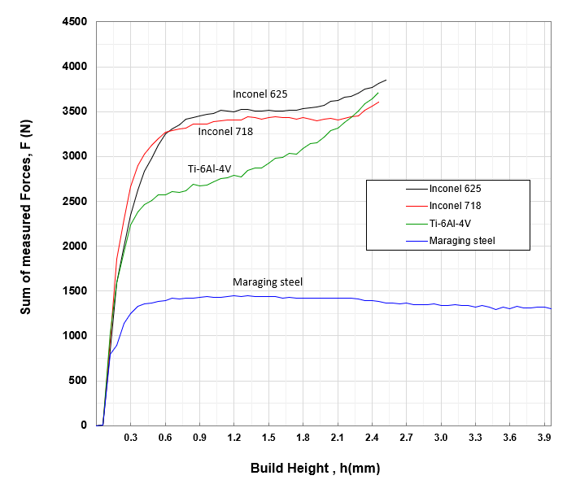
Figure 14: Comparison of the sum of the absolute forces measured during the building of parts #8 to #11 using four different metal powders and the process parameters for the Stripe scan strategy listed in Table 1. The parts were built until the maximum permissible load was reached by any of the load cells or until the maximum height of 4 mm was reached in the case of the maraging steel.

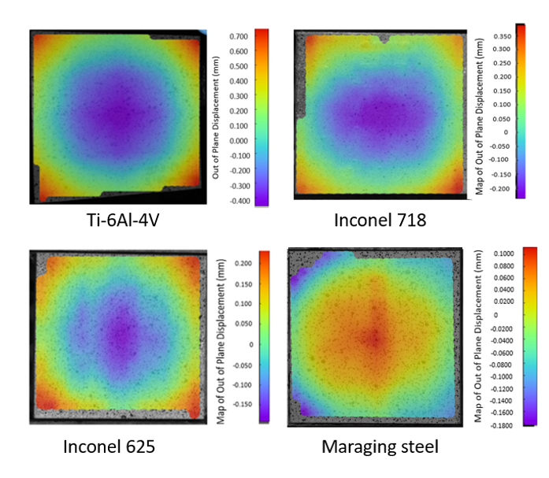
Figure 15: Contour maps of the out-of-plane displacements of parts #8 to #11 measured using DIC on removal from the FTD showing the parts built using high-temperature alloys Ti-6Al-4V (top left), Inconel 718 (top right) and Inconel 625 (bottom left) plus maraging steel (bottom right), see Table 1 for the process parameters.

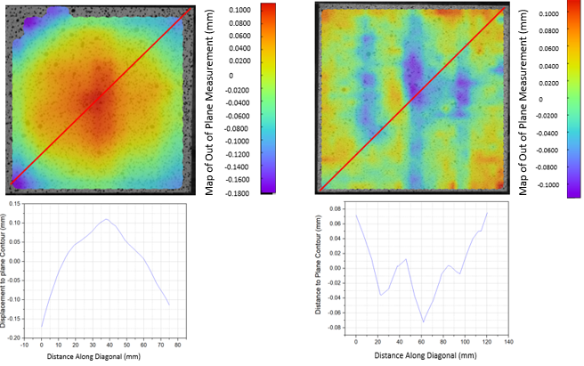

Figure 16: Comparison of DIC measurements of the out-of-plane displacements (positive towards the laser) after removal from the FTD for parts #11 and #12 built using maraging steel powder using argon (left) and nitrogen (right) as the inert gas.

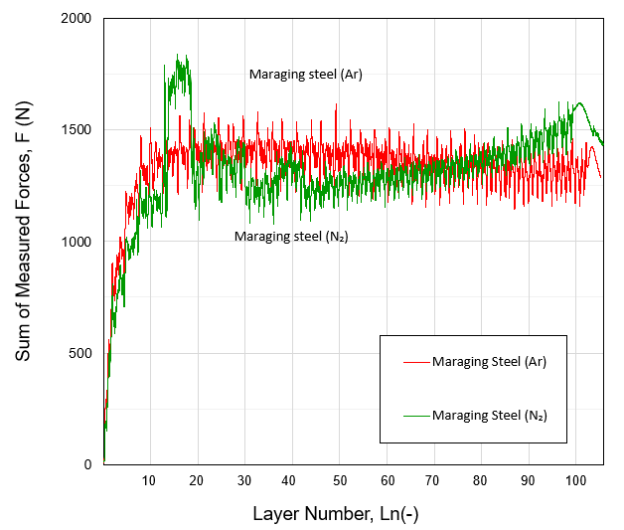
Figure 17: Sum of the absolute forces measured during the building of parts #11 and #12 using maraging steel with argon and nitrogen, respectively, as the inert gas atmosphere. See Table 1 for the processing parameters and Figure 16 for the out-of-plane displacements measured on removal from the FTD.

