Can landscape level semi-natural habitat compensate for pollinator biodiversity loss due to farmland consolidation?
Xiaoyu Shi¹, Haijun Xiao², Shudong Luo³, Jenny Hodgson⁴, Felix J.J.A. Bianchi⁵, Haimin He², Wopke van der Werf⁶, Yi Zou^{1*}
¹ Department of Health and Environmental Sciences, Xi'an Jiaotong-Liverpool University, Suzhou, China
² Institute of Entomology, Jiangxi Agricultural University, Nanchang, China
³ Institute of Apicultural Research, Chinese Academy of Agricultural Sciences, Key Laboratory of Pollinating Insect Biology, Ministry of Agriculture and Rural Affairs, Beijing, China
⁴ Institute of Integrative Biology, University of Liverpool, Liverpool, UK
⁵ Farming Systems Ecology, Wageningen University, Wageningen, The Netherlands
⁶ Centre for Crop Systems Analysis, Wageningen University, Wageningen, The Netherlands
*Corresponding: Yi Zou (yi.zou@xjtlu.edu.cn)
Abstract
Traditional farming landscapes in China consist of small irregular fields with an intimately interspersed semi-natural habitat network of field margins, but are increasingly converted into consolidated ones that consist of standardized fields with reduced areas of field margins and other semi-natural habitat. It is unclear how such farmland consolidation influences pollinator communities, and if there is a negative effect, whether this effect is mitigated by semi-natural habitat present in the wider landscape. We compared the diversity and abundance of wild pollinators in oilseed rape fields that were embedded in landscapes that consisted either of traditional or consolidated farmland. The landscapes spanned a range of semi-natural habitat area from 10% to 73% at a scale of one km radius in Jiangxi Province, China. Pollinators were sampled using pan traps during two years (2015 and 2019). Results showed that pollinator diversity was positively associated with the proportion of semi-natural habitat in both traditional and consolidated farming landscapes, but was higher in traditional farming landscapes. In both years, there was no difference in pollinator abundance between landscapes with traditional and consolidated fields. The results indicate that the network of field margins in traditional farmland supports a diverse pollinator community, and that land consolidation has equivalent effects on pollinator diversity as substantial decreases in semi-natural habitat in the wider landscape. The role of semi-natural habitat in supporting farmland biodiversity and its associated services needs therefore to be considered in plans for farmland consolidation.
Key words: semi-natural habitat, land reorganization, field margin, pollinator conservation, wild bee, China
1. Introduction
Pollinators play an important role in supporting global food production (Klein et al., 2007; Aizen et al., 2009; Vanbergen et al., 2013; Alomar et al., 2018; Woodcock et al., 2019), and there is therefore concern about the widespread decline of wild pollinators (Potts et al., 2010; Nicholls and Altieri, 2013; Potts et al., 2016). Many factors are involved in the decline of wild pollinators, including loss of floral resources and nesting sites, competition from managed honeybees, and use of broad-spectrum insecticides (Tscharntke et al., 2005; Le Féon et al., 2010; Potts et al., 2016). The capacity of the farming landscape to provide life support for wild pollinators, such as floral resources and nesting sites, is tightly linked with landscape composition and configuration (Martin et al., 2019; Sirami et al., 2019).
The farming landscape surrounding agricultural fields plays an important role for pollinator communities. Semi-natural habitats, such as forest and grassland, are beneficial for wild pollinators (Le Féon et al., 2010; Carvell, et al., 2011; Rader et al., 2014; Magrach et al., 2017), as these habitats provide diverse floral resources, nesting sites and nest building materials (Beduschi et al., 2018). Semi-natural habitat can either occur as relatively large patches of several hectares at larger distances from fields in the greater landscape, as is often the case in valley-range landscapes or it can also be finely interspersed as narrow bands (less than 1 m wide) between and along the fields within bunds, field margins and road verges. Scattered hedgerows and perennial shrubs on the field margins, are examples of finely interspersed semi-natural habitat. These finely interspersed patches can support a high diversity of pollinating insects in crops by providing complementary resource habitats within a short range from crops (Carvell, et al., 2011; Fahrig et al. 2011). However, these finely interspersed patches are difficult to quantify in landscape studies and therefore often overlooked (Woodcock et al., 2013).
Traditional farmland in China is heterogeneous and the great majority of Chinese farms (98% percent) are less than 2 hectares and are still largely managed by hand (Rapsomanikis, 2015). Fields are small with a typical area of one “Mu” (1/15 ha). Especially in hilly areas, fields are irregular in shape to follow contours in the terrain, and they are often surrounded by fine-scale network of bunds or field margins to allow people to move between the fields. Such traditional farmland is increasingly converted into landscapes with standardized rectangular fields to support mechanized crop production (Tang et al., 2019). For example, in the “well-facilitated farmland construction” projects, fragments are removed (General Administration of Quality Supervision, 2014). Standardized fields in “consolidated farmland” have a more regular (e.g. rectangular) shape than fields in traditional farmland, and their edges are kept barren or consist of concrete to allow access for agricultural machinery. Thus, in consolidation, finely interwoven semi-natural habitats in farmland is lost. While negative impacts of land consolidation have been reported on aquatic invertebrates (Nam et al., 2019) and wild plants (Osawa et al., 2016), the effect of land consolidation on wild pollinators has not been studied.
The abundance and diversity of wild pollinators in rice-oilseed rape production areas in southern China are influenced by landscape context (Zou et al., 2017). Zou et al. (2017) found that the abundance of wild pollinators in Jiangxi province, China, was positively associated with the area of arable land whereas the diversity of wild pollinators communities was positively associated with the area of semi-natural habitat (mostly forest). In the landscapes of Jiangxi studied by Zou et al. (2017) agriculture was concentrated in valleys while semi-natural habitat (mostly forest) dominated the more rocky and higher parts of the landscape (see also Zhang et al., 2020). Thus, most of the semi-natural habitat in Zou et al. (2017)’s study occurred at greater distances (hundreds of meters or more) from the focal fields in which pollinators were measured. The study of Zou et al. (2017) represents the influence of semi-natural habitat that is not directly associated with the field in field margins, but that is present in the landscape at large. Such semi-natural habitat strengthened pollinator diversity. It is unclear whether such habitats in the wider landscape that support pollinators can compensate for loss of finely interspersed semi-natural habitat close to fields in the cropland due to farmland consolidation. Moreover, it is unknown how much of such “far away” non-crop habitat would be needed to offset a loss in finely interspersed non-crop habitat.
The aim of this study was to assess the effect of land consolidation on the diversity and abundance of wild pollinator communities across landscapes in a semi-natural habitat gradient. We hypothesized that (i) there is a positive relationship between the proportion semi-natural habitat in the wider landscape and the diversity of wild pollinators; (ii) traditional farmland supports a higher wild pollinator diversity than consolidated farmland at a given proportion of semi-natural habitat in the whole landscape because of the presence of a finely interspersed network of field margins, and (iii) presence of substantial areas of semi-natural habitat in the landscape can mitigate the negative effects of farmland consolidation on wild pollinator communities. If the hypotheses are confirmed, we are interested in answering the question whether the effects of land consolidation and semi-natural habitat in the wider landscape are additive (Fig. 1A) or interactive (Fig. 1B). In both cases, it can be quantified which increase in semi-natural habitat at landscape level (indicated by orange arrows in Figure 1) is equivalent to the effect of land consolidation.
Figure 1.
2. Methods
2.1. Study sites
The study was conducted in Jiangxi Province, China (E115°53′, N28°41′) in 2015 and 2019. In both years we selected 18 focal oilseed rape fields. Sixteen fields were studied in both years, and four fields were studied in only one year. The minimum distance between two study sites was at least 4.5 km (Figure 2), which exceeds the maximum foraging range for most bee species (Steffan-Dewenter et al., 2002; Chifflet et al., 2011). All of the sites were at a similar elevation (39.9 ± 17.2 m). Eights fields in consolidated farmland while the other twelve fields were embedded in traditional farmland. The field sizes for consolidated and traditional farmland were 889 ± 364 m² and 813 ± 364 m², respectively (mean ± SD). We assessed the land use in the landscape surrounding the focal fields in GIS at a spatial scale of 1000 m radius at a resolution of 2.5 m in 2014, from the data center of the Chinese Academy of Sciences using ArcGIS 10.0. This resolution prohibited the inclusion of fine-scale field margin networks that were smaller than 2.5 m, therefore this fine-scale semi-natural habitat is not included in the quantification in the amount of semi-natural habitat in the landscape. Land-use types were then ground-truthed in 2014. We distinguished five land use categories: farmland, residential area, roads, semi-natural habitat (including forest, shrub and grassland) and other land use. The average area proportion of semi-natural habitat for consolidated and traditional farmland was 31.2 ± 18.6 % (range 10.0 – 64.1%), and 42.0 ± 21.9 % (range 12% – 71.3%), respectively (Figure 2). The spatial configuration of the landscapes around the 20 focal fields did not change between 2015 and 2019.
Figure 2.

2.2. Pollinator sampling
Pollinator communities in the focal oilseed rape fields were sampled by pan traps. Four trap stations were established in the center of each field at the corners of a 15x15 m² square. Each pan trap station consisted of a 1.5 m stake with three cups attached to the top of the stake and painted UV yellow, UV blue and UV white, respectively (Westphal et al., 2008). This height corresponded with the height of the flowering oilseed rape crop. The cups were filled with a saturated salt solution (NaCl). Both in 2015 and 2019, the traps were open between the end of February and the middle of April (51 ± 2 days), which encompassed the flowering period of oilseed rape across the 20 landscapes. No pesticides were applied in the focal oilseed rape fields during the sampling period. The cups were emptied and refilled five times each year at approximately 10-day intervals. Pollinator specimens were pooled for each field, sorted and identified. Ninety-two percent of the specimens were identified to species level by taxonomists, and the rest were identified to genus- or family level.

2.3. Data analysis
We explored how the abundance and diversity of the pollinator communities (response variables) were influenced by the consolidation status of landscapes and by the proportion of semi-natural habitat at the landscape scale (explanatory variables) using multiple linear regression. We used two metrics for pollinator diversity: the expected number of species for a rarefied individuals (i.e. species richness rarefied at 44 individuals, which was the lowest number of specimens encountered in the 20 sites, here after refers to rarefied species richness) and Hill’s ratio, which is a measure of species evenness. Hill’s ratio was calculated as e^{H’}/S, where H’ is Shannon-Wiener Index, e^{H’} is the effective number of species (Jost, 2006), and S is the total number of species. Hill’s ratio is a number between 0 and 1, tending to 0 in a very uneven community, and tending to 1 in an even community with similar numbers for all species. The abundance of wild pollinators was expressed as the number of individual per 50 sampling days, and then log transformed for normality assumption. We excluded the European honeybee (Apis mellifera, 9.9% of specimens) as these are managed by beekeepers and are considered independent from the landscape context. Explanatory variables were (i) proportion of semi-natural habitat at 1000 m radius (continuous variable), (ii) consolidation status of focal (and surrounding) fields (categorical, i.e. consolidated vs. traditional), and (iii) sampling year (2015 or 2019; categorical). We fitted linear regression models with normal errors for all three dependent variables (log abundance, rarefied species richness and Hill’s ratio, using these three predictors, assuming either additive effects, or additive effects plus interactions in all possible combinations, and then ranked the resulting models for each dependent variable using model ranking according to corrected Akaike Information Criterion (AICc). Selection of the best model was done using AICc and significance testing (see results). We also fitted all models using Site as a random effect, as the observations in the same landscape in different years can be considered as repeated measurements. Models without random effects as identified by model ranking with AICc were compared after refitting with maximum likelihood. We therefore did not consider the Site as a random effect in our results.
We assessed whether all models met normality criteria by inspecting the distribution of residuals (Zuur et al. 2009). Model residuals were checked for spatial autocorrelation using Moran’s I criterion (Gittleman & Kot, 1990). We detected no significant spatial correlation in any of the analyses (p > 0.05). We used the “vegan” package (Oksanen et al., 2019) to calculate the number of rarefied species and Hill’s ratio, and the “dredge” function from the “MuMIn” package (Bartoń 2015) for model selection. Moran’s I (Gittleman & Kot, 1990) of model residuals was calculated using the “ape” package (Paradis & Schliep, 2018).

3. Results
The pan trap sampling in 2015 and 2019 resulted in the collection of a total of 6910 wild pollinators, representing 85 species (Appendix 1). There were 73 Hymenoptera species, ten Diptera species and two Lepidoptera species. The bees Eucera floralia and Lasioglossum proximatum and the butterfly Pieris rapae were the most abundant species with 1401, 1130 and 1128 individuals, respectively.
Rarefied species richness of wild pollinator communities was higher in traditional than consolidated sites in both years (Table 1, Figure 3A, Figure 4A). Species richness was positively associated with the proportion semi-natural habitat (Table 1, Figure 4A) and was higher in 2019 than in 2015 (Table 1). The negative effect of land consolidation on species richness (-2.76 ± 0.72) was large compared to the effect of increasing the amount of semi-natural habitat from zero to 100% (5.00 ± 1.70). These regression estimates imply that the reduction in richness of wild pollinators in consolidated farmland was equivalent to a 55% (i.e. -2.76 / 5.00) reduction in proportion of semi-natural habitat at 1 km radius (Table 1, Figure 4A). No interaction was detected for the effect between semi-natural habitat and consolidation statue on species richness for all models with AICc<2 (Appendix 3). Hill’s ratio of wild pollinator communities was marginally significantly higher in traditional than consolidated fields, while there was a significant interaction between the proportion of semi-natural habitat and year for Hill’s ratio (Table 1, Figure 3B, Figure 4B, Appendix 2B). There was interaction between semi-natural habitat and consolidation statue on Hill’s ratio for the second best model, but the effect was not significant (Appendix 3).
Table 1.
Figure 3.
The selected model for the abundance of wild pollinators included the proportion of semi-natural habitat and year, as well as their interaction (Table 1). The significant interaction indicated that although the main effect of semi-natural habitat on wild pollinator abundance was negative (Figure 4C), this effect was stronger in 2015 than in 2019 (Table 1, Appendix 2C). Land consolidation status was not selected in the best model, indicating that land consolidation did not affect the abundance of wild pollinators (Table 1).
Figure 4.
4. Discussion
Land consolidation projects are steadily increasing in China (Li et al., 2019; Tang et al., 2019), but the consequences of land consolidation for farmland biodiversity are largely unknown. Here we report that (i) wild pollinator richness and evenness were lower in oilseed rape fields in consolidated than in traditional farmland; (ii) the species richness of wild pollinators was positively associated with the proportion semi-natural habitat in the landscape, while the abundance of wild pollinators was negatively associated with the proportion semi-natural habitat in the landscape; and (iii) the loss of diversity of wild pollinators due to land consolidation is substantial and equivalent to the estimated effect size of a 55% reduction in semi-natural habitat.
The lower richness and evenness of wild pollinator communities in landscapes with consolidated farmland as compared to traditional farmland is in line with our first hypothesis, and aligns with findings for aquatic invertebrate in Korean rice systems (Nam et al., 2019) and plant communities in Japan (Osawa et al., 2016). The relatively low pollinator diversity in consolidated fields might be associated with the deterioration of the fine-scale network of vegetation on the edges between fields, as the management of the oilseed rape crops was similar, i.e., based on farmer’s own practice. These fine scale field margins can provide important life support functions for pollinators (Marshall and Moonen, 2002), including nectar and pollen in periods that crops are not flowering (Morandin and Winston 2006; Memmott et al., 2010; Kutt et al., 2016), by providing nesting sites for ground-nesting bees (Gathmann & Tscharntke, 2002; Ullmann et al., 2016), and refuge for a broad range of pollinators during disturbances (e.g. tilling and pesticide application). Field margins in consolidated farmland often consists of barren soil with little vegetation, or concrete irrigation ditches with paved roads between fields, while traditional farmland has vegetated margins and unpaved roads with associated vegetation (Li et al., 2019). Therefore, field margins in consolidated landscapes can support much less vegetation and associated resources for wild pollinators than those in traditional farmland. As vegetated margins in traditional farmland are narrow and ubiquitous, the quantification of all these small elements within fields in the heterogeneous farming landscape is extremely difficult. While further work is needed to ascertain what resources these vegetated margins provide, our findings indicate that traditional farmland with finely interspersed networks of field margin vegetation support a higher pollinator diversity than consolidated ones.
The positive relationship between pollinator diversity and the proportion of semi-natural habitat is consistent with our second hypothesis and is in line with several other studies (Ricketts et al., 2008; Garibaldi et al., 2011; Zou et al., 2017; Eeraerts et al., 2019; Rollin et al., 2019). This confirms the importance of maintaining semi-natural habitat in the agroecosystems for the conservation of wild pollinators. In contrast to pollinator diversity, wild pollinator abundance was negatively associated with the proportion of semi-natural habitat, although this pattern was less pronounced in 2019 than in 2015. The higher abundance of wild pollinators in 2015 than in 2019 may be partly explained by more rainy conditions in 2019 (i.e. 5 more rainy days in 2019 than in 2015; National Meteorological Center, 2019). The negative association between wild pollinator abundance and semi-natural habitat at a 1 km radius may be explained by the fact that landscapes with relatively little semi-natural habitats tended to have a relative large proportion of cropland, which can provide ample resources for wild pollinators when oilseed rape is flowering during parts of March and April because these fields may be colonized by wild plants at that time (Zou et al., 2017). Thus, oilseed rape dominated landscapes may support an abundant albeit relatively species poor pollinator community (Zou et al., 2017). Since land consolidation affects the amount and composition of field margins but not so much the area and composition of crops, the crop-mediated amount of resources for wild pollinators is not expected to be changed, which is consistent with our findings of the absence of an association between land consolidation and wild pollinator abundance.
Our data did not confirm our third hypothesis that land consolidation has a stronger impact on wild pollinator communities in landscapes with little semi-natural habitat than in landscapes with substantial semi-natural habitat. That is, we did not find a significant interaction between the consolidation status of farmland (consolidated vs. traditional) and the proportion semi-natural habitat for the diversity and abundance of wild pollinators. This finding supports the additive effects hypothesis for pollinator diversity depicted in Fig. 1A and do not the interactive effects hypothesis depicted in Fig. 1B. For pollinator abundance, neither of these hypotheses was supported because land consolidation did not affect pollinator abundance, while the proportion of semi-natural habitat did affect pollinator abundance, but negatively.
Our findings on species richness suggest that semi-natural habitats, such as forests, and fine-grained networks of field margins are complementary for supporting wild pollinator communities, and that field margins may provide habitat for certain species that are otherwise lost in consolidated farmland. For example, some of Lasioglossum spp. are ground nesting bees that have a limited mobility (Zurbuchen et al., 2010). When there is no nearby forest present, such species are likely to be only encountered when nearby field margins with suitable nesting sites are available. On the other hand, woody semi-natural habitats can provide nesting habitat for bees that depend on cavities in wood, such as Osmia spp., and these species are most likely less strongly dependent on field margins, and possibly less threatened by land consolidation as long as no woody habitats are removed. Comprehensive understanding of the habitat preference for each species’ would help explain our results, but such studies are unfortunately widely lacking.
Our results suggest that semi-natural habitat can be a factor that offsets wild pollinator species richness loss due to land consolidation. The clearest implication of this result is that semi-natural habitat within 1km of fields should be retained where it occurs. However, it is likely slow and expensive to restore semi-natural habitat in landscapes from which it has already been lost. Depending on the focal landscape, then, there may be several alternative options to avoid loss of pollinator diversity, and it is prudent to consider the practicality of all the options at field level, holding level and landscape level. If the establishment of woody habitats is not feasible alongside land consolidation, the establishment of fine-grained networks with flowering plant species and nesting sites may provide a feasible option to reduce negative impacts on the diversity of wild pollinators to some extent. The degree of offset that is achievable is uncertain, based on our single 2-year study and therefore needs to be interpreted with caution.

5. Conclusion
While China hosts a substantial proportion of the global wild pollinator species (Ren et al., 2018), there is increasing concern about the decline of pollinators. Traditional small-holder farmland in China is in transition as these fields are not suitable for mechanized agriculture. Although farmland consolidation seems to be inevitable (Demetriou, 2012; Li et al., 2019; Tang et al., 2019), the associated loss of pollinator diversity needs to be addressed. On the one hand, robust woody semi-natural habitats that support pollinator biodiversity need to be protected. On the other hand, (re)establishing fine-grained networks of field margins could play a role in mitigation efforts to counteract impacts of land consolidation programs on wild pollinators diversity. It is noteworthy that land consolidation projects in other part of China might have a different situation (e.g. in terms of field size and concrete field margins). Therefore, nationwide effect of land consolidation on pollinator biodiversity require further evaluation.
Acknowledgement
We thank Huanli Xu from China Agricultural University for identifying our samples. We also thank Feiran Wang, Hainan Chong and Ting Jiang for their help in field work. We thank Dongyue Yan and Xinming Huang for lab assistances. This study was financially supported by National Natural Science Foundation of P.R. China (31700363, 31660539), Jiangsu Science and Technology Department (BK20181191), the Fundamental Research Funds of Chinese Academy of Agricultural Sciences (Y2019XK13), and the Division for Earth and Life Sciences of the Netherlands Organization for Scientific Research (grant 833.13.004). Xiaoyu Shi is supported by Xi'an Jiaotong-Liverpool University research and development fund (RDF170107).
References
Aizen, M. A., Garibaldi, L. A., Cunningham, S. A., Klein, A. M. 2009. How much does agriculture depend on pollinators? Lessons from long-term trends in crop production. Annals of Botany 103, 1579-1588.
Alomar, D., Gonzalez-Estevez, M. A., Traveset, A., Lazaro, A. 2018. The intertwined effects of natural vegetation, local flower community, and pollinator diversity on the production of almond trees. Agriculture Ecosystems & Environment 264, 34-43.
Bartoń, K., 2015. MuMIn: Multi-Model Inference. R package version 1.13.4.
Beduschi, T., Kormann, U. G., Tscharntke, T., Scherber, C., 2018. Spatial community turnover of pollinators is relaxed by semi-natural habitats, but not by mass-flowering crops in agricultural landscapes. Biological Conservation 221, 59-66.
Carvell, C., Osborne, J. L., Bourke, A. F. G., Freeman, S. N., Pywell, R. F., Heard. M. S., 2011. Bumble bee species' responses to a targeted conservation measure depend on landscape context and habitat quality. Ecological Applications 21, 1760-1771.
Chifflet, R., Klein, E. K., Lavigne, C., Le Féon, V., Ricroch, A. E., Lecomte, J., Vaissièrè, B. E., 2011. Spatial scale of insect-mediated pollen dispersal in oilseed rape in an open agricultural landscape. Journal of Applied Ecology 48, 689–696.
Demetriou, D., 2016. The assessment of land valuation in land consolidation schemes: The need for a new land valuation framework. Land Use Policy 54, 487-498.
Eeraerts, M., Smagghe, G., Meeus, I., 2019. Pollinator diversity, floral resources and semi-natural habitat, instead of honey bees and intensive agriculture, enhance pollination service to sweet cherry. Agriculture Ecosystems & Environment 284, 106586.
Garibaldi, L. A., Steffan-Dewenter, I., Kremen, C., Morales, J. M., Bommarco, R., Cunningham, S. A., Carvalheiro, L. G., Chacoff, N. P., Dudenhoffer, J. H., Greenleaf, S. S., Holzschuh, A., Isaacs, R., Krewenka, K., Mandelik, Y., Mayfield, M. M., Morandin, L. A., Potts, S. G., Ricketts, T. H., Szentgyorgyi, H., Viana, B. F., Westphal, C., Winfree, R., Klein, A. M., 2011. Stability of pollination services decreases with isolation from natural areas despite honey bee visits. Ecology Letters 14, 1062-1072.
Gathmann, A., Tscharntke, T., 2002. Foraging ranges of solitary bees. Journal of Animal Ecology 71, 757-764.
General Administration of Quality Supervision. 2014. Inspection and Quarantine of China and Standardization Administration of China (2014) Well-facilitated farmland construction- General rules. GB/T 30600-32014.
Gittleman, J. L., Kot, M., 1990. Adaptation: statistics and a null model for estimating phylogenetic effects. Systematic Zoology 39, 227-241.
Jost, L., 2006. Entropy and diversity. Oikos 113, 363-375.
Klein, A. M., Vaissiere, B. E., Cane, J. H., Steffan-Dewenter, I., Cunningham, S. A., Kremen, C., Tscharntke, T., 2007. Importance of pollinators in changing landscapes for world crops. Proceedings of the Royal Society B-Biological Sciences 274, 303-313.
Kutt, L., Lohmus, K., Rammi, I.J., Paal, T., Paal, J., Liira, J., 2016. The quality of flower-based ecosystem services in field margins and road verges from human and insect pollinator perspectives. Ecological Indicators 70, 409-419.
Le Féon, V., Schermann-Legionnet, A., Delettre, Y., Aviron, S., Billeter, R., Bugter, R., Hendrickx, F., Burel, F., 2010. Intensification of agriculture, landscape composition and wild bee communities: A large scale study in four European countries. Agriculture Ecosystems & Environment 137, 143-150.
Le Féon, V., Poggio, S. L., Torretta, J. P., Bertrand, C., Molina, G. A. R., Burel, F., Baudry, J., Ghersa, C. M., 2016. Diversity and life-history traits of wild bees (Insecta: Hymenoptera) in intensive agricultural landscapes in the Rolling Pampa, Argentina. Journal of Natural History 50, 1175-1196.
Li, P. Y., Chen, Y. J., Hu, W. H., Li, X., Yu, Z. R., Liu, Y. H., 2019. Possibilities and requirements for introducing agri-environment measures in land consolidation projects in China, evidence from ecosystem services and farmers' attitudes. Science of the Total Environment 650, 3145-3155.
Magrach, A., Holzschuh, A., Bartomeus, I., Riedinger, V., Roberts, S. P. M., Rundlof, M., Vujic, A., Wickens, J. B., Wickens, V.J., Bommarco, R., Gonzalez-Varo, J. P., Potts, S. G., Smith, H. G., Steffan-Dewenter, I., Vila, M., 2018. Plant-pollinator networks in semi-natural grasslands are resistant to the loss of pollinators during blooming of mass-flowering crops. Ecography 41, 62-74.
Marshall, E. J. P., Moonen, A. C., 2002. Field margins in northern Europe: Their functions and interactions with agriculture. Agriculture Ecosystems and Environment 89, 5-21.
Martin, E. A., Dainese, M., Clough, Y., Baldi, A., Bommarco, R., Gagic, V., Garratt, M. P. D., Holzschuh, A., Kleijn, D., Kovacs-Hostyanszki, A., Marini, L., Potts, S. G., Smith, H. G., Al Hassan, D., Albrecht, M., Andersson, G. K. S., Asis, J. D., Aviron, S., Balzan, M. V., Banos-Picon, L., Bartomeus, I., Batary, P., Bure, F., Caballero-Lopez, B., Concepcion, E. D., Coudrain, V., Danhardt, J., Diaz, M., Diekotter, T., Dormann, C. F., Duflot, R., Entling, M.H ., Farwig, N., Fischer, C., Frank, T., Garibaldi, L. A., Hermann, J., Herzog, F., Inclan, D., Jacot, K., Jauker, F., Jeanneret, P., Kaiser, M., Krauss, J., Le Feon, V., Marshal, J., Moonen, A.C., Moreno, G., Riedinger, V., Rundlof, M., Rusch, A., Scheper, J., Schneider, G., Schuepp, C., Stutz, S., Sutter, L., Tamburini, G., Thies, C., Tormos, J., Tscharntke, T., Tschumi, M., Uzman, D., Wagner, C., Zubair-Anjum, M., Steffan-Dewenter, I., 2019. The interplay of landscape composition and configuration: new pathways to manage functional biodiversity and agroecosystem services across Europe. Ecology Letters 22, 1083-1094.
Memmott, J., Carvell, C., Pywell, R. F., Craze, P. G., 2010. The potential impact of global warming on the efficacy of field margins sown for the conservation of bumble-bees. Philosophical Transactions of the Royal Society B-Biological Sciences 365, 2071-2079.
Morandin, L. A., Winston, M. L., 2006. Pollinators provide economic incentive to preserve natural land in agroecosystems. Agriculture Ecosystems & Environment 116, 289-292.
Nam, H. K., Yoon, S. S., Song, Y. J., Kwon, S. I., Eo, J., Kim, M. H., 2019. Influence of land consolidation on aquatic invertebrate communities and their distribution patterns in Korean rice fields. Entomological Research 49, 436-448.
National Meteorological Center., 2019. URL http://data.cma.cn, (accessed: August 2019).
Nicholls, C. I., Altieri, M.A., 2013. Plant biodiversity enhances bees and other insect pollinators in agroecosystems. A review. Agronomy for Sustainable Development 33, 257-274.
Oksanen, J., Blanchet, F. G., Friendly, M., Kindt, R., Legendre, P., McGlinn, D., Minchin, P. R., O'Hara, R. B., Simpson, G. L., Solymos, P., Stevens, M. H., Szoecs, E., Wagner, H., 2019. Vegan: Community Ecology Package. R Package Version. 2.0-10.
Osawa, T., Kohyama, K., Mitsuhashi, H., 2016. Trade-off relationship between modern agriculture and biodiversity: Heavy consolidation work has a long-term negative impact on plant species diversity. Land Use Policy 54, 78-84.
Paradis E. & Schliep K. (2018). ape 5.0: an environment for modern phylogenetics and evolutionary analyses in R. Bioinformatics 35, 526-528.
Potts, S.G., Biesmeijer, J.C., Kremen, C., Neumann, P., Schweiger, O., Kunin, W. E., 2010. Global pollinator declines: trends, impacts and drivers. Trends in Ecology & Evolution 25, 345-353.
Potts, S. G., Imperatriz-Fonseca, V., Ngo, H. T., Aizen, M. A., Biesmeijer, J. C., Breeze, T. D., Dicks, L. V., Garibaldi, L. A., Hill, R., Settele, J., Vanbergen, A. J., 2016. Safeguarding pollinators and their values to human well-being. Nature 540, 220-229.
R Core Team., 2014. R: A language and environment for statistical computing. R Foundation for Statistical Computing, Vienna, Austria.
Rader, R., Bartomeus, I., Tylianakis, J.M., Laliberte, E., 2014. The winners and losers of land use intensification: pollinator community disassembly is non-random and alters functional diversity. Diversity and Distributions 20, 908-917.
Rapsomanikis, G., 2015. The economic lives of smallholder farmers: An analysis based on household data from nine countries. Rome: Food and Agriculture Organization of the United Nations.
Ren, Z. X., Zhao, Y. H., Liang, H., Tao, Z. B., Tang, H., Zhang, H. P., Wang, H., 2018. Pollination ecology in China from 1977 to 2017. Plant Diversity 40, 172-180.
Ricketts, T. H., Regetz, J., Steffan-Dewenter, I., Cunningham, S. A., Kremen, C., Bogdanski, A., Gemmill-Herren, B., Greenleaf, S. S., Klein, A. M., Mayfield, M. M., Morandin, L. A., Ochieng, A., Viana, B. F., 2008. Landscape effects on crop pollination services: are there general patterns? Ecology Letters 11, 499-515.
Rollin, O., Perez-Mendez, N., Bretagnolle, V., Henry, M., 2019. Preserving habitat quality at local and landscape scales increases wild bee diversity in intensive farming systems. Agriculture Ecosystems & Environment 275, 73-80.
Sirami, C., Gross, N., Baillod, A.B., Bertrand, C., Carrie, R., Hass, A., Henckel, L., Miguet, P., Vuillot, C., Alignier, A., Girard, J., Batary, P., Clough, Y., Violle, C., Giralt, D., Bota, G., Badenhausser, I., Lefebvre, G., Gauffre, B., Vialatte, A., Calatayud, F., Gil-Tena, A., Tischendorf, L., Mitchell, S., Lindsay, K., Georges, R., Hilaire, S., Recasens, J., Sole-Senan, X. O., Robleno, I., Bosch, J., Barrientos, J. A., Ricarte, A., Marcos-Garcia, M. A., Minano, J., Mathevet, R., Gibon, A., Baudry, J., Balent, G., Poulin, B., Burel, F., Tscharntke, T., Bretagnolle, V., Siriwardena, G., Ouin, A., Brotons, L., Martin, J.L., Fahrig, L., 2019. Increasing crop heterogeneity enhances multitrophic diversity across agricultural regions. Proceedings of the National Academy of Sciences of the United States of America 116, 16442-16447.
Steffan-Dewenter, I., Munzenberg, U., Burger, C., Thies, C., Tscharntke, T., 2002. Scale dependent effects of landscape context on three pollinator guilds. Ecology 83, 1421–1432.
Tang, H., Yun, W., Liu, W., Sang, L., 2019. Structural changes in the development of China’s farmland consolidation in 1998–2017: Changing ideas and future framework. Land Use Policy, 89, 104212.
Thies, C., Tscharntke. T., 1999. Landscape Structure and Biological Control in Agroecosystems. Science, 285, 893-895.
Tscharntke, T., Klein, A. M., Kruess, A., Steffan-Dewenter, I., Thies, C., 2005. Landscape perspectives on agricultural intensification and biodiversity-ecosystem service management. Ecology Letters 8, 857-874.
Ullmann, K. S., Meisner, M. H., Williams, N. M., 2016. Impact of tillage on the crop pollinating, ground-nesting bee, Peponapis pruinosa in California. Agriculture Ecosystems & Environment, 232, 240-246.
Vanbergen, A. J., Baude, M., Biesmeijer, J. C., Britton, N. F., Brown, M. J. F., Brown, M., Bryden, J., Budge, G. E., Bull, J. C., Carvell, C., Challinor, A. J., Connolly, C. N., Evans, D. J., Feil, E. J., Garratt, M. P., Greco, M. K., Heard, M. S., Jansen, V. A. A., Keeling, M. J., Kunis, W. E., Marris, G. C., Memmott, J., Murray, J. T., Nicolson, S. W., Osborne, J. L., Paxton, R. J., Pirk, C. W. W., Polce, C., Potts, S. G., Priest, N. K., Raine, N. E., Roberts, S., Ryabov, E. V., Shafir, S., Shirley, M. D. F., Simpson, S. J., Stevenson, P. C., Stone, G. N., Termansen, M., Wright, G. A., Initiative, I. P., 2013. Threats to an ecosystem service: pressures on pollinators. Frontiers in Ecology and the Environment 11, 251-259.
Westphal, C., Bommarco, R., Carre, G., Lamborn, E., Morison, N., Petanidou, T., Potts, S.G., Roberts, S. P. M., Szentgyorgyi, H., Tscheulin, T., Vaissiere, B. E., Woyciechowski, M., Biesmeijer, J. C., Kunin, W. E., Settele, J., Steffan-Dewenter, I., 2008. Measuring Bee Diversity in Different European Habitats and Biogeographical Regions. Ecological Monographs 78, 653-671.
Woodcock, B.A., Edwards, M., Redhead, J., Meek, W.R., Nuttall, P., Falk, S., Nowakowski, M., Pywell, R.F., 2013. Crop flower visitation by honeybees, bumblebees and solitary bees: Behavioural differences and diversity responses to landscape. Agriculture Ecosystems & Environment 171, 1-8.
Woodcock, B. A., Garratt, M. P. D., Powney, G. D., Shaw, R.F., Osborne, J. L., Soroka, J., Lindstrom, S. A. M., Stanley, D., Ouvrard, P., Edwards, M. E., Jauker, F., McCracken, M. E., Zou, Y., Potts, S. G., Rundlof, M., Noriega, J.A., Greenop, A., Smith, H. G., Bommarco, R., van der Werf, W., Stout, J. C., Steffan-Dewenter, I., Morandin, L., Bullock, J. M., Pywell, R. F., 2019. Meta-analysis reveals that pollinator functional diversity and abundance enhance crop pollination and yield. Nature Communications 10, 1481.
Zhang, X., Xie, H., Shi, J., Lv, T., Zhou, C., Liu, W., 2020. Assessing Changes in Ecosystem Service Values in Response to Land Cover Dynamics in Jiangxi Province, China. International Journal of Environmental Research and Public Health 17.
Zou, Y., Bianchi, F. J. J. A., Jauker, F., Xiao, H. J., Chen, J. H., Cresswell, J., Luo, S. D., Huang, J. K., Deng, X. Z., Hou, L. L., van der Werf, W., 2017. Landscape effects on pollinator communities and pollination services in small-holder agroecosystems. Agriculture Ecosystems & Environment 246, 109-116.
Zurbuchen, A., Landert, L., Klaiber, J., Muller, A., Hein, S., Dorn, S., 2010. Maximum foraging ranges in solitary bees: only few individuals have the capability to cover long foraging distances. Biological Conservation 143, 669-676.
Table 1. Overview of most parsimonious models the number of rarefied species, Hill's ratio, the abundance of wild pollinator in response to consolidation status (base: traditional farmland), Year (base: 2015) and proportion of semi-natural habitat. Values indicate the model estimates and standard errors. The “/” indicates that this variable was not included in the model. Asterisks show the significance levels: ‘*’ p < 0.05, ‘**’ p < 0.01 and ‘***’ p < 0.001.

Explanatory variable | Rarefied species diversity | Hill's ratio | Wild pollinator abundance
Consolidation status | -2.76±0.72*** | -0.08±0.04* | /
Year | 3.07±0.68 *** | 0.35±0.07 *** | -1.08±0.27 ***
Semi-natural habitat | 5.00±1.70 ** | 0.35±0.11 ** | -2.70±0.41 ***
Consolidation status*Year | / | / | /
Semi-natural habitat *Year | / | -0.53±0.17 ** | 1.98 ± 0.64 **
Consolidation status*Semi-natural habitat | / | / | /
Consolidation status * Semi-natural habitat * Year | / | / | /

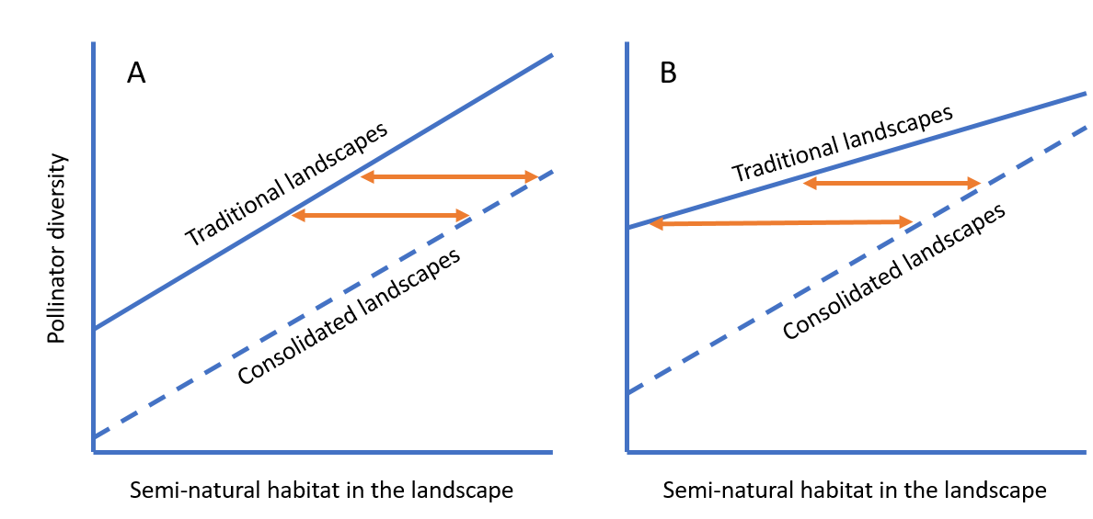
Figure 1. Hypothesized relationships between pollinator diversity (y-axis) and semi-natural habitat (x-axis) in traditional and consolidated landscapes (drawn and dashed lines). The orange arrows indicate the amount of semi-natural habitat that is needed to offset the effect of land consolidation. Case A assumes the effects of land consolidation and semi-natural habitat in the wider landscape are additive. Case B assumes the effects are interactive.

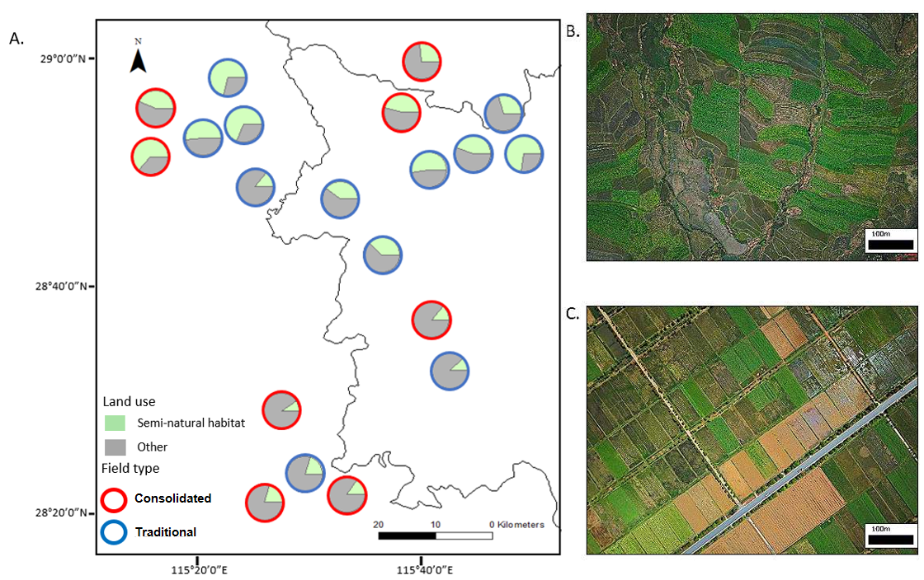
Figure 2. Locations of study sites (A), with pie charts indicating the proportion of semi-natural habitat and lines indicating the administrative boundaries; and an example of traditional (B) and consolidated farmland (C) (Photos by Xiaoyu Shi).
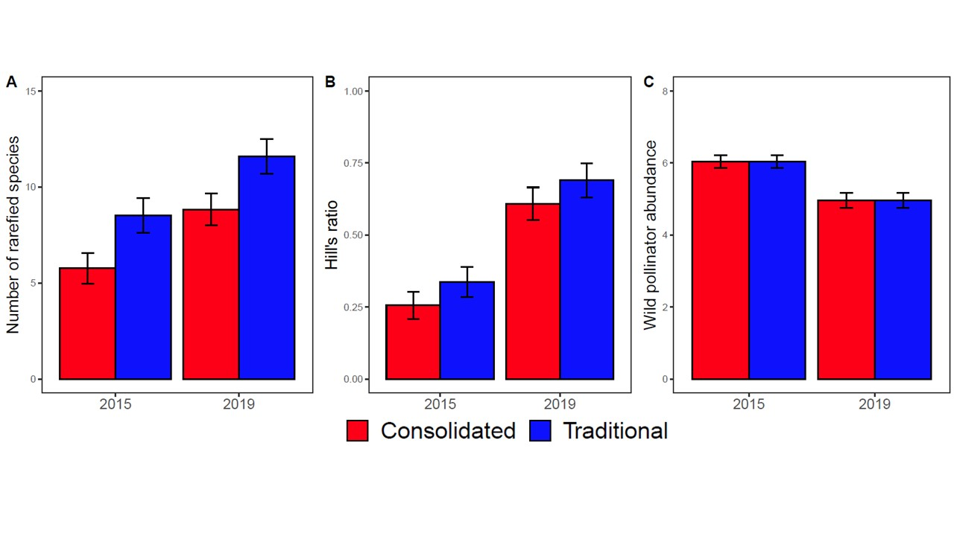
Figure 3. The effect of farmland consolidation on the species richness (estimated based on rarefaction, A), Hill’s ratio (B), and the log abundance of wild pollinators (C). The significance levels can be found in Table 1.

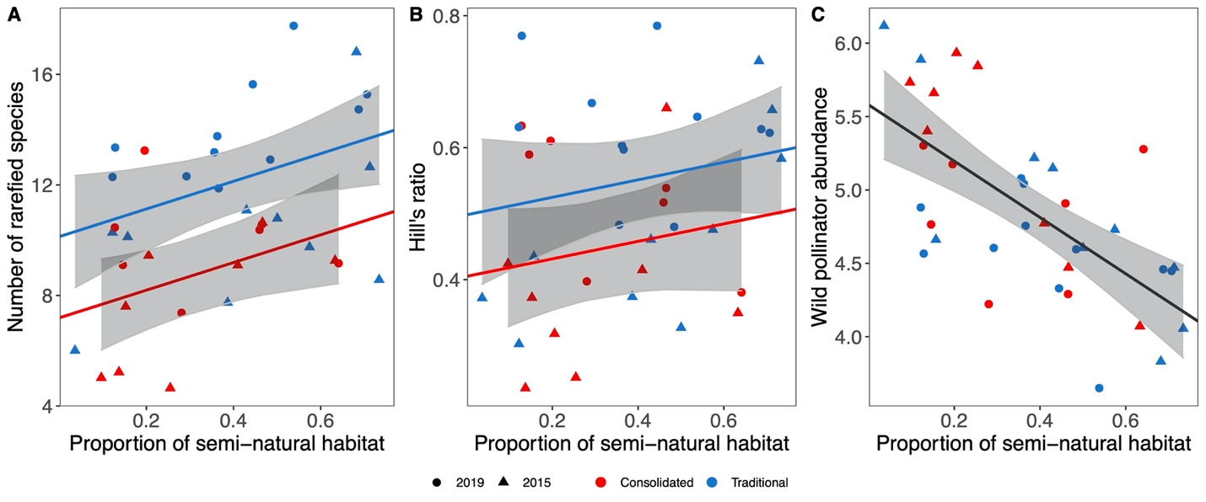
Figure 4. Relationship between the proportion of semi-natural habitat and the species richness (estimated based on rarefaction, A), Hill’s ratio (B), and the abundance of wild pollinators (C). Lines show linear regressions averaged over the two years of the study. Line color indicate regressions for consolidated fields (red) and traditional fields (blue, A and B), and regressions for pooled data (black, C). Plots of regressions for specific years can be found in Appendix 2.

