Agricultural expansion in African savannas – dissimilar effects on composition of trees and mammals
Hemant G. Tripathi*^{1, 2}, Emily S. Woollen², Mariana Carvalho³, Catherine L. Parr ^{4, 5, 6}, Casey M. Ryan²
*hgtripathi05@gmail.com
¹ Faculty of Biological Sciences, University of Leeds, LS2 9JT, UK
² School of Geosciences, University of Edinburgh, Edinburgh EH9 3FF, UK
³ Birdlife International, West Africa Sub-Regional Office, Accra, Ghana
⁴ School of Environmental Sciences, University of Liverpool, Liverpool L69 3GP, UK
⁵ Department of Zoology & Entomology, University of Pretoria, Pretoria 0002, South Africa
⁶ School of Animal, Plant and Environmental Sciences, University of the Witwatersrand, Wits 2050, South Africa

Abstract
Anthropogenic land use is a major driver of biodiversity loss across the planet. However, the global understanding of land use-biodiversity change is mainly based on comparisons of land use endpoints (habitat vs non-habitat) in forest ecosystems. Hence, it may not generalise to ecosystems such as savannas which are ecologically distinct from forests, inherently patchy, and disturbance adapted. We aim to address this geographical and theoretical gap by investigating species- and community-level responses of mammals and trees along a gradient of agricultural expansion, from more intact to highly fragmented woody landscapes, in the Miombo – the southern African savanna woodlands, of northern Mozambique.
Tree abundance, mammal occupancy, and species richness showed a non-linear relationship with agricultural expansion (Land Division Index, LDI) - increasing at intermediate LDI (0.25 to 0.65), decreasing beyond LDI >0.75, and undergoing a high-level >40% decline at extreme levels of agricultural expansion (LDI > 0.9). Despite the similarities in species richness responses, the two groups showed contrasting β-diversity patterns in response to increasing LDI: tree communities had increased turnover (species dissimilarity) and reduced nestedness (homogeneity), while mammals had increased nestedness and reduced turnover at high LDI.
Our analysis along a gradient of land use intensification allows a nuanced understanding of the impacts of moderate levels of land conversion. Biodiversity loss in the savanna landscapes we studied was lower than would be inferred from existing global syntheses of biodiversity-land use relations for Africa or the tropics, probably because such syntheses take a fully converted landscape as the endpoint, whereas most African savanna landscapes are a mosaic of savanna habitats and small scale agriculture. However, at extreme levels of land use change (LDI >0.9 or <17.5% habitat cover) savanna biodiversity appears to be more sensitive to land use than inferred from the meta-analyses. To mitigate the worst effects of land use on biodiversity, the savanna landscapes should retain >25% habitat cover and avoid LDI >0.75. Our findings also suggest that tree diversity may be easier to restore compared with mammal diversity, which became spatially homogeneous.
Keywords Africa, Miombo woodland, agriculture expansion, taxonomic groups, α-and β-diversity, occupancy, Bayesian, Mozambique.

Introduction
Land conversion to agriculture is the major driver of global biodiversity loss, with consequences for ecosystem functioning and human-wellbeing (Haddad et al. 2015; Pfeifer et al. 2017). The expansion of agriculture, and the resulting loss and fragmentation of original habitats, leads to reduced habitat area, increased habitat isolation and novel ecological boundaries (Taubert et al. 2018). These altered landscape-scale ecological characteristics amplify competition, reduce immigration and often increase predation causing population declines, local species extinctions and changes in species composition (Pfeifer et al. 2017). However, these effects vary between ecosystems depending on species’ traits, and on the spatial structure of the habitat (patch) and the surrounding human-modified landscape (matrix) (Ewers and Didham 2006). Currently, the global understanding of the impacts of land use on biodiversity is mainly based on studies from forest ecosystems comparing binary entities (natural vs agricultural land). These limitations suggest a potential geographical and theoretical knowledge gap. Specifically, it overlooks the possibility that different land use-biodiversity relationships may exist in non-forest systems like savannas, and ignores the role of heterogeneous landscape mosaics at intermediate land use intensities with varying patch-matrix structures (Franklin and Lindenmayer 2009). While the former is important for making accurate global biodiversity change projections, the latter is critical for informing local land and biodiversity management.
Savannas are heterogeneous systems, conceptually quite different from the simple patch-matrix dichotomy that often underpins habitat change theory (Jules et al. 2016). Savanna landscapes, and in particular the miombo woodlands that are our focus here, are socio-ecological systems characterised by age-old human-environment interactions. They commonly comprise a mosaic of land covers - including grass-dominated drainage lines, densely wooded crests, dry forest patches, rocky outcrops and open savannas on hydromorphic soils (Frost and Campbell 1996). On top of this mosaic, there is widespread and long standing human land use, including permanent agriculture, shifting cultivation, grazing, tree harvesting for timber and energy, and fire (McNicol et al. 2018). The miombo supports biodiversity that is globally significant due to high endemicity (Linder et al. 2012) and also provides services important to the livelihoods of millions of rural people (Pritchard et al. 2019). Being inherently patchy, and a historically human-managed system which has co-evolved with the land-use activities of people and is characterized by frequent disturbances (Ellis et al. 2010; Ryan et al. 2011), miombo biodiversity may be more resilient to the intermediate land-use changes compared with other tropical biomes (McNicol et al. 2015). However, there is rapid and more complete land cover change underway from mixed farming systems to monoculture farming in several hotspots in Africa, particularly on the eastern seaboard, and around large cities and associated “development” corridors (McNicol et al. 2018). In future, the expansion of agriculture to meet the growing demands of local and commercial markets may lead to transformation of the intermediate heterogeneous savanna landscapes to more agriculture dominated homogenous landscapes where food production will trade-off strongly against biodiversity (Molotoks et al. 2018).
Mitigating biodiversity loss in such landscapes requires a nuanced understanding of how the mosaic of habitat patches and the surrounding non-agricultural land covers facilitate biodiversity (Seppelt et al. 2019). Most biodiversity-land use studies are based on comparisons of only two-levels of land use (natural vs. agricultural) and overlook the distinctions and complexities of land use gradients and biodiversity-land use relationships; thus, they do not provide the information required to mitigate the trade-offs between food production and conservation. Here we study a continuous gradient of agricultural land-use, evaluating the organization of ecological communities to provide more specific information about how much land should be spared and at what levels of fragmentation to maintain biodiversity in agricultural miombo landscapes. Knowledge of landscape-scale habitat thresholds at species- and community-levels, will help plan sustainable agricultural production and biodiversity management. This is specifically very relevant to African savannas where large scale farming is still at a nascent stage (Ryan et al. 2016) and hence, there is scope to design and streamline agricultural policies to reduce biodiversity loss while optimising food production.
Our first aim was to examine how local species richness differs between African savanna landscapes along an agricultural expansion gradient. We expected that the mean local species richness loss in African savannas would be lower than the losses reported from the wet tropics (-18.3%; Murphy and Romanuk, 2014) or Africa (-21.6%; Newbold et al. 2017). This is because the majority of biodiversity-land use studies in the global literature have possibly overestimated biodiversity losses for African savannas by comparing land use endpoints (intact forest versus farmlands) - ignoring that most African savanna landscapes are predominantly intermediate mosaics and have not yet transitioned to the extreme levels of land use change (Murphy et al. 2016).
Our second aim was to compare the α- and β-diversity responses of trees and mammals to understand taxonomic group, and biodiversity measure-specific, differences in biodiversity response to agricultural land use. Studies in other ecosystems suggest that taxonomic groups differ in their responses to habitat modification (Schulze et al. 2004; Scott et al. 2006; Pardini et al. 2009). Investigating β-diversity responses can help understand how ecological communities organize in response to land use, which will have implications for local biodiversity conservation and management strategies (Socolar et al. 2016). We expected that the impact of land use will differ between tree and mammal communities for the following reasons: clearing for small-scale farming is the main land use change in our study area and individual trees are not selectively removed; therefore, population declines of tree species are more likely to be random i.e. more abundant and common tree species will be harvested first – in other words, local species decline ordered by abundance and ubiquity. This would cause reduced richness, but increased dissimilarity among tree communities – subtractive homogenisation, a pattern driven by random local extinctions (Segre et al. 2014; Socolar et al. 2016). Mammal communities on the other hand, are more likely to be structured systematically on the basis of species’ traits, dispersibility and degree of habitat specialization (Ewers and Didham 2006). Habitat specialists are thus likely to decline due to isolation and reduction in the size of habitat fragments (Jamoneau et al. 2012), whilst habitat generalists, more mobile, and non-forest species may proliferate in the patch-matrix mosaic (Cordeiro et al. 2015). As the matrix becomes the dominant feature in the landscape, the majority of the species are lost and only more disturbance-tolerant matrix-preferring species survive (Pardini et al. 2009). Based on this information, we expected that mammals will undergo loss of species richness as well as reduced dissimilarity among mammal communities spatial species dissimilarity i.e. decline in α- and β-diversity at high levels of agricultural expansion – subtractive heterogenisation.
Our third aim was to understand how much agricultural expansion results in high-level biodiversity loss (40-60% loss of species richness ala Hooper et al. 2012), which can severely compromise ecosystem function. Understanding of such landscape-scale habitat and land use thresholds will provide guidelines for future land use management and help maintain biodiversity above safe levels. Studies from forest ecosystems have shown that below 30% habitat cover (or beyond 70% fragmentation) extinction probabilities (Fahrig 1997) and species losses escalate (Andrén 1994; Mascarenhas and Mariano-neto 2014). In the only study demonstrating landscape level thresholds in species richness for savannas (Radford et al. 2005), a lower habitat requirement was found. We expect that due to the inherent patchy nature of the miombo, the levels of fragmentation and habitat cover that lead to high biodiversity loss will be higher than forests.
We expect the results to be useful for landscape planning and management aimed at biodiversity conservation, and also for sustaining local livelihoods. The two taxonomic groups studied are important for provisioning ecosystem services in the region: trees for fruit, fodder and timber (Frost and Campbell 1996; Sileshi et al. 2007) and mammals for food (mostly medium to small sized species; Caro, 2001; Linzey and Kesner, 1997)

Material and Methods
We selected sites along a spatial gradient of fragmentation, rather than fragmentation over time, in this ‘space-for-time’ substitution study. We collected occurrence data (counts for trees and incidence for mammals) at these sites and analysed multi-species occurrence using hierarchical meta-community occupancy models (Dorazio and Royle 2005) in a Bayesian regression modelling framework.

2.1 Study area
We carried out this study from April to July 2016 in Posto Administrativo Lioma, in the district of Gurué, located in the northern part of Zambézia, the second most populous province in Mozambique (Figure 1). The site has a humid climate, with mean temperature of 22.7 ºC and precipitation of 1030 mm year⁻¹, and seasonal rainfall from November to April (INE 2014). It is primarily a miombo savanna landscape dominated by trees of genus Brachystegia and grasses of the genera Hyparrhenia and Andropogon (Frost 1996). Common crops include maize, cassava, rice and beans, as well as cash crops such as pigeon pea, soya, cowpea, sunflower and sesame (INE 2014). Small farms of 1-2 ha in size cover about 90% of the agricultural land (Hanlon and Smart 2012). The commercial farming of soya, which was first introduced in the 1980s by Brazilian companies, stopped due to the civil war (1977-92), and was reinstated in 2002 (Matteo and Otsuki 2016). Since then, small scale commercial farming – mainly driven by the national demand for soya – has been steadily growing, now equalling 2.8 % of agricultural land (Matteo and Otsuki 2016; Baumert et al. 2019).

2.2 Measures of agricultural expansion
We used indicators of fragmentation and changes in miombo cover as a measure of the intensity of agricultural expansion in the miombo ecosystem. To map these changes, we made above-ground biomass maps for 2007 and 2014 using the satellite images obtained by the Phased Array L-band Synthetic Aperture Radar sensor on the Advanced Land Observing Satellite following the methods described in Ryan et al. (2012). We classified all pixels above 15 tC ha⁻¹ as miombo, and all pixels below this value as non-miombo following other studies in the region (Ryan et al. 2012, 2014). We divided the study area into 1 km² grids, which represent a landscape-scale sampling unit (LSU). To ensure that the LSUs are representative of miombo, we excluded LSUs with mean elevation of >800 m ASL (Shirima et al. 2011). In each LSU, we estimated three land cover variables using the landscape ecology statistics tool developed by Jung (2012), and the Python package NLMpy by Etherington et al. (2015) :
- Land Division Index (LDI) as a measure of fragmentation and defined as the probability that two randomly selected points in the landscape are situated in two different patches of the habitat (Jaeger 2000; Mcgarigal 2015)
- Miombo extent (ME) proportion of the LSU covered by miombo in 2014 as a measure of habitat quantity.
- Habitat loss (HL) between 2007 and 2014, as a % of the 2007 miombo area.
Habitat quantity and habitat loss in most cases are negatively correlated, but a landscape can naturally have lower habitat quantities without undergoing habitat loss, so the latter was also included to take into account for this inherent variation.
LDI can differentiate between effects of fragmentation and habitat quantity as it is more sensitive to dissection than shrinkage and, therefore, is a robust measure of fragmentation (Jaeger 2000). We also examined the relationship between diversity and other environmental variables – soil type (ISRIC 2013), accessibility – proximity to the nearest paved road (CIESIN and ITOS 2013), and mean annual temperature (MAT) and precipitation (MAP) (Hijmans et al. 2005). MAP was significantly related to diversity and was used as one of the explanatory variables for occupancy and diversity. Further, ME and HL were correlated with LDI (correlation coefficient r = 0.9 and 0.25, respectively; correlation plot in supporting information: SI Figure 1). Hence, to reduce multicollinearity we used their residuals (i.e. the amount of variation not explained by LDI) as variables following the concept of sequential regression (Dormann et al. 2013) in the order LDI, ME, and HL. Hereafter, HL, and ME refer to the residuals of “HL~LDI”, and “ME~LDI+ HL-residuals”, respectively.

2.3 Species sampling
We collected species occurrence data within each 1 km² LSU: abundance for trees using 20 m radius circular plots, and incidence for mammals using camera traps (Figure 1). For trees, we made a post-hoc selection of 27 LSUs by selecting LSUs with mean elevation of ≤ 800 m ASL, each containing ~3 tree plots. Within each plot, the diameter at breast height (DBH) of all tree stems > 5 cm DBH was measured, and the stems were identified by their local names, with the help of local experts. Stems unidentified in the field were collected and identified later by reference Palgrave et al. (2002). Tree identification was corroborated by botanists at the University of Eduardo Mondlane in Maputo. The 42 tree individuals (2% of total stems) that could not be identified were grouped in to distinct unknown species (n=13) based on morphological characters and given unique codes.
To sample mammal communities, we used a stratified sample of 40 LSUs representing a gradient of fragmentation from low to high. Within each LSU, we placed one camera trap within 100 m of the centre, at the best camera trapping location, chosen as an open and frequently used pathway, to maximize detection (O’Connell et al. 2011). The cameras were visited every week to download the images and check their functioning. Each LSU was considered as a site and every day-night period of the camera trap a sampling occasion. Camera traps were supposed to be operated for 60-65 days, however, due to camera thefts (n=3; excluded from the analysis), disturbance by people, and inclement weather conditions, not all cameras recorded an equal number of camera-days. The camera-days ranged from 8 to 65 and had a mean of 45 days. Mammals in camera trap images were identified to the species level where possible, by reference to field guides (Liebenberg 2000; Kingdon 2001; Stuart and Stuart 2007; Gutteridge and Liebenberg 2013). Where species identification could not be made (n=5), the morphologically distinct individuals were classified to the lowest possible taxonomic group (genus, family or order) and given unique identification codes. Three domestic species in our dataset (dog, cat and pig) were removed from the analysis.
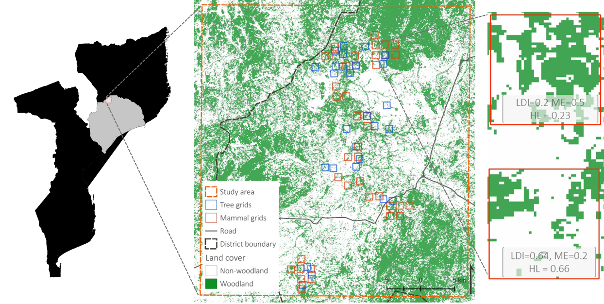
Figure 1: Study area in Zambézia province in north central Mozambique. We selected landscape sampling units (1 km² grids) within which we collected incidence data of mammal (red boxes) and count data of tree species (blue boxes) and computed land division index (LDI), total woodland cover (ME) and woodland cover loss between 2007 and 2014 (HL).

2.4 Statistical analysis
To estimate the total effective species richness and survey completeness for all communities i.e. all LSUs combined (meta-community size), we used the sample-based rarefaction and extrapolation which are methods to standardise biodiversity measures to a set of a smaller and increased number of samples, respectively. This procedure allows for estimation of unobserved richness for a given number of samples and also helps in measuring survey completeness (Hsieh et al. 2016). Further, using the species occurrence data, we derived two types of parameters: (i) the species state: abundance (trees) or occupancy (mammals) of individual species, as an indicator of species response, and (ii) community state: species richness (number of species at each LSU, α-diversity) and species composition (dissimilarity between LSUs in terms of composition of species assemblages, or β-diversity), as indicators of the community-level response. β-diversity, measured by mean community dissimilarity ranging from 0 (low) to 1 (high), can change due to two processes and, thus, has two parts: (i) replacement of species and thereby turnover in the community, and (ii) loss of species with low or no turnover and thereby nestedness in the community. We computed both the turnover (Simpson dissimilarity) and the nestedness components (the difference between Sorenson and Simpson dissimilarity) of the multipart Sorenson dissimilarity, after Baselga (2010).
To test relationships between response (species and community state) and landcover variables (LDI, ME and HL), we built the species and community-level regression models with land cover variables as predictors in linear additive combination. The species-state models were effectively multilevel mixed-effects hierarchical models following the abundance-based Dorazio/Royle/Yamaura (DRY) model (Yamaura et al. 2012) for trees and incidence-based Dorazio/Royle (DR) model (Dorazio and Royle 2005) for mammals. Since the effects of fragmentation can be nonlinear (Andrén 1994; Ewers and Didham 2006), we included polynomial terms of LDI (LDI² and LDI³). In total, we constructed one species-state (occurrence) model and three community-state models (α, β-turnover and β-nestedness) for each taxonomic group. Details of the models, model structure, and parameters are provided in SI (SI models and SI Table 1 and 2).
We specified the models using the BUGS language (Kery 2010), and executed simulations using three Markov chains, with 75,000 iterations for each chain (the first 25,000 iterations of which were discarded as burn-in), and set the thinning rate to 50, yielding 3,000 samples from the posterior distributions. We checked all the models for convergence using the Gelman-Rubin convergence diagnostic, with potential scale reduction factor values approaching 1 considered acceptable (Gelman and Rubin 1992). We use % deviation of the standardised beta-coefficients from the intercept as the standard effect size (± standard deviation) with posterior probabilities (Pp) as a measure of confidence in the posterior estimates. Where more than one species is mentioned together we provide mean Pp of all species concerned and use * to indicate species at P_{p} ≥ 0.95.
Calculations and analysis were undertaken using the statistical software R version 3.4.2 (R Core Team 2017). We used the vegan package (Oksanen et al. 2016) to compute species richness, iNEXT (Hsieh et al. 2016) for sample-based rarefied species richness, accumulation and survey completeness, and adespatial (Dray et al. 2016) for species β-diversities. To fit the Bayesian models we used the jagsUI package (Kellner 2015). For constructing the meta-community models, we followed the R scripts in Kéry and Royle, (2016). Figures were drawn using ggplot2 (Wickham 2009).

Results

3.1 Survey effort, meta-community size and model summary
We measured a total of 1215 tree stems and recorded 864 mammal occurrences (from 1693 trap nights) belonging to 88 and 21 species, respectively. Sample-based species accumulation showed that mammals reached a clear asymptote while trees did not; although both taxonomic groups attained significant survey completeness >95 % (Figure 2). The meta-community models estimated the unobserved species and suggested that the tree communities in the region may contain an estimated mean of 124 species (standard deviation; ± 12), while mammal communities may have about 26 (± 3) species.
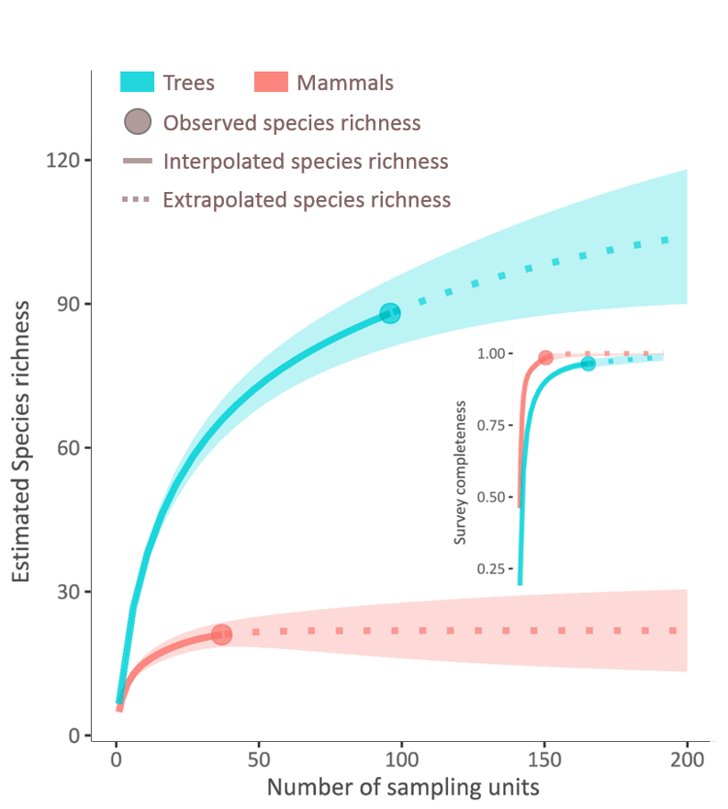
Figure 2: Sample-based estimation of meta-community size. The sample rarefaction- and extrapolation-based species richness estimate and accumulation curve with 95% confidence interval (CI; the shaded region) shows species asymptote and survey completeness >0.95, indicating that our study covered most of the species found in the region for both trees and mammals.
The convergence diagnostic for all posterior summaries was around 1, indicating sufficient convergence and low Monte Carlo error. The mean abundance of all tree species and communities combined in the study area (community-level mean) was 11 (±8) individuals per LSU (1km²). The mean of species-level abundance across all communities (species-level mean) ranged from 0.25 to 80 individuals. The community-level mean occupancy probability (occupancy) of mammals in the region was 0.38 (±0.27) while the species-level mean occupancy ranged from 0.05 to 0.93 indicating high variability in occupancy among species. The species-level mean detection probability of mammals ranged from 0.01 to 0.28 with community-level mean detection at 0.06 (± 0.09) (Figure 3).
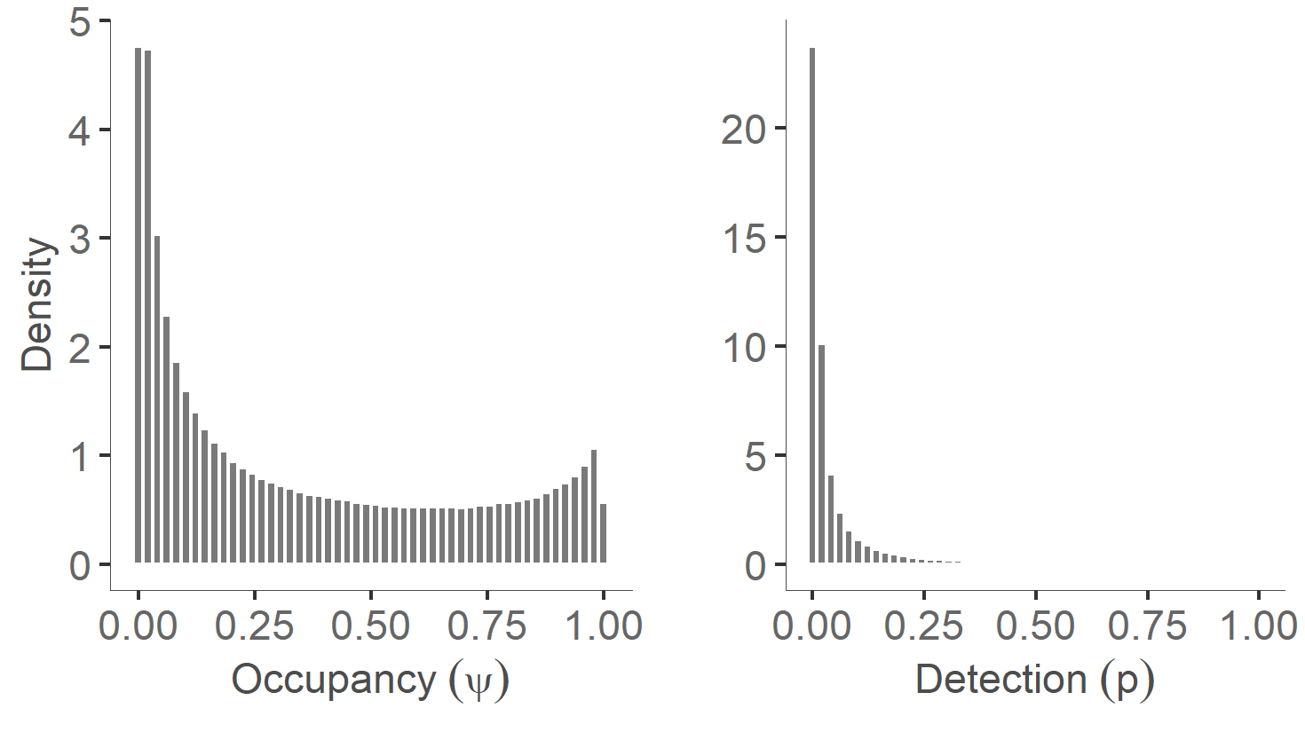
Figure 3: Distribution of community-level mean occupancy (Ψ) and detection probability (p) between mammal species based on parameters from the meta-community occupancy model for the scale of 1 km² and single season survey (April-July) in 2016.

3.2 Effects on species occurrence
At the species-level, the effect of agricultural expansion on tree communities was largely negative as a majority of species had reduced abundance at higher levels of LDI (Figure 4). The negatively affected tree species included dominant miombo species such as Brachystegia spiciformis and B. boehmii, and non-dominants such as Pterocarpus angolensis, Sclerocarya birrea, Combretum apiculatum and Albizia adianthifolia, whereas increasers included Annona senegalensis, Mangifera indica, Terminalia sericea, and Piliostigma thonningii - a rapidly growing species known to colonize clearings and fallow (SI-Figure 4). For mammals, the probability of occupancy of all species responded non-linearly - increased at low to intermediate LDI and reduced after high LDI. The species which had significantly higher occupancy at intermediate LDI consisted of elephant shrews, murids (African spiny mouse, Acomys sp., and thicket rat, Grammomys sp.) and species which are known to survive well in human influenced, disturbed and fragmented landscapes (lesser bushbaby, Galago moholi, and rusty-spotted genet, Genetta maculata). One the other hand, species such as the African giant rat (Cricetomys gambianus), Bush hyrax (Heterohyrax brucei), Spiny mouse (Acomys sp), and South African hedgehog (Atelerix frontalis) showed significant negative reduction in occupancy at high LDI (SI-Figure 5). In summary, LDI was associated with reduced abundance of a majority of tree species, and lower occupancy of all mammal species, thus creating more species losers than winners. Among other variables, the residuals of HL and MAP had poor posterior probabilities (Pp <0.6) and were associated with almost equal number of species winners and losers, and ME had significant negative association with most mammal species. Plots of species-level model coefficients with 95% CI of trees and mammals are provided in the SI.
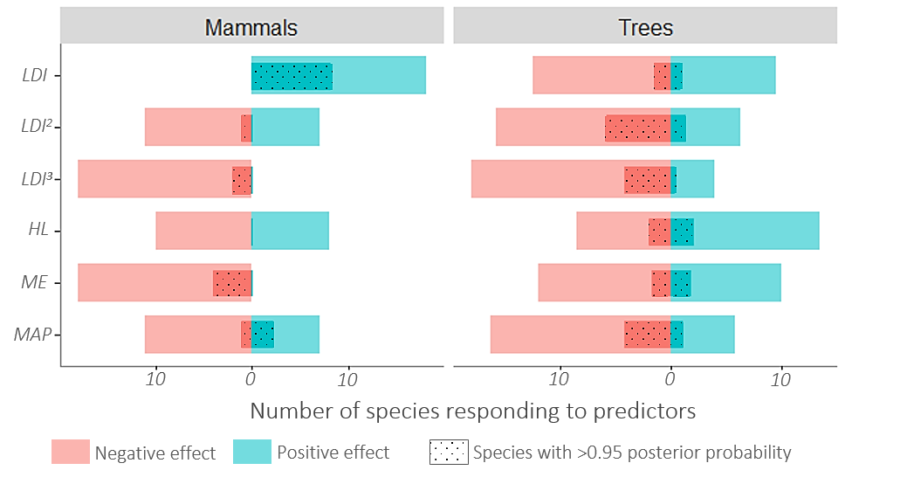
Figure 4: Species-level responses: The majority of species of both groups showed a negative association with LDI - more species losers than winners.

3.4 Effects on α- and β-diversity
The species richness of both trees and mammals showed a non-linear relationship with LDI – increasing from low (<0.25) to moderate (0.25-0.65) and declining at high LDI values (>0.75, Pp=0.9; Figure 5). The threshold of species richness decline for trees was at lower LDI (0.6) compared to that of mammals (LDI 0.75). Interestingly, the nestedness of tree communities reduced rapidly (Pp=0.99) under low LDI, stabilised at moderate LDI, and declined again at high LDI. This was matched with decline and then increase in tree species turnover at low and high LDI values, respectively (Pp=0.89). Mammals, on the other hand, had reduced turnover (Pp=0.95) and increased nestedness (Pp=0.72) in response to LDI. Further, tree species richness showed positive response to HL residuals (Pp=0.85), and negative association with ME residuals (Pp=0.95) and MAP (Pp=0.97). Also, tree species turnover increased with ME residuals (Pp=0.87) and MAP (Pp=0.98), and decreased with HL residuals (Pp=0.95). In the case of mammals, ME, HL and MAP were negatively associated with species richness (Pp=0.86) and positively related to turnover (Pp=0.81). Thus, at high LDI, tree communities lost species richness but increased in within-site dissimilarity – compositional drift, whereas mammals, at high levels of LDI, lost species richness and became more nested and similar in species composition – biotic homogenisation. The species richness, turnover and nestedness of mammals and trees and their model residuals had weak and statistically non-significant (Moran's I= mammals 0.05 and trees = 0.09, p>0.1) spatial autocorrelation.
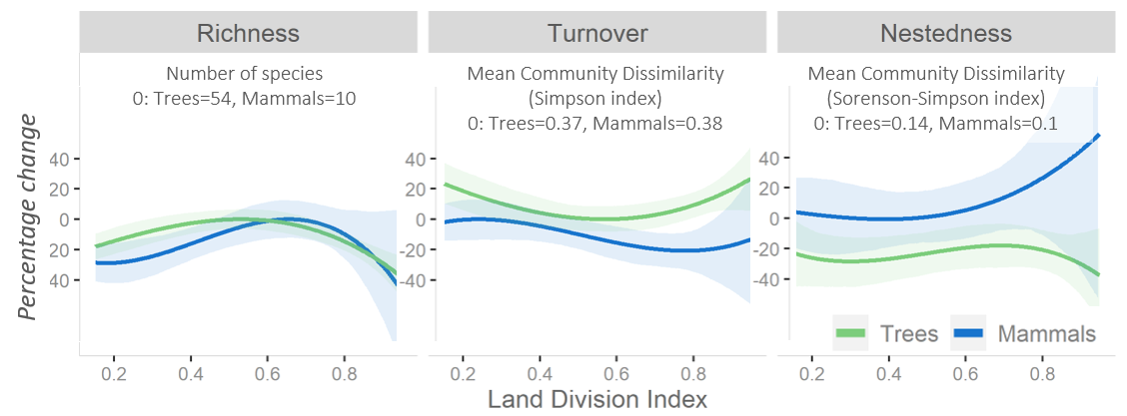
Figure 5: Community level responses of trees and mammals to Land Division Index at 1 km². The lines indicate the best fit from cubic regression and shaded areas represent 95% CI from posterior probabilities of the predicted species richness. The maximum predicted estimate of diversity parameters – richness, turnover and nestedness, was used a baseline and adjusted to 0. Land Division Index is shown to be associated with declining species richness of both trees and mammals and to have different effects on their β-diversities – compositional drift in trees and biotic homogenisation in mammals at high LDI values.

3.5 Levels of biodiversity loss
With maximum observed species richness as a baseline (54 for trees and 10 for mammals), we found that communities of both groups have ~15-25% lower species richness in landscapes with very low LDI (<0.25) than in landscapes with intermediate LDI (0.25-0.65). They increase gradually in richness until the LDI is between 0.6 to 0.7, and begin to decline thereafter, reaching the intermediate level of biodiversity loss (25-40% decline) at 0.8 LDI and the high level (>40% decline) at about 0.9 LDI. Taking the mean of local species richness losses of both taxonomic groups we can state that beyond 0.9 LDI or 90% fragmentation, the ecological communities in the savanna woodlands begin to exhibit high biodiversity loss. As fragmentation and woodland cover (ME) in our study are highly correlated (r=0.90), the 0.9 LDI threshold translates to ~17.5 (± 0.3) % of woodland cover.

Discussion

4.1 Few winners and many losers
Our results show the disruptive effects of agricultural expansion on species populations. We found that agricultural expansion was related to a decrease in population size in 75% of species, indicative of the ‘more species losers than winners’ paradigm (McKinney and Lockwood 1999). The tree species that declined were primarily characteristic miombo and species used by humans for timber and firewood. While the decline of miombo species may be related to the random loss of species through habitat loss, the decline of livelihood-relevant species may be more related to the selective over-harvesting along the edges of habitat patches.
For most mammal species, occupancy was highest at intermediate levels of fragmentation and woodland cover. The species positively associated with the intermediate levels of fragmentation consisted of the rapidly breeding Elephantulus sp. and murids, and generalist predators. Assuming that the less divided woodland landscapes are relatively undisturbed by humans, our finding of positive effects of intermediate fragmentation is similar to the results Caro (2001) in miombo woodlands of western Tanzania, and studies in other ecosystems (Andrén 1994; Conde y Vera and Rocha 2006; Cusack 2011; Rich et al. 2016). By showing that even after the positive effect of intermediate disturbance, most mammal as well as tree species declined in occupancy and abundance, respectively at higher levels of land use and associated fragmentation, the results here expand upon the existence of nonlinear relationships and possible thresholds observed in forests (Andrén 1994; Hill and Caswell 1999; Mönkkönen and Reunanen 1999; Pardini et al. 2010).
4.2 Declines in species richness
As expected, species richness of both trees and mammals reduced with agricultural expansion-led fragmentation and habitat loss. However, both groups showed a hump-shaped pattern of species richness in response to fragmentation - species richness increasing at the intermediate levels of fragmentation (25-65%) but declining steeply beyond a fragmentation (~ 75%) and habitat quantity (miombo extent) threshold (~30%). The non-linear patterns could be explained by intermediate disturbance hypothesis. The intermediate levels of fragmentation and habitat loss would have created landcover heterogeneity which is associated with increase in the landscape-wide species pool due to niche complementarity (Pardini et al. 2010; Tscharntke et al. 2012). In case of tree communities, increase in diversity at intermediate levels despite loss of miombo trees species is possibly due to colonisation of new species as a result of plantations done by humans or regeneration of late successional species as observed elsewhere (Yeboah and Chen 2016). The nonlinear response of mammals may be due to their ability to move and exploit resources in multiple fragments when the fragmentation is low and habitat patches are within reach (Pardini et al. 2005). However, as the landscapes become more fragmented and increasingly homogenous, the size of remaining woodland patches and woody cover in the landscape reduce, leading to increased competition and predation, and subsequent decline in mammal species richness (Magrach et al. 2014).
At the extreme levels of agriculture expansion, comparable to the land use endpoints used in the global syntheses (Murphy and Romanuk 2014; Newbold et al. 2015, 2017), we found >40% decline in species richness (-49% ± 19 after 95% fragmentation). This loss is much higher than the African average of 21.6% in Newbold et al. (2017) and the “tropical average” of 25.6% in Murphy & Romanuk (2014). We found higher biodiversity losses mainly because our study takes into account the landscape-scale biodiversity-land use change whereas the majority of studies in the global syntheses focussed on patch-scale observations where biodiversity losses may be mitigated by landscape scale heterogeneity and source–sink process (Kormann et al. 2018); and hence, underestimated.
The majority of African savanna landscapes, however, have not undergone the complete patch-to-matrix transformation (McNicol et al. 2018). An indication of the impact of intermediate transformation is given by combining all our sites above 25% fragmentation. Here, the reduction in species richness was 13 % (±6). This estimate is just slightly below the global average of 13.6 % reduction in local species richness under complete patch-to-matrix conversions suggested by Newbold et al. (2015), and considerably lower than the average numbers from the global syntheses we discussed above. This is probably a more representative depiction of the current state of biodiversity change in African savannas, which are still at the intermediate stages of land use.

4.3 Taxonomic heterogeneity in β-diversity
The β-diversity response to agricultural expansion, in contrast to the alpha-diversity response, differed between the two taxonomic groups. Tree communities underwent compositional drift in highly fragmented landscapes, possibly because of contrasting successional pathways following random extinctions due to habitat loss. The ubiquitous miombo woodland dominants declined and fast-growing secondary vegetation and successional species became more abundant. Such combined effect of turnover and species loss, results in subtractive heterogenization – loss of species richness with increased dissimilarity between communities (McGill et al. 2015; Socolar et al. 2016), and is represented in our result by increase in the turnover and loss of the nestedness component of tree β-diversity corroborating the similar findings from African woodlands (McNicol et al. 2015) and other ecosystems (Laurance et al. 2006; Arroyo-Rodríguez et al. 2013).
Mammal communities, on the other hand, became more similar in community composition in landscapes dominated by agricultural matrix and fragmented woodland patches. Specifically, they underwent niche-based deterministic reduction leading to a strong subtractive homogenisation - loss of species richness with reduced dissimilarity between communities (McGill et al. 2015; Socolar et al. 2016). This is mainly because, as the woodland habitat in the woodland-agriculture mosaic reduced and became fragmented, disturbance sensitive species with preferences for woodland habitats declined, and a nested subset of ubiquitous disturbance tolerant species survived in the non-woodland matrix. Also, species such as the African giant rat (Cricetomys gambianus), rock hare (Pronolagus rupestris) and the common duiker (Sylvicapra grimmia) are preferentially hunted using dogs and traps (personal observation and Timberlake et al. 2009), which leads to loss of these species across all fragmented landscapes.
The contrasting patterns of β-diversity observed in this study will have implications for maintenance of biodiversity in these human-modified landscapes. Tree communities which experienced biotic heterogenization are more likely to recover as species needed for recovery are maintained in the meta-community species pool (Tscharntke et al. 2012). Mammal communities experience more disruptive effects of fragmentation and, therefore, would require more focused land and conservation management policies to maintain the habitat structure above the thresholds that we discuss below.

4.4 Avoiding high-level biodiversity losses
Comparing the local species richness loss with the limits suggested by Hooper et al. (2012), we found that in the extremely transformed areas (e.g. fragmentation >90% and woodland cover < 17.5%), species richness loss for both groups exceeded the high-level threshold (>40%). Beyond this threshold ecosystems may undergo an extreme shift with severe consequences on ecosystem functioning and services (Hooper et al. 2012). This finding has implications for the future of savanna woodlands under land use change. It suggests that under high land use intensity due to agricultural expansion, there may be unprecedented severe loss of biodiversity and ecosystem functioning. It is also important to note that the woodland end-point itself is not intact and has lost most large mammals already. Comparing the agriculture end-points with more intact woodland landscapes may reveal much more catastrophic biodiversity losses.
For the two taxonomic groups combined, we identified a fragmentation level of 90%, which translated to woodland cover (habitat quantity) of about ~17.5%, beyond which the ecological communities are likely to suffer high level biodiversity loss. The habitat quantity level of ~17.5% in our study can be comparable to the similar thresholds (20-30%) suggested by others in forest ecosystems (Andrén 1994; Fahrig 2003; Estavillo et al. 2013; Hanski 2015). Our habitat level is nearer to the 10% threshold observed in Australian woodlands (Radford et al. 2005), highlighting the possibility that biodiversity in savanna woodlands may be more resilient to agricultural land use-led fragmentation (require lower habitat quantity) compared to forests.

4.5 Limitations
It is worth noting that the effect of fragmentation on individual species may be confounded by local contexts (Ewers and Didham 2006). The remaining woodland patches in the undivided landscapes that we studied may have gone through selective harvesting of tree size classes and defaunation due to hunting for bushmeat, as intact habitats are preferred by local human communities (Timberlake et al. 2009; Zach et al. 2016), which may explain the lower densities of trees and mammals in these areas. The observed nonlinearity in responses of communities in this study would, in that case, simply be the result of multiple filtration processes: harvesting and hunting causing declines in population size across all species (Reyna-Hurtado and Tanner 2007; Hegerl et al. 2015), and fragmentation leading to selection of smaller mammals, generalists and domesticated species (Jamoneau et al. 2012; Keinath et al. 2016). For a clearer understanding of the effect of fragmentation and habitat loss in the region, the biodiversity of undisturbed, less divided and large miombo woodland patches in similar climatic and topographic conditions should be the reference point for community size and integrity. We excluded the high-elevation landscapes which had relatively undisturbed woodland areas, as they were inaccessible and not preferred for farming. But these woodland patches, although mainly non-miombo, may be the last remaining undisturbed refuges supporting fauna that have migrated from the disturbed and fragmented landscapes. Accounting for the role of these high elevation habitats will be important to understand and accurately predict biodiversity change in this region. Lastly, this study is a space-for-time substitution and generalization and validation of the results and the thresholds by undertaking multi-season and multi-spatial scale studies should be the focus of future research.

Conclusion
Our study demonstrates that fragmentation and the associated loss of habitat cover due to agricultural expansion in the African savannas results in reductions in the diversity, abundance and occupancy of the majority of tree and mammal species. At the highest levels of fragmentation and habitat loss, ecological assemblages experience severe reduction in species richness and population size However, as most of the African savanna landscapes are still at the intermediate levels of land use intensification, the extent of local biodiversity loss in the African savanna ecosystems has not reached highest levels.
We show that different taxonomic groups respond differently to land use intensification. Trees undergo subtractive heterogenization with reduction in community size and increased species dissimilarity, while mammal communities experience subtractive homogenisation due to reduction in community size combined with loss of species dissimilarity. Finally, we also show that effects of fragmentation on biodiversity can be non-linear; beyond ~75% fragmentation, the effect of fragmentation switches from positive to negative..
These results underline the ecological importance and conservation value of dynamic and transitional mosaic landscapes in African savannas. They also suggest that to maintain savanna biodiversity losses above safe levels, the landscape must contain >25% habitat cover with <75% fragmentation. However, this does not mean that the savanna landscapes can be modified to those levels without consequences as the effects on species compositions of both groups – Trees and mammals, and richness and population size of trees are noticeable even at low levels of intensification.

Authors’ contributions
HT, CR, and CLP conceived the ideas and designed methodology. HT collected the mammal data and performed the fragmentation analysis. EW collected the tree data. MC facilitated field work and data collection. CR prepared the biomass maps. HT collated and analysed the data and led the writing of the manuscript. All authors contributed critically to the drafts and gave final approval for publication. The authors declare no conflict of interest.

Acknowledgements ssss
Fieldwork of this study was jointly funded by Rufford Small Grants Foundation and Abrupt Changes in Ecosystem Services project (ACES; NE/K010395/1). ACES was funded with support from the Ecosystem Services for Poverty Alleviation (ESPA) programme. The ESPA programme is funded by the Department for International Development (DFID), the Economic and Social Research Council (ESRC) and the Natural Environment Research Council (NERC). We thank Aurélio Bechel (Department of Forestry, University of Eduardo Mondlane-UEM, Maputo) for tree identifications. We also thank Clayton de Brito (UEM) and Amina Amade (Lurio University, Nampula) for assistance during field work.

Data accessibility
Data and R codes used in this study are available from the Git Repository. https://bitbucket.org/ed_trop_land_use/2018_agriexpa_mozambique/src.

References
Ahrends, A., Burgess, N.D., Milledge, S.A.H., Bulling, M.T., Fisher, B., Smart, J.C.R., Clarke, G.P., Mhoro, B.E., Lewis, S.L., 2010. Predictable waves of sequential forest degradation and biodiversity loss spreading from an African city. Proc. Natl. Acad. Sci. U. S. A. 107, 14556–61. https://doi.org/10.1073/pnas.0914471107
Andrén, H., 1994. Effects of habitat fragmentation on birds and mammals in landscapes with different proportions of suitable habitat - a review. Oikos 71, 355–366. https://doi.org/10.2307/3545823
Arroyo-Rodríguez, V., Rös, M., Escobar, F., Melo, F.P.L., Santos, B.A., Tabarelli, M., Chazdon, R., 2013. Plant β-diversity in fragmented rain forests: Testing floristic homogenization and differentiation hypotheses. J. Ecol. https://doi.org/10.1111/1365-2745.12153
Baumert, S., Fisher, J., Ryan, C., Woollen, E., Vollmer, F., Artur, L., Zorrilla-Miras, P., Mahamane, M., 2019. Forgone opportunities of large-scale agricultural investment: A comparison of three models of soya production in Central Mozambique. World Dev. Perspect. https://doi.org/10.1016/j.wdp.2019.100145
Caro, T.., 2001. Species richness and abundance of small mammals inside and outside an African national park. Biol. Conserv. 98, 251–257. https://doi.org/10.1016/S0006-3207(00)00105-1
CIESIN, ITOS, 2013. Global Roads Open Access Data Set, Version 1 (gROADSv1). Palisades, NY: NASA Socioeconomic Data and Applications Center (SEDAC). http://dx.doi.org/10.7927/H4VD6WCT, Center for International Earth Science Information Network (CIESIN), Columbia University, and Information Technology Outreach Services (ITOS), University of Georgia.
Conde y Vera, C.F., Rocha, C.F.D., 2006. Habitat disturbance and small mammal richness and diversity in an Atlantic rainforest area in southeastern Brazil. Brazilian J. Biol. 66, 983–990. https://doi.org/10.1590/S1519-69842006000600005
Cordeiro, N.J., Borghesio, L., Joho, M.P., Monoski, T.J., Mkongewa, V.J., Dampf, C.J., 2015. Forest fragmentation in an African biodiversity hotspot impacts mixed-species bird flocks. Biol. Conserv. 188, 61–71. https://doi.org/10.1016/j.biocon.2014.09.050
Cusack, J., 2011. Characterising Small Mammal Responses to Tropical Forest Loss and Degradation in Northern Borneo Using Capture-Mark-Recapture Methods. MSc Thesis, Imp. Coll. London.
Dorazio, R.M., Royle, J.A., 2005. Estimating Size and Composition of Biological Communities by Modeling the Occurrence of Species. J. Am. Stat. Assoc. 100, 389–398. https://doi.org/10.1198/016214505000000015
Dormann, C.F., Elith, J., Bacher, S., Buchmann, C., Carl, G., Carré, G., Marquéz, J.R.G., Gruber, B., Lafourcade, B., Leitão, P.J., Münkemüller, T., Mcclean, C., Osborne, P.E., Reineking, B., Schröder, B., Skidmore, A.K., Zurell, D., Lautenbach, S., 2013. Collinearity: A review of methods to deal with it and a simulation study evaluating their performance. Ecography (Cop.). https://doi.org/10.1111/j.1600-0587.2012.07348.x
Dray, A.S., Blanchet, G., Borcard, D., Guenard, G., Jombart, T., Larocque, G., Legendre, P., Madi, N., Wagner, H.H., 2016. adespatial: Multivariate Multiscale Spatial Analysis R package, Version: 0.0-7.
Ellis, E.C., Goldewijk, K.K., Siebert, S., Lightman, D., Ramankutty, N., 2010. Anthropogenic transformation of the biomes, 1700 to 2000. Glob. Ecol. Biogeogr. 19, 589–606. https://doi.org/10.1111/j.1466-8238.2010.00540.x
Estavillo, C., Pardini, R., Da Rocha, P.L.B., 2013. Forest loss and the biodiversity threshold: An evaluation considering species habitat requirements and the use of matrix habitats. PLoS One 8, 1–10. https://doi.org/10.1371/journal.pone.0082369
Etherington, T.R., Holland, E.P., O’Sullivan, D., 2015. NLMpy: A python software package for the creation of neutral landscape models within a general numerical framework. Methods Ecol. Evol. 6, 164–168. https://doi.org/10.1111/2041-210X.12308
Ewers, R., Didham, R., 2006. Confounding factors in the detection of species responses to habitat fragmentation. Biol. Rev. Camb. Philos. Soc. 81, 117–142. https://doi.org/10.1017/s1464793105006949
Eycott, A., Watts, K., 2011. Biodiversity in fragmented landscapes : reviewing evidence on the effects of landscape features on species movement. Ratio 1–8.
Fahrig, L., 2010. Effects of Habitat Fragmentation on Biodiversity. Rev. Lit. Arts Am. 34, 487–515. https://doi.org/10.1146/132419
Fahrig, L., 2003. Effects of Habitat Fragmentation on Biodiversity. Annu. Rev. Ecol. Evol. Syst. 34, 487–515. https://doi.org/10.1146/annurev.ecolsys.34.011802.132419
Fahrig, L., 1997. Relative Effects of Habitat Loss and Fragmentation on Population Extinction. J. Wildl. Manage. 61, 603–610.
Franklin, J.F., Lindenmayer, D.B., 2009. Importance of matrix habitats in maintaining biological diversity. Proc. Natl. Acad. Sci. U. S. A. 106, 349–350. https://doi.org/10.1073/pnas.0812016105
Frost, P., 1996a. The Ecology of Miombo Woodlands, in: The Miombo in Transition: Woodlands and Welfare in Africa. p. 266.
Frost, P., 1996b. The Ecology of Miombo Woodlands. Miombo Transit. Woodlands Welf. Africa 266.
Frost, P., Campbell, B.M., 1996. The ecology of Miombo woodlands, in: Campbell, Bruce M (Ed.), The Miombo in Transition: Woodlands and Welfare in Africa. Center for International Forestry Research, Bogor, Indonesia, pp. 11–55.
Gelman, A., Rubin, D.B., 1992. Inference from Iterative Simulation Using Multiple Sequences. Stat. Sci. 7, 457–472. https://doi.org/10.1214/ss/1177011136
Gutteridge, L., Liebenberg, L., 2013. Mammals of Southern Africa and Their Tracks & Signs. Jacana Media.
Haddad, N.M., Brudvig, L. a., Clobert, J., Davies, K.F., Gonzalez, A., Holt, R.D., Lovejoy, T.E., Sexton, J.O., Austin, M.P., Collins, C.D., Cook, W.M., Damschen, E.I., Ewers, R.M., Foster, B.L., Jenkins, C.N., King, a. J., Laurance, W.F., Levey, D.J., Margules, C.R., Melbourne, B. a., Nicholls, a. O., Orrock, J.L., Song, D.-X., Townshend, J.R., 2015. Habitat fragmentation and its lasting impact on Earth’s ecosystems. Sci. Adv. 1, 1–9. https://doi.org/10.1126/sciadv.1500052
Hanlon, J., Smart, T., 2012. Small farmers or big investors? The choice for Mozambique. Res. Rep. 1 - Updat. 1–11.
Hanski, I., 2015. Habitat fragmentation and species richness. J. Biogeogr. 42, 989–993. https://doi.org/10.1111/jbi.12478
Hegerl, C., Burgess, N.D., Nielsen, M.R., Martin, E., Ciolli, M., Rovero, F., 2015. Using camera trap data to assess the impact of bushmeat hunting on forest mammals in Tanzania. Oryx October, 1–11. https://doi.org/10.1017/S0030605315000836
Hijmans, R.J., Cameron, S.E., Parra, J.L., Jones, P.G., Jarvis, A., 2005. WorldClim [WWW Document]. Int. J. Climatol.
Hill, M.F., Caswell, H., 1999. Habitat fragmentation and extinction thresholds on fractal landscapes. Ecol. Lett. 2, 121–127. https://doi.org/10.1046/j.1461-0248.1999.22061.x
Hooper, D.U., Adair, E.C., Cardinale, B.J., Byrnes, J.E.K., Hungate, B. a., Matulich, K.L., Gonzalez, A., Duffy, J.E., Gamfeldt, L., O’Connor, M.I., O/’Connor, M.I., 2012. A global synthesis reveals biodiversity loss as a major driver of ecosystem change. Nature 486, 105–108. https://doi.org/10.1038/nature11118
Hsieh, T.C., Ma, K.H., Chao, A., 2016. iNEXT: An R package for rarefaction and extrapolation of species diversity (Hill numbers). Methods Ecol. Evol. n/a-n/a. https://doi.org/10.1111/2041-210X.12613
INE, 2014. Mozambique in Figures. Inst. Nac. Estatística.
ISRIC, 2013. ISRIC - Soil property maps of Africa at 1 km [WWW Document]. World Soil Inf.
Jaeger, J.A.G., 2000. Landscape division, splitting index, and effective mesh size: New measures of landscape fragmentation. Landsc. Ecol. 15, 115–130. https://doi.org/10.1023/A:1008129329289
Jamoneau, A., Chabrerie, O., Closset-Kopp, D., Decocq, G., 2012. Fragmentation alters beta-diversity patterns of habitat specialists within forest metacommunities. Ecography (Cop.). 35, 124–133. https://doi.org/10.1111/j.1600-0587.2011.06900.x
Jeffrey, S.M., 1977. Rodent Ecology and Land Use in Western Ghana. J. Appl. Ecol. 14, 741–755. https://doi.org/10.2307/2402806
Jules, E.S., Shahani, P., Erik, S., 2016. A Broader Ecological Context to Habitat Fragmentation : Why Matrix Habitat Is More Important than We Thought, J. Veg. Sci. 14, 459–464. https://doi.org/10.1658/1100-9233(2003)014[0459:ABECTH]2.0.CO;2
Jung, M., 2012. LecoS - A QGIS plugin to conduct landscape ecology statistics,. https://doi.org/10.7287/peerj.preprints.116v2
Kalaba, F.K., Quinn, C.H., Dougill, A.J., Vinya, R., 2013. Floristic composition, species diversity and carbon storage in charcoal and agriculture fallows and management implications in Miombo woodlands of Zambia. For. Ecol. Manage. 304, 99–109. https://doi.org/10.1016/j.foreco.2013.04.024
Keinath, D.A., Doak, D.F., Hodges, K.E., Prugh, L.R., Fagan, W., Sekercioglu, C.H., Buchart, S.H.M., Kauffman, M., 2016. A global analysis of traits predicting species sensitivity to habitat fragmentation. Glob. Ecol. Biogeogr. 115–127. https://doi.org/10.1111/geb.12509
Kellner, K., 2015. jagsUI: a wrapper around rjags to streamline JAGS analyses. R Packag. version 1.
Kéry, M., 2010. Introduction to WinBUGS for Ecologists, Introduction to WinBUGS for Ecologists. https://doi.org/10.1016/C2009-0-30639-X
Kéry, M., Royle, J.A., 2016. Applied Hierarchical Modeling in Ecology. Appl. Hierarchical Model. Ecol. 79–122. https://doi.org/10.1016/B978-0-12-801378-6.00003-5
Kéry, M., Schaub, M., 2012. Bayesian Population Analysis using WinBUGS. Bayesian Popul. Anal. using WinBUGS 463–477. https://doi.org/10.1016/B978-0-12-387020-9.00014-6
Kingdon, J., 2001. The Kingdon field guide to African mammals. kingdon F. Guid. to African Mamm.
Laurance, W.F., Nascimento, H.E.M., Laurance, S.G., Andrade, A., Ribeiro, J.E.L.S., Giraldo, J.P., Lovejoy, T.E., Condit, R., Chave, J., Harms, K.E., D’Angelo, S., 2006. Rapid decay of tree-community composition in Amazonian forest fragments. Proc. Natl. Acad. Sci. 103, 19010–19014. https://doi.org/10.1073/pnas.0609048103
Liebenberg, L., 2000. A Photographic Guide to Tracks and Tracking in Southern Africa, Photographic Guides. NEW HOLLAND PUBLISHERS.
Linder, H.P., de Klerk, H.M., Born, J., Burgess, N.D., Fjeldså, J., Rahbek, C., 2012. The partitioning of Africa: Statistically defined biogeographical regions in sub-Saharan Africa. J. Biogeogr. 39, 1189–1205. https://doi.org/10.1111/j.1365-2699.2012.02728.x
Linzey, A. V, Kesner, M.H., 1997. Small mammals of a woodland-savannah ecosystem in Zimbabwe. II. Community structure. J. Zool. 243, 153–162. https://doi.org/10.1111/j.1469-7998.1997.tb05761.x
Magrach, A., Laurance, W.F., Larrinaga, A.R., Santamaria, L., 2014. Meta-analysis of the effects of forest fragmentation on interspecific interactions. Conserv. Biol. 28, 1342–1348. https://doi.org/10.1111/cobi.12304
Mascarenhas, M., Mariano-neto, E., 2014. Forest Ecology and Management Extinction thresholds for Sapotaceae due to forest cover in Atlantic Forest landscapes 312, 260–270. https://doi.org/10.1016/j.foreco.2013.09.003
Matteo, F. Di, Otsuki, K., 2016. Soya bean expansion in Mozambique : exploring the inclusiveness and viability of soya business models as an alternative to the land grab.
Mcgarigal, K., 2015. Fragstats.Help.4.2 1–182. https://doi.org/10.1016/S0022-3913(12)00047-9
McGill, B.J., Dornelas, M., Gotelli, N.J., Magurran, A.E., 2015. Fifteen forms of biodiversity trend in the anthropocene. Trends Ecol. Evol. 30, 104. https://doi.org/10.1016/j.tree.2014.11.006
McKinney, M.L., Lockwood, J.L., 1999. Biotic homogenization: A few winners replacing many losers in the next mass extinction. Trends Ecol. Evol. 14, 450–453. https://doi.org/10.1016/S0169-5347(99)01679-1
McNicol, I.M., Ryan, C.M., Mitchard, E.T.A., 2018. Carbon losses from deforestation and widespread degradation offset by extensive growth in African woodlands. Nat. Commun. 1–19.
McNicol, I.M., Ryan, C.M., Williams, M., 2015. How resilient are African woodlands to disturbance from shifting cultivation? Ecol. Appl. 25, 2330–2336. https://doi.org/10.1890/14-2165.1
Mittermeier, R.A., Mittermeier, C.G., Brooks, T.M., Pilgrim, J.D., Konstant, W.R., da Fonseca, G.A.B., Kormos, C., 2003. Wilderness and biodiversity conservation. Proc. Natl. Acad. Sci. 100, 10309–10313. https://doi.org/10.1073/pnas.1732458100
Molotoks, A., Stehfest, E., Doelman, J., Albanito, F., Fitton, N., Dawson, T.P., Smith, P., 2018. Global projections of future cropland expansion to 2050 and direct impacts on biodiversity and carbon storage. Glob. Chang. Biol. 24, 5895–5908. https://doi.org/10.1111/gcb.14459
Mönkkönen, M., Reunanen, P., 1999. On critical thresholds in landscape connectivity: a management perspective. Oikos 84, 302–305. https://doi.org/10.2307/3546725
Murphy, B.P., Andersen, A.N., Parr, C.L., 2016. The underestimated biodiversity of tropical grassy biomes. Philos. Trans. R. Soc. B Biol. Sci. 371, 20150319. https://doi.org/10.1098/rstb.2015.0319
Murphy, G.E.P., Romanuk, T.N., 2014. A meta-analysis of declines in local species richness from human disturbances. Ecol. Evol. 4, 91–103. https://doi.org/10.1002/ece3.909
Newbold, T., Boakes, E.H., Hill, S.L.L., Harfoot, M.B.J., Collen, B., 2017. The present and future effects of land use on ecological assemblages in tropical grasslands and savannas in Africa. Oikos. https://doi.org/10.1111/oik.04338
Newbold, T., Hudson, L.N.L.N., Hill, S.L.L., Contu, S., Lysenko, I., Senior, R.A., Borger, L., Bennett, D.J., Choimes, A., Collen, B., Day, J., De Palma, A., Diaz, S., Echeverria-Londono, S., Edgar, M.J., Feldman, A., Garon, M., Harrison, M.L.K., Alhusseini, T., Ingram, D.J., Itescu, Y., Kattge, J., Kemp, V., Kirkpatrick, L., Kleyer, M., Correia, D.L.P., Martin, C.D., Meiri, S., Novosolov, M., Pan, Y., Phillips, H.R.P., Purves, D.W., Robinson, A., Simpson, J., Tuck, S.L., Weiher, E., White, H.J., Ewers, R.M., Mace, G.M., Scharlemann, J.P.J.P.W., Purvis, A., Börger, L., Bennett, D.J., Choimes, A., Collen, B., Day, J., De Palma, A., Dıáz, S., Echeverria-Londoño, S., Edgar, M.J., Feldman, A., Garon, M., Harrison, M.L.K., Alhusseini, T., Ingram, D.J., Itescu, Y., Kattge, J., Kemp, V., Kirkpatrick, L., Kleyer, M., Laginha Pinto Correia, D., Martin, C.D., Meiri, S., Novosolov, M., Pan, Y., Phillips, H.R.P., Purves, D.W., Robinson, A., Simpson, J., Tuck, S.L., Weiher, E., White, H.J., Ewers, R.M., Mace, G.M., Scharlemann, J.P.J.P.W., Purvis, A., 2015. Global effects of land use on local terrestrial biodiversity. Nature 520, 45–50. https://doi.org/10.1038/nature14324\rhttp://www.nature.com/nature/journal/v520/n7545/abs/nature14324.html#supplementary-information
O’Connell, A.F., Nichols, J.D., Karanth, K.U., 2011. Camera traps in animal ecology: Methods and analyses, Camera Traps in Animal Ecology: Methods and Analyses. https://doi.org/10.1007/978-4-431-99495-4
Oksanen, J., Blanchet, F.G., Friendly, M., Kindt, R., Legendre, P., McGlinn, D., Minchin, P.R., O’Hara, R.B., Simpson, G.L., Solymos, P., Stevens, M.H.H., Szoecs, E., Wagner, H., 2016. vegan: community ecology package. R Packag. version 2.4-1 Available at: https://cran.r-project.org/web/packa. https://doi.org/10.4135/9781412971874.n145
Palgrave, C.K., B., D.R., Moll, E.J., Palgrave, C.M., 2002. Trees of Southern Africa, Third edit. ed. Struik Publishers, Cape Town, South Africa.
Pardini, R., de Bueno, A.A., Gardner, T.A., Prado, P.I., Metzger, J.P., 2010. Beyond the fragmentation threshold hypothesis: Regime shifts in biodiversity across fragmented landscapes. PLoS One 5. https://doi.org/10.1371/journal.pone.0013666
Pardini, R., De Souza, S.M., Braga-Neto, R., Metzger, J.P., 2005. The role of forest structure, fragment size and corridors in maintaining small mammal abundance and diversity in an Atlantic forest landscape. Biol. Conserv. 124, 253–266. https://doi.org/10.1016/j.biocon.2005.01.033
Pardini, R., Faria, D., Accacio, G.M., Laps, R.R., Mariano-neto, E., Paciencia, M.L.B., Dixo, M., Baumgarten, J., 2009. The challenge of maintaining Atlantic forest biodiversity : A multi-taxa conservation assessment of specialist and generalist species in an agro-forestry mosaic in southern Bahia. Biol. Conserv. 142, 1178–1190. https://doi.org/10.1016/j.biocon.2009.02.010
Pfeifer, M., Lefebvre, V., Peres, C.A., Banks-Leite, C., Wearn, O.R., Marsh, C.J., Butchart, S.H.M., Arroyo-Rodríguez, V., Barlow, J., Cerezo, A., Cisneros, L., D’Cruze, N., Faria, D., Hadley, A., Harris, S.M., Klingbeil, B.T., Kormann, U., Lens, L., Medina-Rangel, G.F., Morante-Filho, J.C., Olivier, P., Peters, S.L., Pidgeon, A., Ribeiro, D.B., Scherber, C., Schneider-Maunoury, L., Struebig, M., Urbina-Cardona, N., Watling, J.I., Willig, M.R., Wood, E.M., Ewers, R.M., 2017. Creation of forest edges has a global impact on forest vertebrates. Nature 551, 187–191. https://doi.org/10.1038/nature24457
Pritchard, R., Grundy, I.M., van der Horst, D., Ryan, C.M., 2019. Environmental incomes sustained as provisioning ecosystem service availability declines along a woodland resource gradient in Zimbabwe. World Dev. 122, 325–338. https://doi.org/10.1016/j.worlddev.2019.05.008
R Core Team, 2017. R: A Language and Environment for Statistical Computing. R Found. Stat. Comput.
Radford, I.J., Dickman, C.R., Start, A.N., Palmer, C., Carnes, K., Everitt, C., Fairman, R., Graham, G., Partridge, T., Thomson, A., 2014. Mammals of Australia’s tropical savannas: A conceptual model of assemblage structure and regulatory factors in the Kimberley region. PLoS One 9. https://doi.org/10.1371/journal.pone.0092341
Radford, J.Q., Bennett, A.F., Cheers, G.J., 2005. Landscape-level thresholds of habitat cover for woodland-dependent birds 124, 317–337. https://doi.org/10.1016/j.biocon.2005.01.039
Reyna-Hurtado, R., Tanner, G.W., 2007. Ungulate relative abundance in hunted and non-hunted sites in Calakmul Forest (Southern Mexico). Biodivers. Conserv. 16, 743–756. https://doi.org/10.1007/s10531-005-6198-7
Rich, L.N., Miller, D.A.W., Robinson, H.S., Mcnutt, J.W., Kelly, M.J., 2016. Using camera trapping and hierarchical occupancy modelling to evaluate the spatial ecology of an African mammal community. J. Appl. Ecol. 1225–1235. https://doi.org/10.1111/1365-2664.12650
Ryan, C.M., Berry, N.J., Joshi, N., 2014. Quantifying the causes of deforestation and degradation and creating transparent REDD+ baselines: A method and case study from central Mozambique. Appl. Geogr. 53, 45–54. https://doi.org/10.1016/j.apgeog.2014.05.014
Ryan, C.M., Hill, T., Woollen, E., Ghee, C., Mitchard, E., Cassells, G., Grace, J., Woodhouse, I.H., Williams, M., 2012. Quantifying small-scale deforestation and forest degradation in African woodlands using radar imagery. Glob. Chang. Biol. 18, 243–257. https://doi.org/10.1111/j.1365-2486.2011.02551.x
Ryan, C.M., Pritchard, R., McNicol, I., Owen, M., Fisher, J.A., Lehmann, C., 2016. Ecosystem services from southern African woodlands and their future under global change. Philos. Trans. R. Soc. B Biol. Sci. 371, 20150312. https://doi.org/10.1098/rstb.2015.0312
Ryan, C.M., Williams, M., Grace, J., 2011. Above- and belowground carbon stocks in a miombo woodland landscape of mozambique. Biotropica 43, 423–432. https://doi.org/10.1111/j.1744-7429.2010.00713.x
Schulze, C.H., Waltert, M., Kessler, P.J.A., Pitopang, R., Veddeler, D., Mühlenberg, M., Gradstein, S.R., Leuschner, C., Steffan-Dewenter, I., Tscharntke, T., 2004. Biodiversity indicator groups of tropical land-use systems: Comparing plants, birds, and insects. Ecol. Appl. 14, 1321–1333. https://doi.org/10.1890/02-5409
Scott, D.M., Brown, D., Mahood, S., Denton, B., Silburn, A., Rakotondraparany, F., 2006. The impacts of forest clearance on lizard, small mammal and bird communities in the arid spiny forest, southern Madagascar. Biol. Conserv. 127, 72–87. https://doi.org/10.1016/j.biocon.2005.07.014
Segre, H., Ron, R., De Malach, N., Henkin, Z., Mandel, M., Kadmon, R., 2014. Competitive exclusion, beta diversity, and deterministic vs. stochastic drivers of community assembly. Ecol. Lett. 17, 1400–1408. https://doi.org/10.1111/ele.12343
Seppelt, R., Beckmann, M., Ceauşu, S., Cord, A.F., Gerstner, K., Gurevitch, J., Kambach, S., Klotz, S., Mendenhall, C., Phillips, H.R.P., Powell, K., Verburg, P.H., Verhagen, W., Winter, M., Newbold, T., 2019. Trade-Offs and Synergies Between Biodiversity Conservation and Productivity in the Context of Increasing Demands on Landscapes, in: Atlas of Ecosystem Services. https://doi.org/10.1007/978-3-319-96229-0_39
Sileshi, G., Akinnifesi, F.K., Ajayi, O.C., Chakeredza, S., Kaonga, M., Matakala, P., 2007. Contributions of agroforestry to Ecosystem Services in the Miombo eco-region of Eastern and Southern Africa. African J. Environ. Sci. Technol. 1, 68–80. https://doi.org/10.4314/AJEST.V1I4.
Socolar, J.B.., Gilroy, J.J., Kunin, W.E., Edwards, D.P., 2016. How should beta-diversity inform biodiversity conservation? Trends Ecol. Evol. 31, 61–80.
Stromgaard, P., 1985. Biomass, growth, and burning of woodland in a shifting cultivation area of South Central Africa. For. Ecol. Manage. 12, 163–178. https://doi.org/10.1016/0378-1127(85)90089-1
Stuart, C., Stuart, T., 2007. Field guide to the larger mammals of Africa, struik publishers.
Taubert, F., Fischer, R., Groeneveld, J., Lehmann, S., Müller, M.S., Rödig, E., Wiegand, T., Huth, A., 2018. Global patterns of tropical forest fragmentation. Nature. https://doi.org/10.1038/nature25508
Timberlake, J., Dowsett-Lemaire, F., Bayliss, J., Alves, T., Baena, S., Bento, C., Cook, K., Francisco, J., Harris, T., Smith, P., Sousa, C. De, 2009. Mt Namuli, Mozambique: Biodiversity and Conservation 115.
Tscharntke, T., Tylianakis, J.M., Rand, T.A., Didham, R.K., Fahrig, L., Batáry, P., Bengtsson, J., Clough, Y., Crist, T.O., Dormann, C.F., Ewers, R.M., Fründ, J., Holt, R.D., Holzschuh, A., Klein, A.M., Kleijn, D., Kremen, C., Landis, D.A., Laurance, W., Lindenmayer, D., Scherber, C., Sodhi, N., Steffan-Dewenter, I., Thies, C., van der Putten, W.H., Westphal, C., 2012. Landscape moderation of biodiversity patterns and processes - eight hypotheses. Biol. Rev. 87, 661–685. https://doi.org/10.1111/j.1469-185X.2011.00216.x
Wickham, H., 2009. ggplot2: Elegant Graphics for Data Analysis. Springer-Verlag New York 35, 211. https://doi.org/10.1007/978-0-387-98141-3
Zach, J., Golden, C.D., Karpanty, S., Stauffer, D., Ratelolahy, F., Holmes, C.M., Kelly, M.J., Link, C., Farris, Z.J., Golden, C.D., Karpanty, S., Murphy, A., 2016. Hunting , Exotic Carnivores , and Habitat Loss : Anthropogenic Effects on a Native Carnivore Community , Madagascar. https://doi.org/10.5061/dryad.mq8r2.The

