Analysis, design and testing of a rolling magnet harvester with diametrical magnetization for train vibration
Yifeng Wang^{1,2}, Shoutai Li^{3,4}, Mingyuan Gao^{3,4*}, Huajiang Ouyang^{5*}, Qing He^{1,2} and Ping Wang^{1,2*}
¹ Key Laboratory of High-speed Railway Engineering (Southwest Jiaotong University), Ministry of Education, Chengdu 610031, China
² School of Civil Engineering, Southwest Jiaotong University, Chengdu 610031, China
³ College of Engineering and Technology, Southwest University, Chongqing 400716, China
⁴ National & Local Joint Engineering Laboratory of Intelligent Transmission and Control Technology, Chongqing 400716, China
⁵ School of Engineering, University of Liverpool, Liverpool L69 3GH, UK

*E-mail: H.Ouyang@liverpool.ac.uk; wping@swjtu.edu.cn; goalmychn@gmail.com

Abstract
Harvesting energy from ambient vibrations, particularly vibrations of a train, is very useful to build a transportation Internet of Things. This paper presents an electromagnetic vibration energy harvester (VEH) based on a cylindrical rolling magnet (RM) and one or three fixed magnets (FMs). This VEH can reach mono-stable and tri-stable potential energy states by changing the number of FMs, and enhance the nonlinearity of the system by reducing the vertical gap between the RM and FMs. Firstly, a theoretical model of the proposed VEH is established. During model construction, the commonly used dipole moment method (DMM) is found unsuitable for calculating the magnetic restoring force acting on the RM since the DMM cannot consider influences of magnet dimensions. Thus, the finite element method is applied. A position-varying factor is exploited to accomplish the electromagnetic coupling of the system. The occurrence of RM slip and the differences between its rolling and sliding effects are investigated. Then, frequency-sweeping tests are performed to understand the dynamical characteristics and energy harvesting capacity of the VEH. The experimental and simulated results under small-magnitude excitations exhibit similar trends, demonstrating the suitability of the theoretical model. The VEH with one FM achieves its maximum instantaneous power of 40.6 mW at 8.0 Hz (9.8 mW at 7.5 Hz for the VEH with three FMs). Finally, the application of this VEH for scavenging energy from the lateral vibration of a metro car body is explored in the laboratory, which suggests its high potential of powering a self-contained onboard monitoring node on a metro train.

Keyword: vibration energy harvesting; cylindrical magnet with diametrical magnetization; railway application; self-contained sensing node.

1. Introduction
Health monitoring of infrastructures is widely utilized in railway industry for identifying the potential failure of critical structures, reducing maintenance cost, and ensuring safety of railway transportation. Electronics such as sensors, wireless transmitters, and GPS modules, are crucial components of a monitoring system but they require reliable power supplies to function. The traditional power-supply solutions of using batteries and electric cable networks involve human intervention and extra maintenance cost because of the unavailability and vulnerability of the power grid and the limited service life of batteries [1]. Besides, it is challenging to power these devices with electric cables in some locations of trains and tracks because of the low-power requirement and distributed characters of these devices [2], [3]. Converting energy from the ambient environment into electricity for local use can overcome the problems caused by traditional power supply solutions, especially in remote areas [4].
Vibrations of vehicle-track components, such as the rail and the bogie frame, are promising sources for energy harvesting to power these onboard and rail-side monitoring devices, as shown in Figure 1. This work intends to develop an electromagnetic vibration energy harvester (VEH) installed on the cabin floor for scavenging energy from the lateral vibration of the car body of a train. The cabin floor of a vehicle can provide enough space to install the VEH. Furthermore, the VEH installed in the cabin of a vehicle allows convenient maintenance.
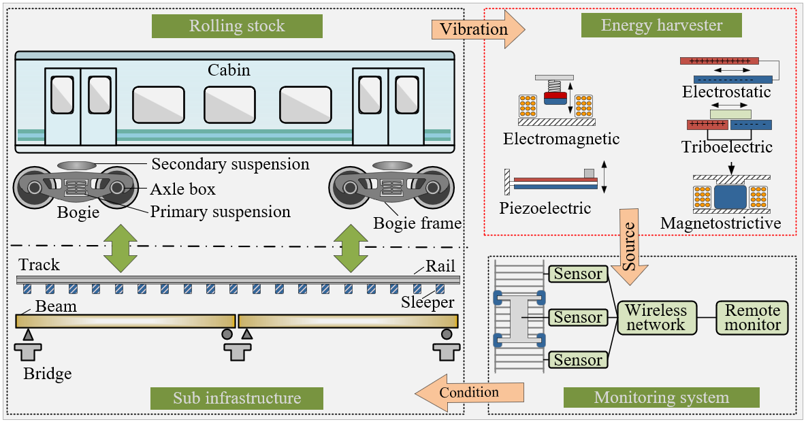
Figure 1. Illustration of vibration energy harvesting applications in the railway industry.

Vibration induced by the discontinuity of wheel-rail contact surface can transmit from a wheelset to a cabin, as well as from a rail to other track infrastructure, as shown in Figure 1. Since the vibration will undergo decay during its transmission, the amount of energy harnessed from the vibration of tracks and rolling stocks depends not only on the types of harvesters but also on the installation locations and the status of trains. According to installation locations, the reported diverse VEHs can be roughly categorized into two groups: onboard and wayside harvesters.
Wayside VEHs, installed on track infrastructure such as rails [5], [6], sleepers [7], bridges [8], are capable of scavenging the vibration energy induced by passing trains and powering electronic devices for health monitoring of infrastructure. As the vibration undergoes decay during transmission, the rail, under the excitation of travelling wheels, vibrates more intensely than other track components. Thus, much research focused on energy harvesting from rail vibrations. Using the inertial force during rail vibration, Gao et al. [5], [6] developed an electromagnetic VEH with a spring-mass structure and a piezoelectric VEH with a cantilever beam structure, both of which are fixed on the rail foot through a clap. Some other researchers studied harvesters driven by rail displacement because of their high energy density. Nelson et al. [9] proposed an inductive coil harvester, composed of a moving coil attached to the rail and a magnet fixed on the ground. Some VEHs utilize mechanical mechanisms, such as the rack-gear mechanism, to convert the linear displacement of rails into the rotation of electromagnetic generator [10]–[14]. Wayside harvesters generally operate when trains pass by, accounting for a very small part of a day. Such a characteristic will limit the total energy scavenged by wayside VEHs.
Onboard VEHs, fixed on rolling stocks, can operate continuously during a train journey. However, the fast speed and compact structure of train bogies restrict the installation position and the volume of onboard VEHs. The installation locations of reported onboard VEHs include the axle box, the bogie frame, and suspensions. For instance, Kim [15] designed a resonant-type electromagnetic VEH fixed on the axle box of a high-speed train and obtained a maximum average power of 147.92 mW at a speed of 300 km/h. Gao et. al [16] developed a pendulum-like electromagnetic VEH for harnessing the energy from the vibration of the bogie of a freight train. Suspensions have been widely utilized in trains to suppress undesired vibrations by dissipating kinetic energy into heat. Energy-harvesting absorbers on trains can harvest such dissipated energy and thus have gained tremendous attention because of the potential to control the dynamical behaviour of trains [17]–[20]. Energy-harvesting suspension systems can be grouped as linear harvesters, converting the vertical vibrations directly into electricity with a simple structure, and rotary harvesters, transforming the linear oscillation into rotational vibration of a generator through a linear-to-rotary mechanism. Rotary harvesters usually have higher energy harnessing capacity but more complex structures and larger dimensions than linear ones [19]. As most of the reported onboard VEHs are mounted on the bogie of a train, components of VEHs have a possibility of falling off under the action of long-term vibration, presenting a risk to the safe operation of trains. Installing the harvester in the cabin of a vehicle may avoid such a risk.
Vibration energy scavenging is a process of converting the kinetic energy of mechanical vibration into electricity using transduction mechanisms, such as electromagnetic [16], [21], piezoelectric [22], [23], triboelectric [24], [25], magnetostrictive [26] and electrostatic. Among all the reported mechanisms, electromagnetic and piezoelectric or the combination of both [27] are mostly exploited in the railway industry.
Electromagnetic VEHs, generally composed of fixed coils and moving magnets, do not depend on advanced materials and are easy to fabricate. Diverse structures of electromagnetic VEHs, such as a spring-mass structure [28], a magnetic-levitation structure [29], and a pendulum-like structure [30] have been reported, enabling electromagnetic VEHs to meet the requirements of different application scenarios. The electromagnetic mechanism is widely exploited in large-scale VEHs for railway applications. Although the output power of reported electromagnetic VEHs has been improved continuously, they have large dimensions and complex structures. Most of the reported small-scale electromagnetic VEHs use magnets sliding through the coil to realize energy conversion [31]. Sliding magnet-based VEHs with small dimensions usually have a displacement restriction on the inertial mass, leading to a limit on the velocity of the inertial mass and the amount of harvested energy [32]. As a result, rotation-translation VEHs have attracted much research interest because of the higher power density. For instance, Moss et al. [32] reported a hybrid rotation-translation harvester exploiting the cycloidal motion of a magnetic sphere to harvest energy from vibrations below 10 Hz. Fu et al. [33] proposed a bistable rotation-translation harvester operating at an ultra-low frequency (< 1 Hz). The spherical shape of the inertial mass makes rolling easier to take place than sliding. Moreover, the magnetic flux of a rolling magnet (RM) has a fast-changing rate than a sliding one, leading to an enhancement to induced voltages. Most rotation-translation VEHs adopted a diametrically magnetized sphere as a mover due to its ideal shape. However, the rolling axis of a sphere in practice is difficult to control during the rotation-translation motion, having an adverse impact on improving energy harvesting efficiency. A cylindrical rolling magnet may contribute to overcome the shortage of spherical magnet.
Piezoelectric VEHs exploit the electromechanical coupling characteristics of piezoelectric materials to convert mechanical energy to electricity. As small deformations of piezoelectric materials can generate a large voltage output, piezoelectric VEHs are sensitive even to slight vibrations and perform well under high-frequency excitations. The cantilever beam, shown in Figure 1, is a typical structure in reported piezoelectric VEHs due to its straightforward architecture and clear pathway of force transmission [34]. However, piezoelectric VEHs usually have large internal resistance. To output the harvested energy, external loads with large resistance are needed to match the internal resistance of the harvester. Such a characteristic would restrict the energy harvesting efficiency and practical application of the piezoelectric VEHs.
Compared with piezoelectric VEHs, electromagnetic harvesters usually have larger dimensions and can generate more energy, especially in the low-frequency range [16]. The performance of electrostatic, triboelectric, and magnetostrictive harvesters highly depends on the properties of the used materials and working conditions. Since the railway industry cannot guarantee the working environment on-site and is price-sensitive, VEHs based on electrostatic, triboelectric, and magnetostrictive mechanisms are seldom reported in railway applications.
In this work, an electromagnetic VEH, based on a cylindrical magnet with diametrical magnetization, is proposed. The cylindrical shape of the magnet makes it roll around its longitudinal axis, maintaining a high magnetic flux changing rate. Without complex connections and motion conversion mechanisms, the proposed VEH has a simple structure and small dimensions. Novel contributions of this work can be summarized as follows:
(1) A VEH which can achieve the monostable and tri-stable potential energy states by changing the number of fixed magnets (FMs), is proposed. The adaptability to various kinds of environmental vibration of this system can be enhanced by adjusting the vertical distance between the RM and FMs.
(2) It is found that the commonly used dipole moment method (DMM) is unsuitable for calculating the magnetic restoring force acting on the RM since the DMM cannot consider influences of magnet dimensions. Therefore, the finite element method is applied.
(3) A position-varying electromagnetic coupling factor is derived and exploited in the established electrodynamic model.
(4) The differences between the rolling and sliding effects are studied in theory.
(5) The applicability of the VEH for harvesting the lateral vibration energy of a metro car body is explored.
The remaining parts of this paper are organized as follows: In Section 2, the design concept, fabrication process, and theoretical model of the VEH are briefly described. Section 3 elaborates model refinement and parameter characterisation. Theoretical studies based on the established model and experimental frequency-sweeping tests are performed in Section 4. Section 5 presents an application of the proposed VEH for train vibration. An experiment to verify the potential of this harvester for driving electronic device is presented in Section 6. Finally, conclusions are drawn in Section 7 according to the relevant analysis.

2. Design, fabrication, and modelling of the harvester
2.1 Design concept and working principle of the harvester
Figure 2(a) presents the schematic of the harvester composed of a frame of a seat and two side columns, two adjustment rings, a rectangular tube, a coil, an RM, FMs, rubber bands and a piece of sandpaper. Each adjustment ring sits on the bottom of each column which supports the tube. Several adjustment rings of different thicknesses are available and can be used to make the desired gap between the tube (and thus the RM) and the FMs. The RM in a cylindrical shape with diametrical magnetization is placed inside the tube and rolls along the tube-length direction shown in Figure 2(a). A coil is wound around the rectangular tube in the length direction above the FMs (the coil in Figure 2(a) is a cut-through view). Oscillations of the RM around the stable points will lead to a change of magnetic flux inside the coil, as well as generating electromagnetic force across the coil. The characteristics of magnetic force vary with the vertical distance between the RM and FMs. Rubber bands passing through the hole reserved at the bottom and top walls of the rectangular tube on either side are used to prevent the direct collision between the RM and the corresponding end side of the tube. A piece of sandpaper is attached to the bottom wall of the rectangular tube to increase the static friction force acting on the RM and avoid slips of the RM. Figure 2(b) shows the two setups of FMs utilized in this work: one FM leads to a monostable potential energy system and three FMs lead to a tri-stable potential energy system.
A prototype of the harvester has been fabricated based on the proposed concept. During fabrication, the dimensions of the coil and rolling magnet are first decided upon, and the particular coil and magnet used in the prototype are the easiest ones we can obtain. The sizes of other components are designed based on the dimensions of the coil and the rolling magnet. For instance, the cross-section of the tube has to be able to pass through the coil and accommodate the rolling magnet inside it, and the length of the tube should be larger than $2\left(π+1\right)r$ times the radius of the cylindrical magnet to enable a tri-stable state. The frame, the tube and the adjustment rings are made of polylactic acid (PLA) via 3D printing technology. A photo of the actual experimental harvester is presented in Figure 2(c). The tube has a length of 90 mm and a rectangular cross-section of 19 mm×19 mm (dimension of inner rectangle: 14 mm ×16 mm). The diametrically magnetized RM has a grade number of N38 and a Ф4 mm × 4 mm dimension. Rubber bands with a diameter of 2 mm are utilized to provide elastic constraints for preventing the direct collision between the RM and the frame on its two sides. Sandpaper with a thickness of 0.2 mm is attached to the bottom inner wall of the tube to hinder the relative slips of the RM. The coil is made from copper wire with a diameter of 0.16 mm. The prototype of the VEH has a gross size of 90mm×50mm×30mm.
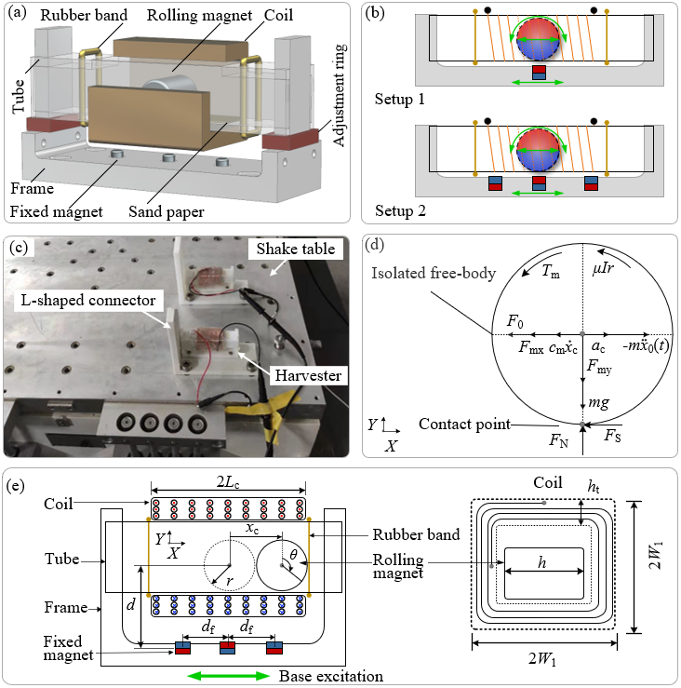
Figure 2. Schematic and working principle of the harvester: (a) schematic of the harvester; (b) setups for FMs; (c) a photo of the actual experimental harvester (two in view); (d) free body diagram of the RM; (e) some crucial parameters of the theoretical model.
2.2 Electromechanical model
To understand the electromagnetic and structural dynamical characteristics of this VEH, a theoretical model is established in this work. Figure 2(d) displays the free body diagram of the RM and Figure 2(e) shows some crucial parameters of the theoretical model. The dynamical equation of the RM can be written as follows:
$$\left\{\begin{matrix}m{\ddot{x}}_{c}=\sum{F_{x}}, ma_{c}=\left(-m{\ddot{x}}_{0}\left(t\right)\right)-F_{mx}-F_{s}-c_{m}{\dot{x}}_{c}- F_{0} (a) \\ m{\ddot{y}}_{c}=\sum{F_{y}},0=F_{N}-F_{my}-mg (b) \\ J\ddot{θ}=\sum{M_{c}}, J\ddot{θ}=F_{s}r-T_{m}-μIr (c)\end{matrix}，\right.$$ | （1）
where $\text{m}$ is the mass and $r$ the radius of the RM; $\text{J}=\frac{1}{2}mr^{2}$ denotes the moment of inertia of the cylindrical RM; It is assumed that there is no relative slip or loss of contact between the RM and the tube. $x_{c}=rθ$ and $y_{c}=0$ are the translational displacement of the rolling axis, and $θ$ the rotational angle; $a_{c}=r\ddot{θ}$ stands for the linear acceleration of the RM and $g$ the gravitational acceleration; $F_{mx}$ and $F_{my}$ are the X-axis and y-axis components of the magnetic force acting on the RM, respectively; $F_{s}$ and $F_{N}$ present frictional and normal forces acting on the contacting point of the RM. As no slipping occurs and the instantaneous velocity of the contact point is zero, $F_{s}$ satisfies $\left|F_{s}\right|<F_{N}μ_{f}$ ($μ_{f}$, the coefficient of the static friction between the RM and the sandpaper), that is, ${-F}_{N}μ_{f}<F_{s}<F_{N}μ_{f}$. According to Eq. 1(b) and 1(c), the friction force acting on the RM can be written as $F_{s}=\left( J\ddot{θ}+T_{m}+μIr\right)/R_{r}$, and the normal force $F_{N}=F_{my}+mg$. The term $\left|F_{s}/\left(F_{N}μ_{f}\right)\right|$ can work as an indicator for judging the occurrence of the relative slip between the RM and the tube. If $\left|F_{s}/\left(F_{N}μ_{f}\right)\right|$ is larger than or equal to one, relative slip occurs; $μ$ presents the electromagnetic coupling factor, which depends upon the angular position ($θ$) and angular velocity ($\dot{θ}$) of the RM; and $I$ is the induced current in the coil. As the induced magnetic field within a long solenoid can be approximated to be uniform [35], the two poles of the RM inside the solenoids should feel the same amount of magnetic forces acting in opposite directions. Therefore, the induced magnetic field of the coil only generates a resistant torque acting on the RM; $c_{m}$ stands for the mechanical damping coefficient; $T_{m}$ is the torque on the RM due to the non-neglectable dimensions of the RM and FMs; ${\ddot{x}}_{0}\left(t\right)$ denotes the acceleration of base excitation. $F_{0}$ denotes the force generated by the rubber band due to its elastic deformation. Rubber bands at two ends of the tube can be regarded as a strongly nonlinear spring system, working with the FMs to provide restoring force to this system. Thus, $F_{0}$ can be integrated into Eq. (1) like the X-axis component of the magnetic force $F_{mx}$ (Detailed calculation of $F_{0}$ is presented in Section 3.1).
As the longitudinal axis of the coil coincides with the X-axis and each turn of the coil can be regarded as parallel to the Y-Z plane, only the X-direction component of magnetic flux intensity is relevant to the magnetic flux within the coil and thus is considered. Substituting Eq. 1(a) to 1(c), the following equation can be obtained:
$$\left(\text{m}r^{2}\text{+}\text{J}\right)\ddot{θ}+\left(F_{mx}+μI+c_{m}R_{r}\dot{θ}+F_{0}\right)∙r+T_{m}=-mr{\ddot{x}}_{0}\left(t\right)$$ | （2）
The governing equation of an electrical circuit, connecting the harvester and a resistive load in series, can be expressed as follows based on Kirchhoff’s Voltage Law [33]:
$$μ\dot{θ}-L\dot{I}-\left(R_{in}+R_{l}\right)I =0$$ | （3）
where $L$ is the inductance of the coil; $R_{in}$ and $R_{l}$ the internal resistance of the coil and the external load. The values of some critical parameters are presented in Table 1.
The magnetic force between the RM and FMs shows a strong nonlinearity, being conducive to broadening the responsive frequency band of the system. The cylindrical magnet undergoes rotary motions inside the tube. Its changing pole positions and approximate distances between the RM and FMs mean that the radial dimension of the RM is unneglectable, that is, it cannot be treated as a sizeless dipole. Besides, the torque term,$T_{m}$, caused by the non-uniformed magnetic field will be omitted when the DMM is utilized. Thus, the DMM does not apply to calculate the magnetic force acting on the RM. Compared with the DMM, the finite element model (FEM) is not affected by the dimensions of magnets but it incurs a high computational workload.
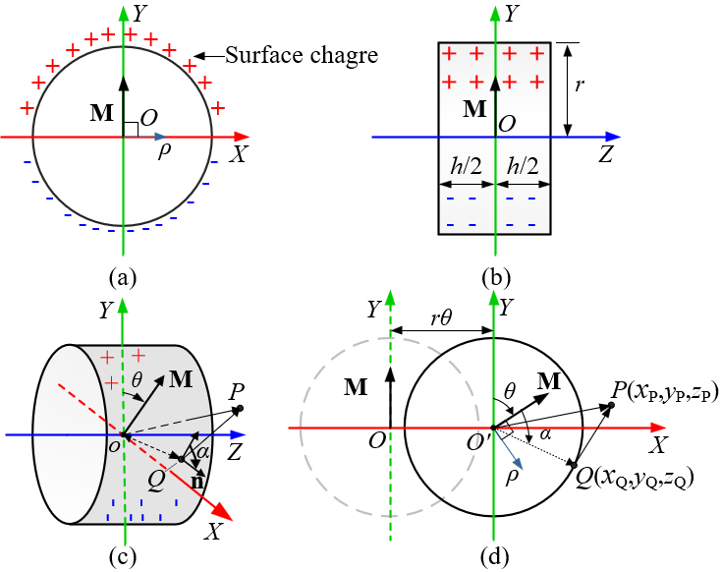
Figure 3. Illustration of the RM with diametrical magnetization: (a) front view; (b) left view; (c) isometric view; (d) parameters used in the model.

The RM oscillates inside the tube, causing a change of magnetic flux in the coil and inducing an electromotive force (EMF) across the coil. Figure 3 illustrates a cylindrical RM with diametrical magnetization, where $M$ denotes the magnetic polarization vector perpendicular to the longitudinal axis of the cylinder; $h$ stands for the height of the cylinder and $r$ the radius of the cylinder; $r$ and $r'$ correspond to position vectors from the central point $O$ of the RM to the observation point $P\left(x_{P},y_{P},z_{P}\right)$ and one point $Q\left(x_{Q},y_{Q},z_{Q}\right)$ on the cylindrical surface, respectively; $n$ is the unit vector normal to the curved surface of the cylinder at point $Q\left(x_{Q},y_{Q},z_{Q}\right)$; The radius $ρ$ of the cylindrical coordinate system fixed on the RM is perpendicular to $M$, as depicted in Figure 3(a). According to the Coulombian approach [36], the magnetic field intensity at observation point $P$ can be expressed as follows [37], [38]:
$$H\left(x_{P},y_{p},z_{P}\right)=\frac{Mr}{4πμ_{0}}\int_{α=-π}^{α=π}{\int_{z_{Q}=-\frac{h}{2}}^{z_{Q}=\frac{h}{2}}{\frac{\left(x_{P}-x_{Q} \right)i_{x}+\left(y_{p}-y_{Q} \right)i_{y}+\left(z_{P}-z_{Q} \right)i_{z}}{{\left({\left(x_{P}-x_{Q}\right)}^{2}+\left(y_{p}-y_{Q}\right)+{\left(z_{P}-z_{Q}\right)}^{2}\right)}^{\frac{3}{2}}}}\cos\left(α\right)dz_{Q}dα}$$ | （4）
where $μ_{0}$ presents the magnetic constant with a value of 12.57E-7 H/m; and $i_{x}$,$i_{y}$, and $i_{z}$ correspond to orthogonal unit vectors along X, Y, and Z axes, respectively;$α$ is the angle between $M$ and $n$. The X-direction component of magnetic field intensity at the plane of $x=x_{P}$ can be expressed as:
$$H_{x}\left(x_{P},y,z\right)=\frac{Mr}{4πμ_{0}}\int_{α=-π}^{α=π}{\int_{z_{Q}=-\frac{h}{2}}^{z_{Q}=\frac{h}{2}}{\frac{\left(x_{P}-x_{Q} \right)}{{\left({\left(x_{P}-x_{Q}\right)}^{2}+\left(y-y_{Q}\right)+{\left(z-z_{Q}\right)}^{2}\right)}^{\frac{3}{2}}}}\cos{α}dz_{Q}dα}$$ | （5）
As point $Q$ is on the cylindrical surface, $\left(x_{Q},y_{Q},z_{Q}\right)$ satisfies $x_{Q}=rθ+r\sin\left(α+θ\right)$ and $y_{Q}=r\cos\left(α+θ\right)$. The corresponding X-direction component of the magnetic flux density at the plane of $x=x_{P}$ can be given as:
$$B_{x}\left(x_{P},y,z\right)=μ_{0}H_{x}\left(x_{P},y,z\right)+δ$$ | （6）
where $δ=M\sin{θ}$ when the point $\left(x_{P},y,z\right)$ locates inside the magnet, and $δ=0$ when the point $\left(x_{P},y,z\right)$ is in the free space. The magnetic flux passing through a multi-turn coil with a square cross-section can be obtained by:
$$Φ_{m}=\frac{N}{2L_{c}h_{t}}\int_{-L_{c}}^{L_{c}}{dx_{P}}\int_{W_{1}-h_{t}}^{W_{1}}{dW}\int_{-W}^{W}{dz\int_{-W}^{W}{B_{x}\left(x_{P},y,z\right)}dy}$$ | （7）
where $N$ presents the number of turns of the coil; $L_{c}$is the half-length of the coil bobbin;$W_{1}$ is half of the side length of the square cross-section of the coil, and $h_{t}$ the thickness of the coil. These variables appearing in the above equation can be found in Figure 2(e). Based on the Faraday’s law of induction, the EMF $ε$ across the coil induced by the rolling cylindrical magnet as a function of time $t$ can be written as:
$$ε=\frac{dΦ_{m}}{dt}=\frac{dΦ_{m}}{ds}\frac{ds}{dt}=\frac{dΦ_{m}}{ds}r\dot{θ}=μr\dot{θ}$$ | （8）
Eq. (8) indicates that the induced EMF is proportional to the rotational velocity of the RM.
Table 1. Design parameters of the prototype.
 | Symbol | Description | Value | Unit
RM | $$m$$ | Mass of the RM | 1.24E-2 kg | kg
 | $$r$$ | The radius of the RM | 6.00E-3 m | m
 | $$h$$ | Hight of the RM | 1.40E-2 m | m
 | $$M$$ | Magnetic remanence | 1.25 | T
Coil | $$L$$ | The inductance of the coil | 7.65E-1 | H
 | $$R_{in}$$ | The internal resistance of the coil | 450 | Ω
 | $$L_{c}$$ | Half-length of the coil bobbin | 2.00E-2 | m
 | $$h_{t}$$ | The thickness of the coil | 1.00E-2 | m
 | $$W_{1}$$ | Half of the side length of the coil | 1.50E-2 | m
 | $$N$$ | Number of turns of the coil | 7850 | -
System | $$μ_{f}$$ | The static friction coefficient between the RM and the tube | 0.14 | -
 | $$c_{m}$$ | Mechanical damping coefficient | 1.50E-2 | N/(m/s)
 | $$d_{f}$$ | Distance between two adjacent FMs | 1.88E-2 | m
 | $$R_{l}$$ | The resistance of the load | 450 | Ω
 | $$g$$ | Gravitational acceleration | 9.81 | m/s²

3. Model refinement and parameter characterisation
The established theoretical model needs reliable values of some critical parameters, including the elastic force generated by rubber bands, the restoring forces acting on the RM generated by the FMs, and the position-varying electromagnetic coupling factor. Then, the typical phase trajectories and time-histories of the structural dynamics of the VEH investigated. Note that the RM and FMs used in the theoretical studies share the same parameters as the authors’ prototype. Detailed parameters can be found in Table 1 and Section 2.1.
3.1 Elastic force generated by rubber bands
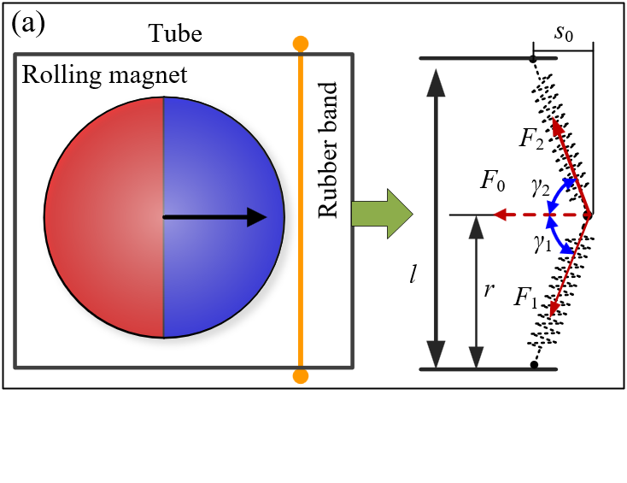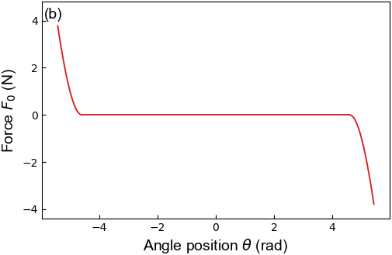
Figure 4. Force generated by the rubber band. (a) the force diagram; (b) the relationship between the elastic force and the deformation of rubber bands.

Rubber bands are selected to restrict the travel of the RM and provide an elastic force for preventing the direct collision between the RM and the frame. When the RM comes into contact with the rubber band, it stops the RM from going beyond them. Note that the energy dissipation during the contact between the RM and the rubber bands is not considered. The rubber bands used in the prototype have a length of 14 mm and a radius of 2 mm. They are installed at the positions of $x_{R}=5.6r$ and $x_{L}=-5.6r$ and pre-tensioned during assembling the prototype to provide initial stiffness. To calculate the elastic force generated by the rubber bands, each of them is simplified as a nonlinear spring, the force diagram of which is shown in Figure 4(a), where $l$ denotes the length of the rubber band. The elastic force $F_{0}$, generated by the rubber band and depending on the deformation $s_{0}$ of the rubber band, can be calculated according to the following equation:
$$F_{0}\left(s_{0}\right)=-(F_{1}\cos{γ_{1}}+F_{2}\cos{γ_{2}})$$ | （9）
where $F_{1}=\frac{EA_{s}}{r}\left(\sqrt{r^{2}+s_{0}^{2}}-r\right)$ and $γ_{1}=\arctan{\frac{r}{s_{0}}}$; Letting $r_{2}=l-r$; $F_{2}=\frac{EA_{s}}{r_{2}}\left(\sqrt{r_{2}^{2}+s_{0}^{2}}-r_{2}\right)$ and$γ_{2}=\arctan{\frac{r_{2}}{s_{0}}}$; $E$ and $A_{s}$ denote Young’s modulus and the cross-sectional area of rubber bands, respectively; the sign “-” indicates that the direction of this force is opposite to the direction in which the rubber band deforms. The deformation of the rubber band $s_{0}$ can be calculated with the angular position of the centre of the RM using the following equation:
$$s_{0}\left( θ\right)=\left\{\begin{matrix}\left(θ-1\right)r-x_{L}; θ<-4.6 rad \\ 0 ; -4.6 rad≤θ≤4.6 rad \\ \left(θ+1\right)r-x_{R}; θ> 4.6 rad \end{matrix}\right.$$ | （10）
Thus, the elastic force $F_{0}$ can be expressed as a function of the angular position $θ$. Figure 4(b) shows the nonlinear relationship between the force $F_{0}$ and the angular position of the centre of the RM.

3.2 Magnetic force and torque acting on the RM
DMM is one of the most used approaches to calculating a magnetic force [32], [33]. Figure 5(a) shows the comparison between the dipole-moment model and the actual force conditions of the RM. Figure 5(a) indicates that the RM takes on not only a force but also a torque because of its finite dimensions. To calculate the toque, a 3D finite element model is established, the mesh of which consists of 6,287,747 internal elements, 377,282 boundary elements, and 3,736 ‘edge’ elements. This 3D model has a spherical physical domain with a radius of 210 mm. Gauss’s Law of the magnetic field of the physical domain is solved by utilizing the scalar magnetic potential as the dependent variable. An infinite element layer with a thickness of 14 mm surrounding the physical domain is employed to reduce the influence of boundary conditions on the calculation results. Maxwell’s Stress Tensor is utilized to compute the force and torque on the RM. Note that the mesh around the boundary of the RM should be very fine to get an accurate result when using Stress Tensor to compute magnetic forces.
Comparisons between the magnetic forces acting on the RM calculated by the DMM and FEM are conducted. The upper and middle subplots of Figure 5(b) present the comparisons of the X-axis and Y-axis components of magnetic forces for the one-FM setup when the vertical gap between the RM and the FM,$d$, equals to 17 mm. The results demonstrate that the magnetic forces calculated by the DMM are very close to (slightly smaller than) that calculated by the FEM. The lower subplot of Figure 5(b) illustrates the comparisons between torque, $T_{m}$, calculated by the FEM, and $F_{mx}∙r$, the equivalent torque caused by the X-axis component of the magnetic force acting on the RM. $T_{m}$ has a larger amplitude than $F_{mx}∙r$, indicating that $T_{m}$ is unneglectable in establishing the dynamical model. However, the DMM cannot consider the torque item caused by the dimension effects of magnets, making it unsuitable to VEHs using rotation-translation magnets. Thus, the magnetic forces and toques used in the following study are all calculated via the established 3D finite element model.
Figure 5(c) shows the magnetic torque and forces acting on the RM at different gaps of $d$=15 mm, $d$=17 mm, and 19 mm for the one-FM setup calculated via FEM, and Figure 5(d) shows the same variables for the three-FMs setup. It can be seen from the figure that both the magnetic force and torque increase along with the decrease of $d$; and the magnetic force is more sensitive to the variation of $d$ than the torque $T_{m}$. The torque curves for the three-FMs setup are flatter in the angular position range from -2.0 rad to 2.0 rad than that for the one-FM setup, indicating that the three-FMs setup may be more sensitive to low-frequency vibration.
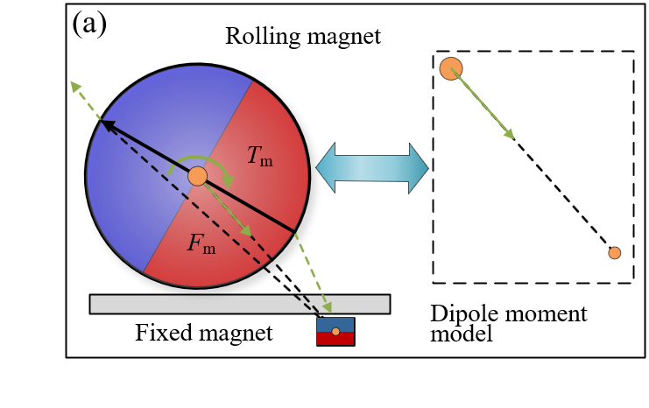
Figure 5. The torque and magnetic force acting on the RM: (a) force conditions of the RM; (b) comparisons between the forces and torques calculated by the DMM and the FEM; (c) magnetic torques and forces for Setup 1; (d) magnetic torques and forces for Setup 2; (e) potential energies for Setup 1; (f) potential energies for Setup 2.

To learn more characteristics about the two setups, the potential energy of the system is calculated. First, the position of $θ=0$ is selected as a reference, the potential energy of which is zero. The conservative forces that contribute to the potential energy of this system include the X-axis component of the magnetic force of $F_{mx}$, the torque $T_{m}$, and the elastic force generated by the rubber bands, $F_{0}$. The X-axis component of the magnetic force, $F_{mx}$, and torque, $T_{m}$, are functions of both variables of $θ$ and $d$. As $F_{0}$ is generated by the deformation of the rubber bands and the deformation is related to the position of the RM, $F_{0}$can be written as a piecewise function of $θ$. The potential energy of the system can be expressed as $U\left(d,θ\right)=\int{\left({T_{m}\left(d,θ\right)+F}_{mx}\left(d,θ\right)∙r+F_{0}\left(θ\right)∙r\right)}dθ+U_{0}$, where $U_{0}$ denotes the constant of integration.
Figure 5(e) and 5(f) present the potential energy of the one-FM and three-FMs setups when $d$ equals 15 mm, 17 mm, and 19 mm. The one-FM setup can generate monostable potential energy and the three-FM setup tri-stable potential energy. The well of potential energy becomes shallow along with the increase of $d$, as well as the tri-stable system gradually degenerating into a bi-stable system. The potential wells for the three-FMs setup are more shallow than those for the one-FM setup. Note that, the potential energy, shown in Figure 5(e) and 5(f), have already taken the influence of rubber bands into account. Because of the rubber bands, the potential energy at the two ends is very high for limiting the stroke of the RM.

3.3 The position-varying electromagnetic coupling factor
The RM oscillates inside the tube, generating an EMF across the coil; in turn, currents flowing through the coil, driven by the EMF, will bring about an electromagnetic damping torque acting on the RM. The electromechanical coupling characteristic of the harvester enables it to convert vibration energy into electricity. Constant electromagnetic coupling factors are commonly exploited to establish a theoretical model of electromagnetic VEHs [39], [40]. However, the RM has a considerable length of stroke when undergoing a rotation-translation cycle inside the tube. Considering the electromechanical coupling factor as a constant may result in a large decrease in calculation accuracy. According to Eq. (3) and Eq. (8), the electromagnetic coupling factor, a position-varying variable, satisfies $μ=\frac{dΦ}{ds}$. Figure 6(a) shows the magnetic flux inside the coil when the RM rolls through the coil, from the numerical simulation. The magnetic flux has an antisymmetric structure because of the rotary motion of the RM. Figure 6(b) is the first derivative of the magnetic flux to the horizontal displacement of $s$, namely the electromagnetic coupling factor $μ$, having a symmetrical structure. This figure demonstrates that $μ$ has large values when the RM enters and exits from the long coil, and reaches its maximum value at the middle point of the coil. According to the potential energy shown in Figure 5(e) and 5(f), the RM for Setup 1 has a large possibility of appearing at the middle point of the coil, and that for Setup 2 are more possible to appear at both ends of the coil. Thus, Setup 1 may have a larger voltage than Setup 2 under the same excitations.
Figure 6. The position-varying electromechanical coupling factor: (a) magnetic flux inside the coil; (b) the position-varying electromechanical coupling factor.

3.4 Typical phase trajectories and time-history data of the two different FM setups
Using the established theoretical model, the dynamical characteristics of the harvester can be investigated through numerical simulations. To analyse the theoretical model, ‘LSODA’, a wrapper to the Fortran solver [41], is utilized to solve the ordinary differential equations (ODEs) of the system. This algorithm has the capability of switching between the Adam method and the backward difference method according to the information at each integration step [42]. Such a characteristic makes the ‘LSODA’ algorithm more efficient for complex dynamic systems. For the two comparison cases, the total time for integration is 10 s and the time step is 0.001 s. Besides, the initial angular position and velocity are both set to zero.
The difference between Setup 1 and Setup 2 is the number of FMs. Setup 1 has one FM beneath the middle point of the coil, leading to a monostable potential energy state. Figure 7(a) shows the typical phase trajectories and time-histories of the monostable system for Setup 1. The black dot in the upper subplot and the black dashed line in the lower subplot of Figure 7(a) denote the stable point of the system. It can be seen from the figure that the RM always oscillates around the stable point under a sinusoidal excitation (frequency:$ω$=5 Hz; acceleration amplitude:$A$=0.2$g$).
For Setup 2, the harvester has three FMs installed at $x=0, ± πr$. Besides, the FMs on the two sides have an opposite polar direction to the middle FM to maintain an attractive force between the RM and each FM when the RM gets near the FMs. Each fixed magnet corresponds to a potential energy well. Due to the influence of the two side magnets, the potential energy well corresponding to the middle FM is more shallow than that at the two sides, which can also be verified by the potential energy curves shown in Figure 5(f). Under excitations, the RM will oscillate around the three potential energy well. Figure 7(b) gives the typical phase trajectories and time-histories of the tri-stable state for Setup 2 under the sinusoidal excitation with a frequency of 5 Hz and an acceleration amplitude of 0.3$g$. The oscillator may vibrate around one stable point or travel between different stable points. When the excitation with a frequency of 5 Hz and an acceleration amplitude of 0.2$g$ is adopted, the oscillator only travels around the left two stable points. For obtaining the typical phase trajectories of the tri-stable state, the acceleration amplitude is increased from 0.2$g$ to 0.3.
Figure 7. Typical phase trajectories and time-history data: (a) phase trajectories and time-histories for Setup 1; (b) phase trajectories and time-histories for Setup 2.

4. Theoretical studies and frequency-sweeping tests
For learning about the electromagnetic and dynamical characteristics of the proposed VEH, theoretical studies on the difference between the rolling and sliding effects and occurrence conditions of the RM slips are carried out using the established theoretical model. The RM, the FM, and the coil used in the theoretical studies are about the prototype. Besides, Frequency-sweeping tests are also performed to verify the suitability of the theoretical model and understand the actual energy harvesting capacity of this VEH.
4.1 Difference between the rolling and sliding effects
A sliding magnet driven by inertial force is the simplest and most used component in electromagnetic VEHs. Recently, some RM-based VEHs have been reported because of their excellent performances in energy harvesting [43]. However, no research has touched on the superiority of the rolling effect to the sliding effect. In this work, the established theoretical model is used to study the difference between the rolling and sliding effects. Figure 8(a) shows the comparative cases designed in this study, where both the rolling and sliding cylindrical magnets have the same translational displacement $5πr$. The coil utilized in this theoretical study shares the same parameters as our prototype. Besides, the two magnets pass through the coil with the same translational speed $v$. The type of motion is the only difference between the two cases.
Figure 8(b) shows the EMFs across the coil when the magnet rolls and slides from Point $B_{1}$ to $B_{2}$ at different translational velocities. The induced EMF increases with the translational velocity $v$ in both cases. For the RM, the EMF reaches its maximum value of 5.8 V at the middle point of the coil, and two smaller peaks also appear near the two ends of the coil. For the sliding magnet, the maximum EMF of 1.8 V is obtained at the two ends of the coil. These results demonstrate that the peak values of the EMF generated by the RM are higher than those by the sliding magnet. Besides, the RM can generate considerable EMF not only at the two ends but also inside the coil. However, the sliding magnet only performs well at the two ends of the solenoid. Note that the initial angular potion of the cylinder will influence the induced EMF across the coil of both Cases.
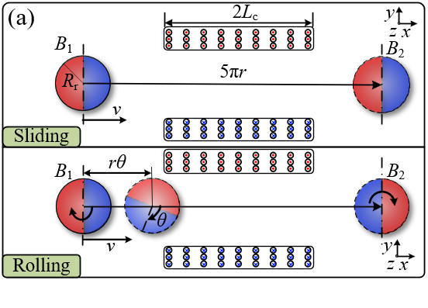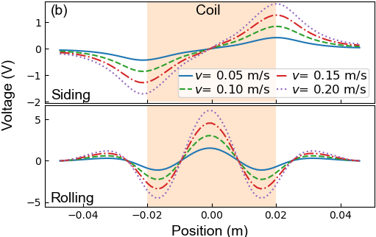
Figure 8. Comparisons between electromagnetic inductions effect by rolling and sliding magnets: (a) comparisons between rolling and sliding cases; (b) EMFs by the rolling and sliding magnets.

4.2 Occurrence conditions of the slips between the RM and the sandpaper
The theoretical model is established based on the assumption that there is no relative slip between the RM and the sandpaper. However, slips cannot be avoided when the system is subject to intense excitations. For pure rolling, the translational velocity at the centre of the RM is coupled with its rotational velocity through $v_{c}=r\dot{θ}$. As the instantaneous velocity of contact points of the RM is always zero and there is no slip, which means that the bottom of the RM is momentarily at rest relative to the tube, $F_{s}$ can be determined from the maximum stiction [44]. Thus, the occurrence of slips between the RM and the sandpaper can be reduced by increasing the friction coefficient. A piece of sandpaper with a thickness of 0.2 mm is attached to the bottom wall of the tube so that there is no direct contact between the RM and the tube. The sandpaper and the RM have a static coefficient of friction of $μ_{f}=0.14$. To validate the established theoretical model, a parametric study is conducted.
Figure 9 displays the maximum values of the item $\left|F_{s}/\left(F_{N}μ_{f}\right)\right|$ for Setup 1 and Setup 2, respectively. For both setups, the sinusoidal excitations have a frequency of $ω$=5 Hz and the acceleration amplitudes vary from 0.05$g$ to 0.40$g$. The blue line with circle makers in Figure 9(a) is the results for Setup1, showing an increasing trend with the increase of acceleration amplitude. It can also be found out that the slip phenomenon begins to occur when the acceleration amplitude increases to 0.2$g$ for Setup 1. The red line with start markers presents the results of Setup 2. For Setup 2, slips first appear when the acceleration amplitude increases to 0.3$g$. Comparisons between two lines in Figure 9 illustrate that slips between the RM and the sandpaper for setup 1 are easier to occur than that for Setup 2.
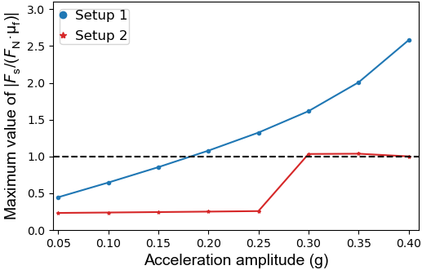
Figure 9. The occurrence of relative sliding between the RM and the tube

4.3 Frequency-sweeping tests
As the theoretical model is established based on strict assumptions, the application of the theoretical model has a limitation, especially for situations with intense excitations. Besides, the accuracy of the theoretical model strongly depends on model parameters. Experimental studies can make up for the shortcomings of the theoretical model and help understand the actual performance of the harvester. A shake table (DC3200-36, Suzhou Sushi Testing Group Co., Ltd.) is used to carry out a frequency-sweeping test to learn about the dynamic characteristics of the prototype. During tests, the excitation frequency $f$ varies exponentially over time $t$ from 5 Hz to 40 Hz. $f(t)$, as a function of $t$, can be written as $f\left(t\right)=5∙2^{\left(t/120\right)}$for forward sweeping, and $f\left(t\right)=40∙2^{\left(-t/120\right)}$ for backward sweeping. At the same time, the excitations have fixed acceleration amplitude and a frequency-varying displacement amplitude. A small acceleration amplitude of 0.2$g$ and an extremely large acceleration amplitude of 2.0$g$ are selected to study the performances of the harvester under excitations with different intensity. 0.2$g$ is close to the lateral acceleration of a car body of metro trains in normal operations. A 2.0$g$-excitation, ten times the acceleration of the 0.2$g$-excitation, is selected as an intense excitation to assess the scope of vibration responses of the harvester. The suitability of the theoretical model, influences of the vertical gap $d$ and setups of the FMs on the dynamic characteristics, and the energy harvesting capability of the harvester are investigated experimentally.
Figure 10(a) and 10(b) are the comparisons between the root mean square (RMS) of experimental EMFs and simulated EMFs for Setups 1 and 2, respectively. For both cases, the vertical gap between the RM and FMs is at 22 mm. For experiments and simulations, the excitations have a frequency sweeping from 5 Hz to 40 Hz and an acceleration amplitude of 0.2$g$. Although there are deviations between the experimental and simulated results, the simulated and experimental data exhibit a similar trend, demonstrating the suitability of the theoretical model. It should be noted that the errors between the estimated and true values of a parameter and model simplifications will affect the calculation accuracy of the model. The geometric errors during fabrication and assembling of the prototype, and the electromagnetic noise of the testing system will also influence the experimental results. Model factors and experimental factors work together to cause differences between theoretical and experimental results.
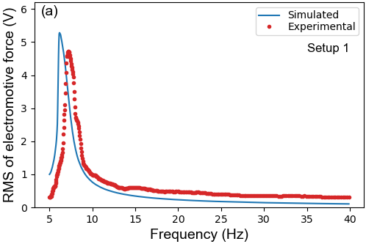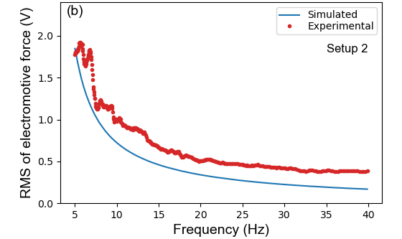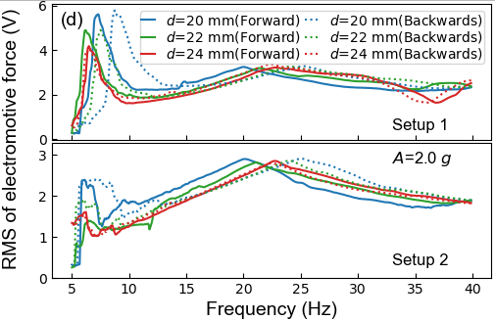
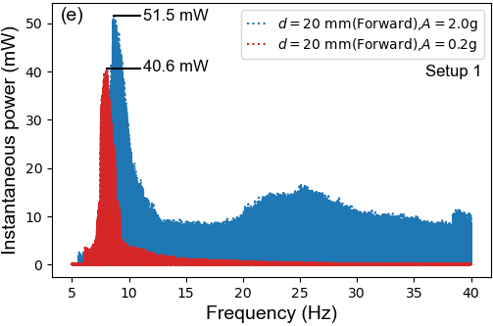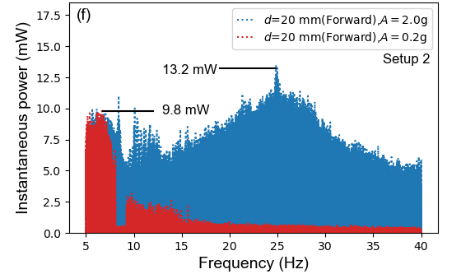
Figure 10. Results of frequency-sweeping test: (a) comparisons between the simulated and experimental results for Setup 1; (b) comparisons between the simulated and experimental results for Setup 2; (c) results of frequency-sweeping tests under the 0.2-$g$ excitation; (d) results of frequency-sweeping tests under the 2.0-$g$ excitation; (e) experimental instantaneous power of Setup 1 when $d=$20 mm; (f) experimental instantaneous power of Setup 2 when $d=$20 mm;
Figure 10(c) shows the RMS of experimental EMFs for Setups 1 and 2 when acceleration amplitude is 0.2$g$ and $d$ is at 20 mm, 22 mm, and 24 mm, respectively. The solid and dotted lines in Figure 10(c) shows the results for conditions of sweeping frequency forward and backwards, respectively. Figure 10(d) shows corresponding results when the acceleration amplitude is 2.0$g$. The comparison between Figure 10(c) and 10(d) reveals that the induced EMF experiences a slight increase when the acceleration amplitude increases ten times from 0.2$g$ to 2.0$g$. This is because an intense excitation will cause slips between the RM and the sandpaper, limiting the increase of the induced EMF. The results of forward frequency sweeping look very similar to those of backward frequency sweeping when the acceleration amplitude is small. The similarity in results between two opposite frequency sweeping directions becomes significant different when the acceleration amplitude increases from 0.2$g$ to 2.0$g$. Besides, the responsive frequency band is broadened when the acceleration amplitude becomes large. The maximum value of the induced EMF increases along with the reduction of $d$, since the stiffness of the system can be enhanced by reducing $d$. And the frequency corresponding to the peak value of the induced EMFs also increases with the reduction of $d$.
The peak values of the EMFs generated by the harvester for Setup 1 under different acceleration amplitudes are larger than those for Setup 2. Note that the EMF generated by the harvester for Setup 1 is not always larger than that for Setup 2. The results of frequency-sweeping tests show that the harvester for Setup 2 can generate larger EMFs than that for Setup 1 when the acceleration amplitude is 0.2$g$ and the frequency near 5 Hz (highlighted by a black box in Figure 10(c)). Besides, we can also find that the bottom of potential energy curves for Setup 2 is flatter than that for Setup 1, indicating that Setup 2 may be more suitable for low-frequency vibration. However, the lowest operating frequency of the shake table employed for frequency sweeping is 5 Hz, limiting our investigations on the performance of the harvester in the frequency range below 5 Hz. In a further study, the authors plan to get a shake table whose operating frequency goes well below 5 Hz to study response characteristics of the harvester in the ultra-low-frequency range.
Table 2. Comparisons with the state-of-art VEHs based rolling oscillators.
Authors/  reference | Year | Transducer | Structural feature | Maximum size | Acceleration amplitude | Excitation frequency | Maximum average power
This work | / | Electromagnetic | Rolling cylinder-tube-fixed magnet | 90 mm | 0.2$g$ (2.0$g$) | 8.0 Hz  (9.0 Hz) | 16.0 mW  (19.2 mW)
Fu et al./[33] | 2020 | Electromagnetic | Rolling sphere-tube- tethering magnet | 80 mm | 0.06$g$ | 0.8 Hz | 60 μW
Zhang et al./[31] | 2019 | Electromagnetic | Rolling cylinder-tube | 80 mm | / | 3.1 Hz | 1.02 mW
Maharjan et al./[43] | 2019 | Electromagnetic | Rolling sphere-cycloid curved tube | 96 mm | / | 5 Hz | 8.8 mW
Kuang et al./[45] | 2019 | Electromagnetic | Rolling pendulum | 50.2 mm | 0.5$g$ | 4.8 Hz | 3.6 mW
Smilek et al./[46] | 2019 | Electromagnetic | Proof mass rolling in a circular cavity | 70 mm | 1.3$g$ | 2.78 | 5.1 mW

For learning about the energy harvesting capability of the proposed VEH, the experimental instantaneous powers for Setups 1 and 2 when $d=20$ mm are provided, as shown in Figure 10(e) and 10(f), respectively. By segmenting the instantaneous power data into 0.2-s sections, and the average power of each section are calculated. Figure 10(e) indicates Setup 1 reaches its maximum instantaneous power of 40.6 mW (average power 16.0mw) at 8.0 Hz under 0.2$g$ excitation, and the maximum instantaneous power of 51.5 mW (average power 19.2mw) at 9.0 Hz under 2.0$g$ excitation. It can also be found that the harvester for Setup 1 performs well in a narrow frequency band between 5 Hz to 10 Hz.
For Setup 2, the instantaneous power obtains its maximum values of 9.8 mW (average power 3.3 mW ) at 6.3 Hz under 0.2$g$ excitation, and 13.2 mW (average power 4.3 mW ) at 25.0 Hz under 2.0$g$ excitation. Comparisons in the energy harvesting capability between the VEH proposed in this work and the state-of-the-art VEHs based on rolling oscillators are carried out, the results of which are shown in Table 2. It can be found that the VEH proposed in this work exhibits good performance in comparison with the state-of-the-art VEHs. Note that the performance of a VEH highly depends on its dimensions and the characteristics of excitations.

5. Application of vibration energy harvesting for metro vehicles
When trains run along the track, vibration induced by defects of the wheel-rail contact surface and the irregularity of the track will be passed to the car body. Vibration of a car body, particularly lateral vibration, is a very important consideration in evaluating the operation safety and has a direct influence on passengers’ riding experience [47]. Since many factors, such as track conditions, train velocity, and stiffness of the suspension system, have impacts on train vibration, it is impossible to eliminate the vibration of rolling stocks. In this work, the proposed VEH is used for scavenging the vibration energy of a car body and monitoring the operating condition of trains. To achieve such a goal, the vibration signal of the car body for a metro vehicle is measured using embedded sensors of an onboard smartphone. Then, a laboratory test system is set up and experimental tests are performed to estimate the performance of the harvester under field-measured vibration. Finally, test results are processed and analysed.
Figure 11(a) shows the setup of using a smartphone to measure the vibration signal of the car body on a metro vehicle. The smartphone is attached on the cabin floor above the bogie, where the proposed VEH can also be installed during its actual application. Note that the measured signals are slightly different when the smartphone is fixed at different locations. The longitudinal and lateral axis of the smartphone are parallel to the forward direction and the lateral direction of the train, respectively. The built-in accelerometer of the smartphone has a sampling frequency of 100 Hz, which can cover the dominant vibration frequency range (0-20Hz) of metro car bodies [48]. The test line has a deigned speed of 80 km/h. Figure 11(b) shows the vertical profile and horizontal alignment of the test metro line. The alignments indicate that there are two left-turn curves with a radius of 450 m in the test interval, which has the potential of undermining the running stability of trains. Besides, the track conditions would deteriorate after years of service, making the vibration problems of the car body more prominent, especially in the curve sections.
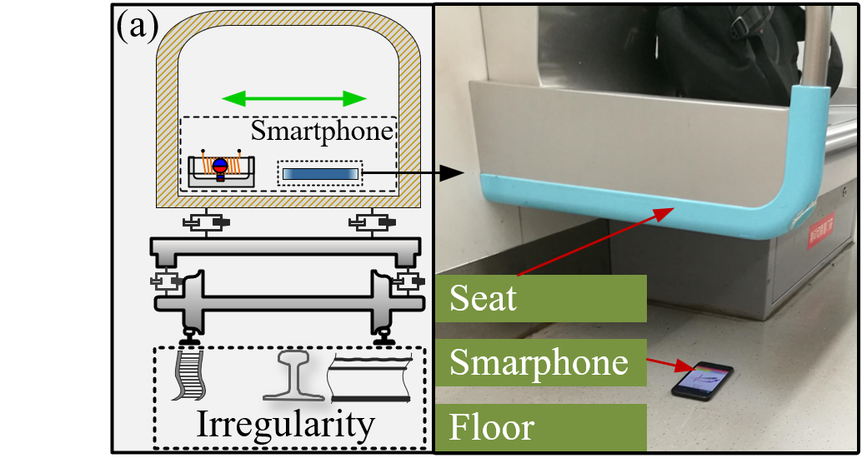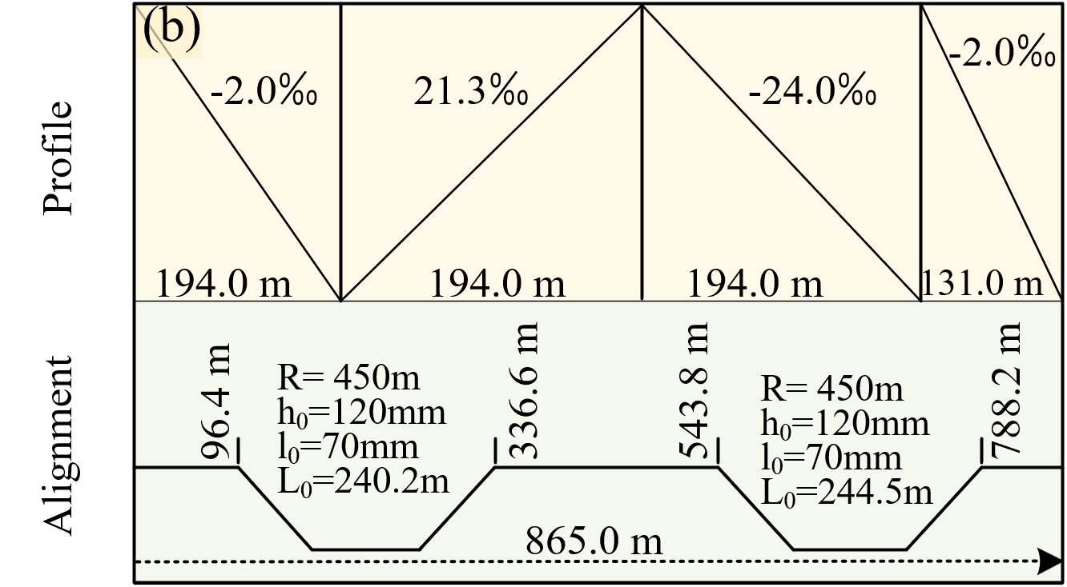
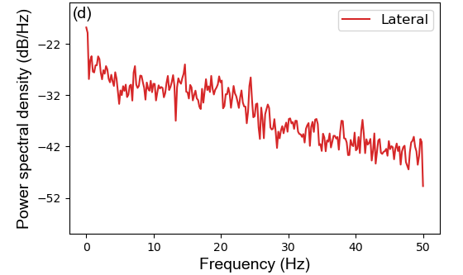
Figure 11. Field test on a metro train using a smartphone:(a) test setup and the surroundings; (b) vertical profiles and horizontal alignments of the test line; (c) measured longitudinal, vertical, and lateral acceleration signals; (d) power spectrum of the measured lateral acceleration.

Figure 11(c) displays field-measured longitudinal, vertical, and lateral accelerations, respectively. It can be deduced that both the vertical and lateral accelerations increase significantly when the train passes the two curve sections. According to the current maintenance rules in the railway industry of China, the lateral acceleration of a car body of a train running at a speed below 200 km/h should not exceed$0.15g$. However, the maximum amplitude of the measured lateral acceleration is close to $0.2g$, which may cause serious passenger discomfort. Figure 11(d) displays the power spectrum of the lateral acceleration signal of the car body. It shows a decreasing trend with the increase of the frequency, indicating that the energy of the lateral acceleration is mainly located in a low-frequency range.
Limited by the in-situ environment, onboard performance tests for the proposed VEH are hard to implement. So instead laboratory tests of the VEH are conducted. The layout of the laboratory test system is shown in Figure 12(a), to reproduce the lateral vibration of the car body of a metro vehicle. As a critical part of the test system, the shake table test system, consisting of a computer, a signal generator, a power amplifier, and an accelerometer, employs a closed-loop control strategy to realize an exact reproduction of field-measured vibration. The oscilloscope (MDO4104C, Tektronix) is utilized to display experimental data and record it to a hard disk with a sampling frequency of 5000 Hz. Figure 12(b) shows the experimental setups during laboratory tests. Figure 12(c) presents the induced EMF of the VEH with one FM under the filed-measured lateral vibration of the car body of a metro vehicle. The vertical gap between the RM and the FM is $d=20 mm$. The EMF obtains its maximum voltage of 2.8 V when the train passes the curves. Figure 12(d) is the corresponding instantaneous power of the VEH under the field-measured lateral vibrations. The results show that the harvester can reach a maximum instantaneous power exceeding 4 mW under the actual lateral vibration of a car body. Besides, the instantaneous power data is segmented into 0.2-s sections and the average power of each section is calculated, as the green line shown in Figure 12(d). The peak value of the average power reaches 1.48 mW. The energy with average power around 1 mW level, through proper energy management and storage, can be used to drive the entire transportation IoT monitoring node system, including sensors and wireless transmission modules [49].
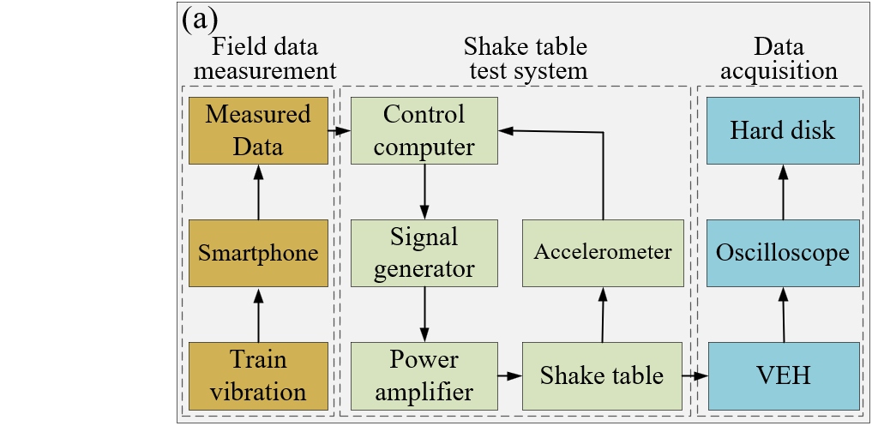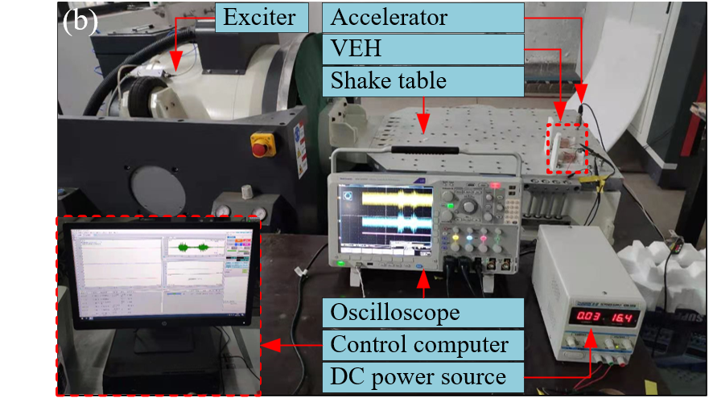
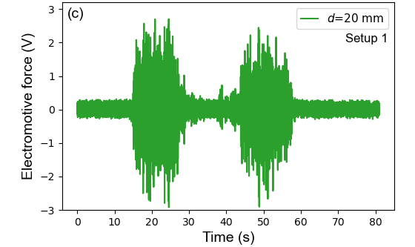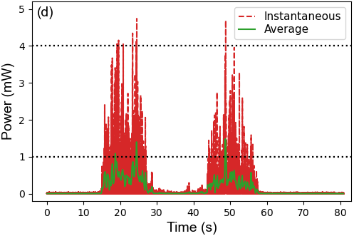
Figure 12. Laboratory tests of the VEH using the field-measured vibration signals: (a) layout of the test system; (b) experimental setup of the laboratory test; (c) the EMF of the VEH for Setup1 under the lateral vibration of a car body; (d) the instantaneous powers of the VEH for Setup 1 under the lateral vibration of a car body.

Based on the laboratory test system, the potential of the harvester to monitor the operating conditions of a metro vehicle is also investigated. The field-measured vibration varies in a relatively small acceleration, but knowledge of the responsive characteristics of the harvester under excitations outside this range is also desirable. Thus, the amplitude of the field-measured lateral acceleration is scaled from 0.25 times to 3.0 times to overcome such an issue. A series of laboratory tests are conducted using these scaled vibration signals, and the vibration signals and corresponding electromotive force data obtained are split into one-second segments. The RMS of the acceleration in each segment and the maximum value of the electromotive force in the corresponding segment is presented as a dot in Figure 13. The colours of these dots indicate the acceleration amplitudes of excitations as different multiples of the field-measured acceleration amplitude. The data sets of the RMS of acceleration and the maximum value of the electromotive force have a Pearson correlation coefficient of r =0.97 and a P-value of 0, indicating that the two variables have a strong linear relationship.
Through the linear regression of these dots, the black line in Figure 13 is obtained as the best fit, the expression of which can be given as $y=33.5x$. The coefficient of determination $R^{2}$ has a value of 0.93, illustrating an excellent fit. According to the linear relationship between the electromotive force and the RMS of acceleration, the vibration level can be predicted via the induced EMF of the harvester. That is to say, the lateral acceleration of the car body can be monitored using the EMF of the VEH. Using the harvested energy to power wireless transmitters and the measured electromotive force signal to monitor the lateral acceleration of the car body, the proposed harvester promises to make a self-contained onboard monitoring node for ride comfort evaluation.
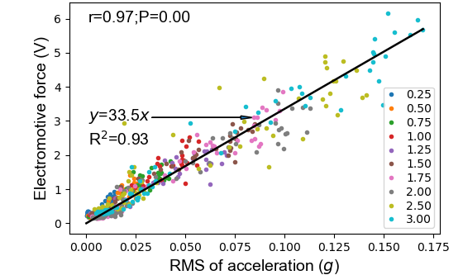
Figure 13. The relationship between the output electromotive force of the harvester and the acceleration amplitude of the excitations.
6. Potential for powering electronics
During the above experiments, resistive loads are employed. However, most of the commercial electronics are not pure resistive load in practice, and the energy harvesting system may present different behaviours. Thus, a digital thermal hygrometer (1.5 V) is selected to learn about the actual performance of the VEH for powering an electronic device. Under excitation, this VEH will generate an alternating current (AC) within a closed circuit. However, most electronics require a direct current (DC) in practice. Thus, a regulation circuit to convert the AC into DC is needed. In this study, a regulation module, mainly composed of a full-wave rectifier and a capacitor, is employed to realize such a conversion. Its electrical diagram is shown in Figure 14(a).
According to the results of the frequency sweeping test, the harvester with one FM will reach its optimal performance under excitations with 0.2$g$ amplitude at 8 Hz. Using such an excitation, the energy harvesting system, consisting of the VEH and the regulation circuit, can be driven. The digital thermo-hygrometer can be successfully activated, sensing the temperature and humidity of the environment and displaying them on the liquid-crystal display (LCD) screen, as shown in Figure 14(b). This test demonstrates that the energy harvesting system can drive commercial low-power electronic devices, confirming the potential for being developed into self-powered transportation IoT monitoring nodes.
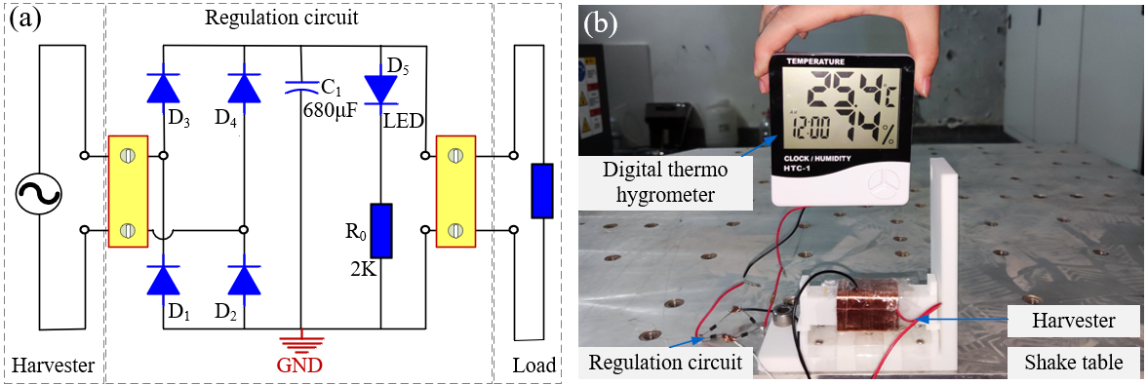
Figure 14. Verification of the capability of the VEH for powering electronic devices: (a) the electrical diagram of the regulation circuit; (b) a digital thermo-hydrometer powered by the energy harvesting system.

7. Conductions
This paper proposes an electromagnetic VEH (vibration-based energy harvester) for train vibration using a diametrically magnetized cylindrical magnet. Modelling, parameter characterisation, theoretical analysis, and experimental tests are conducted to investigate the structural and electrical characteristics and performances of the system. The results indicate that the proposed VEH has an excellent energy harvesting capacity. Using the harvested energy to power wireless transmitters and the measured electromotive force signal to monitor the lateral acceleration of a train car body, the proposed harvester promises to make a self-contained onboard monitor node. The conclusions of this paper are drawn as follows:
(1) A theoretical model of the VEH is established. It is found that the DMM (dipole-moment method) is unsuitable for VEHs based on rotation-translation magnets since the DMM cannot consider the influence of magnet dimensions. A position-varying factor is derived and employed to realize the electromagnetic coupling of the system.
(2) Theoretical analysis on the difference between the rolling and sliding effects and the occurrence conditions of the RM (rolling magnet) slips are performed. The results indicate that the RM can generate a larger EMF (electromagnetic force) than a sliding magnet, and generate considerable EMF not only at the two ends but also inside the coil. Slips between the RM and the sandpaper for Setup 1 (one fixed magnet, referred to as FM) are easier to occur than those for Setup 2 (three FMs).
(3) Frequency-sweeping tests are carried out to validate the suitability of the theoretical model and understand the actual energy harvester capacity of the harvester. The simulated and experimental results exhibit a similar trend, demonstrating the suitability of the theoretical model. The one-FM setup reaches its maximum instantaneous power of 40.6 mW at 8.0 Hz (9.8 mW at 7.5 Hz for the three-FM setup) under 0.2-$g$ excitations.
(4) An application of the VEH for metro vehicles is explored. The harvester can reach a maximum instantaneous power exceeding 4 mW under the real lateral vibration of a metro car body. The induced EMF and the RMS (root mean square) of acceleration show a strong linear relationship, whereby the vibration level can be identified via the electromotive force of the harvester, indicating a feasible approach of a self-powered system for ride comfort monitoring.
(5) The capability of the proposed VEH for driving low-power electronics is confirmed through an experiment.

Acknowledgements
The main theory study of this work is carried out by the first author during his visit to the University of Liverpool under the guidance of the 4th author, and sponsor from the China Scholarship Council. This work is also founded by the National Natural Science Foundation of China, (Grant Nos. 52008343 and U1934214) and the Sichuan Provincial Department of Science and Technology (Grand No. 2020YFG0049). Besides, the authors would like to thank Associate Professor Yuhua Sun from Southwest University, Chongqing, for his help in setting up the laboratory test system.

References
[1] Y. Wang, M. Gao, H. Ouyang, S. Li, Q. He, and P. Wang, ‘Modelling, simulation, and experimental verification of a pendulum-flywheel vibrational energy harvester’, Smart Materials and Structures, vol. 29, no. 11, p. 115023, 2020, doi: 10.1088/1361-665x/abacaf.
[2] N. Bosso, M. Magelli, and N. Zampieri, ‘Application of low-power energy harvesting solutions in the railway field: a review’, null, pp. 1–31, 2020, doi: 10.1080/00423114.2020.1726973.
[3] Y. Sun, P. Wang, J. Lu, J. Xu, P. Wang, S. Xie, et al., ‘Rail corrugation inspection by a self-contained triple-repellent electromagnetic energy harvesting system’, Applied Energy, vol. 286, p. 116512, 2021, doi: 10.1016/j.apenergy.2021.116512.
[4] H. Pan, L. Qi, Z. Zhang, and J. Yan, ‘Kinetic energy harvesting technologies for applications in land transportation: A comprehensive review’, Applied Energy, vol. 286, p. 116518, 2021, doi: 10.1016/j.apenergy.2021.116518.
[5] M. Gao, P. Wang, Y. Cao, R. Chen, and D. Cai, ‘Design and Verification of a Rail-Borne Energy Harvester for Powering Wireless Sensor Networks in the Railway Industry’, IEEE Transactions on Intelligent Transportation Systems, vol. 18, no. 6, pp. 1596–1609, Jun. 2017, doi: 10.1109/TITS.2016.2611647.
[6] M. Y. Gao, P. Wang, Y. Cao, R. Chen, and C. Liu, ‘A rail-borne piezoelectric transducer for energy harvesting of railway vibration’, Journal of Vibroengineering, vol. 18, no. 7, pp. 4647–4663, 2016, doi: 10.21595/jve.2016.16938.
[7] G. Gatti, M. J. Brennan, M. G. Tehrani, and D. J. Thompson, ‘Harvesting energy from the vibration of a passing train using a single-degree-of-freedom oscillator’, Mechanical Systems and Signal Processing, vol. 66–67, pp. 785–792, 2016, doi: 10.1016/j.ymssp.2015.06.026.
[8] W. Hou, Y. Li, Y. Zheng, and W. Guo, ‘Multi-frequency energy harvesting method for vehicle induced vibration of rail transit continuous rigid bridges’, Journal of Cleaner Production, vol. 254, p. 119981, 2020, doi: 10.1016/j.jclepro.2020.119981.
[9] Carl A. Nelson, Stephen R. Platt, Dave Albrecht, Vedvyas Kamarajugadda, and Mahmood Fateh, ‘Power harvesting for railroad track health monitoring using piezoelectric and inductive devices’, 2008, vol. 6928. doi: 10.1117/12.775884.
[10] X. Zhang, Z. Zhang, H. Pan, W. Salman, Y. Yuan, and Y. Liu, ‘A portable high-efficiency electromagnetic energy harvesting system using supercapacitors for renewable energy applications in railroads’, Energy Conversion and Management, vol. 118, pp. 287–294, 2016, doi: 10.1016/j.enconman.2016.04.012.
[11] J. J. Wang, G. P. Penamalli, and L. Zuo, ‘Electromagnetic energy harvesting from train induced railway track vibrations’, in Proceedings of 2012 IEEE/ASME 8th IEEE/ASME International Conference on Mechatronic and Embedded Systems and Applications, Jul. 2012, pp. 29–34. doi: 10.1109/MESA.2012.6275532.
[12] X. Zhang, H. Pan, L. Qi, Z. Zhang, Y. Yuan, and Y. Liu, ‘A renewable energy harvesting system using a mechanical vibration rectifier (MVR) for railroads’, Applied Energy, vol. 204, pp. 1535–1543, 2017, doi: 10.1016/j.apenergy.2017.04.064.
[13] T. Lin, J. J. Wang, and L. Zuo, ‘Efficient electromagnetic energy harvester for railroad transportation’, Mechatronics, vol. 53, pp. 277–286, 2018, doi: 10.1016/j.mechatronics.2018.06.019.
[14] Y. Pan, T. Lin, F. Qian, C. Liu, J. Yu, J. Zuo, et al., ‘Modeling and field-test of a compact electromagnetic energy harvester for railroad transportation’, Applied Energy, vol. 247, pp. 309–321, 2019, doi: 10.1016/j.apenergy.2019.03.051.
[15] J. Kim, ‘A Study on the Improvement of the Durability of an Energy Harvesting Device with a Mechanical Stopper and a Performance Evaluation for Its Application in Trains’, Micromachines, vol. 11, no. 9, 2020, doi: 10.3390/mi11090785.
[16] M. Gao, J. Cong, J. Xiao, Q. He, S. Li, Y. Wang, et al., ‘Dynamic modeling and experimental investigation of self-powered sensor nodes for freight rail transport’, Applied Energy, vol. 257, p. 113969, 2020, doi: 10.1016/j.apenergy.2019.113969.
[17] L. Li, W. Wang, D. Luo, Z. Zhang, L. Qi, and L. Xie, ‘A high-efficiency energy regeneration shock absorber based on twin slider-crank mechanisms for self-powered sensors in railway cars’, Smart Materials and Structures, vol. 30, no. 1, p. 015014, 2020, doi: 10.1088/1361-665x/abc895.
[18] A. Genovese, S. Strano, and M. Terzo, ‘Design and multi-physics optimization of an energy harvesting system integrated in a pneumatic suspension’, Mechatronics, vol. 69, p. 102395, 2020, doi: 10.1016/j.mechatronics.2020.102395.
[19] M. A. A. Abdelkareem, L. Xu, M. K. A. Ali, A. Elagouz, J. Mi, S. Guo, et al., ‘Vibration energy harvesting in automotive suspension system: A detailed review’, Applied Energy, vol. 229, pp. 672–699, 2018, doi: 10.1016/j.apenergy.2018.08.030.
[20] Y. Pan, S. Guo, R. Jiang, Y. Xu, Z. Tu, and L. Zuo, ‘Performance Evaluation of Train Suspension Energy Harvesting Shock Absorber on Railway Vehicle Dynamics’, Volume 3: Modeling and Validation; Multi-Agent and Networked Systems; Path Planning and Motion Control; Tracking Control Systems; Unmanned Aerial Vehicles (UAVs) and Application; Unmanned Ground and Aerial Vehicles; Vibration in Mechanical Systems; Vibrations and Control of Systems; Vibrations: Modeling, Analysis, and Control, 2018. doi: 10.1115/DSCC2018-9202.
[21] L. B. Zhang, H. L. Dai, A. Abdelkefi, S. X. Lin, and L. Wang, ‘Theoretical modeling, wind tunnel measurements, and realistic environment testing of galloping-based electromagnetic energy harvesters’, Applied Energy, vol. 254, p. 113737, 2019, doi: 10.1016/j.apenergy.2019.113737.
[22] S. Zhou, J. Cao, D. J. Inman, J. Lin, S. Liu, and Z. Wang, ‘Broadband tristable energy harvester: Modeling and experiment verification’, Applied Energy, vol. 133, pp. 33–39, 2014, doi: 10.1016/j.apenergy.2014.07.077.
[23] K. Fan, J. Chang, W. Pedrycz, Z. Liu, and Y. Zhu, ‘A nonlinear piezoelectric energy harvester for various mechanical motions’, Appl. Phys. Lett., vol. 106, no. 22, p. 223902, 2015, doi: 10.1063/1.4922212.
[24] Y. Fu, H. Ouyang, and R. B. Davis, ‘Triboelectric energy harvesting from the vibro-impact of three cantilevered beams’, Mechanical Systems and Signal Processing, vol. 121, pp. 509–531, 2019, doi: 10.1016/j.ymssp.2018.11.043.
[25] P. Maharjan, H. Cho, M. S. Rasel, Md. Salauddin, and J. Y. Park, ‘A fully enclosed, 3D printed, hybridized nanogenerator with flexible flux concentrator for harvesting diverse human biomechanical energy’, Nano Energy, vol. 53, pp. 213–224, 2018, doi: 10.1016/j.nanoen.2018.08.034.
[26] H. Jafari, A. Ghodsi, S. Azizi, and M. R. Ghazavi, ‘Energy harvesting based on magnetostriction, for low frequency excitations’, Energy, vol. 124, pp. 1–8, 2017, doi: 10.1016/j.energy.2017.02.014.
[27] S. Mahmoudi, N. Kacem, and N. Bouhaddi, ‘Enhancement of the performance of a hybrid nonlinear vibration energy harvester based on piezoelectric and electromagnetic transductions’, Smart Materials and Structures, vol. 23, no. 7, p. 075024, 2014, doi: 10.1088/0964-1726/23/7/075024.
[28] S. P. Beeby, M. J. Tudor, and N. M. White, ‘Energy harvesting vibration sources for microsystems applications’, Measurement Science and Technology, vol. 17, no. 12, pp. R175–R195, 2006, doi: 10.1088/0957-0233/17/12/r01.
[29] M. Gao, Y. Wang, Y. Wang, and P. Wang, ‘Experimental investigation of non-linear multi-stable electromagnetic-induction energy harvesting mechanism by magnetic levitation oscillation’, Applied Energy, vol. 220, pp. 856–875, 2018, doi: 10.1016/j.apenergy.2018.03.170.
[30] D. Castagnetti, ‘A simply tunable electromagnetic pendulum energy harvester’, Meccanica, vol. 54, no. 6, pp. 749–760, 2019, doi: 10.1007/s11012-019-00976-7.
[31] L. B. Zhang, H. L. Dai, Y. W. Yang, and L. Wang, ‘Design of high-efficiency electromagnetic energy harvester based on a rolling magnet’, Energy Conversion and Management, vol. 185, pp. 202–210, 2019, doi: 10.1016/j.enconman.2019.01.089.
[32] S. D. Moss, G. A. Hart, S. K. Burke, and G. P. Carman, ‘Hybrid rotary-translational vibration energy harvester using cycloidal motion as a mechanical amplifier’, Appl. Phys. Lett., vol. 104, no. 3, p. 033506, 2014, doi: 10.1063/1.4861601.
[33] H. Fu, S. Theodossiades, B. Gunn, I. Abdallah, and E. Chatzi, ‘Ultra-low frequency energy harvesting using bi-stability and rotary-translational motion in a magnet-tethered oscillator’, Nonlinear Dynamics, vol. 101, no. 4, pp. 2131–2143, 2020, doi: 10.1007/s11071-020-05889-9.
[34] M. I. Friswell, S. F. Ali, O. Bilgen, S. Adhikari, A. W. Lees, and G. Litak, ‘Non-linear piezoelectric vibration energy harvesting from a vertical cantilever beam with tip mass’, Journal of Intelligent Material Systems and Structures, vol. 23, no. 13, pp. 1505–1521, 2012, doi: 10.1177/1045389X12455722.
[35] D. E. Bordelon, R. C. Goldstein, V. S. Nemkov, A. Kumar, J. K. Jackowski, T. L. DeWeese, et al., ‘Modified Solenoid Coil That Efficiently Produces High Amplitude AC Magnetic Fields With Enhanced Uniformity for Biomedical Applications’, IEEE Transactions on Magnetics, vol. 48, no. 1, pp. 47–52, Jan. 2012, doi: 10.1109/TMAG.2011.2162527.
[36] E. P. Furlani, Permanent magnet and electromechanical devices: materials, analysis, and applications. Academic press, 2001.
[37] H. L. Rakotoarison, J.- Yonnet, and B. Delinchant, ‘Using Coulombian Approach for Modeling Scalar Potential and Magnetic Field of a Permanent Magnet With Radial Polarization’, IEEE Transactions on Magnetics, vol. 43, no. 4, pp. 1261–1264, Apr. 2007, doi: 10.1109/TMAG.2007.892316.
[38] V. T. Nguyen, ‘Modelling of magnetic fields of permanent magnets with diametrical magnetization’, 2019.
[39] C. Liang, Y. Wu, and L. Zuo, ‘Broadband pendulum energy harvester’, Smart Materials and Structures, vol. 25, no. 9, p. 095042, 2016, doi: 10.1088/0964-1726/25/9/095042.
[40] K. Fan, M. Cai, H. Liu, and Y. Zhang, ‘Capturing energy from ultra-low frequency vibrations and human motion through a monostable electromagnetic energy harvester’, Energy, vol. 169, pp. 356–368, 2019, doi: 10.1016/j.energy.2018.12.053.
[41] A. C. HINDMARSH, ‘ODEPACK, a systematized collection of ODE solvers’, Scientific Computing, pp. 55–64, 1983.
[42] L. Petzold, ‘Automatic Selection of Methods for Solving Stiff and Nonstiff Systems of Ordinary Differential Equations’, SIAM J. Sci. and Stat. Comput., vol. 4, no. 1, pp. 136–148, 1983, doi: 10.1137/0904010.
[43] P. Maharjan, T. Bhatta, M. Salauddin Rasel, Md. Salauddin, M. Toyabur Rahman, and J. Y. Park, ‘High-performance cycloid inspired wearable electromagnetic energy harvester for scavenging human motion energy’, Applied Energy, vol. 256, p. 113987, 2019, doi: 10.1016/j.apenergy.2019.113987.
[44] S. Phommarach, P. Wattanakasiwich, and I. Johnston, ‘Video analysis of rolling cylinders’, Physics Education, vol. 47, no. 2, pp. 189–196, 2012, doi: 10.1088/0031-9120/47/2/189.
[45] Y. Kuang and M. Zhu, ‘Parametrically excited nonlinear magnetic rolling pendulum for broadband energy harvesting’, Appl. Phys. Lett., vol. 114, no. 20, p. 203903, 2019, doi: 10.1063/1.5097552.
[46] J. Smilek, Z. Hadas, J. Vetiska, and S. Beeby, ‘Rolling mass energy harvester for very low frequency of input vibrations’, Mechanical Systems and Signal Processing, vol. 125, pp. 215–228, 2019, doi: 10.1016/j.ymssp.2018.05.062.
[47] D. Liu, T. Li, S. Meng, Z. Lu, and M. Zhong, ‘Investigating the car-body vibration of high-speed trains under different operating conditions with full-scale tests’, null, pp. 1–20, 2020, doi: 10.1080/00423114.2020.1828594.
[48] Y. Wang, J. Cong, P. Wang, X. Liu, and H. Tang, ‘A Data-Fusion Approach for Speed Estimation and Location Calibration of a Metro Train Based on Low-Cost Sensors in Smartphones’, IEEE Sensors Journal, vol. 19, no. 22, pp. 10744–10752, 2019, doi: 10.1109/JSEN.2019.2933638.
[49] M. Gao, P. Wang, J. Lili, B. Wang, Y. Yao, S. Liu, et al., ‘Power generation for wearable systems’, Energy Environmental Science, accepted, 2021.

