**Nonlinear dynamic analysis for a corrugated thin film on a pre-strained finite-thickness bi-layer substrate**

Bo Wang 1, Haohao Bi2*, Huajiang Ouyang[1]*, Yan Wang1, Yan Shi4, Zichen Deng1,5

(1. Department of Engineering Mechanics, Northwestern Polytechnical University, Xi’an, 710072, China

2. Department of Applied Mathematics, Northwestern Polytechnical University, Xi’an 710072, China

3. School of Engineering, University of Liverpool, Liverpool L69 3GH, UK

4. State Key Laboratory of Mechanics and Control of Mechanical Structures, Nanjing University of Aeronautics & Astronautics, Nanjing, 210016, P. R. China

5. MIIT Key Laboratory of Dynamics and Control of Complex Systems, Northwestern Polytechnical University, Xi’an, 710072, China)

## Abstract

To improve the robustness of the film/substrate-type stretchable electronics, an intermediate layer has been adopted in their design in recent years. However, the intermediate layer could significantly influence the static and dynamic behaviours of the tri-layer structure (film/intermediate layer/substrate structure). In this paper, considering the shear stress between the film and intermediate layer and the deformation of the intermediate layer and substrate layer, and accounting for the corrugation shape of the film, an improved theoretical model of the tri-layer structure is established and the buckling behaviour of the tri-layer is studied to obtain static buckling amplitude and wavelength. Then, the governing equation of motion of this structure (using the theory of corrugated beam for the buckled film bonded on a finite-thickness bi-layer substrate) is derived, based on the geometrical homogenization theory and the Lagrange equation. By using the numerical results of buckling analysis and the Jacobi elliptic function, the analytical nonlinear frequency of the tri-layer structure with corrugated film is obtained. Finally, numerical examples are analysed to reveal the influences of the Young’s modulus and thickness of the intermediate layer on the nonlinear frequency of the corrugated tri-layer structure. From these results, it is concluded that when the thickness of the intermediate layer is hundreds times greater than that of the stiff film (which is the dimension of the current typical design), with the increase of the intermediate layer’s Young’s modulus, the nonlinear frequency of the tri-layer structure decreases. However, when the intermediate layer is thinner than the film, the nonlinear frequency is independent of the intermediate layer’s Young’s modulus, which implies that the tri-layer structure degenerates into a bi-layer (film-substrate) structure. These results are helpful for the design of reliable film/substrate-type stretchable electronic devices.

**Keywords:** Corrugated tri-layer structure; Flexible electronics; Corrugated film; Shear stress; Dynamic behaviour;

## Introduction

Bonding a thin stiff film on a pre-strained soft substrate to form a wavy configuration shape has been widely used to fabricate stretchable electronic devices [1-11]. Due to the outstanding flexibility/stretchability performance, this kind of stretchable electronic devices have a broad range of applications, such as stretchable on-skin health-care sensors [12], stretchable thermochromic electronic skin [13], wearable wavy optoelectronic devices [14]. In recent years, several studies have shown that by introducing an intermediate layer between the film and the soft substrate, the strength and robustness of the film-substrate-type stretchable electronic devices can be improved [15]. However, the introduction of the intermediate layer can also bring about some structural issues, such as premature wrinkling [16, 17]. Hence, a systematic study of the static and dynamic behaviours of this kind of tri-layer structure is essential and very useful for the design of the film-substrate-type stretchable electronic devices.

As the wrinkling behaviour of the buckled tri-layer structure is an important engineering problem, it has drawn considerable attention, and improvements are still required in areas such as theoretical modelling [18-23]. Treating the soft substrate as an infinite-thickness plate, Jia et al. [24] investigated the tri-layer structure’s wrinkling problem subjected to in-plane compression, and their results showed that by modulating the intermediate layer’s Young’s modulus, the surface wrinkling of the tri-layer structure would be transformed from one buckling regime (wrinkling of the top single stiff layer resting on a composite bi-layer substrate) to another (wrinkling of a bilayer as a whole on a homogeneous substrate). Cheng et al. [15] analysed the surface wrinkling of a stiff thin film on an infinite-thickness bi-layer compliant substrate, and their results showed that the soft intermediate layer could make the wavelength and the amplitude of the tri-layer structure decrease and facilitate buckling of the tri-layer structure. Recently, Wang et al. [25] studied the buckling of the stiff thin film on a bi-layer finite-thickness substrate, and their results showed that by modulating the intermediate layer’s thickness, the buckling wavelength and the critical buckling strain of the tri-layer structure would be modulated. In addition, as declared in Ref. [25], the interfacial shear stress between the film and the intermediate layer should be considered for the buckled tri-layer structure with finite-thickness substrate, which because shear stress can affect the wrinkling wavelength of that buckled structure. Expect the interfacial shear stress, the deformation of the intermediate layer and the substrate due to the shear stress, needs to be considered, which is useful for the improvement in theoretical modelling. For the issue of the static buckling of the buckled tri-layer structure, there is no research considering this deformation.

It can be concluded that the above studies were all on the static buckling behaviour of the buckled tri-layer structure. However, with the increasing use of stretchable electronic devices in daily life, their dynamic behaviours have generated much interest from scientists and engineers [26, 27]. However, except several papers on the dynamic behaviour of buckled film-substrate structure (referred to as a bi-layer structure in this manuscript) [28-31] (which used the theory of straight beams for the buckled film), there is no study on the dynamic behaviour of the corrugated tri-layer structure in the open literature. To distinguish the tri-layer structure in a dynamic analysis from that in a static analysis, the former is referred to as a corrugated tri-layer structure (for dynamic analysis), and the latter as a buckled tri-layer structure (for static analysis). It should be pointed out that, as found in [32], the corrugation shape of a buckled beam affects its vibration a macro scale.

This manuscript aims to present a theoretical study of the nonlinear vibration of the corrugated tri-layer structure in the form of a corrugated film on a finite-thickness bi-layer soft substrate. In this manuscript, considering the shear stress at the interface between the film and the intermediate layer, and the deformation of the intermediate layer and the substrate due to the shear stress, an accurate theoretical model for the corrugated tri-layer structure is established. The remainder of this paper is organized as follows. In section 2, by using the geometrical homogenization technique and the Lagrange equation, the governing equation of motion of the tri-layer structure is derived; in section 3, the static buckling behaviour of the tri-layer structure is studied; by using the results of the static buckling analysis and the Jacobi elliptic function, the analytical solution of the nonlinear frequency of the tri-layer structure is obtained in section 4. Numerical examples are analysed in section 5; in section 6, the main conclusions of this paper are summarized.

## Dynamics of the finite-thickness tri-layer structure

In this section, the governing equation of the corrugated tri-layer structure (corrugated film-intermediate layer-soft substrate structure) is derived. The schematic of the tri-layer structure is shown in Fig.1, where the stiff thin film is bonded on a pre-strained finite-thickness bi-layer substrate (intermediate layer and compliant substrate) and then the pre-strained bi-layer structure is released. The resulting stiff thin film is modelled as a corrugated beam in a periodic cosine shape in the  plane, plotted in Fig.1b. The width of the film and the thicknesses of the film, the intermediate layer, and the substrate are denoted by, , , and , respectively.  is the final length of the tri-layer structure. These two layers are modelled as two planes. Another assumption is that all the interfaces between any two layers are perfectly laminated without any slippage and the straight side edges of the tri-layer structure before buckling remain straight after buckling and during subsequent vibration.

As found in Ref. [32], the corrugation shape of a corrugated beam could affect its nonlinear vibration on a macro scale. Hence, the analytical model for the buckled film of the tri-layer structure under this investigation needs to be improved.

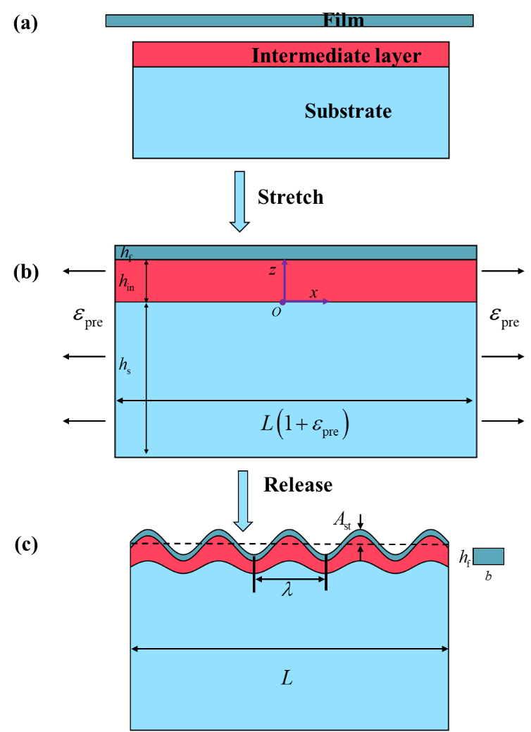

Figure 1. The schematic of the tri-layer structure. (a) the separated components of film and un-deformed bi-layer substrate of the tri-layer structure; (b) a stiff film bonded to a pre-stretched bi-layer substrate; (c) wrinkling due to releasing of the tensile pre-strain.

* 1. ***Homogenization method of the corrugated film***

As the vibration of a corrugated beam is complicated, a simplified approach is to use a homogenisation method. According to the theory of geometrical homogenization [33-35], a co-sinusoidal corrugated beam can be approximated as a straight beam with equivalent material and geometric properties, shown in Fig. 2.

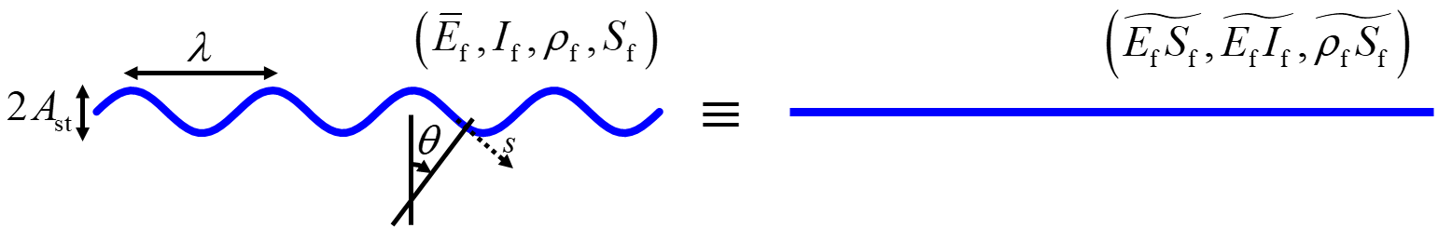

Fig. 2. The geometrical demonstration of the corrugated film

The shape of the corrugated film is almost co-sinusoidal, and it can be described as [36],



where and  are the static buckling amplitude and wavenumber to be determined from a static buckling analysis described in Section 3.

The corresponding equivalent in-plane stiffness , bending stiffness, and linear density  of the corrugated film can be expressed as, respectively [32],







where  represents the angle between the local normal of the corrugated film, and  is the wavelength.  is the average operator ,  is the equivalent length the corrugated film over a wavelength.  denotes the effective Young’s modulus of the film.  and  are the Young’s modulus and Poisson’s ratio of the film.  and  are the in-plane stiffness and the bending stiffness of the thin film, respectively.

* 1. ***Nonlinear governing equation***

To derive the nonlinear governing equation of the corrugated tri-layer structure, and based on the above expressions of the in-plane stiffness  in Eq.(2), bending stiffness in Eq. (3), and linear density  in Eq. (4), the Lagrange equation is utilized, which requires that,



whereis the transverse displacement of the corrugated film, and is described as .  denotes the ‘modal coordinate’ of the corrugated film.  is the Lagrangian.  is the kinetic energy of the corrugated film. is the sum of the bending strain energy , membrane strain energy  in the corrugated film, and the strain energy in the intermediate layer and the soft substrate. These energies are expressed as follows,









where  is the longitudinal strain at the corrugated film’s neutral axis.  is the in-plane pre-strain and  is the longitudinal displacement at the corrugated film’s neutral axis. , ,  and  are transverse displacement, longitudinal displacement, normal stress, and shear stress at the top of the intermediate layer (), respectively.

From Eqs. (2-9), it can be found that those equivalent parameters and equations are all dependent on wavelength  and static buckling amplitude  of the tri-layer structure. Hence, wavelength  and static buckling amplitude  need to be obtained firstly.

## Buckling analysis for obtaining static buckling amplitude and wavelength

In this section, the static buckling behaviour of the buckled tri-layer structure is studied. By minimizing the total strain energy  of the tri-layer structure with respect to wavelength  and static buckling amplitude,  and  can be obtained.

As the shear stress between the film and intermediate layer and the deformation of the intermediate layer and substrate layer are considered, and as represented in Eqs.(8) and (9), the longitudinal displacement of the tri-layer structure, the normal and shear stresses of the intermediate layer and the soft substrate are needed, and they are obtained by solving the plane strain problem for the intermediate layer and the soft substrate. The details of solving the plane strain problem are given in Appendix 1.

***3.1 Equation of equilibrium of the thin stiff film, the intermediate layer, and the substrate***

In consideration of the wrinkling shape of the film expressed in Eq. (1) and the equilibrium of the film at its interface with the intermediate layer, the longitudinal displacement of the corrugated film is assumed as follows [37],



where and  are to be determined. The mathematical form of the longitudinal displacement in this manuscript is different from that in Ref. [15] (where , the shear stress  is ignored) and in Ref. [25] (where ), and the shear stress  at the interface of the film and the intermediate layer is expressed as [36],



Thus, submitting Eqs. and into Eq. , the shear stress  can be re-expressed as,



where  and  are to be determined.

As the intermediate layer and the soft substrate are modelled as finite-thickness planes in this paper, and , , and  in Eqs.(10) and (12) need to be determined, the Airy stress function  is used, which requires that,



As the displacements at the all interface of tri-layer are continuous, the boundary conditions of the intermediate layer and the soft substrate are given as [37], respectively,



and



At the bottom of the soft substrate, the boundary is taken to be free in this paper. Since the thickness of the soft substrate is many times greater than the thickness of the intermediate layer and that of the corrugate film, the form of this boundary does not have a noticeable effect on the mechanical behaviour of the film and the intermediate layer. In this condition, the soft substrate behaves like a half space. A comparison between a free boundary and a fixed boundary in a finite element analysis (FEA) confirms this conclusion about the boundary condition at the bottom of the soft substrate, illustrated in Fig. 3 and Fig. 4.

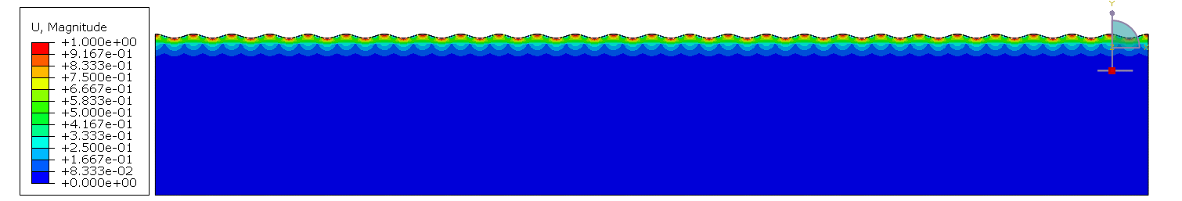

Fig. 3. FEA with free boundary condition.



Fig. 4. FEA with fixed boundary condition.

Solving the plane-strain problems, the longitudinal displacement, the shear stress, the displacements and normal stresses at the top of the intermediate layer () are used for the calculated in the total energy of the tri-layer structure, and they are expressed as follows,







where the coefficients of , , ,  ,,,and are given in the Appendix 1. The detail derivations of Eqs. (14-16) and the coefficients are given in Appendix 1.

***3.2 3. Buckling analysis for the tri-layer structure***

Submitting Eqs. (16-18) into the total strain energy , the effective total strain energy of the tri-layer structure is derived as,



where  is a function of wavenumber , and it is also dependent on the geometric and physical parameters of the tri-layer structure. The detailed expression of function  is given in Appendix 2.

The expression of static buckling amplitude is obtained as [36],



which is valid only when . Although the analytical expression of wavelength  cannot be obtained, it can be calculated using the numerical method shown in Fig. 5. Its determination is essential to dynamic analysis of the corrugated tri-layer structure in the next section.

Fig. 5c reveals how static buckling amplitude  and wavelength  can be obtained from the coordinates of point (solid circle). In addition, by minimising function  with respect to wavenumber , the total strain energy  is minimised and buckling wavelength  could also be obtained [36]. The parameters used for Fig. 5 are: ,, ,, ,, ,, , and . There are typical parameter values of some flexible electronics [24].

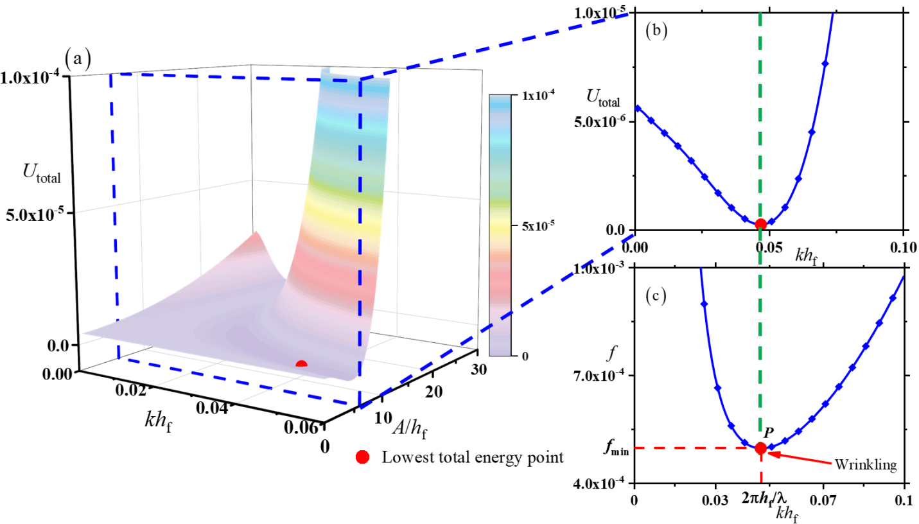

Fig 5. The total energy as a function of  and .

## Nonlinear frequency analysis

Based on the above-derived expressions of the normal stress in Eq. , the shear stress in Eq. , the longitudinal displacement in Eq. and static buckling amplitude in Eq. , and by using the Lagrange equation , the differential equation of motion of the corrugated tri-layer structure can be derived as,



where  and  are coefficients given in Appendix 3.

For convenience, the following nondimensional variables are introduced,



Submitting the non-dimensional parameters in Eq. into Eq. , Eq. can be re-written as,



where  is the natural frequency.

The nonlinear governing equation of the corrugated tri-layer structure is an undamped Duffing oscillator [38, 39]. The Jacobi elliptic function is utilized to obtain the analytical expression of the dimensionless deflection of the ‘corrugated’ film as follows [40, 41],



where  is the initial deflection and  is Jacobi elliptic function.  represents the nonlinear frequency, and  is an elliptic modulus of the Jacobi elliptic function.

## Results and discussion

As studied in section 3, wavelength and static buckling amplitude  are dependent on the parameters of the intermediate layer (for example the Young’s modulus, the thickness), and as studied in section 4, the coefficients  and  of nonlinear dynamic equation Eq. are dependent on wavelength and static buckling amplitude . How the intermediate layer influences the static/dynamic behaviour of the tri-layer structure should be investigated. Thus, in subsection 5.1, the influence of the intermediate layer on static buckling amplitude and wavelength is analysed, and the influence of the intermediate layer on the natural frequency is discussed in subsection 5.2.

* 1. ***The influence of the intermediate layer on static buckling amplitude and wavelength***

It is needed to mention that by modulating  and, the wrinkling shape of the tri-layer structure can be modulated [15, 16, 25]. Hence, the effect of the intermediate layer on the static behaviour of the tri-layer structure should be analysed. To evaluate the effect of the intermediate layer on the static behaviour of the tri-layer structure, Fig. 6 and Fig. 7 are plotted, and the used parameters [25] are:, , , , , , 

In Fig. 6, the influences of the intermediate layer’s Young’s modulus  on wavelength and static buckling amplitude  are discussed. From the results in Fig. 6a and Fig. 6c, one can find that static amplitude and wavelength of the tri-layer structure using the proposed model have good agreement with those obtained by finite element analysis (FEA). At the same time, it is found that when the thickness ratio  of the intermediate layer and the film is set as 1, with the increase of , wavelength and static buckling amplitude  are constants (lines with solid squares). In other words, wavelength  and static buckling amplitude  are independent of , and they can be determined by the geometrical and physical parameters (for example, the thickness and the Young’s modulus) of the film and soft substrate [25]. This phenomenon implies that when the intermediate layer is thinner than the film, the buckled tri-layer structure could be treated as a bi-layer structure (film-substrate with finite thickness) [25].

Here, to more clearly demonstrate how the results in Fig. 6 and Fig. 7 are obtained, the details are given as follows. Firstly, based on the results in Fig. 5c and the detailed expression of function  in Appendix 2, the value of  that minimises  can be obtained by using MATLAB function ‘findpeaks’. Secondly, submitting the minimum value of  into Eq. (20), one can get the value of .

Next, how to the hollow circles in Figs. 6(b) and 6(c) is explained. At a specific value of **, its corresponding  in Appendix 2 is obtained and then its minimum solution  is found using MATLAB function ‘findpeaks’. This process is repeated for various values of **. In the end, a series of ** versus ** is obtained and MATLAB function ‘findpeaks’ is again used to determine the value of ** that minimises **, which is denoted by the hollow circles. The hollow circles, hexagons and squares in Figs. 7(b) and 7(d) are found in the same way.

When the thickness ratio  increases to 40, and below a certain value of  (numerically obtained, shown as a hollow circle in Fig. 6b and Fig. 6d. Fig. 6b and Fig. 6d are the partial enlarged figures of Fig. 6a and Fig. 6c, respectively.), with the increase of , wavelength and static buckling amplitude  decrease (lines with solid circles). Above that value of , with increasing , wavelength  and static buckling amplitude  increase (lines with solid circles). However, when the thickness ratio  increases to 200, wavelength and static buckling amplitude  decrease (lines with solid triangles) with the increase of .

From the results in Fig. 6a and Fig. 6c, it is also interesting to see that there is an intersection point (shown as a solid pentagon) and the abscissa of that intersection point is 2.5 MPa. In other words, when  is equal to that of the soft substrate  and the Poisson’s ratios of the intermediate layer and substrate are equal, the bi-layer substrate could be treated as a single-layer substrate [15].





Fig. 6 Static buckling amplitude  and wavelength as a function of .

Fig. 7 shows wavelength and static buckling amplitude  as a function of the thickness ratio  and the effects of  changes on the static buckling behaviour of the buckled tri-layer structure are discussed.

From the results of Fig. 7a and Fig. 7c, it can be observed that wavelength and amplitude obtained by the proposed model have agreement with those obtained by FEA. When  is taken as 0.5 MPa, increasing, wavelength and static buckling amplitude  firstly decrease (lines with solid circles). Above a certain value of  (shown as a hollow circle in Fig. 7b, numerically obtained. Fig. 7b is a partial enlarged figure of Fig. 7a), increasing, they would increase. Other interesting findings in Fig. 7a and Fig. 7c are that the intermediate layer’s thickness  has less influence on wavelength and static buckling amplitude  (lines with solid circles), when the thickness ratio  is greater than 250. At the same time, increasing, wavelength and static buckling amplitude  would gradually increase as constants, where similar phenomenon are with reported in [25].

As illustrated in Fig. 7a and Fig. 7c, it is interesting to find that with the increase of , wavelength and static buckling amplitude  remain constant (lines with solid triangles), when  is identical to that  and the Poisson’s ratios of the intermediate layer and substrate are equal. In other words, they are independent of . When  is 2 times greater than , below a certain value of  (shown in Fig. 7b, numerically obtained, hollow square), wavelength and static buckling amplitude  firstly increase (lines with squares) with the increase of . However, when  is 4 times greater than , it is easy to note that the tendencies of wavelength and static buckling amplitude  are similar with those for, shown in Fig. 6 (lines with solid tetragons). Below a certain value of , with an increase of , wavelength and static buckling amplitude  decrease.

From the results in Fig. 7, it can be concluded that the trendies of wavelength and static buckling amplitude  where  is smaller than , are opposite of those where  is greater than . However, when the thickness ratio  is greater than 100, wavelength and static buckling amplitude (lines with squares and lines with solid hexagons) remain as constants with the increase of .





Fig. 7 Static buckling amplitude  and wavelength as a function of .

* 1. ***The influence of the intermediate layer on dynamics of the finite-thickness tri-layer structure***

From the above static analysis, it is clear that the introduction of the intermediate layer can affect wavelength and static buckling amplitude  of the buckled structure. How the intermediate layer influences the dynamic behaviour of the corrugated tri-layer structure should also be studied.

To discuss the influence of the intermediate layer on the dynamic response of the corrugated tri-layer structure, by using Eq. (23) and Eq. (24), the results denoted by the solid lines in Figs. 8, 9 and 10 are plotted, which is an analytical approach (using Jacobi elliptic function). The initial condition  is used. The others parameters are given as: , , , , , ,  They represent properties of the materials used for manufacturing stretchable electronics.

Fig. 8 presents the corrugated tri-layer structure’s nonlinear frequency as functions of  and  where , and illustrate the influence of  on the nonlinear frequencyof the corrugated tri-layer structure. From the results in Fig. 8, it can be observed that when the thickness ratio  is set as 1, the nonlinear frequency  remains constant (line with solid squares), which implies that the intermediate layer’s Young’s modulus has a negligible influence on the nonlinear frequency.

However, when thickness ratio  increases to 40, the nonlinear frequency  is a non-monotonic function (line with solid circles).The nonlinear frequency of the corrugated tri-layer structure decreases firstly with the increase of . Above a certain value of  (shown as a hollow circle in Fig. 8b, numerically obtained), with an increase of , the nonlinear frequency increases. When  is 200 times than that of the film, the nonlinear frequency of the corrugated tri-layer structure increases with the increase of .

 

Fig. 8. The nonlinear frequency  as functions of  and  with .

Fig. 9 discusses the influence of  on the nonlinear frequency. From Fig. 9, it is easy to see that with the increase of , the nonlinear frequency of the corrugated tri-layer structure decreases firstly (line with solid circles) where  is taken as 0.5 MPa. Above a certain value of  (shown as a hollow circle in Fig. 9b, numerically obtained), with an increase of  (line with solid circles), the nonlinear frequency of the corrugated tri-layer structure increases.

From the results of Fig. 9, it is also found that with the increase of , the nonlinear frequency of the corrugated tri-layer structure remains constant (line with solid triangles) when  is identical to  and the Poisson’s ratios of the intermediate layer and substrate are equal. In other words, the nonlinear frequency is independent of  . However, when  is greater than  and with the increase of , the nonlinear frequency of the corrugated tri-layer structure increases firstly. Above a certain value of  (shown as a hollow square in Fig. 9b, numerically obtained), with the increase of , the nonlinear frequency of the corrugated tri-layer structure decreases. In addition, it is also observed that when the thickness ratio  increases to 100, the nonlinear frequency decreases and then remains constant. In other words, the nonlinear frequency is independent of , when the thickness ratio  is greater than 100.

From the results in Fig. 9, it can be concluded that the trendy of the nonlinear frequency, where  is smaller than  , is opposite of those where  is greater than . However, when the value of the thickness ratio  is greater than 100 and  is kept at a constant value, the greater the intermediate layer’s Young’s modulus , the smaller nonlinear frequency is.

 

Fig. 9. The nonlinear frequency  as functions of 

with different values of  with .

From the results in Fig. 8 and Fig. 9, it can also be concluded that by modulating  and , the nonlinear frequency of the corrugated tri-layer structure would also be modulated. Because of modulation of , wavelength and static buckling amplitude  are also modulated, as shown in Figs. 6 and 7, and the nonlinear frequency of the corrugated tri-layer structure is also modulated, as it is dependent on wavelength  and static buckling amplitude.

In addition, Fig. 10 shows the influence of the initial displacement  on the nonlinear frequency. From Fig. 10, it is clear that the nonlinear frequency  is dependent on the initial displacement, and this phenomenon is different from that linear frequency , which can be inferred from the coefficients in Eq. . At the same time, from this figure, it is also to note that the dynamic response of the corrugated tri-layer structure exhibits a hardening behaviour, implying that the nonlinear frequency  increases with the initial displacement [42].



Fig. 10. The linear frequency and nonlinear frequency as functions of initial displacement 

## Conclusions

In this paper, the nonlinear frequency of a corrugated stiff thin film bonded on a soft finite-thickness bi-layer substrate (an intermediate layer and a compliant substrate) is investigated. Introducing the intermediate layer, accounting for the interfacial shear stress between the film and intermediate layer and considering the deformation of the intermediate layer and substrate layer, the governing equation of the corrugated tri-layer has been derived via the geometrical homogenization of the corrugated film and the Lagrange equation for the whole structure. Based on the Airy function, static buckling amplitude and wavelength of the buckled tri-layer structure are obtained. By using the analytical results of the static buckling analysis, the Jacobi elliptic function is utilized to obtain the analytical nonlinear frequency expression for the corrugated tri-layer structure. The influences of the intermediate layer’s thickness and Young’s modulus on the nonlinear frequency of the corrugated tri-layer structure are analysed. Some main conclusions are given as follows:

1. By modulating the intermediate layer’s Young’s modulus, the nonlinear frequency of the corrugated tri-layer structure can be modulated. When the intermediate layer is thinner than the film (the thickness ratio of the intermediate layer to the film is smaller than 1), the nonlinear frequency is independent of the intermediate layer’s Young’s modulus, implying that the tri-layer structure can be modelled as a bi-layer structure (film-substrate with finite thickness). When the thickness of the intermediate layer is 40 times greater than that of the film, above a certain value of the intermediate layer’s Young’s modulus, the nonlinear frequency increases with the increase of the intermediate layer’s Young’s modulus. However, when the thickness of the intermediate layer is 200 times greater than that of the film, with the increase of the intermediate layer’s Young’s modulus, the nonlinear frequency decreases.
2. Modulating the intermediate layer’s thickness, the nonlinear frequency can also be modulated. When the intermediate layer is softer than that of the compliant substrate, above a certain value of the intermediate layer’s thickness, with the increase of the intermediate layer’s thickness, the nonlinear frequency increases. However, when the intermediate layer is identical to the soft substrate and the Poisson’s ratios of the intermediate layer and substrate are equal, the nonlinear frequency is independent of the intermediate layer’s thickness. In other words, the corrugated tri-layer structure could be modelled as a bi-layer structure (film-substrate structure with finite thickness). In addition, when the intermediate layer’s Young’s modulus is greater than that of the soft substrate, above a certain value of the intermediate layer’s Young’s modulus, with the increase of the intermediate layer’s thickness, the nonlinear frequency decreases. At the same time, it is also found that when the thickness of the intermediate layer is 100 times greater than that of the film, the greater the Young’s modulus of the intermediate layer is, the smaller nonlinear frequency is.
3. The nonlinear frequency increases with the increase of the initial amplitude. In other words, the dynamic response of the corrugated tri-layer structure exhibits a hardening behaviour.

The results of this paper provide a deeper understanding of the dynamic response of the corrugated tri-layer structure and will be helpful for the design of robust stretchable electronics.

## Acknowledgments

The authors acknowledge the support from the National Natural Science Foundation of China (No.11802319), and the State Key Laboratory of Mechanics and Control of Mechanical Structures (Nanjing University of Aeronautics and astronautics) (Grant No. MCMS-E-0221K01). The second author also would like to acknowledge the support from Innovation Foundation for Doctor Dissertation of Northwestern Polytechnical University (No. CX202044). Part of this work is done during the first author’s visits to the University of Liverpool under the third author’s guidance.

## Appendix 1







where

and







## Appendix 2



## Appendix 3



.

**References**

[1] Y. Su, E. Zhang, Y. Wang, Q. Li, M. Chen, M. Dong, Tunable hierarchical wrinkling surface via microscale patterned vertical deformation, Colloids and Surfaces A: Physicochemical and Engineering Aspects, 607 (2020) 125468.

[2] Z. Cheng, F. Xu, Intricate evolutions of multiple-period post-buckling patterns in bilayers, Science China Physics, Mechanics & Astronomy, 64 (2020) 214611.

[3] D. Rhee, S. Deng, T. Odom, Soft skin layers for reconfigurable and programmable nanowrinkles, Nanoscale, 12 (2020) 23920-23928.

[4] J. Rogers, T. Someya, Y. Huang, Materials and Mechanics for Stretchable Electronics, Science, 327 (2010) 1603-1607.

[5] D. Lee, J. Lee, J. Jin, Innovative evolution of buckling structures for flexible electronics, Composite Structures, 204 (2018) 487-499.

[6] H. Hafeez, Z. Zou, D. Kim, J. Shin, M. Song, C. Kim, W. Choi, J. Song, J. Xiao, S. Ryu, Multiaxial wavy top-emission organic light-emitting diodes on thermally prestrained elastomeric substrates, Organic Electronics, 48 (2017) 314-322.

[7] M. Imburgia, A. Crosby, Rolling wrinkles on elastic substrates, Extreme Mechanics Letters, 6 (2016) 23-30.

[8] Y. Zhang, Y. Huang, J. Rogers, Mechanics of stretchable batteries and supercapacitors, Current Opinion in Solid State and Materials Science, 19 (2015) 190-199.

[9] C. Yu, K. O’Brien, Y. Zhang, H. Yu, H. Jiang, Tunable optical gratings based on buckled nanoscale thin films on transparent elastomeric substrates, Applied Physics Letters, 96 (2010) 041111.

[10] Y. Wang, J. Xiao, Programmable, reversible and repeatable wrinkling of shape memory polymer thin films on elastomeric substrates for smart adhesion, Soft Matter, 13 (2017) 5317-5323.

[11] A. Anjomshoa, A. Shahidi, B. Hassani, E. Jomehzadeh, Finite element buckling analysis of multi-layered graphene sheets on elastic substrate based on nonlocal elasticity theory, Applied Mathematical Modelling, 38 (2014) 5934-5955.

[12] G. Chen, N. Matsuhisa, Z. Liu, D. Qi, P. Cai, Y. Jiang, C. Wan, Y. Cui, W. Leow, Z. Liu, S. Gong, K. Zhang, Y. Cheng, X. Chen, Plasticizing Silk Protein for On-Skin Stretchable Electrodes, Advanced Materials, 30 (2018) 1800129.

[13] G. Lee, G. Bae, J. Son, S. Lee, S. Kim, D. Kim, S. Lee, K. Cho, User-Interactive Thermotherapeutic Electronic Skin Based on Stretchable Thermochromic Strain Sensor, Advanced Science, 7 (2020) 2001184.

[14] T. Kim, C. Lee, S. Kim, J. Hur, S. Lee, K. Shin, Y. Yoon, M. Choi, J. Yang, D. Kim, T. Hyeon, S. Park, S. Hwang, Fully Stretchable Optoelectronic Sensors Based on Colloidal Quantum Dots for Sensing Photoplethysmographic Signals, ACS Nano, 11 (2017) 5992-6003.

[15] H. Cheng, Y. Zhang, K. Hwang, J. Rogers, Y. Huang, Buckling of a stiff thin film on a pre-strained bi-layer substrate, International Journal of Solids and Structures, 51 (2014) 3113-3118.

[16] E. Lejeune, A. Javili, C. Linder, Understanding geometric instabilities in thin films via a multi-layer model, Soft Matter, 12 (2016) 806-816.

[17] E. Lejeune, A. Javili, C. Linder, An algorithmic approach to multi-layer wrinkling, Extreme Mechanics Letters, 7 (2016) 10-17.

[18] S. Ravi, A. Zilian, Simultaneous finite element analysis of circuit-integrated piezoelectric energy harvesting from fluid-structure interaction, Mechanical Systems and Signal Processing, 114 (2019) 259-274.

[19] S. Yoo, G. Choi, W. Lee, J. Park, G. Yi, D. Ryu, P. Yoo, Cumulative energy analysis of thermally-induced surface wrinkling of heterogeneously multilayered thin films, Soft Matter, 14 (2018) 704-710.

[20] A. Nolte, R. Cohen, M. Rubner, A Two-Plate Buckling Technique for Thin Film Modulus Measurements:  Applications to Polyelectrolyte Multilayers, Macromolecules, 39 (2006) 4841-4847.

[21] P. Asdaque, S. Banerjee, S. Roy, An electromechanically coupled intrinsic, mixed variational formulation for geometrically nonlinear smart composite beam, Applied Mathematical Modelling, 65 (2019) 549-565.

[22] J. Zhang, Y. Li, Y. Xing, Theoretical and experimental investigations of transient thermo-mechanical analysis on flexible electronic devices, International Journal of Mechanical Sciences, 160 (2019) 192-199.

[23] R. Kessentini, O. Klinkova, I. Tawfiq, M. Haddar, Transient hygro-thermo-mechanical stresses analysis in multi-layers bonded structure with coupled bidirectional model, International Journal of Mechanical Sciences, 150 (2019) 188-201.[24] F. Jia, Y. Cao, T. Liu, Y. Jiang, X. Feng, S. Yu, Wrinkling of a bilayer resting on a soft substrate under in-plane compression, Philosophical Magazine, 92 (2012) 1554-1568.

[25] C. Wang, S. Zhang, S. Nie, Y. Su, W. Chen, J. Song, Buckling of a stiff thin film on a bi-layer compliant substrate of finite thickness, International Journal of Solids and Structures, 188-189 (2020) 133-140.

[26] G. Li, G. Xu, Y. Zheng, Y. Cao, Non-leaky modes and bandgaps of surface acoustic waves in wrinkled stiff-film/compliant-substrate bilayers, Journal of the Mechanics and Physics of Solids, 112 (2018) 239-252.

[27] Y. Wang, Z. Yu, G. Mao, Y. Liu, G. Liu, J. Shang, S. Qu, Q. Chen, R. Li, Printable Liquid-Metal@PDMS Stretchable Heater with High Stretchability and Dynamic Stability for Wearable Thermotherapy, Advanced Materials Technologies, 4 (2019) 1800435.

[28] H. Bi, B. Wang, Y. Huang, J. Zhou, Z. Deng, Nonlinear dynamic performance of buckled piezoelectric ribbon-substrate energy harvester, Composite Structures, 261 (2021) 113570.

[29] B. Wang, H. Bi, H. Ouyang, Y. Wang, Z. Deng, Dynamic behaviour of piezoelectric nanoribbons with wavy configurations on an elastomeric substrate, International Journal of Mechanical Sciences, 182 (2020) 105787.

[30] B. Wang, H. Bi, Y. Wang, H. Ouyang, Z. Deng, Nonlinear vibration of buckled nanowires on a compliant substrate, Applied Mathematical Modelling, 79 (2020) 230-242.

[31] Z. Ou, X. Yao, X. Zhang, X. Fan, Dynamic stability of flexible electronic structures under step loads, European Journal of Mechanics - A/Solids, 58 (2016) 247-255.

[32] G. Robin, M. Jrad, N. Mathieu, A. Daouadji, E. Daya, Vibration analysis of corrugated beams: The effects of temperature and corrugation shape, Mechanics Research Communications, 71 (2016) 1-6.

[33] M. Potier-Ferry, L. Siad, Homogénéisation géométrique d'une poutre ondulée, Comptes Rendus De L Academie Des Sciences Serie Ii, 314 (1992) 425-430.

[34] B. Haussy, C. Jung, J. François Ganghoffer, Homogenisation of the undulations of a single yarn. Applications to the modelling of the traction, International Journal of Mechanical Sciences, 46 (2004) 961-979.

[35] P. Cartraud, T. Messager, Computational homogenization of periodic beam-like structures, International Journal of Solids and Structures, 43 (2006) 686-696.

[36] Z. Huang, W. Hong, Z. Suo, Nonlinear analyses of wrinkles in a film bonded to a compliant substrate, Journal of the Mechanics and Physics of Solids, 53 (2005) 2101-2118.

[37] H. Bi, B. Wang, C. Su, B. Zhang, H. Ouyang, Y. Huang, Z. Deng, Buckling behaviour of a stiff thin film on a finite-thickness bi-layer substrate, International Journal of Solids and Structures, 219-220 (2021) 177-187.

[38] M. Brennan, G. Gatti, I. Kovacic, On rotating vectors, Jacobi elliptic functions and free vibration of the Duffing oscillator, International Journal of Non-Linear Mechanics, 126 (2020) 103566.

[39] B. Fiedler, A. López Nieto, R. Rand, S. Sah, I. Schneider, B. Wolff, Coexistence of infinitely many large, stable, rapidly oscillating periodic solutions in time-delayed Duffing oscillators, Journal of Differential Equations, 268 (2020) 5969-5995.

[40] I. Kovacic, L. Cveticanin, M. Zukovic, Z. Rakaric, Jacobi elliptic functions: A review of nonlinear oscillatory application problems, Journal of Sound and Vibration, 380 (2016) 1-36.

[41] I. Kovacic, G. Gatti, Some benefits of using exact solutions of forced nonlinear oscillators: Theoretical and experimental investigations, Journal of Sound and Vibration, 436 (2018) 310-326.

[42] B. Chen, J. Huang, J. Ji, Control of flexible single-link manipulators having Duffing oscillator dynamics, Mechanical Systems and Signal Processing, 121 (2019) 44-57.

1. * Corresponding authors: [H.Ouyang@liverpool.ac.uk](mailto:H.Ouyang@liverpool.ac.uk); bihaohao@mail.nwpu.edu.cn.