Redispersible Nanosuspensions as a Plausible Oral Delivery System for Curcumin

Nancy M. Elbaz ª, Lee M. Tatham ^{b}, Andrew Owen ^{b}, Steve Rannard ª, and Tom O. McDonald ª *
ª Department of Chemistry, University of Liverpool, Crown Street, Liverpool L69 7ZD, United Kingdom

^{b} Department of Molecular and Clinical Pharmacology, University of Liverpool, Block H, 70 Pembroke Place, Liverpool L69 3GF, United Kingdom

Abstract
Curcumin is widely used as a nutraceutical ingredient in food and beverage products. It has been reported that curcumin has a broad spectrum of biological activities such as anticancer, anti-inflammatory, antioxidant, and antibacterial effects. Despite the potent therapeutic effect of curcumin, its low aqueous solubility, stability, and oral bioavailability limits its effectiveness. In order to improve the physical and chemical properties of curcumin, we have formulated curcumin as a nanosuspension by using the emulsion templated freeze-drying technique. This approach produces a solid that can be dispersed as required to form a nanosuspension. The formulations were investigated in a screening process using various excipients, resulting in the identification of one curcumin nanosuspension sample which contained only polyethylene glycol (PEG) as the excipient. This formulation exhibited a small diameter (211 nm), low polydispersity (0.06) and zeta potential of -25 mV and was therefore it was chosen for further in vitro investigations. Various experimental parameters such as active agent and excipient concentrations, and sonication time were varied to tune the size and polydispersity of the chosen formulation. The resulting nanosuspension showed an improved chemical stability at pH values that mimic the gastrointestinal tract. An in vitro bioaccessibility experiment showed that the nanosuspension formulation resulted in more dissolution of the curcumin but this was also coupled with reduced stability. Cytotoxicity studies showed that the nanosuspension offered a reduced cytotoxicity profile compared to the solubilised curcumin on both cell lines investigated. This redispersible curcumin nanosuspension formulation may provide new opportunities for the oral dosing of curcumin.
Keywords: Curcumin; nanosuspension; emulsion templated freeze-drying technique; Oral delivery; Cancer

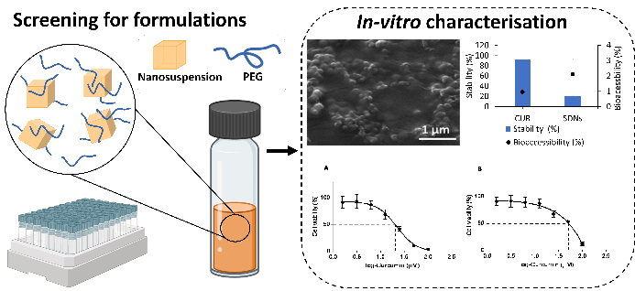
Abstract figure: Curcumin was formulated as a nanosuspension by an emulsion-templated freeze-drying technique. The curcumin formulation could be redispersed to form a nanosuspension and demonstrated favourable colloidal and chemical stability.

- Introduction
Curcumin is the principle active ingredient in turmeric (extracted from the rhizomes of Curcuma longa, belonging to the ginger family), and is responsible for the yellow colour, physiochemical properties and biological activities of turmeric.¹ Several studies have shown that curcumin possesses anticancer properties against colon cancer, breast cancer, lung cancer and prostate cancer.[1] The anticancer effect of curcumin is associated with its ability to induce apoptosis, inhibit cell proliferation, invasion of tumours by inhibiting different cellular signalling pathways. Moreover, curcumin has a high safety tolerance dose, which has been reported as 12 g per day.[2] However, studies have shown that curcumin has low oral bioavailability due to its low aqueous solubility and chemical stability, thus hindering its clinical use.[3,4]

A number of key parameters such as solubility, stability, and excipient biodegradability play a crucial role in the successful formation of drugs. Over 40% of the new chemical entities, drugs or nutraceuticals are lipophilic or poorly soluble in water.[3] There are many formulation approaches available for enhancing the problem of low solubility, stability and/or bioavailability. However, the vast majority of these approaches, such as micronisation, solid dispersion method and use of fatty solutions, have limited potential in enhancing the bioavailability of poorly soluble actives.[5] A promising approach to enhancing an active’s dissolution rate and stability is to formulate the compound into nanoparticles, which increases the surface area of the drug. Such nanoparticle engineering approaches have been widely employed for many therapeutic agents for various pharmaceutical applications.[6] For example, for curcumin, Ubeyitogullari et al. prepared curcumin loaded starch aerogel nanoparticles, with mean diameters of 66 nm, which enhanced the solubility of encapsulated curcumin compared to crude curcumin.[7] Azandeh et al. formulated curcumin loaded PLGA nanoparticles, which demonstrated improved anticancer properties.[6] Gao et al. developed polymer micelles loaded with curcumin that showed improved cellular uptake and apoptosis of colon cancer cells compared to curcumin extract. [8] Additionally, Gota et al. prepared solid lipid nanoparticles containing curcumin and administrated these to human volunteers to investigate the bioavailability of developed nanoparticles. The curcumin concentration in plasma was 22.43 ng/mL for solid lipid nanoparticles after 2.4 hours, while there was no curcumin found in plasma for unformulated curcumin.[9] Despite the diversity of nanocarriers, the lack of toxicity data for the long-term human exposure to nanocarriers complicates the translations of these nanomedicines to clinical use. Therefore, an appealing approach is to process the active into the form of a nanosuspensions, nanoparticles composed entirely of the active molecule, thus removing the need for carrier materials. The simplicity of nanosuspensions has favoured clinical translation with at least 15 marketed nanosuspension in clinical use.[10] Emulsion templated freeze-drying technique is a common method that has been used in the preparation of nanosuspensions (sometimes also referred to as SDNs) with such formulations displaying improved stability and faster dissolution rates.[11–15] This approach requires that the drug is dissolved in an oil phase and the stabiliser is dispersed into a continuous aqueous phase. The emulsification of the two phases is followed by freeze-drying, leading to the supersaturation of both liquids (Fig. 1).[15,16] The volatile oil phase and water sublimate leaving the solidified matrix, consisting of the water-soluble stabilisers containing nanoparticles of drug. These nanoparticles are dispersed in water along with the stabiliser at the point of use. The formation of nanosuspensions by the emulsion templated freeze-drying technique is often carried out in a screening process, where different excipients were used aiming to identify the best excipients that could improve the physicochemical properties of the chosen active. Nonetheless, different actives have been found to require different excipients, and no single excipients can be used for all drugs because there are no empirical or theoretical guidelines for excipients selection.[13–15,17] Consequently, the choice of appropriate stabilisers is crucial for the successful formulation of redispersible nanosuspensions. It is also important to employ the appropriate concentration of active to obtain a completely dispersed drug in aqueous environment and simultaneously avoid nanoparticle aggregation.

Emulsion templated freeze-drying also offers an additional benefit; it results in a solid monolith that can easily be stored in a dry form prior to use, which in turn improve and prolong the storage stability of the formulation. These solid monoliths consist of a matrix of excipients in which drug nanoparticles are contained. The addition of water to the solid matrix results in the dispersion of the nanoparticles made of the active, which are themselves stabilised by the excipients. It is likely that the stabilisers bind to the surface of the active nanoparticles to minimise the solid-liquid interfacial tension, preventing uncontrolled growth of the nanoparticles and stabilising the active particles after dispersion.[13] Nanosuspensions can be used for enhancing the aqueous dissolution behaviour of many poorly water-soluble or poorly permeable actives resulting in increasing the dissolution rate of the active agents, and thus increasing the oral bioavailability of drugs.[15] There are a small number of examples where curcumin has been processed as a nanosuspension, for example, Wang et al. formulated nanosuspensions of curcumin with several stabilisers such as tocopherol polyethylene glycol-1000 succinate, Brij78, and Pluronic-F68, where the nanosuspensions revealed an enhanced dissolution rate and bioavailability.[18] Hirlekar et al. also reported an enhanced dissolution rate and stability of curcumin nanosuspensions which was prepared in combination of poloxamer-188 as a stabiliser.[19] Both these prior examples of curcumin nanosuspensions resulted in dispersions, which may present a challenge for long-term storage. There is a need to produce a formulation of curcumin that can be dispersed on demand to give a curcumin nanosuspension.

In this work, curcumin was formulated into nanosuspensions using the emulsion-templated freeze-drying technique, to produce a solid that could be dispersed to give a nanosuspension. A screening process was carried out using different excipients, combined with characterising the z-average diameter and polydispersity index of resultant nanosuspensions. The samples were evaluated against criteria to refine nanoparticles properties, with the focus being on lower polydispersity index values and reproducibility between samples. One sample that contained only PEG as a stabiliser was chosen for further investigation via varying different parameters, such as curcumin concentration, excipient concentration and sonication time. The aim of these studies was to increase curcumin loading, reduce polydispersity and ensure sample-to-samples reproducibility. The physical properties such as chemical and colloidal stability of chosen nanosuspension sample was then studied. Moreover, the in vitro bioaccessibility and cytotoxicity of the chosen nanosuspensions sample were studied compared to unformulated curcumin.
- Experimental
2.1. Materials
Curcumin (CAS 458-37-7, purity≥94%) Sodium carboxymethyl-cellulose (CMC) degree of substitution 0.7 (average MW ~250,000) (CAS 9004-32-4), poly(styrene sulfonate) (PSS) (average MW ~70,000) (CAS 25704-18-1), sodium alginate (ALG) (from brown algae, medium viscosity, CAS 9005-38-3), polyvinylpyrrolidone (PVP) (MW ~40,000, CAS 9003-39-8), sodium dodecyl sulphate (SDS) (CAS 151-21-3), polyethylene glycol (PEG) (MW 10,000, CAS 25322-68-3), polyvinyl alcohol (MW ~61,000, CAS 9002-89-5), dextran (DEX) (CAS 9004-54-0), Pluronic F-127 (PF-127) (CAS 9003-11-6), ascorbic acid (ASA) (CAS 50-81-7), polysorbate 80 (PS-80) (CAS 9005-67-8), polyethyleneimine (branched, MW ~25,000, CAS 9002-98-6), ethanol, phosphate buffered saline (PBS), tween-80 (CAS 9005-65-6), pepsin (CAS 9001-75-6), mucin (CAS 84082-64-4), pancreatin (CAS 8049-47-6), bile extract (CAS 8008-63-7), calcium chloride (CAS 1035-04-8), glacial acetic acid (CAS 64-19-7), sodium chloride (CAS 7647-14-5), ammonium nitrate (CAS 6484-52-2), potassium phosphate (CAS 7758-11-4), potassium chloride (CAS 7778-77-0), potassium citrate (CAS 866-83-1), urea (CAS 57-13-6), lactic acid sodium salt (CAS 867-56-1), and uric acid (CAS 69-93-2) were purchased from Sigma-Aldrich. Dichloromethane (CAS 75-09-2) and acetonitrile (CAS 75-05-8) were purchased from Thermo-Fisher Scientific. All chemicals were used without further purification. Deionised water was used in all experiments.

  - Methods
    - Emulsion-templated freeze-drying technique of curcumin nanosuspensions
Curcumin solid drug nanoparticles were prepared based on a modified emulsion-templated freeze-drying technique.[12,13,15] A curcumin content in the formulation of 10 wt% was targeted. To achieve this, curcumin was dissolved (10 mg/mL) in a mixture of dichloromethane (4.5 mL) and ethanol (0.5 mL) with ratio 9:1 v/v. Aqueous stock solutions of various excipients were prepared at a concentration of 22.5 mg/mL. The excipients were divided into two groups, polymers or lower MW polymers/surfactants (termed surfactants from hereon). 400 μL of excipients were mixed at 2:1 ratio (266 μL of polymer and 133 μL of lower MW polymer/surfactant) followed by the addition of 100 μL of curcumin solution (oil: water ratio 1:4 v/v). The resulting mixture was emulsified with a Covaris S2x for 15 seconds with a duty cycle of 20, intensity of 10 and 500 cycles/bursts in frequency sweeping mode. Samples were then immediately cryogenically frozen in liquid nitrogen, these samples were then lyophilised using a Virtis benchtop K freeze dryer for 48 hours. All the samples were sealed immediately after lyophilisation until analysis. The initial screen was composed of 32 samples made of binary combinations of the two excipient groups, the composition of the formulations is shown in table 1.

Table 1: A 32-sample screen of 10 wt% curcumin nanosuspensions. A 32-sample library was prepared using different excipients to form binary combinations. The excipients were categorised as either surfactants or polymers to differentiate their volumes during the preparation process. The masses given show the composition of the excipients in each formulation along with the 1 mg of curcumin that was contained in all formulations.

 | Polymers
Surfactants | ALG | CMC | PF-127 | DEX | PEI | PVP | PEG | PS-80
SDS | SDS- 3.0 mg & ALG- 6.0 mg | SDS- 3.0 mg & CMC- 6.0 mg | SDS- 3.0 mg & PF-127- 6.0 mg | SDS- 3.0 mg & DEX- 6.0 mg | SDS- 3.0 mg & PEI- 6.0 mg | SDS- 3.0 mg & PVP- 6.0 mg | SDS- 3.0 mg & PEG- 6.0 mg | SDS- 3.0 mg & PS-80- 6.0 mg
PVA | PVA- 3.0 mg & ALG- 6.0 mg | PVA- 3.0 mg & CMC- 6.0 mg | PVA- 3.0 mg & PF-127- 6.0 mg | PVA- 3.0 mg & DEX- 6.0 mg | PVA- 3.0 mg & PEI- 6.0 mg | PVA- 3.0 mg & PVP- 6.0 mg | PVA- 3.0 mg & PEG- 6.0 mg | PVA- 3.0 mg & PS-80- 6.0 mg
PEG | PEG- 3.0 mg & ALG- 6.0 mg | PEG- 3.0 mg & CMC- 6.0 mg | PEG- 3.0 mg & PF-127- 6.0 mg | PEG- 3.0 mg & DEX- 6.0 mg | PEG- 3.0 mg & PEI- 6.0 mg | PEG- 3.0 mg & PVP- 6.0 mg | PEG- 9.0 mg | PEG- 3.0 mg & PS-80- 6.0 mg
ASA | ASA- 3.0 mg & ALG- 6.0 mg | ASA- 3.0 mg & CMC- 6.0 mg | ASA- 3.0 mg & PF-127- 6.0 mg | ASA- 3.0 mg & DEX- 6.0 mg | ASA- 3.0 mg & PEI- 6.0 mg | ASA- 3.0 mg & PVP- 6.0 mg | ASA- 3.0 mg & PEG- 6.0 mg | ASA- 3.0 mg & PS-80- 6.0 mg
SDS: Sodium Dodecyl sulfate, PVA: Polyvinyl alcohol, PEG: Polyethylene glycol, ASA: Ascorbic acid
ALG: Sodium alginate, CMC: Carboxymethyl cellulose, PF-127: Pluronic F-127, DEX: Dextran,
PEI: Polyethylenimine, PVP: Polyvinylpyrrolidone, PEG: Polyethylene glycol, PS-80: Polysorbate-80

      - Tuning the properties of a chosen nanosuspension formulation containing only PEG as the excipient
One nanosuspension formulation containing only PEG as an excipient was chosen for further investigation. The variables affecting the size of nanosuspension sample such as sonication time (15, 30, and 60 seconds), PEG concentrations (11.25, 22.5, and 45 mg/mL), curcumin loading (10, 13, 23 mg/mL) were studied.

      - Studying the effect of varying PEG concentrations
A range of PEG concentrations (11.25, 22.5, and 45 mg/mL) were prepared, while the experimental parameters such as curcumin concentration (10 mg/mL), sonication time (15 seconds) and oil: water ratio (1:4 v/v) were kept constant. 400 μL of each concentration of PEG was mixed with 100 µL of curcumin (10 mg/mL). Afterwards, the samples were emulsified with a Covaris S2x for 15 seconds and then were frozen and lyophilised as mentioned above.
      - Studying the effect of varying sonication time
To investigate the effect of sonication/emulsification time on the size of the chosen nanosuspension sample, all the experimental parameters such as curcumin and PEG concentration and oil: water ratio were kept constant, while varying the sonication time (15, 30, and 60 seconds). Three experiments were carried out, where each glass vial contains 400 µL of PEG (22.5mg/mL) was mixed with 100 µL of curcumin (10 mg/mL) and then the samples were emulsified with a Covaris S2x for 15 seconds and were frozen and lyophilised as mentioned above.
      - Studying the effect of varying curcumin concentration
To increase drug loading of the chosen nanosuspension sample, different concentrations of curcumin (10, 13, 23 mg/mL) were varied along with PEG concentrations of 22.5 mg/mL, oil: water ratio of 1:4 v/v and sonication time of 15 seconds. 100 μL of each concentration of curcumin was mixed with 400 μL of PEG solution (22.5 mg/mL). Afterwards, the samples were emulsified with a Covaris S2x for 15 seconds and then were frozen and lyophilised as mentioned above.

    - Chemical stability study
The chemical stability of the chosen SDN formulation and unformulated curcumin was carried out in different media including PBS (pH 7.4 and 6.8) and 0.1 M HCl (pH 1.2) under dark conditions. The unformulated curcumin was dissolved in ethanol followed by the addition of each media with a ratio of 1:1, ethanol solution: aqueous solution. 1 mL of each media was added to the nanosuspension to give a final concentration of 1 mg/mL. The concentration of curcumin was measured by HPLC over 24 hours.

    - Colloidal stability study
The colloidal stability of chosen nanosuspension formulation was determined in deionised water under dark conditions. The stability was determined in water as follows: SDN samples (1 mg) were dispersed in 1 mL deionised water. The z-average diameters were determined by DLS at various time intervals over 21 days. All nanosuspension samples were vortexed prior to DLS measurements.

    - In vitro bioaccessibility study
The in vitro bioaccessibility of curcumin was evaluated by passing unformulated curcumin and nanosuspension through a simulated gastrointestinal tract (GIT) consisting of conditions that mimic the mouth, stomach and small intestine (Fig. S3), in accordance to a method previously described in the literature.[20] Firstly, the simulated saliva fluid contained mucin (30 mg/mL) and different salts (Table S1) as mentioned in the literature, and adjusted to pH 6. 1 mL of the unformulated curcumin and curcumin nanosuspension (both at 1 mg/mL with respect to curcumin) were dispersed in water and each sample was mixed with 1 mL of the stimulated saliva fluid and shaken for 10 minutes at 37°C. Stimulated gastric fluid was prepared as an aqueous solution of 200 mL of sodium chloride (2 mg/mL), 700 mL of HCl (7 mg/mL) added to 1000 mL of deionised water. 2 mL of stimulated gastric fluid containing pepsin (3.2 mg/mL) was added to the samples and shaken at 100 rpm at 37°C for 2 hours to mimic stomach transition time. Then, the pH of the samples was adjusted to pH 7 using 0.5 mL of 0.05 M sodium hydroxide aqueous solution, followed by the addition of 4 mL small intestinal fluids and incubation at 37°C for 3 hours. The stimulated small intestinal fluid contained pancreatin (24 mg/mL), bile extract solution (50 mg/mL) and saline solution containing (7.5 M sodium chloride and 0.5 M calcium chloride) and then adjusted to pH 7 using 0.05 M sodium hydroxide. After passing through the simulated fluids, 1 mL of the release media was collected, and the remaining media was centrifuged at 12,000 g for 40 minutes at 4°C. The resulting supernatant was collected and assumed to be the amount of curcumin solubilised in a bioaccessible form. The solubilised curcumin was diluted with acetonitrile (ratio 1:1) and analysed by HPLC. The stability and bioaccessibility were determined using the following equations (1) and (2)
Stability (%) = C_{R}/ C_{I} x 100 | (1)
Bioaccessibility (%) = C_{N}/ C_{I} x 100 | (2)
C_{R} is the concentration of curcumin in the release media after exposure to the simulated gastrointestinal fluids (assuming that there is no degradation occurring in the simulated GIT), C_{N} is the concertation of curcumin in the supernatant, and C_{I} is the initial concentration of curcumin in the system. The initial concentration of curcumin was assumed to be the total amount of curcumin that would be present in the small intestine if there were no losses due to the chemical degradation. It is important to note that this simple in vitro GIT model cannot accurately simulate the complex process takes place in the gastrointestinal tract, but it is a useful way to rapidly screen different samples and identify their physicochemical properties.

    - Statistical analysis
For determining the P values for significance, unpaired t-test (within Graphpad Prism Version 8) was used to determine the significance between the means and mean ± standard deviation of nanosuspension at different pH values.

    - In vitro cytotoxicity MTT assay
Caco-2 and HT-29-MTX cells were seeded at a density of 1 x 10⁴ cells/100 µl into each well of a 96-well plate and incubated for 24h at 37°C, 5% CO₂. Following incubation, 50 µL of the media was aspirated and replaced with 50 µL of media containing curcumin, either as a nanodispersion or aqueous solution (<1% DMSO in media) at a final well concentration of 100, 50, 25, 12.5, 6.25, 3.13, 1.56, or 0 µM curcumin. Following addition of each treatment and control, the 96-well plates were incubated for 48 hours at 37°C, 5% CO₂. Subsequently, the cytotoxicity of each treatment and control was assessed using the (3-(4,5-dimethylthiazol-2-yl)-2,5-diphenyltetrazolium bromide) (MTT) cell viability assay. Briefly, the media containing treatment was carefully aspirated from each well of the 96-well plates, leaving the adhered cells, and replaced with 150 µL of pre-warmed (37°C) DMEM. 50 μL of a pre-warmed (37°C) 5 mg/ml thiazolyl blue tetrazolium bromide solution, prepared in PBS, was also added to each well and the 96-well plates were further incubated for 4 hours at 37ºC, 5% CO₂. Subsequently, the media was carefully aspirated from each well and replaced with 50 µL of DMSO to solubilise any formed formazan crystals. Absorbance was measured at 570 and 620 nm using a CLARIOstar Plus plate reader (BMG Labtech, Germany). Four replicates of each condition were tested and IC₅₀ values were calculated using Prism version 7.04 (GraphPad, US). The plotted average percentage cell viabilities were calculated using equation (3).

$\text{Cell viability }\left(\text{\%}\right)\text{=}\frac{\text{Abs.} \text{test sample - Abs.} \text{blank} }{\text{Abs. control}} \text{x}\text{ 100}$ (3)
  - Characterisation techniques
    - Scanning Electron Microscopy (SEM)
The morphology of SDN sample was characterised with a Tescan FIB SEM S8000G. For FIB SEM S8000G, the samples were imaged in ultra-high vacuum at 5 kV. The SEM samples was prepared as follows; carbon tape was deposited on the aluminium stub followed by adding a glass slide. Then, each sample of freeze-dried formulation was dispersed in 1 ml water (1 mg/mL with regards to curcumin) to give a nanosuspension and a drop of each sample was added on the cover slide and subsequently dried in air. Afterwards, each sample was coated with a gold layer. The coating was performed using by Quorum Q150T ES using gold as a target with thickness 5-10 nm and 10 mA current for 30 seconds. High purity argon was used as sputter gas with pressure between 5x10⁻¹ and 5x10⁻³ mbar and distance between the specimen and sample was around 100 mm.

    - Dynamic Light Scattering (DLS)
The z-average diameter and zeta potential of the nanosuspensions were measured using a Malvern Zetasizer ZS instrument. Each sample containing of 1 mg of curcumin was dispersed in 1 mL deionised water at 25 °C. The zeta potential measurement was performed with Malvern Zetasizer Nano ZS by adding 1 mL of each sample in a disposable folded capillary cell using automatic measurement optimization. Both DLS and zeta potential measurements used Malvern Zetasizer software version 7.11 for analysis, with each sample was analysed in and the results averaged.

    - High Performance Liquid Chromatography (HPLC)
The chemical stability of curcumin and in-vitro bioaccessibility experiment were determined by HPLC. A HPLC system (1260 Agilent Technologies, Santa Clara, CA, USA) equipped with a pump and an ultraviolet-visible spectroscopy detector at 425 nm was used. The mobile phase was a mixture of 0.1% formic acid and acetonitrile at a ratio of 1:1, the flow rate was 1 mL/min, and the run time was 15 minutes. A ZORBAX C18 column (Stablebond Analytical, C18 4.6 x 250 mm) was used, and the injection volume was 20 µL. A calibration curve was prepared using different masses of curcumin (1.25, 2.5, 5, 10, 12.5, 25, and 50 µg) dissolved in a mixture of acetonitrile and PBS (1:1 with regards to volume). The curcumin purity was analysed and is shown in Fig. S1, the calibration curve is shown in Fig. S2.

    - Fourier-transform Infrared (FTIR) Spectroscopy
The chemical composition of curcumin nanosuspensions was investigated using FTIR spectroscopy (VERTEX 70, Bruker, USA). Spectra were obtained between 400-4000 cm⁻¹ with a resolution of 4 cm⁻¹ and an average of 16 scans. Each sample including curcumin, PEG, and the curcumin nanosuspension formulation were measured as powders at 25 °C.
- Results and Discussion
3.1. Investigating emulsion-templated freeze-drying technique for the formation of curcumin nanosuspensions
Curcumin nanosuspensions were prepared using an emulsion-templated freeze-drying technique. The nanosuspension library preparation was carried out using 12 water-soluble excipients, these water-soluble excipients were separated into two groups: higher MW polymers and lower MW polymers and surfactants. The main aim of using a combination of polymers and surfactants was to obtain a redispersible nanosuspension of curcumin with colloidal stability via electrostatic and/or steric mechanism. Eight polymers and four lower MW polymers/surfactants were then used in binary combinations to form a 32-sample screen. Curcumin was dissolved in a mixture of dichloromethane and ethanol (9:1 ratio) and was used with a concentration of 10 wt% curcumin loading relative to the excipients. The mixture was emulsified using ultrasonication and immediately frozen to preserve the emulsion templated structure before freeze-drying. During freeze-drying all volatile components were removed, leaving dry porous matrices of water-soluble excipients containing curcumin nanoparticles. By dispersing the formulation with water at 1 mg/mL with regards to curcumin of water, the curcumin nanosuspensions were formed with the nanoparticles stabilised by the adsorption of water-soluble excipient (Fig. 1).[12,13,15]

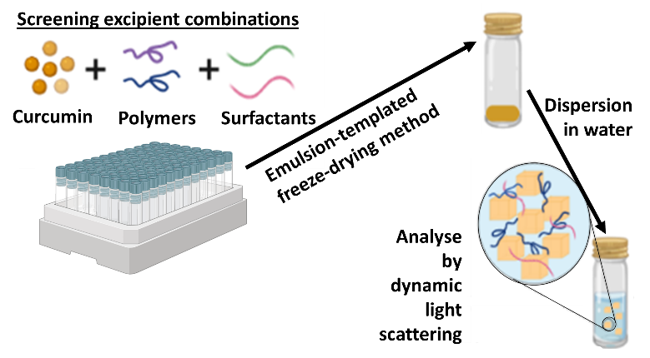
Figure 1: Solid drug nanoparticles can be prepared by the emulsion-templated freeze-drying method. Several excipients such as polymers and surfactants were mixed with an active agent (curcumin) and emulsified in a screening process followed by freeze-drying. The z-average diameter of all samples were then characterised by DLS.
The z-average diameter and zeta potential of nanosuspensions were determined by DLS (Fig. 2A) and electrophoretic mobility measurements (Fig. 2B). Nanosuspensions from the screen were evaluated based on the following criteria: (i) complete aqueous dispersion, (ii) z-average diameter <500 nm, (iii) standard deviation (SD) between the three repeat measurements <15%, and (iv) polydispersity index (PDI) <0.3. Of the 32 samples, four samples met these requirements as shown by the filled bars on Fig. 2A and the PDI values of the 32 nanosuspensions as shown in Table S2. The successful combinations of excipients generally contained PEG, such as PVA/PEG, PEG/PF127, PEG/DEX, and PEG/PEG. There is currently limited data in literature explaining the exact mechanism behind the formation of nanosuspensions by the emulsion templated freeze-drying process. One of the explanation for the success of PEG could be because it has previously been reported as a good cryoprotectant, which prevents nanoparticles aggregation during freeze drying and facilities the re-dispersion of nanoparticles with small sizes and low PDI.[21,22] For example, Lee et al. reported that naproxen nanosuspension containing PEG with 40 wt% demonstrated small sizes without any observed aggregation.[23] It has been suggested that PEG can migrate into the liquid phase leading to a high local concentration of PEG in the liquid phase and thus improving the aggregation prevention effect. Further analysis of our curcumin nanosuspensions by zeta potential measurements (Fig. 2B) revealed that all of the four out of formulations were negatively charged, with values of -12 mV for PVA/PEG, -7 mV for PEG/PF-127, -46 mV for PEG/DEX, and -25 mV for PEG/PEG. The negative charge of the nanosuspension was attributed to the keto form of curcumin, it is known that this form (proton donor) dominates in neutral medium (Fig. S4).[24,25] As PVA, DEX and PEG are neutral polymers,[26–29] the result showed that the interaction between the excipients and curcumin affect the overall charge of the nanoparticles. For instance, the sample containing PEG/PF-127 showed a masking of the negative charge of curcumin with a zeta potential of -7 mV, while the sample containing PEG/DEX had zeta potential of -46 mV. This suggests that PF-127 could be shielding the curcumin charge, as compared to DEX, in presence of PEG. This adds to the theory that there is a difference in excipient interactions with curcumin depending on their structures.

The nanosuspension formulation containing PEG only as an excipient showed the smallest diameter and low PDI of the different formulations. These particles properties can potentially be ascribed to the presence of PEG, which acts as a cryoprotectant and stabiliser. The presence of PEG facilities the re-dispersion of nanoparticles following freeze drying as well as potentially stabilising the re-dispersed nanoparticles.[21,30] PEG is uncharged polymer, and any absorbed polymer may provide a degree of steric to the nanosuspension. Additionally, the zeta potential value of -25 mV suggests that electrostatic repulsion may likely be contributing to the colloidal stability of the formulation. Based on this screening, the nanosuspension formulation containing PEG as the only excipient conferred the required stability and fulfil the above criteria and therefore this sample was chosen for further studies.
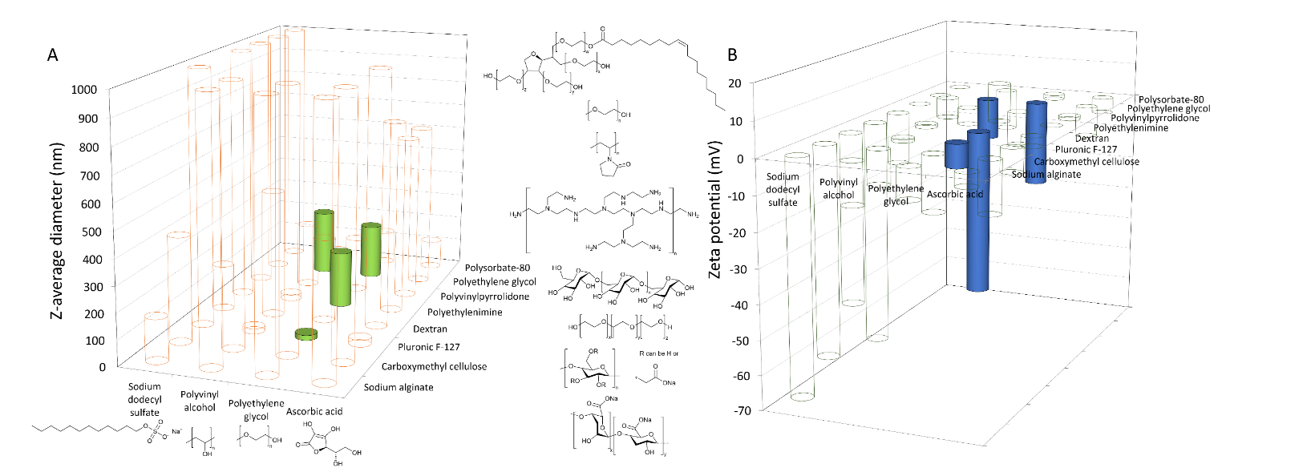

Figure 2: Screening different excipients to identify viable SDN formulations. (A) 32-sample screen of 10 wt% curcumin nanosuspensions. ‘Hits’ highlighted in green meet the following criteria: size <500 nm, PDI <0.3 and SD <15% and fully dispersed in water. The z-average diameter of the nanosuspensions was measured with DLS (1 mg/mL). The structures of the different excipients are shown close to their names. (B) ‘Hits’ highlighted in blue meet the following criteria: size <500 nm, PDI <0.3 and SD <15% and fully dispersed in water. The zeta potential of nanosuspensions was measured with electrophoretic mobility measurement (1 mg/mL).
3.1.1. Tuning the properties of nanosuspensions that contained PEG only as an excipient
Various experimental parameters such as polymer concentration, sonication time, and curcumin concentration were varied to investigate their influence on z-average diameter of the resulting nanosuspensions. By varying the polymer concentration while curcumin concentration was 10 mg/mL and sonication time was 15 seconds, it was found that the z-average diameter of nanosuspensions increased along with increasing the concentration of PEG concentration (Fig. 3A). For example, a SDN sample containing 11.25 mg/mL of PEG had a z-average diameter of 210 nm, while increasing PEG concentration to 45 mg/mL, increased the z-average diameter of nanosuspensions to 440 nm. The PDI values for all samples was ≤0.21, with the lowest particle size distribution obtained when the PEG concentration was 22.5 mg/mL. The trend in the size of the nanosuspensions with increasing PEG concentration may be due to the higher viscosity of aqueous phase at the higher PEG concentrations. It is likely that increase in viscosity would likely have resulted in larger emulsion droplets during the sonication step of the emulsion templated freeze-drying method, which would in turn influence the size of the nanosuspension formed upon freezing. This hypothesis might have been confirmed by DLS measurement of the emulsions however, as it is not possible to accurately measure experimentally due to the high concentration of oil droplets in the emulsion resulting in multiple scattering. It was also found that increasing the concentration of PEG resulted in reduced surface charge on the nanoparticles (an increase in the zeta potential) (Fig. 3B), which could be associated with the PEG masking the surface charge on the negatively charged curcumin, indicating that while PEG does not possess an amphiphilic character, the polymer was adsorbing onto the surfaces of the nanoparticles. From this initial experiment, the SDN formulation prepared using a PEG concentration of 22.5 mg/mL was selected for further investigation as it showed small size, complete water dispersion and narrowest PDI).

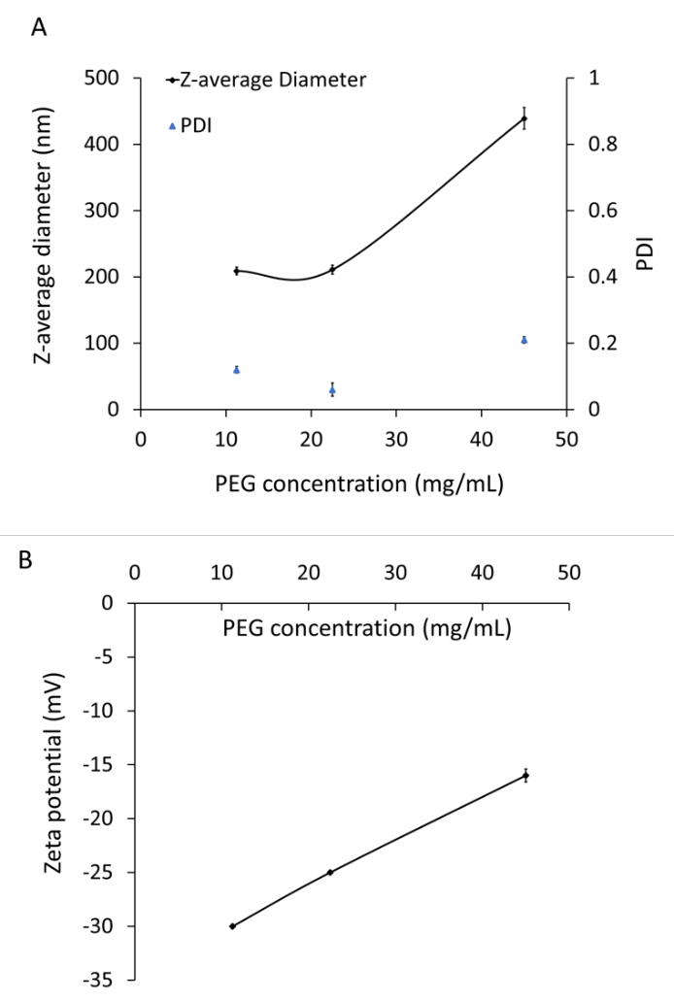
Figure 3: Influence of polymer concentration on the z-average diameter (A) and zeta potential (B) of the nanosuspensions. All the z-average diameter and zeta potential measurements were carried out in triplicate.

As sonication was used to form an emulsion of the curcumin-containing oil droplets in the aqueous solution of PEG. The previous experiments used a sonication time of 15 seconds. Therefore, experiments were undertaken with increased sonication times to study the impact on the z-average diameters of the nanosuspensions. Sonication times of 15, 30, and 60 seconds were used, while oil: water ratio (1:4) and PEG concentration at 22.5 mg/mL and curcumin concentration (10 mg/mL) remained constant. A change in sonication time showed no influence on z-average diameters in the formulation with PEG concentrations (22.5 mg/mL) as shown in Fig. S5. However, increasing the sonication time from 15 to 30 and 60 seconds negatively influenced the ability for the freeze-dried solid monoliths to redisperse in water, as observed by the presence insoluble particles in the samples that could be seen by eye. The presence of insoluble particles could be due to the increased sonication time resulting in scission of the PEG chains.[31] As a result, PEG likely became less effective at stabilising the nanoparticles. Hence, PEG concentration 22.5 mg/mL and sonication time 15 seconds was chosen and used for further studies.

As the earlier results indicating the PEG concentration of 22.5 mg/mL was superior compared to other concentrations, the curcumin concentration was also adjusted in the formulation to aid with particle stabilisation and dispersity. The influence of increasing the curcumin concentration used in the emulsion templated freeze-drying process was then studied, while other parameters were fixed (PEG concentration (22.5 mg/mL), sonication time (15 seconds) and oil: water ratio (1:4). Increasing the concentration of curcumin from 10, 13 to 23 mg/mL, while using PEG concentration of 22.5 mg/mL, showed an increase in the z-average diameter of nanosuspension and PDI (Fig. 4). This increase in size was due to the presence of a higher concentration of curcumin, which led to the formation of more nuclei in the solution, accelerating the growth process.[32] This larger number of particle nuclei were potentially not effectively stabilised by the amount of PEG available, leading the formation of aggregates.[33] Moreover, the nanosuspension prepared at curcumin concentration 13 mg and 23 mg/mL showed incomplete water dispersion. The poor water dispersion was observed by the presence of insoluble particles/aggregates within the samples. This could be due to an insufficient concentration of PEG to stabilise the curcumin nanoparticles. Therefore, the tuned parameters selected were a curcumin concentration of 10 mg/mL with a PEG concentration of 22.5 mg/mL and sonication time of 15 seconds.

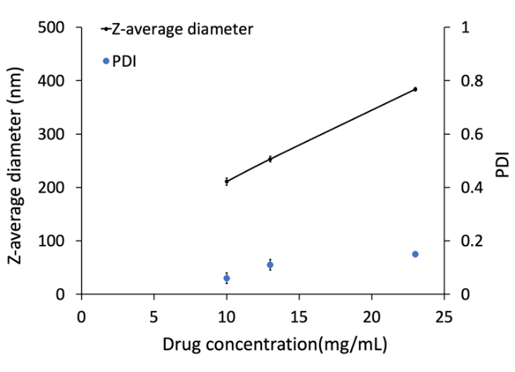
Figure 4: The influence of curcumin concentration (10, 13, and 23 mg/mL) at PEG concentrations 22.5 mg/mL on the z-average diameter of the nanosuspensions. All the z-average diameter measurements were carried out in triplicate.

  - Characterisation of the selected nanosuspension formulation
Analysis of the selected nanosuspension sample by SEM showed that the nanoparticles had a spherical shape and smallest size (50-100 nm), low polydispersity (Fig. 5A) and complete dispersion in water (the visual appearance of a dispersed formulation can be seen in Fig. S6). The narrow distribution of nanoparticles was also confirmed in the size distribution obtained by DLS as shown in Fig. 5B.

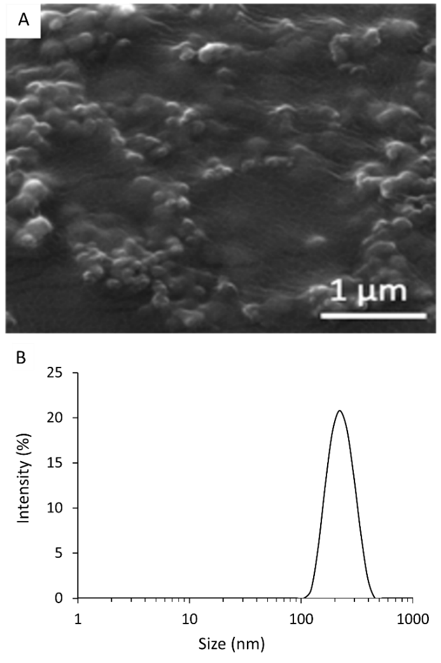
Figure 5: Characterisation of the selected curcumin nanosuspension formulation (22.5 mg/mL for PEG concentration, 10 mg/mL for curcumin concentration, 15 seconds sonication time, and oil:water ratio 1:4). (A) SEM of the curcumin nanosuspension. B) The size distribution was obtained by DLS (the z-average diameter was 216 nm and PDI was 0.05).

The selected nanosuspension formulation was characterised with FTIR spectrometry to identify the chemical composition of curcumin SDN powder after freeze-drying. FTIR spectra of unformulated curcumin, PEG and curcumin nanosuspension formulation are shown in Fig.6. The spectrum of unformulated curcumin showed a sharp peak at 1626 cm⁻¹ assigned to the enol carbonyl stretching, a peak at 1600 cm⁻¹ assigned for aromatic ring stretching and a peak at 1500 cm⁻¹ corresponded to C-O and C-C vibration. A strong peak at 3507 cm⁻¹ assigned to O-H stretching.[34,35] The spectrum of PEG showed peaks assigned as O-H stretching of hydroxyl groups at 3489 cm⁻¹ and a peak corresponded to C-H stretching of alkanes at 2879 cm⁻¹, C-H scissor and bending at 1466-1278 cm⁻¹, C-O stretching of alcohol at 1240 cm⁻¹ and C-O-C stretching of ether at 1094-1059 cm⁻¹.[36] By comparing the spectra of curcumin nanoformulation and PEG, it was observed that the spectrum of curcumin nanoformulation was similar to the spectrum of PEG, but with a few differences. The similarities included the peaks appeared at 2879, 1466, 1278, 1094 and 1278 cm⁻¹. In addition, the spectrum of curcumin nanosuspension showed a peak at 3400 cm⁻¹, which was a shift for the typical curcumin peak (3507 cm⁻¹) assigned for the O-H stretching of intermolecular bonded OH groups. Another peak of curcumin appeared at the spectrum of nanosuspension was at 1624 cm⁻¹ that was assigned to enol carbonyl group stretching vibration. From the FTIR spectra, it was revealed that curcumin was incorporated into the PEG matrices during the preparation process.

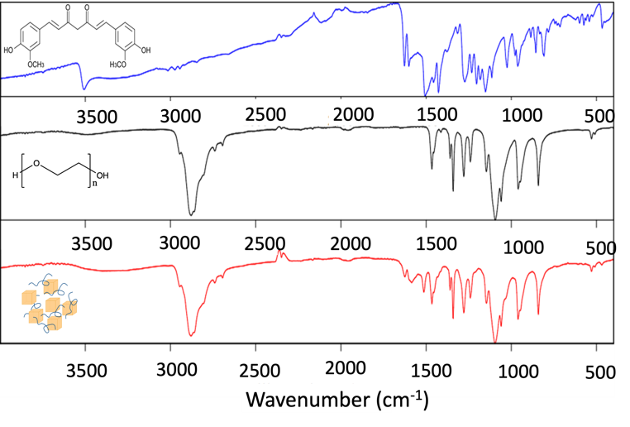
Figure 6: FTIR spectra of unformulated curcumin (Blue), PEG (Black), and curcumin nanosuspension formulation (Red). The FTIR spectrum of curcumin nanosuspension was similar to the spectrum of PEG and had two peaks of curcumin revealing the encapsulation of curcumin in PEG matrices.

  - Curcumin stability study in GIT conditions
Knowledge of the chemical stability of curcumin and nanosuspension in different pH values is important because the formulation will be exposed to different pH values while traveling through the GIT.[35] Additionally, the stability of curcumin is known to be pH-dependent. Moreover, it was known from the literature that curcumin has poor stability at physiological pH (7.4) which hinders its therapeutic effect.[37] Unformulated curcumin was dissolved in ethanol (1 mg/mL) and was then incubated at different pH values (1.2, 6.8, and 7.4) for 24 hours. The concentration of unformulated curcumin was determined with the use of HPLC after 24 hours. Degradation was observed as a decrease in the concentration of curcumin over time. This was found at all pH values, but the extent of concentration decrease was dependent on the pH. At acidic pH (1.2), the unformulated curcumin displayed a slow degradation and after 24 hours 90 % of the curcumin remained. At pH 6.8 and 7.4, 58 % and 34 %, respectively, of curcumin remained in its original form after 24 hours (Fig. 7A). Curcumin showed a faster degradation at pH 6.8 and 7.4 as compared to pH 1.2 over 24 hours, which confirmed that instability of curcumin around physiological pH as reported in previous studies.[38,39] Such instability can be ascribed to the pH-induced changes in curcumin structure. At acidic pH, curcumin was stable because the phenolic group is protonated, which stabilises its conjugated diene structure However, at neutral-alkaline pH, the proton is removed from phenolic group leading to destruction of curcumin structure, where the major degradation mechanism is the oxidation.[39]
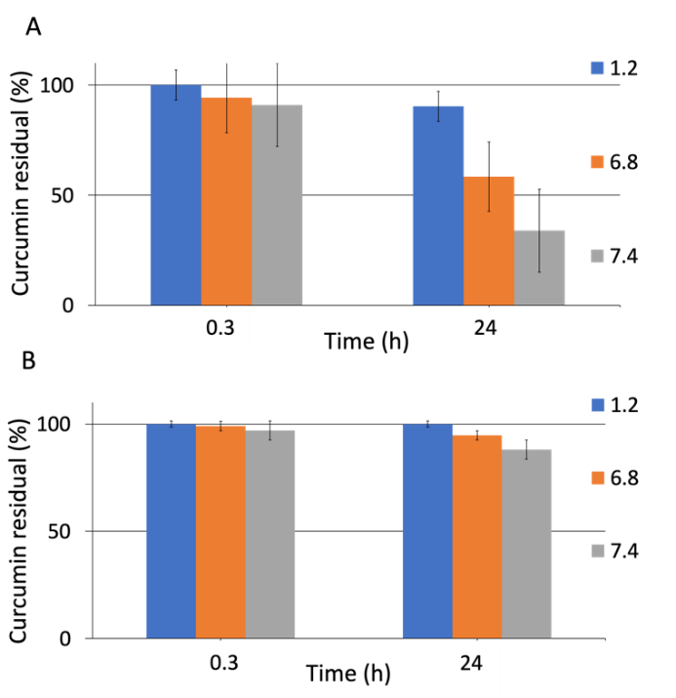

Figure 7: Chemical stability of (A) solubilised unformulated curcumin and (B) curcumin nanosuspension at different pH values (1.2, 6.8, and 7.4) at 37 °C. The residual curcumin percentage were measured by HPLC over 24 hours. All the HPLC measurements were carried out in triplicate.

The chemical stability of the curcumin nanosuspension was then carried out in the same manner. The nanosuspensions were dispersed in solutions with three different pH values (1.2, 6.8, and 7.4). The concentration of curcumin contained within nanosuspensions was measured by HPLC to quantify the amount of curcumin remaining. The nanosuspensions were stable (100%) in acidic conditions (pH 1.2) after 24 hours. At higher pH values some degradation was observed; 97% of curcumin in the nanosuspensions remained stable at pH 6.8, and around 88% of the curcumin was stable at pH 7.4 over 24 hours (Fig. 7B). The formulation of the curcumin as nanosuspensions clearly improved its chemical stability compared to the solubilised form. Such stability of curcumin nanosuspensions could be ascribed to the containment of much of the curcumin within the nanosuspensions, only the curcumin on the outer surface of the nanoparticles was exposed to the external conditions and thus reduced the degradation rate. Sattar et al. showed that the formation of nanosuspensions is a promising approach to enhance the chemical stability of poorly water-soluble drugs such as cyadox.[35] These findings, under conditions that mimic the GIT, show nanosuspensions of curcumin might offer potential for oral drug administration.

  - Colloidal stability study of curcumin nanosuspensions
The stability of nanosuspensions samples containing curcumin and PEG was studied in water to assess the dispersion stability. The z-average diameter and PDI were monitored by DLS over three weeks. The initial z-average diameter and PDI of nanosuspensions was 205 nm ± 2.3, and 0.1 ± 0.01, respectively. After 1 day, the z-average diameter of the nanosuspensions increased up to 360 nm, while PDI decreases to 0.07, a low PDI here indicating that they were still stable and monodispersed. After a week, the z-average diameter of nanosuspensions gradually increased from 360 to 421 nm, while the PDI significantly increased from 0.07 to 0.5. The significant increase in PDI indicates the instability of nanosuspensions after a week. After three weeks, the z-average diameter and PDI of nanosuspensions were increased up to 636 nm and 0.6, respectively (Fig. 8). This increase in z-average diameter and PDI of the nanosuspension could be ascribed to the Ostwald ripening that resulted in particles enlargement, or alternatively particle aggregation to minimise the surface energy. He et al. showed that indomethacin nanosuspension exhibited a high solubility in presence of natural stabilisers such as soybean protein, whey protein, and β-lactoglobulin, which led to aggregation and crystal growth.[40] Indeed, it was reported that increasing the drug solubility in the presence of stabilisers resulting in Ostwald ripening and particles aggregation.[41] However, as the nanosuspensions reported in our work were obtained from a redispersible solid, there would be little need for the formulation to be dispersed over durations as long as a week prior to administration to the patient.

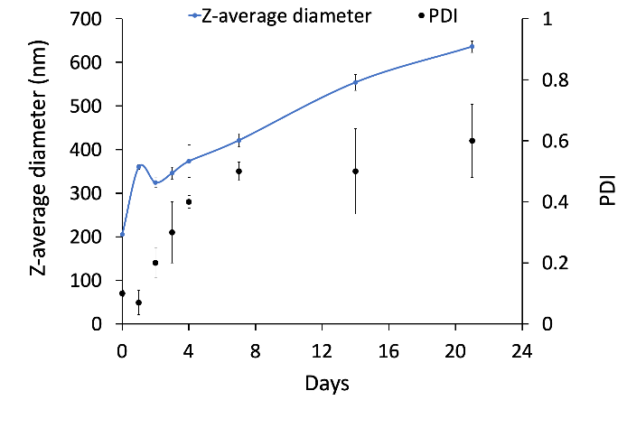
Figure 8: The mean diameter and PDI of nanosuspensions measured by DLS in water at 25 °C over 21 days. All the measurements were carried out in triplicate.

  - In vitro bioaccessibility study
The in vitro bioaccessibility of unformulated curcumin and nanosuspensions was then evaluated with the use of a simulated gastrointestinal tract (GIT). The total amount of curcumin remaining after passing through various GIT conditions and the fraction of curcumin present in the small intestine phase was determined using HPLC. These results were used to calculate the stability and bioaccessibility. The stability was defined as the percentage of curcumin remaining in the overall media after passing through the simulated GIT. While the bioaccessibility was defined as the fraction of curcumin in the small intestine phase, which is considered as the available amount of curcumin for absorption.[39,42,43] For these experiments we did not solubilise the unformulated curcumin in order to reflect its poor aqueous solubility. The concentration of curcumin was above the solubility limit at all stages of the simulated GIT, these conditions were chosen in order to differentiate how nanosuspension formulation might assist dissolution when above the saturation limit of curcumin. The stability of unformulated curcumin (60 %) was significantly higher than nanosuspensions (17%) (Fig. 9). The curcumin degradation under the simulated GIT conditions occurred due to the exposure to the aqueous neutral environment and digestive enzymes such as pepsin.[44,45] Nanosuspensions showed a higher degradation than unformulated curcumin, because nanosuspensions have a much higher surface area compared to the unformulated curcumin powder particles. This renders the curcumin more susceptible to enzymatic degradation than the unformulated curcumin in the larger crystals.[20] On the other hand, the bioaccessibility percentage of curcumin nanosuspensions was improved by 2-fold as compared to unformulated curcumin, which suggests that nanosuspensions enhanced the dissolution rate of curcumin in small intestine phase (Fig. 9). This trend could again be ascribed to the larger surface area of the nanosuspensions which led to a faster dissolution rate than the unformulated curcumin.[46] Overall, the formulation of curcumin into nanosuspensions showed an enhanced in vitro bioaccessibility than the unformulated curcumin. This result is in agreement with literature findings revealing that the confinement of curcumin into nanoscale entities enhanced the curcumin dissolution rate as compared to unformulated curcumin.[13,39,42,43]

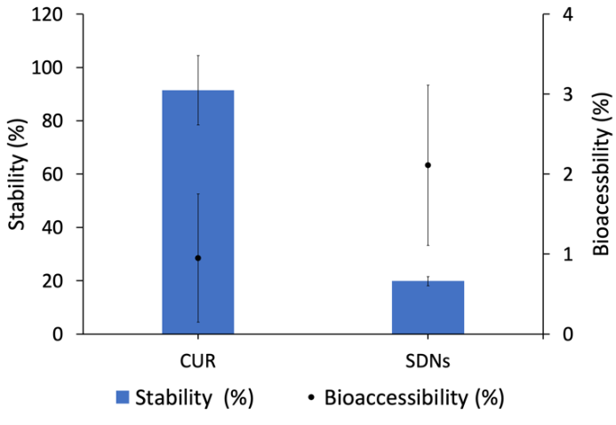

Figure 9: Percentage of stability and bioaccessibility of unformulated curcumin and curcumin nanosuspensions after passing through a stimulated gastrointestinal tract. All the measurements were carried out in triplicate

  - In vitro cytotoxicity MTT assay
The in vitro cytotoxicity was examined using an MTT assay, which evaluated the mitochondria function as a measurement of cell viability permitting the detection of dead cells prior the loss of their shape and integrity. Caco-2 cells, epithelial colorectal adenocarcinoma cells, were used in light of the intended oral administration of developed nanoformulations. HT-29 cells, a human colorectal adenocarcinoma cell line, were also used to assess the anticancer effect of curcumin and nanosuspensions. Previous studies demonstrated that curcumin inhibits the proliferation of various colon cancer cell lines by inducing cell apoptosis and generating reactive oxidation species (ROS).[47,48] The cytotoxicity of solubilised curcumin and the curcumin nanosuspension was studied using Caco-2 cells and HT-29 cells. First, Caco-2 cells was exposed to different concentrations of solubilised curcumin and the curcumin nanosuspensions (0, 0.78, 1.56, 3.13, 6.25, 12.5, 25, 50, 100 µM) and incubated for 48 hours. The cytotoxicity results demonstrated that the IC₅₀ value of unformulated curcumin was 22 µM (Fig. 10A). This result aligned with the literature findings, reporting an anticancer effect of curcumin on different type of cancer cells.[47] The IC₅₀ value of the nanosuspension was 88 µM (Fig. 10B) demonstrating a significant decrease in cytotoxicity profile of the curcumin in this formulation. Such decrease in the cytotoxicity of the nanosuspensions was associated to the reduced concentration of curcumin present in cell culture medium, since much of the curcumin was contained in the nanoparticles compared to the solubilised curcumin control. This resulted in a reduced exposure of the cells to curcumin and in turn reduced the cytotoxicity.

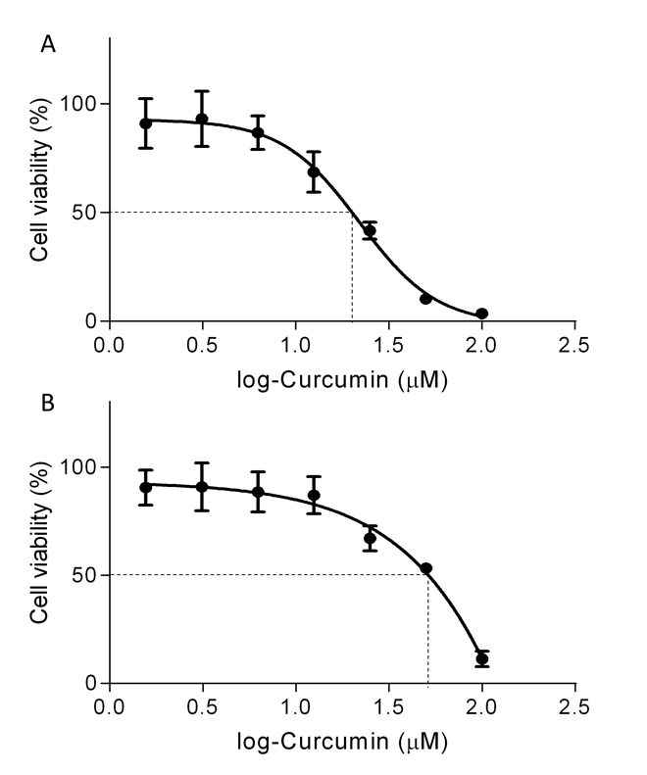

Figure 10: Cell viability of Caco-2 cells after 48 hours incubation with different concentration varying form 0-100 µM of (A) solubilised curcumin and (B) the curcumin nanosuspension. All the measurements were carried out in quadruplicate.
Second, the analysis of cell viability was also performed on HT-29 cells by exposing the cells to different concentrations (0, 0.78, 1.56, 3.13, 6.25, 12.5, 25, 50, 100 µM) of solubilised curcumin and the curcumin nanosuspension. These were also incubated for 48 hours. Solubilised curcumin had an IC₅₀ value of 21.6 µM, which is close to the IC₅₀ value of unformulated curcumin on Caco-2 cells (22 µM) (Fig. 11A). The nanosuspensions showed a higher cell viability compared to unformulated curcumin as the IC₅₀ value was determined to be 52 µM (Fig. 11B). Much like the cytotoxicity on the Caco-2 cells, nanosuspensions were less toxic compared to the solubilised curcumin, this difference can be ascribed to the differences in the amount of curcumin present in solution.
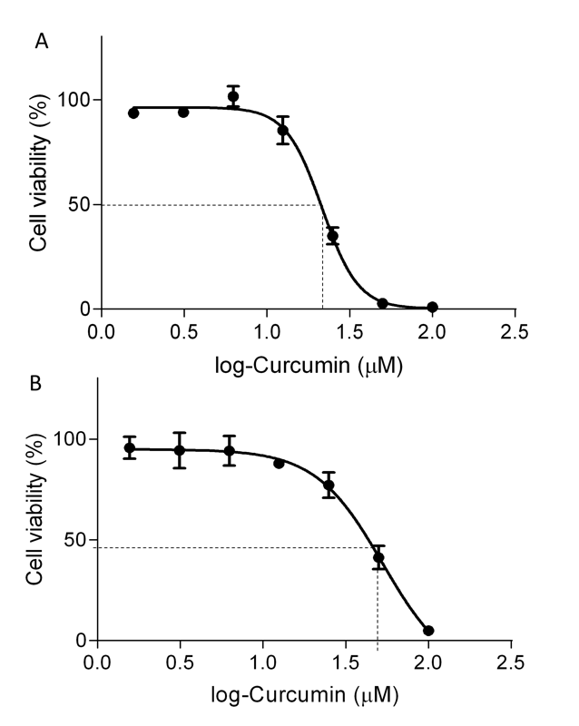

Figure 11: Cell viability of HT-29 cells after 48 hours exposure to different concentration varying form 0-100 µM of (A) unformulated curcumin and (B) the curcumin nanosuspension. All measurements were carried out in quadruplicate.
- Conclusions
Curcumin is a natural nutraceutical that is widely used in food and beverage industry. Recent research has shown that curcumin has multiple therapeutic effects such as anticancer, antibacterial and antioxidant properties. However, curcumin has low aqueous solubility and stability around the physiological pH, which hinder its effectiveness and clinical applications. A promising approach to improve the curcumin stability and bioaccessibility is formulating the curcumin as a nanosuspension using the emulsion-templated freeze-drying technique. In this technique, the curcumin was emulsified with different excipients which encapsulate the curcumin and stabilise it in aqueous solution. A 32-sample library screen was carried out to identify which sample fulfil the assessment criteria including small size, narrow PDI, low SD, and a complete water dispersion. One sample used PEG as the only excipient fulfilled this assessment criteria and therefore was chosen for further investigation. It is likely that the PEG acts as both a stabiliser and cryoprotectant that facilities nanoparticles re-dispersion and stabilised them resulting in their small z-average diameters and narrow PDI. The stability, in vitro bioaccessibility of the chosen the curcumin nanosuspension sample and unformulated curcumin were studied. The stability of unformulated curcumin and the curcumin nanosuspension were studied at different pH values that mimic different sections of the gastrointestinal tract. The study showed that unformulated solubilised curcumin degraded faster compared to the nanosuspension formulation. The nanosuspension showed a higher stability due to the encapsulation of some of the curcumin within the nanoparticles. The degradation of curcumin within the nanosuspension was found to be a pH-dependent, where degradation was slower at acidic pH as compared to neutral pH. When the curcumin nanosuspension was compared to unformulated curcumin (not solubilised by the addition of a cosolvent), the nanosuspension showed faster degradation but greater in vitro bioaccessibility. The in vitro cytotoxicity of unformulated curcumin and nanosuspensions showed that nanosuspension reduced the cytotoxicity profile of curcumin. Overall, the studies showed that nanosuspensions enhanced the physicochemical properties of curcumin such as stability and dissolution rate. Nanosuspensions are therefore promising for improving the physicochemical properties of different poorly soluble drugs and enhancing their cytotoxicity profile. However, more in vitro and in-vivo studies are still required to provide a full understanding of the biological behaviour of curcumin nanosuspensions.
Conflicts of interest
There are no conflicts to declare.
Acknowledgements
The authors would like to thank the Department of Chemistry at the University of Liverpool for supporting NME with an International Postgraduate Research Studentship, we also gratefully acknowledge financial support from the EPSRC (Grant Number EP/S012265/1).

References
[1] J. Park, Anti-carcinogenic properties of curcumin on colorectal cancer, World J. Gastrointest. Oncol. 2 (2010) 169. https://doi.org/10.4251/wjgo.v2.i4.169.
[2] A. Goel, A.B. Kunnumakkara, B.B. Aggarwal, Curcumin as “Curecumin”: From kitchen to clinic, Biochem. Pharmacol. 75 (2008) 787–809. https://doi.org/10.1016/j.bcp.2007.08.016.
[3] S. Kalepu, V. Nekkanti, Insoluble drug delivery strategies: Review of recent advances and business prospects, Acta Pharm. Sin. B. 5 (2015) 442–453. https://doi.org/10.1016/j.apsb.2015.07.003.
[4] V.R. Patel, Y.K. Agrawal, Nanosuspension: An approach to enhance solubility of drugs., J. Adv. Pharm. Technol. Res. 2 (2011) 81–87. https://doi.org/10.4103/2231-4040.82950.
[5] Y. Agrawal, V. Patel, Nanosuspension: An approach to enhance solubility of drugs, J. Adv. Pharm. Technol. Res. 2 (2011) 81–87. https://doi.org/10.4103/2231-4040.82950.
[6] P. Udompornmongkol, B.H. Chiang, Curcumin-loaded polymeric nanoparticles for enhanced anti-colorectal cancer applications, J. Biomater. Appl. 30 (2015) 537–546. https://doi.org/10.1177/0885328215594479.
[7] A. Ubeyitogullari, O.N. Ciftci, A novel and green nanoparticle formation approach to forming low-crystallinity curcumin nanoparticles to improve curcumin’s bioaccessibility, Sci. Rep. 9 (2019) 1–11. https://doi.org/10.1038/s41598-019-55619-4.
[8] X. Gao, F. Zheng, G. Guo, X. Liu, R. Fan, Z.Y. Qian, N. Huang, Y.Q. Wei, Improving the anti-colon cancer activity of curcumin with biodegradable nano-micelles, J. Mater. Chem. B. 1 (2013) 5778–5790. https://doi.org/10.1039/c3tb21091j.
[9] V.S. Gota, G.B. Maru, T.G. Soni, T.R. Gandhi, Nltin Kochar, M.G. Agarwal, Safety and pharmacokinetics of a solid lipid curcumin particle formulation in osteosarcoma patients and healthy volunteers, J. Agric. Food Chem. 58 (2010) 2095–2099. https://doi.org/10.1021/jf9024807.
[10] S. Jacob, A.B. Nair, J. Shah, Emerging role of nanosuspensions in drug delivery systems, Biomat Res. 24 (2020) 1–16. https://doi.org/10.1186/s40824-020-0184-8.
[11] N. Grant, H. Zhang, Poorly water-soluble drug nanoparticles via an emulsion-freeze-drying approach, J. Colloid Interface Sci. 356 (2011) 573–578. https://doi.org/10.1016/j.jcis.2011.01.056.
[12] M. Siccardi, P. Martin, D. Smith, P. Curley, T. McDonald, M. Giardiello, N. Liptrott, S. Rannard, A. Owen, Towards a rational design of solid drug nanoparticles with optimised pharmacological properties, J. Interdiscip. Nanomedicine. 1 (2016) 110–123. https://doi.org/10.1002/jin2.21.
[13] A.C. Savage, L.M. Tatham, M. Siccardi, T. Scott, M. Vourvahis, A. Clark, S.P. Rannard, A. Owen, Improving maraviroc oral bioavailability by formation of solid drug nanoparticles, Eur. J. Pharm. Biopharm. 138 (2019) 30–36. https://doi.org/10.1016/j.ejpb.2018.05.015.
[14] M. Giardiello, N.J. Liptrott, T.O. McDonald, D. Moss, M. Siccardi, P. Martin, D. Smith, R. Gurjar, S.P. Rannard, A. Owen, Accelerated oral nanomedicine discovery from miniaturized screening to clinical production exemplified by paediatric HIV nanotherapies, Nat. Commun. 7 (2016) 13184. https://doi.org/10.1038/ncomms13184.
[15] T.O. McDonald, M. Giardiello, P. Martin, M. Siccardi, N.J. Liptrott, D. Smith, P. Roberts, P. Curley, A. Schipani, S.H. Khoo, J. Long, A.J. Foster, S.P. Rannard, A. Owen, Antiretroviral Solid Drug Nanoparticles with Enhanced Oral Bioavailability: Production, Characterization, and In Vitro-In Vivo Correlation, Adv. Healthc. Mater. 3 (2014) 400–411. https://doi.org/10.1002/adhm.201300280.
[16] H. Zhang, D. Wang, R. Butler, N.L. Campbell, J. Long, B. Tan, D.J. Duncalf, A.J. Foster, A. Hopkinson, D. Taylor, D. Angus, A.I. Cooper, S.P. Rannard, Formation and enhanced biocidal activity of water-dispersable organic nanoparticles, Nat. Nanotechnol. 3 (2008) 506–511. https://doi.org/10.1038/nnano.2008.188.
[17] R.P. Bakshi, L.M. Tatham, A.C. Savage, A.K. Tripathi, G. Mlambo, M.M. Ippolito, E. Nenortas, S.P. Rannard, A. Owen, T.A. Shapiro, Long-acting injectable atovaquone nanomedicines for malaria prophylaxis, Nat. Commun. 9 (2018) 315. https://doi.org/10.1038/s41467-017-02603-z.
[18] Y. Wang, C. Wang, J. Zhao, Y. Ding, L. Li, A cost-effective method to prepare curcumin nanosuspensions with enhanced oral bioavailability, J. Colloid Interface Sci. 485 (2017) 91–98. https://doi.org/10.1016/j.jcis.2016.09.003.
[19] S.D.S. Hirlekar, S. Bhairy, S. Bhairy, R. Hirlekar, R. Hirlekar, Preparation and characterization of Oral Nanosuspension loaded with Curcumin, Int. J. Pharm. Pharm. Sci. 10 (2018) 90–95. https://doi.org/10.22159/ijpps.2018v10i6.22027.
[20] S. Peng, Z. Li, L. Zou, W. Liu, C. Liu, D.J. McClements, Enhancement of Curcumin Bioavailability by Encapsulation in Sophorolipid-Coated Nanoparticles: An in Vitro and in Vivo Study, J. Agric. Food Chem. 66 (2018) 1488–1497. https://doi.org/10.1021/acs.jafc.7b05478.
[21] M.K. Lee, M.Y. Kim, S. Kim, J. Lee, Cryoprotectants for freeze drying of drug nano-suspensions: Effect of freezing rate, J. Pharm. Sci. 98 (2009) 4808–4817. https://doi.org/10.1002/jps.21786.
[22] M.A. Moretton, D.A. Chiappetta, A. Sosnik, Cryoprotection–lyophilization and physical stabilization of rifampicin-loaded flower-like polymeric micelles, J. R. Soc. Interface. 9 (2012) 487–502. https://doi.org/10.1098/rsif.2011.0414.
[23] J.L. Min Kyung Lee, Min Young Kim, Sujung Kim, Cryoprotectants for freeze drying of drug nano-suspensions: Effect of freezing rate, J. Pharm. Sci. 98 (2009) 4808–4817.
[24] W.-H. Lee, C.-Y. Loo, M. Bebawy, F. Luk, R. Mason, R. Rohanizadeh, Curcumin and its Derivatives: Their Application in Neuropharmacology and Neuroscience in the 21st Century, Curr. Neuropharmaco. 11 (2013) 338–378. https://doi.org/10.2174/1570159x11311040002.
[25] S. Manimaran, K. SambathKumar, R. Gayathri, K. Raja, N. Rajkamal, M. Venkatachalapathy, G. Ravichandran, C. Lourdu EdisonRaj, Medicinal Plant Using Ground State Stabilization of Natural Antioxidant Curcumin by Keto-Enol Tautomerisation, Nat. Products Bioprospect. 8 (2018) 369–390. https://doi.org/10.1007/s13659-018-0170-1.
[26] T. Heinze, T. Liebert, B. Heublein, S. Hornig, Functional polymers based on dextran, Adv. Polym. Sci. 205 (2006) 199–291. https://doi.org/10.1007/12_100.
[27] S. Lowe, N.M. O’Brien-Simpson, L.A. Connal, Antibiofouling polymer interfaces: Poly(ethylene glycol) and other promising candidates, Polym. Chem. 6 (2015) 198–212. https://doi.org/10.1039/c4py01356e.
[28] A.A. D’souza, R. Shegokar, Polyethylene glycol (PEG): a versatile polymer for pharmaceutical applications, Expert Opin. Drug Deliv. 13 (2016) 1257–1275. https://doi.org/10.1080/17425247.2016.1182485.
[29] G. Dékány, I. Csóka, I. Erös, Adsorption of neutral polymers on negatively charged liposomes. A novel quantitative method to measure the rate of polymer adsorption on the liposomal surface, Colloid Polym. Sci. 279 (2001) 966–975. https://doi.org/10.1007/s003960100528.
[30] Y. Wang, Y. Zheng, L. Zhang, Q. Wang, D. Zhang, Stability of nanosuspensions in drug delivery, J.Controlled Release. 172 (2013) 1126–1141. https://doi.org/10.1016/J.JCONREL.2013.08.006.
[31] R. Wang, V.S. Murali, R. Draper, Detecting sonolysis of polyethylene glycol upon functionalizing carbon nanotubes, in: Methods Mol. Biol., Humana Press Inc., 2017: pp. 147–164. https://doi.org/10.1007/978-1-4939-6646-2_10.
[32] J. Zhang, Z. Xie, N. Zhang, J. Zhong, Nanosuspension drug delivery system: preparation, characterization, postproduction processing, dosage form, and application, in: Nanostructures Drug Deliv., 2017: pp. 413–443.
[33] Nanosuspensions : A Novel Approach In Drug Delivery, Pharm. Rev. (2008) 1–11. https://www.researchgate.net/publication/26575865_Nanosuspensions_A_Novel_Approach_In_Drug_Delivery (accessed April 30, 2020).
[34] X. Li, H. Yuan, C. Zhang, W. Chen, W. Cheng, X. Chen, X. Ye, Preparation and in-vitro / in-vivo evaluation of curcumin nanosuspension with solubility enhancement, J. Pharm. Pharmacol. 68 (2016) 980–988. https://doi.org/10.1111/jphp.12575.
[35] A. Sattar, D. Chen, L. Jiang, Y. Pan, Y. Tao, L. Huang, Z. Liu, S. Xie, Z. Yuan, Preparation, characterization and pharmacokinetics of cyadox nanosuspension, Sci Rep. 7 (2017) 1–9. https://doi.org/10.1038/s41598-017-02523-4.
[36] M. Luangtana-Anan, J. Nunthanid, S. Limmatvapirat, Effect of molecular weight and concentration of polyethylene glycol on physicochemical properties and stability of shellac film, J. Agric. Food Chem. 58 (2010) 12934–12940. https://doi.org/10.1021/jf1031026.
[37] J. Li, Y. Jiang, J. Wen, G. Fan, Y. Wu, C. Zhang, A rapid and simple HPLC method for the determination of curcumin in rat plasma: assay development, validation and application to a pharmacokinetic study of curcumin liposome Quantitation of curcumin in rat plasma, Biomed. Chromatogr. 23 (2009) 1201–1207. https://doi.org/10.1002/bmc.1244.
[38] Y.J. Wang, M.H. Pan, A.L. Cheng, L.I. Lin, Y.S. Ho, C.Y. Hsieh, J.K. Lin, Stability of curcumin in buffer solutions and characterization of its degradation products, J. Pharm. Biomed. Anal. 15 (1997) 1867–1876. https://doi.org/10.1016/S0731-7085(96)02024-9.
[39] M. Kharat, Z. Du, G. Zhang, D.J. McClements, Physical and Chemical Stability of Curcumin in Aqueous Solutions and Emulsions: Impact of pH, Temperature, and Molecular Environment, J. Agric. Food Chem. 65 (2017) 1525–1532. https://doi.org/10.1021/acs.jafc.6b04815.
[40] W.W. Wei He, Yi Lu, JianpingQi, Lingyun Chen, Fuqiang Hu, Food proteins as novel nanosuspension stabilizers for poorly water-soluble drugs, Int. J. Pharm. 441 (2013) 269–278.
[41] D. YancaiWang, YingZheng, LingZhang, QiweiWang, Stability of nanosuspensions in drug delivery, J. Control. Release. 172 (2013) 1126–1141.
[42] C. Cheng, S. Peng, Z. Li, L. Zou, W. Liu, C. Liu, Improved bioavailability of curcumin in liposomes prepared using a pH-driven, organic solvent-free, easily scalable process, RSC Adv. 7 (2017) 25978–25986. https://doi.org/10.1039/c7ra02861j.
[43] S. Peng, Z. Li, L. Zou, W. Liu, C. Liu, D.J. McClements, Enhancement of Curcumin Bioavailability by Encapsulation in Sophorolipid-Coated Nanoparticles: An in Vitro and in Vivo Study, J. Agric. Food Chem. 66 (2018) 1488–1497. https://doi.org/10.1021/acs.jafc.7b05478.
[44] L. Zou, B. Zheng, R. Zhang, Z. Zhang, W. Liu, C. Liu, H. Xiao, D.J. McClements, Food-grade nanoparticles for encapsulation, protection and delivery of curcumin: Comparison of lipid, protein, and phospholipid nanoparticles under simulated gastrointestinal conditions, RSC Adv. 6 (2016) 3126–3136. https://doi.org/10.1039/c5ra22834d.
[45] K.Z. Ming Ying , Fengwen Huang , Haidong Ye , Hong Xu , Liangliang Shen , Tianwen Huan , Shitong Huang , Jiangfeng Xie , Shengli Tian, Zhangli Hu , Zhendan He , Jun Lu , Kai ZhouMing Ying , Fengwen Huang , Haidong Ye , Hong Xu , Liangliang Shen, Tian, Study on interaction between curcumin and pepsin by spectroscopic and docking methods, Int J Biol Macromol. 79 (2015) 201–208.
[46] R. Jog, D.J. Burgess, Pharmaceutical Amorphous Nanoparticles, J Pharm Sci. 106 (2017) 39–65. https://doi.org/10.1016/j.xphs.2016.09.014.
[47] J.L. Watson, R. Hill, P.W. Lee, C.A. Giacomantonio, D.W. Hoskin, Curcumin induces apoptosis in HCT-116 human colon cancer cells in a p21-independent manner, Exp. Mol. Pathol. 84 (2008) 230–233. https://doi.org/10.1016/j.yexmp.2008.02.002.
[48] A. Agarwal, A. Kasinathan, R. Ganesan, A. Balasubramanian, J. Bhaskaran, S. Suresh, R. Srinivasan, K.B. Aravind, N. Sivalingam, Curcumin induces apoptosis and cell cycle arrest via the activation of reactive oxygen species–independent mitochondrial apoptotic pathway in Smad4 and p53 mutated colon adenocarcinoma HT29 cells, Nutr. Res. 51 (2018) 67–81. https://doi.org/10.1016/j.nutres.2017.12.011.

