Estimation of structural steel and concrete stocks and flows at urban scale – towards a prospective circular economy
Atta Ajayebiª*, Peter Hopkinsonª, Kan Zhou^{b}, Dennis Lam^{b} Han-Mei Chen^{c}, and Yong Wang^{c}

ªExeter Business School, University of Exeter, Northcote House, The Queen’s Drive, Exeter, EX4 4QJ, UK
^{b}Department of Civil and Structural Engineering, University of Bradford, Bradford, West Yorkshire, BD7 1DP, UK
^{c}School of Mechanical, Aerospace and Civil Engineering, University of Manchester, Oxford Rd, Manchester, M13 9PL, UK
* Corresponding author
Abstract:
Quantification of stocks and flows of building construction materials is a key first stage in assessing the potential for creating higher value at end-of-life decisions compared to destructive demolition. Steel and concrete are among the most widely used construction materials primarily in structural components. Such components are highly variable in design, type, and dimensions. In the absence of urban-scale digitised models of structural components or building plans, accurate assessment relies on either onsite inspection or modelling of building dimensions and estimated material intensity (MI) co-efficient which can vary by up to a factor of 100. In this study, we extend previous steel and concrete stock modelling approaches through the development of a method that relies on building archetypes and produces MI coefficients of steel and concrete that are representative of frame types, temporally explicit and disaggregated at the product level. This is compared to the common existent method of calculating MI to demonstrate the capabilities of the proposed method. Coupled with a spatiotemporal model of urban buildings, the developed MI of both methods are applied to a case study of the city of Bradford in the UK. The total in-use stock of steel and concrete within multi-storey buildings is estimated at 81,000 tonnes and 655,000 m³ respectively. The stocks of steel and concrete are disaggregated based on their functions as products, for instance, steel beams are distinguished from reinforcement steel. Subsequently, the embodied carbon of the in-use stock is calculated as 350 kt CO₂eq. The results show the proposed method enables a more granular assessment of the embodied carbon due to the disaggregated assessment of the structural material quantities.
1. Introduction:
Structural materials, notably steel, concrete and brick make up the major stocks of building materials by volume, weight and construction and demolition wastes. Globally The total in-use stock of steel and concrete were 25.7 and 315.8 Gt respectively in 2010 out of a total 792 Gt (Krausmann et al., 2017). In the UK – the focus of this paper, the in-use built environment is estimated to contain more than 5 billion tonnes of concrete and 500 million tonnes of steel. Annually 247Mt of aggregate (MPA, 2018), 82 MT of concrete and 5 Mt of brick (BEIS, 2020) are used in the UK. Non-metallic mineral-based construction materials alone were estimated to be responsible for >10Mt CO₂ in 2018 (MPA, 2018). In 2017, 57 million tonnes of concrete and 12 million tonnes of steel were in the demolition outflows (Streeck et al., 2020).
Structural products and materials are invariably long-lasting. Globally around 80% of existing buildings were constructed before 1990, and half of them before 1960 (Pomponi and Moncaster, 2017). This trend of stock accumulation indicates the significant volumes of the materials within buildings and their potentially diverse characteristics. A growing body of research has studied and developed stock-flow models for specific materials, types and scales (Krausmann et al., 2017) (Haas et al., 2020) (Stephan and Athanassiadis, 2017a). These stocks open the possibility of mining building products, components, and pure materials in the future by reclaiming and re-use afterwards, using new forms of deconstruction over destructive demolition. However, urban buildings are invariably downcycled into lower grade products and materials or landfilled at the point of demolition when a building reaches the end of its service life – often well before the end of technical life of the majority of materials and products (Pomponi and Moncaster, 2017). Moreover, some of the biggest barriers to reclaim and re-use of building structural materials is the lack of match between supply and demand of reusable components. This requires a data registration and exchange database for materials, standard components and products from multiple existing buildings and from which components for a new build can be sourced. This in turn requires detailed and accurate information of exactly what and when reusable components are available from EOSL buildings. Whilst various building component marketplace exists these are mostly for non-structural components (e.g. Salvo, (2020)), waste materials during/after the construction process (e.g. Enviromate (2020)), excessive materials (e.g. Excess materials exchange, (2020) or excavation materials (e.g. Rocks (2020)).
Accurate stock-flow information of the product and material components of existing buildings at the End-of-Service-Life (EOSL) opens the potential to quantify the reclaim potential of future products such as steel or concrete components, assess their future value material streams and their potential carbon and environmental benefits via direct re-use, remanufacture or higher quality recycling. There is increasing interest and evidence of selective product and material reclaim and re-use, notably high value heritage materials and interior products such as ceiling panels, certain metals, doors, carpet tiles and timber (Stephan and Athanassiadis, 2017a)(Gallego-Schmid et al., 2020)(Romero Perez de Tudela et al., 2020).
Urban mining of structural building products and materials has great potential for future circular economy construction systems but faces a number of challenges. These include: firstly, the technical feasibility of being able to separate and reclaim products from buildings that were not originally designed for deconstruction. Secondly, in the absence of detailed building plans, how to accurately estimate the quantity, age and location of stocks and their potential future flows. Thirdly, to determine potential drivers to incentivise greater interest, value, and uptake of end-of-life structural products and materials.
For example, clay bricks bound by concrete mortar considered too difficult to separate without damage (Gregory et al., 2004). Hence, despite an estimated 800 billion tonnes of bricks in buildings worldwide (Streeck et al., 2020), and the UK using over 2 billion each year, little interest in estimating their spatial or temporal distribution for urban mining potential. In a recent paper, the authors address these three challenges in relation to clay bricks bound by concrete mortar (Ajayebi et al., 2020), highlighting new engineering techniques to separate concrete mortar, a novel spatio-temporal stock flow model to estimate the total number of individual structural bricks at urban scale and their embodied carbon and GWP benefit from re-use. The ability to estimate the number of bricks is possible due to their relatively standardised dimensions and from the known external dimensions (footprint on the ground and height) of visible external structures calculated via GIS analysis and geo-data sources including Ordnance Survey maps, google earth etc.
At the EOSL of buildings, concrete is rarely reclaimed for re-use but is typically crushed or downcycled as construction aggregate. A high proportion of structural steel >85% is recycled (BCSA, 2019) often to a lower grade steel (rebar) due to mixing and contamination at the point of collection and reclaim. There is a market for steel re-use and a number of case studies have shown the economic and environmental potential of the direct re-use of steel frame buildings (Brutting et al., 2019), (Sansom and Avery, 2014). In the UK reusing rates are slightly higher for steel decking (10%) and structural hollow steel sections (7%). The remainder is mostly recycled. Moreover, Steel and concrete dominate the embodied carbon (measured as Global Warming Potential: GWP) impact of new constructions hence the ability to selectively reclaim and re-use these products within new builds would make a significant contribution to future zero-carbon and circular economy building and construction systems. For example, our studies have shown increasing the share of reusing concrete blocks and steel decking can decrease the average aggregated embodied GWP of these materials by 27% and 21% respectively (Ajayebi et al., 2020).
Compared to brick, estimations for steel and concrete are complicated by the fact that the majority of the structure (frames, floors, ceilings, foundations etc) comprising these materials are hidden and the dimensions of the components are highly varied. Previous studies have estimated quantities of steel and concrete by coming up with Material Intensity (MI) coefficient of buildings.
In this paper, we use the same spatiotemporal stock-flow 3D model (Ajayebi et al., 2020) to estimate of stocks and flows of steel and concrete in buildings at urban scale in the absence of building plans. The aim of this paper is to present a method for quantification of steel and concrete MI and material stocks of buildings for a UK case study at urban scale using novel MI calculation and spatiotemporal modelling techniques. The paper is novel and distinctive in three ways. Firstly, it creates modelling building archetypes of steel and concrete frame types and their dimensions to create representative component-specific MI. Secondly, it is temporally dynamic, taking account of trends within the construction sector through time. Thirdly, it provides an additional carbon and GWP sub-system to enhance estimations of the embodied carbon of the in-use stocks.
The paper addresses three key research questions
- In the absence of building plans, can we improve levels of accuracy for estimating building structural steel and concrete MI by modelling building frame archetypes?
- Can we apply spatiotemporal GIS and quantify stocks of steel and concrete material intensity at urban scale (thousands of buildings rather than ten’s)?
- What is the embodied carbon of these in-situ concrete and steel products and materials?
The structure of the paper is firstly to describe approaches to modelling building material stock-flows and previous studies on concrete and steel. Secondly, to describe the spatio-temporal model and two different methods. Thirdly to report findings and results. Finally, to discuss conclusions and future research requirements.
2. Background: Stock flow models for building products and materials
Stock-flow models are designed to estimate the stocks of buildings and their rate of accumulation or decline through time. The bottom-up stock assessment approach attempts to account for buildings within urban areas by incorporating multiple sources of data such as spatial land use datasets, construction records, models of buildings, and direct data collection (Augiseau and Barles, 2017). Such approaches connect geometrical aspects of structures to quantities of material stock, typically via an MI coefficient. Calculation of the stocks via MI involves describing the stock accumulation by using a representative unit, such as floor area or volume of buildings, as a proxy for the inventory of in-use materials. It is then possible to estimate the total quantity by multiplying the inventory with a known ratio of material quantity per unit of inventory that is the MI (Gontia et al., (2018); Heeren and Fishman (2019)). As a result, by combining a spatial model of buildings and appropriate set of MI, the quantities of materials can be estimated and mapped at building level or wider urban scale. Wide-scale bottom-up assessment of material stocks benefit from implementation of spatial analysis as it facilitates and enhances the quality of results. Assigning location information and geometry of buildings that can be analysed by Geographical Information Systems (GIS) will add the spatial dimension to the analysis (Lanau et al., (2019); Miatto et al., (2019)).
The ideal data for estimating MI is via building plans or digitised models. This would provide the precise dimensions of each component and would allow for accurate calculation of quantities and dimensions of materials and products. For instance, Building Information Modelling (BIM) has been used at the level individual buildings for both material quantity assessment and accounting for embodied carbon (Cang et al., 2020). For the majority of legacy buildings and pre-BIM, digitised building plans are unavailable. Hence modelling of individual buildings and their components at scale is not normally feasible. The few studies that have attempted this relied on extensive primary data collection (e.g. Moynihan and Allwood (2014)). To show the difficulty of remote analysis, we conducted a pilot study to determine the feasibility and practicality of assessing the number of columns and beams and their dimensions using representative dimensions based on gross floor area (GFA) and expert judgement. A comparison of results for sample building and validation against an actual building plan demonstrated this method was too uncertain (see supplementary material S8 for details).
The bottom-up approach faces a number of challenges. Statistical data on in-use building material stocks are scarce, often of poor highly, heterogeneous in composition and hard to link to physical properties (Wiedenhofer et al., 2015). Hence despite patterns of homogeneity in some structures (such as mass-produced council flats or housing estates), there is often great variation in MI even at small-scale urban studies. For the sake of practicality, bottom-up studies therefore tend to rely on estimations using building ‘archetypes’ to represent groups of buildings (Augiseau and Barles, 2017). By considering representative archetype buildings, it is possible to assess in-use stocks over relatively larger areas. For instance, a study of European buildings by Nemry et al. (2008), generated 53 archetypes of residential buildings representing 80% of the in-use residential buildings in Europe where buildings are classified based on construction decades and for each archetype quantities of construction materials are recorded. Studies using a bottom-up approach increasingly use spatial dimensions of buildings in urban-scale maps as a basis to associate the material quantities of archetypes to modelled buildings. Two notable spatial features that most studies apply are Gross Floor Area (GFA) and Volume. Both GFA and volume had the advantage of being available at cadastre-level spatial datasets that cover large urban areas. GFA -or for earlier studies simply the building’s footprint on the ground- has been used primarily because 2D records and maps of individual buildings existed at urban and country scale for decades. Recent developments in 3D GIS, LIDAR mapping, and satellite imagery provided the opportunity of accessing location-specific data of volumes of constructions that can be used as a basis to estimate the quantities of construction materials. The main advantage of volumetric MI is it can be associated with 3D maps that can be more accurately modelled due to being an external feature that can be mapped at an urban scale.
A second challenge is that most studies only focus on aggregated masses of the materials for the entire buildings (Augiseau and Barles, 2017), rather than disaggregated into products and structures (Stephan and Athanassiadis, 2017a) (Graedel et al., 2011). Studies such as Nemry et al. (2018) have differentiated between the forms and functions of materials within building structures such as internal and external walls. However, the level of disaggregation in almost all previous studies is between ‘materials’ rather than ‘products’ or ‘components’. For instance, concrete in the substructure is not distinguished from vertical load-bearing concrete and all concrete quantities are accounted as total mass or volumes. Similarly, steel reinforcement (rebar) is not distinguished from load-bearing steel beam products.
Thirdly, In order to produce high-resolution results, MI is usually applied in a ‘temporally-static’ manner such as tonnes of steel per volume of building regardless of the time of construction (Wiedenhofer et al., 2019). Building design and stocks of specific frame types and materials will vary through time. Hence in order to assess stocks of concrete or steel, it is important to account for this dynamic when defining MI of the buildings, particularly for multi-storey buildings where the choice of the load- bearing structure would have a great impact on the MI as it is evident from comparative studies of steel-framed vs concrete-framed buildings (Wang et al., 2015). Some studies account for the temporal dynamics by defining archetypes for epochs (Mastrucci et al., 2017), but this may not be enough as the trends of the construction industry change often rapidly (BCSA, 2019). This study proposes a temporally dynamic approach where the year-by-year market share trends in steel versus concrete frames are embedded in the calculation of MI.
Fourthly, mapping embodied carbon at an urban scale was limited by aggregated accounting of materials. A few of the previous bottom-up stock assessments included mapping embodied carbon of the in-use materials which can be instrumental for understanding the impact of embodied carbon on the urban interactions or support carbon reduction policies. (e.g. (Stephan and Athanassiadis, 2017b)(Mastrucci et al., 2017)(Romero Perez de Tudela et al., 2020)). These studies considered several construction materials, but for practicality used aggregated accounting for materials. None of the above studies considers building frame types and disaggregated material types into their assessment. Calculating the embodied carbon of the in-use stock requires linking the quantities of the materials and products to a Life Cycle Assessment (LCA). As LCA is capable of accounting for a variety of steel and concrete products with different qualities, if the stock assessment is capable of distinguishing between the qualitative aspects of the stock, the quality and accuracy of LCA results will be improved.
The wide variability of MI inputs and outputs makes it difficult to translate the findings into large scale urban areas with confidence. To address this (Ortlepp et al., 2018) suggested in order to deal with the limitations of aggregated MI for all buildings, types of buildings and their components to be specified and separate material composition indicators to be defined for each building component of each building type. However, the task of defining elemental material and component indicators for diverse varieties of buildings is an arduous work that requires designing and calculating components of many structures. Previous studies have shown that concrete-frame and steel-frame structures of similar dimensions and functions have dissimilar compositions of quantities and types of steel and concrete (Wang et al., 2015)(Xing et al., 2008). GIS mapping can help to address this uncertainty by adding a spatial dimension to the studies to deduce structural concrete and steel dimensions and quantities based on the widths and depths of structures as it was attempted by (Stephan and Athanassiadis, 2017b). However, despite accounting for the dimensions of structural components, no study has mapped has considered the different types of frames at urban-scale bottom-up assessment.
To address these various challenges and wide variations, this study applies a method to integrate geospatial analysis, building frame archetypes, and temporal trends of the construction industry into a stock-flow model. The following section describes a method based on steel and concrete building frames and volumetric calculation of MI to enable calculation of bills of materials, that are used as a basis for our MI calculations. Section 2 will discuss how the MI of this study shown in Table 1 above is calculated.
3 Materials and methods
3.1 Overview:
The structure of the methodology (Fig. 1) is based on connecting a computer modelling of archetypes, a spatiotemporal model previously reported by (Ajayebi et al., 2020), and an LCA of the components of buildings in order to calculate relevant MI, map in-use stocks of steel and concrete and their embodied carbon. This study follows two methods. Method 1 is based on the existing approach of MI calculations which has been used by the majority of previous bottom-up studies. Method 1 is compared to the previous studies and it is also presented as a basis for comparison to method 2, an improved method for calculating disaggregated and temporally explicit MI in order to demonstrate the strengths and limitations of each method. For this purpose, two representative multi-storey archetypes are modelled and used for calculation of MI of both methods. One archetype represents a typical steel-framed building and the other represents a typical concrete-framed building. For each archetype, detailed bills of materials are calculated from the computer models distinguishing between individual steel and concrete structural components.
For method 1, aggregated quantities of steel and concrete for each of the two archetypes are calculated from the bills of materials regardless of the forms of the structural components. These quantities (mass of steel and volume of concrete) are divided into the building volumes in order to create a set of volumetric MI for each archetype. Method 2 uses disaggregated bill of materials of each of the two archetypes and categorises the steel and concrete quantities of structural components into four groups of structural steel, non-structural steel, superstructure concrete and substructure concrete. Subsequently, an intermediary volumetric MI is calculated for each archetype. This intermediary MI is then extended by being combined with the time-series data on frame types of construction of multi-storey buildings in the UK. This produces a representative year-specific MI.
For each method, the calculated MI is applied to the entire selected buildings of the case study area and the results are mapped and the corresponding embodied are calculated based on both methods and are compared.

Figure 1: The framework of the model: procedures and data sources
UK frame type Time Series

Bill of Materials

Steel MI
Concrete MI
structural steel MI
non-structural steel MI
superstructure concrete MI
substructure concrete MI
Average MI
Temporally Explicit MI

Steel-Framed

Concrete-Framed

Method 2
Method 1
Aggregated MI

Component Specific MI

Granular and rasterised mapping of steel/concrete materials
Rasterised Mapping of steel/concrete components
Embodied Carbon

Spatiotemporal Model
(Ajayebi et al., 2020)

Archetype Modelling

Mapping embodied carbon

Mapping embodied carbon
3.2 Archetypes: Linking Steel-framed vs Concrete-framed archetypes and material intensities
As it was explained before, modelling archetypes is a practical and accurate approach for creating MI for certain building types. Here, based on the frame types, two archetypes are modelled for multi-storey buildings, one for a steel-framed and one for a concrete-framed building. The internal design of the components of each archetype is taken into consideration. The specifications of these archetypes are demonstrated in Table 2. Structural assemblies of foundations, walls, roofs, floors, and structural frames are included in the archetypical analysis. Specifically, heavy components of beams, columns, floor slabs, foundations, walls and light components of rebar, rods, studs, screws, nuts, bolts, and wire mesh are included. The details of the itemisation and specifications of the archetypes are provided in the supplementary material (S1-S3). Computer representation of the mentioned steel and concrete building components are modelled using the library of buildings of the Athena Impact Estimator V5.4, based on their frame types as well as dimensions. For each of the archetypes, the bills of materials are produced in both aggregated (i.e. a total mass of steel and total volume of concrete) and disaggregated (e.g. substructure concrete) forms. The former is used as input for method 1 and the latter as an input for method 2 described more fully in Section 3.5.

  - Table 1: Descriptions of the steel-framed and concrete-framed archetypes. These have been determined by considering two representative sample buildings of the existing archetypes.
Bay Size
Length
Floor Height
Supported Span
Width

Archetypes
Frame type | Steel-Framed | Concrete-framed
Building Height | 12 m | 9.2 m
Gross Floor Area | 2000 m² | 1215 m²
Footprint Area | 500 m² | 405 m²
Supported Span | 9.1 m | 6 m
No. floors | 3 | 4
Volume | 6000 | 3726
Live Load | 3.6 kN/m² | 3.6 kN/m²

3.3 A spatiotemporal-type framework:
The core of the spatiotemporal model is a GIS multilayer framework that has several clusters of data embedded into the map, integrating data on building geometries, locations, GFA, building volumes, year of construction and building types. This study is mounted on the ‘REBUILD’ model that was previously published in Ajayebi et al. (2020). More details about this model and its development are described in the article.
3.4 Method 1: Applying static material intensities
The MI of method 1 are volumetric and are calculated by using the aggregated bills of materials of the two archetypes and dividing into the volumes of buildings. As a result, two sets of MI are produced, one would represent the steel-framed buildings and the other the concrete-framed buildings. Ideally, the MI set of the steel-framed archetype should be applied to the modelled buildings that are steel-framed and similarly for concrete-framed. However, the data about the type of structural frame of individual buildings is not available at granular urban scale in the UK and available surveys on building frame types are aggregated for all buildings at the national level (Housing Survey, 2017). As a result, an average UK MI is calculated based on a 50-50 share for each structural frame type for method 1 in order to replicate the approach of previous studies and compare it to method 2.
The formula and details of calculations of volumetric MI are provided in the supplementary materials S4. The presented volumetric MI in Table 3 are derived from the two archetypes and their aggregated bills of materials. Each volumetric MI describe the quantity of steel or concrete per m³ volume of the building. Based on the steel-framed and concrete-framed sets of MI, an average MI is calculated as 16.67 kg/m³ for steel and 0.11 m³/m³ for concrete respectively. Table 3 highlights the differences in quantities and MI for concrete and steel depending on the frame type. A steel-framed building for example has a concrete MI 40% lower than a concrete framed building but a higher quantity of steel with a consequent 35% higher volumetric MI. The average MI represents all multi-storey buildings and is applied to all selected case study buildings.
  - Table 2: Volumetric MI of the steel-framed and concrete-framed archetypes calculated by method 1
Archetype: Steel-Framed | Quantities | Volumetric MI /m³ | Unit
Total Concrete in Building (m³) | 489 | 0.08 | m³/m³
Total Steel in Building (kg) | 65,865 | 20.28 | kg/m³
Archetype: Concrete-Framed | Quantities | Volumetric MI /m3 | Unit
Total Concrete in Building (m³) | 535 | 0.14 | m³/m³
Total Steel in Building (kg) | 48,684 | 13.06 | kg/m³
Average Building | - | Volumetric MI /m3 | Unit
Concrete (m³) | - | 0.11 | m³/m³
Steel (kg) | - | 16.67 | kg/m³

The derived output is a set of MI for a representative building that is described as mass and volumes of steel and concrete per volume of the building. The MI are also presented in Table 1 along with other studies that used a similar method for comparison. Comparing to the previous studies, it reveals that the calculated MI are in line with the calculations of other studies. To demonstrate this, a comparison of the steel MI of the method 1 of this study and another study that analyses the mean value of more than a hundred previous studies (Heeren and Fishman, 2019) is only %16 different, which is a relatively low difference considering the variations of the studies that were reviewed in Table 6.
Subsequently, the volumetric MI is then applied to all buildings in the case study area on a spatiotemporal model, and granular maps of quantities of steel and concrete are generated. The resolution of this map is at the level of individual buildings.
3.5 Method 2: Applying temporally explicit and component-specific material intensities
For multi-storey buildings, the type of building frames is a pivotal factor in determining the material content (BCSA, 2019). As a result, component level assessment of steel and concrete components requires an integration of frame types into the analysis. Earlier in this paper, we discussed data on frame types of individual buildings is very limited in scope and reliability. However, instead of relying on identifying frame types of individual buildings, the analysis can rely on generating sets of MI that can be associated to the available qualities of buildings (e.g. year of construction) and map component level stocks at an urban level. This section focuses on developing these MI sets.
Method 2 incorporates two sources of data: a) a disaggregated set of MI from the two archetypes, and b) the data from a yearly survey of the market share of multi-storey buildings. This facilitates generating MI that is both disaggregated for construction components, and specific for each year of construction. Method 2 uses the two archetypes that were described in section 2.2. While the bills of materials of the two archetypes were aggregated for methods 1 and to total quantities are described for steel and concrete, method 2 describes bills of materials as four components-specific parts of 1) substructure concrete, 2) superstructure concrete, 3) structural steel, and 4) non-structural steel. Substructure concrete encompasses foundations and ramps while superstructure concrete includes walls, floors, roofs, columns, and beams. Structural steel encompasses steel columns and beams while non-structural steel consists of rebar, rods, studs, and light sections. By categorising the bills of materials into ‘components’, the volumetric component-specific MI of each archetype can be calculated. Details of the archetypes and their aggregated and disaggregated bills of materials and MI are described in the supplementary material S1-S3. The component-specific volumetric MI that are calculated from the two archetypes are displayed in Table 3.
  - Table 3: Volumetric component-specific MI of the steel-framed and concrete-framed archetypes
component-specific MI | Substructure Concrete (m³/m³) | Superstructure Concrete (m³/m³) | Non-structural steel (kg/m³) | Structural Steel (kg/m³)
Archetype:  Steel-Framed (MI_{S}) | 0.016 | 0.066 | 4.545 | 15.743
Archetype: Concrete-Framed (MI_{C}) | 0.026 | 0.118 | 13.066 | 0
The volumetric of MI of Table 4 are used as an intermediary input to generate MI of method 2 that are both component specific and temporally explicit. For this purpose, time series of market trends of the construction industry in the UK in considered as a basis for generating the MI. A year-by-year survey of new constructions in the UK from 1970 onwards revealed that the vast majority (around 90%) of multi-storey buildings were either steel-framed or concrete-framed (BCSA, (2019), Housing Survey, (2017)). Steel-framed and concrete-framed buildings dominate the multi-storey construction sector (supplementary material S5). The other types of construction (e.g. self-sustaining masonry or timber-framed) account for only around 10% of the constructions. The survey recorded the proportions of buildings based on the type of frames and the statistics shows that share of steel-frame buildings increased in the UK since 1980 and reached to above 70% of the market in the 2000s. For the period of 1950–1970 when accurate data on the market shares of building frame types is not available, it is possible to estimate the market shares by defining representative tendency lines. The market trends seem to plateau in recent years that suggest a logarithmic function can define the contemporary and near future market saturation trends. However, for the period of 1950–1970 when historical data in unavailable, the authors believe the best representative retrospective correlation would be linear extrapolations representing a decline during the mentioned period, as it is depicted in Fig. 2.
This data provides an opportunity to be associated with trends of constructions adding to the in-use stocks. For this purpose, two sets of material intensities that were calculated for steel-framed (MIs) and concrete-framed (MIc) archetypes are merged based on these shares, in order to estimate typical MI that are representative for all buildings of the selected temporal cohorts of construction years. The proportions of steel-framed and concrete-framed buildings are applied to create the temporally explicit MI by considering the annual share of construction frame type, as a result a year-specific MI can be calculated by:
EQ1: ${MI}_{t} =\frac{ {MI}_{S}}{{MI}_{C}}*C_{t}$
Where MI_{t} is the volumetric, component specific and spatially explicit material intensity of year t, MI_{S} is the material intensity derived from an archetypical steel-frame building, MI_{C} is the material intensity derived from an archetypical concrete frame building, and C_{t} is the ratio of steel-frame over concrete-frame buildings in year t. The MI values are time-dependent (yearly) and describe quantities of steel and concrete components for per m³ volume of each building. Despite nearly 10% of the multi-storey buildings belonging to other types of frames (e.g. timber, masonry), for the sake of practicality of the calculations, the share of steel and concrete frame buildings are extrapolated to account for 100% of the market. In addition, as the data is only available after 1980, linear trendlines are applied in order to create estimation between 1950 and 1980. The data of the share of structure types and the trendlines are demonstrated in Figure 2.

  - Figure 2: The historical share of multi-storey steel-frame, concrete-frame, extrapolated to cover 1950-2010.
Details of the temporally and component specific MI are described in the supplementary material S5.
The MI table below (Table 4) demonstrates the calculated MI for years 1950-2018. The results show for an average multi-storey building in the UK, total quantities of concrete have been almost constantly decreasing from 0.15 m3/m3 in 1950 to 0.09 m3/m3 in 2018, while the quantities are steel are increasing from 13 kg/m³ in 1950 to 18.5 kg/m³ in 2018. The spatially explicit MI demonstrate that quantities of steel products in multi-storey buildings of the UK has been increasing almost steadily since the 1950s with the steepest increase being between 1970 and 1990. On the contrary, the concrete quantities have been decreasing since the 1950s, but the decrease rate has been levelling off since the 1990s.
  - Table 4: The ratios of concrete-framed (C) and steel-framed (s) buildings and the numbers of buildings of each type both categorized according to the temporal cohorts. Concrete and steel MI are in m3/m3 and kg/m3 respectively.
Frames/ year |  |  | Material Intensity
Year | Steel  framed | Concrete  framed | Substructure  Concrete | Superstructure  Concrete | Non-structural  Steel | Structural  Steel
Pre1950 | 5 | 95 | 0.025 | 0.116 | 12.640 | 0.787
1950 | 6.5 | 93.5 | 0.025 | 0.115 | 12.516 | 1.016
1951 | 7.3 | 92.7 | 0.025 | 0.115 | 12.444 | 1.149
1952 | 8.1 | 91.9 | 0.025 | 0.114 | 12.372 | 1.282
1953 | 9.0 | 91.0 | 0.025 | 0.114 | 12.300 | 1.415
1954 | 9.8 | 90.2 | 0.025 | 0.113 | 12.229 | 1.548
1955 | 10.7 | 89.3 | 0.024 | 0.113 | 12.157 | 1.680
1956 | 11.5 | 88.5 | 0.024 | 0.112 | 12.085 | 1.813
1957 | 12.4 | 87.6 | 0.024 | 0.112 | 12.013 | 1.946
1958 | 13.2 | 86.8 | 0.024 | 0.111 | 11.941 | 2.079
1959 | 14.0 | 86.0 | 0.024 | 0.111 | 11.869 | 2.211
1960 | 14.9 | 85.1 | 0.024 | 0.111 | 11.797 | 2.344
1961 | 15.7 | 84.3 | 0.024 | 0.110 | 11.725 | 2.477
1962 | 16.6 | 83.4 | 0.024 | 0.110 | 11.654 | 2.610
1963 | 17.4 | 82.6 | 0.024 | 0.109 | 11.582 | 2.743
1964 | 18.3 | 81.7 | 0.024 | 0.109 | 11.510 | 2.875
1965 | 19.1 | 80.9 | 0.024 | 0.108 | 11.438 | 3.008
1966 | 20.0 | 80.0 | 0.024 | 0.108 | 11.366 | 3.141
1967 | 20.8 | 79.2 | 0.024 | 0.107 | 11.294 | 3.274
1968 | 21.6 | 78.4 | 0.023 | 0.107 | 11.222 | 3.406
1969 | 22.5 | 77.5 | 0.023 | 0.107 | 11.150 | 3.539
1970 | 23.3 | 76.7 | 0.023 | 0.106 | 11.079 | 3.672
1971 | 24.2 | 75.8 | 0.023 | 0.106 | 11.007 | 3.805
1972 | 25.0 | 75.0 | 0.023 | 0.105 | 10.935 | 3.938
1973 | 25.9 | 74.1 | 0.023 | 0.105 | 10.863 | 4.070
1974 | 26.7 | 73.3 | 0.023 | 0.104 | 10.791 | 4.203
1975 | 27.5 | 72.5 | 0.023 | 0.104 | 10.719 | 4.336
1976 | 28.4 | 71.6 | 0.023 | 0.103 | 10.647 | 4.469
1977 | 29.2 | 70.8 | 0.023 | 0.103 | 10.576 | 4.601
1978 | 30.1 | 69.9 | 0.023 | 0.103 | 10.504 | 4.734
1979 | 30.9 | 69.1 | 0.023 | 0.102 | 10.432 | 4.867
1980 | 38.8 | 61.2 | 0.022 | 0.098 | 9.758 | 6.112
1981 | 41.4 | 58.6 | 0.022 | 0.097 | 9.540 | 6.514
1982 | 42.7 | 57.3 | 0.021 | 0.096 | 9.428 | 6.722
1983 | 44.9 | 55.1 | 0.021 | 0.095 | 9.236 | 7.076
1984 | 46.2 | 53.8 | 0.021 | 0.094 | 9.133 | 7.266
1985 | 50.5 | 49.5 | 0.021 | 0.092 | 8.759 | 7.958
1986 | 56.2 | 43.8 | 0.020 | 0.089 | 8.279 | 8.845
1987 | 61.2 | 38.8 | 0.020 | 0.086 | 7.853 | 9.631
1988 | 62.4 | 37.6 | 0.019 | 0.085 | 7.753 | 9.816
1989 | 61.4 | 38.6 | 0.020 | 0.086 | 7.830 | 9.674
1990 | 65.5 | 34.5 | 0.019 | 0.084 | 7.487 | 10.308
1991 | 64.2 | 35.8 | 0.019 | 0.085 | 7.596 | 10.107
1992 | 68.6 | 31.4 | 0.019 | 0.082 | 7.220 | 10.801
1993 | 70.6 | 29.4 | 0.019 | 0.081 | 7.051 | 11.113
1994 | 67.5 | 32.5 | 0.019 | 0.083 | 7.317 | 10.622
1995 | 67.1 | 32.9 | 0.019 | 0.083 | 7.352 | 10.557
1996 | 66.7 | 33.3 | 0.019 | 0.083 | 7.385 | 10.496
1997 | 66.3 | 33.7 | 0.019 | 0.083 | 7.416 | 10.438
1998 | 69.9 | 30.1 | 0.019 | 0.082 | 7.110 | 11.003
1999 | 72.0 | 28.0 | 0.019 | 0.080 | 6.927 | 11.342
2000 | 77.3 | 22.7 | 0.018 | 0.078 | 6.481 | 12.165
2001 | 75.3 | 24.7 | 0.018 | 0.079 | 6.651 | 11.852
2002 | 74.7 | 25.3 | 0.018 | 0.079 | 6.698 | 11.764
2003 | 77.5 | 22.5 | 0.018 | 0.077 | 6.460 | 12.205
2004 | 77.8 | 22.2 | 0.018 | 0.077 | 6.438 | 12.245
2005 | 78.0 | 22.0 | 0.018 | 0.077 | 6.418 | 12.283
2006 | 77.4 | 22.6 | 0.018 | 0.078 | 6.469 | 12.188
2007 | 77.2 | 22.8 | 0.018 | 0.078 | 6.490 | 12.150
2008 | 75.8 | 24.2 | 0.018 | 0.078 | 6.605 | 11.937
2009 | 74.7 | 25.3 | 0.018 | 0.079 | 6.698 | 11.764
2010 | 73.2 | 26.8 | 0.018 | 0.080 | 6.826 | 11.528
2011 | 73.6 | 26.4 | 0.018 | 0.080 | 6.792 | 11.591
2012 | 74.7 | 25.3 | 0.018 | 0.079 | 6.698 | 11.764
2013 | 75.3 | 24.7 | 0.018 | 0.079 | 6.651 | 11.852
2014 | 74.2 | 25.8 | 0.018 | 0.079 | 6.747 | 11.675
2015 | 73.9 | 26.1 | 0.018 | 0.079 | 6.772 | 11.629
2016 | 75.4 | 24.6 | 0.018 | 0.079 | 6.639 | 11.875
2017 | 75.6 | 24.4 | 0.018 | 0.079 | 6.626 | 11.899
2018 | 74.4 | 25.6 | 0.018 | 0.079 | 6.725 | 11.716

3.6 Study area:
The geographical scope of the study is the city of Bradford in Northern England, UK. The study’s focus is limited to multi-storey buildings. This is because load-bearing masonry and timber frames dominate the structural components of single-storey building stock in England (English Housing Survey, 2018) so we decided to exclude single storey buildings from our analysis. Buildings are categorised into four classes of 1) commercial, 2) office, 3) low rise flats, and 4) high rise flats. These four classes are selected because of their anticipated higher contents of steel and concrete as the model developed by (Ajayebi et al., 2020) demonstrated that the vast majority of all multi-storey buildings in the case study area would fit into these four classes. Data on building dimensions, locations, and construction years are embedded in the model at the resolution of individual buildings. Information about the numbers of buildings of each type, footprint areas and GFA are presented in Table 5.
  - Table 5: The numbers and areas of the buildings and their types in the case study area. The three indicators of the buildings’ dimensions are the footprint area, the gross floor area, and the relevant heights of buildings. The figures are derived from the spatiotemporal model of the case study area developed by (Ajayebi et al., 2020).
 |  |  | Building Footprint Area |  |  | Building Heights
 | No. buildings | Total Gross Floor Area (m²) | Total Footprint Area (m²) | Average Footprint Area (m²) | stdv | Average Building Height (m) | stdv
Low rise | 999 | 215,117 | 93,180 | 93.4 | 142.8 | 6.1 | 2.5
High Rise | 35 | 87,932 | 10,024 | 294.8 | 187.1 | 23.5 | 8.6
Office | 294 | 487,450 | 114,904 | 392.2 | 627.7 | 10.4 | 6.3
Commercial Core | 1,147 | 1,104,555 | 377,306 | 329.2 | 821.5 | 8.6 | 4.8

Figure 3 demonstrates the boundaries of the case study area within the city of Bradford and the footprints of all buildings. The selected buildings that are included in our study are highlighted.
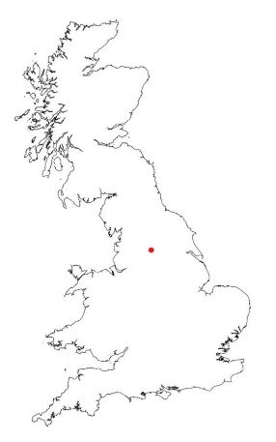
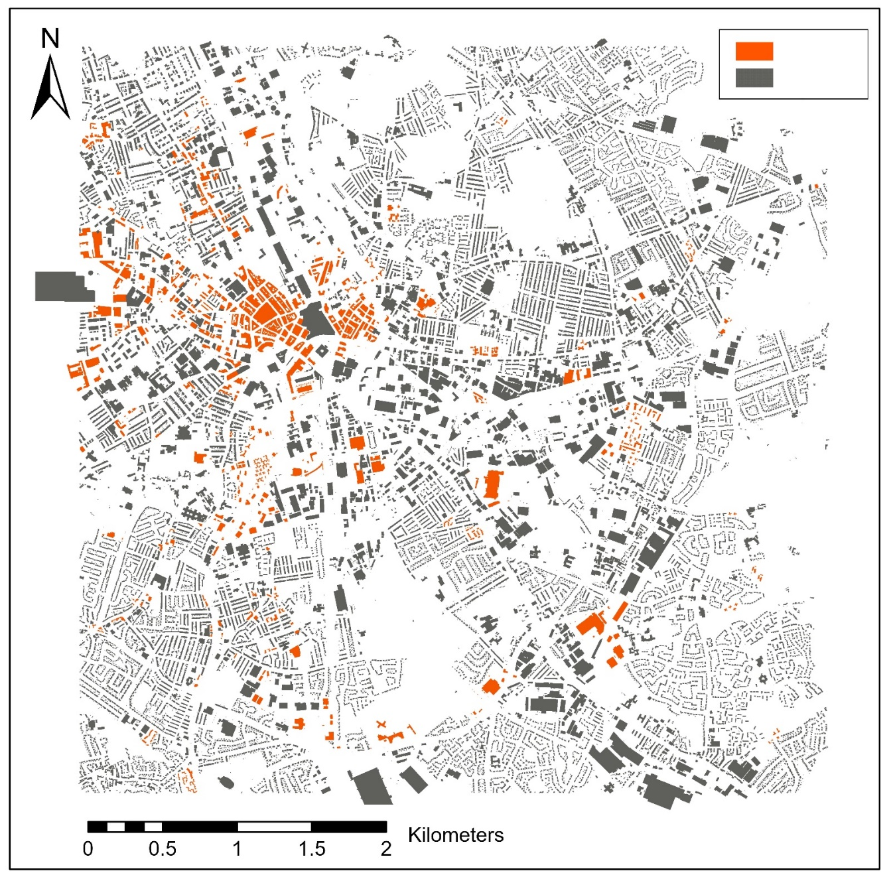
Selected Buildings
All Buildings
  - Figure 3: The geographical scope of the study within the UK (above) and the modelled buildings (orange) compared to the footprints of all constructions in the case study area.
3.7 Mapping embodied carbon
As this study views materials as repositories for potential re-use, accounting for the embodied carbon can help understand the impact of different EOSL activities (including reclaiming and reusing) on the overall GHG emissions of constructions in order to meet carbon reduction goals. Due to the reuse-oriented perspective of this study, the production stage of the components that includes extraction of raw materials, manufacturing of products, and transportation are determining the embodied carbon of this study (BS, 2011). Operational GHG emissions (e.g. associated with heating spaces) are excluded. For this purpose, an LCA is performed with a focus of analysing the four ‘components’ of steel and concrete that are specified in method 2. It should be noted that this LCA calculates the embodied carbon of similar new products that are available on the market, instead of the actually released emissions of the in-use buildings at the time of production/ construction. The LCA is performed by using the SimaPro tool (v8.5.2). The sources of life cycle inventory analysis data are specified in the table S2 and the impact assessment of IPCC GWP 100a is applied. The methodology of calculating the embodied carbon of each of the four products is described in the Supplementary Material S6.
3.8. Validation of material intensities
In this section we compare the calculated MI of this study to a normalised review of previous studies in order to validate the calculated MI. Previous studies (see Table 6 below) have estimated aggregated quantities of steel and concrete derived from the of Material Intensity (MI) coefficient of buildings derived in two different ways, which vary depending on the aims and scope of the study. The first approach applied MI that was obtained and imported from developed models, studies, reports and look-up tables (e.g. Heeren and Fishman (2019); Tanikawa and Hashimoto (2009)). The second approach is to directly calculate the MI based on the bills of materials of certain modelled exemplar buildings (Gontia et al., (2018); Ortlepp et al., (2018). These can be in a form of real or modelled building ‘archetypes’ that are considered to be representative of a certain similar group of buildings (e.g. Nemry et al., 2018, ibid). In another study, (Schebek et al., 2017) considered 19 individual buildings as archetypes that their MI could represent groups of buildings based on their construction decade or building type. As stated above, the type of frame can make a significant difference to the estimation of overall MI. Hence this study presents a new approach to MI calculation-based frame archetypes that allows calculating disaggregated MI.
Table 6 summarises and highlights previous bottom-up approaches to estimating MI of steel and concrete buildings. As it can be seen, there is a substantial variation in MI range which supports a review by (Gontia et al., 2018) into the impact of MI on the quantitative results of material stock assessment studies. This study demonstrated that the MI of similar case studies and materials can vary up to hundred-fold. It also demonstrated that the number of floors and the footprint size of a building have a considerable impact on the MI of materials. As stated above, this variation can be due to the wide variety of dimensions and types of the load-bearing components especially of steel and concrete framed multi-storey buildings. As a result, the architecture, footprint, and the numbers of floors are impacting the material quantities as various steel and concrete products are used. Such variations are often neglected in the bottom-up assessments due to lack of data and therefore MI in the stock-flow literature are highly context-specific and help explain the large variation between different studies.
Representativeness of the MI for the buildings of the case study area were also validated by applying the MI to a few exemplar sample buildings of the case study area and then studying their structure individually. Details of this validation are provided in supplementary material S8.
  - Table 6: A comparison of steel and concrete MI of multi-storey buildings of method1 of this study and previous studies of material stocks
Study | Building Type | MI and units |  | Case study | MI Source | MI type
 |  | Concrete | Steel
(Wang et al., 2015) | Concrete-framed | - | 43-65 kg/m² | China | Calculated | 2D GFA
 | Steel-framed | - | 55-100 kg/m²
(Xing et al., 2008) | Concrete-framed | 0.79 m³/m² | 11.55 kg/m² | Shanghai, China | Calculated | 2D GFA
 | Steel-framed | 0.40 m³/m² | 61.51 kg/m²
(Dimoudi and Tompa, 2008) | Office-Concrete-framed-1 | 0.49 m³/m² | 47.33 kg/m² | Athens, Greece | Calculated | 2D GFA
 | Office-Concrete-framed-2 | 0.71 m³/m² | 78.50 kg/m²
(Tanikawa and Hashimoto, 2009) | Brick base flat | 146 kg/m² | 2 kg/m² | Manchester, UK | Imported | 2D Footprint
 | Concrete block flat | 524 kg/m² | 2 kg/m²
 | Reinforced concrete | 397 kg/m² | 22 kg/m²
(Han and Xiang, 2013) | Residential urban | - | 23-40 kg/m² | China | Calculated | 2D GFA
 | Residential rural | - | 4-6 kg/m²
(Gontia et al., 2018) | Multi-family 80s | - | 190 kg/m² | Sweden | Calculated | 2D GFA
 | Multi-family 2000s | - | 312 kg/m²
(Schebek et al., 2017) | Non-residential | 50-840 kg/m³ | 2-191 kg/m³ | Frankfurt, Germany | Calculated/ Imported | Volumetric
(Heeren and Fishman, 2019) | Residential | 563.71 kg/m² | 48.42 kg/m² | Multiple | Imported | 2D GFA
 | Non-residential | 697.92 kg/m² | 27.42 kg/m²
(Ortlepp et al., 2018) | Commercial | 75 kg/m³ | 37 kg/m³ | Germany | Calculated | Volumetric
 | Office | 226 kg/m³ | 23 kg/m³
(Ortlepp et al., 2016) | Office | 1.3 t/m² | 0.12 t/m² | Germany | Calculated | 2D GFA
 | Institutional | 1.1 t/m² | 0.09 t/m²
This study | Concrete-framed | 0.44 m³/m² | 40.07 kg/m² | Bradford  UK | Calculated | 2D GFA
 | Steel-framed | 0.24m³/m² | 60.86 kg/m²
 | Concrete-framed | 0.14 m³/m³ | 13.06 kg/m³ |  |  | Volumetric
 | Steel-framed | 0.08 m³/m³ | 20.28 kg/m³

4. Results and discussion:
The results of method 1 are demonstrated as stacked volumes of steel and concrete (Figure 4). For better observation, the results are rasterised into 200*200 m² cells where all quantities of materials are aggregated into a single value for each cell. The visualisation shows that there are large concentrations of both steel and concrete within the Northwest of the city, while there are little steel and concrete on the East. It must be noted that while only the quantities of steel and concrete of the selected buildings are visualised in the maps, the footprints of all buildings are included as a reference for the built-up areas.

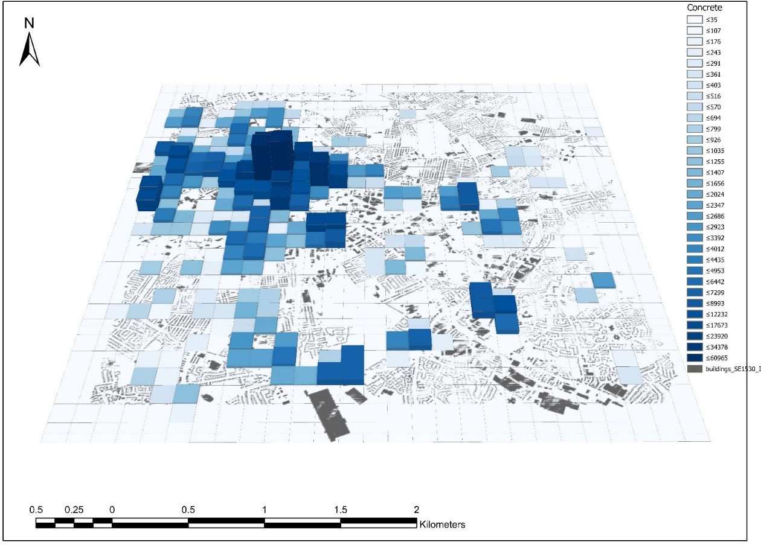
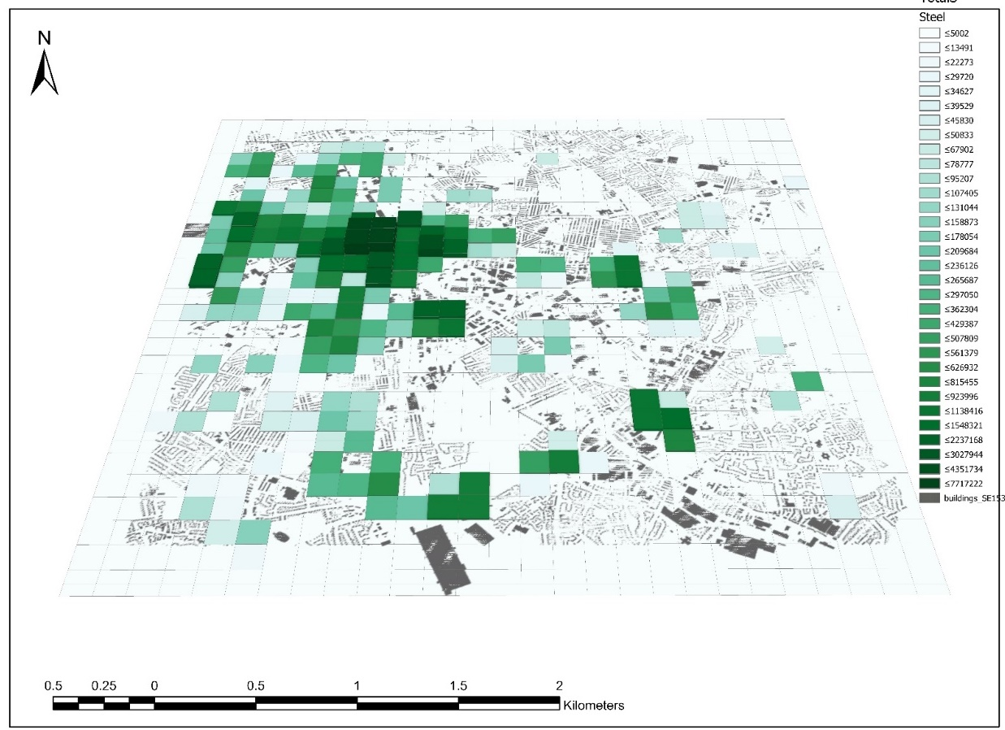
  - Figure 4: Visualisation of rasterised urban stocks of concrete (above) and steel (below). The volumes are exaggerated two thousand-fold or better visualisation.
Method 2 is applied by incorporating the temporal variations in the shares of steel-frame and concrete-frame multi-storey buildings. This would result in specifying steel and concrete into four different components. For the case study area, the total quantities of materials along with the GWPs that are calculated via method 2 are presented in Table 5.
  - Table 7: Quantities of in-use construction products and their associated GWPs calculated according to method 2.
Quantities (m³ for concrete, tonnes for steel)
Building classes | Substructure Concrete |  | Superstructure Concrete |  | Non-structural Steel |  | Structural  Steel
Office | 32,887 |  | 148,877 |  | 14,983 |  | 5,144
Commercial Core | 74,693 |  | 338,093 |  | 34,015 |  | 11,728
High Rise | 5,778 |  | 25,971 |  | 2,547 |  | 1,163
Low Rise | 5,263 |  | 23,771 |  | 2,3736 |  | 896
GWP (kt CO₂eq)
Building classes | Substructure Concrete | Superstructure Concrete |  | Non-structural Steel |  | Structural  Steel
Office | 10.92 | 36.87 |  | 28.87 |  | 11.46
Commercial Core | 24.79 | 83.74 |  | 65.55 |  | 26.13
High Rise | 1.92 | 6.43 |  | 4.91 |  | 2.59
Low Rise | 1.75 | 5.89 |  | 4.57 |  | 2.00

For visualisation, the results are initially granular as the MI of each year is applied to the relevant buildings on the map. However, it should be noted that method 2 provides a representative MI for each year by considering the ‘probabilities’ of any individual building to belong to one frame type. So, the MI is constructed as a combination of the two frame types based on this probability. Thus, considering that in reality, a single building belongs to one of the frame types, method 3 cannot be reliable at the resolution of individual buildings. To overcome this limitation, the results are rasterised to avoid misrepresentation. The results are mapped volumetrically in 200*200m cells to show the areas where there is a concentration of each product (Figure 5).

Concrete - Substructure | Concrete - Superstructure
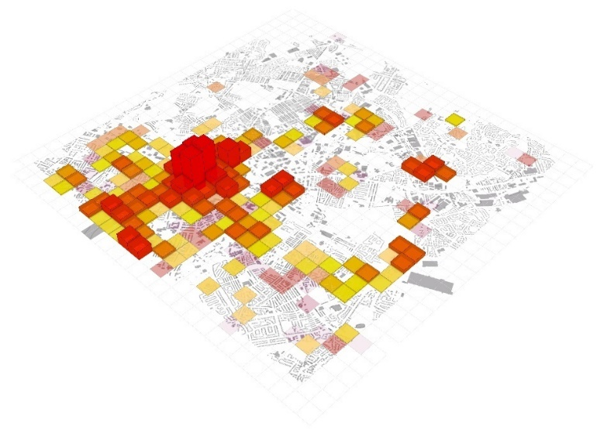 | 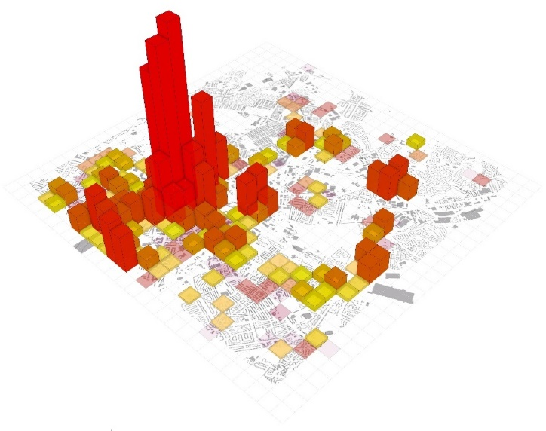
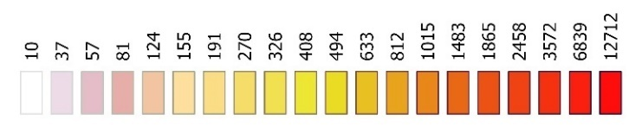
Structural Steel | Non-structural Steel
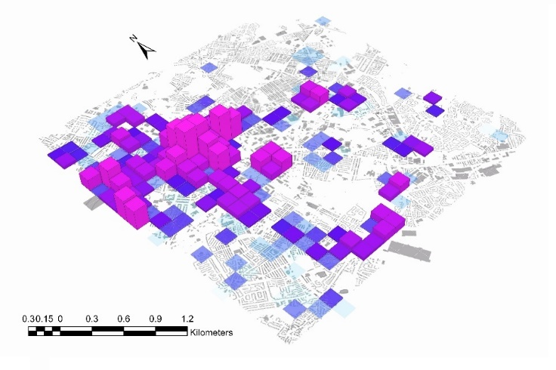 | 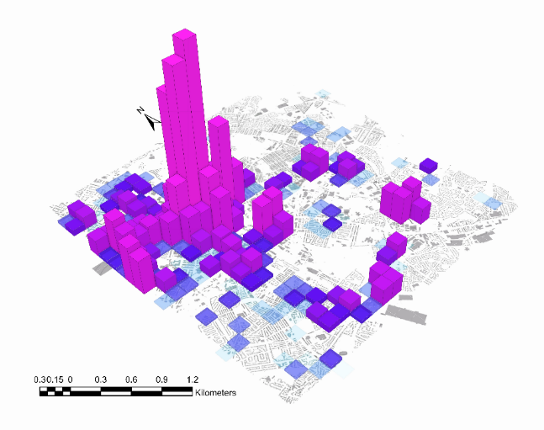
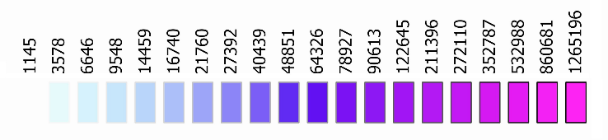
  - Figure 5: Quantities of steel and concrete estimated via method 2 characterised by type of products. The numbers are in m3 and kg respectively. The concrete volumes are exaggerated 2000 times for better visibility. For steel, each m³ of the prism bars represents 2 tonnes of steel.
Similarly, the GWP is calculated for the modelled construction products as it was described in the methodology section. The results assign an embodied carbon to the four specified products of each building. This signifies that if the in-use stock is to be replaced with new similar products today, an equal amount of GHG emission will be released. The total embodied GWP of the case study is presented in Table 4. For better visualisation, the GWP results are rasterised in 200m*200m cells. For each cell, the total amount of GWP of the construction for each product is specified and demonstrated with colour codes in Figure 6.
GWP
Concrete - Substructure | Concrete - Superstructure
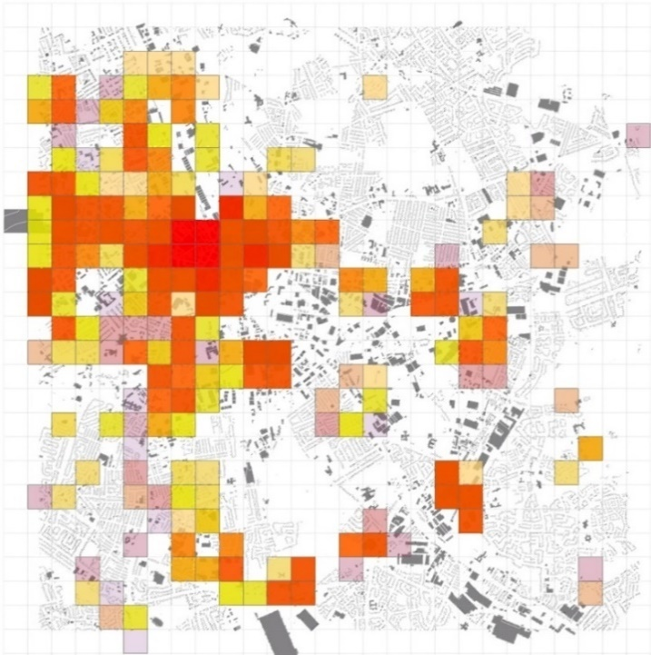 | 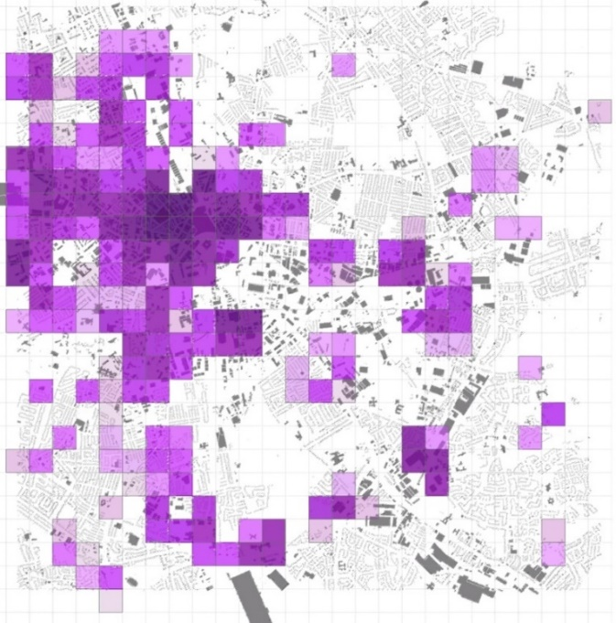
Non-structural Steel | Structural Steel
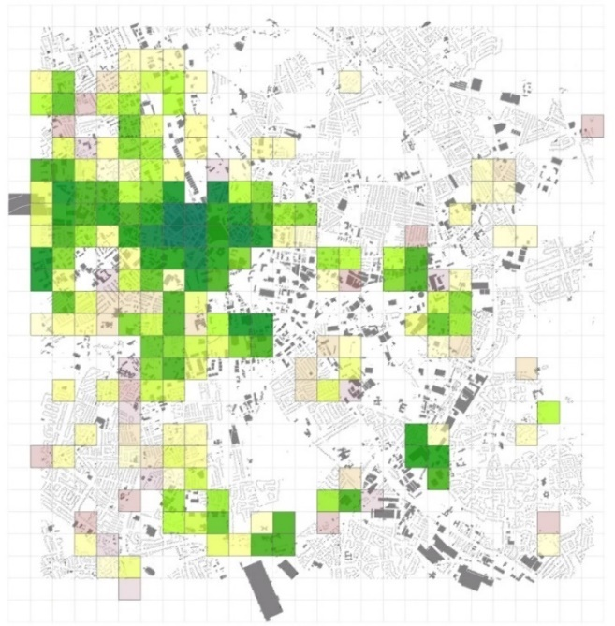 | 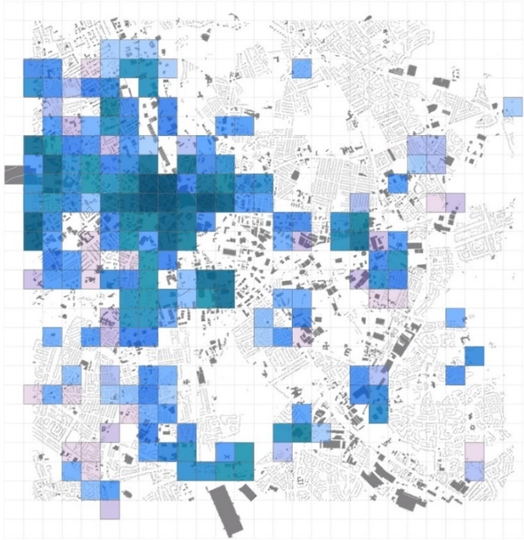

  - Figure 6: summary of results of analysing the case study spatial model with method 1. The values are in kg CO₂ eq.

The aggregated results of the methods for the case study area are presented in Table 8.
  - Table 8: Comparison between the results of the two methods:
 | Steel (tonnes) |  | Concrete (m³) |  | GWP Steel  (tCO₂ eq) | GWP concrete (tCO₂ eq)
Method 1 | 120,200 |  | 949,571 |  | - | -
Method 2 | Structural | Non-structural | Superstructure | Substructure | 231,538 | 275,342
 | 29,141 | 86,463 | 857,853 | 189,425
 | 115,604 |  | 1,047,278

The results of method 2 are visualised as bar chart from 1920 to 2018 (Figure 7). The figure shows there has been a spike in addition of steel and concrete to the urban in-use stock from 1960 to 1990 possibly due to a period of increased construction of multi-storey buildings. There is a noticeable peak at 1980 after which the annual rate of added materials has been declining almost constantly.
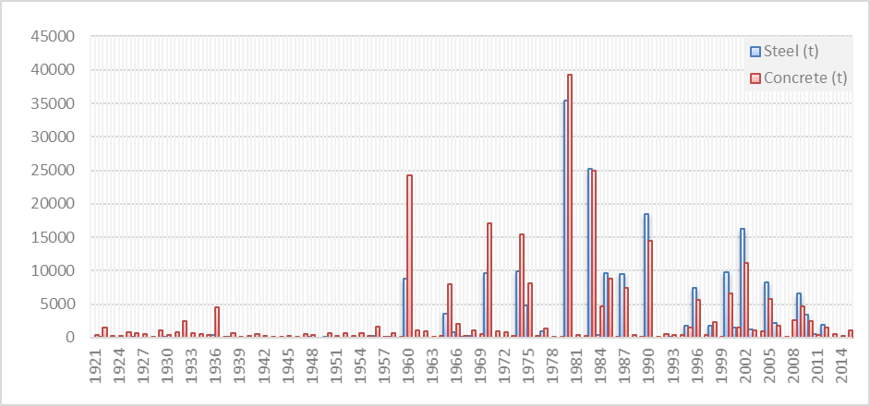
  - 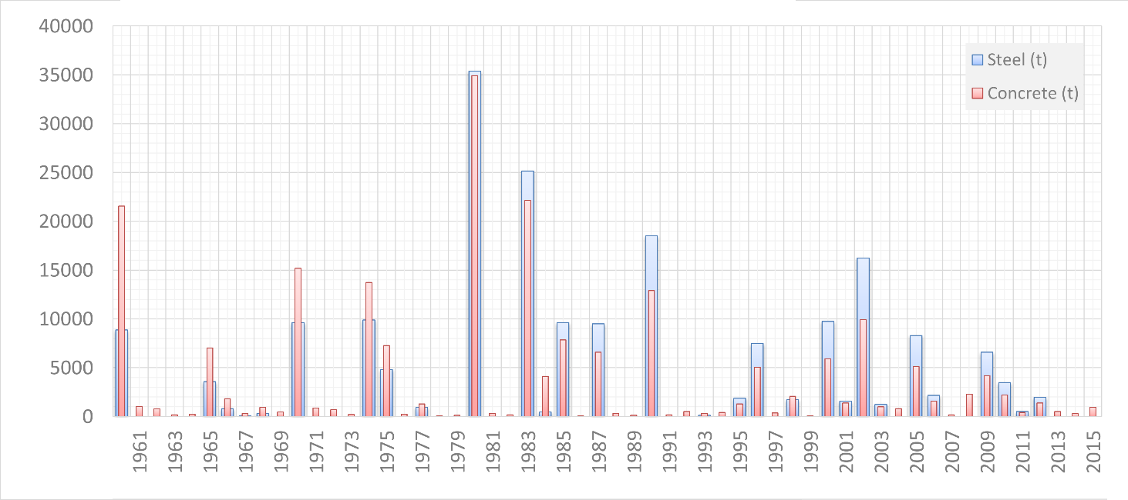Figure 7: Historical addition of steel and concrete (both in tonnes) to the in- use stock
5. Discussion
This study is the first attempt to model in-use structural steel and concrete at urban level by distinguishing between construction frame types. Technical feasibility and practical modelling efforts can be applied and specified to a variety of regions. Results are presented at high resolution which enables estimating quantities of steel and concrete as well as some key qualitative aspects such as approximate location, age, type of product, function of building, structure dimensions, and GWP.
The stock-flow model described estimates the spatial and temporal distribution of in-situ stocks of concrete and steel from 1945-present for over 2200 individual multi-story buildings in a 5km-by-5km area of one UK city. These buildings range in height from 6.1m to 23.5m with a total GFA of nearly 2 million m² and a total volume of 5 million m³. As such it is the largest survey of building steel and concrete MI in the world. The total embodied carbon associated with concrete is 172.3 kt CO₂eq with steel is 165.8 kt CO₂eq.
Method 2 provides an overall assessment of in-situ structural frame steel versus rebar steel and differentiates superstructure (frame, walls, and flooring) and substructure (foundation and ramp) concrete. Superstructure concrete which contains the major opportunity for product and material reclaim constitutes nearly%82 of the total quantity relative to the substructure across the four building types. Superstructure concrete accounts for nearly %77 of the embodied carbon across the four classes of building. Structural steel – primarily the frame, comprises around %26 of the total steel relative to the four building types. Superstructure steel accounts for nearly %29 of the embodied carbon within the total embodied carbon across the four classes of building. In total in-situ concrete and steel constitute around 82,000 tonnes of steel, 655 thousand m³ of concrete (approx. 2Mt) and an embodied GWP of 320 kt CO₂eq. As a comparison total UK steel production in 2018 was 7 million tons and concrete building products were 60 million tonnes (National Statisitcs, 2019).
The wide variation in MI found in previous studies highlights the need to develop spatially explicit MI on case-by-case basis. As data on structural frames of buildings is not commonly available, the multi scenario spatiotemporal analysis of different building frame types provide an opportunity to envisage georeferenced quantities of material stocks when assuming different scenarios. The systematic model developed in this study can be applied to thousands of buildings making large scale assessment possible. The two methods calculated steel and concrete MI in two different ways but as can be seen in Table 5 produce results within 5% variation. Method 2 however provides a basis for calculating primary MI of separate superstructure and substructure materials. The aggregated results of method 2 are expected to be more precise compared to method 1 as the impact of temporal trends in construction practices are implemented in the method. In the absence of building plans or other data on construction details Method 2 provides a step forward in urban-scale assessment of qualities, quantities, and locations of building structural products.
The current study assumes that the relationship between volumes and quantities of structural products is linear. In reality however, the choice of construction products depends on many factors including architecture, loads, geographical environment, or even market conditions at the time of construction. As this study used two archetypes, increasing the numbers of archetypes can improve the quality of results. As modelling archetypes is time consuming, there should be a focus on optimising the archetype making efforts to be most representative of building types and dimensions. For instance, spatial statistical analysis may provide information on the dimensions that would be most representative of the studied constructions of the case study region. The ‘Jenks natural breaks optimisation’ analysis is a type of spatial statistical study of objects that is capable of identifying most representative classification breaks as it seeks to minimise each class's average deviation from the class mean, while maximising each class's deviation from the means of the other groups.
Integration of BIM approaches can also support and enhance creation of the MI datasets and provides an opportunity to generate component and product specific MI. While providing an opportunity, BIM approaches are eighter focusing on prospective buildings, or require significant data collection for individual buildings, thus their availability is very limited.
6. Conclusions
There is a growing need to have spatially explicit characterisation of the in-use stocks of material and products in order to analyse prospective dynamics of stocks and flows and to implement a circular economy. Moreover, strategic urban planning and managing impacts of waste generation and climate change would benefit from such model. Whilst the lack of building plans limits the ability to estimate precise dimensions of structural steel or concrete products, the proposed method using archetypes provides a means to differentiate between structural and non-structural components and focus attention on the significant volume and number of in-situ structural components within urban areas available for future urban mining.
The urban-scale embodied carbon of the in-use built environment has rarely been studied at spatial high resolution and product specification. while there is a growing need to account for and spatialise it considering the growing concerns about climate change and strategies aiming for reducing future carbon emissions. This study improved the assessment of the embodied carbon of the built environment by implementing the temporal pattern of construction types into the analysis. Distinguishing between steel and concrete products that have different functions allowed a more precise assessment of the embodied carbon.

References:
Ajayebi, A., Hopkinson, P., Zhou, K., Lam, D., Chen, H.-M., Wang, Y., 2020. Spatiotemporal model to quantify stocks of building structural products for a prospective circular economy. Resour. Conserv. Recycl. 162, 105026. https://doi.org/10.1016/J.RESCONREC.2020.105026
Augiseau, V., Barles, S., 2017. Studying construction materials flows and stock: A review. Resour. Conserv. Recycl. 123, 153–164. https://doi.org/10.1016/J.RESCONREC.2016.09.002
BCSA, 2019. BCSA Annual Review.
BS, 2011. British Standard EN 15978:2011: Sustainability of construction works. Assessment of environmental performance of buildings. Calculation method.
Dimoudi, A., Tompa, C., 2008. Energy and environmental indicators related to construction of office buildings. Resour. Conserv. Recycl. 53, 86–95. https://doi.org/10.1016/J.RESCONREC.2008.09.008
English Housing Survey, 2018. English Housing Survey, National Statistics.
Gallego-Schmid, A., Chen, H.-M., Sharmina, M., Mendoza, J.M.F., 2020. Links between circular economy and climate change mitigation in the built environment. J. Clean. Prod. 260, 121115. https://doi.org/10.1016/J.JCLEPRO.2020.121115
Gontia, P., Nägeli, C., Rosado, L., Kalmykova, Y., Österbring, M., 2018. Material-intensity database of residential buildings: A case-study of Sweden in the international context. Resour. Conserv. Recycl. 130, 228–239. https://doi.org/10.1016/J.RESCONREC.2017.11.022
Graedel, T.E., Allwood, J., Birat, J.-P., Buchert, M., Hagelüken, C., Reck, B.K., Sibley, S.F., Sonnemann, G., 2011. What Do We Know About Metal Recycling Rates? J. Ind. Ecol. 15, 355–366. https://doi.org/10.1111/j.1530-9290.2011.00342.x
Haas, W., Krausmann, F., Wiedenhofer, D., Lauk, C., Mayer, A., 2020. Spaceship earth’s odyssey to a circular economy - a century long perspective. Resour. Conserv. Recycl. 163, 105076. https://doi.org/10.1016/J.RESCONREC.2020.105076
Han, J., Xiang, W.-N., 2013. Analysis of material stock accumulation in China’s infrastructure and its regional disparity. Sustain. Sci. 8, 553–564. https://doi.org/10.1007/s11625-012-0196-y
Heeren, N., Fishman, T., 2019. A database seed for a community-driven material intensity research platform. Sci. Data 6, 23. https://doi.org/10.1038/s41597-019-0021-x
Krausmann, F., Wiedenhofer, D., Lauk, C., Haas, W., Tanikawa, H., Fishman, T., Miatto, A., Schandl, H., Haberl, H., 2017. Global socioeconomic material stocks rise 23-fold over the 20th century and require half of annual resource use. Proc. Natl. Acad. Sci. 114, 1880–1885. https://doi.org/10.1073/PNAS.1613773114
Lanau, M., Liu, G., Kral, U., Wiedenhofer, D., Keijzer, E., Yu, C., Ehlert, C., 2019. Taking Stock of Built Environment Stock Studies: Progress and Prospects. Environ. Sci. Technol. 53, 8499–8515. https://doi.org/10.1021/acs.est.8b06652
Mastrucci, A., Marvuglia, A., Popovici, E., Leopold, U., Benetto, E., 2017. Geospatial characterization of building material stocks for the life cycle assessment of end-of-life scenarios at the urban scale. Resour. Conserv. Recycl. 123, 54–66. https://doi.org/10.1016/J.RESCONREC.2016.07.003
Miatto, A., Schandl, H., Forlin, L., Ronzani, F., Borin, P., Giordano, A., Tanikawa, H., 2019. A spatial analysis of material stock accumulation and demolition waste potential of buildings: A case study of Padua. Resour. Conserv. Recycl. 142, 245–256. https://doi.org/10.1016/J.RESCONREC.2018.12.011
Moynihan, M.C., Allwood, J.M., 2014. Utilization of structural steel in buildings. Proc. R. Soc. A Math. Phys. Eng. Sci. 470, 20140170. https://doi.org/10.1098/rspa.2014.0170
National Statisitcs, 2019. Monthly Statistics of Building Materials & Components- April 2019.
Nemry, F., Uihlein, A., Jrc, I., Colodel, C.M., Wittstock, B., Braune, A., Lbp, B., Stuttgart, U., Wetzel, C., Hasan, I., Niemeier, S., Frech, Y., Gmbh, C.H., 2008. Environmental Improvement Potential of Residential Buildings. Joint Research Center. https://doi.org/10.2791/38942
Ortlepp, R., Gruhler, K., Schiller, G., 2018. Materials in Germany’s domestic building stock: calculation model and uncertainties. Build. Res. Inf. 46, 164–178. https://doi.org/10.1080/09613218.2016.1264121
Ortlepp, R., Gruhler, K., Schiller, G., 2016. Material stocks in Germany’s non-domestic buildings: a new quantification method. Build. Res. Inf. 44, 840–862. https://doi.org/10.1080/09613218.2016.1112096
Pomponi, F., Moncaster, A., 2017. Circular economy for the built environment: A research framework. J. Clean. Prod. 143, 710–718. https://doi.org/10.1016/J.JCLEPRO.2016.12.055
Romero Perez de Tudela, A., Rose, C.M., Stegemann, J.A., 2020. Quantification of material stocks in existing buildings using secondary data—A case study for timber in a London Borough. Resour. Conserv. Recycl. X 5, 100027. https://doi.org/10.1016/J.RCRX.2019.100027
Sansom, M., Avery, N., 2014. Briefing: Reuse and recycling rates of UK steel demolition arisings. Proc. Inst. Civ. Eng. - Eng. Sustain. 167, 89–94. https://doi.org/10.1680/ensu.13.00026
Schebek, L., Schnitzer, B., Blesinger, D., Köhn, A., Miekley, B., Linke, H.J., Lohmann, A., Motzko, C., Seemann, A., 2017. Material stocks of the non-residential building sector: the case of the Rhine-Main area. Resour. Conserv. Recycl. 123, 24–36. https://doi.org/10.1016/J.RESCONREC.2016.06.001
Stephan, A., Athanassiadis, A., 2017a. Towards a more circular construction sector: Estimating and spatialising current and future non-structural material replacement flows to maintain urban building stocks. https://doi.org/10.1016/j.resconrec.2017.09.022
Stephan, A., Athanassiadis, A., 2017b. Quantifying and mapping embodied environmental requirements of urban building stocks. Build. Environ. 114, 187–202. https://doi.org/10.1016/J.BUILDENV.2016.11.043
Streeck, J., Wiedenhofer, D., Krausmann, F., Haberl, H., 2020. Stock-flow relations in the socio-economic metabolism of the United Kingdom 1800–2017. Resour. Conserv. Recycl. 161, 104960. https://doi.org/10.1016/J.RESCONREC.2020.104960
Tanikawa, H., Hashimoto, S., 2009. Urban stock over time: spatial material stock analysis using 4d-GIS. Build. Res. Inf. 37, 483–502. https://doi.org/10.1080/09613210903169394
Wang, T., Müller, D.B., Hashimoto, S., 2015. The Ferrous Find: Counting Iron and Steel Stocks in China’s Economy. J. Ind. Ecol. 19, 877–889. https://doi.org/10.1111/jiec.12319
Wiedenhofer, D., Fishman, T., Lauk, C., Haas, W., Krausmann, F., 2019. Integrating Material Stock Dynamics Into Economy-Wide Material Flow Accounting: Concepts, Modelling, and Global Application for 1900–2050. Ecol. Econ. 156, 121–133. https://doi.org/10.1016/J.ECOLECON.2018.09.010
Wiedenhofer, D., Steinberger, J.K., Eisenmenger, N., Haas, W., 2015. Maintenance and Expansion: Modeling Material Stocks and Flows for Residential Buildings and Transportation Networks in the EU25. J. Ind. Ecol. 19, 538–551. https://doi.org/10.1111/jiec.12216
Xing, S., Xu, Z., Jun, G., 2008. Inventory analysis of LCA on steel- and concrete-construction office buildings. Energy Build. 40, 1188–1193. https://doi.org/10.1016/j.enbuild.2007.10.016

