Quick Guide: Masting
Andrew Hacket-Pain
Department of Geography and Planning, School of Environmental Sciences, University of Liverpool, UK

What is masting?
Many perennial plants show extraordinary variation in annual reproductive effort, ranging from years with bumper seed crops (informally known as “mast years”) to years with little or no investment in reproduction (Figure 1). Variation is synchronised among individuals and populations, and in exceptional cases spatial synchrony can extend to continental scales. This phenomenon of highly variable and synchronised plant reproduction is known as masting and is found across the plant tree of life.

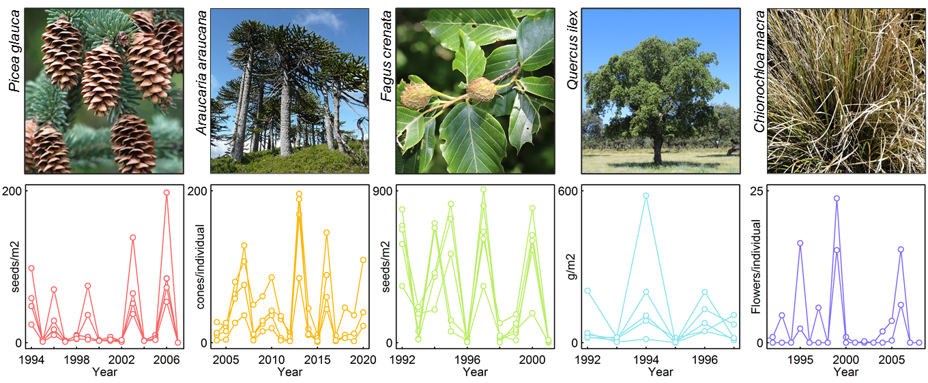
Figure 1. Population-level time-series of reproductive effort in five masting plant species. For each species, data from several local populations are plotted, illustrating the interannual variability and spatial synchrony that characterise masting. In exceptional cases, spatial synchrony of masting can extend to continental scales.

Why do plants do it?
Why would plants forego the opportunity to reproduce every year, and instead produce occasional bumper crops? The two most widely supported explanations are based on economies of scale that emerge when plants concentrate reproductive effort into occasional, synchronised reproductive events. The first explanation is the pollination efficiency hypothesis. Most plants are self-incompatible and concentrating flowering into occasional mast years increases the efficiency of pollen transfer between individuals. The second explanation is based on the observation that years of low seed production starve seed consumers, whose reduced populations are overwhelmed by subsequent large seed crops. This strategy reduces the overall proportion of seeds lost and is known as the predator satiation hypothesis. Crucially, these economies of scale require plants to vary their reproductive output in synchrony with other individuals.

Recent work has refocused on a third theory, the so-called environmental prediction hypothesis, which proposes that plants benefit if they time their large seed crops to take advantage of favourable conditions for germination and establishment. Forecasting the future is hard for plants, but in several geographical regions plants appear to track oscillating modes of climate variability. For example, in tropical southeast Asia, plants can take advantage of the oscillating nature of ENSO to anticipate the arrival of favourable conditions. Using the drought conditions associated with El Niño to trigger mass flowering efforts, plants can ensure that by the time the fruits have ripened, dry conditions have (usually) given over to La Niña-induced rains, which favour germination and seedling establishment.
How do plants do it?
A plant will naturally vary its reproductive output in response to variation in resource availability – a null expectation known as resource matching. However, masting goes beyond this and represents a strategy where synchronised dynamic allocation of resources to reproduction is associated with increased fitness. Plants do not appear to be able communicate with each other to coordinate their reproductive efforts, and masting does not appear to be strictly periodic, so how do individuals within a population achieve synchronised variability in reproduction?

While the patterns of masting might look quite similar in different species (Figure 1), they can deploy quite different mechanisms to achieve synchronised variation in reproduction. For example, oaks (Quercus) typically produce a similar number of flowers each year, but the eventual acorn crop is controlled by the proportion of flowers that are pollinated, fertilised and subsequently mature into acorns. Consequently, large acorn crops tend to follow warm and dry spring seasons, which increase the efficiency of pollen transfer between individuals, and after summer conditions that favour high rates of successful acorn maturation. Other species use different approaches, creating variation in seed crops by strongly varying the number of flowers produced each year. In such species, flowering effort is regulated by hypersensitivity to an external environmental cue such as summer temperature. A still poorly understood mechanism regulates the subsequent flowering effort, probably via an epigenetic control of floral induction. Crucially, shared sensitivity to this external cue generates interannual variability and synchrony of reproductive effort among individuals – the defining features of masting. Where the external environmental cue shows spatial autocorrelation, spatial synchrony of masting emerges via the Moran effect.

Why is masting important?
Humans have utilised the fruits and seeds from masting species for millennia, including commercial and subsistence harvests from pistachio, chestnut, pehuén, citrus and baobab trees, among many other examples. As masting underpins the reproductive success of masting plants, it has long been of interest to land and wildlife managers. For example, some of the earliest masting datasets were collected in the 17th century to inform Central European forest management. While seedling establishment might typically be assumed to occur in pulses only after mast years, we now know that it is more complicated; for example, in closed canopy forests, seedling establishment depends on interactions between masting and natural disturbance. These interactions also mean that the timing and frequency of mast years shapes recovery after wildfire, windstorms and other disturbances, such that masting will play a crucial role in determining the responses of plants to environmental change.

Masting also has wider effects on ecosystems. Mast years represent major shifts in resource allocation, altering carbon and nutrient cycling, and can be associated with strong reductions in plant growth. Mast years are also a classic example of resource pulsing within food webs, driving the population dynamics of seed consumers with cascading effects through the rest of the food web. For example, the abundance of ticks fluctuates in response to the dynamics of their various vertebrate hosts, and peaks in cases of tick-borne human diseases including Lyme and tick-borne encephalitis can follow large regional masting events. Meanwhile in New Zealand, mast years in native forests result in population explosions of non-native rodents and the mustelids that prey on them. When the supply of seeds runs out, the large populations of mice, rats and stoats turn to other food sources, including the eggs of native birds, further increasing the pressure on often already-threatened native species.

How do I find out more?

Kelly, D., and Sork, V. L. (2002). Mast seeding in perennial plants: Why, how, where? Annual Review of Ecology and Systematics 33, 427-447.

Koenig, W. D., and Knops, J. M. H. (2005). The mystery of masting in trees. American Scientist 93, 340-347.

Ascoli, D., Hacket-Pain, A., LaMontagne, J. M., Cardil, A., Conedera, M., Maringer, J., Motta, R., Pearse, I.S., Vacchiano, G. (2020). Climate teleconnections synchronize Picea glauca masting and fire disturbance: Evidence for a fire-related form of environmental prediction. Journal of Ecology 108 1186-1198

Satake, A., Leong Yao, T., Kosugi, Y., Chen, Y‐Y. (2021). Testing the environmental prediction hypothesis for community‐wide mass flowering in South‐East Asia. Biotropica 53 608– 618

Ostfeld R.S., Canham C.D., Oggenfuss K., Winchcombe R.J., Keesing F. (2006). Climate, deer, rodents, and acorns as determinants of variation in Lyme-disease risk. PLoS Biology 4, e145

Bogdziewicz M., Szymkowiak, J., Tanentzap, A.J., Calama. R., Marino, S., Steele, M.A., Seget, B., Piechnik, Ł., Żywiec. (2021). Seed predation selects for reproductive variability and synchrony in perennial plants. New Phytologist 229 2357-2364

