*Vegetation dynamics and Fire History in Färnebofjärden National Park, Central Sweden*

Gina E. Hannon1, Karen Halsall1, Chiara Molinari3, Erin Stoll2,Diana Lilley1, Richard H.W. Bradshaw1.

1Department of Geography and Planning, School of Environmental Sciences, University of Liverpool, UK ([gina.hannon@liv.ac.uk)](mailto:gina.hannon@liv.ac.uk)).

2Biological and Environmental Sciences, Faculty of Natural Sciences, University of Stirling, Scotland.

3Department of Physical Geography and Ecosystem Science, Lund University, Lund,

Sweden

**Abstract**

Palaeoecological studies can identify past trends in vegetation communities and processes over long time scales. Pollen, plant macrofossils and charcoal analyses are used to reconstruct vegetation over the last 6400 years and provide information about former human impact and disturbance regimes in Färnebofjärden National Park, Central Sweden. Three specific conservation planning topics were addressed: 1) the changing ratio of conifers to broadleaved trees; 2) the origin and history of the river meadows and the biodiverse *Populus tremula* meadows; 3) the role of fire in the maintenance of biological values. Early diverse mixed broadleaved forest assemblages with pine were followed by significant declines of the more thermophilic forest elements prior to the expansion of spruce in the Iron Age. The rise to dominance of spruce was a ’natural’ process that has been exaggerated by anthropogenic disturbance to artificially high levels today. The initial river meadow communities were facilitated by fire and frequent flooding events, but subsequent dynamics have more definitely been supported by human activities. Rural abandonment during the last 100 years has led to woody successions. Fire has been a continual disturbance factor with an influence on conservation issues such as *Picea abies* dominance and the maintenance of diverse, non-forest communities. Present occurrence of fire is unusually low, but natural fire frequencies are increasing in the region.

Keywords: Forest Diversity, Conservation, Management, Fire, Charcoal, River Meadows, Pollen, Plant Macrofossils, Ecosystems.

**Introduction**

Preserving large connected areas of valuable vegetation types in their natural or essentially unmodified state is a complex challenge at a time of changing climate. The ‘natural’ state of northwest European forests is difficult to define and maintain in areas with long histories of cultural impact on vegetation (Bradshaw et al., 2015), yet Swedish National Parks are legally required to protect examples of the natural vegetation (SFS, 1982). These National Parks are selected to offer a range of substrates of varied age and conditions, and are often rich in red-listed species of insects, bryophytes, lichens and fungi that are used as indicators of habitat worthy of protection (Gustafsson et al., 1999). Combining the protection of ‘natural’ biodiversity with due regard for the ecosystem services provided by National Parks poses management and planning issues that benefit from a long-term perspective (Willis and Bhagwat, 2010; Jeffers et al., 2015).

Palaeoecological studies are relevant for conservation planning, as they can identify past trends in vegetation communities and processes over long time scales (Willis and Birks, 2006). Such analyses typically use pollen, plant macrofossils and charcoal to reconstruct vegetation and provide evidence about former human impact and disturbance regimes (Hannon et al., 2018). This information can be compared with the modern communities and incorporated into management strategies for promoting favourable conditions and maintaining resilience during a time of rapid climate change (Jackson and Hobbs, 2009; Grace et al., 2019). Fire plays a fundamental but sometimes poorly understood role in ecosystem history (Galanter et al., 2000; Bowman et al., 2009; Molinari et al., 2013). Fire regimes are influenced by a combination of climate, fuel load (in terms of vegetation cover and composition), and crucially by human actions. People have been shaping fire regimes for at least the last 2000-4000 years in eastern Scandinavia, resulting in a dynamic fire regime, driven by both anthropogenic and climatic influences, with many historical periods featuring a more intense fire regime than today (Niklasson and Granström, 2000; Bradshaw et al., 2010; Clear et al., 2014). The early Holocene was characterised by a fire pattern controlled by biomass availability, climate, and other natural drivers, with minimal human influence (Molinari et al., 2018; Molinari et al., 2020). Charcoal records in Scandinavia indicate an increase in fire severity and frequency during the warm, dry climate of the Mid Holocene Thermal Maximum, followed by cooling associated with a decrease in fire, facilitating the spread of spruce (*Picea abies* L. Karst) (Clear et al., 2013). During the latter part of the Holocene, fire was largely driven by human influences, with an increase in artificial fires often used in slash and burn agriculture playing a greater role than natural fires for much of that period (Clear et al., 2013; Molinari et al., 2018). A shift in land use over the last 200 years, involving active fire suppression, has resulted in a significant reduction in wildfires in inhabited areas of Scandinavia (Granström and Niklasson, 2008; Drobyshev et al., 2016), which has favoured the further spread of *Picea* and strongly influenced current vegetation composition and cover.

Färnebofjärden National Park in Central Sweden (60° 10' 60.00" N; 16° 45' 59.99" E) is primarily composed of low-lying, fertile river meadows around the lower Dalälven river, mixed forests and shrubland (Ståhl, 2015). Such rich freshwater habitats are under-represented in protected areas across Sweden (Nilsson and Götmark, 1992). The park lies on the boundary between broadleaved deciduous forests of Southern Scandinavia and the boreal coniferous forests further north. This interface means that the park has a high diversity of southern broadleaved trees, particularly *Quercus robur* together with *Corylus avellana,* *Tilia cordata*, *Fraxinus excelsior* and *Ulmus glabra*, accompanied by many southern herbaceous species including *Inula salicina, Viola stagnina* and *Carex riparia* (Ståhl, 2015). The park currently faces management challenges from a changing climate and the loss of biodiversity reliant on its declining mixed broadleaved woodlands and river meadow communities. Broadleaved trees are currently confined to islands and along the river banks.‘Red listed’ species such as epiphytic mosses, lichens and saproxylic beetles are under threat from biotic homogenization, driven by both natural and cultural forces including climate change, abandonment of riverine hay meadows, commercial forestry operations, a reduced fire regime, modified water levels for hydroelectric purposes and the encroachment and increasing dominance of *Picea* (Naturvårdsverket, 2018)*.* The river meadow communities are becoming colonized by woody shrubs and *Picea* (Ståhl, 2015). The homogenization and reduction in the mixed forest condition is likely to be linked to a loss of many species of insect, bryophyte and lichens that have been dependent in the past on *Quercus, Tilia, Fraxinus, Populus, Alnus* spp. and other broadleaved hosts (Seppä et al., 2009).

In this paper, palaeoecological analyses are used to address three questions posed by the Swedish Environmental Protection Agency for future management of this valuable and mixed ecosystem.

1. Can palaeoecological research generate an estimate of the current ‘natural’ ratio of conifers to broadleaved trees based on knowledge of the spread of spruce and associated decline of broadleaved species?

2. What is the origin and history of the river meadows and the valuable biodiverse *Populus* meadows in the southern end of the park?

3. What was the role of fire in the creation and maintenance of biological values? We examine the changing role of fire through time from isolation of the river from the sea c. 8000 years ago, up to the more recent fire episodes. We use pollen, plant macrofossil and charcoal analyses to reconstruct ecosystem dynamics, fire history and past disturbance. We track long-term dynamics of tree populations, particularly broadleaved elements associated with high biodiversity.

**Sites and Methods**

DEM (Digital Elevation Models) derived from LiDAR (Light detection and Ranging) data ([www.slu.se](http://www.slu.se)) were used to find suitable coring locations within the Park (Figure 1). Contours were created at 5m intervals in ArcMap (pers. comm. Louise Bradshaw) to look for small enclosed basins with a high spatial resolution, recording local species with less ambiguity than at the large open peatland pollen sites investigated in the past (Sandegren and Asklund, 1948; Lundqvist, 1963). Sediment cores were collected during the early summer of 2016, two of which are presented in this paper. Måltidsmosse (60o 9’49.84” N; 16o 45’5.87” E) is part of a non-forested riverine meadow at the southwestern end of the park, approximately 450 m from the Dalälven River. The pollen site is a small depression (c. 20x20 m) within a larger river meadow complex, situated between two rocky outcrops (Figure 1). While recurrent spring floods have flushed the river meadows with nutrients annually in the past, harnessing of water for hydroelectric power over the last century has reduced water levels, resulting in a gradual transition to more peatland conditions. Vegetation today consists predominantly of Ericaceae, *Betula* spp.*, Salix* spp., abundant *Vaccinium* spp.*,* *Myrica gale* and other acidophilus plants. *Pinus* *sylvestris* grows on the rocky outcrops, while *Picea* has been widely planted in the surrounding forests and is invading the meadows. A small hollow, c. 10x10 m, on the central esker peninsula which runs south through the park (60° 12′47.63″N; 15° 46′26.11″E) (Figure 1), was also sampled. Closed canopy forest conditions prevail, with *Pinus* and some *Picea* on the ridge, *Alnus*, *Frangula,* *Salix* and *Betula* on the lower ground, an understory of *Vaccinium* and Ericaceae on the slopes, and Cyperaceae in the hollow.

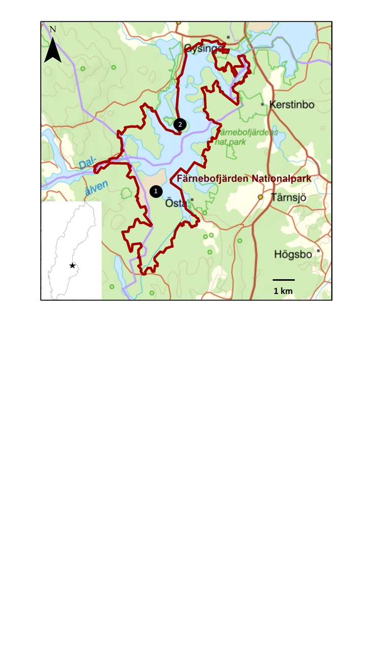

**Figure 1. Färnebofjärdens National Park, Eastern Sweden. The inset outline map shows the park location within Sweden. Måltidsmosse, the river meadow site (❶); the small hollow (❷).**

Prior to sub-sampling, the cores were µXRF-scanned (Olympus Delta ED-XRF) at 0.5-cm intervals using a Geotek MSCL-XZ core scanner to obtain the Industrial Pb record (Schillereff et al., 2016). Three thin sediment samples for radiocarbon determination from Måltidsmosse, and two plant macrofossil samples from the small hollow were submitted to the AMS dating facility at Lund University for analysis (Table 1 Supplementary Material) and analysed using Clam software (Blaauw, 2010) (Figure 2).

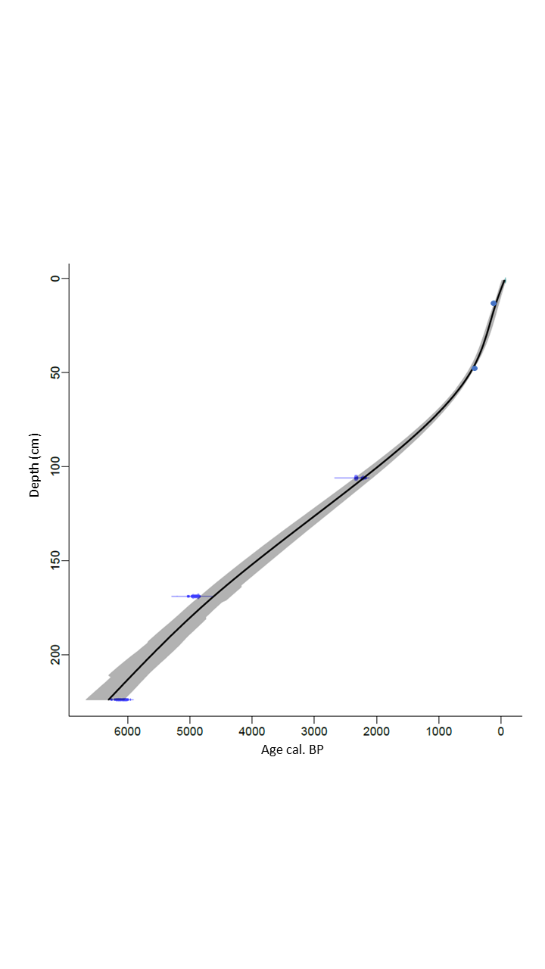

**Figure 2: Calibrated age depth relationship for Måltidsmosse using Clam software (Blaauw, 2010). The two dots mark peak Pb sedimentary values correlated with dated peak values from nearby sites (Bindler et al, 2011).**

The sediment was sub-sampled at regular intervals for pollen, plant macrofossils and charcoal, and prepared using standard methodology (Berglund, 1986). Pollen percentage diagrams were drawn up using the computer programme TILIA, Version 2.0.41 (Grimm, 2015) (Figures 3, 4 & 5). The pollen sum included trees, shrubs and herbs, excluding local producers and aquatics. *Lycopodium* tablets were added to allow the calculation of pollen accumulation rate (PAR,pollen grains/cm2/year). Microcharcoal <100 µm was easily distinguished on the pollen slides due to its intense black colour (Figures 4, 5 & 6). Contiguous 20 cm3 samples were analysed for plant macrofossils and macrocharcoal >250 µm from the small hollow (Figure 6). Contiguous 2 cm3 macrocharcoal samples were analysed from Måltidsmosse, bleached using NaOH, sieved at 250 µm, photographed and quantified using Image J (Halsall et al., 2018). The raw charcoal accumulation rates (CHAR, units/cm2/year) were interpolated to 68-year time steps, a value that corresponds approximately to the median temporal resolution of the entire record (Higuera et al., 2011). All numerical treatments were carried out using the CharAnalysis program (Version 1.1, <http://phiguera.github.io/CharAnalysis/)>. Fire events of local significance are recognised when the charcoal count value (pieces/cm2/yr) exceeds the background fire threshold value for the area (Figure 7a). Fire return interval (FRI) refers to the time between fires within a defined area (Figure 7b), while fire frequency (FF) over time, smoothed using a locally-weighted regression with a 1000-year window, refers to the number of times a fire occurs within a defined area (Figure 7c). The morphology of the individual macrocharcoal fragments were further analysed for types of vegetation burnt, where wood and grasses can be broadly distinguished based on their aspect ratio of width/length (Jensen et al., 2007) (Figure 8). A redundancy analysis was carried out to examine the changing proportion of the vegetation variance through time explained by the charcoal data (Thöle et al., 2016).

**Results and Interpretation**

*Dating*

An age-depth relationship (Figure 2) for Måltidsmosse was drawn up using the radiocarbon dates and by correlation of peak values for atmospherically deposited Pb (Table 1, Supplementary Material), with peak dated values from nearby sites (Bindler et al., 2011). These were calibrated into calendar years BP (cal. BP) using Clam software (Blaauw, 2010). The results from the small hollow revealed that part of the record was missing between the increase in *Picea* pollen at 30 cm, correlated to c. 2100 cal. BP with Måltidsmosse, and the industrial Pb peak at 23cm dated to c. 413-416 cal. BP (Table 1, Supplementary Material).

*Pollen, plant macrofossils and charcoal*

The longest pollen record from c. 6400 cal. BP was from the southern river meadow site, Måltidsmosse (Figure 3). Light-demanding taxa such as *Juniperus comminus, Hippophae rhamnoides, Viburnum* spp.*,* Ericaceae, Poaceae, Cyperaceae and *Galium* were prominent in the initial communities, together with *Pinus, Betula, Alnus, Populus, Corylus* and *Salix* (Figures 3 & 4). The pollen results from the small hollow on the central peninsula show that tree diversity was high c. 6000 cal. BP, comprising both temperate and boreal species (Figure 5). The abundant plant macrofossils recorded (Figure 6) suggest that *Pinus* and *Betula* were the most common local trees, but mixed with diverse broadleaved taxa, e.g. *Quercus, Ulmus, Alnus, Tilia, Populus, Frangula alnus* and *Salix*. *Juniperus*, Ericaceae, Poaceae, Cyperaceae and other wetland herbs were also recorded (Figures 5 & 6). Frequent fern pinnae and fronds were recorded, and monolete spores included both *Thelypteris* and *Dryopteris* (Figure 5). The low values of most herbaceous pollen suggest low light conditions, and a dense diverse mixed forest (Figure 6).

The pollen results from Måltidsmosse indicate that the change from a rich broadleaved forest with *Pinus* around the meadows, to one more dominated by *Pinus*,occurred c. 5000 cal. BP, well before the expansion of *Picea* c. 2100 cal. BP (Figure 3). *Tilia* and *Ulmus* PAR data show a marked decline from c. 5000 cal. BP (Figure 3) and at the small hollow site, many broadleaved tree macrofossil remains decrease/disappear at this time. *Picea* pollen expands at Måltidsmosse in the Iron Age. *Pinus* remains as the dominant tree in the area, with high pollen counts coinciding with peaks in micro- and macrocharcoal c. 1300 cal. BP (Figures 4 & 7). PAR data (Figure 3) show *Picea* and *Populus* values to be higher over the last 200 years than they have ever been in the past, coinciding with the decline in fire frequency (Figure 7). Prior to this, at Måltidsmosse, the pollen percentage data show a succession has taken place in the meadow communities involving Ericaceae, *Vaccinium, Myrica, Juniperus* and *Populus* (Figure 3).

Microcharcoal is present from the beginning of the pollen record at Måltidsmosse (Figure 4) c. 6400 cal. BP. Microcharcoal is continually recorded from the small hollow, with highest values as *Picea* expands, c. 2100 cal. BP (Figure 5). Macrocharcoal fragments are recorded in the earliest sediments but have higher values in the Iron Age closely tracking the microcharcoal record (Figure 6).

The contiguous macrocharcoal count data from Måltidsmosse have been analysed further back in time, showing charcoal deposition since river isolation c. 8000 years ago (Figure 7). CHAR analysis allows a reconstruction of changes in peak magnitude, FF and FRI (Figure 7). In the basal sediments, the fire signal is low (background charcoal level close to zero). One notable fire event is registered around 6400 cal. BP, coinciding with a peak in macrocharcoal data (Figure 7a). FRI during this period is almost 1500 years(Figure 7b), falling to 750 years around 3300 cal. BP, and continues to decrease until a peak (FRI c. 1500 years) at c. 1600 cal. BP. From this period onwards, FRI constantly decreases up to the present day (FRI below 200 years). FF is under c. 2 fires/1000 yr at the beginning of the record, increasing gradually from c. 5000 cal. BP onwards (Figure 7c). A temporary drop is followed by a further steady increase (c. 4 fires/1000 yr) during the Iron Age after c. 2100 cal. BP, coinciding with peaks observed in the microcharcoal data (Figure 4).

The results from the division of macrocharcoal fragment area into three categories using aspect ratios (AR1, AR2 and AR3, from smallest to largest), helps identify the vegetation type from which the charcoal mostly originated (Figure 8), although there is potential overlap between the categories of source vegetation (Jensen et al., 2007). All three categories are recorded c. 6400 cal. BP, at the time of the peak fire event seen in the CHAR results (Figure 7a). The ‘grass’ category (AR1) coincides with high Poaceae, Cyperaceae and herbaceous frequencies throughout the pollen diagram (Figure 4) while the ‘shrub’ category (AR2), corresponds to peaks in *Juniperus, Salix* and Ericaceae pollen. The largest number of macrocharcoal fragments between c. 1600 and 1000 cal. BP belong to the ‘woody’ category (AR3), possibly *Pinus* and *Betula* (Figure 3), but also *Juniperus* and Ericaceae. The ‘non-woody’ fraction is likely to be from Cyperaceae, Poaceae and diverse herbaceous taxa (Figure 4).



**Figure 3: Pollen percentage and selected pollen accumulation rate data (grains/cm2/yr) from Måltidsmosse showing major trees and shrubs. White outlines indicate × 5 exaggeration. Crosses show where plant macrofossils were found.**



**Figure 4 : Pollen percentage diagram for Måltidsmosse showing major herbs, ferns and aquatics. White outlines indicate × 5 exaggeration. Microcharcoal fragments (cm2/cm3) counted on the pollen slides are** < **100 μm. Crosses show where plant macrofossils were found.**

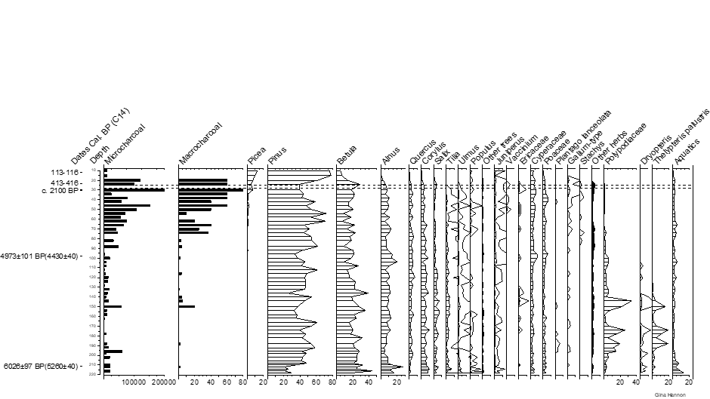

**Figure 5: Pollen percentage diagram from the small hollow on the central esker. Dashed line indicates a hiatus. White outlines indicate × 10 exaggeration. Other trees are *Fraxinus, Carpinus, Sorbus, Frangula* and *Hippophae rhamnoides*. Other herbs are *Artemisia*, Caryophyllaceae, Chenopodiaceae, Asteraceae, Brassicaceae, *Filipendula, Melampyrum, Potentilla, Ranunculus, Rumex*, Rosaceae, Apiaceae, Lamiaceae, Fabaceae, Liliaceae, *Epilobium*. Microcharcoal fragments (cm2/cm3) counted on the pollen slides are** < **100 μm and macrocharcoal units are** > **250 μm/20cm3.**

LisselJuneMacros.emf

**Figure 6: Plant macrofossils and macrocharcoal (**>**250 μm /20cm3), microcharcoal fragments** < **100 μm (cm2/cm3) and the industrial Pb record (PPM) from the small hollow by Lisselsjön. Abbreviations: b= bud, br=bract, fr=fruit, flr=flower, l=leaf, n=needle, , s=seed. Dots represent presence. Other macroremains recorded are *Quercus, Fraxinus, Frangula, Juniperus, Vaccinium, Phragmites, Viola*, Brassicaceae, Apiaceae, *Ranunculus, Lycopus, Hypericum, Epilobium, Filipendula, Cladium, Cicuta, Alisma, Mentha* and *Nuphar*.**

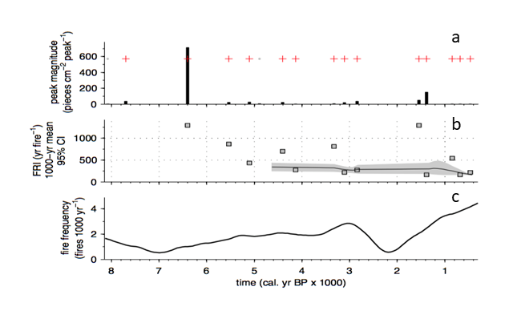**Figure 7: CHAR locally defined continuous fire record reconstructed from the macrocharcoal fragments analysis at Måltidsmosse: (a) Significant local fires (+) and numbers of charcoal fragments; (b) Fire Return Interval (FRI) and (c) Fire Frequency (FF).**

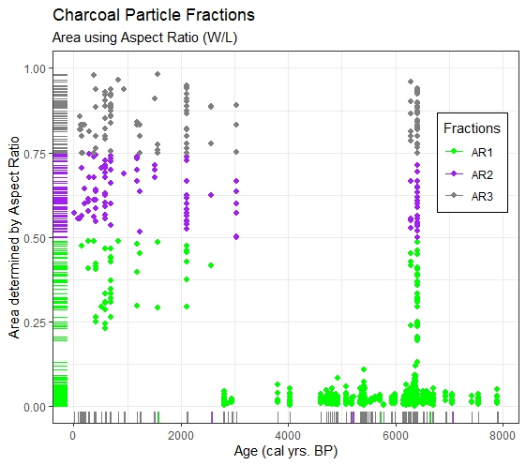

Aspect ratio (width/length)

**Figure 8: Macrocharcoal fragment area divided into three categories using Aspect Ratio (AR) from Måltidsmosse plotted against cal. yr BP.**

** Figure 9: Redundancy analysis showing the changing percentage of vegetation variance attributable to macrocharcoal at Måltidsmosse.**

The redundancy analysis shows significant change through time with a minimum of vegetation variance attributable to fire around 4000 cal. BP and a maximum around 1000 cal. BP.

**Discussion**

The observed changes in pollen, plant macrofossil and charcoal data allow a comprehensive environmental history to be built (Foster et al., 1990; Higuera et al., 2015). The palaeoecological records are in broad agreement with earlier work (Sandegren and Asklund, 1948; Lundqvist, 1963; Giesecke, 2005), but our more detailed analyses of local conditions, plant macrofossils, fire history and tighter dating control allow us to address the specific management questions posed in this study. Vegetation structure and composition has significantly changed through time at Färnebofjärden, diverging considerably from present conditions. These changes are attributable to a combination of climate dynamics, migration processes, differences in fire regime and crucially, human activities. It is of particular importance to identify those changes attributable to human activities as the management of Swedish National Parks is guided by the presumptive ‘natural’ state.

*The ‘natural’ ratio of conifers to broadleaved trees and the spread of spruce.*

The pollen and plant macrofossil data from 6400 years ago show that the vegetation comprised broadleaved forests mixed with *Pinus* and river meadows. By contrast, the present day forests are dominated by conifers, mainly *Picea*, with broadleaved trees generally confined to islands, parts of the central peninsula or along the river banks (Ståhl, 2015). The pollen and plant macrofossil records emphasise the tree diversity of the early mixed forest assemblages and a fern-dominated understorey including *Thelypteris palustris* and *Dryopteris* spp. recorded as spores, together with abundant macrofossil fern fronds. This diversity and the importance of broadleaved trees was largely retained until at least 2000 years ago.

PAR give a more robust idea of forest composition than percentage pollen data and show that *Ulmus* and *Tilia* were significant components in the older forests but retained a significant PAR values until at least 2000 years ago (Figure 3). The plant macrofossil data show *Quercus* was continually present (Figure 6), probably growing beside the river as it does today. The oldest records of the diverse broadleaved community is coincident with the onset of the mid-Holocene Thermal Maximum/Climatic Optimum with warmer and drier conditions in Northern Europe (Houmark-Nielsen and Kjaer, 2003). The more thermophilic *Tilia* follows a south to northward spread into central Sweden during the mid-Holocene (Giesecke, 2005) and is shown at these sites to be common in the early forests (Figures 3, 5 & 6 ). *Ulmus* and *Tilia* pollen show significant declines after c. 4500 cal. BP (Figure 3), coincident with a climatic cooling (Bigler et al., 2006). As these declines predate the expansion of *Picea* they cannot result from competition arising from *Picea* spreading as reported from Finland (Seppä et al., 2009). They are therefore a likely response either to altered climate (Jessen et al., 2005; Hultberg et al., 2017) or possibly resulting from early human activities in the region (Hallgren, 2008).

*Picea* pollen values increase c. 2100 years ago (Figures 3 & 5). The drivers for this increase are likely to be a mixture of climate and migration (Giesecke, 2005), but possibly amplified by anthropogenic disturbance (Bradshaw and Lindbladh, 2005; Hallgren, 2008). The broadleaved tree populations were reduced as *Picea* increased in abundance and while the long-term spreading history of *Picea* was chiefly a ‘natural’ process, the major increase in values during recent centuries is attributable to changes in the fire regime, plantation forestry schemes and modified water levels for hydroelectric purposes (Lindbladh et al., 2014). *Picea* PAR data are higher over the last 100–150 years than they have ever been in the past (Figure 3). ‘Natural’ forest composition is most likely to contain significantly less *Picea* than is seen today.

*The origin and history of the river meadows.*

The pollen record from Måltidsmosse shows mixed, semi-open communities with both southern and northern elements, abundant Polypodiaceae, light demanding herbaceous taxa and some mixed forests, probably on higher ground (Figures 3 & 4). Carcaillet et al. (2001) have suggested that a greater abundance of long thin charcoal fragments indicates a predominance of grasses over shrubs and trees, which have shorter, wider pieces. The charcoal fraction analysis data has all size categories recorded in the initial sediments, but mainly burnt grass category (AR1) between 6300 and 3000 years ago (Figure 8). This supports the conclusion from the pollen analysis (Figure 4), that the river meadow community has a long history. *Potentilla* and Liliaceae require bright, open glades, or other disturbance (Zackrisson, 1977), so repeated fire events may have kept the landscape open in addition to the annual spring flooding events. While some of these fires may have been natural, people have been active in the region since the early Stone Age. Charred cereal grains in ceramic pots have been radiocarbon dated from Funnel Beaker Culture Sites in the region to between 6000 and 5300 cal. BP (Hallgren, 2008). Traces of Stone age settlements have also been identified on the central esker, Enköpsåsen, running through the park (Naturvårdsverket, 2018). The macrocharcoal size analyses data (Figure 8) includes the ‘shrub*’* category (AR2) from c. 2100 cal. BP which could reflect the onset of woody successions in the meadows with *Juniperus*, Ericaceae, *Vaccinium* and *Myrica* *gale* seen in the percentage pollen record (Figure 3). Poaceae and Cyperacecae ‘grass*’* macrocharcoal category (AR1) continues to be recorded (Figure 8), with higher values from c. 2000 cal. BP as Cyperaceae pollen frequencies increase (Figure 4).

The initial drivers of vegetation change in the river meadow community would appear to be fire of natural or anthropogenic origin and frequent flooding events, but the subsequent shifts have more definitely been supported by people, with the use of fire and exploitation of the meadows for hay. Rural depopulation over the last 100 years, reduction of burning and the artificial control of water levels reducing natural flooding episodes have dried out the edges of the meadows and have all contributed to current woody successions. Both the expansion of *Picea* PAR from forestry plantations and the increasing *Populus* PAR values reflect these current successions (Figure 3). This creates a paradox for management, which aims to maintain the river meadow communities, including the ecologically valuable *Populus*, yet restrict spontaneous woody successions and reduce the influence of *Picea.* The river meadow communities, have probable natural origins but have also been influenced by at least 2000 years of cultural history, as described for a protected Norwegian swamp woodland (Natlandsmyr and Hjelle, 2016).  *Picea* can out-compete *Populus* and other shade-intolerant species of trees and shrubs, without regular disturbance (Pigott, 1991). This can also have a substantial effect on soil chemistry, resulting in increased podzol formation (Hallbäcken and Tamm, 1986). The subsequent change in the vegetation community is indicated by the strong presence of *Myrica*, *Vaccinium* and Ericaceae at Måltidsmosse, all of which thrive in more acidic soils (Augusto et al., 2002). The current trends in the palaeoecological data suggest that the river meadows are becoming forest covered and that the *Populus* populations are decreasing. Intervention is required to favour *Populus* and keep the meadows open. ‘Natural’ conditions would require extensive disturbance from spring flooding and occasional summer burning. Resolving these complex issues in the National Park depends on resources and the choice of target groups for biodiversity.

*The changing role of fire and its influence on forest composition*

The prevalence of fire on the landscape can be seen in the micro- and macrocharcoal records (Figures 4, 5, 6 and 7). The redundancy analysis shows a steady increase from 4000 cal. BP up to a peak of 18% of pollen variance attributable to fire, prior to the recent period of fire suppression (Figure 9). Fire scar records from tree-ring analyses show the importance of fire in the region from AD 1500 onwards with high temporal resolution (Drobyshev et al., 2010; Drobyshev et al., 2016) The importance of fire in shaping the vegetation communities is supported by the redundancy analysis (Figure 9) and suggests fires have increased their influence on vegetation dynamics from the Iron Age onwards (Figures 4 & 7). This is attributable to increased human activity as there are significant numbers of Iron Age burial sites on the central esker in the National Park which was an important route crossing from Norrland to Svealand (Naturvårdsverket, 2018). People had probably been influencing the fire regime from at least c. 5000 cal. BP, with a significant increase in the Iron Age c. 2100 cal. BP onwards (Hallgren, 2008).

Fire has had important influence on vegetation dynamics in the National Park. It has most likely contributed to the reduced importance of *Tilia* and *Ulmus* in the forest during the Iron Age (Figure 3) as previously suggested (Bradshaw et al., 2010; Hultberg et al., 2017). The expansion of *Picea* during the late Holocene is seen at both the river meadow site and the closed canopy woodland site around the small hollow at a time when fire frequency was increasing (Figures 3,5,7), as was also recorded in this region by Giesecke (2005). *Picea* trees are fire-sensitive, but are aggressive colonisers of forest gaps in post-fire successions (Molinari et al., 2020). The most rapid increase in *Picea* populations coincides with recent fire suppression (Lindbladh et al., 2014). Anthropogenic pollen indicators such as *Rumex acetosa,* *Galium*, *Potentilla* and *Melampyrum* increase in the Iron Age (Figure 4). These are associated with open spaces created by grazing animals, but also burning and other agricultural activities (Segerström and Emanuelsson, 2002). Fire has therefore been a disturbance factor in the National Park with an important influence on conservation issues such as *Picea* dominance and the maintenance of non-forest communities. Its present occurrence is unusually low, but natural fire frequencies are increasing in the region so prescribed burning for biological value may prove to be unnecessary (Molinari et al., 2018).

**Summary**

* Knowledge of how current vegetation communities have developed from earlier conditions, recognising past legacies, and evaluating what likely future compositions may develop, is of value to current management.
* Using palaeoecological data, we have identified trends and processes such as long-term dynamics of tree populations, loss of biodiversity from extreme disturbance by fire, and human use of the landscape such as grazing, plantation forestry, and consequences of the management of the river water flushing events.
* The pollen data suggest that *Quercus robur*, *Corylus avellana, Alnus* spp.and *Populus* have a long history of sustained natural populations in the Park. The modern valuable *Populus* meadow community is of relatively recent origin. It can be encouraged for biodiversity purposes together with other broadleaved trees (such as *Quercus*, *Corylus, Betula, Frangula* and *Alnus,* which show long and sustained presence), but current climatic conditions may not favour *Tilia or Ulmus*.
* The PAR data show that *Picea* is *'*unnaturally*'* at its highest population level at present. This is linked to human activity (plantation forestry, intervention with the fire regime and water levels) alongside migration processes.
* Despite current woody successions, the river meadows have had a long history. This has been maintained by a combination of fire and/or flooding and haymaking prior to the building of the HEP plant.
* Human activities appear chiefly responsible for both the intense fire regime during the Iron Age, as well as the subsequent fire suppression in recent centuries. Human impact may have been a greater issue than climate change in the last 2000 years, but the combination is powerful.

**Acknowledgements**

We would like to thank Björn-Axel Beier, Swedish Environment Protection Agency (SEPA), for introducing us to Färnebofjärden National Park. We gratefully acknowledge funding from SEPA and Gävleborgs Länsstyrelsen. Richard Chiverrell, University of Liverpool, assisted with the geochemical scans, Louise Bradshaw located potential sites and prepared the map and Peter Ståhl, Björn-Axel Beier and personnel from Gävleborgs Länsstyrelsen assisted in the field. The paper was improved by valuable comments from the referees.

**References**

Augusto L, Ranger J, Binkley D, et al. (2002) Impact of several common tree species of European temperate forests on soil fertility. *Annals of Forest Science* 59: 233-253.

Berglund BE. (1986) *Handbook of Holocene palaeoecology and palaeohydrology,* Chichester, United Kingdom: John Wiley & Sons.

Bindler R, Segerström U, Pettersson-Jensen I-M, et al. (2011) Early medieval origins of iron mining and settlement in central Sweden: multiproxy analysis of sediment and peat records from the Norberg mining district. *Journal of Archaeological Science* 38: 291-300.

Blaauw M. (2010) Methods and code for ‘classical’ age-modelling of radiocarbon sequences. *Quaternary Geochronology* 5: 512-518.

Bowman DMJS, Balch JK, Artaxo P, et al. (2009) Fire in the Earth System. *Science* 324: 481-484.

Bradshaw RHW, Jones CS, Edwards SJ, et al. (2015) Forest continuity and conservation value in Western Europe. *The Holocene* 25: 194-202.

Bradshaw RHW and Lindbladh M. (2005) Regional spread and stand-scale establishment of Fagus sylvatica and Picea abies in Scandinavia. *Ecology* 86: 1679-1686.

Bradshaw RHW, Lindbladh M and Hannon GE. (2010) The role of fire in southern Scandinavian forests during the late Holocene. *International Journal of Wildland Fire* 19: 1040-1049.

Carcaillet C, Bouvier M, Fréchette B, et al. (2001) Comparison of pollen-slide and sieving methods in lacustrine charcoal analyses for local and regional fire history. *The Holocene* 11: 467-476.

Clear JL, Molinari C and Bradshaw RHW. (2014) Holocene fire in Fennoscandia and Denmark. *International Journal of Wildland Fire* 23: 781-789.

Clear JL, Seppä H, Kuosmanen N, et al. (2013) Holocene fire frequency variability in Vesijako, Strict Nature Reserve, Finland, and its application to conservation and management. *Biological Conservation* 166: 90-97.

Drobyshev I, Bergeron Y, de Vernal A, et al. (2016) Atlantic SSTs control regime shifts in forest fire activity of Northern Scandinavia. *Scientific Reports* 6.

Drobyshev I, Niklasson M, Granström A, et al. (2010) Fire activity in Scandinavia during 1500-1900. *Northern Primeval Forests - Ecology, Conservation and Management.* Sundsvall.

Foster DR, Schoonmaker P and Pickett STA. (1990) Insights from paleoecology to community ecology. *Trends in Ecology and Evolution* 5: 119-122.

Galanter M, Levi HI and Carmichael GR. (2000) Impacts of biomass burning on tropospheric CO, NOx, andO3. *Journal of Geophysical Research: Atmospheres* 105: 6633-6653.

Giesecke T. (2005) Holocene dynamics of the southern boreal forest in Sweden. *The Holocene* 15: 858-872.

Grace M, Akçakaya HR, Bennett E, et al. (2019) Using historical and palaeoecologicaldata to inform ambitious speciesrecovery targets. *Philosophical Transactions of the Royal Society B* 374: 20190297.

Granström A and Niklasson M. (2008) Potentials and limitations for human control over historic fire regimes in the boreal forest. *Philosophical Transactions of the Royal Society B* 363: 2353-2358.

Grimm EC. (2015) TILIA software. Version 2.0.41 <https://www.tiliait.com/download/>.

Gustafsson L, De Jong J and Noreng M. (1999) Evaluation of Swedish woodland key habitats using red-listed bryophytes and lichens. *Biodiversity & Conservation* 8: 1101-1114.

Hallbäcken L and Tamm CO. (1986) Changes in soil acidity from 1927 to 1982–1984 in a forest area of south‐west Sweden. *Scandinavian Journal of Forest research* 1: 219-232.

Hallgren F. (2008) Identitet i praktik. Lokala, regionala och överregionala sociala sammanhang inom nordlig trattbägarkultur. *Arkeologi och antik historia.* Uppsala: Uppsala University.

Halsall KM, Ellingsen VM, Asplund J, et al. (2018) Fossil charcoal quantification using manual and image analysis approaches. *The Holocene* 28: 1345-1353.

Hannon GE, Halsall K, Molinari C, et al. (2018) The reconstruction of past forest dynamics over the last 13,500 years in SW Sweden. *The Holocene* 28: 1791-1800.

Higuera PE, Hudiburg TW and Hicke JA. (2015) Combining paleoecology and ecosystem modeling to study forest ecosystem consequences of wildfires from decades to millennia. *American Geophysical Union Abstracts* Fall Meeting 2015.

Higuera PE, Whitlock C and Gage JA. (2011) Linking tree-ring and sediment-charcoal records to reconstruct fire occurrence and area burned in subalpine forests of Yellowstone National Park, USA. *The Holocene* 21: 327-341.

Houmark-Nielsen M and Kjaer KH. (2003) Southwest Scandinavia, 40–15 kyr BP: palaeogeography and environmental change. *Journal of Quaternary Science* 18: 769-786.

Hultberg T, Lagerås P, Björkman L, et al. (2017) The late-Holocene decline of *Tilia* in relation to climate and human activities – pollen evidence from 42 sites in southern Sweden. *Journal of Biogeography* 44: 2398-2409.

Jackson ST and Hobbs RJ. (2009) Ecological Restoration in the Light of Ecological History. *Science* 325: 567-569.

Jeffers ES, Nogue S and Willis KJ. (2015) The role of palaeoecological records in assessing ecosystem services. *Quaternary Science Reviews* 112: 17-32.

Jensen K, Lynch EA, Calcote R, et al. (2007) Interpretation of charcoal morphotypes in sediments from Ferry Lake, Wisconsin, USA: do different plant fuel sources produce distinctive charcoal morphotypes? *The Holocene* 17: 907-915.

Jessen CA, Rundgren M, Björck S, et al. (2005) Abrupt climatic changes and an unstable transition into a late Holocene Thermal Decline: a multiproxy lacustrine record from southern Sweden. *Journal of Quaternary Science* 20: 349-362.

Lindbladh M, Axelsson A-L, Hultberg T, et al. (2014) From broadleaves to spruce – the borealization of southern Sweden. *Scandinavian Journal of Forest research* 29: 686-696.

Lundqvist G. (1963) Beskrivning till Jordartskarta över Gävleborgs Län. *Ca.* Sveriges Geologiska Undersökning.

Molinari C, Carcaillet C, Bradshaw RHW, et al. (2020) Fire-vegetation interactions during the last 11,000 years in boreal and cold temperate forests of Fennoscandia. *Quaternary Science Reviews* 241: 106408.

Molinari C, Lehsten V, Blarquez O, et al. (2018) The climate, the fuel and the land use: long-term regional variability of biomass burning in boreal forests. *Global Change Biology* 24: 4929-4945.

Molinari C, Lehsten V, Bradshaw RHW, et al. (2013) Exploring potential drivers of European biomass burning over the Holocene: a data-model analysis. *Global Ecology and Biogeography* 22: 1248-1260.

Natlandsmyr B and Hjelle KL. (2016) Long-term vegetation dynamics and Land-use history: Providing a baseline for conservation strategies in protected *Alnus glutinosa* swamp woodlands. *Forest Ecology and Management* 372: 78-92.

Naturvårdsverket. (2018) Skötselplan för Färnebofjärdens nationalpark. Stockholm, 147pp.

Niklasson M and Granström A. (2000) Numbers and Sizes of Fires: Long‐Term Spatially Explicit Fire History in a Swedish Boreal Landscape. *Ecology* 81: 1484-1499.

Nilsson C and Götmark F. (1992) Protected areas in Sweden: is natural variety adequately represented? *Conservation Biology* 6: 232-242.

Pigott CD. (1991) Biological flora of the British Isles *Tilia cordata*  (Miller) (T. europaea L. pro parte, *T. parvifolia* Ehrh. Ex Hoffm., *T. sylvestris* Desf., *T. foemina folio minore* Bauhin). *Journal of Ecology* 79: 1147-1207.

Sandegren R and Asklund B. (1948) Beskrivning till Kartbladet Söderfors. Sveriges Geologiska Undersökning.

Schillereff DN, Chiverrell RC, Macdonald N, et al. (2016) Quantifying system disturbance and recovery from historical mining-derived metal contamination at Brotherswater, northwest England. *Journal of Paleolimnology* 56: 205-221.

Segerström U and Emanuelsson M. (2002) Extensive forest grazing and hay-making on mires–vegetation changes in south-central Sweden due to land use since Medieval times. *Vegetation History and Archaeobotany* 11: 181-190.

Seppä H, Alenius T, Bradshaw RHW, et al. (2009) Invasion of Norway spruce (*Picea abies*) and the rise of the boreal ecosystem in Fennoscandia. *Journal of Ecology* 97: 629-640.

SFS. (1982) Svensk författningssamling Naturvårdslag. *1982:1097*.

Ståhl P. (2015) Växter vid Färnebofjärden - en inventering av kärlväxter och vegetation i Färnebofjärdens national park 2011-2013. 87.

Thöle L, Schwörer C, Colombaroli D et al. (2016) Reconstruction of Holocene vegetation dynamics at Lac de Bretaye, a high-mountain lake in the Swiss Alps. *The Holocene* 26: 380-396.

Willis KJ and Bhagwat SA. (2010) Questions of importance to the conservation of biological diversity: answers from the past. *Climate of the past* 6: 759-769.

Willis KJ and Birks HJB. (2006) What Is Natural? The Need for a Long-Term Perspective in Biodiversity Conservation. *Science* 314: 1261-1265.

Zackrisson O. (1977) Influence of Forest Fires on the North Swedish Boreal Forest. *Oikos* 29: 22-32.