Abstract
Crude oil contaminated lands are recognised to have significant contributions to airborne volatile organic compounds (VOCs) with adverse effects on human health and tropospheric ozone. Soil capping systems for controlling harmful emissions are critical engineering solutions where advanced soil remediation techniques are neither available nor feasible. Studies on the adsorption of single VOC species in biochar have shown promising results as a potential capping material; however, current understanding of mixed gas system and multi-component adsorption of VOCs on biochar which would represent more realistic in situ conditions is very limited. We present, for the first time, the results of a study on competitive adsorption of mixed VOCs, including aromatic and non-aromatic VOCs commonly emitted from crude oil contaminated sites on two types of biochar pyrolysed at 500$℃$ from wheat straw and bagasse as feedstock. The kinetics of sorption of multicomponent VOCs including acetone, hexane, toluene and p-xylene in biochar are studied based on the results of an extensive experimental investigation using a bespoke laboratory setup. Both biochar types used in this study presented a high sorption capacity for VOC compounds when tested individually (51-110 mg/g). For the multicomponent mixture, the competition for occupying sorption sites on biochar surface resulted in a lower absolute sorption capacity for each species, however, the overall sorption capacity of biochar remained more or less similar to that observed in the single gas experiments (50-109 mg/g). The chemical interactions via hydrogen bonds, electrostatic attraction, and pore-filling were found to be the main mechanisms of adsorption of VOC in the biochar studied. The efficiency of biochar regeneration was assessed through five cycles of adsorption-desorption tests and was found to be between 88% and 96%. The incomplete desorption observed confirm the formation of likely permanent bonds and heel build-ups during the sorption process.

Keywords: VOCs; Biochar; Crude oil-contaminated soil; Multi-component sorption; Desorption.
1. Introduction
Crude oil contaminated lands are recognised to be one of the major sources of volatile organic compounds (VOCs). VOCs are categorised as hazardous chemicals and can cause a wide range of adverse effects on human health and contribute to the tropospheric ozone (Wang et al., 2015b). The crude oil-associated VOC emissions (CVEs) from contaminated lands can not only affect the neighbouring communities but also be capable of travelling extensive distances (tens of miles) to exacerbate atmospheric pollution in metropolitan areas. High infant mortality rates and severe health problems have been frequently reported near major petroleum spillage sites with alarming cancerous/non-cancerous symptoms of human liver and kidney malfunction, respiratory and neurological system disorders, skin and eye irritations (Rajabi et al., 2020). The technologies for the remediation of oil-contaminated soil are usually time-consuming (e.g., bioremediation), costly (e.g., thermal desorption), environmentally unfriendly for certain approaches (e.g., oxidation) and sensitive to the operating conditions (physicochemical techniques) (Lim et al., 2016; Rajabi and Sharifipour, 2017, 2018, 2019). Such constraints make the conventional remediation techniques unfeasible for applications in large polluted lands or deprived regions. Therefore, an easy-to-localise solution to contain the VOC emissions would protect the health of large communities living near oil-contaminated regions. Examples of such communities affected by VOC contaminated lands have been reported in Latin America (Coronel Vargas et al., 2020) and central Africa (Onyena and Sam, 2020), where affordability to benefit from effective remedial technologies is limited.
Adsorption through carbonaceous materials is a reliable technique and practised in landfill capping systems to remove gas emissions from buried wastes (Xie et al., 2016; Xie et al., 2017; Xie et al., 2018; Wang et al., 2019). Such sorption-based capping systems have the potential to be adopted and redesigned to manage hazardous emissions from contaminated soil. However, containment through engineered organic/inorganic sorbents (e.g., activated carbon or silica gel) are unfeasible for extensive polluted areas due to the cost and advanced technology required for mass production. Biochar, on the other hand, is a low-cost carbonaceous by-product of biomass pyrolysis which has been particularly utilised in a wide variety of applications including separation, carbon sequestration, energy storage/conversion and water filtration (Ahmad et al., 2014; Wang et al., 2020; Yaashikaa et al., 2020). The partial pyrolysis process can convert biomass (e.g., biowaste, agriculture waste) into porous structures which consist of a carbonised mass with reactive superficial chemistry. Such highly reactive and porous material can act as a sink to capture various types of organic and inorganic chemicals (Zhang et al., 2017a). Biochar can be utilised as an affordable sorbent for managing CVEs from contaminated soil since it can be supplied in large quantities from widespread feedstock through the low-tech low-cost combustion process. Interests in applications of biochar in environmental control systems and treatment processes have recently emerged (e.g., soil remediation, carbon sequestration, decontaminations, catalysts, organic solid waste composting, etc.) (Wang and Wang, 2019).
Char-based removals of volatile chemicals have been studied by other researchers too, e.g. benzene (Kumar et al., 2020), cyclohexane (Zhang et al., 2017b; Zhang et al., 2019; Xiang et al., 2020; Zhang et al., 2020b), ethylbenzene (Kim et al., 2019), toluene (Zhang et al., 2017b; Xiang et al., 2020; Yang et al., 2020), and xylenes (Zhang et al., 2020a). Biochar from a range of feedstock has also been tested for the removal of xylene isomers which are among high-detected high-concentrated CVEs (Rajabi et al., 2020). The existing limited studies which have only looked at the adsorption of individual VOC species on biochar provide an incomplete understanding of the biochar potential for containment of VOCs in a multispecies/multi-component system. The competitive adsorption under realistic multispecies systems has received very little attention. This paper, for the first time, provides an insight into the sorption of multicomponent VOC systems on biochar as an exploratory research to provide a scientific base (concept development and validation) of a low-cost system to contain the hazardous emissions from crude oil-contaminated lands with certain level of similarity to the capping systems conventionally used in landfills. Two types of biochar from prevalent agricultural wastes were used as sorbents in this study. The VOC species of toluene, p-xylene, and hexane were used as aromatic/non-aromatic examples of CVEs which are abundantly detected near petroleum polluted sites. Acetone was also considered as it has been frequently used in studies of VOC adsorption in carbon-based adsorbents due to its high volatility and very small molecule size. The rationale was to compare our results with other studies on biochar-based removal of VOCs (Zhang et al., 2017). The competitive sorption of acetone with a lower molar mass (58 g/mol), kinetic diameter (3.8Å) and boiling point (56℃) and without a benzene ring in its molecular shape could further reveal the governing mechanisms of VOC adsorption on biochar under competitive inhibition. Physicochemical properties of biochar samples were studied through elemental analysis, Fourier-transform infrared spectroscopy (FTIR), scanning electron microscopy (SEM), and Brunauer–Emmett–Teller (BET) surface area analysis. A bespoke experimental setup with an in-line GC-FID was developed to investigate the kinetics of both single- and multi-component sorption of VOCs on the samples and to assess their reliability and reusability through five cyclic single-component adsorption-desorption tests on acetone and toluene as representative non-aromatic and aromatic VOCs.

2. Materials and methods
2.1. Biochar and chemicals
Two types of biochar, both formed by pyrolysis at 500 $℃$ sourcing from wheat straw (WS) and bagasse sugarcane (BG), were chosen as commonly available agricultural waste (Yuan and Sun, 2010). These were obtained from Nanjing Zhironglian Technology (China) and Bandung Institute of Technology (Indonesia), respectively. High purity (+99%) analytical grades of acetone, hexane, toluene, and p-xylene were purchased from Acros Organics as adsorbates (Table S1). Biochar samples were manually grounded using a mortar and pestle, then sieved to obtain a size range between 0.5 and 1 mm. The sieved samples were then washed thoroughly using deionised water to remove any impurities, and then oven-dried at 85$℃$ for 24h until the weight stabilised. The dried samples were stored in sealed containers and used for characterisation and sorption tests.

2.2. Biochar characterisation
CHNS elemental analyser (Thermo Scientific™) and scanning electron microscopy (SEM, FEI Quanta™ 650 FEG) were utilised to analyse the elemental composition and structural features of the used biochar, respectively. SEM images were taken under a low accelerating voltage (2.00kV) via Everhart-Thornley Detector (ETD) mode at various magnifications up to 1000x. Detailed information of the porous system of the samples (e.g., BET surface area and pore volume) was determined by the N₂ adsorption-desorption isotherms (Micromeritics® Surface Area Analyser). The samples (typically 0.1-0.2g) were initially degassed using a Micromeritics FlowPrep 060 under a flow of CP grade N₂ at 80$℃$ for 18 hours before BET surface area measurements. Infrared spectra of the samples were taken by Spotlight 200i FTIR Spectroscopy (Perkin Elmer®) in the range of 400-4000 cm⁻¹ as an identification tool to describe the biochar surface functional groups.

2.3. Adsorption and desorption tests
The experimental setup designed and used for investigating the single gas sorption process (details can be found in (Rajabi et al., 2021)) was further extended to create the capability for studying the kinetics of multicomponent sorption processes as well as gas desorption (Fig. S1). The stripping method (pure nitrogen as carrier gas regulated at 0.2 ml/min) was used to convert liquid VOCs (injected into carrier gas at specific rates via a set of syringe pumps). A concentration of 200–220 ppmv was considered for all chemicals in single- and multi-component tests. This range was selected to represent the maximum concentrations reported in the literature for VOC emissions from petroleum contaminated sites (Pandya et al., 2006; Bocos-Bintintan et al., 2019; Rajabi et al., 2020). In order to ensure intended VOC concentrations are achieved in the mixed gas system, four gas-tight microsyringes (Hamilton-1725 TLL; 250 μl) driven by two dual-syringe infusion pumps (Cole-Parmer and Chemyx) at different injection rates of 0.008-0.02 ml/h were employed to gradually inject the liquid chemicals into the flow of carrier gas (0.02ml/min). On average, 3 to 4 hours were required to produce a steady gas stream of desired VOC concentrations. Further details about experimental methodology, calibrations and adjustment of VOC concentrations can be found in (Rajabi et al., 2021). The mixed gas was then passed through a mixing bottle packed with glass beads to ensure its homogeneity before injection into the adsorption column. Based on a careful review of the literature, it appears that both terms (i.e., gas and vapour) are commonly used to refer to VOCs. For example VOCs have been considered as vapours by (Feng et al., 2020) and (Mızrak et al., 2017), whereas (Cheng et al., 2020) and (Minella and Minero, 2021) referred to them as gases. The United States Environmental Protection Agency (EPA) also states that “Volatile organic compounds (VOCs) are emitted gases from certain solids or liquids” (EPA, 2019). Moreover, in this study N₂ was used as a stripping gas, and therefore the mixture is also referred to as gas for consistency and clarity. The temperature of the adsorption column was maintained at 25$℃$ during all adsorption tests using a digital water bath. An in-line GC-FID (Chromatotec®) was utilised for continuous analysis of the outflow gas composition at 15-min intervals. The injection of mixed gas with desired VOC concentration into the sorption column (gas-tight solvent-resistant Plexiglass cell) was continued until the biochar samples (0.5 ± 0.01 g) reached saturation. The saturation state was considered when the stabilised composition of the outflow gas was observed for at least 1 hour. Once the sorption was completed, desorption was initiated by stopping the gas injection and increasing the temperature of the sorption column by submerging that in a water bath to accelerate the process. The temperature was increased at a rate of approximately 4.8 $℃$/min to a maximum temperature of 95$℃$ to initiate/accelerate the desorption process as a technical procedure frequently used in the literature (Xiang et al., 2020; Zhang et al., 2020b). Five single adsorption/desorption cycles were carried out on selected sorbents/sorbates to evaluate the reusability of the biochar. Data collected by the GC-FID were analysed based on the mass conservation equations (Eq. (S1-2) in supplementary materials). Each test was repeated three times, and the mean value with an absolute uncertainty (absolute error) was reported. To obtain further insight into the governing sorption mechanism, the experimental results were compared against well-established kinetic models including pseudo-first and second-order models (PFOM & PSOM), the Elovich model (ELM) and the intra-particle diffusion model (IPDM) (Eq. (S3-7)).

Table 1. Physicochemical properties and pore characteristics of biochar samples.
Biochar | C (%) | H  (%) | N  (%) | S  (%) | O  (%) | O/C | H/C | (O+N)/C | S_{BET}  (m².g⁻¹) | V_{Total-BET}  (cm³.g⁻¹)
BG | 75.94 | 1..77 | 0.40 | NF | 21.89 | 0.289 | 0.024 | 0.293 | 78.15 | 0.1448
WS | 66.57 | 2.66 | 0.98 | <0.3 | 29.49 | 0.443 | 0.040 | 0.458 | 58.38 | 0.0786

3. Results and discussion
3.1. Biochar characterisation
Physicochemical properties of carbonaceous materials govern their sorption mechanisms for the removal of organic/inorganic pollutants (Zhu et al., 2020). Such properties are mainly characterised through elemental composition, porous structure and surface chemistry. CHNS/O elemental composition and porous characteristics of the biochar are presented in Table 1. The oxygen content was measured using the mass balance technique (Chen et al., 2008). Both types of biochar are rich in carbon with 67% and 76% carbonised mass for WS and BG, respectively. The atomic ratios of aromaticity (H/C), hydrophilicity (O/C) and polarity (O+N)/C) for WS char are nearly doubled in comparison to BG. The lower polarity of BG can be attributed to its higher carbon content compared to the high-organic structure of WS with more polar compounds (e.g., cellulose, fatty acids, and lignin) and more aromatic cores, which elevate its polarity too (Cao et al., 2019). FTIR spectra of biochar samples (Fig. 1) indicate a wide variety of oxygen- and hydrogen-containing functional groups on biochar surface which can interact with organic compounds. Similar peaks were found on both samples at 748-874cm⁻¹ (C-H bending), 1512-1692 cm⁻¹ (C=O stretching), 1980-1982 cm⁻¹ (C-H aromatic bending), 2162-2166 cm⁻¹ (C=C=O stretching) and 2958-3044 cm⁻¹ (C-H stretching). BG lacks few peaks at 1314-1378 cm⁻¹ which can be associated with the absence of polar compounds in BG (e.g., lignin, cellulose, and hemicelluloses) which also shows the lower polarity of BG in comparison to WS deduced from the elemental analysis. A lower hydrophilic surface of BG with fewer polar groups can be also confirmed by its lower ratio of O/C (hydrophilicity) and (O+N)/C (polarity). BG has a higher SSA/PV from BET analysis compared with WS (Table 1). Similar observations have been also reported for biochar produced from wheat straw and sugarcane bagasse (Chatterjee et al., 2020). Differences in pore size and shape of both samples can be evaluated using SEM images (Fig. S2). Both samples have a wide range of pore sizes (magnification of 100 & 50 µm); however, BG has a more homogeneous pattern of smaller pores (5 µm) in comparison to WS having fewer but bigger pores/canals at the same scale.
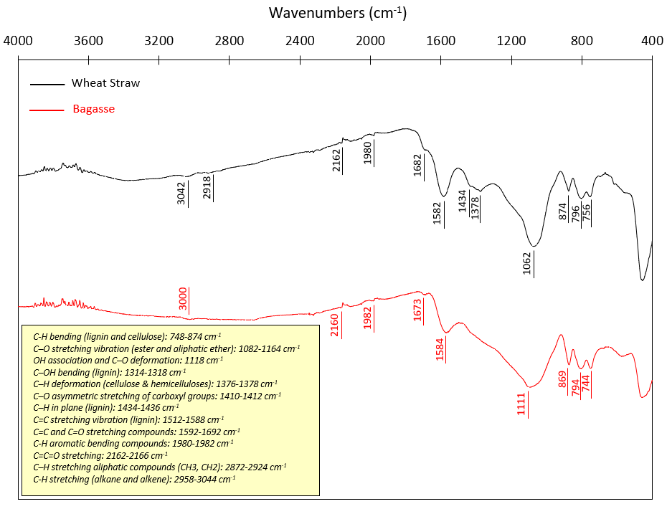
Fig. 1. FTIR spectra of WS and BG biochar.
3.2. Single-component sorption
The single-component sorption kinetics of selected VOCs on BG and WS biochar are presented in Fig. 2. The highest sorbed mass was observed for acetone on BG, followed by p-xylene, toluene, and hexane. The overall differences in adsorption quantities can be attributed to (i) molecular characteristics of the VOCs with different kinetic diameters and non-identical conformation and configuration (steric hindrance), and (ii) biochar surface chemistry and porosity. Acetone can combine with carbonised mass of both samples mostly through carboxylic groups (Yu et al., 2018), and a low kinetic diameter (3.8 Å) enables acetone molecules to interact with more active sites and enter smaller pores/canals (Zhang et al., 2017b). The maximum adsorption ($Q_{eq}$) of acetone on BG (110.1±5.4 mg/g) is more than doubled the adsorbed mass on WS (44.5±2.1 mg/g). This is due to the higher SSA/PV of BG which elevates the pore-filling and access to active sites. On the other hand, the lowest sorption capacity on both samples is related to hexane mainly because of its specific molecular arrangements which affect its success rate for adsorbing onto the carbon surface of the biochar. Hexane molecules (C₆H₁₄) are normally aligned parallel (an elongated cylinder (Wang et al., 2015a)) to carbon surface and can interact with carbon molecules by seven hydrogen atoms only through CH-$π$ bonding, while other aromatic chemicals (e.g., toluene and p-xylene) utilise not only CH-$π$ interactions but also$π$-$π$ stacking and other functional groups in combination with carbon surfaces (Thongsai et al., 2019). Hexane was also found to be more adsorbed on BG (36.8±1.5 mg/g) in comparison to WS (19.7±0.9 mg/g) which can be related to its higher inclination towards hydrophobic carbon surfaces with fewer oxygenated groups and greater porosity (e.g., BG) (Hernández-Monje et al., 2018).
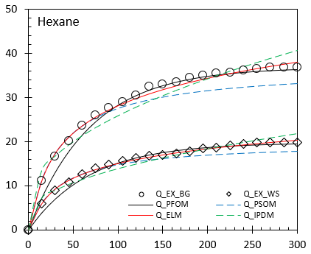
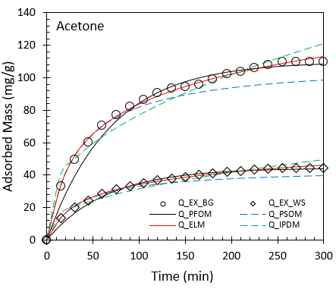
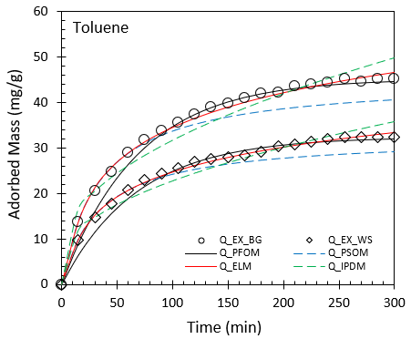
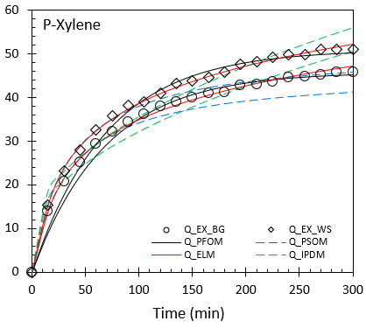
Fig. 2. Kinetics of single-component sorption of VOCs on WS and BG biochar.

Aromatic structures of toluene and p-xylene can be adsorbed onto carbon surface through $π$-$π$ stacking (Navarro Amador et al., 2018), electrostatic attraction (Solanki and Boyer, 2019) and functional groups (Kim et al., 2019) as well as partitioning into non-carbonised mass (Chen et al., 2017). It should be added that adsorption of VOCs on carbon-based materials mainly is a physicochemical process mostly controlled by physical attraction through pore-filling and van der Waals forces in addition to chemical attractions via functional groups and stacking (reversible) rather than chemical reactions (irreversible). The ultimate sorption of toluene on BG (45.2±1.7 mg/g) is slightly higher than WS (32.5±1.6 mg/g) which can be related to the increased pore-filling within BG mass and higher SSA; however, different behaviour was observed for the case of p-xylene. P-xylene molecules with para-substituted benzene cores are more accumulated onto the low-SSA structure of wheat straw due to higher polarity (more polar groups) of wheat straw biochar compared with bagasse (more details in Fig. 1). In addition, the kinetic behaviour of p-xylene sorption on both types of biochar is more or less similar (Fig. 2) since its big molecules and higher steric hindrance might have prevented p-xylene to enter more available pores within the BG structure. Overall, adsorption kinetics of both types of biochar showed reasonable removal capacities up to 110.1±5.4 mg/g compared to the rate of VOC emissions reported for oil-contaminated lands (Ausma et al., 2002; Wang et al., 2015b; Rajabi et al., 2020). It should be noted that the used biochar showed reliable potentials for removal of acetone (44.5 and 110.9 mg/g), hexane (36.8 and 19.7 mg/g), toluene (32.4 and 45.2 mg/g) and p-xylene (24.8 and 51.1 mg/g) in comparison to other reported figures for adsorption on non-activated/non-modified biochar such as acetone: 7.6-50.2 mg/g (Xiang et al., 2020); 7.1-91.2 mg/g (Zhang et al., 2017b); 17.9-25.2 mg/g (Zhang et al., 2020b), toluene: 13.8–65.5 mg/g (Kumar et al., 2020); 12.7-55.1 mg/g (Xiang et al., 2020); 31.2 mg/g (Yang et al., 2020); 12.7-62.9 mg/g (Zhang et al., 2017b); and xylenes: 1.5–60.2 mg/g (Kumar et al., 2020). A statistical analysis also showed a non-linear relationship between each adsorbates’ property (molar mass, boiling point, and kinetic diameter) and adsorption capacity of the used biochar. It revealed that the sorption mechanism of VOCs on biochar may not be only controlled by the molecular properties of VOCs, and other mechanisms such as adsorbent’s surface chemistry and porous structure are also involved. The FTIR spectra taken from clean and saturated samples (WS biochar as an example) by all chemicals are provided in Fig. S3. The characteristic peaks corresponding to acetone (at 529, 1220, 1358, and 1710 cm⁻¹), hexane (at 723, 1379, and 1459 cm⁻¹), toluene (at 464, 693, 726, and 1495 cm⁻¹) and p-xylene (at 482, 793, and 1516 cm⁻¹) on saturated samples in addition to sorption tests can confirm that biochar from agricultural waste can effectively adsorb both aromatic and non-aromatic VOCs.

3.3. Multi-component sorption
Figs. 3 and 4 present the results from multi-component adsorption experiments for mixed VOCs on both biochar types. The presence of chemicals on the biochar surface was confirmed by the corresponding peaks on FTIR spectra of the saturated samples, as shown in Fig. S4. Higher SSA/PV of BG provides more accessible active sites to the mixed gas molecules resulting in higher sorption capacity (109.1±4.3 mg/g) in comparison to that of WS (50.1±2.1 mg/g). The total adsorbed mass of multi-component tests is very slightly lower than that of single gas for both samples which might be due to few active sites left vacant in the competitive process of adsorption. The total adsorbed mass of each VOC in multi-compound tests is noticeably lower (27-75%) than that of the single gas in both samples. This shows that the adsorption capacity of all adsorbates was limited due to the competitive inhibition.
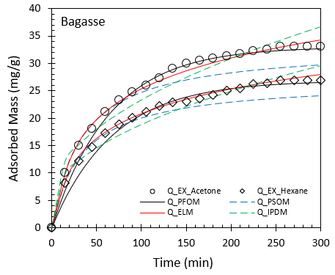
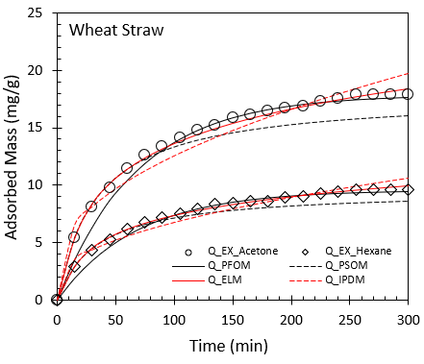
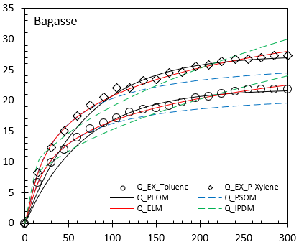
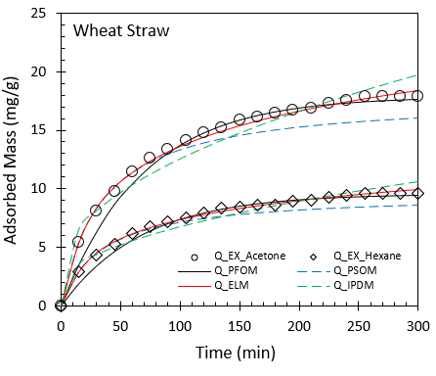
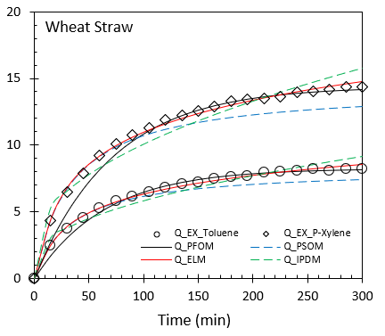
Fig. 3. kinetics of multi-component sorption of acetone, hexane, toluene, and p-xylene on WS and BG biochar.
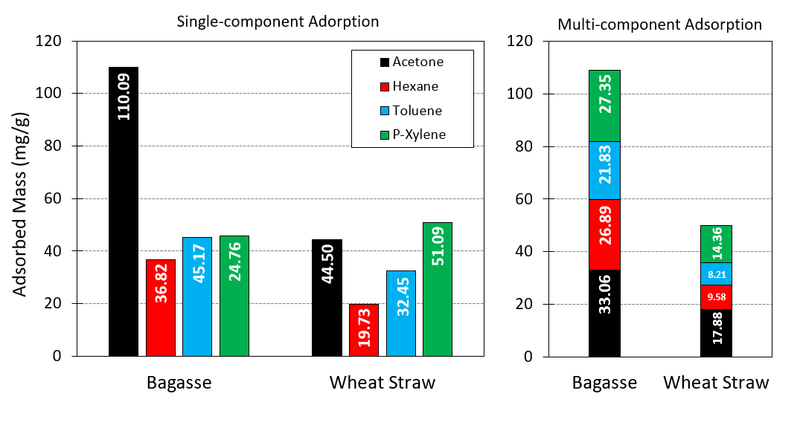
Fig. 4. Comparison of adsorption capacity of BG and WS biochar in single and multi-component experiments.

The reduction in total adsorption capacity of multicomponent gas compared to the single component can be explained by increased competitive inhibition of the sorption process (Fig. 5), which leads to a lower sorbed mass and slightly rapid saturation (Vikrant et al., 2020). The reductions in the saturation time were in the range of 7.1-16.7% and 5.3-13.2% for all the chemicals on WS and BG, respectively. This is attributed to a higher molecular diffusion under competitive inhibition (Jahandar Lashaki et al., 2016). A higher reduction in the overall sorption capacity of each compound in multi-component tests was observed in WS (51-75%) in comparison to BG (27-70%). This is expected to be associated with the lower SSA/PV which gives fewer active sites within the WS structure to adsorbates. The reductions in maximum sorption between individuals and mixtures are more significant for lighter VOCs (acetone) than heavier VOCs considered in this study (hexane, toluene, and p-xylene). This is particularly highlighted on bagasse which can be related to greater van der Waal's interactions between carbon surface and heavier compounds having more carbon atoms (Samaddar et al., 2019). The sorption order also remained unchanged for BG in both single and multi-component tests (acetone>p-xylene>toluene>hexane), for WS however, there was a slight discrepancy in this order for hexane and toluene. A higher uptake of hexane by WS in comparison to toluene may be attributed to the greater molecular diffusivity within the pores. In addition, the larger kinetic diameter of toluene molecules can also act as a barrier to their competitive sorption with hexane to secure access to the active sites.
This behaviour is not valid for acetone with smaller molecules (3.8Å) than hexane since its multi-component uptake by BG is seen to reduce by 65.12%. Larger individual uptake of acetone may be related to the greater contributions of smaller pores in capturing acetone of which a large quantity is now blocked by larger molecules of hexane, toluene, and p-xylene in the competitive process. Similar behaviour observed in uptakes of toluene and p-xylene from mixed gas on both biochar types can be related to their similar kinetic diameter (5.9 Å) and molecular shape (aromaticity); however, their sorbed amounts were more reduced by competitive sorption on WS (29-36%) mainly due to its lower SSA/PV compared with BG (10-27%). The results of multi-component experiments provide confidence in the reliability of biochar as an efficient adsorbent with adequate sorption capacity to control VOC emissions from crude oil contaminated lands for a range of aromatic/non-aromatic chemicals with different molecular characteristics.

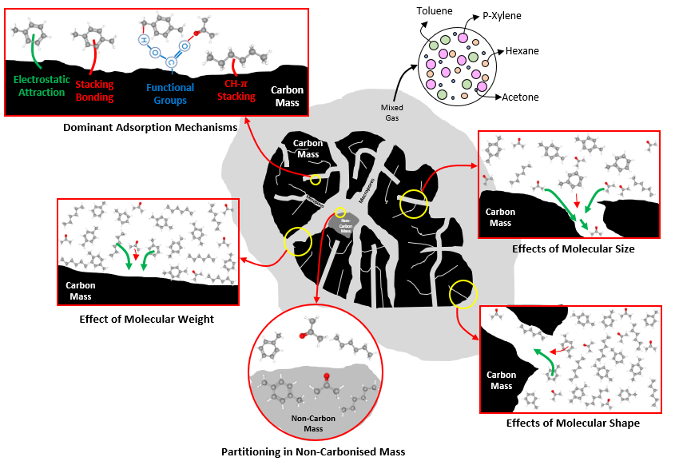
Fig. 5. Graphical description of dominant mechanisms in competitive adsorption.

3.4. Desorption
Desorption is an important index for adsorbents commercialisation since regeneration potential is a critical property of an adsorbent demonstrating its reusability for adsorption system as well as safety/reliability for ex-situ regeneration process (Jang et al., 2020; Feizbakhshan et al., 2021). With regards to the effects of elevated temperature on the desorption process of VOCs on biochar, studies reported indicate that the saturated biochar (from a range of feedstocks) can retain between 50 and 95% of the adsorbed volatile chemicals at 50-60$℃$ (Xiang et al., 2020; Zhang et al., 2020). It shows the reliability of biochar materials for containment purposes to retain adsorbed volatile chemicals even under extreme operating conditions. The desorption process should also be investigated to better comprehend the dominant mechanisms of adsorption (Zhang et al., 2020a). The regeneration potential of the used biochar was investigated through five successive adsorption-desorption tests with acetone and toluene as n(Feizbakhshan et al., 2021)on-aromatic and aromatic CVEs, respectively. The experimental procedure for the assessment of VOC desorption from biochar is described in Section 2.3, and the results are presented in Fig. 6. Both samples (BG and WS) indicated regeneration efficiency (RE) (Eq. S2) of approximately 86.9-96.4% overall cyclic tests as a reliable range for biochar. From the results, it can be observed that the majority of gas desorption occurs in the first cycle. Depending on the biochar type and gas specie, on average, 4 to 13 % of adsorbed gas was released during the first cycle, whereas in subsequent cycles, there were slight fluctuations in the detected regeneration efficiency. The results of desorption tests show that the majority of adsorbed gas remains within the structure of biochar which can be related to the creation of some permanent bonds between VOC molecules and functional groups on biochar surface (Zhang et al., 2017b) and/or heel build-ups during cyclic adsorption-desorption of VOCs (Jahandar Lashaki et al., 2020). Acetone presented the highest and lowest RE for WS (95.4%) and BG (90.1%), respectively, because of its different desorption mechanisms in these samples. Desorption of acetone from wheat straw is simpler than from bagasse since BG has a high-SSA structure in which pore filling is dominant, and more pore blockage and oligomerization are probable during desorption (heel formation) (Lashaki et al., 2012).

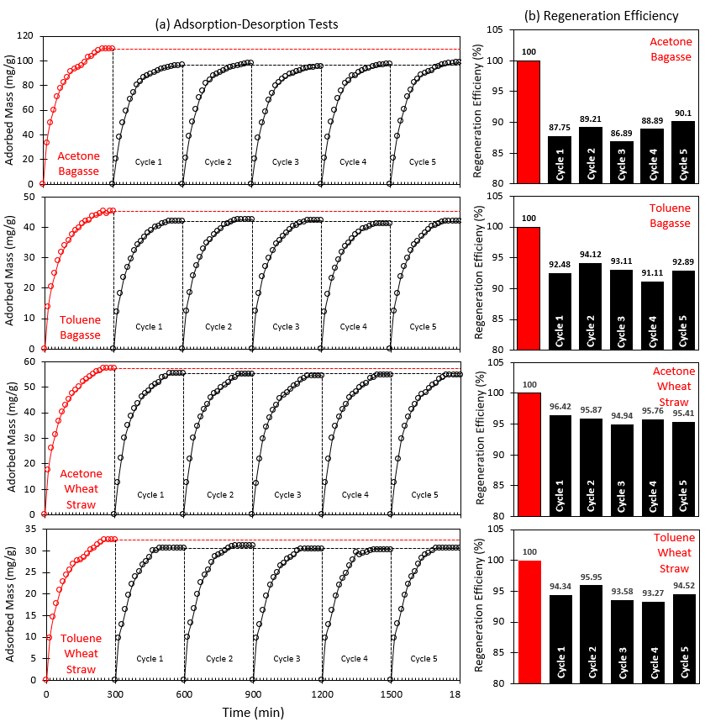
Fig. 6. Adsorption-desorption cycles of acetone and toluene on BG and WS biochar.

Compared to acetone, toluene showed relatively similar desorption behaviour and RE, although its desorption mechanisms may have been different. More molecules of toluene retained within WS after desorption due to its higher boiling point in comparison to acetone and better surface chemistry of WS with more active sites (than BG). However, a higher desorption rate from BG was observed for toluene. Toluene has relatively large molecules and therefore its access to the adsorption sites in smaller pores and canals of BG are limited which leads to an easier release of gas molecules of toluene in larger channels and pores (Yang et al., 2020).

3.5. Sorption modelling
Figs. 2 and 3 also present a comparison of the experimental results with the sorption dynamics anticipated by the conventional kinetic models including PFOM, PSOM, ELM and IPDM. The coefficients of determination (R²) and the sum of the squared errors (SSE) are provided in Table S2-3. Overall, there are strong correlations between the kinetic models and the experimental data. However, the data from the ELM model showed the best fits to the test results in both single gas (e.g., R²=0.998 and SSE=1.33 for hexane on WS) and multi-component sorption experiments (e.g., R²=0.998 and SSE=1.63 for toluene on BG). Based on the results, PFOM and PSOM underestimated the amount of sorption at equilibrium up to 1.23% and 11.53% in single gas and 0.98% and 10.42% in the mixed gas, respectively, while ultimate sorption was overestimated by IPDM up to 9.34% and 9.98% in single and multi-component tests. The robust agreement between the ELM data and experimental results may be attributed to the Elovich equation assumption. The Elovich kinetic model is the best fit for the experimental data when chemical adsorption on heterogeneous adsorbing surfaces is the dominant mechanism (Wu et al., 2009). This agreement indirectly confirms that the chemical interactions of hydrogen bonding (CH-$π$ & $π$-$π$ stacking) and electrostatic attraction through functional groups served as chemisorption sites are the main mechanisms of adsorption in the system, as previously discussed in sections 3.2 and 3.3 along with pore-filling. The curve-fitting plots of IPDM ($Q_{t}^{IPDM}$ versus $t^{0.5}$) for both single- and multi-component sorption were found not to pass through the starting point, showing that the intraparticle diffusion is not the only rate-limiting process in adsorption mechanisms of these VOCs on the samples (Yang et al., 2014).

4. Conclusions
In this paper, we presented an experimental investigation on single and multicomponent sorption kinetics of aromatic and non-aromatic volatile organic compounds on two types of biochar sourcing from commonly available agricultural wastes (wheat straw and bagasse). Investigations of the single and competitive experiments revealed sufficiently high adsorption capacities for both types of biochar, indicating the efficiency of biochar for the removal of VOC emissions from in-land oil spills under more realistic in situ conditions. The tested types of biochar showed relatively similar total adsorption capacity for single (51-110 mg/g) and mixed gases (50-109 mg/g). Bagasse showed the highest sorption capacity in both single and multi-component tests, mainly due to its higher SSA and PV. The highest adsorption on the used biochar was recorded for acetone with the smallest molecular diameter; however, its uptake was reduced up to 65% by competitive inhibition of the multi-component adsorption process. Hydrogen bonding, electrostatic interaction, and pi-stacking, as well as partitioning, were found to be the main sorption mechanisms in both single and competitive VOC uptake by biochar. The Elovich model presented the best fit for the experimental data providing further confirmation for chemical interactions to be the dominant mechanism. The sorption capacity of the biochar samples was adequately sustained after five cycles of sorption-desorption tests (88-96%). The regeneration efficiency is a crucial parameter where adsorbent reproduction is required. The comprehensive experimental work carried out in this study has demonstrated for the first time the promising potentials of biochar as a sustainable, low-cost and effective capping system to uptake and contain the mission of harmful VOCs from crude oil-contaminated lands.

Acknowledgements
H Rajabi acknowledges the financial support through Dean’s Awards of the Faculty of Science and Engineering at the University of Manchester. M Hadi Mosleh and M Sedighi gratefully acknowledge the financial support provided for the project VOCaL by the University of Manchester Research England GCRF QR Allocation and the Department for Business, Energy and Industrial Strategy via British Council by grant 527663638 (GeoGrab). The authors would like to thank Prof. Yazid Bindar and Mr Pandit Hernowo from Bandung Institute of Technology (ITB) for their support in this project and the production of biochar.

References
Ahmad, M., Rajapaksha, A.U., Lim, J.E., Zhang, M., Bolan, N., Mohan, D., Vithanage, M., Lee, S.S., Ok, Y.S., 2014. Biochar as a sorbent for contaminant management in soil and water: a review. Chemosphere 99, 19-33.
Ausma, S., Edwards, G.C., Fitzgerald-Hubble, C.R., Halfpenny-Mitchell, L., Gillespie, T.J., Mortimer, W.P., 2002. Volatile Hydrocarbon Emissions from a Diesel Fuel-Contaminated Soil Bioremediation Facility. Journal of the Air & Waste Management Association 52, 769-780.
Bocos-Bintintan, V., Ratiu, I.A., Al-Suod, H., 2019. Real time monitoring of soil contamination with diesel fuel using photoionization detectors. Arab Journal of Basic and Applied Sciences 26, 446-452.
Cao, Y., Xiao, W., Shen, G., Ji, G., Zhang, Y., Gao, C., Han, L., 2019. Carbonization and ball milling on the enhancement of Pb(II) adsorption by wheat straw: Competitive effects of ion exchange and precipitation. Bioresource Technology 273, 70-76.
Chatterjee, R., Sajjadi, B., Chen, W.-Y., Mattern, D.L., Hammer, N., Raman, V., Dorris, A., 2020. Impact of Biomass Sources on Acoustic-Based Chemical Functionalization of Biochars for Improved CO2 Adsorption. Energy & Fuels 34, 8608-8627.
Chen, B., Zhou, D., Zhu, L., 2008. Transitional adsorption and partition of nonpolar and polar aromatic contaminants by biochars of pine needles with different pyrolytic temperatures. Environmental science & technology 42, 5137-5143.
Chen, Y., Zhang, X., Chen, W., Yang, H., Chen, H., 2017. The structure evolution of biochar from biomass pyrolysis and its correlation with gas pollutant adsorption performance. Bioresource Technology 246, 101-109.
Cheng, J., Li, H., Zhou, J., Lin, Z., Wu, D., Liu, C., Cao, Z., 2020. Laser induced porous electrospun fibers for enhanced filtration of xylene gas. Journal of Hazardous Materials 399, 122976.
Coronel Vargas, G., Au, W.W., Izzotti, A., 2020. Public health issues from crude-oil production in the Ecuadorian Amazon territories. Science of The Total Environment 719, 134647.
EPA, U., 2019. Volatile Organic Compounds’ Impact on Indoor Air Quality. Recuperado de: https://www. epa. gov/indoor-air-quality-iaq/volatile-organiccompounds-impact-indoor-air-quality# intro.
Feizbakhshan, M., Amdebrhan, B., Hashisho, Z., Phillips, J.H., Crompton, D., Anderson, J.E., Nichols, M., 2021. Effects of oxygen impurity and desorption temperature on heel build-up in activated carbon. Chemical Engineering Journal 409, 128232.
Feng, S.-J., Zhu, Z.-W., Chen, H.-X., Chen, Z.-L., 2020. Two-dimensional analytical solution for VOC vapor migration through layered soil laterally away from the edge of contaminant source. Journal of Contaminant Hydrology 233, 103664.
Hernández-Monje, D., Giraldo, L., Moreno-Piraján, J.C., 2018. Study of Hexane Adsorption on Activated Carbons with Differences in Their Surface Chemistry. Molecules (Basel, Switzerland) 23.
Jahandar Lashaki, M., Atkinson, J.D., Hashisho, Z., Phillips, J.H., Anderson, J.E., Nichols, M., 2016. The role of beaded activated carbon’s surface oxygen groups on irreversible adsorption of organic vapors. Journal of Hazardous Materials 317, 284-294.
Jahandar Lashaki, M., Hashisho, Z., Phillips, J.H., Crompton, D., Anderson, J.E., Nichols, M., 2020. Mechanisms of heel buildup during cyclic adsorption-desorption of volatile organic compounds in a full-scale adsorber-desorber. Chemical Engineering Journal 400, 124937.
Jang, Y., Bang, J., Seon, Y.-S., You, D.-W., Oh, J.-S., Jung, K.-W., 2020. Carbon nanotube sponges as an enrichment material for aromatic volatile organic compounds. Journal of Chromatography A 1617, 460840.
Kim, J., Lee, S.S., Khim, J., 2019. Peat moss-derived biochars as effective sorbents for VOCs’ removal in groundwater. Environmental geochemistry and health 41, 1637-1646.
Kumar, A., Singh, E., Khapre, A., Bordoloi, N., Kumar, S., 2020. Sorption of volatile organic compounds on non-activated biochar. Bioresource Technology 297, 122469.
Lashaki, M.J., Fayaz, M., Wang, H., Hashisho, Z., Philips, J.H., Anderson, J.E., Nichols, M., 2012. Effect of Adsorption and Regeneration Temperature on Irreversible Adsorption of Organic Vapors on Beaded Activated Carbon. Environmental Science & Technology 46, 4083-4090.
Lim, M.W., Lau, E.V., Poh, P.E., 2016. A comprehensive guide of remediation technologies for oil contaminated soil — Present works and future directions. Marine Pollution Bulletin 109, 14-45.
Minella, M., Minero, C., 2021. Evaluation of gas / solid photocatalytic performance for the removal of VOCs at ppb and sub-ppb levels. Chemosphere 272, 129636.
Mızrak, B., Altındal, A., Abdurrahmanoğlu, Ş., 2017. Synthesis, characterization and partition coefficients for VOC vapor adsorption onto novel pyridine derivatives Co(II) phthalocyanines. Progress in Organic Coatings 109, 92-96.
Navarro Amador, R., Cirre, L., Carboni, M., Meyer, D., 2018. BTEX removal from aqueous solution with hydrophobic Zr metal organic frameworks. Journal of Environmental Management 214, 17-22.
Onyena, A.P., Sam, K., 2020. A review of the threat of oil exploitation to mangrove ecosystem: Insights from Niger Delta, Nigeria. Global Ecology and Conservation 22, e00961.
Pandya, G., Gavane, A., Bhanarkar, A., Kondawar, V., 2006. Concentrations of volatile organic compounds (VOCs) at an oil refinery. International journal of environmental studies 63, 337-351.
Rajabi, H., Hadi Mosleh, M., Mandal, P., Lea-Langton, A., Sedighi, M., 2020. Emissions of volatile organic compounds from crude oil processing – Global emission inventory and environmental release. Science of The Total Environment 727, 138654.
Rajabi, H., Mosleh, M.H., Mandal, P., Lea-Langton, A., Sedighi, M., 2021. Sorption behaviour of xylene isomers on biochar from a range of feedstock. Chemosphere 268, 129310.
Rajabi, H., Sharifipour, M., 2017. An Experimental Characterization of Shear Wave Velocity (Vs) in Clean and Hydrocarbon-Contaminated Sand. Geotechnical and Geological Engineering 35, 2727-2745.
Rajabi, H., Sharifipour, M., 2018. Influence of weathering process on small-strain shear modulus (Gmax) of hydrocarbon-contaminated sand. Soil Dynamics and Earthquake Engineering 107, 129-140.
Rajabi, H., Sharifipour, M., 2019. Geotechnical properties of hydrocarbon-contaminated soils: a comprehensive review. Bulletin of Engineering Geology and the Environment 78, 3685-3717.
Samaddar, P., Kim, K.-H., Yip, A.C.K., Zhang, M., Szulejko, J.E., Khan, A., 2019. The unique features of non-competitive vs. competitive sorption: Tests against single volatile aromatic hydrocarbons and their quaternary mixtures. Environmental Research 173, 508-516.
Solanki, A., Boyer, T.H., 2019. Physical-chemical interactions between pharmaceuticals and biochar in synthetic and real urine. Chemosphere 218, 818-826.
Thongsai, N., Jaiyong, P., Kladsomboon, S., In, I., Paoprasert, P., 2019. Utilization of carbon dots from jackfruit for real-time sensing of acetone vapor and understanding the electronic and interfacial interactions using density functional theory. Applied Surface Science 487, 1233-1244.
Vikrant, K., Kim, K.-H., Kumar, V., Giannakoudakis, D.A., Boukhvalov, D.W., 2020. Adsorptive removal of an eight-component volatile organic compound mixture by Cu-, Co-, and Zr-metal-organic frameworks: Experimental and theoretical studies. Chemical Engineering Journal 397, 125391.
Wang, G., Dou, B., Zhang, Z., Wang, J., Liu, H., Hao, Z., 2015a. Adsorption of benzene, cyclohexane and hexane on ordered mesoporous carbon. Journal of environmental sciences 30, 65-73.
Wang, H., Fischer, T., Wieprecht, W., Möller, D., 2015b. A predictive method for volatile organic compounds emission from soil: Evaporation and diffusion behavior investigation of a representative component of crude oil. Science of the Total Environment 530, 38-44.
Wang, J., Wang, S., 2019. Preparation, modification and environmental application of biochar: A review. Journal of Cleaner Production 227, 1002-1022.
Wang, Q., Zuo, X., Xia, M., Xie, H., He, F., Shen, S., Bouazza, A., Zhu, L., 2019. Field investigation of temporal variation of volatile organic compounds at a landfill in Hangzhou, China. Environmental Science and Pollution Research 26, 18162-18180.
Wang, Z., Sedighi, M., Lea-Langton, A., 2020. Filtration of microplastic spheres by biochar: removal efficiency and immobilisation mechanisms. Water Research 184, 116165.
Wu, F.-C., Tseng, R.-L., Juang, R.-S., 2009. Characteristics of Elovich equation used for the analysis of adsorption kinetics in dye-chitosan systems. Chemical Engineering Journal 150, 366-373.
Xiang, W., Zhang, X., Chen, K., Fang, J., He, F., Hu, X., Tsang, D.C.W., Ok, Y.S., Gao, B., 2020. Enhanced adsorption performance and governing mechanisms of ball-milled biochar for the removal of volatile organic compounds (VOCs). Chemical Engineering Journal 385, 123842.
Xie, H., Wang, Q., Bouazza, A., Feng, S., 2018. Analytical model for vapour-phase VOCs transport in four-layered landfill composite cover systems. Computers and Geotechnics 101, 80-94.
Xie, H., Wang, Q., Yan, H., Chen, Y., 2017. Steady-state analytical model for vapour-phase volatile organic compound (VOC) diffusion in layered landfill composite cover systems. Canadian Geotechnical Journal 54, 1567-1579.
Xie, H., Yan, H., Thomas, H.R., Feng, S., Ran, Q., Chen, P., 2016. An analytical model for vapor-phase volatile organic compound diffusion through landfill composite covers. International Journal for Numerical and Analytical Methods in Geomechanics 40, 1827-1843.
Yaashikaa, P.R., Kumar, P.S., Varjani, S., Saravanan, A., 2020. A critical review on the biochar production techniques, characterization, stability and applications for circular bioeconomy. Biotechnology Reports 28, e00570.
Yang, G., Chen, H., Qin, H., Feng, Y., 2014. Amination of activated carbon for enhancing phenol adsorption: Effect of nitrogen-containing functional groups. Applied Surface Science 293, 299-305.
Yang, Y., Sun, C., Lin, B., Huang, Q., 2020. Surface modified and activated waste bone char for rapid and efficient VOCs adsorption. Chemosphere, 127054.
Yu, X., Liu, S., Lin, G., Zhu, X., Zhang, S., Qu, R., Zheng, C., Gao, X., 2018. Insight into the significant roles of microstructures and functional groups on carbonaceous surfaces for acetone adsorption. RSC Advances 8, 21541-21550.
Yuan, T.Q., Sun, R.C., 2010. Introduction. Cereal Straw as a Resource for Sustainable Biomaterials and Biofuels, pp. 1-7.
Zhang, X., Gao, B., Creamer, A.E., Cao, C., Li, Y., 2017a. Adsorption of VOCs onto engineered carbon materials: A review. Journal of Hazardous Materials 338, 102-123.
Zhang, X., Gao, B., Fang, J., Zou, W., Dong, L., Cao, C., Zhang, J., Li, Y., Wang, H., 2019. Chemically activated hydrochar as an effective adsorbent for volatile organic compounds (VOCs). Chemosphere 218, 680-686.
Zhang, X., Gao, B., Zheng, Y., Hu, X., Creamer, A.E., Annable, M.D., Li, Y., 2017b. Biochar for volatile organic compound (VOC) removal: Sorption performance and governing mechanisms. Bioresource Technology 245, 606-614.
Zhang, X., Miao, X., Xiang, W., Zhang, J., Cao, C., Wang, H., Hu, X., Gao, B., 2020a. Ball milling biochar with ammonia hydroxide or hydrogen peroxide enhances its adsorption of phenyl volatile organic compounds (VOCs). Journal of Hazardous Materials, 123540.
Zhang, X., Xiang, W., Wang, B., Fang, J., Zou, W., He, F., Li, Y., Tsang, D.C.W., Ok, Y.S., Gao, B., 2020b. Adsorption of acetone and cyclohexane onto CO2 activated hydrochars. Chemosphere 245, 125664.
Zhu, L., Shen, D., Luo, K.H., 2020. A critical review on VOCs adsorption by different porous materials: Species, mechanisms and modification methods. Journal of Hazardous Materials 389, 122102.

