**Effect of External Post-tensioning on Steel-Concrete Composite Beams with Partial Connection**

[Alaa E. El-Sisi](http://www.sciencedirect.com/science/article/pii/S1350630713002951)1, Ahmed I. Hassanin2, Hesham F. Shabaan3, Ahmed I. Elsheikh4

1Postdoctoral Fellow, Department of Civil and Environmental Engineering, University of Missouri, Columbia, MO 65211-2200, USA; Email: [ElsisiAE@missouri.edu](mailto:ElsisiAE@missouri.edu), on leave from Structural Engineering Department, Zagazig University, Zagazig, 44519, Egypt.

2 PhD, Lecturer, Engineering Construction Dept., Faculty of Engineering, Egyptian Russian University, Postal Code11829 (+2) 02 2860-9114, Cairo, Egypt; Email: [ahmed-ibrahim@eru.edu.eg](mailto:ahmed-ibrahim@eru.edu.eg)

3PhD, Professor of Structural Engineering and Dean of Faculty of Engineering,

Zagazig University, Postal Code 44519, Zagazig, Egypt; Email: [hmshaban@eng.zu.edu.eg](mailto:hmshaban@eng.zu.edu.eg)

4 PhD, Professor of Structural and Bio-mechanical Engineering and Dean of School of Engineering, University of Liverpool, F: 0151 7944703, Liverpool, UK; Email: [elsheikh@liv.ac.uk](mailto:elsheikh@liv.ac.uk)

## ABSTRACT

In this paper, an experimental and numerical study was presented for strengthened composite steel-concrete beams using externally post-tensioning tendons with a partial shear connection. Four composite steel-concrete beams under a static monotonic load were tested to validate the numerical model and investigate the different failure mechanisms. The cracking behaviors of the composite beams and overall moment of resistance have been experimentally and numerically studied. The validated numerical model was used to perform a parametric study. It was found that the initial tendon force increased by 18-23% due to the beam bending, which led to an enhancement in the performance of the beam. Moreover, increasing the degree of shear connection (**DOSC)** from 40% to 100% led to an increase in the mean maximum load by 46% and to decrease the mean maximum deflection by 22.5%. In addition, there was an improvement in the slippage by achieving 28% decrease. Also, there was a decrease in steel flange micro-strain by about 51%.

**Keywords:** Composite Beams; Finite Element Modeling; Partial Interaction; Post-tensioning.

## INTRODUCTION

Over the past two decades, the post-tensioning system entered the line of the most widely used strengthening systems. This technique enabled the designers and engineers to achieve more efficient materials usage in terms of decreasing deflection and increasing both the stiffness and bearing capacity of the structural members. Many of the research works studied this strengthening technique and reported on the efficiency of this technique in enhancing the structural element behavior under the influence of different types of loads. Ayyoub et al. performed an experimental investigation on composite beams. It was concluded that although straight tendon profile is favored due to the lower cost, draped tendon performed more efficiently in terms of capacity and deflection. They also concluded that prestressing a conventional composite girder can significantly increase the load at which first yielding occurs and the ultimate capacity of the beams [1]. Chen presented experimental tests on a full-scale composite beam (**CB**) strengthened with external post-tensioning tendons under the effect of positive moments [2]. It was found that adding post-tensioning tendons increased the yield load and ultimate resistance significantly by about 49% and 53% respectively. It was also observed that the maximum moment of the non-strengthened specimens was approximately the plastic moment in which the steel section was completely plastic. While the maximum moment of strengthened specimens ranged from 1.03 to 1.11 from the moment of the yield moment at which the compression flange-initiated yield. Analytical and experimental studies were used by Nie et. al, to investigate the behavior of pre-stressed steel-concrete **CBs** [3]. A reduced stiffness method for measuring the deflection, yield, and final moments of pre-stressed **CBs** was proposed. It was noted that using the slip effect on yield moment and deflection would increase the accuracy of analytical predictions significantly. The yield moment of the pre-stressed continuous steel-concrete **CB** could be finally expressed by:

Mpy = ξ×My (1)

Where ξ= Coefficient of slip effect accounted for the pre-stressed continuous steel-concrete **CB**, and My: Calculated yield moment by transformed section method and it could be determined from Eq.2

My = W (ɛi + ɛy) Es (2)

Where W: equivalent section modulus and ɛi strain at bottom of steel caused by tendon before

casting the concrete slab& ɛy the yield strain of the steel beam respectively.

The formulas proposed can be used accurately for the design and analysis of pre-stressed **CBs** since they showed a strong agreement with the experimental findings.Chen et al. performed a comparative experimental study on pre-stressed continuous steel-concrete **CBs** [4]. The cracking behavior and load-bearing capacity of the beam were tested experimentally. It was found that the ultimate resistance of an externally pre-stressed **CB** is controlled either by distortional lateral buckling or local buckling or by a mode integrated of these two patterns. It was also concluded that pre-stressing with external tendons on a continuous **CB** could increase the degree of internal force and the redistribution of the moment in the beam.

Lorene and Kubica assessed the efficiency of the moment redistribution of the pre-stressed continuous **CBs**. It was noticed that in the ultimate state, the redistribution moment is greater than the non-pre-stressed **CBs** case. Experimental tests were conducted on six **CBs**. Five were pre-stressed with straight and draped tendons [5]. Displacement, slip, and concrete and steel strain results led to several conclusions on pre-stressed **CB** behavior under static loads. It was also concluded that steel-concrete bond cohesion can significantly influence the behavior of the shear connection in CBs. They also found that to determine the load-carrying capacity of the composite beam prestressed with external tendons, the force in the tendons in the ultimate state must be assumed to be the correct value. When the initial force value was used, the capacity was underrated, whereas when the tendon resistance value was used, the capacity was overrated. And it has been concluded that in order to reach the appropriate load capacity of the beam, the initial prestressing force amounted to about 63% of the total force in the tendons in the ultimate state. Push-out tests were performed to determine the load-slip relationship between the concrete slab and the steel I-beam. It was concluded that the tendon provided a substantial part of the connector force before ultimate loads, which resulted in slip prediction difficulties.

De Lee et al. presented an experimental study for three full-scaled non-pre-stressed and pre-stressed **CBs** with the corrugated web under flexural loading [6]. The test result showed that the upper and lower flange initial stress of the steel beam increased significantly due to the accordion effect before compositing with concrete. In addition, the flexural strength and rigidity of the pre-stressed specimens after compositing with concrete were superior to those of the non- pre-stressed specimens.

El-Zohairy et al. used Finite element modeling to simulate steel-concrete **CBs**' nonlinear flexural behavior for beams strengthened externally with post-tensioned wires/tendons [7]. The nonlinear material and geometric behaviors were implemented based on incremental-iterative loading methods. A comparison was provided between the results of the finite element analysis and preceding experimental results. Work was carried out on the overall behavior of the strengthened beams and the effect of external post-tensioning on rigidity, induced stress, slippage between the concrete slab and steel portion, and shear connector moments. It was concluded that using external post-tensioning tendons for steel-concrete **CBs** in the positive moment region increased their ultimate load by 25 percent, the rigidity by 33 percent.

Sousa et al. introduced a nonlinear finite element model based on displacement formulation for the pre-stressed **CBs** [8]. The model included tendon and beam elements where the tendon was modeled as a load-resistant element, and relative displacements between steel and concrete can be taken into account. The pre-stressing stage numerical analysis was performed by adopting a newly evolved strain control equilibrium method, followed by a load-controlled displacement stage. The results showed the influence of considering the partial interaction of the pre-stressed **CBs** on evaluating accurate ultimate resistance and stiffness. It also demonstrated the importance of nonlinear geometric effects of the tendon on moments and stress distribution of the members. It is important to realize that the design of the experiment was carried out with the objective of achieving full composite interaction with small slippage during the experiments.

Ozturk et al. developed a simplified nonlinear fiber-based finite element model of steel-concrete partially composite beams utilizing channel-type mechanical shear connectors. The interaction between the steel beam and concrete slab was accounted for by introducing nonlinear zero-length elements and rigid links. The channel shear connector response used in numerical models was based on the previously obtained experimental response from pushout tests. The results showed that the initial elastic stiffness and load capacity of the composite beams increased as the shear studs were distributed closer to the end of the beam. This indicated what extent the dependence of the stiffness and strength of the composite beams on the location of the shear connector. Furthermore, they concluded that the stiffness of the shear connectors also influences the magnitude of interface slip between steel section and concrete slab and the extent of cross-sectional strain profile compatibility between them [9].

Hassanin et al. performed a recently completed experimental program on scaled bridge composite steel-concrete beams strengthened with external post-tensioning tendons to investigate the fundamental cyclic loading behavior. In addition to studying the effect of the strengthening system, there was another major factor under study which was the degree of shear connection. The study mainly relied on testing the beams under the influence of cyclic loads in addition to changing the degree of shear contact. Based on the experimental results, adding external post-tensioning enhanced the overall performance of the composite beams under cyclic loading by significantly reducing strains of the shear studs by about 23 percent, the concrete flange by about 18 percent, and the steel I-beam bottom flange by about 27 percent at all loading stages [10].

A fundamental aspect of **CB** structural behavior and design is the degree of shear connection (**DOSC**) of the composite connection between the steel section at the top of the flange and the concrete slab. Most of the previous literature dealt with **CBs** in the case of full composite action, although the case of partial composite action is already existed in many buildings and bridges, as a result of increasing the loads, changing the use of the structure, or even the lack of accurate implementation of the full connection between the steel section and the concrete slab.

Most previous studies relied on the use of finite element modeling programs to represent this type of beam. In addition, the studies that were done in most cases used push-out tests rather than experimental composite beam tests. Therefore, this study presents new progress in the following:

* Experimentally study the effect of adding external post-tensioning tendons as a strengthening technique for both full and partial composite beams.
* Numerically study the effect of using straight and triangle tendon profiles in full and partial composite action cases.
* Due to the difficulty of monitoring uplift between the steel beam and concrete slab, it was not paid a lot of attention in previous studies. In this study, the uplift was experimentally and numerically studied.

In this paper, experimental and numerical studies were performed to investigate the influence of adding external post-tensioning tendons on the structural performance of composite beams with partial and full shear interaction. Four steel-concrete **CBs** were tested under the exposure of a positive bending moment. Experimental results such as load-deflection curves, tendon strain, flange strain, and failure mode were analyzed. Finite element modeling was performed, and the model was validated by using the experimental results. The validated finite element model was used to perform a parametric study to show the effect of different parameters, such as tendon pattern and partial interaction.

**EXPERIMENTAL STUDY**

In this section, the experimental program will be discussed, including the sample geometries, the material characteristics, and the test setup.

### Test Specimens and Arrangements

In this paper, four composite beams were studied under a positive moment, see **Table 1**. Composite beams S-B100 and S-B70 were used as controlled specimens, as they have no post-tensioning tendons. The two other beams S-B100T and S-B70T were strengthened by straight external post-tensioning tendons and tested to study the effect of post-tensioning on the composite action levels. The samples were designed with an 11.6 span to depth ratio and 0.25 slab width to span ratio to be as closer as we can to the practical bridge beams.

**Figure 1** illustrates the composite beams; the samples have the same cross-section, which consists of a concrete slab, steel I beam. For the beams S-B100T and S-B70T, two post-tensioning tendons were added to each one. The steel top and bottom flange widths were 82×7.4 mm, and the web height was 160×5 mm. The total beam length was 3250 mm with a simply supported span of 3000 mm. By means of shear stud connectors, a concrete slab 750 mm wide, 100 mm thick, and 3250 mm long was compositely connected to the steel top flange.

In accordance with Eurocode 4 standards, the full and partial shear connections were achieved [11]. One shear stud row of 16 mm diameter and 65 mm length was welded to the top flange at a longitudinal spacing of 187 mm to provide the full composite action of S-B100 and S-B100T beams. While for partially composite action beams S-B70 and S-B70T, the spacing was 250 mm with the same diameter and length. The concrete slab was reinforced in two orthogonal directions with *φ*8 deformed bars (8 mm in diameter). At the supports, two pairs of 8 mm stiffener plates were attached to the steel beam to prevent beam distortion due to the reaction force.

Each post-tensioned beam was utilized by two 10 mm diameter high-strength tendons with a nominal cross-sectional area of 78.5 mm2. The post-tensioning bars were attached to the 20 mm thickness end-plates of the steel beams. The tendons are positioned above the bottom flange at a distance of 40.6 mm. They were extended across the full length of the steel beam on both sides of the web.

The beams S-B100T and S-B70T were post-tensioned after 28 days of concrete casting. The post-tension was applied in two stages for safety issues. In the first stage, the composite specimen was loaded with a small amount of load at a non-post-tensioning state to adequately hold the sample. In the second stage, the post-tensioning was performed until an initial post-tensioning force of 81.7 kN in each line. The cross-section and arrangement of specimens are shown in **Figure 1**.

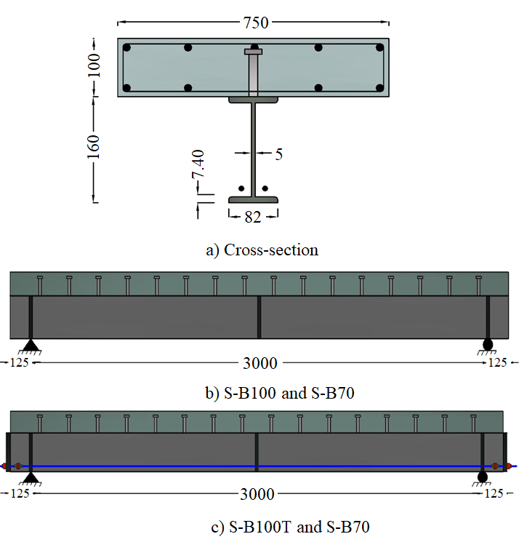

**Figure 1**: Geometry of the test specimens.

### Material Characteristics

The concrete mix for the slabs was designed to give 32 MPa of characteristic compressive strength. The concrete was cast in two patches; from each patch, four cubes were taken to test the mean compressive strength. The 28 days mean compressive strength of the first patch was 34.2, where it was used to cast samples **S-B100** and **S-B100T.** The second patch was used to cast samples **S-B70** and **S-B70T,** anditgave amean compressive strength of 38 MPa after 28 days.

For the preliminary design of the post-tensioning process to manage cracks in the slabs, a nominal concrete tensile strength of 3.4 and 3.8 MPa was used. The mean tensile properties of coupon samples cut off from the beam web, and the flanges and tendon tensile properties were shown in **Table 1**.

Table 1 Summary of Material Properties for the tested Composite Beams

|  |  |  |  |  |  |  |
| --- | --- | --- | --- | --- | --- | --- |
| **Material** | | | **Sample** | | | |
| **Element** | **Property** | | **S-B100** | **S-B70** | **S-B100T** | **S-B70T** |
| **Tendons** | ***fy*,MPa** | | ~ | | 582.4 | |
| ***fu*,MPa** | | ~ | | 716.6 | |
| ***AT*,mm2** | | ~ | | 157 | |
| ***F0*, kN** | | ~ | | 178.6 | 178.6 |
| **I-Beam** | ***fy,* MPa** | Web | 323.6 | | 328.3 | |
| Flange | 336.3 | | 342.4 | |
| ***fu,* MPa** | Web | 492.5 | | 502.4 | |
| Flange | 512.6 | | 517.3 | |
| **Concrete** | ***fcu*, MPa** | | 34.2 | 38 | 34.2 | 38 |

### Full-Scale Setup and Procedure

The test setup is shown in **Figure 2**; it can be seen that a three-point bending setup was used. The load was applied to the test specimens using a 500 kN hydraulic jack. The start, end, and two quarters span shear connectors were instrumented by eight strain gages where two strain gauges were bonded to each connector, i.e., **SG1** to **SG8**. One strain gauge was mounted to the bottom flange at the mid-span of the beam, i.e., **SG10**. Moreover, for post-tensioned beams, a gauge was added to the tendon to calculate the initial strain found due to the post-tensioning process, i.e., **SG9**. Displacement transducers were used to measure the mid-span deflection and the longitudinal slippage between the steel beam and the concrete slab at one of the ends of the beam, i.e., LVDT1 and LVDT2. In addition, another displacement transducer was used to detect the loss of the post-tension strain of the tendons, which was located at the end of the post-tensioning anchor, LVDT3.

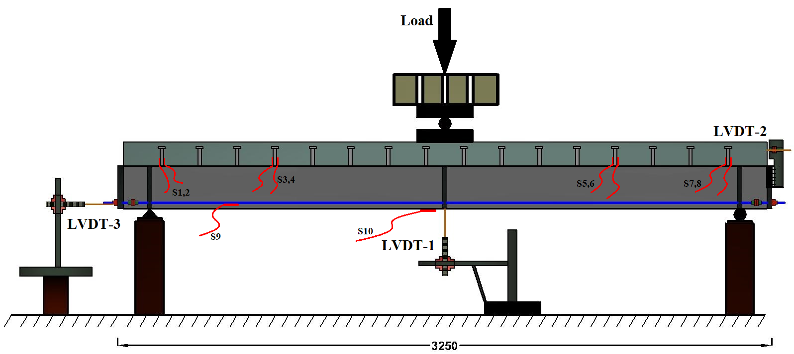

**Figure 2**: The Test Set up and instrumentation of the samples.

## NUMERICAL MODELING

The details of FEM methodology, including material type, element type, and contact details, are outlined in this section. The purpose of this FEM study is to develop an effective numerical model for predicting the static behavior of composite beams externally post-tensioned under partial and full shear connection conditions. A nonlinear 3D finite element analysis (FEA) of composite beams was performed using ANSYS Workbench V.19.2 code [12], see **Figure 3**. The concrete slab material was modeled using ANSYS concrete damage model.

|  |  |  |
| --- | --- | --- |
| Beam component | Used element | Element properties |
| Concrete slab | SOLID65 | Brick element with 8 nodes |
| Steel section | SHELL181 | Shell element with 4 nodes |
| Shear studs | SOLID45 | Brick element with 8 nodes |
| Slab reinforcement and tendons | LINK8 | 3D-link element with 2 nodes |
| Steel section-slab interface | COMBINE39 | Unidirectional spring element |
| CONTAC52 | Contact element |
|  | | |

**Figure 3:** Finite element model of composite steel-concrete beam

For the simulation of concrete, a 3D brick element with eight nodes (SOLID65) was selected, **Figure 3**. Three translational degrees of freedom are found at each node of this element in the nodal x, y, and z directions. This element is suitable for the modeling of crushing failure, concrete tension cracking, and shear transfer of concrete after cracking [13–22]. The SOLID65 element is based on a constitutive model for the triaxial behavior of concrete [12]. The smeared crack analogy is used for tension zones cracking. In addition, the damage and plasticity algorithm was used to account for the possibility of concrete crushing in compression. Before crushing or cracking, The material of concrete elements is assumed to be initially isotropic. Eight integration points are found in each element at which crushing and cracking failure criteria checks are performed. Cracking or crushing occurs once one of the element’s principal stresses exceeds the compressive or tensile strength of concrete. Cracked or crushed regions are formed perpendicular to the relevant principal stress direction. Stresses are then redistributed locally. Therefore, the element is nonlinear and requires an iterative solution. The formation of a crack is achieved by the modification of the stress-strain relationship of the element to introduce a plane of weakness in the requisite principal stress direction.

Similar to a plasticity law was used for the crushing behavior. Once integration point stresses reach the crushing, the softening behavior starts and the stress starts to release with the increase of the strain.

The stress-strain curve was used to simulate the concrete hardening plasticity is dependent on Eqns. 1 and 2 [23].

$$f=\frac{E_{c} ε}{1+{\left(\frac{ε}{ε_{0}}\right)}^{2}} (3)$$

$$ε_{0}=\frac{2{f'}_{c}}{E_{c}} \left(4\right)$$

Where Ec is referring to concrete Young's modulus, ε is referring to concrete strain and εo for concrete failure compression strain and $f$& ${f'}_{c}$ were compressive stress and ultimate strength of concrete respectively.



**Figure 4:** Concrete Compressive Stress-Strain Relation.

SHELL181 (Shell element) had been used for steel components modeling with four nodes per element with six degrees of freedom. The bilinear isotropic plasticity model was used to model components of steel beams. This model requires the definition of Young's modulus, Poison's ratio, yield stress, and plastic tangent modulus. The Young's modulus and Poison's ratio of the steel beams were 210 GPa and 0.3, respectively. The yield stress can be found in **Table 1,** and the tangent modulus was equal to 2000 MPa.

Steel rebar and tendons have been modeled using LINK180 3D link elements, which is a line element with two nodes and three degrees of freedom per node. This element can simulate material and geometric nonlinearities, such as plasticity and large deflection. The bilinear isotropic plasticity model was used for steel rebar and tendon simulation. The Young's modulus, Poison's ratio, yield stress, and tangent modulus of the steel rebar were 210 GPa and 0.3, 340 MPa and 2000 MPa, respectively. The Young's modulus, Poison's ratio yield stress, and tangent modulus of the tendon were selected to be equal to 210 GPa and 0.3, 582.4 MPa and 2000 MPa, respectively. The perfect bond is also assumed between concrete and steel rebars in order to ensure physical contact between reinforced concrete components.

A small line element (LINK180) with the same cross-sectional area of the stud was embedded in the concrete at the location of stud connectors to minimize the stress concentration at these locations.

Due to the concentration of the shear force on the shear connector zone, slippage happens. Previous experimental results showed that slippage will exist even if the degree of shear connection is 100% (Full Connection). The 100% shear connection design means that the failure will not happen in the shear connection before the bending failure of the composite beam. However, slippage will exist due to the flexibility of the shear connector. To get the most accurate behavior of the shear connector, slippage shear force relation was used from the literature.

COMBIN39 element was used to simulate slippage behavior in X-direction between the stud connector bottom node and the steel beam, while for the Y and Z direction COMBIN14 elastic spring element was used. COMBIN39 element requires a definition for the displacement-force relation as a real constant. A multi-linear load-slippage curve was assigned based on literature [24,25]. Equation 5 was used to calculate the load-slippage relation of the shear connector:

$$Q=Q_{u}{\left(1-e^{-18∆}\right) }^{\frac{2}{5}} (5)$$

Where Δ is the slippage, and Qu is the ultimate stud connector force. The force Qu can be calculated from the following relation: Qu=1.106Asf'c0.3Ec0.44; Where As is the stud area, f'c is the concrete ultimate compressive strength, and Ec is the concrete Young's modulus.

For the Y direction, the slippage behavior was neglected; therefore, linear element COMBIN14 was used. COMBIN14 requires only a definition for the stiffness, which was selected to be very high (rigid bond).

Prevention of surface penetration and ensuring physical separation of the steel and concrete components is essential to simulate the interface between the concrete slab and steel beam. Frictionless contact pairs between the top steel flange and the concrete slab were used. The contact pair can support frictionless sliding in the tangential direction and compression in the normal direction of the contact surface. More details about the formulation of ANSYS contact can be found in the documentation [12]. The friction between the steel beam and the concrete slab was neglected so that frictionless contact pairs were used.

In order to confirm the independency of the mesh size, S-B70 model meshed with different element sizes i.e., 25, 50, 75, and 100 mm. The results were very close to each other where the difference between the highest and lowest failure loads was not more than 8%. It was also noted that the difference between the mesh of 25 mm and 50 mm was less than 1.5%. In this study, the element edge size was selected to be 50 mm.

In this study, the strength and the behavior of the beam up to the peak load were the focus. Therefore, load-controlled analysis was performed by applying incremental force on the center of loading plates. The iterative incremental solution was performed to handle the problem nonlinearities such as large deflection, plasticity, and contact.

## EXPERIMENTAL RESULTS

Four simply supported **CB** samples were tested by using a quasi-static mid-span load, i.e., three-point bending setup. In this section, the experimental results will be discussed, including the load-deflection behavior, load slippage behavior, and bottom flange and cable strains. **Table 2** presents the measured initial and ultimate post-tensioning cable forces (***Fy andFu***), ultimate moments (**Mu**), yielding moments (**My**), and the mid-span yield deflection (***δy***) and ultimate deflection (***δu***).

**Table 2.** Summary of Experimental Results.

|  |  |  |  |  |  |  |  |  |  |
| --- | --- | --- | --- | --- | --- | --- | --- | --- | --- |
| **Samples** | ***F0*(kN)** | ***Fu*(kN)** | **∆%** | ***My* (kN.m)** | ***Mu* (kN.m)** | **∆%** | ***δy*(mm)** | ***δu*(mm)** | **∆%** |
| **S-B100** | --- | --- | --- | 82 | 157.5 | 92.1 | 8.6 | 26.8 | 211.6 |
| **S-B70** | --- | --- | --- | 90 | 120 | 33.3 | 11.5 | 28.5 | 147.8 |
| **S-B100T** | 178.6 | 212.3 | 18.8 | 157.5 | 200 | 26.9 | 7.3 | 18.6 | 154.7 |
| **S-B70T** | 107.2 | 132.6 | 23.7 | 116.25 | 158 | 36.1 | 7.8 | 26.4 | 238.4 |

### Load Displacement Behavior

In this section, the testing process and results will be described in detail for each sample. The load-deflection curves for all tested beams are shown in **Figure 5**.



**Figure 5**: Experimental Tests Load-Deflection Curve of the Samples.

As shown in **Figure 5,** the initial behavior of beam **S-B100** was linear elastic. The mid-span bottom flange fiber started to yield at a load of 110 kN, which is equivalent to a mid-span bending moment of 82.5 kN.m.After that, nonlinear behavior was started, as seen in the load-deflection curve. By increasing the load, cracks appeared on the bottom surface of the concrete slab, and the sound of the sudden failure of one of the shear studs was heard. Due to the loss of stability and the drop in the supporting load, the test was stopped at the displacement of 26.8 mm. After the unloading of the specimen, the residual deflection was reported to be equal to 21 mm. The maximum measured uplift and slippage values between steel beam top flange and concrete slab were 0.52 mm and 2.8 mm, respectively.

The beam **S-B70** was designed and tested under partial interaction consideration. The behavior of the beam was more ductile than the fully interacted beam **S-B100**, which led consequently to obvious differences in deflection, slippage, and also maximum load. There was a clear delay in the arrival of the bottom flange to the yield stage in conjunction with the decrease in the corresponding load, which was equal to 120 kN. This happens due to the higher slip flexibility between the steel beam top flange and the concrete slab, which is produced from the more flexible shear action.

The loss of composite action was rapid through the nonlinear phase, starting at the point of the failure load at 160 kN and the occurrence of clear cracks in the bottom surface of the concrete slab. The main reason for this loss is the failure of several shear studs and the increase of shear force transferred to the adjacent studs. The separation between the concrete slab and the top flange became apparent with a maximum value of 0.6 mm near the supports.

Before loading the beam **S-B100T**, post-tensioning was exerted on the sample. Every strand initially had an effective force of 98.3 kN, i.e., 178.6 kN for the two tendons, and the initial upward deflection was recorded to be equal to 2.5 mm. After that, the load was applied to the mid-span point of the sample and gradually increased. Elastic behavior was observed at which the deflection was increased linearly with the load until the occurrence of yielding in the mid-span steel section bottom flange. At this stage, the measured load was 210 kN (157.5 kN.m bending moments), and the resulting deflection of the mid-span was equal to 7.3 mm. Longitudinal cracks were observed on the concrete slab bottom plan at a load of 250 kN (equivalent to a mid-span bending moment of 187.5 kN.m) conjugated with a sudden change in the reading of the shear studs strain gage embedded in the concrete. The maximum positive moment achieved in this beam was 200 kN.m while the deflection of the beam mid-span was 18.6 mm.

The initial post-tensioning force in the post-tensioning tendons was 107.2 kN for beam **S-B70T**, producing an initial camber deflection of 2.4 mm at beam mid-span. The bottom steel flange reached the yield point when the maximum positive moment was equal to 116.25 kN.m equivalent to a post-tensioning force of 132.6 kN in each tendon and 7.8 mm mid-span deflection. Once the moment reached 136 kN.m., the moment-deflection curve behaved nonlinearly. The longitudinal cracks started to appear on the slab bottom surface at the moment of 155 kN.m, and changes in the strain of the shear studs were observed. In this test, the maximum positive moment developed was 158 kN.m and the deflection at mid-span was recorded equal to 26.4 mm.

**Concrete Slab Slippage and Uplift**

**Figure 6** shows the load-slippage curve of the beam **SB-100**. The maximum slippage and uplift values recorded between the concrete slab and the steel beam were 2.8 mm and 0.52 mm, respectively. The behavior was linear until the load of 120 kN, and then the nonlinear behavior was started. The nonlinear behavior consists of two stages, i.e., the pre-and post-peak stages. The nonlinear stage started after the end of the linear stage and ended at the maximum load (Peak). The post-peak stage started at the maximum load until the end of the test.



**Figure 6**: Experimental Tests Load-Slippage Curve.

Similar behavior was observed in beam **SB-70** except that the relation was more ductile and the post-peak stage was shorter due to the fast degradation of the shear connectors. The maximum slip and uplift were recorded equal to 3.05 and 0.6, respectively.

For beam **S-B100T**, at the linear stage, a longitudinal slip between the steel beam and the concrete slab was observed at both ends before longitudinal cracks start to form in the concrete slab. The maximum slip during the test was 3.2 mm and decreased to 2.7 mm, after the unloading stage. Comparing these values to the non-post-tensioned case, **SB-100** shows an increase in the maximum slippage value due to the application of post-tension force. On the other hand, there was a noticeable decrease in the uplift value at the failure load due to the application of post-tension force. The maximum uplift value was 0.23 mm, which is 38% of the case **SB-100**.

For beam **S-B70T**, the total longitudinal slip was equal to 3.1 mm at both ends of the beam. The average uplift value was smaller than its non-post-tensioned counterparts due to the presence of post-tensioning. The maximum uplift value at the supporting points was measured equal to 0.39 mm. **Figure 7** shows the uplift distribution along the beam span, where these values were measured between the steel top flange section and concrete slab bottom surface. The maximum uplift was found in the case of non-post-tensioned partial composite case **S-B70. H**owever, the minimum value was found in the full composite post-tensioned case **S-B100T**. For all beams, the maximum value exists near the support where the shear force is the maximum, and the shear connector damage happens at this location.



**Figure 7**: Experimental Tests Uplift Distribution over Beam Span.

### Bottom Flange and Tendon Strain

**Figure 8a** shows tendons strain, starting from the post-tensioning stage until the end of the unloading stage, where these measurements were used later to calculate the cumulative post-tensioning force in the tendons. The tendon strain increased with a linear curve as the load of **CB** increased before the yielding start. An obvious nonlinear increase of the post-tensioning force was observed after the yielding of the beam. It can be observed that at the same load value, the tendon strain of the partially composite beam **S-B70T** is higher than the strain of the full composite beam **S-B100T**. The **S-B100T** requires a lower pretension force to produce the same load of **S-B70T** due to the higher stiffness inherited from the full composite action.

**Figure 8b** shows the bottom flange strain obtained from the attached gauges at the mid-span of the tested beams. It can be seen that the non-post-tensioned composite beams reached the yield earlier than the post-tensioned composite beams in terms of load. For the **S-B70T** beam, the tendon post-tensioning force (**Fu**) was 177.6 kN, 65% higher than the initial tendon force, as shown in **Table 2**.

|  |  |
| --- | --- |
| a) Tendons strain | b) Bottom flange strain |

**Figure 8:** Experimental Tests Strain Results: a) Tendons and b) Beam Bottom Flange.

### Concrete Cracks

**Figure 9** shows the cracks formed on all sides of the concrete slab of all the samples. It can be noticed that the cracks extend over larger areas and are more visible in the slabs of the beams with partial interaction, i.e., beams **S-B70 and S-B70T**. However, the presence of post-tensioning limited the crack length and area of influence, and in some areas, the cracks become unnoticeable. The key explanation for this crack arresting behavior is the ability of the post-tensioning force to generate an opposite bending moment that decreases the effect of compression force in the concrete slab. This compression force closes the cracks produced from shear studs bearing on concrete and any expected tension force due to bending, which leads to an increase in the load-carrying capacity of the beam. **Figure 10** shows the deformation and crack modes of the sample **S-B100T** during the experimental test.

|  |  |
| --- | --- |
| **S-B100** | **S-B70** |
| **S-B100T** | **S-B70T** |

**Figure 9:** Concrete Cracks for All Specimens.

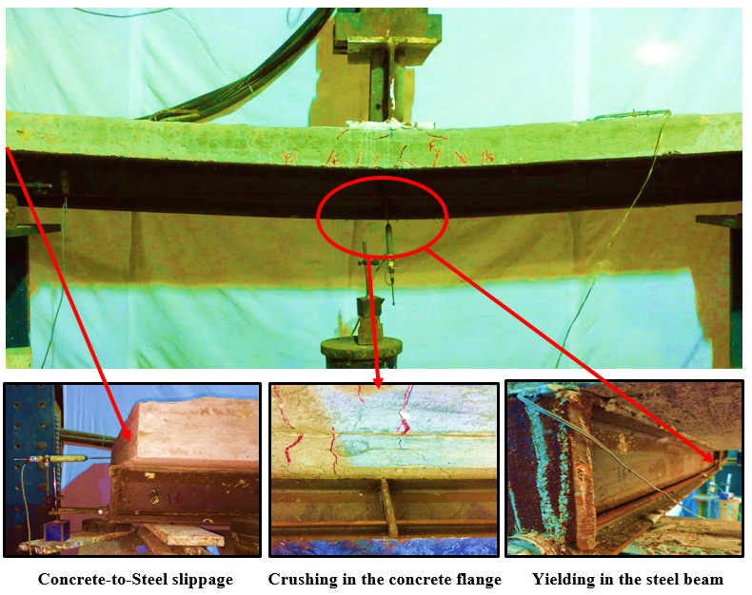

**Figure 10**: Failure of the Sample **S-B100T**.

## NUMERICAL RESULTS

In this section, a comparison will be made between the numerical and experimental results of the modeled and tested beams, respectively. Several parameters will be studied, such as the effect of using different **DOSCs** and tendon profiles. Results such as beam deflection, slippage between concrete and steel, and steel flange strain will be discussed.

### Validation of Finite Element Model

In order to check the validity of the finite element model, the numerical results were compared to the current experimental results of the tested beams **S-B100**, **S-B100T, S-B70,** and **S-B70T**, as seen in **Figures 11** and **12**. **Figures 11a** b, c and **d** show the comparison between the load-deflection curves of the beams with and without post-tensioning. In general, the FEMs were able to predict both the linear and nonlinear behaviors of the **CBs**. The differences between the experimental and numerical maximum loads of samples **S-B100**, **S-B100T, S-B70,** and **S-B70T** were 2.99%, 2.72%, 5.22%, and 3.69% respectively.

The experimental maximum deflections of beams **S-B100**, **S-B100T, S-B70,** and **S-B70T** were 26.72 mm, 21.25 mm, 28.53 mm, and 26.41 mm respectively, while the numerical maximum deflections were 24.07 mm, 18.93 mm, 25.36 mm, and 24.53 respectively. The differences between the experimental and numerical maximum deflections of beams **S-B100**, **S-B100T, S-B70,** and **S-B70T** were-9.92%, -10.91%, -11.22%, and 9.26% respectively.

If we have a look at the stiffness, it can be seen that the differences between the experimental and numerical initial stiffness of beams **S-B100**, **S-B100T, S-B70,** and **S-B70T** were 19.41%, 34.98%, 18.81%, and 15.46% respectively. This might be due to the assumption of the perfect bond between the rebar and the concrete, and the assumed value of concrete elastic modulus.

|  |  |  |
| --- | --- | --- |
|  | |  |
|  | **3** | |

**Figure 11**: Comparison between Load-Deflection Curves for Experimental Tests and **FEM** Results.

**Figure 12** shows a comparison between the experimental and numerical results of the load-slip curves of samples **S-B100, S-B100T**. The models were able to predict the slip behavior with differences of -22.26% and -38.48% for beams **S-B100** and **S-B100T**. The relatively high difference between the experimental and numerical results may be due to the difficulty of simulating the friction behavior between the concrete slab bottom surface and the steel beam top surface.

|  |  |
| --- | --- |
| **S-B100** | **S-B100T** |

**Figure 12:** Comparison between experimental beams and FEM results of the Load-Slippage curves.

**Table 3** summarizes the difference percentage between the results of the FEM and the experimental tests. It can be concluded that this FE modeling technique can be used to simulate the behaviors of **CBs** with and without post-tensioning. However, the FEMs were slightly stiffer than the experimental tests. This might be due to the assumption of frictionless behavior between the steel beam and concrete slab, the perfect bond between the rebar and the concrete, and the assumed value of concrete elastic modulus.

**Table 3:** Difference between Experimental and Numerical Results.

|  |  |  |  |  |  |
| --- | --- | --- | --- | --- | --- |
| **Parameter Sample** | | **S-B100** | **S-B100T** | **S-B70** | **S-B70T** |
| **Max Load, kN** | **Exp** | 201.54 | 265.56 | 147.83 | 211.2 |
| **FEM** | 207.58 | 272.78 | 155.54 | 219.7 |
| **Diff,%** | **2.99** | **2.72** | **5.22** | **3.69** |
| **Max Displacement, mm** | **Exp** | 26.72 | 21.25 | 28.53 | 26.41 |
| **FEM** | 24.07 | 18.93 | 25.36 | 20.53 |
| **Diff, %** | **-9.92** | **-10.91** | **-11.22** | **-22.26** |
| **Initial stiffness, kN/mm** | **Exp** | 15.66 | 40.93 | 11.32 | 20.89 |
| **FEM** | 18.7 | 55.25 | 13.45 | 24.12 |
| **Diff, %** | **19.41** | **34.98** | **18.81** | **15.46** |
| **Max Slippage, mm** | **Exp** | 2.92 | 3.17 | 3.21 | 3.11 |
| **FEM** | 2.27 | 1.95 | 2.48 | 2.36 |
| **Diff, %** | **-22.26** | **-38.48** | **-22.74** | **-24.11** |

### Parametric Study Details

A fundamental point of the design and structural behavior of **CBs** is the level of shear interaction between the concrete slab and steel beam. The full shear interaction describes the case in which the connection between the beam components is able to fully support its applied forces [26]. Although the common design assumption of the **CBs** assumes the full interaction, over the last few decades, the utilization of **CBs** in bridge and building structures led to having composite elements with a partial shear connection in many instances. This could happen when the applied shear forces cannot be supported by the composite action of the beam. In this case, the shear failure of the connection happens before the failure of the other **CBs** components [27,28].

A parametric study for the **CBs** was performed based on the validated **FEM** technique. This study aimed to assess the effects of the tendons profile arrangement of the externally post-tensioned **CBs** with shear connection-level ranges from 40% to full shear connection. In this study, the shear connection level was controlled by varying the number of shear connectors. This does affect not only the overall flexural behavior of composite beams represented by load-deflection curves and ultimate moment capacity, but also the associated modes of failure for either stud failure or slab crushing, and on the of stud shear forces distribution over the length of the beam.

The reference case of this study was the fully shear interacted beam with no post-tensioning force. **Figure 13** shows the used model geometrical characteristics of the composite beams, while **Tables 4** and **5** show the material summary and properties of the section of the composite beams.

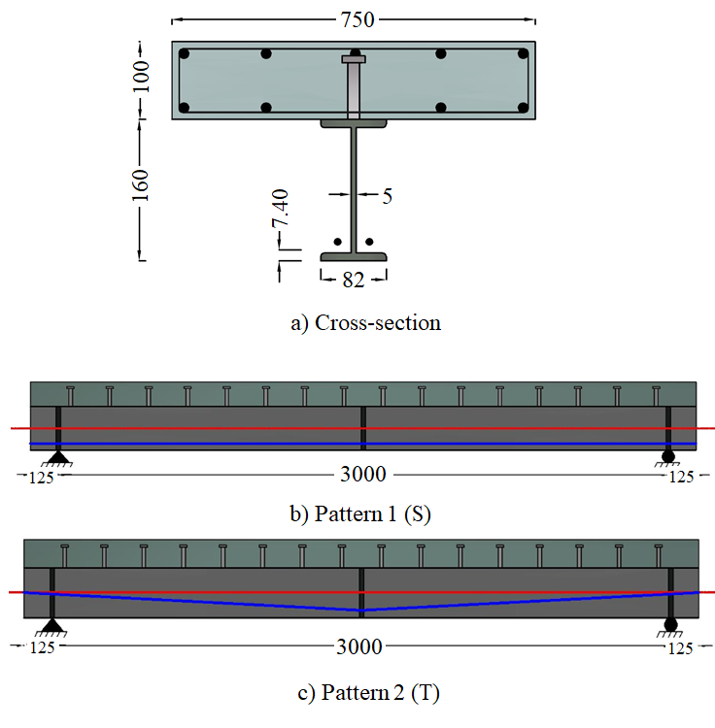

**Figure 13:** Details of the used Tendon Geometries.

**Table 4:** Properties of Material of the Parametric Study Composite Beams

|  |  |  |  |  |  |  |  |  |  |  |  |
| --- | --- | --- | --- | --- | --- | --- | --- | --- | --- | --- | --- |
|  | **Post-tensioning Tendons** | | | | **Steel I-section** | | | | |  | **Concrete** |
| **Beams** | ***fy* (MPa)** | ***fu* (MPa)** | ***AT*(mm2)** | ***F0* (kN)** | ***fy* (MPa)** | |  | ***fu* (MPa)** | |  | ***fcu* (MPa)** |
| Web | Flange |  | Web | Flange |  |
| **S-series** | 582.4 | 716.6 | 157 | 178.6 | 328.3 | 342.4 |  | 502.4 | 517.3 |  | 32 |
| **T- series** | 582.4 | 716.6 | 157 | 107.2 |  |  |

**Table 5:** Details of Composite Beams

|  |  |  |  |  |  |  |  |  |  |  |  |  |
| --- | --- | --- | --- | --- | --- | --- | --- | --- | --- | --- | --- | --- |
| **Beam** |  | | **Group I** | | | |  | | **Group II** | | | |
| **S1** | **S2** | **S3** | **S4** | **T1** | **T2** | **T3** | **T4** |
| **No. of studs** | 16 | | **√** |  |  |  |  |  | **√** |  |  |  |
| 13 | |  | **√** |  |  |  |  |  | **√** |  |  |
| 10 | |  |  | **√** |  |  |  |  |  | **√** |  |
| 7 | |  |  |  | **√** |  |  |  |  |  | **√** |
| **Spacing in pairs (mm)** | 187.5 | | **√** |  |  |  |  |  | **√** |  |  |  |
| 230.7 | |  | **√** |  |  |  |  |  | **√** |  |  |
| 300 | |  |  | **√** |  |  |  |  |  | **√** |  |
| 428.5 | |  |  |  | **√** |  |  |  |  |  | **√** |
| **Level of shear connection %** | | | 100 | 80 | 60 | 40 |  |  | 100 | 80 | 60 | 40 |
| **Tendon profile (mm)** | **Start** | 20 | Straight | | | | **Start** | 80 | Triangle | | | |
| **Mid** | 20 | **Mid** | 20 |
| **End** | 20 | **End** | 80 |

### Results and Discussion

Eight models divided into two groups were built to investigate the effect of changing the profile of the tendons on the CB performance. The first group is for the straight profile tendons; it consists of four **FEMs** with four different **DOSCs**. The straight tendons were located parallel to the lower flange of the steel beam, as shown in **Figure 13b**. In this profile, the tendons were anchored at beam ends and kept free to move up or down relative to the cross-section of the beam through the span. The second group is for the triangle profile; it consists of four **FEMs** with four different **DOSCs**. The tendon endpoints were anchored to the steel beam ends at the mid-height of the steel section, i.e., over the bottom flange by 80 mm while the mid-point is located 20 mm over the bottom flange by using a deviator at mid-span; as seen in **Figure 13c.** **Figure 14** represents a comparison between the load-deflection results of **CBs** of the first and second groups.

Comparing the results of the different **DOSCs**, it can be found that the modeled beams' initial upward movement was approximately the same for each group. The load-deflection behaviors of the beams were very similar for all the cases. The relation consists of a linear zone followed by a nonlinear zone and ends with another linear zone up to the failure. By increasing the **DOSC**, the curves of modeled beams became more plumped. In addition, the elastic limit and the maximum load of the beam increased due to the composite action, which enhances the performance of the **CBs**. However, the ductility of the **CBs** decreased by increasing the **DOSC**.

For group I, increasing the **DOSC** from 40% to 100% led to an increase in the maximum load by 65.85%, the initial stiffness by 58.17%, and the elastic limit by 48.3%. However, it led to a decrease in the maximum deflection by 13.46%. However, for group II, there was an increase in the maximum load, initial stiffness, and elastic limit by 27.94%, 200.54%, and 156.52%, respectively. In contrast, the decrease of the maximum deflection was 23.76%.

Comparing the results of the different groups, i.e., straight and triangle tendon groups, leads to some observations. In general, straight tendon **CBs** showed higher ductility and load-carrying capacity than triangle tendon **CBs**. However, the initial stiffness and elastic limit were lower in the case of straight tendon **CBs** than in the case of triangle tendon **CBs**. The higher deformation capacity of the straight tendon group was related to the redistributing of the shear forces to the remaining studs, which by the way, still gives impetus to keep the composite action at the later loading stages. For the cases of **T1** and **S1**, it can be found that moving from triangle to straight tendon led to an increase in the maximum load and deflection by 4.8% and 46.88%, respectively. It worth mentioning that, by increasing the **DOSC,** the difference in the ultimate load between groups I and II decreases. Moving from **T1** to **S1** led to an increase of maximum load by 4.8% while moving from **T4** to **S4** increase of maximum load by 23.78%. This means that the effect tendon profile is less significant in the case of high **DOSCs** i.e. higher than 80%.

|  |  |
| --- | --- |
|  |  |

**Figure 14:** Effect of **DOSC** and Tendon Profile on the Load vs. Mid-span Deflection Curves

**Figures 15a** and **b** show a comparison between load-slippage results of **CBs** of the first and second groups. The relative slippage between the steel beam and the concrete flange can be used to evaluate the effect of the tendon profile on the composite action of the beams [29]. By comparing the effects of the different **DOSCs** on the slippage results, it can be observed that the beam initial slippage was undetectable due to their small values, **Figure 15**. By comparing the slippage curves of the straight tendon group, it can be found that by increasing the **DOSC** from 40 to 100%, the slippage value decreased by 20.82%, see **Figure 15a**. However, for the case of the triangle tendon group, the decrease percentage was 33.75% between the 40% and 100% **DOSC** cases, **Figure 15b**.

When comparing the two groups, it can be found that the straight tendon profile group gave a greater maximum slippage value than the triangle profile group, see **Figure 15**. This might be due to the straight shape of the tendon, which gives a uniform distribution of post-tensioning forces along the beam due to the constant eccentricity, unlike the triangle profile group.

|  |  |
| --- | --- |
|  |  |

**Figure 15:** Effect of **DOSC** and Tendon Profile on Load-Slippage Behavior.

**Figure 16 s**hows the tendon strain for the different cases of **CBs.** For the straight tendon group, it can be found that the maximum strains of the 40 and 60% **DOSC** cases were higher than the cases of 80 and 100% **DOSC**, although the load was higher in the latter cases. This could happen because of the increase of deflection due to the loss of composite action. In addition, the maximum strain was almost the same for the beams with a **DOSC** of more than 80%.

For group II, the difference between the tendon maximum strain value for the two cases of 60 and 80% **DOSC** was 8.87%, while the difference between 80 and 100% **DOSC** cases was 0.6%, which means that by increasing the **DOSC**, the change in tendon strain decreases.

The incremental increase in the tendon strains is shown in **Figure 16,** which explains that there was a clear impact of the profile of the tendon on the generated tendon strains.

Comparing groups I and II, it can be found that the change of the strain with load is nonlinear in the case of straight tendons and linear in the case of triangular tendons. In group II, the shape of the bending moment diagram of the model is similar to the shape triangle tendon profile. The tendon eccentricity increases with the increase of the bending moment, which might be responsible for the linear load strain relation.

|  |  |
| --- | --- |
|  |  |

**Figure 16:** Effect of **DOSC** and Tendon Profile on Tendon Strain.

**Figure 17** illustrates the ultimate strain at the mid-span of the steel beam bottom flange with different tendon profiles. Ultimate strain in the flange takes the same behavior as the load-deformation behavior of the beam. Due to the application of the post-tensioning force in the first loading stage, an initial negative strain was found in the lower flange. The values of this strain were higher in the case of strain tendons than in the case of the triangular tendon.

For the straight tendon profile group, the eccentricity of the tendon is constant along the beam length, including the maximum moment region. Increasing the **DOSC** led to a decrease in the strain on the lower steel flange. Moving from 40% to 100% **DOSC** decreased the steel flange maximum strain by about 47.6% due to the increase in composite action and decrease in deflection. The strain load relations of the four cases of this group were all bilinear except case **S4**. On the other hand, the stain load relations of the triangle tendon group have a multi-linear curved profile. The curve trends were very close except for the 40% case, where the percentage of increase in strain was 52.5%. This is due to the increase in deformation and the beginning of the loss of composite action.

|  |  |
| --- | --- |
|  |  |

**Figure 17:** Effect of **DOSC** and Tendon Profile on Bottom Flange Strain.

**Figure 18** shows the effect of uplift forces that developed between the steel top flange and the RC slab. This force led to a vertical uplift deformation along the span. It was observed that the deformation of the tested beams had the same variation profile. In addition, the stud near the support had the maximum uplift value.

Under vertical loads, tensile stresses and cracks may occur in the concrete slab at beam ends where a hogging moment exists, In one way or another, the cracked concrete around the contactor creates a separation zone between the concrete slab and the steel beam. This is what produces the uplift. In the used model, the uplift was efficiently monitored by comparing the reference points along the beam span in the contact area between the concrete slab and the steel beam in the vertical direction. This does not mean that the stud has separated itself and rose up, because that means another mode of failure due to the weak welding between the top flange of the steel beam and the shear stud.

Comparing results of beams with straight and triangle tendon profiles, the values of the maximum uplift of the beams with straight tendon profiles were lower than the uplift of the beams with triangle tendon profiles by about 9.75% and 10.24 for the cases S1, and S2, respectively. This effect decayed then significantly reversed for the cases S2 and S3, where the ratios were 0.5% and -46%, respectively. This might be due to the big eccentricity of straight tendons at beam ends caused. For the lower DOSCs, the steel beam behaves more independently, which increases the separation.

The initial compressive force on the concrete flange due to the external post-tensioning force helped to relieve a part of the uplift value that was experienced due to applied load. Based on these results and comparisons, the straight tendons profile showed better behavior and response than the triangle tendons profile. Furthermore, more ductility was obtained when using the straight tendons profile, with no need to use any other tendon profiles due to the difficulty in installing it in reality or modeling it in finite element programs.

|  |
| --- |
| (a) |
| (b) |

**Figure 18:** Uplift Distribution along Beam Span

## CONCLUSIONS AND DESIGN RECOMMENDATIONS

In this paper, experimental and finite element studies were performed for the strengthened of composite beams with externally post-tensioned tendons under static loads. The experimental test results were used to validate the finite element model. In addition, a parametric analysis was performed to investigate the different behaviors of the strengthened composite beams with two tendon profiles under multiple **DOSCs**. The main conclusions are as follows:

* A good agreement between the presented finite element model and the test data was obtained, which assured its reliability and accuracy in the expectation and analysis of the behavior of composite beams externally post-tensioned.
* Increasing the **DOSC** from 40% to 100% led to an increase in the mean maximum load by 46% and to a decrease in the mean maximum deflection by 22.5%. In addition, there was an improvement in the slippage by achieving a 28% decrease. Also, there was a decrease in steel flange micro-strain by about 51%.
* Adding external post-tensioning enhanced the strength of the **CBs** by 32 and 43% for the 100 and 70% DOSC, respectively. The initial tension force on the concrete flange due to the external post-tensioning force helped to decrease the deflection by 20%, slippage by 8%, and the uplift that was experienced due to applied load.
* Using the triangle tendon profile led to an increase in the maximum load by 15% than using the straight one; also, the use of the triangle tendon delayed the occurrence of yield in the steel beam compared to the straight tendon by about 4.5%. However, the effect of tendon profile is not much significant after 80% of DOSC.
* The value of maximum uplift of straight tendon profile beams was relatively low in comparison to the uplift of triangle tendon profile beams by about 46%.

In addition, the following design recommendations can be drawn from this study:

* It is recommended to keep the degree of shear connection more than 80%. This leads to an increase in the mean maximum load and to decrease in the mean maximum deflection in conjunction with an improvement in the slippage capacity, also there was a decrease in steel flange micro-strain.
* It is recommended to use triangle tendon profile tendons for heavy load structure as they can increase the load-carrying capacity by 15%.
* For economic design, simultaneous failure in the concrete flange and the steel beam can be achieved by using post-tensioned tendons. This can be better material used especially for the strengthening of the existing composite structures.

## DATA AVAILABILITY STATEMENT

No data, models, or code were generated or used during the study.

## REFERENCES

[1] Ayyub BM, Sohn YG, Saadatmanesh H. Prestressed composite girders under positive moment. J Struct Eng (United States) 1990. https://doi.org/10.1061/(ASCE)0733-9445(1990)116:11(2931).

[2] Chen S. Experimental study of prestressed steel-concrete composite beams with external tendons for negative moments. J Constr Steel Res 2005. https://doi.org/10.1016/j.jcsr.2005.05.005.

[3] Nie JG, Cai CS, Zhou TR, Li Y. Experimental and analytical study of prestressed steel-concrete composite beams considering slip effect. J Struct Eng 2007. https://doi.org/10.1061/(ASCE)0733-9445(2007)133:4(530).

[4] Chen S, Wang X, Jia Y. A comparative study of continuous steel-concrete composite beams prestressed with external tendons: Experimental investigation. J Constr Steel Res 2009. https://doi.org/10.1016/j.jcsr.2009.03.005.

[5] Lorenc W, Kubica E. Behavior of composite beams prestressed with external tendons: Experimental study. J Constr Steel Res 2006. https://doi.org/10.1016/j.jcsr.2006.01.007.

[6] Kim KS, Lee DH. Flexural behavior of prestressed composite beams with corrugated web: Part II. Experiment and verification. Compos Part B Eng 2011. https://doi.org/10.1016/j.compositesb.2011.04.019.

[7] Ayman E-Z, Hani S, Hesham S, Suzan M, Ashraf E-S. Finite-Element Modeling of Externally Posttensioned Composite Beams. J Bridg Eng 2015;20:4015018. https://doi.org/10.1061/(ASCE)BE.1943-5592.0000756.

[8] Sousa JBM, Parente E, Lima ÉMF, Oliveira MVX. Beam-tendon finite elements for post-tensioned steel-concrete composite beams with partial interaction. J Constr Steel Res 2019. https://doi.org/10.1016/j.jcsr.2019.04.009.

[9] Ozturk A, Baran E, Tort C. Nonlinear Fiber Modeling of Steel-Concrete Partially Composite Beams with Channel Connectors. KSCE J Civ Eng 2019. https://doi.org/10.1007/s12205-019-1163-2.

[10] Hassanin AI, Shabaan HF, Elsheikh AI. Cyclic loading behavior on strengthened composite beams using external post-tensioning tendons (experimental study). Structures 2021. https://doi.org/10.1016/j.istruc.2020.12.017.

[11] CEN. Eurocode 4: design of composite steel and concrete structures - Part 1.1: General rules and rules for buildings. Eur Comm Stand 2004.

[12] ANSYS I. ANSYS Release 18.1 Documentation. 2017.

[13] Aghabeigi P, Farahmand-Tabar S. Seismic vulnerability assessment and retrofitting of historic masonry building of Malek Timche in Tabriz Grand Bazaar. Eng Struct 2021;240:112418. https://doi.org/https://doi.org/10.1016/j.engstruct.2021.112418.

[14] Yuan P, Xiao L, Wang X, Xu G. Failure mechanism of corroded RC beams strengthened at shear and bending positions. Eng Struct 2021;240:112382. https://doi.org/https://doi.org/10.1016/j.engstruct.2021.112382.

[15] Jawdhari A, Fam A. Numerical study on mechanical and adhesive splices for ribbed GFRP plates used in concrete beams. Eng Struct 2018;174:478–94. https://doi.org/https://doi.org/10.1016/j.engstruct.2018.07.085.

[16] Al-Fakher U, Manalo A, Ferdous W, Aravinthan T, Zhuge Y, Bai Y, et al. Bending behaviour of precast concrete slab with externally flanged hollow FRP tubes. Eng Struct 2021;241:112433. https://doi.org/https://doi.org/10.1016/j.engstruct.2021.112433.

[17] Goswami A, Adhikary S Das, Li B. Predicting the punching shear failure of concrete slabs under low velocity impact loading. Eng Struct 2019;184:37–51. https://doi.org/https://doi.org/10.1016/j.engstruct.2019.01.081.

[18] Jawdhari A, Fam A, Noël M. Design equation for concrete-filled FRP tubes in flexure including damage effects. Eng Struct 2021;239:112267. https://doi.org/https://doi.org/10.1016/j.engstruct.2021.112267.

[19] Song J, Wang W, Su S, Ding X, Luo Q, Quan C. Experimental study on the bond-slip performance between concrete and a corrugated steel plate with studs. Eng Struct 2020;224:111195. https://doi.org/10.1016/j.engstruct.2020.111195.

[20] Hassanin AI, Shabaan HF, Elsheikh AI. The Effects of Shear Stud Distribution on the Fatigue Behavior of Steel – Concrete Composite Beams. Arab J Sci Eng 2020. https://doi.org/10.1007/s13369-020-04702-4.

[21] Hassanin AI, Shabaan HF, Elsheikh AI. Fatigue loading characteristic for the composite steel-concrete beams. Frat Ed Integrità Strutt 2021;15:110–8. https://doi.org/10.3221/IGF-ESIS.55.08.

[22] Hassan A, Khairallah F, Elsayed H, Salman A, Mamdouh H. Behaviour of concrete beams reinforced using basalt and steel bars under fire exposure. Eng Struct 2021. https://doi.org/10.1016/j.engstruct.2021.112251.

[23] Desayi P, Krishnan S. Equation for the Stress-Strain Curve of Concrete. J Proc 1964;61. https://doi.org/10.14359/7785.

[24] Ollgaard J, Slutter R, Fisher J. Shear strength of stud connectors in lightweight and normalweight concrete. Eng J Amer Inst Steel Constr 1971.

[25] Johnson RP, Molenstra N. Partial shear connection in composite beams for buildings. Proc - Inst Civ Eng Part 2 Res Theory 1991. https://doi.org/10.1680/iicep.1991.17485.

[26] Mirza O, Uy B. Effects of the combination of axial and shear loading on the behaviour of headed stud steel anchors. Eng Struct 2010. https://doi.org/10.1016/j.engstruct.2009.08.019.

[27] Queiroz FD, Vellasco PCGS, Nethercot DA. Finite element modelling of composite beams with full and partial shear connection. J Constr Steel Res 2007. https://doi.org/10.1016/j.jcsr.2006.06.003.

[28] Qureshi J, Lam D. Behaviour of headed shear stud in composite beams with profiled metal decking. Adv Struct Eng 2012. https://doi.org/10.1260/1369-4332.15.9.1547.

[29] El-zohairy A, Salim H. Parametric study for post-tensioned composite beams with external tendons 2017. https://doi.org/10.1177/1369433216684352.