A criteria-driven approach to the CO₂ storage site selection of East Mey for the Acorn project in the North Sea
Juan Alcalde^{a,b*}, Niklas Heinemann^{c,d}, Alan James^{e}, Clare E. Bond^{b}, Saeed Ghanbari^{f} , Eric J. Mackay^{f}, R. Stuart Haszeldine^{c}, Daniel R. Faulkner^{g}, Richard H. Worden^{g} and Michael J. Allen^{g}.
ª Geosciences Barcelona Geo3Bcn-CSIC, Lluis Solé i Sabarís s/n, 08028 Barcelona, Spain
^{b} Department of Geology and Geophysics, University of Aberdeen, Aberdeen, AB24 3FX, UK
^{c} School of Geosciences, University of Edinburgh, Grant Institute, West Main Road, Edinburgh, EH9 3FE, UK
^{d} Steinmann Institute – Geology, Bonn University, Nussallee 8, 53115 Bonn, Germany
^{e} Pale Blue Dot Energy, Bratherns Eco-Business Park, Banchory, AB 31 4BW, UK
^{f} Institute of Petroleum Engineering, Heriot-Watt University, Riccarton, Edinburgh, EH14 4AS, UK
^{g} Department of Earth, Ocean and Ecological Sciences, University of Liverpool, 4 Brownlow Street, Liverpool L69 3GP, UK
* Corresponding author: jalcalde@geo3bcn.csic.es
Keywords
CCS; CO₂ Storage; Site selection; North Sea; East Mey; Acorn project; TOPSIS

Abstract
Carbon Capture and Storage (CCS) is an essential tool in the fight against climate change. Any prospective storage site must meet a number of criteria that ensure the effectiveness, safety and economic viability of the storage operations. Finding the most suitable site for the storage of the captured CO₂ is an essential part of the CCS chain of activity. This work addresses the site selection of a second site for the Acorn CCS project, a project designed to develop a scalable, full-chain CCS project in the North Sea (offshore northeast Scotland). This secondary site has been designed to serve as a backup, and/or upscaling, option for the Acorn Site, and has to satisfy pivotal project requirements such as low cost and high storage potential. The methodology followed included the filtering of over 100 input sites from the UK CO₂Stored database, according to general and project-specific criteria in a multi-staged approach. This criteria-driven workflow allowed for an early filtering out of the less suitable sites, followed by a more comprehensive comparison and ranking of the 15 most suitable sites. A due diligence assessment was conducted of the top six shortlisted sites to produce detailed assessment of their storage properties and suitability, including new geological interpretation and capacity calculations for each site. With the new knowledge generated in this process, a critical comparison of the sites led to selection of East Mey as the most suitable site, due to its outstanding storage characteristics and long-lasting hydrocarbon-production history, that ensure excellent data availability to risk-assess storage structures. A workshop session was held to present methods and results to independent stakeholders; feedback informed the final selection criteria. This paper provides an example of a criteria-driven approach to site selection that can be applied elsewhere.

Introduction
The 2015 Paris Agreement set the path for the world to reduce anthropogenic CO₂ emissions to try to limit global temperature increase to 1.5 °C (IPCC, 2018; UNFCCC, 2015). This goal cannot be achieved without the capture and subsequent storage of CO₂ (Carbon Capture and Storage: CCS) from fossil fuel-fired power stations and industrial sources, such as steel manufacturing, cement works and petrochemicals, or the unlikely short-term cessation of these activities (Alcalde et al., 2018a; Bui et al., 2018; Haszeldine et al., 2018; Wennersten et al., 2015). Additionally, other low-carbon technologies, which can assist in reducing CO₂ emissions, such as the use and storage of hydrogen, direct air capture or bioenergy with CCS, rely on safe permanent CO₂ storage (Alcalde et al., 2018b; Heinemann et al., 2019; Mander et al., 2017; Sanz-Pérez et al., 2016).
One of the key elements in the CCS chain is the selection of suitable locations for the geological storage of CO₂. A suitable storage site must ensure the safe, sustainable and economic storage of CO₂ over geological timescales. It is therefore important to appraise and select suitable sites that comply with a number of criteria that relate to different aspects of storage operation including geological, engineering, economic, logistical and safety aspects.
The North Sea oil- and gas-rich basins have been repeatedly identified as a potential hub for the development of CCS in Europe. This region has a long history of hydrocarbon exploration and production and has associated production infrastructure in place, and the people-skills and industry supply chains which can routinely deliver complex offshore projects. The North Sea is surrounded by important industrial clusters that could be converted to employ carbon capture technology, and contains more than half of the total CO₂ storage capacity in Europe (SCCS, 2015; Singh and Haines, 2014; Stewart et al., 2014; Swennenhuis et al., 2020; Vangkilde-Pedersen et al., 2009). The North Sea already hosts Sleipner, the world’s first commercial CCS project (Eiken et al., 2011), and there are plans for other CCS initiatives such as the Northern Lights CCS project in Norway, the Porthos CCUS project in the Netherlands and the Net Zero Teesside project in the UK, all of which are at advanced stages of development (Global CCS Institute, 2019). One of these initiatives is the Acorn project, which aims to design and implement a full-chain CCS system, at minimum capital cost of capture, transport and storage, by the early 2020s in the Central North Sea Basin (Alcalde et al., 2019; Allen et al., 2020; Heinemann et al., 2018). Acorn, centred on the Lower Cretaceous Captain Sandstone fairway, has been planned as a scalable project, to which additional sources of industrial CO₂ can be added sequentially in build-out phases. This drives the need to find a second suitable site that can accommodate future expansion of the project.
This paper presents the methodology developed for the selection of a second CO₂ storage site in the North Sea for the Acorn CCS project. Here we present the selection of an appropriate CO₂ storage site that satisfies the need to have a backup storage site for the first phases of the Acorn project, that can also be utilised for further storage as the Acorn project upscales. This second site must be geologically suitable and provide a low-cost, flexible and scalable storage option for the Acorn project. In spite of a variety of site selection methodologies published in the literature, discussed later, a specific criteria-driven workflow, that draws on learnings from other methodologies, was here designed to fit the needs of the Acorn project.

The Acorn project
The Acorn project is a forerunner to become the first CCS commercial project developed on the UK Continental Shelf. It secured the first commercial CCS licence in the UK (OGA, 2018a) and its transportation infrastructure has been listed as the only European Commission’s Projects of Common Interest that involves CO₂. Acorn has been planned to start at a small industrial scale site, but with the potential to expand and become a major hub for the development of a large-scale CCS network in eastern Scotland. In the initial stage of the project, CO₂ will be captured from the St Fergus Gas Terminal, north of Aberdeen (UK), which is connected to three pipelines which are only a short way through their design life, and are unusually compliant for acid gas transport (the Atlantic, the Goldeneye, and the Miller Gas System - MGS). After re-purposing, CO₂ is expected to be transported to offshore storage sites. In future development stages, St Fergus may be connected to Peterhead Harbour for shipping tanker import of CO₂, and the project can be upscaled by connecting an additional high-volume CO₂ source via a redundant UK National Grid gas pipeline that connects Peterhead with the Grangemouth Industrial Complex in central Scotland (Brownsort et al., 2016). This staged investment approach will provide CCS stakeholders across the North Sea regions with a window of opportunity to re-use the abundant redundant offshore oil and gas infrastructure at the end of its productive life and before it is decommissioned (OGA, 2018b; Scafidi and Gilfillan, 2019). Critically, this infrastructure re-use has been identified as an important source of capital cost reduction, which is needed to develop an economically viable CCS industry in the North Sea region (Alcalde et al., 2019). It is expected that this will spark the creation of a CCS industry in the North Sea region (Gross, 2015), which has the mutual potential benefits of delivering social justice for workers employed in the hydrocarbon industry during the expected global energy transition, as well as delivering the means for climate change mitigation (Swennenhuis et al., 2020).
The primary storage site of this project is the Acorn CO₂ storage site, which is an approximately 1,000 km² portion of the Lower Cretaceous Captain Sandstone aquifer, located approximately 100 km off-shore from Aberdeen (UK) (Figure 1) (Allen et al., 2020; Worden et al., 2020). The Acorn site has undergone significant petroleum activity over the last decades (Ghanbari et al., 2020). Different portions of this site have already been appraised in previous studies including the Strategic UK Carbon Capture and Storage Appraisal Project (SSAP) (Pale Blue Dot and Axis Well Technology, 2016), the Goldeneye storage project (Tucker and Tinios, 2017) and the Multistore project (Shell et al., 2015), which all concluded that the site is highly suitable for the injection and long-term storage of CO₂. The potential for re-use of three re-purposed pipelines and the high-quality reservoir characteristics of the Captain Sandstone provide a cost-effective, readily available storage site that could host in excess of 150 Mt CO₂ (Pale Blue Dot and Axis Well Technology, 2016).
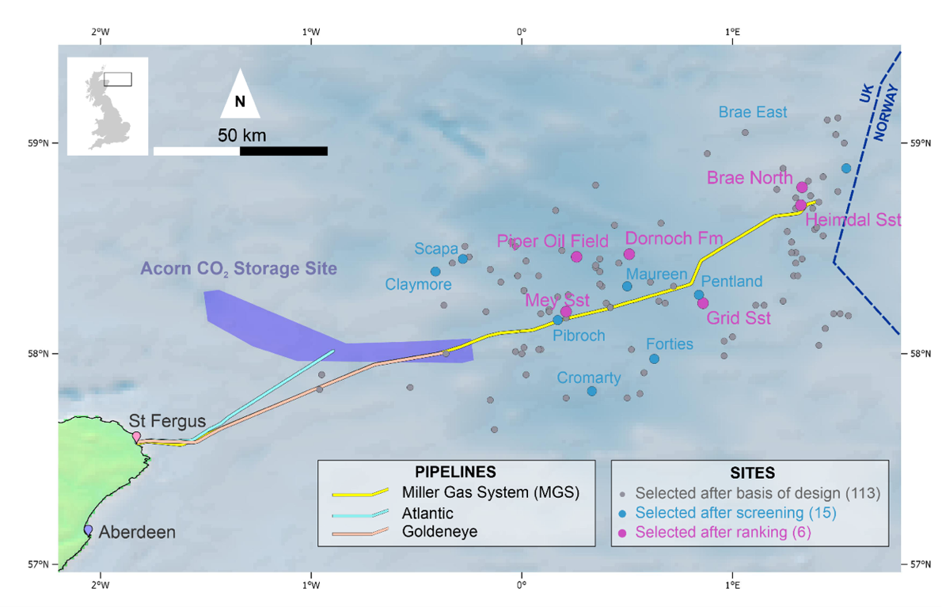
Figure 1: Location of the Acorn CO₂ storage site in the North Sea, with the three pipelines highlighted for potential re-use for CO₂ transport off-shore from St Fergus, and the location of 113 sites considered for selection as Site 2 that met the basis of design (see Figure 2).

The ability to expand industry-scale projects, such as Acorn, requires the selection of an additional ‘secondary’ site to satisfy two crucial purposes. The first purpose is to provide additional storage capacity for a more mature stage of the project when new CO₂ supply scenarios, are added to the project . The second purpose is to act as emergency storage in the undesirable case that the initial site is considered obsolete or unsafe (e.g. due to technical or operational issues encountered in the development or the primary site). These two factors, together with the specific characteristics of the project, determined the methodology that was followed to select Acorn ‘Site 2’, which is the site that will serve as backup to, and potential growth site for, the Acorn project. The formalisation of the site selection methodology is the focus of this work.

Site selection in the literature
Site selection comprises the investigation and ranking of geological sites for their suitability to store CO₂ over geological time scales. Multiple studies have employed source-to-sink assessments as a first order approach, where the CO₂ volumes from large emitter sources are geographically matched with basins or reservoirs, usually using a Geographical Information System (GIS) approach (Bradshaw and Dance, 2005; Edlmann et al., 2015; Sun et al., 2020; UNIDO, 2011; Wei et al., 2013). These assessments can include other criteria, such as infrastructure distribution (e.g. pipelines or transport hubs), risk assessments (e.g. natural seismicity) or data availability. In general, these studies are useful to help determine broad geographic areas of interest, but more specific approaches are needed to address the selection of single storage sites.
Bachu (Bachu, 2000) proposed that (specific) site selection “should be based on a suitability analysis, a proper inventory of potential sites, an assessment of the fate of the injected CO₂ and a capacity-determination, together with surface criteria such as CO₂ capture and transport”. In order to select candidate storage sites, studies such as Chadwick et al. (2008), Ramirez et al. (2010), and Delprat-Jannaud et al., (2014) proposed comprehensive guidelines and different thresholds for geological properties, such as reservoir porosity and seal continuity. A study published by Raza et al. (Raza et al., 2016) extended the range of criteria to a more complete screening system including well types and fluid parameters. These kind of studies can be seen as a first pass to high-grade a number of candidate sites, which then need to be studied in depth to choose the overall best candidate.
As site selection involves the combination of a wide range of geological, engineering, economic and social aspects that will shape the process, a comprehensive definition (like that of Bachu, 2000) is a good starting point for site selection, and against which studies available in the literature could be benchmarked. Preliminary screening studies only focus on one, or a few, of the criteria introduced by Bachu (Bachu, 2000) (e.g. only capacity (Zhou et al., 2011) or only injectivity (Mathias et al., 2009)).
A number of studies have assessed potential storage sites of particular areas where the local geology and other parameters were investigated and compared to find the best storage locations. These conditions can be related to geological zones such as sedimentary basins (e.g. Edlmann et al., 2015; Sun et al., 2020; Yang et al., 2017) or geographical areas such as countries or regions (e.g. Holloway et al., 2006; Wei et al., 2013). These studies often combine first order geological criteria with economic constrains, such as a specified distance to CO₂ sources or to CO₂ transport infrastructure, such as harbours or pipelines. Since these studies were constrained within pre-defined areas, the potential sites available for the screening were limited and the selection tends to be more pragmatic, so that the best site from a pre-determined availability list was selected for further investigation (e.g. Koukouzas et al., 2009; Li et al., 2005).
Studies aiming for less site-specific workflows often employ wider ranges of criteria. The approach proposed by Anthonsen et al. (Anthonsen et al., 2014) suggested a four criteria methodology, comprising basic information of reservoir and seal properties, safety aspects and data coverage. No CO₂ supply or economic parameters were included in their assessment. In their site selection analysis for the Paris Basin, Llamas and Cienfuegos (Llamas and Cienfuegos, 2012) proposed a methodology based on different mathematical algorithms to weight a variety of technical (mainly geological and hydrological) and socio-economic (such as data quality and availability, CO₂ supply, etc.) criteria. On a much larger scale, Wei et al. (Wei et al., 2013) modified the evaluation criteria for site suitability developed by Bachu and Adams (Bachu and Adams, 2003) to assess the suitability of onshore aquifers in China. Using a point system for each criterion, application of the method resulted in a GIS map revealing a prioritised range of suitable CO₂ storage sites. Hsu et al. (Hsu et al., 2012) provided an analytic network process approach, which takes eight criteria into account, mainly basic geological and geographical parameters as well as storage costs, and ranked example reservoirs accordingly. However, since workflows employ different criteria, or with different weighting amongst them and with different degrees of simplification, the outcomes of different site selection studies differed considerably, and the different methodologies are therefore difficult to compare.
Grataloup et al. (Grataloup et al., 2009) used a list of criteria taken from Brosse et al. (Brosse et al., 2010), that combined geological, risk, regulatory and social aspects. They highlighted that certain criteria, called “killer criteria”, are more important for site selection than others, because the lack of compliance with one of these killer criteria results in the exclusion of the potential candidate site. For example, a site featuring high quality reservoir but containing a high-risk leakage pathway (e.g. a poorly abandoned well) will be ruled out from the selection process. A second type of criteria, called “site-qualification criteria” allows for the sites to be qualitatively or quantitatively assessed and ranked according to their suitability. For example, a shorter distance to the source of CO₂ might lead to selection of one site from a pool of candidates with similar reservoir characteristics. The selection process described in Grataloup et al is therefore a two-stage exercise.
In summary, the use of multiple criteria is essential for practical (i.e. non-theoretical) site selection. The methodology presented in this study employs some of the most common criteria used in the previous studies that we have summarised (e.g. capacity, injectivity and containment risk), but include others that are project-specific (e.g. development cost according to the requirements of the Acorn project). The site selection workflow, presented here, builds on the methodology developed in the Strategic UK Carbon Capture and Storage Appraisal (SSAP) project (Gammer et al., 2011; Pale Blue Dot and Axis Well Technology, 2016) commissioned by the Energy Technologies Institute (ETI). This study applied international best practice to screen over 500 aquifer and depleted hydrocarbon fields in the UK North Sea and Irish Sea Basins in order to select a pool of suitable CO₂ storage sites. This methodology includes the two-staged approach suggested by Grataloup et al. (Grataloup et al., 2009), but importantly incorporates two more stages and a quantitative multi-criteria decision-making process, to handle the numerous variables. Our methodology adapts the conclusions and learnings from the SSAP project to the characteristics and needs of the Acorn project (ACT Acorn, 2018a), and also complies with the international standard for CCS (ISO 27914, 2017), which provide recommendations and best practices for the safe and effective storage of CO₂.

Methodology
The criteria-driven workflow employed in this work involves the selection of a suitable site according to general requirements (e.g. great capacity and injectivity, low containment risk, low costs and stakeholder support) (Grataloup et al., 2009), as well as specific requirements particular to the project. For example, one of the priorities of the Acorn project is to reduce the capital cost of the project by the re-use of existing infrastructures (Alcalde et al., 2019), so the economic aspects played a major role in the selection of Site 2. This mixture of general and project-specific requirements ensures that the needs of the project are satisfied while allowing comparison of our methodology with other site selection studies.
The methodology proposed employs information from potential storage sites conventionally collated in storage atlases (Prelicz et al., 2012) as input data. The amount and level of detail of this information varies across databases, but generally incorporates enough geological and engineering information (e.g. location, depth, rock properties, capacity, available subsurface data etc.) to accurately inform site selection assessment.
The workflow involved four major stages including qualitative and quantitative aspects of the prospective sites, and that lead to the selection of the most suitable site ( Figure 2). The level of complexity of the analyses carried out increases with each stage of the workflow while at the same time the number of remaining sites decreases. This allows filtering out unsuitable sites early in the workflow and focus on the more suitable sites in the advanced stages.
- Basis of design, which sets the general requirements, assumptions and specifications of the project which were used to implement a preliminary, high-level filtering of the input sites; the remaining ‘output’ sites were considered ‘selectable’ based on a project-specific set of economic criteria, with their particular suitability for CO₂ storage assessed in the next phase. These criteria should be straightforward and reduce the number of entries effectively without detailed, site-specific research. Common examples of elements that can be considered in the basis of design might include location (e.g. region of interest, onshore vs offshore, maximum distance to the CO₂ source); storage reservoir type (e.g. depleted oil and gas field vs saline aquifer); depth (e.g. to ensure supercritical CO₂ conditions); or risk (e.g. avoid protected regions, poorly abandoned infrastructure or active seismic regions).
- Screening, in which the selectable sites are either taken forward or disqualified based on specified geological and economic criteria. The sites taken forward are considered “most suitable”, but there were too many sites to run detailed individual assessments of each site and a ranking of appropriateness was required.
- Ranking, in which the “most suitable” sites were assessed based on their characteristics and a reduced portfolio of “shortlisted” sites is taken forward based on their performance (i.e. how they rank) against a range of criteria (geological, economic and safety). The final portfolio should ideally present the most suitable short-listed sites while keeping a variety of options open (e.g. in terms of reservoir type – saline aquifers and oil and gas fields) so that the final decision can consider different storage scenarios.
- Due diligence, in which the final sites are analysed in detail to produce enough information about them to inform a decision on the most suitable site, resulting in a “Selected Site”.
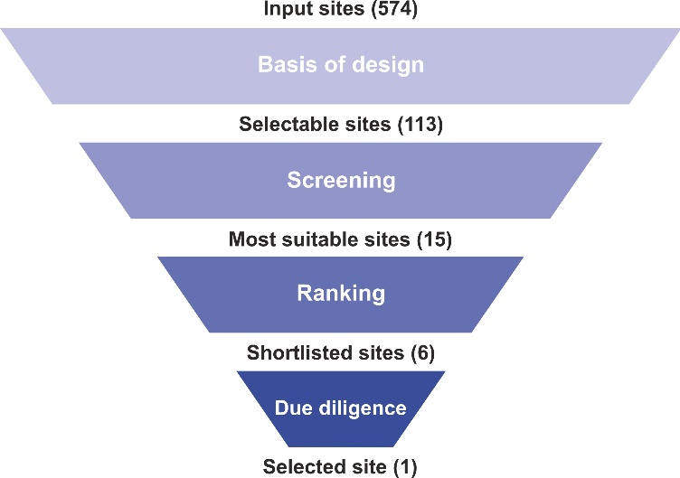
Figure 2: Overview of the site selection workflow designed to select the most suitable site from an initial pool of input sites. The criteria-driven methodology includes four main stages: basis of design, screening, ranking and due diligence. In brackets, implementation of this methodology in this study, where the input of 574 sites of the CO₂ Stored database (Bentham et al., 2014) were subsequently filtered and led to the selection of the most suitable site.
Also, as part of the site selection process, a workshop was run to obtain feedback from external stakeholders on the site selection methodology. The attendees included a mix of academic, industry and public sector representatives, internal and external to the Acorn project, with background in different elements of CO₂ storage. The criteria-driven methodology and the major results were presented to the stakeholders for their discussion. The key feedback points focused on cost, data quality and availability, legal issues, and legacy wells. The workshop provided a quality control of the site selection process, and the methodology presented in this study was reviewed in light of the feedback received. The discussions generated were very productive and the outcomes were key to define the final strategy for the selection of Site 2. A detailed description of the workshop procedure and the major outcomes can be found in (ACT Acorn, 2018a).

Selection of ‘Site 2’

Input data - the CO₂stored database
The CO₂Stored database was developed as part of the Strategic UK Carbon Capture and Storage Appraisal (SSAP) Project, funded by the Energy Technologies Institute and published in 2012. This database was developed to establish the geological storage capacity of the UK continental shelf for CO₂, and is maintained by the Crown Estate (Bentham et al., 2014).
The database includes hydrocarbon reservoirs and saline aquifers with potential for CO₂ storage, i.e. sites that comply with the following criteria:
- The reservoir formations consist dominantly of porous and permeable sandstone or carbonate. Other potential types of CO₂ reservoirs, such as coal seams (Shi and Durucan, 2005) or basalts (Matter et al., 2016), are not included.
- All reservoir formations are either directly overlain by a low permeability sealing unit (such as mudstone or evaporitic rocks), or overlain by other sealed reservoir formations, to ensure the containment of the injected CO₂ in the subsurface.
- The mapped storage units are at depths greater than 800 m below sea level, to ensure that the temperature and pressure at the reservoir (31ºC and 73.7 bar at typical geothermal and geobaric gradients) allow for the CO₂ to remain as a dense supercritical phase (van der Meer et al., 2009). This phase of CO₂ increases the storage capacity of the reservoir while keeping a reduced mobility compared to gaseous CO₂, hence reducing the risk of leakage (Chadwick et al., 2008).
The CO₂Stored database contains important information about the characteristics of each site, from different perspectives: geological (e.g. stratigraphy, lithology, depositional environment), geographical (e.g. location, areal extent), reservoir analysis (e.g. thickness, pore volume, reservoir quality, reservoir conditions, injectivity, theoretical storage capacity), risk (e.g. condition of the seal, fault density, compartmentalization, well density) and economic factors (cost of storage according to different scenarios and assumptions). Entries are classified as either having, or not having identified structures/trap, and being open or closed pressure systems. Storage volumes in the database were calculated using Monte Carlo analysis, combining different factors such as static capacity, permeability, development cost and the maximum allowable pressure build-up in the storage formation. In CO₂Stored, the depth of the unit is combined with the temperature and pressure at the reservoir to calculate the CO₂ density and viscosity. These are then combined via Monte Carlo simulations with other factors such as rock and formation water compressibility, water salinity, aquifer seal capacity, hydrostatic pressure and CO₂ column height to produce estimates on the theoretical capacity of each storage unit. Different methodologies were used to calculate the static capacity depending on the storage unit type, described in (Gammer et al., 2011). The database contains an assessment of the confidence for each (high, medium or low) as well as the source of the featured information. For most parameters, the database also provides a range of values (minimum and maximum) and a most likely value that is based on the different data assessed for their determination. Where possible, the data used in the different stages of the site selection methodology presented, correspond to the most likely values, ensuring the representativeness of the value for the given parameter.
Within the CO₂Stored database, some storage formations have been subdivided, with the purpose of dividing massive sites (usually major saline aquifers) into storage units that are mappable and that still comply with the basis of resource (Pale Blue Dot and Axis Well Technology, 2016), detailed above. This is helpful, for example, in saline aquifers that contain many different compartmentalised portions of the reservoir unit; in this case, the different sub-units are differentiated which therefore enables a better understanding of what the different storage structures look like.

Basis of design
The purpose of the basis of design stage is to set the preliminary requirements or priorities of the project and to serve as a coarse filter of the potential storage sites, as defined in the CO₂stored database, termed input sites. This preliminary filter is applied in order to reduce the input pool of sites to a more manageable number of selectable sites, based on basic first order storage criteria.
The characteristics of the Acorn project were also taken into account during this stage by including some project-specific requirements, including:
- The target geological formations must be offshore on the UK Continental Shelf, in the Central North Sea, (CNS).
- The need for reduced implementation cost of the CO₂ storage site imposes a strong constraint to the selection of suitable sites. The site must be at reach from the St Fergus hub, and the priority is to re-use infrastructures to contain costs (Alcalde et al., 2019). More specifically, Site 2 must make use of the three redundant pipelines considered, Atlantic, Goldeneye and MGS.
- Site 2 must act as a backup of the Acorn site, but also act as an expansion option in later stages of the project, so the upscaling potential (chiefly high capacity and injectivity and low capital cost) is essential.
These aspects were used to produce an initial filtering of the input CO₂Stored sites. To ensure the infrastructure re-use and hence avoid additional costs in the transport of the CO₂ to the site, only the sites close to the three target pipelines were selected (Figure 1). The re-use of these redundant pipelines was identified as the major potential source of cost reduction for both the Acorn project objectives, that included both the Palaeocene sandstones of the East Mey area and the Cretaceous Captain sandstone of the Acorn site (Alcalde et al., 2019). We used the location of the centroid of the different sites to calculate the distance to the pipelines and excluded those located more than 50 km from the position of the pipelines. The 50 km constraint produced a corridor of suitable sites that reduced the initial 579 to 113 sites (Figure 1). Note that this method might exclude some sites whose centroids are outside the 50 km corridor created, but which in fact extend much closer to or across the pipeline corridor. It was however deemed a good enough first-pass approach since the full areas of all the sites were not available. The resulting 113 sites were taken forward to the screening stage.

Site screening
The 113 selectable sites were then evaluated according to seven screening criteria (Figure 2), adapted specifically to the needs of the Acorn project. The seven criteria include CO₂ storage capacity, porosity, permeability, age of the reservoir formation (as older formation tend to have lower reservoir quality, more clay minerals and more carbonate cement than younger formations), date of cessation of production (for oil and gas fields) and well and seismic data availability in the site. These screening criteria were assessed independently and so failure to meet any of them resulted in dismissal of the site from the selection process. Each site was assessed for each criterion based on the data contained in the CO₂Stored database, marking them with “pass” if the site met the criterion and “not pass” if the criterion was not met.

Screening criterion | Description | Rationale | Sites failing the criterion (percentage of the total, N=113 selectable sites)
Capacity | Screening out of sites with a P50 capacity less than 50 Mt CO₂ | Relatively high capacities needed for the expansion stage of the project | 64 (57%)
Porosity | Screening out of sites with porosities lower than 10% | High porosity to ensure high storage efficiency | 2 (2%)
Permeability | Screening out of sites with permeabilities lower than 10 mD | High permeability to ensure high injectivity | 23 (20%)
Age of the reservoir formation | Screening out of sites older than the Mesozoic | Older formation tend to have lower reservoir quality, more clay minerals and more carbonate cement than younger formations | 22 (19%)
Cessation of production | Screening out of hydrocarbon fields which expected cessation of production is later than 2022 | Acorn project expected to be in operation by 2022, so potential hydrocarbon fields must have finished operation by then | 9 (8%)
Well data availability | Screening out of sites not sampled by wells | Needed to ensure the availability of information about the reservoir and the caprock | 5 (4%)
Seismic data availability | Screening out of sites not characterised with the 3D seismic data | Needed to characterise and create the geological model of the site | 4 (4%)
Table 1: Screening criteria used in the selection of Site 2.

The first screening criteria used was storage capacity. i.e., the theoretical volume of reservoir that can store CO₂. Any storage site must have a certain minimum capacity for economic viability, more so if the site is to be used as an expansion from the primary site in a staged project, where the CO₂ resource available will increase as new sources are incorporated. In the Acorn project, the storage will be initially carried out in the Acorn storage site, starting with small fluxes (4.2 Mt CO₂ yr⁻¹) and scaling up to larger ones in later development stages (152.4 Mt CO₂ yr⁻¹) (Alcalde et al., 2019). By the time the Acorn site is full, the quantity of CO₂ flowing to the site will be high, and therefore the buildout storage site must feature greater capacity and injectivity. The CO₂Stored database includes a number of estimates of the theoretical and static capacity of the different sites (Bentham et al., 2014). These estimations were reviewed in the SSAP project, which determined that the P50 theoretical storage resource (in Mt of CO₂) is the best representation of the storage resource for both saline aquifers and hydrocarbon fields, and was therefore selected from the database. The capacities of the 113 sites ranged from 1 to 3,342 Mt CO₂. A P50 capacity of at least 50 Mt was chosen as the criteria threshold. This was not met by the 57% of the sites (64 in total); it was the most failed screening property.
Additionally, two other criteria related to the quality of the reservoirs were included in the screening process, namely average porosity and permeability. The petrophysical properties of the sites were inspected and the porosity and permeability as proxies for storage capacity, and injectivity. Both criteria have a fundamental effect on the capital and operational costs of storage. The average porosities of the studied sites ranged from 9 % to 33 %, whereas the permeabilities ranged from 5 to 7,500 mD. The sites with reservoir formations having porosities lower than 10% and permeabilities lower than 10 mD were discarded. Only two sites (2% of the total) failed the porosity criterion, whereas 23 of the 113 sites (20%) failed the permeability criterion.
The last geological screening criterion used was the age of the target formation. The Palaeozoic rocks in the North Sea region have clearly had a long geological history and have potentially experienced several stages of burial, exhumation and re-burial with commensurate diagenetic changes, and structural deformation-related processes (Evans et al., 2003; Monaghan et al., 2017). Palaeozoic sites are less well studied than Mesozoic and Cenozoic sites and there is uncertainty about their evolution and current reservoir state, particularly when compared to Cenozoic reservoirs. To reduce storage risk, Palaeozoic sites were screened out. Of the studied sites, 22 (19%) were formed by rocks older than Mesozoic. The rest of the sites are divided in Mesozoic (75 sites, 66% of the total) and Palaeogene units (21 sites, 19% of the sites).
Although hydrocarbon production in the North Sea is in decline (with estimated production peak in 1999, Kerr, 2011), there are still approximately 100 producing fields in the UK Central North Sea (source: UK Oil and Gas Authority – OGA Field Production, www.ogauthority.co.uk). The Acorn project is expected to start in operation in 2022 (Alcalde et al., 2019). Hence, we excluded all hydrocarbon fields that are expected to be still in operation by that date, so that the storage operations do not interfere with the hydrocarbon production. Of the 34 oil and gas fields assessed, nine of them had cessation of production dates later than 2022 and were screened out (8% of the remaining selectable sites).
Finally, the sites were assessed in terms of well and seismic data availability. Sites without well data were screened out, because suitability of the reservoir and seal formations will be uncertain and the cost of drilling new wells in order to characterise them would increase project expense. The same rationale is followed regarding the seismic data. In terms of seismic data availability, the Acorn project used the PGS CNS Mega Survey (www.pgs.com/data-library/europe/nw-europe/north-sea/), a 3D reflection seismic dataset that covered most of the Central North Sea region. The locations of the centroids of the 113 sites assessed (Figure 1) were plotted against the coverage map of the CNS Mega Survey, and the sites located outside the seismic dataset coverage area were screened out. Ten of the sites were therefore screened out in this process.
After the assessment of the sites, 23 sites complied with all seven screening criteria (Figure 3). However, ten of these sites corresponded to sub-units of the same two sites, Claymore and Pentland (five subdivisions, respectively). In order to maximise the variety of sites that are selected as output from the screening process (i.e. to avoid including several subdivisions of the same site), we selected the subdivisions with greatest P50 capacity of the Claymore and Pentland subunits. This resulted in the selection of 15 sites, shown in Table 2, that constitute the pool of suitable sites after the screening stage (Figure 2).
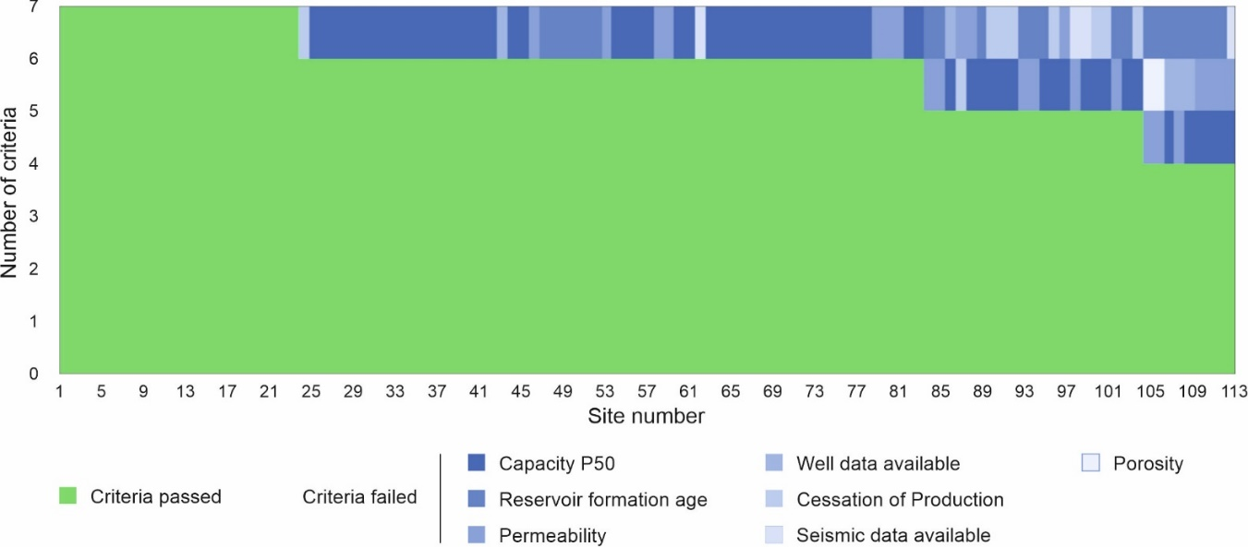
Figure 3: Site screening results. The graph shows the number of criteria passed by each of the 113 sites included in the assessment. 23 sites passed all seven screening criteria.

Site name | Type of site | Formation
Brae East Condensate Field | Gas Condensate | Brae Fm
Brae North Condensate Field | Gas Condensate | Brae Fm
Claymore_014_18* | Saline Aquifer | Kimmeridge Clay Fm
Cromarty Sandstone Member | Saline Aquifer | Sele Fm
Dornoch Formation | Saline Aquifer | Dornoch Fm
Flugga Sandstone Member | Saline Aquifer | Sele Fm
Forties 5 | Saline Aquifer | Sele Fm
Grid Sandstone Member | Saline Aquifer | Horda Fm
Heimdal Sandstone Member | Saline Aquifer | Lista Fm
Maureen 2 | Saline Aquifer | Maureen Fm
Mey 5 | Saline Aquifer | Lista Fm
Pentland_016_21b* | Saline Aquifer | Pentland Fm
Pibroch_015_21 | Saline Aquifer | Piper Fm
Piper Oil Field | Oil & Gas field | Piper Fm
Scapa_014_20 | Saline Aquifer | Valhall Fm
Table 2: Final fifteen sites selected after the initial screening processes. Sites with an asterisk * mark the two sites with more than one subdivision in CO₂Stored that passed all screening criteria; in these cases, the subdivision with the greatest P50 capacity were selected.

Ranking
From a purely technical point of view, all of the 15 ‘most suitable sites’ that remained after the screening stage are suitable candidates to become Site 2; these sites all comply with the criteria employed in the basis of design and the site screening stages. However, the binary method used in the previous stages (i.e. “met” or “not met” with the criteria) is not sufficient to select the final site, and a new type of analysis must be used to decide whether certain sites are more suitable than others. We therefore used a more quantitative ranking strategy to decide which of the most suitable sites will be shortlisted to the due diligence stage (Figure 2).
The applied ranking methodology developed for this project draws on the learning outcomes from the SSAP project (Pale Blue Dot and Axis Well Technology, 2016). It involves using six criteria to rank the selected CO₂ storage sites in order of suitability to host Site 2. These criteria were again selected to comply with the aims of the Acorn project, i.e. primarily reduced costs and high capacity. Some criteria had a positive correlation with the suitability of the site (e.g. higher capacity equates to an increasingly more suitable site) whereas others had a negative correlation (e.g. higher cost equates to an increasingly less suitable site). The six ranking criteria used are: (a) storage resource (P50 capacity), (b) injectivity, (c) unit type, (d) containment risk, (e) development cost and (f) water depth.
Three of the ranking criteria selected (storage capacity, injectivity and unit type) are related to the geological properties of the site. Despite the fact that calculation of storage capacities bears great uncertainty (Anderson, 2017; Wilkinson and Polson, 2019), storage capacity has a strong influence on the total cost of the project because of the economy of scale. Assuming that capital expenditure remains more or less constant, then larger the capacity equates to a lower price per tonne of CO₂ stored. The input sites included very large saline aquifers that extend within the pipeline area and far beyond, featuring massive storage capacities, sometimes 1-2 orders of magnitude greater than other smaller aquifers and fields located entirely within the 50 km corridor around the pipelines. In these cases, their capacities were averaged in proportion to the size located within the pipeline corridor, so that they do not outweigh the smaller sites in the capacity ranking. The injectivity value is calculated as the product of the permeability and the average thickness of the reservoir column; this approach is used as a proxy for how easy or how difficult CO₂ injection will be. Higher injectivity results in a higher rank for a site in terms of this criterion.
The remaining geological criterion used is the unit type. The CO₂Stored database differentiates between four types of storage units: (i) depleted oil and gas fields, (ii) open saline aquifers with identified trap structures, (iii) open saline aquifers without identified trap structures and (iv) fully confined saline aquifers. We assigned a numerical value (0 to 3) to the sites based on their unit types and their suitability for storage, with 0 the least suitable and 3 the most suitable unit type (positive correlation). Depleted oil and gas fields are considered the best storage type (giving a value of 3), as these fields feature proven reservoir and caprock properties (since they have hosted hydrocarbons for geological time periods) and potentially retain redundant infrastructure with opportunity for re-use and hence potential for reduced capital costs (Alcalde et al., 2019). Oil and gas structures are suitable for storage as long as the CO₂ injection does not mobilise the trapped hydrocarbons remaining (Ghanbari et al., 2020). For the remaining types, open aquifers with identified structures (value of 2) are considered more suitable than aquifers without identified structural constraints (value of 1), as they bear lower uncertainty about the reservoir architecture. Fully confined saline aquifers are considered the least suitable type (value of 0), as the confinement can create pressure issues during the injection, affecting the capacity and potentially increasing the risk of leakage through, for example, near-wellbore structures or faults (Fleury et al., 2010; Vilarrasa et al., 2017).
The fourth factor is leakage risk, which combines the risk of leakage through abandoned wells (well risk) and through geological features in, or at the top of, the storage volume (geological risk). In terms of geological risk, the CO₂Stored database contains a qualitative assessment of six factors related to the containment risk of each site. These factors relate to the caprock seal (i.e. fracture pressure capacity, seal geochemical reactivity and seal degradation), and to the presence of faults in the storage area (i.e. fault density, throw of the faults and relationship with the seal thickness and vertical extent of the faults). The seal geochemical reactivity factor was left out of the assessment, as the current understanding of the geochemical processes interface indicates that the reactivity at the CO₂-seal interface and the subsequent leakage potential is negligible (Liu et al., 2012). For the calculation of the leakage risk (“geo-risk”), a value was assigned to each factor, according to their likelihood of failure assessment: 1 for “low”, 2 for “medium” and 3 for “high” risk. Each site has therefore given a combined georisk factor, resulting from the sum of the individual assessments. The resulting geo-risk factor ranges from 5 (low risk) to a maximum of 13 (high risk).
Abandoned wells are a major source of leakage risk, particularly in well-exploited hydrocarbon provinces such as the North Sea (Alcalde et al., 2018a). In this study, a well-risk factor was calculated based on the ratio of hydrocarbon wells per area in the store (in wells/km²). The status and quality of the wells is not taken into consideration at this stage as this would be impractical due to the large quantity of wells to be checked, so the well-risk factor is only dependent on the number of wells present in the store. As the saline aquifers have significantly greater areas than depleted oil and gas fields, the ratio of wells per area is significantly smaller (2-3 orders of magnitude) in these stores. Thus, a well-risk value of 3 was assigned to all the oil and gas fields and a value of 1 was assigned to the saline aquifers. The geo-risk and well-risk factors were summed into the “leakage risk” factor. This combined leakage risk ranged from 7 (i.e. the site with the lowest leakage risk) to 14 (the highest leakage risk).
In terms of development cost, a proxy cost factor based on the geographic location and the depth of the site was calculated. The formula used in this work (eq. 1) assumes a 5-well storage system and costs of £1.1M per kilometre of installed pipeline and £17M per kilometre of installed borehole:
Development cost (in £M) = l (km)* 1.1 £M/km + 5*d (km) * 17 £M/km. (eq. 1),
Where l is the distance of the storage site to the nearest redundant pipeline, and d is the depth of the reservoir below seafloor. The cost assumptions are based on values collected in (Pale Blue Dot and Axis Well Technology, 2016). This approach produces an oversimplified measure of the cost, but it is independent from other criteria (such as injectivity or capacity) and makes it suitable for this study.
Finally, the seawater depth at the storage location is important for the development of the storage site because it determines the type of platform required for the drilling operations. Jack up platforms are the most economic option for water depths of 150 m or less compared to other options like semisubmersible platforms (Lee and Jablonowski, 2010), and therefore shallow seawater is preferred for Site 2. The selected sites are located at seawater depths on the verge of the limit between deep- and shallow-water platforms (i.e., water depths between 100 and 150 m). Thus, the sites were ranked from shallower seawater (more suitable) to deeper seawater (less suitable).

TOPSIS methodology for decision making
The quantification of the 15 sites against these different criteria provided a ranking of their relative suitability to become Site 2 (Table 3). However, none of the 15 sites ranked high (e.g. amongst the top five) in all of the criteria considered. This prevented a direct election of the best site, and so an alternative selection method was employed. To fully integrate all the selection criteria into a single decision-making process, we adapted the TOPSIS (Technique for Order Preference by Similarity to Ideal Solution, Yoon and Hwang, 1995) methodology to the characteristics of our project. The TOPSIS methodology is a compensatory process, i.e. no alternatives are excluded due to a single poor result against one criteria, and therefore it is suitable for multi-criteria decision-making. In TOPSIS, pairs of positive and negative ideal solutions are hypothesised based on the best and worst values for each of the ranking parameters considered; i.e. the positive ideal solution is the one that maximises the positive criteria and minimises the negative criteria, and vice versa (Figure 4). The values of each site and for each of the criteria used are normalised against the maximum values. Not all of the criteria are equally valuable in terms of the suitability of the sites for the purposes of the Acorn project; for example, the water depth can influence the total cost of the project, but its impact in the total operation cost will be lower than the transport and drilling costs calculated in the cost criterion. In order to address this variability in the criteria, a relative weighting was applied to the different normalised values (weighting values for each criteria shown in Table 3). Once the values are normalised and weighted, their distances (i.e. differences) to the positive and negative ideal solutions are calculated. Finally, the TOPSIS score (T_{s}) of each site is then calculated as:
$T_{s}=\sqrt{\frac{d_{+}}{d_{+}+d_{-}}}$ (eq. 2),
where d₊ is the separation from the ideal positive solution and d₋ is the separation from the ideal negative solution (Figure 4).
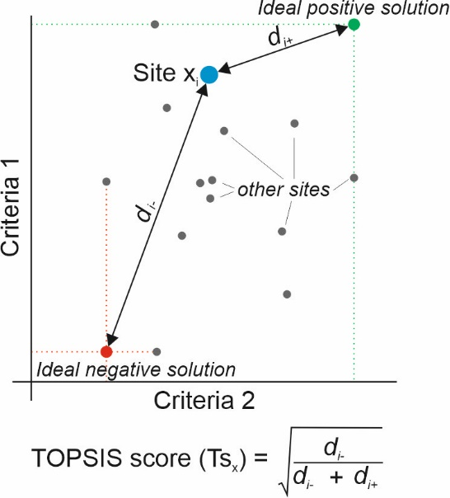
Figure 4: Scheme of the methodology used for site selection, adapted from the Technique for Order Preference by Similarity to Ideal Solution (TOPSIS) (Yoon and Hwang, 1995). The sites are defined in multidimensional space, determined by their values in each of the six ranking criteria. The best and worst values of the sites in each criterion determine the ideal positive and negative solutions to that criterion, respectively. The distances to these ideal positive (di+) and negative (di-) solutions are combined into a TOPSIS score (Ts), that is therefore dependent on all criteria at the same time.
The weighting factors were chosen based on the authors’ best knowledge. The selection of the weighting factors is probably the most subjective input to the TOPSIS process. However, it served as a “quality check” to test different scenarios, some focused on more geological criteria, others on more economic criteria and finally some more averaged. The risk and unit type were assigned the highest weight value (24), followed by the cost (18), the injectivity (14), the capacity (12) and the water depth (8) (Table 3). Different weighting scenarios were tested for sensitivity analysis with a set of four scenarios completed; this confirmed good agreement with the rounded view calculation.
The TOPSIS analysis allowed for the selection of the top six sites that best complied with the desired criteria: Brae North Condensate Field, Dornoch, Grid Sandstone, Heimdal, Mey and the Piper oil field. These sites passed to the final stage of the selection process, the due diligence study.
Criterion | Capacity P50 | Injectivity | Georisk + Well risk | Cost | Unit type | Water depth |  | TOPSIS
Correlation | Positive | Positive | Negative | Negative | Positive | Negative |  | Positive
Weight | 12 | 14 | 24 | 18 | 24 | 8 |  | -
Site name | Rank | Rank | Rank | Rank | Rank | Rank |  | Value | Rank | Decision
Brae East Condensate Field | 11 | 5 | 3 | 13 | 3 | 7 |  | 0.44 | 7 | Hold
Brae North Condensate Field | 9 | 15 | 3 | 11 | 3 | 1 |  | 0.44 | 6 | To due diligence
Claymore_014_18 | 6 | 6 | 5 | 15 | 15 | 12 |  | 0.18 | 14 | Hold
Cromarty Sandstone Member | 14 | 10 | 11 | 10 | 15 | 3 |  | 0.21 | 13 | Hold
Dornoch Formation | 8 | 1 | 8 | 3 | 8 | 6 |  | 0.54 | 3 | To due diligence
Flugga Sandstone Member | 12 | 9 | 11 | 7 | 15 | 10 |  | 0.28 | 11 | Hold
Forties 5 | 5 | 14 | 15 | 9 | 6 | 3 |  | 0.36 | 9 | Hold
Grid Sandstone Member | 2 | 2 | 1 | 2 | 8 | 8 |  | 0.69 | 1 | To due diligence
Heimdal Sandstone Member | 4 | 3 | 15 | 1 | 15 | 3 |  | 0.45 | 5 | To due diligence
Maureen 2 | 3 | 13 | 15 | 5 | 6 | 11 |  | 0.43 | 8 | Hold
Mey 5 | 1 | 7 | 12 | 6 | 6 | 3 |  | 0.55 | 2 | To due diligence
Pentland_016_21b | 7 | 12 | 8 | 8 | 15 | 15 |  | 0.25 | 12 | Hold
Pibroch_015_21 | 15 | 8 | 8 | 4 | 15 | 13 |  | 0.30 | 10 | Hold
Piper Oil Field | 10 | 4 | 3 | 12 | 3 | 14 |  | 0.52 | 4 | To due diligence
Scapa_014_20 | 13 | 11 | 8 | 14 | 15 | 9 |  | 0.15 | 15 | Hold

Table 3: criteria assessed and ranking of the target 15 sites, results of the TOPSIS analysis and decision taken for each of the sites. The sites are coloured based on their rank following a traffic-light scheme, with most suitable sites (ranked 1-5) in green, suitable sites (ranked 6-10) in yellow and least suitable sites (ranked 11-15) in red. The best ranked sites in each criterion are marked in bold. Positive correlation implies that the higher the criterion value, the more suitable the site is, whereas negative correlation implies that the higher the criterion value, the less suitable site the site is. The top six ranked sites were taken forward to the due diligence stage.

Due diligence
The objective of the due diligence stage is to provide an alternative assessment of the key site parameters that is independent from the CO₂Stored database. This approach is not intended to underestimate the value of the work behind the database, but to quality control the values and try to find alternative data sources that help to develop better understanding of the six shortlisted sites, providing precise values for the subsets of the saline aquifers considered. This assessment included the revision of original well log data, technical papers from researchers and oilfield operators, selected analogues, and an overview of the PGS MegaMerge seismic dataset.
The initial action within the due diligence process was to reduce the size of some of the extensive saline aquifers (e.g. Grid, Heimdal, Dornoch and Mey) by considering only those areas which were:
- Within UK national waters.
- Within 15km of one of the three potentially re-usable pipelines.
- Supported with good 3D seismic coverage from the PGS MegaSurvey data set.
- Available for access by 2022 and do not carry significant long-lived producing petroleum assets.
The geographical constraints imposed by the distance to the pipelines and the seismic data coverage of PGS MegaMerge divided two of the super-large saline aquifers, Grid and Mey 5, into two suitable sub-sites. Thus, the due diligence studies were carried out in eight sites: (A) North Brae condensate field, (B1) East Grid, (B2) West Grid, (C) Heimdal, (D1) West Mey, (D2) East Mey, (E) Dornoch and (F) Piper Oil Field (Figure 4). The Piper Oil Field was the only site located out of the 15km polygon, but it was still considered in the due diligence stage because of its suitable characteristics revealed in the ranking stage.
The purpose of the due diligence process was to develop an independent view of key resource input parameters to compare and complement the information included in the CO₂Stored database. The due diligence activity included:
- Review of 3D seismic (dip and strike line) for faults or other potential containment issues.
- Screening for any fields in the area that had Cessation of Production (COP) after 2022.
- Literature review to understand the reservoir properties and provide an independent view from CO₂Stored.
- Review of well logs to understand reservoir properties and depth of the target formations in the subsurface.
- Probabilistic capacity estimate, to complement the assessments included in the CO₂Stored dataset.

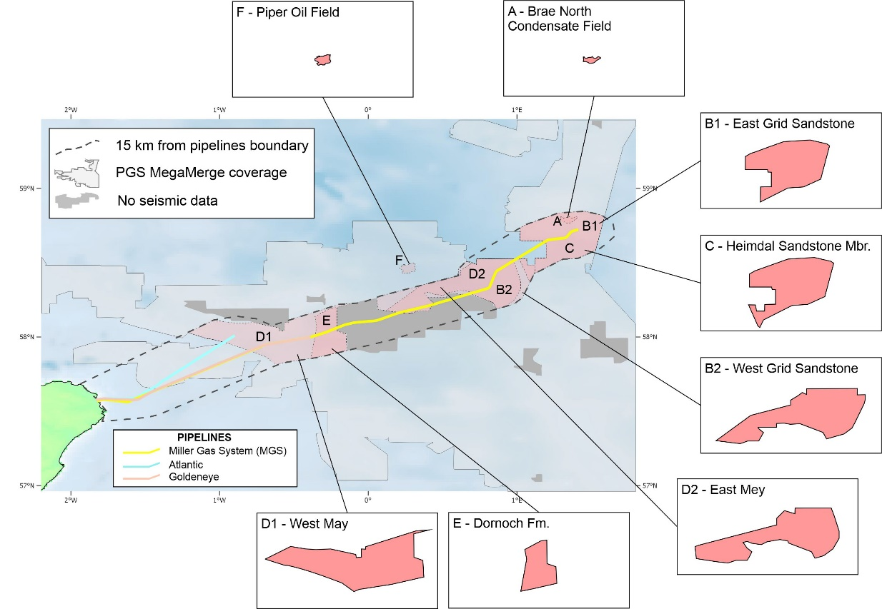
Figure 4: Location of the eight sites (A to F) considered in the due diligence stage. Their shapes were constrained according to a maximum distance of 15km to the three pipelines (orange dashed polygon) and the coverage of the PGS MegaMerge seismic dataset (light grey shaded area).

Site comparison
A summary of the information collated during the due diligence assessment for each site was included in a set of posters that can be accessed via the ACT Acorn website (ACT Acorn, 2018b). This format enabled a better comparison of the properties of the different sites. All eight sites represent good candidates for becoming Site 2. However, during the comparison, six of them were removed from further consideration due to different considerations (Table 4). Two remaining sites, Heimdal and East Mey, were therefore left from which to select the best candidate for Site 2.

Site name | Issue detected | Recommended action | Final decision
(A) North Brae Condensate Field | Significantly more expensive (2 to 3 times more) when compared to the rest of the sites, due to its greater depth, which increases the drilling costs. It also contains a large number of abandoned wells (34 wells), resulting in a well density of 2.1 wells/km². | Hold | Dismissed
(B1) East Grid | Lack of secondary containment reservoirs | Hold | Dismissed
(B2) West Grid | Lack of secondary containment reservoirs. Presence of sandstone injection features from rapid compaction, creating both containment challenges and reservoir complexity. | Hold | Dismissed
(C) Heimdal | No particular issues detected | Face-to-face comparison | Dismissed
(D1) West Mey | At the western part, the Mey Sandstone unit subcrops below shallow sediments close to the seabed, which may be a potential containment risk | Hold | Dismissed
(D2) East Mey | No particular issues detected | Face-to-face comparison | Site selected
(E) Dornoch | Lack of secondary containment reservoirs. Uncertainty in the hydraulic reservoir architecture due to a large shale separating upper and lower sands, which might be the reason for the lack of oil fields in the Dornoch Formation | Hold | Dismissed
(F) Piper Oil Field | Large uncertainty around the status of the more than 40 abandoned wells, following the Piper Alpha disaster. | Hold | Dismissed
Table 4: Issues observed during the site comparison in the due diligence stage and recommendations proposed. Sites C (Heimdal) and D2 (East Mey) were taken forwad to a face-to-face comparison, and the East Mey site was finally selected to become Site 2.

Both East Heimdal and East Mey, present similarities in several aspects, including both having good 3D coverage and access to well data via OGA’s National Data Repository (NDR, https://ndr.ogauthority.co.uk); reservoir quality (e.g. porosity and injectivity) are considered excellent; and there are minimal differences between them in containment risk score, development cost factor and water depth (ACT Acorn, 2018b). However, three aspects helped to tip the balance in favour of the East Mey site:
- Knowledge availability: the Mey Sandstone is a mature oil-producing reservoir, and the East Mey area contains ten oil and gas fields: Balmoral, Blenheim, Bladon, Burghley, Beauly, Brenda, Nicol, MacCulloch, Donan, and the well 15/20b-11. This means that, in addition to the well and seismic data reviewed during the site selection process, a substantial amount of technical data (e.g. hydrogeological or production data) will be available to feed into the storage modelling studies. These models are critical for the selection of the injection locations and to produce predictions of the long-term fate of the injected CO₂ (Alcalde et al., 2019).
- De-risked structures: the Mey Sandstone forms the reservoir targeted in the East Mey site. The East Mey area contains at least six known structures that host the previously listed hydrocarbon fields. The fact that these structures have been capable of trapping fluids for many millions of years helps to reduce the uncertainty on the presence of a fully operational caprock covering the target reservoir in the East Mey area (Worden et al., 2020).
- Abandoned wells status: most hydrocarbon production in the East Mey area exploited fields within the Mey Sandstone reservoir. This implies that the abandonment procedures put in place to plug the wells were aimed at avoiding the escape of fluids from the target formation to the surface. Therefore, abandoned wells in this area are likely to include multiple cement plugs between the Mey Sandstone and the seabed, providing additional barriers to the escape of the CO₂ to the surface in the event of CO₂ migration through the abandoned wells. On the other hand, most of the wells drilled and abandoned in the East Heimdal area originally targeted oil and gas fields deeper than the Heimdal Formation (e.g. the Brae fields) so they may not be properly abandoned in the Heimdal Formation itself, posing a greater containment risk potential in this site.

Discussion
  - Site selection and data handling
The criteria-driven methodology presented in this study (Figure 2) allowed for the selection of East Mey as Site 2 for the Acorn project. Our methodology incorporated valuable learnings from similar studies (see section 3), such as the use of multiple criteria and the inclusion of screening and ranking stages into the site selection workflow. However, the methodologies outlined in previous studies are generally either too region-specific or are only suitable for a first-order approach. Here, the project specifications for the selection of Site 2 drove the creation of a criteria-driven site selection methodology adapted to the context, project requirements and data availability. We defined some absolute, specific criteria (in the basis of design and screening stages) and more relative, weighted factors, or site qualification criteria (in the ranking and due diligence stages), similarly to Grataloup et al’s use of killer and qualification criteria (Grataloup et al., 2009). The top-down site selection process, presented here, employed multiple criteria, that described both qualitative and quantitative information about sites of different nature (geological, engineering, and financial). This forced the use of assumptions (e.g. number of wells and price per km in the calculation of the development cost) and “quantifiers” (e.g. unit type or risk) that allowed us to assign values to otherwise qualitative information. These criteria are suitable for the filtering stages of the site selection process, but they need to be reassessed in the due diligence stage to produce more accurate assessments of the different aspects of sites, particularly those that will determine commercial decisions. We argue that first order selections can be successfully achieved using information compiled in storage databases and atlases, but that comprehensive site selection solutions require handling data sources (e.g. scientific articles or access to raw data sources, such as well-log and seismic data) so that the site selection can reach a commercial level.
The CO₂Stored database contains a comprehensive list of potential storage candidates and a vast amount of information for each of the sites, related to multiple geological, engineering, risk and economic aspects. The site selection presented here benefited significantly from the access to this pre-existing database, which provided the main inputs in most stages of the site selection workflow. However, it is virtually impossible to include all available data for the 113 sites in the assessments, especially given the differences in the range of detail for different sites and the uncertainties that these bring, and the different weights that can influence the final suitability result. A balance must exist between including enough data for the correct understanding of the storage suitability of the candidate sites and including too many criteria, making the result meaningless. Selecting the most appropriate criteria in each phase is therefore critical to ensure this balance.
A remarkable consequence of the site selection process is that the due diligence process led to significant differences in the estimate of storage resource for a number of the sites. The storage capacities calculated in the due diligence stage were derived from a series of reservoir simulation studies reported in the SSAP project (Pale Blue Dot and Axis Well Technology, 2016) and these were up to an order of magnitude greater than those included in the CO₂Stored database. This difference was mainly due to differences in the assumptions of storage efficiency factors, and the fact that single, stochastic storage capacities were calculated for (sometimes massive) sites, where significant spatial variations have been averaged out. This emphasizes the issue that accurate capacity estimations are still a major and outstanding question for CCS (Bachu, 2015; De Silva and Ranjith, 2012), and thus pose an important challenge for the development of CCS technology (Anderson, 2017; Zahasky and Krevor, 2020).

  - The East Mey storage site
The Mey aquifer is a massive saline aquifer and not all of it will be targeted for CO₂ storage. The “East Mey storage site” is hereby defined as a portion of the Palaeocene sandstone interval, called the Mey Sandstone Member, as a potential storage reservoir, with the Lista Shale as caprock (Worden et al., 2020). The East Mey site is located in a mature hydrocarbon area, which has been subject of intense exploration and production activities since the late 1970’s (Gambaro and Currie, 2003). During the due diligence assessment, the target area extended from the Rob Roy to Hamish area in the west to the Burghley field in the east. However, the western part includes the development area around the Scott field, which is still under production (OGA, 2020). The ongoing petroleum production forced the exclusion of this region in favour of extending the storage development complex to the south, to incorporate the fields located southern of the Blenheim field (Figure 6). The majority of the fields in this region are located in the Mey Sandstone petroleum province, and most fields have reached the end of their producing lives. This area hence contains a number of potentially useful storage structures, including the Balmoral, Beauly, Blair, Brenda, Burghley, Glamis, and Stirling fields, which could have a positive impact in the capacity of the East Mey site. However, the East Mey area is still a considerable size (1,127 km²) and so a key part of the future work is to select the optimal injection point(s) and to calculate the dynamic capacity.
The long-lasting hydrocarbon history in the study area presents other important positive and negative implications regarding the storage suitability of the East Mey site. The wealth of subsurface data available (i.e. seismic, well-log, hydrogeological and production data) helps reduce the uncertainty in site characteristics. The containment risk related to caprock efficiency, particularly in the fields area is considered to be minimal. The CO₂ injection can be designed to cross and fill some of the depleted oil and gas fields so that the buoyant CO₂ can be trapped within the structures, in addition to the residual trapping in the body of underlying water. The review of the seismic lines suggests that there are no major faults crossing the Mey Sandstone, although minor faults are commonly present in many of the structures within the target area. On the other hand, there is a substantial number of active and abandoned wells in the area (117 wells in total, according to the OGA, or 0.08 wells per km²) (Figure 6). As the Mey Sandstone is a mature, oil-producing reservoir, well abandonment procedures were designed to avoid the escape of oil and gas from the Mey, which will be helpful in retaining high CO₂ integrity. However, these wells will have to be reviewed on a case by case basis, especially for wells where the oil and gas shows are located at different levels (i.e. stratigraphically higher or lower) than the Mey sandstone, just in case the Mey Formation was left open. Besides, if legacy wells have been poorly abandoned, or have suffered significant deterioration since their abandonment, then they may act as pathways for the vertical migration of CO₂ from the reservoir (Kang et al., 2016; Nicot, 2009). It is thus of great importance to determine well integrity and associated leakage risk prior to any storage operation (Sminchak et al., 2017), although this work can be challenging if the number of wells is high and/or the abandonment records are damaged or missing.
Reservoir quality and reservoir extent are favourable, with high injectivity anticipated. The reservoir architecture indicates the presence of shale baffles, which could help to enhance storage efficiency, but their extent and continuity should be studied in detail during future site characterisation stages. The overall area also has some structural closures in addition to the body of the underlying aquifer, thus affording an ability to buoyantly trap a portion of the CO₂. In summary, all these factors make East Mey a suitable selection for the development of Site 2.
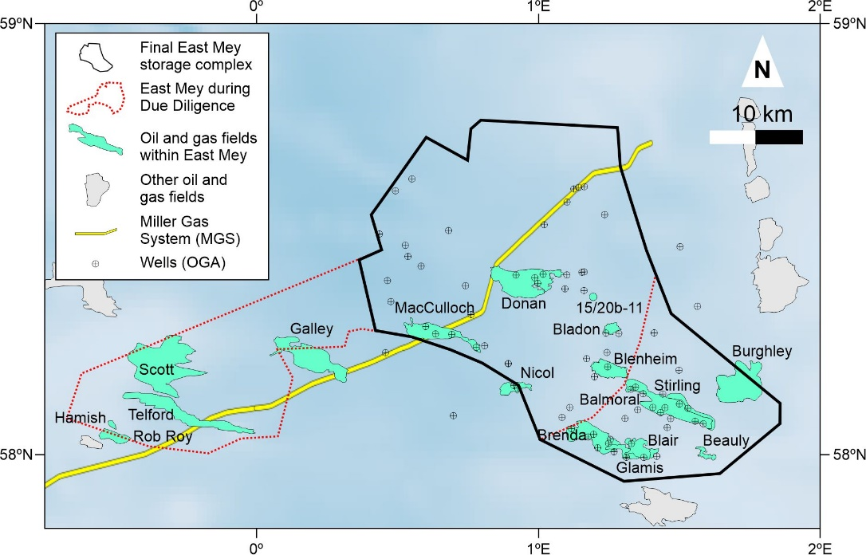
Figure 5: Final location of the East Mey storage complex (black polygon), including the location of the oil and gas fields in the area (in turquoise) and the polygon studied during the due diligence stage (in dotted red). The circled crosses mark the location of the 117 wells that sample the East Mey storage complex and its surroundings (source: OGA).

- Conclusions
A criteria-driven methodology allowed for the selection of East Mey as the most suitable site to serve as backup and/or upscaling option for the Acorn CCS project in northeast Scotland. The workflow draws on some criteria from previous studies for storage site selection, but critically incorporates project-specific elements that ensure the compliance with the aims of Acorn (e.g. high capacity and injectivity, low capital cost, proximity to re-usable infrastructure). The workflow included four major stages, that allowed rationale selection of suitable sites from over 500 input sites from the CO₂Stored database, and ultimately resulted in the most suitable site be chosen. The site selection approach that was employed included different geological, financial, engineering and safety criteria, ensuring that all aspects of the full CO₂ storage chain were reflected. Given the large number of input sites to be analysed, it is imperative to achieve a balance of criteria included, to ensure a correct consideration of the sites while keeping a reasonable level of complexity in the decision-making process.

The selected site, East Mey, belongs to the greater Palaeocene Mey Sandstone Member, and is located in a mature hydrocarbon area. It represents a suitable site due to its excellent reservoir quality (porosity and injectivity), data availability and relatively low risk and development cost. Its decades-long history of hydrocarbon exploitation has both positive and negative aspects to the suitability of the site, ensuring the availability of subsurface (e.g. 3D seismic coverage, well-log and core data) and hydrocarbon production data, reducing the containment uncertainty of the storage structures and increasing the amount of abandoned wells to be monitored in the area. Future work required to develop this site includes selecting the most appropriate injection point(s), calculating its dynamic capacity, analysing in detail the status of the abandoned wells in the area, in order to ensure safe and effective CO₂ storage operations.

Acknowledgements
Project ACT-Acorn is gratefully thanked for funding this study. ACT Acorn, project 271500, received funding from BEIS (UK), RCN (Norway) and RVO (Netherland), and was co-funded by the European Commission under the ERA-Net instrument of the Horizon 2020 programme. ACT Grant number 691712. J. Alcalde is funded by MICINN (Juan de la Cierva fellowship - IJC2018-036074-I). S. Ghanbari is currently supported by the Energi Simulation. Energi Simulation is also thanked for funding the chair in reactive transport simulation held by E. Mackay.

References
ACT Acorn, 2018a. Site selection report [WWW Document]. 10196ACTC Rep 08 01 - Site Sel. Rep. URL https://actacorn.eu/sites/default/files/ACT Acorn Site Selection Report 1.0_0.pdf (accessed 8.14.20).
ACT Acorn, 2018b. Annex 3 Site Selection Posters [WWW Document]. 10196ACTC Rep 08 01 - Site Sel. Rep. URL https://actacorn.eu/sites/default/files/ACT Acorn Site Selection Posters 1.0_0.pdf (accessed 8.14.20).
Alcalde, J., Flude, S., Wilkinson, M., Johnson, G., Edlmann, K., Bond, C.E., Scott, V., Gilfillan, S.M. V., Ogaya, X., Haszeldine, R.S., 2018a. Estimating geological CO2 storage security to deliver on climate mitigation. Nat. Commun. 9, 2201. https://doi.org/10.1038/s41467-018-04423-1
Alcalde, J., Heinemann, N., Mabon, L., Worden, R.H., de Coninck, H., Robertson, H., Maver, M., Ghanbari, S., Swennenhuis, F., Mann, I., Walker, T., Gomersal, S., Bond, C.E., Allen, M.J., Haszeldine, R.S., James, A., Mackay, E.J., Brownsort, P.A., Faulkner, D.R., Murphy, S., 2019. Acorn: Developing full-chain industrial carbon capture and storage in a resource- and infrastructure-rich hydrocarbon province. J. Clean. Prod. 233, 963–971. https://doi.org/10.1016/j.jclepro.2019.06.087
Alcalde, J., Smith, P., Haszeldine, R.S., Bond, C.E., 2018b. The potential for implementation of Negative Emission Technologies in Scotland. Int. J. Greenh. Gas Control 76, 85–91. https://doi.org/10.1016/j.ijggc.2018.06.021
Allen, M.J., Faulkner, D.R., Worden, R.H., Rice-Birchall, E., Katirtsidis, N., Utley, J.E.P., 2020. Geomechanical and petrographic assessment of a CO2 storage site: Application to the Acorn CO2 Storage Site, offshore United Kingdom. Int. J. Greenh. Gas Control 94, 102923. https://doi.org/10.1016/j.ijggc.2019.102923
Anderson, S.T., 2017. Cost Implications of Uncertainty in CO2 Storage Resource Estimates: A Review. Nat. Resour. Res. 26, 137–159. https://doi.org/10.1007/s11053-016-9310-7
Anthonsen, K.L., Aagaard, P., Bergmo, P.E.S., Gislason, S.R., Lothe, A.E., Mortensen, G.M., Snæbjörnsdóttir, S., 2014. Characterisation and selection of the most prospective CO2 storage sites in the Nordic region. Energy Procedia 63, 4884–4896. https://doi.org/10.1016/j.egypro.2014.11.519
Bachu, S., 2015. Review of CO2 storage efficiency in deep saline aquifers. Int. J. Greenh. Gas Control 40, 188–202. https://doi.org/10.1016/j.ijggc.2015.01.007
Bachu, S., 2000. Sequestration of CO2 in geological media: Criteria and approach for site selection in response to climate change. Energy Convers. Manag. 41, 953–970. https://doi.org/10.1016/S0196-8904(99)00149-1
Bachu, S., Adams, J.J., 2003. Sequestration of CO2 in geological media in response to climate change: Capacity of deep saline aquifers to sequester CO2 in solution. Energy Convers. Manag. 44, 3151–3175. https://doi.org/10.1016/S0196-8904(03)00101-8
Bentham, M., Mallows, T., Lowndes, J., Green, A., 2014. CO2STORage evaluation database (CO2Stored). The UK’s online storage atlas. Energy Procedia 63, 5103–5113. https://doi.org/10.1016/j.egypro.2014.11.540
Bradshaw, J., Dance, T., 2005. Mapping geological storage prospectivity of CO2 for the world’s sedimentary basins and regional source to sink matching, in: Greenhouse Gas Control Technologies. pp. 583–591. https://doi.org/10.1016/B978-008044704-9/50059-8
Brosse, É., Badinier, G., Blanchard, F., Caspard, E., Collin, P.Y., Delmas, J., Dezayes, C., Dreux, R., Dufournet, A., Durst, P., Fillacier, S., Garcia, D., Grataloup, S., Hanot, F., Hasanov, V., Houel, P., Kervévan, C., Lansiart, M., Lescanne, M., Menjoz, A., Monnet, M., Mougin, P., Nedelec, B., Poutrel, A., Rachez, X., Renoux, P., Rigollet, C., Ruffier-Meray, V., Saysset, S., Thinon, I., Thoraval, A., Vidal-Gilbert, S., 2010. Selection and Characterization of Geological Sites able to Host a Pilot-Scale CO 2 Storage in the Paris Basin ( GéoCarbone -PICOREF). Oil Gas Sci. Technol. – Rev. l’Institut Français du Pétrole 65, 375–403. https://doi.org/10.2516/ogst/2009085
Brownsort, P.A., Scott, V., Haszeldine, R.S., 2016. Reducing costs of carbon capture and storage by shared reuse of existing pipeline—Case study of a CO2 capture cluster for industry and power in Scotland. Int. J. Greenh. Gas Control 52, 130–138. https://doi.org/10.1016/j.ijggc.2016.06.004
Bui, M., Adjiman, C.S., Bardow, A., Anthony, E.J., Boston, A., Brown, S., Fennell, P.S., Fuss, S., Galindo, A., Hackett, L.A., Hallett, J.P., Herzog, H.J., Jackson, G., Kemper, J., Krevor, S., Maitland, G.C., Matuszewski, M., Metcalfe, I.S., Petit, C., Puxty, G., Reimer, J., Reiner, D.M., Rubin, E.S., Scott, S.A., Shah, N., Smit, B., Trusler, J.P.M., Webley, P., Wilcox, J., Mac Dowell, N., 2018. Carbon capture and storage (CCS): The way forward. Energy Environ. Sci. 11, 1062–1176. https://doi.org/10.1039/c7ee02342a
Chadwick, A., Arts, R., Bernstone, C., May, F., Thibeau, S., Zweigel, P., 2008. Best practice for the storage of CO2 in saline aquifers - observations and guidelines from the SACS and CO2STORE projects, North Star.
De Silva, P.N.K., Ranjith, P.G., 2012. A study of methodologies for CO 2 storage capacity estimation of saline aquifers. Fuel 93, 13–27. https://doi.org/10.1016/j.fuel.2011.07.004
Delprat-Jannaud, F., Korre, A., Shi, J.-Q., McConnell, B., Arvaniti, s A., Boavida, D., Car, M., Gastine, M., Grunnaleite, I., Bateman, K., Poulsen, N., Sinayuc, C., Vähäkuopus, T., Vercelli, S., Wójcicki, A., 2014. State-of-the-Art Review of Co2 Storage Site Selection and Characterisation Methods. CO2GeoNet 2, A132–A605. https://doi.org/10.1177/2050640614548980
Edlmann, K., Edwards, M.A., Qiao, X.J., Haszeldine, R.S., McDermott, C.I., 2015. Appraisal of global CO2 storage opportunities using the geomechanical facies approach. Environ. Earth Sci. 73, 8075–8096. https://doi.org/10.1007/s12665-014-3965-3
Eiken, O., Ringrose, P., Hermanrud, C., Nazarian, B., Torp, T.A., Høier, L., 2011. Lessons Learned from 14 years of CCS Operations: Sleipner, In Salah and Snøhvit. Energy Procedia 4, 5541–5548. https://doi.org/10.1016/j.egypro.2011.02.541
Evans, D., Armour, D., Bathurst, P., 2003. Millennium Atlas : petroleum geology of the central and northern North Sea Lower and Middle Jurassic, Millenium Atlas.
Fleury, M., Pironon, J., Le Nindre, Y.M., Bildstein, O., Berne, P., Lagneau, V., Broseta, D., Pichery, T., Fillacier, S., Lescanne, M., Vidal, O., 2010. Storage: an Overview of the Geocarbone-Integrity Program and Results. Oil Gas Sci. Technol. – Rev. l’Institut Français du Pétrole 65, 435–444. https://doi.org/10.2516/ogst/2010007
Gambaro, M., Currie, M., 2003. The Balmoral, Glamis and Stirling Fields, Block 16/21, UK Central North Sea. Geol. Soc. London, Mem. 20, 395–413. https://doi.org/10.1144/GSL.MEM.2003.020.01.33
Gammer, D., Green, A., Holloway, S., Smith, G., 2011. The energy technologies institute’s UK CO2 Storage Appraisal Project (UKSAP). Soc. Pet. Eng. - Offshore Eur. Oil Gas Conf. Exhib. 2011, OE 2011 2, 1045–1058. https://doi.org/10.2118/148426-ms
Ghanbari, S., Mackay, E.J., Heinemann, N., Alcalde, J., James, A., Allen, M.J., 2020. Impact of CO2 Mixing with Trapped Hydrocarbons on CO2 Storage Capacity and Security in a Saline Aquifer – Case Study from the Captain Sandstone, Moray Firth, UK. Appl. Energy 278, 115634. https://doi.org/10.1016/j.apenergy.2020.115634
Global CCS Institute, 2019. The Global Status of CCS: 2019. Australia.
Grataloup, S., Bonijoly, D., Brosse, E., Dreux, R., Garcia, D., Hasanov, V., Lescanne, M., Renoux, P., Thoraval, A., 2009. A site selection methodology for CO2 underground storage in deep saline aquifers: case of the Paris Basin. Energy Procedia 1, 2929–2936. https://doi.org/10.1016/j.egypro.2009.02.068
Gross, R., 2015. Approaches to cost reduction in carbon capture and storage and offshore wind.
Haszeldine, R.S., Flude, S., Johnson, G., Scott, V., 2018. Negative emissions technologies and carbon capture and storage to achieve the Paris Agreement commitments. Philos. Trans. R. Soc. A Math. Phys. Eng. Sci. 376. https://doi.org/10.1098/rsta.2016.0447
Heinemann, N., Alcalde, J., Johnson, G., Roberts, J.J., McCay, A.T., Booth, M.G., 2019. Low-carbon geoenergy resource options in the midland valley of Scotland, UK. Scottish J. Geol. 55, 93–106. https://doi.org/10.1144/sjg2019-007
Heinemann, N., Robertson, H., Alcalde, J., James, A., Ghanbari, S., Bond, C., Faulkner, D., Allen, M., Mackay, E., Haszeldine, R.S., 2018. Applied risk and consequence analysis for CO 2 storage projects – the Captain X storage site, offshore UK (Acorn), in: 14th Greenhouse Gas Control Technologies Conference Melbourne 21-26 October 2018 (GHGT-14). p. 8.
Holloway, S., Vincent, C.J., Bentham, M.S., Kirk, K.L., 2006. Top-down and bottom-up estimates of CO2 storage capacity in the United Kingdom sector of the southern North Sea basin. Environ. Geosci. 13, 71–84. https://doi.org/10.1306/eg.11080505015
Hsu, C.W., Chen, L.T., Hu, A.H., Chang, Y.M., 2012. Site selection for carbon dioxide geological storage using analytic network process. Sep. Purif. Technol. 94, 146–153. https://doi.org/10.1016/j.seppur.2011.08.019
IPCC, 2018. Global Warming of 1.5°C. An IPCC Special Report on the impacts of global warming of 1.5°C above pre-industrial levels and related global greenhouse gas emission pathways, in the context of strengthening the global response to the threat of climate change,.
ISO 27914, 2017. Carbon dioxide capture, transportation and geological storage — Geological storage.
Kang, M., Christian, S., Celia, M.A., Mauzerall, D.L., Bill, M., Miller, A.R., Chen, Y., Conrad, M.E., Darrah, T.H., Jackson, R.B., 2016. Identification and characterization of high methane-emitting abandoned oil and gas wells. Proc. Natl. Acad. Sci. U. S. A. 113, 13636–13641. https://doi.org/10.1073/pnas.1605913113
Kerr, R.A., 2011. Energy supplies. Peak oil production may already be here. Science 331, 1510–1511. https://doi.org/10.1126/science.331.6024.1510
Koukouzas, N., Ziogou, F., Gemeni, V., 2009. Preliminary assessment of CO2 geological storage opportunities in Greece. Int. J. Greenh. Gas Control 3, 502–513. https://doi.org/10.1016/j.ijggc.2008.10.005
Lee, J., Jablonowski, C.J., 2010. Measuring the Price Impact of Concentration in the Drilling Rig Market. Energy Sources, Part B Econ. Planning, Policy 5, 390–399. https://doi.org/10.1080/15567240903226228
Li, X., Ohsumi, T., Koide, H., Akimoto, K., Kotsubo, H., 2005. Near-future perspective of CO2 aquifer storage in Japan: Site selection and capacity. Energy 30, 2360–2369. https://doi.org/10.1016/j.energy.2004.08.026
Liu, F., Lu, P., Griffith, C., Hedges, S.W., Soong, Y., Hellevang, H., Zhu, C., 2012. CO 2-brine-caprock interaction: Reactivity experiments on Eau Claire shale and a review of relevant literature. Int. J. Greenh. Gas Control 7, 153–167. https://doi.org/10.1016/j.ijggc.2012.01.012
Llamas, B., Cienfuegos, P., 2012. Multicriteria decision methodology to select suitable areas for storing CO2. Energy Environ. 23, 249–264. https://doi.org/10.1260/0958-305X.23.2-3.249
Mander, S., Anderson, K., Larkin, A., Gough, C., Vaughan, N., 2017. The Role of Bio-energy with Carbon Capture and Storage in Meeting the Climate Mitigation Challenge: A Whole System Perspective. Energy Procedia 114, 6036–6043. https://doi.org/10.1016/j.egypro.2017.03.1739
Mathias, S.A., Hardisty, P.E., Trudell, M.R., Zimmerman, R.W., 2009. Approximate Solutions for Pressure Buildup During CO2 Injection in Brine Aquifers. Transp. Porous Media 79, 265–284. https://doi.org/10.1007/s11242-008-9316-7
Matter, J.M., Stute, M., Snebjornsdottir, S.O., Oelkers, E.H., Gislason, S.R., Aradottir, E.S., Sigfusson, B., Gunnarsson, I., Alfredsson, H.A., Wolff-boenisch, D., Mesfin, K., Dideriksen, K., Broecker, W.S., 2016. Rapid Carbon Mineralization for pPermanent Disposal of Anthropogenic Carbon Dioxide Emissions. Science (80-. ). 352, 1312–1314. https://doi.org/dx.doi.org/10.1126/science.aad8132]
Monaghan, A.A., Arsenikos, S., Callaghan, E., Ellen, R., Gent, C., Hannis, S., Henderson, A., Leslie, G., Johnson, K., Kassyk, M., Kearsey, T., Kim, A., Kimbell, G., Quinn, M., McLean, W., Millward, D., Pharaoh, T., Sankey, M., Smith, N., Uguna, C., Vane, C., Vincent, C., Williamson, P., 2017. Palaeozoic Petroleum Systems of the Central North Sea/Mid North Sea High. British Geological Survey, 92 pages. http://nora.nerc.ac.uk/id/eprint/516766
Nicot, J.-P., 2009. A survey of oil and gas wells in the Texas Gulf Coast, USA, and implications for geological sequestration of CO2. Environ. Geol. 57, 1625–1638. https://doi.org/10.1007/s00254-008-1444-4
OGA, 2020. Full list of Offshore Fields in Production [WWW Document]. UK Oil Gas Auth. URL https://www.ogauthority.co.uk/data-centre/data-downloads-and-publications/field-data/ (accessed 7.8.20).
OGA, 2018a. Carbon Capture Storage Licence Awarded [WWW Document]. UK Oil Gas Auth. URL https://www.ogauthority.co.uk/news-publications/news/2018/carbon-capture-storage-licence-awarded/
OGA, 2018b. UKCS Decommissioning 2018 Cost Estimate Report.
Pale Blue Dot, Axis Well Technology, 2016. A Summary of Results from the Strategic UK CO2 Storage Appraisal Project, funded by DECC.
Prelicz, R.M., Mackie, E.A.V., Otto, C.T., 2012. Methodologies for CO2 storage capacity estimation: Review and evaluation of CO2 storage atlases. First Break 30, 71–76. https://doi.org/10.3997/2214-4609.20144131
Ramírez, A., Hagedoorn, S., Kramers, L., Wildenborg, T., Hendriks, C., 2010. Screening CO2 storage options in The Netherlands. Int. J. Greenh. Gas Control 4, 367–380. https://doi.org/10.1016/j.ijggc.2009.10.015
Raza, A., Rezaee, R., Gholami, R., Bing, C.H., Nagarajan, R., Hamid, M.A., 2016. A screening criterion for selection of suitable CO2 storage sites. J. Nat. Gas Sci. Eng. 28, 317–327. https://doi.org/10.1016/j.jngse.2015.11.053
Sanz-Pérez, E.S., Murdock, C.R., Didas, S.A., Jones, C.W., 2016. Direct Capture of CO2 from Ambient Air. Chem. Rev. 116, 11840–11876. https://doi.org/10.1021/acs.chemrev.6b00173
Scafidi, J., Gilfillan, S.M.V., 2019. Offsetting Carbon Capture and Storage costs with methane and geothermal energy production through reuse of a depleted hydrocarbon field coupled with a saline aquifer. Int. J. Greenh. Gas Control 90, 102788. https://doi.org/10.1016/j.ijggc.2019.102788
SCCS, 2015. CO2 storage and Enhanced Oil Recovery in the North Sea: Securing a low-carbon future for the UK.
Shell, The Crown Estate, Scottish Government, Scottish Enterprise, Vattenfall, 2015. CO2Multistore: Optimising CO2 storage in geological formations; a case study offshore Scotland.
Shi, J.Q., Durucan, S., 2005. CO 2 Storage in Deep Unminable Coal Seams 60, 547–558.
Singh, P., Haines, M., 2014. A review of existing carbon capture and storage cluster projects and future opportunities. Energy Procedia 63, 7247–7260. https://doi.org/10.1016/j.egypro.2014.11.761
Sminchak, J.R., Moody, M., Gupta, N., Larsen, G., 2017. Wellbore integrity factors for CO 2 storage in oil and gas producing areas in the Midwest United States. Greenh. Gases Sci. Technol. 7, 817–827. https://doi.org/10.1002/ghg.1599
Stewart, R.J., Scott, V., Haszeldine, R.S., Ainger, D., Argent, S., 2014. The feasibility of a European-wide integrated CO 2 transport network. Greenh. Gases Sci. Technol. 4, 481–494. https://doi.org/10.1002/ghg.1410
Sun, X., Alcalde, J., Gomez-Rivas, E., Struth, L., Johnson, G., Travé, A., Gómez-Rivas, E., Struth, L., Johnson, G., Travé, A., 2020. Appraisal of CO2 storage potential in compressional hydrocarbon-bearing basins: Global assessment and case study in the Sichuan Basin (China). Geosci. Front. 11, 2309–2321. https://doi.org/10.1016/j.gsf.2020.02.008
Swennenhuis, F., Mabon, L., Flach, T.A., de Coninck, H., 2020. What role for CCS in delivering just transitions? An evaluation in the North Sea region. Int. J. Greenh. Gas Control 94, 102903. https://doi.org/10.1016/j.ijggc.2019.102903
Tucker, O., Tinios, L., 2017. Experience in Developing the Goldeneye Storage Permit Application. Energy Procedia 114, 7466–7479. https://doi.org/10.1016/j.egypro.2017.03.1880
UNFCCC, 2015. Adoption of the Paris Agreement. Proposal by the President., Paris Climate Change Conference - November 2015, COP 21. https://doi.org/FCCC/CP/2015/L.9/Rev.1
UNIDO, 2011. Global industrial ccs technology roadmap - sectoral assessment: Source-to-sink matching final report. Report UNI11–ES–001–2.
van der Meer, L.G.H. (Bert), Hofstee, C., Orlic, B., 2009. The fluid flow consequences of CO2 migration from 1000 to 600 metres upon passing the critical conditions of CO2. Energy Procedia 1, 3213–3220. https://doi.org/10.1016/j.egypro.2009.02.105
Vangkilde-Pedersen, T., Anthonsen, K.L., Smith, N., Kirk, K., neele, F., van der Meer, B., Le Gallo, Y., Bossie-Codreanu, D., Wojcicki, A., Le Nindre, Y.M., Hendriks, C., Dalhoff, F., Peter Christensen, N., 2009. Assessing European capacity for geological storage of carbon dioxide-the EU GeoCapacity project. Energy Procedia 1, 2663–2670. https://doi.org/10.1016/j.egypro.2009.02.034
Vilarrasa, V., Bustarret, G., Laloui, L., Zeidouni, M., 2017. A methodology to detect and locate low-permeability faults to reduce the risk of inducing seismicity of fluid injection operations in deep saline formations. Int. J. Greenh. Gas Control 59, 110–122. https://doi.org/10.1016/j.ijggc.2017.02.010
Wei, N., Li, X., Wang, Y., Dahowski, R.T., Davidson, C.L., Bromhal, G.S., 2013. A preliminary sub-basin scale evaluation framework of site suitability for onshore aquifer-based CO2 storage in China. Int. J. Greenh. Gas Control 12, 231–246. https://doi.org/10.1016/j.ijggc.2012.10.012
Wennersten, R., Sun, Q., Li, H., 2015. The future potential for Carbon Capture and Storage in climate change mitigation - An overview from perspectives of technology, economy and risk. J. Clean. Prod. 103, 724–736. https://doi.org/10.1016/j.jclepro.2014.09.023
Wilkinson, M., Polson, D., 2019. Uncertainty in regional estimates of capacity for carbon capture and storage. Solid Earth Discuss. 1–17. https://doi.org/10.5194/se-2019-45
Worden, R.H., Allen, M.J., Faulkner, D.R., Utley, J.E.P.P., Bond, C.E., Alcalde, J., Heinemann, N., Haszeldine, R.S., Mackay, E.J., Ghanbari, S., 2020. The Lower Cretaceous Rodby Shale and the Palaeocene Lista Shale: characterization and comparison of top-seal mudstones at two planned CCS sites, offshore UK. Minerals 10, 691. https://doi.org/10.3390/min10080691
Yang, W., Peng, B., Liu, Q., Wang, S., Dong, Y., Lai, Y., 2017. Evaluation of CO2enhanced oil recovery and CO2storage potential in oil reservoirs of Bohai Bay Basin, China. Int. J. Greenh. Gas Control 65, 86–98. https://doi.org/10.1016/j.ijggc.2017.08.012
Yoon, P.K., Hwang, C.L., 1995. Multiple Attribute Decision Making: An Introduction. Sage Publications Inc., Thousand Oaks, CA.
Zahasky, C., Krevor, S., 2020. Global geologic carbon storage requirements of climate change mitigation scenarios. Energy Environ. Sci. https://doi.org/10.1039/D0EE00674B
Zhou, D., Zhao, Z., Liao, J., Sun, Z., 2011. A preliminary assessment on CO2 storage capacity in the Pearl River Mouth Basin offshore Guangdong, China. Int. J. Greenh. Gas Control 5, 308–317. https://doi.org/10.1016/j.ijggc.2010.09.011

http://www.co2stored.co.uk/

