**SEM Handbook on Experimental Structural Dynamics**

**Model Updating**

John E Mottershead

School of Engineering, University of Liverpool, UK

Michael Link

Department of Civil and Environmental Engineering, University of Kassel, Germany

Michael I Friswell

College of Engineering, Swansea University, Wales, UK

Carsten Schedlinski

ICS Engineering GmbH, Dreieich, Germany

**Abstract**

The term ‘model updating’ describes the process of adjusting the parameters of a finite element model in order that its predictions, in terms of eigenvalues and eigenvectors, are in agreement with measurements obtained by modal testing. The sensitivity method, described in this chapter has been implements numerous times in commercial codes and applied successfully in industry. It has become a mature technology in regular use in the automotive and aerospace industries worldwide. However, there are various subtleties surrounding the application of model updating that are discussed here for the benefit of potential users. Firstly there must be an awareness of the frequency range in which the updated model is to be applied. The available data is generally insufficient to define the system parameters without the use of additional information provided by regularization. And the choice of parameters is of critical importance; it is not only a matter of choosing sensitive parameters, they should also be chosen as part of an engineering understanding of the dynamics of system. Careful choice of parameters, together with regularization, will lead to validated models that predict the behavior of the system beyond the scope of the original test data.

**Contents**

1. Introduction
2. Parameter Estimation
3. Modelling Errors and Measurement Inaccuracy
4. Sensitivity Analysis
   1. Undamped Eigenvalue Residual
   2. Undamped Mode-Shape Residual
   3. Frequency-domain Displacement Response Residual
5. Regularization
6. Parameterization
   1. Mass, Damping and Stiffness Matrix Multipliers
   2. Material Properties, Thicknesses and Sectional Properties
   3. Offset Nodes
   4. Generic Elements
7. Stochastic Model Updating
8. Validation of Updated Models
   1. Benchmark Data
   2. Summary of Model Validation Results
9. Industrial Example Problem
   1. Automotive Example Problem
10. Closure

**Nomenclature**

|  |  |
| --- | --- |
|  | vector of forces |
|  | displacement vector |
|  | vector of outputs |
|  | damping matrix |
|  | matrix of senstivities |
|  | matrix of frequency response functions |
|  | stiffness matrix |
|  | mass matrix |
|  | matrix of stiffness-matrix eigenvalues |
|  | weighting matrix |
|  | eigenvalue |
|  | vector of parameters |
|  | eigenvalue |
|  | matrix of stiffness-matrix eigenvectors |
|  | covariance matrix |
|  | mean |

**Keywords**

Model updating; sensitivity; parameterization; regularization; stochastic model updating; validation.

**1.    Introduction**

Modern and highly sophisticated finite-element (FE) procedures are available for structural analysis, yet practical application often reveals considerable discrepancy between analytical prediction and test results. The way to reduce this discrepancy is to modify the modelling assumptions and parameters until the correlation of analytical predictions and experimental results satisfies practical requirements. Classically, this is achieved by a trial and error approach, which is generally time consuming and may not be feasible in some cases. Thus computational procedures have been developed to update the parameters of analytical models using test data. In particular, modal data (natural frequencies and mode shapes) extracted from measured frequency response data have found broad application as a target for model parameter adjustment. This procedure was described in detail by Natke (1992) and by the present authors (Mottershead and Friswell, 1993; Friswell and Mottershead, 1995; Mottershead et al., 2011) and in recent years has developed into a mature technology applied successfully for the correction of industrial-scale FE models.

One of the first attempts to address the problem of updating or ‘correcting’ finite element models by using vibration measurements was made by Collins, Hart, Hasselman and Kennedy (Collins et al., 1974). This paper has since proved to be extraordinarily influential in providing the common basis for modern model updating codes and techniques using the sensitivity method and probabilistic model updating - including Bayesian model updating. A review of model updating methods was carried out by Mottershead and Friswell (1993) and this was followed by the research monograph *Finite Element Model Updating in Structural Dynamics* (Friswell and Mottershead, 1995). In the review paper the techniques were separated into two categories: Lagrange multiplier methods and penalty function methods. The penalty methods were then divided according to the type of data used: natural frequencies and mode shapes or frequency response functions (FRFs). The research monograph gives more detail. The Lagrange multiplier methods are called direct methods: they have the advantage that closed-form solutions are often available, but their disadvantages include (i) lack of physical meaning of the updated model, (ii) failure to represent known connectivities and (iii) the need for model reduction or eigenvector expansion techniques because of the mismatch of dimensions between the FE model and the measurements. Various approaches were tried to overcome these problems, including Keningsbuch and Halevi (1998) and Smith (1998) both of which appeared in a special issue of *Mechanical Systems and Signal Processing* on Model Updating. Yuen (2012) developed a direct method suitable for use with incomplete modal measurements. Formulation as an inverse eigenvalue problem, also leads to direct model updating solutions (Yuan, 2009), with quadratic orthogonality constraints (Datta et al., 2009) and model-structure preservation (Xie, 2011). In active vibration control, the concept of assigning certain chosen poles while the other poles of the system remain unchanged can be attractive in many applications because instability due to spillover is made impossible. The same principle was applied to model updating by Carvalho et al. (2007), Mao and Dai (2012) and Kuo and Datta (2012) to prevent the occurrence of spurious modes.

The penalty-function methods in the review paper (Mottershead and Friswell, 1993) are called iterative methods in the research monograph (Friswell and Mottershead, 1995). They are also known as sensitivity methods and sometimes called model-based methods. An important part of the sensitivity method is the parameterization of the finite element model and regularization of the ill-conditioned updating equations (Ahmadian et al., 1998; Friswell et al., 1998; Mottershead et al., 2000; Friswell et al 2001). Further contributions include Hua et al. (2009) who developed an adaptive procedure for adjusting the regularization parameter between Newton iterations. Weber et al. (2009) addressed the problem of linear regularization and Newton iterations affecting each other in an undesirable way. Their approach includes nonlinear updating algorithms with consistent regularization of the updating parameters relative to an *a priori* estimate using line search and stopping criteria together with generalized cross-validation for estimating the optimal regularization parameter. Goulet et al. (2013) proposed a model parameterization method based on model falsification – i.e. on the principle that in science, data cannot truly validate a hypothesis; it can only be used to falsify it. A space of possible models (a combination of parameters) was then generated and an error-domain falsification procedure was used reject instances that have unlikely differences (residuals) between predictions and measurements. Wang et al. (2018) carried out nonlinear model updating in the frequency domain by a sensitivity-based approach that firstly localized and characterized discrete nonlinearities before identifying the nonlinear parameters using a semi-analytical output residual. A tutorial on the sensitivity method in model updating was presented by Mottershead et al. (2011).

The area of greatest research activity in very recent times has been in the development of probabilistic (and non-probabilistic) methods for uncertainty quantification in model updating, reviewed in detail by Simoen et al. (2015) covering sensitivity, Bayesian, interval and fuzzy methods, and with particular emphasis on damage detection. Among many notable contributions Jacquelin et al. (2012) introduced a direct method using random matrix theory. Adhikari and Friswell (2010) represented randomized beam-bending properties using the Karhunen-Loève expansion. Goller et al. (2009) proposed a robust method using multi-dimensional Gaussian kernel density functions in the case of insufficient data, thereby enabling the quantification of design insensitivity. Mthembu et al. (2011) used Bayesian evidence for model selection, essentially selection from a finite set of candidate parameter groups based on plausibility. Batou (2015) considered uncertainty in the placement and orientation of sensors and actuators, optimizing the sensitivity of measured data and the robustness of updating parameters.

A distinction should be made regarding the interpretation of uncertainty. Epistemic uncertainty can be reduced by applying additional data. This applies, for example, to the case in model updating when measurements are noisy and the parameters are distinct but are estimated using probabilistic methods in terms of mean values and covariances. The standard deviations may be used as a measure of confidence in the estimated means. The other viewpoint on uncertainty is the frequentist one, known as aleatory uncertainty, which is irreducible and represents for example the distribution on the depth of a finite set of nominally identical beams. In this case the distribution on the depths of the beams is physically meaningful, as well as being useful to a designer wishing to understand the variation in performance resulting from the distribution. Bayesian approaches are inherently epistemic. Early examples include Beck and Katafygiotis (1998) Katafygiotis and Beck (1998) whereby experimental data is used to progressively revise the updating parameters expressed by a posterior probability density function. One problem with the Bayesian approach has been the requirement for large computation, now largely overcome as demonstrated by Goller et al. (2011) using parallelization of the updating code together with the transitional (Markov chain Monte-Carlo) MCMC algorithm, which identifies parameter regions with the highest posterior probability. Behmanesh et al. (2015) used a hierarchical Bayesian method to account for inherent variability due to temperature changes, temperature gradient, wind speed and traffic flow in civil engineering structures. The reader is referred to Yuan (2010) for a detailed exposition of Bayesian inference in model updating.

Mares et al. (2006) and Mottershead et al. (2006) were the first to use the term *stochastic model updating*. Hua et al. (2008) and Khodaparast et al. (2008) developed efficient perturbation methods, applicable to the aleatory (frequentist) problem of multiple, nominally-identical test-strucures. Govers and Link (2010) extended the classical sensitivity-based model updating procedure for the determination of parameter mean values and covariances; similar to the perturbation approach, this technique was based on an assumption of small variability. It was demonstrated very convincingly using data obtained by repeated disassembly and reassembly of the DRL AIRMOD structure (Govers and Link, 2012). Hua et al. (2017) developed a reliability index to assess the quality of a model updated using a perturbation approach. A thorough comparison of sensitivity and Bayesian methods using test data from the AIRMOD structure was given by Patelli et al. (2017). Au (2012) considered the connections between the Bayesian and frequentist approaches and concluded that results obtained by the two methods were very similar in the case of little or no modelling error.

Uncertainty quantification without the restriction of small variability generally demands multiple runs of deterministic finite element code, and the expense of doing so has led to the extensive use of surrogate models. The simplest of these are polynomial input-output response surfaces, as described for example by Fang et al. (2012) with Monte-Carlo simulation (MSC) and significance evaluation using analysis of variance (ANOVA). Zhang et al. (2011) used the polynomial chaos expansion as a surrogate as well as an evolutionary MCMC algorithm where a population of chains is updated by mutation to avoid being trapped in local basins of attraction. Non-probabilistic methods have also been applied in model updating. Khodaparast et al. (2011) using a Kriging model in interval updating to construct a bounding hypercube over the space of parameter uncertainty. This has the advantage of generating not merely a fitted surrogate, but the most probable input-output representation that reproduces the finite element model exactly at the training points. Fang et al. (2015) developed an interval response surface by removing the interaction terms from a second-order polynomial response surface and completing the square. This had the advantage, not only of efficiency, but also it avoided the overestimation frequently encountered with interval arithmetic.

## This chapter provides a basic introduction to the most important procedures of computational model updating and includes simple tutorial examples to reinforce the reader’s understanding together with a typical model updating example taken from the automotive industry, in Section 6. For a complete exposition of the sensitivity method in model updating the reader is referred to the forthcoming book by the present authors (Mottershead et al., in preparation).

**2.    Parameter Estimation**

Parameter updating techniques aim at fitting the parameters of a given initial analytical model in such a way that the model behavior corresponds as closely as possible to the measured behavior. The resulting parameters represent estimated values rather than true values since the test data are unavoidably polluted by unknown random and systematic errors. Also the mathematical structure of the initial analysis is not unique depending on the idealizations made by the analyst for the real structure. The residuals containing the test/analysis differences may be formed by force and response equation errors, by eigenfrequency and mode shape errors and by frequency response errors.

The first step in parameter estimation is the definition of a residual containing the difference between analytical and measured structural behavior,

 (1)

where  denotes the measurement. The analytical prediction is  and  represents the parameters to be updated. The analytical predictions are calculated from the equation of motion in the frequency domain,

;  (2)

where is the dynamic stiffness matrix, with the finite element mass matrix **M**, the damping matric **C** and the stiffness matrix **K.** The excitation frequency is denoted by *ω*, the excitation force vector is **f** and .

Typically the eigenvalues λ and the mode shapes **ϕ** are used as the analytical predictions. These are calculated from the undamped eigenvalue problem  or the complex frequency response functions  calculated from Eq. (2).

The objective is to minimize,

 (3)

where the symmetric weighting matrix  has been included to account for the importance of each individual term in the residual vector.  is difficult to estimate, although at the very least this weighting should include scaling to equalize the effect of amplitude and a reasonable choice is . In general the model response vector represents a non-linear function of the parameters resulting in a non-linear minimization problem. One of the techniques to solve this non-linear optimization problem is to expand the model response vector into a Taylor series about the current parameter estimate, , truncated after the linear term and leading to the linearized expression,

 (4)

where  denotes the residual, the difference between the measured and analytically predicted outputs  and  at the *i*th iteration. The sensitivity matrix  is given by,

 (5)

where  denotes the output data points and  is the parameter index. The sensitivity matrix is computed at the current value of the complete vector of parameters . The error, , is assumed to be small for parameters in the vicinity of .

The minimization  of the weighted objective function (3) yields the linear equation system

 (6)

which at each iteration step *i* is solved for and the model is then updated to give,

 (7)

This procedure continues until consecutive estimates  and  are sufficiently converged.

The case when fewer measurements than parameters are available in Eq. (6)  leads to an underdetermined system, whose solution is not unique. Indeed, if  and , then the model is able to reproduce the measurements, i.e. . Even if a minimum norm or a minimum parameter change solution is selected the resulting parameters will in general not retain their physical meaning. In parameter updating the number of measurements should always be made larger than the number of parameters  which yields overdetermined equation systems. A very effective way of choosing suitable parameters is by the subset selection described by Lallement (1990), and Friswell *et al.* (1998). The data should of course be sensitive to the selected parameters, which must be justified by physical understanding of the structure and the test arrangement. For the overdetermined case the solution of Eq. (6) with respect to Δ**θ***i* gives an improved parameter estimate as

 (8)

Even in the overdetermined case the condition of the sensitivity matrix **G** plays an important role for the accuracy and the uniqueness of the solution. A fundamental requirement to obtain a solution is that .

**3.    Modelling Errors and Measurement Inaccuracy**

Model updating is essentially a process of adjusting certain parameters of the finite element model. The user should be aware of numerous sources of modelling error and make necessary adjustments particularly those aspects of the model that cannot the corrected by changing the values of selected model-updating parameters. Examples of such errors, listed in categories (1) and (2) below, are related to the mathematical structure of the model and generally referred to as *model-structure errors*. These errors cannot be eliminated by model updating and should be eliminated or reduced by careful interrogation of the model before the application of model updating techniques. The errors listed under category (3) are typical of those that can be corrected by model updating.

1. Idealization errors resulting from the assumptions made to characterize the mechanical behavior of the physical structure. Such errors typically arise from:

* simplifications of the structure, for example, when a plate is treated like a beam, which might or might not be erroneous depending on the length to width ratio of the plate and the frequency range to be covered,
* inaccurate assignment of mass properties, for example, when distributed masses are modelled with too few lumped masses or when rotational inertia is disregarded,
* when the finite element formulation neglects particular properties, for example, when the influence of transverse shear deformation or warping due to torsion in beam elements is neglected,
* errors in the connectivity of the mesh i.e. some elements are not connected or are connected to a wrong node,
* erroneous modelling of boundary conditions, for example, when an elastic foundation is assumed to be rigid,
* erroneous modelling of joints, for example, when an elastic connection is assumed to be rigid (clamped) or when an eccentricity of a beam or a plate connection is omitted from the model,
* erroneous assumptions for the external loads,
* erroneous geometrical shape assumptions,
* a non-linear structure assumed to behave linearly.

1. Discretization errors introduced by numerical methods such as those inherent in the finite element method, for example:

* discretization errors when the finite element mesh is too coarse so that the modal data in the frequency of interest is not fully converged,
* truncation errors in order reduction methods such as static condensation,
* poor convergence and apparent stiffness increase due to element shape sensitivity.

1. Erroneous assumptions for model parameters, for example:

* material parameters such as Young’s modulus or mass density,
* cross section properties of beams such as area moments of inertia,
* shell/plate thicknesses,
* spring stiffnesses or
* non structural mass.

When the model includes idealization and discretization errors it may only be updated in the sense that the deviations between test and analysis are minimized. The same happens when the selected correction parameters are not consistent with the real source and the location of the error. The parameters in such cases may lose their physical meaning after updating. A typical result of updating such *inconsistent* models is that they may be capable of reproducing the test data but may not be useful to predict the system behavior beyond the frequency range used in the updating. Similarly, they may not be able to predict the effects of structural modifications or to serve as a substructure model to be assembled as part of a model of the overall structure.

The aim of all structural analyses to predict the structural response can only be achieved if all three kinds of modelling errors are minimized with respect to the given purpose of the structural analysis. Models that fulfil these requirements shall be called *validated models*. Model quality must therefore be assessed in three steps.

Step 1: Assessment of idealization and numerical method errors (model structure errors) prior to parameter updating.

Step 2: Correlation of analytical model predictions and test results and selection of correction parameters.

Step 3: Assessment of model quality after parameter updating. Since a unique solution cannot be expected, this requirement must be related to the intended purpose for which the model is used, for example:

* to predict the system behavior to types of load or response other than those used in the test,
* to predict the system behavior beyond the frequency range and/or at degrees of freedom other than those used for updating,
* to predict the effects of structural modifications,
* to check if the model, when used as a substructure within an assembled complete structure, will improve the response of the whole model.

The validation of updated finite element models is discussed in more detail in Section 9.

**4.    Sensitivity Analysis**

In practice, the first step is the definition of a residual. In this section we consider the following residuals, representing probably the most widely used techniques: real eigenvalues, real mode shapes, and the frequency-domain displacement residual.

A comprehensive selection of these and other residuals with special consideration of statistically based weighting and the statistical properties of the parameter estimates is given by Natke et al. (1995).

**4.1 Undamped Eigenvalue Residual**

The linearized undamped eigenvalue residualsare defined by the differences between the vector of measured eigenvalues and their analytical counterparts , which being undamped are entirely real. The eigenvalues in this case are defined as the squares of the system natural frequencies, , at the linearization point, ‘*i*’. Thus the eigenvalue residual and sensitivity are given by Eqs. (4)-(6) when . It is necessary to ensure that the analytical and measured eigenvalues correspond to the same physical mode. This process, usually referred to as *mode pairing*, may be achieved by carrying out a modal correlation using the modal assurance criterion (MAC) (Friswell and Mottershead, 1995). Special care has to be taken for systems with repeated roots (e.g. axisymmetric systems) where arbitrary combination of mode shapes (analytically and experimentally) may cause significant degradation of MAC values. To overcome this, a general method for transforming analytical eigenvectors is for instance described in (Schedlinski and Staples, 2004), which allows for an easy and especially automated compensation of the effect.

The terms in the sensitivity matrix may be determined analytically (Fox and Kapoor, 1968) by differentiation of the undamped eigenvalue equation,

 (9)

where are the finite-element mass and stiffness matrices respectively and  is the *j*th mode shape. It is seen that only the *j*th eigenvalue and eigenvector are needed to calculate all the *j*th-eigenvalue sensitivities. As well as the analytical approach to calculating the sensitivity matrix terms, it is also possible to obtain numerical approximations by the simple procedure of perturbing the parameters in turn by a suitably small quantity and determining numerically the change in the predicted eigenvalues and eigenvectors. Although efficient procedures exist in finite element codes such as MSC.NASTRAN, there is a considerable advantage in using analytically determined sensitivities when large-scale structures are to be updated.

**4.2 Undamped Mode-Shape Residual**

The linearized undamped mode-shape residuals are the differences between the measured mode shapes at a restricted number of degrees of freedom corresponding to the location of sensors and the analytical modes shapes at the same coordinates. The differences are determined at  measured degrees of freedom. Thus the mode-shape residual and sensitivity are given by Eqs. (4)-(6) when , where the vectors  and  may contain many concatenated vectors of the different analytical and measured mode shapes respectively. The analytical and experimental mode shapes should be normalized in the same way.

The determination of mode-shape sensitivities is a significant computational task and several approaches are available. In this article we consider only the method ofFox and Kapoor [45]. The method, based on expanding the gradients into a weighted sum of the eigenvectors, is widely used due to its simplicity of implementation,

 (10)

which, after substitution of Eq. (10) into the derivative of the eigenvalue equation, produces the factor  in the form,

 (11)

and,

 (12)

This expansion is exact if *H=N* modes are used. For *H<N* the expansion represents an approximation depending on the number of modal terms. Corrections to this approach have been investigated by several authors. Eqs. (10) and (11) show that the expansion contains large factors *ajkh* for neighboring eigenvalues  that can cause convergence problems. Nelson’s method (Friswell and Mottershead, 1995) has the advantage that only the mode shape of interest is required but can be very time consuming in case of large scale finite element models. The antiresonance residual may be used as an alternative to the undamped mode-shape residual, as was considered by D’Ambrogio and Fregolent (2000).

**4.3 Frequency-domain Displacement Response Residual**

Thefrequency response error linearized at  is obtained from the differences of the measured and the analytical frequency response at the measured degrees of freedom . The analytical frequency response is given by,

 (13)

at those degrees of freedom that coincide  with  the measured ones.

The sensitivity matrix,  of the frequency responsemay be obtained by using the identity,

 (14)

where

 (15)

Thus,



(16)

The frequency response function matrix  may be expressed either by,

 (17)

in the case of proportional or modal damping, or by

 (18)

for the general case of nonproportional damping where  and  denote the complex eigenvalues and eigenvectors. In both cases *q* represents the number of modes included in the sum and the terms in the eigenvectors are those corresponding to the measured coordinates.

One problem with the frequency response formulation is the measured and analytical FRF peaks do not coincide leading to large frequency-domain displacement errors. This problem is particularly pronounced when close modes cross over each other such that the orders of the test and analytical modes are different. A possible solution is to firstly update the **M** and **K** matrices using a different residual. The peaks then become closely aligned and the frequency-domain displacement response residual can be used to update the damping matrix **C**. This approach is described in more detail in Section 9.

**5.    Regularization**

The treatment of ill-conditioned, noisy systems of equations is a problem central to finite element model updating (Natke, 1991; Ahmadian et al., 1998; Friswell et al., 2001; Titurus and Friswell, 2008). Such equations often arise in the correction of finite element models by using vibration measurements. The classical weighted least squares method described above can be extended in cases where it difficult to obtain a convergent solution because of an ill-conditioned sensitivity matrix. The objective function, Eq. (1), is extended by the requirement that the parameter changes Δ**θ** should be minimized, to give,

 (19)

The parameter weighting matrix  should be chosen to reflect the uncertainty in the initial parameter estimates (Mottershead and Foster, 1991; Prells 1996; Weber et al. 2009). This may be formally related to Bayesian methods, where the optimum matrices  and  are the inverse of the output and parameter variances respectively (Collins et al., 1974; Friswell, 1989). However, the variance of the initial parameter estimates are rarely known in practice and an alternative given by Link (1993) relates the choice of weighting matrix, , to the inverse of the squared sensitivity matrix according to,

. (20), (21)

This definition allows the parameter changes to be constrained according to their sensitivity. In consequence the parameters remain unchanged if their sensitivity approaches zero.  represents the classical Tikonov regularization (Tikhonov and Arsenin, 1977) used to solve ill conditioned systems of equations.

Eq. (3) is easily extended to penalize differences between the updated parameters and the corresponding initial estimates, or to penalize differences between nominally identical parameters (Ahmadian et al., 1998; Friswell et al., 2001). For example, in an experimental frame structure a number of ‘T’ joints may exist that are nominally identical. Due to manufacturing tolerances the parameters of these joints will be slightly different, although these differences should be small. Therefore a side constraint is placed on the parameters, so that both the residual and the differences between nominally identical parameters are minimized.

Minimizing *J* in Eq. (19) gives the solution

 (22)

where **T***i* is the generalized pseudo inverse of the sensitivity matrix.

The question remains how to choose the regularization parameter *μ*, that provides a balance between the measurement residual, , and the side constraint (or parameter change), . Link (1993) suggested that the factor  lies in the range between 0 (no regularization) and 0.3. High *μ* values are used if there are many insensitive parameters and the matrix  is strongly ill-conditioned. If the ill-conditioning is not too strong . The higher the value of *μ* the higher is the necessary number of iteration steps to achieve convergence.

This regularization approach is very closely related to the optimization of multiple objective functions. From Eq. (19) it is clear that the residual and side constraint are functions of *μ*:  and . The way in which these two terms are balanced depends on the size of the regularization parameter *μ*. If *μ* is too small then the problem will be too close to the original ill-posed problem, but if *μ* is too large then the problem solved will have little connection with the original problem. A useful approach is to plot the norm of the side constraint, , against the norm of the residual, , for different values of *μ*. For multi-objective function optimization this is called the Pareto front and in regularization is called the L curve. Hansen (1994) showed that the norm of the side constraint is a monotonically decreasing function of the norm of the residual. He pointed out that for a reasonable signal-to-noise ratio and the satisfaction of the Picard condition, the curve is approximately vertical for *μ*<*μopt*, and soon becomes a horizontal line when *μ*>*μopt*, with a corner near the optimal regularization parameter *μopt*. The curve is called the L-curve because of this behavior. The optimum value of the regularization parameter, *μopt*, corresponds to the point with maximum curvature at the corner of the log-log plot of the L-curve. This point represents a balance between confidence in the measurements and the analyst’s intuition.

One difficulty in model updating is that the relationship between the parameters and the measurements is non-linear, and the estimation problem is solved by constructing the linearized model and iterating until convergence. At each iteration regularization may be applied, although often the corner of the L-curve disappears as the iterations progress (Titurus and Friswell, 2008), and thus the value of the regularization parameter is difficult to determine. Hence, it is often convenient to set the regularization parameter at the first iteration and retain this value until convergence.

### Example: Two degree-of-freedom statically loaded system

We now consider the two degrees of freedom static example shown in Figure 1. In the initial model the spring constants are all 1 N/m, so that . The *measured* data are taken from a system with , , . The purpose of the example is to show how the stiffness correction may be determined from measured static displacements  and . Two cases will be considered, namely the under-determined and over-determined cases.

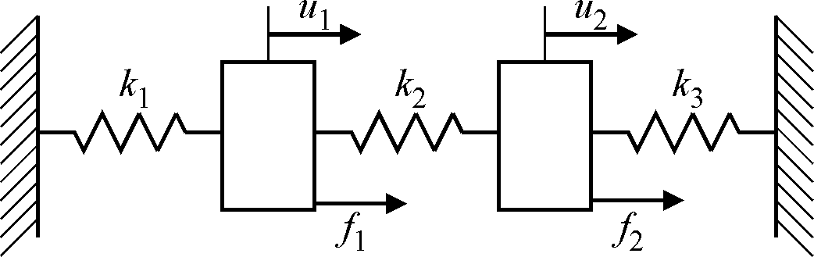

**Figure 1.** Two Degree of Freedom Discrete Example

The updating equation is formulated using a force residual which is obtained by introducing the measured displacement response into the equation of motion (2). In the static load case, *ω*=0, this results in an analytical force vector  which for the example of Figure 1 is given by,

 

The residual defined in Eq. (1) is then calculated from

 (23)

where **f***m*denotes the measured force vector and  is the sensitivity matrix. This latter matrix doesn’t depend on the current stiffness value so that there is no iteration necessary in this simple case. Thus the updating Eq. (23) is of the same form as Eq. (4).

### *Case 1: Under-determined system*

Suppose that the force applied to the springs is , and the measured static deflection is . The vector of stiffness changes that reproduces the measured displacement, for the minimum norm of the stiffness change, may be obtained as ,  and . Figure 2 shows the results obtained by including the side constraint of minimum stiffness change, for various values of regularization parameter,*μ*. In this case the matrix **G** is not ill-conditioned, and hence the side constraint yields a solution that is a weighted average of the minimum norm solution and the zero change solution, as shown by the smooth variation in the spring stiffnesses with *μ* in Figure 2. This is also the reason the residual plot does not have the L-curve shape. Note also that the simulated stiffness change is never recovered by the estimation procedure.



**Figure 2.** The estimation results for the under-determined case. Dotted lines represent the simulated stiffness change. *(Figures 2-10 are reproduced by kind permission of Elsevier)*

### *Case 2: Over-determined system*

Suppose that a second force, , is applied to the springs, giving the measured static deflection of . If this data is combined with the data for the first load case , then the estimation is overdetermined. Since there is no noise or modelling errors the exact spring stiffnesses are obtained: ,  and 

Regularization is most useful when the coefficient matrix is relatively ill-conditioned and noise is present. In this simple example the ill-conditioning is obtained by considering measurements taken at two force levels, namely  and . The exact 'measured' displacement for  is . Noise is added to the measurements:  to  and  to . Figure 3 shows the results obtained by including the side constraint of minimum stiffness change, for various values of regularization parameter, *μ*. The L-curve now has the classical shape, with a defined corner. For low values of regularization parameter the estimation is clearly ill-conditioned leading to large estimated stiffness changes. The condition number of **G** in this example is 880. At the corner of the L-curve the stiffness changes are approximately those obtained from the minimum norm solution for the under-determined case. For a regularization parameter slightly less than that at the corner of the L-curve the stiffness changes are very close to those simulated, although this is impossible to determine solely from the estimated results. Figure 4 shows the results when using the parameter weighting matrix given by Eqs. (19) - (21). Although similar to the results of Figure 3, the updated parameters at the corner of the L curve are now much closer to the simulated values, as shown in Table 1.



**Figure 3.** The estimation results for the over-determined case with the minimum norm parameter change. Dotted lines represent the simulated stiffness change. Circles denote the corner of the L curve and the associated values of residuals and stiffness changes.



**Figure 4.** The estimation results for the over-determined case with parameter weighting matrix given by Eq. (20). Dotted lines represent the simulated stiffness change. Circles denote the corner of the L curve and the associated values of residuals and stiffness changes.

**Table 1.** Updated parameter estimates for the over-determined two degree of freedom static example

|  |  |  |  |  |
| --- | --- | --- | --- | --- |
|  | *μ* |  |  |  |
| No Regularization | 0 | 1.779 | -0.243 | -0.304 |
| L curve corner, Figure 3 | 0.0093 | 1.149 | 0.889 | 1.112 |
| L curve corner, Figure 4 | 0.0179 | 1.179 | 0.836 | 1.046 |
| 'Exact' |  | 1.200 | 0.800 | 1.000 |

Examples of regularization using experimental data may be found in the literature. Examples include Link (1999) on a 5 degree of freedom laboratory test structure using Eq. (22) and Ahmadian et al. (1998) who used the L curve to determine the regularization parameter for the experimental frame structure, mentioned previously, with nominally identical welded joints.

**6.    Parameterization**

The amount of information that can be obtained from vibration test data is limited and therefore taking more measurements in the same frequency range won’t necessarily result in more information. Neither will the additional measurements allow more parameters to be estimated necessarily. The number of parameters should be considerably smaller than the number of measurements. The objective should be that the model-updating problem will be over-determined. Often the resulting equations are ill-conditioned and it is then necessary to apply additional information in the form of a side constraint by regularization as described previously. The parameters should be justified by physical understanding of the structure under test and the test set-up. Ideally the chosen parameters should have a physical meaning directly, but this is not always possible in practice. Equivalent models and their parameters often lead to improved models when ‘physical’ parameters cannot be found. The data should be sensitive to small changes in the parameters. Difficult features, such as joints, may be made more or less sensitive by choosing different types of parameters. A study that includes several different parameterizations of the same joint in a space-frame structure is described by Mottershead et al. (2000).

When choosing parameters it is always advisable to try to understand the behavior of the structure globally, and locally in those regions where local modelling inaccuracies might be responsible for discrepancies in predictions. For example, close study of finite element mode shapes is able to reveal the motion of joints at each of the measured natural frequencies. Parameters can then be chosen that influence this motion and their significance in model updating easily confirmed by sensitivity analysis and subset selection. In regions of high strain energy one would usually choose stiffness parameters whereas mass parameters would be useful in regions of high kinetic energy. Stiffness is generally more difficult to model than mass and it is therefore more likely that errors in stiffness modelling are responsible for inaccurate predictions than mass errors. Damping is in many respects a special case. Whereas finite element mass and stiffness matrices may be readily derived from variational or energy principles, similar derivations for damping are generally not available. Joints and boundary conditions are particularly difficult to model closely. In principle it is possible to design tests that increase the sensitivity of chosen parameters, but this is extremely difficult to achieve in practice.

**6.1 Mass, Damping and Stiffness Matrix Multipliers**

Probably the simplest parameters for model updating are non-dimensional scalar multipliers applied at the element or substructure level. The updated model takes the form,

 (24)

 (25)

 (26)

where in this case *U* stiffness parameters, *S* damping parameters and *R* mass parameters are chosen for updating. The subscript ‘0’ denotes the analytical model before updating. Of course the parameter ,  or  may be applied to more than just one element. In this way the parameters may be applied to substructures, when those elements sharing the same updating parameter are connected, or there may be elements dispersed through the mesh that for some physical reason are to be updated in the same way. One reason why different parts of the structure might be updated using the same parameter would be the sensitivity of the eigenvalues (and eigenvectors) in the frequency range of interest to small changes in the parameters is very similar. In that case separating the elements whose changes have a similar effect would be a bad choice, possibly leading to ill-conditioning of the sensitivity matrix.

It is good practice to scale the updating equations so that the parameters ,  and  take similar numerical values. One way to do this is by dividing the parameter correction by the initial parameter values, which is done implicitly in Eqs. (24) - (26). Returning to the specific discussion of matrix-multiplier parameters, it is seen that the terms  are simply the  element mass matrix, ,  element damping matrix,  and the  element stiffness matrix, , a fact which makes the computation of the various sensitivities especially simple.

**6.2 Material Properties, Thicknesses and Sectional Properties**

The most common material property parameters are Young’s modulus and mass density, identical to the  and  above since the element stiffness and mass matrices are linear in and .

In the case of a beam having a rectangular cross section the element matrices are,

 (27)

and,

 (28)

where *l* denotes the element length and the breadth and thickness of the cross section are denoted by *t* and *b* respectively. Young’s modulus and mass density are represented by *E* and .

The choice of parameters *E* and *I* independently would lead to redundancy and ill-conditioning since they lead to identical eigenvalue sensitivities (except for a scaling factor).  and  independently would be a difficult choice to justify physically. But, both  and  depend upon  and , so that the choice of these two parameters would allow the correction of a beam cross-section meaningfully. Other useful parameters include the thicknesses and dimensions of thin-walled sections and plate thicknesses.

The material parameters, thicknesses and cross-sectional dimensions tend to be powerful updating parameters because they often apply throughout a finite element mesh affecting a large number of elements. Thus a small change in these parameters often affects the natural frequencies very considerably.

**6.3 Offset Nodes**

Joints and boundary conditions are difficult to represent accurately and it is in these regions of the model that assumptions are often made. Probably the most common assumption is that the connection made at a joint or boundary is rigid when in fact there is flexibility. The problem of introducing flexibility into joints and boundaries assumed to be rigid can be tackled in a number of different ways, all resulting in equivalent models with parameters that cannot be justified on physical grounds. However, the dynamic behavior of the model and its physical usefulness will most definitely be improved by this approach.

One approach, useful in many applications, is to make use of offset finite element nodes and to use the offset dimensions to correct the model (Mottershead et al., 1996). Lengthening or shortening an offset dimension usually corresponds to making the joint more flexible or to stiffening it, and in this way it is possible to reconcile the modification with engineering understanding of the structure.

**Example: Parameterization of a ‘T’ joint**

The ‘T’ joint under consideration is shown in Figure 5. It consists of three element, two horizontal and one vertical element, each of which is inextensible so that  and .

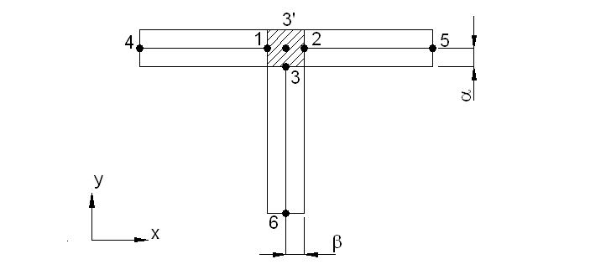

**Figure 5.** ‘T’ joint.

The shaded region may be considered rigid in which case the degrees of freedom at nodes 1, 2 and 3 are referred to node 3’ according to the connection matrix,

 (29)

Construction of the overall stiffness matrix of the ‘T’ joint by the usual methods results in a matrix that contains the offsets  and . If the overall dimensions of the joint remain unchanged then increasing the offsets causes the joint to become stiffer while reducing them makes the joint more flexible. Parameters such as  and  have been found to be extremely effective in the correction of inaccurately modelled joints.

**6.4 Generic Elements**

Generic elements offer perhaps the most sophisticated and most general way to parameterize a finite element model (Gladwell and Ahmadian, 1995; Ahmadian et al., 1997, 2002). The basic idea is to change the element formulation within the limitations imposed by the number of nodes and the degrees of freedom available. A number of different methods are available, based either on eigenvalue decomposition or the application of constraints (not discussed in the present article). Whichever of the different methods are chosen, generic elements are applied at the element (or substructure) level.

Quite often the mass matrix is considered to be accurate and only the stiffness matrix needs to be updated. Then an eigenvalue decomposition of the stiffness may be carried out,

 (30)

where the matrix of eigenvectors is orthogonal, since  is a real symmetric matrix,

 (31)

The eigenvalues and eigenvectors of the stiffness matrix are not the same as those of the element generalized eigenvalue problem, . Each eigenvalue can be thought of as a spring coefficient for a deflection defined by its eigenvector.

A new matrix of eigenvectors may be introduced,

 (32)

so that a new stiffness matrix may be written as,

 (33)

and from Eqs. (31) and (32) it is apparent that **S** is an orthogonal matrix.

It seems at first that the number of updating parameters might be quite large, but the number can be reduced very considerably by applying engineering judgement. For example, the first two stiffness eigenvalues might be very sensitive parameters for many of the lower vibration modes of the complete structure. In this case only the first two diagonal terms,, would be chosen. Otherwise modifying the terms of  will lead to changes in both the stiffness eigenvalues and eigenvectors.

# Example: Eigenvalue decomposition of a beam element

A beam-element stiffness matrix with the properties,  and , can be written as,



and possesses eigenvalues  (with units of stiffness),

and eigenvectors, .

The rigid-body modes describe pure translation and pure rotation about the centre of mass of the beam. Since  it is seen that  is a rank 2 matrix, so that only the strain ‘modes’ contribute to the stiffness of the beam element. The rigid-body modes of  are the same as the rigid-body modes of  so that the mass matrix has no influence on the rigid-body modes, which span the null-space of the element stiffness matrix.

# Example: Generic element parameters for a pinned-pinned beam

The eigenvectors of the stiffness matrix formed from two uniform beam elements with pinned ends are shown in Figure 6. The first and third are symmetric whereas the second and fourth modes are anti-symmetric.

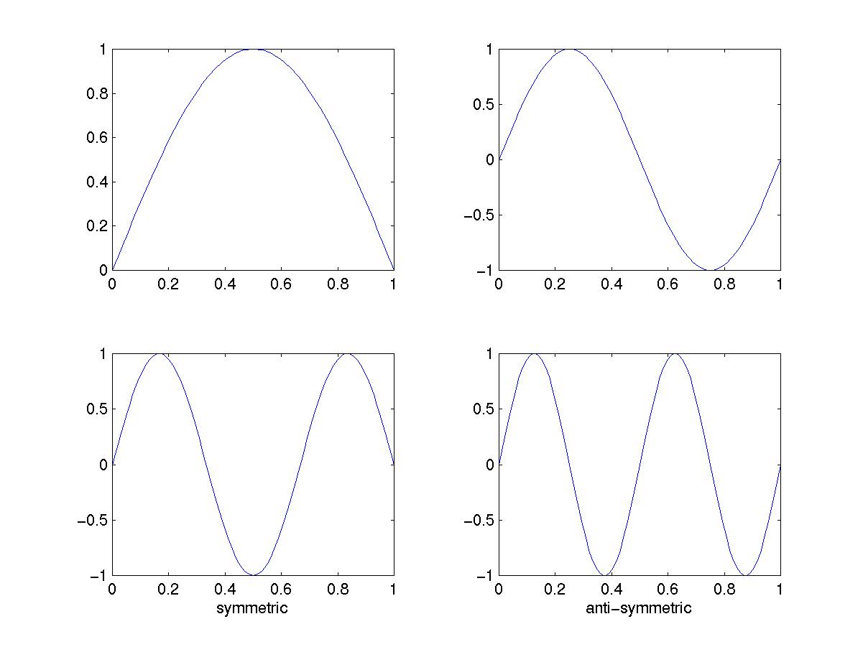

**Figure 6.** Mode shapes of the pinned-pinned beam.

To select modifications to all the eigenvalues but only the symmetric eigenvectors the matrix  is chosen so that,



and 

The element stiffness matrix can be reconstructed as,



and there are five updating parameters,  and 

**Example: Updating a system of 3 beams with offset central span**

We consider the system of three beams connected in-line but with the axis of the central beam offset from the axes of the two outer beams as shown in Figure 7. The breadth of all three beams is 0.2 m and the material is steel (*E=*210 GN/m2, *ρ=*7860 kg/m3). The system is represented by a finite element model consisting of 10 beam elements as indicated in the figure with rigidly fixed ends. Each node has three degrees of freedom, axial and transverse displacements and a rotation about the third axis. The 4th and 7th elements have offset nodes at the left-hand and right-hand ends respectively.

0.1

0.05

0.3

0.4

0.3

1

2

3

4

5

6

7

8

9

10

**Figure 7.** System of 3-beams with offset central span (dimensions in meters)

The connection matrix defining the offset node at the 4th element is given by

.

In the first case a finite element model with initial parameters *E0=*180 GN/m2, *a0=*0.015 m is updated using the correct choice of parameters. Updating is carried out using the standard Moore-Penrose pseudo-inverse based on convergence of the first five natural frequencies. It is seen from Figure 8 that exact convergence to the true solution is obtained in two iterations.

In the second case the finite element model is corrected using generic element parameters. This time the finite-element mass matrix is correct but in the stiffness matrix the offset is initially given by 0.8 of its true value. The elastic modulus is correct. The generic element is formed from the group of elements, 3, 4, 7, 8, at the junctions between the thick and thin beam sections. The stiffness matrices from elements 3 and 4 are uncoupled from elements 7 and 8 but each pair of element has identical eigenvalues. Therefore the eigenvalues of the generic element stiffness matrix occur in pairs. It is found that the first natural frequency of the beam is not very sensitive to the generic element parameters, which represent (shape) stiffnesses at the junctions - well away from the most strained portion of the beam in the middle. The second and third natural frequencies are very sensitive and the fourth mode is axial, and therefore insensitive. A single generic element parameter is not sufficient to produce good results but in Figures 9 and 10 results are shown from two updating parameters . It is seen that the second and third natural frequencies converge correctly after approximately 20 iterations when the parameters  are fully converged.

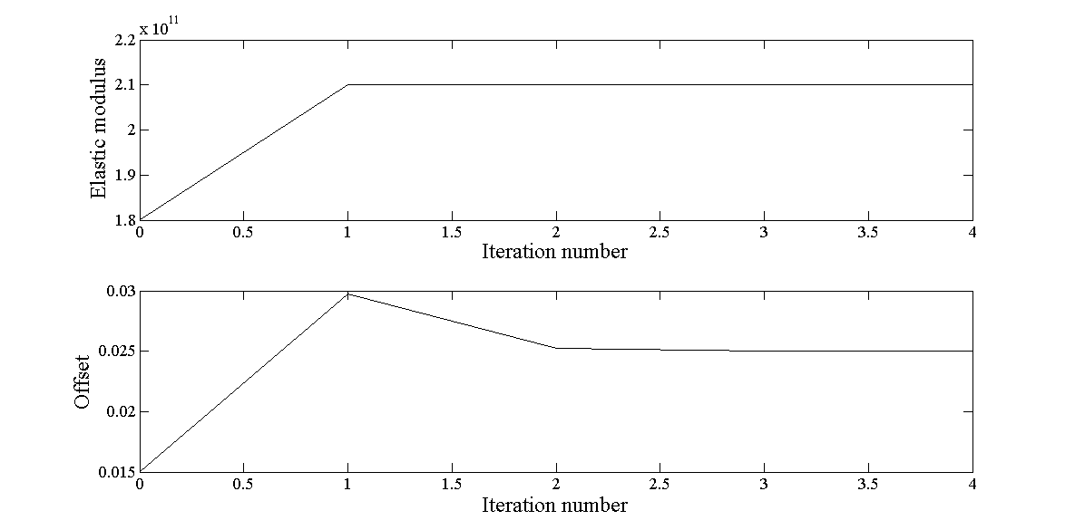

**Figure 8.** Parameter convergence – *E* and *a*

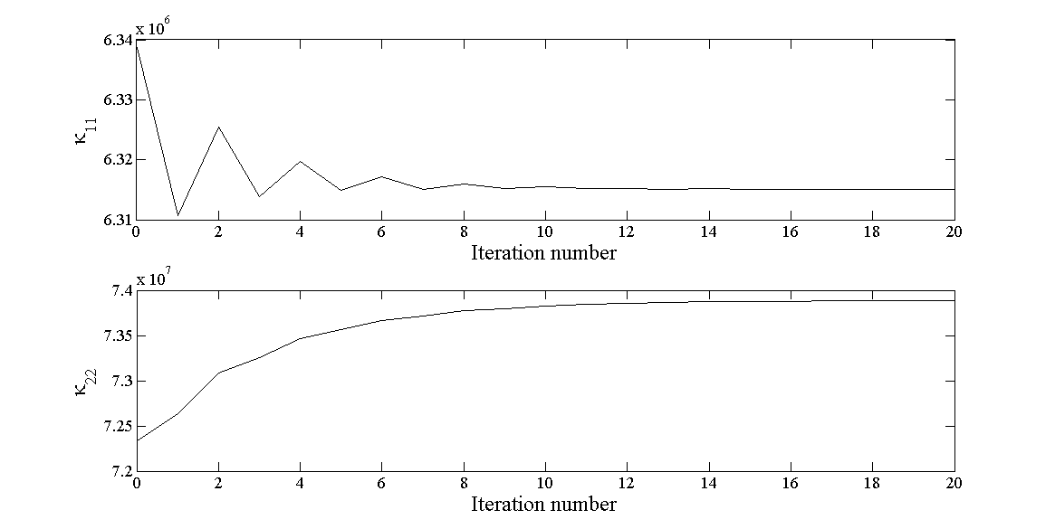

**Figure 9.** Parameter convergence - κ11, κ22

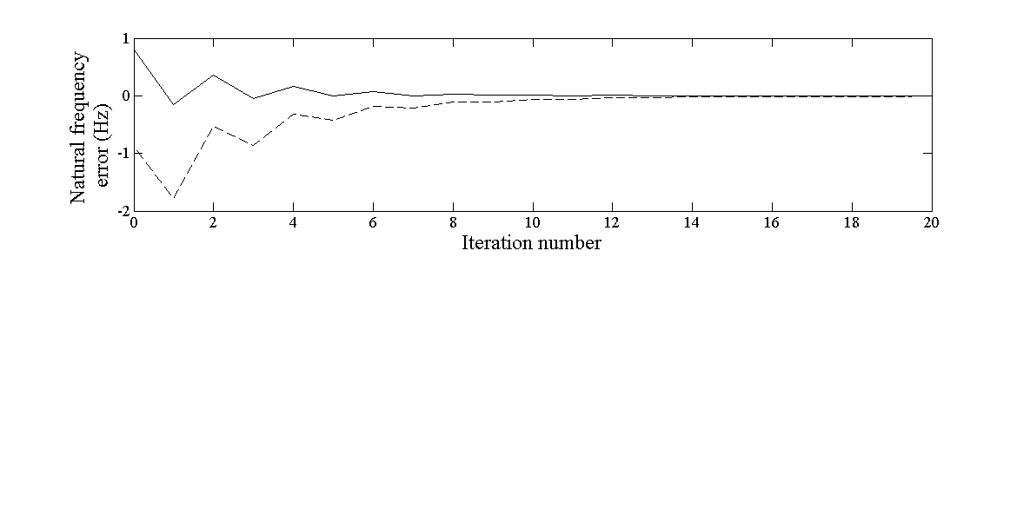

**Figure 10** Convergence of natural frequencies – generic element parameters

Updating was achieved using the weighted (regularized) updating Eq. (22) using the first ten natural frequencies. The second and third diagonal terms of  were given by values of 13000 with the remaining diagonal terms set to unity (off-diagonal terms set to zero), . It is seen that the generic-element parameters are able to provide an updated model that accurately reproduces the dynamic behavior of the offset beam (in the frequency range considered) even though the updated model lacks physically meaning. Nevertheless, such a model may be meaningful within the updating frequency range.

**7.    Stochastic Model Updating**

The stochastic model updating problem may be expressed as,

 (34)

by the assumption of small perturbation about the mean. In Eq. (34) the over-bar denotes the mean,  are experimentally measured outputs, typically natural frequencies and mode-shape terms,  is the  estimate of parameter distribution to be determined, with mean . The mean sensitivity matrix is denoted by  and  represents errors introduced from various sources including inaccuracy of the model and measurement imprecision.

Model updating of the means is a deterministic problem given by, 

 (35)

where is the a predicted output of the model at the iteration. The transformation matrix  is the generalized pseudo inverse of the sensitivity matrix ,

 (36)

and  and  are weighting matrices, to allow for regularization of ill-posed sensitivity equations (see Eq. (22) in Section 5).

It is seen from Eq. (34) that the matrix of output covariances is given by,

 (37)

 (38)

Then, if the error covariances are deemed to be small, an estimate of the parameter covariances may be obtained by inversion, using (36) to obtain,

 (39)

Eq. (39) allows for the computation of using only the transformation matrix, , obtained at the final step of deterministic updating of the means and the measured output covariance. It avoids expensive forward propagation of uncertainty through the model required by alternative approaches. It was shown (Silva et al. 2016) that Eq. (39) may be developed straightforwardly from expressions given previously by Haddad Khodaparast *et al.* (2008),

 (40)

and Govers and Link (2010),

 (41)

Example: Stochastic model updating of a 3 degree of freedom system.

The example considered is the 3 degree of freedom mass-spring system shown in Figure 11.



















**Figure 11**. Three degree of freedom mass-spring example

The nominal values of the parameters of the ‘experimental’ system are: , and . The erroneous random parameters are assumed to have Gaussian distributions with mean values, and standard deviations . The true mean values are the nominal values with standard deviations  (20% of the true mean values). Parameters  and  are assumed to be independent.

*Case 1 – Consistent set of updating parameters*

This example comprises a consistent updating problem where three uncertain stiffnesses, , are deemed to be responsible for observed variability in the three natural frequencies of the system. Eqs. (39) and (40) above were applied and the initial cloud of predicted natural frequencies was made to converge upon the cloud of ‘measured’ natural frequencies as shown in Figure 12. The measured data consisted of 30 separate measurement points (30 points in the 3 dimensional space of the natural frequencies) and the predictions were represented by 1000 points, needed for forward propagation by Latin hypercube sampling (LHS) with imposed correlation from a normal distribution , in order to determine from .

Figure 12 shows the results produced by the two methods, where it is apparent that the updated covariance ellipses from the two solutions are almost indistinguishable from each other or from the covariance ellipse of the ‘measured’ data. Note that the covariance ellipses on the scatter plots encompass 95% of the data (2-sigma ellipses).

Typical convergence characteristics are shown in Figure 13 and the updated parameter values are given in Table 2. The adopted convergence criterion was that the deviation of the predicted eigenfrequencies with respect to the reference ones should be less than a specified tolerance.

The CPU times shown in Table 2 are determined with respect to the solution from Eq. (39). It is seen that for this particular 3 degree of freedom problem, calculation of the parameter covariance matrix is approximately 300 times faster by Eq. (39) than by Eq. (41).

|  |  |
| --- | --- |
|  |  |
| a) *f1* vs *f2*. | b) *f1* vs *f3* . |

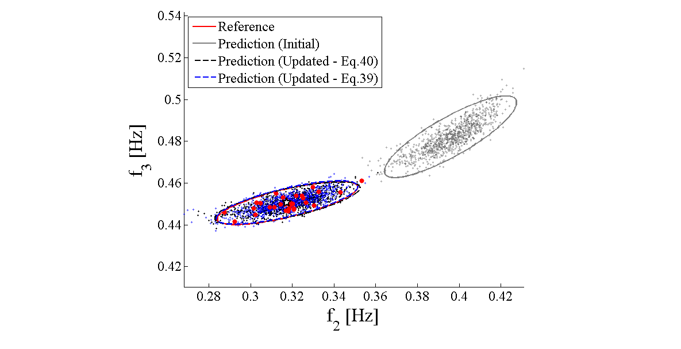

c) *f2* vs *f3*.

Figure 12. Frequency scatter plots (Case 1).

*(Figures 12-21are reproduced by kind permission of Elsevier)*

|  |  |
| --- | --- |
|  |  |
| (a) | (b) |
| Figure 13. Convergence plots (Case 1): a) Mean values of the estimates; b) Standard deviation of the estimates - (dash-dotted line: reference values). | |

**Table 2.** Parameters and eigenfrequencies values.

|  |  |  |  |  |
| --- | --- | --- | --- | --- |
|  | **Reference**  **30 obs.** | **Initial (error %)** | **Updated (error %)**  **Eq(40)**  **1000 obs.** | **Updated (error %)**  **Eq (39)** |
| $\overline{k_{1}}$ [N/m] | 1.001 | 2.0 (99,73) | 1.001 (-0.03) | 1.014 (1.26) |
| $\overline{k_{2}}$ [N/m] | 0.992 | 2.0 (101.55) | 0.993 (0.06) | 0.966 (-2.68) |
| $\overline{k_{5}}$ [N/m] | 1.001 | 2.0 (99.84) | 1.001 (-0.02) | 1.008 (0.69) |
| $σ_{k_{1}}$ [N/m] | 0.197 | 0.3 (52.59) | 0.194 (-1.59) | 0.194 (-1.36) |
| $σ_{k_{2}}$ [N/m] | 0.208 | 0.3 (44.58) | 0.213 (2.35) | 0.211 (1.40) |
| $σ_{k_{5}}$ [N/m] | 0.211 | 0.3 (41.94) | 0.211 (-0.05) | 0.211 (-0.11) |
| $f_{1}$ [Hz] | 0.1586 | 0.2030 (28.02) | 0.1586 (-0.00) | 0.1586 (-0.00) |
| $f_{2}$ [Hz] | 0.3180 | 0.3960 (24.54) | 0.3180 (-0.00) | 0.3180 (-0.00) |
| $f_{3}$ [Hz] | 0.4505 | 0.4823 (7.06) | 0.4505 (-0.00) | 0.4505 (0.00) |
| # Iterations | - | - | 9 | 6 |
| CPU time ratio | - | - | ~300 | 1 |

*Case 2 - Inconsistent updating parameter set*

Case 2 presents an example of an inconsistent updating problem where the updating parameter set does not include all the uncertain parameters responsible for the observed variability in the reference responses. As in the previous cases, the reference data were produced with randomized and , while the updating parameter set is composed of and , i.e., the uncertain is not included in the updating parameter set. In this case regularization was applied with .

Figures 14 and 15 show the results of the updating process.The scatter plots of Figure 14 show that the output means are reconstructed faithfully but the choice of an inconsistent set of updating parameters has resulted in large errors in the reconstructed covariance ellipses. The updating parameters  are fully converged after 30 iterations as shown in Figure 15. This result demonstrates that the selection of updating parameters on the basis of reconstructing the output means is not sufficient to ensure that the output covariances will be well reconstructed.

The inconsistent parameters problem was addressed by Silva et al. (2016) who showed how the updated parameters should be selected based on the scaled covariances of the outputs and a scaled sensitivity matrix, with columns corresponding to candidate parameters  . Based on an assumption that the updating parameters are mutually independent and independent of measurement noise, the output covariance matrix was shown to be given by a sum of rank-1 matrices with each term associated exclusively with a single parameter. The cosine distance between the column  and its projection on the hypersurface defined by the range of the matrix of output covariances was used. A cosine distance of zero (or close to zero) is an indicator of a correctly chosen updating parameter.

|  |  |  |
| --- | --- | --- |
|  |  |  |
| a) | b) | c) |
| **Figure 14.** Frequency scatter plots (Case 2 - Eq. (39)). | | |

|  |  |  |  |
| --- | --- | --- | --- |
|  | |  | |
| a) | | b) | |
|  |  | |  |

Figure 15. Convergence plots (Case 2 - Eq. (39)): a) Mean values of the estimates; b) Standard deviation of the estimates - (dash-dotted line: reference values).

**Example: Parameter selection for stochastic model updating**

The pin-jointed truss shown in Figure 16 has overall dimensions 5m ×1m and is composed of 21 elements in total, each with a stiffness matrix given by,



The five diagonal bars of nominal stiffness  are each randomized for updating. The true mean value of each is equal to the nominal stiffness and the standard deviations are given by  For the purposes of parameter selection, the initial estimates of all the mean stiffnesses, , are considered to be 70% of the reference values and the standard deviations are given by 

4

8

12

16

20

3

19

7

3

11

15

9

5

1

13

17

21

2

6

10

14

18

Figure 16. Pin-jointed truss.

Parameter selection results are shown in Figures 17-20. It is seen that the correct parameters for updating are recognized correctly in each case of different numbers of outputs.

|  |  |
| --- | --- |
|  |  |
| Figure 17. Cosine distance – 1st 10 eigenvalues. | Figure 18. Cosine distance – 1st 15 eigenvalues. |

|  |  |
| --- | --- |
|  |  |
| Figure 19. Cosine distance – All eigenvalues. | Figure 20. Cosine distance – All eigenvalues and eigenvectors. |

It can be seen from the figures that the first bar element  has zero cosine distance. This happens because the boundary condition prevents any extension or compression of , so that all the outputs are insensitive to it. When the constraints are removed, so the truss is in the free-free condition, the cosine distance corresponding to parameter  becomes finite and exceeds the threshold as shown in Figures 19a and 19b – it is seen correctly that  is not a randomized updating parameter.

|  |  |
| --- | --- |
| Figure 21a. Cosine distance – Free-free condition - 1st 10 eigenvalues. | Figure 21b. Cosine distance – Free-free condition - 1st 20 eigenvalues. |

**8.    Validation of Updated Models**

Basic requirements for model validation were formulated in Section 3. It was explained that even when comparisons of experimental modal analysis results with analytical predictions show satisfactory agreement this does not automatically mean that the updated model is capable of predicting the structural response for other loading and/or boundary conditions or for other structural configurations. In the following some findings are reported from a benchmark study defined within the European COST Action F3 on ‘Structural Dynamics’ and described in (Degener, 1997). The study was aimed at investigating the quality of updated models under real practical conditions where neither the modelling assumptions nor the assumptions for updating were unique but defined differently being the participants of the benchmark. The study should show if the expected non-uniqueness of the results due to different computational methods, different structural idealizations and different parameter sets could be tolerated with regard to the intended purpose. The following requirements for a validated model were defined:

(1) The model must be capable of predicting the experimental modal data and/or the frequency response functions (FRFs) within the active frequency range and within certain accuracy limits, of course. The term active frequency range was related to the frequency range used for computational model updating (CMU). The above criterion represents a minimum requirement which does not yet say much about the prediction quality of the model. The prediction quality should therefore be checked using the following additional criteria:

(2) Prediction of the eigenfrequencies and modes beyond the active frequency range.

(3) Prediction of the modal data and/or FRFs of a modified structure. For the benchmark structure two structural modifications were considered consisting of additional masses fixed at two different locations as shown in Figure 22.

The participants were allowed to generate any initial FE model that they found suitable.

**8.1 Benchmark Data**

The benchmark structure was a laboratory structure built to simulate the dynamic behavior of an aeroplane. The structure was initially built for a benchmark study on experimental modal analysis conducted by the Structures and Materials Action Group (SM-AG19) of the Group for Aeronautical Research and Technology in EURope (GARTEUR) (Degener and Hermes, 1996; Degener 1997; Balmes 1997; Link and Friswell, 2003). The test-bed was designed and manufactured by ONERA, France. Figure 22 shows the test structure geometry and the location of the measured degrees of freedom. The overall length of the structure was 1.5 m, the wing span 2.0 m and the overall mass was 44 kg. The overall length of the structure is 1.5 m, the wing span is 2.0m and the overall mass is 44 kg. The material used was aluminum. In order to increase the damping, a 1.1 x 76.2 x 1700 mm3 viscoelastic constraining layer was bonded to the wings. The modal test data for up to 14 modes for the unmodified and also for the two mass- modified structures were provided for the participants. Further details are described in (Link and Friswell, 2003).

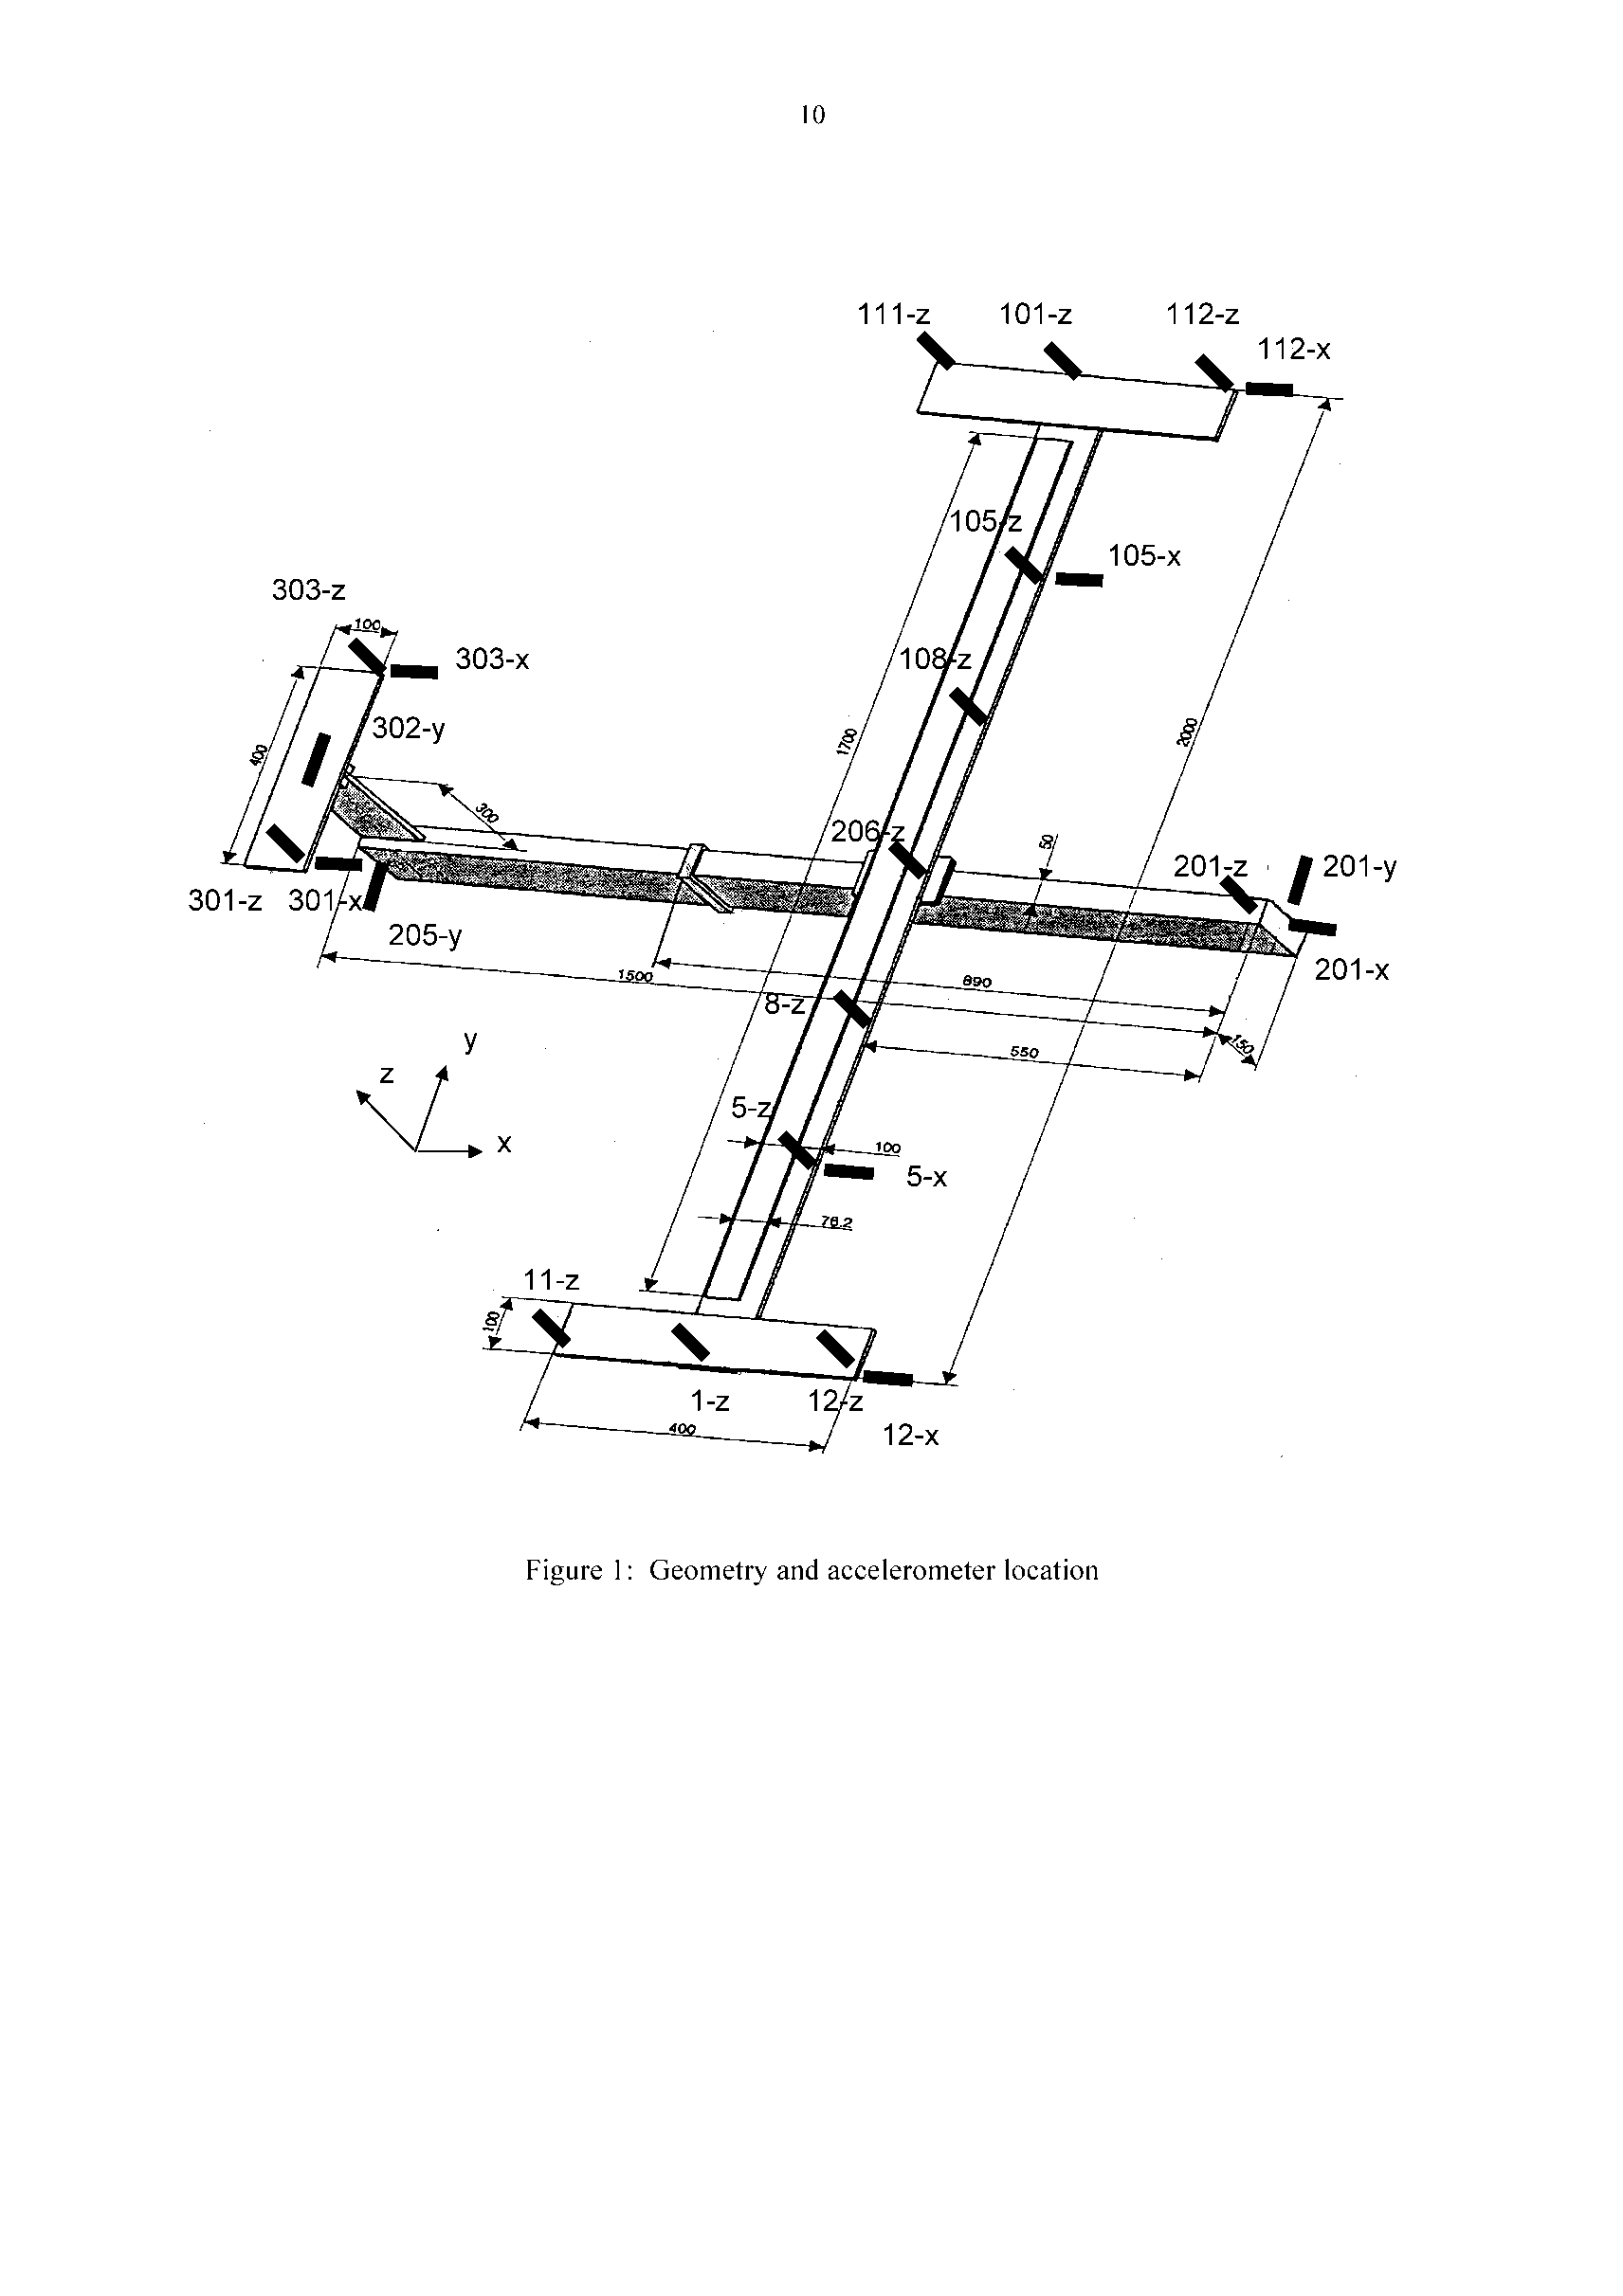

added

masses

**Figure 22.**  Geometry and accelerometer location.

**8.2 Summary of Model Validation Results**

The methods applied by the benchmark participants could be classified according to

(1) the type of test/analysis residuals,

(2) the type of FE model (beam or shell elements) and

(3) the type and number of updating parameters.

Very different choices were made by the participants. The model validation was essentially performed in two steps:

(a) Initial model tuning: This step included updating the parameters of the initial model of the unmodified structure and to check if the model was capable of predicting the experimental modal data within the active frequency range (criterion 1). Some participants extended the checks with respect to the passive frequency range (criterion 2).

(b) Check of prediction capability concerning the modified structures (criterion 3).

Since all the participants used different residuals for their objective function to be minimized, and different types of structural idealization (beam or plate elements), it was difficult to make recommendations on what residual and what parameter choice was the best. It was necessary to carefully select the parameters describing the connections, particularly when beam models were used. The most important issue was to find an appropriate parameter set. With this requirement fulfilled, good prediction results were found, even with the simple eigenfrequency residual. Looking at the great variety of parameters, it became obvious that even though the parameters might be called physical or geometric (like Young’s modulus or a beam off-set) they must be interpreted as non-unique equivalent parameters describing lumped stiffness and mass properties. It was interesting to note that good prediction capabilities of the updated models were achieved in many different ways. In principle it was found that the higher the requirement needed to meet the structure’s intended purpose, the greater are the number of above validation criteria that must to be satisfied.

**9.    Industrial Example Problem**

The updating and validation of large scale finite element models is a challenging task because of the high degree of complexity of today’s mechanical systems and the number of candidate updating parameters potentially involved. In order to succeed a systematic approach should be adopted as shown in Figure 23.

Comparison

adjustment of selected inertia and stiffness parameters

analytical modal analysis

automated update



****0, **X**

O.K.

N.O.K.

experimental modal analysis

test planning

FE  
(re-) modeling

****0T, **X**T

**Figure 23:** Model validation strategy

A bottom-up strategy has proven to be very effective especially when the overall system is composed of many interconnected components. This requires the step-by-step approach shown in Figure 24, starting with single components (*component level*) over subassemblies (*subsystem level*) until the complete system is obtained (*complete system level*). Then model updating and validation becomes feasible as demonstrated for example in (Schedlinski and Staples, 2004; Schedlinski et al., 2004, 2008; Schedlinski, 2012, 2016) and in the automotive example described below.

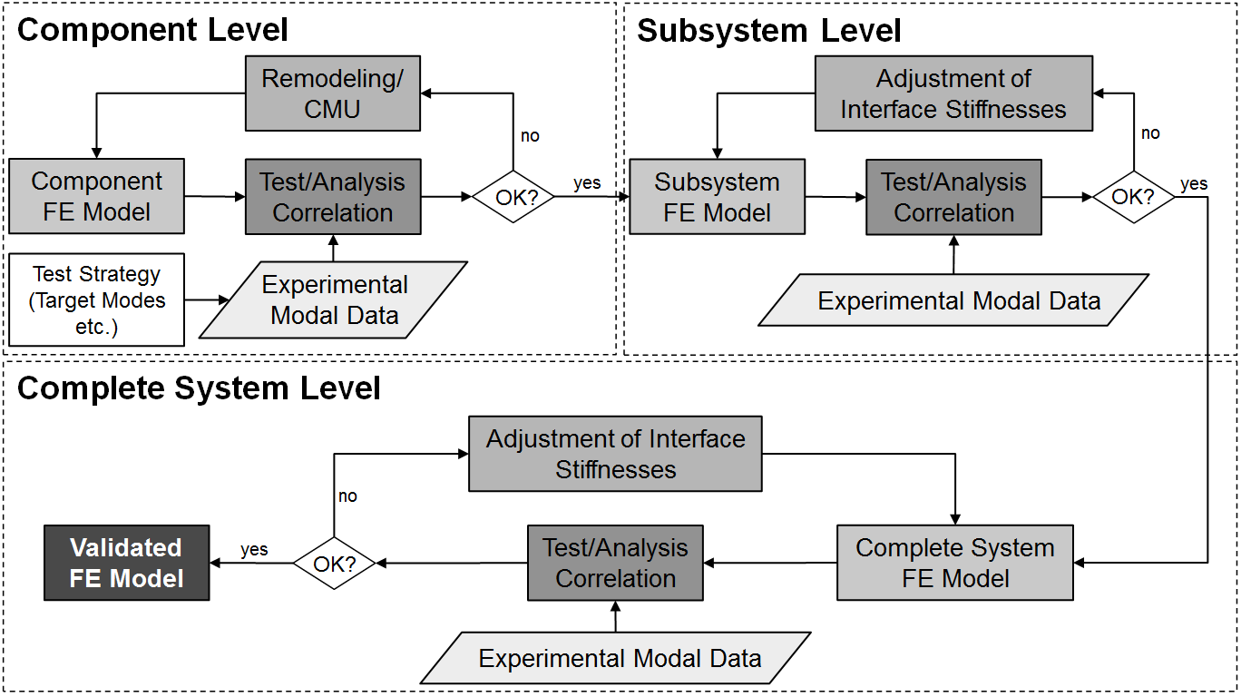

**Figure 24:** Bottom-up strategy

It is usually assumed that all deviations of the analysis from test data is due entirely to uncertainties in the finite element model. There are however test uncertainties too (e.g. exact mounting conditions, signal analysis related errors, observability and controllability, data analysis, nonlinearities) which must be kept as small as possible.

Test planning makes use of the finite element model, which not only enables the design of the test but also considerably simplifies the later correlation with the analytical results. Test planning should cover the following aspects:

* boundary conditions (fixed, free, flexible)
* target modes (frequency range, local and global modes)
* measurement degrees of freedom (MDOFs)
  + assessment of required measurement information
  + selection of sensor locations based on FE model, accessibility, and visualization of modes
  + unique mode shape recognition using the Auto-MAC
* excitation
  + assessment of suitable excitation points
  + selection e.g. based on analytical Mode Indicator Functions (MIF)
  + frequency resolution

For test planning and computational model update several commercial software tools are readily available capable of handling large scale finite element models. Typical parameters for model updating are described in Section 6.

It has proven to be effective to update inertia and stiffness properties first e.g. based on eigenvalue and eigenvector residuals. After successful updating of these parameters, damping parameters can be adjusted by minimizing the deviations in the resonance regions between measured and simulated FRFs.

A common difficulty in computational model updating is the selection of updating parameters. A necessary condition, but not a sufficient one, is that the parameters should be sensitive. Subset selection methods based on comparing the columns of the sensitivity matrix to the vector of residuals can also be helpful. However, engineering understanding of the physical structure and the finite element model is almost always the most important factor. In particular, close inspection of mode shapes to recognize parameters for updating in highly strained regions is a skill that the practitioner should aim to develop for great advantage in model updating.

**9.1 Automotive Example Problem**

In the following the automotive exhaust system shown in Figure 25 shall be updated and validated with particular focus on global vibration behavior and damping. Special attention will be paid to the modelling of interface stiffnesses and damping using the bottom-up strategy introduced above. The identification of local damping parameters will be carried out at every validation step. One important aspect of this procedure is that the properties of the individual joints can be developed separately.

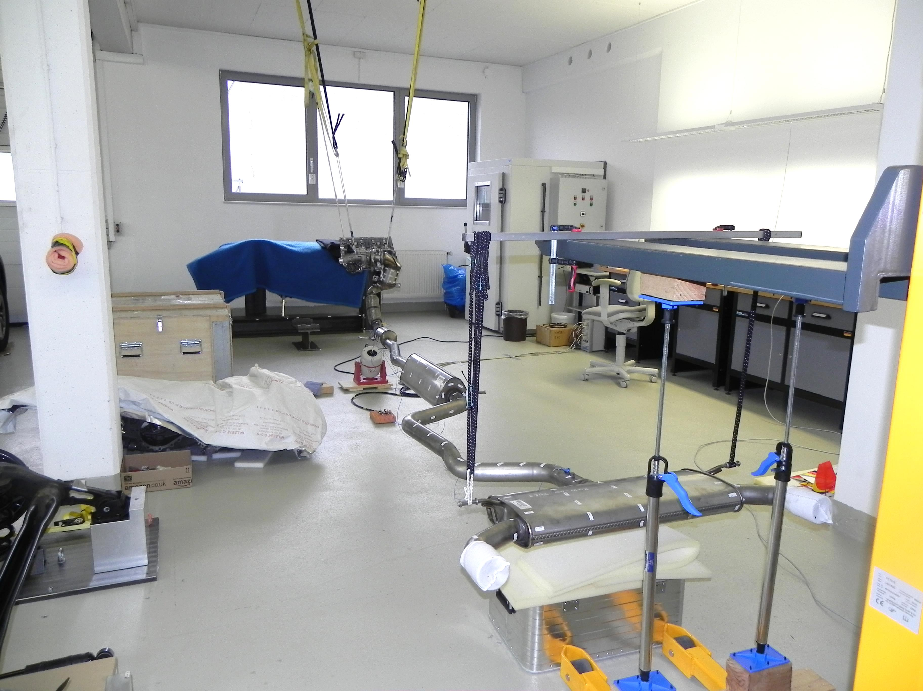

**Figure 25:** Complete automotive exhaust system with shaker excitation

For the bottom-up concept the exhaust system needs to be separated into a number of components, subsystems, and subassemblies. Figure 26 shows the chosen subsystems – at the component level:

* converter 1
* isolation element
* front part including converter 2
* rear part with mufflers

and at the subassembly and system levels:

* assembly of rear and front part (outlined in green in Figure 26)
* complete system

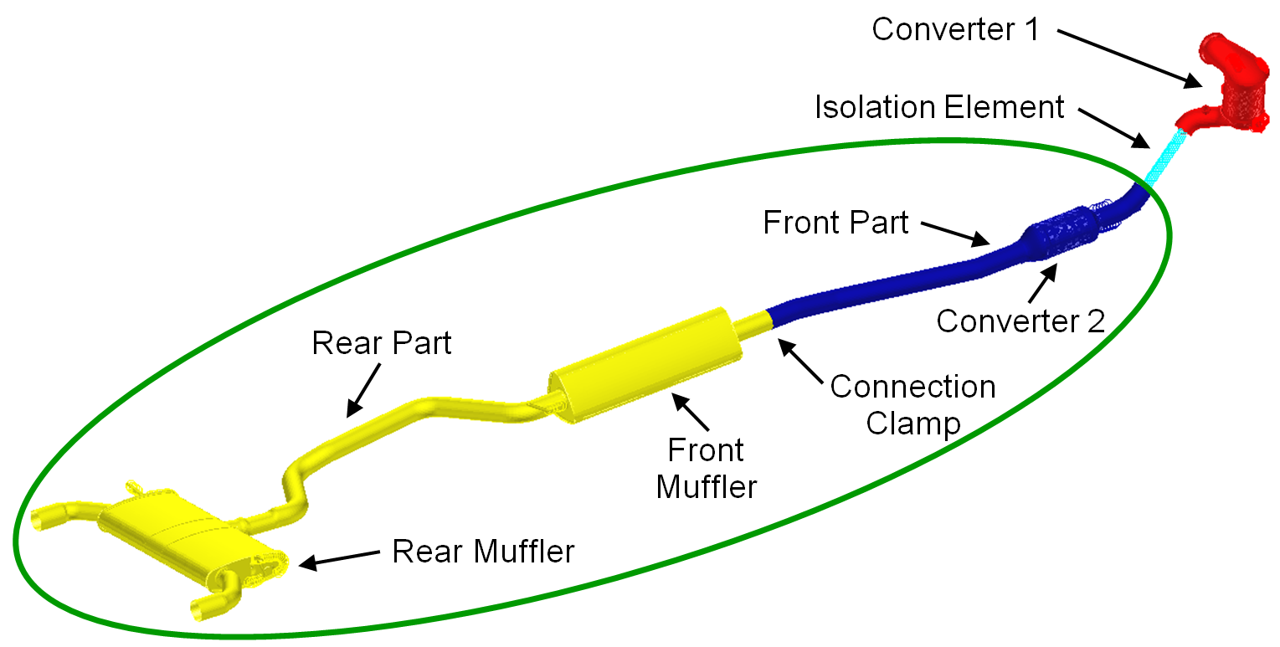

**Figure 26:** Components and subsystems of the exhaust system

Each component and each (sub-) assembly is first subjected to an experimental modal analysis. Frequency response functions are experimentally determined and eigenfrequencies and eigenvectors are identified. Model updating is then carried out step-by-step starting at the component level and leading eventually to the overall system. The bottom-up procedure has several advantages:

* structural modelling deficiencies of components can be located more easily and resolved
* the number of candidate parameters at each validation step can be kept low, which improves convergence and uniqueness of the updating process, and favors the finding of physically meaningful results
* for the validation of the (sub-) assemblies the main focus can be set on the interfaces (joints) between the constituent components, where generally the largest modeling uncertainties exist
* the separate consideration of joints allows the identification of individual joint parameters (stiffness and damping)

In what follows, the bottom-up process is demonstrated on the rear part of the exhaust system at component level. Then the rear and front parts (*Assembly I*, encircled in Figure 26) are considered at subassembly level.

Component level:

The agreement of finite-element eigenfrequencies and eigenvectors with data determined from experimental modal tests for each component is checked and, if necessary, improved by adjusting mass distributions as well as local stiffnesses by remodeling and model updating. Frequency deviations and MAC values serve as evaluation criteria for the achieved quality of the finite element model.

Figure 27 and Table 3 show the initial correlation, i.e. the MAC matrix, as well as the MAC values and frequency deviations. The first six eigenvectors exhibit promising MAC values greater than 80%, but there are two large frequency deviations of more than 4%.



**Figure 27:** Initial MAC matrix for the rear part of the exhaust system

**Table 3:** Initial correlation for the rear part of the exhaust system

|  |  |  |  |  |  |  |
| --- | --- | --- | --- | --- | --- | --- |
| No. | EMA | FEA | EMA [Hz] | FEA [Hz] | Dev. [%] | MAC [%] |
| 1 | 1 | 7 | 12.67 | 12.88 | 1.70 | 96.98 |
| 2 | 2 | 8 | 22.72 | 23.99 | 5.59 | 93.55 |
| 3 | 3 | 9 | 33.74 | 35.29 | 4.59 | 95.65 |
| 4 | 4 | 10 | 49.52 | 50.06 | 1.10 | 95.99 |
| 5 | 5 | 11 | 61.37 | 61.28 | -0.14 | 83.27 |
| 6 | 6 | 12 | 69.94 | 70.27 | 0.46 | 92.92 |
| 7 | 9 | 14 | 173.35 | 169.54 | -2.19 | 57.83 |
| 8 | 12 | 16 | 282.53 | 260.21 | -7.90 | 52.64 |
| 30 % | upper limit of frequency deviations | | | | | |
| 50 % | lower limit for MAC values | | | | | |

As a first step, the masses of the finite element model and of the physical part are compared and reviewed. The total masses match sufficiently well. If large deviations had been found, the mass of the finite element model could be adjusted either globally or locally via the densities of the materials or by (additional) mass elements representing single local masses. At the second step, local stiffnesses of the finite element model are updated, typically shell thicknesses and Young's moduli. Preferably model areas are selected for update which either exhibit a certain degree of modelling uncertainty and/or are especially sensitive to parameter changes.

The already mapped eigenvectors of the rear part of the exhaust system represent global bending modes, characterizing the global vibration behavior of the overall setup. Since the bending modes are primarily influenced by the stiffness of the tube between the two mufflers, the modulus of elasticity of the pipe is chosen as the update parameter. Eigenvectors that were not paired are basically local vibration modes of the mufflers with limited influence on the global dynamic behavior of the overall setup. Therefore, proper representation of these local modes is rated as less important.

The actual model update is carried out using the dedicated model validation software ICS.sysval (Schedlinski, 2018) that makes special use of the MSC.Nastran structural optimization capabilities (SOL200). The software allows for a direct use of Nastran models and thus is capable of handling industrial size finite element models.

The quality of the updated rear part of the exhaust system is presented in Figure 28 and Table 4. The MAC values are improved by the changes applied to the model and the relative frequency deviations are, except for one eigenfrequency, now below 3%. This result can be regarded as good with respect to the goal of validating the global vibration behavior of the complete exhaust system.



**Figure 28:** MAC matrix after model update for the rear part of the exhaust system

**Table 4:** Correlation after model update for the rear part of the exhaust system

|  |  |  |  |  |  |  |
| --- | --- | --- | --- | --- | --- | --- |
| No. | EMA | FEA | EMA [Hz] | FEA [Hz] | Dev. [%] | MAC [%] |
| 1 | 1 | 1 | 12.67 | 12.45 | -1.71 | 96.97 |
| 2 | 2 | 2 | 22.72 | 23.38 | 2.87 | 94.07 |
| 3 | 3 | 3 | 33.74 | 34.20 | 1.37 | 96.42 |
| 4 | 4 | 4 | 49.52 | 49.87 | 0.71 | 96.18 |
| 5 | 5 | 5 | 61.37 | 60.23 | -1.86 | 88.67 |
| 6 | 6 | 6 | 69.94 | 68.60 | -1.91 | 94.34 |
| 7 | 9 | 8 | 173.35 | 167.25 | -3.52 | 73.13 |
| 30 % | upper limit of frequency deviations | | | | | |
| 50 % | lower limit for MAC values | | | | | |

After the successful adaptation of mass and stiffness, the updating process becomes concentrated on damping. For this purpose damping must be defined in the finite element model locally, e.g. as structural damping for individual materials or parts of the model or as discrete viscous damping e.g. for joints.

The evaluation of the finite element model in terms of damping is based on the frequency-domain displacement residual. The non-paired eigenfrequencies of the local modes are disregarded. By adjusting the damping, the differences between the analytical and measured FRF peaks are minimized at the paired eigenfrequencies. During the model update process the convergence should be checked for different damping seed values manually selected based on user experience. By cataloging identified damping values for typical cases a knowledge database can be obtained for material and joint damping that may be used for future modelling tasks.

For the rear part of the exhaust system, structural damping of materials (muffler housings, acoustic wool in mufflers, and connecting tube) were selected as update parameters. Figure 29 shows the individual error sums before (left bars) and after (right bars) updating the damping, as well the total sum for all paired measured eigenfrequencies (the pair of bars to the extreme right). Figure 30 shows a measured FRF next to its counterpart calculated with the finite element model before and after damping updating. The reduction of the error sums due to the damping update as well as the significantly improved match of the FRFs in the resonance areas are clearly visible.

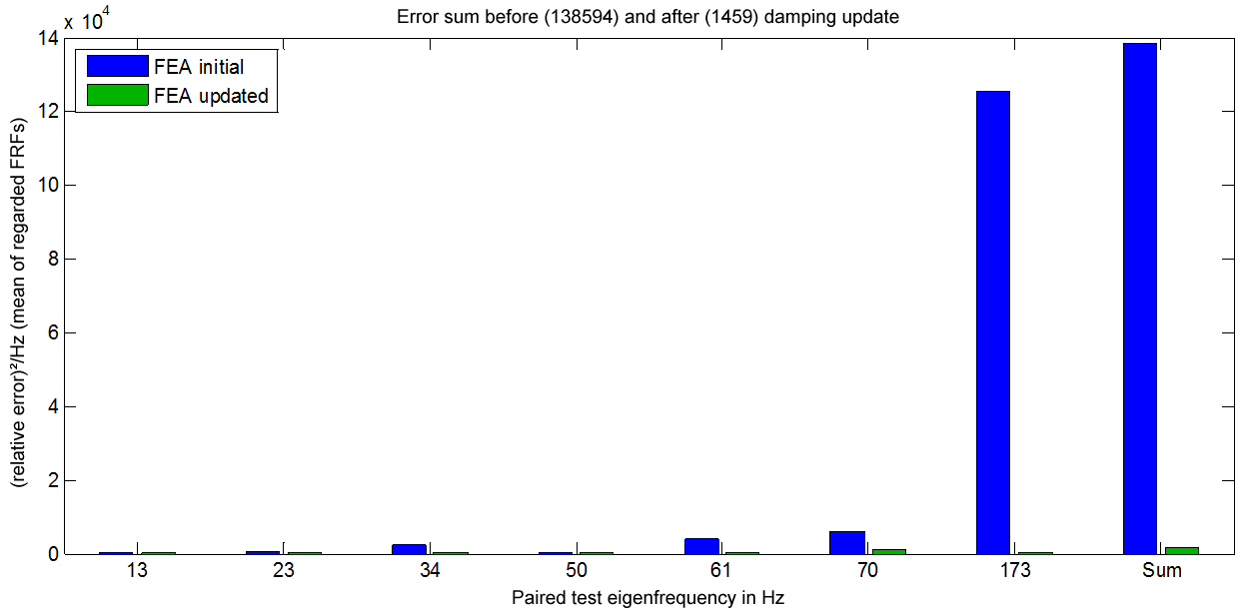

**Figure 29:** Error sums before (FEA initial, left) and after (FEA updated, right) damping update for the rear part of the exhaust system

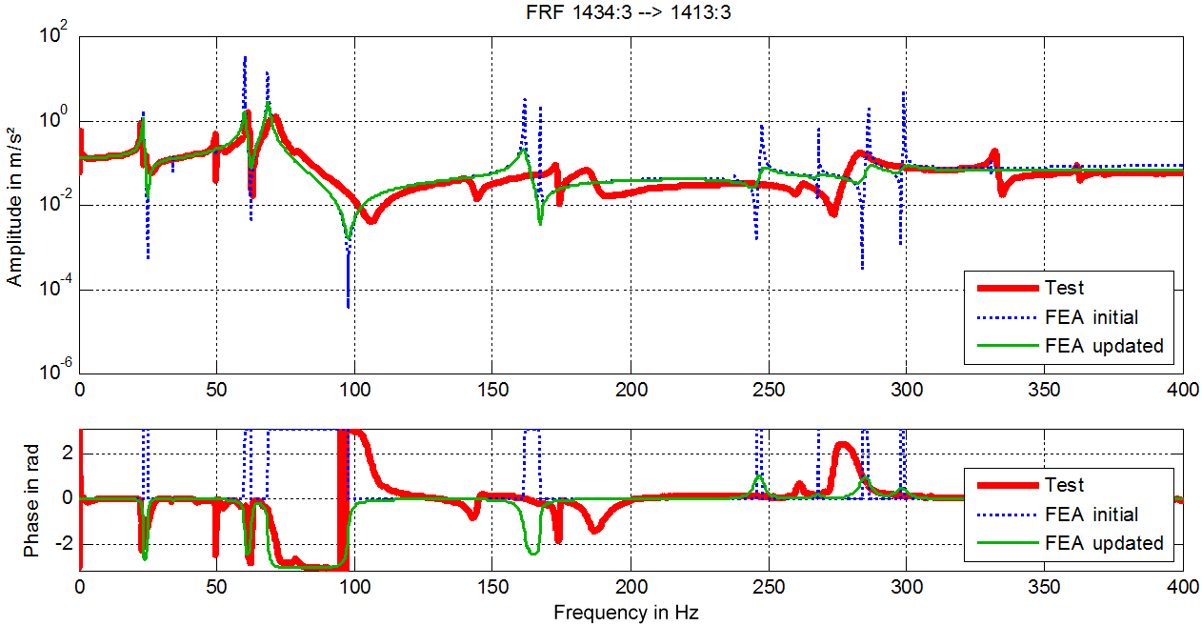

**Figure 30:** Example of FRFs before (FEA initial) and after (FEA updated) damping update for the rear part of the exhaust system

Subassembly level:

After successful model updating of all components with respect to mass, stiffness, and damping the joints within the assemblies can be updated. The approach is similar to that taken with the components: first the overall mass is checked and, if necessary, adjusted, second the stiffnesses of the joints are assessed based on relative frequency deviations and MAC values, and if necessary updated. Then, in the third step, the joint damping is updated based on the deviations of the calculated FRFs from their measured counterparts.

In case of *Assembly I* of the exhaust system (consisting of the rear and the front part), the clamped joint is represented in the finite element model by a completely-modelled clamp assembly. For model updating the Young’s modulus and structural damping of the clamp material are chosen as updating parameters. Alternatively, a spring/viscous damper element representation of the clamp could have been considered.

Figure 31 and Table 5 show the MAC matrix and the correlation table after stiffness update of the clamp. For *Assembly I* twelve global vibration modes can be paired with high or very high MAC values. The relative frequency deviations are below 3% for the first eight natural frequencies. Figure 21 shows a FRF from the test, as well as its FE-generated counterpart before and after damping updating. Again, the updating of damping significantly reduces the deviations in the resonance regions between calculation and test.



**Figure 31:** MAC matrix after model update for *Assembly I*

**Table 5:** Correlation after model update for *Assembly I*

|  |  |  |  |  |  |  |
| --- | --- | --- | --- | --- | --- | --- |
| No. | EMA | FEA | EMA [Hz] | FEA [Hz] | Dev. [%] | MAC [%] |
| 1 | 1 | 1 | 7.53 | 7.46 | -0.88 | 97.81 |
| 2 | 2 | 2 | 10.55 | 10.62 | 0.71 | 95.68 |
| 3 | 3 | 3 | 23.70 | 23.77 | 0.28 | 94.23 |
| 4 | 4 | 4 | 31.79 | 32.01 | 0.71 | 91.12 |
| 5 | 5 | 5 | 42.28 | 41.75 | -1.25 | 95.02 |
| 6 | 6 | 6 | 53.48 | 53.77 | 0.55 | 93.27 |
| 7 | 7 | 7 | 61.71 | 60.37 | -2.17 | 95.81 |
| 8 | 8 | 8 | 69.33 | 70.14 | 1.17 | 94.46 |
| 9 | 9 | 9 | 128.42 | 136.66 | 6.41 | 83.50 |
| 10 | 11 | 11 | 162.16 | 169.27 | 4.38 | 90.63 |
| 11 | 12 | 10 | 173.73 | 166.22 | -4.32 | 77.50 |
| 12 | 13 | 12 | 195.36 | 184.26 | -5.69 | 72.69 |
| 30 % | upper limit of frequency deviations | | | | | |
| 50 % | lower limit for MAC values | | | | | |

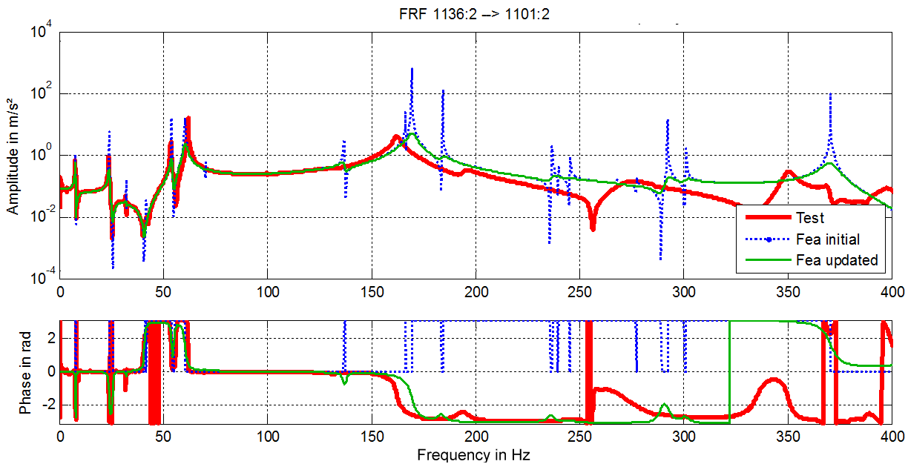

**Figure 32:** Example of FRFs before and after damping updating for *Assembly I*

**10. Closure**

This Chapter describes the complete procedure for finite element model updating by the sensitivity method. It begins with the general formulation of an objective function and linearization of the output in terms of parameters, thereby permitting parameter estimation by iteration. After the separate treatment of systematic errors, typically model-structure errors, the procedure consists essentially of defining a residual, describing the finite-element discrepancy with respect to test data, such as eigenfrequencies, modes shapes or frequency response functions. The resulting equations are generally ill-conditioned and require regularization by the application of side constraints. The corner of the L-curve defines an optimal value of the regularization parameter that maximizes the condition of combined system of updating equations and side constraints. The selection of updating parameters is a crucial step requiring deep understanding of the physical test structure and the finite element model. Numerous parametrization techniques are described. Stochastic model updating is capable of determining the statistics (means and covariances) of updating parameters responsible for observed output variability in nominally identical test structures. Updated models are usually said to be validated when demonstrated to be capable of predicting the behavior of the physical system under different conditions from those used in the updating process. Numerical examples are used throughout to illustrate the main points.

Finally, an industrial-scale industrial example, that of an automotive exhaust system, representative of many multi-component engineering assemblies, is described. A bottom-up strategy is adopted, whereby the standard process of mass and stiffness updating is improved by carrying out additional updating of damping parameters. This leads to a significantly improved match between calculated and measured FRFs. The highlighted procedure for damping update is in particular important for non-metallic materials such as, for example, catalyst ceramics, and for joints, where reliable damping parameters are not readily available. The validated finite element model of the assembly matches the measured eigenfrequencies, eigenvectors, and FRFs much better than the initial model while realistic damping estimates are obtained, thereby highlighting the potential of the model updating and model validation procedures.

**Acknowledgement**

The content and images presented for the automotive example problem are published with the kind permission of the Volkswagen AG, Germany.

**References**

Adhikari S and Friswell MI (2010), Distributed parameter model updating using the Karhunen-Loève expansion, *Mechanical Systems and Signal Processing,* 24, 326-339.

Ahmadian H, Gladwell GML, and Ismail F (1997), Parameter selection strategies in finite element model updating, *ASME J. of Vibration and Acoustics* **119**, 37-45.

Ahmadian H, Mottershead JE and Friswell MI (1998) Regularisation methods for finite element model updating, *Mechanical Systems and Signal Processing*, 12(1), 47-64.

Ahmadian H, Mottershead JE and Friswell MI (2002) Physical realisation of generic element parameters in model updating, *Transactions of the American Society of Mechanical Engineers, Journal of Vibration and Acoustics,* 124(4), 628-632.

Au SK, Connecting Bayesian and frequentist quantification of parameter uncertainty in system identification, *Mechanical Systems and Signal Processing*, 29, 328-342

Balmes E (1997) Garteur Group on Ground Vibration Testing - results from the tests of a single structure by 12 laboratories in Europe. *Proceedings of the International Modal Analysis Conference IMAC XV, Orlando, FL*,1346–1352.

Batou A (2015), Model updating in structural dynamics – uncertainties on the position and orientation of sensors and actuators, *Journal of Sound and Vibration*, 354, 47-64.

Beck JL and Katafygiotis L (1998) Updating models and their uncertainties. I: Bayesian statistical framework, *Journal of Engineering Mechanics*, 124(4), 445-461.

Behmanesh I, Moaveni B, Lombaert G and Papadimitriou C (2015), Hierarchical Bayesian model updating for structural identification, *Mechanical Systems and Signal Processing*, 64-65, 360-376.

Carvalho J, Datta BN, Gupta A and Lagadapati M (2007), A direct method for model updating with incomplete measured data and without spurious modes, *Mechanical Systems and Signal Processing*, 21, 2715-2731.

Collins JD, Hart GC, Hasselman TK and Kennedy B (1974) Statistical identification of structures, AIAA Journal, 12(2), 185-190.

D’Ambrogio W and Fregolent A (2000), The use of antiresonances for robust model updating, *Journal of Sound and Vibration*, 236, 227-243.

Datta BN, Deng S, Sokolov VO and Sarkissian DR (2009) An optimisation technique for damped model updating with measured data satisfying quadratic orthogonality constraints, *Mechanical Systems and Signal Processing*, 23, 1759-1772.

Degener M (1997) Ground vibration results from the tests of an aircraft model performed as part of an European round robin exercise. *Proceedings of the CEAS International Forum on Aeroelasticity and Structural Dynamics, Rome*.

Degener M. and Hermes H (1996) Ground vibration test and finite element analysis of the GARTEUR SM-AG19 testbed*. Deutsche Forschungsanstalt für Luft- und Raumfahrt e. V. Institut für Aeroelastik*, IB 232-96 J 08.

Fang SE, Ren WX and Perera R (2012) A stochastic model updating method for parameter variability quantification based on response surface models and Monte-Carlo simulation, *Mechanical Systems and Signal Processing,* 33, 83-96.

Fang SE, Zhang QH, Ren WX (2015) An interval model updating strategy using interval response surface models, *Mechanical Systems and Signal Processing*, 60-61, 909-927.

Fox R and Kapoor M (1968) Rate of change of eigenvalues and eigenvectors, *AIAA Journal*, 6, 2426-2429.

Friswell MI (1989) The adjustment of structural parameters using a minimum variance estimator. *Mechanical Systems and Signal Processing* **3**(2), 143-155.

Friswell MI and Mottershead JE (1995) *Finite Element Model Updating in Structural Dynamics*, Kluwer Academic Publishers, Dordrecht.

Friswell MI, Mottershead JE and Ahmadian H (1998) Combining subset selection and parameter constraints in model updating, *Transactions of the American Society of Mechanical Engineers*, *Journal of Vibration and Acoustics*, 120(4), 854-859.

Friswell MI, Mottershead JE and Ahmadian H (2001) Finite element model updating using experimental test data: parameterisation and regularisation, *The Royal Society. Philosophical Transactions: Mathematical, Physical and Engineering Sciences,* 359, 169-186.

Gladwell GML and Ahmadian H (1995) Generic element matrices suitable for finite element model updating, *Mechanical Systems and Signal Processing*, 9(6), 601-614.

Goller B, Broggi M, Calvi A and Schuëller GI (2011) A stochastic model updating technique for complex aerospace structures, *Finite Elements in Analysis and Design*, 47, 739-752.

Goller B, Pradlwarter HJ and Schuëller GI (2009) Robust model updating with insufficient data, *Computer Methods in Applied Mechanical Engineering*, 198, 3096-3104.

Goulet J-A, Michel C and Smith IFC (2013), Hybrid probabilities and error domain structural identification using ambient vibration monitoring, *Mechanical Systems and Signal Processing*, 37, 199-212.

Govers Y and Link M (2010), Stochastic model updating - covariance matrix adjustment from uncertain experimental modal data. *Mechanical Systems and Signal Processing*, 24(3), 696–706.

Govers Y and Link M (2012) Using stochastic experimental modal data for identifying stochastic finite element parameters of the AIRMOD benchmark structure, *Proceedings of the International Conference on Noise and Vibration Engineering, USD2012*, Leuven, Belgium, 4697-4715.

Hansen PC (1994) Regularisation tools: a MATLAB package for analysis and solution of discrete ill-posed problems, *Numerical Algorithms,* 6, 1-35.

Hua XG, Ni YQ, Chen ZQ, Ko JM. (2008) An improved perturbation method for stochastic finite element model updating. *International Journal for Numerical Methods in Engineering*, 73, 1845-1864.

Hua XG, Ni YQ and Ko JM (2009), Adaptive regularisation parameter optimisation in output-error-based finite element model updating, *Mechanical Systems and Signal Processing*, 23, 563-579.

Hua, XG, Wen Q, Ni YQ and Chen ZQ (2017), Assessment of stochastically updated finite element models usinf reliability indicator, *Mechanical Systems and Signal Processing*, 82, 217-229.

Jacquelin E, Adhikari S and Friswell MI (2012) A second-moment approach for direct probabilistic model updating in structural dynamics, *Mechanical Systems and Signal Processing*, 29, 262-283.

Katafygiotis L and Beck JL (1998) Updating models and their uncertainties. II: model identifiability, *Journal of Engineering Mechanics*, 124(4), 463-467.

Kenigsbuch R and Halevi Y (1998) Model updating in structural dynamics: a generalised reference basis approach, *Mechanical Systems and Signal Processing*, 12(1), 75-90.

Khodaparast HH, Mottershead JE and Badcock KJ (2011) Interval model updating with irreducible uncertainty using the Kriging predictor, *Mechanical Systems and Signal Processing*, 25(4), 1204-1226.

Khodaparast HH, Mottershead JE and Friswell MI (2008) Perturbation methods for the estimation of parameter variability in stochastic model updating, *Mechanical Systems and Signal Processing*, 22(8), 1751-1773.

Kuo Y-C and Datta BN (2012) Quadratic model updating with no spillover and incomplete measured data: existence and computation of solution, *Linear Algebra and its Application*, 436, 2480-2493.

Lallement G and Piranda J (1990) Localisation methods for parameter updating of finite element models in elastodynamics, *IMAC IIX*, Orlando, Florida, 579-585.

Link M (1999) Updating of Analytical Models – Basic Procedures and Extensions, in *Modal Analysis and Testing*, J.M.M. Silva and N.M.M. Maia (Eds.), Kluwer Academic Publishers, 281-304.

Link M and Friswell MI (2003) Working Group 1: Generation of Validated Structural Dynamic Models- Results of a Benchmark Study Utilising the GARTEUR SM-AG19 Test-Bed. In Golinval J-C and Link M (Eds.): COST Action F3 “Structural Dynamics” (1997-2001)- An European Co-operation in the Field of Science and Technology. *Mech. Systems & Signal processing,* 17(1), 9-20.

Mao X and Dai H (2012), Finite element model updating with positive definiteness and no spillover, *Mechanical Systems and Signal Processing*, 28, 387-398.

Mares C, Mottershead JE and Friswell MI (2006) Stochastic model updating: part 1- theory and simulated examples, *Mechanical Systems and Signal Processing,* 20(7), 1674-1695.

Mottershead JE and Foster CD (1991) On the treatment of ill-conditioning in spatial parameter estimation from measured vibration data. *Mechanical Systems and Signal Processing* **5**(2), 139-154.

Mottershead JE, and Friswell MI (1993) Model updating in structural dynamics: a survey, *Journal of Sound and Vibration*, 167(2), 347-375.

Mottershead JE, Friswell MI, Ng GHT and Brandon JA (1996) Geometric parameters for finite element model updating of joints and constraints, *Mechanical Systems and Signal Processing*, 10(2), 171-182.

Mottershead JE, Link M and Friswell MI (2011) The sensitivity method in finite element model updating: a tutorial, *Mechanical Systems and Signal Processing*, 25(7), 2275–2296.

Mottershead JE, Link M and Friswell MI (in preparation) *Finite Element Model Updating by the Sensitivity Method*.

Mottershead JE, Mares C, Friswell MI and James S (2000) Selection and updating of parameters for an aluminium space-frame model, *Mechanical Systems and Signal Processing*, 14(6), 923-944.

Mottershead JE, Mares C, James S and Friswell MI (2006) Stochastic model updating: part 2- application to a set of physical structures, *Mechanical Systems and Signal Processing,* 20(8), 2171-2185.

Mthembu L, Marwala T, Friswell MI and Adhikari S (2011) Model selection in finite element model updating using the Bayesian evidence statistic, *Mechanical Systems and Signal Processing,* 25, 2399-2412.

Natke HG (1991), On regularization methods applied to the error localization of mathematical models. *Proc. Int. Modal Analysis Conf. IMAC IX*, Florence, Italy, 70-73.

Natke HG (2004) *Einführung in Theorie und Praxis der Zeitreihen und Modalanalyse,* Vieweg Verlag, Braunschweig/Wiesbaden, Germany.

Natke HG, Lallement G and Cottin N (1995), Properties of various residuals within updating of mathematical models, *Inverse Problems in Engineering*, 1, 329- 348.

Patelli E, Govers, Y, Broggi M, Martins Gomes H, Link M and Mottershead JE (2017), Sensitivity or Bayesian model updating: a comparison of techniques using the DLR AIRMOD test data, *Archive of Applied Mechanics*, 87(5), 905-925.

Prells U (1996) A regularisation method for the linear error localisation of models of elastomechanical systems, *Inverse Problems in Engineering*, **3**, 197-217.

Schedlinski C. (2012) Finite Element model validation of a large spinning facility. *Proceedings, ISMA 2012, Leuven, Belgium.*

Schedlinski C. (2018) ICS.sysval product description. http://www.ics-engineering.com.

Schedlinski C. et al. (2004) Experimental Modal Analysis and Computational Model Updating of a Body in White. Proceedings of the Noise and Vibration Engineering Conference, ISMA 2004, Leuven, Belgium.

Schedlinski C. et al. (2008) Computational Model Updating of Structural Damping and Acoustic Absorption for Coupled Fluid-Structure-Analyses of Passenger Cars. *Proceedings of the Noise and Vibration Engineering Conference, ISMA 2008, Leuven, Belgium.*

Schedlinski C and Staples B (2004) Computational Model Updating of Axisymmetric Systems. *Proceedings of the Noise and Vibration Engineering Conference, ISMA 2004, Leuven, Belgium.*

Silva T, Maia NMM, Link M and Mottershead JE (2016), Parameter selection and covariance updating, *Mechanical Systems and Signal Processing*, 70-71, 269-283.

Simoen E, De Roeck G and Lombaert G (2015), Dealing with uncertainty in model updating for damage assessment: a review, *Mechanical Systems and Signal Processing*, 56-57, 123-149.

Smith SW (1998) Iterative matrix approximation for model updating, *Mechanical Systems and Signal Processing*, 12(1), 187-202.

Tikhonov AN and Arsenin VY (1977) *Solutions of Ill-Posed Problems,* John Wiley and Sons, New York.

Titurus B and Friswell MI (2008) Regularization in model updating. *International Journal for Numerical Methods in Engineering*, **75**(4), 440-478.

Wang X, Hill TL, Neild SA, Shaw AD, Khodaparast HH, and Friswell MI (2018) Model updating strategy for structures with localized nonlinearities using frequency response measurements, *Mechanical Systems and Signal Processing*,100, 940-961.

Webber B, Paultre P and Proulx J (2009) Consistent regularisation of nonlinear model updating for damage identification, *Mechanical Systems and Signal Processing*, 23, 1965-1985.

Xie D (2011) A numerical method of structure-preserving model updating problem and its perturbation theory, *Applied Mathematics and Computation*, 217, 6364-6371.

Yuan Y (2009) A symmetric inverse eigenvalue problem in structural dynamic model updating, *Applied Mathematics and Computation*, 213, 516-521.

Yuen K-V (2010) *Bayesian Methods for Structural Dynamics and Civil Engineering*, Wiley, Singapore.

Yuen K-V (2012) Updating large models for mechanical systems using incomplete modal measurement, *Mechanical Systems and Signal Processing* 28, 297-308

Zhang EL, Feissel P and Antoni J (2011) A comprehensive Bayesian approach for model updating and quantification of modelling errors, *Probabilistic Engineering Mechanics*, 26, 550-560.