Electroencephalogram (EEG) responses to indoor sound sources in wooden residential buildings
Alessia Frescura and Pyoung Jik Lee
Acoustic Research Unit, School of Architecture, University of Liverpool, UK
Jeong-Ho Jeong
Building acoustics laboratory, Fire Insurers Laboratories of Korea (FILK), Korea
Yoshiharu Soeta
Biomedical Research Institute, National Institute of Advanced Industrial Science and Technology (AIST), Japan

ABSTRACT
The present study aimed to explore relationships between physiological and subjective responses to indoor sounds. Specifically, the electroencephalograms (EEG) responses to neighbour sounds in wooden dwellings were investigated. Listening tests were performed to collect EEG data in distinct acoustics scenarios. Experimental work was carried out in a laboratory with a low background noise level. A series of impact and airborne sounds were presented through loudspeakers and subwoofer, while participants sat comfortably in the simulated living room wearing the EEG headset (B-alert X24® system). The impact sound sources were an adult walking and a child running recorded in a laboratory equipped with different floor configurations. Two airborne sounds (a lively conversation and a piece of classical piano music) were digitally filtered to resemble good and poor sound insulation performances of vertical partitions. The experiment consisted of two sessions, namely, the evaluation of individual sounds and the evaluation of the combined sound sources. In the second session, pairs of an impact and an airborne sound were presented. During the listening test, electroencephalography alpha reactivity (α-EEG) and electroencephalography beta reactivity (β-EEG) were monitored. In addition, participants were asked to rate noise annoyance using an 11-point scale. The results showed that combined sound sources elicited higher α-EEG, suggesting that it is preferred to the presentation of sounds heard singularly. Similarly, speech and music elicited higher α-EEG activity compared to footsteps. Annoyance showed significant correlations with overall, α-EEG and β-EEG activities in the parietal and central area, together with Poz and right-hemisphere sensors T6 and O2.

1. INTRODUCTION
Footsteps from upstairs neighbours are considered among the most annoying sounds commonly heard in residential buildings [1], [2]. This is especially true in multi-storey wooden houses, a type of structure highly promoted nowadays due to the necessity of enhancing sustainability in the construction industry. Brad et al. [3] reported that residents in timber buildings are still exposed to various noises from their neighbours including impact noise. Exposure to neighbour noise negatively impacts the occupants' life, causing stress and reducing the quality of well-being in their homes [4, 5]. Furthermore, the majority of neighbours sounds are not visible. Thus, hearing neighbours sounds requires effort to divide the senses of perception from their natural intersensorial condition, where multiple senses simultaneously and cooperatively provide information about the environment [6, 7]. There is little evidence of health problems from neighbours’ noises although people spend a lot of their time in or around their home and neighbours’ noises are a major source of annoyance and emotional responses in an urban environment [8]. Several studies investigated the psychological effect of unwanted sound sources from neighbours but many of those focussed on the annoyance caused by footsteps [9-12] and the reasons underlying the high annoyance are still under investigation. Noise annoyance itself is a multifaceted stress response which is related to subjects’ cognition, experiences, and emotional states in respect of noise as well as other acoustical and non-acoustical factors which makes it inherently difficult to assess. Thus, physiological responses to noise were also introduced by many investigators [13-17], some of which included neighbour noise as sound sources [18, 19]. Among the several options available for measuring physiological reactions to auditory stimuli, contemporary technologies made possible the recording of EEG in a relatively easy way by means of portable devices. These offer the precious opportunity of acquiring data directly from the scalp, where brain activity is detectable almost instantaneously in synchrony with the stimulus presentation [20, 21]. EEG variation under noise exposure was investigated by many researchers [22, 23] because subjects generate stress response and their EEG responses may change during exposure to noise. Additionally, Choi et al [24] found that sound sources had the greatest influence on perceived stress when people are exposed to different indoor environments. However, previous research did not investigate the EEG response to common sounds from neighbours; thus further studies are required to explore the effects of neighbour sounds on the EEG response. Several EEG rhythm bands can be obtained from EEG recordings such as alpha (8–12 Hz) and beta (12–30 Hz). The most prominent EEG indicator thereof was alpha-band, which has been shown for having a good measurement, test reliability and high reproducibility. It also can detect early stages of fatigue, annoyance and subjective preference [25, 26]. Beta band has been reported as an indicator of mental activity, arousal, strained, alert or drowsy states [24, 27]. So far, in the studies of annoyance using EEG, the power of a single rhythm has been used to represent the brain activity of people under different acoustics scenarios [28]. However, multiple EEG sub-bands have been used in another study to propose a passenger psychoacoustics annoyance index under exposure to different rail acoustics scenarios [29].
The present study aims to assess the effects of neighbour sound sources in wooden residential buildings on EEG response and annoyance. A laboratory experiment was performed, primarily focusing on the effect of neighbour's impact sounds caused by adult's walking and child's running. It was first hypothesised that alpha (α-EEG) and beta (β-EEG) responses to neighbour sounds might be different across sound sources heard singularly (footsteps, speech, music) or in combination among them (footsteps and speech or footsteps and music). Thus, participants listened to a series of acoustic stimuli resembling footsteps singularly or in combination with other airborne sounds (e.g., speech, music) while wearing an EEG monitoring system B-alert x24®. It was also hypothesised that the type of sound sources (impact or airborne) and the acoustic performance of the partitions would have affected the EEG responses. Thus, all the sound stimuli were filtered to represent different sound insulation performances of vertical and horizontal partitions in lightweight buildings. Lastly, the correlations between annoyance ratings and overall EEG, α-EEG and β-EEG responses were investigated.

2. METHODOLOGY

2.1 Participants
Participants were recruited after the study was ethically approved by the Research Committee of the Fire Insurers Laboratories of Korea (FILK) and by the Central Ethics Committiee of University of Liverpool. Four out of 30 targeted participants took part in the experiment up to now. Participants were adults with self-reported normal hearing aged between 35 and 48 (median= 41 and std=5.7).

2.2 Experimental design
The laboratory experiment was conducted in a sound-proof room with a low background noise level (~25 dBA) in the FILK. The floor area was about 35.7 m² (4.8 m × 7.43 m), which simulates the area of a living room in most common apartments. Participants were sitting on a comfy chair and asked to answer the questionnaire on paper. The stimuli were presented through loudspeakers (GENELEC - 8030A) and a subwoofer (GENELEC – 7060B) which was placed in front of the participants. Sound above 63 Hz was presented via the loudspeakers, while low-frequency sounds below 63 Hz were presented via the subwoofer. White noise (NC 25) was presented through a loudspeaker (GENELEC - 8050A) throughout the experiment as ambient noise in the living room. After a presentation of each stimulus, annoyance was assessed on an 11-point scale (‘0’: not at all and to ‘10’: extremely). The experiment was composed of three sessions (i.e., two combined sounds sessions and one single sound session). There were breaks between sessions to avoid excessive fatigue and loss of concentration. In the single sound session, each of the impact and airborne noise sources was presented for 10 minutes, while, in the remaining sessions, the impact noise combined with airborne noise sources were presented for 14 minutes each. All sound sources and sessions were randomized across participants to avoid order effects. Each session consisted of the repetition of the following 40 s sequence: 10 s of baseline with a presentation of the black screen; 20 s of sound stimulus (single or combined sources); the final 10 s for answering questions. There were breaks between sessions to avoid excessive fatigue and loss of concentration. During the experiment, participants were asked to imagine being relaxing in their own homes.

2.3 Sound stimuli
The sound stimuli were both impact and airborne sounds which are commonly heard from neighboring units in wooden residential dwellings. The impact sound sources were recorded in a laboratory equipped with different wooden floor: a timber joist slab with a chipboard panel on top (i.e., basic floor) with and without a floating floor, a suspended ceiling, and the two solutions installed together. All the configurations were also altered by adding or removing a carpet tiles finish. The recordings were made using a binaural head equipped with two half-inch microphones (Type 40HL, GRAS) representing a person sitting on a sofa in the receiving room. The impact sources were two different kinds of footsteps: an adult walking (1.65m, 50 kg) and a child running (1.12m, 22 kg and 1.05m, 17 kg). Both the adult and children wore socks during the recordings. Sound pressure levels (L_{AFmax}) of the adult walking at normal speeds (1.8 Hz) ranged from 30 to 55 dB across the floor configurations. The child running recordings showed a narrower variation of noise level between 35 and 50 dB (L_{AFmax}). All the sound stimuli chosen for the listening tests showed slightly different frequency characteristics as they were recorded from different configurations. The airborne sources were a lively conversation (‘speech’), and a piece of classical piano music (‘music’). Both clips were digitally filtered using Adobe Audition to resemble lightweight partitions with different sound insulation performances. The weighted sound reduction indices (R_{w}) of the two simulated partitions were R_{w}=52 and R_{w}=33 dB. For the simulated partition with R_{w}=52 dB, the sound levels (L_{Aeq}) were 24 dB and 25 dB, respectively for speech and music, for the poor partitions with R_{w} =33 dB, the levels were 42 dB and 44 dB, respectively for speech and music. The sound pressure levels and frequency characteristics of the selected stimuli are presented in Figure 1 and Table 1, respectively.

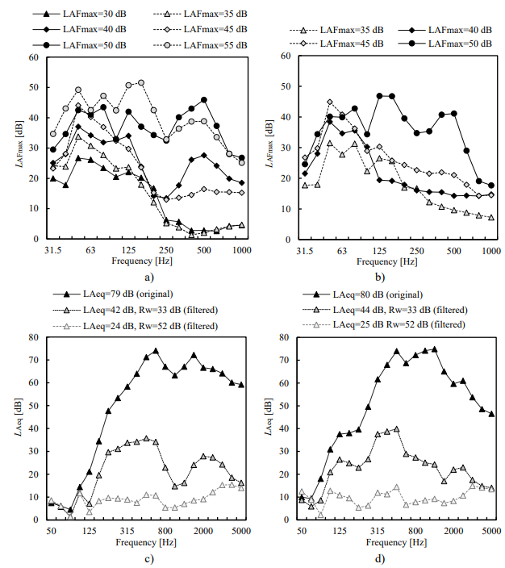
Figure 1: Frequency characteristics of sound stimuli: a) footsteps of an adult walking at the normal pace, b) footsteps of a child running, c) speech and d) music.
Table 1. Sound pressure levels of selected sound stimuli; L_{AFmax} for impact sound sources and L_{Aeq} for airborne sound sources
Source |  | Sound pressure levels [dB]
Impact | Adult walking at the normal pace | 30 – 35 – 40 – 45 – 50 – 55
 | Child running | 35 – 40 – 45 – 50
Airborne | Speech | 24 – 42
 | Music | 25 – 44

2.4 EEG response acquisition
The B-Alert® X24 wireless EEG system (Advanced Brain Monitoring, Carlsbad, CA) was used for EEG data acquisition. In accordance with the International 10-20 system, the following 19 EEG channels were acquired: Fz, F3, F4, Cz, C3, C4, P3, P4, Pz, O1, O2, T5, T3, F7, Fp1, Fp2, F8, T4, and T6—plus POz (as showed in Figure 2) and left and right mastoids. Data was collected at a sampling rate of 256 Hz, and the following bandpass characteristics: 0.1 Hz high-pass filter, 100 Hz fifth order low-pass filter. To avoid artifacts related to eye movements, participants were asked to keep their eyes closed during the stimuli presentation. Data from B-Alert® X24 were monitored through STAT software (03.08.03.00 version).
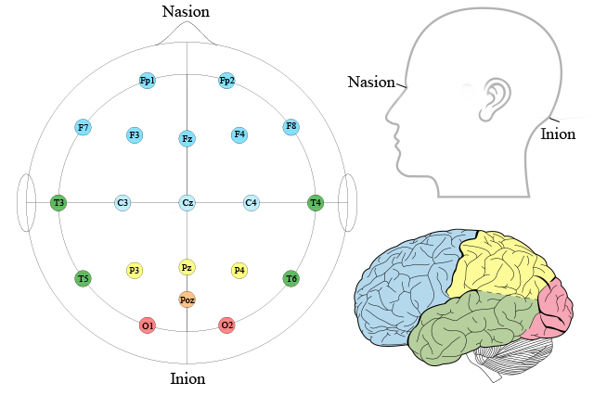
Figure 2: EEG sensors placement for B-Alert X24 System in frontal, central, parietal, temporal, and occipital area with the indication of nasion and inion point.
The recorded EEG data were digitally bandpass filtered using Butterworth filters with cut-off frequencies at 8 and 13 Hz for alpha band and 13 and 30 Hz for beta band. Root-mean-squares (RMS) of each epoch (20 s) were computed at overall, alpha and beta bands.

3. RESULTS AND DISCUSSIONS

3.1 EEG response
During the listening tests, the EEG responses were acquired on STAT software and afterwards analysed using a Matlab code. The average brain activities during each presentation of the stimulus at each sensor position in the frontal, temporal, central, parietal, and occipital areas were computed. Overall activity together with α-EEG and β-EEG are shown in Table 2. The values are averaged results for all the sound sources heard singularly (footsteps of adult walking and child running, speech and music) and averaged results for all the sound sources heard in combination (footsteps together with speech and footsteps together with music). Single sound sources elicited higher overall EEG activity in all scalp positions for the frontal, temporal and central sensors. The only exception is overall EEG activity in T6 which remained unvaried when single or combined sources were presented. Sounds heard singularly elicit smaller α-EEG in all sensors except Fp1 and Fp2. In the previous research on visual preferences, higher α-EEG activity was reported as an indication of subjective preference [25]. Thus, these preliminary results may suggest that combined sound sources are preferred to single sounds. β-EEG activity, similarly to overall EEG trend, is overall higher when listening to single sound sources in the frontal and temporal areas and remained unvaried in the central, parietal and occipital areas. The comparison of α-EEG response to impact and airborne sound sources heard singularly highlighted higher α-EEG activity in all sensors in temporal, central, parietal and occipital areas and in F7 Fz and F4. This could suggest that impact sources are less preferred than airborne ones. The comparison of α-EEG after exposure to a combination of footsteps and airborne sources through different vertical partitions showed a similar tendency for each sensor. Footsteps in combination with speech and music through the partition characterized by R_{w}=52 dB elicited smaller α-EEG activity if compared to the same sounds heard through the poor performing partition (R_{w}=33 dB). In terms of β-EEG activity the two combinations eliciting higher activities are footsteps heard together with speech through the partition characterized by R_{w}=52 dB and footsteps heard together with music through the partition characterized by R_{w}=33 dB. This could suggest higher arousal elicited when hearing to these two combinations among the four considered.
Table 2. Mean EEG activity in logμV for the presentation of single and combined sound sources at frontal, temporal, central, parietal, and occipital positions. Indication of overall EEG activity, α-EEG, and β-EEG frequency bands.
 | Overall |  | α-EEG (8-13 Hz) |  |  | β-EEG (13-30 Hz)
 | Single Sound Sources | Combined Sound Sources |  | Single Sound Sources | Combined Sound Sources |  | Single Sound Sources |  | Combined Sound Sources
Fp1 | 1.15 | 1.01 |  | 0.66 | 0.65 | 0.68 |  | 0.67
F3 | 1.01 | 0.92 |  | 0.63 | 0.64 | 0.74 |  | 0.67
F7 | 0.94 | 0.89 |  | 0.57 | 0.58 | 0.67 |  | 0.65
Fz | 0.99 | 0.94 |  | 0.66 | 0.68 | 0.67 |  | 0.67
Fp2 | 1.14 | 1.00 |  | 0.67 | 0.66 | 0.69 |  | 0.67
F4 | 0.99 | 0.93 |  | 0.64 | 0.65 | 0.69 |  | 0.67
F8 | 0.97 | 0.90 |  | 0.61 | 0.61 | 0.70 |  | 0.69
T3 | 0.77 | 0.74 |  | 0.45 | 0.47 | 0.60 |  | 0.56
T5 | 0.71 | 0.70 |  | 0.43 | 0.45 | 0.58 |  | 0.54
T4 | 0.85 | 0.82 |  | 0.54 | 0.55 | 0.69 |  | 0.65
T6 | 0.79 | 0.79 |  | 0.52 | 0.56 | 0.65 |  | 0.64
C3 | 0.88 | 0.87 |  | 0.58 | 0.62 | 0.66 |  | 0.66
Cz | 0.93 | 0.92 |  | 0.66 | 0.70 | 0.69 |  | 0.69
C4 | 0.91 | 0.90 |  | 0.62 | 0.65 | 0.72 |  | 0.70
P3 | 0.84 | 0.85 |  | 0.56 | 0.62 | 0.67 |  | 0.67
Pz | 0.89 | 0.90 |  | 0.63 | 0.69 | 0.71 |  | 0.71
P4 | 0.87 | 0.88 |  | 0.61 | 0.67 | 0.71 |  | 0.71
O1 | 1.04 | 1.07 |  | 0.72 | 0.79 | 0.92 |  | 0.90
POz | 0.87 | 0.89 |  | 0.62 | 0.69 | 0.70 |  | 0.70
O2 | 0.85 | 0.88 |  | 0.62 | 0.69 | 0.70 |  | 0.70

3.2 Annoyance
Impact sound sources were rated from 0.5±0.6 up to 7.75±2.2 when their impact sound pressure level varied from 30 to 55 dB (L_{AFmax}), showing an almost linear growing trend (R² = 0.98) with the sound pressure level. For airborne sources, annoyance decreased slightly when passing from the scenario in which speech and music were heard through a poor performing partition (R_{w}=33 dB) to the one in which they were heard through the good performing one (R_{w}=52 dB). For speech, it vaired from 5.5±2.4 to 5±3.2 and for music from 4±4.2 to 3.25±3.3. The variation of annoyance between footsteps heard singularly or in combination with speech or music is reported in
Figure 3a and 3b, respectively. Overall, combined sound sources provoked higher annoyance ratings compared to single footsteps sounds, except for footsteps at 45 dB (L_{AFmax}) in combination with speech through the partition performing good (R_{w}=52 dB). The effect of the sound insulation performance of the vertical element is clearly visible, especially when the floor performance is good, and footsteps are heard at 30 dB (L_{AFmax}).
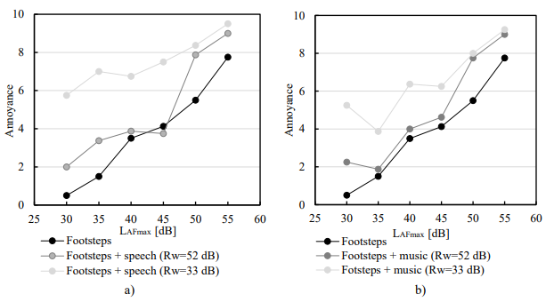
Figure 3: Annoyance ratings of footsteps heard singularly or in combination with an airborne sources heard through vertical partitions characterized by R_{w}=52 dB and R_{w}=33 dB: a) speech and b) music.
Correlation coefficients were computed between annoyance ratings and overall, α-EEG and β-EEG activities in the whole set of sensors’ positions. Higher significant correlations were identified in the parietal and central area, together with Poz and right-hemisphere sensors T6 and O2. Overall EEG activity correlate significantly with annoyance in half of the sensors which were: T5 (r=.138, p<0.05), T6 (r=.238 p<0.01), C3 (r=.173, p<0.05), Cz (r=.190, p<0.01), C4 (r=.195, p<0.01), P3 (r=.225, p<0.01), Pz (r=.200, p<0.01), P4 (r=.228, p<0.01), POz (r=.220, p<0.01)and O2 (r=.266, p<0.01). Annoyance and α-EEG activity correlates significantly in the higher number of sensors (13 out of 10), more specifically, significant correlations with annoyance were found in: F7 (r=.137, p<0.05), Fz (r=.145, p<0.05), F4 (r=.134, p<0.05), T5 (r=.137, p<0.05), T6 (r=.232, p<0.01), C3 (r=.171, p<0.05), Cz (r=.163, p<0.05), C4 (r=.174, p<0.05), P3 (r=.208, p<0.01), Pz (r=.169, p<0.05), P4 (r=.204, p<0.01), POz (r=.201, p<0.01)and O2 (r=.248, p<0.01). As much as it regards β -EEG activity, it shows significant correlations with annoyance for 11 of the examined sensors: Fz (r=.166, p<0.05), F4 (r=.157, p<0.05), T6 (r=.229, p<0.01), C3 (r=.141, p<0.05), Cz (r=.187, p<0.01), C4 (r=.186, p<0.01), P3 (r=.207, p<0.01), Pz (r=.200, p<0.01), P4 (r=.228, p<0.01), POz (r=.202, p<0.01) and O2 (r=.234, p<0.01). In summary, the highest correlation coefficients between annoyance ratings and overall EEG, α-EEG and β -EEG activity were identified in the right-hemisphere sensoros T6, P4 and O2.

4. CONCLUSIONS
This study set out to investigate the EEG response and annoyance provoked by neighbours sounds commonly heard in wooden residential buildings. The observation of preliminary results showed that α-EEG and β-EEG varied when participants were exposed to single or combined sound sources. More specifically, the single sound sources scenario elicited smaller α-EEG activity, suggesting that it is a less preferred option compared to the combined sound sources. Hearing single airborne sound sources (speech or music) elicited higher α-EEG activity in the majority of sensors, implying they were preferred to footsteps from an adult walking or a child running. Among the four combinations of impact and airborne sounds, footsteps together with speech or music through the partition with sound reduction index R_{w}=52 dB provoked smaller α-EEG activity (preferred scenario) if compared to the same sounds heard through the poor performing partition (R_{w}=33 dB). In terms of β-EEG activity the two combinations eliciting higher activities are footsteps heard together with speech through the partition characterized by R_{w}=52 dB and footsteps heard together with music through the partition characterized by R_{w}=33 dB which can be regarded as the more arousing combinations among the four investigated. Annoyance ratings showed significant correlations with overall, α-EEG and β-EEG activity in the parietal and central area, together with Poz and the right-hemisphere temporal sensor T6 and occipital sensor O2. The highest correlations coefficients between EEG activity and annoyance ratings were identified in the the right-hemisphere sensoros T6, P4 and O2.

5. ACKNOWLEDGEMENTS

This project has received funding from the European Union's Horizon 2020 research and innovation programme under grant agreement No 721536. This work was partly supported by a Grant-in-Aid for Scientific Research (B) (Grant No. 18H03324) from the Japan Society for the Promotion of Science.

6. REFERENCES
[1] Jeon JY, Ryu JK, Lee PJ. A quantification model of overall dissatisfaction with indoor noise environment in residential buildings. Applied Acoustics. 2010;71:914-21.
[2] Hongisto V, Mäkilä M, Suokas M. Satisfaction with sound insulation in residential dwellings–The effect of wall construction. Building Environment 2015;85:309-20.
[3] Bard D, Vardaxis NG, Sondergard E. Acoustic Comfort Investigation in Residential Timber Buildings in Sweden. Journal of Sustainable Architecture and Civil Engineering. 2019;24:78-89.
[4] Maschke C, Niemann H. Health effects of annoyance induced by neighbour noise. Noise Control Engineering Journal. 2007;55:348-56.
[5] Hammersen F, Niemann H, Hoebel J. Environmental noise annoyance and mental health in adults: findings from the cross-sectional German Health Update (GEDA) Study 2012. International Journal of Environmental Research Public Health. 2016;13:954.
[6] Schaeffer P. Traité des objets musicaux: Média Diffusion; 2016.
[7] Kane B. Sound unseen: Acousmatic sound in theory and practice: Oxford University Press, USA; 2014.
[8] Stansfeld S, Haines M, Brown B. Noise and health in the urban environment. Reviews on Environmental Health. 2000;15:43-82.
[9] Park SH, Lee PJ, Jeong JH. Emotions evoked by exposure to footstep noise in residential buildings. PloS one. 2018;13:e0202058.
[10] Gover BN, Bradley J, Schoenwald S, Zeitler B. Subjective ranking of footstep and low-frequency impact sounds on lightweight wood-framed floor assemblies. Forum Acusticum2011.
[11] Ljunggren F, Simmons C, Hagberg K. Correlation between sound insulation and occupants’ perception–Proposal of alternative single number rating of impact sound. Applied Acoustics. 2014;85:57-68.
[12] Späh M, Hagberg K, Bartlomé O, Weber L, Leistner P, Liebl A. Subjective and objective evaluation of impact noise sources in wooden buildings. Building Acoustics. 2013;20:193-213.
[13] Van Raaij MT, Dobbe CJ, Elvers B, Timmerman A, Schenk E, Oortgiesen M, et al. Hormonal status and the neuroendocrine response to a novel heterotypic stressor involving subchronic noise exposure. Neuroendocrinology. 1997;65:200-9.
[14] Neus H, Boikat U. Evaluation of traffic noise-related cardiovascular risk. Noise Health. 2000;2:65.
[15] Evans GW, Bullinger M, Hygge S. Chronic noise exposure and physiological response: A prospective study of children living under environmental stress. Psychological Science. 1998;9:75-7.
[16] Griefahn B, Schuemer-Kohrs A, Schuemer R, Moehler U, Mehnert P. Physiological, subjective, and behavioural responses during sleep to noise from rail and road traffic. Noise Health. 2000;3:59.
[17] Vallet M, Gagneux J-M, Blanchet V, Favre B, Labiale G. Long term sleep disturbance due to traffic noise. Journal of Sound Vibration. 1983;90:173-91.
[18] Park SH, Lee PJJB, Environment. Effects of floor impact noise on psychophysiological responses. 2017;116:173-81.
[19] Frescura A, Lee P-J. Emotions elicited by indoor sound sources in wooden residential buidings. INTER-NOISE and NOISE-CON Congress and Conference Proceedings: Institute of Noise Control Engineering; 2020. p. 3624-34.
[20] Walter WG, Dovey V, Shipton H. Analysis of the electrical response of the human cortex to photic stimulation. Nature. 1946;158:540-1.
[21] Adrian ED, Matthews BH. The Berger rhythm: potential changes from the occipital lobes in man. Brain. 1934;57:355-85.
[22] Tsujimura S, Yamada Y. A study on the degree of disturbance by sound under mental tasks using electroencephalogram. Noise Control Engineering Journal. 2008;56:63-70.
[23] Crummer GC, Walton JP, Wayman JW, Hantz EC, Frisina RD. Neural processing of musical timbre by musicians, nonmusicians, and musicians possessing absolute pitch. The Journal of the Acoustical Society of America. 1994;95:2720-7.
[24] Choi Y, Kim M, Chun C. Measurement of occupants' stress based on electroencephalograms (EEG) in twelve combined environments. Building Environment International. 2015;88:65-72.
[25] Soeta Y, Uetani S, Ando Y. Relationship between subjective preference and alpha-wave activity in relation to temporal frequency and mean luminance of a flickering light. JOSA A. 2002;19:289-94.
[26] Gasser T, Bächer P, Steinberg H. Test-retest reliability of spectral parameters of the EEG. Electroencephalography Clinical Neurophysiology. 1985;60:312-9.
[27] Sanei S, Chambers JA. EEG signal processing: John Wiley & Sons; 2013.
[28] Li Z-G, Di G-Q, Jia L. Relationship between electroencephalogram variation and subjective annoyance under noise exposure. Applied Acoustics. 2014;75:37-42.
[29] Chen X, Lin J, Jin H, Huang Y, Liu Z. The psychoacoustics annoyance research based on EEG rhythms for passengers in high-speed railway. Applied Acoustics. 2021;171:107575.

alessia.frescura@liverpool.ac.uk
p.j.lee@liverpool.ac.uk
jhjeong@kfpa.or.kr
y.soeta@aist.go.jp

