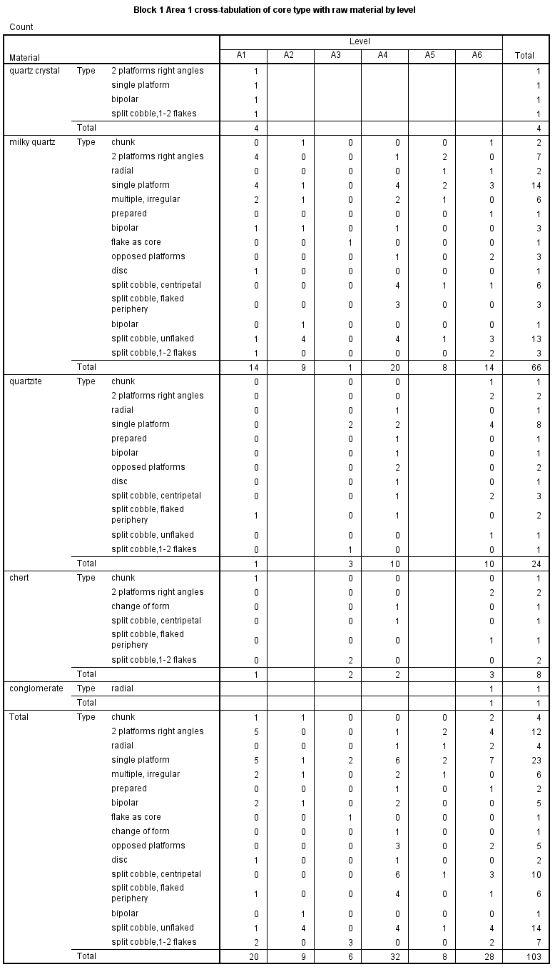
SM Table 6
The frequencies of cores by level, type and raw material in Block 1, Area 1.

