TITLE PAGE
Pregnancy rates and outcomes amongst women with cystic fibrosis in the UK: comparisons with the general population before and after the introduction of disease modifying treatment, 2003-17
Authors: Oluwaseun B Esan¹, Daniela K Schlüter¹, Rhiannon Phillips², Rebecca Cosgriff³, Shantini Paranjothy⁴, Denitza Williams², Rachel Norman⁵, Siobhán B Carr⁶, Jamie Duckers⁷, and David Taylor-Robinson¹

¹Department of Public Health, Policy and Systems, University of Liverpool, Waterhouse Building (2nd Floor, Block F), 1-5 Brownlow Street, Liverpool L69 3GL, UK
²Cardiff School of Sport and Health Sciences, Cardiff Metropolitan University, Llandaff Campus, Cardiff CF5 2YB
³ Data Quality and Improvement, Cystic Fibrosis Trust, One Aldgate, Second floor, London
EC3N 1RE, UK
⁴ Aberdeen Centre for Health Data Science, Institute of Applied Health Sciences, University of Aberdeen, Polwarth Building, Forester Hill, Aberdeen AB25 2ZD
⁵ Research and Development, University Hospital of Wales, Heath Park, Tower Block 2 Cardiff CF14 4XW
⁶ Department of Respiratory Paediatrics, Royal Brompton Hospital, London, UK
⁷ All Wales Adult CF Centre, Cardiff and Vale University Health Board, Cardiff, UK

Corresponding Author: Corresponding Author: Oluwaseun B Esan, Department of Public Health, Policy and Systems, University of Liverpool, Waterhouse Building (2nd Floor, Block F), 1-5 Brownlow Street, Liverpool L69 3GL, UK
Email: Oluwaseun.Esan@liverpool.ac.uk

ABSTRACT
Objective
To compare pregnancy rates and outcomes for women with cystic fibrosis in the UK with the general population and assess the effect of introduction of disease modifying treatment.

Design
A population-based longitudinal study, 2003-17
Setting
United Kingdom
Population
Women aged 15-44 years in the UK CF Registry compared to women in England and Wales.

Methods
We calculated pregnancy and live birth rates for the CF and England and Wales (E&W) populations. For women with CF we compared pregnancy rates before and after ivacaftor was introduced in 2013. We further used CF registry data to assess pregnancy outcomes for mothers with CF, and to assess the relationship between maternal pre-pregnancy lung function and nutritional status and child gestational age.

Main outcome measures
Pregnancy and live birth rates; and child gestational age.

Results
Of 3,831 women with CF, 661 reported 818 pregnancies. Compared E&W the pregnancy rate was 3.3 times lower in the CF population (23.5 vs. 77.7 per 1,000 women years); the live birth rate was 3.5 times lower (17.4 vs. 61.4 per 1,000 women years) with 70% of pregnancies in CF women resulting in live births; abortion rates were also lower (9% vs. 22%). Pregnancy rates increased post-ivacaftor for eligible women with CF, from 29.7 to 45.7 per 1,000 women years. There was no association between pre-pregnancy lung function/nutrition status and gestational age.

Conclusions
Pregnancy rates in women with CF are about a third of the rates in E&W with favourable outcomes, and increased for eligible women post-ivacaftor.

Funding
The study was funded by a Welsh Government Research for Patient and Public Benefit grant.
Tweetable abstract
Pregnancy rates in women with CF are about a third of rate in England and Wales with 70% live births. Ivacaftor increases the rate.

Key words: Cystic fibrosis, Pregnancy, Ivacaftor Epidemiology, CFTR modulator
Abbreviations: CF (cystic fibrosis), wwCF (women with cystic fibrosis), CFTR (cystic fibrosis transmembrane conductance regulator), UK (United Kingdom), E&W (England and Wales), ONS (Office for National Statistics), LB (live birth), IVF (in vitro fertilisation), %FEV1 (percent predicted forced expiratory volume in 1 second.), BMI (body mass index).

INTRODUCTION
Cystic Fibrosis (CF) is the most common autosomal recessive disorder in Caucasians. It is a progressive multisystem disease caused by a reduction or loss of the Cystic Fibrosis Transmembrane conductance Regulator (CFTR) protein function. Over 2,000 mutations of CFTR have been discovered and the most common mutation in cystic fibrosis is deletion of phenylalanine 508 (F508del) ¹.

Considerable advances in care, diagnosis, neonatal screening, and treatments has improved survival over recent decades (Text box 1). As of 2019, over half of babies born, and individuals aged 30 and above, can expect to survive into at least their fifth decade compared to less than 10 years in the 1960s (Text box 1) ^{2,3}. One of the notable advancements in the care of CF is the availability of CFTR modulators such as ivacaftor. Ivacaftor targets the underlying cause of CF through increased chloride transport of the CFTR protein with significant improvement in lung function in people with CF since its launch in the USA in 2012 ⁴.

As people with CF are living longer, healthier lives, more women are considering having families of their own ⁵. Recent studies from Australia, Europe and USA have reported successful pregnancy outcomes in women with CF (wwCF) with reduction in maternal morbidity and mortality; but with limited information on pregnancy outcomes for wwCF compared to the general population ^{6–11}. Patel et.al and Girault et al both found that pregnancies occurred at younger ages in the CF population compared to the general population in France (Patel et al, 26.5 vs 27.6 years, p = 0.006; Girault et al, 28.7 vs 32.1 years, p = .003). Patel et.al used nationwide records and reported an increased risk of preterm labour (aOR, 2.2; 95% CI, 1.9–2.6); while Girault et al, demonstrated similar levels of uncomplicated deliveries, gestational age and birth weight amongst the CF and non-CF population but findings were limited by a small sample size of only 33 wwCF from a single centre. In the UK, recently available evidence on pregnancy in wwCF from the Obstetric Surveillance System data did not capture all wwCF and their pre-pregnancy clinical characteristics such as BMI, lung function, or genotype ⁹. These factors determine preconception health status and may be linked to pregnancy outcomes ¹². Further, there is a paucity of large population-based studies on pregnancy in the era of CFTR modulators, with only one study published to date ¹³.

The objective of this study was to determine current pregnancy rates and outcomes in the whole CF population and compare these with the UK general population, and explore the potential impact of the availability of ivacaftor on pregnancy rates and outcomes based on analysis of data from a sub-population of eligible women who have had access since 2013 ¹⁴. This will provide useful information for clinicians counselling or managing women with CF who are currently pregnant or would like to start a family.

METHODS

Study Design, Setting and Participants
We conducted a retrospective longitudinal observational study of pregnancy rates and outcomes among wwCF of child-bearing age (15-44 years inclusive) in the UK CF Registry between 2003-2017. We describe the baseline characteristics of women of childbearing age (15-44 inclusive) in the UK CF registry who became pregnant. Then two comparisons were made. First, rates and outcomes in the wwCF were compared to those in the general population of England and Wales. Second, for the wwCF only, we compared pregnancy rates and outcomes before and after the availability of ivacaftor for eligible wwCF with all wwCF.
Data sources and baseline characteristics
The UK CF Registry records data from each patient’s comprehensive annual review with a specialist clinician for evaluation of clinical status, pulmonary function, microbiology of respiratory tract secretions and use of major CF-related therapies ¹⁵. Records date back to the 1990s and are estimated to capture approximately 99% of the current CF population with approximately 80% from England ¹⁵. Baseline characteristics of interest were ethnicity, genotype, age at the end of year the woman became pregnant, employment status, CF related diabetes, pancreatic insufficiency, body mass index (BMI) and percent predicted forced expiratory volume in 1 second (%FEV1) based on the Global Lung Initiative reference equations at annual review visit in the three years pre-pregnancy ¹⁶. We used %FEV1 measures across three years due to the large visit-to-visit variation in the measurement of FEV1, meaning that mean values over multiple time points give a better estimate of underlying true lung function ¹⁷.

Conceptions and legal abortions for England and Wales are published annually by the Office of National Statistics (ONS) ¹⁸. Data on early pregnancy loss (miscarriages) are not included in conception publications. Live births are available from the ONS Vital Statistics and birth characteristics publications ¹⁹.

Outcome measures
The main outcomes of interest were pregnancy rates and outcomes. We adopted the ONS definition of conceptions for pregnancies – “pregnancy of a woman that leads either to a maternity or an abortion”, where abortion refers to legal abortion according to the 1967 abortion act ¹⁸. The UK Cystic Fibrosis Registry codes pregnancy as a binary event (yes/no) during annual review with possible outcomes recorded in the case of a “yes” response: live birth, still birth, therapeutic abortion (abortion), spontaneous abortion (miscarriage), undelivered, and unknown. For full questions related to pregnancy captured in the UK CF Registry at annual review, see Supplementary file. Women who were pregnant in two consecutive years with outcome “undelivered” in the former year were counted as a pregnancy case in the former year – but not the latter.
Other pregnancy related outcomes captured in the registry include gestational age (recorded as weeks of completed pregnancy), congenital anomalies, use of invitro fertilisation (IVF) and CF status of child all recorded as categorical variables with possible options of Yes, No or Unknown. We were also interested in the number of women who were pregnant with a mean %FEV1 below 50% in the three years pre-pregnancy as this is a contraindication for pregnancy ²⁰.
Further, we assessed the pregnancy rates and outcomes amongst wwCF with at least one G551D mutation (the group first eligible for disease modulator therapy) to explore effects of modulator therapy on pregnancy rates. The information on genotype was recorded for each mutation and ivacaftor was recorded as a binary variable with possible options of Yes or No.

Statistical analyses

The analyses progressed in four stages. First, we described the characteristics of the population of women of childbearing age (15-44 inclusive) in the registry who became pregnant.
Second, we compared pregnancy and live birth rates between 2003 and 2017 amongst women of child bearing age (15-44 inclusive) for both populations (wwCF and E&W women) calculating three yearly averages to account for year on year variation. In the data for England and Wales, pregnancies resulting in a miscarriage are excluded from the numerator, for better comparison, we excluded miscarriages from the numerator for wwCF in determining the pregnancy and live birth rates. Pregnancy rates were calculated as the total number of pregnancies for the specified time period divided by the total number of women years (wys) for the same time period while live births rates were calculated as the total number of live births divided by the total number of women years for the specified time period and presented as a rate per 1,000 wys (Rate calculations, Supplementary File). Both pregnancy and live birth rates were broken down into the child bearing age groups to determine the age specific rates - the number of pregnancies or live births per 1,000 wys for a specific age group. For abortion, miscarriages, and still births we considered the proportion of pregnancies resulting in these outcomes and made the comparison between both populations where possible.
Third, for wwCF only we compared the pregnancy rate and outcomes for all wwCF with women who had a G551D mutation (those initially eligible for ivacaftor) in the period before (2008-2012) and the period after (2013-2017) ivacaftor became available.
Fourth, for wwCF only, we assessed the association between aspects of maternal health - mean 3-years pre-pregnancy maternal BMI and %FEV1 – and child gestational age using a linear regression model.

Baseline data were summarised as mean and standard deviations (sd) or medians and interquartile ranges (IQR) for continuous variables, and percentages for categorical variables. All analyses were performed using STATA V14 (College Station, Texas, USA) and R V 3.16 (R Foundation for Statistical Computing, Vienna, Austria). All rates were reported with 95% confidence interval (CI) using the Byar’s method ²¹.

Ethical approval, core outcomes set, patient involvement, and funding
The UK CF Registry has NHS research ethics approval: (Huntingdon Research Ethics Committee 07/Q0104/2) for the collection of data into the registry. The CF Trust Registry Research Committee approved the use of anonymised data in this study, under the terms of the NHS ethics approval. Patients were not involved in the development of this research. Core outcome sets were not used. This study was funded by a Welsh Government Research for Patient and Public Benefit grant

Role of the Funder
The funder was not involved in the study design, data collection, data analysis, data interpretation, or in the writing of the report.

RESULTS

Population Characteristics
A total of 3,831 women were followed up during the study period, of which 661 became pregnant, with a total of 818 pregnancies. A flow chart of selection of the study population from the UK CF Registry is in Supplementary Figure S1. Pregnant women with CF were predominantly of white ethnicity (97%), diagnosed in childhood, had two copies for F508del mutation (43.7%), were in employment or education (45%) with pre-pregnancy mean BMI – 22.1 kg/m2 (sd: 3.5), %FEV-1 – 69.5% (sd: 20.1) (Table1). One fifth reported CF related diabetes (21%) and the majority had pancreatic insufficiency (81%). 14% of women who became pregnant had %FEV1 below 50%.

Pregnancies in women with CF and rates compared to the general population

818 pregnancies were reported in the UK CF Registry between 2003 and 2017. 59% of wwCF who became pregnant reported only one pregnancy but some had up to five (Table 2). Records on IVF in the CF population were available in 2016 and 2017 only, of which 34 women with IVF had 25 pregnancies and six women were recorded twice with no information on the number of IVF cycles per woman. Median age at pregnancy was higher amongst women with IVF in comparison with all wwCF who became pregnant (median 31, IQR 27, 34 vs median 27 IQR 23, 31) (Table 2).

Pregnancy rates over the study period in wwCF and in the general population were relatively stable (Figure 1). Overall, compared to the general population the pregnancy rate was 3.3 times lower in women with CF (23.5 vs. 77.7 per 1,000 women years). The pregnancy rate was highest at 30-34 years for wwCF compared to 25-29 years for E&W women (Figure 2). The lowest pregnancy rate was amongst the youngest and oldest for wwCF and those aged 40-44 years for E&W women (Figure 2, Supplementary Table S2). Conceptions for women aged 15-19 years are on the decline in the general population but have remained fairly stable at a low rate in wwCF (Figure 2).

Pregnancy outcomes in women with CF and live birth rates compared to the general population
Pregnancy outcome was available for 773 pregnancies for wwCF, of which 70% had a live birth, 11.6% miscarriage, 9.6% abortion, and the remaining were undelivered (8%) or still births (<1%) (Table 2). 42% of the pregnancies that were undelivered were recorded in 2017, the last year of study. Those with IVF had a live birth rate of 60% (Table 2). The median age of wwCF with a live birth was 27 (IQR 23-31) and similar to the median age of pregnancy.

The overall live birth rate in wwCF was 3.5 times lower than the rate for the general population (17.4 vs 61.4 per 1,000 wys). The age specific live birth rates followed a similar trend of higher rates in the general population across all age groups except for those aged 40-44 years where the rates were similar (Supplementary Figure S2).
The percentage of pregnancies resulting in abortion for women in the general population was double that of wwCF (wwCF 9.6% vs. 21.6% E&W women). 11.6% of wwCF had a miscarriage; the estimate for the general population is 10-20% ²².

Pregnancy rates and outcomes in women with CF eligible for ivacaftor with a G551D mutation
43 women had at least one G551D mutation and were eligible for ivacaftor between 2013 and 2017, representing 6.2% of all wwCF of child-bearing age between 2013-2017. 86% had a recording of ivacaftor for at least one year over the 5-year period. The median number of years of ivacaftor prescription was 4 (IQR 2 - 5). 68 pregnancies were recorded for 51 wwCF with at least one G551D mutation between 2003 and 2017 with half of pregnancies recorded in the five years since ivacaftor became available in 2013. There was a 1.5-fold increase in pregnancy rates between the 2008-2012 and 2013-2017 periods from 29.7 per 1,000 wys (95% C.I 19.0-46.7) to 45.7 per 1000 wys (95% CI 32.4-62.8) (Table 2). Where information was available, outcomes were favourable with more pregnancies resulting in a live birth in the post-ivacaftor period (74% vs. 60%). (Table 2).

Association of pre-pregnancy lung function and nutrition status with child gestational age for wwCF
Gestational age was available for 186 babies (35%) born to wwCF with a median of 37 completed weeks and IQR of 35 to 38 completed weeks. There was no correlation between pre-conception %FEV1 and gestational age (R=0.066, 95% CI -0.16-0.28) or pre-conception BMI and gestational age (R=-0.083, 95% CI -3.0-0.14) (Supplementary Figure S3).

DISCUSSION
Main findings
In this large comparative study of pregnancy in women with CF in the UK, we found that wwCF were approximately 3.3 times less likely to become pregnant than women from the general population (23.5 vs 77.7 per 1,000 wys). Pregnancy rates were highest for women aged 25-29 and 30-34 years for both wwCF and the general population and lowest for those aged 15-19 and 40-44 years. Live births mirrored pregnancy rates with a 3.5-fold difference in the live birth rate (17.4 vs 61.4 per, 1000 wys). The proportion of pregnancies resulting in abortion was lower in wwCF (9% vs. 22% in the general population). Following the introduction of ivacaftor for eligible women with CF who carry the G551D mutation the pregnancy rate increased by one and a half-fold.

Strength and Limitations
Our study has several notable strengths. First, we were able to follow up about 99% of wwCF of child-bearing age using the UK CF Register with baseline characteristics and pre-pregnancy clinical status, hence providing the most up to date pregnancy estimates using population level data across all CF centres in the UK. Further, this is the first study of pregnancies in the UK of wwCF following the availability of the first approved CFTR modulator. As more people with CF become eligible for modulator therapy, prognosis is expected to improve with more wwCF and their partners likely to consider having children. The comparison with the general population allows people with CF and their partners to understand pregnancy related outcomes for wwCF in relation to women of similar age in the general population. This information can be used to facilitate person-centred discussions about the outcomes of pregnancy in wwCF between clinicians and patients.

There are limitations in the data available on pregnancy related outcomes in the UK CF Registry. It was not possible to ascertain exact pregnancy dates, maternal (e.g. delivery method) and neonatal outcomes (e.g. birth weight) with limited reporting of gestational age. As such, we were unable to compare delivery method, birth weight or gestational age of neonates born to wwCF with the general population. Moreover, pregnancy outcomes for 2017 were incomplete for wwCF, hence outcomes for this period are underestimated. Further, data on conceptions were only available for England and Wales, while the CF Registry covers the UK. However, this is unlikely to have had a major impact on our results as Scotland and Northern Ireland represent less than 15% of the UK population, and the overall pattern of pregnancy rates in wwCF are similar to E&W women.

For assessing the impact of modulator therapy on pregnancy rates, we used the initial eligibility criteria for ivacaftor and have therefore not captured all women who may have had the opportunity to receive ivacaftor. Following the first approval of ivacaftor for people with at least one mutation for G551D in 2013 in the UK, there has been a progressive increase in those eligible for ivacaftor and other modulator therapies are now available and approved for use in UK (Orkambi, Symkevi – 2019 and Kaftrio – 2020) with up to 90% of the CF population eligible for modulator therapy ^{23,24}. This raises the need for continued research and improved data completion of the UK CF Registry data on pregnancy related outcomes in this new era of care for people living with CF.

Interpretation
The overall pregnancy rate in wwCF reported in our study was twice the rate reported in the Italian CF population (23.5 vs. 10.6 per 1,000 wys) but similar to that in the US (25.5 per 1,000 wys). In contrast, there was a four-fold difference in the pregnancy rate in US wwCF and that of the US general population due to a higher overall pregnancy rate in the US population. During our study period there was one and a half-fold increase in pregnancy rates in the years 2013-2017 for wwCF with at least one G551D mutation following the introduction of ivacaftor. This is in line with the study in the US by Heltshe et.al who found an increase in pregnancy rates for women with at least one G551D mutation during the post approval period (2012-2014) for ivacaftor ¹¹.

Over our study period, the live birth rate for younger wwCF was relatively stable in comparison with the rate in the general population which has declined from 2009-2011 onwards. This decrease in the general population coincided with an increase in the proportion of pregnancies leading to abortion ^{18,25}. Although, we were unable to assess age specific abortion rates over time in the CF population, the overall percentage of pregnancies resulting in abortions was half that of the general population, (9.6% vs. 21.6%), with miscarriages (11.6%) at a similar level to the general population ²².

Similar to other studies, pregnant wwCF in this study had good nutritional status (mean BMI – 22.1kg.m2) and respiratory function (mean %FEV1 – 69%) with majority reporting first pregnancies ^{26–29}. This is not surprising as most women will consider getting pregnant before their lung function begins to decline and will work at achieving good nutritional status in agreement with their clinical care teams prior to pregnancy. Guidelines published in 2008 suggests %FEV1 <50% is a contraindication for pregnancy, with CF related diabetes and pancreatic insufficiency as potential risk factors for pre-term delivery and caesarean section ²⁰. In our study, 14% of women had mean %FEV1 below 50%, over 20% with CF related diabetes and over 80% were pancreatic insufficient. Although we did not assess the impact of these factors on pregnancy outcomes, recent evidence now demonstrate that pregnancy may not negatively impact maternal health with favourable respiratory function and nutritional status in women with %FEV1 as low as 40%, but pancreatic insufficiency remains a risk for small for gestational age in infants ^{7,12,30}

Gestational age was only available for a subset of wwCF. We did not find any correlation between pre-pregnancy BMI or %FEV1 and gestational age respectively as reported by others ^{6,9,29}. This may be due to the definition of these baseline characteristics, and sample sizes considered in previous studies. For instance, in the study by Ashcroft and colleagues in the UK, they included 56 women and used the %FEV1 and BMI at pregnancy booking (~13 weeks) for baseline recording while we used the mean in the three years pre-pregnancy; an Australian study only included 20 women ^{6,9}.

Conclusion
This observational study represents the largest multicentre study of pregnancy rates amongst wwCF of child-bearing age in comparison with women in the general population in the pre- and post-approval period of ivacaftor in the UK. Pregnancy rates are over three times lower in wwCF than the general population with about 70% resulting in a live birth. The availability of ivacaftor for 6.2% of wwCF of child-bearing age increased the pregnancy rate in this group. Extrapolating this result to the much larger adult CF population now eligible for modulator therapy (90%), we can expect improved health outcomes and survival in CF and an increase in pregnant wwCF in Obstetric departments. It is important obstetricians are aware of the current and expected future trends of pregnancy and cystic fibrosis to help wwCF, their partners and clinical teams in the decision process on whether to start a family.

ACKNOWLEDGEMENTS
We thank the UK CF Registry team and the UK CF centres and clinics for submitting data to the Registry. Special thanks to the people with cystic fibrosis and their families who have agreed for their UK CF Registry data to be used for research.

Author Contributions
DKS, DT-R, and JD conceived the original idea for this study. DKS, OBS, and DT-R designed the study. OBS, DKS, and DT-R developed the analysis plan. OBS extracted the data and prepared the datasets. OBS analysed the data and conducted the literature searches. SBC and JD helped identify previous work and gave the clinical interpretation. OBS, DKS and DT-R wrote the first draft of the paper. All authors were involved in interpreting the findings and revising drafts and agreeing the final version.

Declaration of Interests
Dr. Oluwaseun B Esan is funded by the Welsh Government Research for Patient and Public Benefit, during the conduct of the study. Dr Duckers reports grants from Welsh Government Research for Patient and Public Benefit, during the conduct of the study; personal fees from Chiesi, personal fees from Vertex, personal fees from Trudell, personal fees from Insmed, personal fees from Merke, outside the submitted work. Dr Siobhán B Carr reports speaker honoraria from Chiesi, is a member of the advisory board for Chiesi, Profile Pharma, Vertex, Chair UK Registery Steering Committee, UK CF Trust, received payment to institution from Pharmaxis outside the submitted work.

REFERENCES
1. Clinical and Functional Translation of CFTR. Resources | CFTR2 [Internet]. [cited 2021 Aug 24]. Available from: https://cftr2.org/resources
2. Elborn JS, Shale DJ, Britton JR. Cystic fibrosis: current survival and population estimates to the year 2000. Thorax [Internet]. 1991 [cited 2021 Mar 31];46:881–5. Available from: http://thorax.bmj.com/
3. Keogh RH, Szczesniak R, Taylor-Robinson D, Bilton D. Up-to-date and projected estimates of survival for people with cystic fibrosis using baseline characteristics: A longitudinal study using UK patient registry data. J Cyst Fibros [Internet]. 2018;17(2):218–27. Available from: https://doi.org/10.1016/j.jcf.2017.11.019
4. Volkova N, Moy K, Evans J, Campbell D, Tian S, Simard C, et al. Disease progression in patients with cystic fibrosis treated with ivacaftor: Data from national US and UK registries. J Cyst Fibros [Internet]. 2020 Jan 1;19(1):68–79. Available from: https://doi.org/10.1016/j.jcf.2019.05.015
5. Kazmerski TM, Sawicki GS, Miller E, Jones KA, Abebe KZ, Tuchman LK, et al. Sexual and reproductive health behaviors and experiences reported by young women with cystic fibrosis. J Cyst Fibros. 2018 Jan 1;17(1):57–63.
6. Lau EMT, Barnes DJ, Moriarty C, Ogle R, Dentice R, Civitico J, et al. Pregnancy outcomes in the current era of cystic fibrosis care: A 15-year experience. Aust New Zeal J Obstet Gynaecol [Internet]. 2011 Jun;51(3):220–4. Available from: http://doi.wiley.com/10.1111/j.1479-828X.2010.01287.x
7. Reynaud Q, Rousset Jablonski C, Poupon-Bourdy S, Denis A, Rabilloud M, Lemonnier L, et al. Pregnancy outcome in women with cystic fibrosis and poor pulmonary function. J Cyst Fibros [Internet]. 2020 Jan;19(1):80–3. Available from: https://linkinghub.elsevier.com/retrieve/pii/S1569199319308045
8. Giordani B, Quattrucci S, Amato A, Salvatore M, Padoan R. A case-control study on pregnancy in Italian Cystic Fibrosis women. Data from the Italian Registry. Respir Med [Internet]. 2018 Dec;145:200–5. Available from: https://linkinghub.elsevier.com/retrieve/pii/S0954611118303688
9. Ashcroft A, Chapman S, Mackillop L. The outcome of pregnancy in women with cystic fibrosis: a UK population‐based descriptive study. BJOG An Int J Obstet Gynaecol [Internet]. 2020 Dec 16 [cited 2021 Jan 7];127(13):1696–703. Available from: https://onlinelibrary.wiley.com/doi/10.1111/1471-0528.16423
10. Ahluwalia M, Hoag JB, Hadeh A, Ferrin M, Hadjiliadis D. Cystic fibrosis and pregnancy in the modern era: A case control study. J Cyst Fibros [Internet]. 2014 Jan;13(1):69–73. Available from: https://linkinghub.elsevier.com/retrieve/pii/S1569199313001240
11. Heltshe SL, Godfrey EM, Josephy T, Aitken ML, Taylor-Cousar JL. Pregnancy among cystic fibrosis women in the era of CFTR modulators. J Cyst Fibros [Internet]. 2017 Nov;16(6):687–94. Available from: https://linkinghub.elsevier.com/retrieve/pii/S1569199317300152
12. Middleton PG, Gade EJ, Aguilera C, MacKillop L, Button BM, Coleman C, et al. ERS/TSANZ Task Force Statement on the management of reproduction and pregnancy in women with airways diseases. Eur Respir J [Internet]. 2020 Feb 1 [cited 2021 Jan 7];55(2). Available from: https://doi.org/10.1183/13993003.01208-2019
13. Heltshe SL, Godfrey EM, Josephy T, Aitken ML, Taylor-Cousar JL. Pregnancy among cystic fibrosis women in the era of CFTR modulators. J Cyst Fibros [Internet]. 2017 Nov 1 [cited 2021 Aug 25];16(6):687–94. Available from: http://dx.doi.org/10.1016/j.jcf.2017.01.008
14. NHS Commissioning Board Clinical Commissioning Policy: Ivacaftor for Cystic Fibrosis. 2012.
15. Taylor-Robinson D, Archangelidi O, Carr SB, Cosgriff R, Gunn E, Keogh RH, et al. Data Resource Profile: The UK Cystic Fibrosis Registry. Int J Epidemiol [Internet]. 2018 Feb;47(1):9--10e. Available from: https://academic.oup.com/ije/article/47/1/9/4316111
16. Quanjer PH, Stanojevic S, Cole TJ, Baur X, Hall GL, Culver BH, et al. Multi-ethnic reference values for spirometry for the 3-95-yr age range: the global lung function 2012 equations Stocks and the ERS Global Lung Function Initiative. [cited 2021 Feb 25]; Available from: www.erj.ersjournals.com
17. Taylor-Robinson D, Whitehead M, Diderichsen F, Olesen HV, Pressler T, Smyth RL, et al. Understanding the natural progression in %FEV1 decline in patients with cystic fibrosis: A longitudinal study. Thorax [Internet]. 2012 Oct 1 [cited 2021 Aug 26];67(10):860–6. Available from: http://thorax.bmj.com/
18. Conceptions in England and Wales - Office for National Statistics [Internet]. [cited 2021 Feb 24]. Available from: https://www.ons.gov.uk/peoplepopulationandcommunity/birthsdeathsandmarriages/conceptionandfertilityrates/bulletins/conceptionstatistics/2018
19. Vital statistics in the UK: births, deaths and marriages - Office for National Statistics [Internet]. [cited 2021 Feb 24]. Available from: https://www.ons.gov.uk/peoplepopulationandcommunity/populationandmigration/populationestimates/datasets/vitalstatisticspopulationandhealthreferencetables
20. Edenborough FP, Borgo G, Knoop C, Lannefors L, Mackenzie WE, Madge S, et al. Guidelines for the management of pregnancy in women with cystic fibrosis [Internet]. Vol. 7, Journal of Cystic Fibrosis. Elsevier; 2008 [cited 2021 Feb 24]. Available from: https://pubmed.ncbi.nlm.nih.gov/18024241/
21. Technical Guidance - PHE [Internet]. [cited 2021 Feb 24]. Available from: https://fingertips.phe.org.uk/profile/guidance
22. Magnus MC, Wilcox AJ, Morken N-H, Weinberg CR, Håberg SE. Role of maternal age and pregnancy history in risk of miscarriage: prospective register based study. BMJ [Internet]. 2019 [cited 2021 Mar 18];364:869. Available from: http://dx.doi.org/10.1136/bmj.l869
23. Iacobucci G. Cystic fibrosis: NHS England strikes deal to offer triple combination treatment. BMJ [Internet]. 2020 Jul 1 [cited 2021 Feb 24];370:m2643. Available from: https://www.bmj.com/content/370/bmj.m2643
24. Southern KW, Murphy J, Sinha IP, Nevitt SJ. Corrector therapies (with or without potentiators) for people with cystic fibrosis with class II CFTR gene variants (most commonly F508del). Cochrane database Syst Rev [Internet]. 2020 Dec 17 [cited 2021 Feb 24];12(12):CD010966. Available from: https://www.cochranelibrary.com/cdsr/doi/10.1002/14651858.CD010966.pub3/full
25. Abortion Statistics, England and Wales: 2018 Summary information from the abortion notification forms returned to the Chief Medical Officers of England and Wales. 2019.
26. Girault A, Blanc J, Gayet V, Goffinet F, Hubert D. Maternal and perinatal outcomes of pregnancies in women with cystic fibrosis-A single centre case-control study. Respir Med [Internet]. 2016 Apr 1 [cited 2021 Jan 7];113:22–7. Available from: http://dx.doi.org/10.1016/j.rmed.2016.02.010
27. Patel EM, Swamy GK, Heine RP, Kuller JA, James AH, Grotegut CA. Medical and obstetric complications among pregnant women with cystic fibrosis. Am J Obstet Gynecol [Internet]. 2015 Jan 1 [cited 2021 Jan 7];212(1):98.e1-98.e9. Available from: http://www.ajog.org/article/S0002937814007054/fulltext
28. Reynaud Q, Poupon-Bourdy S, Rabilloud M, Al Mufti L, Rousset Jablonski C, Lemonnier L, et al. Pregnancy outcome in women with cystic fibrosis-related diabetes. Acta Obstet Gynecol Scand [Internet]. 2017 Oct;96(10):1223–7. Available from: http://doi.wiley.com/10.1111/aogs.13185
29. Thorpe-Beeston JG, Madge S, Gyi K, Hodson M, Bilton D. The outcome of pregnancies in women with cystic fibrosis-single centre experience 1998-2011. BJOG An Int J Obstet Gynaecol [Internet]. 2013 Feb;120(3):354–61. Available from: http://doi.wiley.com/10.1111/1471-0528.12040
30. Cohen-Cymberknoh M, Gindi Reiss B, Reiter J, Lechtzin N, Melo J, Pérez G, et al. Baseline Cystic fibrosis disease severity has an adverse impact on pregnancy and infant outcomes, but does not impact disease progression. J Cyst Fibros [Internet]. 2020 [cited 2021 Feb 24];0(0). Available from: http://www.cysticfibrosisjournal.com/article/S156919932030864X/fulltext

Box 1. Key developments in CF care relevant to pregnancy
The first successful delivery of a baby in a woman with CF was first reported in 1960 at a time when median survival for CF was less than 5 years. Although several pregnancies were reported in subsequent years, pregnancy for women with CF was generally discouraged until the 1980s, an era when the CF protein and the CF transmembrane receptor (CFTR) gene were discovered (Figure A). Mutations in the gene lead to abnormal ion transport and a resulting build-up of thick, dehydrated, pH imbalanced mucus which adversely impacts the function of the respiratory, gastrointestinal, and reproductive tracts.
Pregnancy guidelines for women with CF were published in the UK in 2008 with recommendations for multidisciplinary care and a contraindication for women with lung function below percent predicted force expiratory volume of 50%, with pancreatic insufficiency and CF related diabetes as the main risk factors for pre-term delivery and caesarean section. Despite improvements in treatments such as DNase for thinning mucus secretions allowing ease of airway clearance and antimicrobials, the majority of people with CF will eventually develop respiratory failure and many are considered for lung transplantation.
However, a new class of treatments, CFTR modulator therapies which include Ivacaftor (UK, 2013), combination therapies of Symkevi (tezacaftor/ivacaftor, available in UK, 2018) and Orkambi (lumacaftor/ivacaftor available in UK, 2018) and triple therapy – Kaftrio (elexacaftor/tezacaftor/ivacaftor, available in UK, 2020) have ushered in a new era of care for people with CF with over 90% of the people with CF eligible for modulator therapies in the UK. These therapies target the CFTR mutations, increasing the flow of ions across the CFTR protein, which helps to alleviate the symptoms of CF, with notable improvements in mucus clearance, lung function and weight gain.
With the substantial gains in health experienced by people with CF over the last 20 years and anticipated future therapies, obstetricians are increasingly likely to become part of the multidisciplinary teams of women with CF who become pregnant.
Figure A. Timeline of key milestones in treatment and care of people with CF and life expectancy
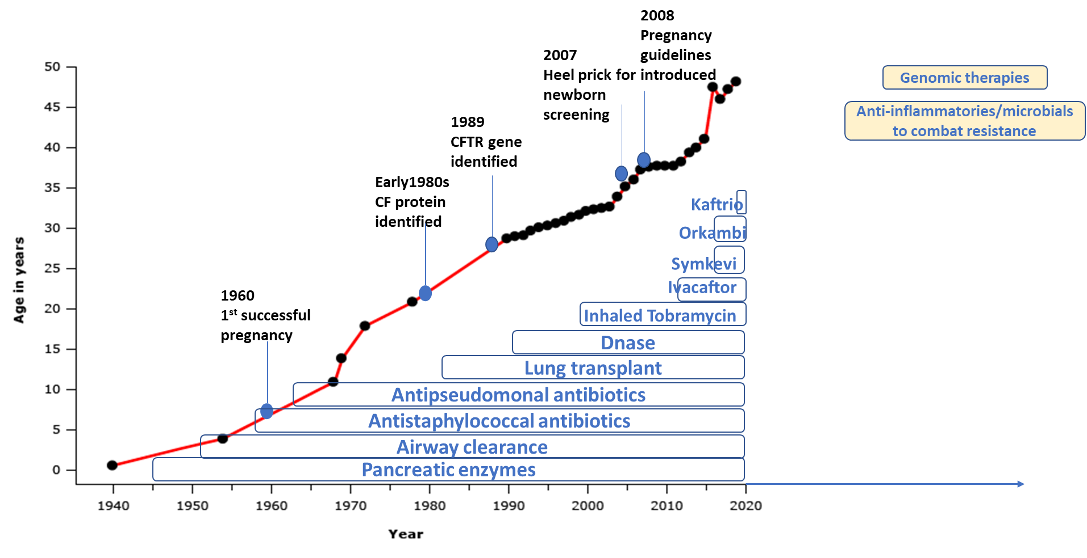
Figure A illustrates the improvements in care, availability of treatments and increasing life expectancy. Future therapies and changes are highlighted in yellow. (Data points from Survival of CF patients - UpToDate https://www.uptodate.com/contents/image?imageKey=PULM%2F61930&topicKey=PEDS%2F110933&source=outline_link and timelines adapted from the UK Cystic Fibrosis Trust https://www.cysticfibrosis.org.uk/get-involved/fundraising/join-our-fundraising-campaigns/cf-week/research-what-the-cf )

FIGURES
Figure 1 Pregnancy rates amongst women with CF (15-44years) in comparison with women in England and Wales, 2003-2017

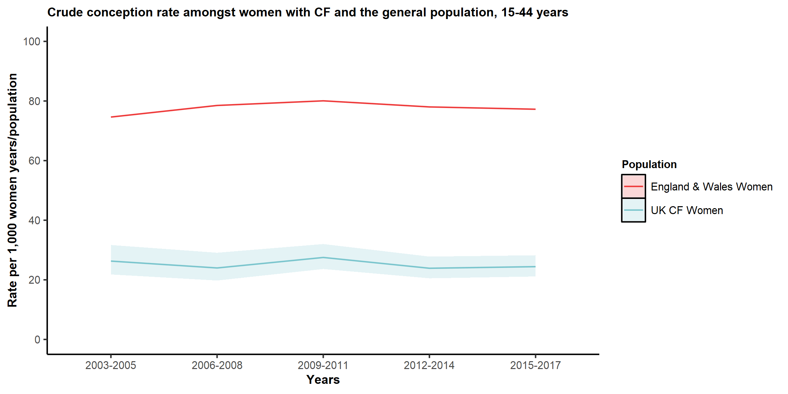

Figure 2. Three yearly age specific pregnancy rate per 1,000 women years/population of women with CF and women in England and Wales, 2003-2017

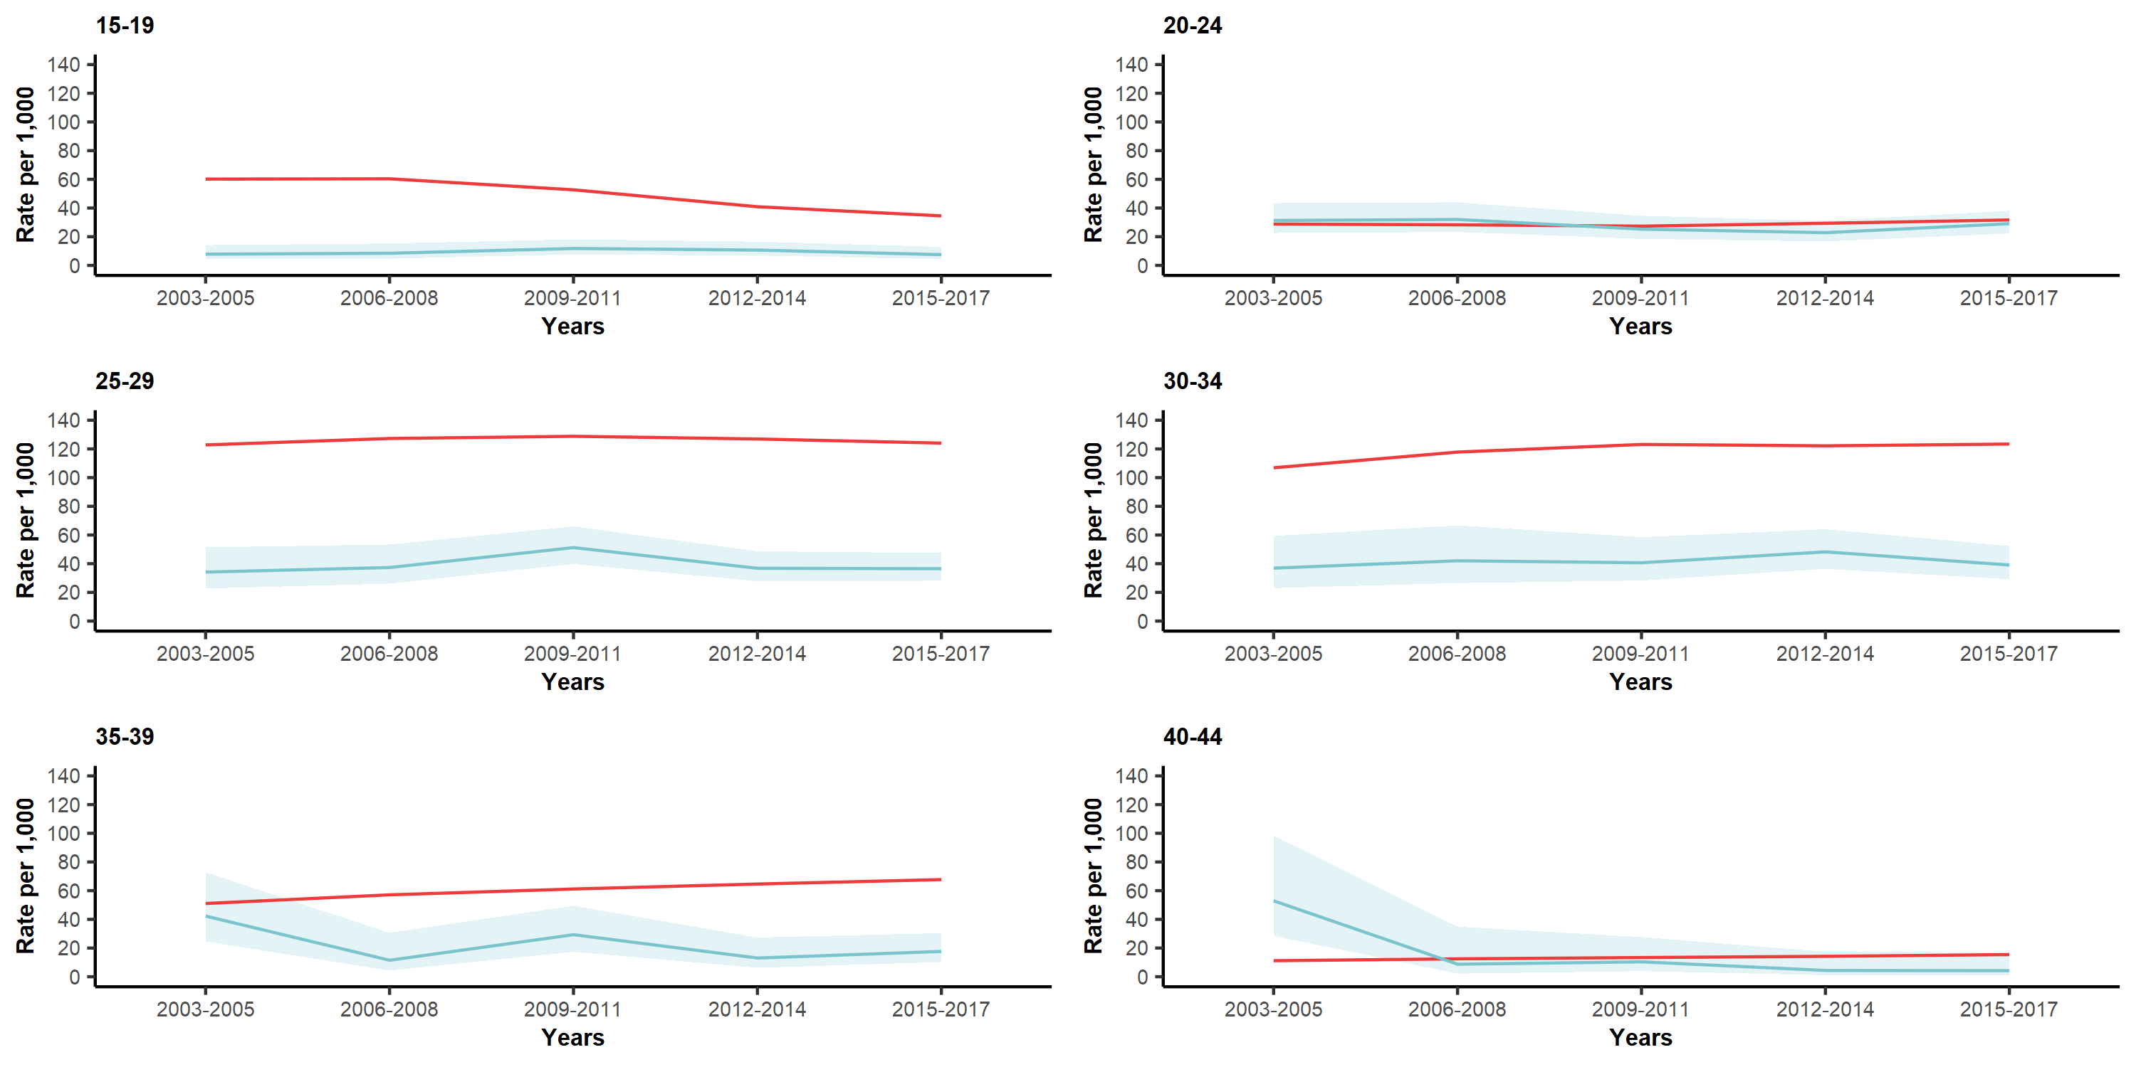

TABLES

Table 1 Baseline clinical and demographic characteristics of the CF study population. These are women captured in the UK CF Registry aged 15-44 who have had a pregnancy between 2003 and 2017 (n =661)
Baseline characteristics | Mean | SD | Range
Age at diagnosis | 6.4 | 9.66 | 0-43.6
Lung function | 69.5 | 20.1 | 15.6-130.2
BMI (Kg/m2) | 22.2 | 3.5 | 14.1-39.4
Baseline characteristics | N | %
Genotype
F508del_Homozygous | 289 | 43.7
F508del_Heterozygous* | 240 | 36.3
G551D† | 51 | 7.7
Other/Unknown | 81 | 12.3
Ethnicity
White | 643 | 1
Non-White | 18 | 0.03
Employment Status
Full-time | 148 | 22.4
Part-time | 110 | 16.6
Home maker | 150 | 22.7
Student | 42 | 6.4
Disabled | 16 | 2.4
Unemployed | 123 | 18.6
Not known | 72 | 10.9
Pre-pregnancy comorbidities
CF related diabetes | 138 | 21
Pancreatic insufficiency | 533 | 81
*Excluding women with at least one G551D mutation. †Women with at least one G551D mutation

Table 2 Pregnancy related outcomes of all wwCF (15-44years) who become pregnant and those with at least one G551D mutation from the UK CF Registry, 2003-2017
Pregnancies in wwCF |  | wwCF, 2003-2017, N=818* (N, %) |  | G551D mutation, 2008-2012, N=19 (N, %) |  | G551D mutation, 2013-2017, N =35 (N, %)
Total number of pregnancies
1 | 481 (58.8) |  | <5 |  | 23 (65.7)
2 | 271 (33.1) |  | 11 (57.9) |  | 8 (22.9)
3 | 52 (6.4) |  | <5 |  | <5
4 | <15 |  | <5 |  | <5
5 | <5 |  | <5 |  | <5
Median maternal age (IQR) | 26 (23 - 31) |  | 27 (23- 29) |  | 29 (23 - 34)
Outcome
Livebirths | 539 (69.7) |  | 12 (63.2) |  | 26 (74.3)
Still births | <5 |  | 0 |  | 0
Miscarriages | 90 (11.6) |  | <10 |  | <5
Abortion | 74 (9.6) |  | <5 |  | <5
Undelivered† | 67 (8.2) |  | 0 |  | <5
Unknown | <40 |  | 0 |  | 0
IVF | 34 |  | <5 |  | <5
Median maternal age (IQR) | 31 (27 - 34)
Pregnancies | 25 |  | - |  | -
Live birth | 15 (60) |  | - |  | -
Miscarriages | <5 |  | - |  | -
Still birth | <5 |  | - |  | -
Undelivered | 5 (20) |  | - |  | -
*661 women had 818 pregnancies; †Outcomes are not complete for 2017, of the 67 recorded as undelivered, 28 were recorded in 2017; numbers less than 5 are not displayed to reduce the risk of deductive disclosure; – Numbers not displayed not applicable

