Pregnancy and outcomes amongst women living with cystic fibrosis in the UK: comparisons with the general population, 2003-2017
Authors
Oluwaseun B Esan¹, Daniela K Schlüter¹, Rhiannon Phillips², Rebecca Cosgriff³, Shantini Paranjothy⁴, Denitza Williams², Rachel Norman⁵, Siobhán B Carr⁶, Jamie Duckers⁷, and David Taylor-Robinson¹

¹Department of Public Health, Policy and Systems, University of Liverpool, Waterhouse Building (2nd Floor, Block F), 1-5 Brownlow Street, Liverpool L69 3GL, UK
²Cardiff School of Sport and Health Sciences, Cardiff Metropolitan University, Llandaff Campus, Cardiff CF5 2YB
³ Data Quality and Improvement, Cystic Fibrosis Trust, One Aldgate, Second floor, London
EC3N 1RE, UK
⁴ Aberdeen Centre for Health Data Science, Institute of Applied Health Sciences, University of Aberdeen, Polwarth Building, Forester Hill, Aberdeen AB25 2ZD
⁵ Research and Development, University Hospital of Wales, Heath Park, Tower Block 2 Cardiff CF14 4XW
⁶ Department of Respiratory Paediatrics, Royal Brompton Hospital, London, UK
⁷ All Wales Adult CF Centre, Cardiff and Vale University Health Board, Cardiff, UK

Corresponding Author: Oluwaseun B Esan, Department of Public Health, Policy and Systems, University of Liverpool, Waterhouse Building (2nd Floor, Block F), 1-5 Brownlow Street, Liverpool L69 3GL, UK
Email: Oluwaseun.Esan@liverpool.ac.uk

Key words: Cystic fibrosis, Pregnancy, Ivacaftor Epidemiology, CFTR modulator

SUPPLEMENTARY INFORMATION
Contents
METHODS 3
Glossary 3
Rate calculation 4
UK CF Registry Pregnancy related pro-forma 2014 5
RESULTS 6
Table S1. Number of women of child bearing age (15-44 years), and pregnancy rate in the UK CF Registry in comparison with women in the general population*, 2003-1017 6
Table S2 Pregnancies and live births by child bearing age groups of women with cystic fibrosis in the UK CF Registry, 2003-2017 7
Figure S1 Flow chart of study population selection from the UK CF Registry, 2003-2017 8
Figure S2. Three yearly age specific live birth rate per 1,000 women years/population of women with CF and women in England and Wales, 2003-2017. 9
Figure S3a. Scatter plots of %FEV1/gestational age (weeks) and regression lines in the three years before pregnancy and among women with cystic fibrosis, 2003-2017. 10
Figure S3b. Scatter plots of BMI/gestational age (weeks) and regression lines in the three years before pregnancy and among women with cystic fibrosis, 2003-2017. 10

METHODS

Glossary
Term | Definition
%FEV1 | percent predicted forced expiratory volume in 1 second
CF related diabetes | Cystic fibrosis-related diabetes (CFRD) is a distinct form of diabetes mellitus that is a complication of CF. It is different from either type 1 or type 2 diabetes mellitus but shares features of both. The primary cause is a relative insulin deficiency related to destruction of pancreatic islets. Insulin resistance also may play a role, especially in association with acute exacerbations or chronic progression of pulmonary disease.
Cystic fibrosis transmembrane conductance regulator | The cystic fibrosis transmembrane conductanse regulator (CFTR) is a membrane protein belonging to the ABC transporter family functioning as a chloride/anion channel transporter in epithelial cells in vertebrates. It is encoded by the CFTR gene. Mutations of the CFTR gene affecting chloride ion channel function leads to dysregulation of epithelial fluid transport in the lung, pancreas and other organs, resulting in cystic fibrosis
F508del (F508) | deletion of phenylalanine 508 is the most common mutation of the CFTR gene responsible for ~70% of cystic fibrosis
Ivacaftor | Ivacaftor is a CFTR protein potentiator that increases chloride transport in the abnormal CFTR protein. It is used to treat the symptoms of cystic fibrosis in people with certain mutations in the CFTR gene (primarily the G551D mutation).
Legal abortion | The legal termination of a pregnancy under the 1967 Abortion Act.
Pregnancy | Pregnancy of a woman that leads either to a maternity or a legal abortion. This excludes early pregnancy loss - spontaneous abortion
Spontaneous abortion | Early pregnancy loss - miscarriage
Therapeutic abortion | Termination of a pregnancy for medical reasons under the 1967 Abortion act.
Women years | The number of women in the study and the amount of time each person spends in the study

Rate calculation

Pregnancy rate
Pregnancy rates were calculated as the total number of pregnancies for the specified time period divided by the total number of women years for the same time period and presented as a rate per 1000 women years (wys). Pregnancies where the outcome was miscarriages were excluded in line with ONS publication of pregnancies. For England and Wales, rates are presented as rate per 1000 population per year equivalent to rate per 1000 wys
E.g. For the CF population, in the 2003 - 2017 period:
Total number of pregnancies = 728 (excluding miscarriages) Total follow-up available for women aged 15-44 years = 30938 wys Pregnancy rate = 728/30938 wys
Pregnancy rate = 0.023531 X 1,000 =23.5 per 1,000 wys

Live birth rate
Live births rates were calculated as the total number of live births divided by the total number of wys for the same time period and presented as a rate per 1000 women years for the CF population. ONS calculates yearly live births rates as the total number of live births divided by the total number of women aged 15-44 years for the same time period. They are presented as a rate per 1000 population per year equivalent to rate per 1000 wys. We took an average of the published rates to determine the three yearly live birth rate and an average of 15 years for the overall birth rate for the 2003-2017 period.

UK CF Registry Pregnancy related pro-forma 2014

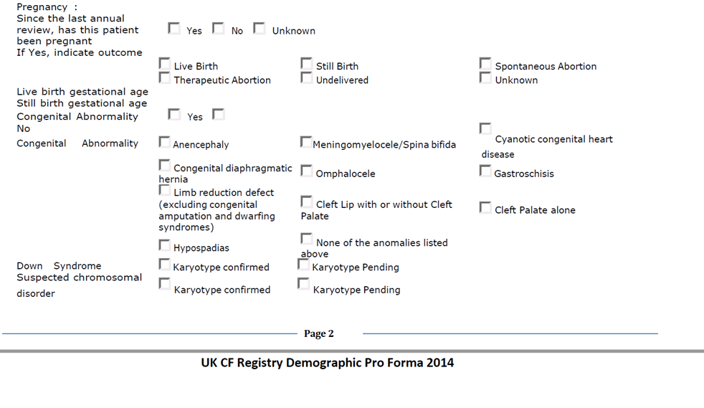
There are potential discrepancies in the way pregnancy related outcomes are counted in the UK CF Registry and England and Wales data. The pregnancy related variables for women with CF included in this study were derived from questions to women at their annual review (pro-forma, shown above). Women are asked if they have been pregnant since their last annual review and are asked to choose from a list of potential outcomes of the pregnancy. As such it was possible for women not to have completed their pregnancy during review and then listing the pregnancy outcome in the following year. Further the date of pregnancy is not recorded. To take account of this, women who were pregnant in two consecutive years with outcome “undelivered” in the former year were counted as a pregnancy case in the former year – but not the latter, while their outcomes were derived in the latter year.
For England and Wales, conception statistics includes records of birth registrations collected under the Births and Deaths Registration Act 1953 and of abortion notifications supplied under the Abortion Act 1967. Similar to our approach, it was possible for conceptions in the current year to result in a maternity or abortion in the following year. The date of conception is estimated by subtracting the gestation period from the baby's date of birth or the date of termination.

RESULTS

Table S1. Number of women of child bearing age (15-44 years), and pregnancy rate in the UK CF Registry in comparison with women in the general population*, 2003-1017

Year | 2003 | 2004 | 2005 | 2006 | 2007 | 2008 | 2009 | 2010 | 2011 | 2012 | 2013 | 2014 | 2015 | 2016 | 2017
CF Women
Genotype | N (%) | N (%) | N (%) | N (%) | N (%) | N (%) | N (%) | N (%) | N (%) | N (%) | N (%) | N (%) | N (%) | N (%) | N (%)
F508_del_1 | 711 (52.5) | 762 (52.4) | 748 (53.2) | 585 (49.7) | 725 (50.9) | 812 (51.5) | 930 (50.6) | 1,008 (50.6) | 1,102 (50.2) | 1,122 (50.2) | 1,144 (50.4) | 1,215 (50.5) | 1,228 (50.3) | 1,230 (49.5) | 1,237 (49.2)
F508_del_2 | 429 (31.7) | 472 (32.5) | 446 (31.7) | 401 (34.1) | 468 (32.9) | 513 (33.1) | 612 (33.9) | 684 (34.3) | 760 (34.6) | 772 (34.5) | 782 (34.4) | 832 (34.6) | 856 (35.1) | 879 (35.4) | 906 (36.1)
G551d | 81 (6.0) | 88 (6.1) | 88 (6.3) | 76 (6.6) | 96 (6.7) | 91 (5.9) | 117 (6.4) | 124 (6.2) | 137 (6.2) | 142 (6.3) | 148 (6.5) | 152 (6.3) | 155 (6.3) | 156 (6.3) | 162 (6.5)
Missing/Other | 134 (9.9) | 132 (9.1) | 124 (8.8) | 114 (9.7) | 134 (9.4) | 136 (8.8) | 148 (8.2) | 177 (8.9) | 196 (8.9) | 201 (9.0) | 197 (8.7) | 206 (8.6) | 202 (8.3) | 220 (8.9) | 208 (8.3)
Total | 1,355 | 1,454 | 1,406 | 1,176 | 1,423 | 1,552 | 1,807 | 1,993 | 2,195 | 2,237 | 2,271 | 2,405 | 2,441 | 2,485 | 2,513
Number of pregnancies | 33 | 53 | 33 | 14 | 41 | 55 | 61 | 57 | 73 | 61 | 48 | 75 | 60 | 82 | 72
Pregnancy rate per 1,000 women years | 24.4 | 36.5 | 23.5 | 11.9 | 28.8 | 35.4 | 33.8 | 28.6 | 33.3 | 27.3 | 21.1 | 31.2 | 24.6 | 33 | 28.7
95% CI | 17.3-34.3 | 27.8-47.7 | 16.7-33.0 | 7.1-20.1 | 21.2-39.1 | 27.2-46.2 | 26.3-43.4 | 22.1-37.1 | 26.4-41.8 | 21.2-35.0 | 15.9-28.0 | 24.9-39.1 | 19.1-31.7 | 26.6-41.0 | 22.7-36.1
Women in general population
Number of pregnancies | 806,810 | 826,809 | 841,831 | 869,961 | 895,867 | 888,607 | 896,466 | 909,245 | 909,109 | 884,748 | 872,849 | 871,038 | 876,934 | 863,106 | 847,204
Pregnancy rate per 1,000 population | 73.5 | 74.9 | 75.5 | 77.5 | 79.4 | 78.6 | 79.3 | 80.5 | 80.4 | 78.5 | 77.8 | 77.8 | 78.3 | 77.3 | 76.1
95%CI | (73.7-73.3) | 52.8-53.0) | (52.8-53.1) | (53.8-54.1) | (54.1-54.3) | (53.6-53.8) | (53.2-53.4) | (53.9-54.1) | (54.5-54.8) | (55.0-55.3) | (56.5-56.8) | (57.4-57.6) | (58.9-59.1) | (59.8-59.9) | (60.4-60.6)
*Conceptions data only published for England and Wales only

Table S2 Pregnancies and live births by child bearing age groups of women with cystic fibrosis in the UK CF Registry, 2003-2017

Category/Age group | 2003-2005 |  |  | 2006-2008 |  | 2009-2011 |  |  | 2012-2014 |  | 2015-2017
Pregnancies* | N | Rate per 1,000 (CI) |  | N | Rate per 1,000 (CI) | N | Rate per 1,000 (CI) |  | N | Rate per 1,000 (CI) | N | Rate per 1,000 (CI)
15-19 | 11 | 7.8 (4.3-14.1) |  | 11 | 8.5 (4.7-15.3) | 21 | 11.8 (7.7-18.1) |  | 20 | 10.7 (6.9-16.6) | 13 | 75 (4.3-12.9)
20-24 | 36 | 31.3 (22.6-43.4) |  | 38 | 32.0 (23.3-44.0) | 39 | 25.3 (18.5-34.6) |  | 40 | 22.8 (16.7-31.1) | 53 | 29.1 (22.2-38.1)
25-29 | 23 | 34.1 (22.7-51.4) |  | 30 | 37.3 (26.1-53.4) | 60 | 51.2 (39.8-66.0) |  | 49 | 36.8 (27.8-48.7) | 56 | 36.5 (28.1-47.4)
30-34 | 17 | 36.9 (22.9-59.4) |  | 18 | 42.0 (26.5-66.7) | 29 | 40.6 (28.2-58.5) |  | 48 | 48.2 (36.4-64.0) | 45 | 39.1 (29.2 -52.3)
35-39 | 13 | 42.3 (24.5-72.8) |  | <5 | - | <15 | - |  | <10 | - | <15 | -
40-44 | 10 | 52.9 (28.5-98.4) |  | <5 | - | <5 | - |  | <5 | - | <5 | -
Total | 110 | 28.4 (23.7-34.0) |  | 103 | 25.6 (21.2-30.8) | 167 | 31.3 (27.2-36.1) |  | 166 | 26.4 (22.9-30.5) | 182 | 28.6 (25.0-32.7)
Live births
15-19 | 7 |  | 5.0 (2.4-10.5) | 8 | 6.2 (3.1-12.3) | 13 | 7.3 (4.2-12.6) |  | 12 | 6.4 (3.6-11.3) | 7 | 4.0 (1.9-8.5)
20-24 | 24 |  | 20.9 (14.0-31.1) | 27 | 22.7 (15.6-33.2) | 31 |  | 20.1 (14.1-28.5) | 34 | 19.4 (13.8-27.1) | 32 | 17.6 (12.4-24.8)
25-29 | 11 |  | 16.3 (9.0-29.0) | 24 | 29.8 (20.0-44.5) | 51 |  | 43.5 (33.1-57.2) | 45 | 33.7 (25.2-45.2) | 41 | 26.7 (19.7-36.3)
30-34 | 7 |  | 15.2 (7.2-31.9) | 12 | 28.0 (15.9-49.3) | 26 |  | 36.4 (24.8-53.5) | 40 | 40.2 (29.5-54.8) | 31 | 26.9 (18.9-38.3)
35-39 | 7 |  | 22.8 (10.9-47.7) | <5 | - | <15 |  | - | <10 | - | <15 | -
40-44 | 6 |  | 31.8 (14.3-70.7) | <5 | - | <5 |  | - | <5 | - | <5 | -
Total | 62 |  | 14.8 (11.6-19.0) | 77 | 17.9 (14.3-22.4) | 137 |  | 22.6(19.1-26.7) | 140 | 20.1 (17.1-23.8) | 123 | 16.5 (13.8-19.7)
Abortions | 12 |  | - | 16 | - | 16 |  | - | 13 | - | 17 | -
Miscarriages | 9 |  | - | 7 | - | 24 |  | - | 18 | - | 32 | -
*Some women had multiple pregnancies and miscarriages are excluded; - Rates not displayed due to deductive disclosure/not applicable for abortions and miscarriages.

Figure S1 Flow chart of study population selection from the UK CF Registry, 2003-2017

Women in the UK CF Registry
1996 – 2017
(n = 6,133)
Women aged 15-44 years
2003-2017
(n=3,831)
Records excluded:
<15 & >44 years - 2,143
Pre-2003 - 159
(n =2,302)
Pregnancies recorded
(n = 1,040)
Records excluded:
Duplicates - 36
Pre-2003 - 186
(n = 222)
Pregnancies included
(n = 818)
Pregnancies with outcomes
(n=773)
Pregnancies with gestational age
(n = 186)

Figure S2. Three yearly age specific live birth rate per 1,000 women years/population of women with CF and women in England and Wales, 2003-2017.

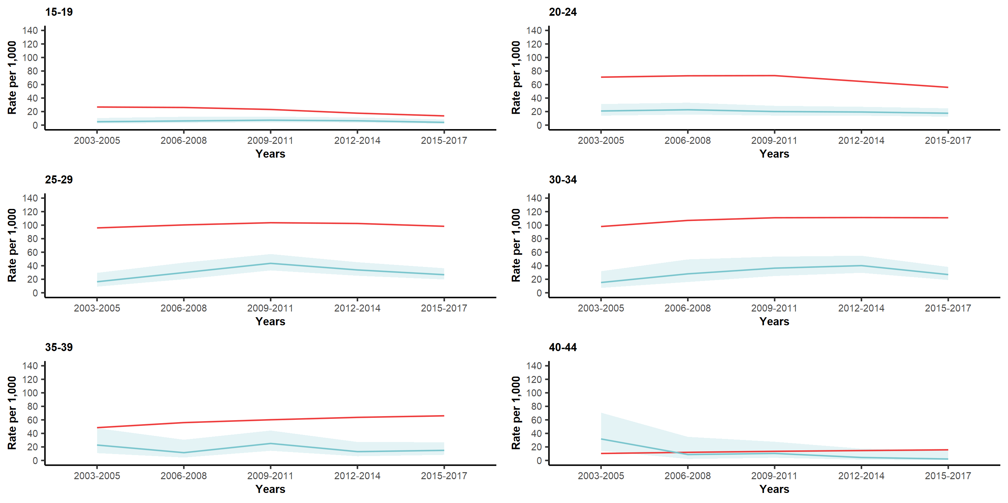

Figure S3a. Scatter plots of %FEV₁/gestational age (weeks) and regression lines in the three years before pregnancy and among women with cystic fibrosis, 2003-2017.

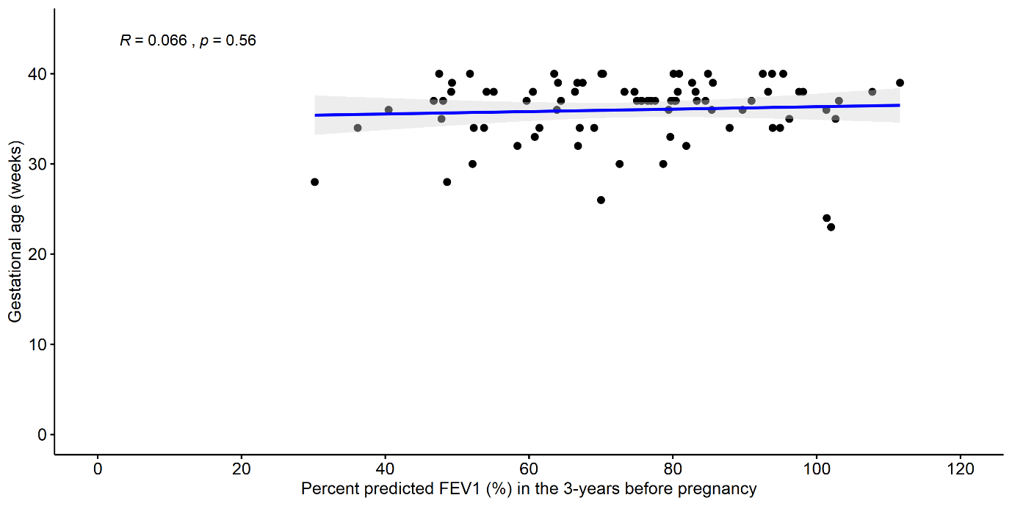

Maternal pre-pregnancy %FEV1 were available for only 76 women (14%). The mean baseline FEV1 was 74.1% predicted (sd=18.2) with a range from 30.2% predicted to 111% predicted

Figure S3b. Scatter plots of BMI/gestational age (weeks) and regression lines in the three years before pregnancy and among women with cystic fibrosis, 2003-2017.

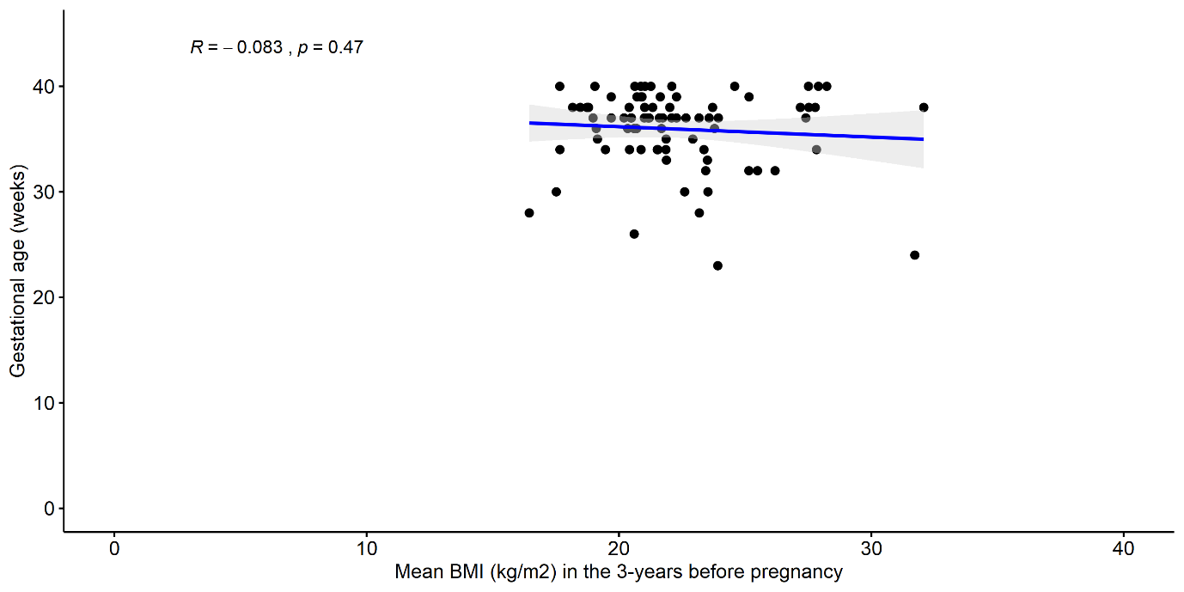

Maternal pre-pregnancy BMI were available for only 76 women (14%). The mean BMI was 22.6 kg/m2 (sd=3.1) with a range of 16.4kg/m2 to 32.1kg/m2.

