EVALUATION OF BIM TOOLS AND ENERPHIT STANDARDS FOR THE ENERGY-EFFICIENT REFURBISHMENT OF HOUSING STOCK IN THE UK
Sinan Celal DADAĞILIOĞLU*, Steve SHARPLES, Haniyeh MOHAMMADPOURKARBASI
University of Liverpool
School of Architecture, Abercromby Square, L69 7ZN, Liverpool, United Kingdom; S.Dadagilioglu@liverpool.ac.uk

Abstract
Globally, the construction industry has been linked to several key environmental issues: increasing energy consumption, resource depletion, and greenhouse gas emissions. Existing buildings make a major contribution to these issues, and this is especially true in the UK, which has the oldest residential building stock amongst developed countries. This, in turn, creates poor building thermal performance. As a sustainable solution for these global issues, there has been an increasing interest in energy-efficient housing refurbishment as a way for the UK to meet its 2050 net-zero targets. Despite awareness in the architectural, engineering and construction (AEC) industry, there has been a low uptake of housing refurbishment among homeowners and housing investors due to strategic ambiguity, cost overruns, and adverse refurbishment outcomes.
Improving new ways of predicting, managing and monitoring the impacts of the built environment, Building Information Modelling (BIM) has considerable potential for building refurbishment projects. One approach to energy-effcient retrofit is EnerPHit, which is the refurbishment version of the Passivhaus standard. This study aims to establish a new conceptual framework for applying BIM tools and the EnerPHit standards to the energy-efficient refurbishment process in the UK housing sector. Besides the benefits from 3D modelling (coordination), further dimensions of BIM implementation – 4D BIM (scheduling), 5D BIM (cost estimating) and its compatible tools for energy analysis – will be discussed for a virtual case study that represents a typical Victorian house in the UK. In this regard, EnerPHit standards will guide the housing refurbishment measures towards the energy efficiency targets considering Passivhaus criteria.
The key findings of the study contribute to the conceptual understanding of the implementation of BIM and EnerPHit assisted process for the energy-efficient housing refurbishment.

Keywords
Refurbishment, Energy Efficiency, BIM, Passivhaus, UK Housing Stock

Introduction
The UK government has formalised a target for net-zero greenhouse gas (GHG) emissions by 2050 [1].The existing building stock is the main contributor to the UK’s energy consumption, and produces 22% of total GHG emissions. However, the annual building-related GHG emission rates are decreasing very gradually to meet the 2050 targets compared to other sectoral trends in the UK (Figure 1) [2]. Energy Performance Certificates (EPC) is a UK government energy efficiency rating system ranging from A (most efficient) to G (least efficient). Out of the 27 million homes in the UK approximately 19 million have EPC ratings below C. Therefore, sustainable building refurbishment must play a crucial role in developing energy efficiency, reducing costs, and mitigating environmental impacts if the UK government is to meet its 2050 target [3]. Despite high energy consumption and GHG emissions in the UK housing stock, there has, historically, been a low demand for housing refurbishment amongst homeowners and housing investors.
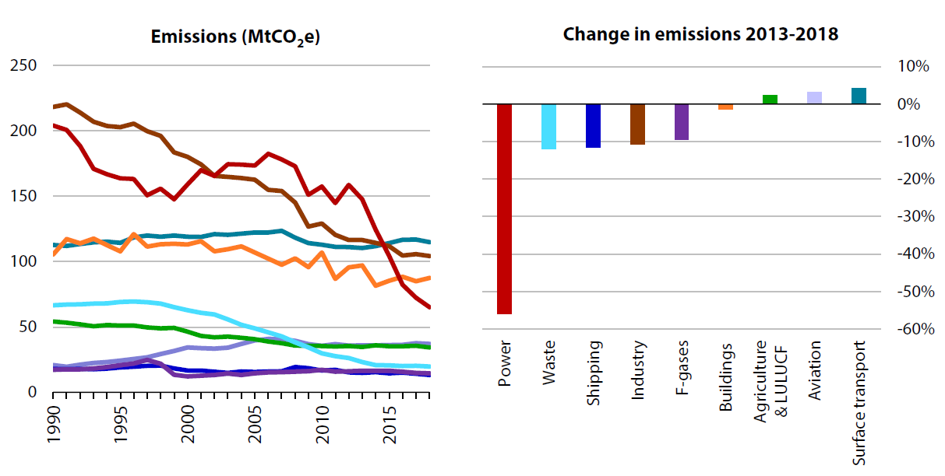
Figure 1. Trends in UK sectoral GHG emissions [2]

Recent literature on building refurbishment has concluded that the conventional retrofit processes lead to ambiguous refurbishment strategies, considerable project delays, cost overruns, extensive efforts, and unsatisfactory refurbishment outcomes to enhance thermal performance by making several alterations to the building envelope and the other components [4,5,6,7]. Some of the main reasons are the fragmented nature of the construction industry and complicated stakeholder requirements. These requirements should be agreed upon to enable the stakeholders to have effective collaboration by utilising new ways of running refurbishment projects [4,8,9,10]. With diverse backgrounds and interests, refurbishment project stakeholders face collaboration issues due to the lack of a common platform for effective teamwork. In addition, the conventional refurbishment process is not adequate for providing a collaborative platform as stakeholders from different disciplines tend to use different design and analysis tools individually [11]. For this reason, dissatisfaction with the refurbishment outcomes is likely for the homeowners due to the silo mentality of the project members to achieve accurate information sharing.
Various researchers have emphasised a holistic approach to sustainable building refurbishment as a new area of interest in the literature [3,12,13,14]. This can be categorised into three main stages:
- Assessment Stage: project setup and data collection
- Method & Strategy Stage: data analysis, strategy formulation, and implementation
- Validation & Verification Stage: post-measurement, post-occupancy survey
This paper focuses on the Method & Strategy stage of a sustainable building refurbishment model.
As a solution to the conventional building refurbishment challenges, several technological means of refurbishment processes – 3D building surveying, BIM, and building energy analysis – can be considered. With these means, it is possible to improve the aforementioned refurbishment stages in consideration of its environmental and economic aspects in the UK housing sector.
With its emerging technologies, innovative tools and collaborative platform, the use of BIM has growing potential for building refurbishment projects, and some considerable benefits of BIM include [15,16,17]:
- To avoid remedial works on refurbishment design
- To provide visual simulations for better coordination
- To optimise refurbishment time
- To reduce the required refurbishment materials
While BIM provides significant benefits in these areas, the German Passivhaus standards – named EnerPHit for building refurbishment – can be considered for energy efficiency in building refurbishment. The Passivhaus standards focus on a high level of occupant comfort while using very little energy for heating and cooling. Some fundamental building physics principles are applied: improved thermal comfort, thermal bridge free, improved airtightness, fresh air with heat recovery, and solar gain [18,19]. With approximately 60,000 Passivhaus-certified buildings, the Passivhaus standards have been rapidly growing low energy buildings not only in the UK but worldwide. Besides, these standards have been an increasing interest of sustainable building refurbishment in terms of energy efficiency [20]. While BIM supports the refurbishment projects with meeting the EnerPHit standards, there is limited research in implementing BIM tools and the EnerPHit standards for the energy-efficient refurbishment in the UK housing stock [9,10,12,14,21].
This paper investigates the semantically modelled refurbishment project of a hypothetical case study using BIM tools and the Passivhaus EnerPHit standards to achieve energy efficiency. In this regard, the proposed case-study methodology will describe how to use the selected BIM tools and EnerPHit standards. After the methodology, the research outcomes will be analysed and evaluated with their pros and cons and, finally, the last section will detail the conclusion of this paper.

Methodology
The main objective of this paper is to evaluate the selected BIM tools and the Passivhaus EnerPHit standards for the energy-efficient refurbishment of a typical UK 19th century Victorian house. To achieve this purpose, the proposed research approach to the methodology focuses on solution-oriented research to provide valid knowledge that helps practitioners solve problems [22]. In this regard, the proposed research design is developed to solve the aforementioned building refurbishment issues (Figure 2). A deep understanding of the reviewed literature plays a central role in defining the problem regarding the conventional refurbishment process. The proposed solution to the defined problems can be the development of the BIM framework. As a holistic approach to energy-efficient housing refurbishment, not only 3D BIM (coordination) but also further dimensions of BIM adoption – 4D BIM (scheduling), 5D BIM (cost estimating) and its compatible tools with the Passivhaus EnerPHit standards – has been considered as an aim of this study. This paper focuses on developing and implementing the solution for the energy-efficient refurbishment of housing stock in the UK.

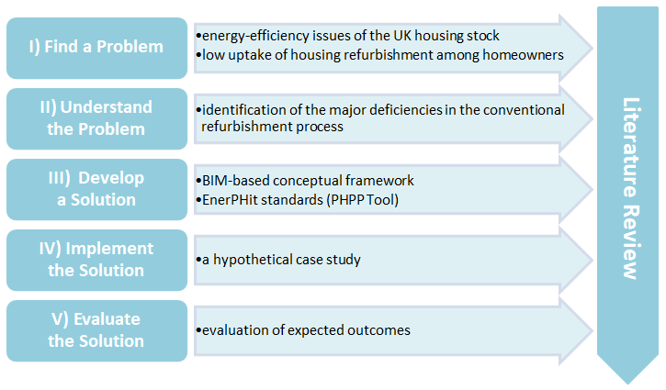
Figure 2. Research Design

The baseline scenario was modelled in ArchiCAD, one of the most convenient and versatile BIM tools used worldwide, with the features of a hypothetical case study representing an terraced 2-storey Victorian house located in Liverpool, UK, which has a temperate maritime climate of cool, wet winters and warm, wet summers The building has only residential use, and has 134m² total treated floor area, 3.2m floor to floor height, 19.7m² total glazing area, and 408m³ net volume. The thermal information of the building envelope is shown in Table 1, and the whole-house refurbishment approach to this building is proposed.

Table 1: Construction details of the hypothetical case study
 | Construction detail | U-value
External Wall | Gypsum board, concrete wall, membrane, cavity, brickwork | 1.65 W/m²K
Ground Floor | Gravel fill, cast concrete, cavity, timber flooring, carpet | 1.35 W/m²K
Window | Single glazed box-sash windows | 4.53 W/m²K
Roof | Stone chipping, bitumen layers, slate tiles | 4.50 W/m²K

Using its geometric and thermal details, the baseline model of the house was created in ArchiCAD - see Figure 3. The potential advantages of BIM in the proposed housing refurbishment model can be categorised as:
- 3D BIM model of the house can be used to better coordinate project stakeholders to avoid remedial works such as clash detection prior to implementing a refurbishment project.
- To simulate and visualise the whole-house refurbishment process in a virtual environment, 4D BIM can be proposed with the aim of developing construction site coordination and time management throughout the building refurbishment process (Annex A).
- With its semantically enriched model, 5D BIM can offer the cost estimation opportunity to the refurbishment project, performing the quantity take-off from the pre-refurbishment to the post-refurbishment processes regarding the chosen Passivhaus-certified building components.

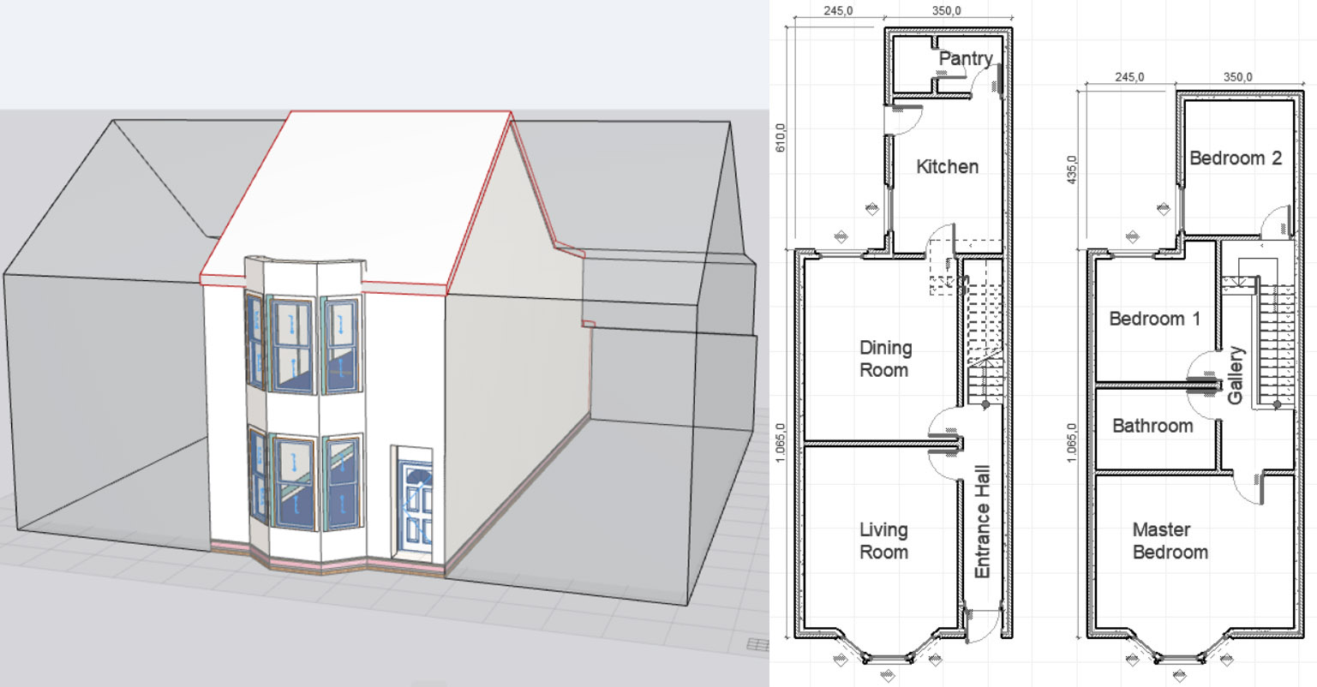
Figure 3. Baseline 3D model and plans

To achieve the Passivhaus EnerPHit standards in the proposed refurbishment model, it is essential to consider the concept of a 'fabric first' approach to introducing the refurbishment measures which focuses on heat retention and airtightness in terms of the material selection in the project. With regards to this, the proposed BIM framework is adapted for a phase-by-phase refurbishment to meet the EnerPHit standards.

Results and Discussion
To systematically evaluate sustainable building refurbishment issues related to the UK housing sector, a BIM-based refurbishment process model was proposed with its theoretical and methodological ideas. As an objective of this study, a semantically enriched BIM model of the chosen hypothetical case study (a typical Victorian house) was created in ArchiCAD. Prior to assembling the whole-house refurbishment framework, a number of essential criteria were considered: 3D coordination, time scheduling, cost estimation, and the building component selection.
The presented baseline BIM model was generated with consideration of the current building envelope characteristics of the house. All appropriate components of the building were defined as different categories and layers in the BIM model: external walls, internal walls, floors, roof, windows, and doors. In this way, the geometric and non-geometric data could be obtained from the model to analyse the current condition of the building and develop highly convenient refurbishment strategies. Furthermore, the generated baseline BIM model can enable the project stakeholders to use a collaborative platform for new material selection among all building components and composite building materials in detail (Figure 4).

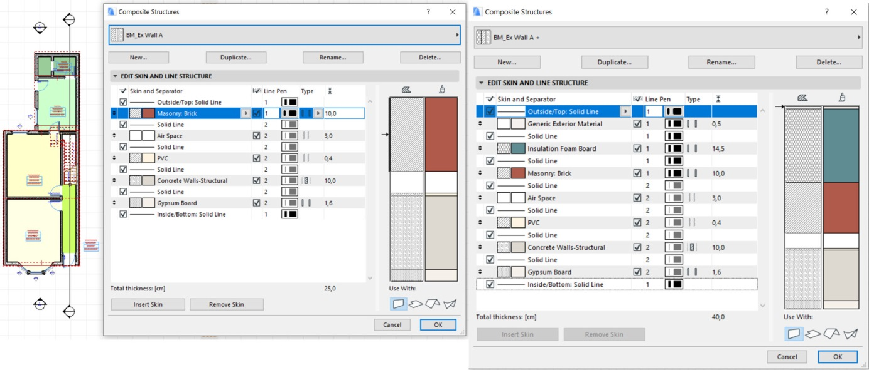
Figure 4. The external wall components before and after the refurbishment project

To organise the implementation process of the Passivhaus EnerPHit standards, the 4D BIM simulation of the refurbishment project was provided, including the definition of the sequences of refurbishment activities. The simulation shows 21-day refurbishment project activities, describing the sequences of external wall, ground floor and roof insulation, windows, doors and ventilation upgrades (Annex A). The external side walls were considered as a different category due to the adjacent buildings providing internal wall insulation. As one of the benefits of the 4D simulation, different construction areas were defined with specific time periods in order to improve time management and avoid overlapping areas throughout the refurbishment project.
To develop the house's base model using BIM tools and the Passivhaus EnerPHit standards, the following building components and insulation materials were implemented phase-by-phase as the main purpose of the proposed refurbishment model - see Table 2.
Table 2: Refurbishment phases, including a summary of U-values (W/m²K) used for each element of the building fabric
Upgrade | Insulation | External Wall  U-value (W/m²K) | Ground Floor  U-value (W/m²K) | Window  U-value (W/m²K) | Roof  U-value (W/m²K)
Base Case | House as-built | 1.65 | 1.35 | 4.53 | 4.50
PH-Phase 1 | EnerPHit wall insulation | 0.23 | 1.35 | 4.53 | 4.50
PH-Phase 2 | EnerPHit floor insulation | 0.23 | 0.24 | 4.53 | 4.50
PH-Phase 3 | Argon-filled double-glazing timber window | 0.23 | 0.24 | 1.23 | 4.50
PH-Phase 4 | EnerPHit roof insulation: Solid (TICS) | 0.23 | 0.24 | 1.23 | 0.14

The generated BIM model offered an opportunity to assess the house for the each of the existing and proposed building components to meet the Passivhaus EnerPHit standards (Annex B). Using these obtained data, the alternative refurbishment scenarios can be measured to achieve the cost estimation stage of the housing refurbishment project.
Overall results of the Passivhaus EnerPHit criteria, which were based on the PHPP calculation, where PHPP is the building energy modelling software for Passivhaus building design, verified the impact on projected energy savings of various insulation (walls, floor, windows, and roof) improvements. Figure 5 shows specific losses and gains heating balance [kWh/(m²month] of the baseline model and proposed refurbishment model calculated with PHPP.
Figure 5 illustrate how refurbishment improvements from the inadequately insulated base case model to the systematically refurbished model achieved the Passivhaus EnerPHit heating demand criteria of less than 25 kWh/m² during the entire year. Based on these results, the Passivhaus-certified building components have a significant role to play in achieving an energy-efficient housing refurbishment project.
The proposed energy-efficient refurbishment model of a typical Victorian house meets the real needs of the UK housing stock as solution-oriented research to provide valid knowledge that helps practitioners and homeowners solve problems. Implementing the BIM-based refurbishment model offered an opportunity for better coordination in building material selection, organisational hierarchy of the refurbishment phases, and collective decision making for the project stakeholders with consideration of the Passivhaus EnerPHit standards. With the use of the Passivhaus-certified building components, this BIM-based approach to housing refurbishment can propose alternative scenarios for homeowners to achieve the EnerPHit criteria in terms of energy efficiency. Although the presented hypothetical case study achieved the heating demand level based on the EnerPHit standards, the thermal performance could be affected by thermal bridging and airtightness issues. In this regard, further research is required to focus on these issues to achieve the Passivhaus EnerPHit criteria ultimately. Experimental research can also be considered to measure the economic feasibility of the proposed model in terms of return on investment in the UK housing stock as a prospective study in the future.

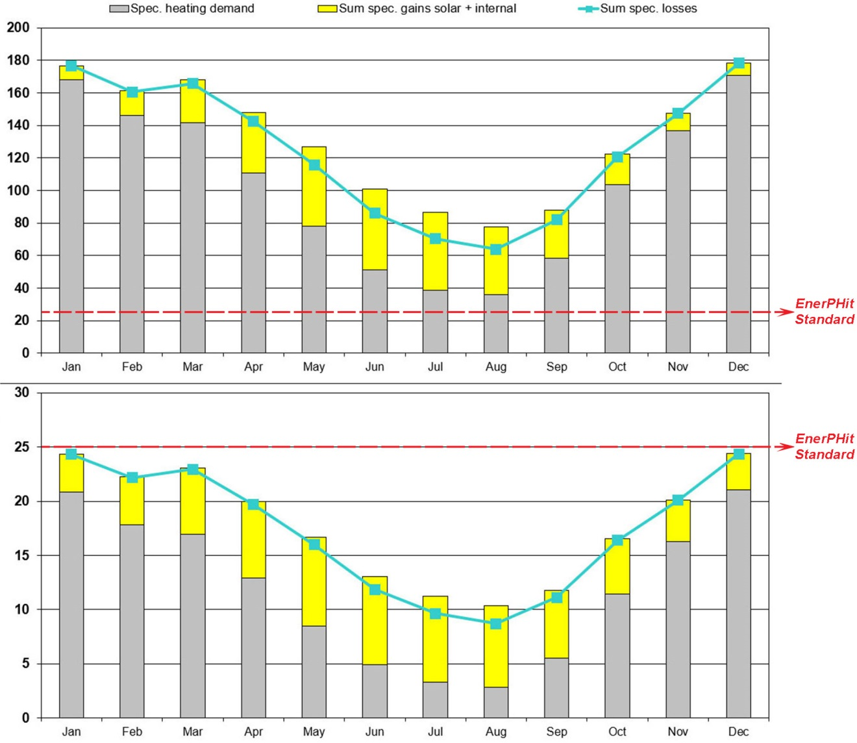
Figure 5. Comparison of specific losses and gains heating balance [kWh/(m²month] of the base case (above) and proposed refurbishment model (below)

Conclusion
This paper has outlined the evaluation of BIM tools and the Passivhaus EnerPHit standards for the energy-efficient refurbishment of the chosen hypothetical case study, which represents a typical Victorian house in the UK. This study considered some of the main reasons for the low uptake for housing refurbishment in the UK and proposed some realistic and effective solutions to the problems of the conventional refurbishment process. The development of the BIM-based model played an integral role to support comprehensive strategies in sustainable housing refurbishment for energy-efficient thermal improvements. The complexity of the conventional building refurbishment process has been addressed through a holistic approach to the solution-oriented research methodology and the correlations between the selected BIM tools and the EnerPHit standards throughout the refurbishment process, which have been established as the purpose of this study. The main finding of this study was that the Passivhaus EnerPHit criteria for energy efficiency could be achieved by implementing the proposed BIM-based housing refurbishment model. The assessment of the presented refurbishment phases shows that the BIM-assisted step-by-step housing refurbishment has considerable potential as an innovative solution to the conventional refurbishment model with utilising its multidimensional benefits for the energy-efficient housing refurbishment in the UK. This paper only focused on the Method & Strategy stage of the sustainable building refurbishment model. Further research, such as the validation & verification stage, will be required to thoroughly investigate and understand the potential outcomes of implementing the BIM and EnerPHit assisted process model for the energy-efficient housing refurbishment.

References
[1] Committee on Climate Change, "Reducing UK emissions: 2018 Progress Report to Parliament - Committee on Climate Change," June 2018: 12/07/2018. TSO, pp. 1–267, 2018, [Online]. Available: www.theccc.org.uk/publications.
[2] Committee on Climate Change, "Reducing UK emissions: 2019 Progress Report to Parliament - Committee on Climate Change," July, pp. 1–93, 2019, [Online]. Available: www.theccc.org.uk/publications.
[3] Y. K. Juan, P. Gao, and J. Wang, "A hybrid decision support system for sustainable office building renovation and energy performance improvement," Energy Build., vol. 42, no. 3, pp. 290–297, 2010, doi: 10.1016/j.enbuild.2009.09.006.
[4] A. Okakpu, A. GhaffarianHoseini, J. Tookey, J. Haar, A. Ghaffarianhoseini, and A. Rehman, "A proposed framework to investigate effective BIM adoption for refurbishment of building projects," Archit. Sci. Rev., vol. 61, no. 6, pp. 467–479, 2018, doi: 10.1080/00038628.2018.1522585.
[5] A. M. Rysanek and R. Choudhary, "Optimum building energy retrofits under technical and economic uncertainty," Energy Build., vol. 57, pp. 324–337, 2013, doi: 10.1016/j.enbuild.2012.10.027.
[6] L. Ustinovichius, V. Popov, J. Cepurnaite, T. Vilutienė, M. Samofalov, and C. Miedziałowski, "BIM-based process management model for building design and refurbishment," Arch. Civ. Mech. Eng., vol. 18, no. 4, pp. 1136–1149, 2018, doi: 10.1016/j.acme.2018.02.004.
[7] C. Wang and Y. K. Cho, "Application of As-built Data in Building Retrofit Decision Making Process," Procedia Eng., vol. 118, pp. 902–908, 2015, doi: 10.1016/j.proeng.2015.08.529.
[8] Y. Arayici, F. Khosrowshahi, A. M. Ponting, and S. Mihindu, "Towards implementation of building information modelling in the construction industry," Fifth Int. Conf. Constr. 21st Century ?Collaboration Integr. Eng. Manag. Technol., pp. 29–34, 2009, doi: 10.13140/2.1.3776.6080.
[9] I. Motawa and K. Carter, "Sustainable BIM-based Evaluation of Buildings," Procedia - Soc. Behav. Sci., vol. 74, pp. 419–428, 2013, doi: 10.1016/j.sbspro.2013.03.015.
[10] K. Park and K. Kim, "Essential BIM Input Data Study for Housing Refurbishment: Homeowners' Preferences in the UK," Buildings, vol. 4, no. 3, pp. 467–487, 2014, doi: 10.3390/buildings4030467.
[11] A. Ghaffarianhoseini et al., "Building Information Modelling (BIM) uptake: Clear benefits, understanding its implementation, risks and challenges," Renew. Sustain. Energy Rev., vol. 75, no. December 2016, pp. 1046–1053, 2017, doi: 10.1016/j.rser.2016.11.083.
[12] Z. Alwan, "BIM performance framework for the maintenance and refurbishment of housing stock," Struct. Surv., vol. 34, no. 3, pp. 242–255, 2016, doi: 10.1108/SS-03-2015-0018.
[13] Z. Ma, P. Cooper, D. Daly, and L. Ledo, "Existing building retrofits: Methodology and state-of-the-art," Energy Build., vol. 55, pp. 889–902, 2012, doi: 10.1016/j.enbuild.2012.08.018.
[14] R. Volk, J. Stengel, and F. Schultmann, "Building Information Modeling (BIM) for existing buildings - Literature review and future needs," Autom. Constr., vol. 38, pp. 109–127, 2014, doi: 10.1016/j.autcon.2013.10.023.
[15] S. S. S. Gardezi, N. Shafiq, M. F. Nurudinn, S. A. Farhan, and U. A. Umar, "Challenges for Implementation of Building Information Modeling (BIM) in Malaysian Construction Industry," Appl. Mech. Mater., vol. 567, no. June, pp. 559–564, 2014, doi: 10.4028/www.scientific.net/AMM.567.559.
[16] E. Gholami, S. Sharples, and J. A. Shokooh, "Exploiting BIM in Energy Efficient Refurbishment : A paradigm of future opportunities," PLEA 2013: Sustainable Architecture for a Renewable Future, vol. 2, no. September. 2013, [Online]. Available: https://researchportal.port.ac.uk/portal/files/2564792/Exploiting_BIM_in_energy_efficient_refurbishment_A_paradigm_of_future_opportunities.pdf.
[17] D. Ilter and E. Ergen, "BIM for building refurbishment and maintenance: current status and research directions," Struct. Surv., vol. 33, no. 3, pp. 228–256, 2015, doi: 10.1108/SS-02-2015-0008.
[18] “What is Passivhaus?,” 2021. https://www.passivhaustrust.org.uk/what_is_passivhaus.php (accessed Jun. 18, 2021).
[19] S. Lewis, A PHPP illustrated. A Designer's companion to the Passive House Planning Package. RIBA Publishing, 2014.
[20] "Passive House Database, Examples," 2018. https://passipedia.org/examples (accessed Jun. 20, 2021).
[21] Y. Arayici, P. Coates, L. Koskela, M. Kagioglou, C. Usher, and K. O'Reilly, "BIM adoption and implementation for architectural practices," Struct. Surv., vol. 29, no. 1, pp. 7–25, 2011, doi: 10.1108/02630801111118377.
[22] M. Saunders, P. Lewis, and A. Thornhill, Research methods for business students. Pearson Education Limited, 2016.

ANNEX A – 4D BIM simulation of the project

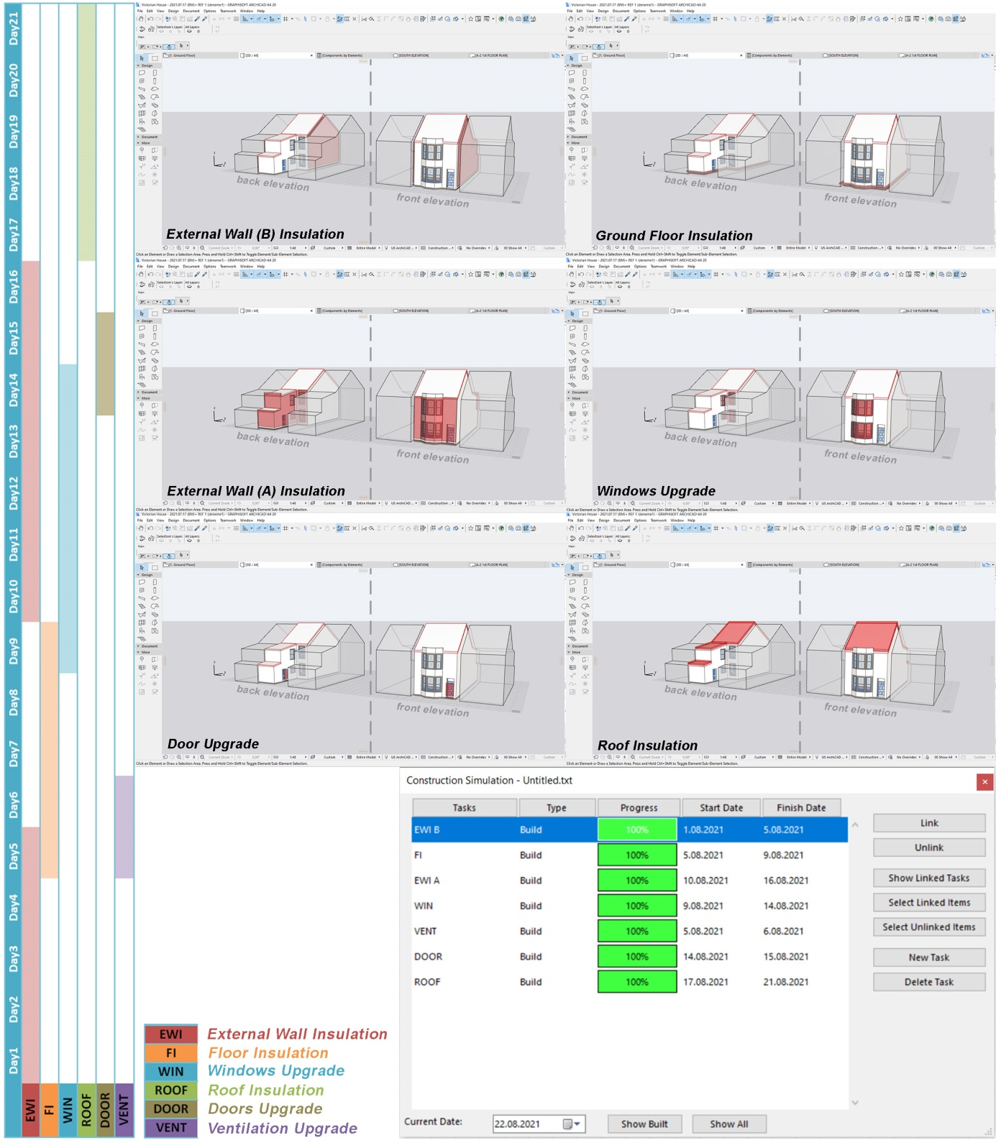

ANNEX B – BIM Model Component Lists (Pre-refurbishment)

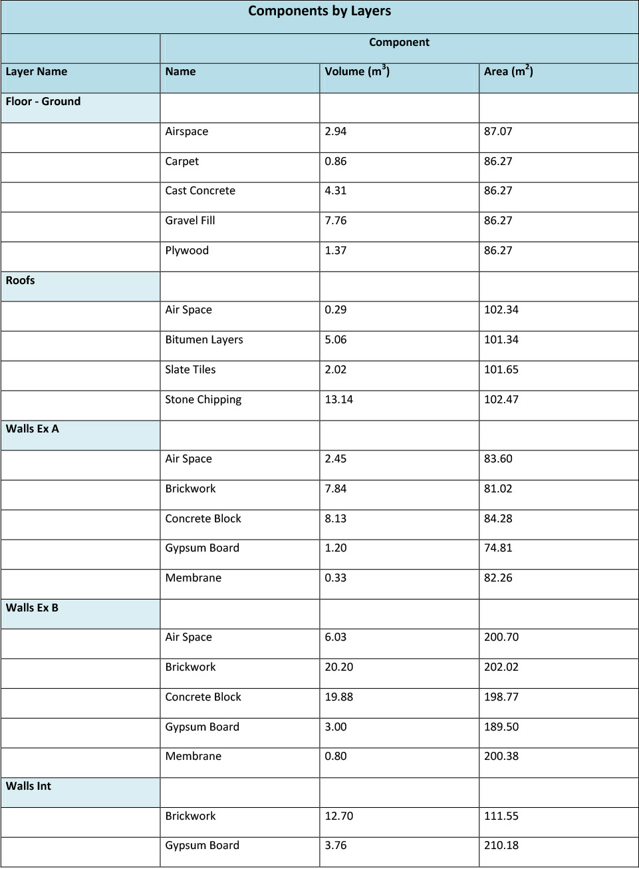

ANNEX B – BIM Model Component Lists (Post-refurbishment)

