Size-independent global elongation and high shape flexibility as an evolutionary hypothesis of accommodating mammalian brains into skulls

Abstract
Little is known about how the large brains of mammals are accommodated into the dazzling diversity of their skulls. It has been suggested that brain shape is influenced by relative brain size, that it evolves or develops according to extrinsic and intrinsic mechanical constraints, and that its shape can provide insights into its proportions and function. We assess this by analysing 84 marsupial cranial endocasts of 57 species including fossils, using 3D geometric morphometrics and virtual dissections. Principal Components Analysis revealed over half of endocast shape variation on a spectrum of elongate, straight to globular, inclined. PGLS analysis revealed little allometry of absolute, and none of relative, endocast volume, and no association between locomotion and endocast shape. There is also limited correspondence between endocast variation, brain region volumes, and previously published neocortical/isotocortical volumes, although extinct species tend to have smaller cerebral hemispheres. Close relatives and conspecifics can have divergent endocast shapes, and our sample contains diverse endocast morphologies superimposed over the main shape variation. An evolutionarily and individually malleable brain with a fundamental tendency to arrange into a spectrum of elongate-to-globular shapes – possibly containing little functional information - may therefore explain the accommodation of brains within the enormous diversity of mammalian skull form.
Keywords: Brain, Justification for the use of a congeneric cortex measurement:
marsupials, allometry, spatial packing, encephalisation, neocortex
Background
The origin of mammals is demarcated by two key innovations – the evolution of a large brain (Rowe et al. 2011) and a fundamental reorganisation of the skull and particularly the endocranial cavity housing the brain (Maier 1993; Koyabu et al. 2014). Fitting the brain into the evolving skull with its diverse functions requires tight evolutionary and developmental integration between the two (Hanken and Thorogood 1993; Richtsmeier and Flaherty 2013). However, the evolution of this relationship – which can be characterised through studies of the endocranial cavity, or “endocast” (Jerison 1973; Macrini et al. 2007a) - is little understood on larger evolutionary scales, with most research focused on the large-brained primates, including humans (Bienvenu et al. 2011; Aristide et al. 2016; Zollikofer et al. 2017) or experimental rodent models (Lieberman et al. 2008; Nieman et al. 2012), and focused on the understanding of the exceedingly large human brain.
The most widely discussed hypotheses of primate shape evolution focus on allometry (change with size) either related to absolute or relative brain sizes. For example, the “spatial packing” hypothesis posits that relatively larger brains can evolve to be flexed at the base and rounded, because this packs the brain most efficiently into a limited space (Biegert 1957; Lieberman et al. 2008; Bastir et al. 2011; Zollikofer et al. 2017). This “spatial packing” hypothesis explains the co-evolution of the mammalian brain and cranial base in primates (Gould 1977; Ross and Ravosa 1993; Ross and Henneberg 1995; Bastir et al. 2011) and mouse strains (Lieberman et al. 2008). Allometry of absolute brain size (rather than relative brain size) also impacts primate brain shape, probably differentially in different clades (Aristide et al. 2016; Sansalone et al. 2020). However, beyond primates, there are multiple hypotheses of how the brain is shaped, involving different levels of organisation. For example, the growing mammalian brain appears to adapt to endocranial shape changes (Jeffery and Spoor 2006; Macrini et al. 2007c; Budday et al. 2015); physical internal constraints of neuronal connectivity determine the shape at least of the neocortex (Atkinson et al. 2015; Mota and Herculano-Houzel 2015); and pleiotropic genetic effects appear to shape both cranial vault and brain and may limit the availability of endocast shapes to selection (Hanken and Thorogood 1993; Koyabu et al. 2014). Lastly, individual brains can grow and shrink substantially in the lifetime of an individual, expanding the osseous braincase (Dechmann et al. 2017), but there is also evolutionary (Koyabu et al. 2014) and developmental (Nieman et al. 2012; Richtsmeier and Flaherty 2013) evidence that the dorsal cranial vault adapts to increases in brain size, not vice versa.
Characterizing the patterns of mammalian brain shape evolution represents a necessary first step in unravelling the complex intrinsic and extrinsic determinants of mammalian brain shape and development. Metatherian mammals (marsupials and their closest extinct relatives) are an ideal study group for this: they are an old (> 110 million years (Eldridge et al. 2019)), monophyletic, phylogenetically well-understood radiation of mammals and occupy all terrestrial ecological niches except for active flight. Body masses of living marsupials span three orders of magnitude (2.6 g up to 85 kg (Weisbecker et al. 2019), with extinct representatives weighing up to 2.7 tonnes (Wroe et al. 2004)), making them particularly well-suited to resolve current debates on whether brain size and brain shape are correlated (Aristide et al. 2016; Zollikofer et al. 2017). In addition, the development of living marsupials and placentals differs considerably: marsupials are born at highly altricial stages compared to placentals, with a uniformly short (maximum of 30 day) pregnancy and a uniform three-phase lactation period (Hinds 1988), in which the milk composition is tailored to the requirements of the pouch young. Marsupial brain development occurs nearly entirely ex utero during lactation (Smith 1997). However, this reproductive difference is not reflected in systematic differences in brain structure, except that marsupials lack a corpus callosum (Ashwell 2010) and may have different scaling of isocortical white matter (Jyothilakshmi et al. 2020), relative brain size (Weisbecker and Goswami 2010), or neuronal scaling (Dos Santos et al. 2017). However, because reproductive traits relating to the maternal investment are an important influence on brain growth (e.g. Bennett and Harvey 1985; Barton and Capellini 2011), the uniformity of marsupial reproduction provides an additional argument for this clade to be a test case for mammalian brain evolution (Pirlot 1981; Weisbecker and Goswami 2010, 2011b; Weisbecker et al. 2015).
Here we use geometric morphometrics to analyse three-dimensional endocranial shape in a sample of 57 marsupial species across all major clades, including 12 extinct species. We aim to determine if a common pattern of shape variation emerges in marsupials, and whether suggestions for allometric patterning of endocast shape, posited for primates, can be generalised to marsupials and could generally explain mammalian brain shape evolution. We also assess how brain shape corresponds with locomotor function (Ahrens 2014; Bertrand et al. 2019b) and phylogeny scales (e.g. Silcox et al. 2009; Thiery and Ducrocq 2015; Bertrand et al. 2016; Bertrand et al. 2019b). To further understand if brain shape is indicative of internal brain structure, we also use volume dissections of our endocasts and a limited dataset of neocortical and isocortical grey matter volumes (noting that iso-and neocortex largely refer to the same structure; Palomero-Gallagher and Zilles 2015) to assess the degree to which brain partition volumes and brain shape correspond in a large, phylogenetically diverse mammalian radiation.

Methods
Specimens
This study is based on endocasts, which have been shown to be a good approximation of brain shape for mammals and marsupials in particular (Jerison 1973; Macrini et al. 2007a). Virtual reconstructions of endocasts from conventional and µCT scans from adult skulls of 57 marsupial species were prepared in Materialise Mimics (v.17-20) through virtually “flood-filling” the endocranial cavity of specimens, mostly by two operators, with some help from technical staff. The list of specimens with their museum numbers is available in the main data file used in this analysis (Supplementary information 1). Multiple specimens, where possible including males and females, were also sourced for 19 species to assess how representative a single endocast is of a species. Scans of extant species were conducted at either the University of Texas High-Resolution X-ray Computed Tomography Facility (Austin, Texas, USA), a SkyScan 1074 at the University of Queensland (School of Biological Sciences), or a Siemens Inveon Pet-CT scanner at the UQ Centre of Advanced Imaging at the University of Queensland (Australia). To allow easy manipulation of large scans, these were cropped to just the brain case and/or subsampled by either using every second slice only and/or reducing the resolution of each slice in ImageJ (Schneider et al. 2012). All but three endocasts were derived from museum specimens (for accession numbers, see Supplementary Information 1). The study also used post-mortem CT scans of one captive dunnart (Sminthopsis macroura), and two captive koalas (Phascolarctos cinereus), whose deaths were unrelated to this study. The S. macroura specimen was obtained in 2008 from Melbourne University under Animal Ethics MAEC (Vic) License No. 06118 and it was scanned under University of Queensland permit ANRFA/SBS/531/12. The koalas were scanned under University of Queensland permit SVS/405/12. CT scans of twelve fossils were also included (for museum accession numbers, see Supplementary Information 1). Note that the Tasmanian tiger (Thylacinus cynocephalus), which went extinct in 1936, is here assigned “extant” status because of its very recent extinction. The small areas of incomplete surfaces at the rear of the cerebellum were virtually repaired in Dromiciops gliroides and Petaurus australis. This involved the scaling and manual fitting of similarly curved cerebral surfaces to complete the missing surface. Caenolestes fuliginosus was scanned in two sessions so that two scans were reconstructed and the resulting two endocasts were retrospectively fit together, using the global registration tool in Mimics.
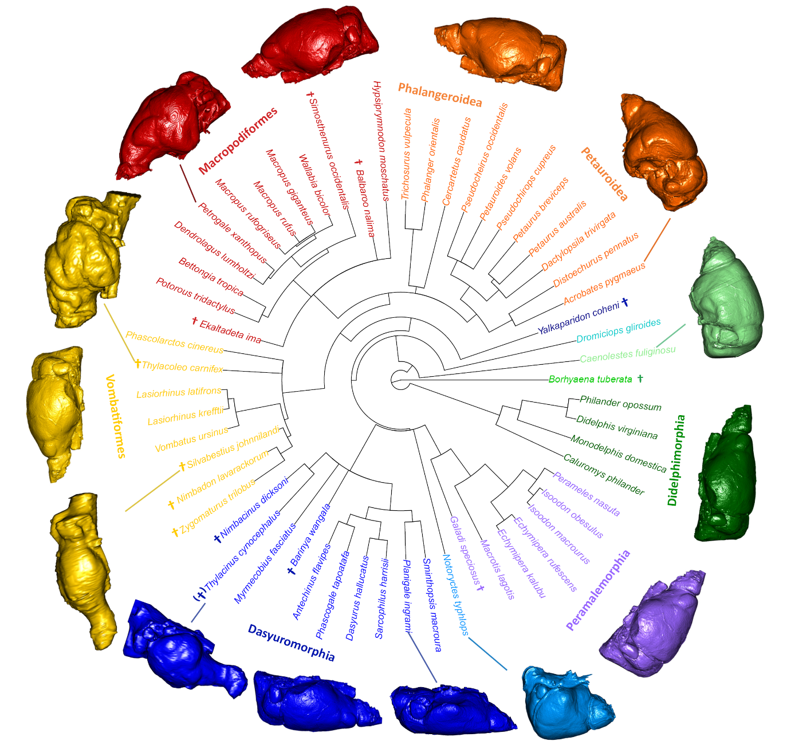
Figure 1: A summary of the species and one of the three phylogenies used, with the “main clade” designations and their colour scheme used throughout the figures of this study. Crosses next to species names denote extinct species. Brain shapes reflect the mean shapes for each clade, as well as notable brain shapes of individual species (connected to their species name by lines) to highlight the diversity of the shapes.

Brain shape and protocol comparisons
All analyses and results, except for manual landmarking procedures, were conducted in the R statistical environment (R core team 2018) and can be replicated with our code on github, which also contains all the data required to run the analyses (LINK REMOVED FOR DOUBLE BLIND REVIEW, BUT SEE ANONYMIZED CODE SUBMITTED). The landmarking of brains represents a challenge because the cerebral hemispheres have large areas with few landmarkable homologous features. This was exacerbated due to varying scan resolutions, and the high diversity of brain shapes within our sample, so that landmark repeatability was expected to be an issue (Pereira-Pedro and Bruner 2018). To capture brain shape effectively, and test the repeatability of our dataset, one of us (maybe give initials here?) therefore landmarked each endocast twice and trialled two different protocols for surface landmark placement. This included a fully manual protocol using only the Checkpoint programme (Wiley 2015). The other protocol used the Checkpoint software (Wiley 2015) for fixed and curve semilandmarks, and automatic placement of surface semilandmarks using Morpho (for landmarking protocols, see Supplementary Information 2). The performance and similarity of these were tested in several ways. To compare the repeatability of the two replicates for each protocol, a Procrustes analysis of variance (ANOVA) was conducted to test for differences between the two replicates for each protocol. To test the correspondence between the morphospace of the two protocols, the distribution of species in multi-dimensional PC space was compared between principal components analyses (PCA) of shape, using a Mantel test in the Vegan R package v. 2.5-6 (Oksanen et al. 2016). In addition, a plot of the Principal Component (PC)1/PC2 morphospaces for each protocol, as well as plots of the shape variation inferred for PC1, were produced for visual comparison.

Brain partitions and additional neo/isocortex data
The endocasts were virtually “dissected” into four partitions representing the cerebrum, olfactory bulbs, cerebellum, and brain stem (the protocol for how the boundaries were defined is in Supplementary information 2). The volumes of dissected partitions were measured using Mimics (versions 17-20) and averaged per species in R if multiple specimens per species were available. Such partitions are only approximate representations of brain regions because they do not allow for internal brain boundaries. However, this method has been successfully used as a general indicator of overall brain proportions (Sakai et al. 2016; Sakai et al. 2018; Bertrand et al. 2019a) and is used with this caveat here. Log-shape ratios of the partition volumes were calculated to adjust for scaling (Mosimann 1970). This was done by deriving the logarithm of the value obtained by dividing each partition volume by the geometric mean of all volumes for a specimen. The geometric mean is equivalent to the centroid size derived from landmark coordinates during Procrustes superimposition, so that the derivation of the log shape ratio mirrors the size-adjustment of shape during Procrustes superimposition.
Because the neocortex comprises a large part of overall volume of the marsupial brain (Pirlot 1981) and mammalian cerebral hemispheres (Jerison 2012), we also endeavoured to assess if any of the endocast shape or cerebral hemisphere volume variation in our sample was suggestive of neocorticalisation – where some marsupials, particularly diprotodontians (Pirlot 1981) or extinct mammals in general (Jerison 2012) have relatively larger neocortices than others. While a confident dissection of the neocortical portion of the cerebral hemispheres was not possible, we matched data from two publications with a sample that was overlapping ours. We therefore computed the log-shape ratios of neocortex volumes from Pirlot (1981) for 17 species of marsupials, including Didelphimorphia, Dasyuromorphia, Peramelemorphia and Diprotodontia; and isocortex grey matter volumes for 19 Diprotodontia from Jyothilakshmi et al. (2020). These log-shape ratios were based on the larger datasets of brain region volumes that the neo/isocortical volume data were part of (for the full datasets from these publications, refer to LINK REMOVED FOR DOUBLE BLIND REVIEW, BUT SEE ANONYMIZED CODE SUBMITTED. In one case for Pirlot (1981) and five cases for Jyothilakshmi et al. (2020), a species in our dataset was matched with a value from a congeneric species of a similar body weight (noted in the supplementary information 1).

Availability of surface files
All endocasts used for endocast dissections and ply files used for automatic landmark placements are available on Figshare. [NB: these are links and will be released as DOIs upon acceptance]

Phylogeny, body mass, and locomotion
The details on tree estimation are in Supplementary information 2; the tree files are part of the raw data folder on this study’s github repository. For all phylogenetic analyses, three placements for the extinct Yalkaparidon, whose phylogenetic affinities are uncertain (Beck et al. 2014), were tested and results were averaged. Figure 1 displays one of these phylogenies. All polytomies were considered as soft polytomies, and randomly resolved to zero branch lengths using the multi2di function from the ape package v. 5.0 (Paradis et al. 2004) in R. In all phylogenetically informed analyses in this paper, the use of different trees had minimal impact on test statistics and no impact on significance levels, and thus an average of the test statistics from the three trees is presented here.
Body mass estimates for extant species were mostly taken from Weisbecker et al. (2013). Body masses for extinct species were derived from multiple publications as outlined in supplementary data 1 (Wroe et al. 1999; Argot 2003; Turney et al. 2008; Travouillon et al. 2009; Black et al. 2012; Sharp 2016)
The locomotor mode for Australian species (entered into the main data file in supplementary information 1) was taken from Weisbecker et al. (2019) and for American species was taken from Nowak (2018). Note that the locomotion of the tree kangaroo Dendrolagus lumholtzi was scored as “hopping”, because this is the main locomotor mode of the species despite the fact that it lives in trees.

Shape analyses
Landmark coordinates were subjected to a generalized Procrustes superimposition and projection into tangent space (Rohlf and Slice 1990) using the R package geomorph v.3.2.1 (Adams et al. 2020). The semilandmarks identified as curves were permitted to slide along their tangent directions in order to minimize Procrustes distance between specimens (Gunz et al. 2005); semilandmarks placed as patches were allowed to slide in any direction on two planes. The resulting Procrustes shape coordinates were averaged over the two replicates per specimen. We then performed a second Procrustes fit on the averaged shape coordinates to account for object symmetry (Klingenberg et al. 2002). Only the symmetric component of shape was used as shape variables in the subsequent analyses.

Principal Component Analysis
We used PCA of species-averaged shape variables to investigate whether variation was restricted to one main axis of brain shape variation, or whether variation was diffuse across several PC axes. To visualize the distribution of species across the main variation of shape within the dataset, PCs explaining more than 10% of variation were plotted. We estimated the amount of PC1 variation relating to allometry by computing a phylogenetic generalized least squares (PGLS) analysis of PC1 scores and centroid sizes (note that we used the procD.pgls algorithm of geomorph throughout for bivariate analyses to match its use in all PGLS analyses of shape (Adams 2014b)). To visualise the shape variation associated with each of these PC axes, we used a surface warping approach (Sherratt et al. 2014) whereby an average-shaped triangular mesh is warped to the shape at the minima and maxima of each PC axis using thin-plate spline. The average-shaped mesh was created by warping a species’ endocast whose shape was close to the mean shape (Phascogale tapoatafa JM12395) to the mean shape of landmark coordinates. To aid interpretation of the surface warps, we also produced landmark displacement graphs depicting the direction and magnitude of shape change vectors of each landmark from the mean shape to the PC minima and maxima.

Phylogenetic signal
To understand the amount of brain shape variation that can be explained by phylogenetic relatedness, we computed K_{mult}, an adaptation of Blomberg’s K that identifies phylogenetic signal in a multivariate context (Adams 2014a). K_{mult} was computed for brain shape, centroid size, and brain region volume log shape ratios (explained below) in order to test the degree to which variation in brain shape, size and volumetric proportions correspond to Brownian-motion evolutionary processes. To illustrate the mean shapes for each clade, we warped the mean shape mesh to the mean shapes of each clade.

Allometry and locomotor mode analyses
We assessed evolutionary allometry of brain shape through PGLS models. Statistical assessment was done by permutation, using 1000 iterations for each model. We considered centroid size (highly-correlated with, and thus here considered equivalent to, endocast volume; R²=0.97) and body mass (the conventional measure of allometry; for body mass references for each species, refer to Supplementary Information 1) as proxies of size. We also analysed a measure of relative brain size, which we produced by obtaining the residuals of a linear regression of log centroid size against log body mass, which in our sample represents a good approximation of slopes found within marsupials (Weisbecker and Goswami 2011a). To visualise how brain shape is predicted by size, we calculated the regression score (Drake and Klingenberg 2008), which is a univariate summary of the direction of the regression vector, and produced a landmark displacement graph of brain shape at small and large brain sizes.
To assess if locomotor mode was associated with endocast shape, we also used PGLS, and included analyses for the possibility that this relationship might be influenced by an interaction between locomotion and size, or differences in shape means according to locomotor mode and size.

Intraspecific variation
To understand how the between-species brain shape variation relates to variation within species, we conducted a PCA of all specimens, without averaging of multiple specimens per species. To additionally assess whether that within-species diversity of endocast shapes might have an important impact on the results of our previous between-species analyses, we also plotted the frequency distributions of the overall Procrustes distance of shapes within species and between species.

Volume analyses, comparisons with shape, and association with neocortex volume
For an estimate of how well partition volumes and shapes correspond, the distribution of species in multi-dimensional PC space between the shape vs. volume PCA was computed using a Mantel test in the Vegan package (Oksanen et al. 2016) in R. We also computed phylogenetic signal (K_{mult}) and evolutionary allometry of brain partition volumes for comparison with K_{mult} of shape variation for further comparisons. Lastly, we assessed if there was any association between shape, cerebral volume, and the literature-derived neocortical/isocortical data (explained above), which might be the case if changes in the relative size of the neocortex are reflected in changes in the relative size of cerebral hemisphere volume. Such an association would suggest that brain shape or volume can be used as an indicator of neocorticalisation, where the neocortical part of the cerebrum expands disproportionately (Jerison 2012; Bertrand et al. 2019a). These analyses were done by PGLS of the association between cerebral log-shape ratio and PC2 and neocortex/isocortex grey matter volumes, using the procD.pgls function of geomorph for consistency with the shape analyses.

Results
Brain shape and protocol comparisons
We trialled manual and automated placement protocols for surface semilandmarks. These performed nearly equally well on several analyses: in the Procrustes ANOVA comparing replicates, the automated protocol had slightly higher repeatability (0.91 with manual vs. 0.92 with automated placement). The Mantel test of PC score matrices revealed a very similar arrangement of species in PC space (matrix correlation = 0.97), and shape variation along PC1 was near-identical as well (Supporting Information 3). Due to the slightly higher repeatability of the automated placement, we present the results from this protocol; however, all analyses can be re-run using the manual protocol in our github code, with near-identical results.

Principal components analysis
The main variation in endocast shape is heavily concentrated on PC1 (Fig. 2), accounting for more than half (56%) of overall brain shape, with PC2 accounting for an additional 12%; the subsequent PCs explain 7% or less of the overall variation and are not considered here.
The shape variation along PC1 is almost entirely related to anteroposterior stretching/compression that results in cylindrical, slender shapes at low scores, and shorter, wider and deeper (and hence more compact and rounded) shapes at high scores (Fig. 2; landmark displacement graphs in supporting Information 4). Thus, more “stretched” brain shapes at low PC1 scores have longer, narrower olfactory bulbs, cerebra, cerebella, and brain stems. High-PC1 brains also tend to have steeper inclines of the ventral cerebral hemispheres relative to the brain base (Fig. 1, see also movie in Supporting Information 4 and landmark displacement graphs in Supporting Information 5). PGLS of PC1 and log centroid size showed that only 12% of PC1 is explained by centroid size (Table 1).
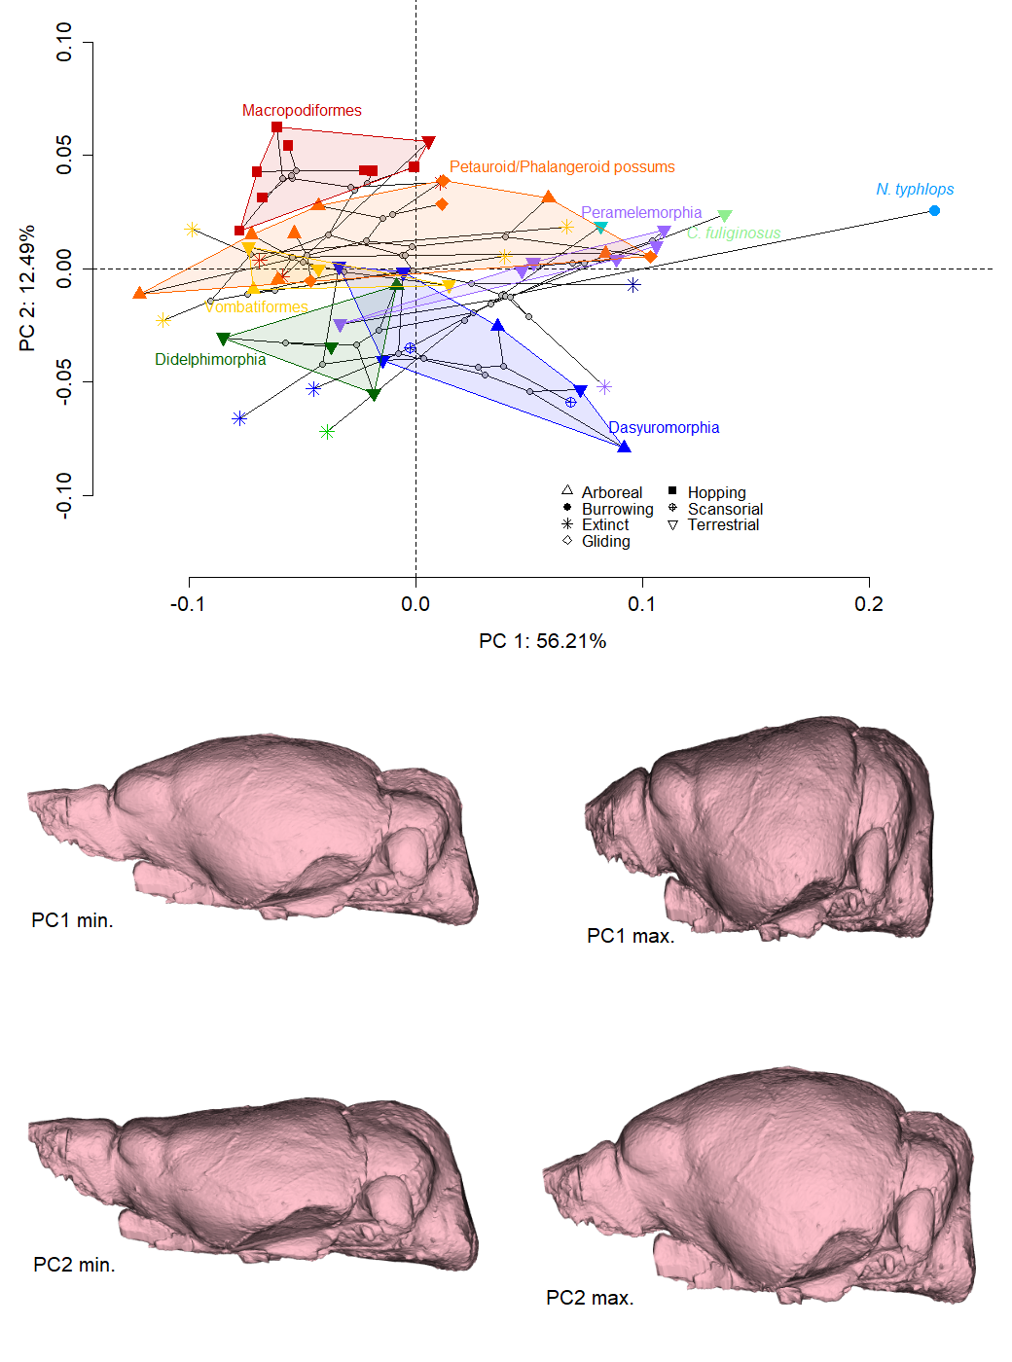
Figure 2: Principal components analysis of brain shape in marsupials (top) and corresponding shape variation from highest to lowest PC1 and 2 scores (bottom). Polygons are drawn around living members of all major clades. Triangles represent extinct species
Dependent variable | Predictor | Df | F | R² | p
 | Allometry
PC1 | Log Centroid size | 56 | 7.186 | 0.12 | 0.02*
Shape | Log Centroid size | 56 | 4.267 | 0.07 | 0.011*
Shape | Log Body Mass | 56 | 3.84 | 0.07 | 0.017*
Shape | Residuals of log brain/log body mass regression | 56 | 2.408 | 0.04 | 0.051.
Shape without vombatiforms and peramelemorphs | Log centroid size without vombatiforms (n=8) and peramalemorphs (n=7) | 41 | 7.91 | 0.17 | 0.001
Shape without vombatiforms and peramalemorphs | Log body mass without vombatiforms and peramalemorphs | 41 | 6.768 | 0.14 | 0.001
 | Locomotion
Shape | Interaction between locomotor modes (see caption) and centroid size | 36 | 0.894 | 0.050 | 0.577
Shape | All locomotor modes (see caption) with centroid size as covariate | 39 | 1.055 | 0.08 | 0.39
Shape | All locomotor modes | 44 | 1.445 | 0.13 | 0.102
Shape of diprotodontians | Hopping (n=8)/nonhopping (n=16) | 23 | 0.285 | 0.01 | 0.971
Shape of diprotodontians | Gliding (n=4)/nongliding (n=20) | 23 | 1.433 | 0.06 | 0.209
 | Brain and Neocortex /Isocortex grey matter vol.s
Brain region vol. log-shape ratio (LSR) | Log geometric mean | 56 | 2.383 | 0.04 | 0.086
Brain region vol. LSR | Log body mass | 56 | 1.794 | 0.03 | 0.161
Shape | Cerebral vol. LSR | 56 | 4.606 | 0.08 | 0.003**
PC2 scores | Cerebral vol. LSR | 56 | 11.779 | 0.18 | 0.003**
PC2 scores | Extant (n=45 vs. extinct (n=12) | 56 | 12.476 | 0.18 | 0.003**
Cerebral LSR | Extant vs. extinct | 56 | 13.07 | 0.19 | 0.001**
PC2 scores | Diprotodontians (n=31) vs. others (26) | 56 | 0.827 | 0.01 | 0.361
Cerebral LSR | Diprotodontians vs. others | 56 | 1.563 | 0.03 | 0.209
Shape | Isoc. grey matter vol. LSR | 18 | 0.578 | 0.03 | 0.672
Cerebral LSR | Isoc. grey matter vol. LSR | 18 | 3.99 | 0.19 | 0.053.
PC2 scores | Isoc. grey matter vol. LSR | 18 | 1.101 | 0.06 | 0.317
Shape scores | Neoc. vol. LSR | 16 | 1.532 | 0.09 | 0.174
Cerebral LSR | Neoc. vol. LSR | 16 | 5.72 | 0.28 | 0.028*
PC2 scores | Neoc. vol. LSR | 16 | 2.911 | 0.16 | 0.108

Table 1: Summary table of all PGLS analyses conducted in this study. Df, degrees of freedom; F, F-value of effect size; R², R-squared value; p, probability of no effect. Sample sizes for factorial categories are noted in the predictor column, except for locomotor modes which were arboreal (n=11+2 scansorial species); terrestrial (n=19); gliding (n=4); hopping (n=8).

We also ascertained that the shape variation along PC1 is not driven by two extremely round-brained outliers, namely the notoryctimorphian Notoryctes typhlops (the highly derived marsupial mole) and the paucituberculatan Caenolestes fuliginosus (a so-called “shrew opossum”; Fig. 1); removal of these species reduces the magnitude, but not the direction, of shape variation along PC1; in addition, the arrangement of species relative to each other in PC1/2 morphospace remains near-identical (Supplementary Information 6 ).
PC2 (accounting for 12% of shape variation) superficially appears to separate diprotodontians from other marsupials, but this difference is not significant (Table 1). Vombatiforms (wombats, koalas, and extinct relatives) and “possums” (Phalangeroidea and Petauroidea) have overall lower PC2 scores compared to the macropodiform kangaroos (Fig. 2). However, extending each clade’s morphospace to also include extinct species (Supplementary Information 7) reveals extensive overlap of macropodiforms, vombatiforms, and petauroid/phalangeroid possums.
High scores of PC2 capture a mostly dorsal and slightly posterior expansion of the cerebral hemispheres relative to the olfactory bulbs and the cerebrum, such that the cerebrum appears enlarged, as well as a slight forward shift of the brain base (Fig. 2; Supplementary Information 4 and warp movies in Supporting Information 8). The variation in cerebral hemisphere volume is the visually most conspicuous feature of PC2. Notably, four distantly related fossil species are among the eight lowest-scoring species on PC2: Borhyaena tuberata (an early Miocene member of Sparassodonta, which is outside the marsupial crown-clade), Galadi speciosus (an early Miocene stem-peramelemorphian), Barinya wangala (an early-to-middle Miocene dasyuromorphian), and Nimbacinus dicksoni (a middle Miocene thylacinid). A subsidiary analysis showed that fossil species (n=12) do indeed have significantly lower PC2 scores than extant species (F= 12.48 p=0.003), and fossil status explained nearly a fifth of PC2 (R² =0.18); but note that PC2 itself only explains 12.5% of endocast shape variation.
We found no statistical association between locomotor mode and brain shape. However, locomotor mode is phylogenetically confounded among marsupials, particularly in relation to the single evolutionary transformation towards hopping. This is relevant because the hopping kangaroos visually appear to score higher on PC2 than most other marsupials. However, we cannot distinguish whether this relates to locomotor mode or represents a random effect of Brownian motion. However, any differences between Macropodiformes and the remaining marsupials is concentrated in a dorsal and anterior expansion of the cerebral hemispheres, rather than the region of potential postural differences around the back of the brain (Russo and Kirk 2013), as shown in a follow-up visualisation comparing the mean landmark configurations of kangaroos versus other Diprodotontia (Supporting Information 9). The arboreal dasyurid Phascogale tapoatafa and arboreal diprotodontians are widely separated in PC morphospace; similarly, the possum genera Petaurus, Petauroides, and Acrobates, which have independently evolved gliding adaptations, have widely diverging brain shapes in PC1/PC2 space. It is also noteworthy that the ecologically very similar wombat genera Vombatus and Lasiorhinus are widely separated on PC1.
Phylogenetic signal
Overall phylogenetic signal (the degree to which Brownian motion evolution along the phylogeny explains the distribution of values) as measured by K_{mult} was moderate (0.48) for shape but much higher for size (1.02). As also visible in PC2 of the PC space, each clade tended to have its own brain shape, but these shapes are broadly similar compared to the diversity of shapes within each clade (see Fig 1, Supporting information 10)

Allometry
Endocast shape displays significant evolutionary allometry, but this is not a major determinant of brain shape (F= 4.27, R²=0.072, p=0.001 using log centroid size; F=3.84 R²=0.065, p= 0.017 using log body mass). Relative brain size (residuals of the regression of brain volumes against body mass) was not significantly associated with brain shape, although this relationship was only just beyond our significance threshold of 0.05 (F= 2.4, R²=0.042, p=0.051). Plotting regression score against centroid size revealed that vombatiforms (wombat, koalas, and extinct relatives) and peramelemorphians (bandicoots and bilbies) have brain shapes that do not follow any allometric pattern (Fig. 3); removing these two groups from the regression analysis resulted in a higher contribution of evolutionary allometry to brain shape in the remaining marsupials (F=7.9, R² = 0.17, p=0.001 using log centroid size; F=6.7; R² = 0.15, p= 0.001 using log body mass). Landmark displacement graphs describing the shape change from the predicted values for a small brain compared to a large brain (Fig. 2) are very similar to the shape changes associated with minimum and maximum PC1 scores, despite the relatively weak association of PC1 and centroid size noted above.

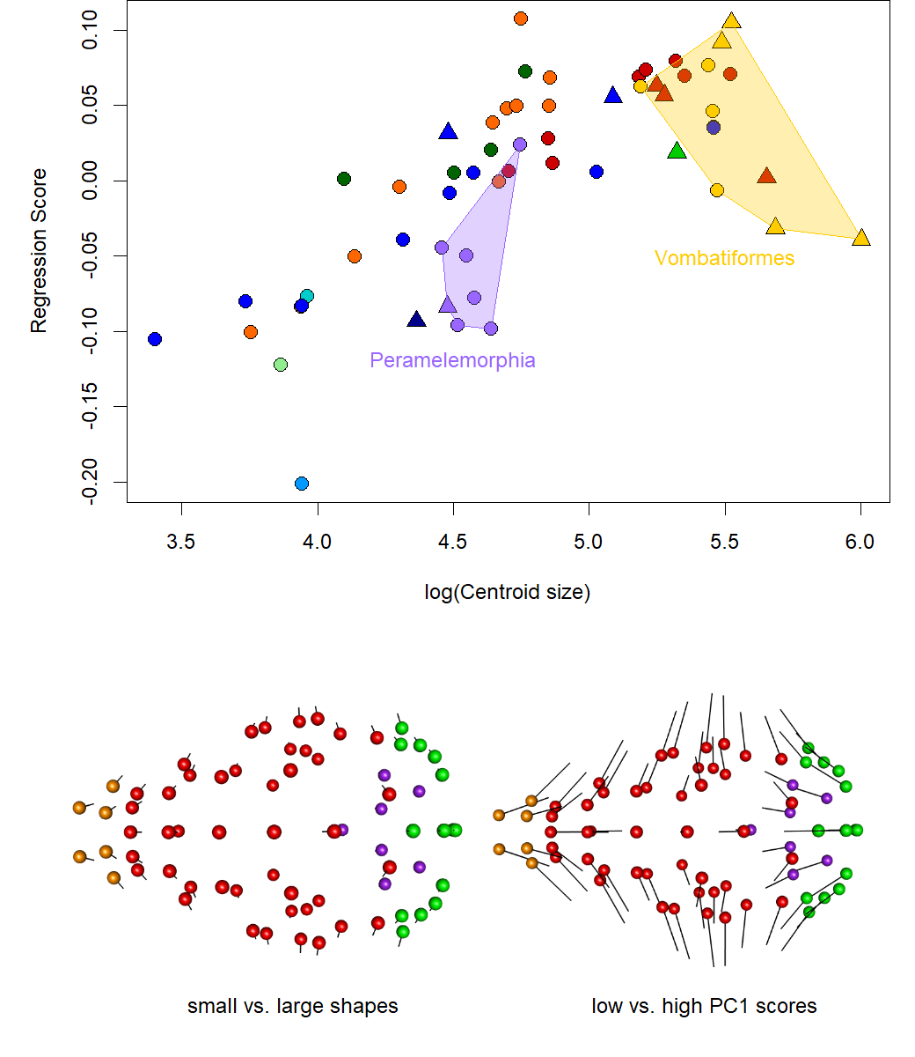
Figure 3: Top: Shape allometry plot of regression scores against log centroid size (above). Colouration as in Fig. 1. Bottom: Shape variation between shapes associated with large and small centroid sizes versus PC1 extremes. Balls indicate the landmark configuration of shapes with large centroid sizes (left)/low PC scores (right); lines point towards the configuration of shapes with small centroid sizes (left)/high PC2 scores. Colours are used to visually differentiate olfactory bulbs (orange), cerebrum (red), cerebellum (green), and brain base (purple)
Intraspecific variation
A PCA of all specimens revealed substantial intraspecific variation in species represented by more than one specimen, resulting in several instances where different species overlap in PC morphospace but individuals of the same species are well separated (Fig. 3). This is consistent with clear visual differences of brain shapes within some species (see Supporting Information 10, which compares strikingly different endocasts of two red kangaroo [Macropus rufus] individuals). However, comparison between intraspecific and interspecific Procrustes distances (Supporting Information 11) shows that, in terms of overall shape, intraspecific shape variation is much lower than interspecific variation.
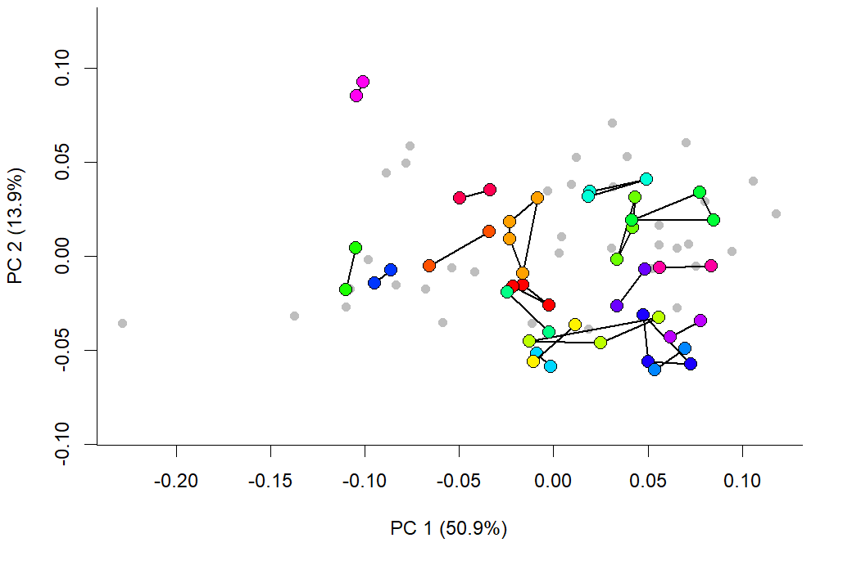
Figure 4: PC1 vs PC2 of all specimens. Species with a single representative are grey points. Members of one species are coloured (arbitrarily) and connected by lines, demonstrating intraspecific variation in brain shapes along the two main axes of shape variation.

Analyses of brain partition volumes and associations with PC1 and neocortex
Compared to brain shape, the relative volumes underlying the main brain partitions differ more by phylogenetic divisions (R²=0.5, p=0.001) and have slightly higher phylogenetic signal (K_{mult} = 0.66), but have no evolutionary allometric component (F= 2.38, R²=0.042, p=0.086 using log geometric mean; F= 1.79, R²= 0.032, p=0.161 using log body mass). A Mantel test of pairwise distances between species in the shape and volume PCAs is significant ( p=0.000, but with low Pearson correlation values of 0.27), confirming our expectation that the two describe different patterns of evolutionary diversification (Fig. 3 shows the distribution of species on a volume-based PCA); for example, the PC1 of volumes shows high loading of olfactory bulb volume that is not apparent along the main variation of shapes (Fig. 2; movies in Supplementary Information 4). However, because PC2 appeared to reflect a spectrum from lower to higher dominance of the cerebrum, we assessed if relative cerebral size (as identified by the log shape ratio value of the cerebrum) was associated with PC2 of the shape PCA, and overall endocast shape. This revealed a significant association of cerebral volume with PC2 (F=11.78, R²=0.18, p=0.003) and overall shape (F=4.5, R²= 0.08, p=0.003), suggesting that PC2 is partially determined by cerebral volume. In keeping with their significantly smaller PC2 scores, fossil taxa also had significantly smaller cerebra relative to the remainder of brain partition volumes F=13.07, p=0.003), and extinct status explained nearly 20% of variation in cerebral volume (R² = 0.19).
We found a significant association, but with low R², between the log shape ratios of cerebral hemispheres and neocortex volumes (across 17 marsupials); the association between cerebral hemisphere LSR and isocortex grey matter volume across 19 Diprotodontia was just outside the significance threshold. Therefore, although cerebral hemisphere volume may be indicative of neocortex volume, this association is not strong.

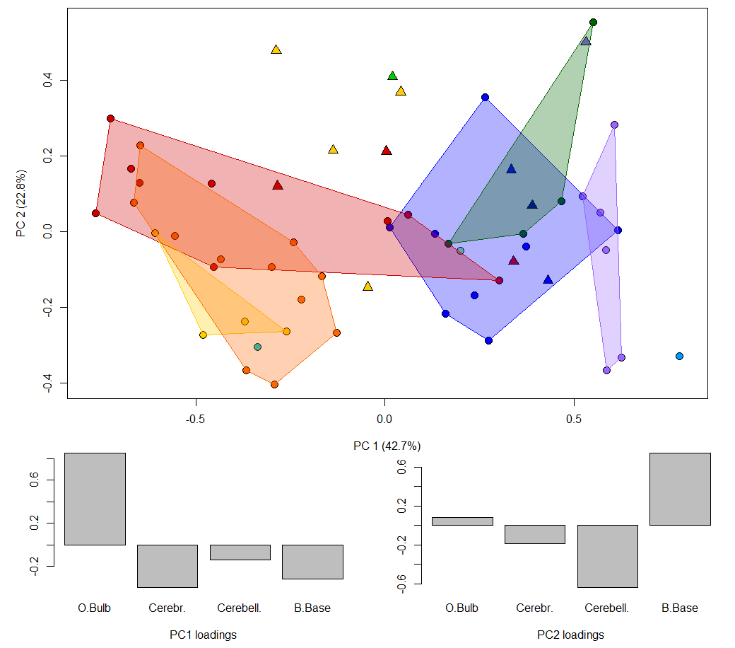 Figure 4: Principal Component Analysis of species according to their brain region volume log-shape ratios (top) and loadings (bottom). Note that the main differentiation between species here is due to volumes of the olfactory bulb. Colouration as in Fig. 1 and 2.
Discussion
Our results reveal that over half of marsupial endocast shape variation lies along a spectrum from elongate/straight to globular/inclined endocast shapes, which strongly resemble the “spatial packing” effects proposed for primates and experiments on mice (Ross and Henneberg 1995; Lieberman et al. 2008; Bastir et al. 2011; Marcucio et al. 2011; Zollikofer et al. 2017). However, “spatial packing” is thought to accommodate relatively larger brains into skulls with short cranial bases, while the marsupial pattern is not associated with relative brain size. The spectrum of shapes is also quite extreme, ranging from nearly spherical in the marsupial mole Notoryctes typhlops to nearly tubular in species like Silvabestius johnnilandi (compare on Fig.1). It resembles other instances where an axis of global change related to elongation determines morphological diversification, for example in the whole body of fishes, lizards, and mustelids (Bergmann and Irschick 2010; Ward and Mehta 2010; Law et al. 2019). Shape diversification partially associated with elongation has also been postulated for the therian cranium (e.g. Cardini et al. 2015), although this pattern (named “Cranial Rule of Evolutionary Allometry”) is also associated with size variation, which has no strong influence in our dataset.
In the case of our endocasts, the high variability of shapes across short evolutionary time scales (or even within species) suggests that the diverse brain tissues within the endocast are integrated to produce a limited set of shapes reflected in PC1 (Felice et al. 2018). So what determines this strong main axis of variation? The pattern resembles an evolutionary “line of least resistance” (Schluter 1996), a genetically favoured direction of morphological evolution. In mammals, strong allometric variation is often portrayed as a hallmark of evolutionary lines of least resistance (e.g. Marroig and Cheverud 2005; Marcy et al. 2020). However, the pattern we observe is not necessarily genetic and shows no strong allometry. In addition, endocasts differ from whole-body or overall cranial shape by emphasizing the juncture between the soft tissue of the brain with its neuronal functionality on one hand, and the osseous skull with its multitude of functions on the other.
Focusing on the interaction between brain and skull tissue, brain shape is known to be mechanically malleable: for example, it can be determined by intrinsic mechanical properties (such as tissue stiffness or internal tension of neurons; Atkinson et al. 2015; Koser et al. 2016; Heuer and Toro 2019), as well as external impacts (e.g. contact with cranial bones during brain growth; Macrini et al. 2007c; Budday et al. 2015). Such impacts are known to change brain shape over short evolutionary time scales and also individual development (Budday et al. 2015; Gómez-Robles et al. 2015), just as observed here. Similarly, brain sizes and regional volumes (and therefore presumably their shape) can vary substantially during individual lifetimes (Burger et al. 2013; Dechmann et al. 2017). Thus, mechanistic processes may mould brains into default shapes which we see on PC1, but without representing a “true” constraint because the shape of the brain is not intrinsically fixed. This is also consistent with our observations of highly unique endocranial shapes. Particularly striking examples of this are the deep “waist” between the cerebrum and the cerebellum, reflecting a deep imprint caused by the highly pneumatised mastoid bone of the pygmy glider Acrobates pygmaeus, or the flat brain with extensive imprint of the middle ear cavity in Planigale ingrami (compare in Fig. 1)
There are at least two reasons to expect allometric patterning of endocast shape. First, smaller mammals have relatively larger brains for their body mass, and would therefore be expected to share similar issues of distributing a heavy brain in a small skull. Second, as postulated under the “spatial packing” hypothesis, brains might need to be packed in a more globular way when their mass increases relative to body mass. However, allometry is not an important part of brain shape variation (mirroring results from a study on squirrels and their extinct relatives; Bertrand et al. 2019b) and our “spatial packing”–like pattern exists without allometry; the much higher phylogenetic signal of centroid size compared to endocast shape also demonstrates the relative evolutionary independence of the two.
Different ways of describing the endocast or brain (shape coordinates, volumetric dissection, and functional region volume such as neocortex) are not interchangeable in terms of the information they contain. What little significant correspondence we find (e.g. overall shape, PC2, and neocortex volume are significantly associated with the relative cerebral hemisphere size) is not sufficient to allow biological conclusions from one measure to the other. This also appears to be the case with specific somatosensory regions such as the visual cortex, which occupies the region that expands most along PC2 (Karlen and Krubitzer 2007). An association with occipital expansion of the neocortex with a potential improvement of vision capabilities has been suggested in rodents and their relatives (e.g. Bertrand et al. 2019a). In marsupials, however, a previous study (Karlen and Krubitzer 2007) showed no differences in visual cortex area between two high-scoring species (Dactylopsila trivirgata and Trichosurus vulpecula) vs. three low-scoring species (Dasyurus hallucatus, Monodelphis domestica, and Didelphis virginiana) on PC2. In addition, the marsupial mole Notoryctes typhlops with its dorsally rounded cerebral hemispheres (Fig. 1) has no functional eyes (Van Dyck and Strahan 2008).
Extinct species have significantly smaller relative cerebral size and PC2 scores than their living relatives, which superficially supports the notion of increasing neocortex dominance (“neocorticalisation”) in mammals (Jerison 2012) and specifically marsupial (Haight and Murray 1981) evolution. However, the lack of clarity surrounding the association between shape and cerebral/neocortical volume suggests that surface area measurements (Jerison 1973; Bertrand et al. 2016) on a sample where these can be made with confidence will be required to clarify this effect.
We found no association of broad locomotor categories with endocast shape, aside from a possible minor, phylogenetically confounded, change in the bipedal, hopping kangaroos relative to the remaining diprotodontians. Gliding was not associated with endocast shape, which contrasts with findings in gliding squirrels (Bertrand et al. 2019b). There is also no obvious connection between facial length and brain globularity (Evans et al. 2017; Zollikofer et al. 2017): for example, the two most globular brains in the sample belong to the relatively short-snouted marsupial mole and the relatively long-snouted shrew opossum (see Fig. 2). This lack of locomotor pattern might be explained either with a relatively rough-grained landmarking protocol, relative breadth of locomotor categories, and the phylogenetically confounded distribution of locomotor mode (for successful finer-grained analysis of ecology and endocast shape (see Ahrens 2014; Bertrand et al. 2019b). However, it is also possible that the evolutionary flexibility of brain shape suggested above, and its apparent propensity to adapt to the braincase, might result in noisy and divergent adaptations that are statistically not tractable. This highlights the potential issue that associations between locomotor mode and endocast shape might be more related to cranial, rather than somatosensory, adaptation.
Phylogenetic divisions in brain shape have been successfully established at finer phylogenetic scales (e.g. Silcox et al. 2009; Thiery and Ducrocq 2015; Bertrand et al. 2016; Bertrand et al. 2019b). we also find moderate phylogenetic signal in brain shape. However, this differentiation is mainly concentrated on the second principal component and explains little shape variation (compare the mean shapes with the shapes of individual species in Fig. 1). Brain shape is, therefore, likely too ambiguous to be useful in marsupial phylogenetics, with specific anatomical scores likely more successful (Haight and Murray 1981; Macrini et al. 2007b).
Conclusions
A pattern of high evolutionary shape plasticity along a global axis of elongation emerges as a powerful mechanism of balancing the evolution of marsupial, and possibly mammalian, cranial function against the need to accommodate the brain. However, the precise mechanisms for this flexibility remain to be understood and are likely quite diverse. For example, on one hand, brain shape and volume proportions can undergo drastic seasonal change in some small mammals (Dechmann et al. 2017). On the other hand, dogs bred for specific, small cranial vault shapes can display pathological cerebellar compression (Hechler and Moore 2018). Lastly, over the large time scales of mammalian brain evolution, increases in brain size appear to have triggered cranial vault expansion through a heterochronic delay in ossification of the cranial roof (Koyabu et al. 2014). The main challenge for understanding how the mammalian brain co-evolves with the skull will therefore be in separating the effects of individual developmental flexibility of brain shape on one hand, and deep time co-evolution between the cranial vault and brain size on the other, in a broader sample of non-primate mammals.
References
Adams, D., M. Collyer, and A. Kaliontzopoulou. 2020. Geomorph: Geometric Morphometric Analyses of 2D/3D Landmark Data. R package.
Adams, D. C. 2014a. A generalized K Statistic for estimating phylogenetic signal from shape and other high-dimensional multivariate data. Systematic Biology 63:685-697.
Adams, D. C. 2014b. A method for assessing phylogenetic least squares models for shape and other high-dimensional multivariate data. Evolution 68:2675-2688.
Ahrens, H. E. 2014. Morphometric study of phylogenetic and ecologic signals in procyonid (Mammalia: Carnivora) endocasts. The Anatomical Record 297:2318-2330.
Argot, C. 2003. Functional adaptations of the postcranial skeleton of two Miocene borhyaenoids (Mammalia, Metatheria), Borhyaena and Prothylacinus, from South America. Palaeontology 46:1213-1267.
Aristide, L., S. F. dos Reis, A. C. Machado, I. Lima, R. T. Lopes, and S. I. Perez. 2016. Brain shape convergence in the adaptive radiation of New World monkeys. Proc. Natl. Acad. Sci. U.S.A. 113:2158-2163.
Ashwell, K. 2010. The neurobiology of Australian marsupials: brain evolution in the other mammalian radiation. Cambridge University Press.
Atkinson, E. G., J. Rogers, M. C. Mahaney, L. A. Cox, and J. M. Cheverud. 2015. Cortical folding of the primate brain: an interdisciplinary examination of the genetic architecture, modularity, and evolvability of a significant neurological trait in pedigreed baboons (Genus &lt;em&gt;Papio&lt;/em&gt;). Genetics 200:651.
Barton, R. A. and I. Capellini. 2011. Maternal investment, life histories, and the costs of brain growth in mammals. Proc. Natl. Acad. Sci. U.S.A. 108:6169.
Bastir, M., A. Rosas, P. Gunz, A. Peña-Melian, G. Manzi, K. Harvati, R. Kruszynski, C. Stringer, and J.-J. Hublin. 2011. Evolution of the base of the brain in highly encephalized human species. Nature Commun. 2:588.
Beck, R. M., K. J. Travouillon, K. P. Aplin, H. Godthelp, and M. Archer. 2014. The osteology and systematics of the enigmatic Australian Oligo-Miocene metatherian Yalkaparidon (Yalkaparidontidae; Yalkaparidontia;? Australidelphia; Marsupialia). J. Mamm. Evol. 21:127-172.
Bennett, P. M. and P. H. Harvey. 1985. Brain size, development and metabolism in birds and mammals. Journal of Zoology 207:491-509.
Bergmann, P. J. and D. J. Irschick. 2010. Alternate pathways of body shape evolution translate into common patterns of locomotor evolution in two clades of lizards. Evolution 64:1569-1582.
Bertrand, O., C., F. Amador-Mughal, and M. T. Silcox. 2016. Virtual endocasts of Eocene Paramys (Paramyinae): oldest endocranial record for Rodentia and early brain evolution in Euarchontoglires. Proceedings of the Royal Society B: Biological Sciences 283:20152316.
Bertrand, O. C., F. Amador-Mughal, M. M. Lang, and M. T. Silcox. 2019a. New virtual endocasts of Eocene Ischyromyidae and their relevance in evaluating neurological changes occurring through time in Rodentia. J. Mamm. Evol. 26:345-371.
Bertrand, O. C., G. San Martin-Flores, and M. T. Silcox. 2019b. Endocranial shape variation in the squirrel-related clade and their fossil relatives using 3D geometric morphometrics: contributions of locomotion and phylogeny to brain shape. Journal of Zoology 308:197-211.
Biegert, J. 1957. Der Formwandel des Primatenschädels und seine Beziehungen zur ontogenetischen Entwicklung und den phylogenetischen Spezialisationen des Kopforgans. Morphol. Jahrb. 98:77-199.
Bienvenu, T., F. Guy, W. Coudyzer, E. Gilissen, G. Roualdès, P. Vignaud, and M. Brunet. 2011. Assessing endocranial variations in great apes and humans using 3D data from virtual endocasts. Am. J. Phys. Anthr. 145:231-246.
Black, K. H., A. B. Camens, M. Archer, and S. J. Hand. 2012. Herds overhead: Nimbadon lavarackorum (Diprotodontidae), heavyweight marsupial herbivores in the Miocene forests of Australia. PLoS ONE 7:e48213.
Budday, S., P. Steinmann, A. Goriely, and E. Kuhl. 2015. Size and curvature regulate pattern selection in the mammalian brain. Extreme Mechanics Letters 4:193-198.
Burger, D. K., J. M. Saucier, A. N. Iwaniuk, and D. M. Saucier. 2013. Seasonal and sex differences in the hippocampus of a wild rodent. Behavioural Brain Research 236:131-138.
Cardini, A., D. Polly, R. Dawson, and N. Milne. 2015. Why the long face? Kangaroos and wallabies follow the same ‘rule’ of Cranial Evolutionary Allometry (CREA) as placentals. Evol. Biol. 42:169-176.
Dechmann, D. K. N., S. LaPoint, C. Dullin, M. Hertel, J. R. E. Taylor, K. Zub, and M. Wikelski. 2017. Profound seasonal shrinking and regrowth of the ossified braincase in phylogenetically distant mammals with similar life histories. Scientif. Rep. 7:42443.
Dos Santos, S. E., J. Porfirio, F. B. da Cunha, P. R. Manger, W. Tavares, L. Pessoa, M. A. Raghanti, C. C. Sherwood, and S. Herculano-Houzel. 2017. Cellular scaling rules for the brains of marsupials: not as “primitive” as expected. Brain Behav. Evol. 89:48-63.
Drake, A. G. and C. P. Klingenberg. 2008. The pace of morphological change: historical transformation of skull shape in St. Bernard dogs. Proc. Roy. Soc. Lond. B 275:71-76.
Eldridge, M. D. B., R. M. D. Beck, D. A. Croft, K. J. Travouillon, and B. J. Fox. 2019. An emerging consensus in the evolution, phylogeny, and systematics of marsupials and their fossil relatives (Metatheria). J. Mammal. 100:802-837.
Evans, K. M., B. T. Waltz, V. A. Tagliacollo, B. L. Sidlauskas, and J. S. Albert. 2017. Fluctuations in evolutionary integration allow for big brains and disparate faces. Scientif. Rep. 7:40431.
Felice, R. N., M. Randau, and A. Goswami. 2018. A fly in a tube: macroevolutionary expectations for integrated phenotypes. Evolution 72:2580-2594.
Gómez-Robles, A., W. D. Hopkins, S. J. Schapiro, and C. C. Sherwood. 2015. Relaxed genetic control of cortical organization in human brains compared with chimpanzees. Proc. Natl. Acad. Sci. U.S.A. 112:14799-14804.
Gould, S. J. 1977. Ontogeny and phylogeny. Harvard University Press.
Gunz, P., P. Mitterroecker, and F. L. Bookstein. 2005. Semilandmarks in three dimensions in D. Slice, ed. Modern Morphometrics in Physical Anthropology. Kluwer Academic, New York.
Haight, J. R. and P. F. Murray. 1981. The cranial endocast of the early miocene marsupial, Wynyardia bassiana: an assessment of taxonomic relationships based upon comparisons with recent forms. Brain Behav. Evol. 19:17-36.
Hanken, J. and P. Thorogood. 1993. Evolution and development of the vertebrate skull: the role of pattern formation. Trends in Ecology & Evolution 8:9-15.
Hechler, A. C. and S. A. Moore. 2018. Understanding and treating Chiari-like malformation and syringomyelia in dogs. Topics in Companion Animal Medicine 33:1-11.
Heuer, K. and R. Toro. 2019. Role of mechanical morphogenesis in the development and evolution of the neocortex. Physics of Life Reviews.
Hinds, L. A. 1988. Hormonal control of lactation. Pp. 55-67 in C. H. Tyndale-Biscoe, and P. A. Janssens, eds. The Developing Marsupial. Models for Biomedical Research. Sprinter, Berlin.
Jeffery, N. and F. Spoor. 2006. The primate subarcuate fossa and its relationship to the semicircular canals part I: prenatal growth. J. Hum. Evol. 51:537-549.
Jerison, H. J. 1973. Evolution of Brain and Intelligence. Academic Press, London.
Jerison, H. J. 2012. Digitized fossil brains: neocorticalization. J Biolinguistics 6:383-392.
Jyothilakshmi, T. K., Y. Gurovich, and K. W. S. Ashwell. 2020. Numerical analysis of the cerebral cortex in diprotodontids (Marsupialia; Australidelphia) and comparison with eutherian brains. Zoology 143:125845.
Karlen, S. J. and L. Krubitzer. 2007. The functional and anatomical organization of marsupial neocortex: Evidence for parallel evolution across mammals. Prog. Neurobiol. 82:122-141.
Klingenberg, C. P., M. Barluenga, and A. Meyer. 2002. Shape analysis of symmetric structures: quantifying variation among individuals and asymmetry. Evolution 56:1909-1920.
Koser, D. E., A. J. Thompson, S. K. Foster, A. Dwivedy, E. K. Pillai, G. K. Sheridan, H. Svoboda, M. Viana, L. d. F. Costa, J. Guck, C. E. Holt, and K. Franze. 2016. Mechanosensing is critical for axon growth in the developing brain. Nature Neuroscience 19:1592.
Koyabu, D., I. Werneburg, N. Morimoto, C. P. E. Zollikofer, A. M. Forasiepi, H. Endo, J. Kimura, S. D. Ohdachi, N. Truong Son, and M. R. Sánchez-Villagra. 2014. Mammalian skull heterochrony reveals modular evolution and a link between cranial development and brain size. Nature Commun. 5. NEEDS PAGE NUMBERS
Law, C. J., G. J. Slater, and R. S. Mehta. 2019. Shared extremes by ectotherms and endotherms: Body elongation in mustelids is associated with small size and reduced limbs. Evolution 73:735-749.
Lieberman, D. E., B. Hallgrímsson, W. Liu, T. E. Parsons, and H. A. Jamniczky. 2008. Spatial packing, cranial base angulation, and craniofacial shape variation in the mammalian skull: testing a new model using mice. J. Anat. 212:720-735.
Macrini, T. E., C. De Muizon, R. L. Cifelli, and T. Rowe. 2007a. Digital cranial endocast of Pucadelphys andinus, a Paleocene metatherian. J. Vert. Paleontol. 27:99-107.
Macrini, T. E., G. W. Rougier, and T. Rowe. 2007b. Description of a Cranial Endocast from the fossil mammal Vincelestes neuquenianus (Theriiformes) and its relevance to the evolution of endocranial characters in therians. The Anatomical Record 290:875-892.
Macrini, T. E., T. Rowe, and J. L. VandeBerg. 2007c. Cranial endocasts from a growth series of Monodelphis domestica (Didelphidae, Marsupialia): a study of individual and ontogenetic variation. J. Morphol. 268:844-865.
Maier, W. 1993. Cranial morphology of the therian common ancestor, as suggested by the adaptations of neonate marsupials. Pp. 165-181 in F. S. Szalay, M. J. Novacek, and M. C. McKenna, eds. Mammal Phylogeny: Mesozoic Differentiation, Multituberculates, Monotremes, Early Therians, and Marsupials. Springer New York, New York, NY.
Marcucio, R. S., N. M. Young, D. Hu, and B. Hallgrimsson. 2011. Mechanisms that underlie co-variation of the brain and face. Genesis 49:177-189.
Marcy, A. E., T. Guillerme, E. Sherratt, K. C. Rowe, M. J. Phillips, and V. Weisbecker. 2020. Australian Rodents Reveal Conserved Cranial Evolutionary Allometry across 10 Million Years of Murid Evolution. The American Naturalist:000-000.
Marroig, G. and J. M. Cheverud. 2005. Size as a line of least evolutionary resistance: Diet and adaptive morphological radiation in new world monkeys. Evolution 59:1128-1142.
Mosimann, J. E. 1970. Size allometry: size and shape variables with characterizations of the lognormal and generalized gamma distributions. J. Am. Stat. Assoc. 65:930-945.
Mota, B. and S. Herculano-Houzel. 2015. Cortical folding scales universally with surface area and thickness, not number of neurons. Science 349:74-77.
Nieman, B. J., M. C. Blank, B. B. Roman, R. M. Henkelman, and K. J. Millen. 2012. If the skull fits: magnetic resonance imaging and microcomputed tomography for combined analysis of brain and skull phenotypes in the mouse. Physiological Genomics 44:992.
Nowak, R. M. 2018. Walker's mammals of the world: monotremes, marsupials, afrotherians, xenarthrans, and sundatherians. Johns Hopkins University Press.
Oksanen, J., F. G. Blanchet, R. Kindt, P. Legendre, P. R. Minchin, R. B. O'Hara, G. L. Simpson, P. Solymos, M. H. H. Stevens, and H. Wagner. 2016. VEGAN-Community Ecology Package.
Palomero-Gallagher, N. and K. Zilles. 2015. Chapter 22 - Isocortex. Pp. 601-625 in G. Paxinos, ed. The Rat Nervous System (Fourth Edition). Academic Press, San Diego.
Paradis, E., J. Claude, and K. Strimmer. 2004. APE: analyses of phylogenetics and evolution in R language. Bioinformatics 20:289-290.
Pereira-Pedro, A. S. and E. Bruner. 2018. Landmarking Endocasts. Pp. 127-142 in E. Bruner, N. Ogihara, and H. C. Tanabe, eds. Digital Endocasts: From Skulls to Brains. Springer Japan, Tokyo.
Pirlot, P. 1981. A quantitative approach to the marsupial brain in an eco-ethological perspective. Rev Can Biol 40:229-250.
R core team. 2018. R: A Language and Environment for Statistical Computing. R Foundation for Statistical Computing, Vienna, Australia.
Richtsmeier, J. T. and K. Flaherty. 2013. Hand in glove: brain and skull in development and dysmorphogenesis. Acta Neuropathologica 125:469-489.
Rohlf, F. J. and D. Slice. 1990. Extensions of the Procrustes method for the optimal superimposition of landmarks. Syst. Zool. 39:40-59.
Ross, C. and M. Henneberg. 1995. Basicranial flexion, relative brain size, and facial kyphosis in Homo sapiens and some fossil hominids. Am. J. Phys. Anthr. 98:575-593.
Ross, C. F. and M. J. Ravosa. 1993. Basicranial flexion, relative brain size, and facial kyphosis in nonhuman primates. Am. J. Phys. Anthr. 91:305-324.
Rowe, T. B., T. E. Macrini, and Z.-X. Luo. 2011. Fossil evidence on origin of the mammalian brain. Science 332:955-957.
Russo, G. A. and E. C. Kirk. 2013. Foramen magnum position in bipedal mammals. J. Hum. Evol. 65:656-670.
Sakai, S. T., B. M. Arsznov, A. E. Hristova, E. J. Yoon, and B. L. Lundrigan. 2016. Big Cat Coalitions: A Comparative Analysis of Regional Brain Volumes in Felidae. 10. NEEDS PAGE NUMBERS
Sakai, S. T., B. Whitt, B. M. Arsznov, and B. L. Lundrigan. 2018. Endocranial development in the coyote (Canis latrans) and gray wolf (Canis lupus): a computed tomographic study. Brain Behav. Evol. 91:65-81.
Sansalone, G., K. Allen, J. A. Ledogar, S. Ledogar, D. R. Mitchell, A. Profico, S. Castiglione, M. Melchionna, C. Serio, A. Mondanaro, P. Raia, and S. Wroe. 2020. Variation in the strength of allometry drives rates of evolution in primate brain shape. Proceedings of the Royal Society B: Biological Sciences 287:20200807.
Schluter, D. 1996. Adaptive radiation along genetic lines of least resistance. Evolution 50:1766-1774.
Schneider, C. A., W. S. Rasband, and K. W. Eliceiri. 2012. NIH Image to ImageJ: 25 years of image analysis. Nature Methods 9:671-675.
Sharp, A. C. 2016. A quantitative comparative analysis of the size of the frontoparietal sinuses and brain in vombatiform marsupials. Mem. Mus. Vic. 74: 331-342.
Sherratt, E., D. J. Gower, C. P. Klingenberg, and M. Wilkinson. 2014. Evolution of cranial shape in caecilians (Amphibia: Gymnophiona). Evol. Biol. 41:528-545.
Silcox, M. T., C. K. Dalmyn, and J. I. Bloch. 2009. Virtual endocast of Ignacius graybullianus (Paromomyidae, Primates) and brain evolution in early primates. Proc. Natl. Acad. Sci. U.S.A. NEEDS VOLUME AND PAGE NUMBERS
Smith, K. K. 1997. Comparative patterns of craniofacial development in eutherian and metatherian mammals. Evolution 51:1663-1678.
Thiery, G. and S. Ducrocq. 2015. Endocasts and brain evolution in Anthracotheriidae (Artiodactyla, Hippopotamoidea). J. Anat. 227:277-285.
Travouillon, K. J., S. Legendre, M. Archer, and S. J. Hand. 2009. Palaeoecological analyses of Riversleigh's Oligo-Miocene sites: implications for Oligo-Miocene climate change in Australia. Palaeogeogr., Palaeoclimat. Palaeoecol. 276:24-37.
Turney, C. S. M., T. F. Flannery, R. G. Roberts, C. Reid, L. K. Fifield, T. F. G. Higham, Z. Jacobs, N. Kemp, E. A. Colhoun, R. M. Kalin, and N. Ogle. 2008. Late-surviving megafauna in Tasmania, Australia, implicate human involvement in their extinction. Proc. Natl. Acad. Sci. U.S.A. 105:12150-12153.
Van Dyck, S. and R. Strahan. 2008. The Mammals of Australia. New Holland Pub Pty Limited, Sydney, Australia.
Ward, A. B. and R. S. Mehta. 2010. Axial elongation in fishes: using morphological approaches to elucidate developmental mechanisms in studying body shape. Int. Comp. Biol. 50:1106-1119.
Weisbecker, V., K. Ashwell, and D. Fisher. 2013. An improved body mass dataset for the study of marsupial brain size evolution. Brain Behav. Evol. 82:81-82.
Weisbecker, V., S. Blomberg, A. W. Goldizen, M. Brown, and D. Fisher. 2015. The evolution of relative brain size in marsupials is energetically constrained but not driven by behavioral complexity. Brain Behav. Evol. 85:125-135.
Weisbecker, V. and A. Goswami. 2010. Brain size, life history, and metabolism at the marsupial/placental dichotomy. Proc. Natl. Acad. Sci. U.S.A. 107:16216-16221.
Weisbecker, V. and A. Goswami. 2011a. Marsupials indeed confirm an ancestral mammalian pattern: A reply to Isler. BioEssays 33:358-361.
Weisbecker, V. and A. Goswami. 2011b. Neonatal maturity as the key to understanding brain size evolution in homeothermic vertebrates. BioEssays 33:155-158.
Weisbecker, V., C. Speck, and A. M. Baker. 2019. A tail of evolution: evaluating body length, weight and locomotion as potential drivers of tail length scaling in Australian marsupial mammals. Zoological Journal of the Linnean Society. NEEDS VOLUME AND PAGE NUMBERS
Wiley, D. 2015. Stratovan Checkpoint. IS THIS CITATION COMPLETE?
Wroe, S., M. Crowther, J. Dortch, and J. Chong. 2004. The size of the largest marsupial and why it matters. Proc. Roy. Soc. B 271:S34-S36.
Wroe, S., T. J. Myers, R. T. Wells, and A. Gillespie. 1999. Estimating the weight of the Pleistocene marsupial lion, Thylacoleo carnifex (Thylacoleonidae:Marsupialia): implications for the ecomorphology of a marsupial super-predator and hypotheses of impoverishment of Australian marsupial carnivore faunas. Aust. J. Zool. 47:489-498.
Zollikofer, C. P. E., T. Bienvenu, and M. S. Ponce de León. 2017. Effects of cranial integration on hominid endocranial shape. J. Anat. 230:85-105.

