Macroevolutionary consequences of mast seeding
Esther E Dale^{1,2,*}, Jessie J Foest³, Andrew Hacket-Pain³, Michał Bogdziewicz^{4,5}, Andrew J Tanentzap²
¹ Manaaki Whenua - Landcare Research, Dunedin, New Zealand
²Ecosystems and Global Change Group, Department of Plant Sciences, University of Cambridge, Cambridge, CB2 3EA, United Kingdom
³Department of Geography and Planning, School of Environmental Sciences, University of Liverpool, Liverpool, UK
⁴Department of Systematic Zoology, Faculty of Biology, Adam Mickiewicz University, Ul. Uniwersytetu Poznańskiego 6, Poznań, 61‐614 Poland
⁵ INRAE, LESSEM, University Grenoble Alpes, Saint-Martin-d’Heres, France
*Author for correspondence: dalee@landcareresearch.co.nz

Abstract
Masting characterises large, intermittent, and highly synchronous seeding events among individual plants and is found throughout the plant Tree of Life (ToL). Although masting can increase plant fitness, little is known about whether it results in evolutionary changes across entire clades, such as by promoting speciation or enhanced trait selection. Here we tested if masting has macroevolutionary consequences by combining the largest existing dataset of population-level reproductive time series and time-calibrated phylogenetic tree of vascular plants. We found that the coefficient of variation (CV_{p}) of reproductive output for 307 species covaried with evolutionary history, and more so within clades than expected by random. Speciation rates estimated at the species-level were highest at intermediate values of CV_{p} and regional-scale synchrony (S_{r}) in seed production, that is, there were unimodal correlations. There was no support for monotonic correlations between either CV_{p} or S_{r} and rates of speciation or seed size evolution. These results were robust to different sampling decisions, and we found little bias in our dataset compared with the wider plant ToL. While masting is often adaptive and encompasses a rich diversity of reproductive behaviours, we suggest it may have few consequences beyond the species level.

Keywords: seed production, macroevolution, diversification, seed mass, trait evolution

1. Introduction
Mast seeding or masting describes synchronous seed production among individual plants and populations that corresponds with large, intermittent reproductive events [1, 2]. This adaptation has evolved separately many times across the plant Tree of Life (ToL) [3-5], because it can ultimately increase fitness by conferring economies of scale that reduce the costs of reproduction per surviving offspring [2]. Masting is selected by different pressures [2], such as pollination efficiency [6, 7] or predator satiation [8-12]. However, little is known about whether it changes evolutionary processes across species, that is macroevolution, defined by rates of speciation, extinction, and phenotypic evolution. The only attempts to address this question have found that some reproductive behaviours associated with masting are evolutionarily conserved across the plant ToL [3-5] or focus specifically in evergreen wet tropical forests [13]. These studies have also considered only some of the ways to measure masting, focusing on temporal autocorrelation [4] and/or temporal variability [3, 5], or using a binary classification of masting [13].
Reproductive behaviours associated with masting may influence the macroevolution of species, namely their diversification and trait evolution (Fig. 1), especially compared to other taxa in the ToL. These behaviours can act as novel innovations if they promote a change in speciation or extinction rates, and thus net diversification rates [14]. Traits can alter speciation rates if they impact adaptation or gene flow directly, such as through changes in pollen placement that reduce gene flow [15]. Traits can also indirectly influence macroevolution, for example by enabling more environments to be occupied, making allopatric speciation more likely [16]. Extinction can also be influenced by traits, typically via changes in population size, range size, or dispersal ability [17]. Two traits that characterise masting behaviours, and thus may influence macroevolution, are the degree of synchrony and temporal variability of reproduction [18].

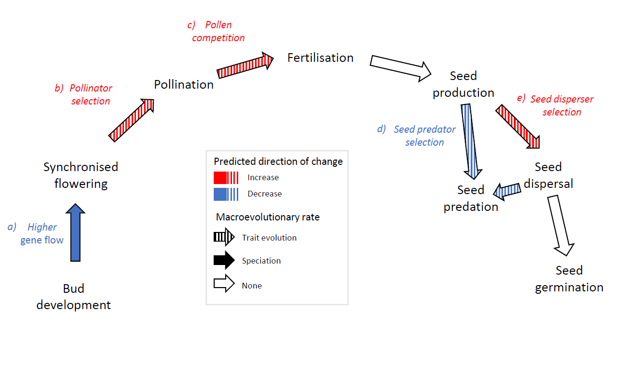
Figure 1 Potential macroevolutionary effects of masting behaviours. Arrows show transitions between reproductive stages in masting species with the type of arrow indicating mechanisms for macroevolutionary effects. Arrow shading indicates a possible influence on a macroevolutionary rate, and colouring indicates the predicted direction of change in that macroevolutionary rate.

Synchronisation of flowering within and between populations could have macroevolutionary effects through increased pollen competition, higher intensity of selection from pollinators, and changes in gene flow. Pollen competition can be more intense in mast years, theoretically allowing adaptations to spread more quickly through the gene pool and hastening phenotypic evolution [19]. More animal pollinators are also attracted to the large floral displays of masting species that exhibit synchronised flowering [20]. This increase in pollinator visitation is likely to intensify pollinator-mediated selection, which could hasten phenotypic evolution in floral traits. Finally, high flowering synchrony at either a population- or regional-scale may dampen speciation rates by promoting gene flow within species.
Large inter-annual variation in seed set and high synchrony in seed production [2, 18] can also influence macroevolution through selective pressures from dispersers or predators of seeds. Regional synchrony can influence selection from seed predators, with direction of that selection depending on degree of synchrony [12]. For example, in Pinus pinea, directional selection from seed predators on interannual variability of seed production had opposite effects for highly synchronised and poorly-synchronised plants [12], demonstrating that disruptive selection due to masting is possible. The selective pressures of predators on traits that are not directly involved in masting should effectively be diluted by large temporal variation that causes predators to starve in non-mast years and be satiated in mast years. In contrast, large inter-annual variation in seed production which attracts seed dispersers to fruit displays in mast years is likely to intensify selection on reproductive traits from seed dispersers.
Masting is typically measured in two main ways that can be associated with macroevolutionary change. First, the economies of scale that select for masting require large inter-annual variation in seed set [2, 18]. These can be estimated by the population-level coefficient of variation (CV_{p}) in seed production [5, 12]. In species with a large CV_{p}, seed predators and dispersers may have contrasting outcomes on the selection of phenotypic traits associated with reproduction, e.g. seed size (Fig. 1d,e). Seed predators can be choosier in years with high seed production and dampen phenotypic selection because seeds within a relatively wider trait range can survive. In contrast, traits selected by seed dispersers may evolve more quickly. Seed dispersers can be highly selective about which seeds to disperse in high seed years [21], resulting in a smaller proportion of seeds gaining dispersal benefits, and therefore more intense selection on seed traits than in years with a smaller seed crop.
Second, most economies of scale also require high synchrony in seed production [2, 18]. Synchrony is measured between individuals [11, 12], but large-scale spatial synchrony between populations over 100s to 1000s km (“regional synchrony”, S_{r}) may also be adaptive (Ascoli et al., this issue). Few studies, however, have enough long-term time series located within dispersal distance of each other to calculate S_{r}. High S_{r} could strengthen selection on reproductive traits, and therefore promote faster trait evolution, such as if pollinators or seed dispersers are attracted to large floral or fruit displays [22, 23]. Species with high S_{r} may also experience relatively higher pollen competition because their pollination efficiency is higher [6] and they can receive pollen from more individuals, thereby promoting faster trait evolution [19]. Conversely, high S_{r} could weaken selection from seed predators. Seed predators can consume a smaller proportion of seeds before being satiated, and therefore exert less selection, when many seeds are available during a short period compared to if the same number of seeds was produced over a longer period. Speciation may also be slower in species with high S_{r}, which promotes gene flow and therefore limits reproductive isolation. Although the potential selection effects can act in opposite ways, overall there are more mechanisms for promoting faster trait evolution with higher values of both CV_{p} and S_{r} through pollinators, seed dispersers, and pollen competition (Fig. 1).
Our aim was to explore whether masting behaviours have wider implications for species and phenotypic diversification beyond their selective advantages for individual fitness [11]. We exploited a new database of 5,057 population-level reproductive time series from 682 species – the largest synthesis of reproductive time series data to date [24]. We first explored the utility of this database for evolutionary inference by comparing biases in the macroevolutionary characteristics of its species with the wider plant ToL. We then tested whether more extreme reproductive behaviours, defined by high values of CV_{p} or S_{r}, were correlated and evolutionarily conserved. We used CV_{p} and the autocorrelation coefficient at a lag of 1-year (AR1) to identify different reproductive strategies and compare their macroevolutionary rates. Using the largest available estimates of species-specific speciation [25] and seed size evolution [26] for vascular plants, we also tested if species with more extreme reproductive behaviours were evolving more quickly in number and seed phenotype.

2. Methods
Reproductive time series
Seed and fruit data were obtained from MASTREE+ [24]. MASTREE+ comprises species-specific time series of annual reproductive effort for perennial plants, and includes measures of flower, pollen, fruit and seed production from wild grown populations (agricultural crops and experimentally manipulated plots were excluded). Data were extracted from the published and grey literature and unpublished datasets. A single time series is considered the set of annual observations described by a unique combination of species, sample location, reproductive variable (e.g. flower, fruit, seed), and measurement unit (e.g. fruit/m²).
We subset MASTREE+ to include only time series with observations of fruit, cone or seed production. We restricted our analyses to time series with at least 5 consecutive years of observations to analyse a larger sample size while maintaining a time series length comparable to previous work [1, 4, 5, 27] and similar in CV_{p} to longer time series (Fig. S1, Supplementary Materials). For each time series, we assessed interannual variability of reproduction by calculating the coefficient of variation at the population-level (CV_{p}) [5]. Our analysis was at the species-level, so we averaged values for species with multiple independent time series. To estimate the spatial synchrony of reproduction, we calculated pairwise Euclidean distances between the geographic coordinates of all independent time series for each species. We then calculated the Spearman rank correlation coefficient between all pairs of time series within 100 km of each other, and all time series generally. Correlation coefficients were averaged at both scales (100 km and globally) to obtain species-level means of spatial synchrony (S_{r}). We only present results for global synchrony, but those at a 100 km scale were generally consistent, albeit with smaller sample sizes (Fig. S2 & Tables S1-S7).

Phylogenetic data and macroevolutionary estimates
We analysed two complementary measures of speciation in the plant ToL. We focus on speciation, rather than diversification, because our predictions of potential masting effects on macroevolution involve changes in speciation, not extinction rates. First, we used existing estimates of speciation rates generated for 73,934 vascular plants with Bayesian Analysis of Macroevolutionary Mixtures (BAMM)[25]. BAMM models heterogeneity in speciation and extinction through time and across lineages and can account for non-random incomplete taxon sampling [28]. It has been extensively validated for estimating speciation rates [29, 30]. The BAMM speciation rate estimates we obtained here were generated using the most comprehensive time‐calibrated phylogenetic tree of seed plants presently available, i.e. GBOTB in Smith and Brown [31]. Second, we estimated speciation rates with the Diversification Rate metric [DR, 32] using the GBOTB phylogeny. DR considers only branch lengths and splitting events and does not accommodate incomplete taxon sampling [32], so we focus on BAMM-derived rates in the Main Text. We used the GBOTB phylogeny for all subsequent analyses that required a phylogenetic tree.
We also tested if masting was associated with the rate of evolutionary change in an important reproductive trait, seed size, which should be under selection from both seed dispersers and predators [33, 34]. We collated existing estimates of the rate of seed size evolution across the plant ToL generated for 13,579 angiosperms [26]. Briefly, seed mass data were obtained from the Royal Botanic Gardens Kew Seed Information Database (http://data.kew.org/sid/) and intersected with a time-calibrated phylogenetic tree for land plants generated with publicly available sequences for seven gene regions [35]. Speciation rates estimated with BAMM for this phylogeny have been shown to be correlated with those from the larger GBOTB tree [25]. BAMM was then used to model rates of seed size evolution [see reference 26 for full details]. The rate of seed size evolution was assumed to follow a different Brownian motion process within each clade of species estimated by BAMM to share macroevolutionary dynamics [36].
There were 307 woody and herbaceous species (65 families) in both MASTREE+ and the GBOTB phylogeny from 45 countries (Fig. S3, Supplementary Materials). Of these species, all had CV_{p} and DR estimates, 105 had a global synchrony estimate, and 274 and 149 had BAMM speciation and seed size evolution estimates, respectively. This subset was generated from 10,687 records in 870 time series (median time series length: 10 years, range: 5 to 62 years), with the highest density of time series in North America and Europe (Fig. S3). Pinaceae, Fagaceae, and Fabaceae were the best represented families in terms of species, with 47, 37 and 22 species respectively. Oak, Quercus, was the most represented genus with 34 species. We resolved all taxonomic names to the species level in the reproductive time series data, phylogeny, and BAMM objects using The Plant List [37] in R v.4.0.3 [38]. Full details are given in the Supplementary Methods.

Clustering reproductive strategies
Different reproductive behaviours can be characterised as masting. Grouping these behaviours into a single “masting” category may obscure correlations with macroevolutionary rates if different groups are associated with speciation and trait evolution in opposing ways. To complement our species-level analyses and test for macroevolutionary differences between contrasting reproductive strategies, we divided taxa into clusters based on their CV_{p} and the autocorrelation coefficient at a lag of 1-year (AR1) values. Although there is no clear indication of how AR1 might directly influence macroevolution, it could do so along with CV_{p} by characterising different masting strategies [18]. A Gower’s distance dissimilarity matrix was generated, using the daisy function in the ‘cluster’ R package [39], which was k-means clustered with the kmeans function from the ‘stats’ package. We performed this cluster analysis with 2-12 clusters and, based on the elbow method [40] of mean sum of squares (See Fig. S4 in the Supplementary Materials), we selected 5 clusters to use for subsequent analyses.

Biases in masting data
MASTREE+ has positive biases to long-lived, woody species from temperate latitudinal regions, so we also tested if it had macroevolutionary biases or was generally representative of the plant ToL. We did so by comparing the speciation rates (both BAMM and DR), and rate of seed mass evolution, of our 307 study species to all other seed plants in the GBOTB phylogeny (n=79,574). BAMM speciation rate and seed mass evolution were compared between groups using Structured Rate Permutations on Phylogenies (STRAPP) via the traitDependentBAMM function in the ‘BAMMtools’ package [41] in R. STRAPP calculates the association between macroevolutionary rates and a binary variable of occurrence in the reproductive time series data using a Mann-Whitney U test. The observed U-statistic is then compared to a distribution of null values to estimate statistical significance. These null correlations were generated by permuting the macroevolutionary rates across the tips of the phylogeny 1000 times while maintaining the position of estimated rate shifts in the phylogeny. For DR, we compared MASTREE+ and GBOTB species by fitting a binomial phylogenetic generalised linear model (PGLM) to a binary variable of whether species occurred in the reproductive time series dataset (see Supplementary Methods).

Hypothesis testing
We tested if species-level masting behaviors, defined by CV_{p} and S_{r}, were evolutionarily conserved using Pagel’s λ [42] and the K statistic [43]. λ estimates how trait similarity correlates with phylogenetic similarity, indicating the degree to which trait values reflect shared evolutionary history. The K statistic, in contrast, compares trait variation within clades to variation among clades, so can detect phylogenetic clustering or overdispersion [42, 43]. With each masting metric as a response variable, we estimated Pagel’s λ using phylogenetic generalised least squares (PGLS) with the gls function in the ‘nlme’ package and a correlation structure generated for the pruned GBOTB phylogeny using the corPagel function in the R package ‘ape’. We constrained λ to between 0 and 1. For the species with standard errors for the masting metrics (i.e. across replicate time series), we also quantified λ incorporating the errors into the PGLS by weighting observations with the inverse variances [44]. We tested the statistical significance of λ values using the anova function in the ‘nlme’ package to compare each PGLS to an equivalent null model fitted without the correlation structure. We estimated the K statistic for each species using the phylogeny pruned from GBOTB and the phylosig function in the ‘phytools’ package in R. We tested the statistical significance of each K statistic with phylosig, which compares the estimated K value to a null distribution generated by randomly shuffling tips in the phylogeny 1000 times. These phylogenetic signal calculations were repeated with and without sampling error. Masting metrics were considered phylogenetically clustered if <2.5% of the K values from the randomised distribution exceeded the observed K, and over-dispersed if <2.5% of the null K values were smaller than the observed K.
We tested if reproductive behaviours defined by CV_{p} and S_{r} were phylogenetically correlated (i.e. coevolving) or evolving independently of each other. We fitted a PGLS regression between the two metrics with the pgls function in the ‘caper’ R package. We used a pruned GBOTB phylogeny and scaled errors along the phylogeny by estimating Pagel’s λ, as is standard practice [45].
To examine the macroevolutionary consequences of masting, we tested whether CV_{p} and S_{r} were associated with BAMM and DR speciation rates, and rates of seed mass evolution. For BAMM speciation rates and rates of seed mass evolution, we utilised STRAPP described above but with the Spearman rank correlation coefficient. For DR, we used the equal-splits with simulation (ES-sim) test (Supplementary Methods). We also used Quantitative State Speciation and Extinction (QuaSSE) models to test the association between speciation rate and CV_{p} and S_{r} [46]. We fitted maximum likelihood models with constant, linear, sigmoidal, or modal speciation functions to each masting metric and constant extinction using the ‘diversitree’ R package. We identified the best supported speciation model for each metric with the Akaike information criterion (AIC).
We also tested whether macroevolutionary rates varied among groups of species with different reproductive behaviours that would have been masked in the species-level analysis. The macroevolutionary differences between clusters of species in the reproductive time series data were compared using several examined and concealed states-dependent speciation and extinction (SecSSE) models for BAMM speciation rates, PGLS for DR speciation rates, and STRAPP for the BAMM-estimated speciation rate and the rate of seed mass evolution. We used the ‘SecSSE’ R package [47] to fit an examined-trait-dependent model (ETD) where speciation rates vary among different reproductive clusters. To assess if the ETD model was supported by our data, we compared it to a null model with constant speciation rates for all species (CR) and a concealed-trait-dependent model (CTD) where speciation rates varied independently of the pre-defined reproductive clusters. For the CTD model, we instead let speciation rates vary among 5 different but unknown clusters, termed “concealed states”, as recommended by ref. [48]. Extinction rates and transition rates between states were fixed across all states for all three models. Starting values were generated using a simple birth-death model with the bd_ML function in the ‘DDD’ R package [49], and we reran the models with values doubled and halved to avoid only finding local maxima. We identified the best model by comparing AIC weights [AICw; 50]. The PGLS model was fitted as described for metric correlations, with the GBOTB phylogeny and DR speciation values as the response and the cluster each species belonged to as an explanatory factor. The STRAPP analysis tested the correlation between BAMM speciation rate or seed mass evolution and the cluster each species belonged to using the Kruskal-Wallis method and 1000 permutations. We also examined the differences in spatial synchrony and absolute latitude between masting clusters with PGLS. Synchrony was negatively skewed so was exponentially transformed beforehand. When fitting the PGLS we co-estimated Pagel’s λ in the same way as described above and the p-values were not corrected for multiple tests.
To test the robustness of the results to our filtering decisions, we repeated all the analyses with different data subsets. We repeated the analyses with reproductive time series of at least 3, 4, and 6 years of consecutive observations to test the effect of the 5-year filtering decision. Similarly, we tested the effect of unit type by separately analysing datasets of only mass-based, counts-based, per-area, or per-individual units. All of the code for performing the analyses can be found on Zenodo [51].

3. Results
(a) Macroevolutionary biases
Macroevolutionary rates were generally representative of those across the wider plant ToL. Both BAMM-estimated rates of speciation and seed mass change were comparable between MASTREE+ and the wider plant ToL (Fig. S5a,b, Supplementary Materials). The DR metric of recent speciation was only a mean of 7% lower (0.85 species Ma⁻¹) in MASTREE+ species than in the wider GBOTB phylogeny (Fig. S5c, Supplementary Materials).
We further related different reproductive strategies to macroevolutionary characteristics by grouping MASTREE+ species into clusters based on their CV_{p} and AR1 values. We found that five clusters best described the data (Fig. S4; Fig. 2a). Although these clusters did not exhibit statistically significant differences in S_{r} and latitude, their values helped us interpret the corresponding reproductive strategies (Fig. 2b,c). For example, cluster A, defined by high CV_{p}, consisted of species with extreme inter-annual variation in seed crop. In contrast, cluster E, defined by low CV_{p} and positive AR1, indicated masting where seed production is similar among years. The remaining clusters B, C, and D generally differed in AR1, indicating that they may reflect different resource use strategies or environments that cause different sequences of low- and high-seed years without necessarily leading to large absolute differences between years.
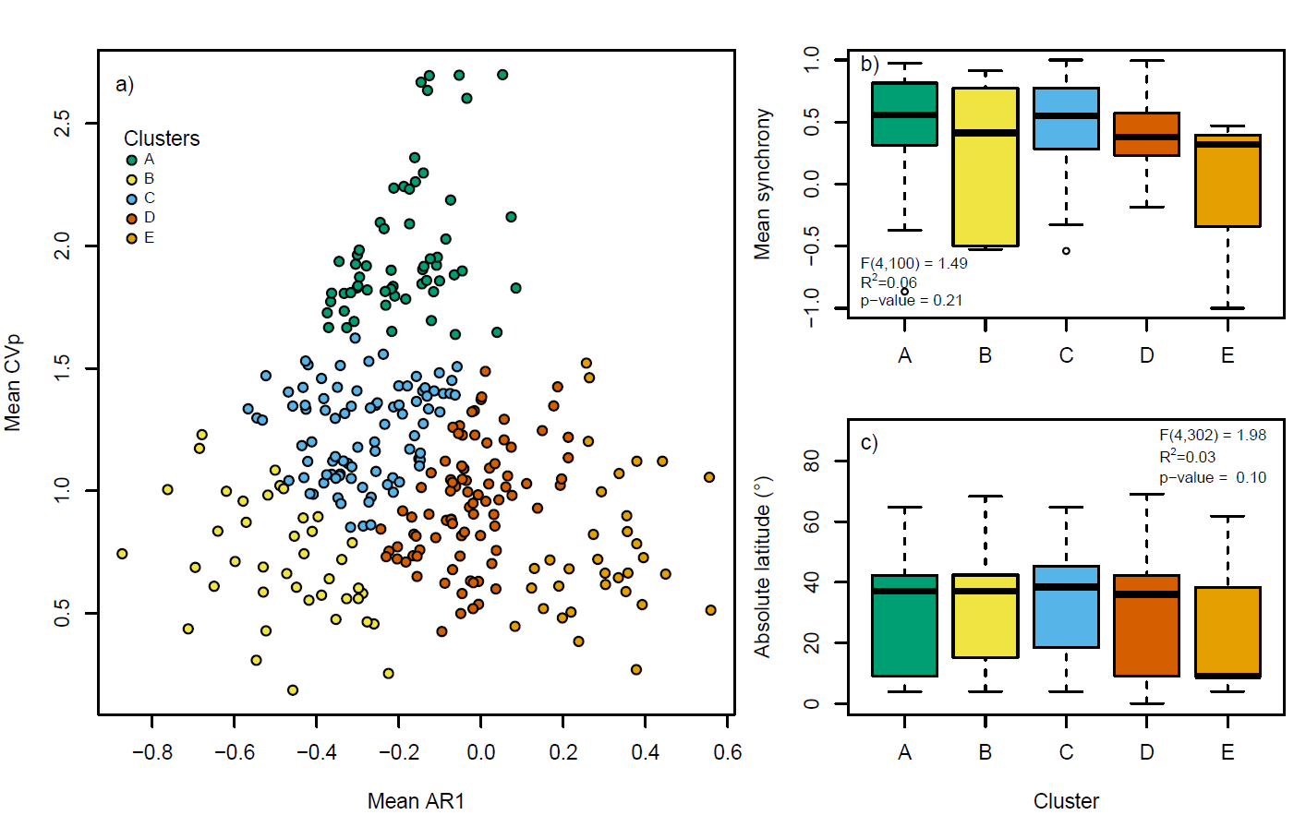
Figure 2. Different reproductive strategies across the plant Tree of Life. a) Species cluster into five groups based on their population-level coefficient of variation (CV_{p}) and lag-1 autocorrelation (AR1). Metrics were averaged across replicate time series for 307 species. Clusters did not vary in mean b) spatial synchrony globally, and c) absolute latitude. PGLS models testing the effect of clusters are shown inset for b) and c).

(b) Phylogenetic patterns
Masting behaviour varied across the plant ToL. CV_{p} showed phylogenetic signal (λ = 0.35; Table 1), implying that values tend to be similar in related species due to their shared evolutionary history. However, there was large variation within clades in all masting metrics (K < 0.05), with CV_{p} more overdispersed than expected, indicating divergence in reproductive strategies within clades (Table 1). No statistically significant phylogenetic signal was detected for S_{r} (Table 1). The masting metrics were not phylogenetically correlated (Table S8, Supplementary Materials), indicating that strong masting behaviour does not require CV_{p} and S_{r} to be coordinated per se (Fig. 3). Masting behaviours could therefore be found across the phylogeny, having arisen frequently in different ways in different parts of the plant ToL (Fig. 3).

Table 1. Phylogenetic signal in masting metrics across vascular plants. Pagel’s λ and Blomberg’s K statistic tested for phylogenetic signal in species-level means of the coefficient of variation in population-level reproduction (CV_{p}) and global spatial synchrony (S_{r}). λ tests for phylogenetic correlation between species based on their shared evolutionary history. Corresponding p-values were calculated from comparing generalised least squares models with and without a Brownian correlation structure scaled by an estimated λ. P-values for the K statistic test for phylogenetic clustering and overdispersion were derived using a randomisation test. Bolded p-values are considered statistically significant if <0.05 for λ and <0.025 for K. N is the number of species.
 |  |  | Blomberg’s K statistic
 | Pagel's λ |  |  | p-value
Masting metric | λ | p-value | K | Clustering | Overdispersion | N
mean CV_{p} | 0.35 | 0.01 | 0.01 | 0.98 | 0.02 | 307
mean S_{r} | 0.00 | 0.84 | 0.03 | 0.35 | 0.66 | 105

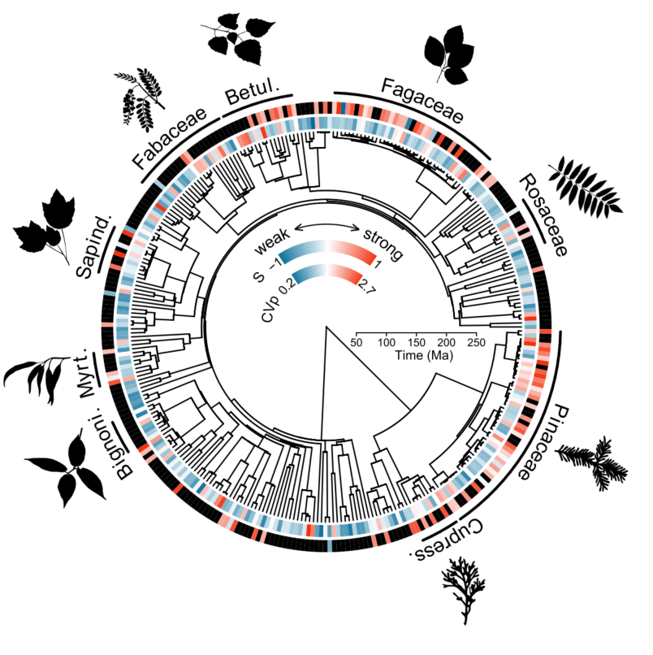
Figure 3. Masting behaviour varies across the plant Tree of Life. Time-calibrated phylogeny from Smith & Brown (26) displaying mean species spatial synchrony (S_{r}) and coefficient of variation in population-level reproduction (CV_{p}) (N = 870 time series from 307 species for CV_{p}, N = 652 time series from 105 species for S_{r}). Values range from blue, indicating weak masting behaviour, to red, indicating strong masting behaviour, with black indicating missing values (S_{r} only). Plant families with at least 8 species included in the study are shown. Plant silhouettes are from phylopic.org (Ferran Sayol & Mattia Menchetta) released under a Public Domain Dedication 1.0 license.

(c) Evolutionary consequences of masting
Masting behaviour was typically not associated with macroevolutionary rates, even when clustered into the different reproductive strategies. There were no statistically significant monotonic correlations between either of the masting metrics and the BAMM-estimated speciation rate or the rate of seed mass evolution, and these correlation coefficients were generally weak (Table 2). However, when non-linear associations were included, we found speciation estimated by QuaSSE was highest at intermediate trait values for both masting metrics (Fig. 4; Table S9, Supplementary Materials). There were also no differences in BAMM-speciation rate or the rate of seed mass evolution among different reproductive strategies (Fig. 5). Instead, speciation rates were estimated to vary independently of the pre-defined reproductive strategies by SecSSE (AIC_{w} ~ 1). Speciation rates varied across five groups that were unrelated to the reproductive strategies with rates ranging from 0.05 to 0.26 spp. Ma⁻¹, except for one group that had an estimated rate of 0.72 spp. Ma⁻¹. All our findings were robust to the speciation rate (BAMM vs. DR), type of units used in analyses, and the minimum duration of time series (Fig. S2 & Tables S1-S7, Supplementary Materials).

Table 2. Masting metrics are not associated with macroevolutionary rates. BAMM-estimated speciation and seed size evolution rates were tested using STRAPP. Correlation coefficients were Spearman’s rank coefficient.
Masting metric | Evolutionary rate | Correlation coefficient | p-value | N
CV_{p} | Speciation | 0.11 | 0.18 | 274
CV_{p} | Seed mass evolution | 0.04 | 0.60 | 164
S_{r} | Speciation | 0.06 | 0.51 | 96
S_{r} | Seed mass evolution | -0.13 | 0.30 | 50

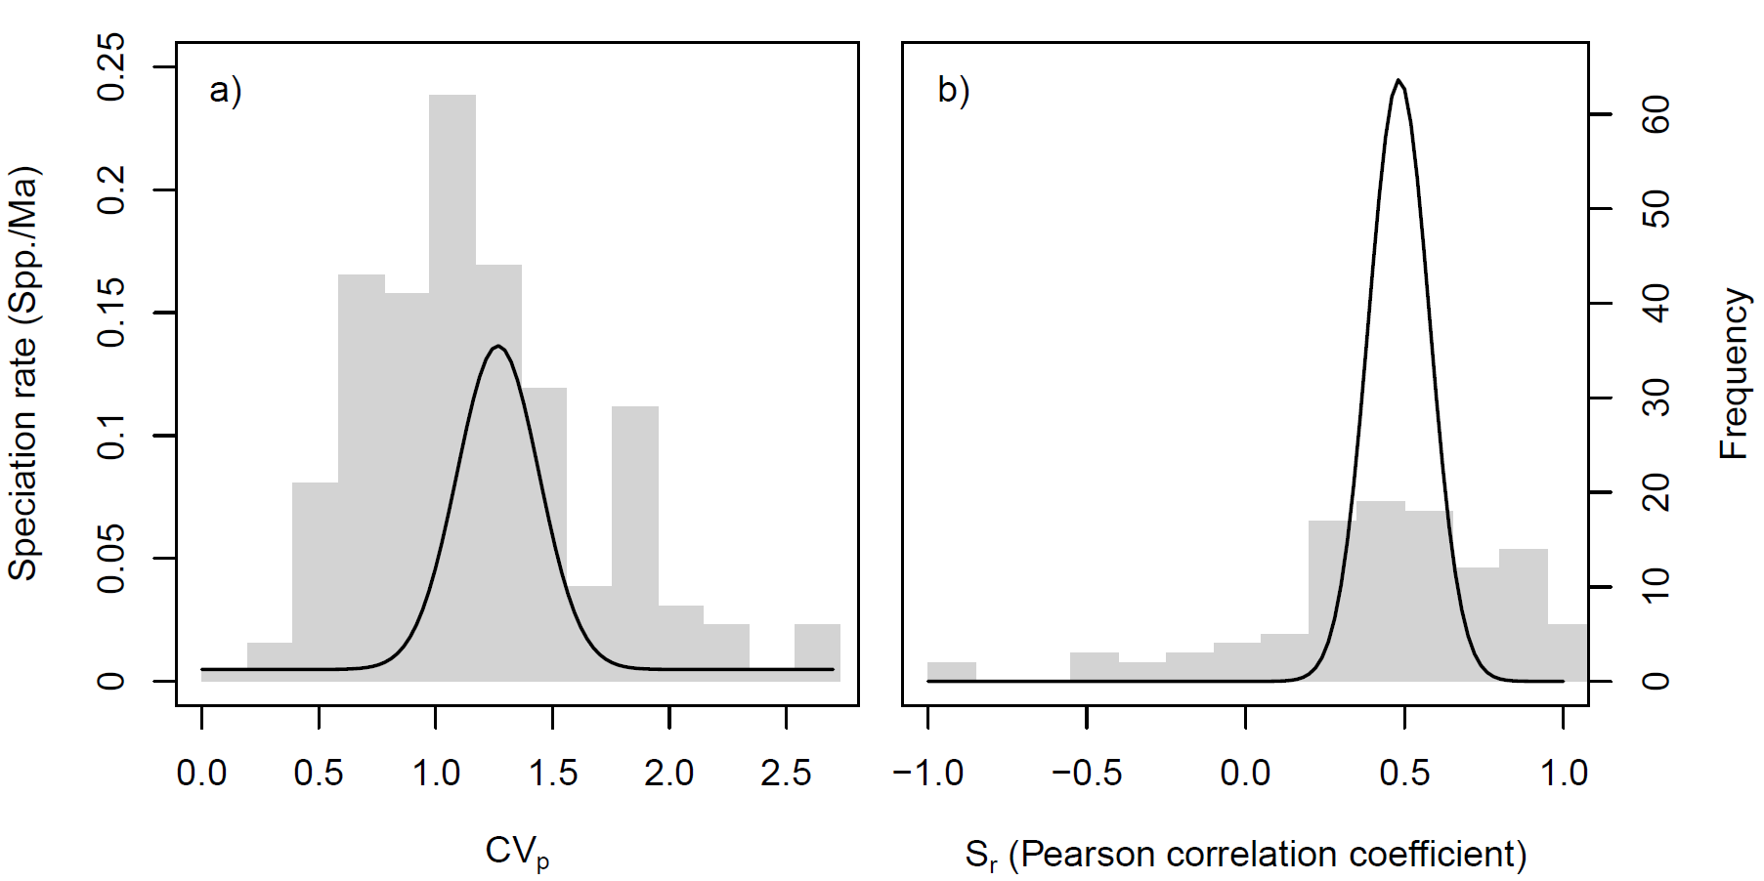
Figure 4. Speciation is highest with intermediate trait values. Modal QuaSSE models relating speciation rate to a) CV_{p} and b) S_{r}. Black lines show the modelled fits, and grey bars show the frequency of species.

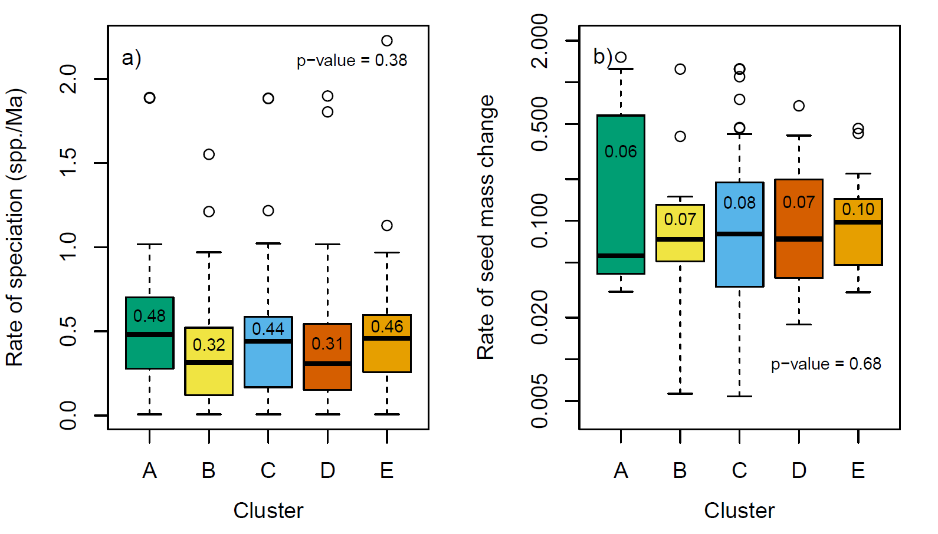
Figure 5. Different reproductive strategies are not associated with different macroevolutionary characteristics. We calculated a) rate of speciation and b) rate of seed mass evolution. The bold horizontal lines show the median, boxes show interquartile range, whiskers are 1.5-times the interquartile range, and points are values outside that range. Colours indicate different reproductive strategies defined using a cluster analysis on AR1 and CV_{p} (Fig. 2a). Characteristics were compared among clusters using STRAPP, with p-values and estimated medians of species-specific rates for each cluster shown on each plot. Rate of seed mass change is unitless.

4. Discussion
Mast seeding is observed in many species [3-5, 11, 12], but here we found that its fitness benefits translate into few macroevolutionary changes. Species with masting-like reproduction were dispersed across the plant ToL and not clustered in clades, consistent with previous reports of variation in masting among close relatives (e.g. Quercus, [52]). Different attributes of long-term seed production (CV_{p} and S_{r}) appeared to be evolving independently (Table S8). We also detected no association between masting metrics and the rate of seed size evolution, a key trait involved in reproduction. This lack of association can arise if masting behaviours cause opposing macroevolutionary effects within species and/or in different species. Within species, there may be varied selection effects, such as from both seed predators and seed dispersers (Fig. 1d, e), which together may result in minimal trait change. For example, stabilising selection on seed size may arise if both larger seeds are more apparent to predators, particularly in forests that dominate in our dataset [53], and smaller seeds experience more interspecific competition post-dispersal [54]. Alternatively, the same type of selection may occur in opposing ways within species [12, 18]. For example in Quercus ilex, pre-dispersal predation by weevils should select for large acorns [55], whereas post-dispersal predation by mammals selects for smaller seeds [33]. Likewise, there may be opposing effects in different species, because of their diversity of predators, pollination methods, and seed dispersal mechanisms [56, 57]. A combination of different types of selection in different species, such as stronger selection from pollinators in animal pollinated species, but weaker selection from seed predators in animal-dispersed species, may obscure association between rates of trait evolution and masting metrics. Negative results may also have arisen because the fitness benefits associated with different masting metrics vary widely. For example, high CV_{p} and high S_{r} may help satiate predators that are highly abundant [11, 12], whereas plants with sparse predators may benefit only from high S_{r} that concentrates flowering effort at one time point to improve pollination [6, 58]. These differences in reproductive strategies can also act independently of masting dynamics, such as through long-distance gene flow, common in many of the wind-pollinated tree species in our analysis [59], which can slow macroevolutionary change. Finally, the speciation effects of masting may depend on other reproductive traits that we have not examined, as macroevolutionary rates varied among groups of species but unrelated to the five different strategies defined by CV_{p} and AR1.
Speciation was highest with intermediate values of both CV_{p} and S_{r}. This type of association between synchrony and speciation rates may be caused by opposing effects of S_{r} on gene flow. We predicted that gene flow would be higher with greater synchrony, but variability in synchrony may promote reproductive isolation in some species, resulting in highest speciation with intermediate S_{r} values. If S_{r} becomes more variable, multiple synchronised groups could arise that are inherently out-of-sync with each other [60]. Consequently, we would expect high gene flow within groups with the same flowering time and low gene flow between groups with different flowering time, which could promote reproductive isolation and faster speciation. Differences in the timing of flowering arising would then promote non-random mating [61, 62]. Disruptive selection on timing of flowering could even result in sympatric speciation through temporal reproductive isolation because it maintains assortative mating within groups that flower at different periods, as pollination can only occur between those individuals that flower concurrently [62]. Close relatives that are out-of-sync occur in the bamboos [63] and coexisting oak species that exhibit reproductive cycles of different frequency [64], resulting in masting of a different periodicity in each species, though these differences could have arisen during or after speciation.
A similar process of opposing effects on speciation may operate for CV_{p}. Species with a high CV_{p} may have low speciation due to large floral displays or seed crops attracting dispersers and pollinators [22, 23] or increasing effectiveness of wind pollination [65] that could increase gene flow in mast years. Additionally, high CV_{p} may limit speciation via coevolution with pollinators or seed dispersers because variable seed or flower availability would make specialisation difficult. Perhaps there is low speciation with low CV_{p} due to less intraspecific seedling competition [66] slowing disruptive selection and therefore speciation rates. The potential for disruptive selection on the synchrony and variability of flowering remains to be examined in masting species.
We advanced previous attempts to explore the evolutionary history of masting by considering spatial synchrony alongside temporal variability, and linking reproductive behaviour to both speciation and trait diversification. Synchrony is important for reconstructing the evolutionary history of masting because it should be strongly involved in reproductive isolation and phenotypic selection. However, its effects can be difficult to detect in large comparative studies like ours because of variation in the life history, diet, mobility, generation time, and dietary specialisation of predators [12], resulting in no clear generalities. Alternatively, masting can arise because plants are simply matching inter-annual variation in weather that limit the resources required for seed production, or are responding to cues that select for synchrony within populations [2]. As these weather cues are synchronised spatially due to large-scale climate patterns, synchrony, especially at the 100+ km scale we measured here, may be more an emergent property of this process rather than a direct benefit to fitness [67, 68]. Synchrony may have also been unimportant for macroevolution in our study because we calculated it over larger distances (≥100 km) than those at which populations interbreed and experience reproductive isolation. Even with our large dataset, we lacked sufficient replicate time series to calculate S_{r} at smaller spatial scales. Future studies could overcome these challenges by testing if spatial synchrony promotes genotypic differentiation between populations within species where the economies of scales from predator satiation are greatest.
A further explanation for finding few statistically significant effects in our study is that our methods are sensitive to sample size. STRAPP, for example, may require many hundreds more species to detect statistically significant correlations between traits and speciation rates [69]. BiSSE, which is similar to QuaSSE and SecSSE, requires at least 300 species for reliable results [70]. Related, these associations may occur only for some masting behaviours. Our clustering of species into different reproductive strategies therefore returns to an important question of how masting is itself defined. By finding that masting is an emergent property associated with different reproductive behaviours (CV_{p}, S_{r}) that evolve independently from each other, our results are consistent with general theory predicting that diverse, species-specific selective pressures will create a diversity of masting behaviours [18].
The evolution of masting has long been of interest to researchers (Koenig et al., this issue), and efforts to compile large reproductive time series datasets have enabled important insights, such as the phylogenetic association between masting and nutrient imbalance [4]. Nevertheless, relatively little is known about the wider macroevolutionary consequences of masting. Here we provide the first steps to address this gap, demonstrating the value of newly available reproductive time series datasets to investigate the macroevolution of masting [24]. Future work should consider whether the macroevolutionary consequences of masting extend to the evolution of floral morphology and other reproductive traits, as well as non-reproductive aspects of the niche, such as geographic distribution or climate niche. Given the variety of reproductive behaviours and varied combinations of these behaviours that encompass masting, future attempts to understand the evolution of plant reproductive patterns must therefore focus on understanding their complexities and examining how these interact to affect evolutionary change.

5. Acknowledgements
We thank Javier Igea for providing the BAMM objects used in our analyses and advice on the statistical methods and Walt Koenig for suggestions of relevant examples from the literature. We would also like to thank Ian Pearse and the three reviewers for their suggestions which substantially improved this manuscript.

6. Author Contributions
EED and AJT conceived and designed the study, analysed and interpreted the data, and wrote the manuscript; JJF and AHP generated the reproductive time series data; JJF and MB provided input to study conception; JJF, AHP, and MB critically revised the manuscript. All authors gave final approval for publication and agreed to be held accountable for the work performed therein.

7. Funding
This work was supported by the Natural Environment Research Council grant number NE/S007857/1 to AHP and AJT and by a PhD studentship to JJF under Natural Environment Research Council grant number NE/S00713X/1. MB was supported by grant no. 2019/35/D/NZ8/00050 from (Polish) National Science Centre, and Polish National Agency for Academic Exchange Bekker programme PPN/BEK/2020/1/00009/U/00001.

8. References
[1] Kelly, D & Sork, VL. 2002 Mast seeding in perennial plants: Why, how, where? Annu Rev Ecol Syst 33, 427-447. (DOI:10.1146/annurev.ecolsys.33.020602.095433).
[2] Pearse, IS, Koenig, WD & Kelly, D. 2016 Mechanisms of mast seeding: resources, weather, cues, and selection. New Phytol 212, 546-562. (DOI:https://doi.org/10.1111/nph.14114).
[3] Tanentzap, AJ & Monks, A. 2018 Making the mast of a rainy day: environmental constraints can synchronize mass seeding across populations. New Phytol 219, 6-8. (DOI:https://doi.org/10.1111/nph.15219).
[4] Fernández-Martínez, M, Pearse, I, Sardans, J, Sayol, F, Koenig, W, LaMontagne, J, Bogdziewicz, M, Collalti, A, Hacket-Pain, A & Vacchiano, G. 2019 Nutrient scarcity as a selective pressure for mast seeding. Nat. Plants 5, 1222-1228.
[5] Pearse, IS, LaMontagne, JM, Lordon, M, Hipp, AL & Koenig, WD. 2020 Biogeography and phylogeny of masting: do global patterns fit functional hypotheses? New Phytol 227, 1557-1567. (DOI:https://doi.org/10.1111/nph.16617).
[6] Kelly, D, Hart, DE & Allen, RB. 2001 Evaluating the wind pollination benefits of mast seeding. Ecology 82, 117-126. (DOI:https://doi.org/10.1890/0012-9658(2001)082[0117:ETWPBO]2.0.CO;2).
[7] Bogdziewicz, M, Pesendorfer, M, Crone, EE, Pérez-Izquierdo, C & Bonal, R. 2020 Flowering synchrony drives reproductive success in a wind-pollinated tree. Ecol Lett 23, 1820-1826. (DOI:https://doi.org/10.1111/ele.13609).
[8] Norton, DA & Kelly, D. 1988 Mast seeding over 33 years by Dacrydium cupressinum Lamb. (rimu) (Podocarpaceae) in New Zealand: The importance of economies of scale. Funct. Ecol. 2, 399-408. (DOI:10.2307/2389413).
[9] Kelly, D, Harrison, AL, Lee, WG, Payton, IJ, Wilson, PR & Schauber, EM. 2000 Predator satiation and extreme mast seeding in 11 species of Chionochloa (Poaceae). Oikos 90, 477-488. (DOI:https://doi.org/10.1034/j.1600-0706.2000.900306.x).
[10] Fletcher, QE, Boutin, S, Lane, JE, LaMontagne, JM, McAdam, AG, Krebs, CJ & Humphries, MM. 2010 The functional response of a hoarding seed predator to mast seeding. Ecology 91, 2673-2683. (DOI:https://doi.org/10.1890/09-1816.1).
[11] Bogdziewicz, M, Kelly, D, Tanentzap, AJ, Thomas, PA, Lageard, JGA & Hacket-Pain, A. 2020 Climate change strengthens selection for mast seeding in European beech. Curr. Biol. 30, 3477-3483.e3472. (DOI:10.1016/j.cub.2020.06.056).
[12] Bogdziewicz, M, Szymkowiak, J, Tanentzap, AJ, Calama, R, Marino, S, Steele, MA, Seget, B, Piechnik, Ł & Żywiec, M. 2021 Seed predation selects for reproductive variability and synchrony in perennial plants. New Phytol 229, 2357-2364. (DOI:https://doi.org/10.1111/nph.16835).
[13] Kurten, EL, Bunyavejchewin, S & Davies, SJ. 2018 Phenology of a dipterocarp forest with seasonal drought: Insights into the origin of general flowering. J. Ecol. 106, 126-136. (DOI:https://doi.org/10.1111/1365-2745.12858).
[14] Vamosi, JC, Magallón, S, Mayrose, I, Otto, SP & Sauquet, H. 2018 Macroevolutionary Patterns of Flowering Plant Speciation and Extinction. Annu. Rev. Plant Biol. 69, 685-706. (DOI:10.1146/annurev-arplant-042817-040348).
[15] Sargent, RD. 2004 Floral symmetry affects speciation rates in angiosperms. Philos Trans R Soc London [Biol] 271, 603-608. (DOI:doi:10.1098/rspb.2003.2644).
[16] Weber, MG & Agrawal, AA. 2014 Defense mutualisms enhance plant diversification. PNAS 111, 16442-16447. (DOI:10.1073/pnas.1413253111).
[17] Beissinger, SR. 2000 Ecological mechanisms of extinction. PNAS 97, 11688-11689. (DOI:10.1073/pnas.97.22.11688).
[18] Koenig, WD, Kelly, D, Sork, VL, Duncan, RP, Elkinton, JS, Peltonen, MS & Westfall, RD. 2003 Dissecting components of population-level variation in seed production and the evolution of masting behavior. Oikos 102, 581-591. (DOI:https://doi.org/10.1034/j.1600-0706.2003.12272.x).
[19] Immler, S & Otto, SP. 2018 The evolutionary consequences of selection at the haploid gametic stage. Am. Nat. 192, 241-249. (DOI:10.1086/698483).
[20] Crone, EE. 2013 Responses of social and solitary bees to pulsed floral resources. Am. Nat. 182, 465-473. (DOI:10.1086/671999).
[21] Zong, C, Wauters, LA, Rong, K, Martinoli, A, Preatoni, D & Tosi, G. 2012 Nutcrackers become choosy seed harvesters in a mast-crop year. Ethol Ecol Evol 24, 54-61. (DOI:10.1080/03949370.2011.587834).
[22] Kelly, D. 1994 The evolutionary ecology of mast seeding. Trends Ecol. Evol. 9, 465-470. (DOI:https://doi.org/10.1016/0169-5347(94)90310-7).
[23] Christensen, KM & Whitham, TG. 1991 Indirect herbivore mediation of avian seed dispersal in pinyon pine. Ecology 72, 534-542. (DOI:https://doi.org/10.2307/2937194).
[24] Hacket-Pain, A, Foest, JJ, Tanentzap, AJ, Thomas, P, Ascoli, D, Bogdziewicz, M, Koenig, WD, Pearse, I, Pesendorfer, M, Satake, A, et al. In Prep. MASTREE+: time-series of plant reproductive effort from six continents. (
[25] Igea, J & Tanentzap, AJ. 2020 Angiosperm speciation cools down in the tropics. Ecol Lett 23, 692-700. (DOI:https://doi.org/10.1111/ele.13476).
[26] Igea, J, Miller, EF, Papadopulos, AST & Tanentzap, AJ. 2017 Seed size and its rate of evolution correlate with species diversification across angiosperms. PLoS Biol. 15, e2002792. (DOI:10.1371/journal.pbio.2002792).
[27] Pearse, IS, LaMontagne, JM & Koenig, WD. 2017 Inter-annual variation in seed production has increased over time (1900–2014). Proc. Royal Soc. B 284, 20171666. (DOI:doi:10.1098/rspb.2017.1666).
[28] Rabosky, DL. 2014 Automatic detection of key innovations, rate shifts, and diversity-dependence on phylogenetic trees. PLoS One 9, e89543. (DOI:10.1371/journal.pone.0089543).
[29] Rabosky, DL, Mitchell, JS & Chang, J. 2017 Is BAMM flawed? Theoretical and practical concerns in the analysis of multi-rate diversification models. Syst. Biol. 66, 477-498. (DOI:10.1093/sysbio/syx037).
[30] Title, PO & Rabosky, DL. 2019 Tip rates, phylogenies and diversification: What are we estimating, and how good are the estimates? Methods Ecol. Evol. 10, 821-834. (DOI:https://doi.org/10.1111/2041-210X.13153).
[31] Smith, SA & Brown, JW. 2018 Constructing a broadly inclusive seed plant phylogeny. Am. J. Bot. 105, 302-314. (DOI:https://doi.org/10.1002/ajb2.1019).
[32] Jetz, W, Thomas, GH, Joy, JB, Hartmann, K & Mooers, AO. 2012 The global diversity of birds in space and time. Nature 491, 444-448. (DOI:10.1038/nature11631).
[33] Gómez, JM. 2004 Bigger is not always better: Conflicting selective pressures on seed size in Quercus ilex. Evolution 58, 71-80. (DOI:10.1111/j.0014-3820.2004.tb01574.x).
[34] Jordano, P. 1995 Frugivore-mediated selection on fruit and seed size: Birds and St. Lucie's cherry, Prunus mahaleb. Ecology 76, 2627-2639. (DOI:https://doi.org/10.2307/2265833).
[35] Qian, H & Jin, Y. 2015 An updated megaphylogeny of plants, a tool for generating plant phylogenies and an analysis of phylogenetic community structure. Plant Ecol. 9, 233-239. (DOI:10.1093/jpe/rtv047).
[36] Rabosky, DL, Santini, F, Eastman, J, Smith, SA, Sidlauskas, B, Chang, J & Alfaro, ME. 2013 Rates of speciation and morphological evolution are correlated across the largest vertebrate radiation. Nat. Commun. 4, 1958. (DOI:10.1038/ncomms2958).
[37] 2013 The Plant List. (Version 1.1 ed.
[38] R Core Team. 2020 R: A language and environment for statistical computing. (Vienna, Austria, R Foundation for Statistical Computing.
[39] Maechler, M, Rousseeuw, P, Struyf, A, Hubert, M & Hornik, K. 2019 cluster: Cluster analysis basics and extensions. (R package version 2.1.0 ed.
[40] Thorndike, RL. 1953 Who belongs in the family? Psychometrika 18, 267-276. (DOI:10.1007/BF02289263).
[41] Rabosky, DL, Grundler, M, Anderson, C, Title, P, Shi, JJ, Brown, JW, Huang, H & Larson, JG. 2014 BAMM tools: an R package for the analysis of evolutionary dynamics on phylogenetic trees. Methods Ecol. Evol. 5, 701-707.
[42] Pagel, M. 1999 Inferring the historical patterns of biological evolution. Nature 401, 877-884. (DOI:10.1038/44766).
[43] Blomberg, SP, Garland JR., T & Ives, AR. 2003 Testing for phylogenetic signal in comparative data: Behavioral traits are more labile. Evolution 57, 717-745. (DOI:https://doi.org/10.1111/j.0014-3820.2003.tb00285.x).
[44] Garamszegi, LZ & Møller, AP. 2010 Effects of sample size and intraspecific variation in phylogenetic comparative studies: a meta-analytic review. Biol. Rev. 85, 797-805. (DOI:https://doi.org/10.1111/j.1469-185X.2010.00126.x).
[45] Orme, D, Freckleton, R, Thomas, G, Petzoldt, T, Fritz, S, Isaac, N & Pearse, W. 2018 caper: Comparative Analyses of Phylogenetics and Evolution in R. (R package version 1.0.1 ed.
[46] FitzJohn, RG. 2010 Quantitative traits and diversification. Syst. Biol. 59, 619-633. (DOI:10.1093/sysbio/syq053).
[47] Alsina, LH, Els, Pv & Etienne, RS. 2021 secsse: Several Examined and Concealed States-Dependent Speciation and Extinction. (R package version 2.1.5. ed.
[48] Herrera-Alsina, L, van Els, P & Etienne, RS. 2018 Detecting the dependence of diversification on multiple traits from phylogenetic trees and trait data. Syst. Biol. 68, 317-328. (DOI:10.1093/sysbio/syy057).
[49] Etienne, RS & Haegeman, B. 2021 DDD: Diversity-Dependent Diversification. (R package version 4.4.1. ed.
[50] Wagenmakers, E-J & Farrell, S. 2004 AIC model selection using Akaike weights. Psychon Bull Rev 11, 192-196. (DOI:10.3758/BF03206482).
[51] Dale, E. 2021 estherdale/masting-macroevolution. (Zenodo.
[52] Koenig, WD, Alejano, R, Carbonero, MD, Fernández-Rebollo, P, Knops, JMH, Marañón, T, Padilla-Díaz, CM, Pearse, IS, Pérez-Ramos, IM, Vázquez-Piqué, J, et al. 2016 Is the relationship between mast-seeding and weather in oaks related to their life-history or phylogeny? Ecology 97, 2603-2615. (DOI:https://doi.org/10.1002/ecy.1490).
[53] Dylewski, Ł, Ortega, YK, Bogdziewicz, M & Pearson, DE. 2020 Seed size predicts global effects of small mammal seed predation on plant recruitment. Ecol Lett 23, 1024-1033. (DOI:https://doi.org/10.1111/ele.13499).
[54] Moles, AT, Warton, DI & Westoby, M. 2003 Do small-seeded species have higher survival through seed predation than large-seeded species? Ecology 84, 3148-3161. (DOI:https://doi.org/10.1890/02-0662).
[55] Bogdziewicz, M, Espelta, JM & Bonal, R. 2018 Tolerance to seed predation mediated by seed size increases at lower latitudes in a Mediterranean oak. Ann. Bot. 123, 707-714. (DOI:10.1093/aob/mcy203).
[56] Herrera, CM, Jordano, P, Guiti, xe, n, J & Traveset, A. 1998 Annual variability in seed production by woody plants and the masting concept: Reassessment of principles and relationship to pollination and seed Dispersal. Am. Nat. 152, 576-594. (DOI:10.1086/286191).
[57] Kelly, D. 2021 Mast seeding: the devil (and the delight) is in the detail. New Phytol 229, 1829-1831. (DOI:https://doi.org/10.1111/nph.16990).
[58] Nilsson, SG & Wastljung, U. 1987 Seed predation and cross-pollination in mast-seeding beech (Fagus sylvatica) patches. Ecology 68, 260-265. (DOI:https://doi.org/10.2307/1939256).
[59] Kremer, A, Ronce, O, Robledo-Arnuncio, JJ, Guillaume, F, Bohrer, G, Nathan, R, Bridle, JR, Gomulkiewicz, R, Klein, EK, Ritland, K, et al. 2012 Long-distance gene flow and adaptation of forest trees to rapid climate change. Ecol Lett 15, 378-392. (DOI:https://doi.org/10.1111/j.1461-0248.2012.01746.x).
[60] LaMontagne, JM, Pearse, IS, Greene, DF & Koenig, WD. 2020 Mast seeding patterns are asynchronous at a continental scale. Nat. Plants 6, 460-465. (DOI:10.1038/s41477-020-0647-x).
[61] Servedio, MR, Van Doorn, GS, Kopp, M, Frame, AM & Nosil, P. 2011 Magic traits in speciation: ‘Magic’ but not rare? Trends Ecol. Evol. 26, 389-397.
[62] Weis, AE. 2015 On the potential strength and consequences for nonrandom gene flow caused by local adaptation in flowering time. J. Evol. Biol. 28, 699-714. (DOI:https://doi.org/10.1111/jeb.12612).
[63] Veller, C, Nowak, MA & Davis, CC. 2015 Extended flowering intervals of bamboos evolved by discrete multiplication. Ecol Lett 18, 653-659. (DOI:https://doi.org/10.1111/ele.12442).
[64] Sork, VL, Bramble, J & Sexton, O. 1993 Ecology of mast-fruiting in three species of North American deciduous oaks. Ecology 74, 528-541. (DOI:https://doi.org/10.2307/1939313).
[65] Smith, CC, Hamrick, JL & Kramer, CL. 1990 The advantage of mast years for wind pollination. Am. Nat. 136, 154-166.
[66] Hett, JM. 1971 A dynamic analysis of age in sugar maple seedlings. Ecology 52, 1071-1074. (DOI:https://doi.org/10.2307/1933815).
[67] Ascoli, D, Vacchiano, G, Turco, M, Conedera, M, Drobyshev, I, Maringer, J, Motta, R & Hacket-Pain, A. 2017 Inter-annual and decadal changes in teleconnections drive continental-scale synchronization of tree reproduction. Nat. Commun. 8, 2205. (DOI:10.1038/s41467-017-02348-9).
[68] Koenig, WD. 2002 Global patterns of environmental synchrony and the Moran effect. Ecography 25, 283-288.
[69] Rabosky, DL & Huang, H. 2015 A robust semi-parametric test for detecting trait-dependent diversification. Syst. Biol. 65, 181-193. (DOI:10.1093/sysbio/syv066).
[70] Davis, MP, Midford, PE & Maddison, W. 2013 Exploring power and parameter estimation of the BiSSE method for analyzing species diversification. BMC Evol. Biol 13, 38. (DOI:10.1186/1471-2148-13-38).

