Article
Organic Cage Inclusion Crystals Exhibiting Guest-Enhanced Multiphoton Harvesting
Guo-Hong Ning,^{1,2,*} Peng Cui,² Igor V. Sazanovich,³ James T. Pegg,⁴ Qiang Zhu,² Zhongfu Pang,² Rong-Jia Wei,¹ Mike Towrie,³ Kim E. Jelfs,⁴ Marc Little,^{2,*} and Andrew I. Cooper^{2,5*}
¹ College of Chemistry and Material Science, and Guangdong Provincial Key Laboratory of Functional Supramolecular Coordination Materials and Applications, Jinan University, Guangzhou 510632, P. R. China
² Department of Chemistry and Materials Innovation Factory, University of Liverpool, 51 Oxford Street, Liverpool L7 3NY, UK
³ Central Laser Facility, Research Complex at Harwell, Rutherford Appleton Laboratory, Harwell, OX11 0QX, UK
⁴ Department of Chemistry, Imperial College London, Molecular Sciences Research Hub, White City Campus, Wood Lane, London, W12 0BZ, UK
⁵ Lead contact
*Correspondence: guohongning@jnu.edu.cn
**Correspondence: malittle@liverpool.ac.uk
The bigger picture
Supramolecular chemistry is a route to materials with functions that can outperform the individual building blocks. One example is host-guest complexation, which has been used widely to tune photophysical properties. However, while host-guest complexation is well understood and often predictable in solution, in molecular crystals supramolecular assembly is much harder to predict. Organic co-crystals often exhibit polymorphism, where small changes to the guest lead to changes to the co-crystal structure that are hard to predict.
Here, we demonstrate that packing coefficients and guest shape are effective and computationally inexpensive screening tools for selecting guests that can be rationally included into a host structure without altering its crystal packing. Using this design approach, we included phtotoactive guests that strongly enhanced the photoluminescent properties of the supramolecular system. The strategy should also be transferrable to a wide range of other systems.

***Correspondence: aicooper@liverpool.ac.uk

SUMMARY
Host-guest complexation is an important supramolecular route to materials. Clear design rules have been developed for complexation in solution. This has proved more challenging for solid-state host-guest co-crystals because they often exhibit polymorphism, leading many researchers to focus instead on bonded frameworks, such as metal-organic frameworks. Here, we report an anthracene-based organic cage (1) that forms isoskeletal host-guest co-crystals with nine similarly-sized solid organic guests. The co-crystals were designed using inexpensive computational methods to identify appropriate guests that have packing coefficients (PCs) ranging from 44% to 50%, coupled with consideration of the guest shape. By complexing highly emissive BODIPY guests into the host structure, we enhanced its two-photon excited photoluminescent properties by a factor of six. Our crystal design approach was also transferrable to hard-to-design ternary organic crystals that were accessed by inserting specific guests into the different sized voids in the host.
Supramolecular chemistry, host-guest assemblies, crystal design, multiphoton absorption spectroscopy, porous solids.
INTRODUCTION
Molecular recognition and host-guest complexation are supramolecular processes that are controlled by noncovalent interactions, such as van der Waals and electrostatic forces, and hydrophobic effects.^{1,2,3,4,5} Controlling noncovalent assembly in supramolecular systems is important for generating host-guest complexes with additional functionality: for example, to control chemical reactivity, to tune optical and electrical properties, or to optimize the binding affinity of gas molecules and organic pollutants.^{6,7,8,9}
Artificial hosts can be divided into two categories. One type contains guest accessible intrinsic cavities that are generated during synthesis; these include crown ethers,^{10,11} cavitands,¹² metal-organic polyhedra,^{13,14} porous organic cages,¹⁵ and cucurbiturils.¹⁶ Synthetic hosts with cavities are often stable in organic solvents and aqueous solutions, enabling their guest binding properties to be investigated in solution;^{7,16,17,18,19,20,21} for example, to determine the effect of the volume, size, shape, and chemical functionality of the host on the formation energy of host-guest complexes.^{22,23,24,25,26,27} As a result of such studies, Rebek proposed the “55% rule”,¹⁸ which states that for optimal host-guest complexation, guests should occupy 55±9% of the total cavity volume of the host. The “55% rule” has been used as a guide to determine if host-guest complexation is likely,^{28,29} although this simplistic approach does not consider the shape, flexibility, or chemistry of either species (Figure 1a). Synthetic hosts with intrinsic cavities can also be used to produce crystalline or amorphous solids that have permanent porosity in the solid state,^{15,30} but their host-guest chemistry can then also be profoundly affected by crystal packing, the pore dimensionality, and the molecular flexibility of the host in the solid state;³¹ as such, solution properties may not always be a reliable guide for the solid state properties. Barbour has recently surveyed the Cambridge Structural Database and found that the fractional occupancy of the accessible space in molecular crystals occupied by organic solvents ranges from 45% to 60%, with the mean close to 51%,³² suggesting that guest loading spans a broader range than for hosts that were assumed to be rigid.
The second type of artificial host is produced by inefficiently packing molecules or atoms to generate solids with guest accessible extrinsic voids; that is, to use building blocks that lack intrinsic covalent cavities. Artificial hosts with extrinsic voids include metal-organic frameworks (MOFs),³³ covalent organic frameworks (COFs),³⁴ and porous organic molecular crystals,^{31,35} which were also screened as part of the Barbour study³². Artificial host frameworks with small extrinsic voids that are close in dimension to the guests can have functional advantages, such as high guest selectivity,^{36,37} although many MOFs and COFs have also been designed to have large voids to maximize their adsorption capacities. Extrinsically porous organic molecular crystals tend, with a few exceptions,³⁸ to have more modest extrinsic pores in the guest-free state,³¹ but they can also undergo pronounced structural rearrangements during host-guest encapsulation (Figure 1b); for example, via inductive crystallization during the absorption of small aromatic guests.³⁹ Such adaptive behavior is quite common for purely organic systems and tends to be more profound for larger guests that can interact more strongly with the host. This behavior can make it impossible to form an isoskeletal⁴⁰ series of host-guest crystal structures, even with relatively small and similarly sized guests, because each host-guest structure becomes essentially unique. This is a key difference with extended bonded frameworks such as MOFs and COFs, and it has so far limited the exploration of host-guest encapsulation processes for molecular host crystals with extrinsic voids (Figure 1) across a broad range of guests. While much effort has been devoted to predicting the crystal structures of organic crystals to address this challenge, these computational methods tend to focus on single-component rigid systems,^{41,42,43} and crystal structure prediction for cocrystals, while possible,^{44,45,46} is more computationally expensive.
Inclusion phenomena, especially guest encapsulation in solution and guest adsorption in rigid porous frameworks, have been studied widely.^{5,47} Often, the structure of the host remains the same—or almost the same—during guest inclusion, enabling inclusion processes to be investigated for a range of guests over different experimental conditions. By contrast, guest inclusion in organic crystals is harder to study across a range of guests, because small changes to the structure or chemistry of the guest can easily cause a profound change to the crystal packing of the host, leading to the crystallization of polymorphs of a solvate⁴⁸ and (frequently) changes in the host-to-guest stoichiometry. Multi-component molecular crystals are, therefore, often designed to incorporate building blocks that can form complementary intermolecular interactions, like hydrogen or halogen bonds,⁴⁹ to induce co-crystallization, and the molecular size and shape of the components has only recently been taken into account.⁵⁰ Recently, we demonstrated that the solvent filled ‘virtual pores’ in a metastable porous organic cage crystal could be trapped using a “crystal retro-engineering” strategy, where a second molecule was co-crystallized into the structure to trap its packing and to generate a stable co-crystal.⁵¹ We envisaged using this approach as a crystal design strategy to form a series of functional organic cage co-crystals, by considering how a wide range of guests (e.g., with different volumes, sizes, and shapes) could be inserted into the ‘virtual pores’ in a porous host. To achieve this, we designed an anthracene-based organic cage (1) that packs to form a porous host with two distinct extrinsic voids, from which a series of co-crystals was designed. By screening 10 different guests (Figure 2i), we determined that isoskeletal organic cage co-crystals were produced when their packing coefficients (PCs; the ratio of the guest volume to the volume of the extrinsic cavity) ranged from 44% (173 Å³) to 50% (198 Å³) (Figure 2i). The shape of the guests also played an important role, and this descriptor is not captured by simply considering the volume of the guest alone. By introducing the fluorescent guests [2-[(methylthio)(2H-pyrrol-2-ylidene)methyl]-1H-pyrrole](difluoroborane) (6, Figure 2) and 4,4-difluoro-1,3-dimethyl-4-bora-3a,4a-diaza-s-indacene (7, Figure 2,), which have PCs of 44% and 47%, respectively, we designed host-guest co-crystals that exhibited two-photon absorption (2PA) fluorescence properties. This was achieved by introducing the guests boron-dipyrromethene. Two-photon excited photoluminescence (2PEP) or multiphoton excited photoluminescence (MPEP) can allow the absorption of two or more photons from low-energy radiation while simultaneously emitting photoluminescence. Such materials have a range of applications, including high-density data storage, long-range telecommunications, and bioimaging, because of their high spatial resolution, deep tissue penetration, low optical scatter,^{52,53} but it remains challenging to design molecular crystals that exhibit MPEP.⁵⁴ Here, we demonstrate that 2PA of molecular crystals can be tuned in isoskeletal organic cage co-crystals by hosting fluorescent guests in a porous crystal lattice in a targeted way. For the co-crystal 1･7, we show that its 2PA can be enhanced by a factor of 6 using our approach compared to the pure host alone. By extension, two ternary organic solids comprising two structurally and chemically different guests were produced, highlighting the degree of flexibility and tuning that is possible with this co-crystal design approach.
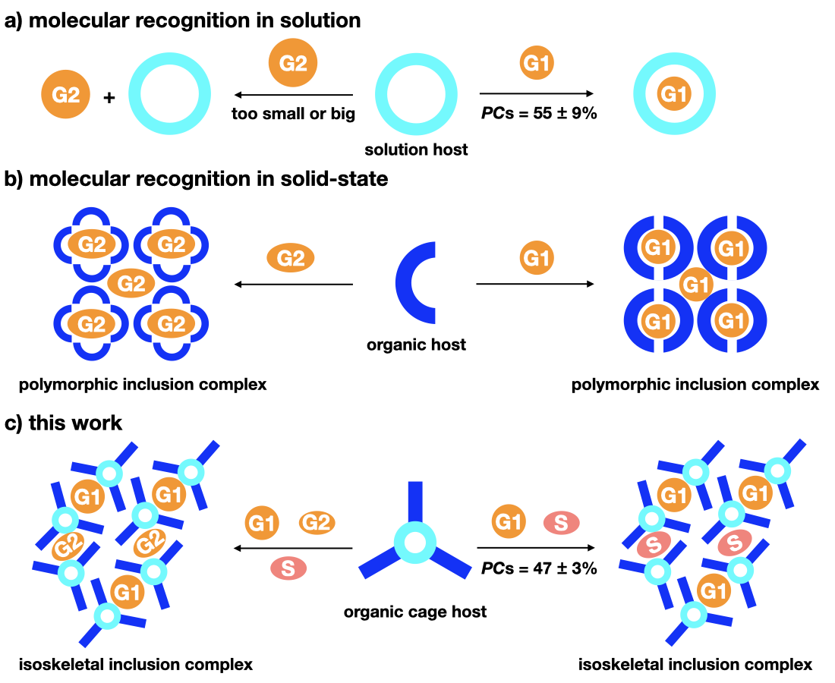
Figure 1. Molecular Recognition in Solution Versus the Solid State
Scheme illustrating (A) molecular recognition in solution, which can be predicted by considering Rebek’s “55% rule”¹⁸; (B) the more unpredictable guest-directed formation of organic inclusion complexes in the solid state, which renders the design of molecular recognition in the solid state challenging; (C) our new design approach for the design of isoskeletal organic host-guest co-crystals in the solid-state (packing coefficient = PC, guest = G, and solvent = S).
RESULTS AND DISCUSSION
Cage synthesis and crystal structure
Molecules with rigid and ‘awkward’ shapes, such as molecular stars⁵⁵ and propeller-shaped molecules,⁵⁶ have been shown to prevent close crystal packing and generate porous crystal lattices.⁵⁷ Here, we designed a propeller-shaped organic cage with three bulky anthracene groups (1, Figure 2a) that was prepared from the Schiff-base condensation of 1,8-diaminoanthracene and 1,3,5-triformylbenzene (see Materials and Methods for full details). The structure of 1 was characterized by NMR (Supplementary Figures S1-2) and high-resolution mass spectrometry (HR-MS) (Supplementary Figure S3). In the ¹H NMR, the disappearance of the aldehyde singlet at 10.4 ppm and the appearance of a singlet at 8.54 ppm indicated the clean formation of 1, which was confirmed using HR-MS by the peak at m/z=841.3081 assigned to [3+2] cage product. The structure of 1 was also confirmed by single-crystal X-ray diffraction (SC-XRD) after growing crystals by slowly diffusing n-pentane into a solution of 1 in 1,4-dioxane. Under these conditions, 1 crystallizes as an inclusion complex with 1,4-dioxane (1･2, Figure 2, where 2 =1,4-dioxane) that has a crystal packing arrangement of 1 referred to as 1α′. In 1･2, cage 1 has a propeller-like shape (Figure 2a) and is packed to form a 2-dimensional (2D) lamellar-like structure (Figure 2b). Within each 2D layer of 1, there are two crystallographically distinct extrinsic cavities (Figure 2c-h, purple and turquoise), which are located between the inefficiently packed anthracene pillars and are occupied with 1,4-dioxane solvent (Figure 3a and Supplementary Figure S4). In the extended structure, layers of 1 are stacked in a densely packed arrangement, via π-π interactions (Figure 2b), and due to this close packing of 2D cage layers, the extrinsic voids in 1･2 are disconnected. By using a 1.2 Å probe, the volumes of the extrinsic voids in 1･2 were calculated to be 393 and 219 Å³ (Figure 2, magenta and cyan, respectively; see Materials and Methods for full details).
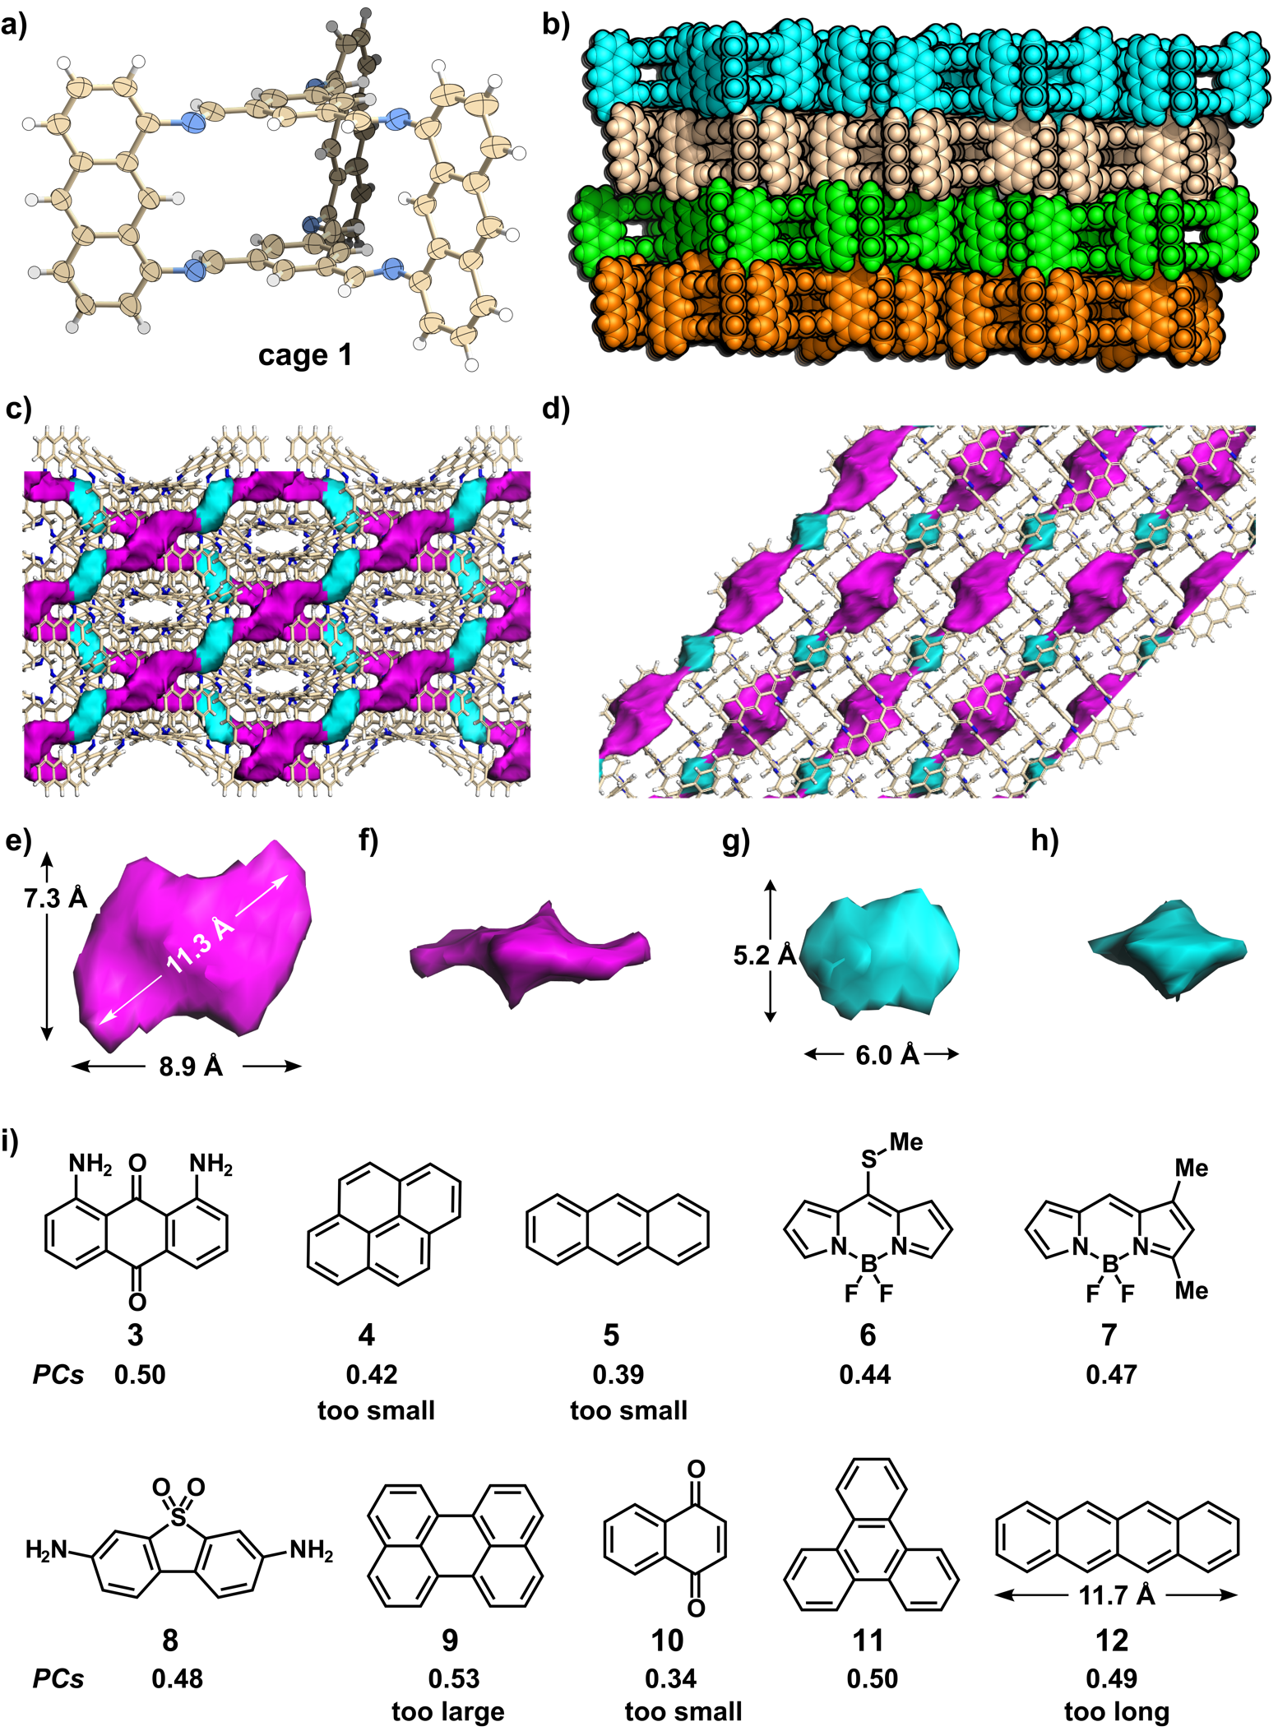
Figure 2. Crystal Structure of 1,4-Dioxane Solvated Host 1･2 (1α′) and Molecular Structures of Guests Used in the Encapsulation Studies
(A) Crystal structure of 1･2 (1α′); ellipsoids displayed at 30% probability. (B) Crystal packing in 1α′ showing the 2D lamellar-like structure, atoms are shown in space-filling mode with the different cage layers highlighted in different colors. (C, D, E, F, G, and H) The 3D arrangement and shapes of the 393 Å³ (magenta) and 219 Å³ (cyan) extrinsic voids in 1･2. c, crystal packing along the c-axis, and (D) along the b-axis. In (A), (C), and (D), carbon, nitrogen, and hydrogen atoms in the cage are shown as light yellow, blue and white, respectively, and the 1,4-dioxane solvents are removed for clarity). (I) The chemical structure of guests used in the encapsulation studies and their respective PCs, calculated using the volume of the 393 Å³ sized extrinsic void in 1･2 as the host cavity.
Guest inclusion studies
Here, we screened organic guest molecules that, in theory, fill the larger solvent-filled extrinsic cavity in 1α′, intending to use the crystal lattice of 1 as a host for a series of organic guests with different functions. Our primary aim was to establish a new design rule that could determine whether co-crystallization or, rather, guest-guest substitution was achievable for a series of guests, based on a simple packing coefficient metric and their dimensions. We explored a series of potential organic guests with different volumes to probe the PC boundary for producing solid-state isoskeletal organic cage co-crystals (Figure 2i).
To test our hypothesis, we computationally screened 10 guests (Figure 2i) through calculation of the PC by determining the host cavity size and guest volumes, along with calculating the maximum dimensions of each guest (see Materials and Methods and Supplementary Table 1). 1,8-diaminoanthraquinone (3) was chosen for the initial experimental screen because it has a PC of 50%, compared to the volume of the larger extrinsic cavity in 1α′ and has compatible dimensions (see Supplementary Table 1). To investigate this experimentally, we crystallized a mixture of cage 1 and guest 3 from 1,4-dioxane after slowly diffusing n-pentane into the solution. This resulted in red plate-shaped crystals that were determined to be 1･3 (I2/a, a = 25.527(5) Å, b = 15.033(3) Å, c = 27.091(5) Å, β = 90.24(3)°, V = 10396(4) Å³, see Table S2 for full details), which has comparable symmetry and unit cell dimensions to those determined for 1･2 (I2/a, a = 25.699(5) Å, b = 15.000(3) Å, c = 27.333(6) Å, β = 90.24(3)°, V = 10536(4) Å³). Further examination revealed that the crystal packing of 1 in 1･2 and 1･3 is identical (Figure 3 and Supplementary Figure S5), with one guest molecule of 3 selected to crystallize in the larger extrinsic cavity in 1･3 instead of two 1,4-dioxane solvent molecules. This behavior suggests that the cage host, 1, selectively encapsulates guest 3 in preference to the excess quantity of the 1,4-dioxane solvent molecules used in the crystallization. In the structure of 1･3, there are multiple C−H…π interactions between cage 1 and guest 3, rationalizing this behaviour, but neither the host nor the guest was designed to interact strongly with each other, which is often a pre-requisite to induce co-crystallization; here, only the relative volumes of the guest and the host cavity were considered.
Building on this co-crystal with guest 3, we extended our screen to include nine further guests: pyrene (4, predicted PC = 42%), anthracene (5, PC = 39%), [2-[(methylthio)(2H-pyrrol-2-ylidene)methyl]-1H-pyrrole](difluoroborane) (6, PC = 47%), 4,4-difluoro-1,3-dimethyl-4-bora-3a,4a-diaza-s-indacene (7, PC = 44%) and 3,7-diaminodibenzo[b,d]thiophene 5,5-dioxide (8, PC = 48%), perylene (9, PC = 53%), 4-naphthoquinone (10, PC = 34%), triphenylene (11, PC = 50%), and tetracene (12, PC = 49%) to determine whether their calculated PCs and dimensions could be used as an effective screening tool to predict if co-crystallisation was likely (Figure 2i and Table S1). Co-crystallisations were carried out using the same conditions, where n-pentane was slowly diffused into a 1,4-dioxane solution containing 1 and the guest.
From the co-crystallization studies with pyrene (4, PC = 42%), we obtained brown, block-shaped crystals that were suitable for SC-XRD analysis. However, the X-ray structure of 1･4 revealed that this co-crystal had a different crystal packing of 1 (referred to as 1β′), compared to that in 1α′. While 1 once again packed to form a 2D lamellar-like structure in 1･4, the Cc space group symmetry was different (Table S3), and there were three crystallographically distinct extrinsic cavities. In 1･4, two of the extrinsic cavities are created between two cages packed in a similar arrangement to that in 1･2, but both cavities are occupied with pyrene in 1･4 (Supplementary Figure S17). The additional extrinsic cavity in 1･4 is created between six pyrene units of six distinct cages packed in an edge-to-face fashion to generate tubular-shaped voids that are occupied with n-pentane (Supplementary Figure S17). Anthracene (5, PC = 39%), which has an even smaller PC than pyrene (PC = 42%), also formed a different structure to 1α′. However, the structure of 1･5, which has P1 symmetry, exhibits a similar crystal packing of 1, guest, and n-pentane as found in 1β′, when one compares individual 2D layers in the crystal structure (Supplementary Figure S18). Taken together, the co-crystallization of 1 with guests 4 and 5 indicated that the original cage host structure of 1α′ was not preserved when the PC was ≤ 42%.
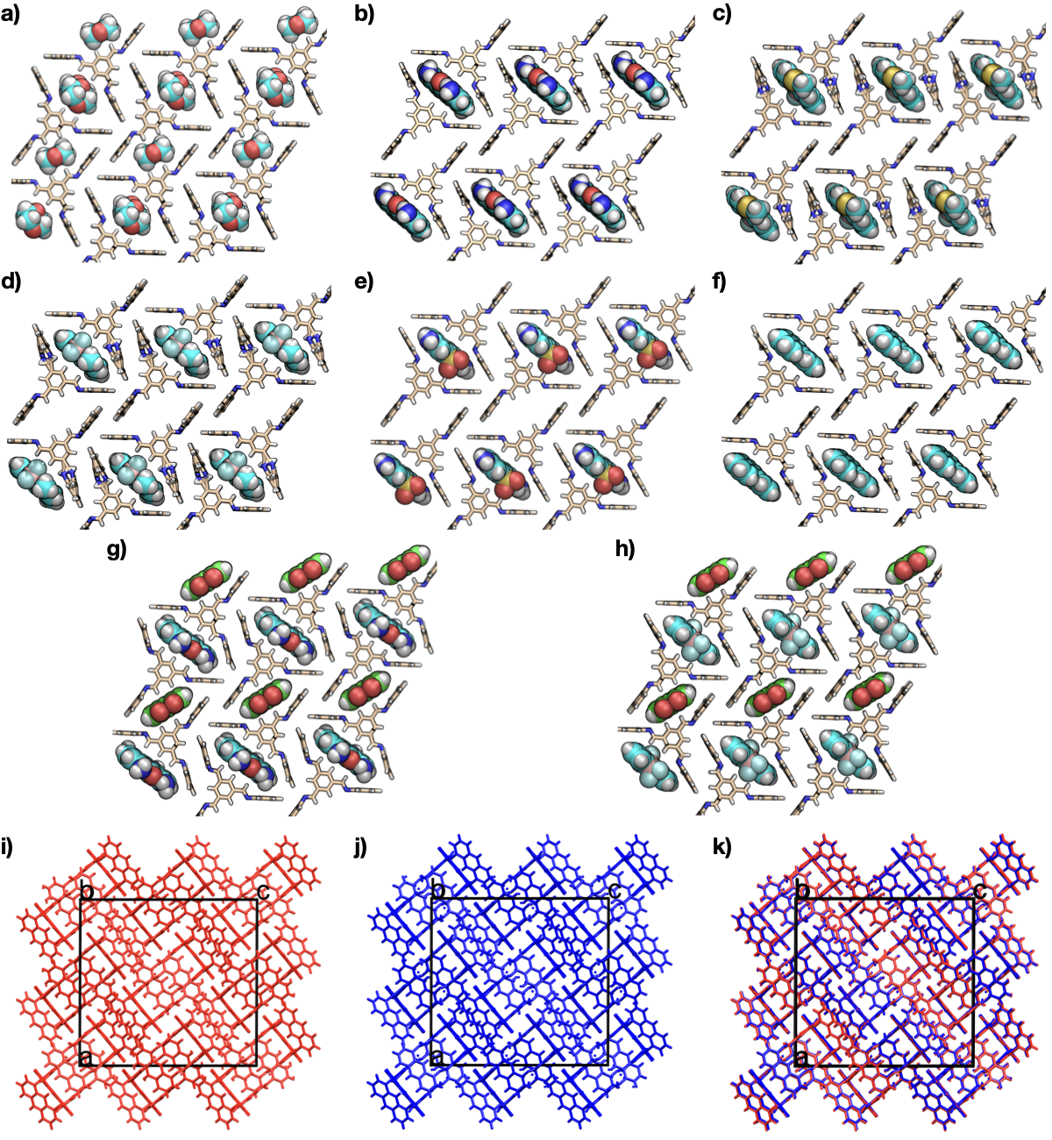
Figure 3. Crystal Structures of Isoskeletal Host-guest Co-crystals Adopting the 1α′ Form
(A) 1･2; (B) 1･3, (C) 1･6; (D) 1･7; (E) 1･8; (F) 1･11; (G) 1･3･10, (H) 1･6･10. The 1,4-dioxane (2) solvate is omitted from the small extrinsic cavities in (B)→ (F) for clarity, and the host, 1, and guests are shown using the stick and space-filling models, respectively, to emphasize the guest. Crystal packing of 1 in 1･2 (I, red) and 1･3 (J, blue). (K) Crystal packing overlay plots of 1･2 (red) and 1･3 (blue); determined using the structure overlay tool in Mercury⁵⁸ after deleting 2 and guest 3 from the respective crystal structures. Unit cell axes are shown in black. Carbon atoms for the host, guests 1 → 11, and guest 10, are shown in yellow, cyans, and green, respectively. Nitrogen, blue; oxygen, red; boron, pink; fluorine, lime green; and hydrogen, white.

By comparison, a series of inclusion host-guest co-crystals, 1･6, 1･7, and 1･8, was obtained as red needle-shaped single crystals by using guests with PCs of 47%, 44%, and 48%, respectively. 1･6, 1･7, and 1･8 crystallized in the monoclinic space group I2/a, with comparable unit cell parameters to those determined for 1･2 and 1･3 (Table S2). The close similarity between the crystal packing of 1 in 1α′ with those found in 1･6, 1･7, and 1･8 revealed that these structures are isoskeletal (Figure 3, and Supplementary Figures S6–8). Hence, the design approach is transferable across four different guests with different functionalities that have PC ranging between 44–50%, albeit with lower guest occupancies of 80% and 85% found by NMR in bulk grown samples of 1･7 and 1･8, respectively (Table S4, and Supplementary Figures S10–14).
To further investigate the PC limit, perylene (9), which was calculated to have a larger PC of 53%, was investigated experimentally. 1･9 crystallized in triclinic space group P$\overline{1}$, and the crystal packing of 1 in 1･9 was comparable to that of 1β′, rather than 1α′ (Supplementary Figure S18). This indicated that when the PC value of the guest was in the range 44–50%, then isoskeletal host-guest co-crystals with the 1α′-type packing were produced via selective guest inclusion in the host, 1, at least within the family of guests investigated here. By contrast, when the PC of the guest was outside this range, solid state structures with different packing arrangements of 1 were formed.
Shape effect
In addition to the PC value, the shape of the guest molecule is also important for determining the likelihood of host-guest co-crystal formation. To prove this, we used triphenylene (11) and tetracene (12), which have similar PCs of 50% and 49%, respectively, but quite different shapes (Figure 2i). The longest calculated dimension of guest 11 is 9.3 Å, which is within the 11.3 Å size limit calculated for the larger extrinsic cavity in 1α′. By contrast, the longest calculated dimension of guest 12 is 11.7 Å, which is, in principle, too large for the same extrinsic cavity in 1α′. Co-crystallisation studies validated this calculation, with an isoskeletal host-guest co-crystal similar to 1α′ formed with guest 11 (Figure 3 and Supplementary Figure S9), whereas a 2D layered packing of 1 more similar to 1β′ was obtained with guest 12 (Supplementary Figure S20). In the crystal structure of 1･12, there are interconnected 1D channels filled with tetracene guest (Supplementary Figure S20), unlike the isolated extrinsic voids in 1･11. The result with guests 11 and 12 demonstrates that a combination of both the PC and the guest shape are important screening tools for determining the likelihood of isoskeletal host-guest co-crystal formation using guests with different shapes and chemical functionalities.
Programmable guest inclusion with two solid guests
4-Naphthoquinone (10) has a smaller calculated PC of 35%, compared to pyrene (4, 42%) and anthracene (5, 39%), both of which induced 1 to form the 1β′ structure (Supplementary Figs. S12–13). When 1 was co-crystallized with guest 10 from 1,4-dioxane solvent, we obtained red block-shaped crystals that crystallized in the triclinic space group P$\overline{1}$. SC-XRD analysis of 1･10 revealed that cage 1 was packed to form a 2D layered structure, but its crystal packing was different to that in 1α′, indicating that its PC of 35% was out of the tolerance range for that packing. The crystal packing of 1 in 1･10 was also different from that in 1β′, but one of its defining features was that guest 10 occupied an extrinsic cavity 1･10 between two cage units packed in an edge-to-face fashion that was reminiscent of the smaller extrinsic cavity in 1α′ (Supplementary Figure S19). For comparison, the volume of the extrinsic cavity occupied by 10 in 1･10 was 219 Å³, which is compatible with the volume of the 217 Å³ extrinsic cavity in 1α′. Since there was a close structural similarity between the guest 10 occupied extrinsic cavity in 1･10 and the smaller extrinsic cavity in 1α′, we were inspired to consider a ternary organic crystal with two guests, in which guest 10 would occupy the smaller extrinsic cavity in 1α′.
Slow addition of n-pentane into a 1,4-dioxane solution of cage 1 and a mixture of guests 3 and 10 in a 2:3:3 molar ratio afforded red block-shaped single crystals of a new ternary organic solid, 1･3･10. The crystal structure of 1･3･10 had monoclinic I2/a symmetry, with a comparable unit cell to that determined for 1･2; indeed, the crystal packing of cage 1 in 1･3･10 and 1α′ are almost identical (Figure 3, and Supplementary Figure S15). By comparison with the structure of 1･2, in 1･3･10, the guest 10 displaces the 1,4-dioxane in the smaller extrinsic cavity to produce the ternary organic solid, indicating that selective and programable guest inclusion was realized utilizing our guest-size driven strategy. A second, similar ternary organic co-crystal was prepared using the guests 6 and 10, to produce 1･6･10 that have identical crystal packing arrangements of 1 and 10 compared to 1･3･10 (Figure 3, and Supplementary Figure S21), showing a degree of generality in this design approach.
Guest enhanced two-photon absorption
The insertion of highly emissive BODIPY guests (such as 6 and 7) into the organic cage host structure of 1 resulted in the formation of host-guest co-crystals of 1･6 and 1･7 that exhibited one-photon emission at 670 and 625 nm, respectively (Supplementary Figure S23). Guests 6 and 7 have emissions signals at 520 and 550 nm, which are within the excitation region of cage 1 (ranging from 300 to 600 nm, Supplementary Figure S22), which allows Förster resonance energy transfer (FRET) between the guest and host⁵⁹. Since BODIPY dyes have been reported to display two-photon excitation fluorescence⁶⁰, we were motivated to investigate the two photon-photoluminescence intensities (TPPL) of 1･2, 1･6, and 1･7, after excitation using different laser powers. Femtosecond laser pulses (50 fs, 10 kHz repetition rate), with wavelengths ranging from 400 to 800 nm, were used to study the TPPL of 1･2, 1･6, and 1･7 at room temperature (see Supplementary Information for experiment details). The solid state absorption spectra of cage 1 indicated that it had an absorption maximum at 400 nm (Supplementary Figure S22). Accordingly, we recorded a series of TPPL spectra at 800 nm, which we assumed would initiate 2PA signals. After excitation at 800 nm, the profiles of lg(I) vs lg(W) (where I and W represent the TPPL peak intensity and laser power, respectively) showed photoluminescence signals from 1･2, 1･6, and 1･7, which revealed their 2PA behaviors and confirmed that 2PA was responsible for the excitation at 800 nm (Supplementary Figure S24). Similar emission spectra profiles were observed for 1･2 and 1･6 regardless of one-photon absorption (1PA), or 2PA (Supplementary Figure S25), indicating that their emission involves the same electronic state. By contrast, a large red-shift (~ 50 nm) was observed between the 1PA and 2PA signals for 1･7, which might be a due to much stronger FRET between cage 1 and guest 7, compared to cage 1 and guest 6 (Supplementary Figure S25).
To determine the two-photon action cross-section (ησ₂), which is the product of 2PA cross-section (σ₂) and photoluminescence quantum yield (η), we used perylene as a reference^{61,62}. Initially, perylene was investigated using our experimental settings, and its σ₂ value was estimated to be 3.2 GM at 800 nm (See SI Section 11 for details), which is close to the reported value (3.0 GM)⁶¹, confirming the reliability of our method. Then, using perylene as the reference, the ησ₂ of 1･2, 1･6, and 1･7 were calculated to be 0.007, 0.010, and 0.044 GM, respectively (see Supplementary Section 11 for full details). As shown in Figure 4b, 1･7 has the largest 2PA action cross-section, which is six times greater than that of 1･2. Such guest-enhanced ησ₂ might be attributed to the FRET between the included BODIPY dye and cage host. Although the two-photon action cross-sections of host-guest co-crystals are not particularly high, it does demonstrate proof of concept for modifiying the photphysical function of the host by forming the host-guest co-crystals in a programmable way.

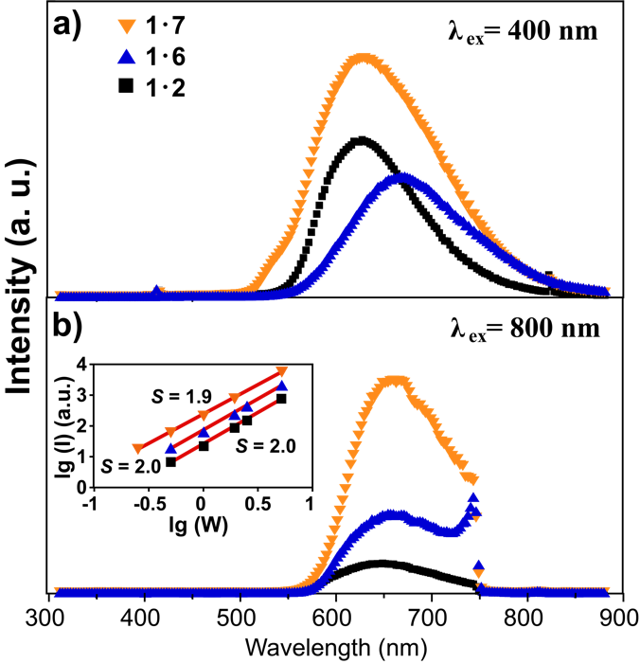
Figure 4. Multiphoton-excited Photoluminescence Spectra of 1･2, 1･6, and 1･7
(A) One-photon excited emission spectra recorded after excitation (λex) at 400 nm for 1･2, 1･6 and 1･7. (B) Two-photon excited emission spectra recorded after excitation at 800 nm for 1･2, 1･6, and 1･7. The inset shows the photoluminescence intensity dependence on laser intensity.

Conclusion
We have developed a new crystal design strategy that was used to produce five host-guest organic co-crystals and two host-guest ternary organic solids in a targeted way. The host-guest co-crystals were designed by introducing guests that had PCs ranging from 44 to 50% when compared to an extrinsic cavity in the crystal structure of the porous host, 1α′. This simple approach was tolerant to different guest shapes and chemical functionalities, and by extension, it enabled double host ternary organic co-crystals to be designed. By introducing highly emissive BODIPY guests into the porous host structure of 1α′, we prepared 1･6 and 1･7, which had far better photo-physical properties than the host alone, with 1･7 exhibiting a two-photon action cross-section that was enhanced by a factor of 6.
Our crystal design approach complements guest inclusion studies performed with other porous organic hosts. Here, we use a crystalline host with a guest-accessible extrinsic cavity that hosts a range of guests, using the PCs to determine whether guest encapsulation is probable. We, therefore, believe that our approach might be readily transferable to a range of different guests. While it remains challenging and computationally expensive to predict the formation of co-crystals by ab initio crystal structure prediction, particularly when co-crystal stoichiometry may also be variable, our approach is relatively simple. It requires only the calculation of host cavity and guest volumes, along with a check to see that no limiting dimensions are violated. While this strategy is not likely to be completely generalizable across all potential guests, we demonstrate a high degree of success across the range of guests we investigated. More broadly, this modular approach could be used to design host-guest organic crystals with new physical functionalities, as suggested by our preliminary guest-enhanced multiphoton harvesting experiments.

EXPERIMENTAL PROCEDURES
Resource availability
Lead contact
Further information and requests for resources should be directed to and will be fulfilled by the lead contact, Andrew I. Cooper (aicooper@liverpool.ac.uk).

Materials availability
All materials generated in this study are available from the lead contact without restriction.

Data and code availability
Supplementary CIFs that include structure factors are available free of charge from the Cambridge Crystallographic Data Centre (CCDC) via www.ccdc.cam.ac.uk/data_request/cif: 1･2 (2000286); 1･3 (2000284); 1･4 (2000291); 1･5 (2000294); 1･6 (2000287); 1･7 (2000289); 1･8 (2000288); 1･9 (2000292); 1･10 (2000290); 1･11 (2000293); 1･12 (2000485), and 1･3･10 (2000285), and 1･6･10 (2001207).

Materials and Methods
Anthracene-based cage (1) synthesis
Sc(OTf)₃ (40 mg, 0.081 mmol) in CH₃CN (10 mL) was added dropwise to a solution of benzene-1,3,5-tricarbaldehyde (100.0 mg, 0.62 mmol), 1,8-diaminoanthracene (192.7 mg, 0.93 mmol) and molecular sieves (3 Å) in chloroform (200 mL). The brown-green solution was stirred at room temperature for 16 hours, and the reaction mixture was then filtered to remove the insoluble polymer by-products and molecular sieves. The resulting brown filtrate was concentrated to 30 mL under reduced pressure at room temperature, and then 400 mL hexane was added to precipitate the cage molecule 1, which was isolated as brown powder in an overall yield of 56%: 143 mg. ¹H NMR (CDCl₃, 500 MHz, 298 K): δ (ppm) 8.54 (s, 6H), 8.52 (s, 6H), 8.47 (s, 3H), 8.32 (s, 3H), 7.86 (d, ²J_{HH} = 8.5 Hz, 6H), 7.46 (dd, ¹J_{HH} = 7.0 Hz, ²J_{HH} = 8.5 Hz, 6H) and 6.87 (d, ²J_{HH} = 7.0 Hz, 6H). ¹³C NMR (CDCl₃, 125 MHz, 300 K): δ (ppm) 161.1, 150.7, 137.0, 132.3, 131.0, 126.1, 125.7, 125.0, 118.7 and 111.2. HR-MS (CI, CH₄): m/z calcd. for [(C₆₀H₃₆N₆)+H]⁺: 841.3080 (M)⁺; found, 841.3081.
General procedures for preparing cage clathrates
As-synthesized cage 1 (20 mg, 24 μmol) was dissolved in 1,4-dioxane (10 mL). The resulting suspension was filtrated through a syringe filter (PTEF, pore size 0.2 μm, Whatman) to give an orange solution. The guest molecule (48 μmol)in powdered form was dissolved into the orange filtrate and the resulting mixture was divided into 10 bathes (1 mL x 10). Slow diffusion of n-pentane into the cage-guest mixture in 1,4-dioxane afforded co-crystals of the host-guest complexes that were suitable for SC-XRD analysis.
Single crystal X-ray diffraction
Single crystal X-ray data sets were measured at beamline I19, Diamond Light Source, Didcot, UK using silicon double crystal monochromated synchrotron radiation (λ = 0.6889 Å, Dectris Pilatus 2M). Crystals were isolated from their crystallization solvents, mounted on MiTeGen loops, and then flash cooled to 100 K under a dry nitrogen gas flow. Data reduction and absorption corrections were performed with xia2.⁶³ Structures were solved using SHELXT,⁶⁴ and reined by full-matrix least-squares on |F|² by SHELXL,⁶⁵ interfaced through the programme OLEX2.⁶⁶ The monoclinic C2/c unit cell parameters for 1∙2 are, a = 37.4 Å, b = 15.0 Å, c = 25.7 Å, β = 133.1°, and the crystal structure was refined in the more orthogonal I-centred unit cell. The isoskeletal host-guests co-crystals had comparable monoclinic C2/c unit cell parameters as 1∙2 and were likewise refined in I-centred monoclinic unit cells. Further details about the crystal structure refinements, including how the guests were modelled, are included in SI Section 12. Supplementary CIFs that include structure factors are available free of charge from the Cambridge Crystallographic Data Centre (CCDC) via www.ccdc.cam.ac.uk/data_request/cif: 1･2 (2000286); 1･3 (2000284); 1･4 (2000291); 1･5 (2000294); 1･6 (2000287); 1･7 (2000289); 1･8 (2000288); 1･9 (2000292); 1･10 (2000290); 1･11 (2000293); 1･12 (2000485), and 1･3･10 (2000285), and 1･6･10 (2001207).
Calculation of cavity volume and guest dimensions
The guest dimensions were calculated using the maximum distance between atoms in the molecule and then using the atomic radii within Maestro (Schrodinger PLC).⁶⁷ The cavity volume was calculated and visualized with a 1.20 Å probe using Mercury^{58,68} where the solvent contact surface was considered. The grid spacing used was 0.7 Å. To isolate cavities of the same type, other pores were blocked with dummy atoms. The cavity volume was calculated as an average over the cell. The guest molecular volume was numerically calculated using Maestro where the atomic radii of non-hydrogen atoms were used. The volume was calculated numerically on a grid using a set of atomic radii within the Schrodinger code. The packing coefficient has been calculated by the following expression:
Packing Coefficient = Guest Molecular Volume / Cavity Volume.
Optical measurement.
One- and two-photon excited photoluminescence (2EPL) measurements were performed at room temperature at 400 and 800 nm, respectively, using an optical Kerr gate setup developed at Central Laser Facility STFC. In these measurements, the optical Kerr gate was used to record time-resolved fluorescence (TRF) data under single-photon and multiphoton excitation conditions. Both laser beams from the dual-beam ULTRA laser system⁶⁹ were used to excite the samples with an fs beam, and the optical Kerr gate was driven with a ps beam. Both laser beams were produced using a Ti:Sapphire regenerative amplifier/multi-pass amplifier lasers optically synchronized through sharing the same seed beam and operating at a 10 kHz repetition rate. The pulse duration of the fs beam was 50 fs and approximately 2 ps for the ps gating beam. The 800 nm beam was the fundamental output from the Ti:Sapphire laser, while the 400 nm beam was produced through frequency doubling. The PL spectra under single- or two-photon excitation, as well as harmonic generation of the excitation pulses, were recorded with Andor Shamrock 303i spectrograph equipped with Andor iDus DU420A CCD camera. The laser power was measured by an optical power meter (PM100A display along with S120UV photodiode sensor from Thorlabs for 400 nm and 800 nm beams).
SUPPLEMENTAL INFORMATION
Document S1. Supplemental experimental procedures, Figures S1–S26, Tables S1–S11, and Supplemental references.
ACKNOWLEDGMENTS
The authors gratefully acknowledge the Engineering and Physical Sciences Research Council (EP/H000925/1 and EP/P005543/1) and the European Research Council under FP7 (CoMMaD, ERC Grant No. 758370) for financial support. K.E.J. is a Royal Society University Research Fellow. The authors thank the Science and Technology Facilities Council for access to Ultra at the Central Laser Facility (18130008) and Diamond Light Source for access to beamlines I19 (CY21726) and I11 (EE17193) that contributed to the results presented here. We thank Miss. Hui Gao for assistance during the multiple photon excited photoluminescence measurments. G.-H.N. thanks for the financial support from Guangdong Basic and Applied Basic Research Foundation (2019B151502024), Guangdong Province Pearl River Scholar Funded Scheme (2019), and the Fundamental Research Funds for the Central Universities (21619315).
AUTHOR CONTRIBUTIONS
G.-H. N., M.A.L., and A.I.C. conceived the project. G.-H. N. and Q.Z. prepared the cage molecules and crystallized organic co-crystals. G.-H. N., M.A.L., P.C., Q.Z., and R.-J.W. performed the single X-ray measurement and interpreted the experimental data. Z. P., J. T. P., and K. E. J. calculated the cavity and the volume of guests. G.-H. N., M.A.L., I. S., and M. T. conducted the multiple photon excited photoluminescence measurement and interpreted the spectroscopic data. All authors contributed to the preparation of the manuscript.
DECLARATION OF INTERESTS
The authors declare no competing interests.
REFERENCES*

(1) Kyba, E.P., Helgeson, R.C., Madan, K., Gokel, G.W., Tarnowski, T.L., Moore, S.S., and Cram, D.J. (1977). Host-Guest Complexation. 1. Concept and Illustration. J. Am. Chem. Soc. 99, 2564–2571.
(2) Lehn, J.-M. (1990). Perspectives in Supramolecular Chemistry—From Molecular Recognition towards Molecular Information Processing and Self-Organization. Angew. Chemie Int. Ed. English 29, 1304–1319.
(3) Lehn, J.-M. (1995). Supramolecular Chemistry: Concepts and Perspectives (VCH: Weinheim).
(4) Fung, B.M., Khitrin, A.K., and Ermolaev, K. (2000). An Improved Broadband Decoupling Sequence for Liquid Crystals and Solids. J. Magn. Reson. 142, 97–101.
(5) Ariga, K., Ito, H., Hill, J.P., and Tsukube, H. (2012). Molecular Recognition: From Solution Science to Nano/materials Technology. Chem. Soc. Rev. 41, 5800–5835.
(6) Hof, F., Craig, S.L., Nuckolls, C., and Rebek Julius, J. (2002). Molecular Encapsulation. Angew. Chemie Int. Ed. 41, 1488–1508.
(7) Yoshizawa, M., Klosterman, J.K., and Fujita, M. (2009). Functional Molecular Flasks: New Properties and Reactions within Discrete, Self-Assembled Hosts. Angew. Chemie Int. Ed. 48, 3418–3438.
(8) Férey, G. (2008). Hybrid Porous Solids: Past, Present, Future. Chem. Soc. Rev. 37, 191–214.
(9) Horike, S., Shimomura, S., and Kitagawa, S. (2009). Soft Porous Crystals. Nat. Chem. 1, 695–704.
(10) Conn, M.M., and Rebek, J. (1997). Self-Assembling Capsules. Chem. Rev. 97, 1647–1668.
(11) Pedersen, C.J. (1967). Cyclic Polyethers and Their Complexes with Metal Salts. J. Am. Chem. Soc. 89, 2495–2496.
(12) Cram, D.J. (1983). Cavitands: Organic Hosts with Enforced Cavities. Science 219, 1177–1183.
(13) Caulder, D.L., and Raymond, K.N. (1999). Supermolecules by Design. Acc. Chem. Res. 32, 975–982.
(14) Fujita, M. (1998). Metal-directed Self-assembly of Two- and Three-Dimensional Synthetic Receptors. Chem. Soc. Rev. 27, 417–425.
(15) Zhang, G., and Mastalerz, M. (2014). Organic Cage Compounds – From Shape-Persistency to Function. Chem. Soc. Rev. 43, 1934–1947.
(16) Barrow, S.J., Kasera, S., Rowland, M.J., del Barrio, J., and Scherman, O.A. (2015). Cucurbituril-Based Molecular Recognition. Chem. Rev. 115, 12320–12406.
(17) Conners, K.A. (1987). Binding Constants: The Measurement of Molecular Complex Stability (New York, NY: Wiley-VCH).
(18) Mecozzi, S., and Rebek Julius, J. (1998). The 55 % Solution: A Formula for Molecular Recognition in the Liquid State. Chem. – A Eur. J. 4, 1016–1022.
(19) Rebek, J. (2009). Molecular Behavior in Small Spaces. Acc. Chem. Res. 42, 1660–1668.
(20) Cram, D.J. (1988). The Design of Molecular Hosts, Guests, and Their Complexes (Nobel Lecture). Angew. Chemie Int. Ed. 27, 1009–1020.
(21) Ballester, P., Fujita, M., and Rebek, J. (2015). Molecular Containers. Chem. Soc. Rev. 44, 392–393.
(22) Schneider, H.-J. (1991). Mechanisms of Molecular Recognition: Investigations of Organic Host–Guest Complexes. Angew. Chemie Int. Ed. 30, 1417–1436.
(23) Schneider, H.-J. (1994). Linear Free Energy Relationships and Pairwise iInteractions in Supramolecular Chemistry. Chem. Soc. Rev. 23, 227–234.
(24) Davis, A. V, and Raymond, K.N. (2005). The Big Squeeze: Guest Exchange in an M4L6 Supramolecular Host. J. Am. Chem. Soc. 127, 7912–7919.
(25) Chang, C.-E., and Gilson, M.K. (2004). Free Energy, Entropy, and Induced Fit in Host−Guest Recognition: Calculations with the Second-Generation Mining Minima Algorithm. J. Am. Chem. Soc. 126, 13156–13164.
(26) Schneider, H.-J. (2009). Binding Mechanisms in Supramolecular Complexes. Angew. Chemie Int. Ed. 48, 3924–3977.
(27) Hammes, G.G., Chang, Y.-C., and Oas, T.G. (2009). Conformational Selection or Induced Fit: A Flux Description of Reaction Mechanism. Proc. Natl. Acad. Sci. 106, 13737– 13741.
(28) Rebek Jr., J. (2005). Simultaneous Encapsulation: Molecules Held at Close Range. Angew. Chemie Int. Ed. 44, 2068–2078.
(29) Turega, S., Cullen, W., Whitehead, M., Hunter, C.A., and Ward, M.D. (2014). Mapping the Internal Recognition Surface of an Octanuclear Coordination Cage Using Guest Libraries. J. Am. Chem. Soc. 136, 8475–8483.
(30) Hasell, T., and Cooper, A.I. (2016). Porous Organic Cages: Soluble, Modular and Molecular Pores. Nat. Rev. Mater. 1, 16053.
(31) Little, M.A., and Cooper, A.I. (2020). The Chemistry of Porous Organic Molecular Materials. Adv. Funct. Mater. 1909842.
(32) van Heerden, D.P., and Barbour, L.J. (2021). Guest-Occupiable Space in the Crystalline Solid State: A Simple Rule-of-Thumb for Predicting Occupancy. Chem. Soc. Rev. 2, 735-749
(33) Furukawa, H., Cordova, K.E., O’Keeffe, M., and Yaghi, O.M. (2013). The Chemistry and Applications of Metal-Organic Frameworks. Science 341, 1230444.
(34) Diercks, C.S., and Yaghi, O.M. (2017). The Atom, the Molecule, and the Covalent Organic Framework. Science 355, eaal1585.
(35) Lin, R.-B., He, Y., Li, P., Wang, H., Zhou, W., and Chen, B. (2019). Multifunctional Porous Hydrogen-Bonded Organic Framework Materials. Chem. Soc. Rev. 48, 1362–1389.
(36) Cadiau, A., Adil, K., Bhatt, P.M., Belmabkhout, Y., and Eddaoudi, M. (2016). A Metal-Organic Framework–Based Splitter for Separating Propylene From Propane. Science 353, 137–140.
(37) Cui, X., Chen, K., Xing, H., Yang, Q., Krishna, R., Bao, Z., Wu, H., Zhou, W., Dong, X., Han, Y., et al. (2016). Pore Chemistry and Size Control in Hybrid Porous Materials for Acetylene Capture From Ethylene. Science 353, 141–144.
(38) Mastalerz, M., and Oppel, I.M. (2012). Rational Construction of an Extrinsic Porous Molecular Crystal with an Extraordinary High Specific Surface Area. Angew. Chemie Int. Ed. 51, 5252–5255.
(39) Jie, K., Liu, M., Zhou, Y., Little, M.A., Bonakala, S., Chong, S.Y., Stephenson, A., Chen, L., Huang, F., and Cooper, A.I. (2017). Styrene Purification by Guest-Induced Restructuring of Pillar[6]arene. J. Am. Chem. Soc. 139, 2908–2911.
(40) Lloyd, G.O., Alen, J., Bredenkamp, M.W., de Vries, E.J.C., Esterhuysen, C., and Barbour, L.J. (2006). Solid-State Self-Inclusion: The Missing Link. Angew. Chemie Int. Ed. 45, 5354–5358.
(41) Price, S.L. (2014). Predicting Crystal Structures of Organic Compounds. Chem. Soc. Rev. 43, 2098–2111.
(42) Jones, J.T.A., Hasell, T., Wu, X., Bacsa, J., Jelfs, K.E., Schmidtmann, M., Chong, S.Y., Adams, D.J., Trewin, A., Schiffman, F., et al. (2011). Modular and Predictable Assembly of Porous Organic Molecular Crystals. Nature 474, 367–371.
(43) Pulido, A., Chen, L., Kaczorowski, T., Holden, D., Little, M.A., Chong, S.Y., Slater, B.J., McMahon, D.P., Bonillo, B., Stackhouse, C.J., et al. (2017). Functional Materials Discovery Using Energy–Structure–Function Maps. Nature 543, 657–664.
(44) Cruz-Cabeza, A.J., Day, G.M., and Jones, W. (2008). Towards Prediction of Stoichiometry in Crystalline Multicomponent Complexes. Chem. – A Eur. J. 14, 8830–8836.
(45) Karamertzanis, P.G., Kazantsev, A. V, Issa, N., Welch, G.W.A., Adjiman, C.S., Pantelides, C.C., and Price, S.L. (2009). Can the Formation of Pharmaceutical Cocrystals Be Computationally Predicted? 2. Crystal Structure Prediction. J. Chem. Theory Comput. 5, 1432–1448.
(46) Bučar, D.-K., Day, G.M., Halasz, I., Zhang, G.G.Z., Sander, J.R.G., Reid, D.G., MacGillivray, L.R., Duer, M.J., and Jones, W. (2013). The Curious Case of (Caffeine)·(Benzoic Acid): How Heteronuclear Seeding Allowed the Formation of an Elusive Cocrystal. Chem. Sci. 4, 4417–4425.
(47) Kitagawa, S., Kitaura, R., and Noro, S. (2004). Functional Porous Coordination Polymers. Angew. Chemie Int. Ed. 43, 2334–2375.
(48) Desiraju, G.R. (2013). Crystal Engineering: From Molecule to Crystal. J. Am. Chem. Soc. 135, 9952–9967.
(49) Mir, N.A., Dubey, R., and Desiraju, G.R. (2019). Strategy and Methodology in the Synthesis of Multicomponent Molecular Solids: The Quest for Higher Cocrystals. Acc. Chem. Res. 52, 2210–2220.
(50) Corpinot, M.K., and Bučar, D.-K. (2019). A Practical Guide to the Design of Molecular Crystals. Cryst. Growth Des. 19, 1426–1453.
(51) Little, M.A., Briggs, M.E., Jones, J.T.A., Schmidtmann, M., Hasell, T., Chong, S.Y., Jelfs, K.E., Chen, L., and Cooper, A.I. (2015). Trapping Virtual Pores by Crystal Retro-Engineering. Nat. Chem. 7, 153–159.
(52) Zheng, Q., Zhu, H., Chen, S.-C., Tang, C., Ma, E., and Chen, X. (2013). Frequency-Upconverted Stimulated Emission by Simultaneous Five-Photon Absorption. Nat. Photonics 7, 234–239.
(53) Medishetty, R., Zaręba, J.K., Mayer, D., Samoć, M., and Fischer, R.A. (2017). Nonlinear Optical Properties, Upconversion and Lasing in Metal–Organic Frameworks. Chem. Soc. Rev. 46, 4976–5004.
(54) Wang, Y., Wu, H., Li, P., Chen, S., Jones, L.O., Mosquera, M.A., Zhang, L., Cai, K., Chen, H., Chen, X.-Y., et al. (2020). Two-Photon Excited Deep-Red and Near-Infrared Emissive Organic Co-Crystals. Nat. Commun. 11, 4633.
(55) Baroncini, M., D’Agostino, S., Bergamini, G., Ceroni, P., Comotti, A., Sozzani, P., Bassanetti, I., Grepioni, F., Hernandez, T.M., Silvi, S., et al. (2015). Photoinduced Reversible Switching of Porosity in Molecular Crystals Based on Star-Shaped Azobenzene Tetramers. Nat. Chem. 7, 634–640.
(56) Kohl, B., Rominger, F., and Mastalerz, M. (2015). Crystal Structures of a Molecule Designed Not To Pack Tightly. Chem. - A Eur. J. 21, 17308–17313.
(57) Bishop, R. (1996). Designing New Lattice Inclusion Hosts. Chem. Soc. Rev. 25, 311–319.
(58) Macrae, C.F., Edgington, P.R., McCabe, P., Pidcock, E., Shields, G.P., Taylor, R., Towler, M., and Van De Streek, J. (2006). Mercury: Visualization and Analysis of Crystal Structures. J. Appl. Crystallogr. 39, 453–457.
(59) Förster, T. (1959). Transfer Mechanisms of Electronic Excitation. Discuss. Faraday Soc. 27, 7–17.
(60) Barros, L.W.T., Cardoso, T.A.S., Bihlmeier, A., Wagner, D., Kölmel, D.K., Hörner, A., Bräse, S., Brito Cruz, C.H., and Padilha, L.A. (2017). Two-Photon Absorption in a Series of 2,6-Disubstituted BODIPY Dyes. Phys. Chem. Chem. Phys. 19, 21683–21690.
(61) Makarov, N.S., Drobizhev, M., and Rebane, A. (2008). Two-Photon Absorption Standards in the 550-1600 nm Excitation Wavelength Range. Opt. Express 16, 4029–4047.
(62) Katoh, R., Katoh, S., Furube, A., Tokumaru, K., and Kotani, M. (2009). Fluorescence Quantum Yield of Aromatic Hydrocarbon Crystals. J. Phys. Chem. C 113, 2961–2965.
(63) Winter, G., Waterman, D.G., Parkhurst, J.M., Brewster, A.S., Gildea, R.J., Gerstel, M., Fuentes-Montero, L., Vollmar, M., Michels-Clark, T., Young, I.D., et al. (2018). DIALS: Implementation and Evaluation of a New Integration Package. Acta Crystallogr. Sect. D Struct. Biol. 74, 85-97
(64) Sheldrick, G.M. (2015). SHELXT – Integrated space-group and crystal-structure determination. Acta Crystallogr. Sect. A Found. Adv. 71, 3–8.
(65) Sheldrick, G.M. (2015). Crystal structure refinement with SHELXL. Acta Crystallogr. Sect. C Struct. Chem. 71, 3–8.
(66) Dolomanov, O. V., Bourhis, L.J., Gildea, R.J., Howard, J.A.K., and Puschmann, H. (2009). OLEX2: A Complete Structure Solution, Refinement and Analysis Program. J. Appl. Crystallogr. 42, 339–341.
(67) Schrödinger (2018). Schrödinger Release 2018-4: MacroModel; Schrödinger, LLC: New York, NY.
(68) Macrae, C.F., Bruno, I.J., Chisholm, J.A., Edgington, P.R., McCabe, P., Pidcock, E., Rodriguez-Monge, L., Taylor, R., Van De Streek, J., and Wood, P.A. (2008). Mercury CSD 2.0 - New Features for the Visualization and Investigation of Crystal Structures. J. Appl. Crystallogr. 41, 466–470.
(69) Greetham, G.M., Burgos, P., Qian, C., Clark, I.P., Codd, P.S., Farrow, R.C., George, M.W., Kogimtzis, M., Matousek, P., Parker, A.W., et al. (2010). ULTRA: A Unique Instrument for Time-Resolved Spectroscopy. Applied Spectroscopy, 64, 1311-1319.

