Figure 1. Graphical presentation of the number of daily COVID-19 cases and deaths in the UK, sourced from Our World in Data, 2020, aligned to the C19PRC Study survey waves. Note: New daily deaths and cases depicted as 7-day rolling average.
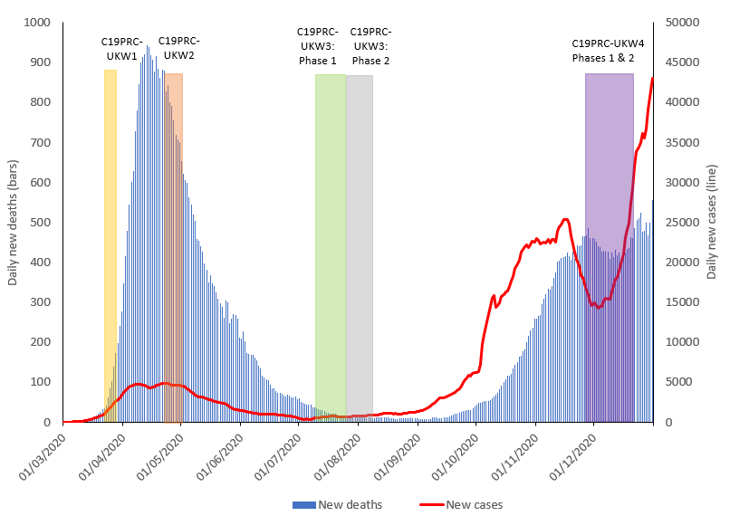
Figure 2. Flowchart of participation in the COVID-19 Psychological Research Consortium Study (C19PRC) Study, Waves 1-4
