Efficacy, safety and impact on antimicrobial resistance of duration and dose of amoxicillin treatment for young children with Community-Acquired Pneumonia: a randomised double-blind non-inferiority factorial trial (CAP-IT)

Target journal: Lancet
Target word count: 3000 (but can go up to 4500)
Abstract target word count: 300
Max references: 30

Abstract (300/300) - structure: Background, Methods, Findings, Interpretation, Funding

Background
Amoxicillin is recommended for oral treatment of childhood community-acquired pneumonia (CAP). CAP-IT investigated the effect of amoxicillin dose and duration on efficacy, safety and antimicrobial resistance.
Methods
In this multicenter double-blinded non-inferiority factorial trial, children in UK/Ireland, clinically diagnosed with uncomplicated CAP and planned for discharge from emergency departments (ED) or hospital wards, were concurrently randomised 1:1 to lower (35-50 mg/kg) or higher (70-90 mg/kg) daily amoxicillin doses; and shorter (3-day) or longer (7-day) duration. The primary endpoint was clinically-indicated systemic antibiotic re-treatment for respiratory infections over four weeks. The trial was powered at 90% with a non-inferiority margin of 8%. Adverse events, duration of parent-reported symptoms and pneumococcal resistance were secondary endpoints. Data were analysed using time-to-event methods.

Findings
Between February 2017-April 2019, 814 children from 29 hospitals were randomised and received at least one dose of trial medication. Median(IQR) age was 2.5 years (1.6-3.7); 52% male; 591/814(73%) were discharged from ED; 223(27%) from ward. 767(94%) children completed trial treatment. A primary endpoint (ascertained in 789;97%) occurred in 51/410(12.6%) children receiving lower versus 49/404(12.4%) higher dose (difference 0.2% [90%CI -3.7,4.0]), and 51/413(12.5%) shorter versus 49/401(12.5%) longer duration (difference 0.1% [90%CI -3.8,3.9)], both meeting non-inferiority criteria. Time to resolution of symptoms differed only for mild cough (12 (shorter) versus 10 days (longer), p=0.04) and sleep disturbance (p=0.026). Adverse events and development of pneumococcal penicillin non-susceptibility was comparable between arms.
Interpretation
In children with CAP, discharged from ED or hospital in high-income settings, effectiveness, adverse events and colonization by penicillin non-susceptible pneumococci were similar with higher versus lower amoxicillin dose, and with 3 versus 7-day amoxicillin treatment. Recommending 3-day amoxicillin treatment for paediatric CAP would result in harmonisation across high- and low/middle-income settings globally.
Funding
Funded by the National Institute for Health Research, grant number 13/88/11; CAP-IT ISRCTN76888927)

Main text (4222/4500)
Introduction
Globally, children younger than five years of age are most likely the highest users of antibiotics prescribed in the community setting.¹ Most prescriptions result from ambulatory visits to healthcare facilities for respiratory conditions.² In the US, up to 5% of under-five year-olds seek medical care for community-acquired pneumonia (CAP) each year, 20% of these in emergency departments (EDs).² In a study of 4560 children without comorbidities presenting with fever to 28 European EDs, the lower respiratory tract was the second most common focus of infection, ³ and in a systematic review by the same authors, >80% children with CAP presenting to European EDs are treated with antibiotics. ⁴ Globally, lower respiratory tract infections are the commonest reason for prescribing antibiotics to children in hospital, accounting for 29% of therapeutic prescriptions.⁵
Bacteria are causally implicated in nearly a third of CAP cases among children <5 years admitted to hospital, and co-detection of viruses and bacteria in the upper airways is common.^{6,7} S. pneumoniae is the most commonly isolated bacterial pathogen, even in settings with high pneumococcal vaccination rates.⁷ Children with clinical signs of pneumonia, including fever, focal chest signs, tachy/dyspnoea and hypoxemia, may exhibit no chest X-ray abnormalities, and the role of inflammatory markers, such as C-reactive protein, in reliably differentiating viral from bacterial pneumonia remains unclear.⁸⁻¹⁰ The clinical picture can be mixed, and with a lack of predictive diagnostic tests to rule out or confirm the need for antibiotic treatment, young unwell children with a range of respiratory clinical signs are likely to continue to be prescribed antibiotics in the future.
Amoxicillin is generally recommended as the first-line antibiotic for CAP.¹¹⁻¹⁷ In low and middle-income countries (LMICs) with high case fatality from CAP in otherwise healthy children, there is randomised evidence to support a total daily amoxicillin dose of at least 80 mg/kg prescribed in two doses for 3 to 5 days to children discharged home from medical care, although most trials predate the availability of pneumococcal vaccine.^{18,19} However, the most appropriate total daily dose and duration of amoxicillin treatment remain unclear for children with CAP diagnosed in and discharged from hospital in high-income settings where pneumococcal vaccination rates are high, and guidelines and clinical practice vary considerably.^{11-13,16,17} Therefore, in the CAP-IT trial, we evaluated whether shorter duration and lower dose of amoxicillin were non-inferior in terms of efficacy, symptom duration, adverse drug effects and development of resistance than longer duration and higher dose.

Methods
Study design
CAP-IT was a multi-centre, randomised, placebo-controlled, 2x2 factorial, non-inferiority trial comparing total daily amoxicillin dose (35-50 mg/kg or 70-90 mg/kg) and duration (3 or 7 days) for the treatment of children with CAP. 800 children were to be recruited from 28 hospitals in the United Kingdom and one in Ireland. The trial protocol was approved by West London & GTAC Research Ethics Committee (16/LO/0831) and has been described elsewhere.²⁰
Based on an internal pilot phase, the protocol was revised to include the following amendments: (i) joint (rather than separate) analysis of children presenting and immediately discharged from the ED and those discharged after a short inpatient stay, (ii) formation of a blinded Endpoint Review Committee (ERC) for adjudication of primary endpoints and (iii) revision of the non-inferiority margin from 4% to 8% in view of a primary endpoint rate of 15% observed in the pilot phase (versus an initial expected rate of 5%). Additional details are provided in the supplementary appendix (appendix p 2).
Participants
Children aged ≥6 months and weighing 6-24 kg were considered for inclusion if they were diagnosed with CAP requiring antibiotics, and presented at the ED, or were being discharged from an observational unit or paediatric ward at a participating site. CAP was defined as (1) cough within 96 hours prior to presentation reported by parent/guardian, and (2) temperature ≥38°C at presentation or reported fever within previous 48 hours, and (3) signs of laboured/difficult breathing or focal chest sign(s), in line with British Thoracic Society guidelines.¹² Randomisation took place at discharge if the clinician had decided to prescribe oral amoxicillin as the only antibiotic, and all other inclusion criteria (appendix pp 2-4) were met. Exclusion criteria included (1) >48 hours of ongoing beta-lactam antibiotic treatment, (2) severe underlying chronic disease, (3) any contraindications to amoxicillin, including allergy, (4) complicated pneumonia (defined as signs of sepsis or local parenchymal or pleural complications), or (5) bilateral wheezing without focal chest signs.
Randomisation and masking
The trial statistician (WS) wrote a computer program to generate randomisation lists based on random permuted blocks, with a 1:1:1:1 allocation to each of the four factorial groups. Randomisation was stratified by centre and prior hospital administration of any non-trial antibiotic (for <48 hours). An independent supplier rebottled, packaged, and labelled trial medication in a blinded manner, and assigned sequential numbers based on the randomisation list. Packages of medication were then delivered to the pharmacies of participating sites. Treatments were randomly assigned by taking the next sequentially numbered package from the relevant stock at site.
Lower and higher drug doses were achieved by administering the same volume according to a weight-banded dosing chart (appendix p 4) using two different strengths of amoxicillin (125mg/5ml and 250mg/5ml), which were otherwise of identical look, smell and taste. The total daily dose was administered as two daily doses based on international recommendations and input from parent representatives.^{11,13-15,17,20} As it is difficult to taste-match suspensions of amoxicillin and placebo, a single amoxicillin brand was used for the first 3 days. For days 4-7, all participants switched medication to either a different amoxicillin-containing suspension (of the same dose) or a matching placebo suspension.
Procedures
Children were screened to ensure they met eligibility criteria during initial clinical assessment or during hospital admission by trained staff. At screening, parents provided a medical history of the child’s respiratory symptoms, and chest and physical examinations were performed. No radiological or laboratory diagnostic tests were mandated but were collected if done as part of routine evaluation. A nasopharyngeal swab was taken at enrolment prior to administration of trial drug.
Follow-up data were collected during scheduled telephone calls on 3, 7, 14, and 21 days after discharge, and on day 28 during a face-to-face visit (or telephone call if a visit was not possible). At all follow-up contacts, information was collected on CAP symptoms, adverse events, adherence to trial medication, and any prescription of non-trial antibiotics. Parents/guardians were also provided with a diary (paper or electronic) to be completed during the first 14 days, on which were collected similar data plus information on health service utilisation. At face-to-face final follow-up visits, a nasopharyngeal swab was collected, and a physical examination was performed. Family doctors were asked about non-trial antibiotic prescriptions if the day 28 visit was missed, provided consent had been given.
Nasopharyngeal swabs were frozen at below -20ºC within 6 hours of being obtained. Samples were batched and sent to Children’s Vaccine Centre (Bristol University) for screening culture, performed by plating samples onto streptococcal selective agar COBA plates and incubation at 37°C and 5% CO₂. Plates were examined at 24 and 48 hours and suspected alpha-haemolytic colonies confirmed by inhibition on optochin disc and solubility on bile salts. All S. pneumoniae isolates were then transferred to the University of Antwerp for confirmatory analysis and penicillin susceptibility testing. Phenotypic penicillin-susceptibility was determined for S. pneumoniae isolates by microbroth dilution across a dilution range for penicillin of 0.016 to 16 mg/L, and interpreted according to EUCAST Clinical Breakpoint Tables v. 10.0 for benzylpenicillin and S. pneumoniae (infections other than meningitis): a) sensitive (minimal inhibitory concentration (MIC) ≤ 0.064 mg/L), non-susceptible (MIC 0.125 to 2 mg/L), and c) resistant (MIC > 2 mg/L).²¹ The same approach was taken for amoxicillin susceptibility testing (isolates with MIC ≤ 0.5 mg/L = sensitive; MIC > 1 mg/L = resistant).²¹ S. pneumoniae ATCC49619 was used for quality control.
Outcomes
The primary endpoint was clinically indicated treatment with systemic antibiotics other than trial medication for respiratory tract infection (RTI), including CAP, within 4 weeks of randomisation. All primary endpoints were reviewed by an Endpoint Review Committee (ERC), blinded to treatment allocation, to adjudicate whether treatment was clinically indicated and whether the additional treatment was due to RTI.
Secondary endpoints included (i) severity and duration of nine parent-reported CAP symptoms (fever, cough, phlegm, fast breathing, wheeze, disturbed sleep, eating/drinking less, interference with normal activity, vomiting); (ii) specified potentially amoxicillin-related clinical adverse events (diarrhoea, thrush, and skin rashes); (iii) adherence to trial medication, and (iv) phenotypic resistance to penicillin at 28 days in nasopharyngeal S. pneumoniae isolates.
Statistical design and analysis
The trial was designed to demonstrate the non-inferiority of lower dose relative to higher dose and shorter duration relative to longer duration, in terms of the primary endpoint. The non-inferiority margin was defined as a risk difference of 8%, assessed against a 2-sided 90% CI. Assuming a 15% antibiotic re-treatment rate based on internal pilot data, 15% loss to follow-up, and no interaction between the two interventions, the sample size of 800 children achieved 90% power.
All analyses excluded participants who had not taken any trial drug. The proportion of children meeting the primary endpoint was obtained from the cumulative incidence at day 28 as estimated by Kaplan-Meier methods i.e. accounting for loss to follow-up. The main effect of each randomisation was estimated by collapsing across levels of the other randomisation factor, after checking for the absence of statistical interaction. Interaction tests between the two randomisations and prior antibiotic exposure were also performed.
Modified versions of the primary endpoint were evaluated in pre-specified sensitivity analyses: 1) retreatment regardless of reason or indication; 2) retreatment for CAP or “chest infection” specifically, rather than any RTI; 3) disregarding retreatment within three days of randomisation in the duration analysis. To provide reassurance that a null result was not due to the inclusion of children with relatively mild infection who might not have benefited from antibiotics, another pre-specified analysis was limited to children with two or more specific abnormal signs at enrolment (appendix p 4).
Analyses of secondary endpoints were based on available data and not adjusted for multiple comparisons. Binary outcomes were compared between the groups using χ² or exact test and logistic regression. Ordered outcomes were compared using rank tests. Duration of CAP symptoms was analysed using time-to-event methods, restricted to children with the particular symptom at enrolment, until the first day the symptom was reported not to be present.
Differences are presented with 2-sided 90% confidence intervals. Data were analysed with Stata (release 15). A Data Monitoring Committee oversaw the study and met three times during the trial. The trial registration numbers are ISRCTN76888927 and EURACT2016-000809-36.

Role of the funding source
The CAP-IT trial was funded by the NIHR HTA Programme, Antimicrobial Resistance Themed Call (grant number 13/88/11). The funder was not involved in the data collection, analysis interpretation, or writing of the article.

Results
Between 1st February 2017 and 23rd April 2019, 2642 children were assessed for eligibility, and 824 were randomised (Figure 1). Ten children received no trial medication and were therefore excluded from the analysis, resulting in an analysis population of 814.
Baseline characteristics are shown in table 1. 421 (52%) children were male and median (IQR) age was 2.5 years (1.6-3.7). At presentation, 441 (54%) were febrile, 578 (71%) had tachycardia, and 528 (65%) had tachypnea. At randomisation, 591 (73%) children were discharged directly from the ED, and 223 (27%) discharged from an observation unit or inpatient ward after a stay of <48 hours. 218 (98%) inpatients and 24 (4%) outpatients had received beta-lactam antibiotics (100% <48h; 76% <24h). Additional details are provided in the supplementary appendix (pp 5-7).
Follow-up telephone calls were completed for 88% participants at day 3, 83% at day 7, 75% at day 14, and 76% at day 21. At day 28, there was face-to-face contact with 484 (59%) children, with information collected on an additional 158 (19%) by telephone. Including information from family doctors on additional antibiotic prescriptions, the primary endpoint was fully evaluable for 789 (97%) children, with the remaining 25 children providing data up to the point of last contact. The daily diary was completed at least once for 587 (72%) children, with complete data provided for 406 (50%).
Active trial medication was discontinued early by 47 (6%) children, while 119 (14%) took fewer doses or a lower volume (mostly marginal) than prescribed (Table 2). The main reasons for early discontinuation were clinical deterioration (n=23), gagging/spitting out (n=7), adverse events (n=6), and clinical improvement (n=3). Adherence was unrelated to the dose of trial medication although, as expected, more children completed active treatment in the shorter than in the longer duration arm (98% vs 91%; although number of doses of trial drug or placebo taken were similar in both arms).
Overall, 139 children received non-trial systemic antibiotic treatment, with the criteria for the primary endpoint met in 100 (12.5%, 90% CI 10.7-14.6%) by day 28 (appendix pp 8-9). The proportions were very similar comparing the lower dose arm (12.6%) and the higher dose arm (12.4%) (difference=0.2%, 90% CI -3.7,4.0%), and comparing the shorter duration arm (12.5%) and the longer duration arm (12.5%) (difference= 0.1%, 90% CI -3.8,3.9%). Both comparisons satisfied the non-inferiority criteria (Figure 2). There was no evidence of statistical interaction between the randomised factorial arms (p=0.62), or between use of antibiotics in previous 48 hours and either the dose randomisation (p=0.46) or the duration randomisation (p=0.59) (appendix pp 10-11). Non-inferiority for both the dose and duration comparisons was confirmed in the sensitivity analyses (Figure 3). The subgroup analysis of children with more severe CAP (n=368) also showed no evidence of an effect of either of the randomised interventions (Figure 3).
Most symptoms resolved quickly, with a median duration of one day for vomiting, 2 days for fever and fast breathing, 3 days for wheeze, 4 days for interference with normal activity, 5 days for reduced appetite, and 6 days for phlegm (appendix p 12). For each of these symptoms, the speed of resolution was unaffected by the dose or duration of amoxicillin. Cough symptoms were more prolonged, with some evidence of slower resolution in the shorter duration group (median 12 days) than the longer duration group (median 10 days) (p=0.040). Similar results were seen for sleep disturbed by cough (p=0.026) and, in a sensitivity analysis, from day 3 among children who had an ongoing cough at that time point (p=0.039). There was no association between the dose of amoxicillin and the duration or severity of cough symptoms. Most cough symptoms reported on or after day 7 were classified as slight/little.
Overall, revisits to the ED were reported for 43 (5%) children and 304 (37%) used healthcare services, for example visiting a general practice, during the follow-up period. There were no differences between randomised groups (appendix p 13). Of participants with available diary data, a majority of children (326; 74%) and parents (264; 64%) spent time away from school, daycare or nursery and work, respectively (children: median 4 days; parents: median 3 days). Return to normal activities for children and parents was comparable between randomized arms (appendix p 13).
In total, 43 (5%) children experienced a serious adverse event (SAE); all were hospitalisations and most (37, 86%) due to a respiratory event (Table 2). There were no differences between randomised groups (Table 2). One SAE (hospital admission for intravenous treatment because of vomiting) was classified as related to trial medication. There were no deaths in the trial. Of potentially drug-related clinical adverse events to amoxicillin, diarrhoea was reported in 345 (44%) children after baseline, skin rash in 193 (24%), and oral thrush in 57 (7%). Skin rash occurred slightly more frequently in children allocated to longer (27%) compared with shorter treatment (22%) (p=0.055), but most were described as slight (73%) or moderate (19%). No other associations between potentially drug-related adverse events and either randomisation were observed.
647 children provided a nasopharyngeal sample at baseline, of which 272 (42%) were positive for S. pneumoniae with penicillin non-susceptibility in 46 samples (7% of all samples, 17% of S. pneumoniae-positive samples, appendix p 14). No penicillin-resistant pneumococci were identified (appendix p 14). At the final visit, 437 children provided a sample, of which 129 (30%) were positive for S. pneumoniae and penicillin non-susceptibility in 21 samples (5% of all samples, 16% of S. pneumoniae-positive samples), similar to baseline. There was no evidence of a difference in pneumococcal carriage or penicillin non-susceptibility at day 28 according to the dose of amoxicillin (Table 2). However, penicillin non-susceptibility was slightly more frequent in pneumococcal isolates in the shorter duration (n=14, 7% of all samples, 22% of S. pneumoniae-positive samples) than in the longer duration group (n=7, 3% of all samples, p=0.063; 11% of S. pneumonia-positive samples, p=0.10; appendix p 15).
Discussion
For children discharged from hospital on oral amoxicillin for the treatment of uncomplicated CAP, lower total daily dose was non-inferior to higher dose, and 3-day was non-inferior to 7-day treatment, in terms of antibiotic retreatment for RTI within 4 weeks. Recovery of parent-reported symptoms was also comparable for lower and higher amoxicillin doses and shorter and longer treatment duration apart from recovery of cough which, albeit mild, was prolonged by approximately two days after the first week in children treated for 3 days. Carriage of penicillin-resistant S. pneumoniae 4 weeks after amoxicillin treatment, severe adverse event rates and rates of pre-specified potentially drug-related adverse events did not differ by amoxicillin dose or duration. No deaths were observed in the trial.
CAP-IT was conducted in a high-income setting with very low mortality from childhood CAP. Antibiotic retreatment for RTI was selected as a clinically significant event likely ascertainable without bias in a placebo-controlled trial. To further guard against bias, all antibiotic retreatments during the trial period where adjudicated by an independent ERC regarding reason and indication for retreatment. We observed a relatively high retreatment rate of 12.5% overall with a very low loss to follow-up for ascertainment of the primary endpoint (3%). Retreatment was related to true “failure”, persistent symptoms unlikely to be responsive to amoxicillin or new RTI episodes occurring within the four-week follow-up period. Antibiotic retreatment rates for RTI were remarkably similar between lower and higher dose and shorter and longer duration treatment.
Time to resolution was comparable between randomization arms for key symptoms, especially fever, which is likely to be worrying to parents and trigger consultation with a healthcare provider.^{22,23} Furthermore, there was no indication of differences in time to return to normal activities for parents and children or in additional use of healthcare services between arms. An exception was the 2-day longer duration of mild cough in children treated for 3 days compared with those treated for 7 days. This is in line with reports for other respiratory infections, such as acute otitis media, with shorter treatment courses associated with slightly slower symptomatic improvement but not worse than longer courses for retreatment. Clearly, time to symptom resolution is an important patient-reported outcome. However, shorter treatment is likely to be a key factor in supporting children’s return to usual activities and this could conceivably be more important to families than slightly longer duration of mild cough. As a placebo was used in CAP-IT, we were unable to investigate family preferences for shorter duration antibiotic treatment, but this has been previously demonstrated with shorter courses also maximizing adherence.²⁴
No relevant impact of either amoxicillin dose or duration on pneumococcal penicillin non-susceptibility was observed in CAP-IT. Importantly, no penicillin-resistant pneumococcal isolates were observed in nasopharyngeal samples taken at final follow-up. There was a trend towards greater penicillin non-susceptibility in children treated for three days compared with those treated for 7 days. However, this was not reflected in amoxicillin resistance. CAP-IT pragmatically focused on phenotypic pneumococcal penicillin-resistance four weeks after treatment as being a key marker of antimicrobial resistance in RTI. We did not evaluate patterns of pneumococcal penicillin resistance during the follow-up period, for example immediately after completion of treatment, as we considered penicillin-resistant colonization at final follow-up to be most relevant at population level (identifying potential long-term “spreaders”) and at the individual level (higher risk of difficult to treat RTIs in the future). While next generation sequencing approaches could provide in depth information about the full impact of amoxicillin dose and duration on the composition of microbiome and resistome, the interpretation of such analyses is likely to be complex.
Given the placebo-controlled design the risk of bias in CAP-IT is low. We aimed to exclude children in whom antibiotics would not be expected to have any effect. For this reason, children with bilateral wheezing and no focal chest signs, more likely to have obstructive airway disease only, were ineligible for enrolment. Treatment typically targeting obstructive airway disease, such as salbutamol or steroids, was administered in 16% of children in CAP-IT, mostly those requiring hospital admission. However, this generally either represented treatment for preexisting hyperreactive airway disease or was discontinued by the time children were being discharged.
We investigated the duration of amoxicillin treatment for uncomplicated CAP on discharge from the emergency department or hospital ward rather than total duration of treatment. This adds complexity as the duration of antibiotic treatment received by children is not fixed. However, we focused on the point of planned discharge from hospital or emergency department when a clinically relevant decision on continued total duration of treatment has to be made as the child can no longer be closely monitored. One third of children in CAP-IT had received beta-lactams in the 48 hours prior to starting trial amoxicillin, but exposure was less than 24 hours and limited to three or fewer doses in 76% of pre-treated children. Pragmatically recommending a 3-day oral amoxicillin course at the point of discharge to be completed at home simplifies guidance for prescribers and generally would result in antibiotic treatment of 4 days or less.
In CAP-IT, total daily amoxicillin dose was delivered in two doses. Our findings may not necessarily be generalizable to thrice daily dosing which is currently mostly used in the UK, especially for antimicrobial resistance outcomes. The CAP-IT twice daily dosing regimen was selected to maximize adherence, especially in those children allocated to lower dose and shorter duration.²⁵ Furthermore, this approach was considered as being family friendly by patient representatives in the design phase and is in line with the WHO and many other international guidance.¹⁵
Conservatively, high-income country national and other international recommendations suggest oral amoxicillin treatment for 5-7 days with a total daily dose of 40 to 90 mg/kg.^{10-12,15,16} Interestingly, the guidance for amoxicillin dosing for CAP in the UK changed during the design phase of the trial, and the British National Formulary for children moved from the lower total daily CAP-IT amoxicillin dose to the higher dose.^{26,27} WHO guidance recommends a total daily amoxicillin dose of at least 80 mg/kg (corresponding to the higher dose investigated in CAP-IT) prescribed for 3 days when treating CAP in under-fives in the community.¹⁵
We can identify no other high-income setting randomised placebo-controlled trials directly comparing both dose and duration of amoxicillin for uncomplicated CAP in children, and the evidence supporting international guidance is surprisingly limited (see Research in context). The eligibility criteria used in many LMIC trials underpinning WHO guidance are characterized by high sensitivity, but low specificity for CAP treatment and this has led some guideline-setting bodies to question the generalizability of findings to other settings.^{11,12}
Children in CAP-IT are likely representative of children with uncomplicated CAP in high-income countries discharged after assessment in the emergency department or a brief inpatient stay. Only 13% of screened children were not approached due to physician preference for an antibiotic other than amoxicillin at discharge. This underlines the on-going importance of amoxicillin for treatment of uncomplicated childhood CAP in the community. CAP-IT findings are likely applicable to children seen in primary care as well. However, in that population a lower rate of CAP likely to benefit from antibiotic treatment is expected. This question is being addressed in the UK by ARTIC-PC (ISRCTN79914298), a randomized placebo-controlled trial investigating the benefit of a seven-day oral amoxicillin treatment course in children presenting to general practice with possible lower RTI.
We know of two other trials in high-income countries addressing optimal duration of amoxicillin treatment of childhood CAP: the SAFER trial in Canada (target recruitment 270, recruiting, NCT 02380352), SCOUT-CAP in the United States (recruited 385, completed December 2019, NCT 02891915). Both are targeting children presenting to emergency departments but not children admitted to hospital, and are comparing a shorter duration of 5 days with a longer duration of 10 days. SCOUT-CAP pragmatically recruited children with CAP treated with one of several beta-lactams and randomized them at 5 days of treatment to an additional 5 days or placebo. The results of this trial will therefore not be generalizable to decision-making about treatment duration when antibiotics are initially prescribed, as children deemed not to have sufficiently improved after 5 days of treatment will not have been recruited. In addition, another Canadian study is planning to compare amoxicillin treatment at 90 mg/kg per day delivered in two or three doses in an open label randomised controlled trial (target recruitment 1370, recruiting, NCT03031210).
In summary, we found that, in children diagnosed with CAP and being discharged from ED or after a short hospital stay in high-income settings, lower amoxicillin dose was non-inferior to higher dose, and 3-day was non-inferior to 7-day treatment, in terms of clinically indicated antibiotic retreatment for RTI during four weeks. We also found that penicillin non-susceptibility in S. pneumoniae colonizing the nasopharynx, parent-reported symptom resolution and adverse events were comparable. Recommendations about dose are not straightforward. Shortening amoxicillin treatment duration for childhood CAP will likely improve adherence and reduce overall antibiotic exposure, as well as enabling harmonisation of antibiotic duration guidelines across high- and low/middle-income settings globally.

Panel: Research in context
Evidence before this study
We searched MEDLINE, Embase and the Cochrane Library using “pneumonia”, “child” and “amoxicillin” for randomised controlled trials, systematic reviews and meta-analyses of the optimal amoxicillin dose and duration for childhood community-acquired pneumonia (CAP). No language restrictions were applied, and the last search was done on 1 June 2020. Very few trials involving head-to-head comparisons of the same antibiotic in different dosing or duration regimens have been conducted in either adults or children. When available, trials were mostly done in LMICs prior to widespread availability of pneumococcal conjugate vaccine and in an era with lower pneumococcal penicillin resistance. Several LMIC-based trials focused on non-severe fast-breathing pneumonia. In summary, total daily amoxicillin doses of 90 mg/kg were not found to be superior to 45 mg/kg, and administration of the latter in two compared to three doses was found to result in comparable pharmacokinetic and clinical outcomes. Similarly, treatment durations of 3 days were found to be non-inferior to 5-day amoxicillin courses in children with non-severe fast-breathing pneumonia in LMIC trials.

Added value of this study
The CAP-IT trial was conducted in the UK and Ireland, and pragmatically enrolled more than 800 children being discharged on amoxicillin for CAP after assessment or a short stay in hospital. This is the first randomised, placebo-controlled non-inferiority factorial trial to investigate optimal dose and duration of amoxicillin treatment in this population in a high-income setting. We found lower total daily dose (35-50 mg/kg) to be non-inferior to higher dose (70-90 mg/kg), and 3-day treatment to be non-inferior to 7-day treatment in terms of antibiotic retreatment for respiratory tract infection within 4 weeks, symptom recovery, severe adverse event rate and pneumococcal penicillin resistance. The only exception to this was slightly slower resolution of cough in the shorter compared with the longer treatment duration (12 vs 10 days), but this did not affect return to school/childcare (for the child) or work (for caregivers).

Implications of all the existing evidence
In children with CAP, discharged from ED or short hospital stay in high-income settings, the effectiveness, adverse events and development of penicillin resistance to S. pneumoniae were similar with 3-day and 7-day oral amoxicillin treatment; higher versus lower dose amoxicillin were also similar. Shortening amoxicillin treatment duration for uncomplicated childhood CAP will likely improve adherence and reduce overall antibiotic exposure, as well as enabling harmonisation of antibiotic duration recommendations for this indication globally.

Contributors
[…]

Declaration of interests
[…]

Acknowledgments
[…]

References
1. Jackson C, Hsia Y, Bielicki JA, et al. Estimating global trends in total and childhood antibiotic consumption, 2011-2015. BMJ global health 2019;4:e001241.
2. Kronman MP, Hersh AL, Feng R, Huang YS, Lee GE, Shah SS. Ambulatory visit rates and antibiotic prescribing for children with pneumonia, 1994-2007. Pediatrics 2011;127:411-8.
3. van de Maat J, van de Voort E, Mintegi S, et al. Antibiotic prescription for febrile children in European emergency departments: a cross-sectional, observational study. The Lancet Infectious Diseases 2019;19:382-91.
4. van de Voort EMF, Mintegi S, Gervaix A, Moll HA, Oostenbrink R. Antibiotic Use in Febrile Children Presenting to the Emergency Department: A Systematic Review. Front Pediatr 2018;6:260-
5. Hsia Y, Lee BR, Versporten A, et al. Use of the WHO Access, Watch, and Reserve classification to define patterns of hospital antibiotic use (AWaRe): an analysis of paediatric survey data from 56 countries. Lancet Glob Health 2019;7:e861-e71.
6. Jain S, Williams DJ, Arnold SR, et al. Community-Acquired Pneumonia Requiring Hospitalization among U.S. Children. New England Journal of Medicine 2015;372:835-45.
7. O'Brien KL, Baggett HC, Brooks WA, et al. Causes of severe pneumonia requiring hospital admission in children without HIV infection from Africa and Asia: the PERCH multi-country case-control study. The Lancet 2019;394:757-79.
8. Fancourt N, Deloria Knoll M, Baggett HC, et al. Chest Radiograph Findings in Childhood Pneumonia Cases From the Multisite PERCH Study. Clinical infectious diseases : an official publication of the Infectious Diseases Society of America 2017;64:S262-S70.
9. Higdon MM, Le T, O'Brien KL, et al. Association of C-Reactive Protein With Bacterial and Respiratory Syncytial Virus-Associated Pneumonia Among Children Aged <5 Years in the PERCH Study. Clinical infectious diseases : an official publication of the Infectious Diseases Society of America 2017;64:S378-S86.
10. Higdon MM, Le T, O’Brien KL, et al. Association of C-Reactive Protein With Bacterial and Respiratory Syncytial Virus–Associated Pneumonia Among Children Aged &lt;5 Years in the PERCH Study. Clinical Infectious Diseases 2017;64:S378-S86.
11. Bradley JS, Byington CL, Shah SS, et al. The Management of Community-Acquired Pneumonia in Infants and Children Older Than 3 Months of Age: Clinical Practice Guidelines by the Pediatric Infectious Diseases Society and the Infectious Diseases Society of America. Clinical Infectious Diseases 2011;53:e25-e76.
12. Harris M, Clark J, Coote N, et al. British Thoracic Society guidelines for the management of community acquired pneumonia in children: update 2011. Thorax 2011;66:ii1-ii23.
13. Esposito S, Cohen R, Domingo JD, et al. Antibiotic therapy for pediatric community-acquired pneumonia: do we know when, what and for how long to treat? The Pediatric infectious disease journal 2012;31:e78-85.
14. World Health Organization. Pocket book of hospital care for children: guidelines for the management of common childhood illnesses. Second ed. Geneva, Switzerland: WHO Press; 2013.
15. World Health Organization. Revised WHO classification and treatment of childhood pneumonia at health facilities: evidence summaries. Geneva, Switzerland: WHO Press; 2014.
16. Le Saux N, Robinson JL, Canadian Paediatric Society ID, Immunization C. Uncomplicated pneumonia in healthy Canadian children and youth: Practice points for management. Paediatr Child Health 2015;20:441-50.
17. Deutsche Gesellschaft für Pädiatrische Infektiologie e.V., Gesellschaft für Pädiatrische Pneumologie. S2k-Leitlinie „Management der ambulant erworbenen Pneumonie bei Kindern und Jugendlichen (pädiatrische ambulant erworbene Pneumonie, pCAP)“. www.awmf.org: Arbeitsgemeinschaft der Wissenschaftlichen Medizinischen Fachgesellschaften (AWMF); 2017.
18. Haider BA, Lassi ZS, Bhutta ZA. Short‐course versus long‐course antibiotic therapy for non‐severe community‐acquired pneumonia in children aged 2 months to 59 months. Cochrane Database of Systematic Reviews 2008.
19. Lodha R, Kabra SK, Pandey RM. Antibiotics for community‐acquired pneumonia in children. Cochrane Database of Systematic Reviews 2013.
20. Lyttle MD, Bielicki JA, Barratt S, et al. Efficacy, safety and impact on antimicrobial resistance of duration and dose of amoxicillin treatment for young children with Community-Acquired Pneumonia: a protocol for a randomIsed controlled Trial (CAP-IT). BMJ Open 2019;9:e029875.
21. Breakpoint tables for interpretation of MICs and zone diameters. Version 10.0, 2020. at http://www.eucast.org.)
22. Bereznicki BJ, Tucker MG, Beggs SA, Zosky GR, Bereznicki LR. Emergency department presentations of febrile children to an Australian public hospital. Journal of Paediatrics and Child Health 2018;54:1308-13.
23. de Bont EG, Francis NA, Dinant G-J, Cals JW. Parents’ knowledge, attitudes, and practice in childhood fever: an internet-based survey. British Journal of General Practice 2014;64:e10-e6.
24. Kardas P. Patient compliance with antibiotic treatment for respiratory tract infections. Journal of Antimicrobial Chemotherapy 2002;49:897-903.
25. Llor C, Hernández S, Bayona C, et al. A study of adherence to antibiotic treatment in ambulatory respiratory infections. International Journal of Infectious Diseases 2013;17:e168-e72.
26. Paediatric Formulary Committee. British National formulary for Children. London: Pharmaceutical Press; 2014.
27. Rann O, Sharland M, Long P, et al. Did the accuracy of oral amoxicillin dosing of children improve after British National Formulary dose revisions in 2014? National cross-sectional survey in England. BMJ open 2017;7:e016363-e.

Tables & Figures

Figure 1: Trial profile

 |  | 2642 assessed for eligibility
1818 not enrolled
- 334 discharged on antibiotic other than amoxicillin
- 671 failed WARD criteria°
- 148 language barrier
- 665 eligible but not enrolled (parents’ decision)

 |  | 824 randomised
Lower dose (35-50 mg/kg per day): 421  - 2 did not take trial medication |  | Higher dose (70-90 mg/kg per day): 412  - 8 did not take trial medication |  | Shorter duration (3-day course): 416  - 3 did not take trial medication |  | Longer duration (7-day course): 408  - 7 did not take trial medication
Follow-up:  - 9 withdrew or were lost *  - 401 had primary endpoint status fully characterised |  | Follow-up:  - 16 withdrew or were lost *  - 388 had primary endpoint status fully characterised |  | Follow-up:  - 12 withdrew or were lost *  - 401 had primary endpoint status fully characterised |  | Follow-up:  - 13 withdrew or were lost *  - 388 had primary endpoint status fully characterised
410 were included in the analysis |  | 404 were included in the analysis |  | 413 were included in the analysis |  | 401 were included in the analysis

Note: °inpatient stay >48 hours, treated with non-beta-lactam antibiotics as inpatients; * follow-up included up to time of withdrawal

Table 1: Participant characteristics at presentation
 |  | Total  (n=814) | Lower  (n=410) | Higher  (n=404) | Shorter  (n=413) | Longer  (n=401)
Characteristics | Age (y) | 2.5 (1.6,3.7) | 2.5  (1.6, 3.7) | 2.4  (1.6, 3.7) | 2.5  (1.7, 3.7) | 2.5  (1.5, 3.7)
 | Male sex | 421 (52%) | 210 (51%) | 211 (52%) | 217 (53%) | 204 (51%)
 | Ethnicity
 | White | 554 (68%) | 275 (67%) | 279 (69%) | 283 (69%) | 271 (68%)
 | Asian or British Asian | 106 (13%) | 55 (13%) | 51 (13%) | 53 (13%) | 53 (13%)
 | Black or Black British | 76 (9%) | 40 (10%) | 36 (9%) | 40 (10%) | 36 (9%)
 | Mixed/other | 78 (10%) | 40 (10%) | 38 (9%) | 37 (9%) | 41 (10%)
Medical history | Asthma or inhaler use within past month | 255 (31%) | 119 (29%) | 136 (34%) | 125 (30%) | 130 (32%)
 | Allergy or eczema | 229 (28%) | 115 (28%) | 114 (28%) | 108 (26%) | 121 (30%)
 | Prematurity | 86 (11%) | 43 (10%) | 43 (11%) | 51 (12%) | 35 (9%)
 | Other underlying disease | 56 (7%) | 37 (9%) | 19 (5%) | 21 (5%) | 35 (9%)
 | Routine vaccinations
 | Yes | 773 (95%) | 388 (95%) | 385 (95%) | 394 (95%) | 379 (95%)
 | No | 26 (3%) | 14 (3%) | 12 (3%) | 15 (4%) | 11 (3%)
 | Unknown | 15 (2%) | 8 (2%) | 7 (2%) | 4 (1%) | 11 (3%)
History of current complaint | Duration of cough (d) | 4 (2, 7) | 4 (2, 6) | 4 (2, 7) | 4 (2, 7) | 4 (2, 6)
 | Duration of fever (d) | 3 (1, 4) | 3 (2, 4) | 3 (1, 4) | 3 (2, 4) | 2 (1, 4)
 | Systemic antibiotics in last 3 months | 129 (16%) | 64 (16%) | 65 (16%) | 66 (16%) | 63 (16%)
 | Systemic antibiotics in last 48 hrs | 242 (30%) | 119 (29%) | 123 (30%) | 123 (30%) | 119 (30%)
Clinical examination | Weight (kg) | 13.5  (11.2,16.4) | 13.6  (11.2,16.8) | 13.3  (11.1,16.2) | 13.8  (11.5,16.4) | 13.2  (10.9,16.4)
 | Temperature (°C) | 38.1 (37.2, 38.8) | 38.1 (37.3, 38.9) | 38.0 (37.2, 38.6) | 38.0 (37.1, 38.7) | 38.1 (37.3, 38.8)
 | Heart rate (beats/min) | 145 (130,160) | 146 (131,160) | 143 (130,158) | 144 (131,158) | 146 (130,162)
 | Abnormal heart rate | 578 (71%) | 307 (75%) | 271 (67%) | 282 (68%) | 296 (74%)
 | Respiratory rate (breaths/min) | 37 (30,44) | 37 (30, 44) | 38 (32, 44) | 36 (30, 43) | 38 (32, 45)
 | Abnormal respiratory rate | 528 (65%) | 270 (66%) | 258 (64%) | 262 (64%) | 266 (67%)
 | Oxygen saturation (%) | 96 (95,98) | 96 (95, 98) | 96 (95, 98) | 96 (95, 98) | 96 (95, 98)
 | Abnormal oxygen saturation | 43 (5%) | 18 (4%) | 25 (6%) | 18 (4%) | 25 (6%)
 | Nasal flaring | 75 (9%) | 33 (8%) | 42 (10%) | 35 (9%) | 40 (10%)
 | Chest retractions | 483 (59%) | 239 (58%) | 244 (60%) | 239 (58%) | 244 (61%)
 | Pallor | 169 (21%) | 82 (20%) | 87 (22%) | 93 (23%) | 76 (19%)
 | Dullness to percussion Absent | 380 (86%) | 194 (86%) | 186 (86%) | 198 (86%) | 182 (86%)
 | Unilateral | 59 (13%) | 32 (14%) | 27 (13%) | 31 (13%) | 28 (13%)
 | Bilateral | 3 (1%) | 0 (0%) | 3 (1%) | 1 (<1%) | 2 (1%)
 | Bronchial breathing Absent | 546 (82%) | 283 (82%) | 263 (82%) | 276 (83%) | 270 (81%)
 | Unilateral | 103 (15%) | 53 (15%) | 50 (16%) | 49 (15%) | 54 (16%)
 | Bilateral | 17 (3%) | 10 (3%) | 7 (2%) | 8 (2%) | 9 (3%)
 | Reduced breath sounds Absent | 389 (50%) | 202 (52%) | 187 (49%) | 202 (51%) | 187 (50%)
 | Unilateral | 336 (44%) | 168 (43%) | 168 (44%) | 174 (44%) | 162 (43%)
 | Bilateral | 46 (6%) | 20 (5%) | 26 (7%) | 20 (5%) | 26 (7%)
 | Crackles crepitations Absent | 134 (17%) | 69 (17%) | 65 (17%) | 71 (18%) | 63 (16%)
 | Unilateral | 562 (71%) | 287 (71%) | 275 (70%) | 290 (72%) | 272 (69%)
 | Bilateral | 100 (13%) | 48 (12%) | 52 (13%) | 42 (10%) | 58 (15%)
Note: Results are number (%) or median (IQR). Abnormal parameters: Respiratory rate: >37/min for age 1-2 years; >28/min for age ≥3 years; Heart rate: >140/min for age 1-2 years; >120/min for age ≥3 years; Oxygen saturation: <92%.

Figure 2: Primary endpoint

- Dose randomisation
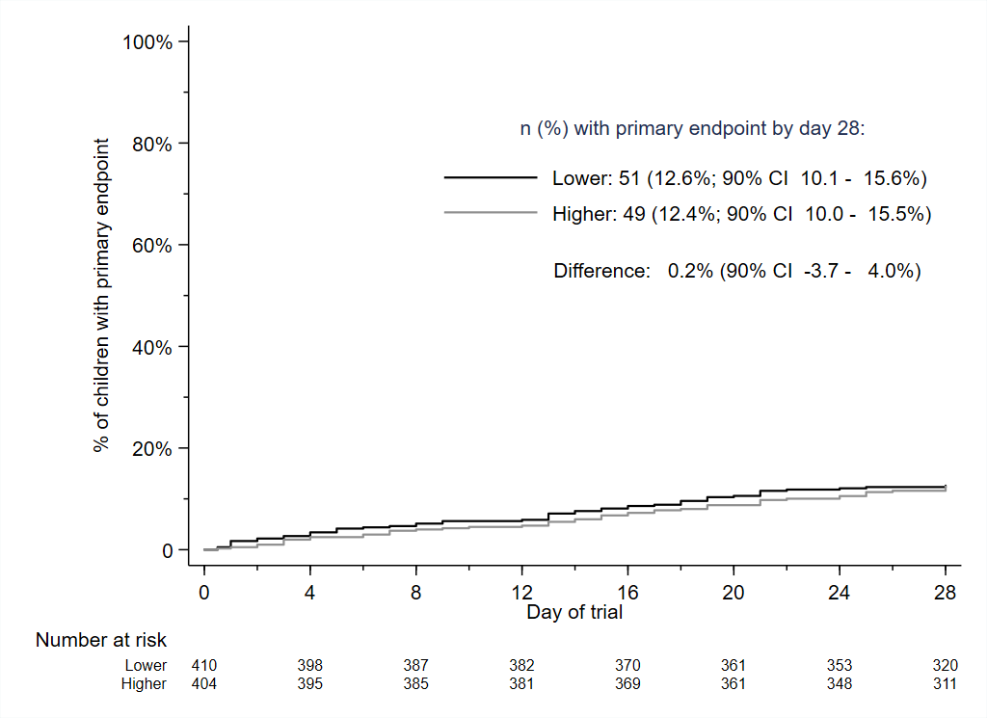

- Duration randomisation
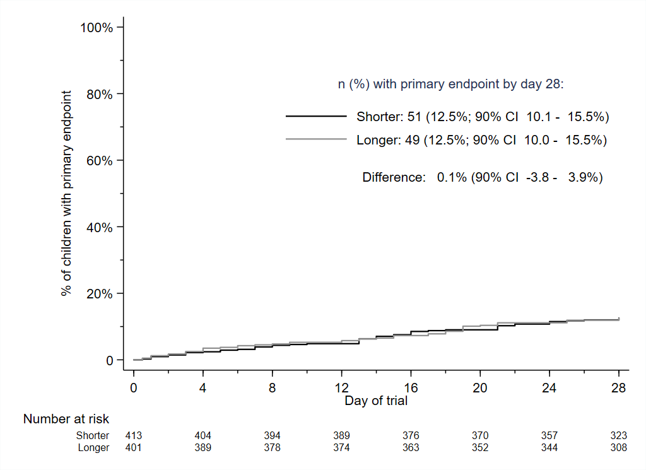

Figure 3: Sensitivity and subgroup analyses for the primary endpoint

- Dose randomisation
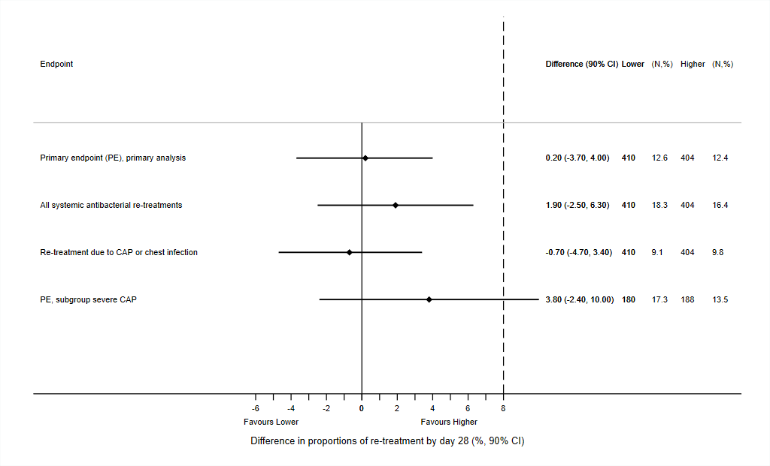

- Duration randomisation
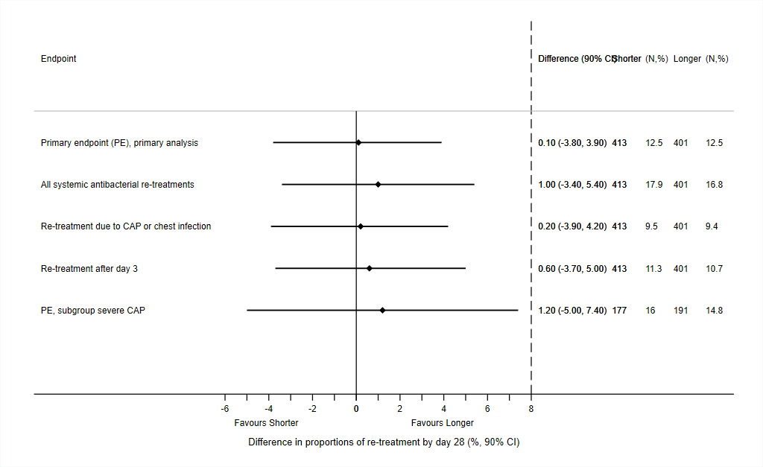

Table 2: Secondary endpoints
Outcome | Total  (n=814) | Lower  (n=410) | Higher  (n=404) | Difference  (90% CI) | p value | Shorter  (n=413) | Longer  (n=401) | Difference  (90% CI) | p value
Adherence: complete course taken
All treatment* | 721 (89%) | 355 (87%) | 366 (91%) | -4% (-8 – -0%) | 0.072 | 358 (87%) | 363 (91%) | -4% (-7 – -0%) | 0.085
Active treatment only** | 767 (94%) | 383 (93%) | 384 (95%) | -2% (-4 – 1%) | 0.32 | 404 (98%) | 363 (91%) | 7% (5 – 10%) | <0.0001
Adherence: all doses taken and never smaller than prescribed volume
All treatment * | 608 (75%) | 304 (74%) | 304 (75%) | -1% (-6 – 4%) | 0.72 | 299 (72%) | 309 (77%) | -5% (-10 – 0%) | 0.13
Active treatment only** | 695 (85%) | 350 (85%) | 345 (85%) | -0% (-4 – 4%) | 0.36 | 386 (93%) | 309 (77%) | 16% (12 – 20%) | <0.0001
Clinical possibly drug-related adverse events post enrolment
Ever diarrhoea | 345 (44%) | 168 (42%) | 177 (45%) | -4% (-9 – 2%) | 0.31 | 187 (46%) | 158 (41%) | 6% (-0 – 11%) | 0.11
Ever oral thrush | 57 (7%) | 27 (7%) | 30 (8%) | -1% (-4 – 2%) | 0.60 | 25 (6%) | 32 (8%) | -2% (-5 – 1%) | 0.26
Ever skin rash | 193 (24%) | 94 (23%) | 99 (25%) | -2% (-7 – 3%) | 0.52 | 87 (22%) | 106 (27%) | -6% (-11 – -1%) | 0.055
Serious adverse event, ever *** | 43 (5%) | 23 (6%) | 20 (5%) | 1% (-2 – 3%) | 0.67 | 25 (6%) | 18 (4%) | 2% (-1 – 4%) | 0.32
S. pneumoniae and antimicrobial resistance – Day 28
Culture sample available | 437 (54%) | 224 (55%) | 213 (53%) |  | 0.58 | 205 (50%) | 232 (58%) |  | 0.019
S. pneumoniae colonization | 129 (30%) | 66 (29%) | 63 (30%) | 0% (-7 – 7%) | 0.98 | 65 (32%) | 64 (28%) | 4% (-3 – 11%) | 0.35
Penicillin-non-susceptibility  a) including all samples | 21 (5%) | 12 (5%) | 9 (4%) | 1% (-2 – 4%) | 0.58 | 14 (7%) | 7 (3%) | 4% (0 – 7%) | 0.063
b) in positive samples | 21 (16%) | 12 (18%) | 9 (14%) | 4% (-7 – 15%) | 0.55 | 14 (22%) | 7 (11%) | 11% (0 – 21%) | 0.10
Amoxicillin-resistance/non-susceptibility  a) including all samples | 4 (1%) | 2 (1%) | 2 (1%) | -0% (-2 – 1%) | 1.00 | 2 (1%) | 2 (1%) | 0% (-1 – 2%) | 1.00
b) in positive samples | 4 (3%) | 2 (3%) | 2 (3%) | -0% (-5 – 5%) | 1.00 | 2 (3%) | 2 (3%) | -0% (-5 – 5%) | 1.00

Note: * considering placebo; ** ignoring placebo; *** No participant had more than one SAE, all SAEs were hospitalisations, no deaths.

