Rape Myths in Practice: The Everyday Work of Accounting for Rape Survivors
Phillip Brooker¹ & Catherine Butler² (Corresponding author: Phillip Brooker (p.d.brooker@liverpool.ac.uk))
¹University of Liverpool, UK; ²University of Exeter, UK.
Abstract:
Introduction: 'Rape mythologising' has been found to be a reason why survivors of rape feel blamed, and might contribute to low rates of reporting or conviction. No research to date examines whether 'rape mythologising' occurs in the conversations of sexual health staff when discussing rape cases.
Methods: Conversation Analysis was used to analyse a focus group conversation between five sexual healthcare clinic staff who routinely provided support to rape survivors, on the topic of three rape cases presented at the clinic.
Results: Three forms of conversation were noted in the focus group: (1) assessing ‘relatability’ in cases, (2) diagnostically reconstructing events and (3) apportioning blame to rapists. Implications for professional training are discussed. In all three, a tension was noted between drawing on rape myths and professional non-blaming discourses.
Conclusion: This research demonstrates the need for further training of those who work with rape survivors.
Introduction
The National Crime Survey for England and Wales (ONS, 2021) recorded 55, 696 offences of rape for the year ending March 2021, compared to 250 ten years previously. The National Crime Survey directly asked households about crime, as they estimate that only 4 in 10 crimes are reported to the police. However, when it comes to sexual violence, the rates of reporting are even lower, with only 16% of survivors reporting their cases to the police (Office for National Statistics (ONS), 2020). This number is likely to be less for rape because of feelings of embarrassment (40%), humiliation (34%), fear of not being believed by the police (25%) or disbelief that a conviction will happen (38%) (ONS, 2020); conviction rates for rape are far lower than for other crimes, with only 1.6 % of reported rapes ending in conviction (Barr & Topping, 2021). In addition, while most rape is perpetrated by someone known to the survivor, rates of conviction are lower for acquaintance rape than for stranger rape (Larcombe, 2002). The Crown Prosecution Service (2021) report Closing the Gap, is written to address the sharp drop in prosecution and conviction for rape, which in July 2020 was reported as falling to the lowest level since records began (Topping & Barr, 2020).
One proposal as to why rates of reporting and conviction are so low is the presence of ‘rape myths’ (Smith & Skinner, 2017; HM Gov, 2021). In the 1970s, Brownmiller (1975) highlighted false but commonly-held beliefs about sexual violence against women, and Estrich’s (1976) reported on how some rapes are viewed as ‘real rape’ while others are disregarded. These beliefs were termed ‘rape myths’ by Burt (1980), which Lonsway and Fitzgerald define as ‘attitudes and beliefs that are generally false but are widely and persistently held, and that serve to deny and justify male sexual aggression against women’ (1994, 134) – thus they are not just stereotypical beliefs but also hold a cultural function. This function is to maintain the status quo of male dominance and uncritically accept some beliefs about rape over others (Conaghan & Russell, 2014). Smith & Skinner (2017) outline the most common myths used, organised around the four categories proposed by Bohner et al. (2009):
Myths that blame the survivor, e.g.:
- Being voluntarily drunk makes the survivor partly responsible for the rape
- The survivor can provoke rape by the way they behave or dress
- It is only rape if the person fought back, got injured or screamed
Myths that cast doubt on allegations, e.g.:
- People often make false allegations, often motivated by regret or revenge
- After a rape, and when giving evidence, all survivors will be visibly distressed
- Delays in reporting a rape should be treated with suspicion
Myths that excuse the perpetrator, e.g.:
- Male sexuality is uncontrollable and can be provoked
- Rape is a ‘crime of passion’
Myths that suggest rape only happens in certain social groups, e.g.:
- Rape happens between strangers in public places
- Sex workers cannot be raped
- Male rape only happens to gay men

The potential for categorising forms of talk in this way suggests that talk can be fit to one or more interpretative repertoires (i.e. ways of discussing and evaluating events that make sense in a conversation according to the speakers’ culture). Similarly, Crawford (1995) suggests three interpretative repertoires, the first of which is along these same lines. The first is the victim-precipitation model, which accords the rapist as being unable to control his sexuality, provoked by the survivor in the way she dressed or behaved. The second is the socio-structural repertoire, where rape is seen as existing on a continuum of sexual oppression. In considering these first two of Crawford’s repertoires, Gavey (2005) asserts that there has been a paradigm shift from the first to the second and that this shift is witnessed in sexual healthcare provision, where rape is now more commonly regarded as existing on a continuum that includes more subtle forms of sexual harassment, uninvited touching, etc. Crawford’s third repertoire is the miscommunication repertoire, where rape is understood as an extreme example of miscommunication, whereby women’s verbal and non-verbal ‘signals’ are unwittingly misinterpreted as indicating consent (such as when a woman is drunk) (Kitzinger & Frith, 1999). O’Byrne et al. (2008) suggest that the miscommunication repertoire informs rape prevention campaigns (e.g. the ‘just say no’ campaign of the 1990s), and is based on the assumption that men and women have different conversational styles that result in frequent miscommunication (Tannen, 1990). However, work with young women (Kitzinger & Frith, 1999), and young men (O’Byrne et al, 2006; 2008 and Hansen et al., 2010), found that both hold a sophisticated and nuanced understanding of the subtle and culturally normative ways that a woman can employ to refuse sex (e.g. with silence, offering excuses or use of body language) without needing to say ‘no’ explicitly.
These rape myths and interpretive repertoires lead to a ‘rape-supportive’ culture that is hostile to women (e.g. with the use of sexist jokes), supports beliefs that are conducive to rape and thus increases the risk of rape itself (Burnett, Mattern, Herakova, Kahl Jr, Tobola & Bornsen, 2009). Rape myths and rape-supportive culture also explain how people respond to survivors and perpetrators, in that the impact on survivors is often minimised and they are blamed for what happened (Carmody & Washington, 2001). Over the last two decades numerous studies have found that rape myths go unchallenged by police, barristers and judges, and so have a direct impact on sentencing and the survivor’s wellbeing during trials (Fávero et al., 2020; HM Gov, 2021; Smith & Skinner, 2017; Smith, 2018). Such lack of support, disbelief or blame of the survivor can lead to ‘secondary victimisation’ (Yamawaki, 2007), with survivors experiencing guilt or shame with regards to their conduct or character, which can also contribute to under-reporting and attrition (Krahe, 2016; Suarez and Gadalla, 2010).
Whether or not a rape survivor chooses to report it to the police, they may have contact with other professionals in relation to the rape, such as accident & emergency staff in the case of immediate injury, general practitioners for emergency contraception or sexual health staff to investigate the risks of sexually transmitted diseases. This is not necessarily a supportive experience; Starzynski, Ullman and Vasquez (2017) found that the more professionals a survivor disclosed to, the more negative their experience as they felt judged and blamed. Furthermore, staff from these various services will hold various levels of training and experience of working with sexual assault, and McKay (2001) found that therapists’ years of experience of working with rape survivors were, paradoxically, positively associated with rape myth acceptance; a finding repeated in Fávero et al.’s (2020) research with police officers. Possible explanations for this might be that therapists and the police are experiencing ‘compassion fatigue’ from repeated exposure (Suarez & Gadalla, 2010); or that therapists and survivors avoid talking about the trauma of sexual assault, resulting in partly and/or implicitly justifying the rape (Fox & Carey, 1999). Similarly, Idisis et al. (2007) presented four rape scenarios to therapists and non-therapists and found that both groups tended to blame the survivor. Idisis et al. (2007) explain this using Anderson’s (1996) functional theory of cognition – that when things do not go as expected people seek to assign blame.
The present study formulates part of a programme of work (along with Fávero et al., 2020; Hansen et al., 2010; Kitzinger & Frith, 1999; Auburn & Lea, 2003) seeking to examine how rape myths operate in practice. In this way, the work presented here might be considered a "ground-up" counterpart to the "top-down" approach presented above, which dominates in the literature (e.g. Bohner et al, 2009; Crawford, 1995; Gavey, 2005; Smith and Skinner, 2017). Whereas the "interpretive repertoires" framework that such authors posit seeks to provide a general framework for classifying rape myths, the present study has instead examined how rape myths might feature within conversations-in-situated-context. In this sense, whilst existing studies provide a broad conceptual understanding of rape mythologizing, the present study aims to supplement this literature by undertaking close investigations of just what conversational work is done in and around the production and proliferation of rape myths. In investigating this we aimed to identify and highlight where rape mythologizing intruded on the accounts of the work of sexual healthcare staff, and suggest ways that this might be avoided.
Methods
Procedure
All members of staff in a sexual health clinic accessed by men and women who had been raped were emailed the information sheet and asked to opt in to attend a focus group. The ninety-minute conversation that constituted the focus group was organised as a discussion of three written summaries of case studies of rape that had been seen in the clinic. The case studies included: a drug rape of a woman by a male stranger; the ongoing anal rape of a woman in a relationship by her partner; and a teenage girl raped by a man she met in a park. Some cases were known to some of the members, whilst others were hearing them for the first time. The conversation was audio-recorded and transcribed verbatim, with some elements being excerpted for transcription according to Conversation Analysis conventions (Sacks, Schegloff and Jefferson, 1974; Hutchby and Wooffitt, 2008; ten Have, 2007).
Conversations were instigated for each case by an initial setup question delivered by one of the authors (Catherine Butler; E in the transcripts): “As we hear these stories, what do they evoke in us, how do they make us feel, and what are our first reactions to them?”. This is a non-standard question for clinicians in talking about rape, and was explored as a way to instigate conversations that clinicians would not usually have about the rape cases they deal with. This line of questioning shaped the ensuing talk-in-interaction; it disrupted the shared identity of the group as clinical professionals by requesting specific information that did not usually feature in their professional dealings with rape cases (i.e. their personal feelings). This was not done as an attempt to make these clinicians appear somehow ‘unprofessional’ or morally-ambiguous – indeed, were it not for E’s questioning, these issues would not have arisen at all. Rather, the aim was to topicalise and subsequently unpick areas where tensions between ‘professional’ and ‘lay’ accounting of rape were instigated.
Furthermore, that the participants expressed these ideas conversationally is what renders their talk amenable to the kind of analysis presented here, and renders the question of whether or not the conversation was "naturally-occurring" moot – the interest is, rather, in how the practitioners conduct a collaborative discussion around the topics they were given and what is made visible about their practice in doing so (i.e. the aspects of the work of doing sexual healthcare provision that their talk serves to make publicly accountable).
Participants
The group comprised five women: three health advisors, a clinic administrator and a clinical psychologist. The group was assembled (and participated in) by Catherine Butler, an author of this paper who also worked at the sexual health clinic and features in the conversations as the clinical psychologist (E in the transcripts). The members had a range of experience of working in sexual health settings – from newly-joined to thirteen years – and ranged in age from the late 20s to the early 50s.
Analysis Plan
We utilised Conversation Analysis (CA) techniques (Hutchby and Wooffitt, 2008; Sacks, 1995; Sacks, Schegloff and Jefferson, 1974; ten Have, 2007), which seek to pay close attention to the everyday work of situated interaction as it is realised through talk. We also draw on subsequent feminist developments and applications of CA (Kitzinger, 2000; Kitzinger and Frith, 1999; Stokoe, 2006; Wilkinson and Kitzinger, 2008) to explore the practices under investigation in terms of rape mythologising as a (gendered) concept.
Practically, the work of doing CA in this research unfolded as follows. Recordings were made of a conversation - the aforementioned focus group - which were transcribed verbatim, at which point the recordings and transcripts were reviewed by the researchers to identify potentially interesting short episodes for closer analysis. The identification of "interesting" or analytically useful episodes was done with regard to multiple considerations, including themes repeated throughout the conversation-at-hand, aspects of the talk which seemed to diverge from research presented in existing literature, areas where tensions between professional clinical work and accounts of rape survivor cases seemed particularly apparent, etc. Once selected, these short excerpts were transcribed according to CA conventions (adapted from Hutchby & Wooffitt (2002: vi-vii) and ten Have (2007: 215-216)), which seek to provide indications not only as to what was said, but also how (i.e. with attention to overlapping talk, timings of pauses, volume and pitch of speech, emphasis on words, etc). On the basis of the resulting full CA-style transcripts as more detailed heuristics for understanding the audio recordings, the researchers then reviewed each of the selected episodes to first provide a full description of the ways in which the talk contained in those episodes unfolded in the situated context of the focus group setting and its participants (i.e. colleagues in a sexual health clinic). These analytic descriptions are presented below, and subsequently framed in relation to existing rape myths literature and current standards in clinical practice to exemplify how such an approach might make useful interventions in both.
The assembling of the group for the purposes of an informal conversation around rape case studies is not something that ‘naturally occurs’ in the sexual health clinic setting; Catherine Butler constructed the conversational setting for research purposes. The active generation of these conversations was required, since it is often the case that clinical practitioners disavow personal responses from their professional accounts of their work. Hence, rather than claim to report on the ‘in-the-wild’ practices of sexual health clinicians’ work, our analysis of this conversation relied on its capacity to provide a breach (Garfinkel, 1967) of the everyday goings-on of the setting. This breach was leveraged as a way to instigate, topicalise and bring to the fore the everyday ways in which sexual health clinicians conceptualised rape myths as part of their work. Moreover, the choice for a researcher and author of this paper to facilitate and feature in the conversation captured proved to be a useful resource. Catherine Butler’s joint status as researcher and sexual health clinician satisfies the ethnomethodological ‘unique adequacy requirement of methods’ (Garfinkel and Wieder, 1992, pg182), which stipulates that adequate descriptions of a setting can result only from a ‘members-level understanding’ of that setting (i.e. a setting must be understood and accounted for in the same terms that members themselves would use). Hence, our analyses were as much reliant on Catherine Butler’s experience of working within the sexual health clinic as they were on the treatment of the transcribed excerpts of conversation. Relatedly, the analyses are not intended to reflect “emergent themes”, as the conversations on which they are based are not themselves “naturally-occurring” – rather, the analyses concern the features of the work of doing sexual healthcare provision as rendered visible through the conversations instigated as part of the study.
Analysis
The CA identified three themes 1) the assessment of the ‘relatability’ of the cases, 2) the diagnostic reconstruction of the case, and 3) apportioning blame and justice. Two transcripts per analytic theme are presented and discussed in relation to how specific elements of the talk-in-interaction (Psathas, 1995) within these excerpts exemplify those themes. Participants names are replaced with anonymised initials from A-D (the clinical psychologist, Catherine Butler, has the initial E).
Assessing the ‘Relatability’ of Cases
A recurring feature of clinicians’ talk was their assessment of the ‘relatability’ of rape survivors – the extent to which clinicians felt they could relate to and empathise with the rape survivors’ situations as detailed in the case materials. The two excerpts demonstrate two differing perspectives on relatability. In Excerpt 1, the group settled on a definition of the situation presented as being primarily about youth as a factor in poor decision-making:
Throughout the interaction, the clinicians repeatedly stated a distinction between themselves and the rape survivor as a member of the category ‘young people’ by making explicit references to youth and age as a way of marking the survivor as belonging to an ‘other’ group (e.g. lines 1, 14, 15, 27, 38) (Sacks, 1995). Notably, the membership criteria for this category was not solely linked to age: for instance in lines 6-8 where D rejected her own membership of ‘young people’ and reinforced her membership of ‘clinician’ on the grounds that though she was young herself, she did not relate to (line 24) certain activities attributed to the category of ‘young people’ (i.e. having sex without first getting to know someone). Moreover, D incorporated aspects of moral judgment into the category by noting a distinction between ‘young people’ and the clinicians; that ‘young people’ did not see anything wrong with casual sex (implying there is something wrong with this) (line 20). In lines 26-35, B reinforced this ‘othering’ of young people, offering an account from the clinical perspective that inspired agreement from the other clinicians (e.g. lines 28-29, 32, 33, 36, 37): that in her (clinical) experience, it was common for young people to report casual sex. At this point in the talk-in-interaction, the clinicians moved from talking about their personal responses to rape (which are centralised around youth and the activities of ‘young people’), to making professionally-grounded assertions about the commonality of cases they saw in the clinic that are due to the activities ‘young people’ routinely engage in. It is notable that the aspects of moral judgment, which were brought in through the initial personal/‘lay’ response to the rape case, persisted into the clinicians’ relating of their professional experiences (cf. Sacks (1995), on the ways that topics persist through a conversation). Hence the category of ‘young people’ (and the moral judgments they activate), by virtue of being established first in the personally-oriented account requested by E, was permitted to feature in the professionally-grounded accounts of rape B went on to offer. This provided the basis for a blurring of personal and professional responses to rape which, although did not occur naturally in clinicians’ professional talk (inasmuch as this conversations was ‘engineered’ by E), nevertheless demonstrates how elements of rape myths (e.g. that certain groups do, but should not, engage in activities that put them more at risk) drive how people relate to rape survivors.
Relatability was handled by the clinicians in a markedly differently way for another rape case. As with Excerpt 1, Excerpt 2 displayed an episode of talk-in-interaction from the opening discussion.
E foregrounded this case as different to the two that had preceded it (lines 2 and 6), primarily on the basis of the age of the survivor (line 3), and requested personal responses from the other clinicians. D offered a cautious initial response on line 9 (“Anger?”) which received consensus from E and the group but nevertheless required E to elicit further detail with which D was not forthcoming (lines 13-18). E then requested talk from B by addressing her specifically on line 19, thereby obligating B to provide the detail that was lacking in D’s account. B offered a candidate reason as to why this case was different from the others, which broke with E’s initial setup of the distinction being one of age – the difference being that the rape survivor and the rapist were in a relationship with one another, whereas previous cases emphasised the rapist being unknown to the survivor (line 25). This provided a basis on which the group could relate to the survivor more easily (as demonstrated by the switch from cautious utterances to more freely-flowing and collaborative conversation that began with B’s turn). Throughout B’s turn, she encouraged a range of empathetic responses to the survivor’s case which considered how she would have felt if she had found herself in the same situation (lines 31-32, 34-35). B also encouraged the other clinicians to contribute to the discussion with similar considerations by addressing them indirectly (e.g. on line 30 and 43 with “y’know” and lines 31 and 35 with “your” and “you”), and by emphasising the emotive aspects of the case such as subjugation, powerlessness (lines 24-28, 48-52) and pain (lines 37-46). B’s encouragement opened the conversation up to such contributions from C and A, who both offered accounts that empathised with the rape survivor’s situation, e.g. A’s claim on line 75. Notably, this more empathetic talk, once begun, turned more explicitly towards the rapist and his actions (e.g. lines 44-66), and away from the usage of rape myths (where the rape survivor’s actions were under scrutiny). In these excerpts, the criterion of age was insufficient if the goal was to generate a fluent clinical conversation around a rape case, whereas relationship status provided a stronger footing on which such conversation was eventually built. This demonstrated the potential for instigating empathetic orientations to rape survivors as a means of mitigating the extent to which rape myths foster negative and damaging reactions (although notably, the specific content of those empathetic orientations are acknowledged as non-generalisable and contextually-dependent - here, age did not work as a criterion though it could elsewhere).
Diagnostically Reconstructing the Event
Another recurring feature of clinicians’ talk was their attempt to understand the rape event by reconstructing how it might have unfolded and the factors leading to it. The two excerpts demonstrate two different ways in which the clinicians undertook the empathic work of accounting for the rape survivor’s situation. In Excerpt 3, the group discussed a pre-existing condition of the rape survivor as a possible reason for her perceived vulnerability to rape.
A began a discussion about the case in reference to her initial judgment of the rape survivor as “streetwise” (i.e. having experience and knowledge of the dangers of everyday life, and thereby being less vulnerable to rape) or not. Though ‘being streetwise’ was established as a potential contributing factor to a rape event by A (lines 1-3), it is noted that this factor did not apply in the case of this particular survivor (4-8). B corroborated A’s account with her own recounting of meeting the rape survivor in the clinic (lines 9-24). In both cases, the evaluation of the rape survivor’s ‘streetwise-ness’ was on the basis of A and B having met the survivor in a clinical capacity (A’s line 2 and B’s lines 9-10). Across lines 9-25, B (with seeming agreement from A and E) talked of the rape event with a sense that failing to be ‘streetwise’ could have been a contributing factor to a rape, and B also offered a new detail in association; that the rape survivor’s attractiveness was somehow associated with ‘streetwise-ness’ (and accordingly, vulnerability to rape). The shared knowledge of the nature of the connection between "streetwiseness" and attractiveness was assumed rather than topicalised, questioned or explored. A offered an alternative reading of the survivor's case based on her own professional interaction with the survivor, noting that initially A thought that a prior health condition, ME, could explain the survivor's lack of "streetwiseness" and therefore her increased vulnerability to rape. A acknowledged that though ME was not pertinent to the rape itself (lines 36-37), it was nonetheless a focal point of their clinical sessions, and of personal interest to A (lines 30-31). An unfinished sentence (across lines 37-40) was immediately followed by a statement to the effect that the ME was professionally evaluated as having no impact of that kind (line 43). Hence, A's talk of ME as a potential factor was ultimately rejected and though that provides no conclusive explanation of the rape itself, B, E and A effectively closed the topic with utterances of agreement (e.g. "m::") rather than picking up the conversational thread or exploring other potential explanations (including ones oriented to the rapist's actions).
In excerpt 4, the group discussed the rape case in regard to the survivor's actions and a relevant factor – that the survivor was drug raped – featured only as a secondary concern.
Excerpt 4 began with E working to generate a conversation around a previous theme of age and generation as a point of distinction between the clinicians and the survivors in these cases, opening the line of questioning out topically and by seeking a response from others verbally and via providing a relevant point of turn transition (Sacks, Schegloff & Jefferson, 1974) (lines 1-9). B took the turn and offered an account of her own personal attitudes and approach to sexualised encounters with males (lines 10-28). B's personal account focused on the management of risk when meeting a new person, in terms of what B is capable of doing/does in order to assess and mitigate risks that may present in such a context. Throughout, E - as the member who asked the original question - overlaps B's talk with 'continuers' (Schegloff, 1982) such as "Mhm." and "°yeah°" that, loosely, indicated encouragement for B to continue speaking and perhaps also agreement with the content of what B was saying. When B drew her turn to a close and left a transition point for another speaker to pick up (line 29), A developed B's line of discussion directly - she provided a completion to B's last (grammatically unfinished) line. As A continued developing her point, both E and B provided further continuers (and assisted in the further development of A's point and the conversational collaboration, e.g. E's added detail at line 38). At line 40, C interjected to add further detail that extended the line of reasoning that has been collaboratively worked up thus far. C's turn (lines 40-48) garnered similar encouragement via continuers from B and E. As C's drew her turn to a close (instigating the pause at line 50, plus E's "Um::?" at line 51 which might have been taken as a request for either new content or a new topic), B took a turn that reflects back on a prior topic of talk - that this case had a drug rape element (line 55). This statement of B's elicited agreement from others (A, C and E) in lines 59-63, though notably, the clinicians did not return to the start of the topic to reframe it as a drug rape episode; rather than informing how a diagnostic reconstruction of a rape event was developed, this key factor appeared at the conclusion of the diagnosis. Hence, though the drug rape element was vital to the clinicians' narrating of "what went on", it did not feature in their talk as it developed collaboratively towards a shared reconstruction of the rape. The unfolding narrative constructed between the clinicians led to a characterisation of the event as being dually about a survivor potentially having been drugged (as a salient fact from the clinical report) and about that survivor having made "unwise decisions" (as a rape myth).
Reflecting on what both of these excerpts show together, we noted that both begin with a discussion of a clinical case that verges on rape mythologising - the talk amongst clinicians primarily concerned qualities inherent in and actions taken by the survivor (i.e. streetwise-ness, "going off" with people you don't know, etc). Though we noted that this does not indicate that clinicians' were talking about the 'deservedness' of rape, these forms of conversation nonetheless hold implications as to what might have been done to prevent the rape from happening - they tell a story that asks what might have happened if the survivor had acted differently, rather than focussing on the rapist's actions as the aggressor. Moreover, in both excerpts, there is a discussion of the influence of factors outside of the survivor's control - a previous health condition (ME) and that the rapist might have drugged the survivor, respectively. However, the cases differ in the weighting given to each of these explanations, with more conversational work being done around exploring the idea of ME as a factor in Excerpt 3 than is spent on exploring the drug rape element of the case discussed in Excerpt 4. This was interesting, since at the outset of Excerpt 3, it was already known that ME was not any kind of contributing factor (as indicated in Excerpt 3, line 43), whereas it was known at the outset of Excerpt 4 that drug rape was a possible explanation of this case (as indicated in Excerpt 4, line 52-58). The late placement of medical facts - ME and drug rape - in the conversational sequence left room upfront for talk that was more easily constructed around rape mythologies (or, at least, survivor-oriented talk from where mythologising might emerge). Of Excerpt 4 specifically, it was worth noting that E, the researcher/clinician, arguably helped to drive the conversation by explicitly asking survivor-oriented questions (i.e. around age and generational differences between a survivor and the clinicians). Nonetheless, the excerpt provided an interesting platform on which to consider why the known fact of a possible drug rape only emerged so late into the conversation, and even where it did emerge, was discussed alongside the survivor's "unwise decisions" rather than as a separate overriding factor. Both excerpts give grounds to consider the explicit outlining of salient medical facts more upfront in conversations, as they shape conversations taking place in sexual health clinics that do not primarily focus on survivors’ actions.
Justice and Apportioning Blame to the Rapist
A final theme identified in clinicians' conversations concerned their attitudes to the perpetrators of the rape events being discussed. These were not natural topics to the clinicians since their professional role puts up barriers to thinking about the criminal sentencing/justice that might be served to the rapists whose survivors the clinicians deal with. However, E steers the conversation towards discussing justice and blame of the rapists; these conversational moments provided a source of insight into how talk incorporating rape myths deal with the presence of counter-narratives (i.e. that the rapist and their actions were to blame). Excerpt 5 showed E instigating a conversation around justice, blame and punishment, and the response of clinicians to that line of questioning.
The excerpt began with E's topicalisation of justice and punishment as something that had not yet, throughout the entirety of their recorded conversation, been spoken about - lines 1-7. E's opening of the conversation was extended, spanning lines 1-13, with little input from other conversants barring C's statement of agreement at line 8. In this period of attempting to open the topic, E presented multiple different phrasings and different lines of enquiry that the clinicians then had the opportunity to pick up - around "justice" and "punishment" (lines 1-3), around the type of man who would drug and/or rape a woman (lines 5-7) and the difficulties in thinking about the male perpetrators when confronted with women's stories to which the clinicians might relate more easily (lines 9-11). E left multiple and frequent relevant turn transition moments - a completed topic plus a pause to invite responses from others - throughout the attempted opening of conversation, but none were picked up by other conversants. E then, in lines 11-13, had to reframe the topic more weakly, tailing off with the desired topic potentially remaining unopen. In lines 15-17 however, A provided a route through which the topic might be opened to the group, by asking a further question to clarify what E might have considered an appropriate response. E took the opportunity to clarify, overlapping A's talk (line 18) and giving a more concrete example drawn from their prior talk in response to the request for further clarity. At this point (lines 22-23), A indicated an understanding of what E has been asking - "°oh I see now°" - followed by a lengthy pause. Though the topic had been opened and (as A suggested) in a way sufficiently clear to be understood by the group, the clinicians nonetheless displayed a reluctance to volunteer to drive the topic further. With nobody taking up the mantle, as last speaker A was obligated to continue (Sacks, Schegloff & Jefferson, 1974), that she did not think of justice at all since her job had given her insight that often, justice was never served to rapists and focussing on justice and punishment caused frustration and anger (lines 24-30). Acknowledging that this was not a definitive answer to E's questioning, A reiterates the key point - "So I don't really think of:" - and tails off, allowing another conversant an opportunity to speak.
What Excerpt 5 shows is the sheer amount of conversational labour required to open up talk of justice and punishment. Despite multiple rephrasings and opportunities for turn transition, E was largely unable to draw out a satisfactory answer from the clinicians - as A suggested, this may be because no such satisfactory answer exists (i.e. justice and punishment are topics that are actively avoided and excluded from their day-to-day work). Excerpt 6 elaborates on this, taken from a later point as the (somewhat stilted) conversation continued.
Here, A continued a discussion of why justice did not form a point of focus in her clinical work by examining what she did focus on - demonstrating to rape survivors that their circumstances are believed - and the value of doing this. The earlier topic of justice was not, however, abandoned, but ran thematically through this talk - for instance at line 2 where believingness was pitched as an alternative to justice, and at line 7 where believingness was pitched as a type of justice that could be more realistically provided in the context of clinical work. Having earlier been asked why justice had not arisen as a topic of their talk, A offered a candidate explanation that set the clinicians' prior talk against the new conversational context of justice, arguing that engaging seriously with (i.e. believing, or displaying belief in) rape survivors’ stories was more valuable and achievable. Thinking in terms of rape mythologising, there are careful distinctions to be made between rape myths and accounts of rape that focus on rape survivors' actions primarily - they are not the same, and it is evidently possible to focus on rape survivor's actions without simultaneously doing rape mythologising. However, there is clearly still a fine and uneasy line between survivor-focussed talk and rape mythologising which clinicians have to carefully navigate. Moreover, since these conversations are ‘unnatural’ (inasmuch as they do not happen spontaneously, and are instigated here for research purposes), the ways in which clinical professionals undertake such navigations are often unspoken. In this instance, what was normally unspoken (but artificially foregrounded in our research) was the notion that apportioning justice and blame was justifiably outside of what a ‘professional (clinical) response’ might look like – this is to say that normally clinicians are not and should not be concerned with identifying blame in any given rape case. However, we might question why it may be that justice sits far more squarely outside of the professional remit of sexual health clinicians’ work, whereas rape mythologizing evidently does not.
Discussion
We found rape myth repertories employed within the three themes identified in the transcripts. Some of the myth repertories noted fitted with Crawford’s (1995) account of rape myth repertoires, e.g. evidence of the victim-precipitation model where rapists were viewed as ‘dreadful creatures’ and the survivor as too young to know better or having become naïve (e.g. due to ME keeping them apart from social situations). The miscommunication model was also present with the suggestion that ‘going off’ with someone for the first time, especially when one is ‘gorgeous’, might give the man/rapist the wrong idea (participants used this discourse despite also discussing that the survivor was drug raped and so the victim-precipitation model might have fitted better). The socio-cultural repertoire was represented in the talk of one survivor being ‘streetwise’, in that their wisdom suggests that they should have expected there to be a rape risk and how they could have prevented it, that she was ‘off her guard’ and made ‘unwise decisions’.
Interestingly, the complexity and range of myth repertories found in these results extends beyond the three repertoires that Crawford (1995) suggests are most commonly used to account for rape. In these participants’ talk we also noticed the participants are doing a range of (seemingly contradictory) things over the course of the whole conversation including: (a) ‘othering’, and so distancing themselves from those who are raped (e.g. because of age differences) and displaying moral judgements and use of rape mythology, and (b) identifying with the rape survivor (e.g. sharing a status of being in a relationship) and focusing more on the rapist (e.g. expressing anger) rather than on the survivor, thus not drawing on rape myths. This finding connects to previous research with language interpreters, where making sense of why rape happens also witnessed the use of ‘othering’/distancing and relating/finding common ground (i.e. being women) (Butler, 2008). Similarly, Gravelin, Biernat & Bucher (2019) found that while identifying with survivors increased feelings of empathy, they also increased feelings of threat and a desire for distance. These positions fit with Herman’s (1992) ideas of secondary trauma: that the clinician risks feeling overwhelmed in relating to survivors’ cases, and so may instead seek to shut off by sufficiently distancing themselves from the affective aspects of those cases. Herman’s model also accounts for Suarez and Gadalla’s (2010) findings on ‘compassion fatigue’ and Anderson’s (1996) ideas of ‘blame seeking’, both linked to the position of distancing. The current study therefore highlights that all sexual health staff are at risk of developing secondary trauma with continued exposure to rape stories as part of their work. Other research has identified that some staff may be more vulnerable to this developing more rapidly than others, i.e. those with personal histories of trauma, those who are younger and those with lower job satisfaction (Ghahramanlou & Brodbeck, 2000).
However, we saw participants using these strategies apparently to protect themselves from such trauma. For instance, they do not readily talk about justice not (only) because it is not within their professional remit, but because it was too hard. In that case, the professional distance they had was a resource for doing their job effectively. In other areas (e.g. in demonstrating to survivors that their stories are believed), their professional work was such that they have to empathise and engage on an affective level. So, the various strategies on display in these participants’ talk could be seen as being stories about the kinds of things they do to keep their work at an appropriate point on the spectrum between ‘professional/cut-off’ and ‘empathetic/overwhelmed’. These strategies sometimes verge on rape mythologizing, but this seemed to help clinicians put a distance between themselves and survivors that may be sometimes necessary to ensure clinicians’ well-being. However, what remained unknown was the impact of this on their clients, and whether it leads in secondary trauma in them (as suggested by Yamawaki, 2007).
Perhaps because the focus group discussion was not a conversation that usually occurred in sexual health clinics, clinicians frequently drew on lay repertoires to account for the discussed rape cases. These repertories hold the potential for rape mythologizing and so might intuitively exist in tension with professional repertories. However, there is a fine line between focusing discussion on rape survivors’ actions and the use of rape myths themselves. Indeed, in discussing the actions of rape survivors, including talk about what they could have done differently to be more ‘streetwise’, clinicians were making the ‘just world’ thesis (Lerner, 1980; Hafer, 2000) - the idea that a rape could be prevented if the survivor had behaved differently, rather than an idea that it could happen at random or because of factors outside of the survivor’s control. This conversational move may be protective in both a clinical and lay context in that it accompanies an idea that by avoiding some behaviours (e.g. ‘going off’ with strangers) one can avoid being raped. However, the inevitable flip side of this belief is blaming those who are raped. This premise is supported by Strömwall, Alfredssonn and Landstrom (2013), who found that participants with higher recorded rates of ‘Belief in a Just World’ (measured by Dalbert’s (2000) scale) were more likely to blame the survivor than the perpetrator in rape vignettes. However, Gravelin, Biernat and Bucher (2019) found that the ‘just world’ thesis more strongly impact the assessment of stranger rape, not acquaintance rape (as in the case of excerpt 1).
The recurrence of these themes in the current research confirms that proposition that these tensions are indeed ‘normal troubles’ (Garfinkel, 1967) that occur for all sexual health staff regardless of job role. However, Karpman’s (1968) drama triangle would suggest a third position existed that was not reported here - that of ‘rescuer’, i.e. wanting to ‘save’ or ‘rescue’ the client from their trauma/pain. Perhaps this did not occur in these accounts because talk of justice was too difficult for these participants as it was considered beyond their clinical role. Instead, participants described being able to offer ‘belief’ to survivors, as something that was within the remit of clinicians as people and as professionals. Walsh et al. (2016) found that women who had been drug raped were particularly concerned about not being believed or acknowledgment that what happened to them constituted rape, influenced by often having poor memory about the event themselves, and the lack of a stereotypical rape script of traumatic fear and injury during the rape (Littleton et al., 2006). This concern is justified as Fávero et al. (2020) found that older police officers, longer in service, disbelieved that rape was as severe when it did not fit stereotypical representations of rape (e.g. including physical violence). In fact, being acknowledged as having been raped was an important influence on whether survivors went on to seek help from services (Kilpatrick et al., 2007; Walsh, et al., 2016; Zinzow & Thompson, 2011). Based on the talk above, it is evident that in offering their belief to survivors, clinicians were able to do something, even if it changed nothing about the traumatic past event itself. Perhaps, aware of the low rates of conviction, the capacity to do something was valued.
Summarising these points of discussion, we can express them as useful insights to direct the future training of sexual health staff. First, our research elaborates on the risks of secondary trauma amongst sexual health clinicians, and their existing strategies for dealing with those risks. This may incorporate training staff to recognise when their talk and/or attitudes may indicate ‘burn out’/‘compassion fatigue’ through having to express compassion in and about difficult situations as their routine business (Suarez & Gadalla, 2010); as well as recognising when their talk may indicate over-empathising at the expense of their personal well-being. In short, being able to draw these out conversationally can help clinicians orient to moments in their work where a risk of secondary trauma may be more concentrated, and help clinicians find ways to maintain their position of offering belief to survivors without putting themselves at risk.
Second, the insights expressed here can be used as a resource for bolstering the ‘hooks’ on which clinicians’ empathetic work can hang – for instance, when working with clients whose circumstances are seemingly incommensurable with clinicians themselves (e.g. where age and its connotations of recklessness are referred to as a non-traversable categorical distance), and where training could be developed to mitigate the risk that those circumstances might instigate rape mythologising to account for why a rape happened and who was to blame. Empathy and personal attitudes and beliefs have been emphasized by other research as formulating essential components of training about sexual assault (Murphy & Hine, 2019; Darwinkel et al., 2013). Third, this research suggests that clinicians already routinely (and effectively) focus on offering belief as a beneficial form of support in ways which do not draw on justice and blame – we suggest such strategies could be further enhanced by developing ways for clinicians to orient to rape cases as events where survivors could do nothing to prevent them. The training implications could be extended to other professionals involved in supporting survivors of rape, including the police, barristers and judged. This is particularly important given that Fávero et al. (2020) found that more senior police officers had higher rates of rape myth acceptance and also considered that is was not necessary to receive specialist training on sexual violence – our research proves otherwise.
Finally, our research affords an opportunity to explore the strategies and tensions inherent in the work of sexual health clinicians, and how these tensions are mitigated. One question to ask is why, when asked a relatively generic question about each case – “how do these cases make you feel?” – clinicians’ talk led specifically to assessments of the relatability of survivors circumstances to their own, and to diagnostic reconstructions of the rape event? Returning to some of the core tenets of conversation analysis (Sacks, 1995), we might argue that the entire conversational context encourages members to demonstrate their knowledge of what constitutes membership in the various categories to which they belong. These categories include both “professional” and “lay” memberships – e.g. the professional context of the sexual healthcare clinic (with its requisite rules and regulations around staff conduct with patients) and the lay context within which each clinician is also a member of society where rapes happen. The conversational context engineered in this research brings to the fore the distinctions between “professional” and “lay” accounting of rape in such a way that participants in those conversations might pay attention to the ‘seen-but-unnoticed-features’ (Garfinkel, 1964, 229) that signify talk’s membership in either group. In short, having such an artificial conversation may prove a good resource for reiterating and reinforcing what counts as “being professional” in a sexual healthcare context, and give room for participants to think (collectively) about how they are and/or how they should be responding to rape survivors and their accounts. Finding a place to host conversations of this kind in the routine work of sexual healthcare could potentially be a valuable tool for training and ongoing professional development. Though this research was focused on sexual health clinicians, a recent report by HM Government (2021) has identified that rape myth repertoires are commonly used by police, barristers and judges in the UK; a finding reinforced by international research, e.g. from Portugal (Fávero et al., 2020) and the United States of America (Page, 2007). These findings would also therefore be usefully applied to other professionals that rape survivors engage with.
Conclusion
This paper has elaborated on the tensions inherent in clinicians’ work with rape survivors and their accounts, by bringing these to the foreground in an engineered conversational setup. We have shown that clinicians have strategies for dealing with these tensions, but there are areas where these may not be easy, perhaps even impossible, to resolve. Previous research (e.g. Fox & Carey, 1999; Idisis et al., 2007; Suarez & Gadalla, 2010; Yamawaki, 2007) has shown that such tensions lead to both decreased quality of care for rape survivors as well as psychological trauma for clinicians. In this sense, the outcomes of this research could be applied back to the ongoing training and professional development of sexual healthcare staff. This model of applying the results of conversation analytic study back onto the practices of those whose conversation has been analysed has been used to great effect in various studies in various contexts (e.g. Hepburn et al., 2014; Sikveland et al., 2016 and Stokoe, 2014). However, it is equally important to recognise that these same approaches do not necessarily tap into the ‘felt’ experience and personal discourses that the present paper argued are enormously influential – e.g. the affective experience that underpins how and why clinicians choose to frame rape accounts in various ways. From a “professional” perspective, it may seem obvious that rape mythologizing has no place in sexual healthcare. We would not necessarily disagree with this, but we might note that where our participants’ talk verged on rape mythologizing, paying attention to the interactional and situational context within which that talk happens may help us appreciate that these ‘rape myths’ hold a different role than (just) ‘victim-blaming’ and create a form of protection against the secondary trauma endemic to the job of supporting rape survivors. In this sense, the issue is not so much one of ‘stamping out’ rape myths from clinical practice but one of navigating around the impossible task of empathising-with-whilst-keeping-a-distance-from a traumatic felt experience. It is unreasonable to expect sexual healthcare staff to have a ‘one size fits all’ solution to this ‘normal trouble’ of the work, and it is equally unreasonable to expect that conversation analysis could be used to provide such an illusory silver bullet (though the hope is that it could render these processes more transparent, where that would assist in clinicians’ work).
This perhaps also elaborates on our conversation analytic approach in terms of what it may and may not be legitimately used to do (e.g. in future research). We cannot treat language as disconnected from the social settings in which it occurs with the intent of making generalised prescriptions on how to ‘tweak’ language for different interactional effects (e.g. say this word and not that word to solve an interactional problem). However, if we seek to retain the local context of individual interactions we can use conversation analysis as a tool for describing how interactions happen the way they do, in ways that take members cues on why they happen the way they do; in this instance, we can separate the talk of our clinical practitioners from the more general concept of ‘rape myths’ by virtue of seeing how those aspects of talk which do verge on rape mythologizing serve a function in the routine work of effective sexual healthcare provision.
Competing Interests
The authors declare that they have no conflict of interest and that the study received financial support from the British Academy.
Ethical Statements
This study was performed in line with the principles of the Declaration of Helsinki. Ethical approval was granted by London-Surrey Borders Research Ethics Committee (08/H0806/53). Informed consent was obtained from all participants to participate in the study and for publications to be written on the results.
Data Availability Statement
The data generated and analysed during the study are not publicly available due to reasons of preserving the anonymity of participants – the anonymised excerpts on which the present analysis is based are included in the text of this paper.
References
Anderson, N. H. (1996). A functional theory of cognition. Mahwah, NJ: Erlbaum.
Auburn, T. & Lea, S. (2003). Doing cognitive distortions: A discursive psychology analysis of sex offender treatment talk. British Journal of Social Psychology, 42(2), 281-298.
Barr, C. & Topping, A. (2021). Fewer than one in 60 rape cases lead to charge in England and Wales. The Guardian: UK edition. https://www.theguardian.com/society/2021/may/23/fewer-than-one-in-60-cases-lead-to-charge-in-england-and-wales (accessed 18.10.21)
Bohner, G., Siebler, F., & Schmelcher, J. (2006). Social norms and the likelihood of raping: Perceived rape myth acceptance of others affects men's rape proclivity. Personality and Social Psychology Bulletin, 32(3), 286-297.
Bohner, G., Eyssel, F., Pina, A., Siebler, F., & Viki, G. T. (2009). Rape myth acceptance: Cognitive, affective and behavioural effects of beliefs that blame the victim and exonerate the perpetrator. In M. A. H. Horvath & J. Brown (Eds.), Rape: Challenging contemporary thinking (pp. 17-45). Cullompton: Willan Publishing.
Brooks, O., & Burman, M. (2017). Reporting rape: victim perspectives on advocacy support in the criminal justice process. Criminology and Criminal Justice, 17(2), 209-225.
Brownmiller, S. (1975). Against our will: Men, women and rape. New York: Bantam Books.
Burnett, A., Mattern, J. L., Herakova, L. L., Kahl, D. H., Tobola, C., & Bornsen, S. E. (2009). Communicating/muting date rape: A co-cultural theoretical analysis of communication factors related to rape culture on a college campus. Journal of Applied Communication Research, 37, 465-485.
Burt, M. (1980). Cultural myths and supports for rape. Journal of Personality and Social Psychology, 38, 217-230.
Butler, C. (2008). Speaking the unspeakable: Female interpreters’ response to working with women who have been raped in war. Clinical Psychology Forum, 192, 22-26.
Carmody, D. C., & Washington, L. M. (2001). Rape myth acceptance among college women: The impact of race and prior victimization. Journal of Interpersonal Violence, 16(5), 424–436.
Conaghan, J., & Russell, Y. (2014). Rape myths, law, and feminist research: ‘Myths about myths’?. Feminist Legal Studies, 22(1), 25-48.
Crawford, M. (1995). Talking difference: On gender and language. London: Sage.
Crown Prosecution Service (2021). Closing the Gap: How the CPS is working to reduce disparity between reported rapes and charges. https://www.cps.gov.uk/sites/default/files/documents/publications/Closing-the-gap-final.pdf (access 13.10.2021)
Dalbert, C. (2000). Beliefs in a just world. In J. Maltby, C.A. Lewis & A. Hill (Eds.) Commissioned reviews of 250 psychological tests (pp. 288-297). Lampeter, Wales: Edwin Mellen Press.
Darwinkel, E., Powell, M., Tidmarsh, T. (2013). Improving police officers’ perceptions of sexual offending through intensive training. Criminal Justice and Behavior, 40(8), 895–908.
Estrich, S. (1976). Real rape: How the legal system victimises women who say no. London: Harvard University Press.
Fávero, M., Del Campo, A., Faria, S., Moreira, D., Ribeiro, F., & Sousa-Gomes, V. (2020). Rape myth acceptance of police officers in Portugal. Journal of Interpersonal Violence, https://doi.org/10.1177/0886260520916282
Fox, R., & Carey, L. A. (1999). Therapists’ collusion with the resistance of rape survivors. Clinical Social Work Journal, 27, 185-201.
Garfinkel, H. (1964). Studies of the routine grounds of everyday activities. Social Problems, 11(3), 225-250.
Garfinkel, H. (1967). Studies in ethnomethodology. Englewood Cliffs, NJ: Prentice Hall, Inc.
Garfinkel, H., & Wieder, D. L. (1992). Two incommensurable, asymmetrically alternate technologies of social analysis. In G. Watson and R. M. Seiler (Eds.) Text in context: Contributions to ethnomethodology (pp. 175-206). London: Sage.
Gravelin, C., Biernat, M., & Bucher, C. (2019). Blaming the victim of acquaintance
rape. Frontiers in Psychology, 9(2422), 1-22.
Ghahramanlou, M., & Brodbeck, C. (2000). Predictors of secondary trauma in sexual assault trauma counselors. International Journal of Emergency Mental Health, 2(4), 229-240.
Gavey, N. (2005). Just sex? The cultural scaffolding of rape. London, UK: Routledge.
Gerber, G. & Cherneski, L. (2006). Sexual aggression toward women. Violence and exploration against women and girls, 1087(1), 35-46.
HM Government (2021). Review into the criminal justice system response to adult rape and serious sexual offences across England and Wales. https://assets.publishing.service.gov.uk/government/uploads/system/uploads/attachment_data/file/994817/rape-review-research-report.pdf (accessed 18.10.2021)
Hafer, C. L. (2000). Do innocent victims threaten the belief in a just world? Evidence from a modified stroop task. Journal of Personality and Social Psychology, 79, 165–173.
Hansen, S., O’Byrne, R., & Rapley, M. (2010). Young heterosexual men’s use of the miscommunication model in explaining acquaintance rape. Sexuality Research and Social Policy: Journal of NSRC, 7(1), 45-49.
Herman, J. L. (1992). Trauma and recovery. London: Harper Collins.
Hepburn, A., Williamson, S., & Butler, C. W. (2014). Intervening with conversation analysis in telephone helpline services: Strategies to improve effectiveness, Research on language and social interaction, 47(3), 239-254.
Hutchby, I., & Wooffitt, R. (2008) Conversation analysis. Cambridge: Polity.
Idisis, Y., Ben-David, S., & Ben-Nachum, E. (2007). Attribution of blame to rape victims among therapists and non-therapists. Behavioral Sciences & The Law, 25, 103-120.
Karpman, S. (1968). Fairy tales and script drama analysis. Transactional Analysis Bulletin, 26(7), 39–43.
Kilpatrick, D. G., Resnick, H. S., Ruggiero, K. J., Conoscenti, L. M., & McCauley, J. (2007). Drug-facilitated, incapacitated, and forcible rape: A national study. Charleston: National Crime Victims Research & Treatment Center, Medical University of South Carolina.
Kitzinger, C. (2000). Doing feminist conversation analysis. Feminism & Psychology, 10(2), 163-193.
Kitzinger, C., & Frith, H. (1999). Just say no? The use of conversation analysis in developing a feminist perspective on sexual refusal. Discourse & Society, 10(3), 293-316.
Krahé, B. (2016). Societal responses to sexual violence against women: Rape myths and the “real rape” stereotype. In H. Kury, S. Redo, & E. Shea (Eds.) Women and children as victims and offenders: Background, prevention, reintegration (pp. 671-700). New York: Springer.
Larcombe, W. (2002). The ‘ideal’ victim v successful rape complainants: not what you might expect. Feminist Legal Studies, 10, 131–148.
Leisenring, A. (2006). Confronting ‘victim’ discourses: The identity work of battered women. Symbolic Interaction, 29, 307-330.
Lerner, M. J. (1980). The belief in a just world: A fundamental delusion. New York: Plenum Press.
Littleton, H. L., Axsom, D., Breitkopf, C. R., & Berenson, A. (2006). Rape acknowledgment and postassault experiences: How acknowledgment status relates to disclosure, coping, worldview, and reactions received from others. Violence and Victims, 21, 761-778.
Lonsway, K. A., & Fitzgerald, L. F. (1994). Rape myths: In review. Psychology of Women Quarterly, 18, 133-164.
MacLeod, N. (2016). “I thought I’d be safe there”: Pre-empting blame in the talk of women reporting rape. Journal of Pragmatics, 96, 96-109.
McKay, K. A. (2001). Therapist responses to clients who have been raped: The effect of rape myth acceptance and ambivalent sexism on therapist perceptions of treatment responses. Pro Quest Dissertations and Theses (AAT 3029954). Cited in E. Suarez & T. Gadalla (2010). Stop blaming the victim: A meta-analysis on rape myths. Journal of Interpersonal Violence, 25(11), 2010-2035.
Ministry of Justice (MoJ), Office for National Statistics (ONS), & Home Office (2013). An overview of sexual offending in England and Wales. https://www.gov.uk/government/statistics/an-overview-of-sexual-offending-in-england-and-wales (accessed 30.9.21).
Moor, A. (2007). When recounting the traumatic memories is not enough: Treating persistent self-devaluation associated with rape and victim-blaming rape myths. Women & Therapy, 30(1-2), 19-33.
Muehlenhard, C., Friedman, D., & Thomas, C. (1985). Is date rape justifiable? The effects of dating activity, who initiated, who paid and men's attitudes towards women. Psychology of Women Quarterly, 9(3), 297-310.
Murphy, A. & Hine, B. (2019). Investigating the demographic and attitudinal predictors of rape myth acceptance in U.K. Police officers: developing an evidence-base for training and professional development. Psychology, Crime & Law, 25(1), 69-89.
Office for National Statistics (2021). Crime survey for England and Wales. https://www.ons.gov.uk/peoplepopulationandcommunity/crimeandjustice/datasets/crimeinenglandandwalesappendixtables (accessed 13.10.2021).
Office of National Statistics (2020). Nature of sexual assault by rape or penetration, England and Wales: year ending March 2020. https://www.ons.gov.uk/peoplepopulationandcommunity/crimeandjustice/articles/natureofsexualassaultbyrapeorpenetrationenglandandwales/yearendingmarch2020#reporting-sexual-assault-to-the-police (accessed 13.10.2021)
O’Byrne, R., Rapley, M., & Hansen, S. (2006). “You couldn’t say ‘no’, could you?”: Young men’s understandings of sexual refusal. Feminism and Psychology, 16, 133–154.
O’Byrne, R., Hansen, S., & Rapley, M. (2008). “If a girl doesn’t say ‘no’…”: Young men, rape and claims of insufficient knowledge. Journal of Community & Applied Social Psychology, 18, 168–193.
Page, A.D. (2007). Behind the blue line: investigating police officers’ attitudes towards rape. Journal of police and criminal psychology, 22, 22-32.
Pestello, F. P., & Pestello, F. G. (2000). Consistency between sentiments and facts. Sociological Inquiry, 70(1), 61-73.
Potter, J., & Wetherell, M. (1987). Discourse and social psychology: Beyond attitudes and behaviour. London: SAGE Publications.
Psathas, G. (1995). Conversation analysis: The study of talk-in-interaction. London: SAGE Publications.
Reece, H. (2013). Rape myths: Is elite opinion right and popular opinion wrong? Oxford Journal of Legal Studies, 33(3), 445–473.
Russel, D. (1982). Rape in marriage. New York: Macmillan.
Sacks, H. (1995). Lectures on conversation, volumes I & II. Oxford: Blackwell.
Sacks, H., Schegloff, E. A., & Jefferson, G. (1974). A simplest systematics for the organization of turn-taking for conversation. Language, 50(4), 696-735.
Schegloff, E. A. (1982). Discourse as an interactional achievement: Some uses of ‘uh huh’ and other things that come between sentences. In D. Tannen (Ed.) Analysing discourse: Text and talk (pp. 71-93). Washington D. C., USA: Georgetown University Press.
Sikveland, R., Stokoe, E., & Symonds, J. (2016). Patient burdening during appointment-making telephone calls to GP practices. Patient Education and Counselling, 99(8), 1310-1318.
Smith, O., & Skinner, T. (2017). How rape myths are used and challenged in rape and sexual assault trials. Social & Legal Studies, 26(4), 441-466.
Smith, O. (2018). Rape trials in England and Ales: observing justice and rethinking rape myths. Cham: Palgrave Macmillan
Starzynski, L. L., Ullman, S. E., & Vasquez, A. L. (2017). Sexual assault survivors’ experiences with mental health professionals: a qualitative study. Women and Therapy, 40(1-2), 228-246.
Stokoe, E. (2006). On ethnomethodology, feminism, and the analysis of categorial reference to gender and talk-in-interaction. The Sociological Review, 54(3), 467-494.
Stokoe, E. (2014). The Conversation Analytic Role-Play Method (CARM): A method for training communication skills as an alternative to simulated role-play. Research on Language & Social Interaction, 47(3), 255-265.
Stromwall, L. A., Alfredsson, H. & Landstrom, S. (2013). Rape victim and perpetrator blame and the Just World hypothesis: The influence of victim gender and age. Journal of Sexual Aggression, 19(2), 207-217.
Suarez, E., & Gadalla, T. (2010). Stop blaming the victim: A meta-analysis on rape myths. Journal of Interpersonal Violence, 25, 2010-2035.
Tannen, D. (1990). Gender differences in topical coherence: Creating involvement in best friends' talk. Discourse Processes, 13, 73-90.
ten Have, P. (2007). Doing conversation analysis. London: SAGE Publications Ltd.
Topping, A. & Barr, C. (2020, July 30). Rape convictions fall to record low in England and Wales. The Guardian, UK Edition. https://www.theguardian.com/society/2020/jul/30/convictions-fall-record-low-england-wales-prosecutions
Walsh, K., Zinzow, H. M., Badour, C. L., Ruggiero, K. J., Kilpatrick, D. G., & Resnick, H. S. (2016). Understanding disparities in service seeking following forcible versus drug- or alcohol-facilitated/incapacitated rape. Journal of Interpersonal Violence, 31(14), 2475–2491.
Wilkinson, S., & Kitzinger, C. (2008). Using conversation analysis in feminist and critical research. Social and Personality Psychology Compass, 2(2), 555-573.
Yamawaki, N. (2007). Rape perception and the function of ambivalent sexism and gender-role traditionality. Journal of Interpersonal Violence, 22(4), 406-423.
Zinzow, H. M., & Thompson, M. (2011). Barriers to reporting sexual victimization: Prevalence and correlates among undergraduate women. Journal of Aggression, Maltreatment & Trauma, 20, 711-725.

Illustrations

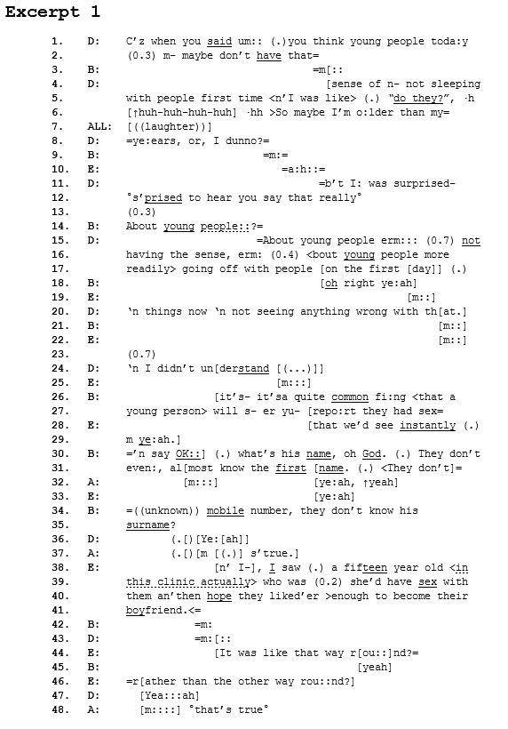
Excerpt 1

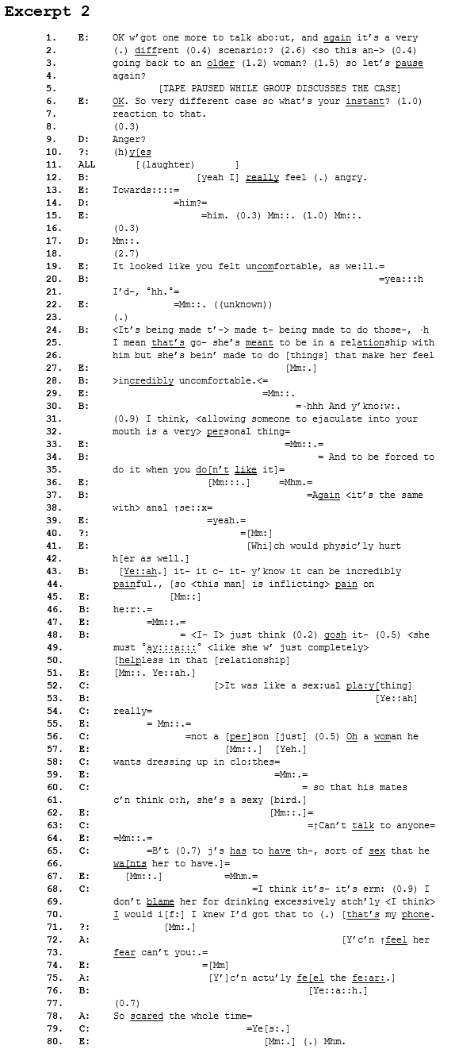
Excerpt 2
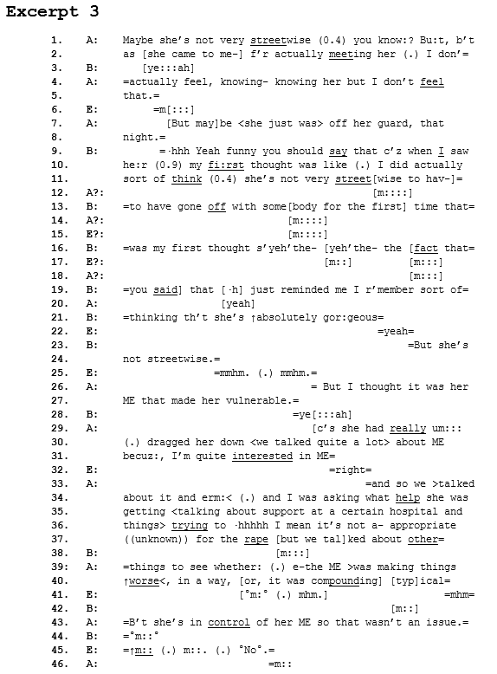
Excerpt 3

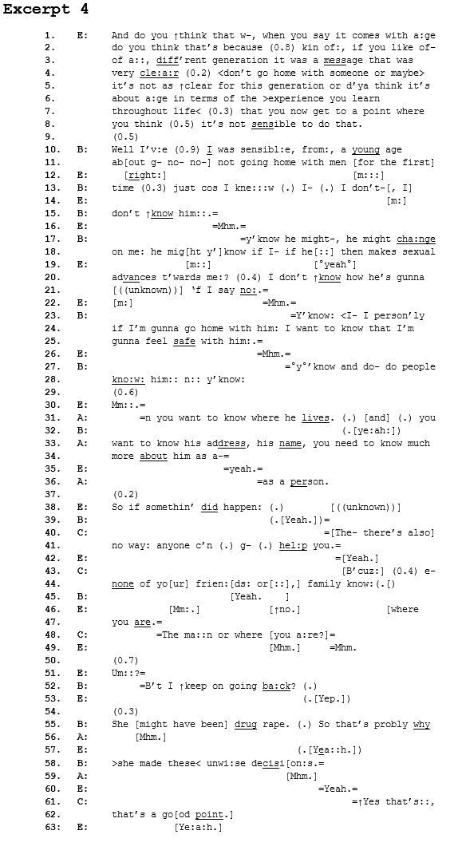
Excerpt 4

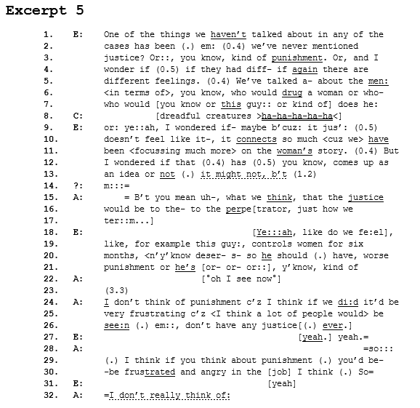
Excerpt 5
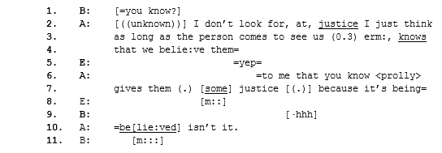
Excerpt 6

Though the term “victim” is used within the context of rape cases when they appear in the criminal justice system, we used the term “survivor” since this is often preferred by those who experience this crime on the grounds that it is more empowering (cf. Leisenring, 2006).
Notably, E’s conversational labour is quite marked here, inasmuch as it appears arduous to start a conversation around the clinicians’ personal responses to the case at hand. This idea of conversational labour as a marker of topical difficulty is explored in depth in a later section.
Myalgic Encephalomyelitis or ME (also known a Chronic Fatigue Syndrome or CFS) is a long-term health condition where sufferers experience abnormal levels of fatigue, often impacting sufferers' social lives and their capacity to engage in everyday social interaction.
Or, as in Excerpt 3, the non-salience of ME as a medical fact relevant to the case at hand.
Which, gathered from previous moments in the recordings, conversants use to refer to 'traditional' forms of punishment such as legal prosecution and imprisonment.

