Investigating spatial impact on indoor personal thermal comfort

Puyue Gong1,3, Yuanzhi Cai2,4, Zihan Zhou2, Cheng Zhang2*, Bing Chen1, Stephen Sharples3  
1 Department of Urban Planning and Design, Xi’an Jiaotong-Liverpool University, China

2 Department of Civil Engineering, Xi’an Jiaotong-Liverpool University, China

3 School of Architecture, University of Liverpool, UK

4 School of Engineering, University of Liverpool, UK

# Abstract

Thermal comfort prediction is essential for both maintaining a favorable indoor environment and reducing energy consumption. Predicted Mean Vote (PMV), as the most popular research method, has a limitation in processing various complex parameters and investigating the individual difference in occupants’ thermal preference. Therefore, machine learning (ML) method has been utilized in exploring the personal thermal comfort prediction because of its strong self-study ability, high-speed computing ability, and complex problem-solving ability. However, the primary variables considered in previous studies focus on the human body’s physiological and psychological aspects, while lack of considering architectural spatial impact, which causes different indoor microclimate. Therefore, the present research proposed a methodology to investigate the impact from spatial parameters on personal thermal comfort prediction model accuracy by developing an ANN-based model and explicitly representing the spatial variables in the model. The spatial parameters were identified and classified into buildings’ spatial features, indoor spatial features and individual spatial features. The data required in developing the ANN-based model were collected by various field experiments. A baseline of model prediction accuracy was calculated by using conventional parameters, including personal-dependent parameters and environmental parameters. It was found that the spatial parameters had a noticeable impact on model prediction accuracies. By considering spatial parameters in the ANN-based model development, the prediction accuracies had been increased significantly compared with the conventional models.

**Keywords:** Personal Thermal Comfort, Spatial impact, Machine Learning, Artificial Neural Network (ANN), Prediction Model

# Introduction

Energy efficiency and thermal comfort are two major driving forces of building design and operation (Guenther & Sawodny, 2019). Heating, ventilation and air conditioning (HVAC) consumes 55% of building operational energy (Xu, 2018), which is mainly used for satisfying occupants’ thermal comfort requirements. When building designers simulates energy consumption during the design period, they assume that the occupants will use facilities in an expected way. Nevertheless, some researchers have found that users behave differently according to their thermal comfort level, which usually beyond the designers’ anticipation in reality (Djongyang et al., 2010; Dai & Jiang, 2020). For example, sometimes users open windows and doors to get air circulation while keeping air conditioners running, which results in more energy consumption. As indicated in Zhang et al. (2018) and Chaudhuri et al. (2019), the potential influence of users’ behavior on energy consumption of residential buildings reaches 10%~ 25%, while the effect on commercial buildings is 5%~30%.

People spend more than 90% of their time in indoor environment (Frontczak & Wargocki, 2011). Better indoor environment design not only reduce energy consumption but also improve users’ working efficiency and well-being (Cui et al., 2013). Therefore, it is essential to investigate the influence from architectural design to occupants’ thermal comfort, so as to provide a more comfort indoor environment. Du et al. (2016) has indicated that architectural spatial design strategies have impact on users’ thermal comfort level by changing the building microclimate.

In addition, occupants’ thermal preference is different because of individual differences, such as age, gender and body mass index (BMI) (Wang et al., 2018). Existing research of indoor thermal comfort focuses on occupants’ average level, such as Predicted Mean Vote (PMV) method (Fanger, 1970), while lack of considering the difference in personal thermal comfort preference. Although more and more research consider the individual thermal comfort difference, the primary variation focuses on the human body’s physiological and psychological aspects (Wang et al., 2018; Katic et al., 2018). To the best knowledge of authors, the architectural spatial impact has not been fully investigated in the studies of personal thermal comfort. Various spatial locations and configuration design has different influence on human, consisting of building orientations, indoor spatial layout and occupants’ indoor locations. Furthermore, it is not clear how to explicitly present these spatial impacts in indoor environment studies.

This paper aims to explore spatial impact on personal thermal comfort level by establishing machine learning based personal thermal comfort prediction models. By conducting sensitivity analyses, the significance of different spatial parameters was investigated.

# Literature Review

## 2.1 Impact factors of Thermal comfort

Fanger’s model (1970) is popularly used in traditional thermal comfort investigations by considering metabolism, clothing, indoor air temperature, indoor mean radiant temperature, indoor air velocity and indoor air humidity. Besides these factors, some scholars found that seasons and outdoor climatic conditions had a psychological effect or direct effect on occupants’ indoor thermal comfort (Wang, 2006; Frontczak& Wargocki, 2011; Chaudhuri, 2017). In addition, occupants’ age, gender, and body composition were considered as major sources for individual difference and taken into account to explore individual difference in thermal preference (Zhang et al., 2001; Huizenga et al., 2001). For example, Lan et al. (2008) pointed that the comfortable temperature of females was 1°C higher than that of males. Another researcher found that the neutral temperature of elder people was 0.54°C lower than that of young people in summer and 0.47°C higher in winter (Peng, 2010). Different body compositions (such as body weight, height and skin fold) stimulated various skin temperatures, which led to the difference in thermal comfort levels (Katic et al., 2018).

However, the above-mentioned research mainly focused on the human’s physiological and psychological aspects, while lack of considering architectural spatial impact, which caused different building microclimate (Du et al., 2016). For instance, Caner and Iten (2020) proved that room orientation influenced indoor occupants’ thermal perception.

The indoor heat distribution was uneven due to the location of heat sources and air circulation channels, which led to various occupants’ thermal perception at different indoor locations. This phenomenon was not fully considered in thermal comfort studies, because the indoor thermal environment was assumed to be steady and uniform (Zhang & Zhao, 2009). Therefore, more investigation should be conducted to identify and investigate the impacts of spatial parameters on occupants’ thermal comfort level.

## 2.2 Traditional Individual thermal comfort analysis

Predicated Mean Vote (PMV) Model is the most widely adopted thermal comfort prediction method (Fanger, 1970; Chaudhuri et al., 2017), but it has a limitation in processing various complex parameters in real time (Guo & Zhou, 2009), neither predicting the individual thermal comfort (Ciabattoni et al., 2015). Moreover, PMV requires a large amount of data with high accuracy (Hoof, 2008), as well as a strict restriction on data type (Kim et al., 2018). Iketa et al. (2021) indicated that PMV has limitation in application scenarios, for example it cannot be used in naturally ventilated buildings. To supplement the PMV in the consideration of individual difference, a predicted percentage of dissatisfied (PPD) was developed to show the percentage of people who are not satisfied (Fanger, 1970). Yao et al. (2009) developed a hybrid adaptive model of thermal comfort (aPMV) to take the local climate and individual differences into consideration, such as cultural and social backgrounds, behavior, and lifestyle. Olissan et al. (2016) proposed a PMVnew model by investigating the regression coefficients of correction factors in order to fulfil the coastal strip of southern Benin.

However, the resulted the neutral temperature obtained by PMV-PPD model was lower than desired by the occupants surveyed, and the prediction results among PMV, aPMV and PMVnew had discrepancies in some cases (Gratien et al., 2020). Therefore, more efficient approaches should be investigated to improve the prediction accuracy by processing various real time data and exploring the spatial impact on individual thermal comfort.

## 2.3 Machine learning-based thermal comfort prediction

Recently, machine learning (ML) method becomes popular in thermal comfort studies because of its strong self-study ability, high-speed computing ability, and complex problem-solving ability (Qian et al., 2020; Wang et al., 2020 (a)). Compared with the PMV model, the accuracy of ML-based thermal comfort prediction was 40% higher on average (Kim et al., 2018; Cosma & Simha, 2018). Meanwhile, the ML method has a better ability to deal with non-standard and nonlinear relationships compared with PMV (Wang et al., 2020 (b)). Some studies have proved that Artificial Neural Network (ANN) had better performance in predicting thermal sensation votes (Qian et al., 2020). Katic et al. (2020) considered individual diversity (gender, weight, and age) and skin temperature in personal comfort models. The results presented the best performance of thermal comfort prediction with a median accuracy of 0.8 by using Support Vector Machine (SVM) with Linear kernel. Six machine learning algorithms were utilized by Kim et al. (2018) to develop personal thermal comfort prediction models, which were Classification Tree (CT), Gaussian Process Classification (GPC), Gradient Boosting Method (GBM), Kernel Support Vector Machine (kSVM), Radom Forest (RF), and Regularized Logistic Regression (regLR) algorithms, considering heating and cooling intensity and location, chair occupancy, air temperature and relative humidity. The median accuracy of prediction models was 0.73 based on the best performing algorithm, which was higher than PMV modes with a median accuracy of 0.51. Qian et al. (2020) used ML algorithms to predict occupants’ thermal comfort votes (TCV) by considering environmental parameters, personal parameters, climatic types, and adaptive control measures. Compared with PMV, including ePMV and aPMV models, the ML models had smaller errors in predicting TCV, especially ANNs model has the smallest mean square error, and the smallest mean absolute error value. Shan et al. (2020) applied a Levenberg-Marquardt (LM) algorithm-based ANN in thermal comfort prediction and investigated the impact of occupants’ skin temperature at different location on prediction performance. They found that the optimal personal comfort model obtained an accuracy of 89.2%.

However, most above-mentioned ML-based models were developed using Fangers’ PMV model to predict occupants’ general thermal comfort rather than establishing an individual prediction model (Qian et al., 2020). It cannot satisfy the developing demand of personal thermal comfort prediction. Therefore, some scholars start to establish the personal thermal comfort prediction model by applying ML technologies. For example, Chaudhuri et al. (2017) implemented individual thermal comfort prediction models based on six types of ML algorithms, which include Support Vector Machine (SVM), ANN, Logistic Regression (LR), Linear Discriminant Analysis (LDA), K-Nearest Neighbors (KNN) and CT. For each occupant, indoor and outdoor environment parameters (air temperature, air velocity, mean radiant temperature, relative humidity) and personal parameters (gender, age, metabolic rate, clothing rate) were measured, as well as occupants’ thermal comfort voting. The prediction accuracy of these approaches achieved 73.14-81.2%, while the accuracy of PMV was only 41.86-65.5%.

Same as traditional thermal comfort studies, ML-based personal thermal comfort models mainly focused on occupants’ physiological and psychological difference, without considering spatial impact. Few studies considered the spatial related difference into the ML-based personal prediction model, such as adding desk-specific air velocity measures to obtain the district ambient environment (Guenther & Sawodny, 2019). While the other difference caused by various spatial locations and spatial configuration design was not taken into consideration. Therefore, more spatial factors should be integrated into the ML-based personal thermal comfort prediction model development, and the impact on prediction accuracy from these factors should be investigated in depth.

# Proposed methodology

To integrate the spatial parameters into the personal thermal comfort prediction model and probe into the influence of these parameters on models’ accuracy, a research methodology was proposed, as shown in Figure 1.

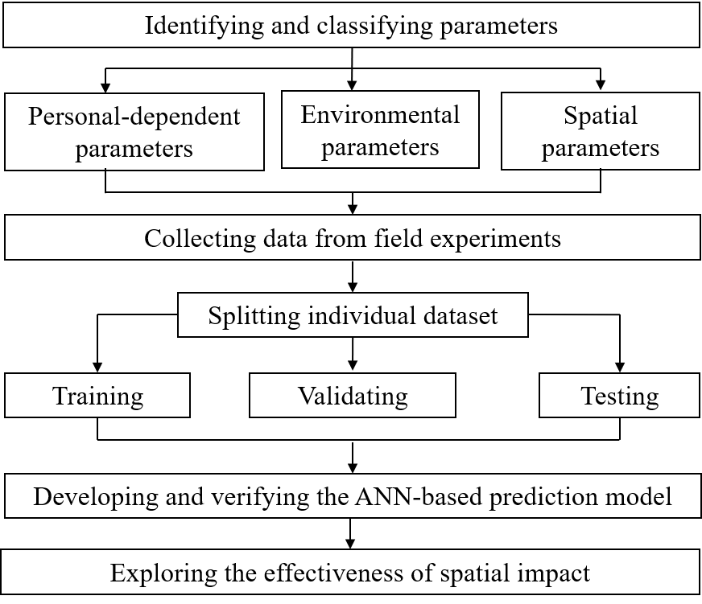

Figure 1 The proposed methodology

First of all, essential personal-dependent parameters and environmental parameters were summarized according to literatures. More focus was on identifying and classifying the parameters of spatial impacts on occupants’ thermal comfort level. Field experiments were designed to collect relevant data and form datasets for individuals, which were split into training, validating and testing sections. Subsequently, the ANN-based personal thermal comfort prediction model was established, and the impact of spatial parameters on the prediction accuracy was investigated. To verify the results from ANN-based model, four popularly used ML algorithms were utilized, which included Subspace KNN and SVM. By comprehensively evaluating the results, the significances of individual single and combinations of spatial impacts were ranked. From which, better combinations of parameters were identified based on the model prediction accuracy.

## 3.1 Identifying and classifying parameters

The ANN-based personal thermal comfort prediction model was established by augmenting spatial parameters based on PMV model. Therefore, the personal-dependent paraments (subjects’ age, gender, BMI, clothing insulation level and metabolic rate) and environmental parameters (average indoor air temperature, humidity and airspeed, and mean radiant temperature) considered in PMV also been taken into account in present research. Additionally, the outdoor weather was also considered, including outdoor temperature, humidity, and weather condition. Apart from these parameters, the spatial impact was classified into spatial features of buildings, spatial features of indoor space, and spatial features of individuals as shown in Table 1. The spatial features of buildings were identified as sunlight exposure condition. Spatial features of indoor space expressed the indoor spatial configuration, including relative coordinates to subjects, surface temperature and orientation of windows, doors and heat sources. The spatial features of individuals were introduced as ambient air temperature and humidity of subjects, as well as their forehead skin temperature.

Table 1 Parameters’ identification and classification

|  |  |  |  |  |
| --- | --- | --- | --- | --- |
| Categories | Features | | Description | |
| Personal-dependent parameters | Subjects’ basic information | | Age, gender and BMI | |
| Clothing insulation level | | Calculated by using ASHRAE-2010 | clo |
| Metabolic rate | | Met Units |
| Environmental parameters | Indoor environment | | Average indoor air temperature, humidity and air speed | Temperature (℃) Humidity (%) Air speed (m/s) |
| Outdoor weather | | Outdoor temperature, humidity and weather condition | Weather condition: sunny (1), cloudy (2), and overcast (3) |
| Mean Radiant Temperature | | Calculated by using ASHRAE-2010 | ℃ |
| Spatial parameters | Buildings’ spatial features | Exposure to sunlight exposure(S) | Whether or not exposure to direct sunlight | not exposure to sunlight (0) or exposure to sunlight (1) |
|  |  |  |
| Indoor spatial features | Surface temperature of windows, doors and heat sources | Heat sources including windows, air outlets of air conditions, and door | ℃ |
| Tree-Dimensional Cartesian coordinates | The distances of subjects to windows, doors and heat sources in three dimensions | (X-axis, Y-axis, Z-axis) |
| Window orientation (O) | The window face north, south, or east | Northward, southward, and eastward were recorded as (1) and (2) and (3) |
| Individual spatial features | Ambient environment (AE) | The air temperature and humidity | Temperature (℃) Humidity (%) |
| Forehead skin temperature of subjects (FST) | The skin temperature at the forehead | ℃ |

### 3.1.1 Spatial features of buildings

Direct sunlight through windows significantly contributed to indoor heat flow, which affected occupants’ thermal comfort level (Alawadhi, 2018). Chinazzo et al. (2019) proved that both daylighting illuminance and temperature had influence on occupants’ thermal perception. Therefore, the sunlight exposure condition were classified as buildings’ spatial features.

### 3.1.2 Spatial feature of indoor space

Huizenga et al. (2006) indicated that the effect of window surface temperature and the effect of solar radiation transmitted by the windows and absorbed by the body are significant on occupants’ thermal comfort level. Additionally, they found that the geometry of windows (including window size and distance to the window) is an essential impact on indoor thermal comfort level. For example, the closer a person is to a window, the greater the impact on comfort. Oliveira et al. (2021) claimed that glazed elements of windows usually led to undesired heat losses which are disturbing elements for occupants’ indoor thermal comfort. Additionally, Chi et al. (2020) proved that the orientation influenced indoor temperature and further affected individuals’ thermal perception in the same window-wall ratios (WWRs). Therefore, surface temperature and orientation of windows, as well as its relative coordinates of subjects to windows, should be considered.

The material of doors (such as timber and stainless steel) has different heat transfer coefficient with concrete wall, which led to temperature difference surrounding door. Li et al. (2017) indicated that air-conditioned room had problems in strong local blowing and poor air circulation, which had negative influence on indoor thermal comfort level. They claimed that the installation location of air conditioners and air supply parameters had closed relationship with occupants’ thermal preference. Therefore, door and air conditioners should be considered as spatial features of indoor space.

In the present research, surface temperature and orientation were recorded under real experimental condition. The relative coordinates of subjects to windows, doors and air conditioners were calculated using Equation 1.

$\left(x,y,z\right)=\left(\left|x_{1}-x_{2}\right|,\left|y_{1}-y_{2}\right|,\left|z_{1}-z_{2}\right|\right)$ (Eq.1)

Where, x1 and y1 were the coordinates of subjects’ location in x- and y-axes; z1 was the height of subjects’ forehead; x2, y2 and z2 were the coordinates of the center points of windows, doors and air conditioners in x-, y- and z-axes, respectively.

### 3.1.3 Spatial features of individual

Due to the uneven heat distribution in the room, there were differences in each occupant's ambient temperature and humidity, which impacted individual thermal comfort that led to different skin temperature of individuals. Cosma and Simha (2019) indicated that forehead skin temperature was the most correlated index with occupants’ comfort sensation. Therefore, subjects’ ambient air temperature, humidity, and forehead skin temperature were considered as individual spatial variables.

## 3.2 Collecting data from field experiments

The field experiment was designed to collect static and dynamic data of individuals. The static data consisted of subjects’ age, gender, BMI, and the heights of the foreheads’ center points when subjects sat and stood, correspondingly. Meanwhile, the coordinates of windows, doors, heat sources and testing locations were recorded to calculate relative locations.

The dynamic data acquisition was conducted periodically during the experiment, including subjects’ clothing isolation level, metabolic rate, outdoor temperature, indoor temperature and humidity at subjects’ location, subjects’ forehead skin temperature, and indoor wind speed. Meanwhile, the thermal comfort voting results were collected periodically by using ASHRAE 7-point continuous voting scale (-3 (cold), -2 (cool), -1 (slightly cool), 0 (neutral), 1 (slightly warm), 2 (warm), 3 (hot)), as shown in Figure 2.

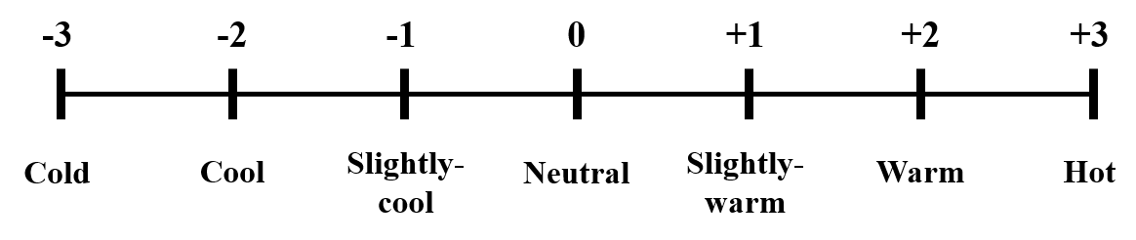

Figure 2 ASHRAE Thermal Comfort scale

## 3.3 The thermal comfort prediction model development and verification

As presented in the literature review, ANN has better performance in thermal comfort predicting studies, therefore, ANN was selected to develop a thermal comfort prediction model based on the data collected from the experiments.

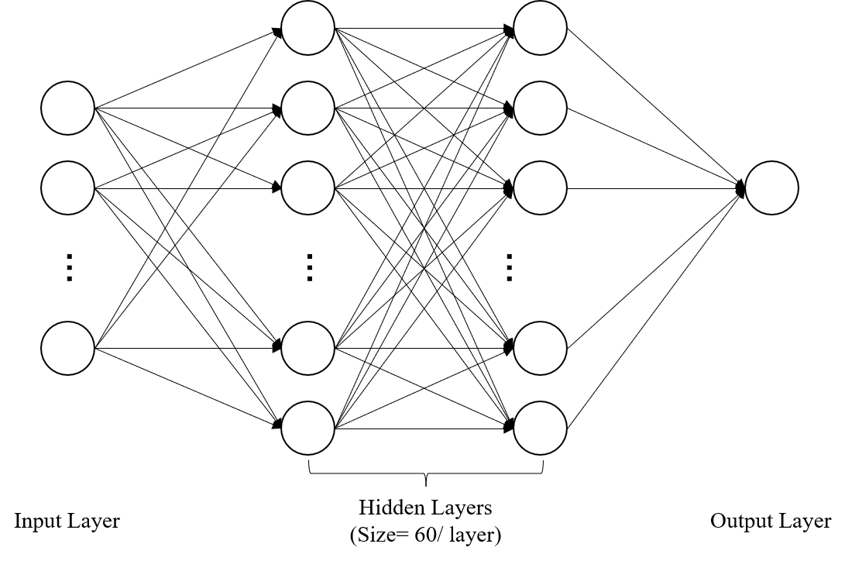

Figure 3 The end-to-end artificial neural network structure

To develop ANN-based prediction model, empirical solutions proven in previous studies were used for reference (Moon & Kim, 2010; Moon, 2012). As shown in Figure 3, the end-to-end ANN structure included an input layer, two hidden layers, and a classification output layer.

In the field of deep learning, there is a consensus that higher segmentation accuracy can be achieved using a deeper and wider model. However, as the depth and width of the model increase, the amount of computation time required increases dramatically. Since many feature combinations need to be tested in this study, it is necessary to choose an ANN model of appropriate size to ensure sufficient accuracy while minimizing the computational effort. Therefore, the prediction accuracy of ANN models of different sizes when using conventional feature combinations was first tested, and the results were summarized in Table 2. It can be observed that an ANN model with two hidden layers and 60 neurons per layer can achieve a prediction accuracy of 70%, while further increasing the size of ANN can only yield a smaller accuracy improvement. Therefore, a two-layer ANN structure with 60 neurons per layer was adopted for subsequent experiments.

Table 2 The prediction accuracy of ANN models with different sizes when using conventional feature combinations

|  |  |  |  |  |
| --- | --- | --- | --- | --- |
| Number of layers | Number of neurons per layers | | | |
| 10 | 30 | 60 | 90 |
| 1 | 63.5% | 67.8% | 68.3% | 69.3% |
| 2 | 63.5% | 68.1% | ***70.4%*** | 70.6% |
| 3 | 65.6% | 70.2% | 71.0% | 71.1% |
| 4 | 65.9% | 70.4% | 71.9% | 72.3% |

The loss function used in the output layer was crossentropy, and the network is trained by using the Scaled Conjugate Gradient method. The dataset was split in the ratio of 70%: 15%: 15% for training, validation and testing respectively. The training set is used to optimize the ANN model, while the validation set is used to stop the optimization process (the training process is stopped when the accuracy of the model does not improve on the validation set), and finally the test set is used to test the accuracy setoff the trained model. Since the data in the test set is never used to train the ANN model, testing the accuracy of the ANN model on the test set is considered as the validation of the ANN model.

To verify the results from ANN-based model, two more ML algorithms were utilized, including SVM and Subspace KNN. These two ML models not only have achieved relatively high prediction accuracy in the study of thermal comfort prediction (Katic et al., 2020; Kim et al., 2018; Qian et al., 2020; Guenther & Sawodny, 2019), but also have been widely used in other domains, such as remote sensing (Mountrakis, 2011; Ma et al., 2019), biomedical engineering (Sarhan et al., 2020; Hosseini et al., 2021) and robot control (Wang et al., 2012). Therefore, they were selected to provide verifications for our proposed method. The datasets of those two algorithms were divided into training and testing sets in the percentage of 70%: 30%.

## 3.4 Exploring the effectiveness of spatial parameters

An ablation experiment was conducted to investigate the impact of spatial parameters on the prediction accuracy. Sensitivity coefficient (SC) was applied to measure the effectiveness of different spatial impact (Zhang & Ong, 2017), by using the following equation.

$SC={(A_{1}-A_{0})}/{A_{0}}$ (Eq.2)

where, A0 was the predicting accuracy when considering personal-dependent and environmental parameters only; A1 was the predicting accuracy when considering personal-dependent, environmental, and spatial parameters.

For each subject, 7 single spatial variables and 57 combinations were considered in the calculation of SC value, which were sorted from high to low to evaluate their significance.

# Case studies

## 4.1 Study area

Suzhou is located at 30° 47′‒32° 02′ N, 119° 55′‒121° 20′E in Eastern China and has a subtropical monsoon maritime climate with four distinct seasons. The annual average temperature in January is 3.1°C and 28°C in July (Zhou et al., 2020). The average yearly precipitation is about 1100mm but concentrated in April to September and lowest in December and January (Qi, 2008). The air conditioning systems are utilized as the major heating approach during winter and cooling approach during summer in Suzhou.

The first experiment was carried out in the periods from 28th November to 2nd December (5 days) in Room 1, while the second one was from 4th to 8th January (5 days) in Room 2, which were typical wintertime in the area. On each experimental day, two experiments were conducted from 12 p.m. to 3 p.m. and 3 p.m. to 6 p.m., respectively. The 3rd, 4th, and 5th experiments were conducted during the period of 22nd and 23rd September (2 days) in Room 3, 25th September (1 day) in Room 4, and from 27th to 30th September (4 days) in Room 5, respectively. On each day, three experiments were conducted from 9.30 am to 11.30am, 1.30 pm to 3.30 pm, and 4.0 0pm to 6.00 pm, respectively. .

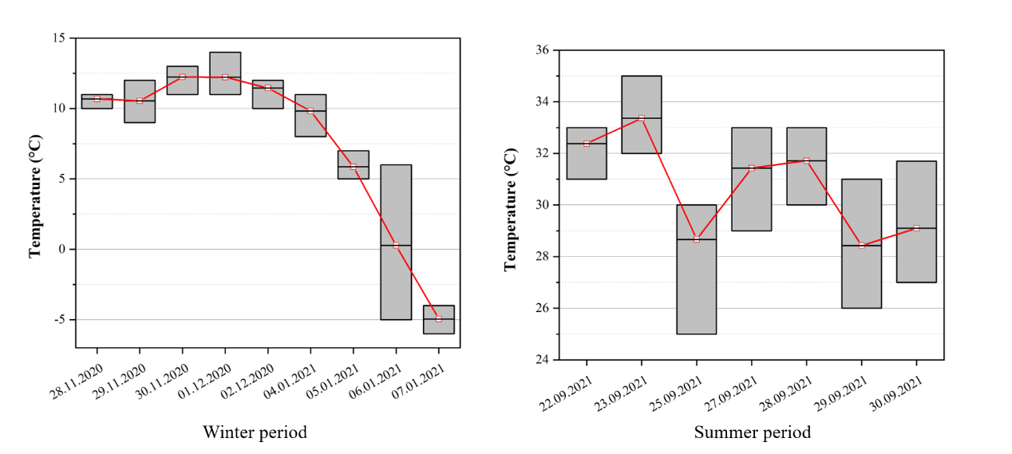

Figure 4 Outdoor temperature during the investigation period

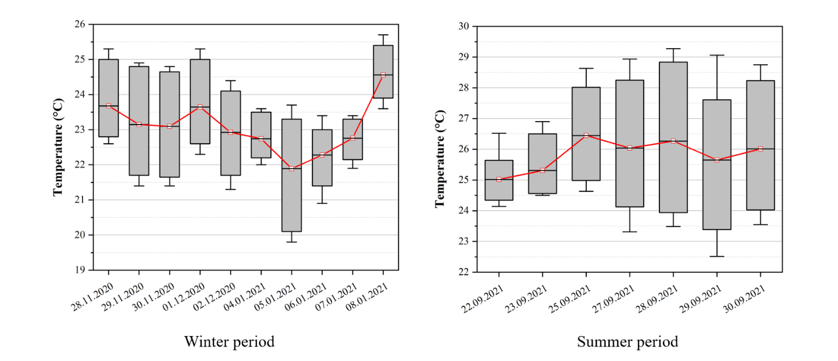

Figure 5 Indoor temperature during the investigation period

As shown in Figure 4, in winter experiment days, the outdoor air temperature ranged between 9°C and 13°C, with an average of 11.5°C in the first five days, and the temperature ranged between -6°C and 11°C, with an average of 2.05°C in the other days. In summer experiment days, the outdoor air temperature ranged between 23°C and 35°C, with an average of 30.7°C. Figure 5 presents the indoor temperature recorded during those experiments. The indoor temperature ranged from 20°C to 25.5°C in these two case studies in winter, although the set temperature of the air conditioners was increased from 17°C to 30°C. In summer, the indoor temperature ranged from 23.5°C to 28.5°C when the set temperature of the air conditioners was set between 18°C and 30°C.

## 4.2 Experimental settings

As shown in Figure 6, five rooms were used for field experiments including three rooms facing north (Rooms 1 and 2) and two rooms (Rooms 3, 4 and 5) facing south. Room 1 and Room 2 were in the same building of a university campus which were used for data collection in winter. Room 1 was a 10.5m × 6.3m × 3m classroom in the fifth floor with an area of 64 m2, and the window-to-wall ratio (W/W) was 0.4. Room 2 was a 9m × 7.5m × 3m classroom on the fourth floor with an area of 67.5 m2, and the W/W was 0.468. Room 3, Room 4 and Room 5 were in different office buildings near the university campus which were used for data collection in summer. Room 3 was a 7.6m × 5.05m × 2.98m meeting room on the sixth floor with an area of 38 m2, and the W/W was 0.468. Room 4 was an 8.26m × 5.42m × 2.7m meeting room on the first floor with an area of 44.8 m2, and the W/W was 0.368. Room 5 was a 7.5m × 8.1m × 2.7m office room on the fifth floor with an area of 60.75 m2, and the W/W was 0.613.

Six thermometers were hanged from the ceiling by using long stickers and all thermometers were kept 1.1 meters above the ground to obtain the indoor air temperature. Another six thermometers were mounted on small wooden tripod on table, and the center point of thermometers were kept 1.1 meters above the ground in order to obtain the ambient air temperature. The layout of five experimental rooms were exhibited in Figure 6 and the coordinates of the center points of windows, door, air conditioners and subjects’ locations were shown in Table 3.

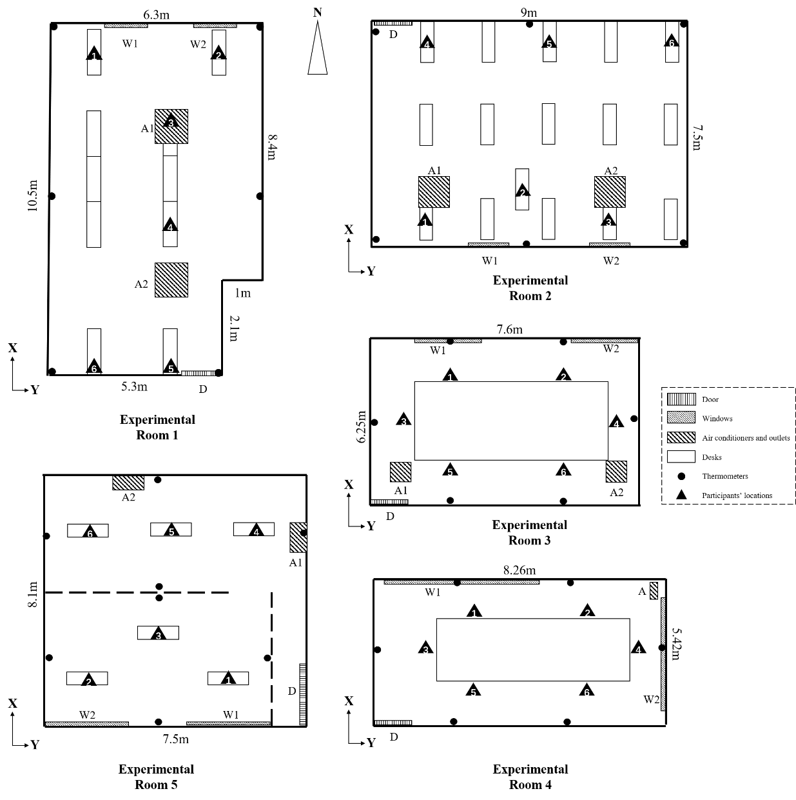

Figure 6 The layout of five experimental rooms

Table 3 Coordinates of the center points of windows, doors, air conditioners and subjects’ locations in five experimental rooms (unit: m).

|  |  |  |  |  |  |  |  |  |  |  |  |
| --- | --- | --- | --- | --- | --- | --- | --- | --- | --- | --- | --- |
| **Room 1** (Room orientation: *Northward*; Experimental period: Winter- *2020.11.28~2020.12.02*) | | | | | | | | | | | |
| Coordinates | Window 1 *(W1)* | Window 2 *(W2)* | | | Door  *(D)* | | | Air conditioner 1 *(A1)* | | Air conditioner 2 *(A2)* | |
| X | 10.5 | 10.5 | | | 0 | | | 7.5 | | 3.2 | |
| Y | 1.05 | 4.05 | | | 4.6 | | | 3.3 | | 3.3 | |
| Z | 1.5 | 1.5 | | | 1.1 | | 3.0 | | | 3.0 | |
| Coordinates | Location 1 | | Location 2 | | | Location 3 | | Location 4 | Location 5 | | Location 6 |
| X | 9.9 | | 9.9 | | | 7.4 | | 4.75 | 0.5 | | 0.5 |
| Y | 5.2 | | 0.9 | | | 3.3 | | 3.3 | 3.3 | | 0.9 |
| Z | The height of subjects’ forehead when they sit. | | | | | | | | | | |
| **Room 2** (Room orientation: *Southward*; Experimental period: Winter- *2021.01.04~2021.01.08*) | | | | | | | | | | | |
| Coordinates | Window 1 *(W1)* | | Window 2 *(W2)* | | | Door  *(D)* | | Air conditioner 1 *(A1)* | | Air conditioner 2 *(A2)* | |
| X | 0 | 0 | | | 7.5 | | | 2.2 | | 2.2 | |
| Y | 3.0 | 6.4 | | | 0.7 | | | 1.6 | | 7.1 | |
| Z | 1.5 | 1.5 | | | 1.1 | | 3.0 | | | 3.0 | |
| Coordinates | Location 1 | | Location 2 | | | Location 3 | | Location 4 | Location 5 | | Location 6 |
| X | 0.6 | | 2.2 | | | 0.6 | | 6.9 | 6.9 | | 6.9 |
| Y | 1.6 | | 4.35 | | | 7.1 | | 1.6 | 4.65 | | 8.4 |
| Z | The height of subjects’ forehead when they sit. | | | | | | | | | | |
| **Room 3** (Room orientation: *Northward*; Experimental period: Summer- *2021.09.22~2021.09.23*) | | | | | | | | | | | |
| Coordinates | Window 1 *(W1)* | | Window 2 *(W2)* | | | Door  *(D)* | | Air conditioner 1 *(A1)* | | Air conditioner 2 *(A2)* | |
| X | 3.7 | 6.71 | | | 0.7 | | | 0.455 | | 6.25 | |
| Y | 0 | 0 | | | 7.5 | | | 1.5 | | 1.5 | |
| Z | 1.5 | 1.5 | | | 1.1 | | 3.0 | | | 3.0 | |
| Coordinates | Location 1 | | Location 2 | | | Location 3 | | Location 4 | Location 5 | | Location 6 |
| X | 3.55 | | 3.55 | | | 2.1 | | 2.1 | 1.5 | | 1.5 |
| Y | 2.81 | | 4.91 | | | 1.51 | | 6.25 | 2.81 | | 4.91 |
| Z | The height of subjects’ forehead when they sit. | | | | | | | | | | |
| **Room 4** (Room orientation: *Northward*; Experimental period: Summer- *2021.09.25*) | | | | | | | | | | | |
| Coordinates | Window 1 *(W1)* | | | Window 2 *(W2)* | | | Door *(D)* | | | Air conditioner *(A)* | |
| X | 5.42 | | | 2.75 | | | 0 | | | 5.12 | |
| Y | 2.55 | | | 8.26 | | | 0.45 | | | 7.52 | |
| Z | 1.8 | | | 1.8 | | | 1.04 | | | 1.61 | |
| Coordinates | Location 1 | | Location 2 | | | Location 3 | | Location 4 | Location 5 | | Location 6 |
| X | 3.76 | | 3.76 | | | 2.98 | | 2.22 | 2.22 | | 2.68 |
| Y | 4.03 | | 5.33 | | | 6.65 | | 5.33 | 4.03 | | 2.98 |
| Z | The height of subjects’ forehead when they sit. | | | | | | | | | | |
| **Room 5** (Room orientation: *Southward*; Experimental period: Summer- *2021.09.27~2021.09.30*) | | | | | | | | | | | |
| Coordinates | Window 1 *(W1)* | | Window 2 *(W2)* | | | Door  *(D)* | | Air conditioner 1 *(A1)* | | Air conditioner 2 *(A2)* | |
| X | 0 | | 0 | | | 4.4 | | 5.6 | | 7.7 | |
| Y | 4.7 | | 1.2 | | | 5.38 | | 7.1 | | 2.65 | |
| Z | 1.35 | | 1.35 | | | 1.16 | | 2.7 | | 2.7 | |
| Coordinates | Location 1 | | Location 2 | | | Location 3 | | Location 4 | Location 5 | | Location 6 |
| X | 2.23 | | 2.23 | | | 3.0 | | 6.7 | 6.7 | | 6.7 |
| Y | 4.4 | | 1.3 | | | 2.85 | | 5.96 | 3.66 | | 1.36 |
| Z | The height of subjects’ forehead when they sit. | | | | | | | | | | |

## 4.3 Experimental procedure

Subjects randomly choose their locations in the first experiment and seated for two hours to carry out thermal sensation voting, after that, they took a half-hour break. They changed their locations in the second experiment. In this way, it is guaranteed that each subject could be tested at six different locations in every room. Before starting the experiments, the subjects were asked to stay in the experiment room with a constant set temperature of 17°C and natural ventilation for 30 min so as to mitigate the effect of pre-experiment activities and heat exposure. Meanwhile, all subjects were prohibited from drinking alcohol and coffee for 12 hours before testing. In winter, the initial temperature set for the air conditioners was 17°C, and then it was raised by 1°C per 10 minutes until the set temperature reached 30°C. In summer, the initial temperature set for the air conditioners was 18°C, and then it was raised by 2°C per 10 minutes until the set temperature reached 30°C. The doors and windows were kept closed during these experiments. Meanwhile, subjects were required to be seated and read books, avoiding activities that may cause apparent emotional fluctuations (Zhou et al., 2017).

Subject’s thermal comfort level was investigated by using ASHRAE 7-point continuous voting scale, and instantaneous value of the air temperature were recorded every 10 minutes. The indoor air temperature and relative humidity (RH) were measured by using Xiaomi blue tooth thermometers, which accuracy achieved ± 0.1 ℃ and ± 1 % RH with measuring range of 0℃ ~60℃ for temperature and 0% ~99% for RH, respectively. Subjects’ forehead skin temperature (FST), surface temperature of windows, doors and air conditioners were measured by suing a FLIR E85 thermal camera, which had a measuring range of -20℃ ~120℃ and an accuracy of ± 2 ℃. Additionally, Testo 405i anemometers were utilized to obtain air velocity with a measuring range of 0~10 m/s and an accuracy of ± 0.1 m/s.

# 4.4 Subjects’ Information

Ten Chinese healthy subjects were recruited, including four males and six females, whose physiological information is shown in Table 4.

Table 4 Physiological information of participants

|  |  |  |  |  |  |  |
| --- | --- | --- | --- | --- | --- | --- |
| Subject | Gender | Age | Height (cm) | Weight (kg) | BMI | The height of the occupant's forehead when sitting (m) |
| 1 | Female | 27 | 161 | 61 | 23.5 | 1.28 |
| 2 | Female | 23 | 163 | 49 | 18.4 | 1.26 |
| 3 | Male | 25 | 175 | 76 | 24.8 | 1.28 |
| 4 | Male | 28 | 184 | 79 | 23.3 | 1.30 |
| 5 | Female | 20 | 163 | 59 | 18.8 | 1.14 |
| 6 | Female | 21 | 166 | 54 | 19.6 | 1.17 |
| 7 | Male | 21 | 173 | 54 | 18.0 | 1.15 |
| 8 | Male | 25 | 183 | 76 | 22.7 | 1.17 |
| 9 | Male | 26 | 168 | 62 | 22.0 | 1.17 |
| 10 | Male | 21 | 170 | 62 | 21.5 | 1.16 |

## 4.5 Academic ethics consideration

Before the start of the experiment, the subjects were fully aware of the objective and content of the experiment. All subjects signed the consent forms for data collecting permission. The experiment was approved by the university ethics committee.

# Results and analysis

In total, 1762 questionnaires on individual thermal comfort voting were collected, among which 1690 groups of data were valid (including 847 groups from winter and 843 groups from summer) and used to establish the personal thermal comfort prediction model. A baseline of model prediction accuracy was calculated by using conventional parameters, including personal-dependent parameters and environmental parameters as introduced in Table 1. Sixty-four scenarios were considered to evaluate the significance of different spatial variables by calculating the corresponding SC values, including seven scenarios considering single spatial variables, five scenarios considering the combinations of multiple spatial variables among same categories, and 52 scenarios considering the combinations of all spatial variables.

## 5.1 The influence of single spatial variables

The comparison among single spatial variables from building’s spatial features, indoor spatial features and individual spatial features were conducted to explore their impact to prediction accuracy. Buildings’ spatial features included *building’s* *sunlight exposure condition* (S). Indoor spatial features consisted of *window* (W), *doors* (D), and *air conditioners* (A). Individual spatial features included subjects’ *forehead skin temperature* (FST) and *ambient environment* (AE).

Table 5 The results of personal thermal comfort prediction model considering single spatial variables

|  |  |  |  |  |  |
| --- | --- | --- | --- | --- | --- |
|  | | **Accuracy** | **SC value** | **R2** | **RMSE** |
| PMV result | | 0.2763 | - | - | - |
| Conventional model | | 0.7093 | - | 0.5713 | 0.6405 |
| Indoor spatial parameters | + Windows (*W)* | 0.7599 | 7.1% | 0.7064 | 0.5301 |
| + Door (*D*) | 0.7196 | 1.42% | 0.5819 | 0.6325 |
| + Air Conditioners (*AC*) | 0.7445 | 4.93% | 0.6587 | 0.5715 |
| Individual spatial parameters | + Forehead skin temperature (*FST*) | 0.706 | -0.49% | 0.5732 | 0.6391 |
| + Ambient environment (*AE*) | 0.7558 | 6.44% | 0.6921 | 0.5428 |
| Buildings’ spatial parameters | + Sunlight (*S*) | 0.7143 | 0.68% | 0.5812 | 0.6330 |

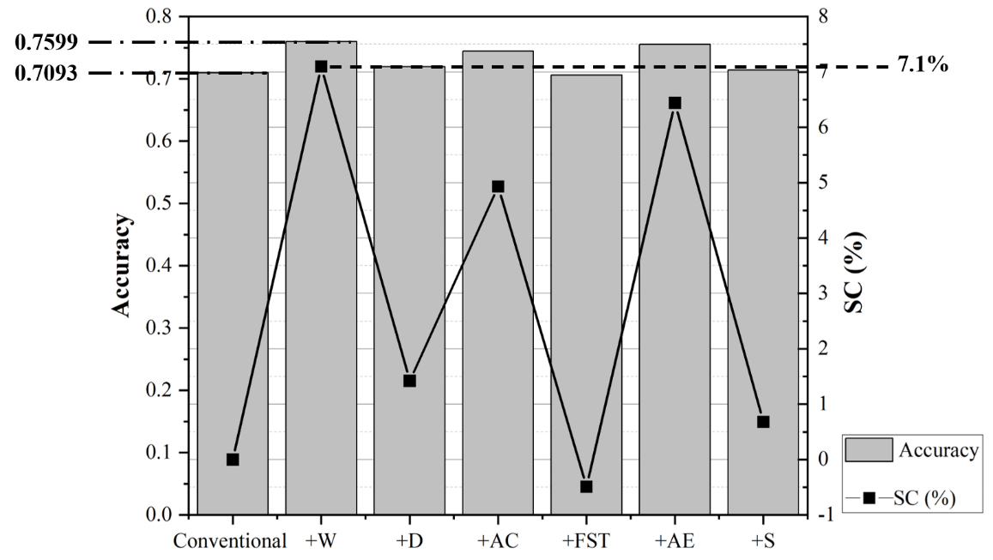

Figure 7 Results of ANN-based prediction models (average value of four subjects)

As shown in Table 5 and Figure 7, the average prediction accuracy and SC values of different single spatial variables were displayed by using the result of conventional model as the baseline. The higher the SC value, the more significant improvement in the model prediction accuracy. Additionally, R2 (the coefficient of determination) value and RMSE (Root Mean Squared Error) value were calculated and displayed in Table 5 in order to express the errors between the predicted values and the actual values. The higher the R2 value, the higher the accuracy of prediction models. On the contrary, the higher RMSE value, the lower the accuracy of prediction models.

The considerations of spatial variables had a prominent increasing in prediction accuracy, except FST. The best three results were obtained by considering W, AC and AE, with an increasing of 7.1%, 4.93% and 6.44%, respectively. Moreover, the prediction models considering W, AC and AE had higher R2 value (0.7064, 0.6587 and 0.6921, respectively) and lower RMSE value (0.5301, 0.5715 and 0.5428, respectively) compared with conventional model (R2=0.5713; RMSE=0.6405). In addition, the consideration of D and S had a slight influence on model prediction accuracy improvement, where the corresponding SC values were 1.42% and 0.68%, respectively. Furthermore, both D and S had a trivial influence on improving model prediction performance with higher R2 value (0.5819 and 0.5812, respectively) and lower RSME value (0.6325 and 0.633, respectively) than that of the conventional model. On the contrary, the consideration of FST had a negligible negative influence on the prediction accuracy improvement, but it had slightly higher R2 value (0.5732) and slightly lower RMSE value (0.6391) compared with the conventional model.

## 5.2 The influence of multiple spatial variables in the same categories

The influence of each combination was investigated according to the average prediction accuracy and SC values. As displayed in Table 6, there were five combinations of multiple spatial variables in the same categories, including four combinations of indoor spatial features and one combination of individual spatial features.

Table 6 The results of personal prediction models considering combinations in the same categories

|  |  |  |  |  |  |
| --- | --- | --- | --- | --- | --- |
|  | | **Accuracy** | **SC value** | **R2** | **RMSE** |
| Conventional model | | 0.7093 | - | 0.5713 | 0.6405 |
| Combinations among indoor spatial parameters | +W +D | 0.7007 | -1.24% | 0.7212 | 0.5165 |
| +W +AC | 0.7854 | 10.70% | 0.7349 | 0.5037 |
| +D +AC | 0.7475 | 5.36% | 0.6543 | 0.5751 |
| +W +D +AC | 0.7866 | 10.87% | 0.6531 | 0.5762 |
| Combinations among individual spatial parameters | +FST +AE | 0.7309 | 3.02% | 0.6556 | 0.5741 |

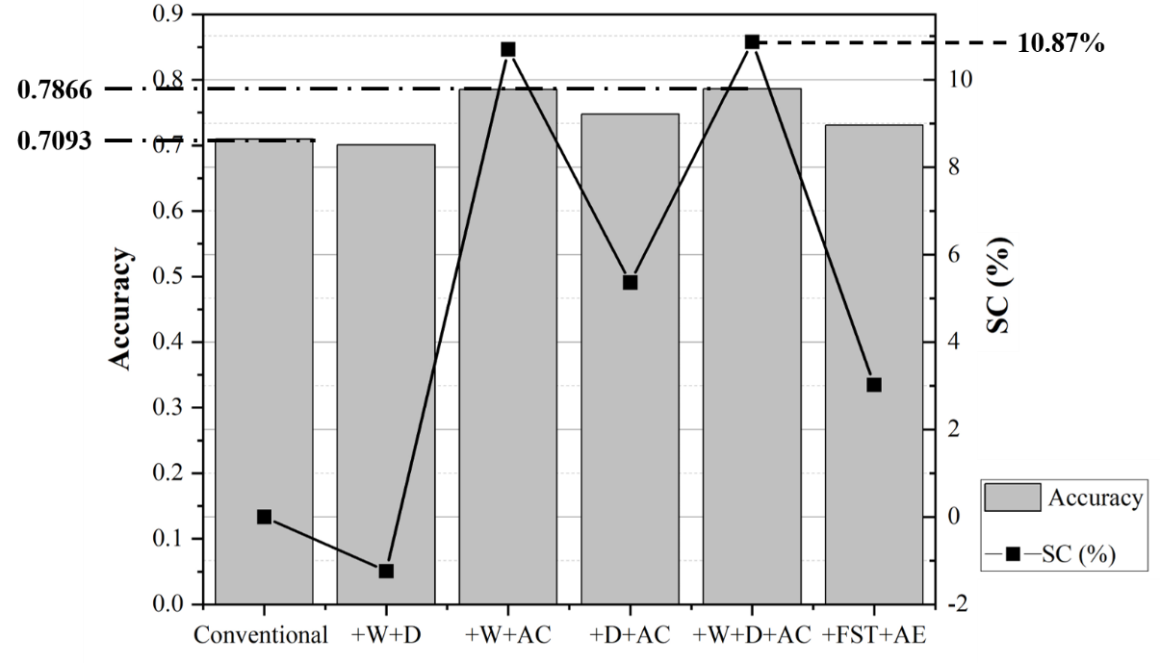

Figure 8 The prediction accuracy of multiple spatial parameters among the same categories

Table 6 and Figure 8 presented the prediction accuracies and the SC values of the combinations of indoor spatial features, as well as the combination of individual spatial features (AE+FST). It can be seen that the combination of all indoor spatial features (W+D+AC) had a distinct influence on model prediction accuracy with an improvement of 10.7%. However. D had positive impact on the prediction accuracy only if considered in conjunction with AC and its contribution was not as significant as that of W or AC in combinations. Additionally, the combination of individual spatial features (AE+FST) had an intermedia influence on model prediction accuracy. All combinations of individual spatial features had higher R2 value (>0.6531) and lower RMSE value (<0.5762) compared with the conventional model. The SC value of this combination was 3.02% which was lower than that of AE (6.44%, as shown in Figure 6), and higher than that of FST (-0.49%, as shown in Figure 7). Moreover, the model considering the combination of FST and AE had lower R2 value (0.6556) and higher RMSE value (0.5741) than individually considering AE.

## 5.3 The influence of multiple spatial variables among all categories

The ten combinations with the highest SC values were investigated to explore the significance of variables on the model prediction accuracies, which were presented in Table 7 and Figure 9. The combination of all spatial variables was presented as well for comparison. Meanwhile, the values of R2 and RMSE of each combination were displayed in Table 7. The combination of all spatial variables was presented as well for comparison.

Table 7 The results of personal thermal comfort prediction model considering combinations among all categories

|  |  |  |  |  |  |
| --- | --- | --- | --- | --- | --- |
|  | | **Accuracy** | **SC value** | **R2** | **RMSE** |
| Conventional model | | 0.7093 | - | 0.5713 | 0.6405 |
| 1 | +W +AE | 0.8097 | 14.12% | 0.7696 | 0.4696 |
| 2 | +W +D +AE | 0.8062 | 13.63% | 0.7553 | 0.4839 |
| 3 | +W +D +AC +AE | 0.8056 | 13.54% | 0.7541 | 0.4851 |
| 4 | +W +D +AE +S | 0.7973 | 12.37% | 0.7547 | 0.4845 |
| 5 | +W +AE +FST | 0.7967 | 12.29% | 0.7466 | 0.4924 |
| 6 | +W +AC+ FST +S | 0.7943 | 11.95% | 0.7442 | 0.4948 |
| 7 | +W +AC +AE +S | 0.7902 | 11.37% | 0.7435 | 0.4954 |
| 8 | +W +D +AE +FST +S | 0.7902 | 11.37% | 0.7305 | 0.5078 |
| 9 | +W +AC +AE | 0.7866 | 10.87% | 0.7361 | 0.5025 |
| 10 | +W +AC | 0.7854 | 10.70% | 0.7349 | 0.5037 |
|  | + all spatial parameters | 0.7795 | 9.87% | 0.7188 | 0.5188 |

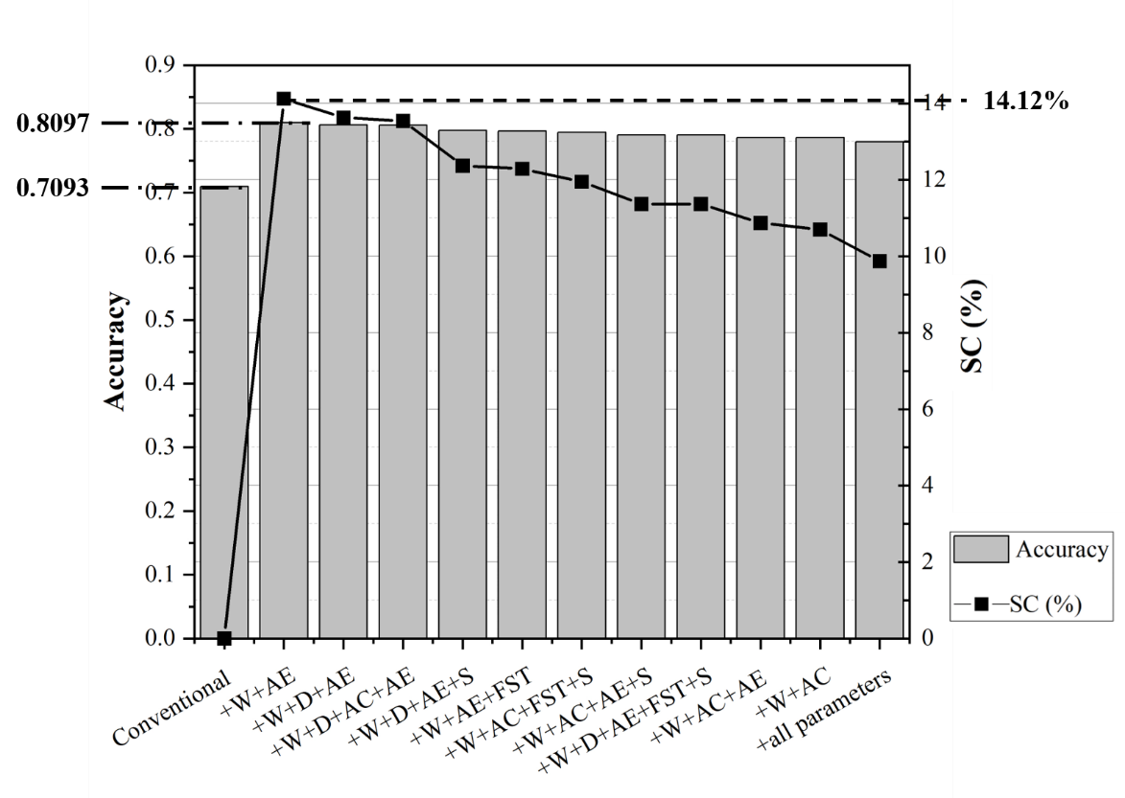

*Figure 9 The prediction accuracy of multiple spatial parameters among all categories*

As shown in Table 7 and Figure 9, the best combination with the highest accuracy (0.8097) was W+AE with an improvement of 14.12% compared with the conventional model. Moreover, Top 10 combinations of spatial features had significant contribution on improving model prediction performance as they had higher S2 value (>0.749) and lower RMSE value (<0.5037) compared with the conventional model. When considering all spatial parameters, the prediction accuracy was 0.7795 with an increasing rate of 9.87%, which was much lower than that of the Top 10 combinations (all over 10.7%). In addition, the value of S2 (0.7188) was lower and RMSE (0.5188) was higher than Top 10 combinations. It means that some spatial variables had a negative influence on the model prediction accuracy. Therefore, considering more spatial variables did not necessarily improve the prediction accuracy.

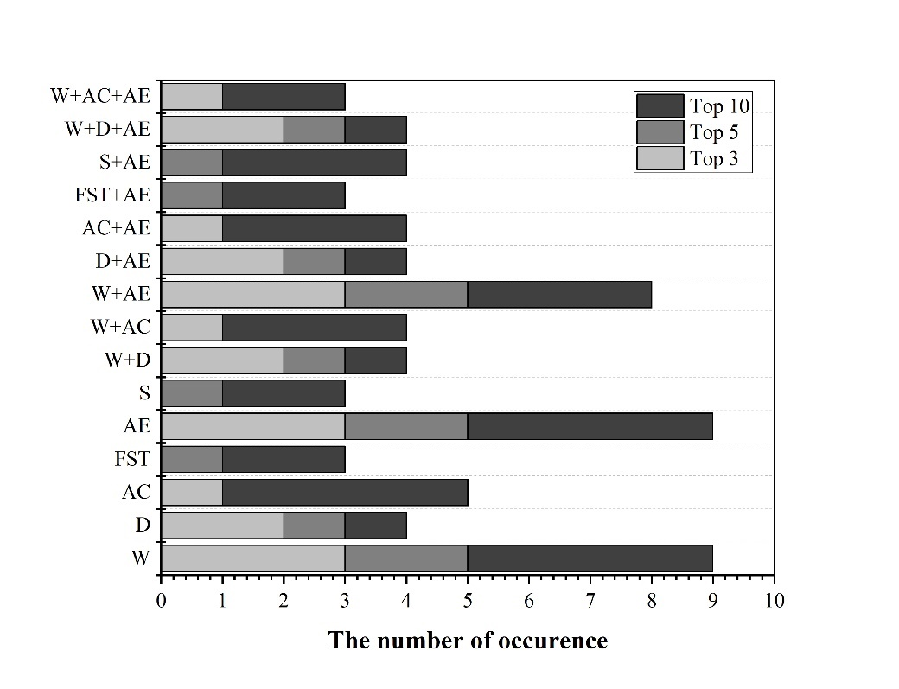

Figure 10 The occurrence of each variable and combinations in the TOP 10 combinations

Figure 10 displayed the number of occurrences of variables and combinations in the Top 3, Top 5 and Top 10 combinations. For example, the combination of W+D+AE occurred 2 times in the Top 3 combinations, 3 times in the Top 5 combinations and 4 times in the Top 10 combinations. It was the same finding in the previous section that W and AE appeared in all Top 5 combinations and occurred 9 times in Top 10 combinations, which means that these two variables should be considered in the model development. Although AC rarely appears in the Top 5 combination, it occurred in half of the Top 10 combinations. Therefore, D and AC were considerably important variables in the model development.

# 5.4 Verification of spatial variables significance

Two machine learning algorithms were chosen for model verification in this research, which were Subspace KNN and SVM. Figure 11 displayed the average prediction accuracy and SC values of single spatial variables by using these different ML algorithms.



*Figure 11 Results of SVM, Subspace KNN and ANN-based prediction models*

As shown in Figure 11, the average prediction accuracy and SC values of SVM, Subspace KNN and ANN-based models considering different single spatial variables were displayed by using the result of the conventional model as the baseline. The higher the SC value, the more significant improvement in the model prediction accuracy. ANN-based personal thermal comfort prediction models had higher accuracy than the other two ML algorithms. Similar results had been obtained in these ML-based prediction models compared with the ANN-based models that most of the spatial parameters had a noticeable impact on the model prediction accuracies. Among which, *windows* and *ambient environment* had a significant impact on increasing model prediction accuracies. The consideration of *air conditioners* had a contribution to enhancing both ANN-based and SVM-based model prediction accuracies, while it had little influence on the Subspace KNN-based model. Additionally, the door had a positive influence on increasing all these model prediction accuracies. In comparison, the consideration of *door* had a much more significant impact on Subspace KNN-based and SVM-based models than the ANN-based model. Moreover, the subject’s *forehead skin temperature* and *sunlight exposure condition* had negligible influence on the prediction performance of all these models.

## 5.5 Discussion

Based on the scenarios discussed above, it was found that the spatial parameters had a prominent impact on model prediction accuracies improvement. Single variables and combinations of indoor spatial features (*windows*, *doors*, and *air conditioners*) significantly influenced model prediction accuracy. The influence of combination of individual spatial features (subjects’ *ambient environment* and *forehead skin temperature*) and the individual impact of ambient environment on prediction accuracies were prominent. Additionally, buildings’ spatial features (*sunlight exposure condition*) had slight contribution on prediction accuracy improvement. The best combination with the highest accuracy was W+AE, with an increase of 14.12% compared with the conventional model. According to the Top10 combinations among all spatial variables, it was found that *windows* and *ambient environment* were essential in improving the model accuracies. *Air conditioners* and *doors* were considerably important variables. Additionally, the ANN methods performed well in predicting individual thermal comfort level. By considering spatial parameters in the ANN-based model development, the prediction accuracies significantly increase compared with the conventional model.

# Conclusions

This paper proposed a methodology to investigate the impact from spatial parameters on personal thermal comfort prediction model accuracy by developing an ANN-based model and explicitly representing the spatial variables in the model. The spatial parameters were categorized into buildings’ spatial feature (*sunlight exposure condition*), indoor spatial features (the coordinates and temperature of *windows, doors* and *air conditioners, as well as orientation of windows*) and individual spatial features (subjects’ *forehead skin temperature*and *ambient environment*). Field experiments were conducted to collect relevant data for establishing the ANN-based model. A baseline of model prediction accuracy was calculated by using conventional parameters, including personal-dependent parameters and environmental parameters. The sensitivity coefficient (SC) values of 64 scenarios were calculated to evaluate the significance of different spatial variables on the model prediction accuracies.

It was found that the spatial parameters had a noticeable impact on model prediction accuracies. By considering spatial parameters in the ANN-based model development, the prediction accuracies had been increased significantly compared with the conventional models. Single variables and combinations of indoor spatial features significantly influenced model prediction accuracy. The influence of combination of individual spatial features and the individual impact of ambient environment on prediction accuracies were prominent. Additionally, buildings’ spatial features had slight contribution on prediction accuracy improvement. According to the Top10 combinations among all spatial variables, it was found that *windows* and *ambient environment* were essential in improving the model accuracies.

Limitations of this research were identified in the following: (1) The primary issue was the small size of the dataset, particularly the diversity of subjects and experimental spaces; (2) This research was based on one-time batch learning in typical wintertime and summertime in low-raise-buildings in a four-season distinct city. There is a possibility that its results can be challenged over time as the measurement parameters and data size grow. Therefore, our future works will increase the dataset by collecting data from more subjects in various experimental rooms in different weather and different seasons.

# Acknowledgments

The author disclosed receipt of the following financial support for the research, authorship, and/or publication of this article: This works is financially supported by the XJTLU Research Development Fund (RDF-15-01-19), (RDF-18-01-40), 2018 Key Program Special Fund in XJTLU (KSF-E-04), and the UK ICE Research Development Enabling Fund (ICE-RDF-2020).

# Reference

A. Olissan, C. Kouchade, P. Andr ́e, et al. 2016. Examen du PMV/PPD de Fanger dans les ambiances naturellement ventil ́ees de la bande coti`ere du Benin, Int. J. Innov. Sci. Res. 5 (2016) 766–777.

Alawadhi, E.M., 2018. Double solar screens for window to control sunlight in Kuwait. Building and Environment 144, 392–401. doi:10.1016/j.buildenv.2018.08.058

Peng, C., 2010. Survey of thermal comfort in residential buildings under natural conditions in hot humid and cold wet seasons in Nanjing. Frontiers of Architecture and Civil Engineering in China, 4(4), 503–511. https://doi.org/10.1007/s11709-010-0095-1

Caner, I., Ilten, N., 2020. Evaluation of occupants’ thermal perception in a university hospital in Turkey. Proceedings of the Institution of Civil Engineers - Engineering Sustainability 173, 414–428. doi:10.1680/jensu.19.00059

Chaudhuri, T., Soh, Y.C., Li, H., Xie, L., 2017. Machine learning based prediction of thermal comfort in buildings of equatorial Singapore. IEEE International Conference on Smart Grid and Smart Cities (ICSGSC), (2017) 72-77. doi: 10.1109/ICSGSC.2017.8038552.

Chaudhuri, T., Soh, Y. C., Li, H., & Xie, L., 2019. A feedforward neural network based indoor-climate control framework for thermal comfort and energy saving in buildings. Applied Energy, 248(February), 44–53. <https://doi.org/10.1016/j.apenergy.2019.04.065>

Chi, F., Wang, Y., Wang, R., Li, G., Peng, C., 2020. An investigation of optimal window-to-wall ratio based on changes in building orientations for traditional dwellings. Solar Energy 195, 64–81. doi:10.1016/j.solener.2019.11.033

Cosma, A.C., Simha, R., 2018. Thermal comfort modeling in transient conditions using real-time local body temperature extraction with a thermographic camera. Building and Environment 143, 36–47. doi:10.1016/j.buildenv.2018.06.052

Cosma, A. C., & Simha, R., 2019. Machine learning method for real-time non-invasive prediction of individual thermal preference in transient conditions. Building and Environment, 148(November 2018), 372–383. <https://doi.org/10.1016/j.buildenv.2018.11.017>

Ciabattoni, L., Cimini, G., Ferracuti, F., Grisostomi, M., Ippoliti, G., Pirro, M., 2015. Indoor thermal comfort control through fuzzy logic PMV optimization. International Joint Conference on Neural Networks (IJCNN), (2015) 1-6. doi: 10.1109/IJCNN.2015.7280698.

Cui, W., G. Cao, J.H. Park, Q. Ouyang, and Y. Zhu., 2013. Influence of Indoor Air Temperature on Human Thermal Comfort, Motivation and Performance. Building and Environment 68: 114–122.

Djongyang, N., Tchinda, R., Njomo, D., 2010. Thermal comfort: A review paper. Renewable and Sustainable Energy Reviews 14, 2626–2640. doi:10.1016/j.rser.2010.07.040

Fanger, P. O. 1970. Thermal comfort. Analysis and applications in environmental engineering. Copenhagen: Danish Technical Press.

Guenther, J., Sawodny, O., 2019. Feature selection and Gaussian Process regression for personalized thermal comfort prediction. Building and Environment 148, 448–458. doi:10.1016/j.buildenv.2018.11.019

Huizenga, C., Hui, Z., Arens, E., 2001. A model of human physiology and comfort for assessing complex thermal environments. Building and Environment 36, 691–699. doi:10.1016/s0360-1323(00)00061-5

Ikeda, H., Nakaya, T., Nakagawa, A., Maeda, Y., 2021. An investigation of indoor thermal environment in semi-cold region in Japan – Validity of thermal predictive indices in Nagano during the summer season. Journal of Building Engineering 35, 101897. doi:10.1016/j.jobe.2020.101897

Jin Dai and Shuguang Jiang, 2020. Passive space design, building environment and thermal comfort: A university building under severe cold climate, China. Indoor and Built Environment 0(0)1-21. July 22, 2020. DOI: 10.1177/1420326X20939234

J.van Hoof, 2008. Forty Years of Fanger’s Model of Thermal Comfort: Comfort for All?. Indoor Air 18, no. 3: 182–201. https://dx.doi.org/10.1111/j.1600-0668.2007.00516.x.

Katić K., Li, R., Verhaart, J., Zeiler, W., 2018. Neural network based predictive control of personalized heating systems. Energy Build. 174 https://doi.org/10.1016/j. enbuild.2018.06.033.

Kiki, G., Kouchadé, C., Houngan, A., Zannou-Tchoko, S.J., André, P., 2020. Evaluation of thermal comfort in an office building in the humid tropical climate of Benin. Building and Environment 185, 107277. doi:10.1016/j.buildenv.2020.107277

Kim, J., Zhou, Y., Schiavon, S., Raftery, P., Brager, G., 2018. Personal comfort models: Predicting individuals' thermal preference using occupant heating and cooling behavior and machine learning. Building and Environment 129, 96–106. doi:10.1016/j.buildenv.2017.12.011

Lan, L., Lian, Z., Liu, W., Liu, Y., 2008. Investigation of gender difference in thermal comfort for Chinese people. European Journal of Applied Physiology 102, 471–480. doi:10.1007/s00421-007-0609-2

Lan, L., Tsuzuki, K., Liu, Y.F., Lian, Z.W., 2017. Thermal environment and sleep quality: A review. Energy and Buildings 149, 101–113. doi:10.1016/j.enbuild.2017.05.043

Li, D., Menassa, C. C., & Kamat, V. R., 2017. Personalized human comfort in indoor building environments under diverse conditioning modes. Building and Environment, 126(July), 304–317. <https://doi.org/10.1016/j.buildenv.2017.10.004>

Management Association, Information Resources, editor., 2020. Deep Learning and Neural Networks: Concepts, Methodologies, Tools, and Applications (3 Volumes). IGI Global. http://doi:10.4018/978-1-7998-0414-7

Moon, J.W., Kim, J.-J., 2010. ANN-based thermal control models for residential buildings. Building and Environment 45, no. 7: 1612–1625. doi:10.1016/j.buildenv.2010.01.009

Moon, J.W., 2012. Performance of ANN-based predictive and adaptive thermal-control methods for disturbances in and around residential buildings. Building and Environment 48, 15–26. doi:10.1016/j.buildenv.2011.06.005

Qi R., 2008. Study on habitat fragmentation and its impacts on biodiversity at urban areas: a case of Suzhou. PhD Thesis. Shanghai: East China Normal University.

Qian Chai, Huiqin Wang, Yongchao Zhai, Liu Yang., 2020. Using Machine Learning Algorithms to Predict Occupants’ Thermal Comfort in Naturally Ventilated Residential Buildings. Energy and Buildings 217: 109937.

Shan, C., Hu, J., Wu, J., Zhang, A., Ding, G., & Xu, L. X., 2020. Towards non-intrusive and high accuracy prediction of personal thermal comfort using a few sensitive physiological parameters. Energy and Buildings, 207, 109594. <https://doi.org/10.1016/j.enbuild.2019.109594>

Wang, Z., 2006. A field study of the thermal comfort in residential buildings in Harbin. Building and Environment 41, 1034–1039. doi:10.1016/j.buildenv.2005.04.020

Wang, Z., de Dear, R., Luo, M., Lin, B., He, Y., Ghahramani, A., & Zhu, Y., 2018. Individual difference in thermal comfort: A literature review. Building and Environment, 138, 181–193. <https://doi.org/10.1016/J.BUILDENV.2018.04.040>

Wang, Z., Wang, J., He, Y., Liu, Y., Lin, B., Hong, T., 2020. Dimension analysis of subjective thermal comfort metrics based on ASHRAE Global Thermal Comfort Database using machine learning. Journal of Building Engineering 29, 101120. doi:10.1016/j.jobe.2019.101120

Wang, Z., Zhang, H., He, Y., Luo, M., Li, Z., Hong, T., Lin, B., 2020. Revisiting individual and group differences in thermal comfort based on ASHRAE database. Energy and Buildings 219, 110017. doi:10.1016/j.enbuild.2020.110017

Wenqi Guo, Mengchu Zhou, 2009. Technologies toward thermal comfort-based and energy-efficient HVAC systems: A review, in. doi:10.1109/icsmc.2009.5346631

Xiaoyu Du, Regina Bokel & Andy van den Dobbelsteen., 2016. Architectural Spatial Design Strategies for Summer Microclimate Control in Buildings: A Comparative Case Study of Chinese Vernacular and Modern Houses, Journal of Asian Architecture and Building Engineering, 15:2, 327-334, DOI: 10.3130/jaabe.15.327

Xu, H., 2018. Intelligent control and energy saving of HVAC in building decoration engineering. Technology and application. DOI:10.13655/j.cnki.ibci.2018.10.025.

Yao, R., Li, B., Liu, J., 2009. A theoretical adaptive model of thermal comfort – Adaptive Predicted Mean Vote (aPMV). Building and Environment 44, 2089–2096. doi:10.1016/j.buildenv.2009.02.014

Zhang, C., Ong, L., 2017. Investigating Building Sustainability by Applying Sensitivity Analysis of Impact Factors during Design Stage, in. doi:10.1061/9780784480823.019

Zhang, H., Huizenga, C., Arens, E., Yu, T., 2001. Considering individual physiological differences in a human thermal model. Journal of Thermal Biology 26, 401–408. doi:10.1016/s0306-4565(01)00051-1

Zhang, Y., Bai, X., Mills, F.P., Pezzey, J.C.V., 2018. Rethinking the role of occupant behavior in building energy performance: A review. Energy and Buildings 172, 279–294. doi:10.1016/j.enbuild.2018.05.017

Zhang, Y., Zhao, R., 2009. Relationship between thermal sensation and comfort in non-uniform and dynamic environments. Building and Environment 44, 1386–1391. doi:10.1016/j.buildenv.2008.04.006

Zhou, X., Xiong, J., Lian, Z., 2017. Predication of skin temperature and thermal comfort under two-way transient environments. Journal of Thermal Biology 70, 15–20. doi:10.1016/j.jtherbio.2017.08.001

Zhou, Y., Chen, A., Ouyang, J.Q., Liu, Y., Zheng, A., Yang, Z., Zhang, Y., Wang, B., Jia, Y., Jiao, S., Zeng, Q., Lu, C., 2020. Comparing community birdwatching and professional bird monitoring with implications for avian diversity research: a case study of Suzhou, China. Avian Research 11. doi:10.1186/s40657-020-00205-w

**Appendix. Field experiment results**

Table A.1 Ambient temperature of locations with sunlight exposure and relevant subjects’ thermal comfort level

|  |  |  |  |  |  |
| --- | --- | --- | --- | --- | --- |
|  | **AT** | **AT_average** | **AH** | **AH_average** | **Thermal comfort level** |
| **Room 4- Location 3** | | | | | |
| Sunlight | 30~27.1 | 28.98 | 63~48 | 56.67 | 50%: Hot; 33.3%: Slightly Hot; 16.7%: No feeling |
| No sunlight | 29.1~24.3 | 26.84 | 64~46 | 55.67 | 6.67%: Hot; 26.7%: Slightly Hot; 53.3%: No feeling; 13.3%: Slighting Cold |
| **Room 5- Location 1** | | | | | |
| Sunlight | 30.1~24.1 | 29.1 | 71~50 | 60.00 | 7.4%: Hot; 22.2%: Slightly Hot; 55.6%: No feeling; 7.6%: Slightly Cold |
| No sunlight | 29.9~24.2 | 26.5 | 71~50 | 59.00 | 4.5%: Hot; 19.1%: Slightly Hot; 49.4%: No feeling; 22.5%: Slightly Cold; 4.5%: Cold |
| **Room 5- Location 2** | | | | | |
| Sunlight | 24.7~30.7 | 28.2 | 49~70 | 58.00 | 20%: Hot; 26.7%: Slightly Hot; 46.7%: No feeling; 6.6%: Slightly Cold |
| No sunlight | 30.1~24.3 | 27.1 | 49~73 | 57.00 | 7.6%: Hot; 23.9%: Slightly Hot; 54.3%: No feeling; 12%: Slightly Cold; 2.2%: Cold |

Table A.2 The thermal comfort level of Subject 1 and Subject 2 at different locations in Room 3 and Room 5

|  |  |  |
| --- | --- | --- |
| **Room 3** | | |
| Location 1 | Subject 1 | 85.7%: Slightly Hot; 14.3%: No feeling |
| Subject 2 | 28.6%: Slightly Hot; 42.8%: No feeling; 28.6%: Slighting Cold |
| Location 2 | Subject 1 | 28.6%: No feeling; 28.6%: Slightly Cold; 42.8%: Cold |
| Subject 2 | 14.3%: Slightly Hot;14.3%: No feeling; 42.8%: Slighting Cold; 28.2%: Cold |
| Location 3 | Subject 1 | 57.1%: Slightly Hot; 42.9%: No feeling |
| Subject 2 | 28.6%: Slightly Hot; 57.1%: No feeling; 14.3%: Slighting Cold |
| Location 4 | Subject 1 | 28.6%: Slightly Hot; 28.6%: Slighting Cold; 42.8%: Cold |
| Subject 2 | 6.67%: Hot; 26.7%: Slightly Hot; 53.3%: No feeling; 13.3%: Slighting Cold |
| Location 5 | Subject 1 | 28.6%: Slightly Hot; 71.4%: No feeling |
| Subject 2 | 42.9%: No feeling; 14.2%: Slightly Cold; 42.9%: Cold |
| Location 6 | Subject 1 | 14.3%: Slightly Hot; 71.4%: No feeling; 14.3%: Slighting Cold |
| Subject 2 | 42.9%: Slighting Cold; 57.1%: Cold |
| **Room 5** | | |
| Location 1 | Subject 1 | 28.6%: Slightly Hot; 28.6%: No feeling;14.2%: Slighting Cold; 28.6%: Cold |
| Subject 2 | 42.9%: Hot; 57.1%: No feeling |
| Location 2 | Subject 1 | 28.6%: Hot; 28.6%: Slightly Hot; 28.6%: No feeling; 14.2%: Slighting Cold |
| Subject 2 | 14.3%: Hot; 28.6%: Slightly Hot; 57.1%: No feeling |
| Location 3 | Subject 1 | 14.3%: Slightly Hot; 57.1%: No feeling; 14.3%: Slighting Cold; 14.3%: Cold |
| Subject 2 | 28.6%: Hot; 28.6%: Slightly Hot; 42.8%: No feeling |
| Location 4 | Subject 1 | 14.3%: Slightly Hot; 28.6%: No feeling; 42.8%: Slighting Cold; 14.3%: Cold |
| Subject 2 | 14.3%: Hot; 14.3%: Slightly Hot; 28.6%: No feeling; 42.8%: Cold |
| Location 5 | Subject 1 | 28.6%: Hot; 28.6%: Slightly Hot; 28.6%: No feeling; 14.2%: Slighting Cold |
| Subject 2 | 28.6%: Slightly Hot; 28.6%: No feeling; 42.8%: Cold |
| Location 6 | Subject 1 | 14.3%: Hot; 14.3%: Slightly Hot; 14.3%: No feeling; 57.1%: Slighting Cold |
| Subject 2 | 28.6%: Hot; 14.3%: No feeling; 14.3%: Slightly Hot; 42.8%: Cold |