Hepatitis B vaccination impact and the unmet need for antiviral treatment in Blantyre, Malawi

Alexander J. Stockdale^{1,2}, James E. Meiring^{1,3}, Isaac T. Shawa^{1,4}, Deus Thindwa^{1,5}, Niza M. Silungwe¹, Maurice Mbewe¹, Rabson Kachala⁶, Benno Kreuels^{7,8,9}, Pratiksha Patel¹, Priyanka Patel¹, Marc Y. R. Henrion^{1,10}, Naor Bar-Zeev¹¹, Todd D. Swarthout^{1,12}, Robert S. Heyderman¹², Stephen B. Gordon^{1,10}, Anna Maria Geretti¹³, Melita A. Gordon^{1,2}

Affiliations:
1 Malawi-Liverpool-Wellcome Trust Programme, Blantyre, Malawi
2 Institute of Infection, Veterinary and Ecological Sciences, University of Liverpool, Liverpool, United Kingdom
3 Oxford Vaccine Group, Department of Paediatrics, University of Oxford, Oxford, United Kingdom
4 University of Malawi College of Medicine, Faculty of Biomedical Science and Health Professions Blantyre, Malawi
5 Department of Infectious Disease Epidemiology, London School of Hygiene and Tropical Medicine, London, United Kingdom
6 Malawi Ministry of Health, Capitol Hill, Lilongwe, Malawi
7 University of Malawi College of Medicine, Faculty of Medicine, Blantyre, Malawi
8 Department of Tropical Medicine, Bernhard Nocht Institute for Tropical Medicine and
9 1st Department of Medicine, University Medical Centre, Hamburg-Eppendorf, Hamburg, Germany;
10 Liverpool School of Tropical Medicine, Liverpool, United Kingdom
11 International Vaccine Access Center, Johns Hopkins Bloomberg School of Public Health, Baltimore, Maryland, United States of America
12 NIHR Global Health Research Unit on Mucosal Pathogens, Research Department of Infection, Division of Infection and Immunity, University College London, London, United Kingdom
13 Department of Infectious Diseases, Fondazione PTV, Faculty of Medicine, University of Rome Tor Vergata, Rome, Italy

Running title: Hepatitis B in Blantyre, Malawi
Summary (40 words): In a large census-based community serosurvey in Blantyre, Malawi adult HBsAg prevalence was 5.1%, and 0.3% among vaccine-eligible children. Estimated vaccine impact was 95.8% (95% CI 70.3-99.4). Up to 9% of HBsAg-positive adults had an unmet need for antiviral treatment.
Electronic word count: 3402
Number of figures and tables: 4 figures, 3 tables
Conflict of Interest Statement
Dr. Bar-Zeev reports grants from Merck-Sharp-Dohme, Johnson & Johnson and Serum Institute of India, outside the submitted work. Prof. Geretti reports grants and personal fees from Roche Pharma Research & Early Development, grants and personal fees from ViiV Healthcare, personal fees from Janssen, grants and personal fees from Gilead, consulting fees for GSK, outside the submitted work. The remaining authors report no competing interests.
Funding Statement
AJS was supported by a Wellcome Trust Clinical PhD Fellowship Grant (109130/Z/15/Z). The STRATAA study was funded by a Wellcome Trust Strategic Award (no. 106158/Z/14/Z) and the Bill and Melinda Gates Foundation (no. 617 OPP1141321). The Malawi-Liverpool-Wellcome Trust Clinical Research Programme is supported by a Wellcome Trust Major Overseas Programme Core Award. This research was funded by the Wellcome Trust. For the purpose of open access, the author has applied a CC BY public copyright licence to any Author Accepted Manuscript version arising from this submission. The funders did not have any role in the conduct of the study, writing of the manuscript or decision to submit for publication.
Conference presentations
Data from this study has been presented at the International Liver Congress from the European Association for the Study of the Liver 2020 (Digital) and the 11th European Congress on Tropical Medicine and International Health, Liverpool, United Kingdom, 2019
Corresponding author contact
Dr Alexander J. Stockdale, Institute of Infection, Veterinary and Ecological Sciences, University of Liverpool, Ronald Ross Building, 8 West Derby Street, Liverpool, L69 7BE, United Kingdom
Telephone: +44 151 795 9667; Email: a.stockdale@liverpool.ac.uk
Alternate corresponding author
Prof Melita Gordon, Malawi Liverpool Wellcome Trust Programme, Chichiri 3, PO Box 30096, Blantyre, Malawi
Telephone: +265 99 256 303, Email: magordon@liverpool.ac.uk

ABSTRACT
Background
Hepatitis B is the leading cause of cirrhosis and liver cancer in sub-Saharan Africa. To reduce hepatitis-associated mortality, antiviral treatment programmes are needed. We estimated prevalence, vaccine impact and need for antiviral treatment in Blantyre, Malawi to inform an effective public health response.
Methods
We conducted a household study in Blantyre in 2016-2018. We selected individuals from a census using random sampling and estimated age-sex-standardised HBsAg seroprevalence. Impact of infant hepatitis B vaccination, which began in 2002, was estimated by binomial log-linear regression comparing individuals born before and after vaccine implementation. In HBsAg-positive adults, eligibility for antiviral therapy was assessed.
Results
Of 97,386 censused individuals, 6,073 (median age 18 years; 56.7% female) were sampled. HBsAg seroprevalence was 5.1% (95% CI 4.3–6.1) among adults and 0.3% (0.1–0.6) among children born after vaccine introduction. Estimated vaccine impact was 95.8% (70.3–99.4). Of HBsAg-positive adults, 26% were HIV-positive. Among HIV-negative individuals, 3%, 6% and 9% were eligible for hepatitis B treatment by WHO, European and American hepatology association criteria, respectively.
Conclusions
Infant HBV vaccination has been highly effective in reducing HBsAg prevalence in urban Malawi. Up to 9% of HBsAg-positive HIV-negative adults are eligible, but have an unmet need, for antiviral therapy.

Keywords: Hepatitis B; Vaccination; Epidemiology; Antiviral Agents; Malawi; Africa, South of the Sahara; Public Health

BACKGROUND
In sub-Saharan Africa, chronic hepatitis B is the leading cause of liver cirrhosis and hepatocellular carcinoma (HCC).[1] HCC is the second-highest incident cancer in men and fourth among women in the region, and is usually diagnosed at an advanced stage when curative treatment is no longer possible.[2, 3] In 2016, the World Health Assembly set ambitious targets to reduce the incidence of viral hepatitis by 90% and mortality by 65% by 2030, calling for improved efforts to prevent, diagnose and treat chronic hepatitis B.[4] Modelling studies project that while hepatitis B prevalence will decline among children due to vaccination programmes, hepatitis B-related mortality will increase by 2030 in sub-Saharan Africa without implementation of treatment programmes for adults.[5] Data from Western and Asian cohorts show that in chronic hepatitis B antiviral therapy results in several important outcomes including regression and reversal of liver fibrosis, reduction in HCC incidence, improved survival and increased quality of life.[6-8] In the Gambia, a community hepatitis B virus (HBV) screen-and-treat strategy was deemed to be feasible and cost-effective.[9]
The infant hepatitis B vaccine, was introduced into national immunisation schedules across sub-Saharan Africa between 1994 and 2014, and in Malawi in 2002. The World Health Organization (WHO) recommends commencing the first dose at birth but this has not been implemented in most sub-Saharan African countries, including Malawi.[10] In 2019, three-dose coverage starting at 6 weeks was median 87% (interquartile range (IQR) 74-93) across the region and 95% in Malawi.[11] A community assessment of vaccine impact has not previously been conducted in southern Africa, outside of South Africa, and there are therefore no data for Malawi.
In a previous systematic review, we estimated that hepatitis B surface (HBsAg) prevalence was 8% among adults in Malawi, but observed that available data were predominantly based on convenience sampling, hence at significant risk of bias.[12] Estimates of the community-level burden of hepatitis B virus (HBV) infection and disease, and the projected need for hepatitis B treatment are required to inform an effective public health response.[4] To address a significant gap in knowledge, we conducted a census-based serological and liver-disease survey in Blantyre, Malawi to ascertain HBsAg seroprevalence and impact of hepatitis B vaccination and to estimate the population-level eligibility and unmet need for hepatitis B treatment.

METHODS
Census and serological survey
Individuals of all ages resident in Ndirande, Blantyre, Malawi were randomly selected from a population demographic census and invited to participate in a serosurvey in 2016-2018. Ndirande is an unplanned urban township in the north of Blantyre. Malawi is a low-income country in southern Africa with a life expectancy at birth of 64 years and national HIV prevalence of 10.6% (95% CI 9.9-11.2) among adults.[13]
We used single-stage random probability sampling, with age-stratification to oversample younger children, as part of a co-incident typhoid epidemiology study (Strategic Typhoid Alliance across Africa and Asia).[14, 15] Global positioning satellite (GPS) co-ordinates of households were recorded (eTrex 30x, Garmin, USA) to assess spatial distribution of selected individuals. If a randomly selected individual in the serosurvey could not be located or did not consent, another household member from the same age-stratification group was requested to participate, or secondarily, a replacement was selected by further randomisation from the census age-stratum. Educational, marital and employment data were recorded from serosurvey participants. We estimated a sample size requirement of 5913 based on an anticipated HBsAg prevalence of 8.1% for precision of 1% (Appendix 1). Vaccination status of children aged ≤10 years was obtained from the family-held vaccine record or if unavailable, parent or guardians’ report. Venous EDTA samples were collected in consenting participants’ households, stored in cool boxes and transported to the study laboratory. Plasma samples were separated by centrifugation and stored at -80°C.

Evaluation of HBV disease
We returned to households of individuals aged ≥16 years who tested HBsAg-positive by laboratory enzyme immunoassay and invited them to participate in an evaluation of treatment eligibility based on WHO 2015, European Association for the Study of the Liver 2017 (EASL) and American Association for the Study of the Liver (AASLD) 2018 criteria (Appendix 2).[8, 16, 17] For pregnant women, for whom transient elastography is not recommended, we returned >6 weeks after delivery to invite them to participate. Inclusion criteria for evaluation of treatment eligibility were HBsAg seropositivity, residence in the study catchment area and capacity to consent. We conducted assessments in community halls close to participants’ residences. Rapid point-of-care HIV testing was offered in accordance with national guidelines using Determine anti-HIV (Alere, South Africa) for screening, followed by confirmation with Uni-Gold HIV (Trinity Biotech, Ireland). We performed clinical examination to elicit signs of chronic liver disease. We assessed liver stiffness using transient elastography in the right mid-axillary intercostal space after fasting for >3 hours (FibroScan 430 Mini, Echosens, France). Reliability criteria were IQR/median <0.3 if >7.1kPa.[18] We applied categorical interpretative cut-offs of 7.9 kPa for significant fibrosis (F2) and 9.5 kPa for cirrhosis (F4) according to cross-sectional comparative data from the Gambia and Senegal.[19] Participants meeting EASL criteria were referred for treatment with tenofovir.

Laboratory investigations
Laboratory investigations were performed in the Malawi-Liverpool-Wellcome Trust Laboratories in Blantyre. We tested for HBsAg using the Monolisa HBsAg-Ultra (Bio-Rad, France) enzyme-linked immunoassay (ELISA in accordance with manufacturer instructions. Samples showing intermediate reactivity (sample/cut-off ratio >0.9) and all positive samples were repeated in duplicate. Hepatitis B e antigen (HBeAg), anti-HBe, hepatitis C antigen/antibody (HCV Ag/Ab) and anti-hepatitis delta virus (anti-HDV) were tested by ELISA using Monolisa HBeAg-Ab (Bio-Rad), Monolisa HCV Ag-Ab ULTRA v2, (Bio-Rad) and ETI-AB-DELTAK-2 (Diasorin, Italy), respectively. HBV DNA was quantified using an in-house real-time PCR, with a lower limit of quantification of 34 IU/ml (Appendix 3). ALT was measured using an automated assay with an upper limit of normal of 32 U/L (AU480, Beckmann Coulter, CA, USA).

Ethical review
Ethical permission to conduct the study was obtained from the National Health Sciences Research Committee of Malawi (16/11/1698 and 15/5/1599) and the University of Liverpool (reference 1954). Participants in the serological survey and clinical evaluation provided written informed consent. The study was conducted in accordance with the Declaration of Helsinki (2013).

Statistical analysis
We estimated population HBsAg prevalence using survey design weights from age-stratification and used post-stratification iterative proportional fitting with 5-year age-sex groups from the census to adjust estimates to the population distribution. In a sensitivity analysis, we also adjusted for geographic area to account for geographic variation in response rate. Where date of birth was unknown, we estimated the year mid-point from reported age. We assessed spatial clustering of HBsAg-positive participants using Getis-Ord Gi* and Anselin Local Moran’s I statistics. Association between HBsAg and explanatory variables were assessed by binomial logistic regression, applying sampling probability weights. For multivariable model selection among participants ≥16 years we considered variables with p<0.25 in univariable analysis for inclusion and included a restricted cubic spline for age to account for variation in HBsAg prevalence with respect to age. To calculate socioeconomic status (SES), we analysed responses to a household economic survey from 12,080 households (Appendix 4) using principal component analysis to derive relative wealth quintiles for 44 areas represented in the serosurvey.[20] To estimate vaccine impact, we compared individuals born within 5 years prior to vaccine introduction in 2002 (aged between 15 and 21 years at the date of sampling) with those born within 5 years after vaccine introduction (aged 10 to 16 years), and in a sensitivity analysis, compared those born within 10 years before and after implementation. Ages in the two groups overlapped due to the 18-month duration of the serosurvey. Vaccine impact was calculated as (1-risk ratio (RR)) x 100) where RR was estimated from binomial log-linear regression, adjusted for survey weights. In sensitivity analyses, we compared the primary model with Poisson regression with robust standard errors and logistic regression models, and assessed the effect of adding participant age at sampling and 2-year birth cohort intervals as co-variates using the Wald test, to assess for an age-cohort effect. Analyses were conducted in ArcGIS Pro 2.4.1 (Esri, USA) and Stata 16.1 (Statacorp, USA).

RESULTS
HBsAg seroprevalence and vaccine impact
Overall 6,073 individuals participated in the serological survey and were tested for HBsAg, from a total census population of 97,386 (Figure 1). Median age of serosurvey participants was 18 years (IQR 8-37) and 3,455/6,073 (56.7%) were female. This compares to a median age of 17 years (IQR 4-32) and a female proportion of 51.5% in the national 2018 census.[21] The serosurvey oversampled younger children and older adults relative to the census distribution (Figure 2). A total of 160/6,073 (2.6%) participants tested positive for HBsAg. No spatial clustering of HBsAg-positive individuals was observed with Getis-Ord Gi* and Anselin Local Moran’s I statistics (Appendix 5). The age- and sex-standardised prevalence of HBsAg in the general population was 3.1% (95% confidence interval (CI) 2.6–3.7). Prevalence peaked among males aged 30-39 years and declined among older adults (Figure 3, Appendix 6).
Vaccination status was obtainable from 1,172/2,085 (56.2%) children aged ≤10 years and 631/931 (67.8%) children aged ≤5 years. Data sources comprised health records for 722/1,172 (61.6%) and parent/guardian report for 450/1,172 (38.4%). Completion of 3-dose HBV vaccination was reported for 1,141/1,172 (97.4%) children ≤10 years and 619/631 (98.1%) among children ≤5 years, for whom vaccine status was known. Vaccine coverage was associated with data source, with 96.5% reporting complete vaccination from health records and 98.6% from oral parental/guardian report, p=0.03. Only 31 children were ascertained to be unvaccinated and none tested HBsAg-positive. Standardised HBsAg prevalence was 0.6% (95% CI 0.2–1.4) among 913 children with unknown vaccination status, which was not significantly different from children completing all 3 doses (0.2%; 95% CI 0.1–0.8, p=0.26).

Among children born after infant vaccine implementation in 2002, standardised HBsAg prevalence was 0.3% (95% CI 0.2–0.6), while among all adolescents and adults born prior to vaccine introduction it was 5.1% (95% CI 4.3–6.1) (Table 1). Vaccine impact was 95.9% (95% CI 70.6–99.4) in the primary analysis, comparing individuals born in the 5 years prior to vaccine introduction (aged 15-21 years) with those born in the 5 years afterwards (aged 10-16 years). In a sensitivity analysis, comparing those born 10 years before and after vaccine introduction, vaccine impact was 93.3% (95% CI 83.1–97.4). Sensitivity analyses including Poisson regression with robust standard errors and logistic regression models were consistent with the primary model (Appendix 7). Inclusion of age and cohort variables did not indicate a significant age-cohort effect. Post-stratification adjustment for geographic area did not affect prevalence estimates (Appendix 8). By univariate analysis, HBsAg-positive individuals aged ≥16 years were more likely to be male, in paid or self-employment, and to be married, separated or divorced. No association with educational attainment or regional SES status was observed. In a multivariable model, greater odds of HBV infection were observed in males and separated or divorced individuals (Table 2).

Treatment eligibility
Evaluation for treatment eligibility occurred a median of 4.9 months (IQR 2.2, 7.6) after the serosurvey. Of 150 HBsAg-positive serosurvey participants aged ≥16 years, we were able to locate 114 in the township (76.0%); four had died, two were unable to provide consent and nine had moved outside the region (Figure 4). A total of 94/114 (82.5%) eligible individuals agreed to participate in evaluation of treatment eligibility. Participants had a higher level of education, higher SES, and higher rate of employment relative to non-participants (Appendix 9).
Characteristics of the clinical evaluation population are shown in Table 3. Of 93/94 (98.9%) who agreed to HIV testing, 24/93 (25.8%) were HIV positive, of which 7 (29.1%) were newly diagnosed. Median CD4 count was 519 cells/mm³ (IQR 412, 577). Of those with HIV/HBV co-infection, 16/24 (67%) were on antiretroviral therapy (ART), all of which contained HBV-active agents including tenofovir, and all 16 had HBV DNA suppression <34 IU/ml. Anti-HDV was positive in 2/94 (2%) and HCV Ag/Ab was negative in all participants. HBeAg was positive in 10/94 (11%): 25% (6/24) among HIV-positive participants and 6% (4/69) among HIV-negative participants, p=0.02. In the HIV-negative population, HBV DNA was >2000 IU/ml in 28% (19/69) and >20,000 IU/ml in 16% (11/69), and 3% (2/69) had an ALT >ULN. Liver stiffness exceeding 9.5kPa was observed in 3/69 (4%) of the HIV negative and 1/24 (4%) of the HIV positive population. Following clinical evaluation of the HBsAg-positive and HIV-negative population using WHO, EASL and AASLD criteria, 2.9%, 5.7% and 8.7% met eligibility criteria for HBV treatment, respectively (Figure 4). Projecting EASL criteria to the national population of 17.6 million, this represents an estimated 25,586 individuals (95% CI 7,172 –65,519) requiring HBV treatment (Appendix 10).

DISCUSSION
Fifteen years after implementation of the hepatitis B vaccination programme in Malawi, we observed a vaccine impact of 96%, by comparison of people born 5 years before and after vaccine introduction. Coverage exceeding 97% was observed among children for whom vaccination status could be ascertained. These encouraging data show that in the setting of very high vaccine coverage, HBV vaccination has been highly effective, with a low residual HBsAg prevalence (<0.5%)among children born after HBV vaccination was added to the enhanced programme of immunization.
There are limited existing data evaluating community HBV vaccine performance from sub-Saharan Africa. In the Gambia, among 753/2670 young adults who could be linked to vaccination data, estimated vaccine efficacy was 94% (95% CI 77-99).[22] In Senegal estimated vaccine efficacy was 95% (95% CI 77- 99) among 9-12 year old participants of a HBV vaccination study.[23] In a household survey in South Africa, HBsAg prevalence was 0.9% among 15-19 year olds born after vaccine implementation, relative to 2.8% among those born before implementation.[24] In a sample of 18-month old children attending vaccine clinics in South Africa, HBsAg prevalence was 0.4%, relative to historical pre-vaccination prevalence of 9.9% in the Eastern Cape.[25] In serosurveys in Ethiopia and Nigeria, in the setting of lower vaccine coverage rates ranging from 55-85%, direct vaccine effectiveness estimates ranged from 66-81%.[26, 27] Collectively these studies show vaccination in sub-Saharan Africa has had a significant impact in reducing HBV prevalence among children but also highlight the paucity of adequately-powered representative community assessments across much of the region, and the importance of achieving high vaccine coverage. Maternally-acquired HBV is associated with an increased risk of chronicity and development of cirrhosis,[28] and is not prevented by vaccination beginning at 6 weeks. Evaluation of transmission rates from HBsAg-positive mothers are required to better assess the need for birth-dose vaccination and antenatal maternal antiviral therapy.[29]
To date there are very limited representative data on the unmet need for antiviral therapy at the community level . Based on Malawi’s 2018 census population of 17.6 million people, we estimate that 25,586 HIV-negative people (95% CI: 7,225–65,657) are eligible, and have an unmet need, for HBV treatment by EASL criteria. This compares to an estimated 970,000 adults living with HIV of whom 810,000 are currently receiving ART [13], highlighting that HBV antiviral treatment is an achievable public health goal. A quarter of HBsAg-positive adults at the community level had HIV co-infection in this study, of whom two-thirds were already receiving HBV-active ART, all with HBV DNA suppression. This is consistent with results of a national HIV survey in which 68% of individuals had HIV virological suppression, demonstrating the remarkable progress Malawi is making toward HIV control.[13] HIV treatment programmes represent a model for HBV due to similarities, including the need for lifelong antiviral therapy including tenofovir, and the potential to share clinic staff, facilities and laboratory equipment.[1]
In our population serosurvey, we observed low HBsAg prevalence in vaccine eligible children, a peak in the 30-40 year age group and declining prevalence among older adults. Declining prevalence after 40 years may be due to spontaneous HBsAg clearance, or death from cirrhosis or HCC or from infections that share epidemiological risk factors.[30] Increasing prevalence between adolescence and 40 years may be the result of incident HBV transmission, or due to HIV prevention messaging such as promotion of condom use among younger cohorts.[13] A detailed understanding of transmission is limited by the cross-sectional design and lack of previous historical data in children for Malawi. A longitudinal cohort or a repeated cross-sectional survey is required to better elucidate trends in transmission. The lack of association we observed between HBV and socioeconomic status is in contrast to most infectious diseases, where poverty has a causal role. The population under study has high poverty levels and limited intra-sample variation in SES could cause a lack of observable association in this sample. Male gender was an independent risk factor for HBV infection among adults, in keeping with other studies from sub-Saharan Africa.[31] Causal mechanisms may include unsafe circumcision, shared razor blades and use of shared equipment at barbershops.[32]
Modelling studies project that HBV antiviral treatment programmes are necessary to reduce HBV- associated mortality or mortality will rise beyond 2030, even in the context of effective infant vaccination.[5] Thus the success of the vaccination programme we observed does not abrogate responsibility to tackle the anticipated rise in adult liver disease. In this community, by use of WHO, EASL or AASLD criteria, 3, 6 and 9% HBsAg-positive individuals respectively were eligible for treatment.[8, 16, 17] Two previous community studies have assessed HBV treatment eligibility in sub-Saharan Africa, in the Gambia and Zambia. In the Gambia, 4.4% of community participants and 9.7% of HBsAg-positive blood donors were eligible for treatment, based on EASL 2012 criteria.[33] In Zambia 10% were treatment eligible by WHO criteria and 17% by EASL 2017 criteria.[34] In a hospital-based sample in Ethiopia, 20% had cirrhosis and 25.2% required treatment by EASL 2012 criteria.[35] These compare to estimates from a recent systematic review where globally, 12% of participants in community studies required treatment.[36] International treatment criteria are derived from European and Asian data, and prospective cohort data from sub-Saharan are required to validate treatment criteria in sub-Saharan Africa, considering that the African region has among the highest prevalence of hepatitis B globally.[37] Recent evidence from Ethiopia observed that WHO guidelines failed to identify as eligible for treatment 36% of patients with compensated cirrhosis, who are likely to benefit most from antiviral treatment.[38]
Our study benefitted from significant strengths including a large sample size, an unbiased census-based random population selection method, and the capacity for adjustment for undersampling of harder-to-reach demographic groups using the population census. We also used rigorous methods to assess treatment eligibility in line with international guidelines. There are several limitations to this analysis. First due to high vaccine coverage we were unable to estimate vaccine effectiveness, with only 31 unvaccinated children identified in the sample. Instead, we estimated vaccine impact, comparing birth cohorts relative to the timing of national vaccine introduction. This approach relies upon an assumption that exposure risk is equivalent between the two groups. Pre-vaccination data among children were not available to facilitate a comparison of age-matched groups[12], although some age overlap between pre- and post-vaccination groups did occur due to the 18-month duration of the serosurvey. We also suffered from a low rate of confirmed vaccine coverage due to limited availability of parent-held vaccination records. Second, our findings may not be nationally or regionally generalisable since we sampled from an urban population where vaccine uptake exceeds national coverage.[11] In the 2018 population census, 84% of Malawians resided in rural areas. Third, reasons for refusal were not recorded during the serosurvey to assess nonresponse bias. We mitigated this potential bias using post-stratification weighting to adjust estimates to the population age and sex distribution and did not detect an influence of geographic non-response on estimates. Fourth, we were unable to locate a third of HBsAg-positive individuals, limiting the statistical power available to estimate eligibility. Non-participants had lower socioeconomic status and educational attainment which could have resulted in selection bias, and under-estimation of liver disease burden. Our cross-sectional assessment may have resulted in further under-estimation of the total need for treatment given that parameters used to assess eligibility such as HBV DNA and ALT may fluctuate and evolve over time.
In conclusion, in urban Malawi, fifteen years of infant HBV vaccination has been associated with a vaccine impact of 96%. Among HIV-negative individuals, antiviral therapy was required in 3-9% of HBsAg-positive adults, a significant unmet need. This is an achievable public health goal and an opportunity to prevent cirrhosis and reverse trends in rising hepatitis B associated mortality. Research to evaluate longitudinal performance of treatment eligibility criteria and to support treatment programme implementation are required to eliminate HBV as a public health threat in sub-Saharan Africa.

Acknowledgements
The authors would like to thank Ndirande community leaders, Health Surveillance Assistants, and the community of Ndirande, Blantyre. We thank the members of the STRATAA consortium.
Conflict of Interest Statement
Dr. Bar-Zeev reports grants from Merck-Sharp-Dohme, Johnson & Johnson and Serum Institute of India, outside the submitted work. Prof. Geretti reports grants and personal fees from Roche Pharma Research & Early Development, grants and personal fees from ViiV Healthcare, personal fees from Janssen, grants and personal fees from Gilead, consulting fees for GSK, outside the submitted work. The remaining authors report no competing interests.
Funding Statement
AJS was supported by a Wellcome Trust Clinical PhD Fellowship Grant (109130/Z/15/Z). The STRATAA study was funded by a Wellcome Trust Strategic Award (no. 106158/Z/14/Z) and the Bill and Melinda Gates Foundation (no. 617 OPP1141321). The Malawi-Liverpool-Wellcome Trust Clinical Research Programme is supported by a Wellcome Trust Major Overseas Programme Core Award. This research was funded by the Wellcome Trust. For the purpose of open access, the author has applied a CC BY public copyright licence to any Author Accepted Manuscript version arising from this submission. The funders did not have any role in the conduct of the study, writing of the manuscript or decision to submit for publication.

REFERENCES
1. Lemoine M, Thursz MR. Battlefield against hepatitis B infection and HCC in Africa. J Hepatol 2017; 66:645-54.
2. International Agency for Research on Cancer/ World Health Organisation. Global Cancer Observatory. Available at: https://gco.iarc.fr/. Accessed 12 April 2019.
3. Yang JD, Mohamed EA, Aziz AO, et al. Characteristics, management, and outcomes of patients with hepatocellular carcinoma in Africa: a multicountry observational study from the Africa Liver Cancer Consortium. Lancet Gastroenterol Hepatol 2017; 2:103-11.
4. World Health Organisation. Global Health Sector Strategy on Viral Hepatitis 2016-2021. Geneva, Switzerland: WHO, 2016.
5. Nayagam S, Thursz M, Sicuri E, et al. Requirements for global elimination of hepatitis B: a modelling study. Lancet Infect Dis 2016; 16:1399-408.
6. Kim WR, Loomba R, Berg T, et al. Impact of long-term tenofovir disoproxil fumarate on incidence of hepatocellular carcinoma in patients with chronic hepatitis B. Cancer 2015; 121:3631-8.
7. Marcellin P, Gane E, Buti M, et al. Regression of cirrhosis during treatment with tenofovir disoproxil fumarate for chronic hepatitis B: a 5-year open-label follow-up study. Lancet 2013; 381:468-75.
8. European Association for the Study of the Liver. EASL 2017 Clinical Practice Guidelines on the management of hepatitis B virus infection. J Hepatol 2017; 67:370-98.
9. Nayagam S, Conteh L, Sicuri E, et al. Cost-effectiveness of community-based screening and treatment for chronic hepatitis B in The Gambia: an economic modelling analysis. Lancet Glob Health 2016; 4:e568-78.
10. World Health Organisation. Hepatitis B vaccines: WHO position paper—Recommendations. Vaccine 2010; 28:589-90.
11. World Health Organization/ UNICEF. WHO-UNICEF estimates of DTP3 coverage. WHO, Geneva, 2020.
12. Stockdale AJ, Mitambo C, Everett D, Geretti AM, Gordon MA. Epidemiology of hepatitis B, C and D in Malawi: systematic review. BMC Infect Dis 2018; 18:516.
13. Government of Malawi. Malawi Population Based HIV Impact Assessment (MPHIA) 2015-16. Colombia University, New York, USA: PHIA Project, 2018.
14. Thindwa D, Farooq YG, Shakya M, et al. Electronic data capture for large scale typhoid surveillance, household contact tracing, and health utilisation survey: Strategic Typhoid Alliance across Africa and Asia. Wellcome Open Res 2020; 5:66.
15. Darton TC, Meiring JE, Tonks S, et al. The STRATAA study protocol: a programme to assess the burden of enteric fever in Bangladesh, Malawi and Nepal using prospective population census, passive surveillance, serological studies and healthcare utilisation surveys. BMJ Open 2017; 7:e016283.
16. Terrault NA, Lok ASF, McMahon BJ, et al. Update on prevention, diagnosis, and treatment of chronic hepatitis B: AASLD 2018 hepatitis B guidance. Hepatology 2018; 67:1560-99.
17. World Health Organisation. Guidelines for the Prevention, Care and Treatment of Persons with Chronic Hepatitis B Infection. Geneva: World Health Organization, 2015.
18. Boursier J, Zarski JP, de Ledinghen V, et al. Determination of reliability criteria for liver stiffness evaluation by transient elastography. Hepatology 2013; 57:1182-91.
19. Lemoine M, Shimakawa Y, Nayagam S, et al. The gamma-glutamyl transpeptidase to platelet ratio (GPR) predicts significant liver fibrosis and cirrhosis in patients with chronic HBV infection in West Africa. Gut 2016; 65:1369-76.
20. Fry K, Firestone R, Chakraborty NM. Measuring equity with nationally representative wealth quintiles. Washington DC, USA: PSI, 2014.
21. National Statistical Office of Malawi. Malawi Population and Housing Census Main Report. Zomba, Malawi: NSO, 2018.
22. Peto TJ, Mendy ME, Lowe Y, Webb EL, Whittle HC, Hall AJ. Efficacy and effectiveness of infant vaccination against chronic hepatitis B in the Gambia Hepatitis Intervention Study (1986-90) and in the nationwide immunisation program. BMC Infect Dis 2014; 14:7.
23. Coursaget P, Leboulleux D, Soumare M, et al. Twelve-year follow-up study of hepatitis B immunization of Senegalese infants. J Hepatol 1994; 21:250-4.
24. Samsunder N, Ngcapu S, Lewis L, et al. Seroprevalence of hepatitis B virus: Findings from a population-based household survey in KwaZulu-Natal, South Africa. Int J Infect Dis 2019; 85:150-7.
25. Schoub BD, Matai U, Singh B, Blackburn NK, Levin JB. Universal immunization of infants with low doses of a low-cost, plasma-derived hepatitis B vaccine in South Africa. Bull World Health Organ 2002; 80:277-81.
26. Odusanya OO, Alufohai E, Meurice FP, Ahonkhai VI. Five-year post-vaccination efficacy of hepatitis B vaccine in rural Nigeria. Human Vaccines 2011; 7:625-9.
27. Argaw B, Mihret A, Aseffa A, et al. Sero-prevalence of hepatitis B virus markers and associated factors among children in Hawassa City, southern Ethiopia. BMC Infect Dis 2020; 20:528.
28. Shimakawa Y, Lemoine M, Njai HF, et al. Natural history of chronic HBV infection in West Africa: a longitudinal population-based study from The Gambia. Gut 2016; 65:2007-16.
29. Keane E, Funk AL, Shimakawa Y. Systematic review with meta-analysis: the risk of mother-to-child transmission of hepatitis B virus infection in sub-Saharan Africa. Aliment Pharmacol Ther 2016; 44:1005-17.
30. Mendy ME, McConkey SJ, Sande van der MA, et al. Changes in viral load and HBsAg and HBeAg status with age in HBV chronic carriers in The Gambia. Virol J 2008; 5:49.
31. Bwogi J, Braka F, Makumbi I, et al. Hepatitis B infection is highly endemic in Uganda: findings from a national serosurvey. Afr Health Sci 2009; 9:98-108.
32. Spengane Z, Korsman S, Mkentane K, et al. Blood and virus detection on barber clippers. S Afr Med J 2018; 108.
33. Lemoine M, Shimakawa Y, Njie R, et al. Acceptability and feasibility of a screen-and-treat programme for hepatitis B virus infection in The Gambia: the Prevention of Liver Fibrosis and Cancer in Africa (PROLIFICA) study. Lancet Glob Health 2016; 4:e559-67.
34. Vinikoor MJ, Sinkala E, Kanunga A, et al. Eligibility for hepatitis B antiviral therapy among adults in the general population in Zambia. PLoS One 2020; 15:e0227041.
35. Desalegn H, Aberra H, Berhe N, et al. Treatment of chronic hepatitis B in sub-Saharan Africa: 1-year results of a pilot program in Ethiopia. BMC Med 2018; 16:234.
36. Tan M, Bhadoria AS, Cui F, et al. Estimating the proportion of people with chronic hepatitis B virus infection eligible for hepatitis B antiviral treatment worldwide: a systematic review and meta-analysis. Lancet Gastroenterol Hepatol 2021; 6:106-19.
37. World Health Organisation. Global Hepatitis Report. Geneva, Switzerland: WHO, 2017.
38. Aberra H, Desalegn H, Berhe N, et al. The WHO guidelines for chronic hepatitis B fail to detect half of the patients in need of treatment in Ethiopia. J Hepatol 2019; 70:1065-71.

Table 1: Prevalence of hepatitis B surface antigen stratified by birth date and vaccination status
Population | Crude HBsAg prevalence |  | Population standardised HBsAg prevalenceª | Risk ratio  (95% CI) | P value
 | Frequency | % (95% CI) | % (95% CI)
All individuals | 160/6073 | 2.6 (2.3 – 3.1) | 3.2 (2.7 – 3.7)
Birth date relative to vaccine introduction^{b}
5 yr before vaccine | 15/500 | 3.0 (1.8 – 4.9) | 2.9 (1.8 – 4.7) | Reference
5 yr after vaccine | 1/758 | 0.1 (0.02 – 0.7) | 0.1 (0.02 – 0.8) | 0.04 (0.06 – 0.29) | 0.001
10 yr before vaccine | 30/884 | 3.4 (2.4 – 4.8) | 3.6 (2.5 – 5.1) | Reference
10 yr after vaccine | 5/1932 | 0.3 (0.1 – 0.6) | 0.2 (0.1 – 0.6) | 0.07 (0.03 – 0.17) | <0.0001
All before vaccine | 152/3280 | 4.6 (4.0 – 5.4) | 5.1 (4.3 – 6.0) | Reference
All after vaccine | 9/2793 | 0.3 (0.2 – 0.6) | 0.3 (0.2 – 0.6) | 0.06 (0.03- 0.12) | <0.0001
Vaccination status  for age ≤10 years  Completed 3 doses | 3/1141 | 0.3 (0.1 – 0.8) | 0.2 (0.1 – 0.8) | Reference
Unknown status ^{c} | 5/913 | 0.5 (0.2 – 1.3) | 0.6 (0.2 – 1.4) | 2.3 (0.5 – 10.2) | 0.26
Incomplete ^{d} | 0/31 | 0.0 (0.0 – 11.0) | - | -
ª Standardised to census age and sex distribution. ^{b}Hepatitis B vaccination was introduced on 1st January 2002. ^{c}Participants born after vaccine introduction for whom vaccination status could not be ascertained from parent, guardian or documentation; vaccine status was ascertained for 1172/2085 (56.2%) children ≤10 years. ^{d}Received 0,1 or 2 doses.

Table 2: Participant characteristics associated with hepatitis B infection in the serosurvey: binomial logistic regression model
Characteristic | Univariate  Odds ratio (95% CI) | P value | Multivariable modelª  Odds ratio (95% CI) | P value
Age, per year | 1.03 (1.03 – 1.04) | <0.001 | ª
Age, years  0-14  15-29  30-44  45-59  >60 | 0.09 (0.04 – 0.18)  Reference  1.82 (1.22 – 2.73)  0.81 (0.45 – 1.46)  0.74 (0.35 – 1.56) | <0.001 | -  Reference  1.80 (0.87 – 3.72)  1.49 (0.56 – 3.98)  0.55 (0.20 – 1.50) | <0.001
Birth date  Born prior to vaccine  Born after vaccine | Reference  0.06 (0.03 – 0.11) | <0.001
Sex, male vs female | 1.46 (1.04 – 2.03) | 0.03 | 1.60 (1.06 – 2.41) | 0.02
Marital status^{b}  Single  Married  Separated/divorced  Widowed | Reference  1.58 (1.00 – 2.49)  2.73 (1.12 – 6.64)  0.96 (0.39 – 2.36) | 0.08 | Reference  1.51 (0.75 – 3.02)  2.89 (0.96 – 8.67)  1.67 (0.53 – 5.22) | 0.21
Education^{b}  Primary  Secondary  Vocational  University  None | Reference  1.07 (0.72 – 1.59)  0.63 (0.23 – 1.78)  1.44 (0.57 – 3.61)  1.36 (0.37 – 4.96) | 0.79
Employment^{b}  Unemployed  Student  Self-employed  Paid employee  Unpaid family worker  Retired | Reference  0.93 (0.40 – 2.16)  2.44 (1.28 – 4.64)  2.20 (1.11 – 4.38)  1.30 (0.62 – 2.72)  1.65 (0.22 – 12.60) | 0.01
Socioeconomic status^{c}  Highest quintile  2nd highest quintile  Middle quintile  2nd Poorest quintile  Poorest quintile | Reference  1.21 (0.62 – 2.37)  0.73 (0.36 – 1.49)  1.11 (0.57 – 2.17)  1.10 (0.56 – 2.17) | 0.49
ªMultivariable model considers individuals aged ≥16 years and includes a cubic spline variable for age to account for change in prevalence with respect to age. ^{b}Education, employment, marital status and socioeconomic status data are applicable to individuals aged >16 years. ^{c}Socioeconomic quintiles are derived for the 44 health surveillance areas in the serosurvey in which the participants resided.

Table 3: Characteristics of participants and outcome of community evaluation of HBV treatment eligibility
Characteristic  median (IQR) or n(%) | All participants  n=94 | HIV positive populationª  n=24 | HIV negative population  n=69
Age, years | 36 (29, 41) | 39 (36, 47) | 34 (27, 38)
Sex, female | 49 (52) | 14 (58) | 35 (51)
CD4 count (cells/mm³)^{b} |  | 519 (412, 577)
On ART |  | 16/24 (67)
On TDF or 3TC |  | 16/24 (67)
Symptoms/signs of CLD
Signs of CLD | 3 (3) | 1 (4) | 2 (3)
Past medical history
History of tuberculosis | 7 (7) | 6 (25) | 1 (1)
Diabetes | 1 (1) | 0 (0) | 1 (1)
Renal disease | 1 (1) | 0 (0) | 1 (1)
Hypertension | 1 (1) | 0 (0) | 1 (1)
Alcohol consumption
Abstinent | 59 (63) | 12 (50) | 47 (68)
Low risk | 23 (25) | 9 (38) | 14 (20)
Hazardous | 10 (11) | 3 (13) | 6 (9)
Harmful | 1 (1) | 0 (0) | 1 (1)
Alcohol dependence | 1 (1) | 0 (0) | 1 (1)
Hepatitis D and C serology
Anti-HDV | 2 (2) | 0 (0) | 2 (3)
HCV Ag/Ab | 0 (0) | 0 (0) | 0 (0)
Hepatitis B viral markers
HBeAg | 10 (11) | 6 (25) | 4 (6)
HBV DNA (IU/ml) | 81 (<32, 801) | <32 (<32, <32) | 215 (51, 2880)
HBV DNA> 2000 IU/ml | 19 (20) | 0 (0) | 19 (28)
HBV DNA> 20,000 IU/ml | 11 (12) | 0 (0) | 11 (16)
ALT (IU/L) ^{c} | 10 (8, 13) | 12 (10, 15) | 9 (8, 12)
ALT> ULN | 2 (2) | 0 (0) | 2 (3)
ALT>2x ULN | 0 (0) | 0 (0) | 0 (0)
Liver stiffness measurement (kPa) | 4.8 (4.0, 6.4) | 4.5 (4.0, 5.4) | 5.1 (4.0, 6.9)
≥7.9kPa | 10 (11) | 1 (4) | 9 (9)
≥9.5kPa | 4 (4) | 1 (4) | 3 (4)
ªOne participant did not consent to HIV testing ^{b}CD4 count available for 21/23 (91%) of HIV positive individuals ^{c} The assay upper limit of normal was 32 U/L.
Abbreviations: IQR interquartile range; CD4 cluster of differentiation 4; ART antiretroviral therapy; TDF tenofovir disoproxil fumarate; CLD chronic liver disease; HCV hepatitis C virus; HDV hepatitis D virus; Ag/Ab antigen/antibody; HBV hepatitis B virus; ALT alanine transaminase

Figure 1 : Flowchart of census and recruitment to the serological survey and community HBV treatment evaluation study
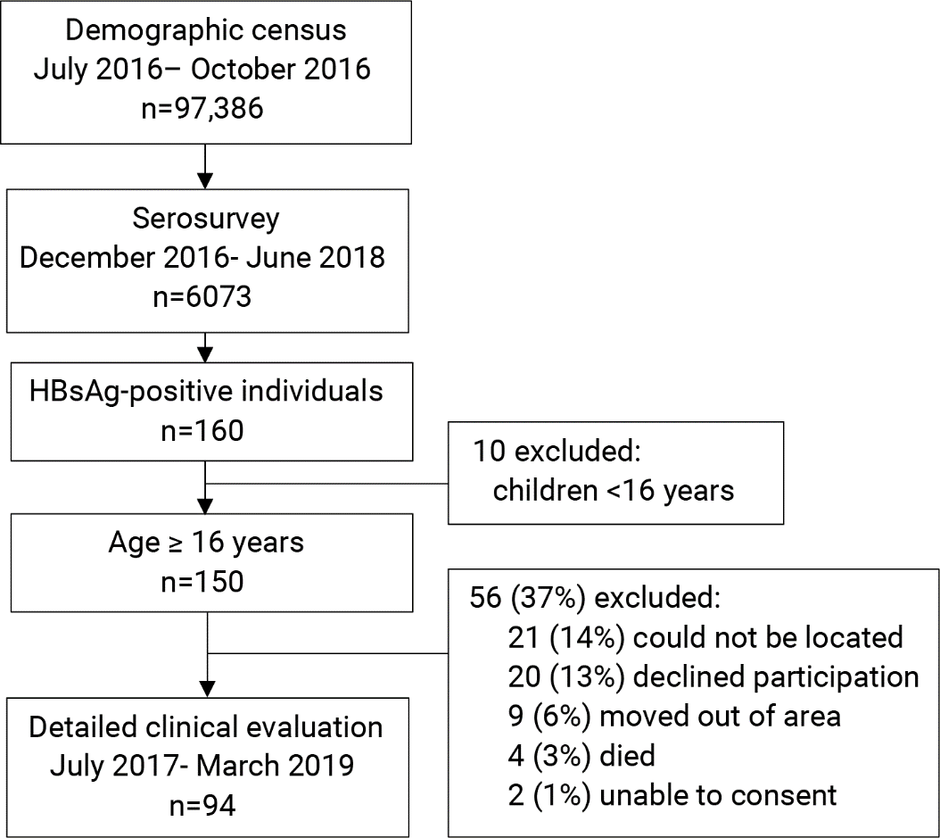

Figure 2: Distribution of age and sex in the serosurvey relative to the demographic census ª
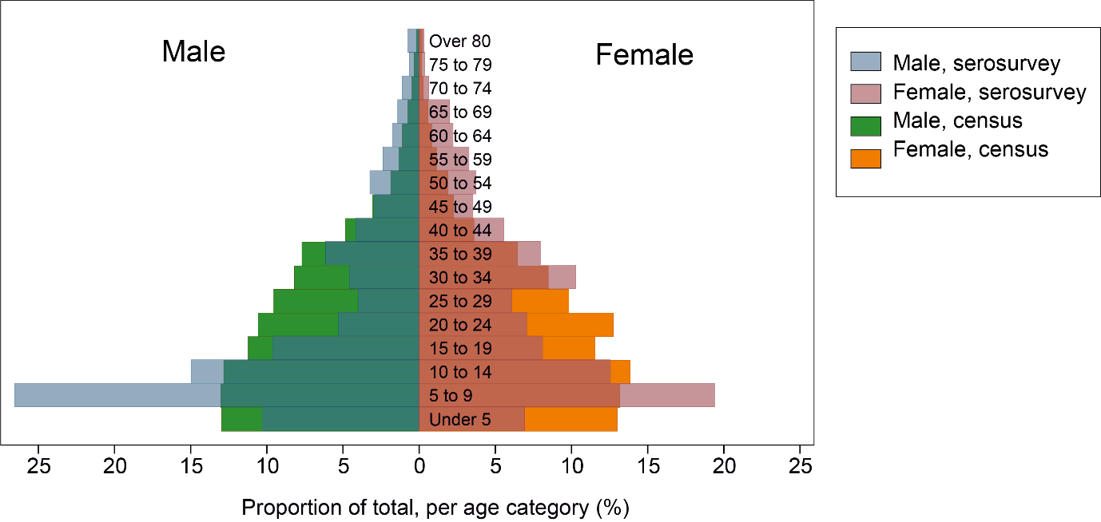

ª Serosurvey age distribution is layered over census distribution data.

Figure 3: Prevalence of hepatitis B surface antigen stratified by age and sex groups and HBV vaccine coverageª
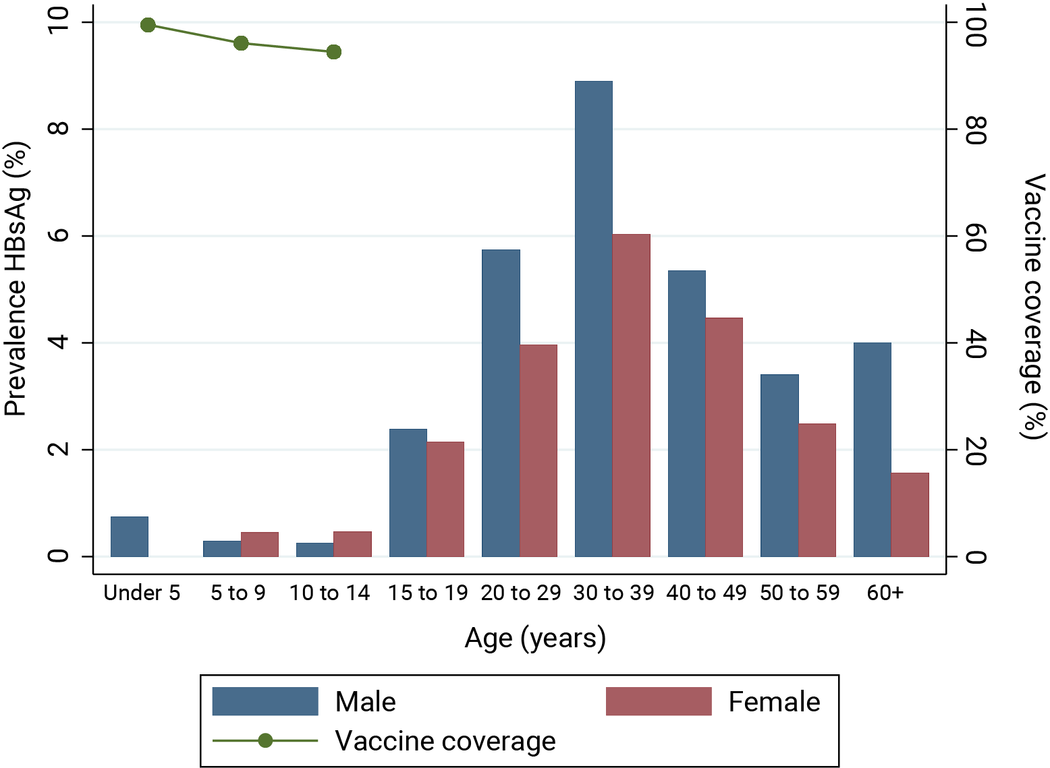

ªVaccine coverage shown among serosurvey participants born after implementation of the vaccine in 2002. Tabulated age and sex stratified prevalence data are shown in appendix 6.
Figure 4: Outcomes of community clinical evaluation for HBV treatment eligibilityª
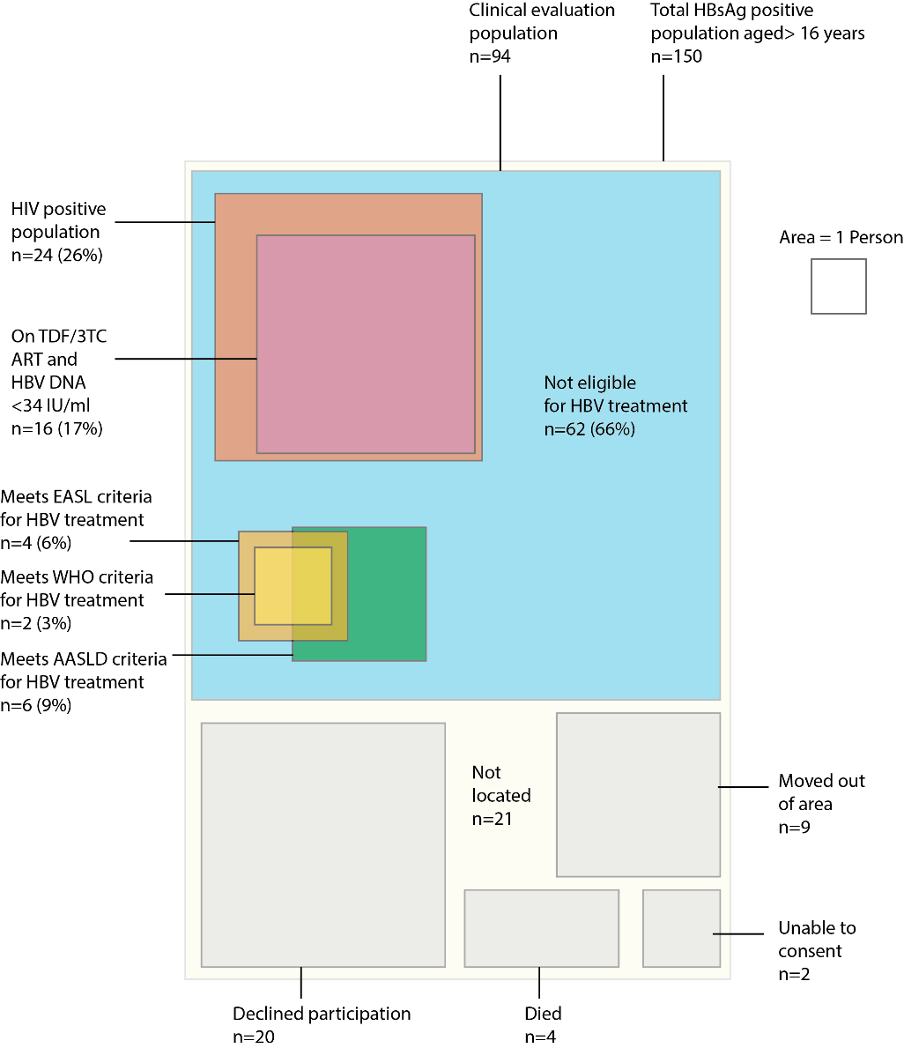
Abbreviations: TDF tenofovir disoproxil fumarate ; 3TC lamivudine ; HBsAg hepatitis B surface antigen; HBV hepatitis B virus; WHO World Health Organization; EASL European Association for Study of the Liver; AASLD American Association for the Study of the Liver. ª Area is proportional to the number of people in each group. Treatment eligibility criteria are considered only for HIV negative individuals, as all HIV positive people should receive ART containing TDF/3TC.

