A multifunctional electromagnetic device for vibration energy harvesting and rail corrugation sensing
Yifeng Wang^{1,2}, Shoutai Li^{3,4}, Peigen Wang^{3,4} Mingyuan Gao^{3,4*}, Huajiang Ouyang^{5*}, Qing He^{1,2}, and Ping Wang^{1,2*}
¹ Key Laboratory of High-speed Railway Engineering (Southwest Jiaotong University), Ministry of Education, Chengdu 610031, China
² School of Civil Engineering, Southwest Jiaotong University, Chengdu 610031, China
³ College of Engineering and Technology, Southwest University, Chongqing 400716, China
⁴ National & Local Joint Engineering Laboratory of Intelligent Transmission and Control Technology, Chongqing 400716, China
⁵ School of Engineering, University of Liverpool, Liverpool L69 3GH, UK
*Corresponding author: E-mail: goalmychn@foxmail.com; H.Ouyang@liverpool.ac.uk; wping@swjtu.edu.cn;

Received xxxxxx
Accepted for publication xxxxxx
Published xxxxxx
Abstract
A multifunctional electromagnetic device for harvesting rail vibration energy and sensing rail corrugation is proposed. Firstly, the optimal coil position is investigated theoretically and verified through experiments. Then, experimental frequency-sweeping tests are carried out to understand the response characteristics of the harvester. Two sections of a metro line with/without rail corrugations are selected to measure rail roughness and vibration. Using the field-measured rail vibration as excitations, the response characteristics of the harvester are investigated through indoor experiments. Experimental results demonstrate that occurrences of corrugation can be identified through time-frequency analysis of the electromotive forces of the harvester. Besides, electrical load tests under normal rail vibration demonstrate that this harvester will yield its maximum power of 18.6 mW (average power: 1.5 mW) when the resistance of the external electrical load is close to the internal resistance of the coil. The capability to energise small commercial electronic devices is verified by charging a supercapacitor, and driving LEDs, a digital clock, and a thermo-hygrometer to work, respectively. The capabilities of the harvester for powering low-power electronics and sensing rail corrugation pave the wave for designing a self-powered sensing node for rail corrugation monitoring.
Keywords: vibration energy harvesting; electromagnetic; rail corrugation sensing; self-powered-and-sensing node.

- Introduction

Railway transport has undergone rapid development in recent years due to its high capacity in transportation and low energy consumption. Among all railway systems, the urban rail transit system is of great significance in solving traffic congestion, alleviating air pollution and facilitating the daily commute in big cities. However, the frequent starting and braking of urban rail transit trains make vehicle-track components more prone to damage. Besides, the rapid extension of urban rail transit networks has created a great demand for health monitoring of vehicle-track structures. These monitoring devices are usually powered by the power grid and batteries. The electrical cables connecting distributed monitoring devices require large investments and daily maintenance. Limited lifespan and potential pollution caused by consumed batteries limit the usage of batteries. Therefore, maintenance-free and cost-saving power sources are needed in building distributed monitoring systems for track structures.
Rail corrugation, a typical kind of rail damage, is a visible periodical wear phenomenon appearing on the rail surface. The presence of rail corrugation will significantly change wheel-rail contact states, leading to abnormal vibration of vehicle-track components [1]. The abnormal vibration will accelerate the degradation of vehicle-track components and impact the passengers’ ride comfort. The formation and development of rail corrugation are influenced by numerous factors. To date, there has not been a uniform theory to explain the formation mechanism of different rail corrugations [2].

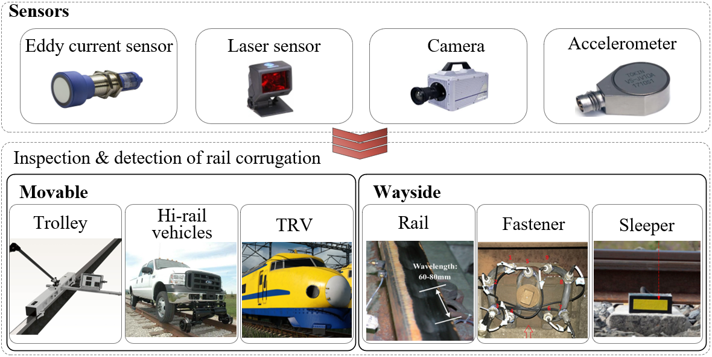
Figure 1. Sensors and detection methods for rail corrugation inspection.

Rail corrugation inspection plays an essential role in evaluating the state of track and developing maintenance strategies. A feeler gauge is a common tool for railway maintenance [3]. Besides, some dedicated sensing devices have been developed to improve inspection efficiency. In developing these sensing devices for rail corrugation, eddy current sensors, laser sensors, cameras, and accelerometers, as shown in Figure 1, are commonly exploited. According to the installed positions, these sensing devices can be roughly categorized into two groups: wayside devices and moveable devices [4]. Wayside sensing devices are suitable for monitoring rail corrugations in critical sections. Sensors installed on movable platforms such as trolleys [5], Hi-vehicles [4], track recording vehicles (TRVs), even in-service vehicles [6], make it possible to inspect rail corrugations of the whole railway line with only one piece of equipment. For most movable inspection equipment, the in-service trains must be offline during inspection [3].
Vibration induced by wheel-rail interactions can be transmitted upwards to the car body, and downwards to the subgrade. Vibration energy will be dissipated in the form of heat during transmission. Harvesting the wasted vibration energy to power electrical monitoring devices are conducive to improving energy efficiency. Furthermore, harvesting vibration energy for local usage is suitable for distributed monitoring networks in railway applications, contributing to saving investment in electrical grids and reducing environmental pollution caused by consumed batteries [7–11]. Vibration energy harvesting, as a promising technology, can generate electricity by harnessing wasted energy [12–14].
Vibration energy can be captured via electromagnetic [15,16], piezoelectric[17,18], triboelectric [19] and magnetostrictive mechanisms [20]. Electromagnetic vibration energy harvesters (VEHs) are usually composed of fixed coils and movable magnets or in reverse [21]. The relative displacement between coils and magnets results in the change of magnetic flux within the coil as well as the voltage output across the coil. Electromagnetic VEHs do not depend on advanced materials, but they usually have larger dimensions than VEHs utilizing other energy conversion mechanisms [22]. Piezoelectricity refers to the electric charges accumulated in certain solid materials in response to the mechanical stress applied to the materials [23,24]. Piezoelectric VEHs are very sensitive even to small excitations [11]. However, the large internal resistance of piezoelectric materials limits the applicability of piezoelectric VEHs [25]. The triboelectric effect is a type of contact electrification phenomenon occurring when two materials having distinct dielectric characteristics separate from each other [26]. Thus, triboelectric VEHs highly depend on the selected materials. Magnetostrictive materials are usually made of expensive rare-earth elements, making it challenging to fabricate magnetostrictive VEHs on a large scale.As the railway industry is price-sensitive and has complex on-side environments, electromagnetic transduction is one of the most promising mechanisms in vibration energy harvesting for railway applications [27,28].
Vibration energy harvesting systems in railway applications can be roughly categorized into two groups: track-side and onboard energy harvesters [29]. Track-side harvesters, harnessing energy from track vibration, are conducive to reducing the effects of vibration on track structures [30]. Using the relative displacement between the rail and ground, Zhang et al. [31] developed an electromagnetic VEH based on a rack-gear system. Besides, other structures such as the pendulum-like structure [32], and spring-mass-like structure [33] have been proposed to harness the energy of track vibration. The reported track-side VEHs are mainly fixed in positions where the track vibrates intensely, such as the rail foot and the top of sleepers [34]. The irregularity of track and unevenness of the wheel-rail contact interface will also cause vertical vibration of vehicles. Thus, numerous researchers have also focused on onboardvibration energy harvesting [22].
The authors’ literature survey suggests that harvesting energy from the vibration of tracks and vehicles is promising. To form an intelligent railway system, a multifunctional VEH based on a rolling magnet (RM) is proposed in this work. This device has the functions of both harvesting energy from rail vibration and sensing rail corrugation. The railway track mainly vibrates in a low-frequency range. Some harvester architectures, such as the sawtooth structure [35] and the sleeve-shaft structure [36], are reported to enhance the performance of the harvester under low-frequency excitation. In this work, an RM-based oscillator is adopted in the harvester, making the RM easy to oscillate even under small excitation, compared with common sliding-magnet-based harvesters. The magnetic field of the RM will rotate during the oscillation of the RM, leading to a larger changing rate of magnetic flux within the coil. Characteristics of the simple and compact structure, the one-to-one relationship between the output signals and excitations which is important for corrugation sensing, and the wide frequency band of the response of this system endow the proposed harvester with a promising prospect in energy harvesting from rail vibration. Contributions of this work can be summarized as follows:
(1) A device being able to act as an energy harvester and a sensor for rail corrugation is proposed.
(2) A theoretical study is performed to verify that the coil position utilized by the prototype is optimal.
(3) Using the field-measured rail vibration as excitation, the capability of the harvester for sensing rail corrugation is investigated.
(4) The capability of this harvester for powering low-power electronic devices is justified by experiments.
(5) A concept of establishing a self-powered sensing node for monitoring rail corrugation based on the energy harvester is proposed and a simple test system to demonstrate its feasibility is also built.
The rest of the paper is organized as follows: Section 2 gives an introduction to the prototype and the model of the harvester. In Section 3, the optimal position of the coil is investigated. Section 4 describes the frequency sweep tests results. The capabilities of the harvester on sensing rail corrugation and powering electrical devices are investigated in Sections 5 and 6, respectively. Section 7 provides an application scenario of the harvester for establishing a self-powered sensing node for rail corrugation monitoring.

- Prototype and modelling of the harvester

This harvester consists of a frame, a cylindrical RM with diametrical magnetization, a cylindrical FM with axial magnetization, a coil, two supports, a top cover, and two cantilevers, as shown in Figure 2. The frame is the supporting structure of the entire harvester to protect the coil and provide a rolling channel to RM. A U-shaped structure is in the middle of the frame and connected to the bottom wall of the frame. The RM oscillates vertically inside the U-shaped channel. The FM, marked by a blue box in Figure 2, is fixed in the hole on the back of the U-shaped structure and provides recovery forces to oscillations of the RM. The coil with a square cross-section is wound around the U-shaped structure. Two supports are utilized to adjust the vertical position of the coil. A top cover is fixed on the top end of the frame and exploited to restrict the motion of the coil. Two cantilevers are installed on the top and bottom ends of the U-shaped channel to limit the stroke of the RM and provide elastic forces to the RM when collisions occur. In practice, the harvester is fixed on the rail foot through a pair of rail clips, as shown in Figure 2. The right and left clips are connected through a bolt making no hazards to the rail. Vertical vibration of the rail can drive the harvester to convert kinetic energy into electricity. The occurrence of rail corrugation will significantly change the characteristics of rail vibration, as well as the output voltages of the harvester. As a mono-stable system, the voltage output of the harvester has a strong relationship with base excitations. Such a characteristic provides a possibility of sensing the occurrence of rail corrugation with the proposed VEH.

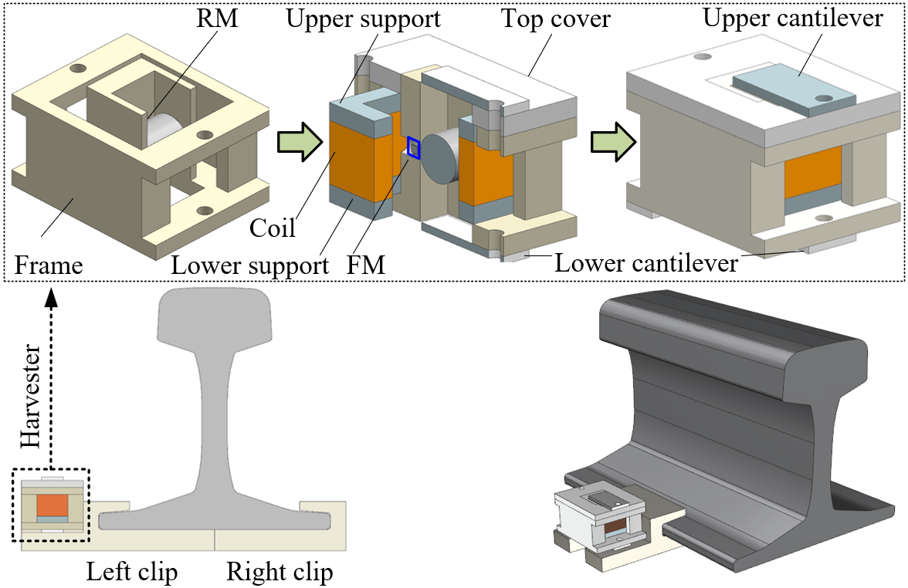
Figure 2. Composition and installation of the proposed electromagnetic device for rail vibration energy harvesting.

According to the design concept, a prototype of the harvester is fabricated via 3D printing technology. The frame, a top cover, two supports, two cantilevers are all made of polylactic acid (PLA) via a 3D printer. This harvester has a gross dimension of 50mm×40mm×40mm. The cylindrical RM with a dimension of $ϕ12 mm×14mm$ has a grade number of N38. The fixed magnet ($ϕ 2 mm×3mm$) has a grade number of N52. The centres of the FM and the RM have a horizontal distance of 2 mm. The coil has a square cross-section of $30 mm×30mm$, a thickness of 10 mm, as well as a length of 16 mm along the axis direction. The coil is wounded with 0.16-mm copper wire and has a turn number of 2000. The coil and the RM utilized in the prototype are the most widely available ones. The dimensions of other components are determined on top of the sizes of the coil and the RM. Some parameters of the prototype, such as the diameter of the wire, are worked out based on research experiences [3,37], which may not be optimal. Therefore, parameter optimization on the prototype will be conducted in a future study.
The RM vibrates inside the U-shaped channel, leading to a change of magnetic flux within the coil and generating a voltage output. Figure 3(a) shows a diametrically magnetized cylindrical RM inside the U-shaped channel. According to the Coulombian approach [38], the magnet can be replaced with an equivalent distribution of volume charge $σ_{v}$ and surface charge $σ_{s}$ of magnetized material shown in Figure 3(b). As the RM has a uniform diameter, the volume charge $σ_{v}=-∇ M$, defined as the divergence of the polarization vector $M$, equals to zero [39]; the magnetic field intensity can be calculated with the surface charge component. Thus, the magnetic field intensity at observation point $P\left(x_{P},y_{p},z_{P}\right)$ (one point in the 3D space) can be written as follows [40]:
$$H\left(x_{P},y_{p},z_{P}\right)=\frac{1}{4πμ_{0}}\iint{\frac{σ_{s}}{{\left|i-i^{'}\right|}^{3}}\left(i-i^{'}\right)ds}$$ | （1）
where $μ_{0}$ stands for the vacuum permeability with a value of 12.57×10-7 H/m; $i$ and $i^{'}$ are the position vectors from the middle point $O(0,0,0)$ of RM to the observation point $P\left(x_{P},y_{p},z_{P}\right)$ and point $Q\left(x_{Q},y_{Q},z_{Q}\right)$ (one point on the surface of the RM). The surface charge satisfies $σ_{s}=M∙n=\left|M\right|\cos{α}$, where $n$ is the unit vector normal to the surface of the RM at point $Q$; $α$ is the angle between $M$ and $n$. Thus, Eq. (1) can be rewritten as the following equation:
$$H\left(x_{P},y_{p},z_{P}\right)=\frac{\left|M\right|r}{4πμ_{0}}\int_{α=-π}^{α=π}{\int_{z_{Q}=-\frac{h}{2}}^{z_{Q}=\frac{h}{2}}{\frac{\left(x_{P}-x_{Q} \right)i_{x}+\left(y_{p}-y_{Q} \right)i_{y}+\left(z_{P}-z_{Q} \right)i_{z}}{{\left({\left(x_{P}-x_{Q}\right)}^{2}+{\left(y_{p}-y_{Q}\right)}^{2}+{\left(z_{P}-z_{Q}\right)}^{2}\right)}^{\frac{3}{2}}}}}∙\cos\left(α\right)dz_{Q}dα$$ | (2)
where $r$ and $h$ are the radius and height of the RM; and $i_{x}$,$i_{y}$, and $i_{z}$ stand for unit vectors along the x, y, and z axes, respectively. The corresponding remnant flux density at point $P$ can be expressed as:
$$B\left(x_{P},y_{p},z_{P}\right)=μ_{0}H\left(x_{P},y_{p},z_{P}\right)+δ$$ | (3)
where $δ=M$ if $P$ is inside the RM; $δ=0$ if $P$ is out of the RM. With the calculated magnetic flux density in the 3D free space, the magnetic flux passing through the coil can be obtained [41]:
$$Φ_{m}=\frac{N}{L_{c}h_{t}}\int_{-{0.5L}_{c}}^{{0.5L}_{c}}{dx_{P}}\int_{{0.5W}_{c}-h_{t}}^{{0.5W}_{c}}{dW}\int_{-W}^{W}{dz_{P}\int_{-W}^{W}{B_{x}\left(x_{P},y_{p},z_{P}\right)}dy_{P}}$$ | (4)
where $N$ is the number of turns of the coil; $L_{c}$, $W_{c}$ and $h_{t}$ are the bobbin length, width, and thickness of the coil; $B_{x}\left(x_{P},y_{p},z_{P}\right)$ is the x-axis component of $B\left(x_{P},y_{p},z_{P}\right)$. According to Faraday’s law of induction, the EMF $ε$ across the coil can be written as a function of time $t$:
$$ε=\frac{dΦ_{m}}{dt}$$ | （5）
The motion of the RM will cause an EMF across the coil and generate a current within the closed circuit. The dynamic behaviours of the RM are influenced by several kinds of forces, including the magnetic force from the FM, the gravity of the RM, the friction force from the back wall of the U-shaped channel, the mechanical and electrical damping forces as shown in Figure 3(a). The gravity of the RM, $mg$, is a volume force and remains constant during its vibration. The magnetic force from the FM provides a restoring force to the dynamic system, enabling the RM to oscillate vertically.

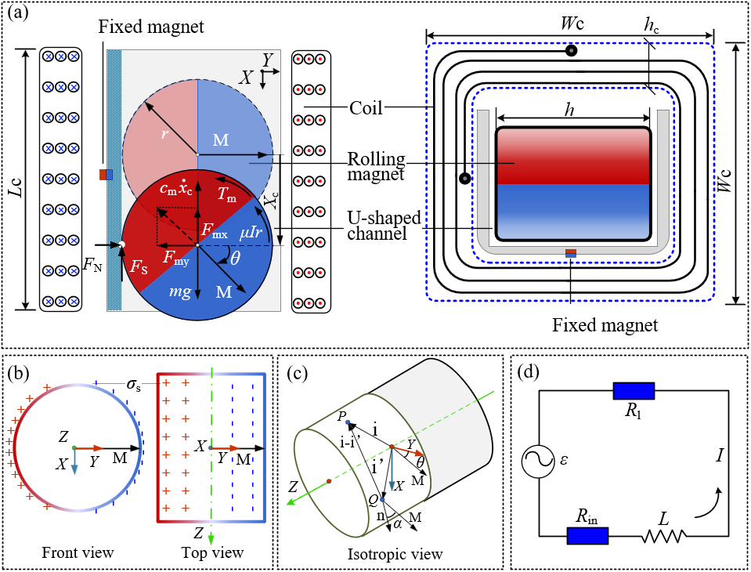
Figure 3. Parameter definition. (a) parameters of force and dynamic motion; (b) the front and top views of the RM; (c) isotropic view of the RM; (d) the equivalent circuit.

Figure 4. The magnetic force and torque acting on the RM: (a) the x-axis component of the magnetic force from the FM (unit: N); (b) the y-axis component of the magnetic force from the FM (unit: N); (3) the torque from the FM (unit: N·m).

Figure 4(a), 4(b) and 4(c) show the x-axis component, $F_{mx}$, y-axis component, $F_{my}$, of the magnetic force and the torque, $T_{m}$, when the horizontal gap between the FM and the RM equals 2mm. The magnetic force and torque, are calculated via the finite element method. As the magnetic force and torque vary with the vertical displacement $x_{c}$ and angular position $θ$ of the RM, the contours of the magnetic force and torque can be obtained, as shown in Figure 4. Compared with the gravity of the RM, the x-axis component of the magnetic force is significantly larger and plays a dominant role in the dynamical behaviours of the RM. The gravity will make the equivalent stable point of the RM move downward slightly. When base excitations become intense, the friction force acting on the RM may not be enough, and slips between RM and the back wall of the U-shaped channel will occur. At this time, the rotary and translational motion of the RM will be decoupled ($x_{c}≠rθ$), shifting from a single degree of freedom system to a double one. During oscillation, the RM receives mechanical damping forces mainly coming from the deformation of materials. As the RM is surrounded by the coil and frame of the harvester, observing the dynamic behaviours of the RM, and measuring the mechanical damping force of this system directly is difficult. The induced current within a closed circuit will generate an electromagnetic damping force on the RM too. Complex forces make it difficult to predict the dynamic behaviours of RM in theory. Thus, the actual energy-harvesting performance of this harvester is mainly investigated through experiments in this work.

- Optimal coil position

RM-based energy harvesters usually have two kinds of coil arrangements: one is setting the longitudinal axis of the coil perpendicular to the translational motion direction of the RM as Case 1 shown in Figure 5(a) [41–43]; the other is setting the longitudinal axis of the coil parallel to the translational motion direction of the RM as Case 2 shown in Figure 5(a) [44]. The harvester proposed in this work belongs to the category of Case 2. In the prototype, the centre of the coil coincides with that of the RM when the RM stays at its stable position. The coil arrangement of the proposed harvester is believed to affect EMF. To find the favourable position of the coil, a theoretical study is conducted in this section.
In Cases 1 and 2, the distance between the coil and the stable point of the RM, $d$, varies from -30 mm to 30 mm. In the study, the RM is set to undergo pure rolling oscillations around its stable point, which can be expressed as a function of time $θ\left(t\right)=\frac{π}{4}\sin{2πft}$ ($f$=10 Hz, the vibration frequency; $x_{c}=rθ$, the vertical displacement of the RM). For Case 2, the EMF across the coil can be calculated according to Eqs. (4) and (5), directly. For Case 1, each turn of the coil can be regarded as parallel to the z-x plane. Only the y-direction component of magnetic flux intensity is relevant to the magnetic flux within the coil and thus is considered. The magnetic flux within the coil of Case 1 can be calculated:
$Φ_{m}=\frac{N}{L_{c}h_{t}}∙\int_{-{0.5L}_{c}}^{{0.5L}_{c}}{dy_{P}}\int_{{0.5W}_{c}-h_{t}}^{{0.5W}_{c}}{dW}\int_{-W}^{W}{dz_{P}\int_{-W}^{W}{B_{y}\left(x_{P},y_{p},z_{P}\right)}dx_{P}}$ | (6)
where $B_{y}\left(x_{P},y_{p},z_{P}\right)$ is the y-axis component of $B\left(x_{P},y_{p},z_{P}\right)$. The EMF across the coil of Cases 1 and 2 can be calculated across Eqs. (5) and (6). Note that this study of the magnetic flux does not consider the structural dynamical characteristics of the harvester, and the FM makes no contributions to the generation of EMFs since there is no relative motion between the coil and the FM. Some parameters of the coil and RM utilized in the prototype and theoretical model are presented in Table 1.
Figure 5(b) shows the root-mean-square (RMS) values of induced EMF when the coil is at different positions, indicating that the coil of Case 2 can generate larger EMFs than that of Case 1. It can also be found that the coil can generate the largest EMF when the centre of the coil coincides with the stable point of the RM. The horizontal position of the small solid circle in Figure 5(b) corresponds to the coil position adopted in the proposed harvester, verifying that this coil arrangement of the proposed harvester leads to a large EMF. Besides, the red arrows in Figures 5(c) and 5(d) show the distributions of the remnant flux density within the x-y plane when the RM is at its stable point. The results demonstrate that although the coil of Case 2 has a smaller magnetic flux passing through the coil than that of Case 1, it has a larger magnetic flux changing rate during vibration of the RM, therefore resulting in a larger EMF.
Figure 5(e) shows the experimental setup utilized to verify the theoretical results. During experiments, the shake table vibrates horizontally with an acceleration of 10 g at 10 Hz. In Figure 5(e), a T-shaped structure is designed and fabricated to realize the vibration modes of the RM in Cases 1 and 2. During experiments, the RM always vibrates around the FM, and the change of the relative distance between the coil and the stable point (the centre point of the RM when the potential energy of the system is lowest) is realized by adjusting the position of the coil on the T-shaped structure. The EMF of the coil when it is fixed at different positions is recorded by an oscilloscope. Experimental results of the two cases are presented in Figure 5(f). They have a similar trend to the theoretical results. Besides, the values of the experimental and the theoretical results are very close. The good agreement between them demonstrates the rationality of the theoretical model.

Table 1. Parameters of the prototype.
Object | Symbol | Description | Value | Unit | Object | Symbol | Description | Value | Unit
RM | $$m$$ | Mass of RM | 12.4 | g | Coil | $$L_{c}$$ | Bobbin length of the coil | 16 | mm
 | $$r$$ | Radius of RM | 6 | mm |  | $$W_{c}$$ | Width of the coil | 30 | mm
 | $$h$$ | Height of RM | 14 | mm |  | $$h_{c}$$ | The thickness of the coil | 5 | mm
 | $$M$$ | Remanence of RM | 1.25 | T |  | $$N$$ | Number of turns of the coil | 2000 | -
FM | - | Mass of FM | 2.0 | g |  | $$R_{in}$$ | Resistance of the coil | 194 | Ω
 | - | Radius of FM | 2 | mm
 | - | Height of FM | 2 | mm
 | - | Remanence of FM | 1.44 | T
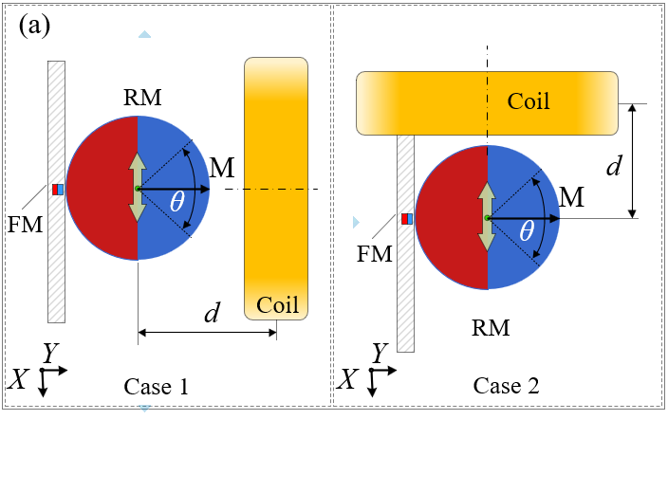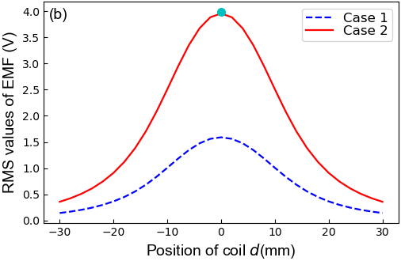
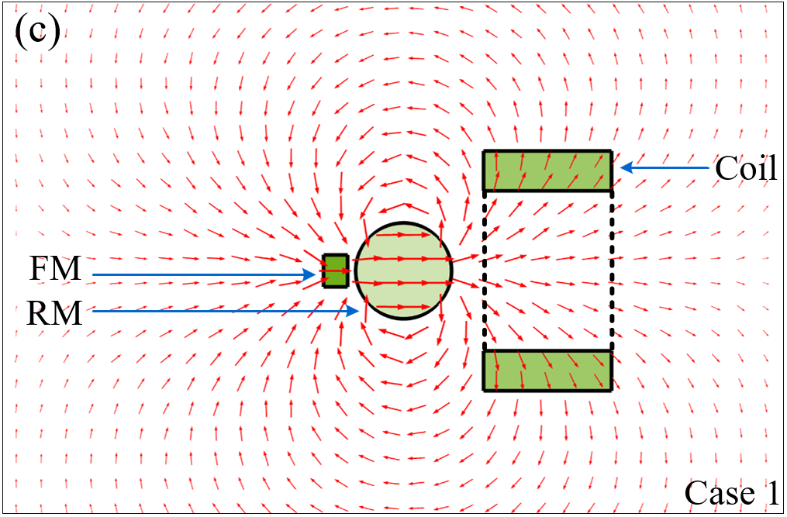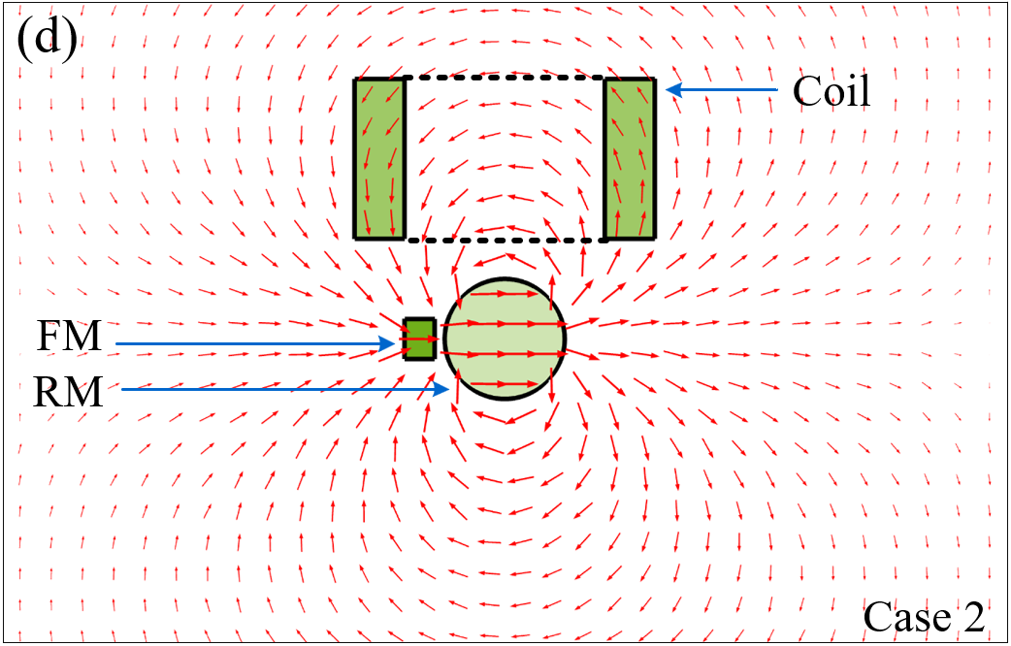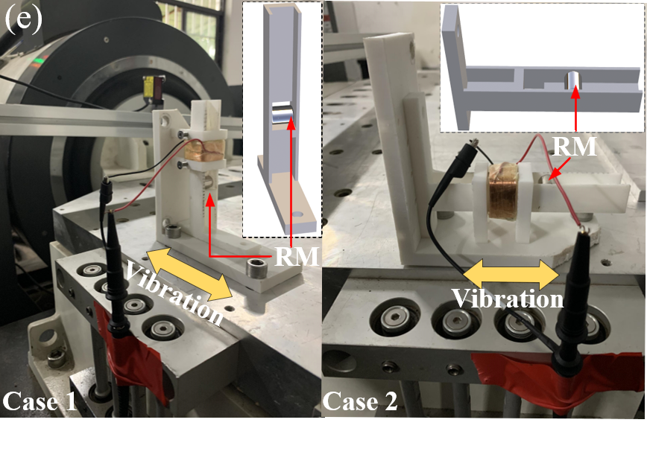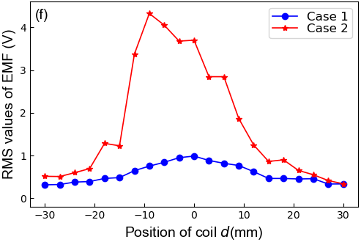
Figure 5. The optimal position of the coil: (a) two comparison cases of coil positions; (b) the maximum values of induced EMF when the coil is at different positions; (c) the distribution of magnetic flux density for Case 1; (d) the distribution of magnetic flux density for Case 2; (e) experimental setup for model verification; (f) experimental results.

- Frequency sweep tests
To learn about the response characteristic of the harvester, frequency-sweeping tests are carried out, as shown in Figure 6. This testing system consists of a controlling computer, a signal generator, a power amplifier, a shake table (DC3200-36, Suzhou Sushi Testing Group Co., Ltd.), an accelerometer, an oscilloscope (MDO4104C, Tektronix) and two prototypes of the harvester. The accelerometer, installed on the shake table, is employed to monitor the vibration of the table and give feedback to the controlling computer for realizing the closed-loop control strategy. During tests, the prototypes of the harvester are fixed on the table via bolts. An oscilloscope is adopted in experiments to display and record the voltage data of the harvester.
As the contact surface roughness of the U-shaped channel of the harvester can influence the dynamic behaviours of the RM, this work intends to investigate the impact of surface roughness on the performance of the harvester through frequency-sweeping tests. A piece of sandpaper with a thickness of 0.2 mm is stuck to the back wall of the U-shaped channel of one prototype to enhance the roughness of the contact surface. For comparison, the other prototype is without sandpaper. During tests, the excitation frequency $f$ varies exponentially between 5Hz and 1000 Hz with a speed of 1 octave per minute. Excitation frequency $f$ can be expressed as a function of time $t$ (unit: s): sweeping forward, $f(t)=5×2^{\left(t/60\right)}$Hz; sweeping backwards, $f(t)=1000×2^{\left(-t/60\right)}$Hz. Considering performances of the shake table and characteristics of real rail vibration, the acceleration amplitude of excitation is set to 5$g$, 10$g$, and 15$g$, respectively, with the maximum displacement being restricted to 2 mm [3].
Figure 7(a) shows the RMS values of the EMF generated by the prototype without sandpaper, and Figure 7(b) shows the same results of the prototype with sandpaper. They indicate that the harvester performs well in the frequency range below 400 Hz. The harvester without sandpaper reaches its maximum RMS voltage of 6.7 V at about 20Hz. Its peak values of the RMS voltage increase from 5.5 V to 6.7V with the increase of acceleration amplitude. However, for the harvester with sandpaper, the peaks of the RMS voltage at about 20 Hz disappear. This may be due to a reduced number of slips because the sandpaper can increase the friction force acting on the RM; meanwhile, the mechanical damping force of the system will increase, influencing the dynamic characteristics of the RM. Besides, the thickness of the sandpaper will weaken the nonlinear magnetic force between the RM and the FM slightly. The results of the two comparative cases demonstrate that the harvester without sandpaper can generate larger EMFs than that with sandpaper. Thus, the prototype of the harvester without sandpaper will be adopted in the following experimental studies. For the two cases, the results of sweeping frequency forward and backward sweeps are quite consistent. In the upper subplot of Figure 7(a), there is a gap between the forward and backward curves at some frequencies. This phenomenon may be caused by many factors such as the nonlinearity of the system, the different initial conditions in forward and backward frequency sweepings, and the random disturbances from the shake table. The influences of these factors on the results will be investigated in a future study.

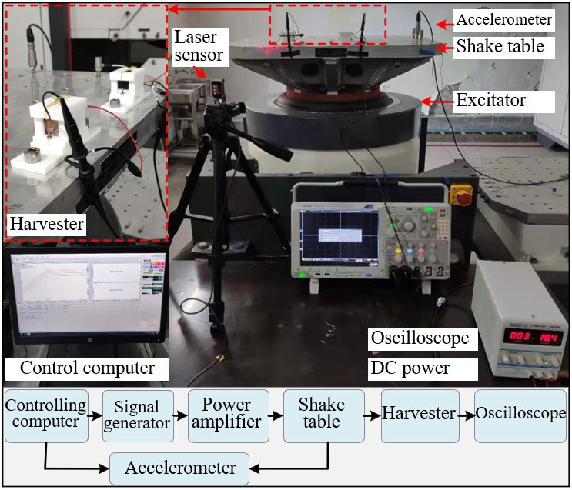
Figure 6. Experimental setups for the frequency sweep test.

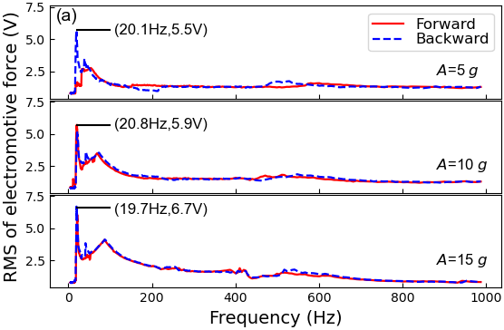
Figure 7. Response characteristics of the harvester: (a) results of the prototype without sandpaper; (b) results of the prototype with sandpaper.
- Tests of the sensing capability for rail corrugation

Periodical characteristics of rail corrugation will change rail vibration in both time and frequency domains. To learn about the influence of rail corrugation on rail vibration, two railway sections (Section 1 without obvious rail corrugation; Section 2 with corrugation) are selected to conduct field tests.
Sections for field tests are both located in the tunnel of one operating line of Shenzhen metro, China. The two sections have the same track structures (bi-block sleepers embedded in the monolithic track bed) and a fastening system (damping fastener: stiffness of rail pad 16kN/mm; damping of rail pad $5.0×{10}^{4}$N·s/m). UIC 60 rail (bending stiffness: $6.62×{10}^{6}N∙m^{2}$; linear density: 60.64 kg/m) is employed in the two sections with a sleeper space of 0.60 m. Running speeds of trains in two sections are very close: Section 1: about 79 km/h; Section 2: about 76 km/h. Figure 8(a) shows the rail without corrugation and Figure 8(b) the rail with obvious corrugation. The wave depth and length are critical features to depict the corrugation, which affect the dominant frequency and magnitude of abnormal rail vibration. However, the wave depth and length of rail corrugation cannot be quantified with naked eyes directly as the wave depth is usually on a micrometre scale. During tests, an instrumented trolley fabricated by Müller-BBM Rail Technologies is adopted to measure the unevenness of the rail surface. Figure 8(c) shows the field-testing situation using the trolley.

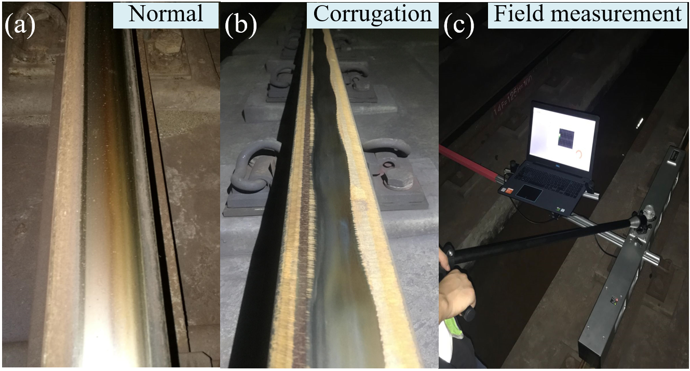
Figure 8. Field test of rail corrugation: (a) rail without corrugation; (b) rail with corrugation; (c) field measurement of rail corrugation.

Figure 9 denotes the rail roughness versus wavelength in 1/3 octave band. In Figure 9, the green dash-dotted line denotes the threshold of rail roughness defined by ISO 3095:2013 [45]. The red solid line represents the rail-roughness spectrum for the section with corrugated rail, and the blue dashed line represents the rail-roughness spectrum for the section with normal rail. It can be seen from the figure that the blue dashed line is always below the green dash-dotted line, indicating that the latter can be considered to be free of corrugation in ISO 3095:2013. However, the red solid line is significantly higher than the green dash-dotted line when the wavelength is shorter than 200 mm. The spectrum reaches a peak value at the wavelength of 40.1 mm and the wave depth of 22.7 $μm$, demonstrating that rail corrugation has occurred. The dominant frequency of rail vibration $f_{r}$, related to the wavelength of corrugation, can be roughly estimated with the equation of $f_{r}=\frac{v}{λ}$ [46], where $v$ denotes the running speed of the train and $λ$ the wavelength of rail corrugation.

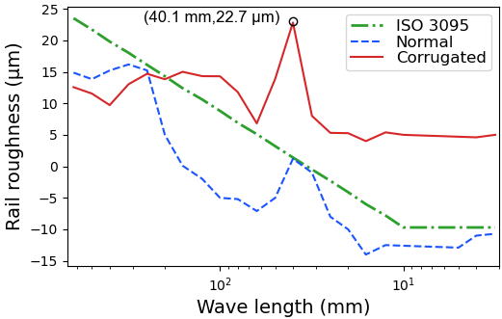
Figure 9. On-site measured rail roughness of the two sections.

Besides measuring rail roughness, the rail vibration of the two sections is also measured in situs. Figure 10(a) shows the rail acceleration of the normal-rail section when one train passes the test point. It can be found that there are several apparent peaks, the maximum value of which exceeds 200 $m/s^{2}$. These peaks are caused by passing bogies and each bogie corresponds to one peak. Figure 10(b) presents the field-measured rail acceleration of the corrugated rail section. The magnitude of rail acceleration has a significant increase compared with that of the normal-rail section, reaching a maximum value exceeding 600 $m/s^{2}$. To extract more information from field-measured rail acceleration data, the Short-time Fourier transform (STFT) is employed. The sampling frequency of rail vibration signals is 6400 Hz. Each segment for performing STFT contains 512 data points and 256 data points are being overlapped between two adjacent segments. Figure 10(c) shows the time-frequency spectrum of normal rail vibration calculated by STFT, and Figure 10(d) shows that of corrugated rail vibration. For vibration of the normal rail, the energy of acceleration signals is dispersed in a large frequency range from tens of Hz to thousands of Hz, especially when the bogie is passing. However, for corrugated rail, the energy of acceleration signals is centred around a fixed frequency 530Hz, which is consistent with the estimated result ($f_{r}=\frac{v}{λ}=\frac{76 km/h}{40.1 mm}=526.5Hz$).

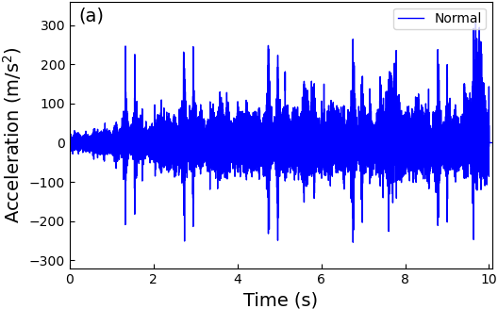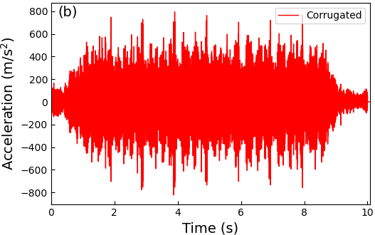
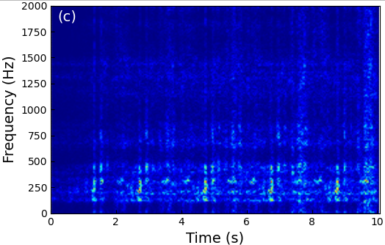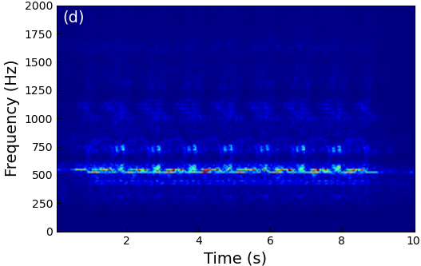
Figure 10. Time-frequency characteristics of the rail vibration: (a) time history of the normal-rail acceleration; (b) time history of the corrugated-rail acceleration; (c) STFT of the normal-rail acceleration; (d) STFT of the corrugated-rail acceleration.

Limited by complex on-site conditions, field tests is difficult to implement in a short time. Thus, indoor experiments to investigate the response characteristics of the harvester are carried out using field-measured rail vibration signals. The field-measured signals are inputted to the shake table for regenerating normal-rail and corrugated-rail vibrations in the laboratory. Figure 11(a) shows the comparison between the root mean square (RMS) values of rail acceleration and induced EMF of the harvester for normal-rail vibration, and Figure 11(b) shows the comparison for corrugated rail. During data processing, these signals are firstly divided into 0.1-second segments, and then the RMS value of each section is calculated and displayed. The comparisons demonstrate that waveforms of the induced EMFs correlate well with those of the excitation signals for both the normal-rail and corrugated-rail conditions. It should be pointed out that the harvester for normal-rail vibration can generate a higher EMF than that for corrugated-rail vibration. The possible reasons for such a phenomenon are that the harvester is more sensitive to low-frequency vibration, and intense vibration may cause the slipping motion of the RM.
Figures 11(c) and 11(d) are the STFT of the induced EMFs for normal-rail and corrugated-rail vibration. Figure 11(c) illustrates that the signal generated by the harvester for normal-rail is located in a low-frequency range. For vibration of corrugated rail, the signal generated by the harvester is mainly located in the same low-frequency range. However, there is also a considerable frequency component corresponding to corrugation, highlighted by the red ellipse in Figure 11(d). For a further understanding of relationships between the responses of the harvester and excitations in the frequency domain, the power spectrum densities (PSDs) of the responses and excitations for both normal-rail and corrugated-rail cases are also provided in Figure 11(e) and 11(f). The response of the harvester for corrugated rail has an apparent component corresponding to the dominant frequency of rail corrugation. Based on such a characteristic, this harvester can be exploited to detect the occurrence of rail corrugation.

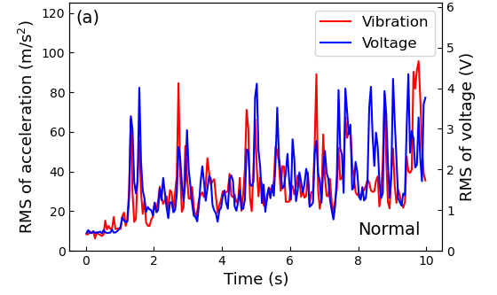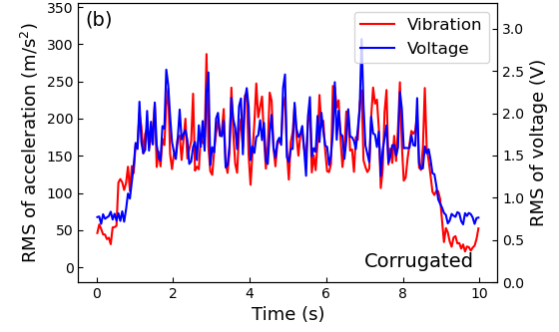
Figure 11. Experimental tests of the VEH using the field-measured rail vibration signals: (a) responses of the harvester under the normal-rail vibration; (b) responses of the harvester under the corrugated-rail vibration; (c) STFT of the harvester response under the normal-rail vibration; (d) STFT of the harvester response under the corrugated-rail vibration; (e) the PSD of the harvester responses and the corresponding normal-rail vibration; (f) the PSD of the harvester responses and the corresponding corrugated-rail vibration.

- Tests for the energy harvesting capacity

To learn about the energy harvesting capacity of the proposed VEH, a series of laboratory tests are conducted. First, the optimal resistance of the external electrical load for harvesting more energy is investigated. Then, the energy harnessed by the VEH is employed to charge a supercapacitor and enable low-power electronics.
For utilizing the scavenged electrical energy, the harvester and an external electrical load should be connected to a closed circuit, as shown in Figure 3(d). A rotary potentiometer (WTH118-1A 2W, 470Ω) is selected to work as the external electrical load of the closed circuit, the resistance of which can be adjusted by turning its knob. The coil employed in the prototype has a fixed internal resistance,$R_{in}$, of 194 Ω. Thus, the output power of the system will vary along with the resistance of the external electrical load. Indoor experiments are conducted to confirm the optimal resistance of the external load for obtaining more power. During experiments, the prototype is mounted on the shake table and the field-measured normal-rail vibration is employed as the excitation signal. The resistance of the potentiometer, $R_{l}$, varies from 30 Ω to 400 Ω and the corresponding voltage across the load is recorded. Figure 12(a) shows the maximum values of the voltage across the external electrical load and the current passing through the circuit under different resistances of the external electrical load. Test results indicate that the voltage across the external load increases with its resistance. However, the maximum value of current shows a decreasing trend when the resistances of the external load increase. The red line in Figure 12(b) denotes the maximum value of the harnessed power by the external load. The results demonstrate that the output power will reach its peak value of 18.6 mW (corresponding average power: 1.5 mW) when the resistance of the external load is close to that of the coil. Besides, energy conversion efficiency $η=\frac{P_{l}}{P_{l}+P_{c}}×100\%$ is defined, where $P_{l}=I^{2}R_{l}$ denotes the power harnessed by the external electrical load, $P_{c}=I^{2}R_{in}$ the power dissipated on the coil, and $I$ the current within the closed circuit. The blue line in Figure 12(b) denotes the calculated energy conversion efficiency$η$. It can be found that$η$ increases with the resistance of the external load when the resistance of the coil is fixed. Comparisons between the lines of output power and the energy conversion efficiency indicate that the energy conversion efficiency is not the highest when the output power reaches its peak value.
Besides discussions on the optimal resistance of the external load, the capacity of the harvester for powering commercial electronics is also investigated. Three kinds of electronics, including 16 LEDs (2.2V for each, connected in parallel), a mini digital clock (1.5V), and a digital thermo-hygrometer (HTC-1, 1.5V) are selected to conduct performance tests. The RM oscillating inside the coil will generate an alternating current (AC) within a closed circuit. However, most commercial electronics require a direct current (DC). A regulation circuit based on a full-wave rectifier, as shown in Figure 13(a), is adopted to convert the AC into DC for fulfilling the requirements of commercials electronics. During tests, this harvester is fixed on the shake table and generate DC power under field-measured normal rail vibration. First, a supercapacitor (2.5V, 0.35F) is charged using the harvested energy and the resulting voltage during charging is shown in Figure 13(b). It takes about 15 minutes to charge the capacitor from 0V to 2.5V. Then, a total of 16 LEDs are lighted up using the harnessed energy, as shown in Figure 13(c) and Supplementary Video 1. Besides, the harvested energy is employed to drive a mini digital clock which is usually powered by a button cell with a voltage of 1.5 V. Figure 13(d) and Supplementary Video 2 show that the digital clock can work normally to display the time on its screen. This harvester can also be used to activate a digital thermo-hygrometer and sustain its normal operation, as shown in Figure 13(e) and Supplementary Video 3. Tests results demonstrate that this harvester has a capacity for providing electrical energy to low-power commercial electronic devices, showing a promising prospect of powering track health motoring devices.

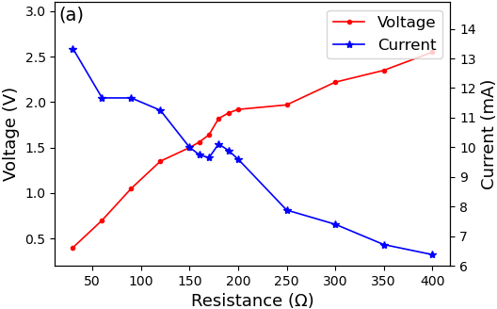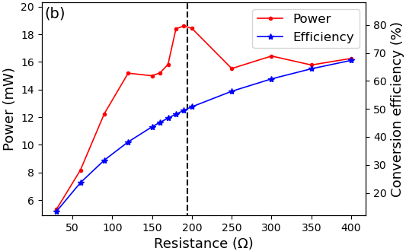
Figure 12. Optimal resistance of the external electrical load : (a) the voltage and current vary with the resistance of the external electrical load; (b) the output power and energy conversion efficiency vary with the external electrical load.

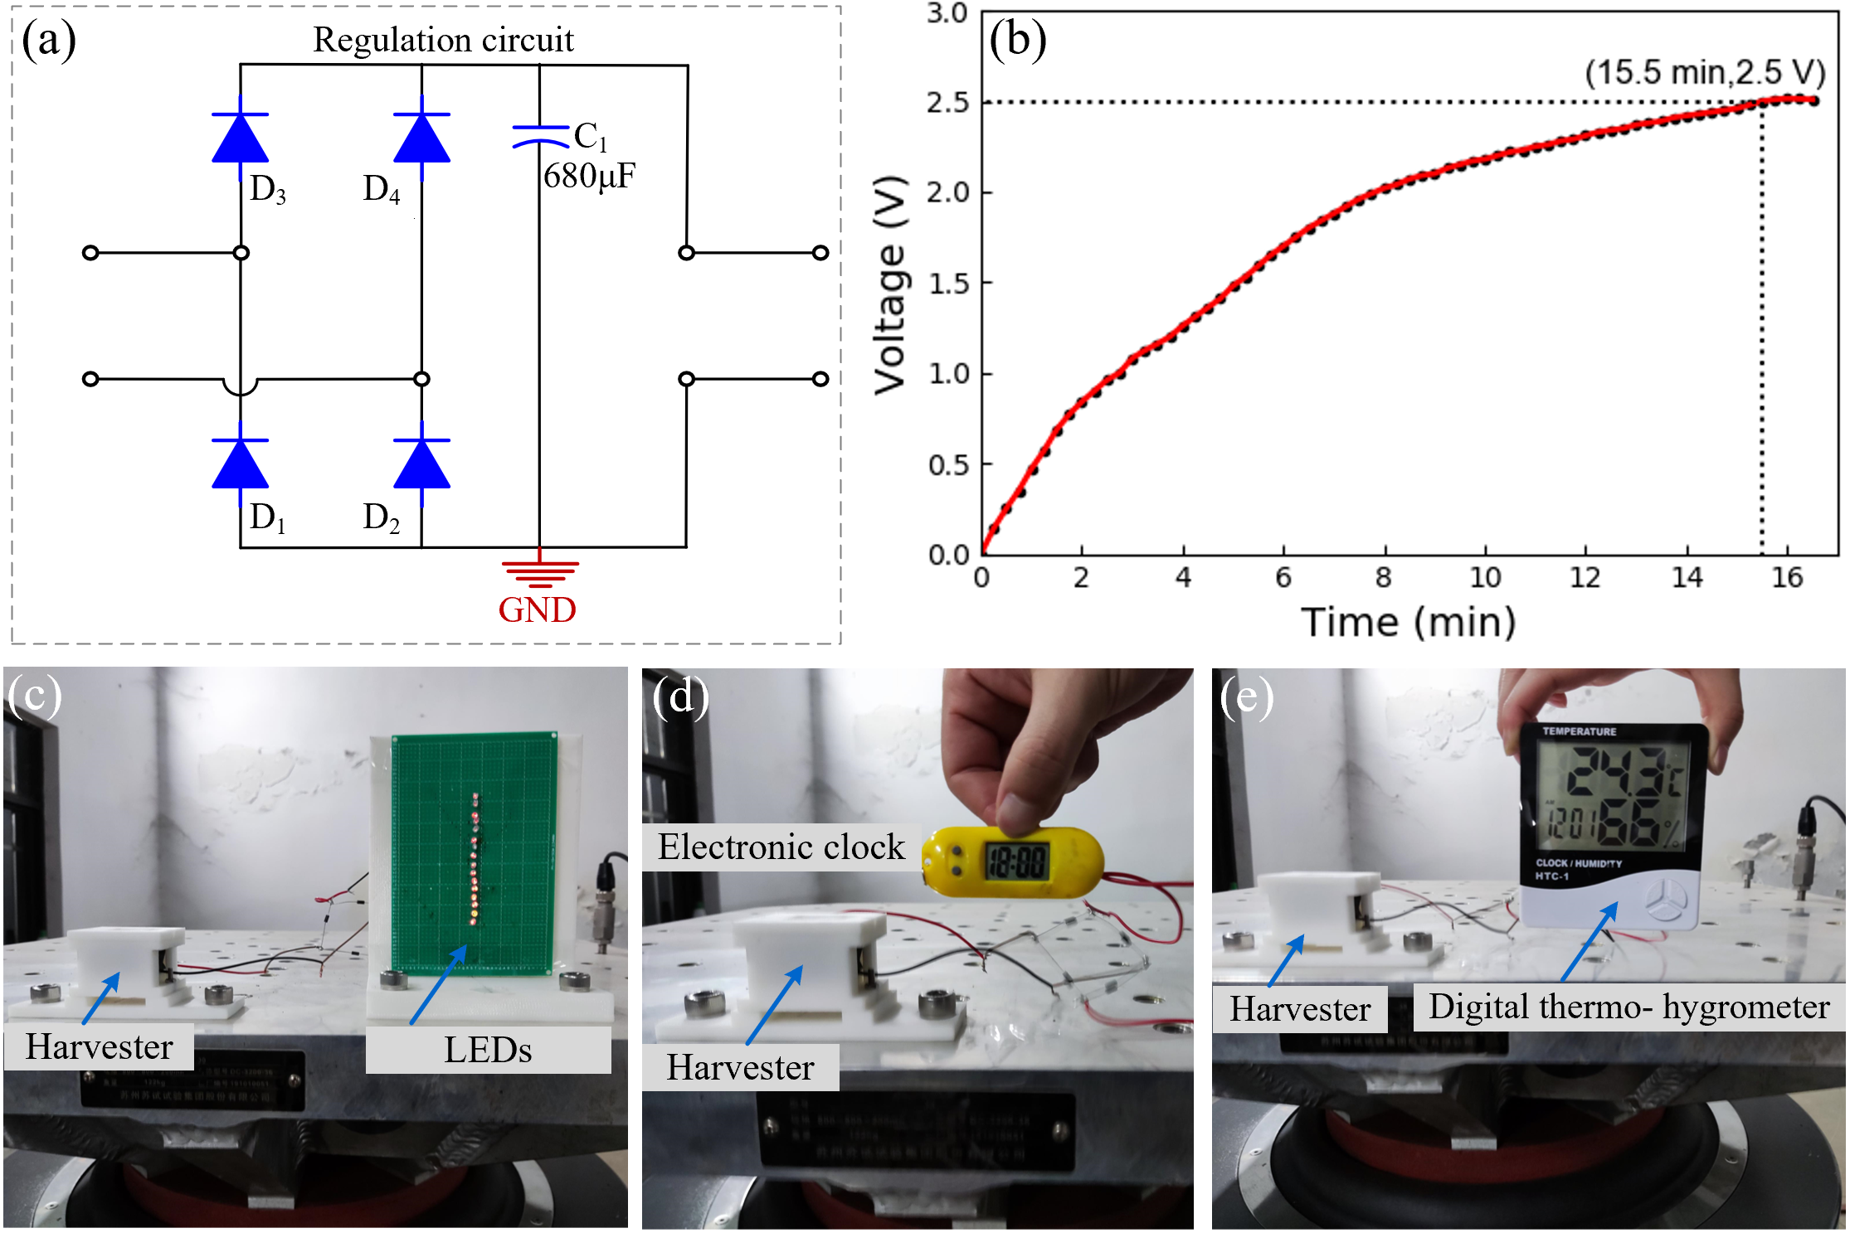
Figure 13. The load test of the harvester: (a) the regulation circuit; (b) the voltage curve of the supercapacitor during charging; (c) 16 LEDs being lighted up by the harvester; (d) a mini electronic clock driven by the harvester; (e) a digital thermo-hygrometer driven by the harvester.

- Application scenarios of the self-powered sensing node for monitoring rail corrugation monitoring

Figure 14(a) shows the concept of a self-powered sensing node for rail corrugation using the proposed multifunctional device. In such an application scenario, the energy harvesting systems, including a harvester, an energy management circuit, and a supercapacitor, can be mounted to the rail foot. Wheel-rail interactions will cause rail vibration, driving the harvesting system to convert kinetic energy to electricity. The energy harvesting system can work as long as trains pass through, regardless of whether corrugation occurs. The sensing capability of the harvester enables the detection of corrugation via analysing the EMF of the harvester. A wireless transmitter, integrated into the self-powered sensing node, is utilized for transmitting the EMF signals of the harvester to receivers besides the railway. The supercapacitor is utilized for storing the energy generated by the harvester and providing stable energy to the transmitter. Such a self-powered sensing system will lead to a reduction of maintenance costs and alleviating environmental issues caused by waste batteries.

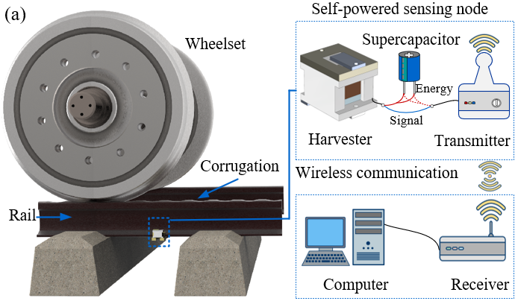
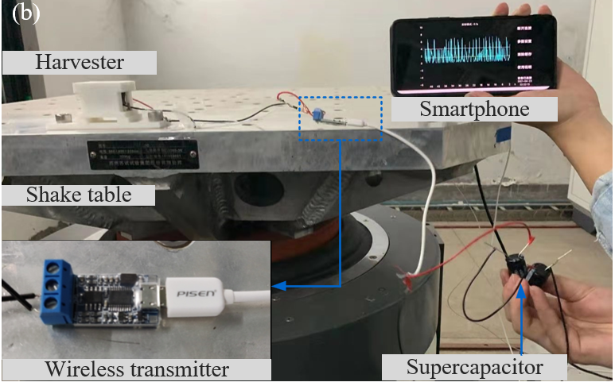
Figure 14. Application scenarios of a self-powered sensing node for monitoring rail corrugation and indoor tests: (a) application scenarios of a self-powered sensing node for monitoring rail corrugation; (b) indoor tests of the self-powered sensing node.
This study also establishes a simple indoor test system to validate the feasibility of the above concept. The self-powered sensing system contains a prototype of the harvester, a wireless transmitter based on Bluetooth (5V), a smartphone embedded with a Bluetooth module, and two supercapacitors (2.5V and 0.35F each). The voltage channel of the transmitter is connected to the coil of the harvester and transmits the EMF signal to the receiver (Smartphone) with a frequency of 10 Hz. During tests, two supercapacitors connected in series are utilized to power the transmitter. The smartphone can receive, display, and store voltage data from the transmitter in real-time. Figure 14(b) and Supplementary Video 4 show the wireless transmitter can successfully transmit voltage data of the harvester to the receiver. This simple system is set up for verifying the feasibility of the proposed concept and additional work must be done to enable field applications.

Conclusions

A multifunctional electromagnetic device is proposed in this study, which is capable of harnessing energy from rail vibration and sensing the occurrence of rail corrugation. Based on investigations of this work, the following conclusions are drawn:
(1) The results of the theoretical study demonstrate that the optimal setup of the coil is setting its longitudinal axis parallel to the translation-motion direction of the rolling magnet (RM). And this result is verified by experiments.
(2) Frequency-sweeping test results indicate that this harvester performs well in the frequency range below 400 Hz, which covers the dominant frequency range of normal rail vibration.
(3) Two sections of an operating metro line (with/without rail corrugations) are selected to measure rail roughness and collect rail vibration signals. Indoor experiments are conducted using the field-measured rail vibration as excitation, results of which show that the occurrence of corrugation can be detected through time-frequency analysis on the induced electromotive force (EMF) of the harvester.
(4) Electrical load tests under normal rail vibration indicate that the output power will reach its peak value of 18.6 mW (corresponding average power:1.5 mW) when the resistance of the external electrical load is close to the internal resistance of the coil. The capability of this harvester for power small commercial electronic devices is verified by charging a supercapacitor and driving light-emitting diodes (LEDs), a mini digital clock, and a thermo-hygrometer.
(5) A simple indoor test system is set up to validate the feasibility of designing a self-powered sensing node for monitoring rail corrugation. Follow-up work is currently undergoing to enable field applications of this system.

Acknowledgements
The work by the first author is finished during his visit to the University of Liverpool under the sponsor from the China Scholarship Council. This research is funded by the xxxxx National Natural Science Foundation of China, (Grant Nos. Nos. 52008343 and U1934214), the Sichuan Provincial Department of Science and Technology (Grant No. 2020YFG0049), and Natural Science Foundation of Chongqing, China (Grant No. cstc2021jcyj-msxm2222). The authors would also like to thank Dr Jun Lu from Southwest Jiaotong University and Associate Professor Yuhua Sun from Southwest University for their help in conducting experiments.

References

[1] Thompson D. CHAPTER 7 - Mitigation Measures for Rolling Noise. In: Thompson D, editor. Railway Noise and Vibration, Oxford: Elsevier; 2009, p. 223–79. https://doi.org/10.1016/B978-0-08-045147-3.00007-4.
[2] Cui X, Huang B, Du Z, Yang H, Jiang G. Study on the Mechanism of the Abnormal Phenomenon of Rail Corrugation in the Curve Interval of a Mountain City Metro. Null 2020;63:996–1007. https://doi.org/10.1080/10402004.2020.1782551.
[3] Sun Y, Wang P, Lu J, Xu J, Wang P, Xie S, et al. Rail corrugation inspection by a self-contained triple-repellent electromagnetic energy harvesting system. Applied Energy 2021;286:116512. https://doi.org/10.1016/j.apenergy.2021.116512.
[4] Falamarzi A, Moridpour S, Nazem M. A review on existing sensors and devices for inspecting railway infrastructure. Jurnal Kejuruteraan 2019;31:1–10.
[5] Grassie SL, Kalousek J. Rail Corrugation: Characteristics, Causes and Treatments. Proceedings of the Institution of Mechanical Engineers, Part F: Journal of Rail and Rapid Transit 1993;207:57–68. https://doi.org/10.1243/PIME_PROC_1993_207_227_02.
[6] Tsunashima H, Kojima T, Marumo Y, Matsumoto A, Mizuma T. Condition monitoring of railway track and driver using in-service vehicle. IET Conference Proceedings 2008:13-13(1).
[7] Gao M, Wang P, Jiang L, Wang B, Yao Y, Liu S, et al. Power generation for wearable systems. Energy Environ Sci 2021;14:2114–57. https://doi.org/10.1039/D0EE03911J.
[8] Li S, Wang Y, Yang M, Sun Y, Wu F, Dai J, et al. Investigation on a broadband magnetic levitation energy harvester for railway scenarios. Journal of Intelligent Material Systems and Structures 2021:1045389X211026383. https://doi.org/10.1177/1045389X211026383.
[9] Wang Y, Li S, Gao M, Ouyang H, He Q, Wang P. Analysis, design and testing of a rolling magnet harvester with diametrical magnetization for train vibration. Applied Energy 2021;300:117373. https://doi.org/10.1016/j.apenergy.2021.117373.
[10] Gao M, Cong J, Xiao J, He Q, Li S, Wang Y, et al. Dynamic modeling and experimental investigation of self-powered sensor nodes for freight rail transport. Applied Energy 2020;257:113969. https://doi.org/10.1016/j.apenergy.2019.113969.
[11] Wang Y, Gao M, Ouyang H, Li S, He Q, Wang P. Modelling, simulation, and experimental verification of a pendulum-flywheel vibrational energy harvester. Smart Materials and Structures 2020;29:115023. https://doi.org/10.1088/1361-665x/abacaf.
[12] Fang S, Zhou S, Yurchenko D, Yang T, Liao W-H. Multistability phenomenon in signal processing, energy harvesting, composite structures, and metamaterials: A review. Mechanical Systems and Signal Processing 2022;166:108419. https://doi.org/10.1016/j.ymssp.2021.108419.
[13] Huang D, Chen J, Zhou S, Fang X, Li W. Response regimes of nonlinear energy harvesters with a resistor-inductor resonant circuit by complexification-averaging method. Science China Technological Sciences 2021;64:1212–27. https://doi.org/10.1007/s11431-020-1780-x.
[14] Miao G, Fang S, Wang S, Zhou S. A low-frequency rotational electromagnetic energy harvester using a magnetic plucking mechanism. Applied Energy 2022;305:117838. https://doi.org/10.1016/j.apenergy.2021.117838.
[15] Pan Y, Liu F, Jiang R, Tu Z, Zuo L. Modeling and onboard test of an electromagnetic energy harvester for railway cars. Applied Energy 2019;250:568–81. https://doi.org/10.1016/j.apenergy.2019.04.182.
[16] Yan B, Yu N, Zhang L, Ma H, Wu C, Wang K, et al. Scavenging vibrational energy with a novel bistable electromagnetic energy harvester. Smart Materials and Structures 2020;29:025022. https://doi.org/10.1088/1361-665x/ab62e1.
[17] Wang J, Zhou S, Zhang Z, Yurchenko D. High-performance piezoelectric wind energy harvester with Y-shaped attachments. Energy Conversion and Management 2019;181:645–52. https://doi.org/10.1016/j.enconman.2018.12.034.
[18] Fan K, Tan Q, Zhang Y, Liu S, Cai M, Zhu Y. A monostable piezoelectric energy harvester for broadband low-level excitations. Appl Phys Lett 2018;112:123901. https://doi.org/10.1063/1.5022599.
[19] Fu Y, Ouyang H, Davis RB. Triboelectric energy harvesting from the vibro-impact of three cantilevered beams. Mechanical Systems and Signal Processing 2019;121:509–31. https://doi.org/10.1016/j.ymssp.2018.11.043.
[20] Yang Zhu, J. W. Zu, L. Guo. A Magnetoelectric Generator for Energy Harvesting From the Vibration of Magnetic Levitation. IEEE Transactions on Magnetics 2012;48:3344–7. https://doi.org/10.1109/TMAG.2012.2199289.
[21] Li Z, Yan Z, Luo J, Yang Z. Performance comparison of electromagnetic energy harvesters based on magnet arrays of alternating polarity and configuration. Energy Conversion and Management 2019;179:132–40. https://doi.org/10.1016/j.enconman.2018.10.060.
[22] Pan H, Qi L, Zhang Z, Yan J. Kinetic energy harvesting technologies for applications in land transportation: A comprehensive review. Applied Energy 2021;286:116518. https://doi.org/10.1016/j.apenergy.2021.116518.
[23] Wang J, Shi Z, Xiang H, Song G. Modeling on energy harvesting from a railway system using piezoelectric transducers. Smart Materials and Structures 2015;24:105017. https://doi.org/10.1088/0964-1726/24/10/105017.
[24] Li Z, Li X, Liu B, Wang J. Influence of vehicle body vibration induced by road excitation on the performance of a vehicle-mounted piezoelectric-electromagnetic hybrid energy harvester. Smart Materials and Structures 2021;30:055019. https://doi.org/10.1088/1361-665x/abf41f.
[25] Ling M, Cao J, Zeng M, Lin J, Inman DJ. Enhanced mathematical modeling of the displacement amplification ratio for piezoelectric compliant mechanisms. Smart Materials and Structures 2016;25:075022. https://doi.org/10.1088/0964-1726/25/7/075022.
[26] Wang K, Zhou J, Ouyang H, Chang Y, Xu D. A dual quasi-zero-stiffness sliding-mode triboelectric nanogenerator for harvesting ultralow-low frequency vibration energy. Mechanical Systems and Signal Processing 2021;151:107368. https://doi.org/10.1016/j.ymssp.2020.107368.
[27] Wang Z, Wang W, Gu F, Wang C, Zhang Q, Feng G, et al. On-rotor electromagnetic energy harvester for powering a wireless condition monitoring system on bogie frames. Energy Conversion and Management 2021;243:114413. https://doi.org/10.1016/j.enconman.2021.114413.
[28] Gholikhani M, Beheshti Shirazi SY, Mabrouk GM, Dessouky S. Dual electromagnetic energy harvesting technology for sustainable transportation systems. Energy Conversion and Management 2021;230:113804. https://doi.org/10.1016/j.enconman.2020.113804.
[29] V. J. Hodge, S. O’Keefe, M. Weeks, A. Moulds. Wireless Sensor Networks for Condition Monitoring in the Railway Industry: A Survey. IEEE Transactions on Intelligent Transportation Systems 2015;16:1088–106. https://doi.org/10.1109/TITS.2014.2366512.
[30] Fan K, Xia P, Zhang Y, Qu H, Liang G, Wang F, et al. Achieving high electric outputs from low-frequency motions through a double-string-spun rotor. Mechanical Systems and Signal Processing 2021;155:107648. https://doi.org/10.1016/j.ymssp.2021.107648.
[31] Zhang X, Zhang Z, Pan H, Salman W, Yuan Y, Liu Y. A portable high-efficiency electromagnetic energy harvesting system using supercapacitors for renewable energy applications in railroads. Energy Conversion and Management 2016;118:287–94. https://doi.org/10.1016/j.enconman.2016.04.012.
[32] Dotti FE, Sosa MD. Pendulum systems for harvesting vibration energy from railroad tracks and sleepers during the passage of a high-speed train: A feasibility evaluation. Theoretical and Applied Mechanics Letters 2019;9:229–35. https://doi.org/10.1016/j.taml.2019.03.005.
[33] Carl A. Nelson, Stephen R. Platt, Dave Albrecht, Vedvyas Kamarajugadda, Mahmood Fateh. Power harvesting for railroad track health monitoring using piezoelectric and inductive devices. vol. 6928, 2008. https://doi.org/10.1117/12.775884.
[34] Yang F, Gao M, Wang P, Zuo J, Dai J, Cong J. Efficient piezoelectric harvester for random broadband vibration of rail. Energy 2021;218:119559. https://doi.org/10.1016/j.energy.2020.119559.
[35] Yang Z, Tan Y, Zu J. A multi-impact frequency up-converted magnetostrictive transducer for harvesting energy from finger tapping. International Journal of Mechanical Sciences 2017;126:235–41. https://doi.org/10.1016/j.ijmecsci.2017.03.032.
[36] Q. Pan, B. Wang, L. Zhang, Z. Li, Z. Yang. Whisk-inspired Motion Converter for Ocean Wave Energy Harvesting. IEEE/ASME Transactions on Mechatronics 2021:1–1. https://doi.org/10.1109/TMECH.2021.3093939.
[37] Lu J, Gao M, Wang Y, Wang P. Health monitoring of urban rail corrugation by wireless rechargeable sensor nodes. Structural Health Monitoring 2018;18:838–52. https://doi.org/10.1177/1475921718782395.
[38] Furlani EP. Permanent magnet and electromechanical devices: materials, analysis, and applications. Academic press; 2001.
[39] Nguyen VT. Modelling of Magnetic Fields of Permanent Magnets with Diametrical Magnetization. Thesis. 2019.
[40] H. L. Rakotoarison, J. P. Yonnet, B. Delinchant. Using Coulombian approach for Modeling Scalar Potential and Magnetic Field of a Permanent Magnet with Radial Polarization. 2006 12th Biennial IEEE Conference on Electromagnetic Field Computation, 2006, p. 438–438. https://doi.org/10.1109/CEFC-06.2006.1633228.
[41] Moss SD, Hart GA, Burke SK, Carman GP. Hybrid rotary-translational vibration energy harvester using cycloidal motion as a mechanical amplifier. Appl Phys Lett 2014;104:033506. https://doi.org/10.1063/1.4861601.
[42] Fu H, Theodossiades S, Gunn B, Abdallah I, Chatzi E. Ultra-low frequency energy harvesting using bi-stability and rotary-translational motion in a magnet-tethered oscillator. Nonlinear Dynamics 2020;101:2131–43. https://doi.org/10.1007/s11071-020-05889-9.
[43] Vandewater LA, Moss SD. Probability-of-existence of vibro-impact regimes in a nonlinear vibration energy harvester. Smart Materials and Structures 2013;22:094025. https://doi.org/10.1088/0964-1726/22/9/094025.
[44] Zhang LB, Dai HL, Yang YW, Wang L. Design of high-efficiency electromagnetic energy harvester based on a rolling magnet. Energy Conversion and Management 2019;185:202–10. https://doi.org/10.1016/j.enconman.2019.01.089.
[45] ISO 3095:2013(en), Acoustics — Railway applications — Measurement of noise emitted by railbound vehicles n.d. https://www.iso.org/obp/ui/#iso:std:iso:3095:ed-3:v1:en (accessed March 11, 2021).
[46] Grassie SL. Rail corrugation: Characteristics, causes, and treatments. Proceedings of the Institution of Mechanical Engineers, Part F: Journal of Rail and Rapid Transit 2009;223:581–96. https://doi.org/10.1243/09544097JRRT264.

