Mental Workload Evaluation of Virtual Object Manipulation on WebVR: An EEG Study

Wenxin Sun
Design School
Xi’an Jiaotong-Liverpool University Suzhou, China wenxin.sun19@student.xjtlu.edu.cn

Ji Han
Department of Civil Engineering and Industrial Design
University of Liverpool Liverpool, United Kingdom ji.han@liverpool.ac.uk
Mengjie Huang*
Design School
Xi’an Jiaotong-Liverpool University Suzhou, China mengjie.huang@xjtlu.edu.cn
*Corresponding Author

Yong Yue
School of Advanced Technology Xi’an Jiaotong-Liverpool University Suzhou, China yong.yue@xjtlu.edu.cn
Rui Yang
School of Advanced Technology Xi’an Jiaotong-Liverpool University Suzhou, China
r.yang@xjtlu.edu.cn

Abstract—Virtual object manipulation as a key feature has been studied in virtual reality (VR) environments. Previous studies highlighted user experience on three basic types of virtual object manipulation, translation, rotation and scaling. However, prior literature mainly studied task performance in manipulation modes with different degrees of freedom (DoF), and few studies assessed user experience by evaluating the psychological response, such as mental workload on these three basic manipulation types in virtual environments. This paper compared manipulation modes with 1DoF and 3DoF to assess users’ mental workload as a critical indicator of user experience by electroencephalogram (EEG) measurement and questionnaires in manipulation tasks on the webpage with VR effects (also known as WebVR). By applying signal processing and statistical methods to analyze EEG data from ten subjects, the results demonstrated that the participants generally perceive less mental workload by 1DoF manipulation modes than 3DoF on WebVR. Besides, this study also found some different results between objective and subjective data.

Keywords—mental workload, virtual object manipulation, user experience, EEG, WebVR
- INTRODUCTION
Previous research pointed out that virtual object manipulation is an essential feature in simulated environments [1], including three basic manipulation types (namely translation, rotation and scaling) [2]. Virtual object manipulation is the common interactive mode in game or application design and development from mouse- and touch- based interfaces to head-mounted display. Besides, the webpage with virtual reality (VR) effects (also known as WebVR) is one of the most convenient ways to provide VR experience to consumers, because of the prevalence of smartphones and personal computers. Prior studies proposed the manipulation with the degree of freedom (DoF) separation compared with another manipulation mode, direct manipulation, to improve user experience by enhancing task performance [3]. Specifically, DoF separation is an approach to restrict virtual objects to transform on x-, y- or z-axis respectively, while direct manipulation refers to the operation of transforming virtual objects arbitrarily [1]. This paper mainly studied and highlighted 1DoF manipulation mode (which belongs to DoF separation and restricts users to transform virtual objects on one specific axis) and 3DoF manipulation mode as direct manipulation (which allows
transforming virtual object without any limitation in the virtual environments).
Besides task performance, previous literature demonstrated that psychological response should be another critical indicator of user experience in virtual environments [4]. It has also been reported that mental workload, which can reflect people’s cognitive status, directly impacts user experience [5]. However, few studies assessed user experience by evaluating the psychological response, such as mental workload on virtual object translation, rotation and scaling in the simulated environments. Therefore, this paper compared two manipulation modes, namely 1DoF and 3DoF, to evaluate users’ mental workload as an indicator of user experience on WebVR, by applying signal processing and statistical methods to analyze electroencephalogram (EEG) data and subjective data from ten subjects.
The main contributions of this paper are listed as follows:
(i) adopting an EEG-based method to evaluate mental workload from subjects to transform virtual objects on WebVR; (ii) evaluating mental workload as a critical indicator of user experience in translation, rotation, and scaling tasks on WebVR.
- RELATED WORK
- Virtual Object Manipulation
Virtual object manipulation is a crucial feature when people interact within virtual environments. Related literature studied translation, rotation and scaling as three basic types of virtual object manipulation to transform 3D objects in the virtual world [2]. Several studies have proposed DoF separation as a manipulation mode to enhance task performance (e.g., precision and efficiency) instead of another mode, direct manipulation [2][3]. The existing literature extensively highlighted the DoF separation which has the capacity to improve task performance in both 2D screen-based virtual environments and immersive environments [6]. For instance, prior studies have revealed that the decreased DoF is associated with less efficiency but higher precision in immersive environments [7-9]. Previous research also demonstrated that the participants always tend to have a higher chance to perceive less mental workload on average when using 3DoF controller in manipulation tasks [10]. Besides, DoF separation and direct manipulation can be regarded as interactive modes with different levels of interaction fidelity

(IF), and related literature demonstrated that high IF contributes to improve user experience, while low IF provides comparable experiences [11].
However, there was little literature to explore psychological response, particularly mental workload, with adopting DoF separation or direct manipulation in virtual environments. Other literature studied perceived mental workload completely impacts user experience in the virtual environments by psychological responses, such as eye- tracking, heartbeat, electrocardiogram (ECG) and EEG [4, 5].
- Mental workload
Mental workload (also known as cognitive load) refers to the usage of memory resources on completing a task [12]. The limited memory resources are directly associated with the information processing of the brain. Prior literature proposed the theory of cognitive load (mental workload), which is a problem-solving strategy to efficiently utilize and organize working memory resources on cognitive tasks [13]. As most people have a typical pattern of the brain's information processing, they usually tend to respond to external stimuli similarly. That is why studies paid particular attention to improve interactive modes and reduce mental workload in various simulated environments [4, 5]. Thus, the user interfaces should be simplified, and the visualization of interactive modes should also be presented in a user-friendly way to avoid overload working memory resources. Additionally, existing literature also demonstrated that the different level of task difficulty has a direct impact on users’ mental workload [12], and interactive modes with lower difficulty can reduce people’s perceived mental workload and improve user experience on cognitive tasks [4, 5]. This study focused on 1DoF and 3DoF manipulation modes as interactive modes to evaluate people’s mental workload during cognitive tasks.
- Mental workload measurement
Related literature pointed out two main approaches to measure mental workload, namely subjective methods and psychological responses [12]. The former one includes various widely-used questionnaires, such as NASA task load index (NASA TLX) and subjective workload assessment technique (SWAT) [1, 2]. Additionally, many psychological measures can assess mental workload, such as eye movement, heartbeat, ECG and galvanic response [14, 15]. Specifically, EEG signals are discovered to be extensively influenced by cognitive status and have been applied to evaluate mental workload [16].
EEG techniques have been widely used to record and evaluate neurological activity in the existing literature [17]. Four brain regions, namely parietal, occipital, temporal, and frontal areas, have been studied and highlighted to be associated with various cognitive responses, particularly perceived mental workload [18]. EEG is an essential psychological measure and becomes suitable for analyzing cognitive states due to its high temporal resolution [19]. As it cannot be directly interpreted to mental workload, spectral analysis is commonly used to extract frequency bands to address this issue. It is consistently recognized that the brain can produce several intervals corresponding to each band, such as 0.5–4 Hz (delta band), 4–8 Hz (theta band), 8–13 Hz (alpha band), 13–30 Hz (beta band) and 30–40 Hz (gamma band) [20]. Traditional analysis of EEG data can be categorized into two ways, including time- and frequency-
domain analysis. Few studies extensively applied event- related potentials (ERPs) to use in the time-domain analysis of EEG to assess the mental workload, but it cannot be applied to measure the real-time monitor during tasks [21, 22]. Thus, several techniques have been proposed based on frequency- domain analysis, particularly spectral analysis.
Spectral analysis is an approach to extract and measure frequency bands of EEG signals. Studies presented that theta and alpha bands are extensively relevant to mental workload [23, 24] using the widely-used analysis method of theta-alpha ratio (TAR). Related literature pointed out that TAR is efficiently applied to assess mental workload [25. Scholars obtained the TAR value by the spectral analysis to compute with the theta band in the middle frontal area (Fz) and alpha band in the central parietal area (Pz) on cognitive tasks [17, 18]. Other studies presented that theta and alpha bands were extracted from specific channels [26] and discovered that the increase in mental workload is highly related to an increase in theta power and a decrease in alpha power [27].
- METHODS
- Participants
Ten subjects were recruited to participate in the experiment, with six males and four females between 20 and 35 years old. The majority of participants (7 out of 10) had limited experience in virtual object manipulation. The participants were suggested to avoid alcohol and caffeine before the experiment. All of them were informed of the process of this study and signed an individual consent form. During the experiment, they were asked to perform manipulation tasks on WebVR with wearing an EEG headset. After each session of the experiment, they were also required to fill in questionnaires. The University Ethics Committee has granted ethical approval for this study.
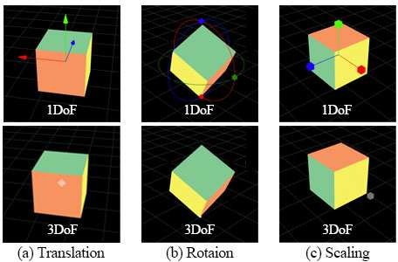
Fig.1 1DoF and 3DoF controllers of virtual object manipulation: (a) translation, (b) rotation and (c) scaling

- Experimental tasks
This experiment included translation, rotation, and scaling sessions. Each session was designed and implemented originating from 1DoF and 3DoF manipulation modes as shown in Fig.1. In the translation session shown in Fig.1(a), the participants used the 1DoF controller (with three bars) to translate the virtual object on the x-, y- and z-axis respectively, and they applied the 3DoF controller (with white dot inside) to drag the virtual object arbitrarily. In the rotation session shown in Fig.1(b), the virtual object can be rotated around one specific axis by the 1DoF controller (with three circles) and be rotated on x-, y-, z-axes synchronously by the 3DoF

controller. In the scaling session displayed in Fig.1(c), similar to the other two manipulation types, the 1DoF controller of scaling (with three bars) had the restriction to scale virtual objects on one specific axis; meanwhile, the 3DoF controller (with white dot outside) provided an approach to scale virtual
alpha power were computed to obverse their changes; (vi) the average TAR was calculated by Equation (1) for each EEG segment in the 2s interval window and 1s overlap window to assess mental workload of each task; (vii) TAR values were normalized for each participant.

objects on x-, y-, z-axes synchronously.
The experimental platform was built on the Chrome
𝑇𝐴𝑅 = 𝑡he𝑡𝑎𝐹z
𝑎𝑙𝑝h𝑎𝑃z
(1)

browser with an open toolbox, Threejs. Forty-two webpages were developed, including two training and five task webpages for each manipulation mode displayed in Fig.1. In each session of the experiment, participants learned to transform virtual objects with specific manipulation modes on training webpages and then were required to complete manipulation tasks on task webpages respectively. The experimental setup was presented in Fig.2. During the experiment, the participants were asked to wear the EEG headset shown as (a) in Fig.2. Besides, they were required to use a computer and a traditional mouse to conduct manipulation tasks displayed as (b) and (c) in Fig.2.
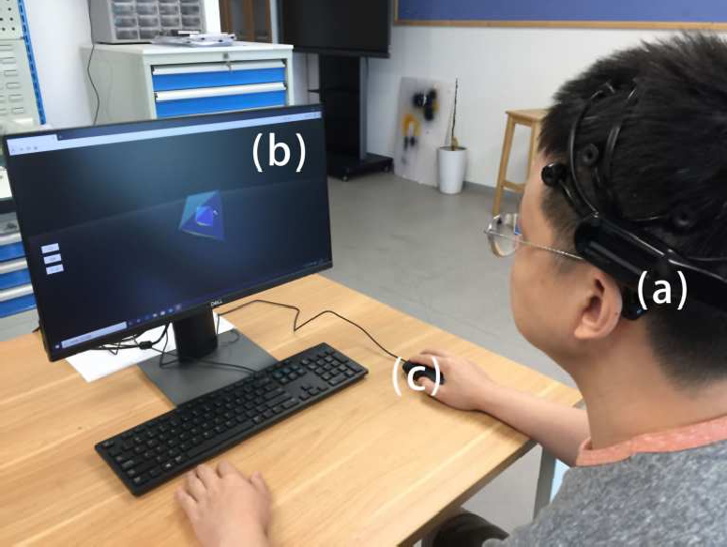
Fig.2 Experimental setup: (a) EEG headset, (b) 2D screen and (c) traditional mouse

- EEG data acquisition and processing
The raw EEG data were recorded at the sampling rate of 128 Hz adopting a flexible EEG system Emotiv EPOC X, a 14-channel cap with saline sensors. Fourteen electrodes mapped to these channels are located in different brain regions, and electrodes were required to be placed on the participants’ scalp directly for the completeness and accuracy of EEG data. In particular, this study focused on two regions of the brain, namely Fz and Pz. EEG data with essential frequency bands from four Fz electrodes (F3, F4, F7 and F8) and two Pz electrodes (P7 and P8) were applied to measure and identify mental workload in this study as displayed in Fig.3.
EEG activity was recorded during each task as one EEG segment, and five EEG segments of one specific manipulation mode were collected for each participant. An open-source software, EEGLAB, was used for pre-processing of all EEG segments, and MATLAB was applied to compute TAR with pre-processed EEG data. The following steps were the details of data processing: (i) a bandpass filter was applied to extract signals in the range of 0.1-40 Hz; (ii) the baseline for each participant was necessarily removed to analyze multiple tasks uniformly; (iii) independent component analysis (ICA) was adopted to reject artefacts and noise; (iv) outliers were removed by Hampel outlier filter; (v) after data pre- processing, theta and alpha bands were extracted by wavelet decomposition analysis at level 5, and the average theta and
where TAR means theta-alpha ratio computed with theta band power in Fz and alpha band power in Pz.

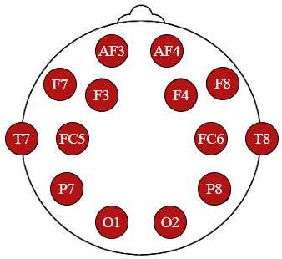
Fig.3 Channel locations of EEG headset (among which F3, F4, F7, F8, P7 and P8 were applied in this study)

- Questionnaire
After completing all tasks in each session mentioned above, the participants were required to fill out the modified NASA Task Load Index (TLX). NASA TLX is an extensively questionnaire to rate workload score. The first section (6 items) of NASA TLX was applied to evaluate mental workload for manipulation modes. The participants were asked to respond to questions using a 7-point Likert scale ranging from 1 (“not responsive”) to 7 (“very responsive”). The means and standard deviations of the workload score were calculated with the same weights of each question. Then, the Kruskal-Wallis test was applied to compare workload scores among different manipulation modes.
- RESULTS
- Theta and alpha bands
Generally, the theta and alpha bands were directly associated with perceived mental workload across different manipulation modes. In the translation session, the change of theta power between 1DoF and 3DoF controllers demonstrated an increasing trend in the Fz region; meanwhile, 3DoF controllers contributed to the lower alpha power in the Pz region compared with 1DoF controllers as shown in Fig.4(a). Similarly, Fig.4(c) demonstrates the same trend in scaling tasks, and it can be clearly observed the increase in theta band power and the decrease in alpha band power from 1DoF to 3DoF mode. However, although 3DoF controllers contributed to more theta band power in rotation tasks displayed in Fig.4(b), participants gained less alpha band power when using 1DoF controllers by contrast with translation and scaling tasks. Fig.4 apparently shows the changes of essential band power, but there was no significant difference across these manipulation modes comparing the changes of theta and alpha band power on average in each session by the Friedman test.

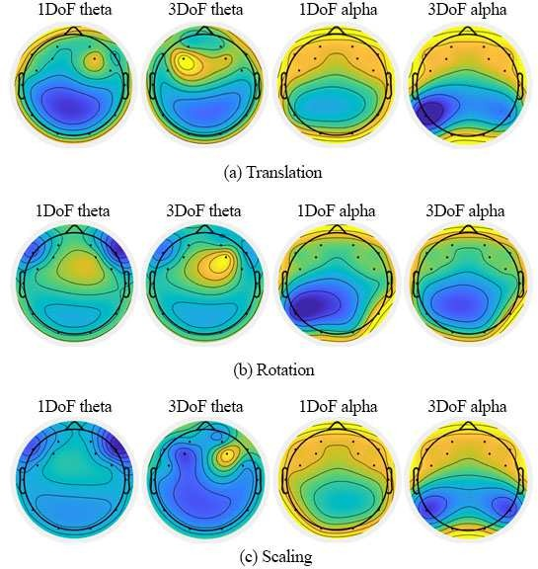

Fig.4 The brain topographic map comparison (theta and alpha frequency power) between 1DoF and 3DoF in translation, rotation and scaling tasks: (a) translation, (b) rotation and (c) scaling

- TAR analysis
TAR values were computed to reflect participants’ mental workload for manipulation modes by applying theta and alpha band power. Table 1 describes the mean (M) and the standard deviation (SD) of TAR values, and the result of the Friedman test across manipulation modes on WebVR.

TABLE 1. MEAN, STANDARD DEVIATION AND P VALUE OF TAR ACROSS MANIPULATION MODES
- Subjective evaluation
As displayed in Table 2, data from the questionnaires presented the statistically significant difference between 1DoF and 3DoF controllers in terms of perceived workload in the scaling session by the Kruskal-Wallis test, which means participants tended to rate 1DoF with a significantly lower workload score (higher mental workload) than 3DoF ( 3² =4.970, p=0.026). However, there was no significant difference between 1DoF and 3DoF modes when participants conducted translation and rotation tasks. In the translation session, 1DoF controllers (M=5.267) presented relatively a higher workload score (lower mental workload) than 3DoF (M=4.567) on average. Meanwhile, the similar situation showed in the rotation session as 3DoF controllers (M=4.433) were rated with a lower workload score (higher mental workload) than 1DoF (M=4.967) on average.
TABLE 2. MEAN, STANDARD DEVIATION AND P VALUE OF SUBJECTIVE DATA ACROSS MANIPULATION MODES

Manipulation Manipulation  Types Modes | Mean | Standard p value (Kruskal-  Deviation Wallis test)
Translation 1DoF | 5.267 | 0.7852 0.075 (p>0.05)
3DoF | 4.567 | 1.1864
Rotation 1DoF | 4.967 | 1.2765 0.080 (p>0.05)
3DoF | 4.433 | 2.2235
Scaling 1DoF | 6.150 | 0.4287 0.026 (p<0.05)
3DoF 6.750 0.1682

- DISCUSSION
This study investigated the difference in mental workload between DoF separation (namely 1DoF) and direct (namely 3DoF) manipulation modes based on EEG data. Due to the restriction of DoF separation to transform virtual objects in the simulated environments, participants paid particular attention to operate in one specific direction without any extra

interference, and thus 1DoF controllers led to less mental

Manipulation
Manipulation
Mean Standard
p value
workload in translation and scaling tasks according to EEG

Types Modes Deviation (Friedman test)
measurements. Although direct manipulation was more

Translation
Rotation Scaling
0.006 (p<0.05)

0.497 (p>0.05)
1DoF | 0.8151 | 0.0200
3DoF | 0.9330 | 0.0139
1DoF | 0.9462 | 0.0253
3DoF | 0.9464 | 0.0134
1DoF | 0.8615 | 0.0130

0.006 (p<0.05)
consistent with human behavior in the physical world, 3DoF manipulation mode was still relevant to much extra information, leading to the increased mental workload on WebVR. Previous literature presented that the limited

3DoF 1.1556 0.0654

As shown in Table 1, it can be observed apparently that TAR of 1DoF was significantly smaller than 3DoF (3²=4.320, p=0.038) on average in translation tasks. In other words, the participants perceived higher mental workload when using 3DoF controllers, and 1DoF mode contributed lower mental workload in the translation session. Additionally, it is also apparent that 1DoF mode performed less TAR on average than 3DoF (3²=10.120, p=0.002) during scaling tasks, which means that the participants gained less mental workload to scale virtual objects with 1DoF controllers. Unlike translation and scaling, 1DoF controllers led to slightly lower but similar TAR values on average than 3DoF (3²=0.480, p=0.488) in rotation tasks as shown in Table 1. In summary, the experimental results reported that 1DoF controllers contributed lower mental workload in both translation and scaling tasks than 3DoF controllers with a significant difference, while 3DoF and 1DoF controllers presented similar workload in rotation tasks.
memory resources of the brain are associated with information
processing, linking with mental workload [13]. From this perspective, 1DoF manipulation mode with fewer memory resources would be the recommended manipulation mode, once lower mental workload that participants perceived symbolized better user experience on WebVR.
Existing studies proposed that the level of task difficulty has a direct impact on users’ mental workload, because of the limited memory resources in the brain [12] and demonstrated similar findings that people perceived more mental workload in cognitive tasks with the higher level of difficulty [24, 25]. In the current study, the results based on EEG measurements showed that 1DoF controllers should be easier to operate without extra information than 3DoF in most situations, especially in the translation and scaling sessions. In other words, the advantages of 1DoF manipulation mode should be clearly found in manipulation tasks on WebVR by regarding mental workload as an essential feature of user experience. Therefore, this study presented that the participants perceived lower mental workload when using 1DoF controllers, which might be associated with improving user experience on WebVR.

Prior literature demonstrated that people perceived more mental workload with the increase in theta band power and the decrease in alpha band power from simple to complex experimental setups [21, 23, 25, 27]. In this study, similar results were found that theta band power increased and alpha band power decreased from 1DoF to 3DoF mode in translation and scaling tasks; meanwhile, the participants tended to feel lower mental workload when using 1DoF controllers compared with 3DoF controllers. Therefore, the changes of theta and alpha band power highly depended on the level of task difficulty, and the participants gained the increasing theta and the decreasing alpha band power in tasks from 1DoF to 3DoF manipulation mode in the current study.
According to subjective data from NASA TLX, this study found that participants tended to rate 1DoF with a significantly higher mental workload than 3DoF in the scaling session, while 1DoF and 3DoF controllers showed no significant variation of mental workload in the translation and rotation sessions. Previous research also demonstrated that the participants always tended to have a higher chance to perceive less mental workload when using 3DoF controller in translation, rotation and scaling tasks according to subjective data analysis [10]. However, this result from subjective data differentiated from the findings as mentioned above based on EEG measurements. There are several possibilities to come to such contradictory points: (i) the higher dimension of manipulation modes led to more mental workload without participants’ consciousness. Particularly, prior literature showed people gained more workload in higher dimension environments (e.g., VR) and lower dimension equipment (e.g., 2D screen) linked with less perceived mental workload [2]; (ii) as direct manipulation (3DoF manipulation) mode was more consistent with human behavior in the physical world [10, 11], the participants were used to operate virtual objects in direct manipulation mode, which seemed to be more natural and efficient in their subconscious; (iii) a relatively small sample size might affect the subjective results in the current study, and thus more participants would be involved in future studies.
- CONCLUSION
This study mainly concentrated on the differences in mental workload between 1DoF and 3DoF manipulation modes with EEG measurements on WebVR. EEG data were collected from ten participants during the experiment. Applying the signal processing and statistical methods, the changes of the average theta and alpha band power were observed from EEG data analysis; meanwhile, TAR values were computed to reflect the participants’ mental workload for each manipulation mode. The experimental results from EEG data demonstrated that 1DoF manipulation mode generally contributed to less workload compared with 3DoF during the experiment, although a similar level of workload was perceived by the participants using 3DoF and 1DoF controllers in rotation tasks. Meanwhile, the participants gained higher theta band power and lower alpha band power by using 3DoF controller, which means the higher dimension of manipulation mode tended to be associated with higher mental workload in manipulation tasks. However, the subjective data showed some different results. Participants tended to rate 1DoF with a significantly higher mental workload than 3DoF in the scaling session, while there was no significant difference between 1DoF and 3DoF controllers when participants conducted translation and rotation tasks
based on NASA TLX. More subjects will be involved in future studies for further validation.
Therefore, this study presented that 1DoF manipulation showed clear advantages to transform virtual objects compared with 3DoF on WebVR based on EEG results. This study contributed to existing knowledge by proposing an EEG-based method to assess mental workload from subjects during WebVR manipulation tasks and evaluating mental workload as a critical indicator of user experience in translation, rotation and scaling tasks on WebVR.
ACKNOWLEDGMENT
This work is financially supported by Key Program Special Fund in XJTLU (KSF-E-34, KSF-A-19), Research Development Fund of XJTLU (RDF-18-02-30), and The Natural Science Foundation of the Jiangsu Higher Education Institutions of China (20KJB520034). The University Ethics Committee has granted the ethical approval for this study.
REFERENCES
- D. Mendes, F. Relvas, A. Ferreira, and J. Jorge, “The Benefits of DoF Separation in Mid-air 3D Object Manipulation,” in Proceedings of the 22nd ACM Conference on Virtual Reality Software and Technology. 261-268, 2016.
- R. Alkemade, F. J. Verbeek, and S. G. Lukosch, "On The Efficiency of A VR Hand Gesture-based Interface for 3D Object Manipulations in Conceptual Design," International Journal of Human–Computer Interaction, vol. 33, no. 11, pp. 882-901, 2017.
- M. Kim and J. Han, "Effects of Switchable DOF for Mid-Air Manipulation in Immersive Virtual Environments," International Journal of Human–Computer Interaction, vol. 35, no. 13, pp. 1147- 1159, 2019.
- C. Tremmel, C. Herff, T. Sato, K. Rechowicz, Y. Yamani, and D. J. Krusienski, “Estimating Cognitive Workload in An Interactive Virtual Reality Environment Using EEG,” Frontiers in Human Neuroscience, vol. 13, no. 401, 2019.
- H. Al-Samarraie, A. Eldenfria, M. L. Price, F. Zaqout, and W. M. Fauzy, “Effects of Map Design Characteristics on Users’ Search Performance and Cognitive Load,” The Electronic Library, 2019.
- J. Parong and R. E. Mayer, “Learning Science in Immersive Virtual Reality,” Journal of Educational Psychology, vol. 110, no.6, pp. 785, 2018.
- J. G. Grandi, H. G. Debarba, L. Nedel, and A. Maciel, "Design and Evaluation of a Handheld-based 3D User Interface for Collaborative Object Manipulation," in Proceedings of the 2017 CHI Conference on Human Factors in Computing Systems, pp. 5881-5891, 2017.
- J. J. Y. Kim, J. B. Son, H. S. Leem, and S. H. Lee, "Psychophysiological Alteration After Virtual Reality Experiences Using Smartphone-Assisted Head Mount Displays: An EEG-Based Source Localization Study," Applied Sciences, vol. 9, no. 12, pp. 2501, 2019.
- T. Butkiewicz, A. H. Stevens, and C. Ware, "Multi-touch 3D Positioning with the Pantograph Technique," in Proceedings of the ACM SIGGRAPH Symposium on Interactive 3D Graphics and Games, pp. 1-9, 2019.
- W. Sun, M. Huang, R. Yang, J. Zhang, L. Wang, J. Han, and Y. Yue, “Workload, Presence and Task Performance of Virtual Object Manipulation on WebVR,” in 2020 IEEE International Conference on Artificial Intelligence and Virtual Reality (AIVR), pp. 358-361, 2020.
- K. Rogers, J. Funke, J. Frommel, S. Stamm, and M. Weber, “Exploring Interaction Fidelity in Virtual Reality: Object Manipulation and Whole-body Movements” in Proceedings of the 2019 CHI Conference on Human Factors in Computing Systems, pp. 1-14, 2019.
- E. Galy, M. Cariou, and C. Mélan, "What is the Relationship Between Mental Workload Factors and Cognitive Load Types?" International Journal of Psychophysiology, vol. 83, no.3, pp. 269-275, 2012.
- J. Sweller, “Cognitive Load Theory, Learning Difficulty, and Instructional Design,” Learning and Instruction, vol. 4, no. 4, pp. 295- 312, 1994.

- L L. Cabañero, R. Hervás, I. González, J. Fontecha, T. Mondéjar, and
J. Bravo, "Analysis of Cognitive Load Using EEG when Interacting with Mobile Devices," in Multidisciplinary Digital Publishing Institute Proceedings, vol. 31, no. 1, pp. 70, 2019.
- L. Cabañero, R. Hervás, I. González, J. Fontecha, T. Mondéjar, and J. Bravo, "Characterisation of Mobile-device Tasks by Their Associated Cognitive Load through EEG Data Processing," Future Generation Computer Systems, vol. 113, pp. 380-390, 2020.
- S. Shao, Q. Zhou, and Z. Liu, "Mental Workload Characteristics of Manipulator Teleoperators with Different Spatial Cognitive," International Journal of Advanced Robotic Systems, vol.16, no.6, pp. 172, 2019.
- J. P. Trammell, P. G. MacRae, G. Davis, D. Bergstedt, and A. E. Anderson, “The Relationship of Cognitive Performance and the Theta- alpha Power Ratio is Age-dependent: an EEG Study of Short-Term Memory and Reasoning During Task and Resting-state in Healthy Young and Old Adults,” Frontiers in Aging Neuroscience, vol. 9, pp. 364, 2017.
- A. Dan and M. Reiner, “Real Time EEG-Based Measurements of Cognitive Load Indicates Mental States During Learning,” Journal of Educational Data Mining, vol. 9, no. 2, pp. 31-44, 2017.
- A. Dan and M. Reiner, “EEG-based Cognitive Load of Processing Events in 3D Virtual Worlds is Lower than Processing Events in 2D Displays,” International Journal of Psychophysiology, vol.122, pp. 75- 84, 2017.
- A. Dan and M. Reiner, “Reduced Mental Load in Learning a Motor Visual Task with Virtual 3D Method,” Journal of Computer Assisted Learning, vol. 34, no. 1, pp. 84-93, 2018.
- F. Sugimoto, M. Kimura, Y. Takeda, M. Akamatsu, S. Kitazaki, K. Yajima, and Y. Miki, “Effects of One-pedal Automobile Operation on the Driver's Emotional State and Cognitive Workload,” Applied Ergonomics, vol. 88, pp. 103.
- I. P. Bodala, J. Li, N. V. Thakor, and H. Al-Nashash, “EEG and Eye Tracking Demonstrate Vigilance Enhancement with Challenge Integration,” Frontiers in human neuroscience, vol. 10, pp. 273, 2016.
- Y. K. Wang, T. P. Jung, and C. T. Lin, “Theta and Alpha Oscillations in Attentional Interaction During Distracted Driving,” Frontiers in Behavioral Neuroscience, vol. 12, pp. 3, 2018.
- J. M. Rogers, J. Jensen, J. T. Valderrama, S. J. Johnstone, and P. H. Wilson, “Single-channel EEG Measurement of Engagement in Virtual Rehabilitation: A Validation Study,” Virtual Reality, pp. 1-10, 2020.
- W. Klimesch, “Alpha and Theta Oscillations Reflect Cognitive and Memory Performance: A Review and Analysis,” Brain Research Reviews, vol. 29, no.2-3, pp. 169-195, 1999.
- P. Antonenko, F. Paas, R. Grabner, and T. Van Gog, “Using Electroencephalography to Measure Cognitive Load,” Educational Psychology Review, vol. 22, no. 4, pp. 425-438, 2010.
- M. Keskin, K. Ooms, A. O. Dogru, and P. De Maeyer, “EEG & Eye Tracking User Experiments for Spatial Memory Task on Maps,” International Journal of Geo-Information, vol. 8, no.12, pp. 546, 2019.

