Corneal Biomechanical Properties Following Corneal
Cross-Linking: Does Age Have an Effect?

Bandar Alenezi^{a,b} , Ahmed Kazaili^{c,d}, Riaz Akhtar^{c}, Hema Radhakrishnanª
ª School of Health Sciences, Faculty of Biology, Medicine and Health, University of Manchester, Manchester, UK
^{b} College of Applied Medical Sciences, Qassim University, Buraidah, Qassim, KSA
^{c} Department of Mechanical, Materials and Aerospace Engineering, School of Engineering, University of Liverpool, UK.
^{d} Department of Biomedical Engineering, College of Engineering, University of Babylon, Hillah, Iraq.

Correspondence: Hema Radhakrishnan, Carys Bannister Building, School of Health Sciences, Faculty of Biology, Medicine and Health, University of Manchester, Manchester, United Kingdom. Email: Hema.Radhakrishnan@manchester.ac.uk

Declarations of interest: None of the authors has a financial or proprietary interest in any material or method mentioned.

Abstract
Purpose: To explore the effect of age on corneal biomechanical properties following corneal cross-linking (CXL).
Methods: A total of 12 pairs of human eye-banked corneas (24 corneas, from 14 females and 10 males) were used in the study. The mean donor age was 48.5 years (ranging from 26 to 71 years). Corneas were divided into three age groups: A (26–41 years), B (42–57 years) and C (58–71 years), with four pairs in each group. For each pair, the right corneas were cross-linked using accelerated CXL with UVA (10 mW/cm²) and riboflavin, while the left corneas served as controls and were not exposed to either UVA irradiation or riboflavin. The corneal elastic modulus of the anterior, mid and posterior corneal stroma was measured using nanoindentation.
Results: The difference in the corneal elastic modulus following CXL was significant in the anterior (p=0.00002) and mid stroma (p=0.001); however, the difference was not significant in the posterior stroma (p=0.27) when compared to control corneas. The corneal elastic modulus of the anterior stroma increased by 178.44% in Group A, 119.7% in Group B and 50.73% in Group C compared to control corneas. For the mid stroma, the elastic modulus increased by 47.35% in Group A, 25% in Group B and 24.56% in Group C. No differences were observed in the posterior stroma between age groups.
Conclusions: Corneal elasticity showed a greater response to CXL in the younger group compared to older groups. CXL treatment showed effectiveness in enhancing stromal strength, and the effect was concentrated in the anterior and mid stroma with minimal impact on the posterior stroma in all age groups.

Keyword:
Human cornea, corneal stroma, cross-linking, age, biomechanical properties, elastic modulus, nanoindentation.

1. Introduction
Corneal biomechanical properties change with age due to a natural cross-linking process (Elsheikh et al., 2007). This change is caused by an increase in the number of covalent bonds between collagen fibrils in the stroma (Malik et al., 1992). The increase in cross-linking leads to a substantial increase in corneal stiffness with age (Elsheikh et al., 2007). Therefore, the age of a patient could potentially play a role in their response to some corneal treatments, such as corneal cross-linking (CXL). CXL treatment is used to enhance the biomechanical properties of the compromised keratoconic cornea by forming additional cross-links within the corneal stroma (Wollensak, 2006), particularly intermolecular cross-links between collagens molecules, and within proteoglycans, as well as between collagens and proteoglycans (Zhang et al., 2011). These cross-links contribute to halting the corneal thinning that is associated with the progression of keratoconus (Randleman et al., 2015; Wollensak, 2006). Keratoconus is a disorder characterised by the degeneration of central corneal structure. The organisation of collagen fibrils in keratoconic corneas is different from those in healthy corneas. A healthy cornea consists of an interlaced structure of collagen fibrils in the posterior stroma, while this structure appears symmetric and more organised towards the anterior stroma, forming a stronger network (White et al., 2017). However, in keratoconic corneas, the interlaced structure of collagen fibrils is more concentrated in the cone region of the stroma compared to the posterior stroma (White et al., 2017). This disruption in collagen structure in a keratoconic cornea, characterised by fewer cross-links (Vellara and Patel, 2015), reduces corneal strength and leads to further progression of keratoconus (Meek et al., 2005).
Keratoconus usually begins during childhood (Jiménez et al., 1997; Kennedy et al., 1986), and CXL treatment is offered for children, adolescents, and adults to halt its progression (Kymionis et al., 2014; Raiskup et al., 2015). To date, it is unclear whether younger eyes would benefit more from CXL treatment compared to older ones. The natural cross-linking process between molecules within the corneal stroma makes older corneas stiffer than younger corneas (Elsheikh et al., 2007). As older corneas would have already developed additional cross-links with age, these could react differently to CXL treatment compared to younger corneas. Therefore, it could be hypothesised that CXL treatment would be more successful in younger eyes than in older eyes.
Most long-term follow-up studies of the adult population (average age of 30 years) have shown that CXL is an effective treatment option for improving corneal topographical measurements or at least for stabilising the progression of keratoconus (Kymionis et al., 2014; Raiskup-Wolf et al., 2008; Wollensak et al., 2003a). In paediatric groups, CXL also halts the progression of keratoconus, however, this effect appears to be transient and keratoconus usually starts progressing again 2—3 years after CXL treatment despite the initial improvement (Chatzis and Hafezi, 2012; Mazzotta et al., 2018; Padmanabhan et al., 2017). Keratoconus is more aggressive in paediatric patients (Ertan and Muftuoglu, 2008) progressing rapidly (Chatzis and Hafezi, 2012). Thus, it has been suggested that it is best to offer CXL as soon as keratoconus is detected (Chatzis and Hafezi, 2012).
Despite the recent developments in CXL treatment, to date, there is no suitable method that allows a direct and accurate measure of corneal biomechanical properties in vivo. Therefore, it has been difficult to monitor and document the localised changes in corneal biomechanics in patients (Kamiya et al., 2009; Tian et al., 2016). Lab-based biomechanical data has shown that corneal rigidity significantly increases following CXL (Dias et al., 2013; Wollensak et al., 2003b), and the increase is more pronounced in the anterior cornea (Kohlhaas et al., 2006). Scanning acoustic microscopy (SAM) and Brillouin microscopy have been used to evaluate the effect of CXL across stromal depths (Beshtawi et al., 2013b; Scarcelli et al., 2013). These two techniques indirectly describe the changes in biomechanical properties following CXL. SAM uses ultrasound waves to determine the speed of sound through the tissue and, consequently, the elastic modulus. Brillouin microscopy is a non-contact method that involves illuminating the tissue with a laser to measure the Brillouin frequency shifts that result from a scattering spectrum. The Brillouin shift is related to the elastic modulus, which can be used to estimate the change induced by CXL in corneal biomechanics. The nanoindenter, however, offers a direct measurement of corneal tissue properties through indentation of the corneal tissue and determination of the elastic modulus (Kazaili et al., 2019). This technique has the possibility to be used to determine tissue stiffness at different depths in the corneal stroma before and after CXL treatment. Additionally, nanoindentation has the potential to help in accurately determining whether the effects of CXL differ depending on the age group.
The current study aims to explore whether corneal elasticity measurements differ following CXL in different age groups. It also evaluates the depth-dependent effect of CXL on corneal biomechanical properties across stromal depths using nanoindentation.

2. Materials and Methods

2.1. Tissue Acquisition
A total of 12 human donor eye-banked corneal pairs (24 corneas) were studied. The corneas were obtained from the Manchester Eye Bank (NHS Blood and Transplant, Tissue and Eye Services, UK). These corneas were determined unsuitable for transplantation due to low endothelial cell count. The corneas used in this study were permitted for research use by the donors’ relatives when transplantation was not possible. All corneas were obtained and used according to the Declaration of Helsinki for research involving the use of human tissue. The mean age of the donors was 48.5 years (ranging from 26 to 71 years) and the donors included seven females and five males. Corneas with a 3-mm scleral rims were retrieved from the donors’ eyes within 24 hours of death and stored in organ culture media at 34°C at the Eye Bank. During this period, the corneas swelled due to changes in the extracellular matrix. After a period of 10 days, the corneas were screened for scars and opacities, and the quality of the endothelial layers was assessed. The corneas arrived from the Eye Bank in bottles filled with organ culture media. Upon arrival in the laboratory, the corneas were transferred to a bottle of fresh media containing 10% dextran and placed in the incubator for 24 hours to reduce the swelling prior to CXL treatment. The corneas were divided into three age groups: (Group A: 26–41 years, Group B: 42–57 years and Group C: 58–71 years, four corneas for each age group) to investigate the effect of age on corneal elasticity after CXL. Figure (1) shows the main steps of the experimental procedure including the preparation of corneal tissues, treatment and testing.

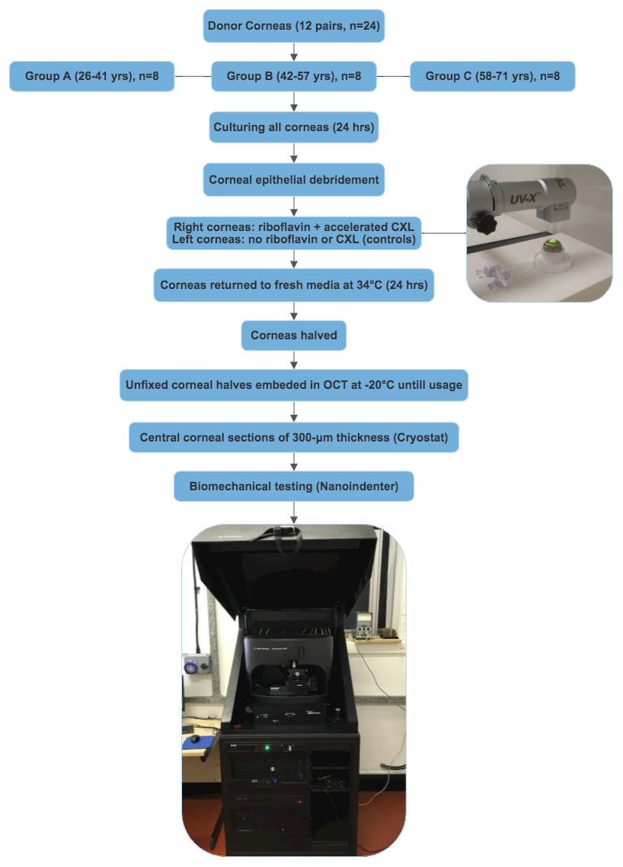
Figure 1: The experimental procedure. The flow chart shows the steps of corneal tissue preparation, treatment and biomechanical testing.

2.2. Corneal Cross-linking Procedure
Each cornea was mounted on an artificial anterior chamber, which was subsequently filled with a small amount of phosphate-buffered saline (PBS) to maintain corneal shape and stability during the treatment. All corneas underwent debriding of the central 8 mm of the corneal epithelium by gentle scraping with a blunt blade. The right corneas were cross-linked, while the left corneas served as controls and were not exposed to either UVA irradiation or riboflavin. Riboflavin 0.1% solution (10 mg riboflavin-5-phosphate in 10 mL dextran 20% solution) was dropped onto the cross-linked corneas at five-minute intervals for 30 minutes. This step was followed by the accelerated CXL technique (UVA irradiation with an intensity of 10 mW/cm²) for nine minutes (UV-XTM 2000, energy dose of 5.4J/cm², IROC Innocross AG, Zurich, Switzerland), and riboflavin was applied at three-minute intervals during UVA irradiation. All corneas were then returned to fresh media with 10% dextran and placed in an incubator at 34°C for 24 hours.

2.3. Sample Preparation for Elasticity Assessment
The cross-linked and control corneas were halved using a blunt blade and embedded in frozen tissue medium blocks (KP-CryoCompound, Netherlands) and stored at
-20ºC until usage. From one half of each halved cornea, central corneal sections of 300-μm thickness were obtained using a cryostat (Leica CM-3050-S cryostat, Leica Microsystems, UK) and mounted on clean glass slides. The tissue sections were then investigated using nanoindentation.

2.4. Tissue Elasticity Assessment
The shear storage modulus $(G^{'})$ of corneal sections was measured using oscillatory nanoindentation (G200 Nanoindenter, KLA-Tencor Milpitas, California, USA) at room temperature (21.5°C). This method has previously been used to test soft biological tissues (Panpho et al., 2019; Peters et al., 2018). It has also been utilised to measure localised viscoelastic properties of corneas in vitro (Kazaili et al., 2019). The principle and the experimental procedure of oscillatory nanoindentation have been described in detail elsewhere (Akhtar et al., 2018). The nanoindenter was equipped with a flat-ended cylindrical 100μm flat punch tip (Synton-MDP Ltd, Nidau, Switzerland). Corneal sections were placed on a sheet of 600-grit sandpaper, and fixed from the far margins with scotch tape. The sandpaper sheet was fixed on a flat-solid stage. In order to maintain the hydration of the sections during the experiment, three drops of PBS-dextran solution were added to each sample’s centre prior to mechanical testing. The process of the mechanical testing is shown in figure (2). The mechanical testing for each measurement was performed within 4–5 minutes. The corneal thickness was divided into three equal sections to comprise/define different stromal depths; the first third was referred to as the anterior stroma, the second third as the mid stroma and the third one was referred to as the posterior stroma. At the centre of each stromal depth, two points were indented, with 300-μm spacing between each indent. Poisson’s ratio (v) of the cornea was assumed to be 0.5, based on a previous study (Uchio et al., 1999). To ensure sufficient contact between the tip and the tissue, a pre-compression of 5 μm was selected. An oscillating frequency of 110 Hz (resonant frequency of the nanoindenter) with an oscillation amplitude of 500 nm was chosen for the experiments (Akhtar et al., 2016; Kazaili et al., 2019). The elastic modulus (E) was calculated using Equation (1) (Akhtar et al., 2018).
$$E=G^{'} ( 2 \left(1+v\right))$$ | … (1)
where E is elastic modulus, G′is shear storage modulus, and v is Poisson’s ratio.

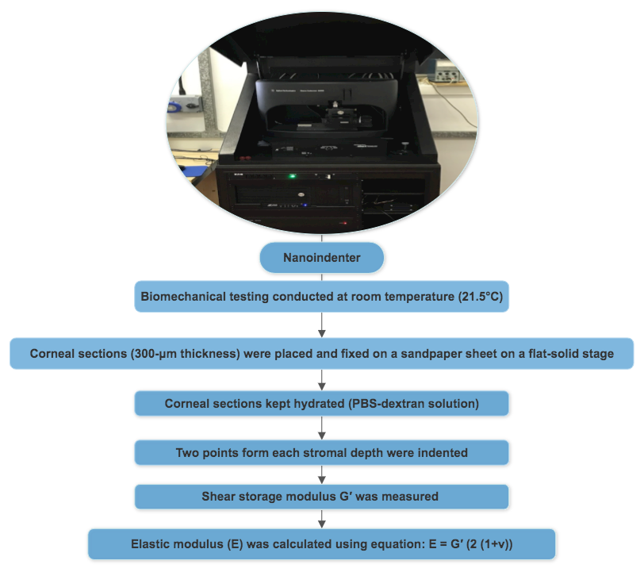
Figure 2: The process of elasticity assessment. The flow chart shows the steps of the biomechanical testing conducted using the nanoindenter.

2.7. Statistical Analysis
Statistical analysis was performed using SPSS software (IBM Corp. Released 2015. IBM SPSS Statistics for Mac, Version 23.0. Armonk, NY: IBM Corp.). Normality assumptions were examined using Skewness and Kurtosis tests. Parametric tests were performed for statistical analysis as data were normally distributed. A repeated measures ANOVA was performed followed by pairwise comparisons (post hoc, Bonferroni) to identify changes in the corneal elastic modulus through stromal depths. A paired t-test was conducted to determine treatment outcomes. A p-value of <0.05 was considered to be statistically significant. Figures were produced using GraphPad Prism (Version 8.4.1 for Mac, GraphPad Software, San Diego, California USA).

3. Results
Figure (3) shows the corneal elastic modulus at different stromal depths in cross-linked and control corneas. The figure shows an increased corneal elastic modulus following CXL treatment, which is more pronounced in the anterior stroma, as expected. The change in the corneal elastic modulus following CXL was significant in the anterior (p=0.00002, r=2.01) and mid stroma (p=0.001, r=1.32); however, the change was not significant in the posterior stroma (p=0.27, r=-0.34) when compared to control corneas (paired t-test). The repeated measures ANOVA showed a significant difference in the corneal elastic modulus across the three corneal depths in the cross-linked corneas (F_{2,22}=67.69, p<0.0001), while the difference was not significant in the control corneas (F_{2,22}=8.11, p=0.11). The pairwise comparisons (post hoc, Bonferroni) further revealed a significant difference in the corneal elastic modulus between the anterior and mid stroma (p=0.00005), anterior and posterior stroma (p=0.000006), and also between mid and posterior stroma (p=0.0001) in the cross-linked corneas. For the control corneas, post hoc tests did not show significant differences in the corneal elastic modulus between anterior, mid and posterior stroma (Figure 3). Overall, following CXL treatment, the corneal elastic modulus increased by 105.23% in the anterior stroma and 31.42% in the mid stroma, and no changes were observed in the posterior stroma.

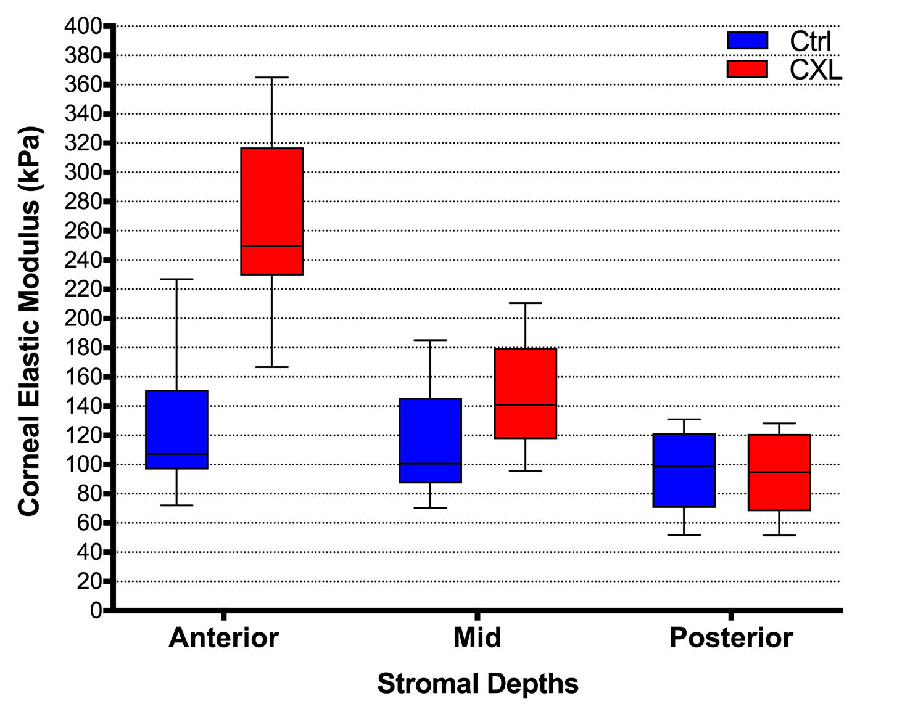
Figure 3: Effect of CXL on the corneal elastic modulus at all stromal depths. Ctrl: Control corneas (n=12), CXL: Cross-linked corneas (n=12).

Figure (4) illustrates the change induced by CXL on the corneal elastic modulus amongst all age groups in the anterior, mid and posterior stroma. The figure also shows that the corneal elastic modulus in control corneas was greater for the oldest group (Group C) throughout all three of the tested stromal depths in comparison with the two younger groups (Groups A and B). The response of corneal elasticity to CXL treatment was greater in the younger corneas (Group A) compared to the older groups in the anterior and mid stromal depths; however, there were no changes observed in the corneal elastic modulus of the posterior stroma between age groups following CXL treatment.

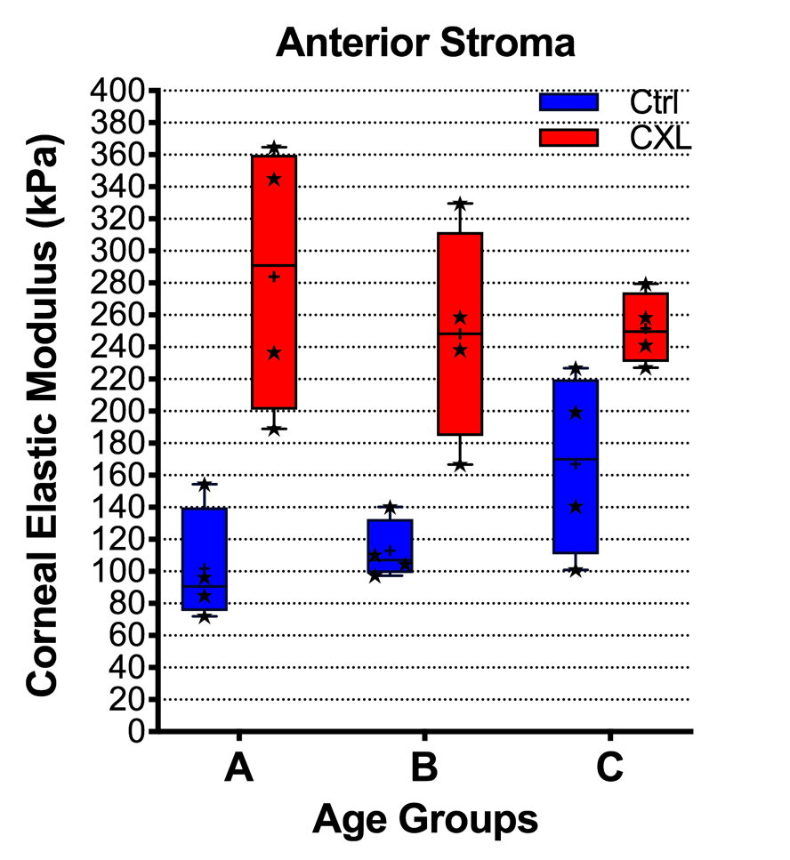

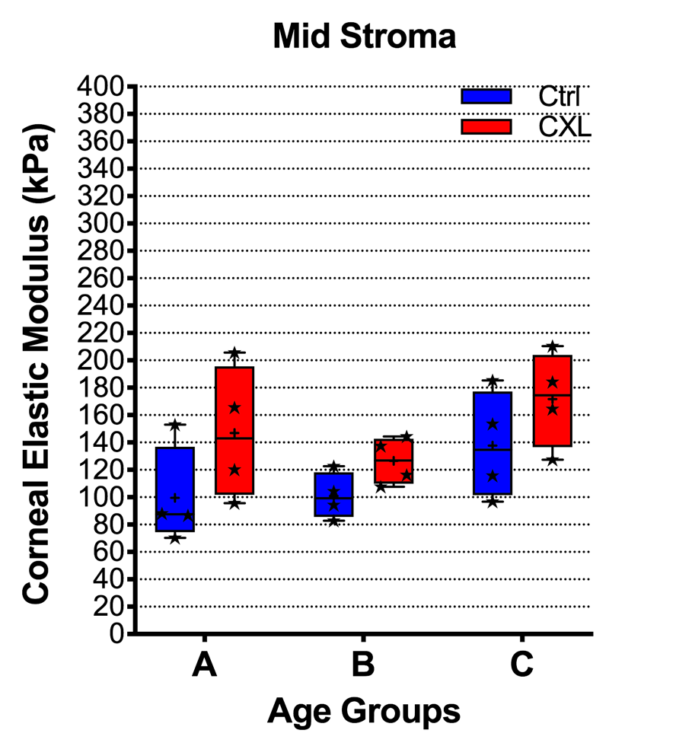

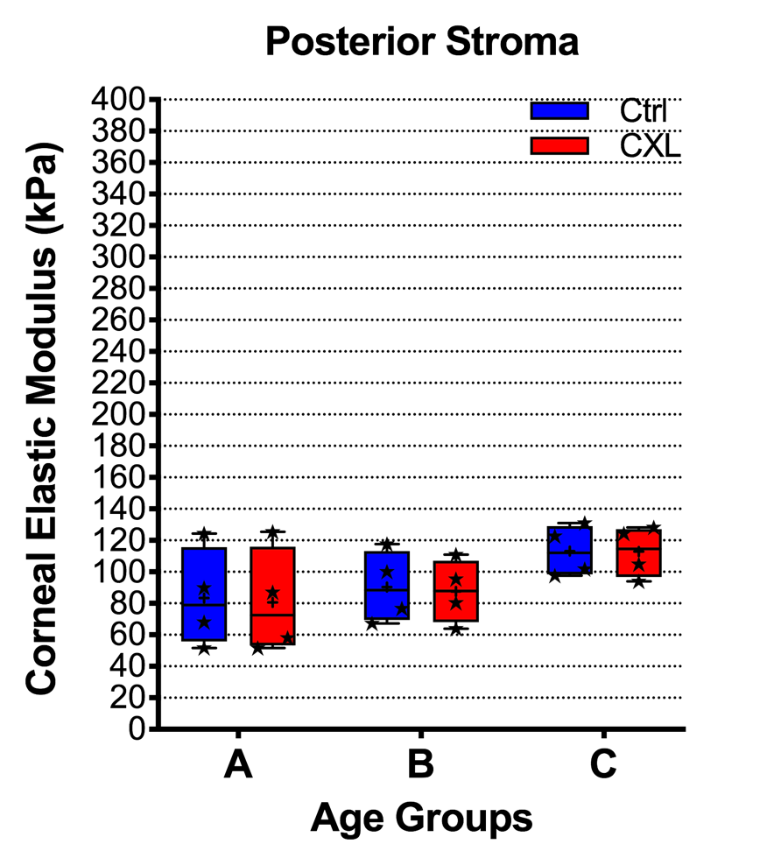
Figure 4: Effect of CXL on the corneal elastic modulus (individual values) at all stromal depths for each age group. CXL: Cross-linked corneas, Ctrl: Control corneas. Group A: (26–41 years), Group B: (42–57 years), Group C: (58–71 years), 8 corneas for each age group.

The response of the corneal elastic modulus to CXL treatment (change in percentage) in all age groups is shown in Figure (5). The results for the anterior stroma indicate that the corneal elastic modulus increased by 178.44% in Group A, 119.7% in Group B and 50.73% in Group C compared to control corneas. For the mid stroma, the corneal elastic modulus increased by 47.35% in Group A, 25% in Group B and 24.56% in Group C. For the posterior stroma, there were no changes observed between age groups following CXL treatment. Thus, the overall results showed that the response in Group A was greater than other age groups in both the anterior and mid stroma.

Figure 5: Effect of CXL on the corneal elastic modulus (in percentage) following CXL in all stromal depths for each age group. Group A: (26–41 years), Group B: (42–57 years), Group C: (58–71 years), 8 corneas for each age group.

4. Discussion
The results from the current study show that CXL increases the corneal modulus of elasticity in the anterior corneal regions and that this change is more effective in younger corneas. UV-A irradiation intensively penetrates the cornea up to the mid stroma; hence, two-thirds of CXL’s effectiveness is concentrated in the top half of the stroma. Previous laboratory studies have shown that CXL significantly improves corneal biomechanical strength (Dias et al., 2013; Wollensak et al., 2003b), and this significant effect is largely localised in the anterior one-third of the corneal stroma (Beshtawi et al., 2013b; Kohlhaas et al., 2006). It was reported that the Young’s modulus of the anterior stroma for human corneas aged 65–84 years could be increased by 66.67% following CXL (Kohlhaas et al., 2006), and this increase might be even greater (90.24%) when the sample included younger corneas (a range of 39–88 years) (Dias et al., 2013). The degree of change in the biomechanical measurements of the anterior stroma in these two studies was lower than that found in the current study (105.23%). This change might be explained by the wider range of donors’ ages, with the inclusion of more young corneas in our study compared to the other two studies (Dias et al., 2013; Kohlhaas et al., 2006).
The current study shows that the response of the older corneas to CXL, particularly for the anterior stroma modulus measurements, was lower than that in the other age groups. It was also noticeable that the baseline measurements of the corneal elastic modulus were greater for the older group compared to the other groups. Older corneas would have already developed additional cross-links with age, causing a natural stiffness (Elsheikh et al., 2007; Piñero and Alcón, 2014), so it would be expected that older corneas do not respond to CXL in the same way as younger corneas. Age is considered to be a factor that affects tissue stiffness in the cornea (Elsheikh et al., 2007), and corneal stiffness increases significantly with age (Elsheikh et al., 2007; Piñero and Alcón, 2014). Investigating the collagen fibrils has also led to the suggestion that the cornea becomes stiffer with ageing (Daxer et al., 1998). In the current study, the corneal elastic modulus was shown to increase with the donor’s age in both cross-linked and control corneas. This finding is consistent with the evidence that the natural age-related stiffness is induced by the additional cross-links in collagen fibrils (Daxer et al., 1998; Elsheikh et al., 2007).
Various attempts to clinically investigate the biomechanical changes induced by CXL have been reported in the literature. These attempts involved two devices currently available in clinical practice: the Ocular Response Analyzer (ORA)(Kamiya et al., 2009) and the Corneal Visualization Scheimpflug Technology (Oculus Corvis ST) (Tian et al., 2016). The data generated using ORA did not show any significant changes in biomechanical parameters following CXL for keratoconus treatment (De Bernardo et al., 2015; Sedaghat et al., 2010; Spoerl et al., 2011) for either short-term follow-ups: (e.g., 6 months) (Sedaghat et al., 2010) or long-term observations (e.g., 24 months) (De Bernardo et al., 2015). The biomechanical data obtained from Corvis shows a very wide variation (Nemeth et al., 2013). The difference in published data between clinical and laboratory research on corneal biomechanical measurements could potentially be attributed to the fact that, firstly, clinical studies were undertaken on keratoconus patients, while laboratory studies usually use non-keratoconic corneas. Secondly, intraocular pressure (IOP) and central corneal thickness (CCT) are considered to be factors that affect the biomechanical parameters currently used in clinical settings (Kamiya et al., 2009; Tian et al., 2016), thus, it is also possible that these factors may be responsible for the differences in biomechanical findings between in vivo and ex vivo studies. Thirdly, although ORA and Corvis are useful devices that measure corneal biomechanical behaviour in clinical scenarios, their data are obtained via an indirect measure, which can be considered to be an estimate rather than an accurate evaluation. A precise method that provides detailed biomechanical information is necessary to explore the change in biomechanical properties between different age groups following CXL treatment. The high level of variation reported in clinical data (Nemeth et al., 2013) could make it challenging to obtain such data using the devices currently available in clinical settings. Therefore, the current study, with the use of donor corneas and a direct measurement tool, is essential for providing this necessary information. Nanoindentation was chosen for the current study due to its capability to directly measure biomechanics at different depths within the tissue layers, with minimal tissue preparation required (Akhtar et al., 2016). The current study shows that nanoindentation is ideal for determining localised changes in the cornea in vitro following CXL treatment. Therefore, further development of nanoindentation technology could lead the possibility of its implementation in clinical settings, allowing for the direct measurement of corneal elasticity.
Ideally, a study investigating the effect of age on corneal biomechanics and CXL should have a wide age range, from at least teenage years onwards. Although the model used in the current study (human eye-banked cornea model) is appropriate for such a study, it restricts the range of donors’ ages as well as the sample size, both of which are difficult to control. Previous laboratory studies on CXL using human tissues were also limited to small sample sizes, due to limitations in tissue availability (Beshtawi et al., 2013a; Kohlhaas et al., 2006). Eye-banked corneas tend to be from older age groups, which could reduce the applicability of this data to younger eyes, which generally undergo CXL in a clinical scenario. However, our results show that corneal stiffness increases with age at a similar degree to that shown in clinical studies. A large clinical study has investigated the change in corneal biomechanics with age using ORA (Celebi et al., 2018). The study included 2039 healthy Caucasian adults ranging from 20- to 80-years old, divided by decades into seven age groups. Their results showed that the measurements of biomechanical parameters such as corneal hysteresis and corneal resistance factor are lower in older groups compared to younger groups. Similar findings have also been reported in more recent clinical studies (Momeni-Moghaddam et al., 2019; Zhang et al., 2019). This clinical data indicates that older eyes have lower deformability compared to younger eyes, which suggests an increase in corneal stiffness with age. The results of our control group have shown similar outcomes to those of these clinical studies. The availability of more young donor corneas would be helpful in assisting researchers to provide further evidence on the role of age in CXL treatment outcomes.

Hydration of corneal tissue is found to have a significant effect on the biomechanical behaviour of the cornea (Hatami-Marbini and Rahimi, 2015). Dehydrated tissues could show more stiffness compared to hydrated tissues (Hatami-Marbini and Rahimi, 2016). Hydration could, theoretically, have affected the results of the current study; however, this is unlikely for a number of reasons. Firstly, we tested two different points for each stromal depth level, and there was no significant change recorded from a point to another. Secondly, sections were hydrated with PBS-dextran solution. PBS has shown suitability for maintaining corneal hydration for a short period of time (such as one hour) (Kazaili et al., 2019), and dextran is known to minimise corneal swelling. The mechanical measurement for each chosen point in the stroma took only four to five minutes, so PBS-dextran solution is not expected to affect tissue hydration, particularly for such a short testing time. Furthermore, room temperature was kept constant during all experiments (21.5°C) to control any potential evaporation. Finally, the measurements collected from different age groups were consistent with the evidence of age-related corneal stiffness (older corneas are stiffer than younger cornea) (Elsheikh et al., 2007), which increases the validity of the data of the current study. Therefore, for the reasons stated above, tissue hydration is unlikely to have had an impact on the results of the current study.

Conclusions
The current study reveals that the effect of CXL treatment is more pronounced in younger corneas compared to older ones. This suggests a potential benefit of offering CXL treatment for keratoconus/refractive surgery patients as early as possible to obtain better results. The study also confirmed that the effect of CXL is largely localised in the top half of the stroma with minimum impact on the posterior stroma.

Acknowledgments
The authors thank the Manchester Eye Bank (NHS Blood and Transplant, Tissue and Eye Services, UK) for providing the donor corneas for the current study. We also greatly thank Dr. Chantal Hillarby (Centre for Tissue Injury and Repair, the University of Manchester, UK) for her valuable contribution. We want to acknowledge Mr. Arun Brahama (Manchester Royal Eye Hospital, UK) who kindly provided the cross-linker. We thank Dr Sue Shawcross (Blond McIndoe Laboratories, the University of Manchester, UK) for her support. The study has been funded with scholarship fund awarded to BA by Qassim University, Saudi Arabia.

References

Akhtar, R., Draper, E.R., Adams, D.J., Hay, J., 2018. Oscillatory nanoindentation of highly compliant hydrogels: A critical comparative analysis with rheometry. J. Mater. Res. 33, 873–883. https://doi.org/10.1557/jmr.2018.62
Akhtar, R., Draper, E.R., Adams, D.J., Pfaff, H., 2016. Complex shear modulus of hydrogels using a dynamic nanoindentation method, in: Conference Proceedings of the Society for Experimental Mechanics Series. pp. 141–145. https://doi.org/10.1007/978-3-319-21455-9_17
Beshtawi, I.M., Akhtar, R., Hillarby, M.C., O’Donnell, C., Zhao, X., Brahma, A., Carley, F., Derby, B., Radhakrishnan, H., 2013a. Scanning acoustic microscopy for mapping the microelastic properties of human corneal tissue. Curr. Eye Res. 38, 437–444. https://doi.org/10.3109/02713683.2012.753094
Beshtawi, I.M., O’Donnell, C., Radhakrishnan, H., 2013b. Biomechanical properties of corneal tissue after ultraviolet-A-riboflavin crosslinking. J. Cataract Refract. Surg. https://doi.org/10.1016/j.jcrs.2013.01.026
Celebi, A.R.C., Kilavuzoglu, A.E., Altiparmak, U.E., Cosar Yurteri, C.B., 2018. Age-related change in corneal biomechanical parameters in a healthy Caucasian population. Ophthalmic Epidemiol. 25, 55–62. https://doi.org/10.1080/09286586.2017.1351997
Chatzis, N., Hafezi, F., 2012. Progression of keratoconus and efficacy of corneal collagen cross-linking in children and adolescents. J. Refract. Surg. 28, 753–758. https://doi.org/10.3928/1081597X-20121011-01
Daxer, A., Misof, K., Grabner, B., Ettl, A., Fratzl, P., 1998. Collagen fibrils in the human corneal stroma: Structure and aging. Investig. Ophthalmol. Vis. Sci. 39, 644–648.
De Bernardo, M., Capasso, L., Lanza, M., Tortori, A., Iaccarino, S., Cennamo, M., Borrelli, M., Rosa, N., 2015. Long-term results of corneal collagen crosslinking for progressive keratoconus. J. Optom. 8, 180–186. https://doi.org/10.1016/j.optom.2014.05.006
Dias, J., Diakonis, V.F., Kankariya, V.P., Yoo, S.H., Ziebarth, N.M., 2013. Anterior and posterior corneal stroma elasticity after corneal collagen crosslinking treatment. Exp. Eye Res. 116, 58–62. https://doi.org/10.1016/j.exer.2013.07.028
Elsheikh, A., Wang, D., Brown, M., Rama, P., Campanelli, M., Pye, D., 2007. Assessment of corneal biomechanical properties and their variation with age. Curr. Eye Res. 32, 11–19. https://doi.org/10.1080/02713680601077145
Ertan, A., Muftuoglu, O., 2008. Keratoconus clinical findings according to different age and gender groups. Cornea 27, 1109–1113. https://doi.org/10.1097/ICO.0b013e31817f815a
Hatami-Marbini, H., Rahimi, A., 2016. Interrelation of Hydration, Collagen Cross-Linking Treatment, and Biomechanical Properties of the Cornea. Curr. Eye Res. 41, 616–622. https://doi.org/10.3109/02713683.2015.1042546
Hatami-Marbini, H., Rahimi, A., 2015. Stiffening effects of riboflavin/UVA corneal collagen cross-linking is hydration dependent. J. Biomech. 48, 1052–1057. https://doi.org/10.1016/j.jbiomech.2015.01.038
Jiménez, J.L.O., Jurado, J.C.G., Rodriguez, F.J.B., Laborda, D.S., 1997. Keratoconus: Age of onset and natural history. Optom. Vis. Sci. 74, 147–151. https://doi.org/10.1097/00006324-199703000-00025
Kamiya, K., Shimizu, K., Ohmoto, F., 2009. Effect of aging on corneal biomechanical parameters using the ocular response analyzer. J. Refract. Surg. 25, 888–893. https://doi.org/10.3928/1081597X-20090917-10
Kazaili, A., Geraghty, B., Akhtar, R., 2019. Microscale assessment of corneal viscoelastic properties under physiological pressures. J. Mech. Behav. Biomed. Mater. 100, 103375. https://doi.org/10.1016/j.jmbbm.2019.103375
Kennedy, R.H., Bourne, W.M., Dyer, J.A., 1986. A-48 Year Clinical and Epidemiologic Study of Keratoconus. Am. J. Ophthalmol. 101, 267–273.
Kohlhaas, M., Spoerl, E., Schilde, T., Unger, G., Wittig, C., Pillunat, L.E., 2006. Biomechanical evidence of the distribution of cross-links in corneas treated with riboflavin and ultraviolet A light. J Cataract Refract Surg 32, 279–283. https://doi.org/10.1016/j.jcrs.2005.12.092
Kymionis, G.D., Grentzelos, M.A., Liakopoulos, D.A., Paraskevopoulos, T.A., Klados, N.E., Tsoulnaras, K.I., Kankariya, V.P., Pallikaris, I.G., 2014. Long-term follow-up of corneal collagen cross-linking for keratoconus-the cretan study. Cornea 33, 1071–1079. https://doi.org/10.1097/ICO.0000000000000248
Malik, N.S., Moss, S.J., Ahmed, N., Furth, A.J., Wall, R.S., Meek, K.M., 1992. Ageing of the human corneal stroma: structural and biochemical changes. BBA - Mol. Basis Dis. 1138, 222–228. https://doi.org/10.1016/0925-4439(92)90041-K
Mazzotta, C., Traversi, C., Baiocchi, S., Bagaglia, S., Caporossi, O., Villano, A., Caporossi, A., 2018. Corneal Collagen Cross-Linking With Riboflavin and Ultraviolet A Light for Pediatric Keratoconus: Ten-Year Results. Cornea 37, 560–566. https://doi.org/10.1097/ICO.0000000000001505
Meek, K.M., Tuft, S.J., Huang, Y., Gill, P.S., Hayes, S., Newton, R.H., Bron, A.J., 2005. Changes in collagen orientation and distribution in keratoconus corneas. Investig. Ophthalmol. Vis. Sci. 46, 1948–1956. https://doi.org/10.1167/iovs.04-1253
Momeni-Moghaddam, H., Hashemi, H., Zarei-Ghanavati, S., Ostadimoghaddam, H., Yekta, A., Aghamirsalim, M., Khabazkhoob, M., 2019. Four-year changes in corneal biomechanical properties in children. Clin. Exp. Optom. 102, 489–495. https://doi.org/10.1111/cxo.12890
Nemeth, G., Hassan, Z., Csutak, A., Szalai, E., Berta, A., Modis, L., 2013. Repeatability of ocular biomechanical data measurements with a scheimpflug-based noncontact device on normal corneas. J. Refract. Surg. 29, 558–563. https://doi.org/10.3928/1081597X-20130719-06
Padmanabhan, P., Reddi, S.R., Rajagopal, R., Natarajan, R., Iyer, G., Srinivasan, B., Narayanan, N., Lakshmipathy, M., Agarwal, S., 2017. Corneal Collagen Cross-Linking for Keratoconus in Pediatric Patients—Long-Term Results. Cornea 36, 138–143.
Panpho, P., Geraghty, B., Chim, Y.H., Davies, H.A., Field, M.L., Madine, J., Akhtar, R., 2019. Macro- and micro-mechanical properties of the ovine aorta: Correlation with regional variations in collagen, elastin and glycosaminoglycan levels. Artery Res. 25, 27–36. https://doi.org/10.2991/artres.k.191114.003
Peters, A.E., Akhtar, R., Comerford, E.J., Bates, K.T., 2018. The effect of ageing and osteoarthritis on the mechanical properties of cartilage and bone in the human knee joint. Sci Rep 8, 5931. https://doi.org/10.1038/s41598-018-24258-6
Piñero, D.P., Alcón, N., 2014. In vivo characterization of corneal biomechanics. J. Cataract Refract. Surg. https://doi.org/10.1016/j.jcrs.2014.03.021
Raiskup-Wolf, F., Hoyer, A., Spoerl, E., Pillunat, L.E., 2008. Collagen crosslinking with riboflavin and ultraviolet-A light in keratoconus: long-term results. J Cataract Refract Surg 34, 796–801. https://doi.org/10.1016/j.jcrs.2007.12.039
Raiskup, F., Theuring, A., Pillunat, L.E., Spoerl, E., 2015. Corneal collagen crosslinking with riboflavin and ultraviolet-A light in progressive keratoconus: ten-year results. J Cataract Refract Surg 41, 41–46. https://doi.org/10.1016/j.jcrs.2014.09.033
Randleman, J.B., Khandelwal, S.S., Hafezi, F., 2015. Corneal cross-linking. Surv Ophthalmol 60, 509–523. https://doi.org/10.1016/j.survophthal.2015.04.002
Scarcelli, G., Kling, S., Quijano, E., Pineda, R., Marcos, S., Yun, S.H., 2013. Brillouin microscopy of collagen crosslinking: Noncontact depth-dependent analysis of corneal elastic modulus. Investig. Ophthalmol. Vis. Sci. 54, 1418–1425. https://doi.org/10.1167/iovs.12-11387
Sedaghat, M., Naderi, M., Zarei-Ghanavati, M., 2010. Biomechanical parameters of the cornea after collagen crosslinking measured by waveform analysis. J. Cataract Refract. Surg. 36, 1728–1731. https://doi.org/10.1016/j.jcrs.2010.06.056
Spoerl, E., Terai, N., Scholz, F., Raiskup, F., Pillunat, L.E., 2011. Detection of biomechanical changes after corneal cross-linking using ocular response analyzer software. J. Refract. Surg. 27, 452–457. https://doi.org/10.3928/1081597X-20110106-01
Tian, L., Wang, D., Wu, Y., Meng, X., Chen, B., Ge, M., Huang, Y., 2016. Corneal biomechanical characteristics measured by the CorVis Scheimpflug technology in eyes with primary open-angle glaucoma and normal eyes. Acta Ophthalmol. 94, e317–e324. https://doi.org/10.1111/aos.12672
Uchio, E., Ohno, S., Kudoh, J., Aoki, K., Kisielewicz, L.T., 1999. Simulation model of an eyeball based on finite element analysis on a supercomputer. Br. J. Ophthalmol. 83, 1106–1111. https://doi.org/10.1136/bjo.83.10.1106
Vellara, H.R., Patel, D. V, 2015. Biomechanical properties of the keratoconic cornea: A review. Clin. Exp. Optom. https://doi.org/10.1111/cxo.12211
White, T.L., Lewis, P.N., Young, R.D., Kitazawa, K., Inatomi, T., Kinoshita, S., Meek, K.M., 2017. Elastic microfibril distribution in the cornea: Differences between normal and keratoconic stroma. Exp. Eye Res. 159, 40–48. https://doi.org/10.1016/j.exer.2017.03.002
Wollensak, G., 2006. Crosslinking treatment of progressive keratoconus: New hope. Curr. Opin. Ophthalmol. https://doi.org/10.1097/01.icu.0000233954.86723.25
Wollensak, G., Spoerl, E., Seiler, T., 2003a. Riboflavin/ultraviolet-A-induced collagen crosslinking for the treatment of keratoconus. Am. J. Ophthalmol. 135, 620–627. https://doi.org/10.1016/S0002-9394(02)02220-1
Wollensak, G., Spoerl, E., Seiler, T., 2003b. Stress-strain measurements of human and porcine corneas after riboflavin-ultraviolet-A-induced cross-linking. J. Cataract Refract. Surg. 29, 1780–1785. https://doi.org/10.1016/S0886-3350(03)00407-3
Zhang, B., Shweikh, Y., Khawaja, A.P., Gallacher, J., Bauermeister, S., Foster, P.J., 2019. Associations with Corneal Hysteresis in a Population Cohort: Results from 96 010 UK Biobank Participants. Ophthalmology 126, 1500–1510. https://doi.org/10.1016/j.ophtha.2019.06.029
Zhang, Y., Conrad, A.H., Conrad, G.W., 2011. Effects of ultraviolet-A and riboflavin on the interaction of collagen and proteoglycans during corneal cross-linking. J. Biol. Chem. 286, 13011–13022. https://doi.org/10.1074/jbc.M110.169813

