Clinical Picture
Title:
A mass in the right upper quadrant highlights the need for a comprehensive community-based public health strategy

Authors:
Richard Nhlane MBChB^{1,2}, Benno Kreuels MD^{1,2,3}, Jane Mallewa MD^{1,2}, Karen Chetcuti MBBS^{1,4}, Professor Melita A. Gordon PhD^{4,5} Alexander J. Stockdale PhD^{1,4,5}
Affiliations:
¹ Department of Medicine, Queen Elizabeth Central Hospital, Chichiri, Blantyre, Malawi
² Malawi College of Medicine, Chichiri, Blantyre, Malawi
³ Department of Tropical Medicine, Bernhard Nocht Institute for Tropical Medicine & I Department of Medicine, University Medical Center Hamburg-Eppendorf, Hamburg, Germany.
⁴ Malawi-Liverpool-Wellcome Trust Programme, Chichiri, Blantyre, Malawi
⁵ Institute of Infection, Veterinary and Ecological Sciences, Ronald Ross Building, 8 West Derby Street, University of Liverpool, Liverpool, United Kingdom

Authors Contributions: RH, BK, JM, KC, MG and AS provided clinical care for this patient. RN, BK and AS wrote this case report. KC acquired the ultrasound images. All authors reviewed and revised the manuscript.

Conflict of interest statement: The authors report no conflicts of interest.

Role of funding source: AS is supported by a Wellcome Trust Clinical PhD Fellowship grant 109130/Z/15/Z. The funder had no role in the writing or decision to submit for publication.

Ethics approval: The patient provided written consent for the publication of this Clinical Picture. Ethical permission to conduct the study of patients with hepatocellular carcinoma described in the manuscript was obtained from the National Health Sciences Research Committee of Malawi (15/5/1599) and the University of Liverpool (reference 1954).
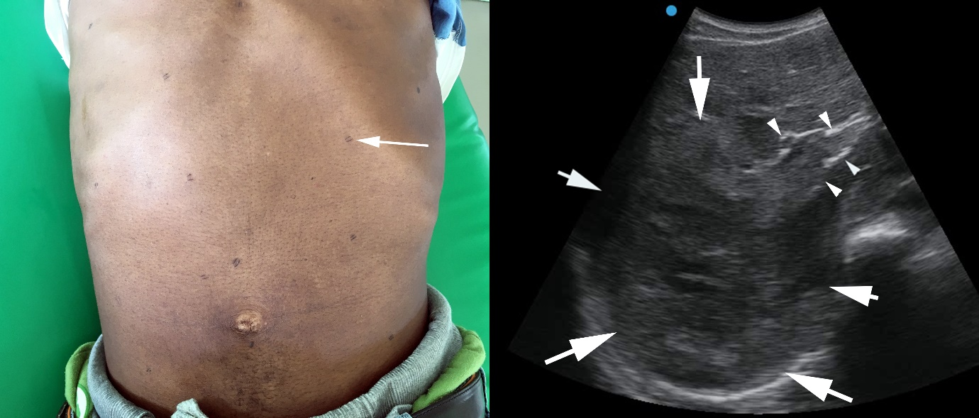

A 34 year old man presented with a four-month history of epigastric abdominal pain, which was constant and progressive. He reported substantial weight loss. He was a non-smoker. He had received Helicobacter pylori eradication therapy and traditional medicine including scarification, the practice of making sharp incisions to relieve pain, with no improvement in symptoms.
A mass in the right upper quadrant of the abdomen and scarification marks were observed (arrow, Figure 1A). A firm mass was palpable extending 8cm below the subcostal margin.
Abdominal ultrasound visualised a heterogenous mass within the right liver lobe measuring 11·8cm (arrows showing boundaries) invading the right portal vein (arrowheads). (Figure 1B) We diagnosed hepatocellular carcinoma (HCC). A hepatitis B surface antigen rapid test was positive. This patient died 3 months following admission.
In sub-Saharan Africa, HCC is the cancer reported to have the second highest mortality among men and the fourth among women, according to the Global Cancer Observatory. Late diagnosis is common due to referral delay and initial care-seeking from traditional healers. In southern Africa, hepatitis B was estimated to be the attributable cause of 29% of liver cancer in the Global Burden of Disease study. In the region, median age of onset is 46 years.
A strategic plan to reduce mortality from chronic hepatitis B was approved at the World Health Assembly in 2016. Yet modelling data show that without implementation of additional public health measures, mortality will continue to rise beyond 2030 in sub-Saharan Africa.
Effective public health tools to tackle hepatitis B-associated mortality in sub-Saharan Africa are available. These include community screen-and-treat programmes, birth-dose vaccination (in contrast to vaccination schedules starting at 6 weeks), and antenatal antiviral therapy for highly viraemic women. Our patients with HCC, diagnosed late and with little time, lack a voice to make these demands.

Picture Quiz
A 34 year old man in Malawi presented with four months of epigastric pain. An ultrasound demonstrated a large heterogenous mass in the right lobe of the liver. Which of the following interventions are most likely to reduce mortality from hepatocellular carcinoma in sub-Saharan Africa?
A: Public health measures to reduce hazardous alcohol consumption
B: Ultrasound surveillance for patients with chronic hepatitis B
C: Community screening and antiviral treatment for hepatitis B (Correct answer)
D: Chemoembolisation and radiofrequency ablation

