Receptance-based partial eigenstructure assignment by state feedback control
Shike Zhang, Huajiang Ouyang
School of Engineering, university of Liverpool, Liverpool L69 3GH, UK
Abstract: The partial eigenvalue assignment problem has drawn much attention for decades because of its usefulness and fascinating appeal in vibration control. It is also a mathematically challenging problem, particularly when the mathematical description is cast in the second-order formulation framework. Previous methods require either the system matrices, such as mass, damping or stiffness matrix, or the eigenvectors of the original system. Those data, especially the system matrices which are usually obtained from a finite element model, are not easy to obtain or very accurate. To overcome this drawback, a new partial eigenvalue assignment method by multi-input active control is proposed in this paper. Only part of the receptance matrix of the original system is required in this method. In addition, this method can simultaneously assign eigenvalues and the associated eigenvectors, including assigning nodes at desired locations. Three numerical examples are used to validate the proposed method and demonstrate the role of the control efforts. The robustness of the proposed method is analysed through a Monte-Carlo simulation. Numerical results show that this method is robust for the four-DoF damped system where there are 5% variations of the needed receptance matrix elements. This paper reports the first attempt to make partial eigenstructure assignment in the second-order eigenvalue framework using only the receptances.
Keywords: Partial eigenvalue assignment; eigenstructure assignment; receptance method; active control; robustness analysis

Introduction
Eigenvalues and eigenvectors play a fundamental role in determining the dynamic behaviour of a vibrating system. It is very appealing and useful to be able to assign eigenvalues and/or eigenvectors to a structure or machine so as to avoid large-amplitude vibration or make a structure respond in a desirable way. The eigenvalue assignment problem has drawn increasing interest in recent years. There are already number of eigenvalue assignment methods which have been developed in the past decades. Those eigenvalue assignment methods can be roughly grounded into two categories: forward and inverse approaches. The forward approaches usually perform a series of modifications on the models until the required eigenvalues are achieved. Those methods [1, 2] are usually time consuming and not guaranteed to get a desired solution. In contrast, the objective of the inverse methods is to determine the required modifications so that the modified system can have the desired dynamic behaviour [3, 4].
In principle, the inverse problems can be solved using a structural physical model [5-7] or a modal model [4, 8]. However, many methods are difficult to apply to complicated structures. The main reason is that the model, which usually is a finite element model, is often simplified and the modal model suffers from the modal truncation problem. Receptance based eigenvalue assignment method, on the other hand, can overcome those drawbacks because the receptance matrix can be directly obtained from experimental work. Tsuei and Yee [9] showed a frequency relocating method which only needs the frequency response function data at the designated modification points. Park and Park [10] aimed to find required multiple lumped mass, damper and stiffness modifications to assign eigenvalues and eigenvectors of a structure. They also investigated the existence and uniqueness of the exact solutions. Kautsky et al. [11] solved the pole placement problem through state feedback control. Robust solutions were obtained by defining a solution space of linearly independent eigenvectors corresponding to the desired eigenvalues. Chu and Datta [12] proposed a robust state feedback control algorithm by minimising the condition numbers of the closed-loop eigenvectors. Kyprianou et al. [13] presented the assignment of natural frequencies using an added mass and several springs. Abdelaziz and Valasek [14] presented a computationally efficient algorithm for solving the pole placement of linear multi-input systems with non-singular system matrix by state-derivative feedback. Ram and Mottershead [15] proposed a receptance based eigenvalue assignment method through active control. It was demonstrated that all the poles might be assigned actively without the information of M, C, and K matrices. Tehrani et al. [16] gave a robust analysis on that receptance-based pole placement method. Tsai et al. [17] applied the receptance method on a geared rotor-bearing system. The experimental results proved the effectiveness of the frequency assignment method. Araújo and Santos [18] introduced a novel theorem for eigenvalue perturbation inspired by the results of Brauer [19]. The results were successfully applied in the model updating and partial natural frequency assignment problems. The same authors [20] used a Smith predictor-based approach to design the feedback control in second-order symmetric linear systems under long input time-delay. Richiedei and Tamellin [21] developed a full-state feedback method for active antiresonance assignment and regional pole placement. The method can also be extended to systems with asymmetric matrices.
In practical applications, it is very common that only a small number of eigenvalues need to be relocated, for example, to avoid resonance. The modification of a subset of the natural frequencies, however, may lead to unexpected changes of other eigenvalues. This phenomenon is known as frequency spill-over. To avoid or minimize the unexpected changes of the other eigenvalues, partial eigenvalue assignment methods have been developed. Datta et al. [22] derived an explicit solution to the partial eigenvalue assignment problem based on orthogonality relations for the symmetric definite quadratic pencil with single input control. The multi-input partial pole placement problem was addressed by Datta and Sarkissian in [23]. The method requires only a small number of the eigenvalues that need to be reassigned and the corresponding eigenvectors. Ram and Elhay [24] considered the multi-input partial pole assignment problem as a sequence of pole assignments by single input control. A closed-form, non-iterative solution was obtained by using the natural framework of second-order differential equations. Qian and Xu [25] also discussed the partial eigenvalue assignment problem and derived the robust closed-loop system by minimizing the condition number of the eigenvectors matrix of the closed-loop system. Cai et al. [26] proposed an algorithm for solving the partial quadratic eigenvalue assignment problems. They established a mathematical condition on the existence of solutions for the partial quadratic eigenvalue assignment problems. Bai and Wan [27] proposed a constructive method for solving partial quadratic eigenvalue assignment problem using the receptances, system matrices and a few undesired open-loop eigenvectors. A receptance based active control method [15] for partial pole placement was developed by Tehrani et al. [28]. This method was demonstrated experimentally on a lightweight glass-fibre beam and a heavy modular structure. Multi-input active vibration control by the method of receptance was derived by Ram and Mottershead [29]. Ouyang and Zhang [30] explored the partial assignment of natural frequencies using passive modifications, which seemed to be the first paper that reported partial frequency assignment via passive structural modifications, albeit on only mass-spring systems. Belotti et al. [31] developed a partial eigenvalue assignment method for general structures using passive modifications. The feasible required passive modifications were estimated through a three-step procedure that considered both the desired eigenvalues and the physical constraints. Mokrani et al. [32] minimized the control effort required for partial pole placement in multi-input, multi-output systems with receptance method. De Almeida [33] provided a method to solve the partial eigenvalue assignment problem for regional assignment. The target eigenvalues were assigned to a given D-region. Dantas et al. [34] considered the time delay problem in the receptance based partial pole placement method using rank-one control. The stability of the closed-loop system is optimized by the Nyquist stability criterion. Xie [35] proposed a receptance method for partial quadratic eigenvalue assignment problem using receptance matrices and the unwanted eigenpairs of open-loop system. Besides, the norms of feedback gain matrices and the condition number of closed-loop system were simultaneously minimized.
Eigenvalues and eigenvectors (i.e., eigenpairs), together, constitute the eigenstructure of the system. In addition to the eigenvalue assignment, the eigenstructure assignment problem is also an active topic. In many engineering applications, it is usually expected that certain locations on a structure should vibrate slightly. Eigenstructure assignment can force a system to respond in a desired way, for example, no vibration at desired locations called nodes. Datta [36] gave an overview of the approaches for the partial eigenstructure assignment problem before 2002. Duan and Liu [37] used a proportional-plus-derivative feedback controller to assign eigenstructures for the second order linear systems. Rastgaar et al [38] provided a review of eigenstructure assignment methods for vibration cancellation. Ouyang et al. [39] developed a receptance-based eigenstructure assignment method with mass and stiffness modifications using measured receptances. The method was applied to a 5-degree-of-feedom (DoF) laboratory structure and was shown to be effective by the experimental results. Liu et al. [40] achieved eigenstructure assignment by adding multiple mass-spring systems to the original system with receptances. A passive modification and active control hybrid method for eigenstructure assignment was proposed by Belotti and Richiedei [41]. This work demonstrated that the objective can be efficiently accomplished by minimizing the rank of a matrix which relied on the system matrices of the original system and the desired eigenstructures. Recently, this work was further developed by Belotti et al. [42] with an experimental validation, which aims to assign a mode shape and a frequency to a cantilever beam controlled by a piezoelectric actuator. Liu et al. [43] addressed the frequencies and modes assignment problems by adding subsystems. Three methods different in computational efficiency were proposed in this paper for assignment by arbitrarily complex subsystems and connections. An eigenstructure assignment theory was adapted to reduce vibration and avoid shimmy on landing gears by Laporte et al. [44]. This method was used to stabilise the landing gear with better vibration response.
The aforementioned partial eigenvalue assignment methods, however, require either the system matrices [22-25, 31] or the eigenvectors of the original system [28, 45, 46]. It is usually very difficult to get accurate system matrices and the measurement of the eigenvectors of the open-loop system may require great efforts. Therefore, this paper proposes a receptance-based partial eigenstructure assignment method which does not require system matrices or eigenvectors of the original system. To the authors’ best knowledge, there is no published paper which reports successful partial eigenstructure assignment using only receptances. This method is compared with the method proposed by Ram and Mottershead in [29] and there are clear advantages in this new method proposed in this paper. The detailed derivations of the proposed method are given in section 2. Section 3 presents three numerical examples to validate the performance of this new method. A robust analysis on this method is presented in Section 4.

2 Receptance-based eigenstructure assignment

2.1 Problem description
Consider a linear, time-invariant, n-degree of freedom undamped vibrating system that is described by the following second order differential equation
$M\ddot{x}+C\dot{x}+Kx=0$ (1)
where $M$, $C,K∈R^{n×n}$ are symmetric mass, damping and stiffness matrices, respectively.
To shift the eigenvalues of the system to desired locations while keeping the other eigenvalues unchanged, the system in equation (1) can be modified by applying a control force u as follows:
$M\ddot{x}+C\dot{x}+Kx=Bu$ (2)
where $u=F^{T}\dot{x}+G^{T}x$ and $B=\left[b_{1}, b_{2}, ⋯,b_{i}\right]$ is a $n×i$ matrix, describing the control force distribution over the structure.$F$ and$G∈R^{n×i}$ are control gain matrices and $F=\left[f_{1}, f_{2}, ⋯f_{i}\right]$ and $G=\left[g_{1}, g_{2}, ⋯g_{i}\right]$. Here, $i$ denotes the number of actuators/inputs, which can be much smaller than n. In addition, the control force does not have to be applied to every degree of freedom and in fact doing so is also impossible for large complicated structures. Therefore, there are many zero elements in matrix $B$ which indicate absence of a control force at the related degrees of freedom.
The quadratic eigenvalue problems corresponding to the open-loop and closed-loop systems in equation (1) and (2), respectively, are given by
$\left(λ_{k}^{2}M+λ_{k}C+K\right)v_{k}=0, k=1,2,…,2n$ (3)
$\left(μ_{k}^{2}M+μ_{k}C+K\right)w_{k}=B\left(μ_{k}F^{T}+G^{T}\right)w_{k}, k=1,2,…,2n$ (4)
The $2n$ eigenvalues ${\left\{λ_{k}\right\}}_{k=1}^{2n}$ with corresponding eigenvectors ${\left\{v_{k}\right\}}_{k=1}^{2n}$ in equation (3) are the eigenpairs of the open-loop system. Similarly, ${\left\{μ_{k}\right\}}_{k=1}^{2n}$ and ${\left\{w_{k}\right\}}_{k=1}^{2n}$ in equation (4) are the eigenpairs of the closed-loop system. The eigenvalues of open-loop system are assumed to be distinct, as are the eigenvalues of the closed-loop system. The case of repeated eigenvalues is not discussed in this paper. It should be pointed out that an eigenvalue and its corresponding eigenvector form an eigenpair and they are linked intrinsically in an eigenvalue problem, e.g., equation (3), and thus the demand of an arbitrary eigenpair is unlikely to be met. Partial eigenstructure assignment is even more challenging and may not be mathematically possible.
The receptance matrix of an M-C-K system with eigenvalue $μ_{k}$ can be expressed as $H\left(μ_{k}\right)={\left(μ_{k}^{2}M+μ_{k}C+K\right)}^{-1}$. It should be stated that the receptances can be measured quite easily in practice and thus measured receptances should be used when assigning eigenvalues or eigenpairs to a real structure (as done in [37, 40], for example), but the receptances used in this paper are derived theoretically for the purpose of introducing a new method and validating it.
A subset of eigenvalues of the open-loop system is required to be shifted to desired locations. Meanwhile, to avoid spill-over, it is further requested that the other eigenvalues are unchanged. However, the real structures usually have infinity number of eigenvalues. It is impossible or difficult to retain all the eigenvalues except the unwanted eigenvalues with the receptance method. Therefore, it is more practical to alter a subset of eigenvalues and remain another subset of eigenvalues.
Without loss of generality, the first $2m<2n$ eigenvalues of ${\left\{λ_{k}\right\}}_{k=1}^{2n}$ are required to be changed to predetermined eigenvalues ${\left\{μ_{k}\right\}}_{k=1}^{2m}$ and the next $2(p-m)$ eigenvalues remain unchanged ${\left\{μ_{k}\right\}}_{k=2m+1}^{2p}={\left\{λ_{k}\right\}}_{k=2m+1}^{2p}$, $2p≤2n$. These conditions can be written in the form
$μ_{k}=\left\{\begin{aligned}\begin{matrix}μ_{k} (desired eigenvalues) & k=1,2,…, 2m \end{matrix} \\ \begin{matrix}λ_{k} (unchanged eigenvalues) & k=2m+1,…, 2p\end{matrix} \\ \begin{matrix}not of concern & k=2p+1,…,2n \end{matrix}\end{aligned}\right.$ (5)
For clarify, it should be pointed out that the proposed method in this paper is applicable for $2p=2n$ condition. In other words, this new method can be used to assign a subset of eigenvalues and keep all the other eigenvalues unchanged, which is a partial eigenvalue assignment problem studied by a number of researchers, for example, in [20-24]. However, the authors of this paper believe the eigenvalue problem defined in equation (5) is more useful and realistic than a strict partial eigenvalue assignment. This is because a real structure has a large number of frequencies (or eigenvalues) and thus partial eigenvalue assignment is not only very difficult to achieve but also unnecessary. When a few frequencies are assigned and a few other frequencies stay unchanged, the remaining frequencies that are far away from the frequency range of concern can be left as they would become, with equal or almost equal vibration performance as partial eigenvalue assignment but at a much lower cost.

2.2 Partial eigenvalue assignment with receptance
A partial eigenvalue assignment method was proposed by Ram and Mottershead in [29]. For brevity, this method is named Method 1 in this paper. Although Method 1 uses a receptance matrix, the eigenvectors of the open-loop system corresponding to the unchanged eigenvalues are also needed. To show the differences between Method 1 and the subsequent method proposed in this paper, a brief introduction on Method 1 is presented in the following.
One assumption in Method 1 is that the eigenvectors of the closed-loop system corresponding to the unchanged eigenvalues, are also unchanged. That is to say,
$μ_{k}=λ_{k}, w_{k}=v_{k}, k=2m+1,…,2p$ (6)
For the $2(p-m)$ invariant eigenvalues ${\left\{λ_{k}\right\}}_{k=2m+1}^{2p}$, substituting equation (6) into (4) gives
$\left(λ_{k}^{2}M+λ_{k}C+K\right)v_{k}=B\left(λ_{k}F^{T}+G^{T}\right)v_{k}, k=2m+1,…,2p$ (7)
According to equation (3), it can be obtained that
$B\left(λ_{k}F^{T}+G^{T}\right)v_{k}=0, k=2m+1,…,2p$ (8)
Equation (8) could be expanded as
$\left(b_{1}\left(λ_{k}f_{1}^{T}+g_{1}^{T}\right)+…+b_{i}\left(λ_{k}f_{i}^{T}+g_{i}^{T}\right)\right)v_{k}=0, k=2m+1,…,2p$ (9)
Equation (9) can be satisfied whenever
$\left[\begin{matrix}λ_{k}v_{k}^{T} & 0 & ⋯ & 0 & v_{k}^{T} & 0 & ⋯ & 0 \\ 0 & λ_{k}v_{k}^{T} & ⋯ & 0 & 0 & v_{k}^{T} & ⋯ & 0 \\ ⋮ & ⋮ & ⋮ & ⋮ & ⋮ & ⋮ & ⋮ & ⋮ \\ 0 & 0 & ⋯ & λ_{k}v_{k}^{T} & 0 & 0 & ⋯ & v_{k}^{T}\end{matrix}\right]\left[\begin{matrix}f_{1} \\ ⋮ \\ f_{i} \\ g_{1} \\ ⋮ \\ g_{i}\end{matrix}\right]=\left[\begin{matrix}0 \\ 0 \\ 0 \\ 0 \\ 0 \\ 0\end{matrix}\right]$ (10)
or in a compact form
$T_{k}y=0, k=2m+1,…,2p$ (11)
For the $2m$ eigenvalues ${\left\{μ_{k}\right\}}_{k=1}^{2m}$ that are to be changed, pre-multiplying (4) by the receptance matrix $H\left(μ_{k}\right)$ on both sides leads to
$w_{k}=H\left(μ_{k}\right)B\left(μ_{k}F^{T}+G^{T}\right)w_{k}, k=1,2,…,2m$ (12)
By introducing the scaling vector $α_{k}={\left[α_{k1},α_{k2},…,α_{ki}\right]}^{T}$
$α_{kj}=\left(μ_{k}f_{j}^{T}+g_{j}^{T}\right)w_{k}$, $j=1,2,…,i$ (13)
and
$r_{kj}=H\left(μ_{k}\right)b_{j}, j=1,2,…,i$ (14)
Then equation (12) can be recast as
$w_{k}=r_{k1}α_{k1}+r_{k2}α_{k2}+…+r_{ki}α_{ki}, k=1,2,…,2m$ (15)
So, equation (13) can be reformed as
$\left[\begin{matrix}μ_{k}w_{k}^{T} & 0 & ⋯ & 0 & w_{k}^{T} & 0 & ⋯ & 0 \\ 0 & μ_{k}w_{k}^{T} & ⋯ & 0 & 0 & w_{k}^{T} & ⋯ & 0 \\ ⋮ & ⋮ & ⋮ & ⋮ & ⋮ & ⋮ & ⋮ & ⋮ \\ 0 & 0 & ⋯ & μ_{k}w_{k}^{T} & 0 & 0 & ⋯ & w_{k}^{T}\end{matrix}\right]\left[\begin{matrix}f_{1} \\ ⋮ \\ f_{i} \\ g_{1} \\ ⋮ \\ g_{i}\end{matrix}\right]=\left[\begin{matrix}α_{k1} \\ α_{k2} \\ ⋮ \\ α_{ki}\end{matrix}\right]$ (16)
or
$U_{k}y=α_{k}, k=1,…,2m$ (17)
Then the partial eigenvalue assignment can be achieved by solving the following equation
$\left[\begin{matrix}U_{1} \\ ⋮ \\ U_{2m} \\ T_{2m+1} \\ ⋮ \\ T_{2p}\end{matrix}\right]\left[\begin{matrix}f_{1} \\ ⋮ \\ f_{i} \\ g_{1} \\ ⋮ \\ g_{i}\end{matrix}\right]=\left[\begin{matrix}α_{1} \\ ⋮ \\ α_{2m} \\ 0 \\ ⋮ \\ 0\end{matrix}\right]$ (18)
where $T_{k}$, $U_{k}$ and $α_{k}$ are defined by (10), (17) and (13) respectively. The gain matrices F and G can be obtained from (18). It has been noticed that this partial eigenvalue assignment method requires the eigenvectors of the open-loop system corresponding to the invariant eigenvalues in equation (10). In the subsequent section, a receptance-based eigenstructure assignment method, which does not need the eigenvectors of the open-loop system, is introduced.

2.3 Receptance-based eigenstructure assignment method
It has been indicated that Method 1 has an assumption that the eigenvectors of the closed-loop system corresponding to the invariant eigenvalues are the same as the eigenvectors of the open-loop system. This assumption leads to the requirement of the knowledge of the eigenvectors of the open-loop system. Although these eigenvectors could be measured, the efforts to get accurate eigenvectors is very big and in practice it is impossible to measure a whole eigenvector. Therefore, it is worth exploring a method which does not need the eigenvectors of the open-loop system. For simplicity, the method proposed in this section is named Method 2.
Method 2 has major differences compared with Method 1. To help understand this new method, they are listed here.
(a) The eigenvectors of the closed-loop system corresponding to the invariant eigenvalues do not have to be equal to the eigenvectors of the open-loop system in Method 2.
It should be point out that in the application of Method 2, ${\left\{w_{k}\right\}}_{k=2m+1}^{k=2p}$ are self-defined. Without knowing ${\left\{v_{k}\right\}}_{k=2m+1}^{k=2p}$, there is a possibility that ${\left\{w_{k}\right\}}_{k=2m+1}^{k=2p}$ equals to ${\left\{v_{k}\right\}}_{k=2m+1}^{k=2p}$. However, this possibility exists in the sense of mathematics but is very small in practice. Method 2 is still applicable in this situation. This means that Method 2 can assign some desired eigenpairs and keep certain other eigenpairs or all the other eigenpairs unchanged. Compared with Method 1, one advantage in Method 2 is that it is not necessary to require ${\left\{w_{k}\right\}}_{k=2m+1}^{k=2p}={\left\{v_{k}\right\}}_{k=2m+1}^{k=2p}$. Therefore, there is no need to know ${\left\{v_{k}\right\}}_{k=2m+1}^{k=2p}$.
(b) Unlike Method 1 which specifies matrix B a priori, matrix B in this new method is allowed to have unknown elements. In a real engineering application, based on the number of actuators available and the positions (DoFs) of the structure where the actuators can be attached, some elements of B are predetermined and some other elements are left as unknowns to be determined. Doing so allows an engineer to take into account the number of actuators available and any restrictions on actuator deployment on the structure, and at the same time retain the freedom of tailoring part of B to achieve the goal of partial eigenstructure assignment. In fact, leaving some B elements to be determined is found to lead to solutions that need fewer actuators than specifying B a priori in this method.
(c) The desired eigenvectors of the closed-loop system are pre-defined to improve the dynamic behaviour of the vibration system. (d) Instead of arbitrarily choosing the scaling vectors $α_{k}$, they can be determined during the process.
- Matrix B and scaling vectors $α_{k}$
The first step in Method 2 is to determine force distribution matrix B and scaling vectors $α_{k}$.
Suppose a known mass modification matrix $ΔM$ is added on the left side of equation (4), an equilibrium force $μ_{k}^{2}ΔMw_{k}$ should be added on the right side to maintain satisfaction of equation (4). This modification matrix $ΔM$ can be chosen arbitrarily as long as those invariant eigenvalues ${\left\{λ_{k}\right\}}_{k=2m+1}^{2p}$ are not the eigenvalues of the modified system. One thing that must be made clear is that this mass modification, is like a ‘fictitious mass’. It is only used for the easy determination of matrix B and scaling vectors $α_{k}$ and it is not applied to the closed-loop system in the actual modification.
For those invariant eigenvalues, equation (4), with the modification matrix, can be reformed as
$\left(λ_{k}^{2}\left(M+ΔM\right)+λ_{k}C+K\right)w_{k}=B\left(λ_{k}F^{T}+G^{T}\right)w_{k}+λ_{k}^{2}ΔMw_{k}$ (19)
where $k=2m+1,…,2p$.
Define another receptance matrix ${\tilde{H}}_{k}={\left(λ_{k}^{2}\left(M+ΔM\right)+λ_{k}C+K\right)}^{-1}$. The receptance matrix of the mass-perturbed system can be (i) obtained from experiments, or (ii) derived from the receptance matrix of the original system directly and easily, by means of the Woodbury matrix identity (please see the appendix). For option (i), although it seems that an extra measurement of a receptance matrix may be needed in this method, the increase of measurement workload is a small price to pay for avoiding the measurement of open-loop eigenvectors, which is very difficult to achieve. Pre-multiplying equation (19) by ${\tilde{H}}_{k}$ gives
$w_{k}={\tilde{H}}_{k}B\left(λ_{k}F^{T}+G^{T}\right)w_{k}{+λ}_{k}^{2}{\tilde{H}}_{k}ΔMw_{k}, k=2m+1,…,2p$ (20)
It can be rearranged as
$\left({I-λ}_{k}^{2}{\tilde{H}}_{k}ΔM\right)w_{k}={\tilde{H}}_{k}B\left(λ_{k}F^{T}+G^{T}\right)w_{k}, k=2m+1,…,2p$ (21)
If the eigenvectors of the closed-loop system are pre-defined, the left-hand side of the above equation can be denoted as
$\left({I-λ}_{k}^{2}{\tilde{H}}_{k}ΔM\right)w_{k}=p_{k}, k=2m+1,…,2p$ (22)
Using the scaling vector $α_{k}$ defined in equation (13), equations (21) and (22) lead to
$p_{k}={\tilde{H}}_{k}Bα_{k}, , k=2m+1,…,2p$ (23)
For the desired eigenvalues, equation (12) remains valid as
$w_{k}=H_{k}Bα_{k }, k=1,2,…,2m$ (24)
Equations (23) and (24) can be written into one equation
$Bα_{k}=υ_{k}, k=1,2,…,2p$ (25)
where $B∈R^{n×i},$ and
$υ_{k}=\left\{\begin{aligned}\begin{matrix}H_{k}^{-1}w_{k}, k=1,2,…,2m\end{matrix} \\ {\tilde{H}}_{k}^{-1}p_{k}, k=2m+1,2m+2,…,2p \end{aligned}\right.$ (26)
For each pair of complex-conjugate eigenvalues $μ_{k}$ and $μ_{k+1}$ $( k=1,3,…,2p-1)$, the following equation can be obtained
$μ_{k}={\overline{μ}}_{k+1}, α_{μ_{k}}={\overline{α}}_{μ_{k+1}}, υ_{k}={\overline{υ}}_{k+1} ( k=1,3,…,2p-1)$ (27)
Then the problem is to determine matrix B and scaling vectors $α_{k}$ by solving the following equation
$BA=Υ$ (28)
where $A∈C^{i×p}$, $Υ∈C^{n×p}$ and
$$A=[α_{1}, α_{3},…,α_{2p-1}]$$
$$Υ=[υ_{1}, υ_{3},…,υ_{2p-1}]$$
In damped vibrating systems, both $A$ and $Υ$ are complex matrices. For simplification, let
$A_{real}=Real(A)$ and $A_{imag}=Imag(A)$
$Υ_{real}=Real(Υ)$ and $Υ_{imag}=Imag(Υ)$
Equation (28) can be rewritten as
$B\tilde{A}=\tilde{Υ}$ (29)
where $\tilde{A}=\left[\begin{matrix}A_{real} & A_{imag}\end{matrix}\right]$ and $\tilde{Υ}=\left[\begin{matrix}Υ_{real} & Υ_{imag}\end{matrix}\right]$.
To guarantee that equation (29) has solutions, a simple assumption is made that the number of independent variables in equation (29) is no smaller than the number of equations. There will be multiple solutions under this assumption. On the other hand, if all the elements in matrix $B$ and $A$ are assumed to be unknown, it is usually difficult to get good solutions.
In this paper, an $\left(i×i\right)$ invertible matrix block in matrix $B$, is pre-determined to simplify the calculations of matrix B and scaling matrix $A$. Therefore, the number of inputs $i$ had better satisfy
$\left(n×i+i×2p-i^{2}\right)≥n×2p$ (30)
The above equation equals
$$(i-n)(i-2p)≤0$$
So, the following requirement on the number of inputs can be obtained
$\min\left\{n,2p\right\}≤i≤\max\left\{n,2p\right\}$ and $i$ is an integer number
Since the number of inputs should be smaller than or equal to the number of degrees of freedom. The above requirement needs to be reformed as
$2p≤i≤n$or $i=n$
It has to be noted that this requirement on the number of inputs is not always necessary. The number of inputs is good enough as long as equation (29) can be solved. The proposed requirement in this paper is to reduce the efforts of calculations and minimize the numerical errors when solving equation (29).
For $2p≤i≤n$, matrix B can be partitioned into
$B=\left[\begin{matrix}B_{e} \\ B_{f}\end{matrix}\right]$, where $B_{e}∈R^{i×i}$, and $B_{f}∈R^{(n-i)×i}$
It is easy to define an invertible matrix block $B_{e}$, leaving matrices $B_{f}$ and scaling vectors $α_{k}$ in $A$ to be determined from equations (29).
Similarly, for $i=n$, B is an $n×n$ invertible matrix which is pre-determined and only scaling vectors $α_{k}$ in matrix $A$ are to be determined.
The above derivation is based on damped systems while it is also suitable for undamped system. However, the requirement on the number of actuators for an undamped system is different from the requirement for a damped system. For undamped system, there is no imaginary part in equation (28). So, similar as equation (30), to make sure the number of independent variables is no smaller than the number of equations in equation (28), the following requirement on the number of actuators can be concluded
$\left(n×i+i×p-i^{2}\right)≥n×p$ (31)
Therefore, the number of actuators should follow $p≤i≤n$ for undamped system.
- Gain matrices F and G
In the previous section, force distribution matrix B and scaling matrix $A$ have been obtained. Since $α_{kj}=\left(μ_{k}f_{j}^{T}+g_{j}^{T}\right)w_{k}$ $( j=1,2,…,i)$, it can be obtained that
$\left[\begin{matrix}μ_{k}w_{k}^{T} & 0 & ⋯ & 0 & w_{k}^{T} & 0 & ⋯ & 0 \\ 0 & μ_{k}w_{k}^{T} & ⋯ & 0 & 0 & w_{k}^{T} & ⋯ & 0 \\ ⋮ & ⋮ & ⋮ & ⋮ & ⋮ & ⋮ & ⋮ & ⋮ \\ 0 & 0 & ⋯ & μ_{k}w_{k}^{T} & 0 & 0 & ⋯ & w_{k}^{T}\end{matrix}\right]\left[\begin{matrix}f_{1} \\ ⋮ \\ f_{i} \\ g_{1} \\ ⋮ \\ g_{i}\end{matrix}\right]=\left[\begin{matrix}α_{k1} \\ α_{k2} \\ ⋮ \\ α_{ki}\end{matrix}\right]$ (32)
or
${\tilde{U}}_{k}y=α_{k}, k=1,…,2p$ (33)
Then gain matrices F and G can be calculated by solving the following equation
$\left[\begin{matrix}{\tilde{U}}_{1} \\ ⋮ \\ {\tilde{U}}_{2p}\end{matrix}\right]\left[\begin{matrix}f_{1} \\ ⋮ \\ f_{i} \\ g_{1} \\ ⋮ \\ g_{i}\end{matrix}\right]=\left[\begin{matrix}α_{1} \\ ⋮ \\ α_{2p}\end{matrix}\right]$ (34)

2.4 The procedure and requirements
The procedure and some important features of Method 2 are summarised below.
(a). Decide on the desired and unchanged eigenvalues and define the desired eigenvectors.
(b). Measure the receptance matrices of the open-loop system at the desired eigenvalues. Make simple mass modifications on the open-loop system and measure the receptance matrices of the mass-modified system at the unchanged eigenvalues.
(c). Choose an invertible matrix $B$ or $B_{e}$. Then calculate the scaling matrix $A$ using equation (29).
(d). Determine the gain matrices $F$ and $G$ by solving equation (34).
Although Method 2 does not need the eigenvectors of the open-loop system, it has a drawback compared with Method 1. The more eigenvalues to be retained, the more inputs are usually required for Method 2. A list of features of Method 1 and Method 2 are shown in Table 1.
Table 1 The comparison of Method 1 and Method 2
 | Method 1 | Method 2
Required data | Receptance matrices; eigenvectors of the open-loop system corresponding to the invariant eigenvalues | Receptance matrices
Inputs | Single input or multiple inputs | Multiple inputs
Objectives | Assign a subset of eigenvalues and keep the others unchanged. | Assign a subset of eigenvalues and keep the other eigenvalues unchanged;  Assign eigenvectors corresponding to the desired eigenvalues and invariant eigenvalues

2.5 System with inaccessible degrees of freedom
The derivations in subsection 2.3 are based on a n degrees of freedom system. In reality, not all the degrees of freedom are physically accessible to actuation or sensing. That is, there exist some inaccessible degrees of freedom. A brief explanation is given here to show this method is still appliable with inaccessible degrees of freedom.
Considering that only the first q ($q≤n$) degrees of freedom are accessible to actuation and sensing, equations (23) can be written as
$\left[\begin{matrix} p_{k1} \\ p_{k2}\end{matrix}\right]=\left[\begin{matrix}{\tilde{H}}_{k11} & {\tilde{H}}_{k12} \\ {\tilde{H}}_{k21} & {\tilde{H}}_{k22}\end{matrix}\right]\left[\begin{matrix}B_{1} \\ 0\end{matrix}\right]α_{k}, , k=2m+1,…,2p$ (35)
where $p_{k1}∈C^{q×1}$, $p_{k2}∈C^{(n-q)×1}$, ${\tilde{H}}_{k11}∈C^{q×q}$, ${\tilde{H}}_{k12}∈C^{q×(n-q)}$, $B_{1}∈R^{q×i}$ and $α_{k}∈C^{i×1}$. Equation (35) could be reformed as
$\left[\begin{matrix} p_{k1} \\ p_{k2}\end{matrix}\right]=\left[\begin{matrix}{{\tilde{H}}_{k11}B}_{1}α_{k} \\ {{\tilde{H}}_{k21}B}_{1}α_{k}\end{matrix}\right] , k=2m+1,…,2p$ (36)
Extracting the first row of equation (36) results in
$p_{k1}={{\tilde{H}}_{k11}B}_{1}α_{k} , k=2m+1,…,2p$ (37)
Similarly, equation (24) can also lead to the following equation
$w_{k1}={H_{k11}B}_{1}α_{k} , k=1,2,…,2m$ (38)
Where $w_{k1}$ is the first q elements in $w_{k}$ and $H_{k11}$ is a $q×q$ matrix block at the left-top corner of the full receptance matrix $H_{k}$.
Apparently, equations (37) and (38) are similar as equations (23) and (24). The procedure of dealing with equations (23) and (24) is still appliable for equations (37) and (38). This means the method can still achieve partial eigenstrcuture assignment with part of receptance matrices. One thing that need to pay attention is the assigned eigenvectors in this case are not the true eigenvectors. The assigned eigenvectors are part of the eigenvectors at those accessible degrees of freedom. The example 2 in next section is demonstrated to prove this method can be applied to a system with inaccessible degrees of freedom.

3 Numerical examples
To demonstrate the performance of the proposed method, three numerical examples are presented in this section. The required receptance matrices in the following examples are obtained from simulations, which are usually measured from experiments in engineering applications.
Example 1. Consider an open-loop 4-DoF mass-damper-spring system with
$M=\left[\begin{matrix}1 & & & \\ & 2 & & \\ & & 2 & \\ & & & 1\end{matrix}\right]$， $C=\left[\begin{matrix}1 & -1 & & \\ -1 & 2 & -1 & \\ & -1 & 2 & -1 \\ & & -1 & 1\end{matrix}\right]$, $K=\left[\begin{matrix}2.5 & -0.5 & & \\ -0.5 & 1 & -0.5 & \\ & -0.5 & 2 & -1.5 \\ & & -1.5 & 2\end{matrix}\right]$
shown in Fig. 1
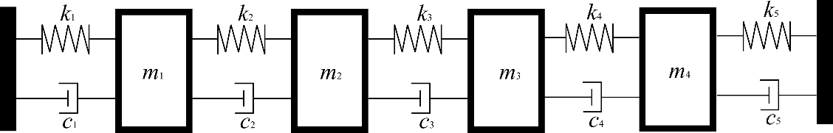
Fig. 1 A 4-DoF lump mass system
The eigenvalues of this system are
$λ_{1,2}=-0.06±0.42i$, $λ_{3,4}=-0.67±0.60i$, $λ_{5,6}=-0.50±1.29i$, $λ_{7,8}=-0.77±1.36i$
The corresponding eigenvectors are listed in Table 2. Example 1 is used to show the performance of the new method and three different cases are considered in this example. The first case is to assign all eight conjugate eigenpairs. The last two distinct (non-conjugate) eigenvalues are specially assigned to be equal to the open-loop eigenvalues. So, this looks like partial eigenvalue assignment but it is more than the conventional partial eigenvalue assignment in the sense that some eigenvectors are also assigned at the same time. In case 2, the first two distinct eigenpairs are assigned while the other two distinct eigenpairs are kept, which is proper partial eigenstructure assignment. In case 3, the first two distinct eigenpairs are assigned while the third distinct eigenpair is kept; the remaining (the 4th) distinct eigenpair is not controlled. Although case 3 is not a complete partial eigenstructure assignment, it is of particular significance in real applications in which only a small number of eigenpairs need to be changed, several other eigenpairs need to be retained, and all the other eigenpairs are left uncontrolled, which can be a cheaper solution than proper partial eigenstructure assignment.
Case 1: The first two pairs of eigenvalues are to be changed to desired eigenvalues as shown below and the remaining two pairs of eigenvalues stay unchanged.
$μ_{1,2}=-0.50±0.50i$, $μ_{3,4}=-0.90±0.80i$, $μ_{5,6}=-0.50±1.29i$, $μ_{7,8}=-0.77±1.36i$
Table 2. Eigenvalues and eigenvectors of the open-loop system
$$λ_{k}$$ | $v_{k}^{T}$
$$-0.06+0.42i$$ | 1.00 + 0.00i | 3.14 - 2.14i | 4.20- 2.33i | 3.63 - 1.66i
$$-0.06-0.42i$$ | 1.00 - 0.00i | 3.14 + 2.14i | 4.20+ 2.33i | 3.63 +1.66i
$$-0.67+0.60i$$ | 1.00+ 0.00i | -1.18 - 2.86i | 0.90 + 1.13i | -0.10 + 1.02i
$$-0.67-0.60i$$ | 1.00 - 0.00i | -1.18 + 2.86i | 0.90 - 1.13i | -0.10 - 1.02i
$$-0.50+1.29i$$ | 1.00 + 0.00i | 0.01 - 0.46i | 0.00 + 0.02i | -0.25 + 0.27i
$$-0.50-1.29i$$ | 1.00 - 0.00i | 0.01 + 0.46i | 0.00 - 0.02i | -0.25 - 0.27i
$$-0.77+1.36i$$ | 1.00 + 0.00i | -0.59 - 0.23i | -0.10 - 1.25i | 1.33 + 2.27i
$$-0.77-1.36i$$ | 1.00 - 0.00i | -0.59 + 0.23i | -0.10 + 1.25i | 1.33 - 2.27i
Additionally, the following nodes in the four modes shown in Table 3 are to be created in the closed-loop system.
Table 3. The desired eigenvalues and eigenvectors
$$μ_{k}$$ | $$w_{k}^{T}$$
$$-0.50+0.50i$$ | 1.00 + 0.00i | 3.00 - 2.00i | 0 | 3.00 - 2.00i
$$-0.50-0.50i$$ | 1.00 - 0.00i | 3.00 + 2.00i | 0 | 3.00 +2.00i
$$-0.90+0.80i$$ | 1.00 + 0.00i | 0 | 0.90 + 1.50i | -0.10 + 1.00i
$$-0.90-0.80i$$ | 1.00 - 0.00i | 0 | 0.90 - 1.50i | -0.10 -1.00i
$$-0.50+1.29i$$ | 1.00 + 0.00i | 0.00 - 0.80i | 0 | -0.20 - 0.30i
$$-0.50-1.29i$$ | 1.00 - 0.00i | 0.00 + 0.80i | 0 | -0.20 + 0.30i
$$-0.77+1.36i$$ | 1.00 + 0.00i | -0.50 - 0.00i | -0.10 - 1.00i | 0
$$-0.77-1.36i$$ | 1.00 - 0.00i | -0.50 + 0.00i | -0.10 + 1.00i | 0
In this case, n=4, 2p=8. Then the number of the inputs $i=4$ is chosen. Matrix B is predetermined as
$$B=\left[\begin{matrix}1 & -1 & 2 & 1 \\ 0.5 & 1 & 2 & 1 \\ -2 & -1 & 0.5 & 1 \\ -1 & 2 & 1.5 & 0.5\end{matrix}\right]$$
A mass 0.5 is added on coordinate 1 so the mass modification matrix is $ΔM=diag([0.5, 0, 0, 0])$.
Then the scaling matrix $A$ can be obtained using equation (28). Equation (34) gives the gain matrices $F$ and $G$ as
$F=\left[\begin{matrix}-1.25 & -0.65 & 0.58 & -2.09 \\ 1.95 & 1.63 & -1.02 & 1.82 \\ -0.46 & -0.52 & 0.05 & -2.14 \\ -1.17 & -1.16 & 1.27 & -2.80\end{matrix}\right]$, $G=\left[\begin{matrix}-1.29 & -0.87 & 0.67 & -1.27 \\ -2.38 & -1.32 & 1.92 & -6.73 \\ -1.85 & -1.60 & 0.54 & -4.20 \\ -2.17 & 1.27 & 0.49 & -2.27\end{matrix}\right]$
The closed-loop system can be described by
$$M\ddot{x}+C\dot{x}+Kx-BF^{T}\dot{x}-BG^{T}x=0$$
and the eigenvalue and eigenvectors of the closed-loop system are found to be exactly those as expected.
Case 2: To find out if assigning different eigenvectors may affect the performance of Method 2 (and at the same time keep the eigenvectors corresponding to those kept eigenvalues unchanged), another group of desired eigenpairs are listed in Table 4. The first two pairs of eigenvalues are to be shifted to desired locations together with different desired eigenvectors (different in the sense of being compared with those eigenvectors in Case 1) and the remaining two eigenpairs are kept unchanged.
Table 4 The desired eigenvectors and remaining eigenpairs
$$μ_{k}$$ | $$w_{k}^{T}$$
$$-0.50+0.50i$$ | 1.00 + 0.00i | 1.00 - 4.00i | 2.00 - 2.00i | -2.00 - 4.00i
$$-0.50-0.50i$$ | 1.00 - 0.00i | 1.00 + 4.00i | 2.00+2.00i | -2.00 +4.00i
$$-0.90+0.80i$$ | 1.00 + 0.00i | -2.00 – 3.00i | -3.00 + 2.00i | 1.00 - 2.00i
$$-0.90-0.80i$$ | 1.00 - 0.00i | -2.00+3.00i | -3.00 – 2.00i | 1.00 +2.00i
$$-0.50+1.29i$$ | 1.00 + 0.00i | 0.01 - 0.46i | 0.00 + 0.02i | -0.25 + 0.27i
$$-0.50-1.29i$$ | 1.00 - 0.00i | 0.01 + 0.46i | 0.00 - 0.02i | -0.25 - 0.27i
$$-0.77+1.36i$$ | 1.00 + 0.00i | -0.59 - 0.23i | -0.10 - 1.25i | 1.33 + 2.27i
$$-0.77-1.36i$$ | 1.00 - 0.00i | -0.59 + 0.23i | -0.10 + 1.25i | 1.33 - 2.27i
Following the same procedure in Case 1 and adopting the same force distribution matrix B yield
$F=\left[\begin{matrix}-0.25 & -0.31 & 0.73 & -1.46 \\ -0.65 & -0.41 & 2.20 & -4.46 \\ 0.71 & -0.14 & -1.62 & 2.44 \\ 0.66 & 0.25 & -1.59 & 2.75\end{matrix}\right]$, $G=\left[\begin{matrix}0.53 & 0.25 & -1.57 & 3.04 \\ -1.42 & -1.06 & 4.16 & -7.95 \\ 1.54 & 0.74 & -3.76 & 6.82 \\ 0.40 & 0.42 & -0.85 & 1.65\end{matrix}\right]$
The eigenvectors and eigenvalues of the closed-loop system are as expected in Table 4.
Case 3: In this case, the first and second pairs of eigenvalues $λ_{1,2}$ and $λ_{3,4}$ are to be changed to $μ_{1,2}=-0.5±0.5i$ and $μ_{3,4}=-0.90±0.80i$, while only the third pair of eigenvalue stays unchanged. The last pair of eigenvalues is not concerned (controlled). The desired eigenvectors corresponding to the first and second pairs of eigenvalues and the unchanged eigenpairs are shown in Table 5, which are the same as the eigenvectors shown in Table 4.
Table 5. The desired eigenvalues and eigenvectors
$$μ_{k}$$ | $$w_{k}^{T}$$
$$-0.50+0.50i$$ | 1.00 + 0.00i | 1.00 - 4.00i | 2.00 - 2.00i | -2.00 - 4.00i
$$-0.50-0.50i$$ | 1.00 - 0.00i | 1.00 + 4.00i | 2.00+2.00i | -2.00 +4.00i
$$-0.90+0.80i$$ | 1.00 + 0.00i | -2.00 – 3.00i | -3.00 + 2.00i | 1.00 - 2.00i
$$-0.90-0.80i$$ | 1.00 - 0.00i | -2.00+3.00i | -3.00 – 2.00i | 1.00 +2.00i
$$-0.50+1.29i$$ | 1.00 + 0.00i | 0.01 - 0.46i | 0.00 + 0.02i | -0.25 + 0.27i
$$-0.50-1.29i$$ | 1.00 - 0.00i | 0.01 + 0.46i | 0.00 - 0.02i | -0.25 - 0.27i
Again, four actuators are adopted here and the invertible force distribution matrix $B$ is defined as the same as the matrix B in Case 1.
The same procedure in Case 1 is applied here and equation (34) gives the gain matrices $F$ and $G$ as
$F=\left[\begin{matrix}-1.03 & 0.11 & -0.32 & -0.41 \\ 1.23 & 0.81 & 0.26 & -0.99 \\ 0.63 & -1.57 & 1.22 & -1.40 \\ -1.08 & -0.65 & -0.25 & 0.16\end{matrix}\right]$, $G=\left[\begin{matrix}-1.45 & -0.85 & 0.10 & -0.11 \\ -1.10 & 0.82 & 0.48 & -2.88 \\ 2.96 & -0.49 & -0.91 & 3.65 \\ -0.03 & -0.96 & 1.81 & -2.12\end{matrix}\right]$
Now the closed-loop system becomes
$$M\ddot{x}+C\dot{x}+Kx-BF^{T}\dot{x}-BG^{T}x=0$$
with eigenvalues found to be
$μ_{1,2}=-0.50±0.50i$, $μ_{3,4}=-0.90±0.80i$, $μ_{5,6}=-0.50±1.29i$, $μ_{7,8}=-1.34±2.12i$
The eigenvectors of this closed-loop system are presented in Table 6. It can be seen that the closed-loop system has those desired eigenvalues and eigenvectors. The only difference between Case 2 and Case 3 is that the last pair of eigenvalues is not concerned in Case 3.
Table 6. Eigenvalues and eigenvectors of the closed-loop system
$$μ_{k}$$ | $$w_{k}^{T}$$
$$-0.50+0.50i$$ | 1.00 + 0.00i | 1.00 - 4.00i | 2.00 - 2.00i | -2.00 - 4.00i
$$-0.50-0.50i$$ | 1.00 - 0.00i | 1.00 + 4.00i | 2.00+2.00i | -2.00 +4.00i
$$-0.90+0.80i$$ | 1.00 + 0.00i | -2.00 – 3.00i | -3.00 + 2.00i | 1.00 - 2.00i
$$-0.90-0.80i$$ | 1.00 - 0.00i | -2.00+3.00i | -3.00 – 2.00i | 1.00 +2.00i
$$-0.50+1.29i$$ | 1.00 + 0.00i | 0.01 - 0.46i | 0.00 + 0.02i | -0.25 + 0.27i
$$-0.50-1.29i$$ | 1.00 - 0.00i | 0.01 + 0.46i | 0.00 - 0.02i | -0.25 - 0.27i
$$-1.34+2.12i$$ | 1.00+0.00i | 0.06 - 0.27i | -0.12+0.38i | -0.39 - 0.14i
$$-1.34-2.12i$$ | 1.00 - 0.00i | 0.06 + 0.27i | -0.12 - 0.38i | -0.39 + 0.14i
If the control effort of active control is defined by the Frobenius norm of the feedback gain matrices, which can be written as $En={\left\|\begin{matrix}F \\ G\end{matrix}\right\|}_{F}^{2}$, the control efforts in Case 2 and Case 3 can be calculated as 382.05 and 57.61, respectively. Apparently, the control effort in Case 3 is much smaller than the control effort in Case 2, which means that leaving some unimportant eigenvalues uncontrolled will reduce the control effort.
In example 1, all the 4 degrees of freedom in this system can be measured or actuated. However, in most engineering cases, not all the degrees of freedom of the system could be measured. The next example is to demonstrate how to deal with a system with inaccessible degrees of freedom and the number of actuators required can be reduced if only a small number of eigenvalues need to be maintained.
Example 2. Consider an undamped 10-DoF system, as shown in Fig. 2. This example was used by Ouyang and Zhang in [30].
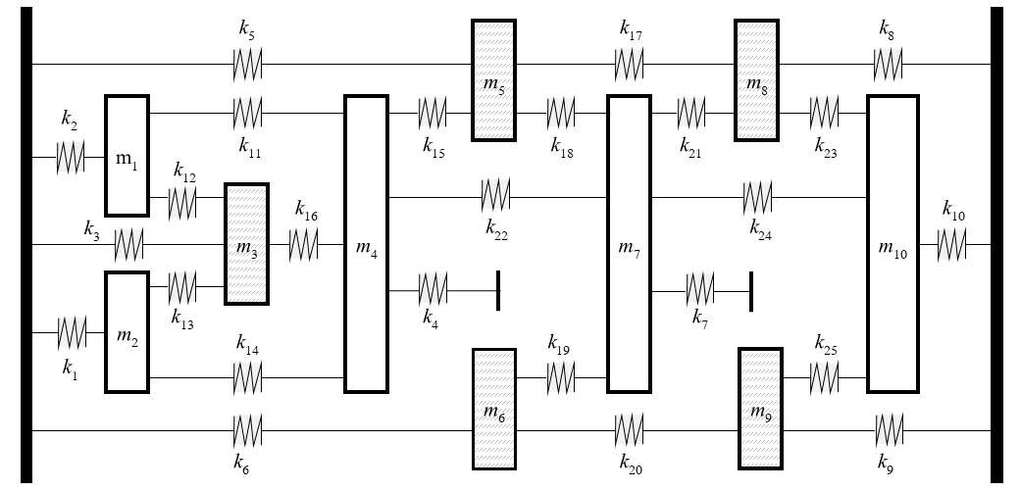
Fig. 2 A 10-DoF lumped mass system

The values of the mass and stiffness parameters are listed in Table 7 and the natural frequencies of the open-loop system are presented in the second row in Table 8.
Table 7. System parameters
$$m_{i},i=1,…,10 [kg]$$ | $$30, 35, 40, 45, 45, 45, 40, 35, 30, 25$$
$$k_{i},i=1,…,25 [N/m]$$ | $$2.4×{10}^{5}$$
Table 8. Natural frequencies of the open-loop system and the closed-loop system
 | Natural frequencies [rad/s]
Open-loop | 80.0 | 98.1 | 120.9 | 148.7 | 151.9 | 168.7 | 179.5 | 189.1 | 205.7 | 221.7
Closed-loop | 90.0 | 110.0 | 120.9 | 149.0 | 150.4 | 167.6 | 190.4 | 193.0 | 206.0 | 221.7
It is wanted that the first two pairs of eigenvalues of the open-loop system are shifted from $λ_{1,2}=±80i rad/s$ and $λ_{3,4}=±98i rad/s$ to $μ_{1,2}=±90i rad/s$ and $μ_{3,4}=±110i rad/s$, while the third pair of eigenvalues $μ_{5,6}=±120.92i rad/s$ is unchanged. In addition, only 5 among the 10 degrees of freedom could be measured or observed. The others are inaccessible. Mass 3, 5, 6, 8, and 9 are chosen as the measurable degrees of freedom in this example. Besides, only displacement feedback matrix G is adopted here.
The desired eigenvectors corresponding to first three pairs of eigenvalues are shown in Table 9. It should be mentioned that the eigenvectors in this example are not the whole eigenvectors of the system, but the eigenvector elements at the measurable degrees of freedom.
Table 9. Eigenvectors corresponding to the first three pairs of eigenvalues
Open-loop system |  |  | Desired eigenvectors
$$λ_{1,2}$$ | $$λ_{3,4}$$ | $$λ_{5,6}$$ | $$μ_{1,2}$$ | $$μ_{3,4}$$ | $$μ_{5,6}$$
-0.95 | 0.88 | -0.42 | -0.70 | -0.70 | -0.40
-1 | -0.11 | 1.00 | -1.00 | -0.10 | 1
-0.96 | -1.00 | -0.93 | -0.90 | 1.00 | -0.60
-0.89 | -0.38 | 0.85 | -0.50 | 0.30 | 0.70
-0.80 | -0.85 | -0.59 | -0.60 | 0.60 | -0.60
In this example, $n=5$ and $p=3$. Then the number of inputs is chosen as $i=$3. Define the control force distribution matrix $B∈R^{5×3}$ as
$B=\left[\begin{matrix}B_{e} \\ B_{f}\end{matrix}\right]$ and $B_{e}=\left[\begin{matrix}1 & 1.5 & 1.5 \\ -1.2 & -1 & -0.5 \\ -0.1 & -3 & -1\end{matrix}\right]$
Two lumped masses 10 kg and 20 kg are placed on mass 3 and 5, respectively. By using equation (28), matrix $B$ and scaling matrix $A$ can be obtained
$B=\left[\begin{matrix}1 & 1.5 & 1.5 \\ -1.2 & -1 & -0.5 \\ -0.1 & -3 & -1 \\ 3.68 & -4.11 & -0.57 \\ 2.35 & -2.06 & -0.55\end{matrix}\right]$ and $A=10^{5}×\left[\begin{matrix}0.13 & 0.67 & -0.30 \\ -0.79 & 1.22 & -0.04 \\ 2.08 & -3.95 & -0.06\end{matrix}\right]$
Then equation (34) gives the gain matrix $G$ as
$$G^{T}=10^{5}×\left[\begin{matrix}0.50 & -0.12 & -0.22 & -0.25 & -0.06 \\ 1.18 & 0.35 & -0.27 & -0.19 & -0.06 \\ -3.51 & -1.03 & 1.02 & 0.60 & 0.31\end{matrix}\right]$$
The closed-loop system is governed by
$$M\ddot{x}+Kx-BG^{T}x=0$$
with the natural frequencies shown in the third row in table 8. The eigenvectors associated with the concerned eigenvalues can be seen to be the same as the desired ones presented in Table 9.
Example 3. This example demonstrates the differences between the two methods described in section 2. The open-loop system in example 1 is adopted here. The two methods are applied to assign the second pair of eigenvalues $μ_{3,4}=-0.90±0.80i$ and keep the first pair of eigenvalues $μ_{1,2}=-0.06±0.42i$ unchanged.
It has been explained in section 2 that the method proposed by Ram and Mottershead [29] uses the receptance matrices and some eigenvectors of the open-loop system. As shown in table 2, the eigenvectors of the open-loop system corresponding to the unchanged eigenvalues are
$$v_{1}={\overline{v}}_{2}={\left[\begin{matrix}1.00 + 0.00i & 3.14 - 2.14i & 4.20 - 2.33i & 3.63 - 1.66i\end{matrix}\right]}^{T}$$
With the accurate eigenvectors, Method 1 can certainly find the closed-loop system with the right expected eigenvalues. However, considering the scenario that the measured eigenvectors of the open-loop system are inaccurate, for example, the measured eigenvectors associated with the unchanged eigenvalues are
$$v_{1}^{*}={\overline{v}}_{2}^{*}={\left[\begin{matrix}1.00 + 0.00i & 3.14 - 2.14i & 4.20 - 2.33i & 1-2i\end{matrix}\right]}^{T}$$
If the force distribution matrix $B^{*}$ and the scaling vector $α^{*}$ are defined as
$B^{*}={\left[\begin{matrix}1 & 0.5 & -2 & -1\end{matrix}\right]}^{T}$ and $α^{*}={\left[\begin{matrix}1 & 1\end{matrix}\right]}^{T}$
After obtaining the receptance matrices $H^{*}(μ_{1,2})$, the gain vectors can be calculated through equations (10) – (18) as
$f^{*}={\left[\begin{matrix}-0.36 & -0.61 & 0.54 & -0.97\end{matrix}\right]}^{T}$ $g^{*}={\left[\begin{matrix}0.00 & -0.50 & 0.68 & -0.52\end{matrix}\right]}^{T}$
leading to eigenvalues
$μ_{1,2}^{*}=-0.11±0.36i$, $μ_{3,4}^{*}=-0.90±0.80i$, $μ_{5,6}^{*}=-0.56±1.17i$, $μ_{7,8}^{*}=-0.69±1.32i$
The resulting eigenvalues $μ_{1,2}^{*}$ are not the same as $-0.06±0.42i$ (to stay unchanged), though. It means that Method 1 is not able to achieve accurate partial eigenvalue assignment when the eigenvectors of the open-loop system are inaccurate. In this case, Method 2, which does not need the eigenvectors of the open-loop system, is more suitable.

4 Robustness analysis
Although there is no need to build a finite element model or numerical model of the system in the receptance method and thus the errors associated with modelling can be avoided, the receptance matrix, which is usually obtained from experiment, may suffer from measurement errors, uncertainty of the system or the misfitting of the frequency response function. The errors contained in the receptance matrix, could lead to poor results for the partial assignment. This section makes an analysis of the robustness of Method 2 by using example 1 in section 3. The same targets in Case 1, which are to shift the first two pairs of eigenvalues to $μ_{1,2}=-0.50±0.50i$ and $μ_{3,4}=-0.90±0.80i$ and keep the remaining two pairs of eigenvalues unchanged as $μ_{5,6}=-0.50±1.29i$ and $μ_{7,8}=-0.77±1.36i$, are expected here. Also, the force distribution matrix B is defined as the same as the matrix B in example 1 in section 3. Three different scenarios are considered in this section.

4.1 Receptance matrices with several contaminated elements
Consider the 4-DoF system in example 1. Suppose that the receptance matrices, which are obtained from simulation in this paper, are contaminated at one or two locations. The added numerical perturbation is defined as
$${\hat{h}}_{ij}\left(μ_{k}\right)=h_{ij}\left(μ_{k}\right)*rand(0.95,1.05)$$
where ${\hat{h}}_{ij}\left(μ_{k}\right)$ is the contaminated receptance, $h_{ij}\left(μ_{k}\right)$ is the true receptance and $rand(0.95,1.05)$ returns a random number between 0.95 and 1.05 which leads to a 5% variation of the true receptance at most. Besides, to maintain the symmetrical characteristic of a receptance matrix, $h_{ji}\left(μ_{k}\right)$ is also perturbed and ${\hat{h}}_{ji}\left(μ_{k}\right)={\hat{h}}_{ij}\left(μ_{k}\right)$.
There are eight receptance matrices to be measured or to be simulated in this example. The contaminated elements in each matrix are shown in Table 10.
Table 10. Contaminated elements in each receptance matrix
Receptance matrix | Contaminated elements
$$\hat{H}\left(μ_{1,2}\right)$$ | ${\hat{h}}_{12}={\hat{h}}_{21}$, ${\hat{h}}_{23}={\hat{h}}_{32}$
$$\hat{H}(μ_{3,4})$$ | $${\hat{h}}_{12}={\hat{h}}_{21}$$
$$\hat{H}(μ_{5,6})$$ | ${\hat{h}}_{23}={\hat{h}}_{32}$, ${\hat{h}}_{43}={\hat{h}}_{34}$
$$\hat{H}(μ_{7,8})$$ | $${\hat{h}}_{13}={\hat{h}}_{31}$$
Fig. 3 shows a Monte-Carlo simulation with 1000 samples. Those eight rectangles represent regions of obtained eigenvalues and they are defined as
$$Region\left(μ_{k}\right)=μ_{k}+\left[-0.05, 0.05\right]±\left[-0.05, 0.05\right]i$$
It can be seen all the obtained eigenvalues fall into small regions which are close to the nominal values of targeted ones. The variance of each eigenvalue is very small. Also, Fig. 3 indicates that the real part of the eigenvalues of closed-loop system, which affect the system damping, are more sensitive to the receptance errors.
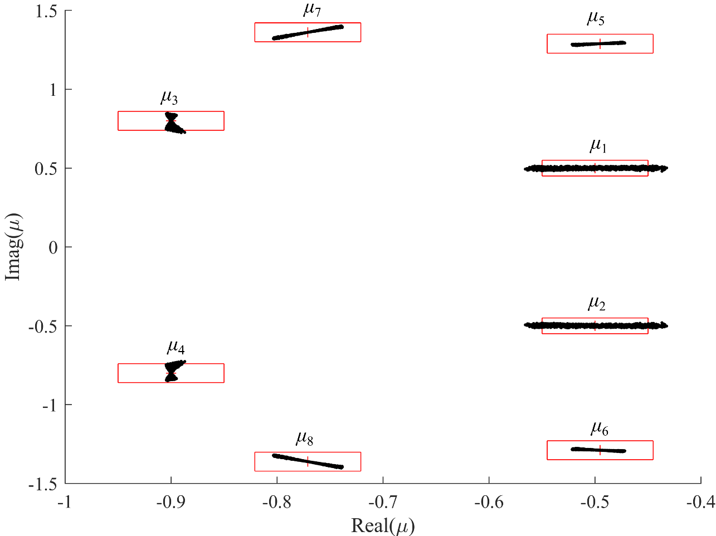
Fig. 3 Eigenvalues of the closed-loop system (with a few contaminated elements in receptance matrices)

4.2 Receptance matrices with one pair of contaminated eigenvalues
Consider the case that the receptance matrices at one pair of eigenvalues are contaminated. It is worth to find out whether the other pairs of eigenvalues will be affected. The receptance matrix with errors is simulated as
$$\hat{H}\left(μ_{k}\right)=H\left(μ_{k}\right)*rand(0.95,1.05)$$
Suppose that the receptance matrices at the second pair of eigenvalues $H\left(μ_{3,4}\right)$ are contaminated. A new Monte-Carlo simulation with 1000 samples is conducted. Fig. 4 shows the new variability of the obtained eigenvalues. It is clear that only the eigenvalues $μ_{3,4}$ are uncertain and all the other three pairs of eigenvalues are exactly where they are expected. Similarly, if the receptance matrices at the other one or two pairs of eigenvalues are contaminated, only the corresponding eigenvalues are uncertain and the others are unaffected. This is good for the real applications when only a few receptance matrices are uncertain.
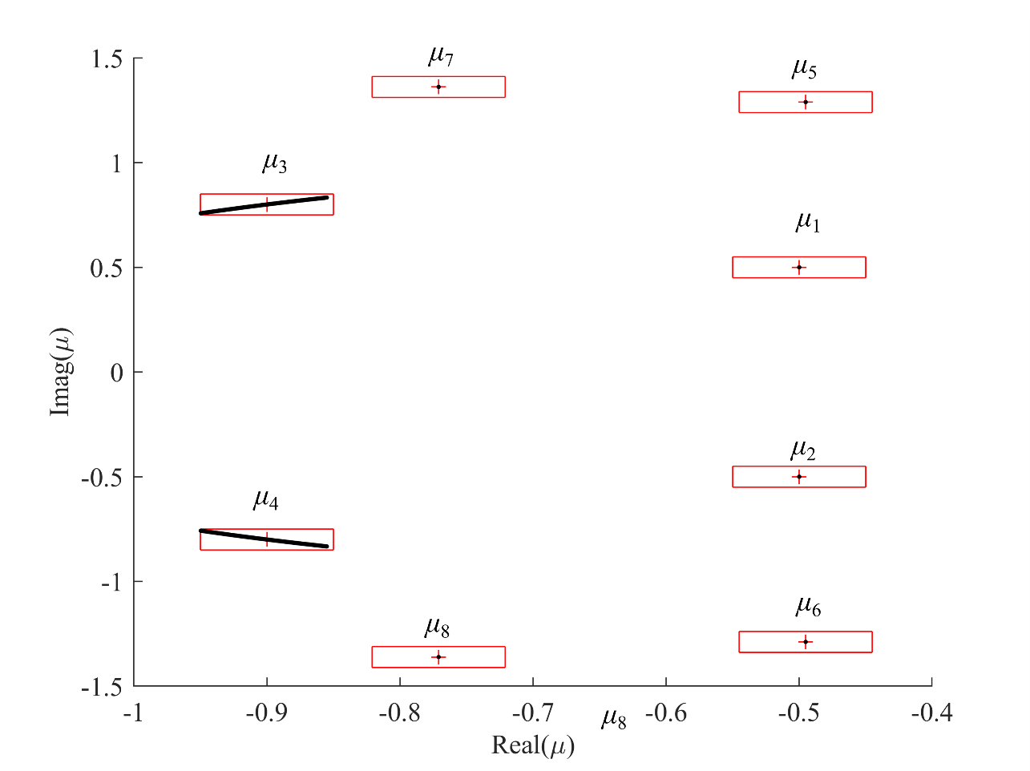
Fig. 4 Eigenvalue spread (with contaminated receptance matrices $H\left(μ_{3,4}\right)$ )

4.3 Fully contaminated receptance matrices
Now, suppose that all required receptance matrices are variable by as much as 5% of their nominal values. Fig. 5 shows the variability of the obtained eigenvalues. By comparison it with Fig. 3, the variation of the imaginary part of each eigenvalue is seen to be bigger because more noise is included. However, it still can be seen that most of the obtained eigenvalues are within small regions of frequencies (represented by rectangles). Therefore, this method can be said to be robust in terms of the errors in the measured receptances for the four-DoF damped system.
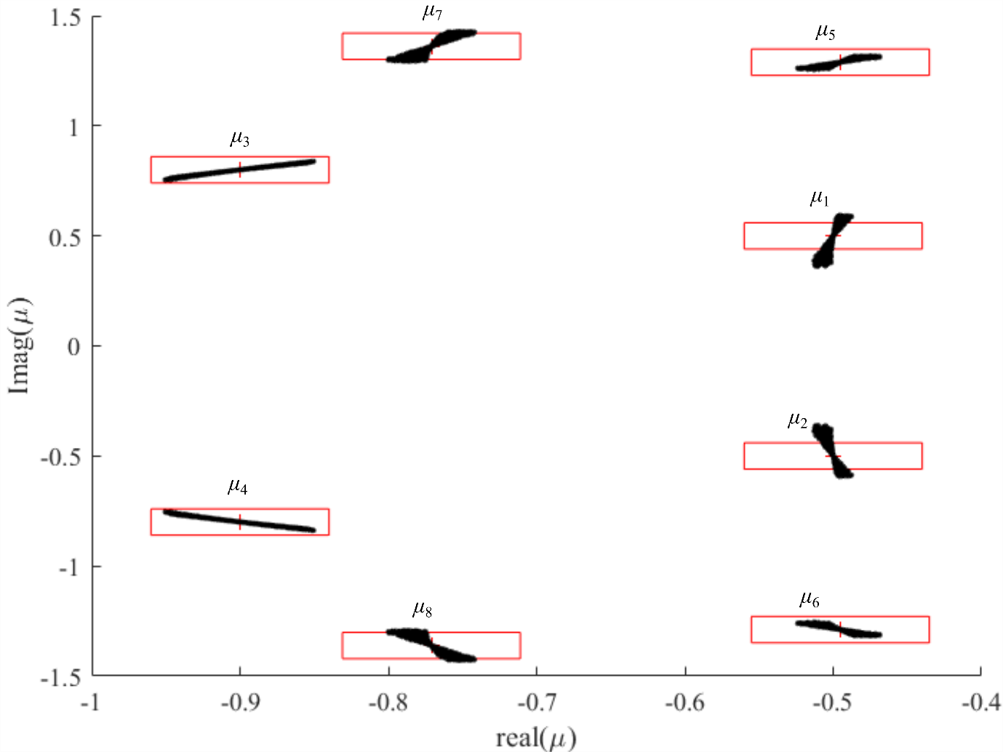
Fig. 5 Eigenvalues spread (all receptance matrices are contaminated)

5 Conclusions
A partial eigenstructure assignment method by state feedback control is proposed in this research. This method does not need the physical model (or finite element model) since it is based on measure receptances, and the eigenvectors of the open-loop system. Only part of the receptance matrix is required. A comparison between this method and the method proposed by Ram and Mottershead (Multiple-input active vibration control by partial pole placement using the method of receptances, Mechanical Systems and Signal Processing, 40 (2013) 727-735) is presented. It shows that this new method has advantages when the eigenvectors are hard to obtain or inaccurate. It is also verified by means of numerical examples that this method can work efficiently for systems with inaccessible degrees of freedom. This method can assign some desired eigenpairs and keep all the other or some of the other eigenpairs unchanged. With the same number of actuators and same force distribution matrix B, compared with keeping all the other eigenpairs unchanged, the control effort is smaller if only some of the other eigenpairs are kept. This finding should enable a more cost-effective solution in practice.
The robustness of this method is also analysed. Three scenarios of contaminated receptance matrices are considered. The simulation results show this method is robust where there are 5% variations of receptance matrices for a four-DoF damped system. Besides, if a few receptance matrices are contaminated at certain eigenvalues, all the other eigenvalues are unaffected and only the related eigenvalues are uncertain to a small extent.
However, in this method, the number of the required inputs depends on the total number of the assigned and unchanged eigenvalues, and the number of degrees of freedom. This may restrict the application of this partial eigenstructure assignment method in real applications. Therefore, further research is needed to investigate how to reduce the number of required inputs.

Declaration of Competing interest
The authors declare that they have no known competing financial interests or personal relationships that could appeared to influence the work reported in this paper.

Acknowledgements
The first author is grateful to the support of University of Liverpool in the form of a PhD scholarship.

Appendix
The Woodbury matrix identity, named after Max A. Woodbury, states that the invers of a rank correction of a matrix can be expressed as a rank correction of the inverse. The Woodbury equation [47] can be stated as
${\left(A+UV^{T}\right)}^{-1}=A^{-1}-A^{-1}U{\left(I+V^{T}A^{-1}U\right)}^{-1}V^{T}A^{-1}$ (A1)
where I is an identity matrix. $U$ and $V$ can be any matrices or simple row or column vectors.
In subsection 2.3, the receptance matrix of the mass-modified system is defined as
${\tilde{H}\left(λ\right)=\left(K+λC+λ^{2}M+λ^{2}ΔM\right)}^{-1}$ (A2)
And the receptance matrix of original system is denoted as $H\left(λ\right)={\left(K+λC+λ^{2}M\right)}^{-1}$. By replacing matrices $A$, $U$ and $V$ in equation (A1) with matrices $\left(K+λC+λ^{2}M\right)$, $λ^{2}ΔM$ and I respectively, the following equation can be obtained
$\tilde{H}\left(λ\right)=H\left(λ\right)-λ^{2}H\left(λ\right)ΔM{\left(I+λ^{2}H\left(λ\right)ΔM\right)}^{-1}H\left(λ\right)$ (A3)
Therefore, the receptance matrix of the mass-modified system can be derived from the receptance matrix of the original system using equation (A3).

References
[1] R.E.D. Bishop, D.C. Johnson, The mechanics of vibration, Cambridge University Press, (1960).
[2] D.J. Ewins, Modal testing: theory, practice and application, second ed., Research Studies Press, Baldock, Herfordshire, UK, (2000).
[3] R.J. Pomazal, V.W. Snyder, Local modifications of damped linear systems, AIAA Journal, 9 (1971) 2216-2221.
[4] J.O. Hallquist, An efficient method for determining the effects of mass modifications in damped systems, Journal of Sound and Vibration, 44 (1976) 449-459.
[5] S. Xu, J. Qian, Orthogonal basis selection method for robust partial eigenvalue assignment problem in second-order control systems, Journal of Sound and Vibration, 317 (2008) 1-19.
[6] K. Farahani, H. Bahai, An inverse strategy for relocation of eigenfrequencies in structural design. Part I: first order approximate solutions, Journal of Sound and Vibration, 274 (2004) 481-505.
[7] K. Farahani, H. Bahai, An inverse strategy for relocation of eigenfrequencies in structural design. Part II: second order approximate solutions, Journal of Sound and Vibration, 274 (2004) 507-528.
[8] J.F. Baldwin, S.G. Hutton, Natural modes of modified structures, AIAA Journal, 23 (1985) 1737-1743.
[9] Y.G. Tsuei, E.K.L. Yee, A method for modifying dynamic properties of undamped mechanical systems, Journal of Dynamic Systems, Measurement, and Control, 111 (1989) 403-408.
[10] Y.H. Park, Y.s. Park, Structural modification based on measured frequency response functions: an exact eigenproperties reallocation, Journal of Sound and Vibration, 237 (2000) 411-426.
[11] J. Kautsky, N. Nichols, Robust pole assignment in linear state feedback, International Journal of Control, 41 (1985) 1129-1155.
[12] E.K. Chu, B.N. Datta, Numerically robust pole assignment for second-order systems, International Journal of Control, 64 (1996) 1113-1127.
[13] A. Kyprianou, J.E. Mottershead, H. Ouyang, Assignment of natural frequencies by an added mass and one or more springs, Mechanical Systems and Signal Processing, 18 (2004) 263-289.
[14] T. Abdelaziz, M. Valasek, Direct algorithm for pole placement by state-derivative feedback for multi-input linear systems-Nonsingular case, Acta Polytechnica, 41 (2005) 637-660.
[15] Y.M. Ram, J.E. Mottershead, Receptance method in active vibration control, AIAA Journal, 45 (2007) 562-567.
[16] M. Ghandchi Tehrani, J.E. Mottershead, A.T. Shenton, Y.M. Ram, Robust pole placement in structures by the method of receptances, Mechanical Systems and Signal Processing, 25 (2011) 112-122.
[17] S.-H. Tsai, H. Ouyang, J.-Y. Chang, Inverse structural modifications of a geared rotor-bearing system for frequency assignment using measured receptances, Mechanical Systems and Signal Processing, 110 (2018) 59-72.
[18] J.M. Araújo, T. Santos, A multiplicative eigenvalues perturbation and its application to natural frequency assignment in undamped second-order systems, Proceedings of the Institution of Mechanical Engineers, Part I: Journal of Systems and Control Engineering, 232 (2018) 963-970.
[19] A. Brauer, Limits for the characteristic roots of a matrix. IV: Applications to stochastic matrices, Duke Mathematical Journal, 19 (1952) 75-91.
[20] J.M. Araújo, T.L.M. Santos, Control of a class of second-order linear vibrating systems with time-delay: smith predictor approach, Mechanical Systems and Signal Processing, 108 (2018) 173-187.
[21] D. Richiedei, I. Tamellin, Active control of linear vibrating systems for antiresonance assignment with regional pole placement, Journal of Sound and Vibration, 494 (2021) 115858.
[22] B.N. Datta, S. Elhay, Y.M. Ram, Orthogonality and partial pole assignment for the symmetric definite quadratic pencil, Linear Algebra and its Applications, 257 (1997) 29-48.
[23] B.N. Datta, D.R. Sarkissian, Multi-input partial eigenvalue assignment for the symmetric quadratic pencil, Proceedings of the 1999 American Control Conference (Cat. No. 99CH36251), 1999, pp. 2244-2247
[24] Y.M. Ram, S. Elhay, Pole assignment in vibratory systems by multi-input control, Journal of Sound and Vibration, 230 (2000) 309-321.
[25] J. Qian, S. Xu, Robust partial eigenvalue assignment problem for the second-order system, Journal of Sound and Vibration, 282 (2005) 937-948.
[26] Y.-F. Cai, J. Qian, S.-F. Xu, The formulation and numerical method for partial quadratic eigenvalue assignment problems, Numerical Linear Algebra with applications, 18 (2011) 637-652.
[27] Z.-J. Bai, Q.-Y. Wan, Partial quadratic eigenvalue assignment in vibrating structures using receptances and system matrices, Mechanical Systems and Signal Processing, 88 (2017) 290-301.
[28] M.G. Tehrani, R.N. Elliott, J.E. Mottershead, Partial pole placement in structures by the method of receptances: theory and experiments, Journal of Sound and Vibration, 329 (2010) 5017-5035.
[29] Y.M. Ram, J.E. Mottershead, Multiple-input active vibration control by partial pole placement using the method of receptances, Mechanical Systems and Signal Processing, 40 (2013) 727-735.
[30] H. Ouyang, J. Zhang, Passive modifications for partial assignment of natural frequencies of mass–spring systems, Mechanical Systems and Signal Processing, 50-51 (2015) 214-226.
[31] R. Belotti, H. Ouyang, D. Richiedei, A new method of passive modifications for partial frequency assignment of general structures, Mechanical Systems and Signal Processing, 99 (2018) 586-599.
[32] B. Mokrani, A. Batou, S. Fichera, L. Adamson, D. Alaluf, J.E. Mottershead, The minimum norm multi-input multi-output receptance method for partial pole placement, Mechanical Systems and Signal Processing, 129 (2019) 437-448.
[33] M.O. de Almeida, J.M. Araújo, Partial eigenvalue assignment for LTI systems with D-Stability and LMI, Journal of Control, Automation and Electrical Systems, 30 (2019) 301-310.
[34] N.J.B. Dantas, C.E.T. Dorea, J.M. Araujo, Partial pole assignment using rank-one control and receptance in second-order systems with time delay, Meccanica, 56 (2021) 287-302.
[35] H. Xie, A receptance method for robust and minimum norm partial quadratic eigenvalue assignment, Mechanical Systems and Signal Processing, 160 (2021) 107838.
[36] B.N. Datta, Finite-element model updating, eigenstructure assignment and eigenvalue embedding techniques for vibrating systems,, Mechanical Systems and Signal Processing, 16 (2002) 83-96.
[37] G.-R. Duan, G.-P. Liu, Complete parametric approach for eigenstructure assignment in a class of second-order linear systems, Automatica, 38 (2002) 725-729.
[38] M. Rastgaar, M. Ahmadian, S. Southward, A review on eigenstructure assignment methods and orthogonal eigenstructure control of structural vibrations, Shock and Vibration, 16 (2009) 706731.
[39] H. Ouyang, D. Richiedei, A. Trevisani, G. Zanardo, Eigenstructure assignment in undamped vibrating systems: a convex-constrained modification method based on receptances, 27 (2012) 397-409.
[40] Z. Liu, W. Li, H. Ouyang, D. Wang, Eigenstructure assignment in vibrating systems based on receptances, Archive of Applied Mechanics, 85 (2015) 713-724.
[41] R. Belotti, D. Richiedei, Dynamic structural modification of vibrating systems oriented to eigenstructure assignment through active control: A concurrent approach, Journal of Sound and Vibration, 422 (2018) 358-372.
[42] R. Belotti, D. Richiedei, A. Trevisani, Multi-domain optimization of the eigenstructure of controlled underactuated vibrating systems, Structural and Multidisciplinary Optimization, 63 (2021) 1-16.
[43] H. Liu, H. Gao, Y. Ma, Receptance-based assignment of dynamic characteristics: a summary and an extension, Mechanical Systems and Signal Processing, 145 (2020) 106913.
[44] D.J. Laporte, V. Lopes, D.D. Bueno, An approach to reduce vibration and avoid shimmy on landing gears based on an adapted eigenstructure assignment theory, Meccanica, 55 (2020) 7-17.
[45] S. Brahma, B. Datta, An optimization approach for minimum norm and robust partial quadratic eigenvalue assignment problems for vibrating structures, Journal of Sound and Vibration, 324 (2009) 471-489.
[46] L. Zhang, X.T. Wang, Partial eigenvalue assignment for high order system by multi-input control, Mechanical Systems and Signal Processing, 42 (2014) 129-136.
[47] M. Woodbury, Inverting modified matrices. Memorandum Report 42, Statistical Research Group, Institute for Advanced Study, Princeton, NJ, 1950.

