Receptance-based computation of stability crossing curves for single-input-multiple-output second-order linear systems with two time-delays
Zhong-Hui Lv ª, Jia-Fan Zhang ^{b *}, Huajiang Ouyang ^{c}
ª Wuhan Institute of Shipbuilding Technology, Wuhan 430050, China
^{b} School of Mechanical Engineering, Wuhan Polytechnic University, Wuhan 430023, China
^{c} School of Engineering, University of Liverpool, The Quadrangle, Liverpool L693GH, UK

Abstract: For a complete stability analysis of multi-dimensional controlled systems modelled in the framework of second-order linear differential equations with two time-delays, the determination of stability crossing curves (or stability switching curves) within the domain of the delays is significantly important. This paper presents a simple receptance-based approach to solve this problem for a single-input-multiple-output controlled system using its second-order model. The proposed approach is based on a reduced characteristic function of the controlled system. This characteristic function is directly related to the receptance of the uncontrolled system and has a peculiar form that is well-suited for an effective method of calculation of these curves. Moreover, this method can find the direction in which the characteristic roots cross the imaginary axis as the delays deviate from a stability crossing curve. An example case study with two independent and constant delays is given to demonstrate the effectiveness of the proposed approach.
Keywords: Time-delay system, Second-order system, Single-input-multiple-output, Stability, Stability crossing curve, Receptance

- Introduction
The time-delay phenomena inevitably exist in controlled mechanical and structural systems, primarily due to the time it takes in the feedback loop to acquire and process the information about the dynamic states, and to execute the control action. The stability analysis of time-delayed systems within the domain of the delays is complicated due to the transcendental nature of their characteristic equations containing some exponential terms about the time delays, which have an infinite number of characteristic roots (also known as eigenvalues or poles). As the number of delays increases, a stability analysis becomes much more challenging [1-3].
A linear time invariant time-delayed system is normally modelled by a set of first-order delay-differential equations (DDEs), and has been extensively researched in the past decades [4, 5]. Recently, a very thorough review on the stability analysis and the computation of characteristic roots for first-order DDEs with constant delays was presented in [6]. In this article, we concentrate however on controlled mechanical and structural systems with two independent and constant delays whose equations of motion are naturally formulated in the second-order setting, and determine their stability boundaries in the space of time delays. The work makes use of single-input-multiple-output (SIMO) control.
There existed some articles that discussed the stability analysis of the scalar second-order DDE with a single delay, e.g., early works on the stability conditions of the system parameters [7,8] and the delay [9-11], and recent works [12,13]. In addition, a homotopy continuation method was developed to find the characteristic roots of a two delays system [14]. Another interesting study that is worth pointing out here investigated the effects of two delays on stability and performance of a single-degree-of-freedom (SDOF) active feedback control system [15]. The two delays correspond to the velocity and displacement feedback loops, respectively. The stable and unstable regions and the boundaries that separate them in the plane of the time delay pair were identified in [15].
For multi-input-multi-output (MIMO) time-delayed systems modelled by the multidimensional second-order DDEs with constant delays, many researches focused on full or partial eigenvalue assignment using the system matrices and/or the receptances via single-input/multi-input control [16-26]. In regard to stability design, a novel approach to numerically computing feedback gains of the single-input feedback controllers was presented in [27], and their method guaranteed robust stability in a predefined margin. In [28, 29], the authors proposed a receptance-based delay compensation strategy that was combined with the filtered Smith predictor, and the obtained results outperformed pure pole/eigenvalue assignment techniques. Additionally, they also provided a receptance-based stability criterion for second-order systems with a time-varying delay [30]. The critical time delay for a SIMO system with a single time delay was determined in [31]. By using the singular value decomposition technique, the problem was reduced to finding the roots of a certain polynomial. Some researchers discussed the stability analysis and estimation of the critical time delay for the two-DOF model of mechanical systems subjected to friction-induced vibration [20,32,33]. In [34], the authors examined the effects of incomplete boundary conditions and actuator delay on the dynamic responses of seismically excited civil structures. Some of the authors of this article put forward a reduced characteristic function, which was built on the measured receptance of the uncontrolled systems, for second-order MIMO DDEs with two constant delays [35]. The resultant characteristic function was exploited to conduct the stability-testing and the computation of the dominant eigenvalues within a pre-specified region in the complex eigenvalue plane.
This work presents another form of the above characteristic function to determine stability boundaries of SIMO systems with two constant time delays. To the best of the authors’ knowledge, little research has touched upon the stability boundaries of multidimensional second-order DDEs with two time-delays. It is well known that a linear time-invariant time-delayed system of retarded type is asymptotically and exponentially stable if and only if all its infinitely many characteristic roots lie in the open left complex half-plane [6]. The boundaries separating the stable and unstable regions in the space of the time delays is referred to as stability crossing curves (also known as stability switching curves or critical curves) for two-delay case. From continuity of eigenvalues, it is clear that, for any point on stability crossing curves, the corresponding DDEs has at least one pair of purely imaginary characteristic roots. As the obtained characteristic function is not a normal characteristic quasi-polynomial, the famous cluster treatment of characteristic roots (CTCR) paradigm (see e.g. [36]) is not adopted to analyse stability boundaries of time-delayed systems under investigation in this paper. However, for a special case of characteristic functions given by
$g\left(s; {}_{1},{}_{2} \right)=P_{0}\left(s\right)+P_{1}\left(s\right)e^{-{}_{1}s}+P_{2}\left(s\right)e^{-{}_{2}s}=0$ (1)
where $P_{i}\left(s\right) (i=0,1,2)$ are polynomials, Reference [37] provided a detailed study on the stability crossing curves and the crossing direction. The proposed method in [37] facilitates the computation in this article.
The article is organized as follows. Section 2 describes the problem to be solved and presents the derived characteristic function. Then, the proposed method to determine the stability crossing curves is introduced, and some application issues involved are discussed in Section 3. The case study is analysed in Section 4, and the concluding remarks are drawn in Section 5.

- Problem statement
The dynamics of a SIMO second-order system with two constant time delays is governed by
$M\ddot{x}\left(t\right)+C\dot{x}\left(t\right)+Kx\left(t\right)=bu\left(t,τ_{1},τ_{2}\right)+f\left(t\right)$ (2)

$u\left(t,τ_{1},τ_{2}\right)=-g_{1}^{T}y\left(t-τ_{1}\right)-g_{2}^{T}\dot{y}\left(t-τ_{2}\right)$ (3)

$y\left(t\right)=Dx\left(t\right)$ (4)
with $x\left(t\right)$ being the n×1 displacement vector; $M$, $C$ and $K$ are respectively the n×n mass, damping and stiffness matrices; $u\left(t,τ_{1},τ_{2}\right)$ is the scalar delayed control variable and $f$ is an externally applied force vector; $b$ is the n×1 control input distribution vector and $D$ is the m×n measurement distribution matrix; $y\left(t\right)$ is the m×1 measurement output vector; $g_{1}$ and $g_{2}$ are respectively the m×1 displacement and velocity feedback gain vectors; $τ_{1}>0$ and $τ_{2}>0$ are displacement and velocity feedback time-delays, respectively, which themselves may be considered to contain the input control delay. Substituting (3), (4) into (2) gives
$M\ddot{x}\left(t\right)+C\dot{x}\left(t\right)+Kx\left(t\right)=b\left(-g_{1}^{T}Dx\left(t-τ_{1}\right)-g_{2}^{T}D\dot{x}\left(t-τ_{2}\right)\right)+f\left(t\right)$ (5)
Laplace transform of (5) with zero initial conditions yields
$\left(s^{2}M+sC+K\right)x\left(s\right)=-b\left(g_{1}^{T}De^{-sτ_{1}}+sg_{2}^{T}De^{-sτ_{2}}\right)x\left(s\right)+f\left(s\right)$ (6)
or
$\left[s^{2}M+sC+K+b\left(g_{1}^{T}De^{-sτ_{1}}+sg_{2}^{T}De^{-sτ_{2}}\right)\right]x\left(s\right)=f\left(s\right)$ (7)
Thus, the characteristic function of the second-order linear controlled system (2) is obtained as follows:
$f\left(s;τ_{1},τ_{2} \right)=det\left(Ζ\left(s\right)\right)=det\left[s^{2}M+sC+K+b\left(g_{1}^{T}De^{-sτ_{1}}+sg_{2}^{T}De^{-sτ_{2}}\right)\right]$ (8)
where $Ζ\left(s\right)$ is the so-called dynamic stiffness matrix of the controlled system (2). Suppose that A and Q are nonsingular matrices of appropriate orders. The following determinant formula is valid [38]
$\left|A+EQF\right|=\left|A\right|\left|Q\right|\left|Q^{-1}+FA^{-1}E\right|$ (9)
Substituting $A=s^{2}M+sC+K$, $E=b$, $F=g_{1}^{T}{De}^{-sτ_{1}}+sg_{2}^{T}{De}^{-sτ_{2}}$ and $Q=I$ (identity matrix) into (9), then $f\left(s;τ_{1},τ_{2} \right)$ in (8) can be rewritten as follows:
$f\left(s;τ_{1},τ_{2} \right)=det\left[s^{2}M+sC+K\right]\left(1+\left(g_{1}^{T}e^{-sτ_{1}}+sg_{2}^{T}e^{-sτ_{2}}\right)h_{0m}\left(s\right)\right)$ (10)
with
$h_{0m}\left(s\right)=D{\left(s^{2}M+sC+K\right)}^{-1}b={DH}_{0}\left(s\right)b$ (11)
The formula in (10) holds for any $s$ except for finite eigenvalues $s_{0i}$ (i=1,2,...,2n) of the uncontrolled system, which are roots of $det\left[s_{0i}^{2}M+s_{0i}C+K\right]=0$. Notice that $H_{0}\left(s\right)$ and $h_{0m}\left(s\right)$ in (10) and (11) are the n×n full receptance matrix and the m×1 measurement receptance vector of the uncontrolled system, respectively.
As is well known, the stability boundaries of system (2) implies that for a specific combination of delays $\left(τ_{1},τ_{2} \right)$, the characteristic function $f\left(s;τ_{1},τ_{2} \right)$ in (10) has a pair of imaginary roots $s=±jω, ω>0$, i.e.
$f\left(s=jω;τ_{1},τ_{2} \right)=det\left[s^{2}M+sC+K\right]\left(1+\left(g_{1}^{T}e^{-sτ_{1}}+sg_{2}^{T}e^{-sτ_{2}}\right)h_{0m}\left(s\right)\right)=0$ (12)
Generally speaking, ${\left.det\left[s^{2}M+sC+K\right]\right|}_{s=ωj}≠0$, when $C≠0$. Thus, $f\left(s;τ_{1},τ_{2} \right)$ can be reduced to the simplified one for the problem under study as follows:
$f_{m}\left(s; τ_{1},τ_{2}\right)=1+g_{1}^{T}{h_{0m}\left(s\right)e}^{-sτ_{1}}+sg_{2}^{T}{h_{0m}\left(s\right)e}^{-sτ_{2}}$ (13)
This equivalent characteristic function involves a much smaller number of terms than the original determinant. Moreover, it is entirely based on receptance of the uncontrolled system (which can be measured fairly easily on real structures) and the feedback gain vectors. Subsequently, the determination of the stability crossing curves is discussed based on $f_{m}\left(s; τ_{1},τ_{2}\right)$.

- Determination of the stability crossing curves
Firstly, a method of computing stability crossing curves which was given in [37] is briefly reviewed. The function (1) in Section 1 is rewritten as follows:
$a\left(s; {}_{1},{}_{2} \right)=1+a_{1}\left(s\right)e^{-{}_{1}s}+a_{2}\left(s\right)e^{-{}_{2}s}$ (14)
with $a_{i}\left(s\right)=P_{i}\left(s\right)/P_{0}\left(s\right), i=1, 2$, and they are rational functions of $s$. When $P_{0}\left(s\right)$ in (1) does not have imaginary roots, $g\left(s; {}_{1},{}_{2} \right)$ and $a\left(s; {}_{1},{}_{2} \right)$ share all the roots in a neighbourhood of the imaginary axis. Therefore, attention should be turned to $a\left(s; {}_{1},{}_{2} \right)$ for all its crossing points and directions of crossing from the solutions of
$a\left(s=jω; {}_{1},{}_{2} \right)=1+a_{1}\left(s\right)e^{-{}_{1}s}+a_{2}\left(s\right)e^{-{}_{2}s}=0$ (15)
For $s=jω$, 1, $a_{1}\left(jω\right)e^{-j{}_{1}ω}$ and $a_{2}\left(jω\right)e^{-j{}_{2}ω}$ in (15) can be considered three vectors in the complex plane, their magnitudes are independent of $τ_{1}$ and $τ_{2}$, and these vectors sum to zero. When these vectors form a triangle in the complex plane, then Eq. (15) has a solution at $s=jω$ for some delay values of $τ_{1}$ and $τ_{2}$. From this geometric characteristic, Eq. (15) is valid if and only if
$\left|a_{1}\left(jω\right)\right|+\left|a_{2}\left(jω\right)\right|≥1$ (16)
and
$-1≤\left|a_{1}\left(jω\right)\right|-\left|a_{2}\left(jω\right)\right|≤1$ (17)
The crossing frequency set $Ω=\left\{ω>0\left|a\left(jω; {}_{1},{}_{2} \right)=0 for some \left(τ_{1},τ_{2} \right)\right.\right\}$ can be identified as the set of $ω$ that satisfy (16) and (17). Notice that the crossing frequency set $Ω$ consists of a finite number of intervals of finite length [37]. Additionally, the collection of all the crossing points $\left(τ_{1},τ_{2} \right)$ on $Ω$ form the stability crossing curves in the $τ_{1}-τ_{2}$ plane. It should also be noted that when $P_{0}\left(jω\right)=0$ for a $ω≠0$, $s=jω$ for this $ω$ can be a zero of $g\left(s; {}_{1},{}_{2} \right)$ in (1) $for some \left(τ_{1},τ_{2} \right)$ if and only if $\left|P_{1}\left(jω\right)\right|=\left|P_{2}\left(jω\right)\right|$ [37].
By sweeping the frequency $ω$, $\left|a_{1}\left(jω\right)\right|±\left|a_{2}\left(jω\right)\right|$ are visualized as functions of $ω$, which can be used to identify the range of frequencies $ω$ for which (16) and (17) hold. For the obtained frequency range, the delay solutions (or the stability crossing curves) are given by
${}_{1}=\frac{Arg\left(a_{1}\left(jω\right)\right)+\left(2p-1\right)π±θ_{1}}{ω}$, $θ_{1}=\cos^{-1}\left(\frac{1+{\left|a_{1}\left(jω\right)\right|}^{2}-{\left|a_{2}\left(jω\right)\right|}^{2}}{2\left|a_{1}\left(jω\right)\right|}\right)$,
$p=p_{0}^{±}, p_{0}^{±}+1, { p}_{0}^{±}+2, ...$ (18)

${}_{2}=\frac{Arg\left(a_{2}\left(jω\right)\right)+\left(2q-1\right)π∓θ_{2}}{ω}$, $θ_{2}=\cos^{-1}\left(\frac{1+{\left|a_{2}\left(jω\right)\right|}^{2}-{\left|a_{1}\left(jω\right)\right|}^{2}}{2\left|a_{2}\left(jω\right)\right|}\right)$,
$q=q_{0}^{±}, { q}_{0}^{±}+1, q_{0}^{±}+2, ...$ (19)
In ${}_{1}$ formula of (18), $p=p_{0}^{±}$ are the smallest possible integers such that the corresponding ${{}_{1}}^{±}$ calculated are nonnegative, respectively; $q=q_{0}^{±}$ have the same meaning for ${{}_{2}}^{∓}$ in ${}_{2}$ formula of (19). It is shown from (18) and (19) that for each imaginary root $ω_{c}∈ Ω$ with a given set of minimal positive delays $\left(τ_{10},τ_{20} \right)$, the same imaginary root will also exist at all the infinite number of countable nonnegative delays of the form
$$\left(τ_{1l},τ_{2k} \right)=\left(τ_{10}+\frac{2π}{ω_{c}}l,{ τ}_{20}+\frac{2π}{ω_{c}}k\right)$$
$l=0,1,2,..., k=0,1,2,...$ (20)
The collection of those points on the stability crossing curves satisfying the constraint $0<τ_{k}ω<2π$, k =1,2 is called the kernel critical curves. They have the smallest delay values which lead to the same imaginary root $ω$.
The stability crossing curves are a series of continuous curves in the $τ_{1}-τ_{2}$ plane for each frequency range of $Ω$ and may consist of closed curves, spiral-like curves, and open-ended curves. Given the facts that the left and right end point of a frequency interval Ω_{i} of $Ω$ would satisfy one of the equations in (16) and (17), i.e., $\left|a_{1}\left(jω\right)\right|-\left|a_{2}\left(jω\right)\right|=1$(type 1), $\left|a_{2}\left(jω\right)\right|-\left|a_{1}\left(jω\right)\right|=1$(type 2) or $\left|a_{1}\left(jω\right)\right|+\left|a_{2}\left(jω\right)\right|=1$(type 3), an interval Ω_{i} is known as type lr if the left end of Ω_{i} is of type l and its right end is of type r. The stability crossing curves on different types of Ω_{i} may have different shapes. For detailed discussions on these, including the direction of crossing the imaginary axis as $\left(τ_{1},τ_{2} \right)$ deviates from a curve, interested readers can refer to [37]. It should be noted that there are two degenerate cases of (15): (1) if $a_{1}\left(jω\right)=0$ for a $ω∈ Ω$, the corresponding stability crossing curves, calculated by (18) and (19), are a series of horizontal lines; (2) if $a_{2}\left(jω\right)=0$ for a $ω∈ Ω$, the corresponding stability crossing curves are a series of vertical lines.
Now, the stability boundaries of system (2) can be determined by using the method introduced above. Notice that a special case for system (2) in which there are zero imaginary characteristic roots is not discussed within this article. The equivalent characteristic function $f_{m}\left(s; τ_{1},τ_{2}\right)$ in Section 2 is rewritten as the form of (15)
$f_{m}\left(s; τ_{1},τ_{2}\right)=1+a_{1}\left(s\right)e^{-{}_{1}s}+a_{2}\left(s\right)e^{-{}_{2}s}$ (21)
by letting
$a_{1}\left(s\right)=g_{1}^{T}h_{0m}\left(s\right)$, $a_{2}\left(s\right)=sg_{2}^{T}h_{0m}\left(s\right)$ (22)
As the elements of $h_{0m}\left(s\right)$ are the transfer functions of system (2), and $g_{1}$ and $g_{2}$ are constant vectors, the two main assumptions that should be made in the above method are that for $f_{m}\left(s; τ_{1},τ_{2}\right)$, (1) $a_{1}\left(s\right)$ and $a_{2}\left(s\right)$ are rational polynomials with their denominator polynomial degree not smaller than their numerator polynomial degree, and (2) $\lim_{s→}\left(\left|a_{1}\left(s\right)\right|+\left|a_{2}\left(s\right)\right|\right)<1$ is true.
Example 3.1. A SIMO second-order time-delayed system with system matrices as follows:
$M=\left[\begin{matrix}1 & 0 \\ 0 & 1\end{matrix}\right] , C=\left[\begin{matrix}0.5 & 0 \\ 0 & 0\end{matrix}\right], K=\left[\begin{matrix}2 & -1 \\ -1 & 1\end{matrix}\right], b=\left[\begin{matrix}0 \\ 1\end{matrix}\right], D=\left[\begin{matrix}1 & 0 \\ 0 & 1\end{matrix}\right]$, $g_{1}=g_{2}=\left[\begin{matrix}1 \\ 1\end{matrix}\right]$.
It can be shown that
$$h_{0m}\left(s\right)=D{\left(s^{2}M+sC+K\right)}^{-1}b=\frac{1}{s^{4}+0.5s^{3}+3s^{2}+0.5s+1}\left(\begin{matrix}1 \\ s^{2}+0.5s+2\end{matrix}\right)$$
$$a_{1}\left(s\right)=g_{1}^{T}h_{0m}\left(s\right)=\frac{s^{2}+0.5s+3}{s^{4}+0.5s^{3}+3s^{2}+0.5s+1}$$
$$a_{2}\left(s\right)=sg_{2}^{T}h_{0m}\left(s\right)=\frac{s^{3}+0.5s^{2}+3s}{s^{4}+0.5s^{3}+3s^{2}+0.5s+1}$$
Obviously, the above assumptions hold for this example.

- Case study
A five-DOF second-order time-delayed system is taken as an example case. The matrices involved are given as follows:
$$M=I_{5×5} , C=\left[\begin{matrix}\begin{matrix}1 & 0 & 0 \\ 0 & 1 & 0 \\ 0 & 0 & 0\end{matrix} & \begin{matrix} 0 & 0 \\ 0 & -1 \\ 0 & 0\end{matrix} \\ \begin{matrix}0 & 0 & 0 \\ 0 & -1 & 0\end{matrix} & \begin{matrix}0 & 0 \\ 0 & 1\end{matrix}\end{matrix}\right], K=\left[\begin{matrix}\begin{matrix}10 & -5 & 0 \\ -5 & 10 & -5 \\ 0 & -5 & 10\end{matrix} & \begin{matrix} 0 & 0 \\ 0 & 0 \\ -5 & 0\end{matrix} \\ \begin{matrix}0 & 0 & -5 \\ 0 & 0 & 0\end{matrix} & \begin{matrix}10 & -5 \\ -5 & 5\end{matrix}\end{matrix}\right],$$
$b=\left[\begin{matrix} \begin{matrix}0 \\ 0 \\ 0\end{matrix} \\ \begin{matrix}-1 \\ 1\end{matrix}\end{matrix}\right]$, $D=\left[\begin{matrix}\begin{matrix}0 & 1\end{matrix} & \begin{matrix}1 & 0 & 0\end{matrix} \\ \begin{matrix}0 & 1\end{matrix} & \begin{matrix}0 & 0 & 0\end{matrix}\end{matrix}\right]$, $g_{1}=\left[\begin{matrix}-2 \\ -1\end{matrix}\right]$, $g_{2}=\left[\begin{matrix}-1 \\ 3\end{matrix}\right]$.
The controlled system with zero delays is stable and has eigenvalues $-0.0812±0.5791j$, $-0.4201±1.9456j$, $-0.5972±2.9353j$, $-0.3915±3.6311j$, $-0.0099±4.3900j$. Formulating $h_{0m}\left(jω\right)$, $a_{1}\left(jω\right)$ and $a_{2}\left(jω\right)$ according to (11) and (22) and sweeping the frequency $ω$ in the range of [0, 6], $\left|a_{1}\left(jω\right)\right|±\left|a_{2}\left(jω\right)\right|$ is shown in Figure 1. Four blue rectangles in Figure 1, denoted by Ω₁, Ω₂, Ω₃ and Ω₄, mark the four intervals of frequency $ω$ for which the triangle conditions (16) and (17) hold. The zoomed-in view of the four frequency intervals are shown in Figure 2(a) to (d). It is found that Ω₁ = [0.711,0.735], Ω₂ = [2.348,2.740], Ω₃ = [3.298,3.418] and Ω₄ = [4.377,4.562]. Thus, the crossing frequency set $Ω=$Ω₁∪Ω₂∪Ω₃∪Ω₄.
Fig.1. $\left|a_{1}\left(jω\right)\right|±\left|a_{2}\left(jω\right)\right|$ versus $ω$ for the example

- Ω₁
- Ω₂
- Ω₃
- Ω₄
Fig.2(a) to (d). The four crossing frequency intervals in Fig. 1.

From (18) and (19), the stability crossing curves corresponding to Ω₁ can be determined. A part of them is depicted in Figure 3. In fact, they extend to infinity in the two-dimension $τ_{1}-τ_{2}$ plane, although larger values of the delay pairs rarely happen in practice. Each branch of the curves has the similar and deformed shape. These curves represent the delay values for which the characteristic equation of the example case has a pair of conjugate complex roots on the imaginary axis. In Figure 3, the black and blue curves respectively manifest the calculated $\left({{}_{1}}^{±},{{}_{2}}^{∓} \right)$ pairs from (18) and (19) for p and q values. To show the structure of the stability crossing curves and the crossing direction clearly, the left-most curve in Figure 3 is taken as an example to reveal their further details in Figure 4. The straight black (blue) arrow drawing on the curve represent the increasing direction of $ω$. The curved arrows crossing the curve points to the direction of $\left(τ_{1},τ_{2} \right)$ deviating from the curve where a pair of conjugate complex roots cross the imaginary axis to the right-hand side of the complex plane.

Fig.3. Stability crossing curves corresponding to Ω₁ for the example
Fig.4. The detailed structure of the left-most curve in Fig. 3.

Similarly, the stability crossing curves and their detailed structures corresponding to Ω₂, Ω₃ and Ω₄ are shown in Figure 5 to Figure 10. Next, the shape of the crossing curves corresponding to each frequency interval is explained. As is mentioned in Section 3 and shown in Figure 2(a), Ω₁ is of type13, then its corresponding curves are a series of spiral-like curves with vertical axes, as shown in Figure 3. The curves’ shape corresponding to type 31 is also in the same form as that of type 13. For type 32 and type 23, the corresponding curves are in the form of a series of spiral-like curves with horizontal axes, as illustrated by Figure 2(b) and Figure 5 for Ω₂, and Figure 2(d) and Figure 9 for Ω₄. For type 11, type 22 and type 33, a series of closed curves are generated along the horizontal and vertical directions, as shown in Figure 2(c) and Figure 7 for Ω₃.
Additionally, the transient responses for an initial condition in the cases of three different pairs of time-delays are displayed in Figure 11. One pair (denoted by a symbol • ) precisely resides on a particular stability crossing curve. Another pair (denoted by ) sits inside the loop of the closed curve and the third pair sits outside the loop (denoted by ), as shown in Figure 8. The time-delay values $\left(τ_{1},τ_{2} \right)$ of these three cases are $\left(0.9015, 0.9152 \right)$, $\left(0.9030, 0.9152 \right)$ and $\left(0.9015, 0.9160 \right)$, respectively. It is obvious from Figure 11 that they represent critical stability, asymptotical stability and instability, respectively.

Fig.5. Stability crossing curves corresponding to Ω₂ for the example

Fig.6. The detailed structure of the lowest curve in Fig. 5.

Fig.7. Stability crossing curves corresponding to Ω₃ for the example

Fig.8. The detailed structure of the lower left curve in Fig. 7.

Fig.9. Stability crossing curves corresponding to Ω₄ for the example
Fig.10. The detailed structure of the lowest curve in Fig. 9.

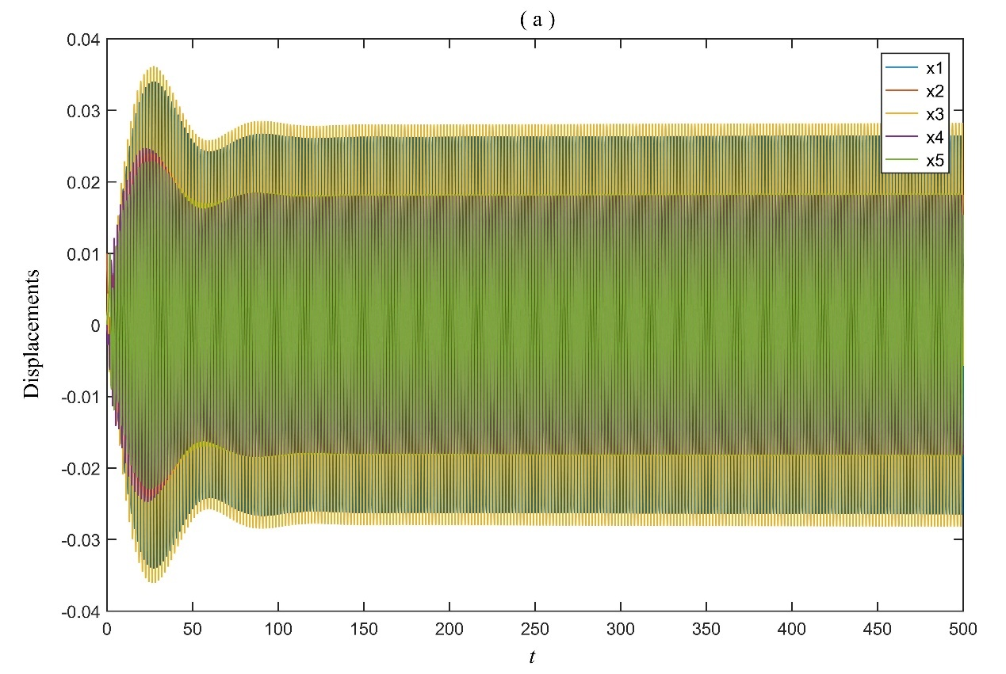
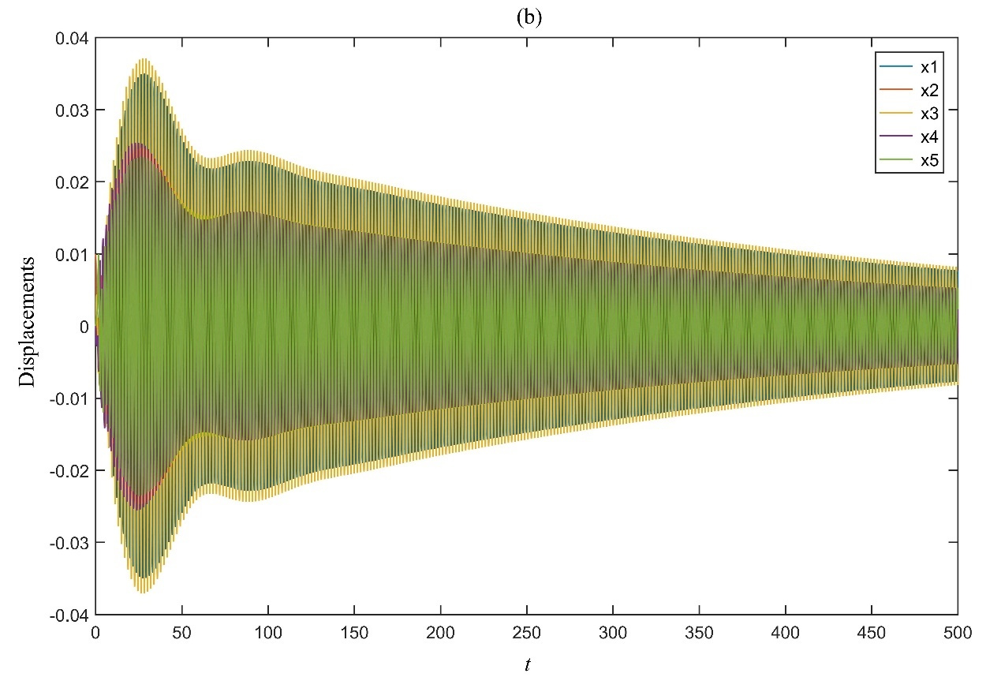
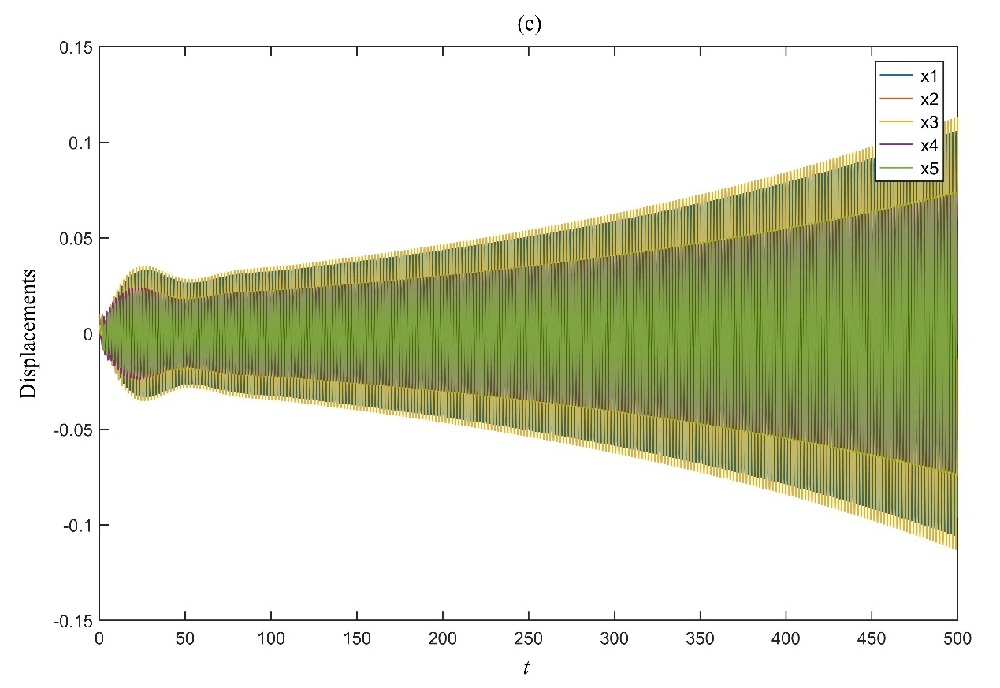
Fig.11. Time responses of the example for an initial condition $x\left(0\right)={\left[0, 0.01, 0, 0, 0\right]}^{T}$, $\dot{x}\left(0\right)={\left[0, 0, 0, 0, 0\right]}^{T}$ in the cases of three different pairs of time-delays: (a) $\left(τ_{1},τ_{2} \right)=\left(0.9015, 0.9152 \right)$ corresponding to the point • in Fig. 8., (b) $\left(τ_{1},τ_{2} \right)=\left(0.9030, 0.9152 \right)$ corresponding to the point in Fig. 8. and (c) $\left(τ_{1},τ_{2} \right)=\left(0.9015, 0.9160 \right)$ corresponding to the point in Fig. 8.

- Concluding remarks
This paper presents a receptance-based approach to the determination of stability crossing curves for single-input-multi-output (SIMO) second-order controlled system with two constant time-delays. The computationally complex characteristic function of multidimensional second-order time-delayed systems is reduced to a simplified equivalent characteristic function, which facilitates the solutions of the problem under study by using a convenient and reliable computing method. Moreover, the equivalent characteristic function is based on the measured receptance and does not require the knowledge of specific parameters of the uncontrolled system. The set of crossing frequencies of the controlled system can also be easily obtained.
References
[1] E. Jarlebring, Critical delays and polynomial eigenvalue problems, J. Comput. Appl. Math. 224(1) (2009) 296–306.
[2] Q. Gao, N. Olgac, Bounds of imaginary spectra of LTI systems in the domain of two of the multiple time delays, Automatica, 72 (2016) 235–241.
[3] C. Yuan, S. Song, Q. Gao, et al. A novel frequency-domain approach for the exact range of imaginary spectra and the stability analysis of LTI systems with two delays, IEEE Access, 8(2020) 36595–36601.
[4] R. Hu and Q. Lu, Optimal time-delay control for multi-degree-of-freedom nonlinear systems excited by harmonic and wide-band noises, Int. J. Struct. Stab. Dynam. 21(4) (2021)2150053.
[5] H. Wu, X.-H. Zeng and D.-G. Gao, Periodic response and stability of a maglev system with delayed feedback control under aerodynamic lift, Int. J. Struct. Stab. Dynam. 21(3) (2021)2150040.
[6] L. Pekar and Q. Gao, Spectrum analysis of LTI continuous-time systems with constant delays: a literature overview of some recent results, IEEE Access, 6 (2018) 35457–35491.
[7] S. Bhatt and C. Hsu, Stability criteria for second-order dynamical systems with time lag, J. Appl. Mech. 33 (1966) 113–118.
[8] C. Hsu and S. Bhatt, Stability charts for second-order dynamical systems with time lag, J. Appl. Mech. 33 (1966) 119–124.
[9] K.L. Cooke and Z. Grossman, Discrete delay, distributed delay and stability switches, J. Math. Anal. Appl. 86 (1982) 592–627.
[10] C. Abdallah, P. Dorato, J. Benitez-Read, and R. Byrne, Delayed positive feedback can stabilize oscillatory systems. in Proc. American Control Conf., San Francisco, CA, 1993, pp. 3106–3107.
[11] Z. H. Wang and H. Y. Hu, Stabilization of vibration systems via delayed state difference feedback. J. Sound Vib. 296(1-2)(2006)117–129.
[12] S. Elmadssia, K. Saadaoui, A. Zaguia, et al. Stabilization domains for second order delay systems, IEEE Access, 9(2021) 53518–53529.
[13] B. Du, Q.-L. Han, S. Xu et al. On joint design of intentionally introduced delay and controller gain for stabilization of second-order oscillatory systems, Automatica, 116 (2020) 108915.
[14] S. Surya, C. P. Vyasarayani and T. Kalmar-Nagy, Homotopy continuation for characteristic roots of delay differential equations using the Lambert W function, J. Vib. Control. 24(17)(2018)3944–3951.
[15] M.S. Ali, Z.K. Hou, M.N. Noori. Stability and performance of feedback control systems with time delays, Comput. Struct. 66 (2-3)(1998) 241–248.
[16] Y. Ram, A. Singh and J.E. Mottershead, State feedback control with time delay, Mech. Syst. Signal Process. 23 (2009) 1940–1945.
[17] K.V. Singh, R. Dey and B. Datta, Partial eigenvalue assignment and its stability in a time delayed system, Mech. Syst. Signal Process. 42 (2014) 247–257.
[18] T. Li and E.K.-W. Chu, Pole assignment for linear and quadratic systems with time-delay in control, Numer. Linear Algebra Appl. 20 (2) (2013) 291–301.
[19] Y. Ram, J. E. Mottershead and M. Tehrani, Partial pole placement with time delay in structures using the receptance and the system matrices, Linear Algebra Appl. 434 (2011) 1689–1696.
[20] K.V. Singh and H. Ouyang, Pole assignment using state feedback with time delay in friction-induced vibration problems, Acta Mech. 224 (2013) 645–656.
[21] Z.-J. Bai, M.-X. Chen and J.-K. Yang, A multi-step hybrid method for multi-input partial quadratic eigenvalue assignment with time delay, Linear Algebra Appl. 437 (2012) 1658–1669.
[22] X. Jinwu, Z. Chong and D. Li, Partial pole assignment with time delay by the receptance method using multi-input control from measurement output feedback, Mech. Syst. Signal Process. 66–67 (2016) 743–755.
[23] Z.-J. Bai, J.-K. Yang and B. Datta, Robust partial quadratic eigenvalue assignment with time delay using the receptance and the system matrices, J. Sound Vib. 384(2016)1–14.
[24] J. Xiang, C. Zhen and D. Li, Partial pole assignment with time delay by the receptance method using multi-input control from measurement output feedback, Mech. Syst. Signal Process. 66–67(2016) 743–755.
[25] L. Zhang, Multi-input partial eigenvalue assignment for high order control systems with time delay, Mech. Syst. Signal Process. 72–73(2016)376–382.
[26] R. Ariyatanapol, Y.-P. Xiong, and H. Ouyang, Partial pole assignment with time delays for asymmetric systems, Acta Mech. 229 (2018) 2619–2629.
[27] N.J.B. Dantas, C. E.T. Dórea and J. M. Araújo, Design of rank-one modification feedback controllers for second-order systems with time delay using frequency response methods, Mech. Syst. Signal Process. 137(2020)106404.
[28] J.M. Araújo, T.L.M. Santos, Control of a class of second-order linear vibrating systems with time-delay: Smith predictor approach, Mech. Syst. Signal Process. 108 (2018) 173–187.
[29] J.M. Araújo, T.L.M. Santos, Control of second-order asymmetric systems with time delay: Smith predictor approach, Mech. Syst. Signal Process. 137(2020)106355.
[30] T.L.M. Santos, J.M. Araújo and T.S. Franklin, Receptance-based stability criterion for second-order linear systems with time-varying delay, Mech. Syst. Signal Process. 110 (2018) 428–441.
[31] P. Ramachandran and Y. M. Ram, Stability boundaries of mechanical controlled system with time delay, Mech. Syst. Signal Process. 27(2012)523–533.
[32] J.-J. Sinou and B. Chomette, Active vibration control and stability analysis of a time-delay system subjected to friction-induced vibration, J. Sound Vib. 500(2021) 116013.
[33] Y. Liang, H. Yamaura and H. Ouyang, Active assignment of eigenvalues and eigen-sensitivities for robust stabilization of friction-induced vibration, Mech. Syst. Signal Process. 90(2017)254–267.
[34] Y. Tang and H. Qin, Stability and accuracy analysis of real-time hybrid simulation (RTHS) with incomplete boundary conditions and actuator delay, Int. J. Struct. Stab. Dynam. 20(11) (2020)2050122.
[35] J.-F. Zhang, H. Ouyang, K.-W. Zhang, et al. Stability test and dominant eigenvalues computation for second-order linear systems with multiple time-delays using receptance method, Mech. Syst. Signal Process. 137(2020)106180.
[36] R. Sipahi, and N. Olgac, A unique methodology for the stability robustness of multiple time delay systems, Syst. Control Lett. 55(10)(2006)819–825.
[37] K. Gu, S. Niculescu, and J. Chen, On stability crossing curves for general systems with two delays. J. Math. Anal. Appl. 311(2005)231–253.
[38] K.M. Abadir and J.R. Magnus, Econometric Exercises, Vol. 1, Matrix Algebra, (Cambridge University Press, New York, 2005).

