An electromagnetic vibration energy harvester using a magnet-array-based vibration-to-rotation conversion mechanism

Yifeng Wang^{1,2}, Peigen Wang^{3,4}, Shoutai Li^{3,4}, Mingyuan Gao^{3,4*,**}, Huajiang Ouyang^{5**}, Qing He^{1,2} and Ping Wang^{1,2,**}
¹ Key Laboratory of High-speed Railway Engineering (Southwest Jiaotong University), Ministry of Education, Chengdu 610031, China
² School of Civil Engineering, Southwest Jiaotong University, Chengdu 610031, China
³ College of Engineering and Technology, Southwest University, Chongqing 400716, China
⁴ National & Local Joint Engineering Laboratory of Intelligent Transmission and Control Technology, Chongqing 400716, China
⁵ School of Engineering, University of Liverpool, Liverpool L69 3GH,
*Corresponding author, E-mail: goalmychn@gmail.com
**The three authors have the same contribution to this study.

Abstract
Using energy harvested from ubiquitous vibration for powering the increasing number of low-power electronics is a promising technique. This paper proposed an electromagnetic vibration energy harvester using an innovative vibration-to-rotation conversion mechanism based on a magnet array. A magnet vibrating along a straight path will induce a torque on a rotatable cylinder fixed with an array of magnets, driving the cylinder to rotate and thus generating electricity via electromagnetic transduction. A theoretical model of the harvester is established and verified through experiments. The dynamical characteristics and optimal parameters of the harvester are investigated theoretically. Then, the optimal resistance of the external load and the capability of this harvester in energizing low-power electronics are studied. Experimental results demonstrate that the root-mean-square (RMS) of the output power will reach its maximum value of 106.5 mW with a 300-Ω external load. Finally, an application scenario of harvesting energy from train vibration is proposed. Numerical simulation results indicate that the output power increases along with the speed of the vehicle; specifically, it will be 50 mW when the train runs at a speed of 80 km/h. This study indicates that the proposed magnet array-based vibration energy harvester is effective in powering low-power electronics.

Keywords: Vibration; Energy harvesting; vibration-to-rotation conversion; Magnet array

1. Introduction
Mechanical energy, such as in the form of vibration and fluid flow, is omnipresent in the environment and easy to employ [1]–[3]. Nowadays, large-scale power generation from massive mechanical energy sources, such as hydraulic and wind energy, has been well developed. However, the technology for harvesting low-scale mechanical energy is still under development. Low-power electronics such as portable devices, wireless sensors, and wearable electronics, have been developed rapidly in recent years, and their requirements for sustainable and independent power supplies have led to the creation of some energy harvesters. Harvesting local energy for local use is conducive to averting shortcomings of conventional battery solutions, such as environmental pollution and limited lifespan. Thus, harnessing low-scale mechanical energy has attracted substantial attention from both industry and academia.
Vibration everywhere, such as wind-induced vibration [4], [5] and track vibration[6], is one of the most common mechanical energy sources in nature. Converting vibration energy into electricity can be achieved through several mechanisms, including piezoelectric [7], electrostatic [8], triboelectric [9], and electromagnetic [3], [10]–[12] effects. The piezoelectric effect is one of the most utilized mechanisms in converting vibration energy into electricity because of its ease of miniaturization, high energy conversion efficiency, and sensitivity to small vibration [13]. However, the large internal resistance of piezoelectric VEH limits their capability of powering electrical loads although piezoelectric vibration energy harvesters (VEHs) can output significant voltages [14], [15]. Using electrostatic and triboelectric effects to harvest vibration energy has also been investigated. For instance, Fu et al[9] have developed a novel system based on triboelectric and electrostatic effects to harness vibration energy from the vibro-impact of three parallel cantilevered beams. To date, electrostatic and triboelectric VEHs are still in the research phase, as the performance of electrostatic and triboelectric harvesters deeply depend on microelectromechanical manufacturing technologies and advanced materials [14]. Based on the Faraday law of electromagnetic induction, the relative motion between the magnet and coil will generate an electromotive force across the coil, converting kinetic energy into electricity. As electromagnetic VEHs do not rely on advanced materials, complex fabrication technologies, and strict working conditions, they show more advantages in practical usages than VEHs based on other principles.
Electromagnetic VEHs can be roughly categorized into two groups: the linear and the rotary types. The linear type electromagnetic VEHs usually utilize the electromagnetic induction effect directly. The inertia force [10] or relative displacement [16] will lead to linear reciprocating relative motions between magnets and coil, converting kinetic energy into electricity. The linear electromagnetic VEHs usually perform well near their natural frequency [14]. However, vibrations appearing in nature usually vary in a broad frequency range. To overcome such a problem, strategies for extending the resonant frequency band, such as parameter tunning [17], integrating multiple linear harvesters in one device, and introducing nonlinearity [2], have been proposed and investigated.
Compared with linear harvesters, the rotary ones usually are more cost-effective and smaller in dimensions [18]. The rotary type electromagnetic VEHs mainly consist of two subsystems: the motion-converting subsystem and the rotary energy-generating subsystem. The rotary energy-harvesting subsystem is sometimes retrofitted from common commercial generators to reduce the fabrication difficulty and obtain stable performance. The motion-converting subsystem is employed to convert linear motion into rotation for driving the rotary energy-generating subsystem. The main reported translation-to-rotation mechanisms can be roughly classed into three groups: rack-pinion [19]–[23], ball-screw [24]–[28], and hydraulic mechanisms [29], [30]. The rack-pinion structure is commonly utilized. However, the backlash and high friction in such a mechanism will lead to low efficiency. As the rack and gear should match with each other, the rack-gear system requires high-precision manufacturing. Converters based on the ball-screw mechanism have considerable friction in low frequency and do not perform well at high frequency [18]. Hydraulic-based harvesters use the fluid flowing in pipelines to transmit force and drive the hydraulic motor. The special way of transmitting forces makes the installation of hydraulic-based energy harvesting devices more flexible. However, the hydraulic-based VEHs also have drawbacks such as the large response time, low mechanical transmission efficiency, high cost because of the need for precision sealing and changing the hydraulic fluid regularly. Besides the above three conversion mechanisms, some novel translation-to-rotation mechanisms, such as the cable or string transmission[1], [31] and cantilever-ratchet structure [32], have also been reported in designing VEHs.
However, the linear-motion and rotary-motion components for most vibration-to-rotation mechanisms have direct contact during force transfer, such as the teeth of the rack and gear, and the ball and screw. Direct contact will lead to friction forces, wear of materials, and even contact fatigue failures. In this work, a novel motion-converting mechanism, free of direct physical contact between the linear and rotary motion components, is proposed. This mechanism mainly has two parts: a linear vibrating magnet (LVM) fixed on the excitation source and a rotatable cylinder with a magnets array (CMA). The reciprocating motion of the LVM will generate oscillatory magnetic forces on the magnet array (MA), creating a time-varying torque on the cylinder and driving it to turn around.
The advantages of the proposed translation-to-rotation mechanism can be summarized into three points: (a) the linear-motion and rotation-motion components are free of direct physical contact. The friction force, wear of materials, and fatigue failure caused by physical contacts can be averted, conducive to improving energy converting efficiency and the reliability of the system; (b) the linear-motion and rotation-motion components are coupled with magnetic force, belonging to flexible coupling. The flexible coupling is beneficial to averting structure damage when the vibration amplitude becomes too large; (c) the introduction of magnetic force-based coupling makes the requirements of this system on vibration directions no longer as strict as common mechanical motion-conversion mechanisms. That is to say, the proposed motion conversion mechanism can convert multiple-direction vibration into the rotation and realize energy harvesting. Based on the proposed motion-converting mechanism, an electromagnetic VEH is developed and investigated.
The paper is organized as follows: In Section 2, the working principle, the prototype, and the theoretical model of the harvester are introduced briefly; Section 3 shows the results of theoretical analyses, including verification of the theoretical model, dynamical characteristics of the harvester, and discussions on the optimal parameters of the harvester. In Section 4, experiments are conducted to investigate the performance of the harvester; Then, an application scenario for harvesting energy from deformations of the absorber of a metro vehicle; Finally, conclusions are drawn based on the theoretical and experimental studies.

2. Working principle, prototype, and theoretical model of the harvester
2.1 Working principle of the motion conversion mechanism
In this work, a magnetic force-based mechanism to convert vibration/linear motion into rotary motion is proposed. This motion-conversion mechanism mainly consists of two components: the LVM and the CMA. $N$ equally spaced magnets of the MA are arranged along a triangle-wave line on the cylindrical surface of radius $R$, as shown in Figure 1(a). These magnets on the cylindrical surface will form a closed ring. The distribution of the MA can be depicted with three parameters: $d_{1}$, $d_{2}$, and $d_{3}$. $d_{1}=2πR/N$ is the lateral interval between two adjacent magnets on the cylindrical surface. $d_{2}=4d_{3}/N$ denotes the Z-axis interval between two adjacent magnets on the cylindrical surface. $d_{3}$ stands for the amplitude of the triangular-wave line. Such an arrangement of these magnets is aimed to obtain a large resultant torque along the longitudinal axis of the cylinder. The generation of the driving torque is related to not only the LVM but also the MA. In practice, the LVM undergoes linear vibration along the Z-axis, as shown in Figure 1(b). It will generate attractive forces on these magnets on the cylindrical surface. Due to the arrangement of the MA in space, these magnetic forces will create a torque driving the cylinder to rotation. In Figure 1(b), $d_{4}$ is the horizontal distance between the LVM and the longitudinal axis of the cylinder. $d_{5}$ presents the vibration amplitude of LVM.

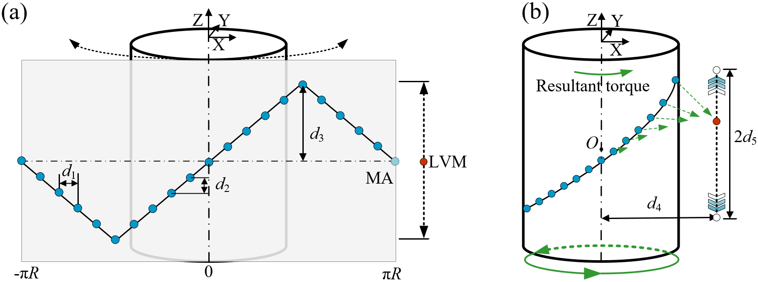
Figure 1. The working principle of the vibration-to-rotation mechanism proposed in this work: (a) the distribution of the MA on the cylindrical surface; (b) the schematic diagram of the working principle.

2.2 Prototype of the vibration energy harvester
Based on the proposed vibration-to-rotation mechanism, an electromagnetic energy harvester is designed and fabricated. This harvester utilizes the rotary cylinder to drive a mini generator for converting kinetic energy to electricity. As shown in Figure 2(a), the harvester contains a base, two bearings, a shaft, a rotary generator, a gear connected to the generator, and the CMA. The shaft is supported via the two bearings on a U-shaped frame linked to an inverted T-shaped stand, which has two holes for fixing this system. The generator can be mounted to one arm of the frame with bolts. The cylinder shares the same longitudinal axis with that of the shaft and connects to the shaft via a key. Besides, a ring gear, matched with the gear of the generator, is embedded inside the cylinder, turning with the cylinder and driving the generator. Note that an LVM fixed on the linear vibration source is also needed in this energy harvesting system. The dimensions of the prototype are determined based on applications and available mechanical parts at reasonable prices. The optimization in the dimensions of the prototype will be conducted in a future study.

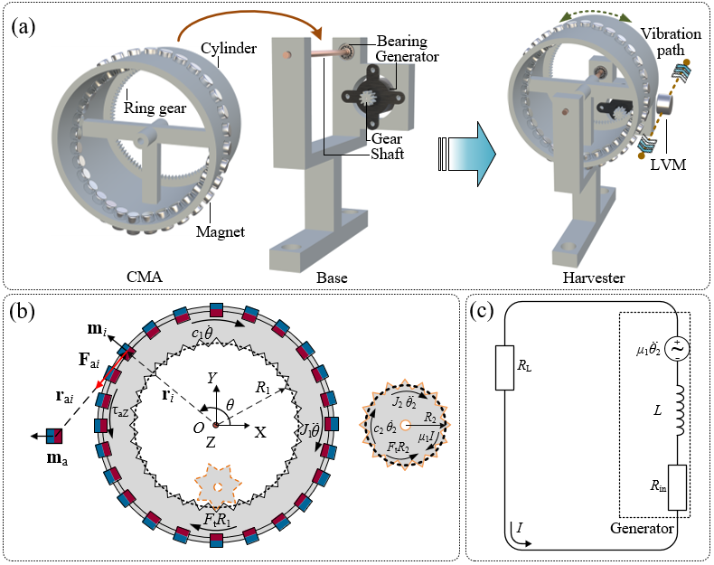
Figure 2. The proposed electromagnetic energy harvester: (a) the model of the harvester; (b) the free-body diagrams of the cylinder and the gear; (c) the equivalent circuit of the system.
2.3 Theoretical model of the harvester
For a better understanding of the characteristics of this VEH, a theoretical model is established. To calculate the magnetic forces acting on the MA of the cylinder by the LVM, the magnetic dipole moment method (MDMM) is adopted. According to the MDMM, the magnetic moment of a magnet can be written as follows [33]:
$$m=MV$$ | (1)
where $M$ denotes the magnetization vector of the magnet. For uniformly magnetized magnets, the value of $M$ can be estimated using $\left|M\right|=\frac{B_{r}}{μ_{0}}$, $B_{r}$ standing for the remanence of the magnet and $μ_{0}$ the permeability of free space with a value of 4π×10−7 H/m; $V$ is the volume of the magnet. The magnetic field generated by the magnet can be expressed as follows:
$$B\left(r\right)=\frac{μ_{0}}{4π}\left(\frac{3r\left(m∙r\right)}{{\left|r\right|}^{5}}-\frac{m}{{\left|r\right|}^{3}}\right),$$ | (2)
where $r$ is the vector from the centre of the magnet to the measuring point. As the free-body diagram of the cylinder shown in Figure 2(b), the magnetic force $F_{ai}$ generated by magnet $m_{a}$ upon magnet $m_{i}$ can be given as:
$$F_{ai}=∇\left(m_{i}∙B_{a}\right)=\frac{3μ_{0}}{4π{\left|r_{ai}\right|}^{5}}\left(m_{a}\left(m_{i}∙r_{ai}\right)+m_{i}\left(m_{a}∙r_{ai}\right)-5r_{ai}\left(m_{a}∙r_{ai}\right)\left(m_{i}∙r_{ai}\right)\right)$$ | (3)
where $m_{a}$ is the magnetic moment of the LVM; $m_{i}$ ($i$=1, 2, …$N$) is the magnetic moment of one magnet of the MA; $B_{a}$ is the magnetic field generated by $m_{a}$; $r_{ai}$ denotes the position vector from the centre of the magnet $m_{a}$ to that of $m_{i}$. As the magnet $m_{i}$ is fixed on the surface of the cylinder, the force $F_{ai}$ will generate a torque on the centre point $O$ of the cylinder, which can be calculated using $τ_{ai}=F_{ai}×r_{i}$. $r_{i}$ presents the position vector from $O$ to $m_{i}$. Since the cylinder can only roll along Z-axis and there are $N$ magnet fixed on the cylindrical surface, the Z-axis component of the total torque caused by the magnet $m_{a}$ can be obtained by:
$$τ_{aZ}=\sum_{i=1}^{N}{τ_{aiZ}}$$ | (4)
where $τ_{aZ}$ is the driving torque of the system and $τ_{aiZ}$ the Z-axis component of $τ_{ai}$. During operation, this system also generates some other resistant torques. In Figure 2(b), the free-body diagrams of the cylinder and gear are presented. According to the force diagram, the dynamic model of the system can be written as follows:
$$\left\{\begin{matrix}J_{1}\ddot{θ}+c_{1}\dot{θ}+F_{t}R_{1}=τ_{aZ} \\ J_{2}{\ddot{θ}}_{2}+c_{2}{\dot{θ}}_{2}+μ_{1}I=F_{t}R_{2}\end{matrix}\right.$$ | (5)
where $J_{1}$ is the moment of inertia of the CMA, and $J_{2}$ the moment of inertia of the generator including the gear; $c_{1}$ and $c_{2}$ presents the mechanical damping coefficient of the CMA and generator; $F_{t}$ denotes the tangential component of the interaction force between the ring gear of the cylinder and the gear of the generator; $R_{1}$ and $R_{2}$ stands for the pitch radii of the ring gear and the gear of the generator; $μ_{1}$ is the electromechanical coupling coefficient of the generator and $I$ the electrical current within the closed-circuit as shown in Figure 2(c); $θ$ and $θ_{2}$ are the angular displacements of the cylinder and generator, respectively. As the ring gear of the cylinder and the external gear of the generator match with each other, the gear ratio can be expressed as $g_{r}=\frac{θ_{2}}{θ}$. Thus, Eq. (5) can be rewritten as follows:
$$J\ddot{θ}+c\dot{θ}+μI=τ_{aZ}$$ | (6)
where $J=J_{1}+g_{r}^{2}J_{2}$ is the moment of inertia of the system, $c=c_{1}+g_{r}^{2}c_{2}$ presents the mechanical damping coefficient of the system, and $μ=g_{r}μ_{1}$ denotes electromechanical coupling factor of the system. The electromotive force output by the generator is proportional to its rotational speed. Applying Kirchhoff's voltage law to the circuit, the electrical differential equation of the circuit can be written as:
$$μ\dot{θ}-L\dot{I}-\left(R_{in}+R_{L}\right)I=0$$ | (7)
where $R_{in}$ and $R_{L}$ are the resistance of the generator and the external load; $L$ denotes the inductance of the generator. Note that $μ\dot{θ}=μ_{1}g_{r}\dot{θ}=μ_{1}{\dot{θ}}_{2}$. The output power of the system can be estimated using the following equation:
$$P_{out}=I^{2}R_{L}$$ | (8)

Table 1 shows some critical parameters utilized in establishing the theoretical model. For a better understanding of the characteristics of the system, the driving torque acting on the CMA, $τ_{aZ}$, when the LVM and the CMA are at different positions, is calculated and presented in Figure 3(a). During the calculation, the horizontal distance between the moving path of the LVM and the longitudinal axis of the cylinder,$d_{4}$, is fixed at 70 mm. It can be found that the variation of the position of the LVM has significant influences on the driving torque of the CMA. When the LVM is just facing a magnet of the MA, the Z-axis component of resultant torque acting on the cylinder equals zero, that is, this system reaches its equivalent stable point. However, moving the LVM will break the balance of the system and the CMA will rotate to reach its new stable point. Figure 3(b) shows the potential energy of the system when the LVM and the CMA are at different positions. The potential energy of the system can be obtained as $U\left(Z_{0},θ_{0}\right)=\int_{0}^{θ_{0}}{τ_{aZ}\left(Z_{0},θ_{0}\right)dθ}+U_{Z_{0}}$, where $Z_{0}$ is the position of the LVM, $θ_{0}$ the angular position of the CMA, and $U_{Z_{0}}$ constant of integration. It can be seen from the figure that the angular position corresponding to the minimum potential energy of the system changes with the position of the LVM. As the system always tends to maintain the minimum potential energy, the CMA will rotate with the motion of the LVM.

Table 1. Critical parameters of the energy harvesting system.
Object | Symbol | Description | Value | Unit | Object | Symbol | Description | Value | Unit
CMA | $$R$$ | The radius of the cylinder | 50 | mm | System | $$J$$ | Moment of inertial of the system | 3.03E-4 | $$Kg∙m^{2}$$
 | - | The length of the cylinder | 73 | mm |  | $$c$$ | The mechanical damping factor of the system | 2.0E-2 | $$Kg∙m^{2}/s$$
 | $$N$$ | The number of magnets | 32 | - |  | $$μ$$ | The electromechanical coupling factor of the system | 0.4 | $$N∙m/A$$
 | $$D_{1}$$ | The diameter of the magnets | 8 | mm |  | $$L$$ | Inductance of system | 3.2 | mH
 | $$h_{1}$$ | The thickness of the magnets | 5 | mm |  | $$n_{1}$$ | Number of teeth of the gear | 100
 | - | Magnet grade | N52 | - |  | $$n_{2}$$ | Number of teeth of the ring gear | 10 | -
 | $$d_{3}$$ | The amplitude of the triangular-wave line | 16 | mm |  | $$g_{r}$$ | The gear ratio | 10 | -
LVM | $$D_{2}$$ | Diameter of LVM | 20 | mm |  | $$d_{4}$$ | The horizontal distance between the LVM and Z-axis | 70 | mm
 | $$h_{2}$$ | Thickness of LVM | 20 | mm |  | $$R_{in}$$ | Resistance of the generator | 97 | Ω
 | - | The grand number of LVM | N52

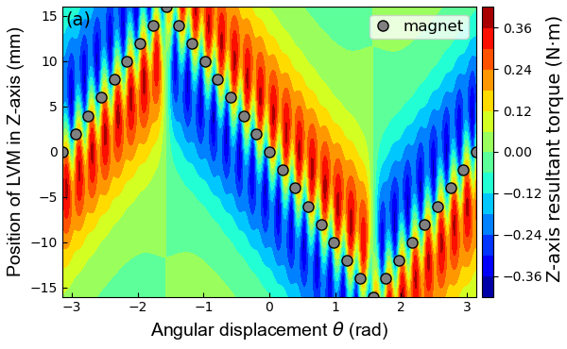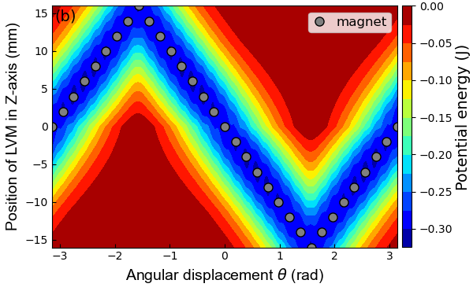
Figure 3. The torque and potential energy of the system when the LVM and CMA are at different positions: (a) the Z-axis component of the resultant torque acting on the cylinder; (b) the potential energy of the system.

3. Theoretical investigations

Based on the established theoretical model, a series of investigations are performed to learn about the characteristics of the system. First, the theoretical model is verified via experimental results. Then, the typical dynamic behaviours of the system are presented. Finally, the optimal parameters about the MA and the LVM are investigated through a series of simulations.
3.1 Validation of the theoretical model
To verify the feasibility of the theoretical model, comparisons between the experimental results and predicted results by the theoretical model are conducted. A slider-crank mechanism is employed in the setup of the exciter for providing low-frequency and repeatable harmonic vibration, as shown in Figure 4(a) and Supplementary Video 1. The LVM is fixed on the slider and does linear vibration periodically along the Z-axis direction via the crank driven by a motor. The oscillation frequency of the slider can be tuned via adjusting the rotational speed of the motor and the amplitude via changing the length of the crank. Figure 4(b) shows the schematic of the test setup. In the experiments, the motor is controlled by adjusting its input voltage. A Kraft paper card is attached to the slider and moving with the latter. The real-time displacement of the card is measured via the Laser displacement sensor. The vibration frequency of the slider can be obtained by analysing the displacement data of the Kraft paper card. The output signals of the harvester are recorded and displayed on an oscilloscope. $d_{4}$ and $d_{5}$ are fixed at 70 mm and 16 mm, respectively. Other parameters about the LVM, CMA and the system can be found in Table 1.
Figure 5 shows the RMS of the open-circuit voltage from simulations and experiments. The experimental results show good agreement with the simulation results of the theoretical model, demonstrating the validity of the established theoretical model. Limited by the performance of the motor, the excitation frequency below 1.3 Hz is hard to achieve during experiments.

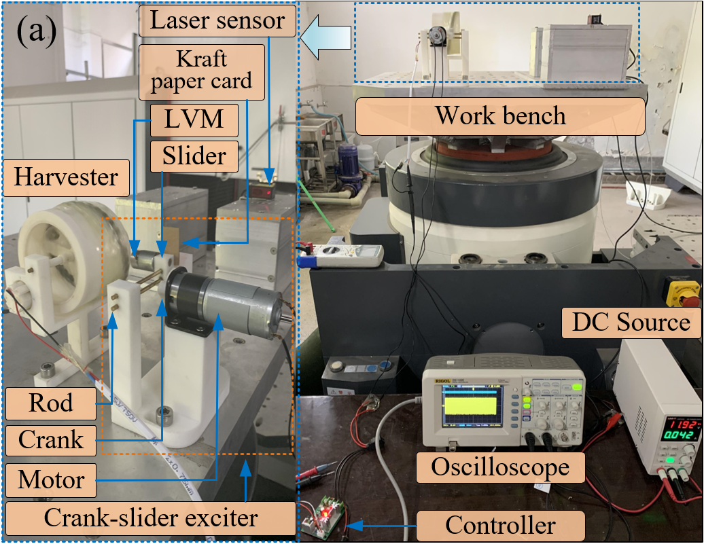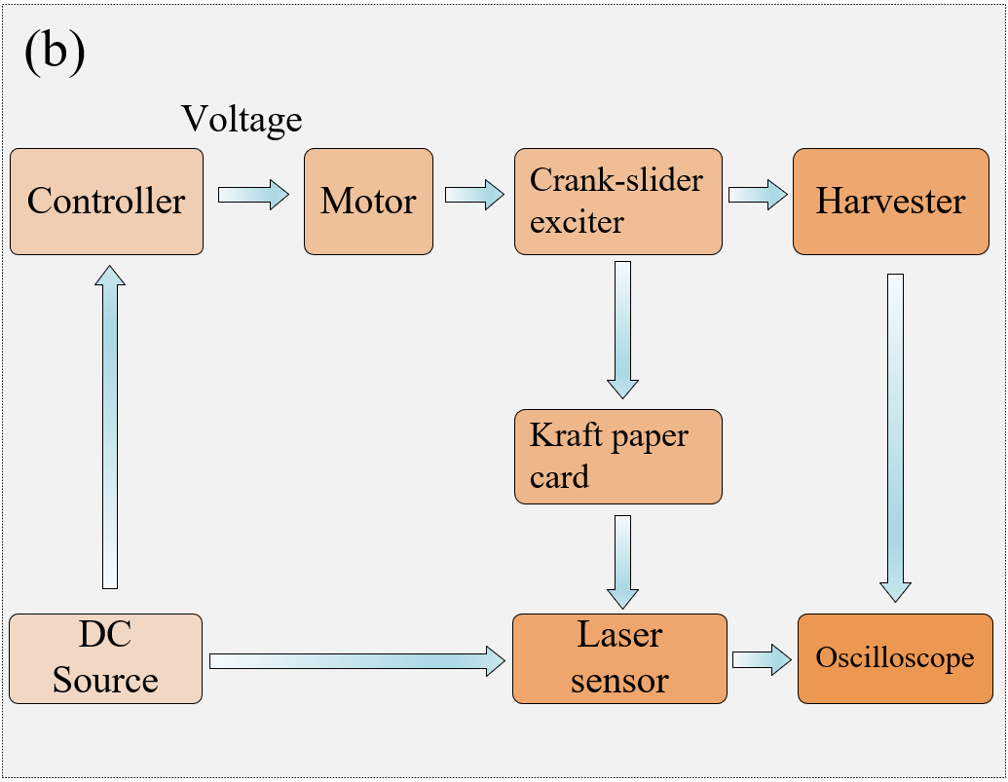
Figure 4. Photos and schematic of the experimental setup: (a) photos of the experimental setup; (b) schematic of the experimental setup.
Figure 5. Comparisons between the experimental and simulation results.
3.2 Dynamical characteristics of the harvester
After validating the theoretical model, a series of simulations are performed to learn about the dynamic characteristics of this system. During simulations, the vibration frequency of the LVM is fixed at $f$= 5 Hz and the vibration amplitude $d_{5}$ increases from 1.6 mm to 19.2 mm. Figure 6(a) shows the time-history responses (rotations of the cylinder) under excitations with small amplitudes ($d_{5}=$ 1.6 mm, 2.8 mm, 4.0 mm, and 5.2 mm) and Figure 6(b) are the corresponding phase portraits. Figure 6(c) presents the time-history responses under excitation with large amplitudes ($d_{5}=$ 9.6 mm, 12.8 mm, 16.0 mm, and 19.2 mm) and Figure 6(d) the corresponding phase portraits. These dots in Figure 6 are Poincaré points sampled at a time interval of $T=\frac{1}{f}=0.2$s. Results in Figures 6(a) and 6(b) indicate that the response curves are smooth when the vibration amplitude is smaller than 5.2 mm. Besides, the Poincaré points in Figure 6(b) gather at one point on corresponding phase orbits, indicating that this system has strong periodicity under small-amplitude excitations. In Figure 6(c), the vibration amplitude $d_{5}$ has a significant increase compared with that in Figure 6(a), demonstrating that more kinetic energy will be fed into this energy harvesting system. Under intense vibrations, the time-history response curves are no longer smooth and the periodicity becomes weak along with the increase of $d_{5}$. It can even be seen this system rotates continuously when $d_{5}$=19.2 mm. In Figure 6(d), phase portraits are messy and the corresponding Poincaré points are scattered when excitations become intense. Such phenomena demonstrate that intense excitation will weak the periodicity of this system.
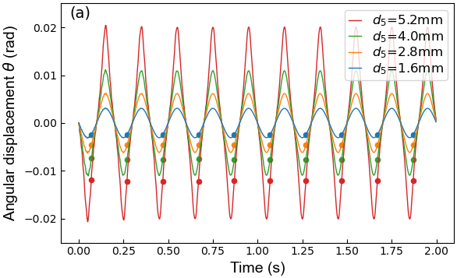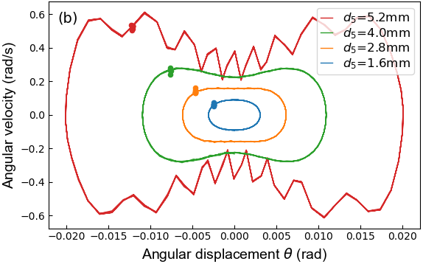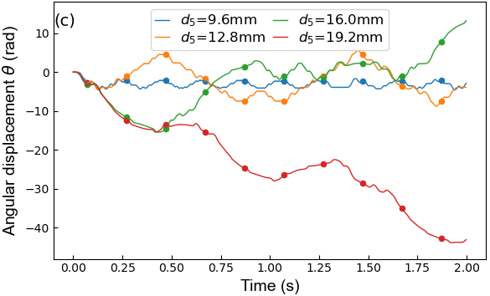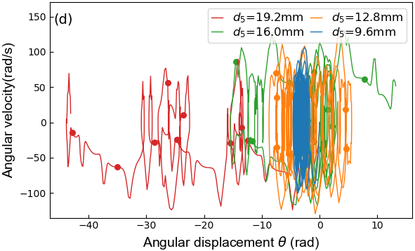
Figure 6. Dynamical characteristics of the system: (a) the time-history responses under small excitations; (b) the phase portraits under small excitations; (c) the time-history responses under intense excitations; (d) the phase portraits under intense excitations.

3.3 Effects of some parameters on the performance of the harvester
Parameters of the MA and LVM have significant influences on the performance of motion transmission of this system. Thus, a series of simulations are performed to investigate the effects of these parameters on the performance of the harvester. Firstly, the influences of the MA arrangement, including the shape, the amplitude, and the periods of the MA, on the performance of the system are investigated. Then, the effects of characteristics of the LVM, such as the remanence, the vibration amplitude, and the vibration direction, on the performance of the system are studied.
3.3.1 Effects of MA arrangement on the performance of the system
The arrangement of the MA has a critical influence on the dynamic behaviours of the system. For bringing it to light, simulations based on the established theoretical model are conducted. In simulations, the vibrating path of the LVM is parallel to the longitudinal axis of the cylinder. The LVM vibrates with a fixed amplitude of 16 mm and a frequency increasing from 0 to 5 Hz. The initial angular displacement and velocity of the cylinder are set to zero. The angular displacement and velocity of the cylinder from 0 to 6 s are calculated via integration at a time step of 2.5E-3 s. The RMS value of the output voltage of the harvester is selected to evaluate the performance of the system. Other parameters not specified are consistent with the values provided in Table 1. The numerical results are displayed in Figure 7 below.
Figure 7(a) shows the triangular-wave and sine-wave arrangements of the MA, respectively. The two kinds of arrangements have the same amplitude of 16 mm and the number of magnets. The simulation results of the two arrangements are presented in Figure 7(b). The results of the two arrangements show a similar increasing trend with the increase of excitation frequency. However, the red line of the sine-wave arrangement shows greater fluctuations than the green line of the triangular-wave arrangement, demonstrating that the system with a triangular-wave arrangement has more stable performance. Thus, the triangular-wave arrangement is adopted in the prototype.

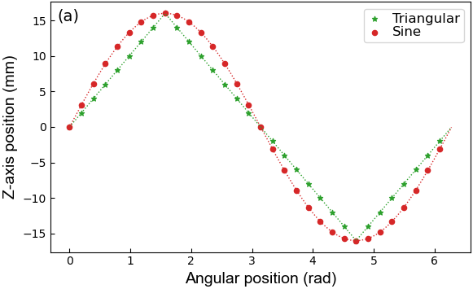
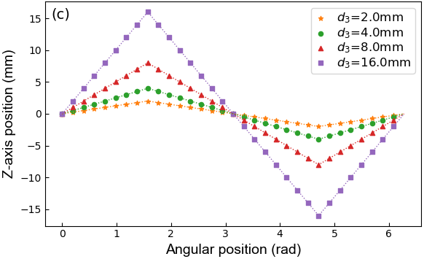
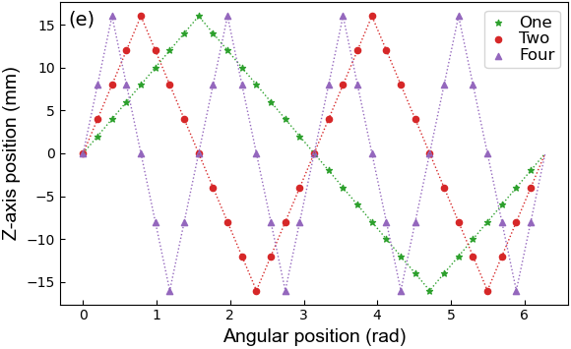
Figure 7. Effects of MA arrangement on the system performance in simulations: (a) the MA arrangements with triangular-wave and sine-wave arrangements; (b) open-circuit voltage for the MA arrangements with triangular-wave and sine-wave shape; (c) the MA arrangements with different amplitudes; (d) open-circuit voltage for the MA arrangements with different amplitudes; (e) the MA arrangements with different periods at a 16-mm amplitude; (f) open-circuit voltage for the MA arrangements with different periods at a 16-mm amplitude.
Then, the influences of the amplitude of the MA on the performance of this system is discussed. In simulations, the amplitude of the triangular wave of the MA increase from 2.0 mm to 16 mm, as shown in Figure 7(c). The RMS values of the open-circuit voltage of the harvester when the MA has different amplitudes are shown in Figure 7(d). These results demonstrate that the performance of this system becomes better when $d_{3}$ increases from 2 mm to 16 mm, especially in the high-frequency range. When $d_{3}$ is small, the performance of this system decreases dramatically. These results indicate that the larger the amplitude of the MA is, the better performance of this system can be obtained. Therefore, the amplitude of the triangular wave should be as large as possible in the prototype if other conditions permit.
Besides the shape and amplitude of the MA, the periods of the MA influences the performance of this system. Figure 7(e) shows the distributions of the MA with one, two and four periods. Note that the total number of magnets consisting of the MA does not change with the number of periods. Simulation results corresponding to the three cases are presented in Figure 7(f). These results indicate that the system with one period performs better than that with two/four periods. Therefore, the one-period MA with a triangular-wave shape utilized in the prototype is optimal.

3.3.2 Effects of the parameters of the LVM
Since the LVM is a crucial component of the energy harvesting system, the parameters of the LVM are also of significance in affecting the performance of this system. In simulations, the MA has a triangular-wave shape and an amplitude of 16 mm. The LVM does sinusoidal vibration and its vibrating path is contained in the plane of $Y=d_{4}$. The angle between the vibrating path of the LVM and the Z-axis (the longitudinal axis of the cylinder) $φ$, is employed to reflect the vibrating direction of the LVM, as shown in Figure 8(a). Other parameters can be found in Table 1.
According to Eq. (3), the remanence of the LVM is proportional to the magnetic force acting on the cylinder. Thus, a series of simulations are conducted to investigate the influence of the remanence of the LVM on the performance of the system. During simulation, the vibration amplitude $d_{5}$ of the LVM is fixed at 16 mm and the vibration frequency increases from 0 Hz to 5 Hz. Besides, the vibration direction of the LVM is parallel to the Z-axis, namely, $φ$ equals zero. The simulation results when the remanence of the LVM, $B_{r}$, equals to 0.2 T, 0.3 T, 0.5 T, and 1.4 T are presented in Figure 8(b). These results demonstrate that the RMS of the open-circuit voltage increase along with the vibration frequency $f$ of the LVM. However, the increasing trend will be interrupted when the vibration reaches a specific frequency which the authors call ‘Stop Frequency’. The curves in Figure 8(b) indicate that the ‘Stop Frequency’ increases along with the remanence $B_{r}$ of the LVM. In general, the stronger the remanence of the LVM, the better performance of this system, especially in the high-frequency range. Thus, the magnets of the MA and the LVM utilized in the prototype have the same grade number of N52 and remanence of 1.47T, which are the strongest the authors can obtain.
Then, the effects of the vibration amplitude and frequency of the LVM on the performance of this system are investigated. During simulations, the vibration amplitude of the LVM varies from 0 to 32 mm. The results corresponding to the vibration frequency of 3 Hz, 5 Hz, and 7 Hz are shown in Figure 8(c). It can be found that this system does not work when the vibration amplitude is too small. Besides, it can also be seen that the higher the vibration frequency, the better the performance of the system, under the same vibration amplitude condition. Note that the maximum vibration frequency of the LVM should match with the remanence of the utilized magnets. If the remanence of the LVM is not enough, the performance of the harvester will become worse when the excitation frequency exceeds the ‘Stop Frequency’.
The vibration direction of the LVM also plays a critical role in influencing the performance of the harvester. The angle,$φ$, varies with the change of the vibration direction of the LVM. In simulations, the LVM has a vibration amplitude of 16 mm and a frequency of 5Hz. The simulation results for $φ$ varying from 0 to $π$ are presented in Figure 8(d). It can be found that when $φ$ equals 0 or $π$, namely, the vibration direction of the LVM is parallel to the Z-axis, this energy harvesting system reaches its best performance. However, the performance of this system becomes significantly worse when $φ$ is near $π/2$, namely, the vibration direction of the LVM is perpendicular to the Z-axis. Therefore, the vibration direction of the LVM should be parallel to the Z-axis as much as possible in practice. It can also be found that this system has significant outputs in a large angle range, indicating that this system has a capacity of harvesting multi-direction vibration energy.
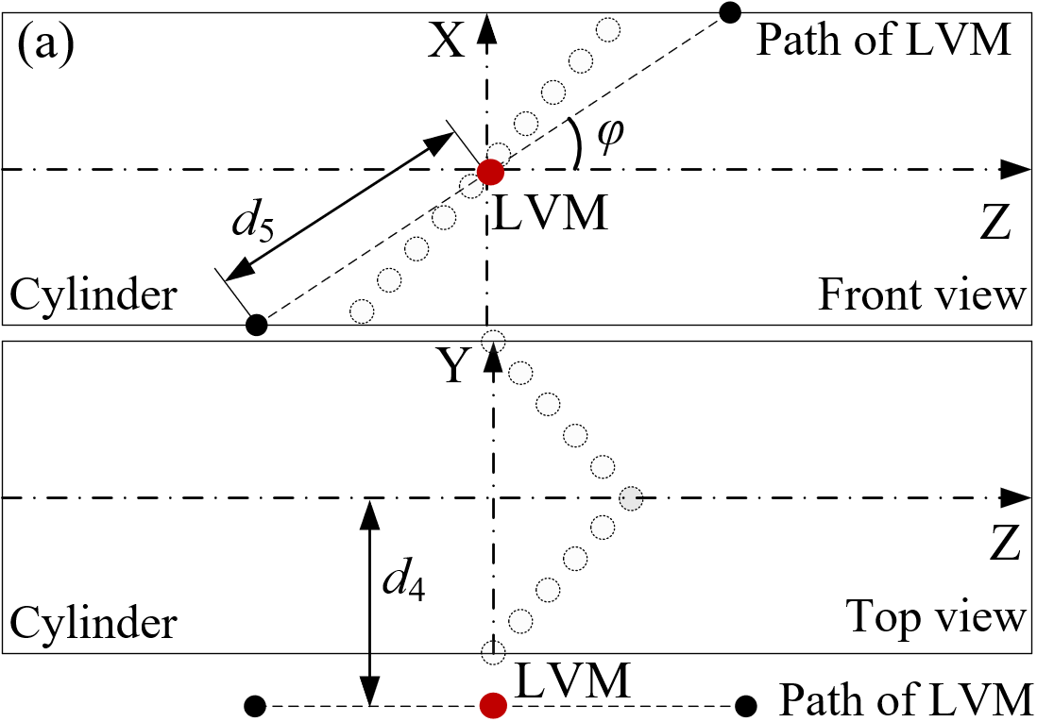
Figure 8. The influence of the parameters of the LVM on the performance of this energy harvesting system: (a) vibration direction of the LVM; (b) the influence of the remanence of the LVM; (c) the influence of the vibration amplitude of the LVM; (d) the influence of the vibration direction of the LVM.

4. Experimental investigations on the energy harvesting capacity of the harvester
To learn about the energy harvesting capacity of the proposed VEH and its potential for powering electronics, a series of electrical experiments are conducted. Firstly, the optimal resistance of the external load is investigated under harmonic vibration. Then, the capabilities of the harvester for scavenging energy from hand-shaking vibration and for enabling low-power electronics are studied.
4.1 Optimal resistance of the external load
To employ the harvested energy, an external load should be connected to the harvester in series within the same closed circuit, as shown in Figure 3(c). The resistance of the external load ought to match the internal resistance of this system for obtaining maximum energy output. To determine the optimal resistance of the external load, a series of experiments are conducted. A sliding rheostat is connected to the harvester to work as an external load. The RMS voltage across the sliding rheostat is measured with a voltmeter. Figure 9(a) shows the diagram of the electrical circuit utilized in the experiments. Figure 9(b) presents the RMS of the output power of the system under different vibration frequencies. This figure indicates that the RMS of the output power generally increases along with the excitation frequency. However, the large electromagnetic damping force, when the external load is small, will cause a decrease in the output power, especially for high-frequency vibration. Such a drawback can be overcome by increasing the remanence of utilized magnets. It can also be found that the RMS values of the output power corresponding to different excitation frequencies will reach their peak value when the resistance of the external load is about 300 Ω. This energy harvesting system reaches its maximum output power of 106.5 mW under a 300-Ω external load and a 5-Hz excitation.
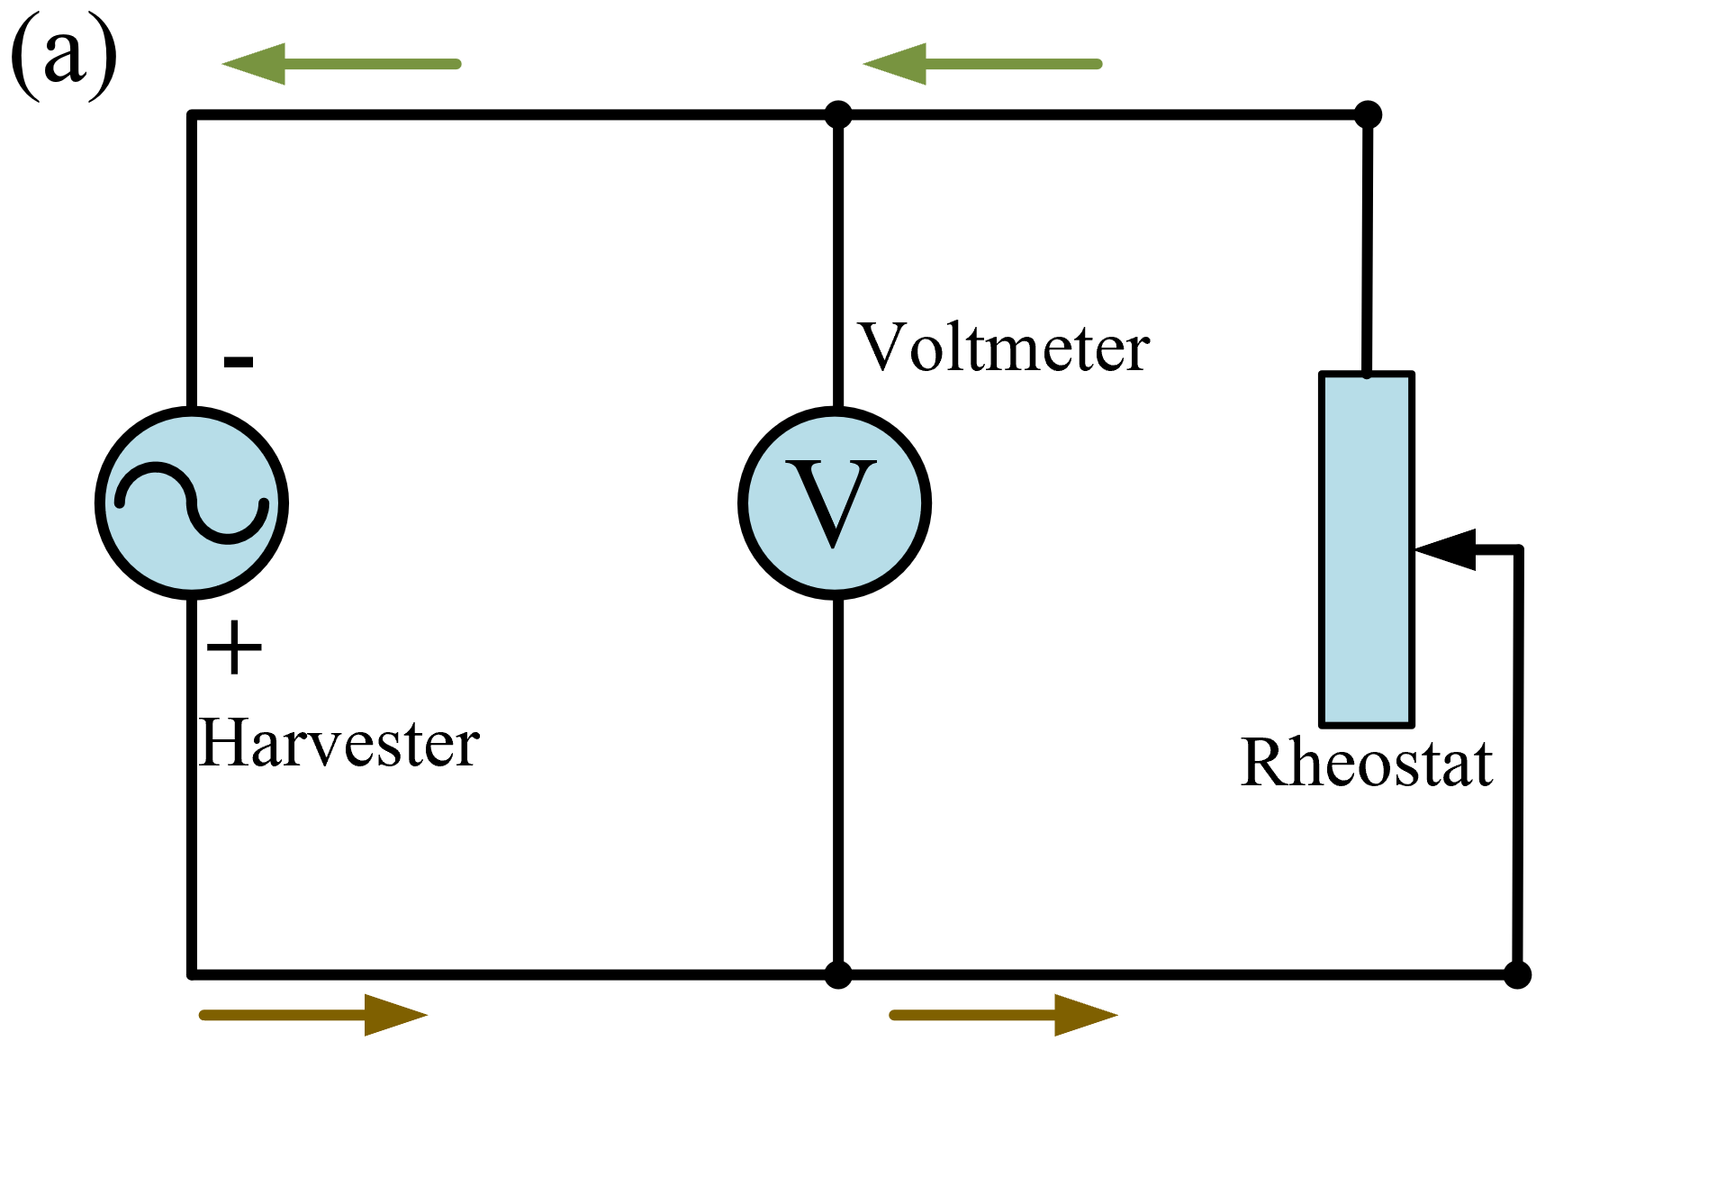
Figure 9. Performance of the harvester under harmonic vibration: (a) diagram of the electrical circuit; (b) the RMS of the output power under different vibration frequencies.

4.2 Performance of the harvester under hand-shaking vibration
During the investigation of the optimal resistance of the external load, the form of excitation is harmonic. However, most vibrations in nature are random. To learn about the actual characteristics of the harvester under random vibration, the energy harvesting capacity of this system is studied when excited by hand-shaking vibration.
In the experiments, the LVM is held in one’s hand and shaken with periodic-like hand motions. The vibration of the LVM will drive the CMA to rotate which turn the generator to produce electricity. To measure the hand vibration, an acceleration sensing module (JY901 by Wit-Motion Company) is stuck on the back of the hand holding the LVM, as shown in Figure 10(a) and Supplementary Video 2. This sensing module has a maximum sampling frequency of 200 Hz. The measurement data can be transmitted to the computer in real-time via a cable. Figure 10(b) shows the measured acceleration (in the Z-axis direction). The maximum value of the horizontal acceleration exceeds 2.0 $m/s^{2}$. Figure 10(c) is the power spectral density (PSD) curve of the horizontal acceleration, demonstrating that the dominant frequency of hand-shaking vibration is about 2 Hz. Figure 10(d) shows the open-circuit voltage of the harvester, which has a similar waveform with the horizontal acceleration of hand-shaking vibration. The time-history of open-circuit voltage is divided into 1-second sections and the RMS value of each section is calculated, as shown in Figure 10(e). The RMS of the open-circuit voltage can reach its maximum value of about 12V.
The external load (a sliding rheostat) utilized to investigate the optimal resistance is a purely resistive element. However, most electronics contain other electrical elements. The harvester may behave differently when employed to power non-resistive electronics. To find out the capability of this harvester for powering usual electronics, experiments for enabling low-power electronics are conducted. In practice, the harvester will generate an alternative-current (AC) voltage. However, most electronics require direct-current (DC) voltage for normal operation. Thus, a full-bridge rectifier circuit, as shown in Figure 10(f), is employed to convert the AC voltage of the harvester into DC voltage for fulfilling the requirement of common electronics. Figure 10(g) shows that the harvester can successfully power a digital clock from the energy harvested from hand-shaking vibration. In Figure 10(h), a digital thermo-hygrometer is enabled by the harvester and can sense the temperature and humidity continuously. Besides, the harvester under hand-shaking vibration can also be utilized to power a digital calculator, as shown in Figure 10(i).
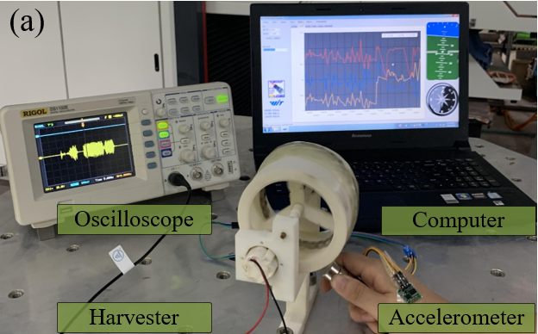
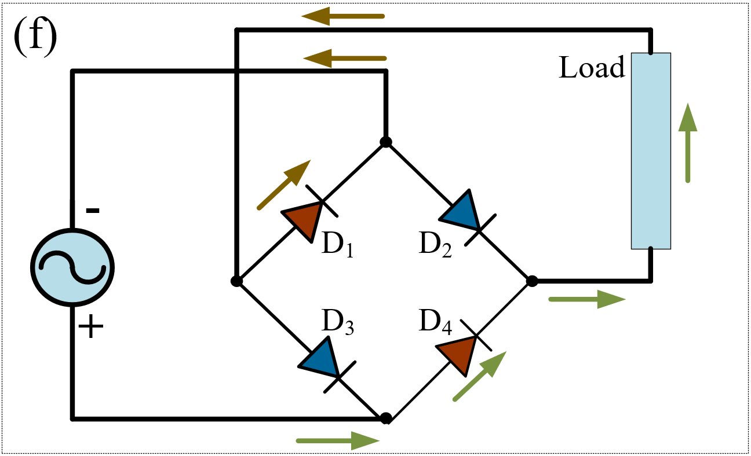
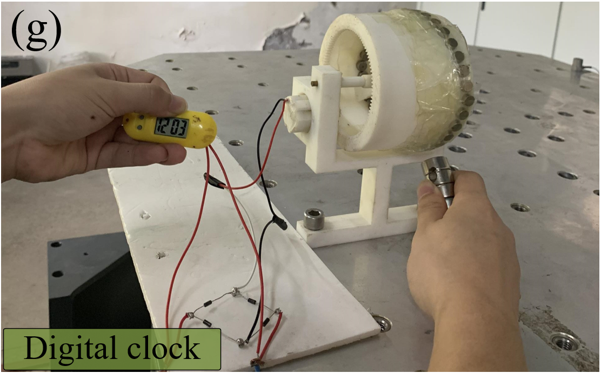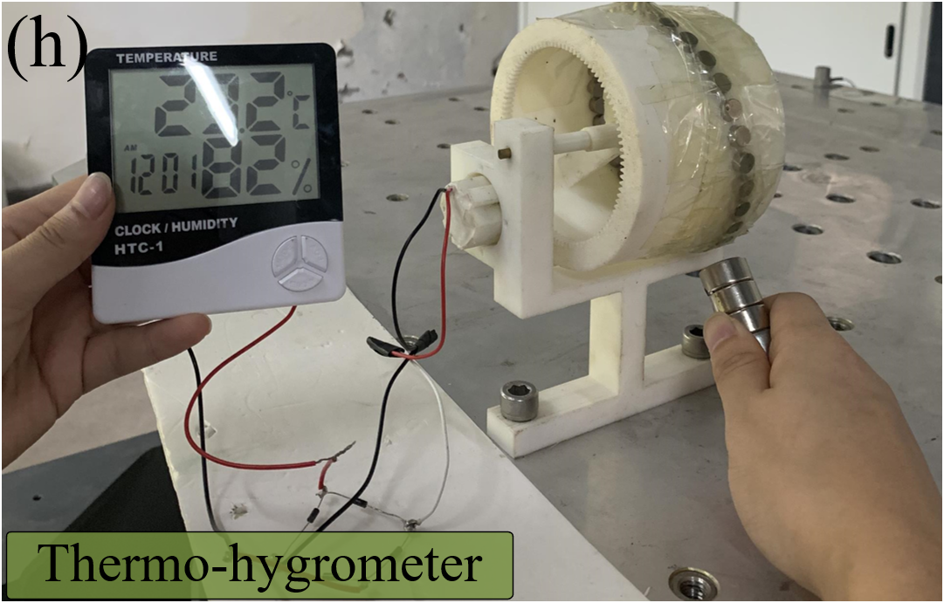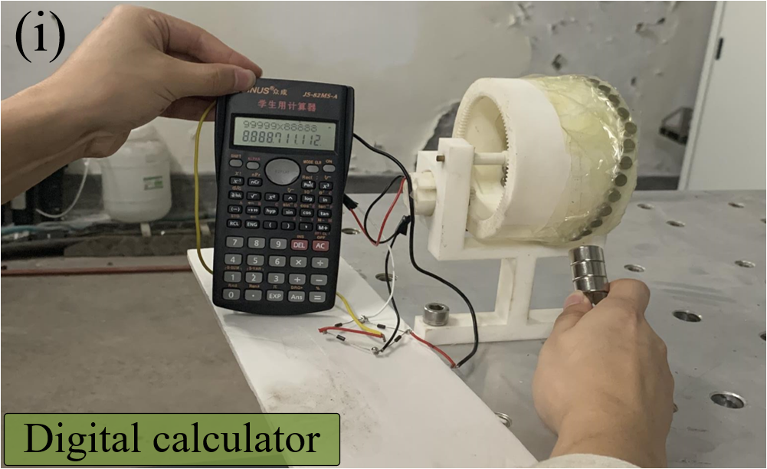
Figure 10. Performance of the harvester under hand-shaking vibration: (a) experimental setup; (b) the acceleration of hand-shaking vibration; (c) the PSD curve of the acceleration signal; (d) the open-circuit voltage of the harvester; (e) the RMS value of the open-circuit voltage; (f) the diagram of the full-bridge rectifier circuit; (g) a digital clock powered by the harvester; (h) a digital thermo-hygrometer enabled by the harvester. (i) a digital calculator energized by the harvester.

5. An application scenario for harvesting energy from train vibration
One common cause of train vibration is the wheel-rail interaction [34]. Usually, the vibration energy will be dissipated in the environment in the form of heat. In recent years, intelligent railway systems based on vehicle-track condition monitoring have developed rapidly. However, these monitoring devices require a stable power supply. Harvesting the wasted vibration energy and converting it to electricity for powering these monitoring devices are very useful. Many researchers have developed energy-harvesting suspension systems to scavenge wasted vibration energy [3]. Inspired by these works, an application scenario of the proposed harvester is provided, as shown in Figure 11. In the proposed application scenario, this harvester will work as a damper but will not replace the original primary shock absorber. As shown in Figure 11, these LVMs are fixed on the lower fixed board and these harvesters are bound to the upper fixed board. The lower and upper fixed boards are connected to the rotary positioning arm of the bogie and the bogie frame and move with them, respectively. When the vehicle runs along the track, relative motions between the bogie frame and the rotary positioning arm will be generated, leading to the relative motions between the LVMs and CMAs of the harvester array. As this energy harvesting system and the primary shock absorber are connected in parallel, the relative motions between the LVMs and CMAs equal the deformations of the shock absorber.

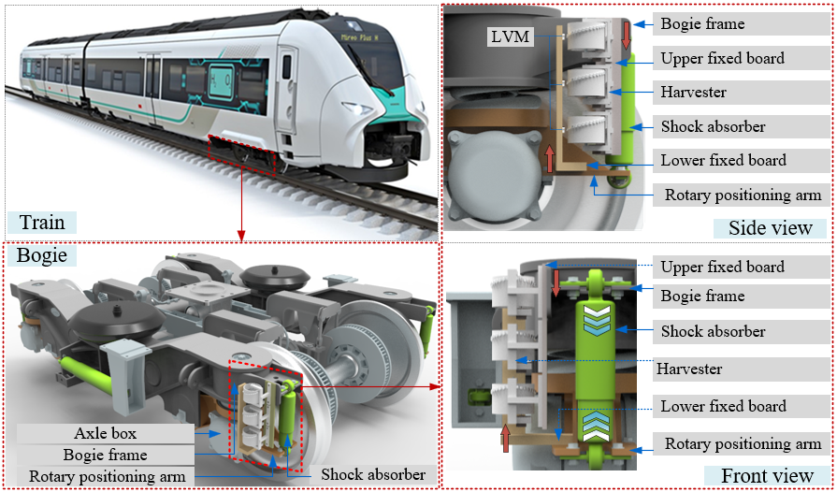
Figure 11. Application of the proposed harvester for scavenging energy from train vibration.

As this work is in the early phase of development, on-site measurement on a metro vehicle is hard to implement due to some safety factors. Thus, a vehicle-track coupling dynamic model based on multibody dynamics is established using the Universal Mechanism (UM) software [35] to obtain the deformation of the absorber. Table 3 shows some critical parameters utilized in the dynamical model. The class-5 track irregularities designated by the federal railroad administration (FRA), USA, are employed in the model [36], [37]. These parameters come from a metro system, which has been utilized in the authors’ previous study [35]. Based on the established vehicle-track dynamical model, the deformation of the suspension system when the train runs at different speeds can be calculated. Figure 12(a) displays the deformation data of the front-right primary shock absorber of the front bogie when the vehicle runs at speeds of 10 km/h, 30 km/h, 50 km/h, and 70 km/h, respectively. Results in Figure 12(a) indicate that the deformation amplitude will exceed 10 mm when the vehicle runs at different speeds. However, the deformation amplitude reaches its maximum value of about 20 mm when the vehicle runs at a speed of 30km/h. Figure 12(b) is the corresponding fast Fourier transform (FFT) spectrum of absorber deformations when the vehicle runs at different speeds. Results in Figure 12(b) demonstrate that the frequency band of the absorber deformation signal become broad with the increase of the running speed, and the frequency corresponding to the peak value of the FFT spectrum increase as well.

Table 3. Critical parameters of type A subway vehicle [35].
 | Item | Parameters | Unit
1 | Wheel tread type | LMA | -
2 | Wheelbase | 2.5 | m
3 | Mass of wheel | 1,900 | kg
4 | Nominal rolling circle radius | 0.84 | m
5 | Lateral distance of the rolling circle | 1.493 | m
6 | Mass of bogie | 2,721.5 | kg
7 | Length between bogie pivot centres | 15.7 | m
8 | Mass of car body | 50,877 | kg
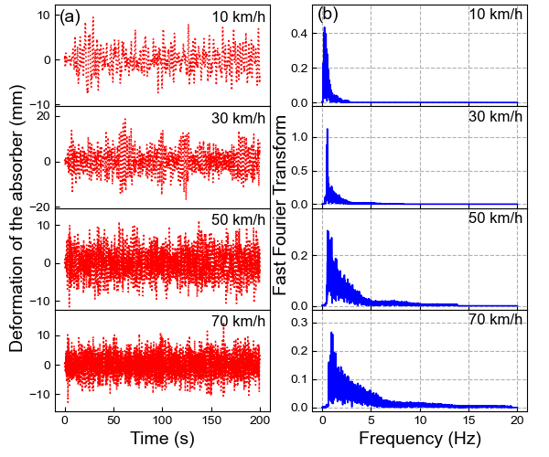
Figure 12. Simulated deformation of the absorber when the train runs at different speeds: (a) time-series data of absorber deformation; (b) the FFT spectrums of absorber deformations.

Figure 13. Performance of the harvester when the train runs at different speeds.

Based on the established vehicle-track coupling system, the absorber deformations at different running speeds of the vehicle can be obtained. Using the simulated deformation of the absorber as excitations, the performance of the harvester when the train runs at different speeds can be calculated. In simulations, a 300-Ω external load is connected to the harvester. Figure 13 shows the RMS of the calculated output power of the harvester when the train runs at different speeds. These results demonstrate that the RMS of the output power increases along with the speed of the vehicle. When the train runs at a speed of 80 km/h, this system will generate an output power of 50 mW. In practice, multiple harvesters can be arranged side by side, as shown in Figure 11. Thus, more energy can be obtained by using multiple harvesters.
The harvester in this work is designed to power low-power monitoring devices when the often-used energy sources are not available. Table 4 presents the power consumption of some sensors and wireless data transmission nodes, which can be utilized in health condition monitoring for infrastructure. It demonstrates that the proposed harvester is capable of energising these low-power monitoring devices. The proposed mechanism is an optional way when the often-used power sources are not available [38], [39]. Table 5 shows the out power of some vibration-based energy harvesters reported in the railway industry. It can be found that the proposed harvester is superior in energy harvesting capacity. Thus, the study and implementation of the proposed mechanism make sense for both the traditional and vibration-based energy sources. Having low manufacturing and maintenance costs and being able to energise these low-power monitoring devices, the proposed mechanism, thus, can be considered as a cost-effective way when the often-used energy sources are limited [40]. This study reinforces the prospect of using the energy harvested from train vibration to power onboard monitoring systems.

Table 4. The power consumption of some sensors and wireless data transmission nodes [41].
Sensor/  WSN node | Type/function | Manufacturer | Power consumption | Note
ADXL345 | Accelerometer | Analog Device | 350μW | 3-Axis, $\text{±}$16g
VS1100A | Accelerometer | Colibrys | 9.9mW | Measurement range $\text{±}$100g
Z4D-C01 | Distance meter | Omron | 70mW | Sensing distance 6.5$\text{±}$1mm
HC-SR04 | Distance meter | Jieshen | 65mW | Sensing distance $≤$7.0m
TS1000T | Inclinometer | Colibrys | 9.9mW | Angular accuracy$<\text{±}0.5°$
HC-SR501 | Infrared detector | / | 325μW | Operating temperature -150-70℃
DHT11 | Temperature & humidity | Ylelectronic | 12.5 mW | 20-90%RH; 0-50℃
ADC | Signal Conversion | / | 3.6 mW | 16 bits
LoRa node | Data transmission | / | 100mW[42] | Transmission distance $≤$60 Km
ZigBee node | Data transmission | / | 100.5mW | Transmission distance 10-100m

Table 5. The out power of some vibration-based energy harvesters reported in the railway industry.
Item | Mechanism | Maximum size (mm) | Mounting position | Power(mW)
Wischke et al.[43] | Cantilevered piezoelectric beam | 80 | Sleeper | 0.38 (max)
Yuan et al. [44] | Piezoelectric drum | 250 | Sleeper | 0.081 (rms)
Nelson et al.[45] | Electromagnetic, voice-coil | / | Rail bottom | 0.146 (avg)
Zhang et al.[46] | Electromagnetic, rack and pinion | / | Rail bottom | 36.5 (avg)
Hadas et al.[47] | Electromagnetic, spring-less resonant | 51 | Sleeper | 15 (max)
Ung et al.[48] | Electromagnetic, magnetic ball-coil | 31.8 | Bogie | 0.874 (rms)
Rana et al. [49] | Cantilevered piezoelectric beam | 0.6 | Suspension spring | 1.288 (max)
Bradai et al.[50] | Electromagnetic, spring resonant | 80 | Wagon | 10 (max)
This work | Electromagnetic, magnet array | 140 | Shock absorber | 50 (rms)
max: the maximum value of power; rms: the root-mean-square value of power; avg: the average value of power.

6. Conclusions
In this work, a magnet-array-based electromagnetic harvester is developed to realize the efficient utilization of vibration energy in the environment. A series of theoretical and experimental studies are conducted to understand the characteristics of the energy harvesting system. The main findings of this study are summarized as follows:
(1) The theoretical model of the harvester is established and verified. Based on the established model, the dynamical characteristics and optimal parameters of the harvester are investigated. Results indicate that the harvester shows strong periodicity under small-amplitude vibration and the periodicity gradually disappears with the increase of vibration intensity.
(2) The optimal resistance of the external load and energy harvesting capacity of the harvester are studied. This system reaches its maximum output power of 106.5 mW (root-mean-square value) with a 300-Ω external load and a 5-Hz excitation. The capability of this harvester in powering low-power electronics, such as a digital thermo-hygrometer and a digital calculator, is demonstrated through experiments.
(3) An application scenario of the harvester for scavenging energy from train vibration is provided. These results demonstrate that the RMS of the output power increases along with the speed of the vehicle. When the train runs at a speed of 80 km/h, one harvester will generate an output power of 50 mW.
This study shows the applicability of the proposed magnet-array-based vibration-to-rotation conversion mechanism in vibration energy harvesting and the possibility of establishing a self-powered onboard railway monitoring system.

Acknowledgements
The work of the first author is finished during his visit to the University of Liverpool sponsored by the China Scholar Council. This work also obtained foundations from the National Natural Science Foundation of China, (Grant Nos. 52008343, U1934214, and 51878576) and the Natural Science Foundation of Chongqing, China (Grant
No. cstc2021jcyj-msxmX1128). In addition, the authors would like to express thanks to Associate Professor Yuhua Sun from Southwest University, Chongqing, for his help in carrying out indoor tests.

References
[1] K. Fan et al., “A string-suspended and driven rotor for efficient ultra-low frequency mechanical energy harvesting,” Energy Convers. Manag., vol. 198, p. 111820, Oct. 2019, doi: 10.1016/j.enconman.2019.111820.
[2] M. Gao et al., “Dynamic modeling and experimental investigation of self-powered sensor nodes for freight rail transport,” Appl. Energy, vol. 257, p. 113969, 2020, doi: 10.1016/j.apenergy.2019.113969.
[3] H. Pan, L. Qi, Z. Zhang, and J. Yan, “Kinetic energy harvesting technologies for applications in land transportation: A comprehensive review,” Appl. Energy, vol. 286, p. 116518, 2021, doi: 10.1016/j.apenergy.2021.116518.
[4] M. Y. Gao, P. Wang, Y. F. Wang, and Y. Wang, “Energy harvesting of track-borne transducers by train-induced wind,” J. Vibroengineering, vol. 19, no. 3, pp. 1624–1640, 2017, doi: 10.21595/jve.2017.17592.
[5] J. Wang et al., “Enhancement of low-speed piezoelectric wind energy harvesting by bluff body shapes: Spindle-like and butterfly-like cross-sections,” Aerosp. Sci. Technol., vol. 103, p. 105898, 2020, doi: 10.1016/j.ast.2020.105898.
[6] Y. Wang, M. Gao, H. Ouyang, S. Li, Q. He, and P. Wang, “Modelling, simulation, and experimental verification of a pendulum-flywheel vibrational energy harvester,” Smart Mater. Struct., vol. 29, no. 11, p. 115023, 2020, doi: 10.1088/1361-665x/abacaf.
[7] S. P. Beeby, M. J. Tudor, and N. M. White, “Energy harvesting vibration sources for microsystems applications,” Meas. Sci. Technol., vol. 17, no. 12, pp. R175–R195, 2006, doi: 10.1088/0957-0233/17/12/r01.
[8] X. Guo, Y. Zhang, K. Fan, C. Lee, and F. Wang, “A comprehensive study of non-linear air damping and ‘pull-in’ effects on the electrostatic energy harvesters,” Energy Convers. Manag., vol. 203, p. 112264, 2020, doi: 10.1016/j.enconman.2019.112264.
[9] Y. Fu, H. Ouyang, and R. B. Davis, “Triboelectric energy harvesting from the vibro-impact of three cantilevered beams,” Mech. Syst. Signal Process., vol. 121, pp. 509–531, 2019, doi: 10.1016/j.ymssp.2018.11.043.
[10] Y. Sun et al., “Rail corrugation inspection by a self-contained triple-repellent electromagnetic energy harvesting system,” Appl. Energy, vol. 286, p. 116512, 2021, doi: 10.1016/j.apenergy.2021.116512.
[11] C. Liang, Y. Wu, and L. Zuo, “Broadband pendulum energy harvester,” Smart Mater. Struct., vol. 25, no. 9, p. 095042, 2016, doi: 10.1088/0964-1726/25/9/095042.
[12] K. Fan, J. Liu, M. Cai, M. Zhang, T. Qiu, and L. Tang, “Exploiting ultralow-frequency energy via vibration-to-rotation conversion of a rope-spun rotor,” Energy Convers. Manag., vol. 225, p. 113433, 2020, doi: 10.1016/j.enconman.2020.113433.
[13] Z. Yang, S. Zhou, J. Zu, and D. Inman, “High-Performance Piezoelectric Energy Harvesters and Their Applications,” Joule, vol. 2, no. 4, pp. 642–697, 2018, doi: 10.1016/j.joule.2018.03.011.
[14] Z. Wang, T. Zhang, Z. Zhang, Y. Yuan, and Y. Liu, “A high-efficiency regenerative shock absorber considering twin ball screws transmissions for application in range-extended electric vehicles,” Energy Built Environ., vol. 1, no. 1, pp. 36–49, 2020, doi: 10.1016/j.enbenv.2019.09.004.
[15] D. Huang, J. Chen, S. Zhou, X. Fang, and W. Li, “Response regimes of nonlinear energy harvesters with a resistor-inductor resonant circuit by complexification-averaging method,” Sci. China Technol. Sci., vol. 64, no. 6, pp. 1212–1227, 2021, doi: 10.1007/s11431-020-1780-x.
[16] E. Asadi, R. Ribeiro, M. B. Khamesee, and A. Khajepour, “Analysis, Prototyping, and Experimental Characterization of an Adaptive Hybrid Electromagnetic Damper for Automotive Suspension Systems,” IEEE Trans. Veh. Technol., vol. 66, no. 5, pp. 3703–3713, May 2017, doi: 10.1109/TVT.2016.2606607.
[17] V. R. Challa, M. G. Prasad, and F. T. Fisher, “Towards an autonomous self-tuning vibration energy harvesting device for wireless sensor network applications,” Smart Mater. Struct., vol. 20, no. 2, p. 025004, 2011, doi: 10.1088/0964-1726/20/2/025004.
[18] A. Maravandi and M. Moallem, “Regenerative Shock Absorber Using a Two-Leg Motion Conversion Mechanism,” IEEEASME Trans. Mechatron., vol. 20, no. 6, pp. 2853–2861, Dec. 2015, doi: 10.1109/TMECH.2015.2395437.
[19] Z. Li, L. Zuo, J. Kuang, and G. Luhrs, “Energy-harvesting shock absorber with a mechanical motion rectifier,” Smart Mater. Struct., vol. 22, no. 2, p. 025008, 2012, doi: 10.1088/0964-1726/22/2/025008.
[20] L. C. Rome, L. Flynn, E. M. Goldman, and T. D. Yoo, “Generating Electricity While Walking with Loads,” Science, vol. 309, no. 5741, p. 1725, 2005, doi: 10.1126/science.1111063.
[21] L. Zuo and P.-S. Zhang, “Energy Harvesting, Ride Comfort, and Road Handling of Regenerative Vehicle Suspensions,” J. Vib. Acoust., vol. 135, no. 1, 2013, doi: 10.1115/1.4007562.
[22] S.-B. Choi, M.-S. Seong, and K.-S. Kim, “Vibration control of an electrorheological fluid-based suspension system with an energy regenerative mechanism,” Proc. Inst. Mech. Eng. Part J. Automob. Eng., vol. 223, no. 4, pp. 459–469, 2009, doi: 10.1243/09544070JAUTO968.
[23] X. Zhang, Z. Zhang, H. Pan, W. Salman, Y. Yuan, and Y. Liu, “A portable high-efficiency electromagnetic energy harvesting system using supercapacitors for renewable energy applications in railroads,” Energy Convers. Manag., vol. 118, pp. 287–294, 2016, doi: 10.1016/j.enconman.2016.04.012.
[24] Ian L. Cassidy, Jeffrey T. Scruggs, and Sam Behrens, “Design of electromagnetic energy harvesters for large-scale structural vibration applications,” 2011, vol. 7977. [Online]. Available: https://doi.org/10.1117/12.880639
[25] Y. KAWAMOTO, Y. SUDA, H. INOUE, and T. KONDO, “Modeling of Electromagnetic Damper for Automobile Suspension,” J. Syst. Des. Dyn., vol. 1, no. 3, pp. 524–535, 2007, doi: 10.1299/jsdd.1.524.
[26] L. Xie, S. Cai, G. Huang, L. Huang, J. Li, and X. Li, “On Energy Harvesting From a Vehicle Damper,” IEEEASME Trans. Mechatron., vol. 25, no. 1, pp. 108–117, Feb. 2020, doi: 10.1109/TMECH.2019.2950952.
[27] Y. Liu, L. Xu, and L. Zuo, “Design, Modeling, Lab, and Field Tests of a Mechanical-Motion-Rectifier-Based Energy Harvester Using a Ball-Screw Mechanism,” IEEEASME Trans. Mechatron., vol. 22, no. 5, pp. 1933–1943, Oct. 2017, doi: 10.1109/TMECH.2017.2700485.
[28] Y. Zhang, A. Luo, Y. Wang, X. Dai, Y. Lu, and F. Wang, “Rotational electromagnetic energy harvester for human motion application at low frequency,” Appl. Phys. Lett., vol. 116, p. 053902, 2020, doi: 10.1063/1.5142575.
[29] S. Guo, L. Xu, Y. Liu, X. Guo, and L. Zuo, “Modeling and Experiments of a Hydraulic Electromagnetic Energy-Harvesting Shock Absorber,” IEEEASME Trans. Mechatron., vol. 22, no. 6, pp. 2684–2694, Dec. 2017, doi: 10.1109/TMECH.2017.2760341.
[30] Z. Fang, X. Guo, L. Xu, and H. Zhang, “Experimental Study of Damping and Energy Regeneration Characteristics of a Hydraulic Electromagnetic Shock Absorber,” Adv. Mech. Eng., vol. 5, p. 943528, 2013, doi: 10.1155/2013/943528.
[31] L. Bowen, J. Viñolas, J. L. Olazagoitia, and J. Echávarri Otero, “An Innovative Energy Harvesting Shock Absorber System Using Cable Transmission,” IEEEASME Trans. Mechatron., vol. 24, no. 2, pp. 689–699, Apr. 2019, doi: 10.1109/TMECH.2019.2892824.
[32] K. Fan, J. Liu, D. Wei, D. Zhang, Y. Zhang, and K. Tao, “A cantilever-plucked and vibration-driven rotational energy harvester with high electric outputs,” Energy Convers. Manag., vol. 244, p. 114504, 2021, doi: 10.1016/j.enconman.2021.114504.
[33] S. C. Stanton, C. C. McGehee, and B. P. Mann, “Nonlinear dynamics for broadband energy harvesting: Investigation of a bistable piezoelectric inertial generator,” Phys. Nonlinear Phenom., vol. 239, no. 10, pp. 640–653, 2010, doi: 10.1016/j.physd.2010.01.019.
[34] Y. Wang, S. Li, M. Gao, H. Ouyang, Q. He, and P. Wang, “Analysis, design and testing of a rolling magnet harvester with diametrical magnetization for train vibration,” Appl. Energy, vol. 300, p. 117373, 2021, doi: 10.1016/j.apenergy.2021.117373.
[35] Y. Wang, P. Wang, Z. Li, Z. Chen, and Q. He, “Forecasting Urban Rail Transit Vehicle Interior Noise and Its Applications in Railway Alignment Design,” J. Adv. Transp., vol. 2020, p. 5896739, 2020, doi: 10.1155/2020/5896739.
[36] K. Youcef, T. Sabiha, D. El Mostafa, D. Ali, and M. Bachir, “Dynamic analysis of train-bridge system and riding comfort of trains with rail irregularities,” J. Mech. Sci. Technol., vol. 27, no. 4, pp. 951–962, 2013, doi: 10.1007/s12206-013-0206-8.
[37] J. Zhou, G. Shen, H. Zhang, and L. Ren, “Application of modal parameters on ride quality improvement of railway vehicles,” Veh. Syst. Dyn., vol. 46, no. sup1, pp. 629–641, 2008, doi: 10.1080/00423110802033049.
[38] G. Miao, S. Fang, S. Wang, and S. Zhou, “A low-frequency rotational electromagnetic energy harvester using a magnetic plucking mechanism,” Appl. Energy, vol. 305, p. 117838, 2022, doi: 10.1016/j.apenergy.2021.117838.
[39] S. Zhou and L. Zuo, “Nonlinear dynamic analysis of asymmetric tristable energy harvesters for enhanced energy harvesting,” Commun. Nonlinear Sci. Numer. Simul., vol. 61, pp. 271–284, 2018, doi: 10.1016/j.cnsns.2018.02.017.
[40] K. Yang, T. Qiu, J. Wang, and L. Tang, “Magnet-induced monostable nonlinearity for improving the VIV-galloping-coupled wind energy harvesting using combined cross-sectioned bluff body,” Smart Mater. Struct., vol. 29, no. 7, p. 07LT01, 2020, doi: 10.1088/1361-665X/ab874c.
[41] M. Gao, P. Wang, Y. Wang, and L. Yao, “Self-Powered ZigBee Wireless Sensor Nodes for Railway Condition Monitoring,” IEEE Trans. Intell. Transp. Syst., vol. 19, no. 3, pp. 900–909, Mar. 2018, doi: 10.1109/TITS.2017.2709346.
[42] M. R. Villarim et al., “An Evaluation of LoRa Communication Range in Urban and Forest Areas: A Case Study in Brazil and Portugal,” in 2019 IEEE 10th Annual Information Technology, Electronics and Mobile Communication Conference (IEMCON), Oct. 2019, pp. 0827–0832. doi: 10.1109/IEMCON.2019.8936194.
[43] M. Wischke, M. Masur, M. Kröner, and P. Woias, “Vibration harvesting in traffic tunnels to power wireless sensor nodes,” Smart Mater. Struct., vol. 20, no. 8, p. 085014, 2011, doi: 10.1088/0964-1726/20/8/085014.
[44] Y. Tianchen, Y. Jian, S. Ruigang, and L. Xiaowei, “Vibration energy harvesting system for railroad safety based on running vehicles,” Smart Mater. Struct., vol. 23, no. 12, p. 125046, 2014, doi: 10.1088/0964-1726/23/12/125046.
[45] Carl A. Nelson, Stephen R. Platt, Dave Albrecht, Vedvyas Kamarajugadda, and Mahmood Fateh, “Power harvesting for railroad track health monitoring using piezoelectric and inductive devices,” 2008, vol. 6928. doi: 10.1117/12.775884.
[46] X. Zhang, Z. Zhang, H. Pan, W. Salman, Y. Yuan, and Y. Liu, “A portable high-efficiency electromagnetic energy harvesting system using supercapacitors for renewable energy applications in railroads,” Energy Convers. Manag., vol. 118, pp. 287–294, 2016, doi: 10.1016/j.enconman.2016.04.012.
[47] Z. Hadas, C. Ondrusek, and V. Singule, “Power sensitivity of vibration energy harvester,” Microsyst. Technol., vol. 16, no. 5, pp. 691–702, 2010, doi: 10.1007/s00542-010-1046-4.
[48] C. Ung, S. Moss, L. A. Vandewater, S. C. Galea, W. K. Chiu, and G. Crew, “Energy Harvesting from Heavy Haul Railcar Vibrations,” Int. Conf. Intell. Sens. Sens. Netw. Inf. Process. 2013, pp. 95–98, 2013, doi: 10.1109/ISSNIP.2013.6529771.
[49] V. S. Rana and A. Chauhan, “Energy harvesting from locomotive and coaches by piezoelectric ceramic using MEMS technology,” in 2015 International Conference on Innovations in Information, Embedded and Communication Systems (ICIIECS), Mar. 2015, pp. 1–6. doi: 10.1109/ICIIECS.2015.7193179.
[50] S. Bradai, S. Naifar, C. Viehweger, and O. Kanoun, “Electromagnetic Vibration Energy Harvesting for Railway Applications,” 2018.

